Figure 1a. Percentage of extractions at centers with off-site cardiac surgery (CS) facilities
p<0.001

Figure 1b. Mean Charlson Comorbidity Index according to admitting centers’ cardiac surgery (CS) status (2004-2014)

Figure 2a. In-hospital adverse events of study groups
p<0.001 for all
*MACE: Composite of mortality, thoracic complications and cardiac complications

Figure 2b. Trends in in-hospital adverse events form 2004-2014
*non-significant (p≥0.05); † p<0.05; †† p<0.001

Figure 2c. Adjusted odds ratios (aORs) of adverse outcomes according to admitting hospital cardiac surgery facility
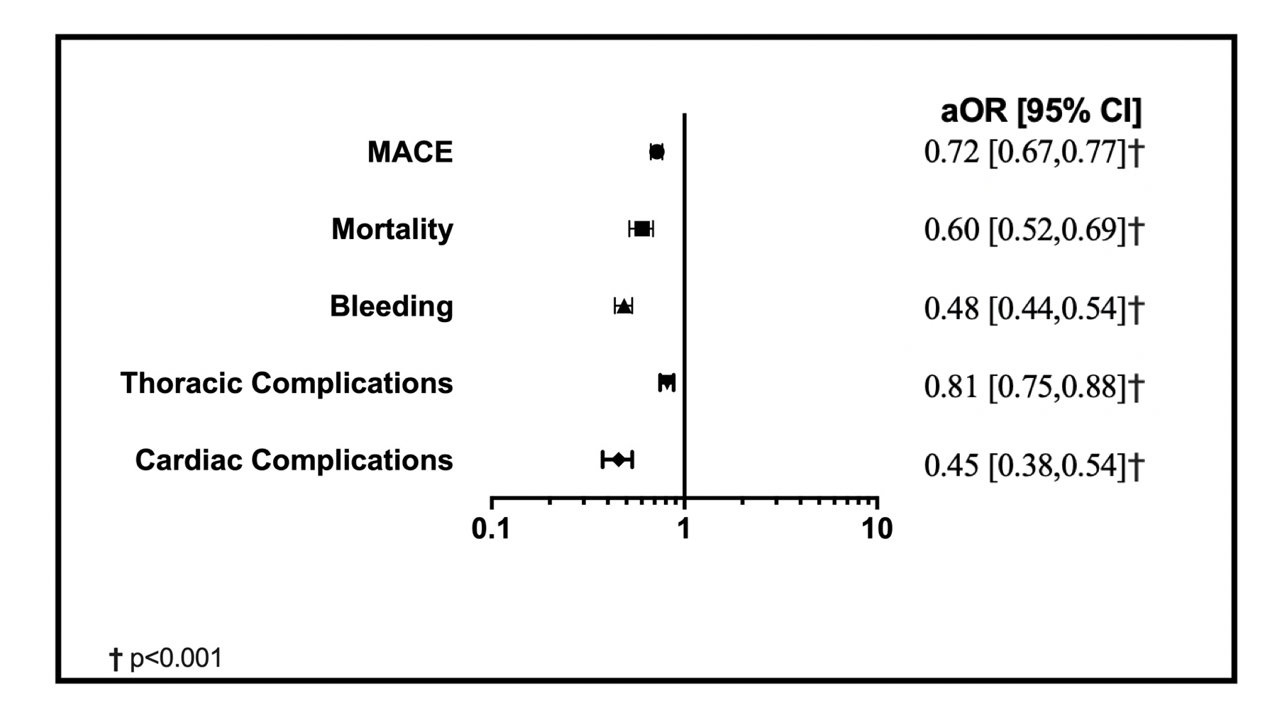
*MACE: Composite of mortality, thoracic complications and cardiac complications

