The relative rate of kill of the MMV Malaria Box compounds provide links to the mode of antimalarial action and highlight scaffolds of medicinal chemistry interest

Imran ULLAH^, Raman SHARMA², Antonio METE³, Giancarlo A. BIAGINI², Dawn M. WETZEL⁴ and Paul D. HORROCKS*¹
¹Institute for Science and Technology in Medicine, Keele University, Staffordshire ST5 5BG, United Kingdom; ²Research Centre for Drugs and Diagnostics, Liverpool School of Tropical Medicine, Pembroke Place, Liverpool L3 5QA, United Kingdom; ³Medsyndesign Ltd, Advanced Technology Innovation Centre, 5 Oakwood Drive, Loughborough, LE11 3QF, United Kingdom; ⁴Department of Pediatrics, University of Texas Southwestern Medical Center, Dallas, 75235 Texas, USA

*Corresponding author. Institute for Science and Technology in Medicine, Keele University, Staffordshire ST5 5BG, United Kingdom.
Tel: +44-(0)-1782-733670
E-mail: p.d.horrocks@keele.ac.uk
Running title: Antimalarial relative rate of kill

Abstract
Objectives: Rapid rate-of-kill (RoK) is a key parameter in the target candidate profile 1 (TCP1) for the next-generation antimalarial drugs for uncomplicated malaria, termed Single Encounter Radical Cure and Prophylaxis (SERCaP). TCP1 aims to rapidly eliminate the initial parasite burden, ideally as fast as artesunate, but minimally as fast as chloroquine. Here we explore whether the relative RoK of the Medicine for Malaria Venture (MMV) Malaria Box compounds are linked to their mode of action (MoA) and identify scaffolds of medicinal chemistry interest.
Methods: We used a Bioluminescence Relative RoK (BRRoK) assay over 6 and 48h, with exposure to equipotent-IC₅₀ concentrations, to compare the cytocidal effects of Malaria Box compounds to benchmark antimalarials.
Results: BRRoK assay data demonstrate the following relative RoK from fast to slow: inhibitors of PfATP4 > parasite hemoglobin catabolism > DHFR-TS > DHODH > bc1 complex. Core scaffold clustering analyses reveal intrinsic rapid cytocidal action for diamino-glycerols and 2-(aminomethyl)phenol, but slow action for 2-phenylbenzimidazoles, 8-hydroxyquinolines, and triazolopyrimidines.
Conclusion: This study provides proof of principle that a compound’s RoK is related to its MoA, and target’s intrinsic RoK is also modified by factors affecting a drug’s access to it. Our findings highlight that as we use medicinal chemistry to improve potency, we can also improve the RoK for some scaffolds. Our BRRoK assay provides the necessary throughput for drug discovery and a critical decision-making tool to support development campaigns. Finally, two scaffolds, diamino-glycerols, and 2-phenoxybenzylamine, exhibit fast cytocidal action, inviting medicinal chemistry improvements towards TCP1 candidates.

Introduction
Resistance by P. falciparum to front-line therapeutics necessitates new drugs with novel MoA to circumvent parasite resistance mechanisms.^{1,2} This need was initially met by the identification of 20,000 hits with sub-micromolar potency against P. falciparum intraerythrocytic stages from an extensive screening campaign of around four million compounds from the libraries of St. Jude Children's Research Hospital, TN, USA, Novartis and GSK. ^{2–6} Triaging these hits to establish development priorities requires additional pharmacodynamic information, key amongst which is their rate-of-kill (RoK).⁷ Rapid RoK is specifically identified by MMV as a key requirement within a future SERCaP to treat malaria.^{1,8} The target candidate profile TCP1 requires an immediate effect to rapidly eliminate parasites, minimally as fast as chloroquine and ideally as fast as artesunate. If resistance renders artemisinin ineffective, TCP1 candidates will ideally replace it.^{1,8}
Antimalarial RoK is currently determined in vivo with mouse models or phase IIa clinical trials.⁹ It is defined by (i) the parasite reduction ratio (PRR), the fold-reduction from starting parasitaemia after 48 hours (h, one erythrocyte-stage cycle) of treatment and (ii) parasite clearance time (PCT), time until parasites are no longer detectable in peripheral blood films⁹. The only in vitro RoK assay that provides the PRR and PCT parameters is the recrudescence assay at GSK Tres Cantos,¹⁰ representing the gold-standard for RoK determination in vitro. However, its challenging technical aspects, such as requirements for parasite recrudescence over 21-28-days, limit applicability to small-scale lead validation.^{7,11–13} To address this assay bottleneck, we reported a microplate-based BRRoK assay that discriminates between minimum essential and ideal TCP1 candidates within 6h (BRRoK^{6h}), ¹⁰ and published RoK data for 370 open-access Medicine for Malaria Venture’s Malaria Box compounds relative to a panel of known antimalarial benchmarks. ^{2,7} In this study, we extend this study of RoK for the Malaria Box compounds to demonstrate the following proof-of-principles. First, to show that compounds with similar BRRoK have similar MoA, we compared BRRoK^{6h} from Malaria Box compounds to their predicted MoA. Five clusters emerged, with each representing distinct relative RoK correlating with different MoA. Second, to demonstrate that Malaria Box compounds with related scaffolds have similar rates of antimalarial killing, BRRoK^{6h} were compared based on compounds’ core scaffold with five clusters emerging that we then correlated with what we know about potential MoA. Third, we had previously identified 178 Malaria Box compounds that showed little cytocidal activity within 6h.¹⁰ Thus, we extended the assay over 48h (BBRoK^{48h}) to ensure completion of one intraerythrocytic cycle. Most compounds without activity in the BRRoK^{6h} showed activity in the BRRoK^{48h}, providing links to their MoA. Our data demonstrates that a revised BRRoK assay at two timepoints, 6 and 48h, provides a critical decision-making tool for antimalarial drug discovery and development campaigns.
Methods
The transgenic Dd2 P. falciparum clone (Dd2^{luc})^{14,15} were cultured as described previously.⁷ The antimalarial drugs and the Malaria Box compounds were prepared as shown in Table S1. Malaria Box IC₅₀ were measured in Dd2^{luc} and deposited in the ChEMBL – Neglected Tropical Disease Open Access repository (ChEMBL3392923, see Van-Voorhis et al.,¹⁶).
The BRRoK^{48h} assay was carried out as described previously⁷. Briefly, compounds were serially diluted (9× IC₅₀, 3x IC₅₀, 1x IC₅₀ and 0.3× IC₅₀ concentrations from a determination of IC₅₀ at 48h) in 96-multiwell plates, trophozoite-stage (20–26 h post-infection) cultures of Dd2^{luc} were added and mixed by pipetting to give a final 200 μL volume in each well with 3-fold IC₅₀ dilution series of drugs, 1% parasitaemia and 2% haematocrit. To estimate the BRRoK^{48h}, the plates were incubated continuously in the presence of the compounds for 48h prior to assay at 37°C. As described previously, ^{7,17} 40 μL of P. falciparum culture were transferred to a white 96-multiwell plate (Greiner, UK) and lysed with 10 μL of passive lysis buffer (Promega, UK). An equal volume, 50 μL, of the supplied luminogenic substrate was mixed with the lysed parasites and the bioluminescence was measured for 2 s in a Glomax-Multi Detection System (Promega, UK). Experiments were carried out as technical triplicates on the same plate, with three independent biological repeats of each plate performed. Controls in each biological replicate consisted of trophozoite-stage culture with no drug added (100%) or uninfected erythrocytes (0%). The mean and standard deviation (SD) of bioluminescence data from three independent biological repeats were expressed as a proportion of the untreated control (100%) and calculated as follows: 100 × [μ(S) − μ (−)/μ (+) − μ (−)], where μ(S), μ (+) and μ (−) represent the means for the sample in question and 100% and 0% controls, respectively. The Z′ score of the BRRoK^{48h} assay was calculated as follows: Z′ = 1 − [(3σ₍₊₎ + 3σ₍₋₎)/μ₍₊₎ − μ₍₋₎], where μ₍₊₎and σ₍₊₎ are the mean and SD of the no-drug (untreated) positive control, respectively, and μ₍₋₎ and σ₍₋₎ are the mean and SD from uninfected erythrocytes (negative control), respectively.¹⁸ The signal/background (S/B) ratio was calculated as follows: [μ₍₊₎ − μ₍₋₎]/σ₍₋₎.
As previously described,⁷ a principle components analysis (PCA) was performed on the BRRoK assay data for the MMV Malaria Box compounds (48h assays using a 9× IC₅₀, 3x IC₅₀, 1x IC₅₀ and 0.3× IC₅₀ series) using the KNIME analytics platform, to reduce the dimensionality of these data sets¹⁹, allowing the concentration-rate relationship to be captured in one parameter. The first principle component (PC1) accounted for 78% of the total variance of the data (see supplementary materials). A zero-meaned PC1 value is used to provide a description of the RoK relative to known antimalarial benchmark controls (see Table S1).⁷
Results
The BRRoK^{6h} for the Malaria Box identifies compound clusters linked by common modes of antimalarial action
That antiplasmodial in vitro RoK correlates with MoA has been established for a small number of antimalarial drugs, predominantly within classes that have been or are currently used.¹⁰ We have previously described a determination of the rates of initial cytocidal kill (over 6h) using the Bioluminescence Relative Rate of Kill (BRRoK) assay for 370 compounds from the Malaria Box open-access drug discovery resource relative to a range of benchmark antimalarials for which both in vitro and in vivo rates of kill data were available.⁷ This determination used a P. falciparum strain genetically modified to express a bioluminescent luciferase reporter protein, with cytocidal action determined by loss of bioluminescent signal following exposure to increasing concentrations of test compound. Analysis of the normalised concentration-dependant bioluminescent signals by principle components analysis provides for a rank of initial cytocidal action that enables rate of kill relative to known controls to be described. Termed PC1, for first principle component, these are presented as zero-meaned data where low values such as -97.4 relate to the extremely rapid acting dihydroartemisinin and higher values, such as 55.4, for the slow-acting atovaquone.⁷
With BRRoK^{6h} data for 370 Malaria Box compounds, we correlated these with MoA data made available as part of this open source drug discovery project (Figure 1).^{20–34} PC1 were plotted against their IC₅₀ (ChEMBL3392923, see Van-Voorhis et al.,¹⁶) and mapped against benchmark antimalarials. Compounds with RoK ≥ dihydroartemisinin (DHA, PC1= -97.4) and ≥ chloroquine (CQ, PC1 = -73.7, log PRR= 4.5, 99% PCT= 32h) meet the TCP1 ideal and minimum essential criteria, respectively. Generally, compounds with RoK ≥ CQ are considered fasting acting, those with a RoK ≥ Quinine (QN, PC1 = -52), Mefloquine (MQ, PC1 = −42.4, log PRR = 3.7 and 99.9% PCT = 43 h) or Piperaquine (PQ, PC1 = -37, log PRR = 4.6, 99% PCT = 33h) are considered moderate acting, and those with RoK ≥ Atovaquone (ATQ, PC1 = 55.4, log PRR = 2.9 and 99.9% PCT = 90 h) are slow-acting (Figure 1, S1 Table). Thus, compounds with an initial rapid RoK and nM potency, like artemisinins, occupy the bottom-left quadrant those such as atovaquone, whilst potent, being slow-acting occupies the upper left-hand quadrant (Figure 1).
MoA data was sourced from specific activity assays (e.g. in vitro enzyme inhibition assays) to comparative metabalomic profiling, and as such the MoA association for the Malaria Box are often tentative. We hypothesized that compounds with a shared MoA would exhibit similar BRRoK^{6h} data. Five MoA including compounds targeting (i) PfATP4, a Na⁺-ATPase in the parasite’s plasma membrane, ii) bifunctional Plasmodium enzyme dihydrofolate reductase-thymidylate synthase (DHFR-TS), (iii) dihydroorotate dehydrogenase (DHODH), (iv) the bc₁ complex of the mitochondrial electron transport chain and (v) parasite hemoglobin catabolism (Figure 1A-E) were clustered. These MoA were selected because in vitro PRR data are available for > 10 compounds (Table S2) in each class.^{16,20,21,27,28,35} RoK were identified from fast to slow: PfATP4 > parasite hemoglobin catabolism > DHFR-TS > DHODH > bc1 complex. Using one-way ANOVA with a post-hoc Tukey test ^{7,16,20,29,30}, we found that compounds targeting PfATP4 exhibit the fastest RoK and are significantly faster than other clusters (Figure 1F). Compounds targeting parasite hemoglobin catabolism are significantly faster than those targeting DHFR-TS, DHODH and bc₁ complex, and compounds targeting DHFR-TS are faster than DHODH and bc1 complex inhibitors (all p < 0.01), while other pairwise comparisons are not significant.
BRRoK^{6h} highlights rapid cytocidal activity for diamino-glycerols and 2-(aminomethyl)phenol scaffolds in the Malaria Box
The Malaria Box compounds were selected to be structurally diverse.² We wished to determine whether substructure analysis of these novel Malaria Box compounds reveals novel core scaffolds with shared RoK activity, and thus potentially with new MoA. BRRoK^{6h} data was overlaid with five distinct scaffolds; diamino-glycerols, 2-(aminomethyl)phenol, 2-phenylbenzimidazole, 8-hydroxyquinolines, and triazolopyrimidine (Figure 2). Table S3 shows full structures and the core scaffold substructures, with > 5 compounds for each scaffold annotated. We found a fast BRRoK for diamino-glycerols and 2-(aminomethyl)phenols, and slow BRRoK for 2-phenylbenzimidazoles, 8-hydroxyquinolines and triazolopyrimidines (Figure 2A-E). The five core scaffolds identified BRRoK ranking from fast to slow: diamino-glycerols > 2-(aminomethyl)phenol > 2-phenylbenzimidazole > 8-hydroxyquinolines > triazolopyrimidine. The diamino-glycerol scaffold exhibited the fastest cytocidal action among the group (p < 0.01 for all, except 2-(aminomethyl)phenol where p > 0.05 by ANOVA (Figure 2F). Similarly, compounds in the 2-(aminomethyl)phenol scaffold exhibited significantly faster action (p < 0.01) than the 2-phenylbenzimidazole, 8-hydroxyquinolines and triazolopyrimidine scaffolds (Figure 2F).
BRRoK^{48h} confirms slow cytocidal action for a subset of compounds in the Malaria Box
The BRRoK^{6h} assay identified fast-acting Malaria Box compounds as TCP1 candidates, including the fastest-acting PfATP4 inhibitor spiroindolone MMV396749 (Table S2). However, almost half of the Malaria Box showed little cytocidal activity against intraerythrocytic trophozoites over 6h. We predicted that these compounds might have a lag phase in their cytocidal action, such as shown by the antimalarial atovaquone with a 48h lag in cytocidal action.¹⁰ We therefore employed a revised BRRoK assay over 48h (BRRoK^{48h}) to ensure completion of one full intraerythrocytic cycle. For validation, we selected different benchmark antimalarials, which covered multiple MoA.⁷ Dd2^{luc} parasites were exposed to a 3-fold serial dilution (9–0.33 × IC₅₀) for 48h, the resulting bioluminescence signal normalized to an untreated control, and the normalized bioluminescent signal plotted against drug concentration (Figure S1). We found the identical relative ranking order of benchmark antimalarial drugs (i.e. artemisinin > chloroquine > 4-methanolquinolines > atovaquone) to BRRoK^{6h},⁷ which is identical to both the in vivo and in vitro RoK.^{31–33,35}
We had sufficient material available for 178 slow-acting Malaria Box compounds. Along with the benchmark antimalarial drugs ATQ, CQ, DHA, MQ, PPQ, pyronaridine (PYN) and QN, we subjected them to a BRRoK^{48h} assay (Table S4; Figures S2, S3). 95% confidence intervals for the Z′ score (0.85-0.95), maximum coefficient of variation (0.9%-2.84%), and signal/background ratio (2580-5001) indicate a robust and sensitive microplate-based assay of the BRRoK^{48h} data. Using mean ± SD for each IC₅₀-fold BRRoK^{48h} normalized bioluminescent signal, a PCA was carried out for concentration-dependent effects (Figure S4; Tables S5-S6). PC1 accounts for 78% of the variance at 48h, with most contributions provided by the 3X IC₅₀ data.
We next plotted BRRoK^{6h} and BRRoK^{48h} PC1 against IC₅₀ data (Figure 3, Table S7). Figure 3A highlights these compounds’ slow action over 6 h, with compounds clustering adjacent to the slow acting atovaquone. Plotting BRRoK^{48h} data against IC₅₀ results in a wide distribution of 48h RoK for these compounds (Figure 3B). Interestingly a number of initially slow acting compounds now show a 48h RoK within the TCP1 target range (>chloroquine) and presumably reflect a shorter lag phase in their action, such as the 24hr lag phase reported for pyrimethamine.¹⁰ The majority of compounds, however, still show a BRRoK PC1 more similar to atovaquone, and thus potentially a longer lag phase. To explore this, compounds with two predicted slow-acting MoA^{16,20,22–26,29,30,34,36–39} were correlated with BRRoK^{48h}; 38 were DHODH inhibitors (Figure 4A, Table S7) and 18 were bc₁ complex inhibitors (Figure 4B, Table S7). Unfortunately, due to small sample size, one-way ANOVA did not indicate statistical significance (p > 0.05) (Fig 4C) between these different MoA but did indicate that their longer lag phases resulted in higher BRRoK^{48h} PC1 scores (Figure 4C).
Discussion
The next-generation antimalarial drugs should rapidly eliminate parasite burden, ideally as fast as artesunate, but at least as fast as chloroquine.¹ Whilst we have previously used the BRRoK^{6h} assay to measure the relative RoK for 370 Malaria Box compounds, here we show that BRRoK^{6h} data provides links to the antimalarial MoA (with PfATP4 > parasite hemoglobin catabolism > DHFR-TS > DHODH > bc1 complex) and that comparison with scaffold sub-structures identified five core scaffolds with the relative RoK: diamino-glycerols > 2-(aminomethyl)phenol > 2-phenylbenzimidazole > 8-hydroxyquinolines > triazolopyrimidine. We also predicted that compounds with minimal activity at 6h might have a lag phase, like atovaquone and DSM265.^{7,10,35} Thus, we determined the RoK of apparently slow-acting compounds using a BRRoK^{48h} assay and show that many of the slow-acting compounds are likely DHODH and bc₁ complex inhibitors. In short, compounds in the Malaria Box with similar targets and chemical core substructure exhibit similar time-dependant RoK dynamics. Although our study is limited to a library of 400 compounds that lack a full biochemical target validation, it provides the proof-of-principle that BRRoK data offers an opportunity to rapidly prioritize compounds in the TCAMS, or other, library by informing predictions of structure-activity and MoA. Moreover, we note that using the BRRoK assay at two-time points, 6 and 48h, we not only have the potential to rapidly identify and discriminate between compounds that meet the ideal and minimum TCP1 criteria, but also identify compounds that likely exhibit a lag time in drug action between 6 and 48h. This BRRoK assay format, however, does not provide a reliable assessment of the extent and timing of this lag time, as would be reported by a recrudescence assay.¹⁰
A compound’s immediate cytocidal activity likely results from the nature of the target and the ease of access to the target. The first aspect considers how quickly a deficit in this target’s function will lead to cell death – i.e. its MoA. In vitro assays of RoK report that antimalarial drugs with a similar MoA result in similar RoK.^{7,10} We have significantly extended this observation here for the open Source Malaria Box, a critical collection of antimalarial drug discovery compounds. Whilst an important caveat is that for most compounds described the target association is tentative, this library is still the best described and investigated resource in this endevour.²¹ Nonetheless, here we were able to consider five MoA groups due to availability of in vitro PRR data and at least 10 MMV compounds annotated for each MoA from a range of sources.^{16,20,21,27,28,35} Specifically; (i) PfATP4 (Figure 1A): 33 compounds are annotated as PfATP4 inhibitors (Figure 1A).^{20,29} In vitro PRR data are available for exemplar PfATP4 inhibitors (+)-SJ733,36²¹ a dihydroisoquinoline with a slow-to-moderate RoK, and KAE609/NITD609,²⁷ a spiroindolone with a moderate to fast RoK. Most potential Malaria Box PfATP4 inhibitors were reported as having a BRRoK^{6h} between the moderate mefloquine ¹⁰ (comparable to the PRR reference pyrimethamine¹⁰) and the rapidly-acting dihydroartemisinin. The fastest-acting PfATP4 inhibitor was the spiroindolone MMV396749, with several studies reporting a fast to moderate cytocidal activity for PfATP4 inhibitors.^{7,16,20,21,27,29} The Malaria Box also contains five structural analogues of the slower acting PfATP4 inhibitor (+)-SJ733; two have PC1s falling between the fast-acting dihydroartemisinin and chloroquine with the remaining three between mefloquine and atovaquone, supporting the prediction of a moderate to slow RoK of the dihydroisoquinolines. (ii) Plasmodium dihydrofolate reductase-thymidylate synthase (DHFR-TS) (Figure 1B): 14 compounds are annotated as DHFR-TS inhibitors, clustering with known antifolate antimalarial drugs that target DHFR-TS, P218, pyrimethamine, and WR99210.^{29,40–42} Pyrimethamine has a lag phase of 24 h, which is the slowest RoK after ATQ.¹⁰ The BRRoK^{6h} confirms slow cytocidal activity for this cluster, between slow-acting atovaquone and moderate-acting pyronaridine. (iii) Dihydroorotate dehydrogenase (DHODH) (Figure 1C): 43 compounds are annotated as DHODH inhibitors, and BRRoK^{6h} show that they share a slow initial cytocidal action. This slow RoK correlates with the atovaquone-like in vitro PRR data for DSM265³⁵, due to its 24-48h lag phase. One outlier, MMV666102, falls between pyronaridine and mefloquine showing a slow-to-moderate cytocidal action. Whilst no additional target information is available, we predict that this compound may have additional targets. (iv) bc₁ complex inhibitors: 18 compounds are annotated as bc₁ complex inhibitors and are slowly cytocidal in the BRRoK^{6h} and are comparable to atovaquone which shares the same MoA.¹⁰ Comparing BRRoK with the predicted MoA for all four groups indicates that compounds with a similar MoA have similar RoK. The predicted MoA used here was primarily obtained through metabolomics^{16,29,30} and readily highlights the potential for BRRoK to complement such studies. (v) Parasite hemoglobin catabolism: Allman et al.,²⁹ reports a compound group in the Malaria Box that perturbs parasite hemoglobin catabolism. Parasite hemoglobin catabolism compounds formed our second fastest-acting cluster (Figure 1E). However, as expected, the BRRoK^{6h} data reveals a broad RoK range for these compounds, which agrees with metabolomics data, as these compounds have a range of predicted targets. For example, chloroquine, known for accumulation within the digestive vacuole of Plasmodium, clusters with this group, but the resulting metaprint is divergent, due to the overall lack of significant metabolic changes or dysregulation induced by chloroquine.^{29,43} MMV390048, which inhibits the phosphatidylinositol 4-kinase (PI4K), and AZ412, which inhibits the putative vacuolar ATPase,^{12,29,44} also clusters with this group. Interestingly, as expected from compounds with different targets, the BRRoK^{6h} appears to form subclusters within this group. Upon additional target data availability, we would predict that this currently broad class of compounds could be further categorised into slow, moderate, and fast-acting groups.
A second means to classify compounds for comparison to the BRRoK^{6hr} data is through their chemical structure (Figure 2). Our analysis suggests that structurally similar compounds exert a similar RoK. This is not surprising if they share the same target, and our analysis suggests that medicinal chemistry may not only improve IC₅₀ potency for candidates but may also help improve RoK within chemical class and a well-defined MoA. For example, all five triazolopyrimidine scaffold members (Figure 2A) inhibit DHODH and are structural analogs of DSM265, a known slow-acting compound in clinical trials.³⁵ However, their PC1 varies between 23 and 67, highlighting room to influence the initial cytocidal action within the limits of this chemical class and the intrinsic limits of the MoA. A range of slow cytocidal activity is also reported for 8-hydroxyquinolines (PC1 of 8.8-95.4) (Figure 2B), with one annotated as a DHODH inhibitor. We also report two fast-acting scaffolds: diamino-glycerols and 2-(aminomethyl)phenol (Figure 2C-D). The diamino-glycerol is the fastest scaffold described here, which agrees with a predicted MoA as four of these nine compounds are PfATP4 inhibitors.^{16,20,29} It would be interesting to investigate whether the remaining five compounds also affect PfATP4. Three of these five compounds are designated as probe-like and were not characterised in metabolomic studies that focussed on drug-like compounds in the Malaria Box.²⁹ Furthermore, five compounds are structurally related to the amino alcohol-carbazoles, which has demonstrated long-lasting and fast-acting antimalarial activity in vivo,⁴⁵ in agreement with BRRoK^{6h} measurements here. The next most fast-acting compound cluster is the 2-(aminomethyl)phenol scaffold. Interestingly, BRRoK^{6h} indicated five of 14 compounds in this scaffold are likely inhibitors of parasite hemoglobin catabolism (PC1 between -79 and -51),²⁹ which is the second fastest-acting compound cluster according to MoA comparisons and agrees with our chemical clustering analyses. Eight compounds are probe-like, so metabolomic data are not available, however, Creek et al.⁴³ have shown an artemisinin-like metabolomic signature for three of these compounds, thus confirming the relative fast action of this scaffold. These data illustrate how BRRoK data can be effectively employed alongside other datasets to inform how decisions are made regarding the selection of targets for further study and/or development.
Given the short timeframe of the BRRoK^{6h}, a second attribute that may influence RoK is ease of target access. Within our in vitro assay, compounds must migrate through up to four membranes to access a target within an infected erythrocyte and the biophysical parameters of size, hydrophobicity, hydrogen-bonding capabilities and charge may contribute to how easily access occurs. Another consideration for compounds with a basic charge at physiological pH, is that of access/accumulation within the digestive vacuole in the trophozoite, irrespective of the final target site. Biophysical properties span charge type, lipophilicity, polarity, size, 3D-shape, flexibility and H-bond properties.⁴⁶ To investigate what influence molecular properties have on BRRoK^{6h}, we calculated key biophysical properties for Malaria Box compounds (PC1) (Table S8) and compared compounds with relative RoK faster than DHA and slower than atovaquone to see if extremes of RoK are associated with significantly different molecular properties. We expanded analyses to include compounds reported to have a common, fast MoA (PfATP4), a common, slow MoA (bc₁ complex), a common fast core (2-(Methylamino)-Phenols, 2-MAP), and a common, slow core (2-Phenylbenzimidazoles, 2-Ph-Bz) (Table S8-9). These analyses do not reveal molecular property differences associated with BRRoK, although an important limitation here are the numbers of compounds in each group. Finally, we compared individual compounds with the fastest BRRoK^{6h} and slowest BRRoK^{6h} in the five MoA clusters investigated here and found some small differences (Table S10). The fastest compound in each MoA often has a lower MW, less rotatable bonds and is more aromatic in nature compared to the slowest, suggesting that careful biophysical property control may allow compound design to achieve improvements in RoK within a well-defined MoA/chemical class.
Perhaps the key benefit of RoK analysis considering both the MoA and chemical substructure is that outliers emerge that would appear to warrant additional validation or follow up. An example from this study are the three 1,2-diaza-9-fluorenones (MMV666021, MMV6666026 and MMV665934) for which the proposed MoA is the bc₁ complex, which would imply a very slow RoK. However, we instead found that two of these have very fast BRRoK. Also, of interest is the structural singleton MMV142383, which has the fastest RoK (PC1= -131.5) and is categorised as acting by hemoglobin catabolism. Exceptions found using sub-structure analysis may have either miscategorized MoA or alternatively, they may have more than one MoA. The latter would be of particular interest as would theoretically lead to less resistance if more than one target is involved.
In summary, we provide a demonstration that for leading antimalarial drug discovery compounds that their RoK are related to their MoA, and that a compound’s RoK is also likely modified by factors that affect target access. Thus, as we use medicinal chemistry to improve compound potency, we could also influence the RoK for some scaffolds. Our modified BRRoK assay provides the necessary throughput for drug discovery and a critical decision-making tool to support development campaigns. Although our study was performed on a small pool of compounds, the scaffolds we identified provide a strong basis for discovery antimalarial prioritization. Our core analysis approach has identified two scaffolds, diamino-glycerols, and 2-(aminomethyl) phenol, that exhibit fast cytocidal action, inviting medicinal chemistry improvements towards possible TCP1 candidates. Some less-represented scaffolds have also been identified with fast cytocidal action, and medicinal chemistry may allow discovery of compounds that meet the TCP1 profile. Further insights might be gained from our data, as targets are defined for additional MMV compounds.

Acknowledgments
We thank MMV for the assembly and supply of the Malaria Box, Dr. Leah Imlay for review of the manuscript and Dr. Sneha Ray for her medicinal chemistry advice and review of the manuscript.

Funding
We wish to acknowledge support from Keele University (ACORN PhD scholarship award and the Charles Wallace Trust (to I.U) and The Biochemical Society (to P.H.). G.A.B. is supported, in part, by the Medical Research Council (MR/L000644/1, MC_PC_13069 and MC_PC_14111). DMW was supported by NIH K08 AI103106, a Children’s Clinical Research Advisory Committee (CCRAC) Junior Investigator Award, a CCRAC Early Investigator Award, a 2019 Harrington Scholar-Innovator Award, and funds from the UT Southwestern Department of Pediatrics.

Transparency declarations
None to declare.

Supplementary data
Supplementary Figures S1 to S4 and Tables S1 to S10 are available at JAC Online (http://jac.oxford journals.org/).

References
1. Burrows JN, Hooft Van Huijsduijnen R, Möhrle JJ, et al. Designing the next generation of medicines for malaria control and eradication. Malar J 2013; 12 : 187.
2. Spangenberg T, Burrows JN, Kowalczyk P, et al. The open access Malaria Box: A drug discovery catalyst for neglected diseases. PLoS One 2013; 8 : e62926.
3. Gamo F-J, Sanz LM, Vidal J, et al. Thousands of chemical starting points for antimalarial lead identification. Nature 2010; 465 : 305–310.
4. Guiguemde WA, Shelat AA, Bouck D, et al. Chemical genetics of Plasmodium falciparum. Nature 2010; 465 : 311–315.
5. Plouffe D, Brinker A, McNamara C, et al. In silico activity profiling reveals the mechanism of action of antimalarials discovered in a high-throughput screen. Proc Natl Acad Sci 2008; 105 : 9059–9064.
6. Meister S, Plouffe DM, Kuhen KL, et al. Imaging of Plasmodium liver stages to drive next-generation antimalarial drug discovery. Science (80- ) 2011; 334 : 1372–1377.
7. Ullah I, Sharma R, Biagini GA, et al. A validated bioluminescence-based assay for the rapid determination of the initial rate of kill for discovery antimalarials. J Antimicrob Chemother 2017; 72 : 717–726.
8. Burrows JN, Duparc S, Gutteridge WE, et al. New developments in anti-malarial target candidate and product profiles. Malaria Journal 2017; 16 : 26.
9. White NJ. Assessment of the pharmacodynamic properties of antimalarial drugs in vivo. Antimicrobial Agents and Chemotherapy 1997; 41 : 1413–1422.
10. Sanz LM, Crespo B, De-Cózar C, et al. P. falciparum in vitro killing rates allow to discriminate between different antimalarial mode-of-action. PLoS One 2012; 7 : e30949.
11. Baragaña B, Hallyburton I, Lee MCS, et al. A novel multiple-stage antimalarial agent that inhibits protein synthesis. Nature 2015; 522 : 315–320.
12. Hameed P. S, Solapure S, Patil V, et al. Triaminopyrimidine is a fast-killing and long-acting antimalarial clinical candidate. Nat Commun 2015; 6 : 6715.
13. McConville M, Fernández J, Angulo-Barturen Í, et al. Carbamoyl triazoles, known serine protease inhibitors, are a potent new class of antimalarials. J Med Chem 2015; 58 : 6448–6455.
14. Wong EH, Hasenkamp S & Horrocks P. Analysis of the molecular mechanisms governing the stage-specific expression of a prototypical housekeeping gene during intraerythrocytic development of P. falciparum. J Mol Biol 2011; 408 : 205–221.
15. Hasenkamp S, Sidaway A, Devine O, et al. Evaluation of bioluminescence-based assays of anti-malarial drug activity. Malar J 2013; 12 : 58.
16. Van Voorhis WC, Adams JH, Adelfio R, et al. Open source drug discovery with the Malaria Box compound collection for neglected diseases and beyond. PLoS Pathog 2016; 12 : e1005763.
17. Hasenkamp S, Wong EH & Horrocks P. An improved single-step lysis protocol to measure luciferase bioluminescence in Plasmodium falciparum. Malar J 2012; 11 : 42.
18. Zhang J-H, Chung TDY & Oldenburg KR. A simple statistical parameter for use in evaluation and validation of high throughput screening assays. J Biomol Screen 1999; 4 : 67–73.
19. Berthold MR, Cebron N, Dill F, et al. KNIME - the Konstanz information miner. In: Preisach CBerhardt HSchmidt-Theime Let al. ., eds. Data Analysis,. Mach Learn Appl Ger Springer 2009; 11 : 26.
20. Lehane AM, Ridgway MC, Baker E, et al. Diverse chemotypes disrupt ion homeostasis in the malaria parasite. Mol Microbiol 2014; 94 : 327–339.
21. Fedewa G, Clark JA, Kirk K, et al. (+)-SJ733, a clinical candidate for malaria that acts through ATP4 to induce rapid host-mediated clearance of Plasmodium. Proc Natl Acad Sci 2014; 111 : E5455-62.
22. Fong KY, Sandlin RD & Wright DW. Identification of β-hematin inhibitors in the MMV Malaria Box. Int J Parasitol Drugs Drug Resist 2015; 5 : 84–91.
23. Liu L, Richard J, Kim S, et al. Small molecule screen for candidate antimalarials targeting Plasmodium Kinesin-5. J Biol Chem 2014; 289 : 16601–16614.
24. Dickerman BK, Elsworth B, Cobbold SA, et al. Identification of inhibitors that dually target the new permeability pathway and dihydroorotate dehydrogenase in the blood stage of Plasmodium falciparum. Sci Rep 2016; 6 : 37502.
25. Tiwari NK, Reynolds PJ & Calderón AI. Preliminary LC-MS Based Screening for Inhibitors of Plasmodium falciparum Thioredoxin Reductase (PfTrxR) among a Set of Antimalarials from the Malaria Box. Molecules 2016; 21 : 424.
26. Paiardini A, Bamert RS, Kannan-Sivaraman K, et al. Screening the medicines for malaria venture ‘Malaria Box’ against the Plasmodium falciparum Aminopeptidases, M1, M17 and M18. PLoS One 2015; 10 : e0115859.
27. Rottmann M, McNamara C, Yeung BKS, et al. Spiroindolones, a potent compound class for the treatment of malaria. Science (80- ) 2010; 329 : 1175–1180.
28. Coteron JM, Marco M, Esquivias J, et al. Structure-guided lead optimization of triazolopyrimidine-ring substituents identifies potent Plasmodium falciparum dihydroorotate dehydrogenase inhibitors with clinical candidate potential. J Med Chem 2011; 54 : 5540–61.
29. Allman EL, Painter HJ, Samra J, et al. Metabolomic profiling of the malaria box reveals antimalarial target pathways. Antimicrob Agents Chemother 2016; 60 : 6635–6649.
30. Creek DJ, Chua HH, Cobbold SA, et al. Metabolomics-based screening of the Malaria Box reveals both novel and established mechanisms of action. Antimicrob Agents Chemother 2016; 60 : 6650–6663.
31. Bahamontes-Rosa N, Rodríguez-Alejandre A, González-Del-Rio R, et al. A new molecular approach for cidal vs static antimalarial determination by quantifying mRNA levels. Mol Biochem Parasitol 2012; 181 : 171–177.
32. Linares M, Viera S, Crespo B, et al. Identifying rapidly parasiticidal anti-malarial drugs using a simple and reliable in vitro parasite viability fast assay. Malar J 2015; 14 : 441.
33. Pukrittayakamee S, Chantra A, Simpson JA, et al. Therapeutic responses to different antimalarial drugs in vivax malaria. Antimicrob Agents Chemother 2000; 44 : 1680–1685.
34. Ahyong V, Sheridan CM, Leon KE, et al. Identification of Plasmodium falciparum specific translation inhibitors from the MMV Malaria Box using a high throughput in vitro translation screen. Malar J 2016; 15 : 173.
35. Phillips MA, Lotharius J, Marsh K, et al. A long-duration dihydroorotate dehydrogenase inhibitor (DSM265) for prevention and treatment of malaria. Sci Transl Med 2015; 7 : 296ra111.
36. Aroonsri A, Akinola O, Posayapisit N, et al. Identifying antimalarial compounds targeting dihydrofolate reductase-thymidylate synthase (DHFR-TS) by chemogenomic profiling. Int J Parasitol 2016; 46 : 527–35.
37. Von Koschitzky I, Gerhardt H, Lämmerhofer M, et al. New insights into novel inhibitors against deoxyhypusine hydroxylase from Plasmodium falciparum: Compounds with an iron chelating potential. Amino Acids 2015; 47 : 1155–66.
38. Hain AUP, Bartee D, Sanders NG, et al. Identification of an Atg8-Atg3 protein-protein interaction inhibitor from the medicines for malaria venture malaria box active in blood and liver stage Plasmodium falciparum parasites. J Med Chem 2014; 57 : 4521−4531.
39. Vallières C & Avery S V. The candidate antimalarial drug mmv665909 causes oxygen-dependent mrna mistranslation and synergizes with quinoline-derived antimalarials. Antimicrob Agents Chemother 2017; 61 : e00459-17.
40. Basco LK, de Pécoulas PE, Wilson CM, et al. Point mutations in the dihydrofolate reductase-thymidylate synthase gene and pyrimethamine and cycloguanil resistance in Plasmodium falciparum. Mol Biochem Parasitol 1995; 69 : 135–138.
41. Canfield CJ, Milhous WK, Ager AL, et al. PS-15: a potent, orally active antimalarial from a new class of folic acid antagonists. Am J Trop Med Hyg 1993; 49 : 121–6.
42. Yuthavong Y, Tarnchompoo B, Vilaivan T, et al. Malarial dihydrofolate reductase as a paradigm for drug development against a resistance-compromised target. Proc Natl Acad Sci U S A 2012; 109 : 16823–8.
43. Cobbold SA, Chua HH, Nijagal B, et al. Metabolic dysregulation induced in Plasmodium falciparum by dihydroartemisinin and other front-line antimalarial drugs. J Infect Dis 2016; 213 : 276–286.
44. Younis Y, Douelle F, Feng T-S, et al. 3,5-Diaryl-2-aminopyridines as a novel class of orally active antimalarials demonstrating single dose cure in mice and clinical candidate potential. J Med Chem 2012; 55 : 3479–3487.
45. Charman SA, Greco B, Bashyam S, et al. Long-lasting and fast-acting in vivo efficacious antiplasmodial azepanylcarbazole amino alcohol. ACS Med Chem Lett 2017; 8 : 1304–1308.
46. Veber DF, Johnson SR, Cheng HY, et al. Molecular properties that influence the oral bioavailability of drug candidates. J Med Chem 2002; 45 : 2615–23.

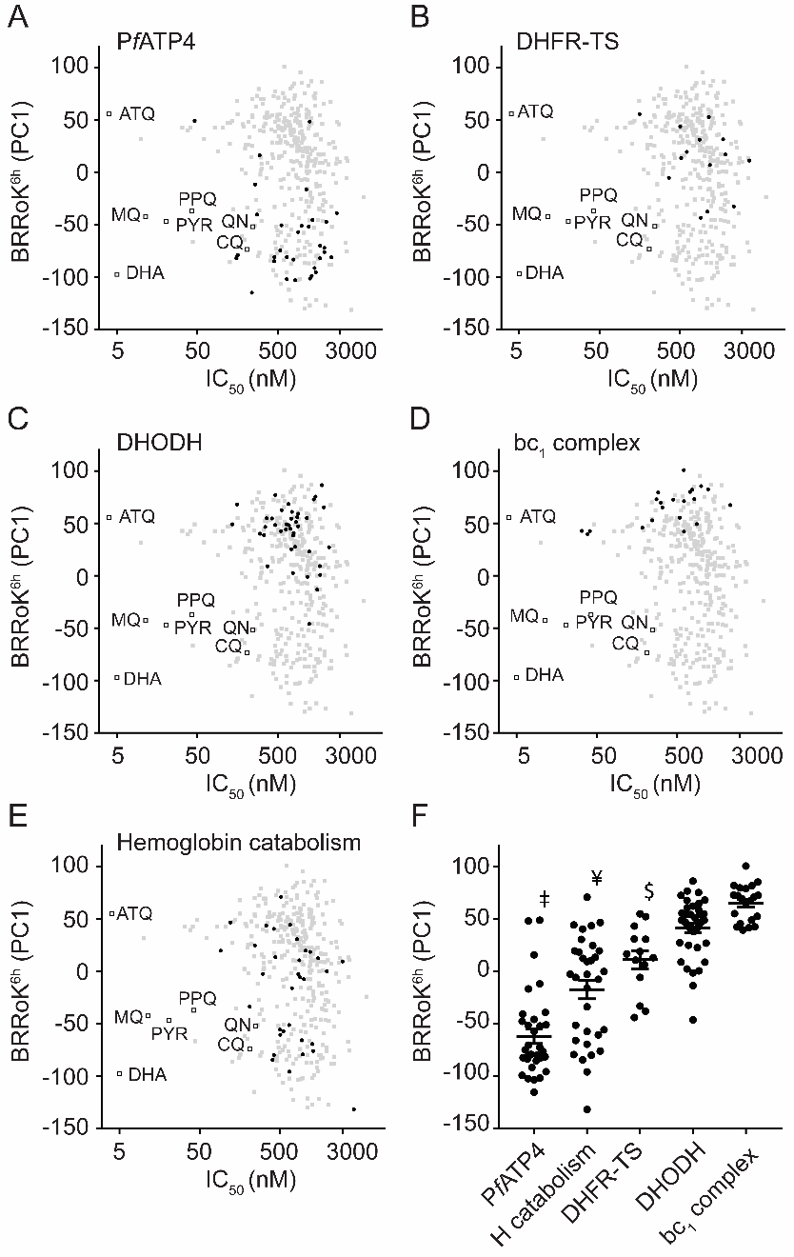
Figure 1. Correlating mode of drug action with the BRRoK^{6h} in the MMV Malaria Box compounds.
Zero-meaned PC1 data for known antimalarial drugs (open squares), all Malaria Box compounds (grey filled squares) and Malaria Box compounds predicted to use the indicated MoA (black filled circles) for (A) PfATP4, (B) parasite hemoglobin catabolism, (C) dihydrofolate reductase-thymidylate synthase (DHFR-TS), (D), dihydroorotate dehydrogenase (DHODH) and (E) mitochrondrial bc₁ complex are plotted against their IC₅₀. Faster initial rates of cytocidal activity are represented with lower PC1 values. See Table S2 for PC1, IC₅₀ and predicted MoA data for individual compounds. (F) One-way ANOVA with post-hoc Tukey test comparing the BRRoK^{6h} data⁷ for each MoA group (whisker plots represent the mean and SD)^{16,20,29,30}. ‡ = PfATP4 cluster, significantly different from all clusters (p < 0.01). ¥ = parasite hemoglobin catabolism (H catabolism), significantly different than DHODH and bc₁ complex (p < 0.01). $ = DHFR-TS, significantly different than the bc₁ complex (p < 0.01). ATQ, atovaquone; CQ, chloroquine; DHA, dihydroartemisinin; MQ, mefloquine; PPQ, piperaquine; PYN, pyronaridine; QN, quinine.

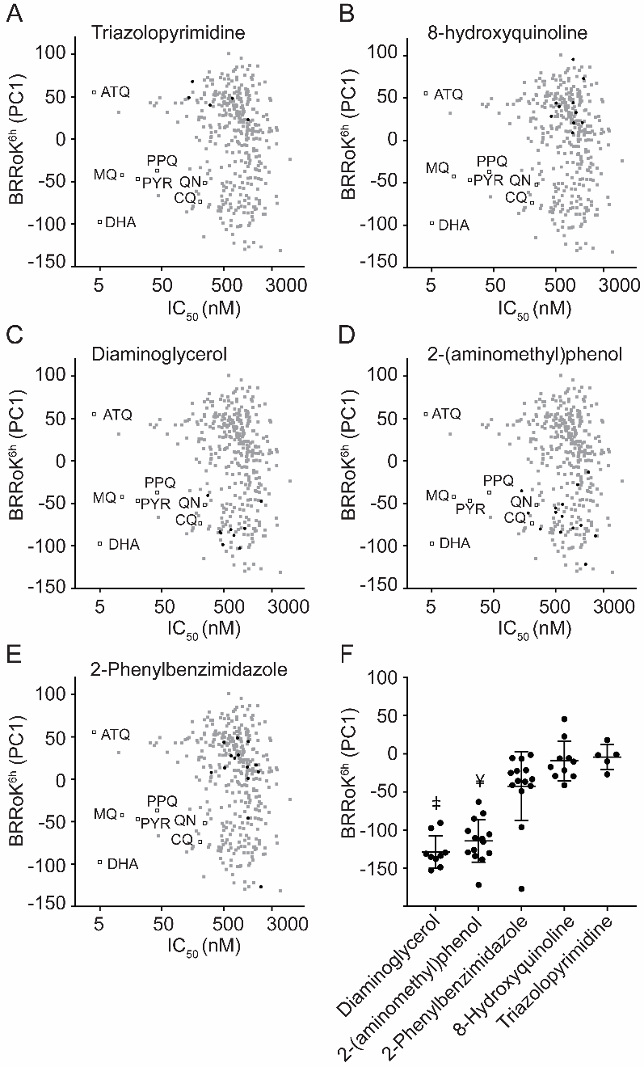
Figure 2. BRRoK^{6h} data illustrates related compounds in the MMV Malaria Box that share a similar relative RoK. Zero-meaned PC1 data for known antimalarial drugs (open squares), all Malaria Box compounds (grey filled squares) and Malaria Box compounds sharing the indicated related core scaffolds (black filled circles) of (A) diamino-glycerols, (B) 2-(aminomethyl)phenol, (C) 2-phenylbenzimidazole, (D) 8-hydroxyquinolines, and (E) triazolopyrimidine are plotted against their IC₅₀. Faster initial rates of cytocidal activity are represented with lower PC1 values. See Table S3 for PC1, IC₅₀ and structures for individual compounds. (F) One-way ANOVA with post-hoc Tukey test comparing the BRRoK^{6h} data⁷ for each group (whisker plots represent the mean and SD) based on the indicted related core scaffold. ‡ = Diamino-glycerols, significantly different than 2-phenylbenzimidazole, 8-hydroxyquinolines, and triazolopyrimidine scaffolds (p < 0.01). $ = 2-(aminomethyl)phenol, significantly different than 2-phenylbenzimidazole, 8-hydroxyquinolines, and triazolopyrimidine scaffolds (p < 0.01). ATQ, atovaquone; CQ, chloroquine; DHA, dihydroartemisinin; MQ, mefloquine; PPQ, piperaquine; PYN, pyronaridine; QN, quinine.

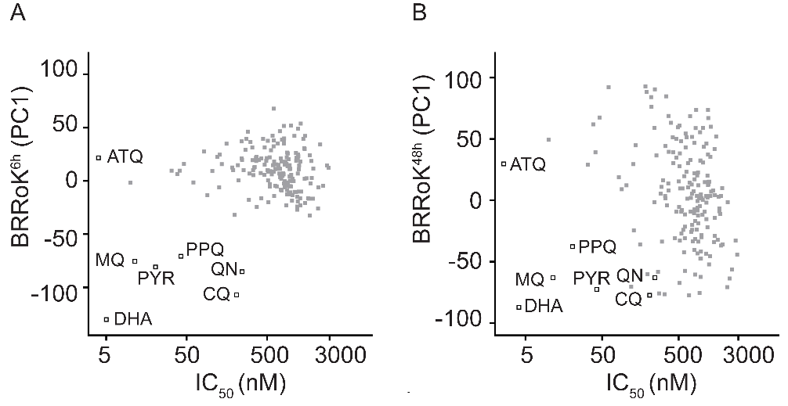
Figure 3. Distribution of BRRoK (PC1) against IC₅₀ for the MMV Malaria Box compounds.
Zero-meaned PC1 data for 178 compounds in the MMV Malaria Box (grey filled squares) and 7 benchmark antimalarial drugs (open squares) are plotted against their IC₅₀ for (A) 6hr and (B) 48h. See Table S2 for PC1 and IC₅₀ data for individual compounds. ATQ, atovaquone; CQ, chloroquine; DHA, dihydroartemisinin; MQ, mefloquine; PPQ, piperaquine; PYN, pyronaridine; QN, quinine.

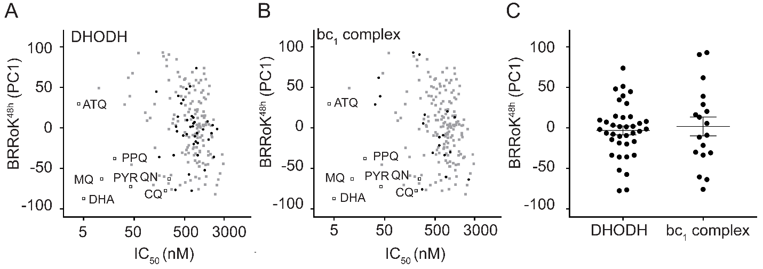
Figure 4. Correlating mode of drug action with the BRRoK^{48h} in the MMV Malaria Box compounds. Zero-meaned PC1 data for known antimalarial drugs (open squares), all Malaria Box compounds (grey filled squares) and Malaria Box compounds with a predicted MoA (black filled circles) that targets, (A) DHODH or (B) the bc1 complex are plotted against their IC₅₀. See Table S2 for PC1, IC₅₀ and predicted MoA data for individual compounds. (C) One-way ANOVA with post-hoc Tukey test comparing the BRRoK^{48h} data (whisker plots represent the mean and SD) for both groups clustered based on the indicted predicted MoA data^{16,20,29,30}. No significant difference was found (p = 0.6). ATQ, atovaquone; CQ, chloroquine; DHA, dihydroartemisinin; MQ, mefloquine; PPQ, piperaquine; PYN, pyronaridine; QN, quinine.

^ Current address: Department of Pediatrics, University of Texas Southwestern Medical Center, Dallas, 75235 Texas, USA

