First submission of paper ‘EAHP European Statements Survey 2018, focusing on Section 1: Introductory Statements and Governance, Section 3: Production and Compounding as well as Section 4: Clinical Pharmacy Services’ for Keele EPrints Repository. Paper published by European Journal of Hospital Pharmacy December 2019.
© European Association of Hospital Pharmacists 2019. No commercial re-use. See rights and permissions. Published by BMJ.
To cite: Amann S, Underhill J, Horák P, et al. Eur J Hosp Pharm Epub ahead of print: [please include Day Month Year]. doi:10.1136/ ejhpharm-2019-002028

EAHP European Statements Survey 2018, focusing on Section 1: Introductory Statements and Governance, Section 3: Production and Compounding as well as Section 4: Clinical Pharmacy Services
Corresponding author: Steffen Amann, Hospital Pharmacy, Munich Municipal Hospital Group, Munich, Germany steffen.amann@eahp.eu
Petr Horák, Hospital Pharmacy, University Hospital Motol, Prague 5, Czech Republic
Jonathan Underhill, Centre for Medicines Optimisation, Keele University, Keele, UK
Nicholas Gibbons, Centre for Medicines Optimisation, Keele University, Keele, UK
Aida Batista, Department of Pharmacy, Centro Hospitalar Vila Nova de Gaia/Espinho, EPE, Vila Nova de Gaia, Portugal
Nenad Miljković, Head of Hospital Pharmacy Services, Institute of Orthopaedic Surgery “Banjica”, Mihajla Avramovica 28, Belgrade, Serbia

Abstract:
Objectives The 2018 EAHP European Statements Survey focussed on sections 1, 3 and 4 of the European Statements of Hospital Pharmacy. Statistical data on the level of implementation and on the main barriers to implementation of the Statements were collected. A further aim was to identify barriers in general, such as lack of awareness.
Methods An online questionnaire was sent to all hospital pharmacies in EAHP member countries. Data were analysed at Keele University School of Pharmacy, UK. As with previous reports, the survey was divided into three sections: section A asking general questions about the hospital pharmacy; Section B addressing questions about the current activity of pharmacists around each statement from Sections 1, 3 and 4; and Section C focusing on their ability to implement the statements.

Results 719 complete responses were obtained from a sample of 5,164 hospital pharmacies, giving a response rate of 14%. Section A result indicated that 45% of responders worked in teaching hospitals, 79% of hospital pharmacies had 10 or less pharmacists, and 48% of hospital pharmacies served over 500 beds. Section B results found a high percentage of positive responses for activity in section 1 (introductory statements and governance) and section 3 (production and compounding). However, response to questions in section 4 (clinical pharmacy services) produced more variable responses with 6 of the 15 questions producing less than 50% positive responses. Five questions revealing the lowest implementation levels were further analysed in greater detail. The questions correspond to Statements 4.4, 4.5, 4.8, 1.1, and 4.2., which need most efforts to be implemented. The major barriers for implementation identified were lack of capacity and that other health professionals in the hospital fulfil the tasks.
Conclusions This survey provides useful information on the implementation status as well as the barriers to and drivers of implementation of sections 1, 3 and 4 of the Statements. This will allow the EAHP to plan its implementation support programme for its members. To increase the quality of data as well as the feedback to the hospital pharmacies, the EAHP is planning to combine the survey with the self-assessment tool of the European Statements of Hospital Pharmacy.

Introduction
The European Statements of Hospital Pharmacy (‘Statements’) express commonly agreed objectives which every European health system should aim for in the delivery of hospital pharmacy services. The Statements were formulated via a methodological consultation process by members of the European Association of Hospital Pharmacists (EAHP) together with patient and healthcare professional organisations. Therefore, the EAHP survey has been focused on measuring implementation of the Statements across European countries since 2015. This new survey model was intended to support EAHP efforts in implementing the Statements. The EAHP Survey Group established a model with a 'baseline survey' and two 'statements surveys' rotating in 2-year cycles, each year covering three of six sections of the Statements.
The complete results are provided to all the members of EAHP and a detailed report with additional tables and figures is available. This article provides an overview of the most important results of the latest survey in 2018 that covered sections 1, 3 and 4 of the Statements and compares these data with the results of the 2016 survey, which focused on the same sections, and the baseline survey in some cases.
Methods
To be able to compare the results with previous statement surveys, the same questions were used as in the 2016 survey. The survey was conducted from October 2018 to November 2018, spanning 34 countries. In line with previous years, the survey consisted of three sections:
- Section A: general questions about the participant’s hospital pharmacy, such as workforce skill-mix and number of beds served
- Section B: questions about the current activity of pharmacists around each statement from Sections 1, 3 and 4 (see also Table 2)
- Section C: questions about the hospital’s readiness and ability to implement the statements
The questions in Section B of the survey were to identify if the participant thought that the statements of hospital pharmacy are already being implemented within their hospital. To achieve this aim, the pharmacists who participated in the survey were asked to rate the degree to which they were able to comply with each statement. A value was allocated to each response using a scale of 1-5, where a 1 indicated that they were never able to comply with the statement, while a 5 indicated that they always complied with the statement. For some questions in the survey a Yes/No option was used, as it deemed more appropriate to use rather than a scale of 1-5 in those cases.
For the purposes of identifying those statements where the barriers to implementation were greatest, a response of 3, 4 or 5 was deemed to indicate less difficulty in complying with that statement – a ‘positive response’. Where this was not the case, the participant was asked a follow up question to identify the barriers in implementing the statement.
In order to improve the efficiency in the analysis of the results and provide greater insight into the key drivers and barriers to implementation of the statements, the respondent was given five pre-selected options to choose from. Additionally, there was an 'Other' option, where the respondent could provide a free-text response. The five options were based on the most frequent answers given in the 2015 baseline survey:
- We are prevented by national policy and/or legislation
- Not considered to be a priority by my managers
- Not considered to be a priority by me
- We would like to do this but we have limited capacity
- We would like to do this but we have limited capability.
The questions in section C explore further the barriers to implementation of the statements in general such as lack of awareness, agreement, workforce barriers and those related to confidence in their ability to implement them. Responders were asked to state the level of their agreement with each question posed, from 1 (strongly disagree) to 5 (strongly agree). These implementation questions were asked in every EAHP statements survey.
The survey was created using the online survey software SurveyMonkey® and distributed by email collector to one email address per hospital. National coordinators were provided with the list of emails for their country. There were weekly reminders sent out over the duration of the survey until complete responded. For countries, who did not wish to share the emails of the pharmacies, a weblink version of the survey was provided. This approach required respondents to provide a unique code at the start of the survey.
Results were exported from SurveyMonkey® for further analysis and reporting. Responses were planned to be analysed by the proportion of positive answers regarding the implementation of a Statement overall and per country. Significance testing was performed to compare the results of some of the survey questions to the same question asked in the 2016 EAHP Statements Survey.

Results
5,164 hospital pharmacies were invited to complete the survey, with 719 complete responses (13.9%), a slight decrease compared to 2016 (15.8%). Response rates vary widely across countries; the highest number came from Germany with 99, followed by Hungary with 55 and Czech Republic with 43 responses. 16 of the 35 countries had a response rate of over 30%, which was higher in 2016 with 21 of 35. Table 1 shows responses rates broken down by country with response rates from the 2016 survey for comparison.
Section A
The results showed that 45% (324, n=719) of responders worked in teaching hospitals. These numbers are similar to those in the baseline survey (42%) and the 2016 survey (43%). Some 73% of respondents were from general hospitals (525, n=719). This number is again very similar to those seen in previous surveys (71% in the baseline survey and 74% in the 2016 survey). Approximately 43% of hospital pharmacies served hospitals with 100–500 beds (310; 48% in 2016 and 50% in the baseline survey), 24% served hospitals with 500–1000 beds, 24% served hospitals with >1000 beds, and 9% served hospitals with <100 beds. The majority of the hospital pharmacies (570, 79%) only employed 1–10 fully qualified pharmacists at the time of the survey and a similar number of pharmacy technicians (523 pharmacies, 73%). Some 58% (415, n=719) of responders reported that their hospital pharmacy was involved in the procurement, supply or supervision of medical devices.
Section B
The questions together with the overall results are shown in Table 2. Questions highlighted as red have less than 50% of participants given a positive response regarding the implementation of the corresponding Statement (n=8). Questions with over 75% of positive answers have been highlighted as green (n=11) and with positive responses between 50 and 75% and are not marked (n=12).
Figure 1 shows these results of the 2018 EAHP Statements Survey alongside with the results of the 2016 survey. The numbers in brackets on the bottom axis are the number of responses by country for the 2018 survey. Most of the questions in section 1 (introductory statements and governance) and all of the questions in section 3 (production and compounding) produced a high percentage of positive responses. However, response to questions in section 4 (clinical pharmacy services) produced more variable responses with 6 of the 15 questions producing less than 50% positive responses.
The five questions which received the least positive responses are shown in Figure 3:
- S4.4: The pharmacists in our hospital enter all medicines used onto the patient’s medical record on admission. (2018: 30.3%, 2016: 29.3%, baseline: 28.5%)
- S4.5: The pharmacists in our hospital contribute to the transfer of information about medicines when patients move between and within healthcare settings. (2018: 41.0%, 2016: 41.4%, baseline: 44.0%)
- S4.8: Do you have an agreed strategic plan for the development of clinical pharmacy services in your hospital? (2018: 47.3%, 2016: 45.0%, baseline: no data)
- S1.1: The pharmacists in our hospital work routinely as part of a multidisciplinary team. (2018: 47.8%, 2016: 47.7%, baseline: 59.1%)
- S4.2: All prescriptions in our hospital are reviewed and validated as soon as possible by a pharmacist. (2018: 54.9%, 2016: 58.1%, baseline: 62.9%)
Further investigation resulted in more detailed information.
Question related to EAHP Statement 4.4:
The pharmacists in our hospital enter all medicines used onto the patient’s medical record on admission.
Figure 3 shows the percentage of respondents who gave a positive response when asked if pharmacists enter all medicines used onto the patient’s medical record on admission. Overall, only 30% of responses were positive to this question, a similar result to the 2016 survey where 29% of the total responses were positive. However, a paired samples t-test indicated that an increase in the mean percentage of positive responses for countries between the 2016 survey (mean = 25.0%) and the 2018 survey (mean = 31.1%) was statistically significant (p=0.023).
In every country surveyed less than half of the respondents gave a positive response, except the Netherlands, Spain, Turkey and UK. When looking at the responses from individual countries who participated in both surveys, the percentage of positive responses increased in 16 countries, decreased in 14 countries and stayed the same in 4 countries. To further understand this, respondents who answered the question with a negative response were asked what is preventing pharmacists from entering medicines onto patient’s medical records. The overall results are shown in Figure 4. The most frequent overall response was that ‘other healthcare professionals do this’ with a total of 313 responses. This was observed in previous EAHP surveys, where in many countries and hospitals, the role of the hospital pharmacists is limited to the procurement of medicines, rather than engaging in clinical responsibilities. Another major barrier was ‘We would like to do this but we have limited capacity’ (274 responses across all countries). Not being considered a priority by managers was also identified with 156 responses. These 3 options accounted for 75% of all responses.
Participants were also asked if ‘pharmacists in our hospital reconcile medicines on admission’. Overall 41% of all responses were positive, a slight decrease from the 42% observed in the 2016 survey. Of the 34 countries participating, 20 returned a more positive result when compared to the 2016 survey. The largest increase was seen in Turkey where the percentage of positive responses increased from 65% to 95%.
Figure 4 showed that lack of capacity was cited as the second largest barrier to pharmacists entering medicines used onto patients’ records on admission, so the relationship between this activity and pharmacist workforce was investigated further. The responses when asked if hospital pharmacists enter all medicines used onto the patient’s medical record on admission are shown in Figure 5, where the results are grouped by the number of fully qualified pharmacists employed by the hospital. The proportion of more negative responses (1 or 2) is much higher for the lowest staffing level (1-10 pharmacists), although it is important to note that the total numbers of responses for the higher staffing levels are fairly small (n=4).
A Kruskal-Wallis H test showed that there was a statistically significant difference in responses to pharmacists entering medicines used onto patients records on admission between the groupings of working pharmacist numbers, χ2(3) = 30.0, p < 0.01, with a mean rank of 342 for the '1 to 10 pharmacists' group, 418 for the '11 to 50 pharmacists' group, 492 for the '51 to 100 pharmacists' group and 621 for the 'More than 100 pharmacists' group. Hospitals employing more pharmacists were more likely to have pharmacists regularly entering medicines used onto patients’ medical record on admission.

Question related to EAHP Statement 4.5: The pharmacists in our hospital contribute to the transfer of information about medicines when patients move between and within healthcare settings.
The responses to the question ‘The pharmacists in our hospital contribute to the transfer of information about medicines when patients move between and within healthcare settings' are shown below in Figure 6. The overall response was only 41% positive, showing this statement is not currently implemented widely across European hospitals. The overall response observed in the 2016 survey which was also 41%, indicating that progress on this issue may be minimal. The positive response rate between countries was varied; in 21 countries less than half of the respondents gave a positive response but 5 countries gave an average positive response of 75% or greater. This variation in responses between countries is similar to what was observed in Figure 3, which also described a more clinical role suggesting the role of hospital pharmacists in some countries is less focused on clinical activities than others.
Although the mean percentage of positive responses for countries increased between the 2016 survey (mean = 38.3%) and the 2018 survey (mean = 42.5%), a t-test showed this increase was not quite statistically significant (p=0.056).
When asked what are the barriers to pharmacists contributing to the transfer of information about medicines when patients move between healthcare settings, the most frequent response was other healthcare professionals do this (249 responses), limited capacity (213 responses) and not considered to be a priority by my managers (132 responses). Nearly all countries identified ‘other healthcare professionals do this’ or ‘limited capacity’ as the biggest barrier to implementation. North Macedonia, Bulgaria and Poland most notably highlighted national policy/legislation as a barrier.

Question related to EAHP Statement 4.8: Do you have an agreed strategic plan for the development of clinical pharmacy services in your hospital?
Figure 7 shows the percentage of respondents who gave a positive response when asked “Do you have an agreed strategic plan for the development of clinical pharmacy services in your hospital”. The overall positive response rate for this question was 47%, up from 45% from the 2016 survey. This question was not included in the original baseline survey. Of the countries who participated in both 2016 and 2018 surveys, 21 saw an increase in the percentage of positive responses, whilst 11 saw a decrease and 2 remained the same.
A paired samples t-test indicated that the mean percentage of positive responses for countries for the 2016 survey (mean = 43.3%) was not significantly different when compared to the 2018 survey (mean = 49.2%) (p=0.062).
The main barriers to implementing this statement were identified as ‘not considered to be a priority by my managers/clinicians’ (256 responses) and ‘limited capacity’ (219 responses). There were 32 free text responses from the ‘Other’ category, where many of these responses highlight capacity and not being a priority to be the main barriers. All countries identified the biggest barrier as either not being considered a priority by managers or limited capacity. There were very few responses for ‘not considered to be a priority by me, suggesting many pharmacists see the importance of a strategic plan.
The percentage of pharmacists responding that they have an agreed strategic plan for the development of clinical pharmacy services in their hospital grouped by the number of fully qualified pharmacists working at the hospital. The amount of positive responses was much lower for the lowest grouping of working pharmacists (43.3% for the 1-10 pharmacists group) compared to the groups with more working pharmacists (ranging from 60.7% - 80.0%). An explanation could be that pharmacists working in hospitals employing fewer pharmacists do not have time to spare for additional responsibilities such as this.
A chi-square test of independence was performed to examine the relation between number of pharmacists employed in a hospital and the number of pharmacists having an agreed strategic plan for the development of clinical pharmacy services in their hospital. The relation between these variables was significant, χ2(3) = 18.9, p < 0.01. Hospitals employing fewer pharmacists were less likely to having an agreed strategic plan for the development of clinical pharmacy services in their hospital.
Question related to EAHP 1.1: The pharmacists in our hospital work routinely as part of a multidisciplinary team.
Figure 8 shows the responses to the question “The pharmacists in our hospital work routinely as part of a multidisciplinary team”. The overall positive response rate for this question was 48%, up from 46% from the 2016 survey. Out of the 34 countries that participated in both the 2018 and 2016 surveys, 18 countries increased their percentage of positive responses, 15 decreased and 1 stayed the same. The mean percentage of positive responses for countries increased in the 2018 survey (mean = 51.0%) compared to the 2016 survey (mean = 44.7%), although a t-test showed this result just fell short of being statistically significant (p=0.051).
Respondents who gave a positive response were asked ‘What type of multidisciplinary activities are you involved with?’. Membership of multidisciplinary committees, specific therapeutic groups and educational activities all received a high number of responses (295, 305 and 275 respectively). Multidisciplinary ward rounds and consulting with patients about medicines received fewer responses (196 and 106 responses). A similar pattern of responses was observed for the 2016 survey.
Respondents who gave a negative response to the initial question were asked “What is preventing you or your pharmacists from routinely working as part of a multidisciplinary team?”. Limited capacity was identified as the largest barrier to implementation with 267 responses, more than double the second most popular choice ‘not considered to be a priority by my managers’ (122 responses). Limited capacity was a barrier in almost every country surveyed.
The overall results for this statement question grouped by the number of fully qualified pharmacists working at the hospital show again, that the percentage of positive responses increases as the staffing levels increase (38.2% for the 1-10 pharmacists group, increasing to 83.7%, 90% and 100% as the staffing group level increments).
A Kruskal-Wallis H test showed that there was a statistically significant difference in responses to pharmacists working routinely as part of a multidisciplinary team between the groupings of working pharmacist numbers, χ2(3) = 103.4, p < 0.01, with a mean rank of 322 for the '1 to 10 pharmacists' group, 501 for the '11 to 50 pharmacists' group, 530 for the '51 to 100 pharmacists' group and 648 for the 'More than 100 pharmacists' group. Hospitals employing fewer pharmacists were less likely to have pharmacists working routinely as part of a multidisciplinary team.
Additionally, a Mann-Whitney test indicated that teaching/university hospitals reported more positive responses when asked if pharmacists in the hospital routinely work as part of a multidisciplinary team than non-teaching hospitals (p < 0.01), with a mean rank of 390 for teaching/university hospitals and 335 for non-teaching hospitals.

Question related to EAHP Statement 4.2: All prescriptions in our hospital are reviewed and validated as soon as possible by a pharmacist.
When asked “All prescriptions in our hospital are reviewed and validated as soon as possible by a pharmacist” the overall positive response rate for this question was 55%. This is a less positive response than the 2016 survey (58% positive) and the baseline survey (63% positive). Figure 9 shows the results broken down by country, which shows that the response between countries was mixed, with a large range between results. In 6 countries 100% of responses were positive, while many more countries gave a very low number of positive responses. When compared to the 2016 survey 15 countries increased their percentage of positive responses, 14 countries saw a decrease and 5 remained the same.
A paired samples t-test indicated that the mean percentage of positive responses for countries was not significantly different for the 2016 survey (mean = 52.6%) compared to the 2018 survey (mean = 56.0%), (p = 0.322).
Participants who gave a negative response to statement 4.2 were then asked what was preventing this. The most common response was limited capacity with 218 responses. Not considered to be a priority by my managers (154 responses) also had many responses. Additional barriers from the ‘Other’ category included pharmacists not having access to patients’ records.
Respondents who gave a positive response to the initial question were asked ‘Does this review and validation by a pharmacist take place prior to the administration of medicines?’. The overall positive rate for the 2018 survey is 88%, similar to the 2016 survey figure which was 89%. This question was not included in the baseline survey.
A Kruskal-Wallis H test showed that the difference in responses to pharmacists reviewing all prescriptions in the hospital between the groupings of working pharmacist numbers was not statistically significant, χ2(3) = 5.5, p = 0.137, with a mean rank of 354 for the '1 to 10 pharmacists' group, 372 for the '11 to 50 pharmacists' group, 460 for the '51 to 100 pharmacists' group and 510 for the 'More than 100 pharmacists' group.

Section C: Results of the Implementation Questions
Figure 11 shows the main results of the implementation questions. Awareness of the Statements (I1, baseline: 35%, 2018: 54%) and agreement with the Statements (I2, baseline: 52%, 2018: 67%) has both been steadily increasing since the baseline survey. The percentage of respondents agreeing that their hospital pharmacy has the capability (I3, baseline: 22%, 2018: 31%) and the capacity to implement the statements (I4, baseline: 12%, 2018: 11%) and that their hospital is committed helping the pharmacy to implement the statements (I5, baseline: 21%, 2018: 21%) are relatively low and have seen no relevant change since the baseline survey.
Discussion
The survey reflects the high professional standards of hospital pharmacy in Europe. Even though the results presented in this publication focus on the most challenging statements with the lowest percentage of positive answers, the overall results show a high implementation rate on many of the Statements. In particular, the results for section 3 reached over 80% on average within the range of 71 to 90% and additionally produced a high percentage of positive responses compared to 2016. This reflects the tremendous professional contribution of hospital pharmacists to safe and high-quality medicines prepared individually for patients or patient groups in hospital pharmacies all over Europe.
Response to questions in section 4 (clinical pharmacy services) produced more variable responses with 6 of the 15 questions producing less than 50% positive responses. A possible broad explanation for the decrease in positive responses could be that the overall capacity of hospital pharmacists has been further stretched since the baseline survey. Another possible explanation for this increase in negative responses could be that some respondents may now be familiar enough with the EAHP Statements surveys to know that if they give a negative response to a question they are then offered the opportunity to provide further feedback on an issue, which they wish to do.
Examination of the five statements where the barriers to implementation were greatest revealed that barriers to implement the statements reported in 2016 are still in place. A major barrier to implementation was a lack of capacity to implement the statements. Interestingly, this barrier is mostly independent and not correlated to the number of pharmacists working in a hospital or in the country. Another highly ranked reason was that other healthcare professionals are doing this in the moment. As results from many projects prove, hospital pharmacists are very well accepted if they provide services to patients,, the professions, who carry out these services at the moment should be considered as partners for the future changes.
As seen from the results of section C and Figure 11, the awareness of and the agreement with the Statements by hospital pharmacists have both been steadily increasing. This is fundamental to implementing change. The slow or minor change in the other implementation barrier supports the evidence that implementation is a gradual process, so any changes on a large scale happen slowly and are not yet reflected in the survey results. It should also be noted that this result measures average change across all countries, and that individual countries may have seen greater changes. The positive change in the level of awareness also reflects the activities of the EAHP Statement Implementation Ambassadors, suggesting that the implementation project should continue to be developed. Removing the main barriers such as insufficient staffing will take a long time, and increasing awareness is a necessary first step in this journey. EAHP provides a self-assessment tool to not only assess but also benchmark the implementation of the Statements with other hospital pharmacies in Europe. This gives a clearer, more individualised and detailed information to hospital pharmacies than the overall results of the surveys can provide.
There are several limitations to this study. The first and most important limitation was that the number of responses from some member countries was very small, and hence did not allow a precise statistical evaluation at country level. The reason for this is that countries have a wide variety in the number of hospital pharmacies, which not always correlates with the number of inhabitants. The second limitation was the necessity to find a balance between the length of the questionnaire resulting in workload for responders and the level of detail sought in identifying the main implementation barriers. The limitation in comparing the 2018 results with 2016 is also the small numbers. Therefore, it is not clear whether changes are through different respondents or really changes in the situation.
Despite these limitations, the survey results provide an up to date picture of the current state of Hospital Pharmacy in Europe in relation to the Statements. There appear to be more barriers to hospital pharmacies engaging in more clinically and patient focused activities such as medication history reconciliation, direct patient information or working in a multidisciplinary team. Lack of capacity, capability and support from managers are the commonly cited reasons for this. Again, there was considerable variation across the different countries, reflecting the diversity of the situation in European countries. The role of the clinical pharmacist where pharmacists are visible on the wards and in clinics, while well established in some countries, is still a rarity in others. In these countries many hospitals employ low numbers of staff for hospital pharmacies in relation to their number of beds, which supports the ‘lack of capacity’ responses. In addition, the capacity of hospital pharmacists is often negatively impacted by inevitable non-productive external causes, such as medicine shortages and FMD.

Conclusion
The main objective of the 2018 EAHP Statements Survey was to provide an assessment throughout European countries of the level of implementation of sections 1, 3, and 4. The main barriers to and drivers of implementation should be identified and possible progress in implementation investigated. This objective has been reached, thanks to the enormous efforts of national coordinators and all the hospital pharmacists who responded to the survey.
The results enable EAHP to prioritise efforts in its implementation activities. The Statement self-assessment tool (SAT) is already being used by many pharmacists and will be widely promoted over the next few months. The goal is to extract data from the SAT and analyse it using a similar methodology to that used from the statement survey data and allow trends to continue to be analysed. This will increase the consistency of the data and hopefully result in a wider response from European hospital pharmacies.

Contributors PH, JU and AB planned the study and designed the questionnaire. NG set up the online form, sent the questionnaire to responders and tracked responses. PH, AB, SA and NM communicated with EAHP members and raised awareness about the survey. NG, JU and SA conducted the survey, evaluated data and performed statistical analysis. SA, JU, NG, PH, AB and NM prepared the manuscript.
Funding The authors have not declared a specific grant for this research from any funding agency in the public, commercial or not-for-profit sectors.
Competing interests None declared.
Patient consent Not required.
Provenance and peer review Not commissioned; internally peer reviewed.
Data sharing statement The complete set of data from the survey is available to EAHP member associations.

Tables and figures
Table 1: Response rate per country 2018, 2016 and baseline
Country | Requests  2018 | Requests  2016 | Requests 2018 vs. 2016 | Responses  2018 | Responses  2016 | Responses 2018 vs. 2016 | Percentage  2018 | Percentage  2016 | Baseline  2015 | Percentage 2018 vs. 2016
Austria | 45 | 48 | -3 | 32 | 27 | 5 | 71% | 56% | 47% | 15%
Belgium | 135 | 172 | -37 | 30 | 45 | -15 | 22% | 26% | 22% | -4%
Bosnia | 20 | 23 | -3 | 10 | 12 | -2 | 50% | 52% | 33% | -2%
Bulgaria | 66 | 73 | -7 | 12 | 17 | -5 | 18% | 23% | 14% | -5%
Croatia | 42 | 36 | 6 | 28 | 16 | 12 | 67% | 44% | 79% | 23%
Czech Republic | 92 | 104 | -12 | 43 | 42 | 1 | 47% | 40% | 63% | 7%
Denmark | 9 | 8 | 1 | 8 | 7 | 1 | 89% | 88% | 88% | 1%
Estonia | 24 | 25 | -1 | 5 | 10 | -5 | 21% | 40% | 64% | -19%
Finland | 62 | 82 | -20 | 12 | 16 | -4 | 19% | 20% | 17% | -1%
France | 1.560 | 1.835 | -275 | 23 | 50 | -27 | 1% | 3% | 7% | -2%
Germany | 342 | 383 | -41 | 99 | 82 | 17 | 29% | 21% | 22% | 8%
Greece | 119 | 106 | 13 | 33 | 32 | 1 | 28% | 30% | 31% | -2%
Hungary | 99 | 111 | -12 | 55 | 54 | 1 | 56% | 49% | 62% | 7%
Iceland | 2 | 2 | 0 | 1 | 2 | -1 | 50% | 100% | 100% | -50%
Ireland | 66 | 73 | -7 | 26 | 32 | -6 | 39% | 44% | 48% | -5%
Italy | 585 | 609 | -24 | 39 | 36 | 3 | 7% | 6% | 5% | 1%
Latvia | 37 | 45 | -8 | 1 | 6 | -5 | 3% | 13% | 11% | -10%
Lithuania | 38 | 39 | -1 | 6 | 9 | -3 | 16% | 23% | 7% | -7%
Luxembourg | 5 | 6 | -1 | 4 | 3 | 1 | 80% | 50% | 50% | 30%
Malta | 5 | 5 | 0 | 0 | 3 | -3 | 0% | 60% | 50% | -60%
Montenegro | 6 | 6 | 0 | 5 | 4 | 1 | 83% | 67% | N/A | 16%
Netherlands | 98 | 108 | -10 | 17 | 18 | -1 | 17% | 17% | 35% | 0%
North Macedonia | 29 | 31 | -2 | 8 | 13 | -5 | 28% | 42% | 58% | -14%
Norway | 31 | 32 | -1 | 12 | 20 | -8 | 39% | 63% | 56% | -24%
Poland | 81 | 38 | 43 | 19 | 21 | -2 | 23% | 55% | 7% | -32%
Portugal | 89 | 89 | 0 | 15 | 38 | -23 | 17% | 43% | 22% | -26%
Romania | 67 | 66 | 1 | 19 | 14 | 5 | 28% | 21% | 41% | 7%
Serbia | 63 | 65 | -2 | 28 | 45 | -17 | 44% | 69% | 78% | -25%
Slovakia | 71 | 76 | -5 | 31 | 33 | -2 | 44% | 43% | 52% | 1%
Slovenia | 29 | 31 | -2 | 19 | 22 | -3 | 66% | 71% | 57% | -5%
Spain | 250 | 250 | 0 | 6 | 39 | -33 | 2% | 16% | 17% | -14%
Sweden | 34 | 37 | -3 | 12 | 19 | -7 | 35% | 51% | 24% | -16%
Switzerland | 60 | 60 | 0 | 21 | 17 | 4 | 35% | 28% | 43% | 7%
Turkey | 696 | 821 | -125 | 21 | 70 | -49 | 3% | 9% | 6% | -6%
UK | 207 | 216 | -9 | 19 | 30 | -11 | 9% | 14% | 36% | -5%
Total | 5.164 | 5.711 | -547 | 719 | 904 | -185 | 14% | 16% | 17% | -2%

Table 2: EAHP Survey Questions and overall results
Section 1: Introductory Statements and Governance
S1.1 The pharmacists in our hospital work routinely as part of a multidisciplinary team. | 48% of responses were positive
S1.3 Our hospital is able to prioritise hospital pharmacy activities according to the agreed criteria. | 65% of responses were positive
S1.5 The pharmacists in our hospital are engaged in the supervision of all steps of all medicine use processes. | 70% of responses were positive
S1.5.2 Do you have an approved human resource plan in place to address this? | 25% of responses were positive
S1.6 At least one pharmacist from our team is a full member of the Drug & Therapeutics Committee or equivalent. | 89% of responses were positive
S1.6.2 The pharmacists in our hospital take the lead or have an active role in coordinating the activities of the Drugs & Therapeutics Committees or equivalent. | 90% of responses were positive
S1.7 The pharmacists in our hospital are involved in the design, specification of parameters and evaluation of ICT used within medicines processes. | 63% of responses were positive
Section 3: Production and Compounding
S3.1 The pharmacists in our hospital check if a suitable product is commercially available before we manufacture or prepare a medicine. | 90% of responses were positive
S3.2 When medicines require manufacture or compounding, we either produce them in our hospital pharmacy or we outsource to an approved provider. | 88% of responses were positive
S3.3 The pharmacists in our hospital undertake a risk assessment to determine the best practice quality requirements before making a pharmacy preparation. | 81% of responses were positive
S3.4 The pharmacy in our hospital has an appropriate system in place for the quality assurance of pharmacy prepared and compounded medicines. | 77% of responses were positive
S3.4.2 The pharmacy in our hospital has an appropriate system in place for the traceability of pharmacy prepared and compound medicines. | 82% of responses were positive
S3.5 Our hospital has appropriate systems in place for the preparation and supply of hazardous medicines. | 71% of responses were positive
S3.5.2 Our hospital has appropriate systems in place to minimise the risk of exposing hospital personnel, patients and the environment to harm from hazardous medicines. | 79% of responses were positive
S3.6 Our hospital has written procedures that ensure staff are appropriately trained to reconstitute or mix medicines in a patient care area. | 72% of responses were positive
S3.6.2 Were pharmacists involved in approving these procedures? | 82% of responses were positive
Section 4: Clinical Pharmacy Services
S4.1 The pharmacists in our hospital play a full part in shared decision-making on medicines, including advising, implementing and monitoring medication changes. | 59% of responses were positive
S4.2 All prescriptions in our hospital are reviewed and validated as soon as possible by a pharmacist. | 55% of responses were positive
S4.2.2 Does this review and validation by a pharmacist take place prior to the administration of medicines? | 88% of responses were positive
S4.3 The pharmacists in our hospital have access to the patients’ health record. | 66% of responses were positive
S4.3.2 The pharmacists in our hospital document their clinical interventions into the patients’ health record. | 66% of responses were positive
S4.3.4 We analyse these clinical pharmacy interventions to inform quality improvement plans. | 80% of responses were positive
S4.4 The pharmacists in our hospital enter all medicines used onto the patient’s medical record on admission. | 30% of responses were positive
S4.4.2 The pharmacists in our hospital reconcile medicines on admission | 41% of responses were positive
S4.4.4 When reconciling medicines, the pharmacists in our hospital assess the appropriateness of all patients’ medicines, including herbal and dietary supplements. | 44% of responses were positive
S4.5 The pharmacists in our hospital contribute to the transfer of information about medicines when patients move between and within healthcare settings. | 41% of responses were positive
S4.6 The pharmacists in our hospital ensure patients and carers are offered information about their medicines in terms they can understand. | 57% of responses were positive
S4.6.3 Have the pharmacists in your hospital received appropriate education and support to help them explain the risks and benefits of medicines, in terms patients/carers can understand? | 70% of responses were positive
S4.7 The patients in our hospital are informed when medicines are used outside of their marketing authorisation. | 62% of responses were positive
S4.7.2 Do hospital pharmacists do this? | 39% of responses were positive
S4.8 Do you have an agreed strategic plan for the development of clinical pharmacy services in your hospital? | 47% of responses were positive

Figure 1: Comparative data: Overall percentage of positive responses from the 2018 EAHP Statements survey and 2016 survey.
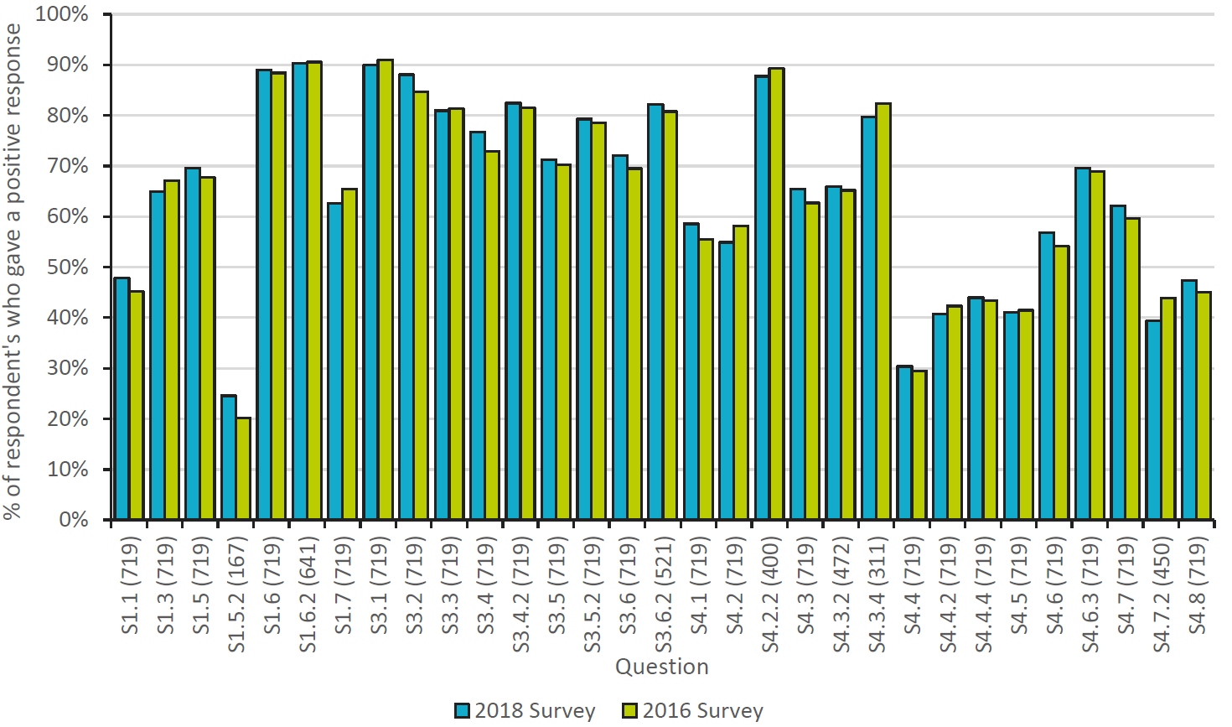

Figure 2: The mean percentage of positive responses to a question across all respondent countries.
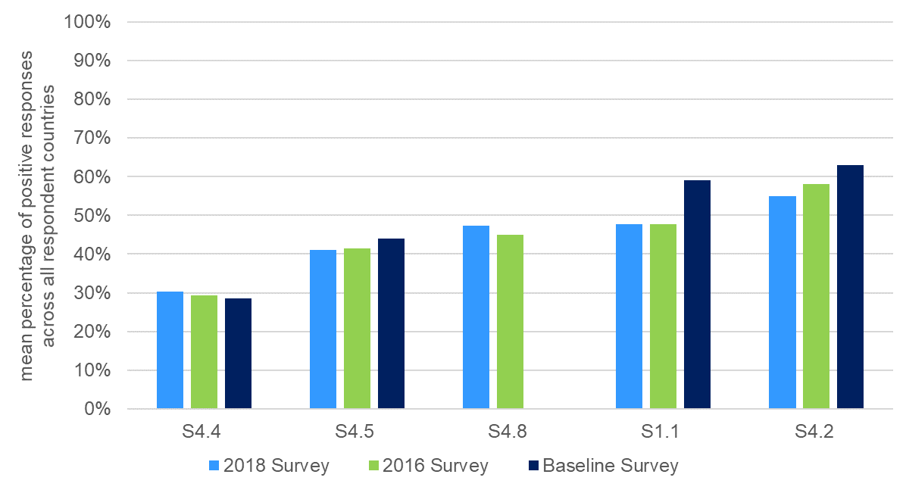
Figure 3: Percentage of respondents who gave a positive response to the statement “The pharmacists in our hospital enter all medicines used onto the patient’s medical record on admission.”
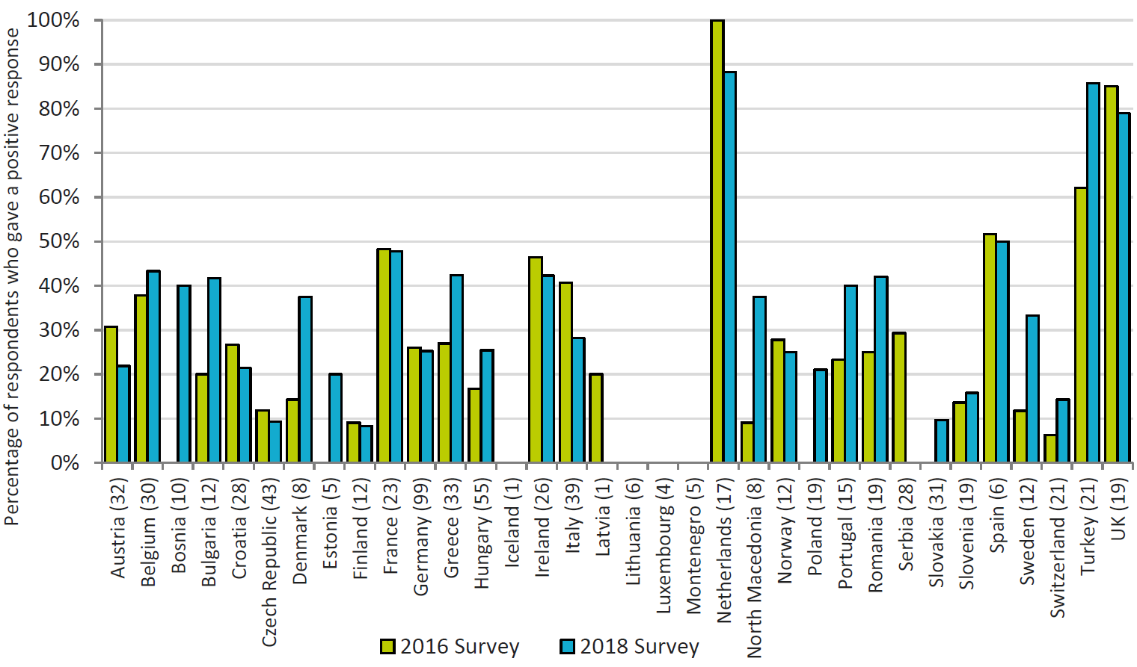
Figure 4: Results from the question S4.4.1 ‘What is preventing pharmacists from entering medicines onto patient’s records on admission?’
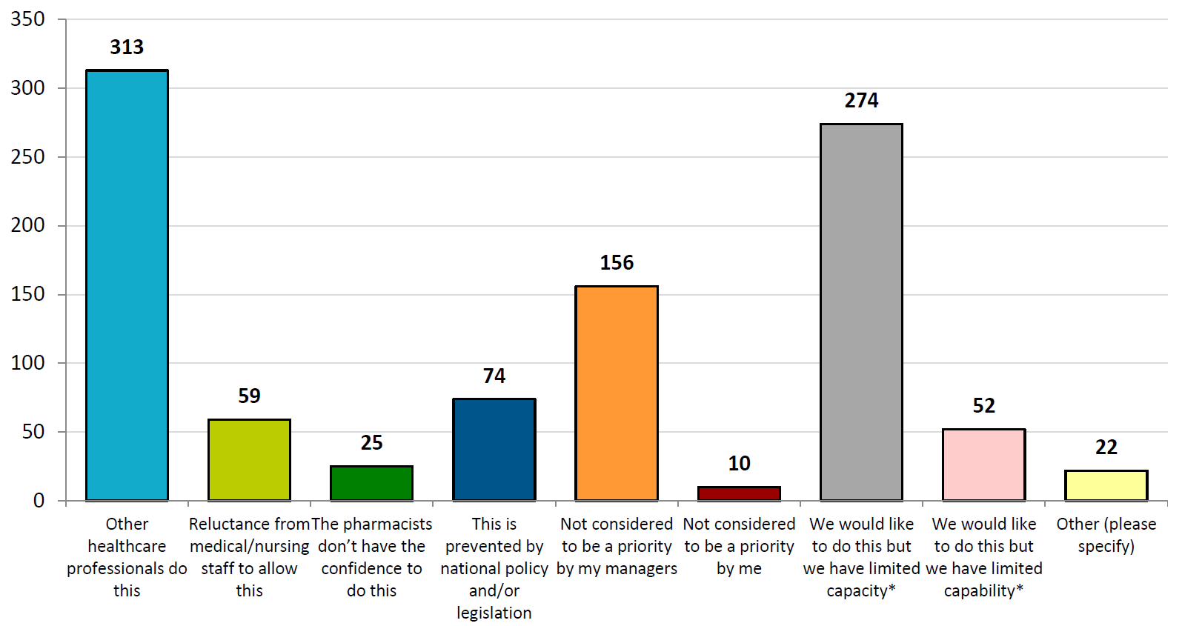
Figure 5: Overall results of responses to the statement “The pharmacists in our hospital enter all medicines used onto the patient’s medical record on admission” (Grouped by number of fully qualified pharmacists employed by the hospital)
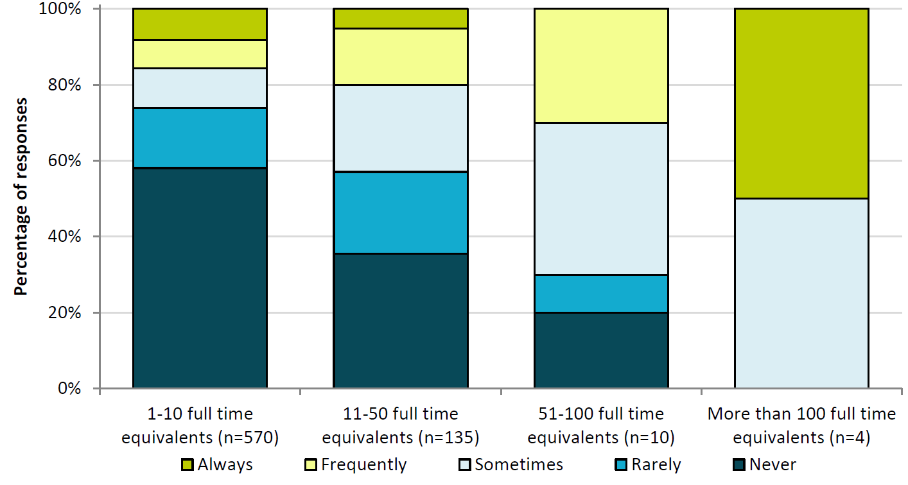
Figure 6: Percentage of respondents who gave a positive response to the statement “The pharmacists in our hospital contribute to the transfer of information about medicines when patients move between and within healthcare settings”.
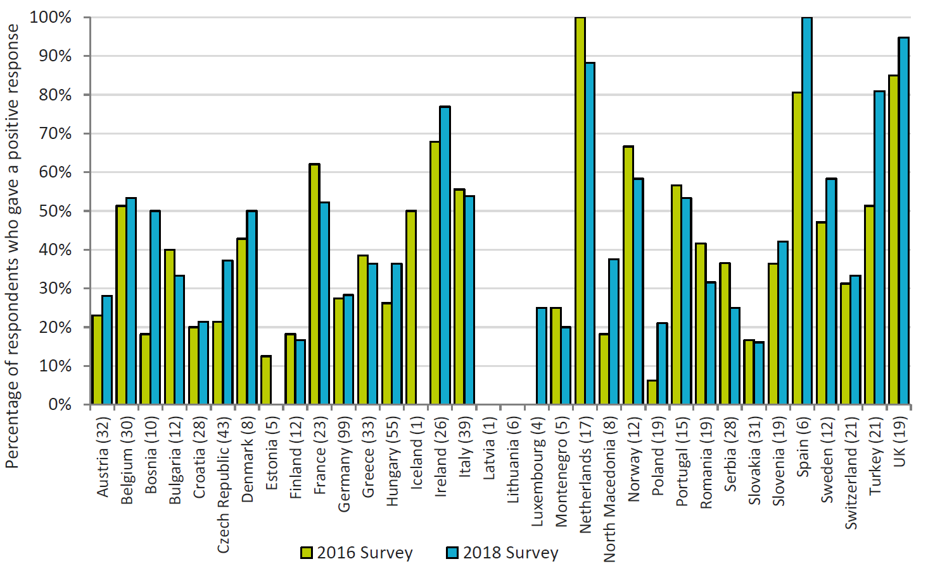
Figure 7: Percentage of respondents who gave a positive response to the statement “Do you have an agreed strategic plan for the development of clinical pharmacy services in your hospital?”
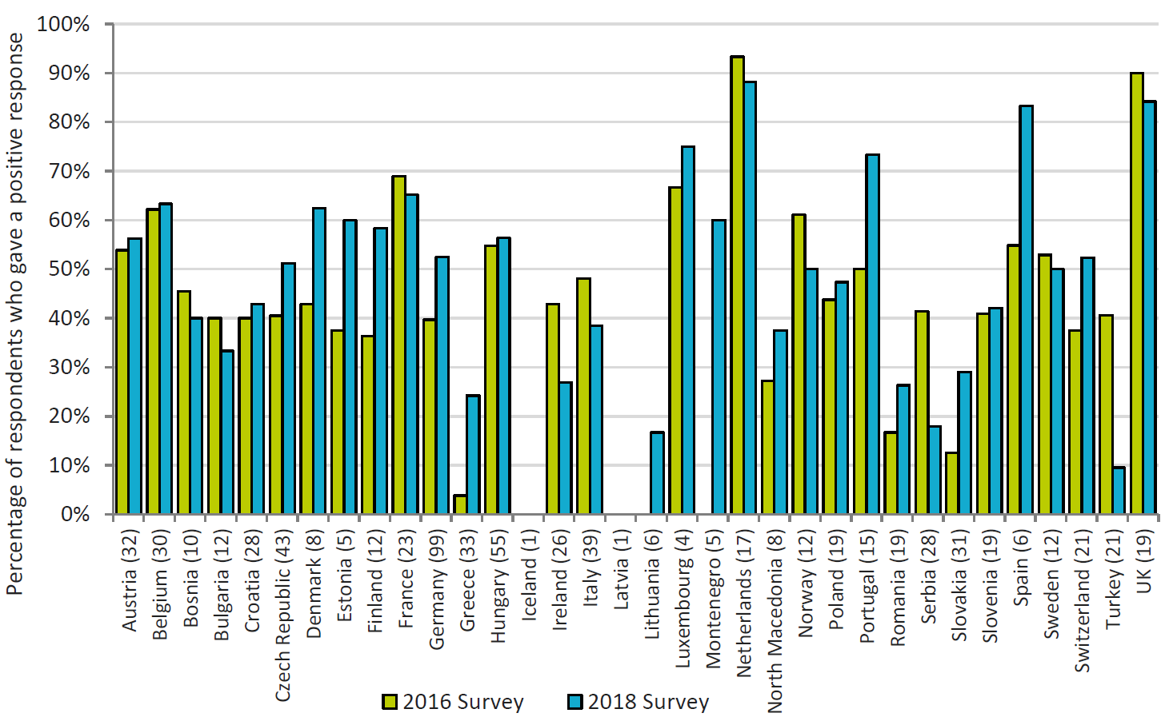
Figure 8: Percentage of respondents who gave a positive response to the statement “The pharmacists in our hospital work routinely as part of a multidisciplinary team?”
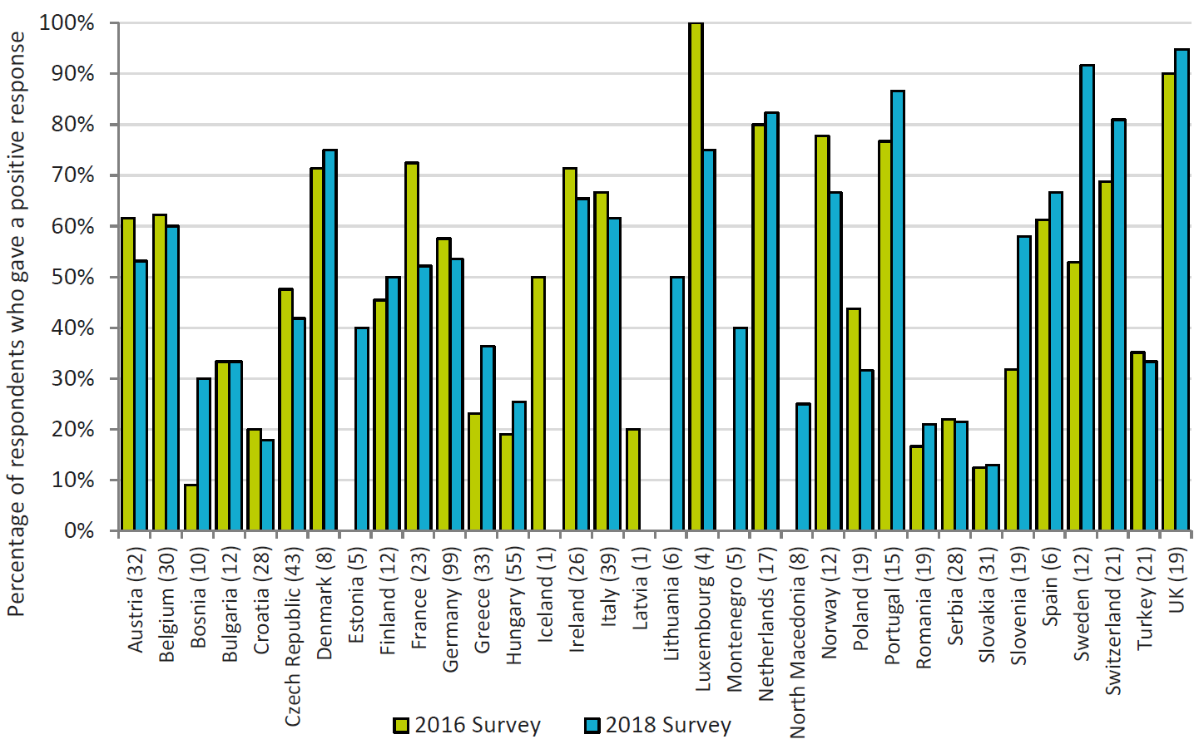
Figure 9: Percentage of respondents who gave a positive response to the statement “The pharmacists in our hospital work routinely as part of a multidisciplinary team?”
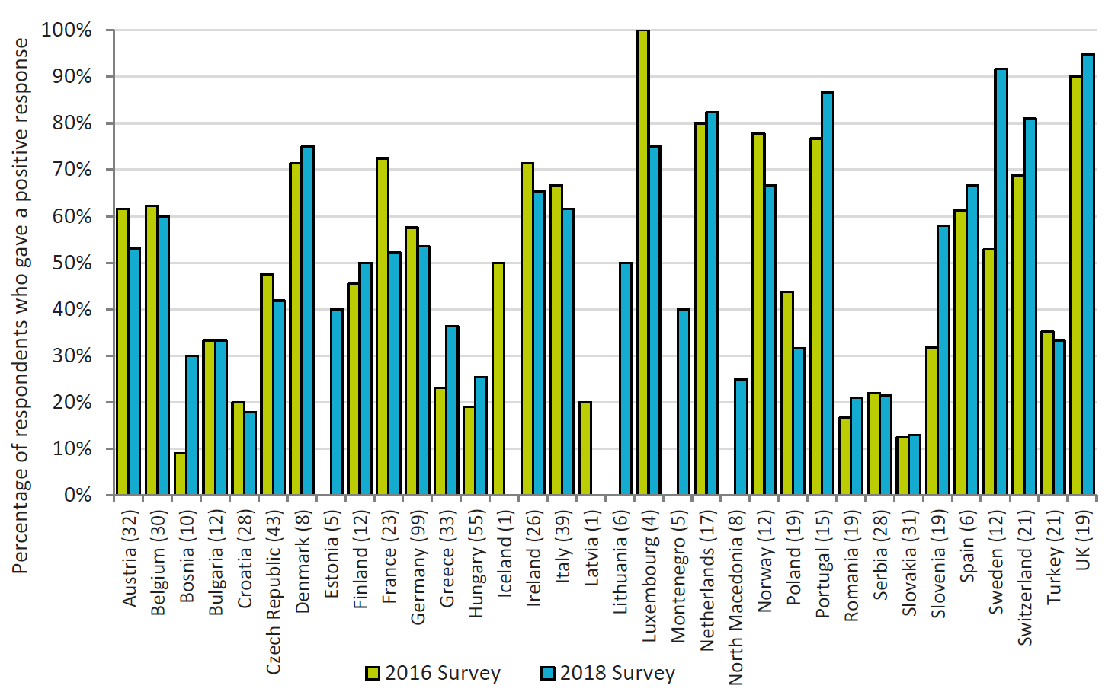
Figure 10: Percentage of respondents who gave a positive response to the statement “All prescriptions in our hospital are reviewed and validated as soon as possible by a pharmacist”.
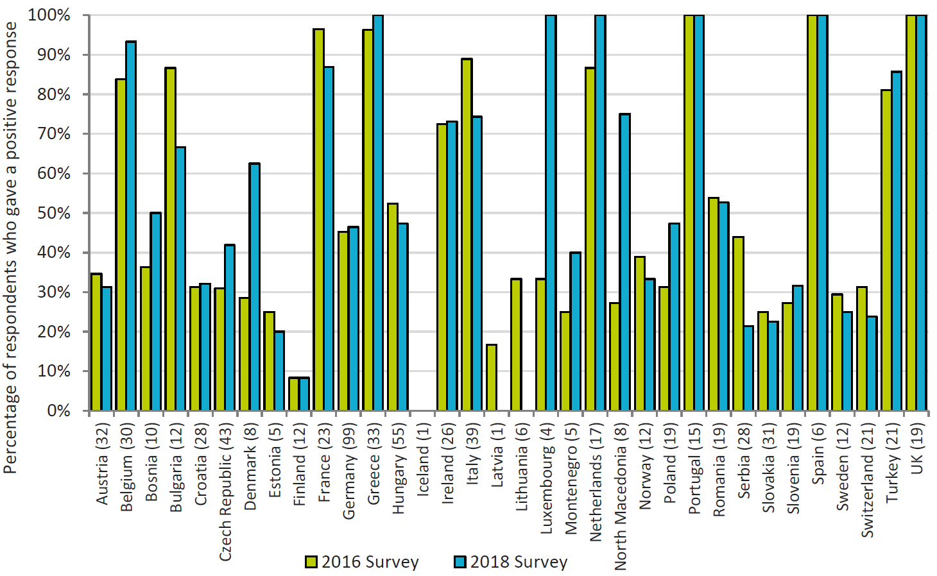
Figure 11: agreement with the implementation
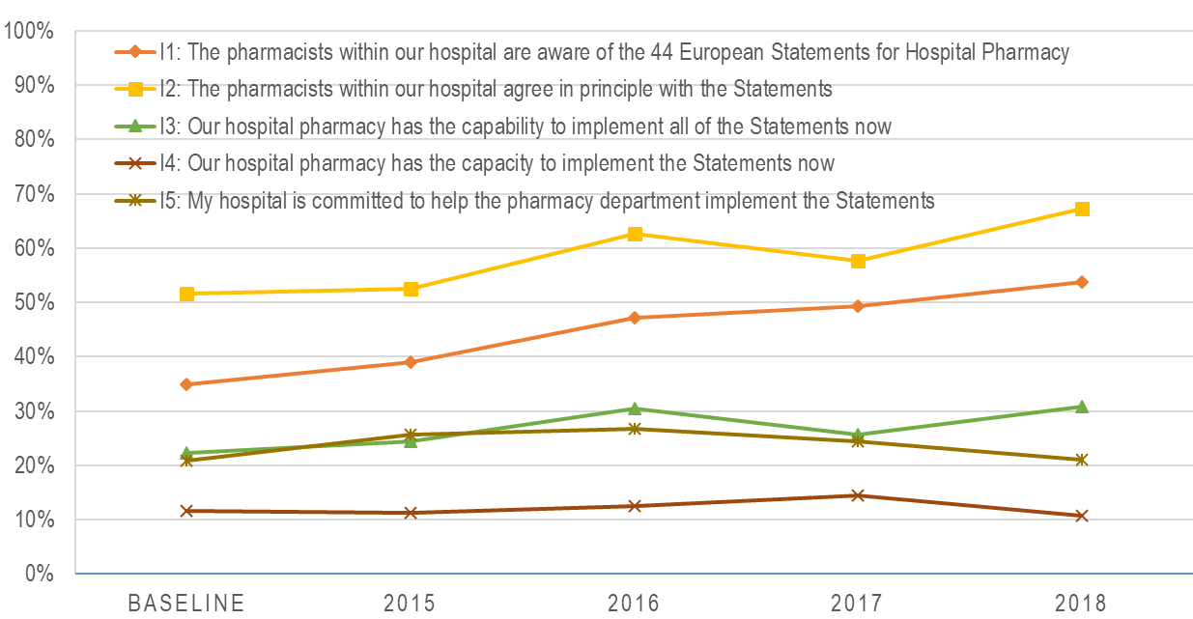
References

Anon. The European Statements of Hospital Pharmacy. Eur J Hosp Pharm 2014;21:256–8; http://www.eahp.eu/sites/default/files/eur_j_hosp_pharm-2014-editorial-256-8.pdf
Maskrey N and Underhill J. The European Statements of Hospital Pharmacy: achieving consensus using Delphi and World Café methodologies Eur J Hosp Pharm 2014;21:264-266 doi:10.1136 http://ejhp.bmj.com/content/21/5/264.full
Horák P, Peppard J, Sýkora J, et al. EAHP survey and European Statements of Hospital Pharmacy – can we achieve a perfect match? Eur J Hosp Pharm 2014;21:291–3
European Statements of Hospital Pharmacy Survey Results 2018, Statements Sections 1, 3 and 4 http://www.eahp.eu/sites/default/files/eahp_survey_report_2018-19.pdf
Horák P, Peppard J, Sýkora J, et al. EAHP European statements baseline survey 2015: results. Eur J Hosp Pharm 2016;23:69–75.
https://developer.surveymonkey.com/
Quintens C, De Rijdt T, Van Nieuwenhuyse T, Simoens S, Peetermans WE, Van den Bosch B, et al. Development and implementation of "Check of Medication Appropriateness" (CMA): advanced pharmacotherapy-related clinical rules to support medication surveillance. Bmc Medical Informatics and Decision Making. 2019;19. pmid:30744674 https://doi.org/10.1186/s12911-019-0748-5
Phan, H., Williams, M., McElroy, K., Burton, B., Fu, D., & Khandoobhai, A. (2019). Implementation of a student pharmacist-driven medication history service for ambulatory oncology patients in a large academic medical center. Journal of Oncology Pharmacy Practice. https://doi.org/10.1177/1078155219831066
http://sat.eahp.eu/en/home
Frontini, R. Falsified Medicines Directive: Are We Heading in the Right Direction? 2017 Medicine Access @ Point of Care. https://doi.org/10.5301/maapoc.0000011

