Trial characteristics associated with the underrepresentation of women as lead authors in heart failure clinical trials

Sera Whitelaw BSc¹, Lehana Thabane PhD¹, Mamas A Mamas BM Bch DPhil², Nosheen Reza MD³, Khadijah Breathett MD MS⁴, Pamela S Douglas MD⁵, Harriette GC Van Spall MD MPH^{1,6,7}

¹Department of Health Research Methods, Evidence, and Impact, McMaster University, Hamilton, Ontario, Canada
²Keele Cardiovascular Research Group, Keele University, Stroke-on-Trent, United Kingdom
³Division of Cardiovascular Medicine, Perelman School of Medicine at the University of Pennsylvania, Philadelphia, Pennsylvania, United States
⁴Division of Cardiovascular Medicine, Sarver Heart Center, University of Arizona, Tucson, Arizona, United States
⁵Duke University Clinical Research Institute, Duke University, Durham, North Carolina, United States
⁶Department of Medicine, McMaster University, Hamilton, Ontario, Canada
⁷Population Health Research Institute, Hamilton, Ontario, Canada

Correspondence to: Dr. Harriette Gillian Christine Van Spall
20 Copeland Avenue
David Braley Research Building, Suite C3-117
Hamilton, Ontario L8L 0A3
Phone: (905) 521-2100 x40601
Fax: (905) 297-3785
Harriette.VanSpall@phri.ca

@serawhitelaw @mmamas1973 @noshreza @KBreathettMD @pamelasdouglas @hvanspall

Tweet: Among 403 #HF #RCTs 2000-2019 #women were underrepresented as authors, with ⬇️odds of lead #authorship in RCTs that were multicenter, led in North America / Europe, tested drug interventions, or had men as senior authors. #WIC #researchleadership #diversity #equity

Funding: Dr. Van Spall receives research salary support from McMaster Department of Medicine and the Women As One Escalator Award, and funding support from the Canadian Institutes of Health Research.

Disclosures: The authors have nothing of relevance to this work to disclose.

Word count: 4999

ABSTRACT

Background: Clinical trials change practice in cardiology, and leading them requires research training, mentorship, sponsorship, and networking. Women report challenges in obtaining these opportunities.

Objective: To evaluate temporal trends in representation of women as authors in heart failure (HF) randomized controlled trials (RCTs) published in high-impact medical journals and explore RCT characteristics associated with women as lead authors.

Methods: We searched MEDLINE, EMBASE and CINAHL for HF RCTs published in journals with impact factor >10 between January 1, 2000 to May 7, 2019. We assessed trends in the gender distribution of authors and used multivariable logistic regression to determine characteristics associated with women as lead authors.

Results: We identified 10,596 unique articles, of which 403 RCTs met inclusion criteria. Women represented 15.6% (95% CI 12.2%-19.6%), 12.9% (95% CI 9.8%-16.6%), and 11.4% (95% CI 8.5%-14.9%) of the lead, senior, and corresponding authors, respectively. The proportion of women authors has not increased over time. Women had lower odds of lead authorship in RCTs that were multi-center (OR 0.58, 95% CI 0.18-0.96, p=0.037); coordinated in North America (OR 0.21, 95% CI 0.08-0.70, p=0.011) or Europe (OR 0.33, 95% CI 0.09-0.91, p=0.039); tested drug interventions (OR 0.42, 95% CI 0.16-0.97, p=0.043); or had men as the senior author (OR 0.50, 95% CI 0.21-0.93, p=0.043).

Conclusions: Women are underrepresented as authors of HF RCTs, with no improvement in temporal trends. Women had lower odds of lead authorship in RCTs that were multi-center, coordinated in North America or Europe, tested drug interventions, or had men as senior authors.

CONDENSED ABSTRACT
In this systematic review, we assessed temporal trends in the gender distribution of authors in randomized controlled trials (RCTs) of heart failure and assessed RCT characteristics independently associated with women as lead authors. Among 403 RCTs published between 2000-2019, women were under-represented as lead (15.6%) and senior (12.9%) authors and corresponding authors (11.4%). The proportion of women in these authorship positions has not changed over time. After adjusting for trial factors, women had lower odds of lead authorship in RCTs that were multi-center, coordinated in North America or Europe, tested drug interventions, or had men as senior authors.

KEY WORDS

Heart failure, randomized controlled trials, authors, gender

ABBREVIATIONS

ACC= American College of Cardiology
AHA= American Heart Association
CI= Confidence interval
HF= Heart failure
IQR= Interquartile range
JAMA= Journal of the American Medical Association
OR= Odds ratio
RCTs=Randomized controlled trials
SD= Standard deviation
US= United States

INTRODUCTION

Women are underrepresented in most fields of academic medicine, and in particular, in cardiology. (1) A study by Blumenthal et al. demonstrated that men dominate academic cardiology faculty (84% men, 17% women), and are significantly more likely to be full professors. (2) In most academic institutions, research output is a key metric of success and leading research studies is a path to career advancement and global reach. In the United States (US), women represent 25.5% of heart failure (HF) specialists and it is unclear whether this distribution is reflected among those who lead HF research. (3)

Randomized controlled trials (RCTs) generate the best-quality evidence among primary research methodologies, are often practice-changing, and receive the greatest spotlight at global meetings. (4,5) Among research methodologies, RCTs pose unique challenges, require infrastructure and larger amounts of funding, and can take years from planning to completion. Leading them typically requires advanced research training, mentorship, sponsorship, networking, and typically, academic appointments at research institutes. Women report obtaining these opportunities less frequently than men. (6,7)

HF has experienced a revolution of practice changing RCTs, with major advances in treatment. (8-10) In this systematic review, we sought to determine the gender distribution among authors in impactful trials in HF and explore clinical trial characteristics independently associated with women as lead authors. We hypothesized that women would be underrepresented as lead, senior, and corresponding authors overall, with stable temporal trends.

METHODS
Study overview
This study is registered in the International Prospective Register of Systematic Reviews (PROSPERO; ID:193416). Our study and the reporting followed Preferred Reporting Items for Systematic Reviews and Meta-Analyses (PRISMA) guidelines. (11)
Data sources and searches
With the aid of a professional information specialist, we conducted a systematic search of the literature, restricted to the English language, for articles published in MEDLINE, EMBASE and CINAHL. Search terms included heart failure and randomized controlled trials. The preliminary search strategy for MEDLINE is available in the supplementary appendix 1.
Study selection
The authors independently screened all titles and abstracts from the search against predefined eligibility criteria. Screening and decision-making were performed in duplicate. We included RCTs published in English between January 1, 2000 and May 7, 2019 that recruited adults (≥18 years old) with HF. To include studies more likely to inform clinical practice, we limited the RCTs to those published in medical journals with an impact factor > 10 in 2019. (12) The impact factor threshold of 10 was empirically chosen. We included full-text manuscripts reporting primary outcomes. We excluded protocols as well as publications subsequent to the first manuscript that described the primary outcomes of an RCT. Thus, we excluded publications describing post-hoc, intermediate, or secondary analyses. We classified gender as uncertain if we were unable to ascertain the gender of authors.

Data extraction and analysis
Two authors independently extracted the following information in duplicate: year of publication, journal impact factor, region, location of recruitment, type of consent, type of intervention, level of randomization, type of follow up, scope of trial, number of centers, funding type, journal of publication, total number of authors, and gender of authors in lead (first), middle, senior (last), and corresponding position. We only included individual authors who were listed in the author section of the manuscript. If applicable, we documented shared authorship roles in the marquee positions. We did not include individuals in trial investigator committees or consortia in the analysis. We determined gender via manual online searches of author names in conjunction with institution names. Sources for this information included photographs and pronouns descriptors on professional and institutional websites as well as social media accounts.
We performed descriptive analysis, presenting continuous variables as median and interquartile range (IQR), and categorical variables as numbers and percentages. We used multivariable logistic regression to determine RCT characteristics associated with women as lead authors. The characteristics under consideration included continent of RCT coordination, type of intervention, number of centers, type of funding and gender of senior authors. We did not include journal of publication as a predictor variable because authorship is decided prior to submission for publication. We reported results as odds ratio (OR) with corresponding 95% confidence interval (CI) and associated p-values. We analyzed temporal trends using the Jonckheere-Terpstra proportion trend test. All p values were two tailed, and the level of significance was set at alpha = 0.05. Data was analyzed using SPSS (version 23; IBM Corporation).

RESULTS
Our systematic search produced 10,596 unique articles, of which 8,278 were excluded on the basis of title and/or abstract review. We assessed 2,318 full-text articles, of which 403 met eligibility criteria (Figure 1).
Characteristics of included RCTs
The 403 RCTs were authored by a total of 4346 authors (median 10, IQR 6-13 per trial). There were no RCTs with shared lead or senior authors. Most RCTs were conducted in Europe (54.3%), limited to single countries (74.9%), involved multiple centers (57.3%), and tested drug interventions (67.2%). All RCTs obtained informed consent. Most randomized individual patients (98.5%). Men comprised a majority of lead (84.4%), senior (87.1%), and corresponding authors (88.6%) (Table 1).
Temporal trends in gender of authors
We were able to ascertain the gender of all 4346 authors. The median number of authors per RCT increased from 8 (IQR 5-11) in 2000-2003 to 15 (IQR 12-19) in 2016-2019. Of a total of 4346 authors, 852 (19.6%, 95% CI 18.5%-20.8%) were women. The proportion of women among authors in any position has not changed significantly from 2000 to present (p=0.326) (Figure 2).
Among 403 authors in each of the lead, senior, and corresponding positions, 63 (15.6%, 95% CI 12.2%-19.6%), 52 (12.9%, 95% CI 9.8%-16.6%) and 46 (11.4%, 95% CI 8.5%-14.9%), respectively, were women. The proportion of women in these authorship positions decreased numerically over time, but the trends were not significant (lead author, p=0.061; senior author, p=0.327; corresponding author; p=0.624) (Figure 3). Women comprised only 28 (12.1%) and 33 (14.3%) of lead and senior authors, respectively, of multi-centre trials; 5 (1.2%) and 2 (0.5%) of lead and senior authors, respectively, of device trials; and 35 (8.7%) and 32 (7.9%) of lead and senior authors, respectively, of drug trials.
Gender of lead and senior authors according to journal of RCT publication
The 403 RCTs were published in 14 major medical journals. Most RCTs were published in European Journal of Heart Failure (n=104), Journal of the American College of Cardiology (n=88) and Circulation (n=60). Among journals with at least 20 RCTs published during the study period, the proportion of women as lead authors was greatest in European Journal of Heart Failure (23.1%), Journal of the American Medical Association (JAMA) (22.2%) and Journal of the American College of Cardiology (14.7%). Among journals with at least 20 RCTs published during the study period, the proportion of women as senior authors was greatest in JAMA (22.2%), New England Journal of Medicine (15.8%) and Circulation (15.0%) (Table 2).
Multivariable analysis of RCT characteristics associated with women as lead authors
Women had lower odds of lead authorship in RCTs that were multi-center rather than single- center (OR 0.58, 95% CI 0.18-0.96, p=0.037); coordinated in North America (OR 0.21, 95% CI 0.08-0.70, p=0.011) or Europe (OR 0.33, 95% CI 0.09-0.91, p=0.039) relative to Central and South America; tested drug interventions (OR 0.42, 95% CI 0.16-0.97, p=0.043) relative to other interventions; or had men in the senior authorship position (OR 0.50, 95% CI 0.21-0.93, p=0.043).
There was no significant association between women in lead authorship position and: trials coordinated in Asia and Australia (OR 0.24, 95% CI 0.04-1.88, p=0.162) relative to trials coordinated in Central and South America; device / surgery trials (OR 0.37, 95% CI 0.09-1.45, p=0.213), relative to other interventions; and industry funding (OR 0.62, 95% CI 0.32-1.40, p=0.901) or relative to public funding (Table 3).
DISCUSSION
This systematic review demonstrated that among 403 HF RCTs published in high impact medical journals between 2000 and 2019, women comprised only 15.6%, 12.9%, and 11.4% of lead, senior, and corresponding authors, respectively. There was no significant temporal change in the proportion of women in these authorship positions. Among a total of 4346 authors in any authorship position in these RCTs, 19.6% were women. The proportion of women authors in any authorship position did not change over time. Women had lower odds of lead authorship in RCTs that were multi-center, coordinated in North America or Europe, tested drug interventions, or had men as senior author (Central illustration).

Our findings suggest that women are underrepresented in leadership and collaborative roles and that there has been no change in temporal trends over the past two decades. This parallels the gender gap among physicians in cardiovascular subspecialties such as HF in the US (74.5% men, 25.5% women) (3,13,14). This gap has persisted, with no change in the proportion of women HF subspecialty trainees (26%) in the US since 2011. (15) The gender gap seen in clinical settings appears to be amplified in clinical trial leadership.

Among research methodologies, RCTs pose unique challenges – prolonged duration before academic output is generated, expense that requires external funding, and complexity that requires extended training, mentorship, research infrastructure, and networking. (4,5) However, there are several gender-based inequities that make a research career challenging for women. (6,7,16,17) In a survey of 507 physicians, women perceived institutes to be less supportive towards women than men, less likely to nominate them for promotion, and less likely to include them in research networks. (18,19) Women face barriers in research funding and publication which may affect metrics required for promotion and retention in research careers. In a study of peer-reviewed research grants, women were assigned lower grant scores than men even after controlling for more than 20 potential confounders, including publications and history of funding success. (20) Manuscripts and conference abstracts led by women were accepted more often when reviewers were blinded to the gender of authors. (21,22) Women are underrepresented in editorial boards, potentially amplifying the gender bias in publication acceptances. (23) These barriers may be reasons why women with an interest in cardiovascular research instead pursue full-time clinical careers, which offer greater job stability relative to funding-dependent research positions. (24)

We found that women are less likely to be lead authors when men are senior authors, suggesting a gender association – either intended or unintended – between mentees and mentors. A prior analysis of publications (including primary research, viewpoints, editorials) in 6 general cardiology journals in 1996, 2006, and 2016 found that 16.5% of lead authors were women; and that there was an association between the gender of lead and senior authors; (25) Another bibliometric analysis of primary research articles published in 3 high-impact general cardiology journals found that 26.7% of lead authors were women, and that there was an association between gender of lead and senior author; these articles were not restricted to RCTs. (26) The estimates of women in lead positions in these two studies are slightly different from our study, possibly due to different date ranges, (25,26) a broader focus than HF alone, inclusion of articles other than primary research, (25) and inclusion of research methodologies other than clinical trials. (26) A recent review of 118 HF clinical trials published between 2001 and 2016 reported a lower proportion of women as first (10%) and senior authors (8%) than our study, possibly due to the smaller number of included trials, shorter date range, and exclusion of trials with < 400 participants. (27) This study did not provide descriptive statistics or temporal trends in gender composition of each type of author (lead, corresponding, middle, or senior) due to the limited sample size; but did reported no change in the proportion of women who were either lead or senior authors (16%) over time. Importantly, this study and the ones prior to it neither assessed the role of women as collaborators nor assessed trial characteristics independently associated with women as lead authors. (25-27)

Women are more likely to lead single- rather than multi-center trials, which are logistically more complex to coordinate but have the advantage of increased generalizability and potential to change practice compared to single center trials. (28) Multi-center trials require a larger collaborative network, but a gender gap exists in large research collaborations that have a greater reach. (29) For example, a recent bibliometric analysis of publications from 12 geographies and 27 subject areas found that relative to men, women had fewer collaborations both inside and outside their institutions, as measured by the number of co-authorships of research papers. (30) Collaborations broaden networks, are associated with greater number of grants and publications, and have implications on clinical trial involvement. (30,31) The gender gaps in research collaboration and the types of trials women lead are likely multifactorial, may include gender bias, less prominent profiles and international recognition, less sponsorship by mentors, and exclusion from informal networks.

Women had lower odds of RCT leadership in North American and Europe where many higher-profile RCTs are coordinated. Odds of RCT leadership were greatest in Central and South America, where there may be a slightly higher proportion of women cardiologists; for example, women represent approximately 29% of cardiologists in Brazil, 12.6% of cardiologists in the US, and 6 to 20% of cardiologists in European countries. (3,32,33) Thus, regions with the greatest proportion of women leading RCTs may be those with a greater proportion of women cardiologists. There may also be regional differences in the proportion of women in academic settings, although data is lacking in this regard. (34) Finally, there may be differences in culture, networking opportunities, and research-clinical integration that account for some differences.

Women had lower odds of leading RCTs that tested the effect of drug interventions. Most drug trials are funded by pharmaceutical companies, which are known to offer funding to women less commonly than men. (35) Although not statistically significant, our results show that industry funding of a trial tended to be associated with lower odds of women in lead authorship position; the wide confidence intervals around the estimated odds are suggestive of limited statistical power. (36) An analysis of 220,908 physicians who received industry funding found that 75.1% were men, and that men received significantly greater funding than women. (37) Women may be viewed less favourably as researchers by industry funding sources due to bias. (38) In observational studies, reviewers have been found to assess equal productivity less positively for women than men applicants. (39) Success begets success, and structural biases that favour men via collaborations, speaking engagements, grants, publications, and salary awards make them favourable candidates for downstream opportunities, including leadership of drug and device trials. (38,39)
The importance of women as leaders in clinical trials is multi-fold. In a survey of 1,123 internal medicine trainees, most women perceived the field of cardiology to lack the mentors they desired. (40) A vast majority of women researchers (77%) have men, rather than women, as their mentors according to a survey of young researchers at the National Institute of Health. (41) The gender association between senior and lead authors and the underrepresentation of women as mentors in clinical trials - assessed using the surrogate status of senior author – may deprive women from leading clinical trials themselves, creating a cycle of underrepresentation of women as leaders in clinical trials. In addition, other associated benefits of having women as lead authors in clinical trial – increased enrolment of women as trial participants and increased citations per publication relative to men – may be lost. (26,42)

Efforts to enhance the recruitment, retention, and career advancement of women as clinical trialists in cardiology should be a priority. (24,43) Organizations such as the American Heart Association (AHA) and American College of Cardiology (ACC) have directed efforts to recruit women and encourage success in the field of cardiology. (44,45) Both organizations have developed ‘Women in Cardiology’ committees dedicated to the advancement of women. (44,45) The AHA has implemented a scholarship program for trainees and a mentorship award recognizing those who have been exceptional mentors to women in cardiology. (44) The ACC has implemented mentorship programs, leadership workshops, networking opportunities, and visiting women professor programs, and most recently created a Clinical Trials Research Boot Camp program to increase the number of women and underrepresented cardiologists leading clinical trials. (46) Organizations such as Women As One provide platforms to mentor and promote women in cardiology. (46) Most of these initiatives are not specific to research, however, and increasing women in cardiology is a first step towards closing the gender gap in cardiovascular research. In order to increase the proportion of women who lead research, a zero-tolerance policy for workplace bullying and harassment – reported in many research institutes as a factor in attrition of women researchers - should be enforced. (24,43) Leaders of research institutes should be educated about gender disparities in research career advancement, (43) eliminate inappropriate questions during interviews for recruitment and promotion, and mitigate implicit bias in selection processes. (24) Programs that support career flexibility and work-life integration should be developed. (24,43) Institutions should provide equal renumeration to promote the retention of women in academic settings. (47)

To increase the proportion of women who lead impactful clinical trials, societies could initiate national and international collaborative research networks for women to advance their careers, broaden their reach, and increase the likelihood of multi-site clinical trial involvement. Formal research networks or registries led by women for women could offer research collaboration, mentorship and sponsorship opportunities tailored to the needs of professional women. Industry and grant funding agencies should receive anti-bias training, conduct blind reviews of applications, and use more objective review criteria. (48,49) They should be transparent and include gender breakdowns of principal investigators who applied for and received funded (Table 4). (24,48,49) Women scientists should be included as board and executive committee members of research institutes, reviewers and chairs on grant panels, members of scientific advisory boards, key opinion leaders, and journal editorial board members. Inclusion in these positions should be proportional to their representation in the field to close some of the gender gaps. (48,49) Speaking engagements as well as on-line and social media engagement could help increase the profile of women researchers who are not recognized or included in research networks in their home institutions.

To our knowledge, this is the first systematic review to assess the gender breakdown of clinical trial leadership and to examine clinical trial factors associated with women as lead authors in any medical field. The strengths of our study included the comprehensive search strategy and the inclusion of RCTs published in high-impact factor journals over a 2-decade time span. The review process and data extraction were conducted independently by two authors and discrepancies were resolved by consultation with a third author, which reduced the likelihood that the results of our study were due to single reviewer bias or chance. The volume of RCTs systematically reviewed minimized the potential for bias caused by chance.

Limitations should be noted. This review was restricted to the English language articles published studies in high-impact medical journals. The gender distribution of authors and associations described in this study may not apply to RCTs that were excluded from this review. It is possible that the representation of women authors in lower-impact journals do not follow the trends identified within this study. Data regarding author gender were obtained from online sources, and we cannot account for error in the primary sources. We were not able to account for gender non-binary authors based on our search of online sources. We did not account for clustering of authorship teams or trial coordinating centers across clinical trials. We used lead and senior authorship status as surrogates for mentees and mentors as well as for leadership of RCTs, although we recognize that some trials are led by industry partners. We did not account for the degrees of authors or distinguish between clinician and non-clinician researchers, although we acknowledge that all researchers play an important role in clinical trial involvement. We could not assess race or ethnicity of authors, and recognize that gender disparities in research are amplified among racial/ethnic groups. (50) The multivariable analysis is exploratory in nature, and the results should be interpreted with caution. There is a risk of overfitting due to the low ratio of events to the degrees of freedom for the characteristic variables. (51)
Conclusion
Among 403 HF RCTs published between 2000-2019, women were under-represented as lead, senior, and corresponding authors. The proportion of women in these authorship positions has not changed. Women had lower odds of lead authorship in RCTs that were multi-center, coordinated in North America or Europe, tested drug interventions, or had men as the senior author. Given the independent gender association between lead and senior author, recruiting, training, and advancing women as leaders of RCTs may be a strategic way – among others – to rapidly increase the proportion of women leading RCTs.

CLINICAL PERSPECTIVES
Competency in medical knowledge: Women are underrepresented in a majority of RCTs of HF, and this trend has persisted over time. Women had lower odds of lead authorship in RCTs that were multi-center, coordinated in North America or Europe, tested drug interventions, or had men as the senior author.
Translational outlook: Addressing the factors associated with underrepresentation of women may facilitate gender balance in RCT leadership and advance women as leaders of RCTs.

ACKNOWLEDGMENTS
The authors thank Mohammad Alruwayeh, Yousif Eliya and Kristen Sullivan for their assistance with data extraction.

REFERENCES
- Association of American Medical Colleges. 2018-2019 The state of women in academic medicine: exploring pathways to equity. https://www.aamc.org/data-reports/data/2018-2019-state-women-academic-medicine-exploring-pathways-equity Accessed June 3, 2020.
- Blumenthal DM, Olenski AR, Yeh RW et al. Sex Differences in Faculty Rank Among U.S. Academic Cardiologists. Circulation 2017;135:506-517.
- Mehta LS, Fisher K, Rzeszut AK et al. Current demographic status of cardiologists in the United States. JAMA Cardiol 2019;4:1029-1033.
- Beaumont D, Arribas M, Frimley L, Balogen E, Roberts I, Shakur-Still H. Trial management: we need a cadre of high-class triallists to deliver the answers that patients need. Trials 2019;20:354.
- Guyatt GH, Haynes RB, Jaeschke RZ et al. Evidence-Based Medicine Working Group. Users’ guides to the medical literature, XXV: evidence-based medicine: principles for applying the users’ guides to patient care. JAMA 2000;284:1290-1296.
- Buddeberg-Fischer B, Stamm M, Buddeberg C et al. The impact of gender and parenthood on physicians' careers — professional and personal situation seven years after graduation. BMC Health Serv Res 2010; 40.
- Patton EW, Griffith KA, Jones RD, Stewart A, Ubel PA, Jagsi R. Differences in mentor-mentee sponsorship in male vs female recipients of National Institutes of Health grants. JAMA Intern Med 2017;177:580-582.
- O’Conner CM. The globalization of heart failure research. J Am Coll Cardiol 2015;3:657-658.
- Vanduganathan M, Tahhan AS, Greene SJ, Okafor M, Kumar S, Butler J. Globalization of heart failure clinical trials; a systematic review of 305 trials conducted over 16 years. Eur J Heart Fail 2018;20:1068-1071.
- Bothwell LE, Greene JA, Podolsky SH, Jones DS. Assessing the gold standard- lessons from the history of RCTS. N Eng J Med 2016;364:2175-2181.
- Moher D, Liberti A, Tetlaff J, Altman G, PRISMA Group. Preferred reporting items for systematic reviews and meta-analyses: the PRISMA statement. PLos Med 2009;6:e1000097.
- Web of Science Group. 2019 journal citation report: full journal list. https://clarivate.com/webofsciencegroup/article/announcing-the-2019-journal-citation-reports/ Accessed April 20, 2020.
- Lewis SJ, Mehta LS, Douglas PS et al. Changes in the professional lives of cardiologists over 2 decades. J Am Coll Cardiol 2017;69:452-462.
- Stone AT, Carlson KM, Douglas PS, Morris KL, Walsh MN. Assessment of subspecialty choices of men and women in internal medicine from 1991 to 2016. JAMA Intern Med 2019;180:140-141.
- American Board of Internal Medicine. Percentage of first-year fellows by gender and type of medical school attended. https://www.abim.org/about/statistics-data/resident-fellow-workforce-data/first-year-fellows-by-gender-type-of-medical-school-attended.aspx Accessed August 1, 2020.
- Ortega RF, Mehran R, Douglas PS. The conundrum and opportunity of gender equity for evidence generators. JAMA Cardiol 2020;8.
- Chisholm-Burns MA, Spivey CA, Hagermann T, Josephson MA. Women in leadership and the bewildering glass ceiling. Am J Health Syst Pharm 2017;74:312-324.
- Foster SW, McMurray JE, Linzer M, Leavitt JW, Rosenberg M, Carnes M. Results of a gender-climate and work-environment survey at a midwestern academic health center. Acad Med 2000;75:653-660.
- Mehta L, Sharma G, Douglas P, Rzeszut A. Discrimination and harassment in cardiology: insights from the 2019 American College of Cardiology global professional survey. J Am Coll Cardol 2020;75:3631.
- Tamblyn R, Girard N, Qian CJ, Hanley J. Assessment of potential bias in research grant peer review in Canada. CMAJ 2018;190:E489-499.
- Budden AE, Tregenza T, Aarssen LW, Koricheva J, Leimu R, Lortie CJ. Double-blind review favours increased representation of female authors. Trends Ecol Evol 2008;23:4-6.
- Roberts SG, Verhoef T. Double blind reviewing at EvoLang 11 reveals gender bias. J Lang Evol 2016;1:163-167.
- Balasubramanian S, Saberi S, Yu S, Duvernoy CS, Day SM, Agarwal PP. Women representation among cardiology journal editorial boards. Circulation 2020;141:603-605.
- Sharma G, Sarma AA, Walsh MN et al. 10 Recommendations to enhance recruitment, retention, and career advancement of women cardiologists. J Am Coll Cardiol 2019;74:1839-1842.
- Ashgar M, Usman MS, Aibani R et al. Sex differences in authorship of academic cardiology literature over the past 2 decades. JACC 2018;72:681-685.
- Ouyang D, Sing D, Shah S et al. Sex disparities in authorship order of cardiology publications. Circulation 2018;11:e005040.
- Reza N, Tahhan AS, Mahmud N, DeFilippis EM, Alrohaibani A, Vaduganathan M, Greene SJ, Ho AH, Fonarow GC, Butler J, O’Connor C, Fiuzat M, Vardeny O, Pina IL, Lindenfeld J, Jessup M. Representation of women authors in international heart failure guidelines and contemporary clinical trials. Circ Heart Fail 2020.
- Bhandari M, Schemitsch EH. Beyond the basics: the organization and coordination of multicenter trials. Tech Orthop 2004;19:83-87.
- Elsiever. Gender in the global research landscape. https://www.elsevier.com/__data/assets/pdf_file/0008/265661/ElsevierGenderReport_final_for-web.pdf Accessed June 10, 2020.
- Tong CW, Madhur MS, Rzeszut AK et al. Status of early-career academic cardiology: a global perspective. J Am Coll Cardiol 2017;70:2290-2303.
- Block P, Weber H, Kearney P. Manpower in cardiology II in western and central Europe (1999-2000). Eur Heart J 2003;24:299-310.
- Mainardi GM, Cassenote AJF, Guilloux AGA, Miotto BA, Scheffer MC. What explains wage differences between male and female Brazilian physicians? a cross-sectional nationwide study. BMJ Open 2019;9:e023811.
- Jagsi R, Biga C, Poppas A et al. Work activities and compensation of male and female cardiologists. J Am Coll Cardol 2016;67:529-541.
- World Health Organization. Gender equity in the health workforce: Analysis of 104 countries. https://apps.who.int/iris/bitstream/handle/10665/311314/WHO-HIS-HWF-Gender-WP1-2019.1-eng.pdf?sequence=1&isAllowed=y&te=1&nl=in-her%20words&emc=edit_gn_20200312 Accessed June 11, 2020.
- Chopra SS. Industry funding of clinical trials: benefit or bias? JAMA 2003;290:113-114.
- Du Prel JB, Hommel G, Bohrig B, Blettner M. Confidence interval or p-value: part 4 of a series on evaluation of science publications. Dtsch Arztebl Int 2009;106:335-339.
- Rose SL, Sanghani RM, Schmidt C, Karafa MT, Kodish E, Chisolm GM. Gender differences in physician’s financial ties to industry: a study of disclosure data. PLoS One 2015;10:e0129197.
- Witteman HO, Hendricks M, Straus S, Tannenbaum C. Are gender gaps due to evaluations of the applicant or the science? A natural experiment at a national funding agency. Lancet 2019;393:531-540.
- Silibiger NJ, Stubler AD. Unprofessional peer reviews disproporitionately harm underrepresented groups in STEM. PeerJ 2019;7:e8247.
- Douglas PS, Rzeszut AK, Merz NB et al. Career preferences and perceptions of cardiology among US Medicine Trainees. JAMA Cardiol 2018;3:682-691.
- Martinez Ed, Botos J, Dohoney KM et al. Falling off the academic bandwagon. EMBO Rep 2007;8:977-981.
- Nielson MW, Andersen JP, Schiebinger L, Schneider JW. One and a half million medical papers reveal a link between author gender and attention to gender and sex analysis. Nat Hum Behav 2017;1:791-796.
- Lau ES, Wood MJ. How do we attract and retain women in cardiology? Clin Cardiol 2018;41:264-268.
- American Heart Association. Women and special populations. https://professional.heart.org/professional/Communities/WomenandSpecialPopulations/UCM_475317_Women-and-Special-Populations.jsp Accessed June 22, 2020.
- American College of Cardiology. Women in cardiology section. https://www.acc.org/membership/sections-and-councils/women-in-cardiology-section/about-us/section-mission-and-objectives Accessed June 22, 2020.
- Women As One. Promoting equity in medicine. https://www.womenasone.org/ Accessed June 26, 2020.
- Douglas PS, Biga C, Burns KM et al. 2019 ACC Health policy statement on cardiologist compensation and opportunity equity. J Am Coll Cardiol 2019;74:1947-1965.
- Alverez SNE, Jagsi R, Abbuhl SB, Lee CJ, Myers ER. Promoting gender equity in grant making: what can a funder do? Lancet 2019;393:e9-e11.
- Ross JS, Gross CO, Krumholz HM. Promoting transparency in pharmaceutical industry-sponsored research. Am J Public Health 2012;102:72-80.
- American College of Cardiology. American College of Cardiology diversity and inclusion initiative. https://www.acc.org//~/media/Non-Clinical/Files-PDFs-Excel-MS-Word-etc/About%20ACC/Diversity/2018/03/Diversity-Inclusion-Strategy-Summary.pdf Accessed June 11, 2020.
- Ogundimu EO, Altman DG, Collins GS. Adequate sample size for developing prediction models is not simply related to events per variable. J Clin Epidemiol 2016;76:175-182.

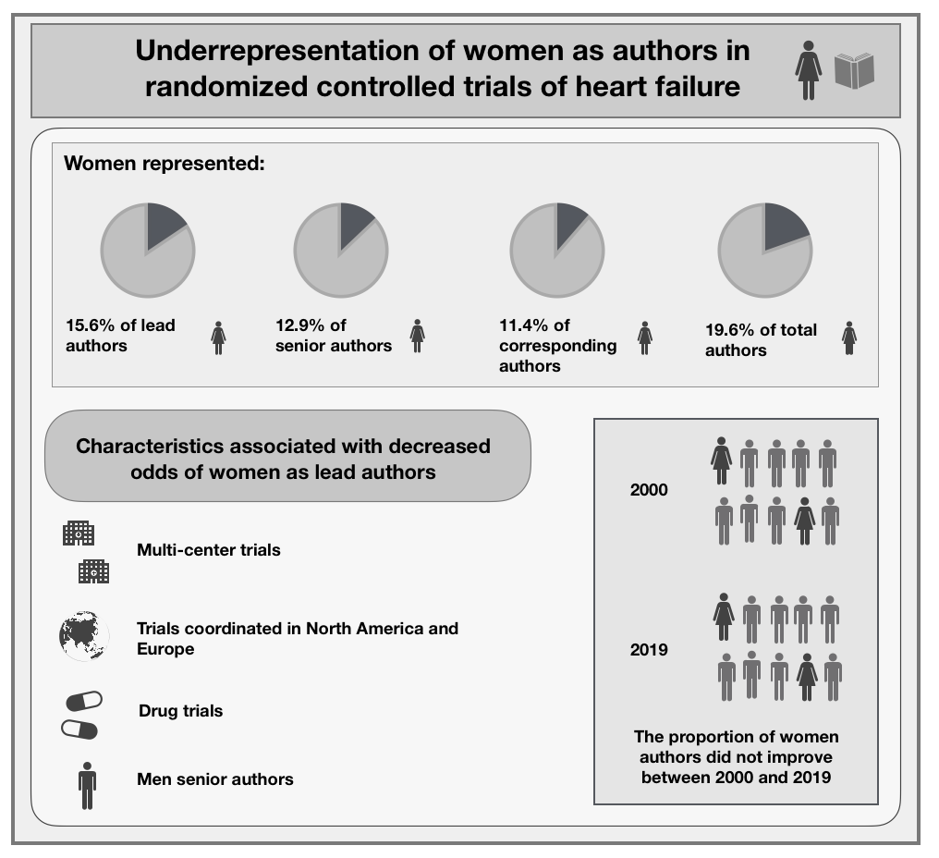

Central image: Under-representation of women as authors in randomized controlled trials of heart failure published in high-impact journals

Of 403 RCTs published in high-impact journals, women were underrepresented as authors of HF RCTs, with no improvement in temporal trends. Women had lower odds of lead authorship in RCTs that were multi-center, coordinated in North America or Europe, tested drug interventions, or had men as senior authors.

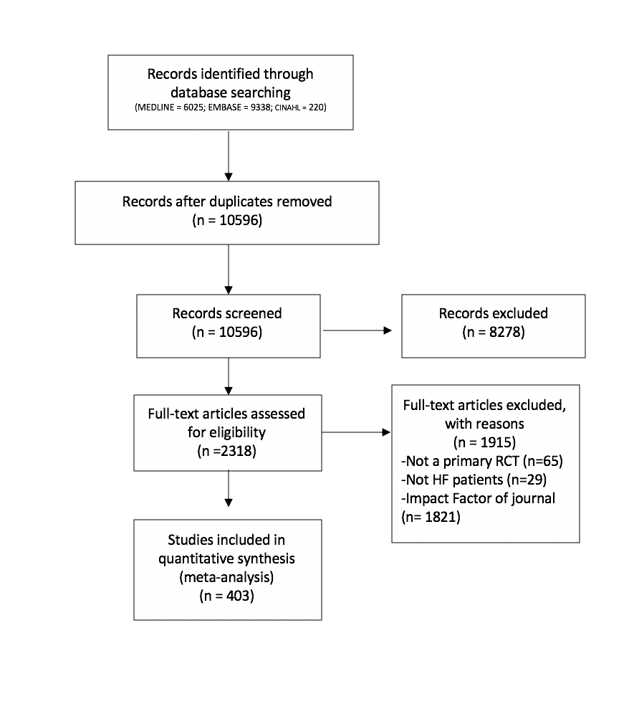
Figure 1. PRISMA diagram of included RCTs

A systematic search of MEDLINE, EMBASE and CINAHL was conducted to identify RCTs published between January 1, 2000 and May 7, 2019 that recruited adults with HF published in medical journals with an impact factor >10.

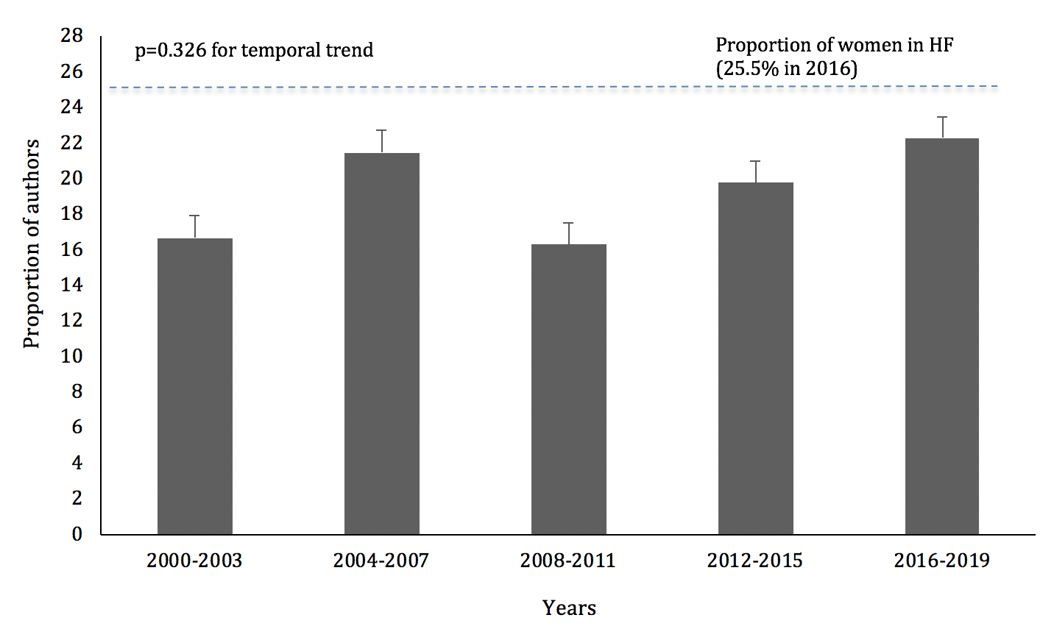
Figure 2. Proportion of women in any authorship position in RCTs of HF published in high impact-factor journals between 2000 and 2019

Temporal trends in the gender of authors in any position were analyzed using the Jonckheere-Terpstra proportion trend test (two-tailed testing, α=0.05). The sample included 403 RCTs and 4346 authors, 19.6% of whom were women. The proportion of women in any authorship position did not change significantly over time (p=0.326).

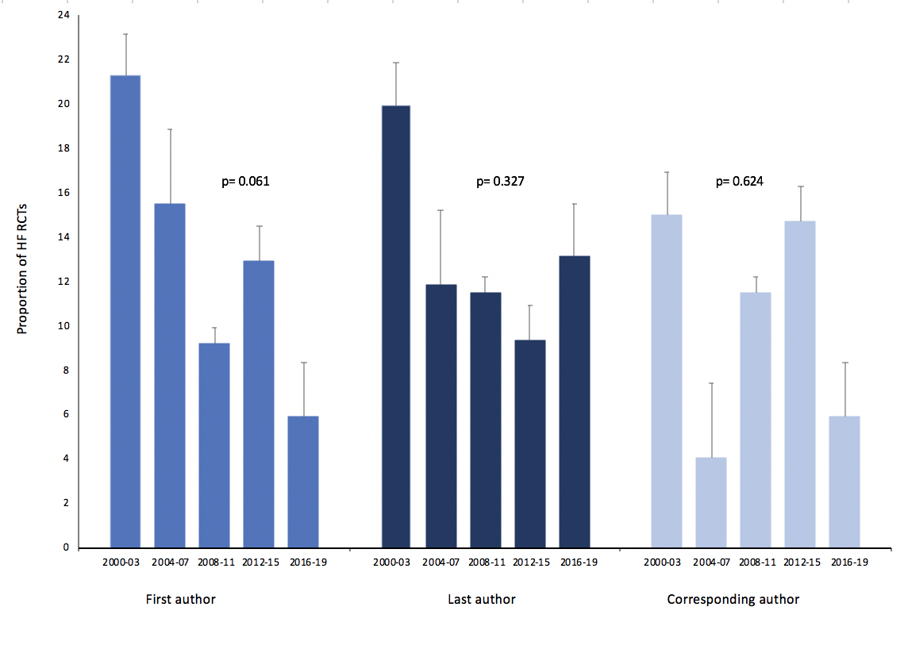
Figure 3. Proportion of HF RCTs published in high impact-factor journals between 2000 and 2019 with women as lead, senior, and corresponding authors.

Temporal trends in the gender distribution of lead, senior and corresponding authors were analyzed using the Jonckheere-Terpstra proportion trend test (two-tailed testing, α=0.05). The sample included 403 RCTs, with 403 authors in each position. Women represented 15.6%, 12.9%, and 11.4% of the lead, senior, and corresponding authors, respectively, with no change in temporal trends (lead author, p=0.061; senior author, p=0.327; corresponding author; p=0.624).

Table 1. Characteristics of RCTs (n=403) included in the study

Clinical trial characteristic |  | No. (%) of trials  (n=403)
Unit of randomization | Individual | 397 (98.5)
 | Cluster | 6 (1.5)
Type of consent | Informed | 403 (100.0)
Region of coordinating center | North America | 147 (36.5)
 | Central and South America | 15 (3.7)
 | Australia | 10 (2.5)
 | Asia | 12 (3.0)
 | Europe | 219 (54.3)
Eligibility criteria | Reported | 403 (100.0)
Recruitment | Inpatient | 93 (23.1)
 | Ambulatory | 310 (76.9)
Type of intervention | Health service | 49 (12.2)
 | Drug | 271 (67.2)
 | Device | 46 (11.4)
 | Surgery | 8 (2.0)
 | Exercise / Rehabilitation | 29 (7.2)
Number of centers | Single center | 172 (42.7)
 | Multi-center | 231 (57.3)
Type of follow up | Face-to-face | 392 (97.3)
 | Database | 11 (2.7)
Scope of trial | National | 302 (74.9)
 | International | 101 (25.1)
Type of funding | Public | 185 (45.9)
 | Industry | 163 (40.4)
 | Public and Industry | 55 (13.6)
Gender of lead author | Male | 340 (84.4)
 | Female | 63 (15.6)
Gender of senior author | Male | 351 (87.1)
 | Female | 52 (12.9)
Gender of corresponding author | Male | 357 (88.6)
 | Female | 46 (11.4)
Year of publication | 2000-2003 | 127 (31.5)
 | 2004-2007 | 109 (27.0)
 | 2008-2011 | 47 (11.7)
 | 2012-2015 | 51 (12.7)
 | 2016-2019 | 69 (17.1)

Table 2. Gender breakdown of lead and senior authors of RCTs published in major medical journals (n=403)

Journal | No. (%) of RCTs | No. (%) of RCTs with women lead author | No. (%) of RCTs with women senior author
American Journal of Respiratory and Critical Care Medicine | 2 (0.5) | 0 (0.0) | 0 (0.0)
Annals of Internal Medicine | 1 (0.2) | 1 (100.0) | 0 (0.0)
British Medical Journal | 4 (1.0) | 1 (25.0) | 2 (50.0)
Circulation | 60 (14.9) | 8 (13.3) | 9 (15.0)
Circulation Research | 6 (1.5) | 1 (16.7) | 1 (16.7)
European Heart Journal | 42 (10.4) | 4 (9.5) | 6 (14.3)
European Journal of Heart Failure | 104 (25.8) | 24 (23.1) | 13 (12.5)
European Respiratory Journal | 1 (0.2) | 0 (0.0) | 0 (0.0)
Journal of the American Medical Association | 27 (6.7) | 6 (22.2) | 6 (22.2)
Journal of the American Medical Association Cardiology | 3 (0.7) | 0 (0.0) | 1 (33.3)
Journal of the American Medical Association Internal Medicine | 6 (1.5) | 1 (16.7) | 1 (16.7)
Journal of the American College of Cardiology | 88 (21.8) | 13 (14.7) | 4 (4.5)
Lancet | 21 (5.2) | 1 (4.8) | 3 (14.3)
New England Journal of Medicine | 38 (9.4) | 3 (7.9) | 6 (15.8)
Total | 403 | 63 | 52

Table 3. Multivariable analysis of clinical trial characteristics associated with female lead authors in RCTs of HF (n=403)

Variable |  | OR (95% CI) | p-value
Region | Central & South America | 1.00 (Reference) | –
 | Europe | 0.33 (0.09-0.91) | 0.039
 | North America | 0.21 (0.08-0.71) | 0.011
 | Asia & Australia | 0.24 (0.04-1.88) | 0.162
Type of intervention | Other | 1.00 (Reference) | –
 | Drug | 0.42 (0.16-0.97) | 0.043
 | Device / Surgery | 0.37 (0.09-1.45) | 0.213
Number of centers | Single center | 1.00 (Reference) | –
 | Multi-center | 0.58 (0.18-0.96) | 0.037
Type of funding | Public | 1.00 (Reference) | –
 | Industry | 0.62 (0.32-1.40) | 0.901
Gender of senior author | Women | 1.00 (Reference) | –
 | Men | 0.50 (0.21-0.93) | 0.043

Table 4. Recommendations to improve the representation of women authors in RCTs

Recommendations for early- and mid- career women cardiologists | Engage in on-line and social media networks, limiting content to science  Participate in national and international research networks or registries that offer women research collaboration, mentorship and sponsorship opportunities  Invest in clinical research training (certificate programs offered by societies, advanced degrees and fellowships offered by universities)
Recommendations for senior men and women cardiologists | Mentor and sponsor the next generation of women trialists
Create a supportive culture to ensure equal opportunity and recognition

Learn to recognize and intervene during harassment
Recommendations for academic and departmental leadership | Receive education about gender disparities in research career advancement  Eliminate inappropriate questions during interviews for recruitment and promotion, and mitigate implicit bias in selection processes  Develop mentoring and sponsoring programs for career growth of researchers  Include women as board or executive committee members at research institutes  Ensure equal opportunity (in recruitment and retention, compensation, access to resources) and recognition for researchers based on objective criteria  Encourage self-nominations and eliminate reliance on department chairs or committees to nominate researchers for awards or advancement opportunities
 | Implement a zero-tolerance policy for workplace harassment
 | Implement flexible promotion policies that recognize the familial and child rearing demands of early-career investigators
Recommendations for industry and grant funding agencies | Encourage women to apply for funding opportunities  Participate in anti-bias training  Conduct blind reviews of applications and use more equitable review criteria  Provide gender breakdown of applicants and awards  Include women scientists as reviewers and chairs on funding committees  Include women in luminary networks (key opinion leaders, scientific advisory boards)
Recommendations for journals | Provide equitable peer review  Set objective criteria and avoid informal networks for the selection of editors and editorial boards

