Prosthesis-Patient Mismatch Increases Early and Late Mortality in Low Risk Aortic Valve Replacement
Walid Elmahdy, MSc, PhD, FRCS C Th^{1*}, Mohamed Osman, MSc, PhD, FRCS C Th^{1*}, Mohamed F Farag, MSc, PhD ^{2,3}, Ahmad Shoaib, MD ⁴, Haisam Saad, MB BCh, MRCS ¹, Keith Sullivan, PhD ³, Unni Krishnan, PhD ², Samer Nashef, BSc, PhD, FRCS ¹, Marius Berman, MD, FRCS C Th¹
* These authors contributed equally
- Royal Papworth Hospital, Cardiac surgery department, Cambridge Biomedical Campus, Cambridge, UK.
- Royal Papworth Hospital, Cardiology department, Cambridge Biomedical Campus, Cambridge, UK
- School of Life and Medical Sciences, University of Hertfordshire, Hertfordshire, UK
- Keele University, Stoke-on-Trent, UK
No conflict of interest to declare for all the authors.
No external fund received for this work.
Correspondence to:
Mr Mohamed Osman, MSc, PhD, FRCS C Th
Royal Papworth Hospital
Cambridge Biomedical Campus
Cambridge, CB2 0AY
United Kingdom
Tel +44 (0)122 363 8000
Mobile +447596408910
m.a.othman@gmail.com
Word count: 2905
ABBERVIATIONS
AVR: aortic valve replacement
BSA: body surface area
EOA: effective orifice area
EOAI: indexed effective orifice area
PPM: prosthesis-patient mismatch
TAVI: transcatheter aortic valve implantation

PERSPECTIVE STATEMENT
Prosthesis-patient mismatch (PPM) has gained attention since first described 40 years ago. Previous studies have shown conflicting evidence regarding increased early and late morbidity and mortality with PPM after aortic valve replacement (AVR). This study focuses on low-risk patients undergoing AVR. The findings suggest that PPM in this cohort was associated with a poor outcome.

ABSTRACT
Objectives: The concept of prosthesis-patient mismatch (PPM) has gained much attention since first described 40 years ago. Previous studies have shown conflicting evidence regarding increased early and late morbidity and mortality with PPM after aortic valve replacement (AVR). The aim of this study was to evaluate the effects of PPM on short- and long-term mortality in low-risk patients after isolated AVR.
Methods: A retrospective, single-centre study involving 1707 consecutive patients ≤80 years of age with preserved left ventricular systolic function who underwent elective, primary isolated AVR operations from 2008 to 2018. Patients were stratified into 2 groups according to the presence of PPM (n=96), defined as effective orifice area index <0.85cm²/m² body surface area, and no-PPM (n=1611). The effect of PPM on mortality was evaluated with univariate and multivariate analyses.
Results: 30-day mortality was 0.8% (4.2% in PPM group vs. 0.6 in no-PPM group; P=0.005). PPM occurred more in female gender, obese and older patients. PPM was highly predictive of associated with long-term all-cause mortality (median 4 years [IQR Q1-Q3 2-7]; HR: 1.79, 95% CI: 1.27–2.55, P=0.002), and remained strongly and independently associated predictive after adjustment for other risk factors (HR: 1.60, 95% CI: 1.10–2.34, P=0.014). In propensity score-matched analysis, the adjusted mortality risk was higher in PPM group (OR:1.52, 95% CI: 1.05–2.19, P=0.03) compared to no-PPM group.
Other independent predictors of long-term mortality included diabetes, raised serum creatinine, persistent atrial fibrillation, long bypass time and high EuroSCORE.
Conclusions: In a single-centre observational study, PPM increased early mortality and was an independently associated with predictor of long-term all-cause mortality after low-risk, primary isolated AVR operations. Strategies to avoid PPM should be explored and implemented.

Keywords: Mismatch PPM, aortic valve, small annulus, risk, mortality

Introduction
Prosthesis-patient mismatch (PPM) after aortic valve replacement (AVR) occurs when the effective orifice area (EOA) of the implanted valve prosthesis is too small compared to the patient’s body surface area (BSA), a concept first described by Rahimtoola in 1978(1). PPM is expressed by the indexed EOA (EOAI), calculated by dividing the corresponding EOA of each valve type and size by the patient’s BSA(2).
The prevalence of PPM after AVR in the literature varies largely between 20-70% for moderate PPM (EOAI >0.65 cm²/m² and <0.85 cm²/m²) and 2-20% for severe PPM (EOAI ≤0.65 cm²/m²)(3).The impact of PPM after AVR on early and late morbidity and mortality has been a subject of debate. Previous studies showed favourable results despite the occurrence of PPM(4,5), however, an equally large body of evidence demonstrated a significant association between PPM and adverse outcomes, including cardiac-related deaths(6,7). Explanations for the discrepancies between available studies include the application of different parameters to define PPM in the aortic position (i.e. indexed geometric orifice area versus EOAI), different cut-off values ranging from <0.6 to <1.1 cm²/m², different methods of calculating EOAI (EOAI predicted from in vitro versus in vivo data or EOAI measured by Doppler echocardiography), several generations of valve designs and population heterogeneity(8-11).
From contemporary data, advanced age, severe left ventricular concentric hypertrophy, poor left ventricular systolic function and concomitant coronary bypass surgery are validated as significant risk factors for early and late adverse outcomes with PPM after AVR(4,12,13). However, whether PPM adversely affects patients at low surgical risk remains unknown.
Objectives:
The aim of this study was to determine the effect of PPM (cut-off value EOAI <0.85 cm²/m² as described by Pibarot and colleagues(2)) on short- and long-term mortality after low-risk isolated AVR.
METHODS
Study design
We undertook a single-centre retrospective observational study. The study was conducted in accordance with the Declaration of Helsinki and Good Clinical Practice guidelines. Anonymised data were obtained from the institutional database normally utilised for patient care and therefore the need for informed consent was waived by the institutional Medical Ethical Committee. Baseline, echocardiographic, operative and outcome data were prospectively collected, validated and entered into the database, which was analysed retrospectively.
Study population
Between July 2008 and July 2018, 1707 patients ≤80 years of age with preserved left ventricular systolic function underwent first-time, elective isolated AVR using a mechanical or stented biological valve prosthesis. Patients with other associated cardiac procedures, previous cardiac surgery, urgent/emergency operations, congestive cardiac failure, severe left ventricular concentric hypertrophy (defined as left ventricular mass index of >149 g/m² in male and >122 g/m² in female, as measured by transthoracic echocardiography), impaired left ventricular systolic function or transthoracic echocardiography showing significant structural heart abnormalities apart from those concerning the aortic valve were excluded.
Surgical technique
Standard anaesthesia and surgical technique, extracorporeal circulation and myocardial protection methods were used. The majority of operations were approached through a full median sternotomy followed by antegrade cold blood cardioplegia for myocardial protection. Cardioplegia was administered in an antegrade fashion through the aortic root and/or selectively in both coronary ostia to induce and maintain cardiac arrest. Retrograde administration of cardioplegia was used according to surgeon’s preference. The largest suitable prosthesis was chosen. No aortic annular enlargement procedures were performed. The cut-off age for using mechanical versus biological prosthesis was dictated according to updated practice guidelines.
PPM and definitions
PPM was evaluated by the EOAI. The EOAI was calculated by dividing the corresponding EOA of each valve type and size (registered in vitro values published by each manufacturer) by each patient’s BSA. PPM was defined as EOAI <0.85 cm²/m²(2). A subgroup analysis of moderate PPM and severe PPM was not performed because of the small number of patients with severe PPM (n=11). Preserved left ventricular systolic function was defined as left ventricular ejection fraction of >50%, as calculated by Simpson method using transthoracic echocardiography.
Study outcomes
Follow-up data concerning mortality were gathered from the updated databases. Short-term mortality was defined as in-hospital death or death occurring within 30 days of surgery. Long-term all-cause mortality was defined as death occurring due to any cause up until documented longest follow-up.
Statistics
Paired and unpaired t tests were used for comparison of normally distributed and Wilcoxon rank sum test used for non-normally distributed variables. Where necessary, log transformations were employed. Data are presented as mean (standard deviation) or median and interquartile range (IQR Q1-Q3. Dichotomous variables were compared using χ2 test or Fisher’s exact test, as appropriate. The Kaplan-Meier survival methods with log-rank tests were used. To investigate the relationship between PPM and long-term mortality, univariate and multivariable hazard regression models of Cox were used. The bootstrap technique using one thousand samples was used as a way to account for final multivariable model uncertainty. All study variables were first analysed with univariate analysis and those that showed a significant interaction (P < 0.1) were entered into the final multivariable analysis. Furthermore, we applied propensity score matching (PSM) with 1:2 matching (without replacement) to estimate the average treatment effect adjusted for baseline differences between the two groups of interest. Furthermore, we performed logistic regression and Cox-regression analysis on matched cohort. We also construct Kaplan-Meier survival estimates on matched data.
Analyses were performed with Stata V.15 (StataCorp, College Station, TX, USA).

RESULTS
Characteristics of the study population
A total of 1707 consecutive patients were included in the study. The surgical records of all patients were reviewed. Baseline patient characteristics are shown in Table 1. A total of 1437 aortic valve bioprostheses and 270 aortic valve mechanical prostheses were implanted (Table 2). EOA were derived from the literature as provided by the manufacturers and from scientific publications from in vitro measurements (Table 3) (14-16). PPM was detected in 96 out of 1707 patients (5.6%). 84% of patients received bioprostheses with approximately 28% having size 19-21 mm prostheses. The PPM group were older in age (71±7 vs. 68±10 years, P=0.002), had significantly more female patients (58.3 vs. 44.8 %, P=0.011), more obese patients (88±19 vs. 82±17 kg, P=0.002), higher prevalence of prostheses size 19-21 mm implanted (66.7 vs. 25.8 %, P<0.001) and bioprosthetic valves (98.9 vs. 83.3 %, P<0.001) compared to the no-PPM group. Cardiopulmonary bypass time, aortic clamp time and distribution of baseline comorbidities were not different between the two groups. The EuroSCORE was slightly higher in PPM than no-PPM group (5.9±1.6 vs. 5.4±1.9, P=0.004), probably owing to a higher percentage of female and elderly patients in the PPM group. The patients were followed up for a median of 1506 [781-2612] days, approximately 4 [2-7] years.
PPM and short-term mortality
Median in-hospital stay was 7 [6-10] days and was not significantly different between the 2 study groups (PPM 8 [6-12] days vs. no-PPM 7 [6-10], P=0.705). 13 patients (0.8%) died within 30 days of surgery (4 patients in PPM group [4.2%] vs. 9 patients in no-PPM group [0.6%], P=0.005). All early deaths in PPM group and 4 from no-PPM group had size 19-21 mm prostheses implanted. All early deaths were from cardiovascular-related causes (i.e. sudden death, fatal myocardial infarction or stroke, pump failure or fatal arrhythmia), with the majority attributed to severe pump failure (10/13).
PPM and long-term mortality
Long-term all-cause mortality was 17% (290 out of 1707 patients) at a median follow up of 4 [2-7] years. PPM was highly associated with predictive of mortality (36/96 deaths in PPM group [37.5%] vs. 254/1611 in no-PPM group [15.8%], HR: 1.79, 95% CI: 1.27–2.55, P=0.002). There was no significant difference in mortality between patients with moderate or severe PPM (31/85 patients died with moderate PPM [36.5%] vs. 5/11 with severe PPM [45.5%], P=0.742). The Kaplan-Meier survival curves separated early and the difference remained constant for up to 10 years follow-up (Figure 1).
Of the baseline characteristics in Table 1, the following were associated with long-term all-cause mortality using univariate hazard regression model of Cox: increasing age (HR: 1.06, 95% CI: 1.05–1.08, P<0.001), hypertension (HR: 1.50, 95% CI: 1.17–1.93, P=0.001), diabetes (HR: 1.94, 95% CI: 1.49–2.53, P<0.001), raised preoperative serum creatinine (HR: 1.008, 95% CI: 1.006–1.009, P<0.001), chronic pulmonary disease (HR: 1.59, 95% CI: 1.21–2.10, P=0.002), peripheral vascular disease (HR: 1.64, 95% CI: 1.04–2.59, P=0.047), previous myocardial infarction (HR: 1.95, 95% CI: 1.12–3.42, P=0.033), persistent atrial fibrillation (HR: 2.42, 95% CI: 1.71–3.42, P<0.001), long bypass time (HR 1.004, 95%CI 1.0003-1.008, P=0.04), prostheses size <23 mm (HR: 0.81, 95% CI: 0.64–1.04, P=0.100) and high EuroSCORE (HR: 1.27, 95% CI: 1.24–1.31, P<0.001) (Supplemental Table 1).
The following variables were then entered into the final baseline multivariate Cox proportional hazard model: age, hypertension, diabetes, serum creatinine, chronic pulmonary disease, peripheral vascular disease, pervious myocardial infarction, persistent atrial fibrillation, bypass time, prostheses size <23 mm and EuroSCORE. Multivariate analysis showed that PPM remained significantly associated with predictive of long-term all-cause mortality after adjustment for other risk factors (HR: 1.60, 95% CI: 1.10–2.34, P=0.014) and after bootstrap resampling, the optimism-corrected c-index was 0.021 and the calibration slope was 0.911, which suggests no over fitting of the model. It remained significant after excluding patients with implanted mechanical prostheses (HR 1.56, 95% CI 1.02–2.36; P=0.042) or Mitroflow biological valve (HR 1.40, 95% CI 1.01-2.19; P=0.048) from the analysis. Other independent predictors included diabetes (HR: 1.53, 95% CI: 1.15–2.02, P=0.003), raised preoperative serum creatinine (HR: 1.006, 95% CI: 1.004–1.008, P<0.001), persistent atrial fibrillation (HR: 1.67, 95% CI: 1.16–2.37, P=0.006), long bypass time (HR 1.004, 95% CI 1.0001-1.009, P=0.043) and high EuroSCORE (HR: 1.19, 95% CI: 1.07–1.34, P=0.002).
In a propensity score matching analysis, the risk of long-term all-cause mortality was higher in PPM group (Odds ratio: 1.52, 95% CI: 1.05-2.19, P=0.03) compared to no-PPM group after adjustment of baseline differences between the two groups (Supplemental Table 2).

DISCUSSION
The main finding of this study was that PPM, defined as EOAI <0.85 cm²/m², is associated with a significant increase in 30-day mortality and is an independently associated with predictor of all-cause mortality at a median follow up of 4 years, with more than 2-fold reduction in survival compared to no-PPM, following low-risk, first-time isolated AVR operations (Figure 2).
Previous studies have long debated the relationship between PPM and survival, with some showing no association between PPM and decreased survival(13-17,18), and just as many reporting the contrary(3,10,16). Moreover, several large observational meta-analyses demonstrated decreased survival in patients with severe PPM yet failed to show a significant association with moderate PPM(19-22). Furthermore, a few studies demonstrated the deleterious impact of PPM on long-term survival, but results were inconsistent in the short-term(19-21). Of note, there is a large heterogeneity in available studies regarding patients’ age, left ventricular systolic function and inclusion of patients with other associated procedures including coronary bypass and/or concomitant valve surgery.
To reduce the impact of confounding variables in this study, we decided to adopt a unique approach by including only PPM after elective, isolated primary AVR in patients at low surgical risk, an approach that was previously adopted in our institution(23). The study cohort included only patients ≤80 years of age with preserved left ventricular systolic function who were electively operated on “every day’s list” with the lowest expected mortality. Indeed, in patients at low surgical risk, mortality should be foreseen and prevented. We opted to use the in vitro EOA values provided by the manufacturers since these values are uniform and publicly available for all types of prosthetic valves. This information is also readily available to plan surgery and potentially prevent PPM. We grouped patients with moderate and severe PPM together, in a similar fashion to previous studies, as the number of patients with severe PPM was generally not large enough to provide meaningful results(2,11,24,25).
Previous studies showed high postoperative mortality in patients with PPM in the aortic position only with concomitant coronary bypass surgery, but not with isolated AVR(20,21). We found that PPM is associated with a significant increase in postoperative mortality in patients with isolated primary AVR. Of note, all in-hospital mortality cases died within few days from surgery due to cardiovascular-related causes, needing escalation of inotropes, circulatory support and even return to theatre for re-implantation of a bigger size bioprosthesis, but with no success. Even though the overall in-hospital mortality was only 0.8% (as expected in such low-risk patients), there was a 7-fold increase in mortality for PPM patients compared to no-PPM patients (4.2 vs. 0.6%). It is alarming how the high mortality for patients with PPM can be masked by the generally accepted, in fact “impressive”, low overall mortality. We also found that PPM is an independently associated with predictor of long-term mortality after adjustment of other important risk factors and also remained significant in propensity score-matched analysis. Of note, the increased risk of late mortality associated with PPM has been previously attributed to the persistence of left ventricular hypertrophy, impaired coronary flow reserve, persistence/recurrence of heart failure due to residual left ventricular afterload(12,22) and accelerated structural valve degeneration(24,25).
In this study, PPM occurred more frequently in female, obese or older patients, bioprostheses and in small implanted prostheses size 19/21 mm. Some studies have shown that women have smaller aortic roots than men(26). The association between obesity and PPM has been recently described, however, it does not seem to add a significant impact on survival(27). Old age is associated with increased risk of calcification of aortic annulus and aorta, which may also limit the ability to implant larger prostheses. Older patients also more frequently receive bioprosthetic rather than mechanical valves. Due to their design, mechanical valves have better haemodynamic performance with larger EOA and lower gradients compared to bioprosthetic valves of the same generation(3). Nonetheless, newer generations of bioprosthetic valves have improved haemodynamics and are associated with lower rates of PPM(28-29). Small valves in PPM group were twice as prevalent compared to no-PPM group, which may reflect the general acceptance of PPM, especially in the absence of a readily available alternative at the time of surgery, and the election to avoid more complex surgical solutions such as aortic root enlargement. In particular, aortic root enlargement was not performed as it is widely believed that PPM has poor outcomes only in the presence of impaired left ventricular function and was therefore deemed a high-risk and unnecessary intervention in patients with preserved left ventricular function. Also, as this operation is rarely done, contemporary surgeons may lack the skills to perform it.
Clinical implications
Most contemporary strategies implemented to avoid PPM are individual-based, with no clear organisational or team approach, ending up mostly in accepting an unanticipated PPM during surgery as a survival solution, which may be justified in high-risk patients, but not in low-risk ones. In light of the results of the present study, PPM should ideally be avoided in every patient undergoing AVR. The risk of PPM can be estimated by calculating the predicted EOAI (using in vitro reference values) at the time of AVR(30). In our view, this process should start quite early during the patient referral process, following a strategy based on 2 steps: first; precise routine echocardiographic measurement of the aortic annulus which is a readily available investigation, and second; creation of a PPM prediction model, using large database records, incorporating preoperative annulus size and actual implanted prosthesis size. With this approach, a patient with a certain BSA referred for AVR, with an annulus size “predictive” of a small implanted prosthesis will be: first; highlighted from the referring physician, second; discussed in a “Small Aortic Valve Annulus Multidisciplinary Team” meeting (SAVA-MDT), exploring all available options, and third; involved in the decision making process based on the anticipated severity of PPM and the patient’s baseline risk profile. Nowadays, several options are available to prevent PPM, including the implantation of newer generation of surgical prosthetic valves including sutureless valves(28), aortic root enlargement in selected patients(31), and transcatheter aortic valve implantation (TAVI) (Figure 2) (32). This strategy will allow early decision making to avoid PPM and to achieve favourable outcomes.
Study limitations
This was a retrospective observational study, and therefore, has inherent limitations of the retrospective design. We were unable to perform subgroup analyses of moderate and severe PPM due to small number of patients with severe PPM (n=11). This also reflects the rarity of severe PPM. EOA was predicted by reference tables, which may not reflect the actual in vivo values of the EOAI. Additionally, although this is a single-centre study, it is still subjected to differences over time in individual surgical techniques of valve decalcification, prosthesis type, sizing and implantation. However, this is an inherent limitation in all studies where patients are enrolled over a long period of time. Furthermore, postoperative or long-term echocardiography data with regard to transvalvular gradients and left ventricular mass regression after AVR was lacking. Previous trials with serial assessment of these parameters have shown different results in patients with or without PPM. Finally, our long-term analysis reports all-cause mortality, and thus deaths unrelated to PPM might have been included. Having said that, all-cause mortality is considered an appropriate endpoint to follow in the long term because it accounts for both cardiac and systemic diseases and is unaffected by any reporting or misclassification bias.

CONCLUSIONS
In a single-centre observational study, PPM increased early mortality and was an independently associated with predictor of long-term all-cause mortality after low-risk, primary isolated AVR operations. Strategies to possibly avoid PPM should be explored and implemented. A structured Small Aortic Valve Annulus Multidisciplinary Team (SAVA-MDT) should be considered and implemented in current practice.

Funding
None.

REFERENCES
- Rahimtoola SH. The problem of valve prosthesis-patient mismatch. Circulation. 1978;58:20–24
- Pibarot P, Dumesnil JG. Prosthesis-patient mismatch: definition, clinical impact, and prevention. Heart. 2006 Aug 1;92(8):1022–9.
- Pibarot P, Dumesnil JG. Prosthetic Heart Valves. Circulation. 2009 Feb 24;119(7):1034–48.
- Howell NJ, Keogh BE, Ray D, Bonser RS, Graham TR, Mascaro JD et al. Patient-Prosthesis Mismatch in Patients With Aortic Stenosis Undergoing Isolated Aortic Valve Replacement Does Not Affect Survival. Ann Thorac Surg. 2010 Jan;89(1):60–4.
- Sportelli E, Regesta T, Salsano A, Ghione P, Brega C, Bezanteet G al. Does patient–prosthesis mismatch after aortic valve replacement affect survival and quality of life in elderly patients? J Cardiovasc Med. 2016 Feb ;17(2):137–43.
- Hong S, Yi G, Youn Y-N , Lee S, Yoo KJ, Chang BC., Effect of the prosthesis–patient mismatch on long-term clinical outcomes after isolated aortic valve replacement for aortic stenosis: A prospective observational study. J Thorac Cardiovasc Surg . 2013 Nov;146(5):1098–104.
- Fuster R, Monteroargudo J, Albarove O , Hornero Sos F, López S, Codoñer M, et al. Patient-prosthesis mismatch in aortic valve replacement: really tolerable? Eur J Cardio-Thoracic Surg . 2005 Mar;27(3):441–9.
- Tasca G, Mhagna Z, Perotti S, Centurini P, Sabatini T, Amaducci A. et al. Impact of Prosthesis-Patient Mismatch on Cardiac Events and Midterm Mortality After Aortic Valve Replacement in Patients With Pure Aortic Stenosis. Circulation . 2006 Jan 31 ;113(4):570–6.
- Monin J-L. Prosthesis-patient mismatch: myth or reality? Heart . 2009 Jun 1 ;95(11):948–52.
- Bleiziffer S, Ali A, Hettich IM , Akdere D, Laubender R, Ruzicka D et al. Impact of the indexed effective orifice area on mid-term cardiac-related mortality after aortic valve replacement. Heart . 2010 Jun 1 ;96(11):865–71.
- Mohty D, Dumesnil JG, Echahidi N, Mathieu P, Dagenais F, Voisine P et al. ,Impact of Prosthesis-Patient Mismatch on Long-Term Survival After Aortic Valve Replacement : influence of age, obesity, and left ventricular dysfunction. J Am Coll Cardiol . 2009 Jan 6 ;53(1):39–47.
- Ruel M, Al-Faleh H, Kulik , Chan KL, Mesana TG, Burwash I, Prosthesis–patient mismatch after aortic valve replacement predominantly affects patients with preexisting left ventricular dysfunction: Effect on survival, freedom from heart failure, and left ventricular mass regression. J Thorac Cardiovasc Surg . 2006 May ;131(5):1036–44.
- Jamieson WRE, Ye J, Higgins J, Cheung A , Fradet GJ, Skarsgard P et al. , Effect of Prosthesis-Patient Mismatch on Long-Term Survival With Aortic Valve Replacement: Assessment to 15 Years. Ann Thorac Surg . 2010 Jan ;89(1):51–9.
- Walther T, Rastan A, Falk V., Patient prosthesis mismatch affects short- and long-term outcomes after aortic valve replacement, Eur J Cardiothorac Surg. 2006 Jul;30(1):15-9. Epub 2006 May 26.
- Marquez S, Hon RT, Yoganathan AP., Comparative hydrodynamic evaluation of bioprosthetic heart valves, J Heart Valve Dis , 2001, vol. 10 (pg. 802-811)
- Rao V, Jamieson WR, Ivanov J Armstrong S, David TE. , Prosthesis-patient mismatch affects survival after aortic valve replacement. Circulation . 2000 Nov 7 ;102(19 Suppl 3):III5-9.
- Tully PJ, Aty W, Rice GD, Bennetts JS, Knight JL, Baker RA., Aortic Valve Prosthesis–Patient Mismatch and Long-Term Outcomes: 19-Year Single-Center Experience, Ann Thorac Surg . 2013 Sep ;96(3):844–50.
- Flameng W, Meuris B, Herijgers P, Herregods MC,. Prosthesis–Patient Mismatch is Not Clinically Relevant in Aortic Valve Replacement Using the Carpentier-Edwards Perimount Valve. Ann Thorac Surg . 2006 Aug ;82(2):530–6.
- Head SJ, Mokhles MM, Osnabrugge RLJ, Pibarot P, Mack MJ, Takkenberg JJ et al.,The impact of prosthesis–patient mismatch on long-term survival after aortic valve replacement: a systematic review and meta-analysis of 34 observational studies comprising 27 186 patients with 133 141 patient-years. Eur Heart J . 2012 Jun ;33(12):1518–29.
- Takagi H, Yamamoto H, Iwata K , Goto SN, Umemoto T., A meta-analysis of effects of prosthesis–patient mismatch after aortic valve replacement on late mortality. Int J Cardiol . 2012 Aug 23 ;159(2):150–4.
- Chen J, Lin Y, Kang B , Zhinong W, Indexed effective orifice area is a significant predictor of higher mid- and long-term mortality rates following aortic valve replacement in patients with prosthesis-patient mismatch. Eur J Cardio-Thoracic Surg . 2014 Feb 1 ;45(2):234–40.
- Ruel M, Rubens FD, Masters RG , Pipeet A , Bédardal , Hendry PJ et al, Late incidence and predictors of persistent or recurrent heart failure in patients with aortic prosthetic valves. J Thorac Cardiovasc Surg . 2004 Jan ;127(1):149–59.
- Nashef SAM , Freed DH, Drain AJ , Kitcat J., Jones M, Death in low-risk cardiac surgery: the failure to achieve a satisfactory cardiac outcome (FIASCO) study. Interact Cardiovasc Thorac Surg . 2009 Oct 1 ;9(4):623–5.
- Flameng W, Rega F, Vercalsteren M, Herijgers P, Meuris B., Antimineralization treatment and patient-prosthesis mismatch are major determinants of the onset and incidence of structural valve degeneration in bioprosthetic heart valves. J Thorac Cardiovasc Surg . 2014 Apr ;147(4):1219–24.
- Mahjoub H, Mathieu P, Larose E, Dahou A, Sénéchal M, Dumesnil JG et al. , Determinants of aortic bioprosthetic valve calcification assessed by multidetector CT. Heart . 2015 Mar 15 ;101(6):472–7.
- Bonderman D, Graf A, Kammerlander AA , Kocher A, Laufer G, Lang IM. et al. ,Factors Determining Patient-Prosthesis Mismatch after Aortic Valve Replacement – A Prospective Cohort Study. Merx MW, editor. PLoS One. 2013 Dec 3;8(12):e81940.
- Coisne A, Ninni S, Edmé J-L , Modine T, Mouton S, Pilato R et al., Obesity Paradox in the Clinical Significance of Effective Prosthetic Orifice Area After Aortic Valve Replacement. JACC Cardiovasc Imaging . 2019 Jan;12(1):208–10.
- Bavaria JE, Desai ND, Cheung A, Petracek MR, Groh MA, Borger MA et al., The St Jude medical trifecta aortic pericardial valve: Results from a global, multicenter, prospective clinical study. J Thorac Cardiovasc Surg . 2014 Feb ;147(2):590–7.
- Botzenhardt F, Eichinger WB, Guenzinger R, Bleiziffer S., Wagner I., Bauernschmitt R. et al., Hemodynamic performance and incidence of patient-prosthesis mismatch of the complete supraannular perimount magna bioprosthesis in the aortic position. Thorac Cardiovasc Surg . 2005 Aug ;53(4):226–30.
- Bleiziffer S, Eichinger WB, Hettich I, Guenzinger R, Ruzicka D, Bauernschmitt R et al. , Prediction of valve prosthesis-patient mismatch prior to aortic valve replacement: Which is the best method? Heart . 2007 May ;93(5):615–20.
- Castro LJ, Arcidi JM, Fisher AL , Gaudiani VA., Routine enlargement of the small aortic root: A preventive strategy to minimize mismatch. In: Annals of Thoracic Surgery. 2002. p. 31–6.
- Pibarot P, Weissman NJ, Stewart WJ , Hahn RT, Lindman BR, McAndrew T et al. Incidence and Sequelae of Prosthesis-Patient Mismatch in Transcatheter Versus Surgical Valve Replacement in High-Risk Patients With Severe Aortic Stenosis. J Am Coll Cardiol. 2014 Sep 30 ;64(13):1323–34.

LEGENDS
Figure 1. Probability of event-free survival according to prosthesis-patient mismatch
Kaplan-Meier curves showing probability of event-free survival after low-risk, primary isolated aortic valve replacement operations. Prosthesis-patient mismatch, defined as indexed effective orifice area <0.85 cm²/m², was highly associated with long-term all-cause mortality with a hazard ratio of 1.8, and remained strongly and independently associated after adjustment for other risk factors.
PPM: prosthesis-patient mismatch
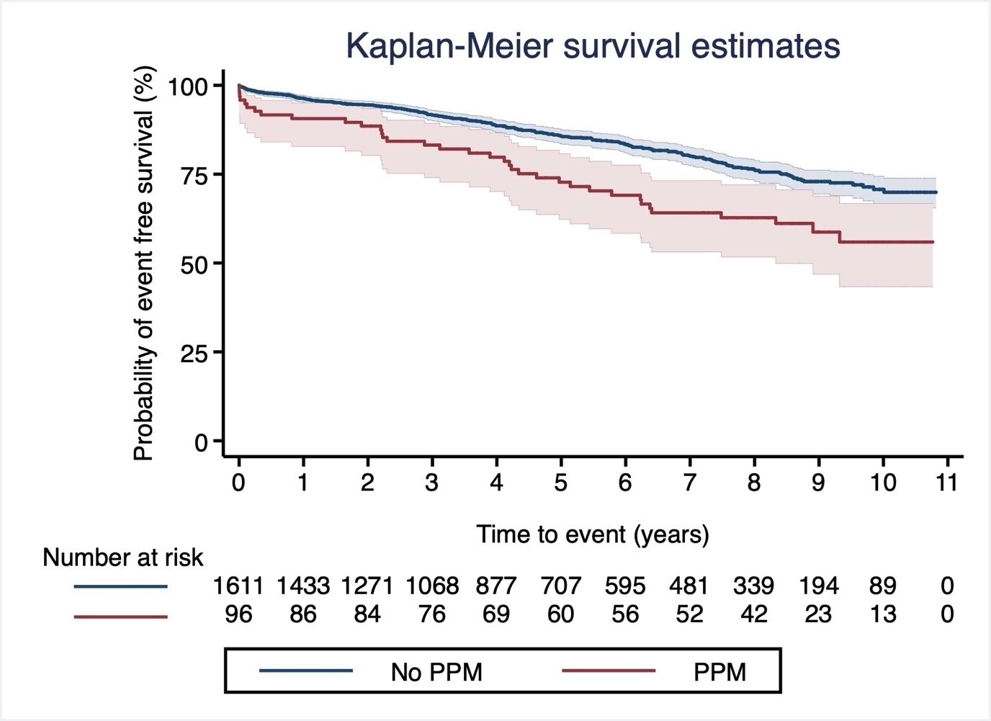

Figure 2. In 1707 patients undergoing low-risk, first-time isolated AVR operations, PPM was independently associated with all-cause mortality at long-term follow up, with more than 2-fold reduction in survival compared to no-PPM. As PPM should ideally be avoided in every patient undergoing AVR, we propose that all patients with an annulus size predictive of a small implanted prosthesis are discussed in SAVA-MDT meeting to explore available options to prevent PPM, including the implantation of newer generation of surgical prosthetic valves, aortic root enlargement in selected patients and TAVI.
AVR: aortic valve replacement, LV: left ventricle, PPM: prosthesis-patient mismatch, SAVA-MDT: Small Aortic Valve Annulus Multidisciplinary Team, TAVI: transcatheter aortic valve implantation
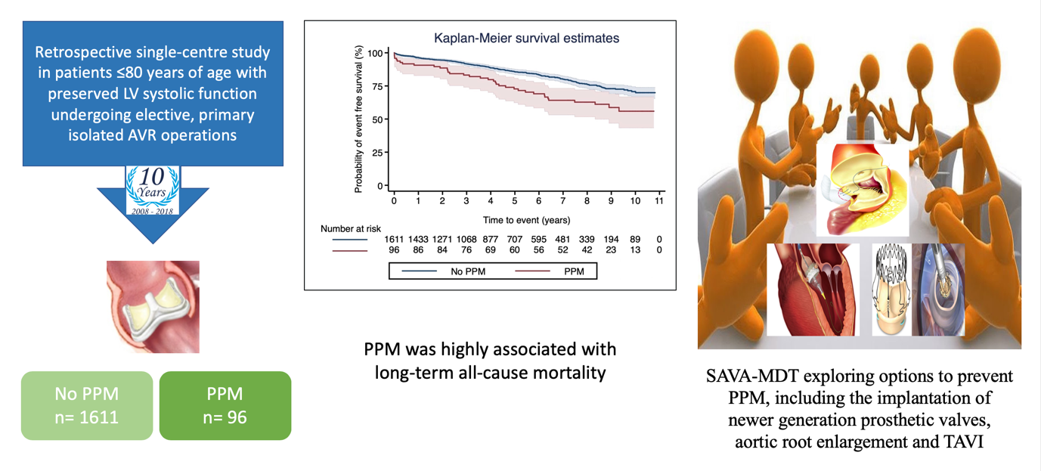

Table 1 Baseline Patient characteristics
 | Whole Group  (n=1707) | PPM  (n=96) | No-PPM  (n=1611) | P Value
Age (yrs) | 68±2 | 71±7 | 68±10 | 0.002
Female | 777 (45.5) | 56 (58.3) | 721 (44.8) | 0.011
Body mass index (kg/m²) | 29±6 | 31±6 | 29±6 | <0.001
Height (cm) | 168±11 | 167±11 | 168±10 | 0.480
Weight (kg) | 83±18 | 88±19 | 82±17 | 0.002
Hypertension | 1012 (59.3) | 64 (66.7) | 948 (58.8) | 0.138
Diabetes | 312 (18.3) | 17 (17.7) | 295 (18.3) | 1.000
Preoperative serum creatinine (µmol/L) | 90±31 | 93±22 | 90±32 | 0.343
Chronic pulmonary disease | 289 (16.9) | 16 (16.6) | 273 (16.9) | 1.000
Peripheral vascular disease | 91 (5.3) | 1 (1.04) | 90 (5.58) | 0.058
Cerebrovascular accident | 41 (2.4) | 3 (3.12) | 38 (2.35) | 0.499
Previous myocardial infarction * | 61 (3.6) | 1 (1.04) | 60 (3.72) | 0.255
Persistent atrial fibrillation | 117 (6.9) | 7 (7.3) | 110 (6.8) | 0.835
Current smoker | 103 (6.0) | 5 (5.2) | 98 (6.1) | 1.000
Valve type
Biological | 1437 (84.2) | 95 (98.9) | 1342 (83.3) | <0.001
Mechanical | 270 (15.8) | 1 (1.1) | 269 (16.7)
Biological Valve size (EOAI)
19 mm (0.911±0.116) | 85 (4.9) | 20 (20.8) | 65 (4.0) | <0.001
21 mm (1.051±0.163) | 395 (23.2) | 44 (45.9) | 351 (21.8) | <0.001
23 mm (1.130±0.168) | 601 (35.2) | 20 (20.8) | 581 (36.0) | 0.002
25 mm (1.213±0.203) | 427 (25.0) | 12 (12.5) | 415 (25.8) | 0.003
27 mm (1.321±0.295) | 153 (8.9) | 0 | 153 (9.5) | <0.001
29 mm (1.892±0.208) | 42 (2.5) | 0 | 42 (2.6) | 0.168
31 mm (2.108±0.246) | 3 (0.2) | 0 | 3 (0.2) | 1.000
33 mm (2.820) | 1 (<0.1) | 0 | 1 (<0.1) | 1.000
Valve size group
<23 mm | 480 (28.1) | 64 (66.7) | 416 (25.8) | <0.001
≥23 mm | 1227 (71.9) | 32 (33.3) | 1195 (74.2) | <0.001
Bypass time (min) | 74±26 | 75±26 | 74±26 | 0.736
Aortic clamp time (min) | 55±17 | 54±16 | 55±18 | 0.618
Indexed effective orifice area | 1.16±0.25 | 0.75±0.08 | 1.18±0.23 | <0.001
Valve pathology
Aortic stenosis | 1625 (95.2) | 84 (87.5) | 1541 (95.7) | <0.001
Aortic regurgitation | 82 (4.8) | 12 (12.5) | 70 (4.3)
Left ventricular ejection fraction (%) † | 61±6 | 60±7 | 61±6 | 0.275
Aortic valve mean pressure gradient (mmHg) † | 56±14 | 55±16 | 56±14 | 0.294
Left ventricular end diastolic diameter (mm) † | 54±7 | 54±6 | 54±7 | 0.546
EuroSCORE | 5.4±1.9 | 5.9±1.6 | 5.4±1.9 | 0.004
Logistic EuroSCORE | 5.1±3.5 | 5.7±3.3 | 5.1±3.5 | 0.075
Reoperation for any reason ‡ | 27 (1.6) | 26 (1.6) | 1 (1.0) | 1.000
Pacemaker placement during index admission | 51 (2.9) | 50 (3.1) | 1 (1.0) | 0.361
Values are mean ± standard deviation or n (%). Chronic pulmonary disease defined as long term use of bronchodilators or steroids for lung disease. EOAI: indexed effective orifice area.
* All patients included in this study had unobstructed coronary arteries, as detected by coronary angiography, requiring no intervention at the time of aortic valve replacement operations.
† Measured by transthoracic echocardiography within the 3 months preceding surgery. Left ventricular ejection fraction values correspond to all patients in the study. Aortic valve mean pressure gradient values correspond to patients with aortic stenosis pathology (n=1625). Left ventricular end diastolic diameter values correspond to patients with aortic regurgitation pathology (n=82).
‡ Reoperation reasons include structural valve degeneration, valve thrombosis or infective endocarditis.

Table 2 Prosthetic valve distribution (n=1707)
Prosthesis Type | Number (%)
Mechanical | 270 (15.8)
ATS | 175 (10.2)
St. Jude Medical Regent | 95 (5.6)
Biological * | 1437 (84.2)
Carpentier-Edwards Perimount | 58 (3.4)
Carpentier-Edwards Perimount Magna | 949 (55.6)
Carpentier-Edwards Standard Porcine | 30 (1.7)
Medtronic Hancock | 36 (2.1)
Medtronic Hancock II | 27 (1.6)
Medtronic Mosaic | 29 (1.7)
Sorin Mitroflow | 202 (11.8)
St. Jude Medical Epic | 100 (5.8)
St. Jude Medical Trifecta | 6 (0.3)
* Eight types of biological valves were used because the study was conducted over 10 years period. Also, the introduction of newer valve generations and the fact that many surgeons were involved in the study had contributed to the variety of valves used.

Table 3 Values of expected effective orifice areas (EOA) for the different aortic valve prostheses implanted
Valve prosthesis | Number (%) | 19 mm | 21 mm | 23 mm | 25 mm | 27 mm | 29 mm | 31 mm
Mechanical | 270 (15.8)
ATS | 175 (10.2) | 1.55 | 2.02 | 2.56 | 3.17 | 3.84 | 4.59 | 5.53
St Jude Medical Regent | 95 (5.6) | 1.70 | 2.0 | 2.50 | 2.60 | 3.50 | 4.0 | -
Biological | 1437 (84.2)
Carpentier-Edwards Perimount | 58 (3.4) | 1.22 | 1.82 | 1.96 | 2.12 | 2.38 | 2.66 | -
Carpentier-Edwards Perimount Magna | 949 (55.6) | 1.58 | 1.90 | 2.07 | 2.33 | 2.38 | 2.84 | -
Carpentier-Edwards Standard Porcine | 30 (1.7) | 1.0 | 1.1 | 1.3 | 1.5 | 2.0 | 2.1 | -
Medtronic Hancock II | 63 (3.7) | - | 1.2 | 1.4 | 1.6 | 1.8 | 2.0 | -
Medtronic Mosaic | 29 (1.7) | 1.02 | 1.13 | 1.56 | 1.80 | 1.97 | 2.22 | -
Sorin Mitroflow | 202 (11.8) | 1.60 | 2.0 | 2.30 | 2.50 | 2.70 | - | -
St. Jude Medical Epic | 100 (5.8) | 1.44 | 1.57 | 1.69 | 1.81 | 1.93 | - | -
St. Jude Medical Trifecta | 6 (0.3) | - | 1.63 | 1.81 | 2.02 | 2.20 | - | -

Supplement figure 1: KM survival estimates on matched data
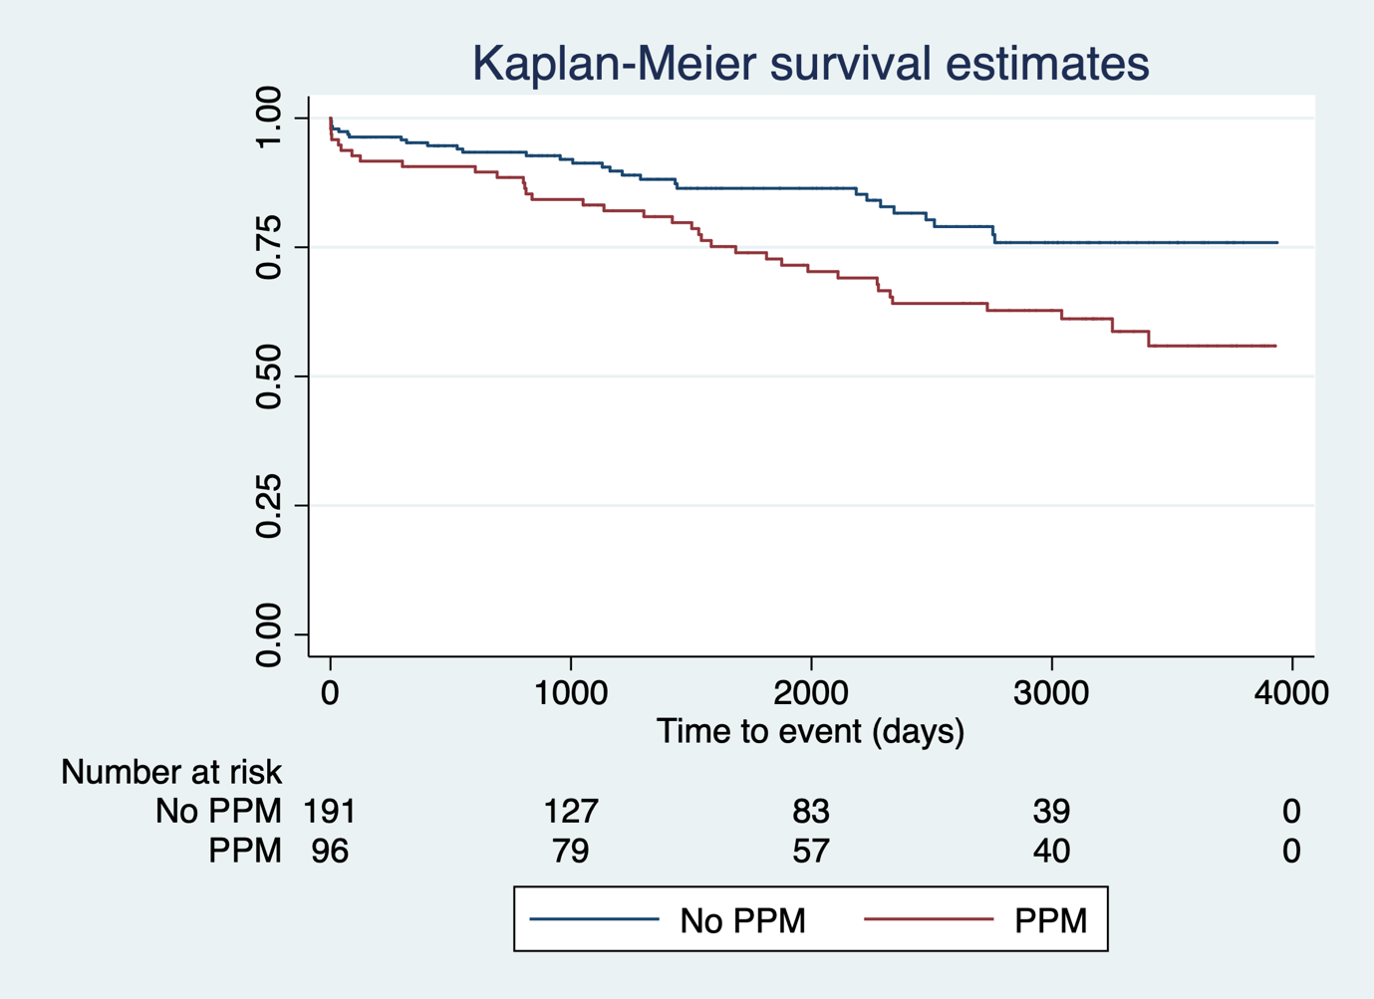
Log rank P – 0.008

Supplement figure 2: Diagnostics for Propensity Matching
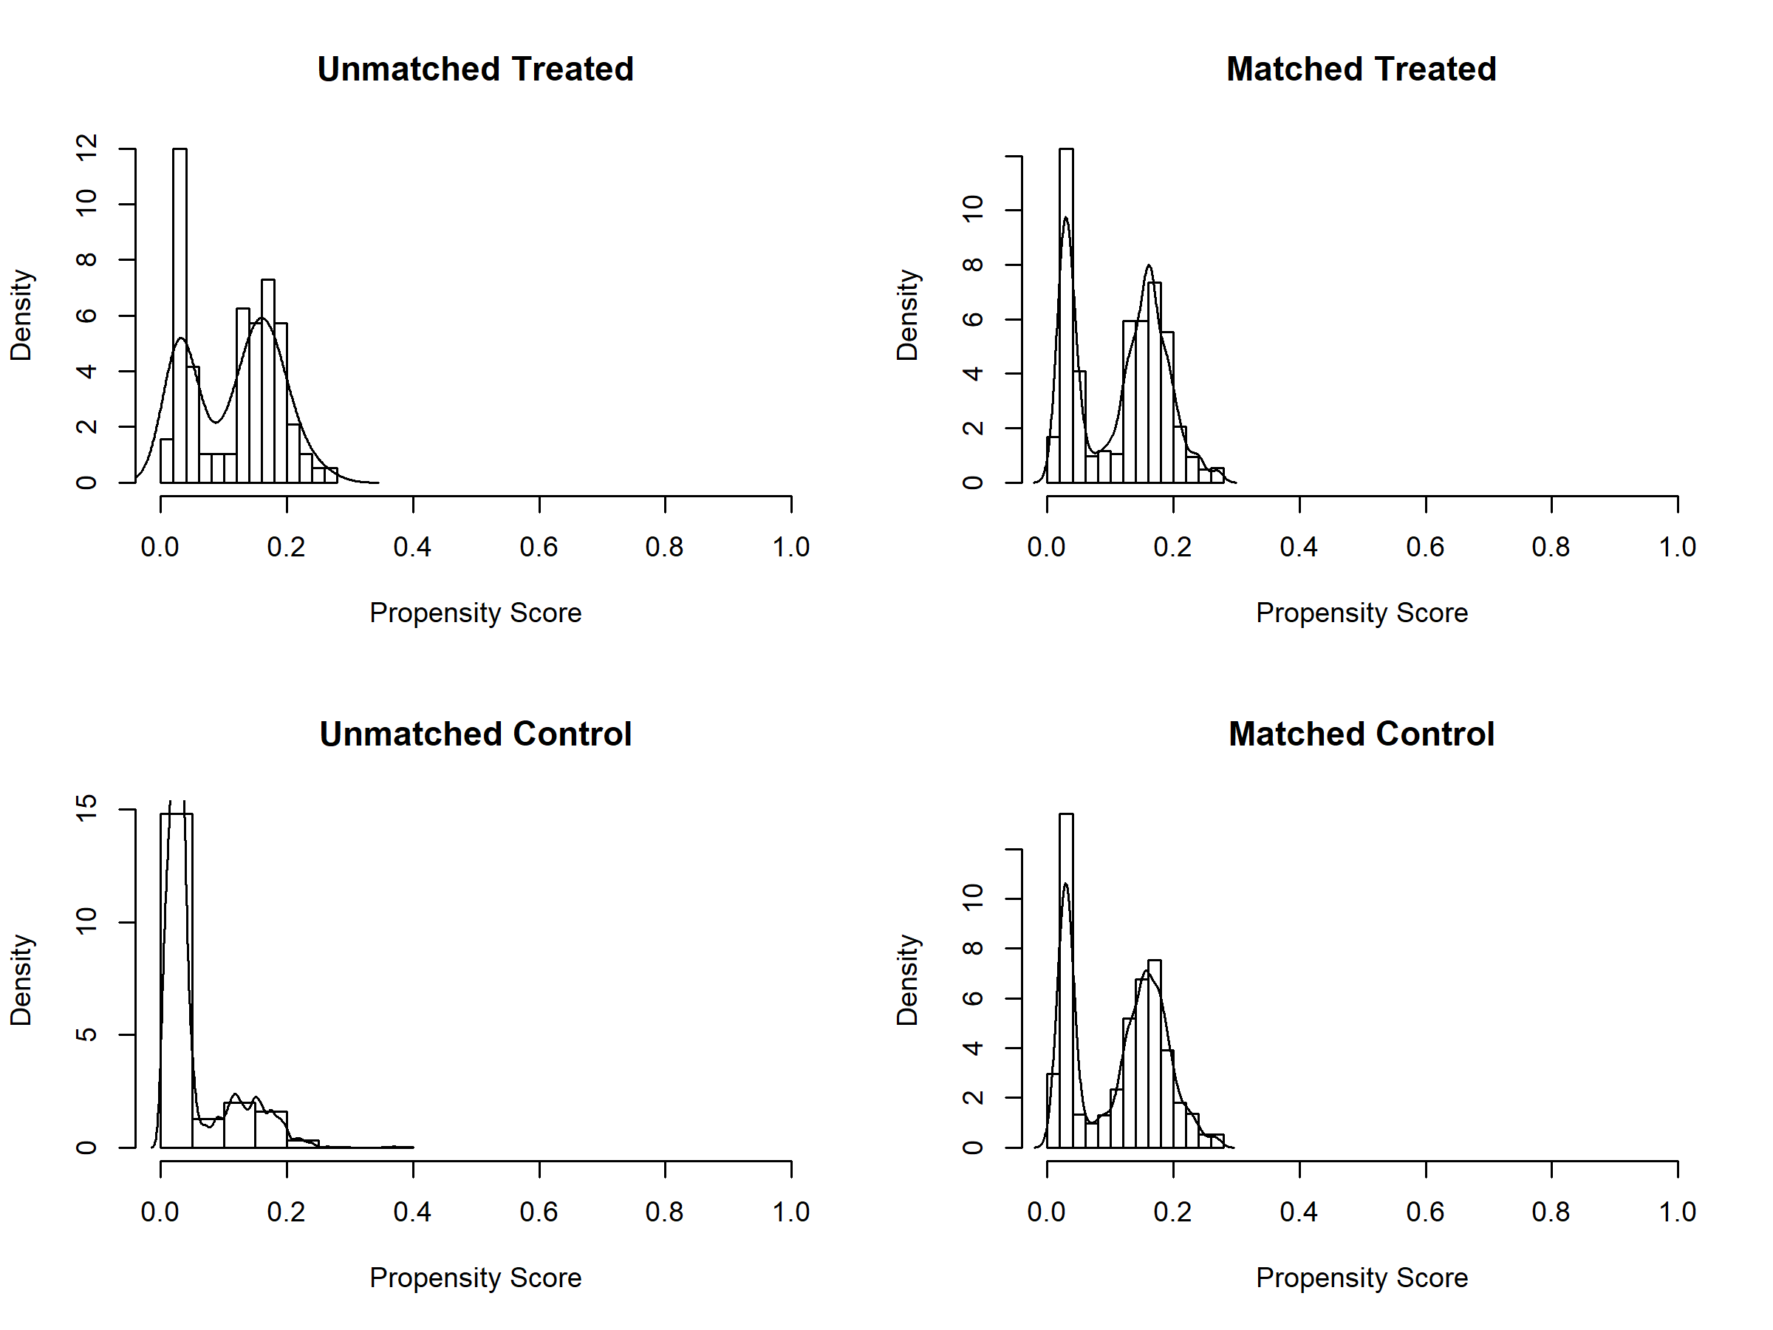

Supplement figure 3: Standardized difference before and after propensity matching
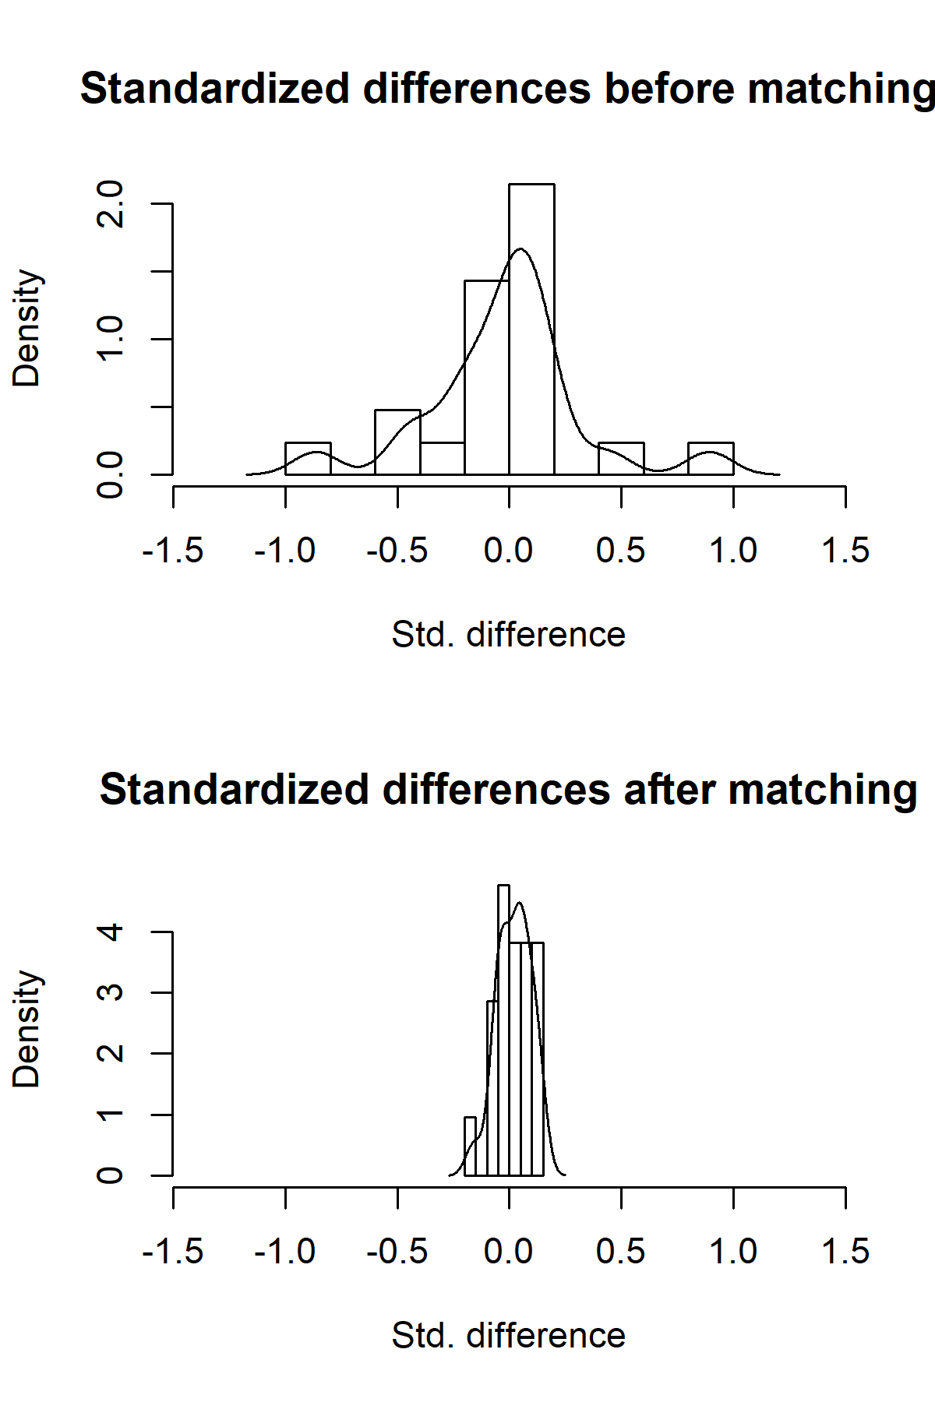
Supplemental table 1: Factors associated with long-term all-cause mortality using univariate hazard regression model of Cox

 | Hazard Ratio  (95% confidence interval) | P Value
Age | 1.06 (1.05-1.08) | <0.001
Female | 1.21 (0.96-1.53) | 0.113
Body mass index | 1.03 (0.01-8.11) | 0.170
Hypertension | 1.50 (1.17-1.93) | <0.001
Diabetes | 1.94 (1.49-2.53) | <0.001
Preoperative serum creatinine | 1.008 (1.006-1.009) | <0.001
Chronic pulmonary disease | 1.59 (1.21-2.10) | 0.002
Peripheral vascular disease | 1.64 (1.04-2.59) | 0.047
Cerebrovascular accident | 1.30 (0.65-2.63) | 0.478
Previous myocardial infarction | 1.95 (1.12-3.42) | 0.033
Persistent atrial fibrillation | 2.42 (1.71-3.42) | <0.001
Current smoker | 1.31 (0.85-2.03) | 0.238
Biological valve size <23 mm | 0.81 (0.64-1.04) | 0.095
Bypass time | 1.004 (1.0003-1.008) | 0.044
Aortic clamp time | 1.004 (0.997-1.01) | 0.273
Aortic stenosis | 1.25 (0.94-1.66) | 0.111
Aortic valve mean pressure gradient | 1.21 (0.77-1.98) | 0.549
Aortic regurgitation | 0.64 (0.37-1.09) | 0.178
Left ventricular end diastolic diameter | 0.87 (0.23-1.32) | 0.487
Left ventricular ejection fraction | 1.47 (0.28-2.94) | 0.329
EuroSCORE | 1.32 (1.25-1.40) | <0.001

Supplement table 2: Propensity score-matched analysis with average treatment effects
Outcome | Statistics | OR/HR | (95% CI) | P Value
Long-term all-cause mortality | Logistic regression analysis | OR∗:3.71 | 2.02 – 6.80 | <0.001
 | Cox regression analysis | HR∗: 2.03 | 1.22 – 3.39 | 0.006

∗ Adjusted for age, hypertension, diabetes, preoperative serum creatinine, chronic pulmonary disease, peripheral vascular disease, atrial fibrillation, previous myocardial infarction, prosthesis size <23 mm, EuroSCORE and bypass time.

Supplement table 2: Post Match baseline differences between two groups

Variables | No PPM (n- 191) | PPM (n- 96) | P-value
Age (SD) | 71.80 (6.05) | 71.32 (7.54) | 0.28
Hypertension (%) | 64.40 | 66.67 | 0.70
Diabetes (%) | 14.66 | 17.71 | 0.50
Creatinine (SD) | 85.46 (38) | 89.77 (27) | 0.84
H/O COPD (%) | 12.04 | 16.67 | 0.28
H/O PVD (%) | 1.05 | 1.04 | 0.99
H/O AF (%) | 7.85 | 7.29 | 0.86
H/O MI | 1.05% | 1.04% | 0.99
Valve size group <23 (%) | 63.87 | 66.67 | 0.64
Valve size group >23 (%) | 36.13 | 33.33
EuroSCORE (SD) | 5.95 (1.46) | 5.99 | 0.58
Bypass time (min) | 75.92 (24) | 75.23 | 0.41

