District energy system modeling and optimal operation considering CHP units dynamic response to wind power ramp events

**Abstract**: With the increase in clean energy penetration, its power curtailment during operation is made increasingly evident. In this circumstance, it is imperative to address the conflict between inflexible combined heat and power (CHP) units and variable wind and solar power. In this paper, a novel coordinated optimal operation strategy of a district energy system with CHP, wind power and energy storage is established with the following characteristics: the optimal installed capacity of electric energy storage (EES) is determined to smooth the high frequency fluctuation of wind power generation; the CHP units achieve dynamic response to wind power ramp events timely after EES smoothing; and the CHP model with start-stop and dynamic response mechanism is able to reduce the installed capacity of electric boiler (EB) significantly. One-week operation data is adopted in the case studies to increase the reliability of simulation results. The simulation results show that with EES integration, high frequency wind energy curtailment is reduced, the capability of peak regulation and power ramp of CHP units is enhanced by start-stop and the proposed dynamic response mechanism and environmentally sustainable and socially resilient cities is promoted.

*Keywords*: district energy system; optimal operation; wind power ramp events; dynamic response; start-stop strategy.

## 1. Introduction

### 1.1 Motivation and problem description

Development of clean energy resources such as wind energy has grown rapidly in the world over the last decade (Alkhalidi et al., 2018). Among the clean energy resources, wind generation occupies a remarkable portion of the renewable generations in energy distribution management, due to high energy efficiency, zero carbon emissions and low operating costs (Alrashed, 2020). In some European countries, Denmark has the ambitious goal of achieving 100% renewable electricity and heating sectors by 2035 and Finland as a leading country in RES has decided to increase their RES share to 38% by 2020 (Salomón et al., 2011). However, in the northeast of China, wind farms produced almost 20% less electricity, and a major factor for the low efficiency of wind farms results from significant curtailments of wind power. Besides, the proportion of heat supply units in CHP units is high due to the long winter heating period (Wang et al., 2016). Therefore, to satisfy the high heat load level, coal-fired CHP plants are the main sources for providing load demands of district heating in winter, which still occupies an irreplaceable position in generator units. While the poor ramp capability of CHP units increases the difficulty in response to wind power ramp events timely (Wang, Lahdelma, Wang, Jiao, Zhu, & Zou, 2015). The wind power generation has rapid fluctuation and large amplitude, and the CHP units cannot respond to the high frequency band of wind power ramp events. Therefore, large-capacity EES devices are widely used in district energy system optimal operation to compensate the high frequency band of wind power generation. Besides, most optimal operation problems usually select the data from one day for the simulation and take one day as the time scale, which makes the simulation results non-universal (Chen, McElroy, & Kang, 2018). Moreover, due to the high cost of large-scale investment in EES equipment, how to enhance the capability of peak regulation and power ramp of CHP units, and to choose optimal small installed capacity of EES device to smooth high frequency band of wind power generation on a long time-scale have become urgent highlights in the process of building a green and sustainable society for the future (Yang et al., 2020).

### 1.2 Literature review

EES devices can improve the flexibility of system operation greatly due to its operation flexibility and quick response to wind power ramp events. Although there are plenty of references in this research, some deficiencies still need to be further improved. As for modeling part, in (Nasrolahpour et al., 2018), a stochastic bi-level optimization model was proposed, considering the interactions between the storage facility and the wind farms, and the existing market opportunities for the storage facility. Besides, the work in (Li, Yang, Li, Zhao, & Tian, 2019) presented a new optimal scheduling mode for minimizing the operating costs of an isolated microgrid (MG) by using chance-constrained programming. Wind power generation uncertainty was also considered as probabilistic constraints to optimize the EES allocation. In above articles, during EES allocation process, the ability that EES can smooth high frequency band of initial wind power fluctuation wasn’t taken into consideration. As for model solution part, many approaches have been investigated to realize wind power ramp control with EES. (Wen et al., 2015) proposed a solution using hybrid multi-objective particle swarm optimization (HMOPSO) to allocate the EES for minimizing wind-penetrated power system operation cost. The uncertainty of wind power was also considered as an essential part of the cost probability optimization problem to determine the EES placements and sizes. In addition, a basic first-order low-pass filter (FLF) with a fixed time constant was applied in (Liu， Gong， Geng，& Jiang， 2019) to regulate the EES power and energy to smooth wind power. These two articles didn’t propose a control strategy on time scale aiming at charging or discharging of EES devices either. As for peak regulation ability of EES devices, the value of EES system in shifting wind generation, limiting the ramp rate of wind generation locally, participating in the market and providing operating reserve has been analyzed in (Gong, Baldick, & Jiang, 2015). However, this article only considered the impact that EES can smooth fluctuations in high frequency wind power generation on electric power system (EPS), which made the analysis limited and uncertain. Thus, in overall energy system, setting proper installed capacity and adopting appropriate charging and discharging control strategy at different times are vital for EES devices to mitigate wind power fluctuation and reduce the wind power curtailment which CHP units cannot compensate.

There exist a large number of references about energy distribution and optimal operation in district energy system, whereas some researches about the peak-shaving ability of CHP unit still need further study. The energy system analysis model EnergyPLAN composed of CHP units and wind turbines was presented in (Lund & Münster, 2003), which has been used to analyze the integration of large-scale wind power into the national Danish electricity system. Nevertheless, CHP units’ response to wind power ramp events has never been mentioned in this paper. In some conventional power ramp constraints of CHP units (Dolatabadi, Jadidbonab, & Mohammadi-Ivatloo, 2018), the threshold of power ramp was a fixed value in the whole dispatch period, which limits the response ability of CHP units to wind power ramp events in time. In addition, a model for operating a CHP system and a wind farm as a portfolio was proposed in (Anna et al., 2015), which demonstrated that the flexibility of the CHP system can be used to balance the fluctuations in wind power production. Therefore, promoting the flexibility of CHP units performs an important function on peak load regulation in overall energy system, which needs to be studied further.

To enhance the capability of peak regulation, the CHP units in (Chen et al., 2015) were equipped with EB and thermal energy storage (TES) to satisfy both heat and power load demands. Otherwise, except for EB and TES devices, in (Rinne & Syri, 2013), ground source heat pumps (GSHP) and CO2 emission factors of CHP in district heating system (DHS) in Finland’s energy system was calculated, based on hourly data at present and in various future scenarios. Besides, the results showed that CHP units equipped with heat pumps not only could help reinforce peak regulation capacity but also help reduce CO2 emissions. Furthermore, a CHP-DH system with clean energy resources and EES devices was proposed in (Wang, Yin, Abdollahi, Lahdelma, & Jiao, 2015) to promote the penetration of clean energy resources, approach the climate change mitigation target in the context and build green and sustainable cities. However, the above articles have all overlooked a question that due to the poor ramp response capability of CHP units, serious wind power curtailment still existed in order to balance power and heat in energy system. Although，the study in (Li, Xing, & Peng, 2018) established a CHP dispatch model for better integration of wind power based on electric boiler with thermal storage (EBTS), the question of how to balance CHP units’ power output, the installed capacity of EB and overall cost of system has not been resolved yet. Thus, the reasonable start-stop strategy of CHP units needs to be taken account to resolve above problems.

With regard to the accuracy and representativeness of simulation results, the research in (Vasilj, Gros, Jakus, & Zanon, 2019) presented a model for day-ahead scheduling of the combined heat production and electric energy production for a residential microgrid, whereas only several sets of day-ahead predicted values were applied to trial tests. In another research (Tavakoli et al., 2018), a two-stage energy management strategy for the contribution of electric vehicles in response programs of commercial building microgrids was addressed. However, only day-ahead and hour-ahead values were selected to make rolling optimization simulations. Moreover, in the case study of (Cheng, Wei, Wang, & Bi, 2019; Chen et al., 2018; Li, Xing, & Peng, 2018；Shakouri G. & Kazemi, 2018), only the typical-day data were applied in the simulation experiments, which made the simulation result not persuasive since one-day data was not representative. For example, there are have major differences in characteristics of load demands between weekday and weekend. Therefore, at least adopting one week’s data can increase the reliability of simulations to make results accurate.

### 1.3 Contributions and paper organization

The motivation of this paper is to achieve that the installed capacity of EES devices account for a small proportion of the wind power generation, and that the CHP units can increase the capability of peak regulation, achieve dynamic responses to the wind power ramp events timely but maintain its basic power output at a lower level, which can promote environmentally sustainable and socially resilient cities. The main contributions of this paper are: (1) A charging and discharging optimal control strategy of EES devices is proposed and the proper installed capacity of EES is determined to smooth high frequency band of original wind power generation and then promote the stability of electrical power system；(2) The dynamic power ramp constraints of CHP units are addressed to limit the power ramp rate of CHP at any time period and the CHP units are also fitted with EB devices, both of which conditions can better achieve dynamic response to wind power ramp events and be effective in improving the flexibility of regulating peak-shaving; (3) Taking account of the start-stop constraints, the power and heat output becomes lower and more stable, and the installed capacity of EB devices as well as overall cost of system are significantly reduced, which is beneficial to build green communities; (4) To make the simulation results more representative and persuasive, one-week wind and load data which has characteristics of weekdays and weekends is adopted for simulation experiments rather than only one-day data.

The rest of the paper is organized as follows: the district energy system optimization model is established in Section 2. Afterwards, the simulation results are obtained in Section 3, including smoothing initial wind power by EES and the contrast of CHP unit with or without start-stop strategy. Finally, Section 4 draws the conclusions. The schematic diagram of the research content in this paper is shown in Fig. 1.

Fig. 1 Schematic diagram of the research content in this paper

## 2. District energy system optimal operation modeling

To achieve thermoelectric decoupling and to enhance the flexibility of the power supply structure, EBTS are essential in district energy systems (Cheng, Wei, Wang, & Bi, 2019). Because of its sensitive response and urgent need for emergency use, the energy storage (ES) can be used to accommodate the remaining electrical and thermal load in the energy system except for the output power and heat by wind, solar, EBs and CHP units (Merlin, Delaunay, Soto, & Traonvouez, 2016). However, the cost of EES equipment is high, and thus a small capacity of EES device are adopted in this model. Coupling power with thermal energy sectors, CHP plants play an important role in providing flexibility in terms of dispatch of heat production and balancing power systems with high penetration of intermittent renewable like wind power (Liu et al., 2016). However, the CHP units in Fuxin city, located in the northeast of China are mostly coal-fired units, which has increased the pollutant emission such as CO2. Moreover, the CHP units usually have the characteristics of stable operation, poor flexibility and poor capability of peak regulation. Therefore, the maximum power output of the CHP units is limited in this model, and the steady operation at base load is maintained as much as possible. In response to the need for green, low-carbon, and sustainable development, this model has increased the penetration of renewable energy sources to achieve the target of making CESs fully consumed (Ghadikolaei, et al., 2012).

### 2.1 Objective function

In economic dispatch with district energy system, the objective function of this paper composed of four parts is as follows:

|  |  |
| --- | --- |
|  | (1) |

where,  is the total cost; is the penalty term about smoothing wind power;  is EES operation cost; is the fuel cost of CHP units;  is the start-stop cost of CHP units. Each cost will be described in detail as follows.

(1) Cost of smoothing wind power fluctuation:

To ensure that the ramp rate of combined wind power output is within the threshold value, the objective function of smoothing wind power is determined:

|  |  |
| --- | --- |
|  | (2) |

where,denotes the penalty factor for wind power ramp; *PRval* is the threshold value;  is the expected combined wind-storage output power at time *t*;  is the expected combined wind-storage output power at time . A large penalty factor ofwill ensure that the wind power ramp limitcan be minimized first in the optimization process. As the actual regulation is ambiguous in practice, the

penalty factor we adopted in the following analysis is set as 1000 (SCE/kWh), sufficiently large to give priority to satisfy this limitation.

(2) EES devices operation cost

Due to the high operation cost of EES devices, another objective function related to EES operation is as below

|  |  |
| --- | --- |
|  | (3) |

where, ‘a’ and ‘b’ are the power-specific investment cost ($/kW) and energy-specific investment cost ($/kWh);  is the maximum output of EES devices at time *t*;  is the maximum storage capacity of EES at time *t*; *ce* is the operating cost factor ($/kWh),is the absolute value of EES’s charging or discharging power(>0, discharging,<0, charging). With larger charging or discharging value, the operation costis higher, and vice versa. Thus, the operation cost is proportional to the charging or discharging power.

(3) Fuel cost of CHP unit

The fuel cost of a CHP unit is determined jointly by its power and heat production, and the typical cost function is quadratic. Therefore, the overall fuel cost varies quadratically with both power and heat production. To incorporate such non-linear fuel cost, a linear simplification of the quadratic cost function is provided as follows:

|  |  |
| --- | --- |
|  | (4) |

where,  is non-negative value constrained to satisfy; is the fuel cost for the CHP at time *t*; *N* is number of units; *M* is number of corner points of feasible operation region.

(4) Start-stop cost of CHP units

The expression of the cost  caused by the frequent starts and stops of the CHP units is defined (Dong et al., 2009)

|  |  |
| --- | --- |
|  | (5) |

where,  is the start-on parameter;  is the shut-down parameter;  is the cost of start-on once, and  is the cost of shut-down once.

### 2.2 Constraints for district energy system model

#### 2.2.1 Heat and power balance constraints

The heat balance of this district energy system means that the district heat demand is satisfied by CHP and EBTS. Eq. (6) is the heat balance for the system. Similarly, the power balance is written as in Eq. (7).

|  |  |
| --- | --- |
|  | (6) |
|  | (7) |

where,  and  are heat output produced by CHP and EBTS units respectively at time *t*.  is heat demand in this district energy system at time *t*. In Eq. (7), , and  are wind and CHP units power output.  is the discharging or charging power of the EES units at time *t*.  is the power consumed by the EBs as well as  is power demand in this district energy system at time *t*.

#### 2.2.2 Constraints for smoothing wind power by EES

With the increasing penetration of wind generation, the influence of variability and uncertainty on energy system becomes significant and the risk of energy unbalance due to wind power ramp event grows. Besides, the CHP units did not have enough capability to respond continual wind ramp events. Therefore, the continuous support of EES is provided to improve the performance of wind power ramp control and mitigate the rapid fluctuation of wind power output. However, taking into account of the limited capacity of the EES devices, the capability to realize wind power ramp control is restricted within the range of EES unit output. The expected combined output poweris described as follows:

|  |  |
| --- | --- |
|  | (8) |

where,  is wind power output;  is EES power output. Eq. (9) can be obtained by combining Eq. (8):

|  |  |
| --- | --- |
|  | (9) |

where,is equal to,which is the power difference between the wind power output at the current time *t* and the combined wind-storage power output at time . Converted from Eq. (9),. As shown in Eq. (2), the upper limit ofis, and the lower limit ofis. Combined with  and the advanced control strategy, the EES power output value at time *t* is determined as Eq. (10), so that the joint fluctuation of wind-storage power output is within the power ramp limitation (Li, Mo, & Chen, 2019). The charging and discharging optimal control strategy of EES devices is explained as follows:

|  |  |
| --- | --- |
|  | (10) |

where, *k*=1, 2…,, is prospective time cycle and  is time period. When  is within the threshold value under time period between the current moment and the prospective time cycle，the status of the battery remains unchanged. When  exceeds the upper limit at the current time step or  exceeds the lower bound at time , the battery is in a charging state and the charging value is. When  exceeds the lower limit at the current time step or  exceeds the upper bound at time , the battery is in a discharging state and the discharging value is . Under the ideal condition, it is assumed that the initial storage level equals to the storage level at the end of the planning horizon. Specifically, the electric energy storage level at current time step *t* is affected by the storage level at time . The storage efficiency (Wee, Choi, & Vilathgamuwa, 2013) should also be taken into account besides charging or discharging efficiency. The electricity storage balance can be written as in Eq. (11).

|  |  |
| --- | --- |
|  | (11) |

For different states of EES devices, the expressions of charging and discharging efficiency are as follows:

|  |  |
| --- | --- |
|  | (12) |

The operation constraints of EES are as follows:

|  |  |
| --- | --- |
|  | (13a) |
|  | (13b) |
|  | (13c) |

The optimized joint wind-storage power output  solved above is used as a new wind power output for subsequent joint synergetic dispatch in the district energy system.

#### 2.2.3 CHP unit dynamic response to wind power ramp events

The conventional power generation units have to be ramped up or even started up frequently to supply system power load demand during a negative wind power ramp event and ramped down or even shut down to fully accommodate wind power. Therefore, taking into account of the capability of peak regulation and being response to wind power ramp event, the extraction type CHP unit is as the preferred object of this paper because of its large adjustment range of power and heat output to achieve dynamic tracking of wind power ramp events. The operational area of the extraction type CHP unit is shown in the red part of Fig.2.

(1) Feasible operational area

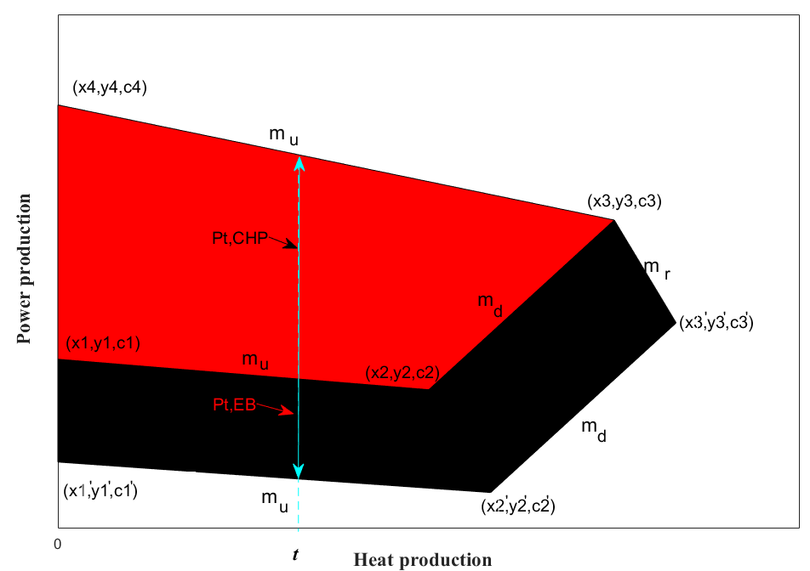

Fig. 2 Schematic diagram of CHP unit operation region

The power production, heat production, and fuel cost of the corner point *i* (intersection of the boundaries) are defined as (*xk,y~~k~~,ck*). Besides, the heat and power production of the CHP at time *t* are coupled. As any point within the area can be represented by the convex combination of corner points (Lahdelma & Hakonen, 2003), the relationship between power production, heat production, fuel cost, and the coordinates of the corner points are expressed by

|  |  |
| --- | --- |
|  | (14a) |
|  | (14b) |
|  | (14c) |

where,  and  are power and heat production of CHP unit. As is shown in Fig.2, introducing EB to operate in parallel with the CHP unit will expand the overall heat and power production area. The equivalent heat and power production from CHP unit when coupled with an EB devices are expressed as:

|  |  |
| --- | --- |
|  | (15a) |
|  | (15b) |

where,  is the equivalent power output after adding EB, and  is the equivalent heat output after adding EB.

(2) Heat and power production constraints

From Fig. 2, the heat and power output adjustable range of the CHP unit are presented as follows:

|  |  |
| --- | --- |
|  | (16a) |
|  | (16b) |
|  | (16c) |

After adding the EB, the equivalent heat and power production constraints are as below:

|  |  |
| --- | --- |
|  | (17a) |
|  | (17b) |
|  | (17c) |

(3) Constrains of dynamic response to wind power ramp events

In order to achieve dynamic tracking of wind power ramp events, in this paper the ramp rate of CHP units is not set as constant, while it will change with the different wind power ramp values. The control strategy is as follows:

|  |  |
| --- | --- |
|  | (18) |

When wind power experiences a negative ramp event, the CHP units has to be ramped up, and the ramp up rate is larger than the negative of wind power ramp down value. On the contrary, when wind power experiences a positive ramp event, the CHP units has to be ramped down, and the ramp down rate is less than the negative of wind power ramp up value (the ramp up value is positive, and the ramp down value is negative). After adding the EB, the equivalent power ramp formula is defined as:

|  |  |
| --- | --- |
|  | (19a) |
|  | (19b) |

where, *k*=1, 2…,  (positive number) is the ramping-up limit of the equivalent CHP power ramp event, and  (negative number) is the ramping-down limit of the equivalent CHP power ramp event.

(4) CHP units start-stop constraints

Since the CHP units restricted by the higher lowest output, in order to further enhance its peak regulation flexibility, the CHP units start up and shut down strategy is introduced in the following

|  |  |
| --- | --- |
|  | (20a) |
|  | (20b) |

where, *k* is the number of CHP units, and  is operating status of the *k*th unit (1 is running, 0 is stopped). When , it means the *k*th unit is start on. On the contrary, when , it means the *k*th unit is shut down. Besides, the operating state after start-on and the stop state after shut down are maintained for at least 2 hours.  should satisfy the following constraints.

|  |  |
| --- | --- |
|  | (21a) |
|  | (21b) |
|  | (21c) |

(5) EBTS operation constrains

The EBTS consists of EB and TES is adopted in this paper to achieve peak load shifting. When wind curtailment appears, the EB device will operate at maximum power to accommodate wind power generation, and the heat output of EBTS is controlled by changing the endothermic and exothermic rates of TES devices. There is a proportional relationship between the power consumption and the heat output of the EB device.

|  |  |
| --- | --- |
|  | (22) |

The start-stop of EB is defined as:

|  |  |
| --- | --- |
|  | (23) |

where, ST is the operating status of EB (1 is running, 0 is stopped), and is the power load demand at the time *t*. The full-time heating capacity of EB is realized by TES. Therefore, TES is affected by the operating status of EB. In the EB operation period, the heat production of EB is absorbed by TES devices. In the other period, the thermal energy of TES is supplied outwardly until the amount of heat storage is 0. In addition, the endothermic and exothermic rates are adjusted based on the regulating peak thermal demand. The thermal energy storage balance of EBTS is defined as

|  |  |
| --- | --- |
|  | (24) |

where,  is the stored thermal energy at  moment;  is the self-exothermic efficiency of EBTS devices;  is the exothermic efficiency; and  is the endothermic efficiency at time *t*. In this model, the heat stored in EBTS devices should be always larger than the heat released. The constraints of EBTS are as below:

|  |  |
| --- | --- |
|  | (25a) |
|  | (25b) |
|  | (25c) |

As a brief summary, the objective functions of the proposed model are shown in (1-5), and the constraints are shown in (6-7), (11-13), (16-21) and (23-25).

## 3. Case study

In the case study, the installed capacity of generator units is designed according to a real city ‘Fuxin’ from the northeast of China. The configuration of this paper refers to the actual installed capacities of wind farm, thermal plant, EES and EB as well as local residents’ load demands in Fuxin. The detailed configuration in this paper’s simulation model is shown in Table 1. Besides, this model is solved by ‘Cplex’ and ‘Yalmip’ solvers in MATLAB (Sun, Bie, & Zhang, 2016).

|  |  |  |  |  |  |  |  |
| --- | --- | --- | --- | --- | --- | --- | --- |
| Scenario | Installed capacity of each generator and load (MW) | | | | | | |
| Wind | EES | CHP | EB | TES | Power load | Heat load |
| 1 | 250 | 15 | / | / | / | / | / |
| 2 | 250 | 15 | 200 | 250 | 250 | 120 | 100 |
| 3 | 250 | 15 | 100*2 | 200 | 200 | 120 | 100 |

Table 1 List of installed capacity data in each scenario

Scenario 1 (S1) is the simulation of smoothing wind power fluctuation by EES device. Scenario 2 (S2) is the simulation of CHP units’ dynamic response to wind power ramp events. Scenario 3 (S3) is the simulation of optimal operation of CHP units with start-stop strategy.

### 3.1 Simulation of smoothing wind power fluctuation by EES device

In S1, the simulation results of smoothing wind power fluctuation are based on proposed control method of Eq. (10). Fig. 3 shows the initial and target wind power curve based on one-week data from 2018/12 /10 to 12/16.



Fig. 3(a) Comparison of the initial and target wind power generation curve for one week



Fig. 3(b) EES power output curve for one week

From Fig. 3(a), it can be seen that in comparison of the two curves, the high frequency fluctuations in the target wind power generation curve have been reduced after smoothing strategy according to Eq. (2) and (10). As is shown in Fig. 3(b), on account of the restricted capacity of EES devices, to achieve the target wind power generation, the EB device accommodate the remaining wind power that the EES cannot smooth. In this simulation, the proportion of EES is 6% of the initial wind power generation, which indicates that the installed capacity of EES is small in the district energy system. Since the small installed capacity of EES can smooth the high frequency fluctuation of the initial wind power curve, the amount of wind power curtailment in high frequency band reduces. In general, the total reduction is 2948.16MW·h. For further analysis of the effect that EES to mitigate wind power fluctuations, Day 6 is selected for detailed discussion. The following figures show the two wind power curves and EES power output on Day 6.

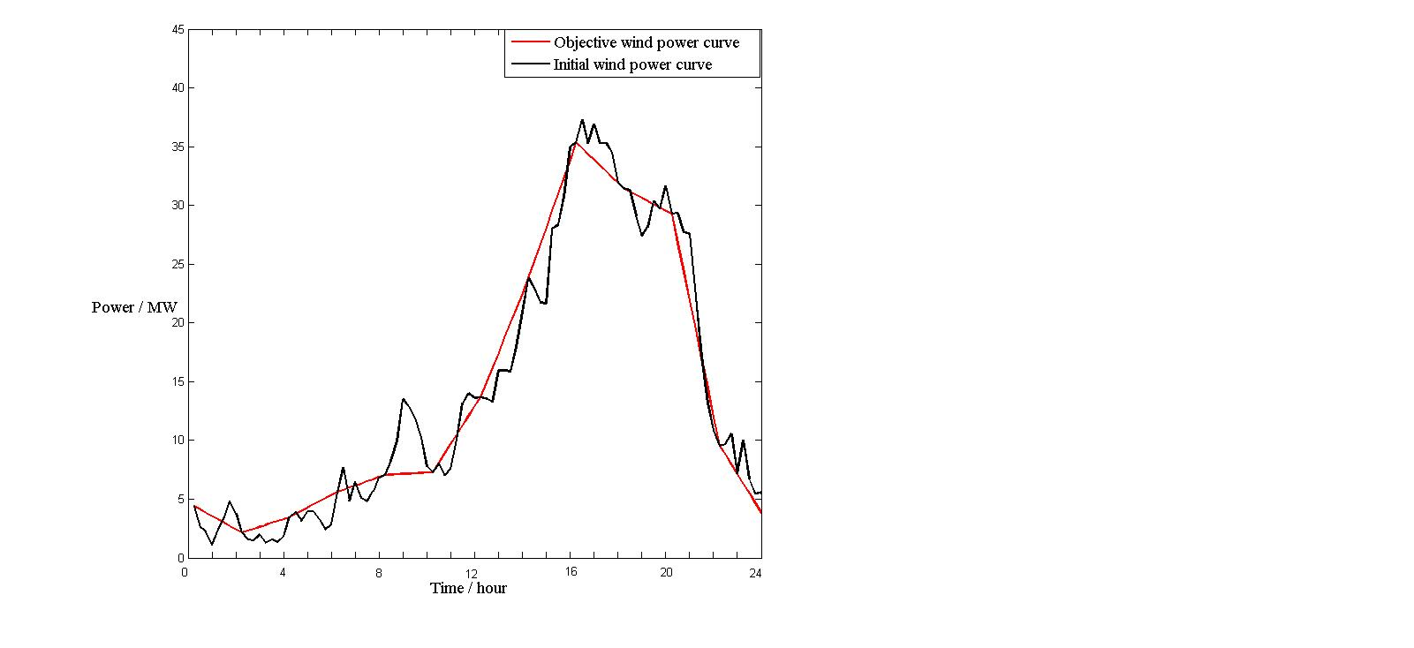

Fig. 4(a) comparison of the initial and target wind power generation curve on Day 6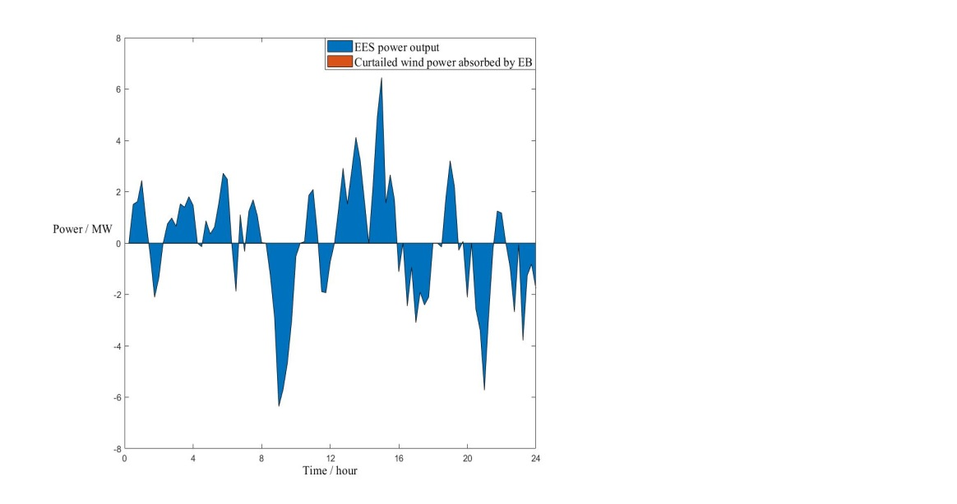

Fig. 4(b) EES power output curve on Day 6

From Fig. 4(a), the initial wind power generation curve fluctuates around the target curve. At 8 a.m. on Day 6, when the actual wind power curve is over the target wind power curve, the EES devices begin to charge. Meanwhile, at the corresponding moment in Fig. 4(b), the value of EES power output is negative to decrease the wind power output. When the time reaches 12 p.m., the actual wind power output curve is less than the target wind power curve, and the EES devices begin to discharge. At the same time, the value of EES power output positive to increase the target wind power output. Since the difference value between the two wind curves is within the capacity of EES devices, there is not curtailed wind energy which can be absorbed by EB devices. To further analyze the effect caused by EES for smoothing wind power fluctuation, the Fig. 5 shows the ramp rate of the initial and target wind power curves on Day 6.

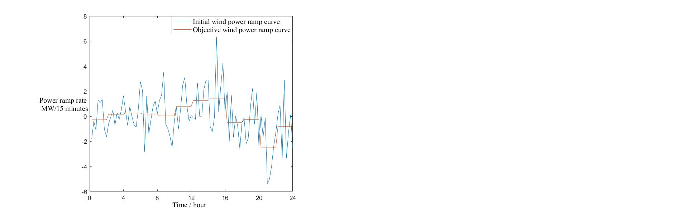

Fig. 5 Initial and target wind power ramp curves on Day 6

As is shown in Fig. 5, the maximum ramp rate of initial curve is almost to 6 MW/15 minutes, and the minimum ramp rate is close to -6 MW/15 minutes. Besides, the amplitude and frequency of initial ramp rate event is larger than the target one. The target curve is relatively stable, which has lower ramp up limits and higher ramp down limits. Thus, the EES devices play a significant role in smoothing wind power fluctuations.

### 3.2 CHP units dynamic response to wind power ramp events

In a district energy system, in order to keep power balance, the power system must offer enough ramping capability to accommodate wind power ramp events. Meanwhile, the heat and power load demand should also be satisfied. To further analyze the ramp capability of CHP units, in Scenario 2, an EB with installed capacity of 250 MW is adopted without start and stop. In the synergetic scheduling optimization of the district energy system, the target wind power rather than initial wind power is adopted in the following simulations. Fig.6 shows the operation region of CHP units before and after adding EB devices, and the initial and the equivalent depth of peak regulation with the different heat output.

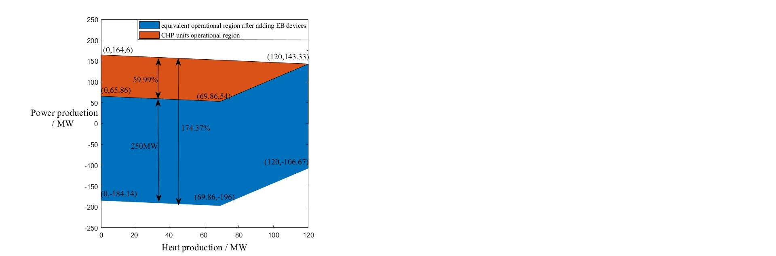

Fig. 6 Initial and equivalent CHP reperational region

As shown in Fig. 6, when the heat production is from 0 to 69.86 MW, the peak regulation capability of CHP units with the 200 MW EB is 98.74 MW, and the depth of peak shaving is 59.99%. Besides, when the heat production is from 69.86 MW to 120 MW, the peak regulation capability reduces from 98.74 MW to 0, and the depth of peak shaving decreases from 59.99% to 0. After adding EB devices, the equivalent capability and the depth of peak regulation both increases. From Fig. 6, when the heat production is from 0 to 69.86 MW, the equivalent ability of peak regulation increases to 309.99 MW, and the depth of peak shaving increases to 174.37%. In Fig. 6, when the power production value starts to be negative, it means that the wind power output is larger than the power load demand. Therefore, the equivalent power output value becomes negative. After adding EB devices, the depth of peak regulation is more than 100%, which means that the combined power output of CHP and EB units in the whole district energy system is in negative state of power generation. In other words, the electricity consumed by EB devices is larger than the electricity generated by CHP units. As the minimum power output of the CHP units is larger, except for satisfying the load demand, an excess of wind power output is consumed by EB devices to keep system power balance. Thus, with the increase of wind power curtailment, the electricity absorbed by EB also increases, which results in negative combined power output.



Fig. 7 Diagram of the ramp rate line for one week

The above analysis shows that adding EB devices will augment the capability and depth of peak regulation. However, to ensure that CHP units can dynamically track wind power ramp events, the ramp rate of CHP units should also be larger than that of wind turbines. Fig. 7 shows ramp rate curves for one week. In this simulation, 10 is ，and -10 is . After smoothing by EES devices, the wind power ramp line tends to be gentle. Compared with the CHP ramp curve, the absolute value of wind turbine ramp is smaller than that of CHP at any time. Besides, when the wind power ramp event is positive, the CHP ramp event is opposite to it, which denotes that the CHP unit makes a dynamic response to wind power ramp events. After adding EB, the absolute value of combined power ramp is larger than the absolute value of CHP power ramp, which also indicates that enlarging the equivalent ramp rate of CHP unit is conducive to achieve dynamic response to wind ramp event.

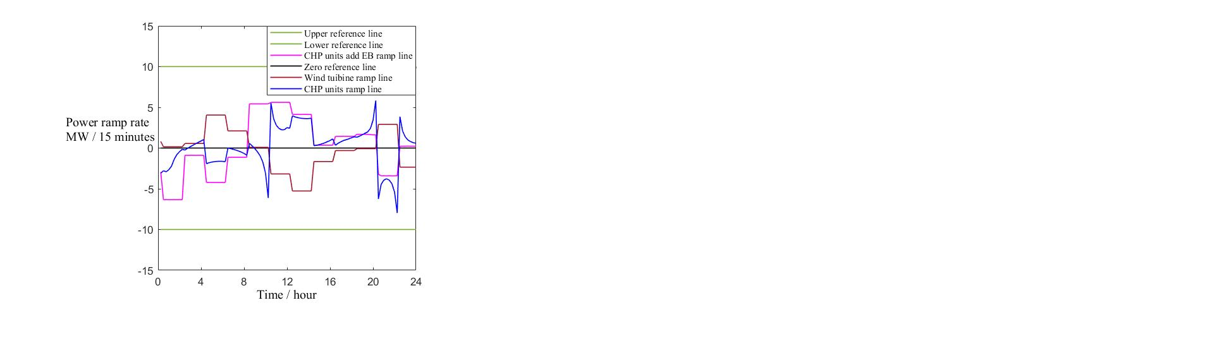

Fig. 8 Comparison of ramp rate lines on Day 5

Taking Day 5 for detailed discussion, Fig. 8 shows that there are some error points in this simulation. For example, at 2 p.m., the absolute value of CHP power ramp is smaller than the absolute value of wind power ramp, which violates the ramp constraints in this model. At 9 p.m., the absolute value of CHP power ramp is smaller than the absolute value of combined power ramp, which means that adding EB devices has no positive effect on ramp events. The requirement that equality constraint of system power balance must be satisfied restricts the ramp constraints of the generated units.

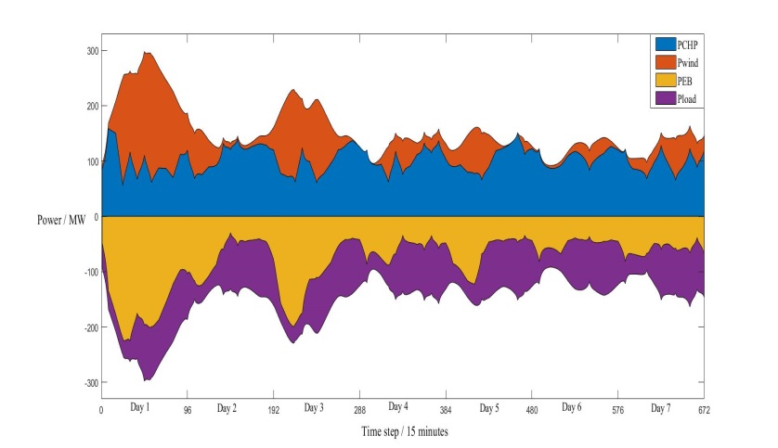

Fig. 9(a) Power output balance for one week

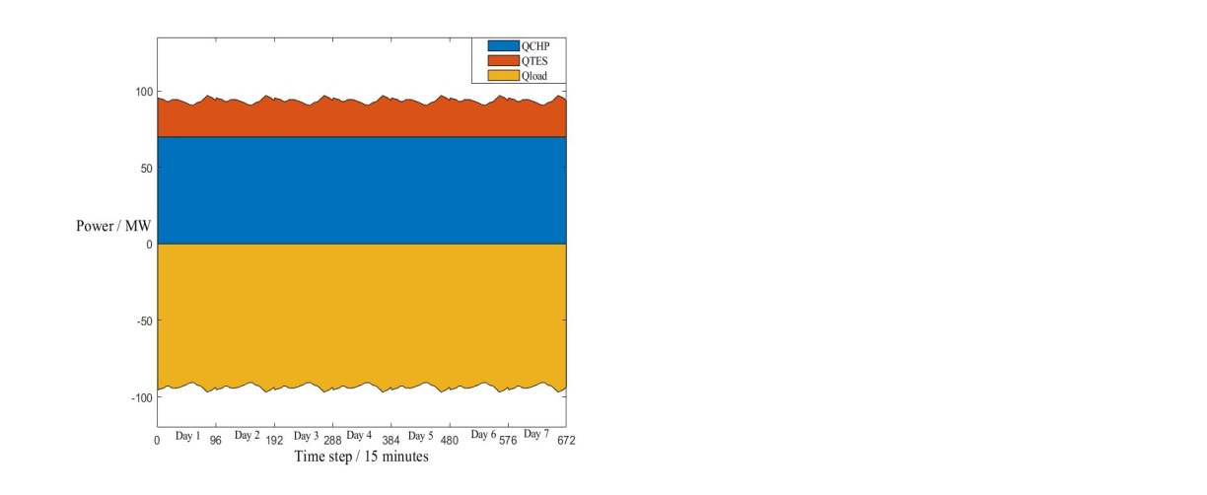

Fig. 9(b) Heat output balance for one week

Fig. 9(a) and (b) show the simulation results of power and heat balance for one week respectively. In Fig. 9(a), it is seen that the minimum operating power of CHP unit is around 50 MW. In general, CHP unit ramp more steeply than wind turbine, which achieves the dynamic response to wind ramp event. On Day 1 and Day 3, the wind energy is totally consumed and the CHP unit has larger minimal power output. Thus, the maximum power absorbed by EB devices exceeds 200 MW but within the installed capacity of EB. To absorb an excess of wind curtailment, EB consume a lot of electricity from wind and CHP, which means that installed capacity of EB needs to be enough large to absorb electricity. In other days of the week, the power absorbed by EB is within 150MW. In Fig. 9(b), the heat produced by TES is less than 30 MW for one week, while the heat absorbed by TES is more when the heat produced by EB is more. In other words, most of the heat generated by the EB is abandoned. To improve the utilization rate of heat generated by EB under the premise of wind power totally consumed, the CHP unit should be more flexible. Therefore, the CHP units with start and stop strategy should be adopted in the following simulation to enlarge the flexibility of CHP units.

### 3.3 Optimal operation of CHP units with start-stop strategy

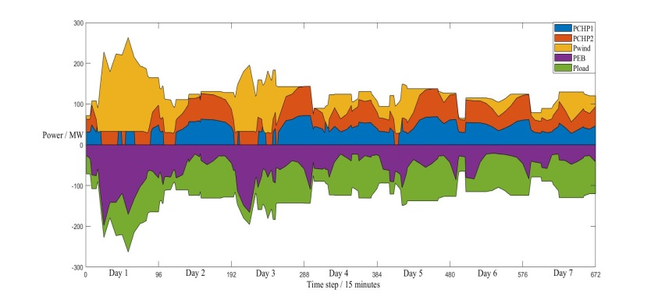

Fig. 10(a) Power balance within one week with CHP units start & stop strategy

In Scenario 3, Fig. 10 shows the power and heat balance with CHP units start and stip strategy. It can be seen that from Day 2 to Day 7, the top curve of the wind power output area tends to be flat, which means that the total ramp trend of CHP units accommodates the fluctuations in wind power ramp events. When both CHP units are under operation, the absolute ramp rate of the sum of the CHP unit power output is larger than the absolute ramp rate of wind power ramp event. However, when a single unit operates, the ramp rate tends to be 0. On Day 1 and Day 3, the minimum power output of CHP units is smaller than Fig.9(a), and the wind energy is totally consumed. Thus, the power absorbed by EB devices is smaller than Fig.9(a), which indicates that the CHP units with start and stop strategy is superior to one without start and stop.

The specific performance is as follows: compared with CHP units without start and stop strategy, the CHP units with start and stop strategy increases the adjustment depth of peak regulation due to the decreased minimum power output; the CHP units with start and stop strategy increases the flexibility of units; the CHP units with start and stop strategy reduces the installed capacity of EB devices. On Day1 and Day 3, the power consumed by EB from wind and CHP is within 200MW, and on other days, the power consumed by EB is within 100MW, which is 50MW lower than in S2. The start and stop strategy of CHP units depends on the power output value of the wind turbine. When wind power output is at its peak, the CHP units should be shut down or at lowest power output state; when wind power is at its trough, the CHP units should both be start up. In this simulations, the target wind power without considering wind power curtailment is pretended to be totally consumed.

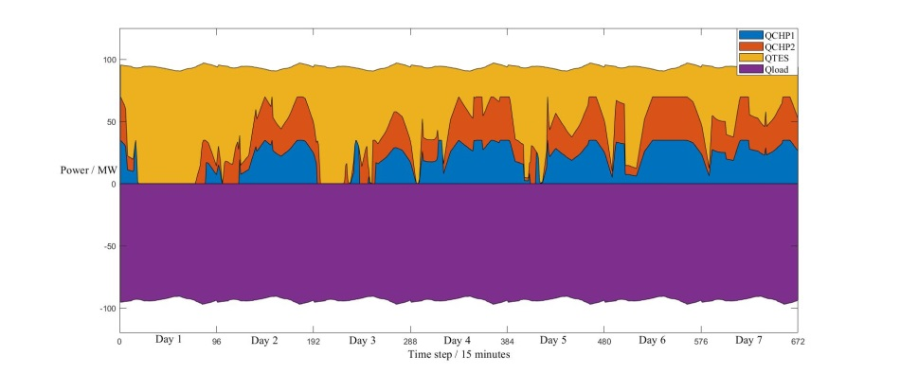

Fig. 10(b) Heat balance within one week with CHP units start and stop strategy

Compared to Fig. 9(b), the heat generated by TES devices in Fig. 10(b) is more, which denotes that the TES device has a higher utilization rate for the heat generated from EB under the condition of CHP units with start and stop strategy. On Day 1 and Day 3, when only a single unit operates, the heat supply power is 0. At other times, the heat output is not constant, while the heat output trend of the two units is consistent.

The CHP unit with or without start and stop strategy has different objective function. The most significant difference is that CHP units with start and stop strategy has to consider . The following table shows the objective function value of the two simulation.

|  |  |  |
| --- | --- | --- |
|  | Scenario 2(without CHP units start and stop strategy) | Scenario 3(with CHP units start and stop strategy) |
| Objective function value  (×106 $) | 10.6275 | 11.7086 |
| Minimum power output of CHP units (MW) | 55.57 | 32.92 |
| Minimum heat output of CHP units (MW) | 69.86 | 0 |
| Maximum power absorbed by EB (MW) | 234.97 | 197.78 |

Table 2 Comparison of simulation results in S2 and S3.

As shown in Table 2, there exist some differences between simulation results in S2 and S3. As for the minimum power output value of joint the 2 CHP units, S2 is higher than S3. With regard to minimum heat output value of joint the 2 CHP units, S3 is zero during some certain time periods, which is far below S2. In addition, the maximum power absorbed by EB in S2 is larger by 40 MW than in S3. Thus, the fuel cost of CHP units in S3 is certainly lower than in S2. Whereas, the total cost in S3 is 10.17% more than in S2, due to extra CHP’s start-stop cost.

## 4. Conclusions

In order to realize that CHP unit can achieve the dynamic response to wind power ramp events, this paper proposes a novel optimal operation model considering dynamic ramp constraints. Besides, the simulations of CHP units with and without start & stop strategy is addressed to verify the proposed dynamic response control strategy. Getting the optimal operation scheduling strategy under the CHP model with start-stop and dynamic response mechanism is solved in this paper. In addition, after using the small installed capacity of EES to smooth the initial wind power, the total amount of wind power curtailment is reduced to 2948.16MW·h. Moreover, without start & stop strategy, after equipping with EB devices, the peak regulation depth of CHP units increased from 59.99% to 174.37%. Meanwhile the ramp rate of CHP is more stable and larger than before. In comparison of simulation results between S2 and S3, when the CHP units with start & stop strategy, the power and heat output of CHP units are lower than without start & stop strategy under general conditions. With start & stop strategies, the installed capacity of EB is reduced, and the utilization rate of heat generated by EB increases, whereas, the total cost is 10.17% more than without start & stop strategy.

This study treats the entire energy system as a whole for the coordinated dispatch. In the long run, since the electric power system and the district heating system are controlled separately by different operation organizations, a decentralized manner using optimality condition decomposition merits further investigation in future studies. Moreover, as for the data applied in simulations, rather than one-week data, data which can reflect seasonal variation should also be considered in future studies.

### Acknowledgement

This work was partially supported by the National Natural Science Foundation of China (61703081), the Liaoning Revitalization Talents Program (XLYC1801005), Natural Science Foundation of Liaoning Province (20170520113), and the State Key Laboratory of Alternate Electrical Power System with Renewable Energy Sources (LAPS19005).

### Nomenclature

|  |  |  |  |
| --- | --- | --- | --- |
| *Abbreviations* | | *Subscripts* | |
| CHP | combined heat and power | *f* | CHP units fuel cost |
| EES | electric energy storage | *r* | penalty cost for smoothing wind |
| EB | electrical boiler | *e* | investment and operation cost of EES |
| EPS | electric power system | *s* | start-stop cost of CHP units |
| TES | thermal energy storage | *t* | time index |
| DHS | district heating system | *up,k* | ramping-up limit of CHP |
| EBTS | electric boiler with thermal storage | *down,k* | ramping-down limit of CHP |
| ES | energy storage | *val* | value |
| *Greek letters chr* | | | charging power of EES |
| *α* | penalty factor for wind power ramp | *dis* | discharging power of EES |
| *ω* | start-on parameter of CHP | *Roman letters* | |
| *ψ* | shut-down parameter of CHP | *Q* | heat load demand (MW) |
| *Superscripts* | | *P* | power load demand (MW) |
| *o* | expected combined wind-storage output | *C* | cost of this system ($) |
| *EES,Max* | maximum output of EES | *Ramp* | Ramp rate of CHP |
| *fuel* | fuel cost for CHP | *ST* | operating status of EB |
| *k* | corner point of CHP operation region | *SOC* | storage level of EES |

### Reference

Alkhalidi, A., Qoaider, L., … Jiryes, S. (2018). Energy and water as indicators for sustainable city site selection and design in Jordan using smart grid. *Sustainable Cities and Society*, 37, 125-132.

Alrashed, S. (2020). Key performance indicators for Smart Campus and Microgrid. *Sustainable Cities and Society*, 60.

Chen, X., … Xia, Q. (2015). Increasing the Flexibility of Combined Heat and Power for Wind Power Integration in China: Modeling and Implications. *IEEE Transactions on Power Systems*, 30(4), 1848-1857.

Chen, X., McElroy, M. B., &Kang, C. (2018). Integrated Energy Systems for Higher Wind Penetration in China: Formulation, Implementation, and Impacts. *IEEE Transactions on Power Systems,* 33(2), 1309-1319.

Cheng, W., Wei, W., Wang, J., &Bi, T. (2019). Convex optimization based adjustable robust dispatch for integrated electric-gas systems considering gas delivery priority.*Applied Energy*, 239, 70-82.

Dolatabadi, A., Jadidbonab, M., &Mohammadi-Ivatloo, B. (2018). Short-term Scheduling Strategy for Wind-based Energy Hub: A Hybrid Stochastic/IGDT Approach. *IEEE Transactions on Sustainable Energy*, 99, 1-1.

Dong, Q., Tian, K., Zhang, Y., &Zeng, M. (2009). The Situation and Problems of CHP Industry in China. *Management and Service Science*, 1-4.

Ghadikolaei, H. M., Tajik, E., … Aghaei, J. (2012). Integrated day-ahead and hour-ahead operation model of discos in retail electricity markets considering DGs and CO2 emission penalty cost. *Applied Energy*, 95, 174-185.

Gong, Y., Baldick, R., &Jiang, Q. (2015). Ramp Event Forecast Based Wind Power Ramp Control With Energy Storage System. *IEEE Transactions on Power Systems*, 99, 1-14.

Anna, H., Marco, Z., … Anders, S. (2015). Operational Strategies for a Portfolio of Wind Farms and CHP Plants in a Two-Price Balancing Market. *IEEE Transactions on Power Systems*, 31(3), 1-1.

Lahdelma, R., &Hakonen, H. (2003). An efficient linear programming algorithm for combined heat and power production. *European Journal of Operational Research*, 148(1), 141-151.

Li, B., Mo, X., &Chen, B. (2019). Direct Control Strategy of Real-Time Tracking Power Generation Plan for Wind Power and Battery Energy Storage Combined System. *IEEE Access*, 7, 147169-147178.

Li, Y., Yang, Z., Li, G., Zhao, D., &Tian, W. (2019). Optimal Scheduling of an Isolated Microgrid With Battery Storage Considering Load and Renewable Generation Uncertainties. *IEEE Transactions on Industrial Electronics*, 66(2), 1565-1575.

Liu, L., Zhu, T., … Pan, Y. (2016). Multiple energy complementation based on distributed energy systems – Case study of Chongming county, China[J]. Applied Energy, 192(15), 329-336.

Liu, W., Gong, Y., Geng, G., &Jiang, Q. (2019). Refined ramp event characterization for wind power ramp control using energy storage system. *IET Renewable Power Generation*, 13(10), 1731-1740.

Lund, H., &Münster, E.(2003). Modelling of energy systems with a high percentage of CHP and wind power. *Renewable Energy*, 28(14), 2179-2193.

Salomón, M., Savola, T., … Martin, A. (2011). Small-scale biomass CHP plants in Sweden and Finland. *Renewable & Sustainable Energy Reviews*, 15(9), 4451-4465.

Merlin, K., Delaunay, D., Soto, J., &Traonvouez, L.(2016). Heat transfer enhancement in latent heat thermal storage systems: Comparative study of different solutions and thermal contact investigation between the exchanger and the PCM. *Applied Energy*, 166, 107-116.

Nasrolahpour, E., Kazempour, J., … Zareipour, H. (2018). Impacts of Ramping Inflexibility of Conventional Generators on Strategic Operation of Energy Storage Facilities. *IEEE Transactions on Smart Grid*, 9(2), 1334-1344.

Rinne, S., &Syri, S. (2013). Heat pumps versus combined heat and power production as CO2 reduction measures in Finland. *Energy*, 57, 308-318.

Shakouri G, H., &Kazemi, A. (2017). Multi-objective cost-load optimization for demand side managementof a residential area in smart grids. *Sustainable Cities and Society*, 32, 171-180.

Sun, C., Bie, Z., &Zhang, Z. (2016). A new framework for the wind power curtailment and absorption evaluation. *International Transactions on Electrical Energy Systems*, 26.

Tavakoli, M., … Pouresmaeil, E. (2018). A two stage hierarchical control approach for the optimal energy management in commercial building microgrids based on local wind power and PEVs. *Sustainable Cities and Society*, 41, 332-340.

Vasilj, J., Gros, S., Jakus, D., &Zanon, M. (2019). Day-Ahead Scheduling and Real-Time Economic MPC of CHP Unit in Microgrid With Smart Buildings. *IEEE Transactions on Smart Grid*, 10(2), 1992-2001.

Wang, H., Lahdelma, R., Wang, X., Jiao, W., Zhu, C., &Zou, P. (2015). Analysis of the location for peak heating in CHP based combined district heating systems. *Applied Thermal Engineering*, 87, 402-411.

Wang, H., Yin, W., Abdollahi, E., Lahdelma, R., &Jiao, W. (2015). Modelling and optimization of CHP based district heating system with renewable energy production and energy storage. *Applied Energy*, 159, 401-421.

Wang, J., You, S., … Zong, Y. (2019). Investigation of real-time flexibility of combined heat and power plants in district heating applications. *Applied Energy*, 237, 196-209.

Wee, K. W., Choi, S. S., &Vilathgamuwa, D. M. (2013). Design of a Least-Cost Battery-Supercapacitor Energy Storage System for Realizing Dispatchable Wind Power. *IEEE Transactions on Sustainable Energy*, 4(3), 786-796.

Wen, S., Lan, H., … Fu, Q. (2015). Economic Allocation for Energy Storage System Considering Wind Power Distribution. *IEEE Transactions on Power Systems*, 30(2), 644-652.

Xia, S., Bu, S. Q., Luo, X., Chan, K. W., &Lu, X. (2018). An Autonomous Real-Time Charging Strategy for Plug-In Electric Vehicles to Regulate Frequency of Distribution System With Fluctuating Wind Generation. *IEEE Transactions on Sustainable Energy*, 9(2), 511-524.

Yang, C., Lee, K., & Li, S. (2020). A mixed activity-based costing and resource constraint optimal decision model for IoT-oriented intelligent building management system portfolios. *Sustainable Cities and Society*, 60.

Yang, L., Zhang, X., &Gao, P. (2018). Research on heat and electricity coordinated dispatch model for better integration of wind power based on electric boiler with thermal storage. *IET Generation, Transmission & Distribution*, 12(15), 3736-3743.