Title: Incidence and mortality due to thromboembolic events during the COVID-19 pandemic: Multi-sourced population-based health records cohort study.

Authors:
Suleman Aktaa, Jianhua Wu PhD, Ramesh Nadarajah, Muhammad Rashid, Mark de Belder, John Deanfield, Mamas A Mamas, Chris P Gale

Table 1. Patient characteristic for admissions in England with arterial and venous thromboembolic events between 1st Feb 2018 and 31st July 2020, by study period (pre-COVID-19 and during COVID-19), and COVID-19 status.

Table 2. Incidence rates, absolute risk change and adjusted relative risk between pre-COVID-19 and COVID-19 periods.

Figure 1. Incidence rates of thromboembolic events, by the type of thromboembolic event and COVID-19 status.

Figure 2. Incidence rates of deep venous thrombosis and pulmonary embolism events, by COVID-19 status.

Figure 3. Daily number of thromboembolic related deaths, by the type of thromboembolic event and place of death.

Table 1. Patient characteristics for admissions in England with arterial and venous thrombo-embolic events between 1st Feb 2018 and 31st July 2020, by study period (pre-COVID-19 and during COVID-19), and COVID-19 status.

 | Study period |  | COVID-19 status
 | Before COVID-19 period | COVID-19 period | COVID-19 +ve | COVID-19 -ve
N | 185846 | 86577 | 84728 | 1849
Women (%) | 90904 (48.9) | 41453 (47.9) | 40594 (47.9) | 859 (46.5)
Age (%)
0-49 | 22943 (12.4) | 10944 (12.8) | 10760 (12.8) | 184 (10.2)
50-59 | 21837 (11.8) | 10850 (12.6) | 10651 (12.7) | 199 (11.0)
60-69 | 31920 (17.3) | 15146 (17.6) | 14846 (17.7) | 300 (16.6)
70-79 | 47039 (25.5) | 21829 (25.4) | 21380 (25.4) | 449 (24.9)
80+ | 60603 (32.9) | 27059 (31.5) | 26389 (31.4) | 670 (37.2)
Charlson comorbidity index
0 | 31611 (17.0) | 14711 (17.0) | 14455 (17.1) | 256 (13.8)
1 | 43147 (23.2) | 18572 (21.5) | 18287 (21.6) | 285 (15.4)
2 | 36159 (19.5) | 16050 (18.5) | 15771 (18.6) | 279 (15.1)
3 | 26739 (14.4) | 12611 (14.6) | 12307 (14.5) | 304 (16.4)
4+ | 48190 (25.9) | 24633 (28.5) | 23908 (28.2) | 725 (39.2)
Atrial fibrillation (%) | 36413 (19.6) | 16708 (19.3) | 16223 (19.1) | 485 (26.2)
Arterial TE (%) | 119373 (64.2) | 55166 (63.7) | 53975 (63.7) | 1191 (64.4)
Venous TE (%) | 66473 (35.8) | 31411 (36.3) | 30753 (36.3) | 658 (35.6)
DVT (%) | 30586 (16.5) | 13852 (16.0) | 13712 (16.2) | 140 (7.6)
PE (%) | 35575 (19.1) | 17767 (20.5) | 17162 (20.3) | 605 (32.7)
Note: frequency (percentage) was reported for each category. TE, thrombo-embolic events; DVT, deep vein thrombosis; PE, pulmonary embolism.

Table 2. Incidence rates, absolute risk change and adjusted relative risk between pre-COVID-19 and COVID-19 periods.

 | Incidence rate (per 100,000) |  |  | Absolute risk change |  | Unadjusted relative risk* | Adjusted relative risk**
Conditions | Pre-COVID-19 | COVID-19 period |  | Percentage (95% CI) |  | RR (95% CI) | RR (95% CI)
All patients
TE | 1090 | 1590 |  | 45.9% (45.1-46.6%) |  | 1.42 (1.41-1.43) | 1.43 (1.41-1.44)
Arterial TE | 720 | 1036 |  | 43.8% (42.9-44.7%) |  | 1.40 (1.39-1.41) | 1.42 (1.40-1.44)
Venous TE | 369 | 554 |  | 50.0% (48.6-51.3%) |  | 1.46 (1.45-1.48) | 1.44 (1.42-1.47)
DVT | 164 | 233 |  | 42.2% (40.3-44.1%) |  | 1.48 (1.46-1.50) | 1.46 (1.42-1.49)
PE | 205 | 329 |  | 60.8% (59.0-62.7%) |  | 1.54 (1.52-1.56) | 1.49 (1.46-1.52)
* A Poisson regression model was used to calculate the relative risk, accounted for time trend.
**A Poisson regression model was used to calculate the relative risk, adjusted for age, sex, COVID-19 status, Charlson Comorbidity Index and time trend. TE, thromboembolic events; DVT, deep vein thrombosis; PE, pulmonary embolism.

Figure 1. Incidence rates of thromboembolic events, by the type of thromboembolic event and COVID-19 status.
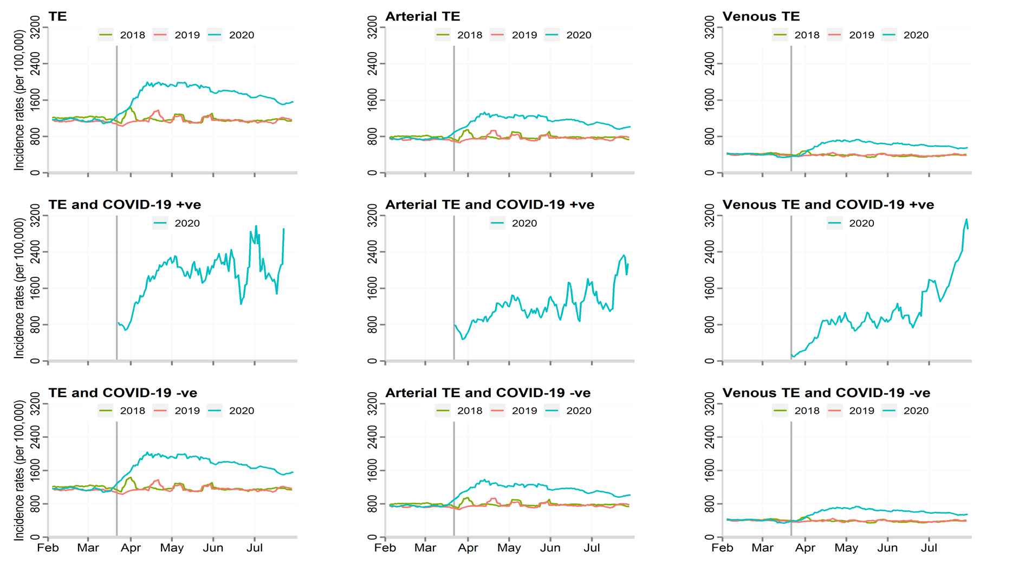
TE; thrombo-embolic events

Figure 2. Incidence rates of DVT and PE events, by COVID-19 status.
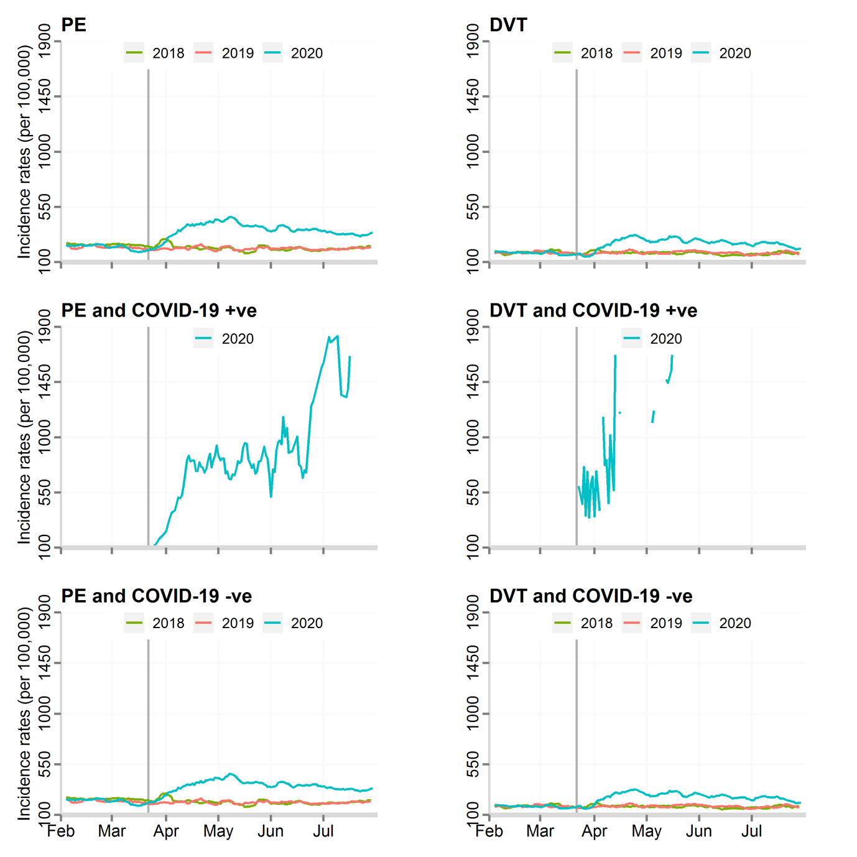
DVT, deep vein thrombosis; PE, pulmonary embolism.

Figure 3. Daily number of thromboembolic related deaths, by the type of thromboembolic event and place of death.
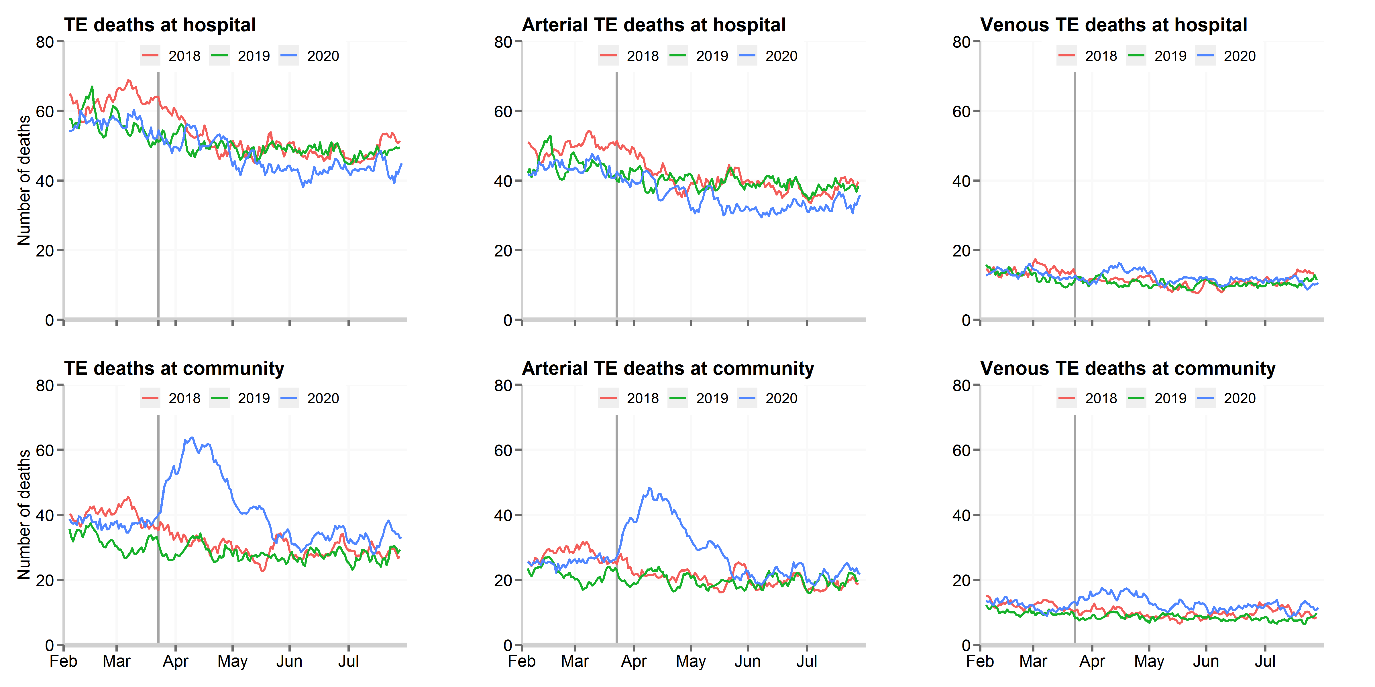
TE; thrombo-embolic events

