Title of paper: Performing Diabetes: Felt Surveillance and Discrete Self-Management.

Author: Author

Address:
Centre for Population Health Sciences
University of Edinburgh
Medical School
Teviot Place
Edinburgh
EH8 9AG

Corresponding email: Version for Blind Review (after round 1 of peer review)

Acknowledgements: I would like to thank Professors Name and Name for their insightful comments on this paper and the research project. I would also like to thank two anonymous reviewers for their vital and encouraging comments on earlier drafts of the paper.

Submitted for consideration for Theme Issue: Surveillance and Performance
Performing Diabetes: Felt Surveillance and Discrete Self-Management.

Abstract

Sustaining the diabetic body involves visible practices of expert self-management: injecting insulin and testing blood sugar levels. Drawing from qualitative interviews and online questionnaires, collected for a project on ‘the everyday geographies of living with diabetes’, in this paper, I consider how people with type 1 diabetes manage the visibility of these practices. I contend that a sense of panopticism influences people’s self-management, which in turn creates a sense of a diabetes norm. This feeling of surveillance leads to many people managing their self-management in ways that are discrete. Erving Goffman’s discussions on the management of personal fronts provides a lens to understand this management but also a means of considering the small ways surveillance and norms are co-opted or contested by people with diabetes. While many participants note practical reasons for the discretion of self-management this co-opting suggests that it is not a norm that people are entirely happy with and that this feeling of surveillance has a negative impact on life with diabetes.

Key words:
diabetes; surveillance; performance; discrete norms; self-management

Introduction

Diabetes is a disease caused by a lack of insulin, a hormone developed in the pancreas, which means the body cannot turn glucose into energy. There are over 3.2 million people in the UK diagnosed with diabetes mellitus and about 10% have type 1 diabetes (Diabetes UK website). The author of this paper is one of these 10% and so in order to convey the thoroughly embodied aspects of diabetes self-management, photographs of the author’s body have been used (as has one of a friend of the author). These photographs were taken expeditiously by the author’s friends and colleagues ‘in the moments’ of diabetes self-management. Of course they are still staged – “actors are always already on the stage” as Judith Butler (2004: 160) writes – as the author knew they were being taken. However the actions in the photographs are performed as they would have been done (and are everyday) had there been no camera.

In type 1 diabetes the body produces no insulin at all and regular injections (figure 1 and 2) or a continuous pumping of insulin into the body (figure 3), are required to compensate. In order to manage insulin intake, most people with type 1 will self-test their blood sugar levels by pricking their fingertip with a small device containing a lancet and then smearing a drop of blood on a small electronic meter (figure 4). Blood sugar (or glucose) is a measure of the amount of sugar in one’s blood and is usually measured in millimoles per litre (mmol/l). Together, the injecting of insulin and testing of blood sugar comprise the main visible and noticeable elements of diabetes self-management. This paper draws from the experiences of people with type 1 diabetes only as people with this type will always need to test their blood sugar levels and inject insulin (either by injection device or pump). If the management of insulin is incorrect people may experience an episode of low blood sugar, known as hypoglycaemia: symptoms are usually acute and involve light-headedness, shaking, sweating and potentially loss of control over one’s body. Alternatively high blood sugar, known as hyperglycaemia, involves less acute symptoms but can lead to long-term complications such as amputation, loss of eyesight and heart attack.

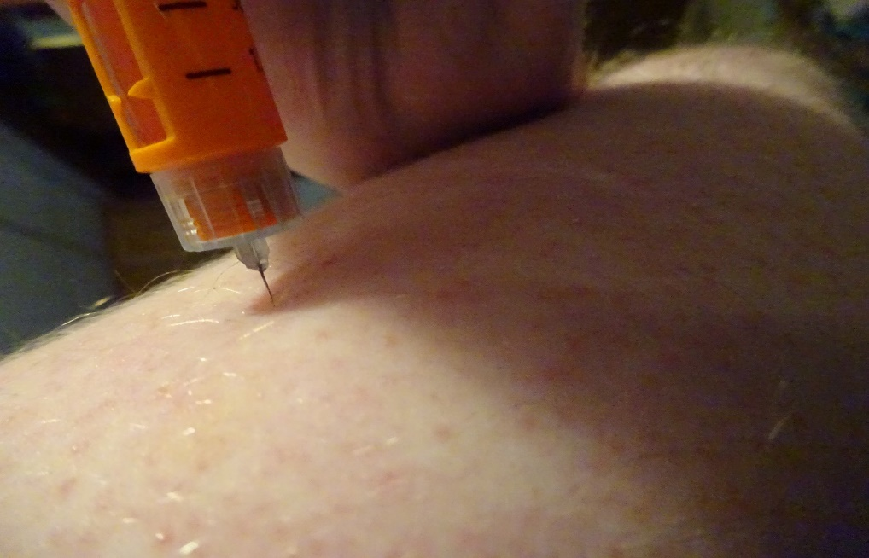
Figure 1. This picture is a close up of myself injecting insulin into my arm using an insulin ‘pen’ and attached disposable needle (author’s own photograph).

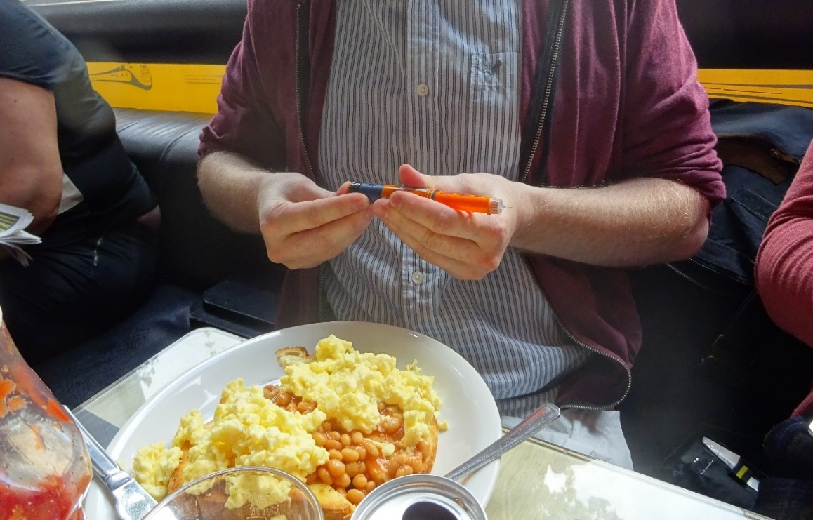
Figure 2. In this picture I am preparing to inject insulin into my body. The picture demonstrates that the self-management acts of diabetes are often done in public places such as cafés and restaurants (author’s own photograph).
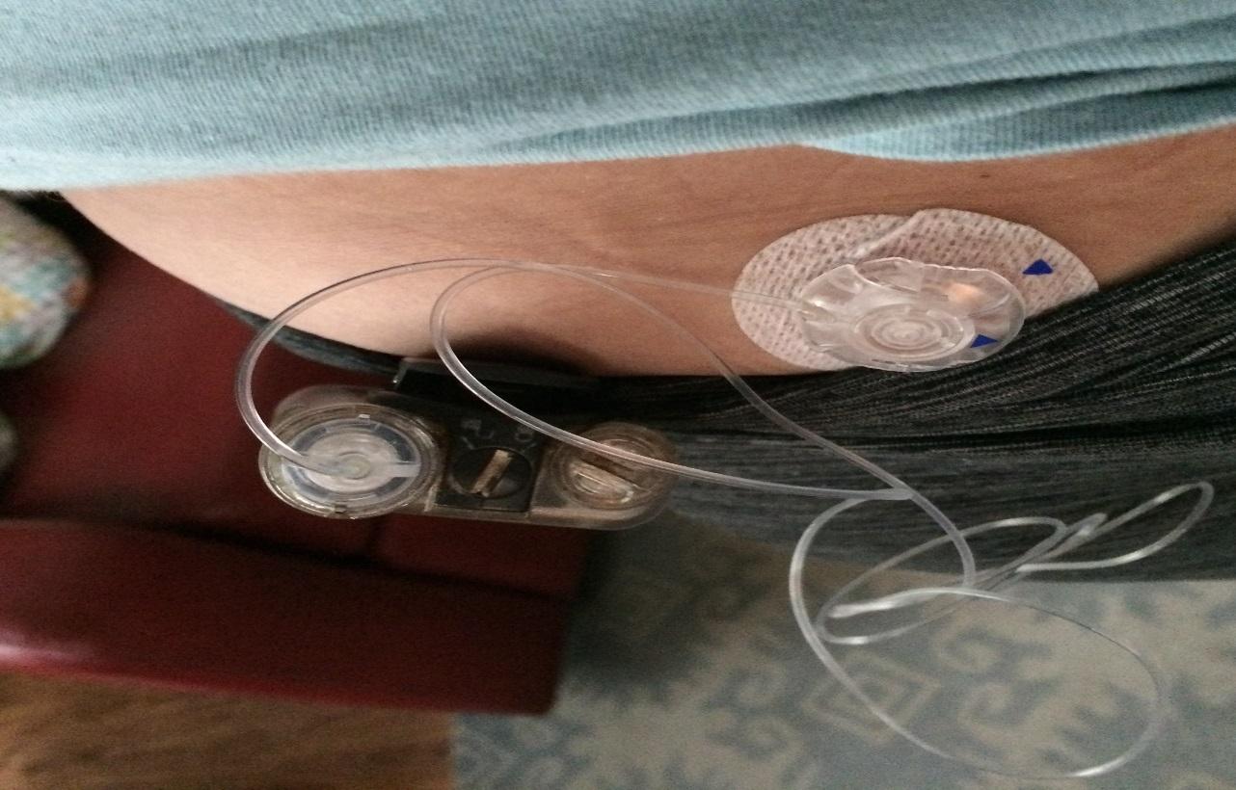
Figure 3. Photograph of insulin pump clipped onto trousers. The cannula (connecting thin white tube) supplies insulin from the pump into the injection site. Photograph received through personal communication with author and reproduced with permission.

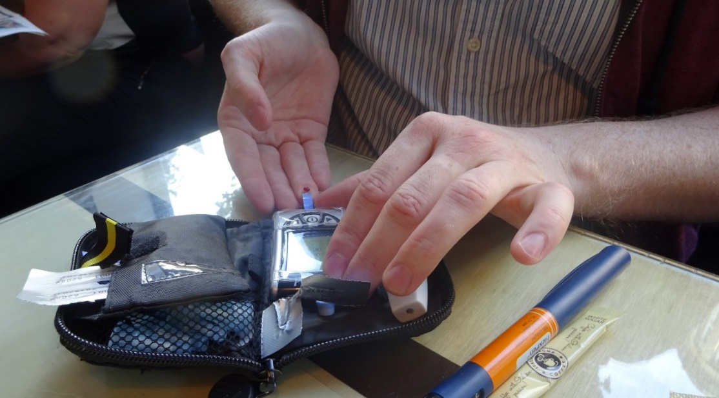
Figure 4. In this picture, I have pricked my finger using a small lancet device and I am spreading the blood onto the end of a test strip which has been inserted into the meter. A few seconds after smearing the blood on the strip it will display a number which will represent the amount of sugar in my blood at that moment in time (author’s own photograph).

In this paper I argue that people with diabetes often express a sense of ‘felt surveillance’ of their bodies when in public space. This feeling is especially prominent when conducting the self-management practices necessary for those living with the condition. People with diabetes experience a particular ‘distress’ (Balfe et al 2013) living with the condition. This distress involves aspects of the day-to-day management, relationships with health care staff and potentially stigmatising or misleading accounts of diabetes causality. Balfe et al (2013: 4) consider “self-consciousness about diabetes” as a key aspect of this distress. The authors briefly consider people with diabetes’ feelings of being disconcerted if other people see their self-management practices. However the feeling is not unpacked further and while the authors do touch on ways that these various aspects of distress can be managed, they do not elaborate on this intra-personal affective notion. Instead they consider managing distress in terms of maintaining control over the physiological symptoms of the condition. With this paper I wish to build upon Balfe et al’s (2013) findings by unpacking the idea of a felt surveillance which stems, in part, from the self-consciousness they describe.

To do this I initially consider Michel Foucault’s (1991) discussion of panopticism, discussing a sense of being under constant surveillance while in public spaces which causes people with diabetes to conduct the embodied practices of self-management discreetly. I add to our understandings of both diabetes ‘self-consciousness’ and surveillance studies by arguing that there is some sense of a ‘diabetic norm’ to which people with diabetes feel a need to conform.

However there are problems with using panopticism to explain people with diabetes’ feelings of surveillance. Scholars have critiqued Foucault’s discussion of panopticism as neglecting important ways that surveillance is co-opted or resisted (Yar 2003, McCahill and Finn 2012). I contribute therefore to existing critiques of panopticism being applied to settings beyond institutions (Yar 2003). Attempting to extrapolate this feeling of self-consciousness, I explore Erving Goffman’s insights into how people may in some small ways co-opt the feeling of surveillance to create small moments of resistance. I also draw some ideas from Jean-Paul Sartre, through the lens of Joyce Davidson’s (2003) work with women with agoraphobia and her discussion of maintaining a sense of self when faced with the gaze of others. I touch on ideas from Judith Butler as well, to suggest some reasons why people may wish to co-opt the feeling of surveillance rather than resist it outright. With these conceptual coordinates I present the limits of panopticism in understanding the feelings of surveillance of people with diabetes. In doing so, I argue that the surveillance they feel is not necessarily an oppressive or limiting power but a power which people with diabetes can use to manage their identities and control their “personal front” (Goffman 1971: 34). Nonetheless there remains a vestige of panopticism in the form of a felt surveillance, which, to borrow terms from Goffman (1971), can direct an individual’s ‘presentation of the self’ and create various ‘fronts’ depending on different ‘audiences’.

One of Yar’s (2003) main critiques is that panopticism implies a ‘normalising’ power of the ‘gaze’ which Foucault does not acknowledge in depth. Yar (ibid: 261) has problems with visibility leading directly to subjectivity:

The subject of the gaze is rendered in terms of its passivity, confined to internalising the behavioural repertoires laid out by the disciplining authority. This overlooks the extent to which the subject has an active role within its reception of the gaze, and renders it nigh impossible to give an adequate account of creativity and resistance.

Such active responses to surveillance are being increasingly explored by scholars interested in surveillance studies (Wood 2003). McCahill and Finn (2012) for example discuss how frequent young offenders, subject to an obvious and often invasive surveillance from authorities utilise what small ‘cultural capital’ they have at their exposure, usually their own bodies, to effect resistance to the surveillance. Additionally the offenders often seemingly collude with some forms of surveillance in an attempt to avoid further or increased surveillance. These individuals are still experiencing a form of surveillance but they act within that surveillance to resist what, and when, they can.

Butler aids in our understanding of the form of resistance seen in McCahill and Finn (2012) by stressing the “paradox of subjectivation … is precisely that the subject who would resist such norms is itself enabled, if not produced, by such norms” (Butler 2011: xxiii). Butler’s claims open the productive forms of power that Yar (2003) claims Foucault underexplores for conversation. A person lives and acts under a set of norms, which they cannot always challenge. Therefore they often live within these norms, adhering to the accepted or even enforced rules. Any agency or feeling that is done or felt against a norm is only done or felt because there is a norm to rebel against. If there are no norms there are no rebels. Butler therefore does not necessarily rally against tearing down all norms but instead seeks to work in more room to loosen the hold a norm has on society. “Hyperbolic” (Butler 2011: 181) resistance, such as drag is one such way as they bring a norm into sharp focus and contrast. However not everyone is able to enact such rebellious agency and Butler (ibid: xxiii) writes that: “although this constitutive constraint does not foreclose the possibility of agency, it does locate agency as a reiterative or rearticulatory practice, immanent to power, and not a relation of external opposition to power”. These small resistances, being ‘immanent’ rather than in ‘opposition’ can occur as a form of co-opting.

Such forms of resistance may often go unnoticed and instead resistance is understood predominantly as those big instances of rebellion against norms, rules or surveillance. Goffman (1971: 44) offers some ideas for how this co-opting can exist within an embodied performance that is “‘socialised’, moulded, and modified to fit into the understanding and expectations of the society in which it is presented”. By using one’s ‘stigma’ in a mischievous way, ‘cynical’ performers, as Goffman outlines, present themselves with an indifference to the how their audience receives their performance. This is opposed to those ‘sincere’ performers and who believe in the ‘reality’ they are performing. Goffman (1971: 28-29) writes that:

It should be understood that the cynic with all his [sic] professional disinvolvement, may obtain unprofessional pleasures from his masquerade, experiencing a kind of gleeful spiritual aggression from the fact that he can toy at will with something his audience must take seriously.

While the sincere performer wishes to believe in their own performance, the cynic can be lacklustre in performing, thereby resisting any feeling to perform credibly. Nonetheless the cynic is still performing, still giving ground to the ‘expectations of society’ while simultaneously taking back a small measure of empowerment by controlling their performance to some extent.

I believe therefore that bodies are still performed with recourse to a normalising gaze, even if there is room for resistance it is often resistance that works within or alongside norms. This gaze is felt to punish any whose body steps out of line. This is especially true of ‘leaking’ bodies (Longhurst 2001). For instance Boyer (2012: 556) writes of breastfeeding in public:

The forms of social opprobrium for breastfeeding in public uncovered in this [her] research ranged from gestures and odd looks to a looser, more visceral sense or feeling about the discomfort of others … Tuts, glares and funny looks serve as indicators that women breastfeeding in public are ‘failing’ in their duty to maintain public comfort.

There is in intra-personal affective force, felt by people that encourages solid and non-leaking bodies. There is an implicit disapproval of any bodies that are not clean, bounded and healthy. Even so, I agree with Yar (2003) that people retain agency in the face of this force and can choose from different fronts to present to others, albeit this choosing takes place within an enveloping regulatory framework.

Davidson (2003) sheds some light on the embodied aspects of felt surveillance through her discussion of Sartre and women with agoraphobia. Drawing from Sartre, she argues that embodied information must be controlled so that it is not misinterpreted by others:

One simply cannot dictate how one’s subjectivity is reconstituted in the Other’s eyes. The Other’s look can seem to rob the individual of vital aspects of their identity, reducing their sense of embodied selfhood to that of an object over which they have only limited control (ibid: 114)

People may perform their bodies discreetly in order to enact an “information control” (Goffman 1968: 57) which in turn helps them protect a sense of self. This control was vital to the women in Davidson’s study as they have agoraphobia and experienced an existential crisis in certain situations. Diabetes may not carry the same existential consequences for individuals if it becomes ‘known’ but there are reasons why people wish to keep the condition private that are not necessarily stemming from a sense of diabetic norms. Nonetheless the awareness of being seen supports the idea of a felt surveillance.

It is not so important that this felt surveillance is actually occurring (as surveillance is in McCahill and Finn 2012). Regardless of the ‘proof’ (Yar 2003) of surveillance there is an affective sense of being watched, similar to what Evans and Colls (2009: 1073) note as an “unverifiable gaze”. This gaze swirls around people creating a sense of almost constant self-awareness, a threat that at any moment – although especially those moments when self-management is enacted in public – one’s self may be questioned. However, we are brought back to panopticism as the experience of felt surveillance demonstrates that people are aware of punitive consequences, even if these punishments are imagined or self-inflicted. The norms of behaviour have become internalised.

Felt surveillance is perhaps hard to pin down as a concept but it is important. I argue that people with diabetes experience this form of surveillance – attempting to conform to a set of norms influenced by existing societal norms but then mediated by their own attempts to conserve personal information, maintain privacy and avoid ‘spoiled spaces’ (Balfe 2005). This surveillance leads to an obscuring of the everyday ‘doing’ of diabetes. Often this obscuring takes a radical spatial form as people with diabetes enter public toilets to practice their self-management, thereby removing the performance from public sight altogether. There forms feelings of censorship and shame of the diabetic body: a feeling that the body is offensive when enacted in public space. This sense of shame is wrestled with as people with diabetes reflect the cynical and sincere performances of their diabetes, highlighting the way choices are made by recourse to society’s expectations but also to their own desires to not feel shame about their bodies and actions.

Following a brief overview of the methods for this project, I attempt to validate the use of panopticism as an initial theoretical framework for understanding the data and the lived experiences of type 1 diabetes. I outline the ways in which people with diabetes feel they are being watched and explain why this is felt as surveillance. In doing so, I hope to demonstrate that norms of diabetes behaviour are being created. In the following, larger, section I demonstrate how the participants attempt to manage their bodies within these norms: at times working firmly alongside and at other times working less firmly alongside – if never actually working directly in opposition. This section is split into four sub-sections of: managing the sight, managing the audience; managing the site and managing each other.

Methods

The data used in this paper are drawn from a project on ‘the everyday geographies of living with diabetes’. This project involved the gathering and analysing of a large quantity of qualitative data in the form of online questionnaires and interviews. The questionnaire was qualitative and encouraged open responses from respondents – as opposed to many questionnaires, which collect only basic information. The questionnaire was created using the surveymonkey service and posted on a number of UK (one US) diabetes discussion forums. 127 responses were received. Responses varied in length, detail and usefulness. Some were very short but provided insightful accounts of living with diabetes, others could be very long but contain little of relevance to life with the condition. 74 of the respondents had type 1 diabetes and 91 of the respondents were female.

The project involved 41 interviews. 31 of these interviews were face-to-face in various locations around Glasgow, while ten were over the telephone but still involved participants from Glasgow and the surrounding areas. Participants were recruited through various diabetes support groups in Glasgow and with the help of clinicians working with people with diabetes who passed on information about the research. Interviews ranged in length from about 30 minutes to over 2 hours. 31 of the interviewees had type 1 diabetes. 22 of the interviewees were female. All of the questionnaire respondents and participants gave permission for their data to be used in the research project. All names for participants are pseudonyms.

The sample was a convenience sample and participants were self-selecting. The interview section of the fieldwork was limited to Glasgow due to constraints of time and expense. The project was not intended to explore the specificities of living with diabetes in Glasgow but given a grounded theory approach to analysing the data such results would have been explored had they arisen. Alas, specificities of managing diabetes in Glasgow were not a key emerging theme. The online questionnaire section was restricted to mostly UK sites in order to exclude radically different experiences of living with diabetes in other countries. For example, global inequalities are clear in diabetes care as diabetes medical technology is scarce in many lower income countries (Kengne et al 2013). Inequalities exist within western countries as well, especially with regards to free national healthcare systems (Mainous et al 2006). Aspects of accessibility to healthcare are not a theme of this paper. The paper focuses on commonalities in the experience of diabetes among western participants who had ready access to healthcare.
The data used in this paper are drawn from both the questionnaire responses and the interviews. This data was thematically analysed by the author. The author used a grounded theory approach, however, as will be seen the data collected and analysed was often influenced by the author’s own experiences with diabetes and opinions of living with diabetes. The paper is about the main visible signifiers of diabetes (injecting insulin and testing blood). As such, it was a focus of topic guides for both the questionnaire and interview and the responses from participants were intriguing in their complexity. It was therefore decided to focus only on people with type 1 diabetes, for whom injecting and testing are invariably part of everyday life. This is not necessarily so for people with type 2 who often manage their diabetes through diet and exercise. Questionnaire respondents were made aware of the author’s own diabetes through the information sheet page of the online questionnaire and interviewees were told of the author’s diabetes either when the interview was being arranged or at the beginning of the interview when participants were asked to review the information sheet.

Establishing norms of diabetic behaviour in public space

Diabetes is a thoroughly embodied condition. At times of self-management a person must work on their body and so their awareness of their body is heightened. The bloody and penetrative procedure of diabetes self-management led many participants to believe that the practices may be something that could disturb possible observing others. For instance Steven, is aware that others may have a needle phobia:

I used to have a brother-in-law who, you didn’t even need to show him a needle, you just had to say the word and he fainted ... So I’m not trying to make their life any more difficult than it is, so you become quite aware of the sort of type of company you’re in, what you can get away with.

Steven’s embodied self-censorship is not dissimilar to the ‘considerate smoker’ introduced by Poland (2000). Poland writes that ideas of clean public environments and polluting behaviours have become so normalised that smokers have become sensitive to the visibility of their habit, making sure that it is done in appropriate, mostly hidden, spaces and places. Steven realises that his self-injection may be similarly disturbing to others. He hints at an established and internalised diabetes self-management norm as he considers “what he can get away with”, implying that there are limits to how much his body can be on display. It is important to note, though, that he also hints at a sense of testing these limits.

Part of this sense of creating a public discomfort are possible confusions of injecting insulin and injecting illicit drugs. For instance, Allison remarks: “it’s not heroin so I’m alright [injecting in public]”. Nonetheless, some participants, like Derek felt that injecting insulin could be mistaken as something unambiguously deviant (see Proudfoot 2011 or Rhodes et al 2007):

I mean if the dialogue from whoever it is sees you injecting, they might take it the wrong way because they’re naïve … they might think you are actually injecting some illegal substance and they might have some derogatory comment to make, then that’s a different kettle of fish [from someone who is needle phobic].

When Derek was first diagnosed he worried about a life of injections: “initially that’s what I thought … I’m going to be like a heroin addict, I’m going to have to shoot up and all the rest of it, it wasn’t a nice thought”. However Derek soon put those fears to rest, quickly realising that for injections, “you just get a bit of fat and that’s it, you’re in”. Derek held the initial ‘naïve’ (to borrow his own term) view that self-injecting in public was somehow deviant and denoted an illicit behaviour. However, after so many years, he has become much more comfortable with his body and penetrating its boundaries so easily. Not all participants came to terms with having to self-manage as easily. Sheila tells about injecting in the toilet when out at a restaurant:

Sheila: I would go to the bathroom and inject there, but then I still had to take the needle out in the toilet, in the bathroom and inject, you still had people pass you by and I worried that people would think I was a drug user and so I was always so embarrassed about it.

Interviewer: Did you actually have any incidents of people accusing you of being a drug user or saying …?

Sheila: No, I think it was more my own perception and I think it was more to do with … how I might perceive somebody else injecting.

Sheila self-monitors her body, thinking about how her body may be seen and understood by others, rather than reacting to an actual experience of being challenged as doing something illicit. Interestingly Sheila’s retreat to the restaurant toilet may in fact heighten her sense of being mistaken for doing something illicit as she notes a sense of ‘sanitary surveillance’ (Braverman 2010) while in the toilet suggesting that even here, norms about diabetes and embodied self-management apply.

Other participants reflected on the visibility of self-management, while discussing injecting in front of children. For example, Anna says:

Anna: I’ll not jag [inject] in front of them, I don’t want them to see it’s OK injecting a jag, until they’re old enough.

Interviewer: To understand it’s a medical thing?

Anna: Like as you say, granny’s a diabetic and she has to take insulin, kinda educate them on it. I feel with the younger ones now it’s too much of that about [illegal drug usage] … I just don’t let them see me doing it. They know what the [blood] test is; they’ve seen me doing that. But the jag I … stopped doing [in front of them] because, well I didn’t like them seeing me do it just in case they thought, ‘it’s alright to take a jag’. You’ve got to teach them, when you see needles lying outside not to touch it.

Anna worries that her grandchildren will be unable to distinguish insulin injections from illicit drug use. Injecting drug use carries a certain stigma, to which people with diabetes are aware. Injecting for diabetes management is not illicit but people may be influenced by what Sara Ahmed (2004: 82) refers to as a “performativity of disgust” as two practices, with similar performativities involving exposed flesh, penetration of the body through needles and blood become connected in their minds. This may explain why participants often referenced illicit drug use as they take the same feelings of disgust and practices of concealment understood with illicit drug use (see Briggs 2013) and apply them to their diabetes management. Although the stigma is felt, the feeling is real and so these accounts start to provide a “burden of proof” (Yar 2003: 262) that a sense of panopticism is present in the lives of many participants. Without necessarily encountering any direct rules or drills about how diabetes should be done, people with diabetes establish their own.

Managing self-management

Participants felt that public self-management could be mistaken as a ‘performance’ of diabetes. As Mina writes: “I still have problems with testing and injecting before meals in public because I feel ‘on show’”. Alice also reflects on self-management in public and says: “because I’ve seen people that … maybe had something wrong with them … and I know I’ve looked at them and thought things like, she’s just doing that for attention, to get someone to feel sorry for her”. Wendell offers some explanation drawing upon Goffman’s (1968) concept of ‘passing’: “someone who can pass but chooses not to may be seen as soliciting sympathy and special treatment” (Wendell 2013: 170). By their visibility, the self-management practices of diabetes create a performance of diabetes whether the participants intended this or not. People with diabetes may attempt to manage their self-management, a set of performative acts and procedures that ensure a minimal performance of diabetic bodies in public space. In the following discussion three main strategies for this managing will be covered: managing the sight; the audience; and the site. A fourth strategy of managing each other is also discussed and encompasses forms of co-opting and resistance that people with diabetes employ in the face of this felt surveillance.

Managing the sight

Feeling surveillance led to many people concealing their self-management while in public. For instance, Angelica writes that she will “mainly try to hide the reality. Will inject privately where possible and do sugar tests as discreetly as possible”. Brianna, also writes: “only my partner ever sees me test or inject. I don’t let anyone else see on purpose. Some might catch a glimpse, but no-one has ever commented”. Through this concealment people with diabetes are ‘screening the real’ (Diedrich 2007) of diabetes. Nonetheless others remark that they are more open to their self-management practices being seen and so suggest that the norm of diabetes discretion does not always hold so tight. Gilbert writes, “colleagues/friends [are] always curious and interested. I’ve never had any adverse reactions”. Gary agrees, writing that “some people are curious. Some claim to be horrified, but usually [they] watch and ask questions without passing out”. However both Gilbert and Gary immediately qualify their feelings with following statements: Gilbert writes: “I openly, but discreetly, inject in public”. Gary writes something similar: “I have never felt the need to hide away, though I do try to be sensitive to other people’s discomfort around needles … when ‘out and about’ a quick jab in the abdomen was all but invisible even in a busy public place”. Both respondents here still perform their self-management within a norm of diabetes discretion. Boyer (2011: 433) reports a similar response among women who breastfeed in public. While some women tell of their “bravado” when breastfeeding in public, there was still a “view that there were ‘correct’ and ‘incorrect’ ways to breastfeed outside the home”. A similar ‘bravado’ is evident in the accounts above as Gilbert and Gary suggest open and accepted practices of self-management only to qualify this by describing their discrete performances.

Managing the audience

The process of carrying out interviews helped reveal this sense of felt surveillance among the participants. For many of the face-to-face interviews I met with people in cafés in Glasgow and they were aware of the visibility of their self-management in these spaces. For instance when meeting with Elise in a popular chain coffee shop, she was eating a small cake and so had to take some insulin. As she prepared her injection she briefly cast her gaze around the surrounding tables. I ask her about this and she talks about feeling comfortable injecting in public:

I suppose it depends on where you are sitting as much as anything if you’re in a corner … but most of the time it’s not really a problem … I suppose I just try to be a wee bit considerate towards other people but at the same time it’s something that I’ve got to do and people have to appreciate that as well.

Elise mixes the discreet performance of a ‘considerate injector’ with the noticeable performance of the ‘assertive injector’. She is attempting to balance others’ sensitivities to the visibility of the practice with her own compelling need to inject. Similarly, as we talk in a quiet café, Samantha tests her blood sugar level and explains that:

Samantha: [I] quite often go to the toilets [to test]. I mean there [referring to her just completed test], because I knew that you knew and that’s why I just did it.

Interviewer: Were you more comfortable to do it here because I do the same thing as well?

Samantha: Uh-huh and quite often I’ll be sitting at a lunch table … and I’ll sit there and do it and most of my friends know what I’m doing.

My knowledge of diabetes and its everyday necessities, meant that Samantha knew I knew what it was she was doing. Therefore, Samantha felt comfortable testing in front of me, even though we had never met each other prior to this interview. Around knowledgeable others, Samantha is able to drop her discreet front, enacting her management more freely by not having to go to the toilet.

The audience to self-management is important. Allison explains this importance: “to be fair, I’m not a public injector ... I’m not worried about it but I wouldn’t consciously inject in front of my work colleagues … if they came into my office when I was injecting. It’s very discreet because I’ve got the [insulin injector] pen”. Earlier in our interview, while explaining how she does her self-management in front of others, Allison had said that she is not a “secret injector” but later, in the quote above, she says she is not a “public injector”. After I ask her about this she explains the contradiction:

Yeah, I know, that’s a kind of contradictory statement. What I mean is I don’t have any issues about jagging because I need to … If I was jagging at work, I wouldn’t deliberately jag if I knew somebody was going to walk in on that minute, it would be a quieter time when I choose to jag … But, as I say, [if] we’ve got friends in; we’ve got friends who are diabetic … then we [her and Steven] wouldn’t bother about jagging in front of them because they’re used to their husband or wife [injecting] … So it is a bit of a weird answer, I realise that.

Audience management is vital to the control of information about diabetes. The accounts from Allison and Samantha highlight the complex “audience segregation” (Goffman 1971: 57) of diabetes self-management which is borne out of a sense of possibly being under surveillance in different situations. Samantha and Allison do not inject when they are not in control of the potential audience.

Indeed, the relative ease of concealing many of the management practices of diabetes means that people can pass. Franklin takes advantage of this and tells of how he does not like to “make a big fuss about it [diabetes] and make it seen and get a lot of attention”. Jessica also expresses a preference for passing:

In here [work/office] I come into this room [referring to a small conference room] to take my blood testing because … I just don’t think anybody needs to know … I think why do they need to know I’m diabetic? Why do they need to know that I’m testing my blood? And why do they need to know I’m taking insulin? … People know I’m diabetic but they don’t know I test my blood here [referring to her workplace and, more specifically, the small, private meeting room at her work where we are doing the interview], they don’t know I take my insulin here, because they’ve never seen me.

Jessica is protecting herself from the gaze of others and her account is not dissimilar from the accounts of the women in Davidson’s (2003) study. Jessica in not necessarily trying to avoid an existential crisis but nonetheless feels a need to control how much of her identity as someone with diabetes is revealed to others. Jessica maintains this control through not discussing her diabetes. As such, her colleagues do know she has diabetes but they are unaware of how much the condition impacts on Jessica’s life or indeed of how much work she puts in to maintaining this particular front.

Suggesting something similar to the ‘bravado’ (Boyer 2011) discussed earlier, Franklin explains that: “at the same time if someone wants to know about it [self-management practices and diabetes more generally], I’ve got no issues discussing it with them”. Despite this willingness to talk Franklin says that, at work, he practices his self-management in the toilet. Although not censoring the discussion, by concealing the embodied aspects, Franklin presents a condition that exists in words and conversation but not in/on his body. The self-management practices of diabetes become normalised as hidden.

Managing the site

A key part of managing self-managing is managing the site in which it takes place. Many of the participants’ accounts up to this point have referred to spatial methods for concealing diabetes: from using free meeting rooms at work to toilets in restaurants. When in public places, a public toilet is frequently the most convenient space. Toilets have a particular significance for people with diabetes (Balfe 2005, Jenkins et al 2011). For instance, Balfe (2005: 266) finds that people use toilets for self-management to maintain ‘normal’ identities but, also, that toilets can be a “spoiled space” and so have a negative impact on identity. In my data many people referred to toilets in restaurants or cafés and so for the discussion in this section the toilets referred to are those found in such premises.

The toilet was rarely considered to be a suitable place for self-management. Arthur says: “when you’re out, going to a toilet in a restaurant … they’re not the best places, I would refuse to go to the toilet. If somebody in a restaurant came up to me and said, ‘you shouldn’t be doing that here [at the table]’, I think I would walk out”. However toilets could also be a convenient private space as Richard explains:

Because usually you go to the loo, the worst, … the place that’s heaving with germs and infections, but that’s the one place in a public spot that you can have some privacy and that’s all that’s required, you’re in and out in … five seconds and that’s it, finished, full stop, no problem, no problem at all.

Lillian agrees with Richard and adds that: “if you’re at a table that’s quite enclosed … if it’s a busy pub … I would maybe be more worried of people seeing things, but I would say most of the time I probably would go to the toilet … yeah, probably the toilet most of the time”. For Lillian, the toilet allows a modicum of privacy in a crowded space despite being a possible “spoiled space” (Balfe 2005: 266). It is a place where Lillian can escape a felt surveillance and carry out her self-management with less fear of being noticed.

Toilets are a particular kind of ‘performative space’ (Gregson and Rose 2000). Barcan argues that “toilets are technologies of concealment. They make waste ‘disappear’ and they ‘provide a literal and moral escape from the unacceptable’” (Barcan and Hawkins quoted in Barcan 2005: 10). Longhurst (2001: 66) meanwhile notes the function of toilets for ‘leaking’ bodies “as spaces in which bodily boundaries are broken and then made solid again. They are spaces in which bodies are (re)made and (re)sealed ready for public scrutiny”. Feeling surveillance while practicing self-management in public, some people retreat to toilets, configuring injecting and testing as practices which are part of a process unsuitable for potential public sight. Toilets therefore expose the performative nature of public diabetes self-management. Many people further acknowledge this performativity when telling of how they contort their bodies to inject or test or manipulate their clothes to discreetly administer an injection. I have turned to my own body again, in Figure 5, to demonstrate.

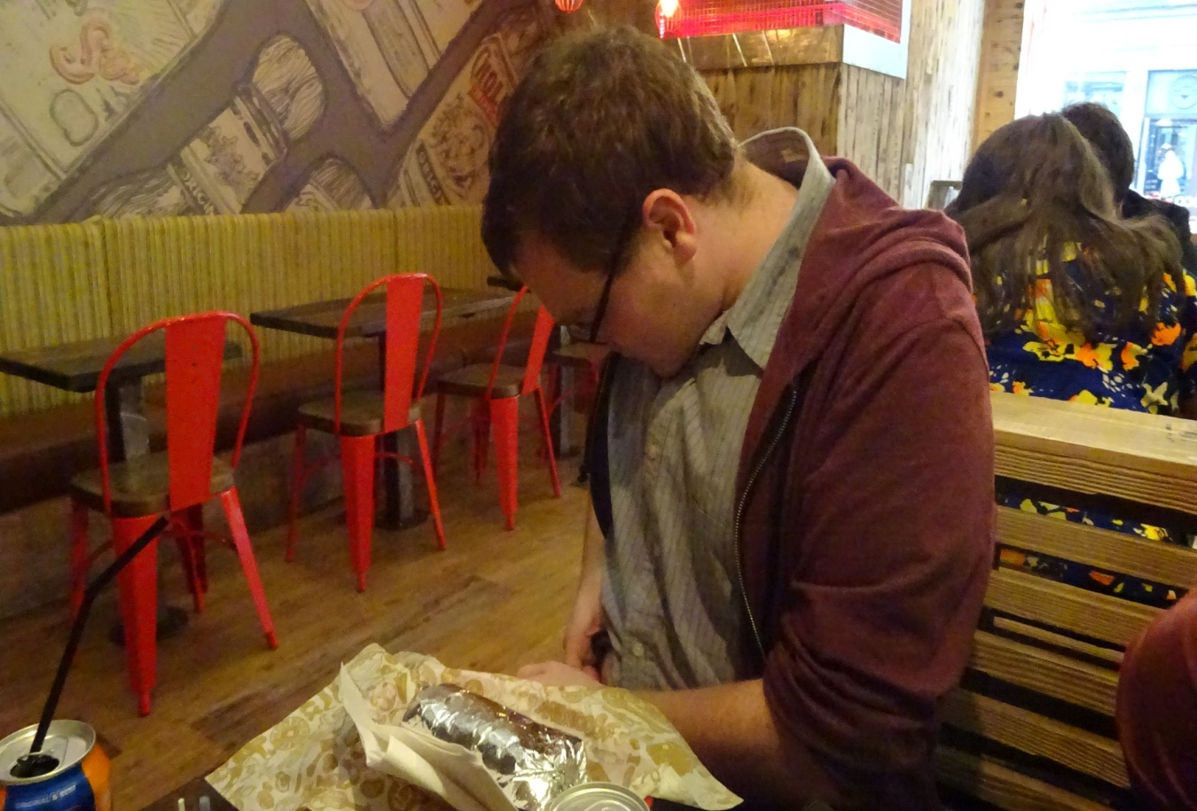
Figure 5: I am injecting insulin into my stomach at a fast food restaurant. Very little of the act of injecting can be seen by others as I discreetly move the bottom of my shirt to reveal an area for injection (author’s own photograph).

Managing each other

While the above discussion outlines how people with diabetes feel their bodies are monitored, the following discussion is about people whose bodies are being monitored. In a particularly telling encounter, Sheila monitors the body of a fellow person with diabetes, while maintaining her own concealment:

Sheila: I was at a meeting one time and this chap sitting beside me took out his insulin pen and he injected and he made some grumblings of ‘I’ve got to take this injection and to hell with anybody else’. I … had a wee laugh to myself and I said to him ‘I might be upset about you and I might be upset about needles … you’re just doing that right in front of me’ … Of course, I had no qualms about this and he went ‘I’m…I’m…em’, he … stuttered about it because … he obviously never thought that somebody else might be having a difficulty with needles.

Interviewer: You were just winding him up?

Sheila: I was just having a wee wind up and I was having a giggle about it. But I thought it took me many, many years to get to that stage where I could have a bit of fun about it. But I never said to him I was diabetic … But he takes his injection … and he just carries on with the meeting. It was just his attitude … he was arrogant, about no giving a damn, about anybody’s thoughts or feelings about him taking this [injection], and I thought, ‘hey wait a minute, there might be other reasons why somebody might be upset’.

Interviewer: The sort of reason you’d thought about for so long?

Sheila: Aye!

Interviewer: And he’s just got this instant confidence of just whipping it out and going for it?

Sheila: Aye!

Sheila’s ‘wind up’, questions this man’s diabetic behaviour and she makes him think about the visibility of his diabetic body. If before, he did not feel his body was under surveillance, he certainly feels it is now. Sheila is re-assuring herself that diabetes and its self-management is something to be hidden, and that this man is somehow ignorant of this norm. Sheila’s encounter represents this internalised norm of diabetes behaviour as an encounter with a person who openly enacts their diabetes self-management is met with a call for censorship rather than encouragement.

There was a feeling among my participants that being seen doing self-management could instil a sense of shame. Linda helps explain this feeling:

Linda: I think that becomes a bit more awkward … a bit more self-conscious [being in enclosed spaces]. I guess that also would have an affect on how one feels long term, there’s a sort of sense of shame I guess.

Interviewer: Do you feel that sense of shame?

Linda: Sometimes yes … shame and secrecy have a lot to do with each other. When people feel ashamed of something they keep it secret, so it goes the other way around as well. I don’t want other people … to know because I don’t want to spark curiosity, I don’t want to stick out as different … In certain situations I really want to stay anonymous. So I keep it secret and then the feeling kicks in because it’s linked in the brain, secrecy and shame.

Linda evokes the ideas of Sartre, as discussed by Davidson (2003), as she discusses how her self-management makes her noteworthy and so threatens her sense of identity as she loses some control over how others will interpret her identity. As Davidson (ibid: 111-112) remarks, quoting Sartre:

For Sartre, this ‘true self’ from which we are ‘alienated’ does not already exist ‘underneath’ or hidden behind the false. Rather, it must be created, brought into being by independent action in the world, by increased awareness and realisation of our potential for total freedom.

Likewise there is no authentic form of ‘diabetic’ lying underneath social conventions but there are alternative forms, which are not being enacted. One such form would see the self-management practices as something less remarkable so that Linda can retain her anonymity, still being discrete about management, but also not feel a sense of shame if her diabetic body was noticed. However, Linda is currently unable to realise this “potential for total freedom” and will not until the norm of discretion around self-management is relaxed.

Glen likewise discusses this sense of shame with me as he responds to a comment from me which he perceives as somewhat leading.

Interviewer: It’s easy to hide as a diabetic.

Glen: Yeah, but your choice of words … ‘it’s easy to hide’, why did you use the word hide? … Hide implies that it is something that shouldn’t be open or there is a shame to it … The idea that privacy is only for something that you’re going to hide and if you have nothing to hide then you don’t have anything to worry about … It’s interesting that you chose the word hide … I don’t think you need to apply things like that. Most diabetics, they just live. They just go through the motions and they do stuff like that. It’s not about hiding or being more open about it or telling people.

Glen is voicing the opposite viewpoint to Sheila in the previous example. He is questioning me, as he reacts passionately to my comment about diabetes being easy to hide, he challenges what he perceives to be my accepted viewpoint on how people with diabetes should manage the visible practices involved with the condition. In this interview I was not advancing that people with diabetes should act in this way but attempting to stoke conversation. That shame could be felt from the secrecy or hiding of self-management suggests that, while there may be practical and considerate reasons for the diabetes self-management norm discussed in the opening empirical section, it can also create undeserved negative feelings among people with diabetes.

Such assertions of not having to hide or be restricted in doing public self-management were common in the data. However there were few mentions of outright resistance to the norm of diabetes discretion. Instead more mundane acts of resistance were described. For instance Catherine describes injecting in front of her friend even though she knew it made her friend uncomfortable:

The ‘friend’ [Catherine uses scare quotes in her questionnaire response to indicate the unfriendliness of her friend] … didn’t like it when I did injections in front of her. I just used to do them anyway but that was upsetting. I know this might sound a bit selfish but I feel it’s me having to inject myself and if there was any choice for me I wouldn’t do it. So other people who don’t like it should just kinda suck it up! Look away if you feel uncomfortable with seeing someone inject.

While Catherine presents this assertive attitude to injecting in front of her objecting ‘friend’ she still notes that this creating of conflict was upsetting. Catherine then rationalises her actions as her own health is paramount but still feels the pressure to enact a discrete diabetic body as she feels such assertiveness as “selfish”, thereby acknowledging that she perceives her behaviour and body to have a duty to public comfort.

Alongside assertions such as Catherine’s the panoptic gaze was co-opted. The possibility of being mistaken as an illicit drug user was used as a source of disarming humour for some participants. To prepare other for the sight of his injection, George says: “I just make a joke, I say ‘yeah I’m going to shoot up now’ … I don’t have any problems telling people, I don’t think it’s anything to be ashamed of”. By using the phrase ‘shooting up’, George is toying with the seriousness with which his injecting could be interpreted by others (as something illicit). Through his cynical performance of ‘shooting up’ he both acknowledges the possible misinterpretation and stigma of injecting but with his humour aims to dispel any tension among those who may see him practice his self-management.

Glen tells of another form of co-opting the expected discretion of diabetes as he reflects on testing his blood sugar levels at work:

The most noticeable thing when I’m eating at lunch is probably the clicking of the pen as you push it in or the beep of the glucose meter when the test strip is testing … and I’ll hide that under the desk so people scratch their head, where’s that beeping coming from?

Glen’s co-opting is enacted within the experience of a felt surveillance. These are minor resistances to the panoptic gaze. In the case of those living with type 1 diabetes and with reference to the data analysed in this project it may seem at first glance that the norms of diabetes behaviour in public space are firmly established and rarely challenged. There are no hyperbolic displays of resistance to the norm. But there are still resistances that work “immanent: to power if not in direct and obvious “opposition” (Butler 2011: xxiii). Catherine injects her insulin regardless of her friend’s opinion but still feels selfish at this open performance of diabetes. Commonalities with illicit drug use may be co-opted as jokes while Glen uses the lack of visibility and knowledge about diabetes to create confusion for others in his workplace. The everyday resistance to the “constitutive constraint” (ibid) of diabetes is seen in the seemingly minor grumbles and complaints of my participants, often little heard, and seldom acknowledged, by others.

Conclusion

Foucault (1991: 202-203) writes that:

He [sic] who is subjected to a field of visibility, and who knows it, assumes responsibility for the constraints of power; he makes them play spontaneously upon himself; he inscribes in himself the power relation in which he simultaneously plays both roles; he becomes the principle of his own subjection. By this very fact, the external power may throw off its physical weight; it tends to the non-corporal; and, the more it approaches this limit, the more constant, profound and permanent are its effects: it is a perpetual victory that avoids any physical confrontation and which is always decided in advance.

In this paper I have tried to express the “perpetual victory” of panopticism in creating ‘docile diabetic bodies’. The bodies described in the paper are docile as they, largely, conform to the norms that people with diabetes implicitly set for themselves. Docile bodies, however, are not fixed or permanent but are malleable, as Foucault (1991: 136) describes: “a body is docile that may be subjected, used, transformed and improved”. Docile bodies retain the possibility for co-opting the norms and enacting resistance. The participants in this paper often felt surveillance rather than experiencing it directly. While I argue that the feeling of surveillance is important this is not to say that my participants never also experienced actual surveillance of their diabetic bodies, such as being reprimanded for public self-management (as Catherine notes in the previous section). However feeling surveillance with possible but rarely enacted punitive consequences was a more frequently recurring theme. Other bodies experience similar felt surveillance in public spaces. Smoking and breastfeeding pollute public space and so are policed to limit their visibility. While there are good arguments for encouraging this with smoking; breastfeeding represents a more symbolic discomfort with an exposed part of a sexualised body as it performs a ‘leaking’ (Longhurst 2001) bodily transgression. Both these performative bodies become stigmatised, as dirty and ‘inconsiderate’ (Poland 2000). Fat bodies meanwhile are subjected to an “unverifiable gaze” (Evans and Colls 2009: 1073) instilling a sense of paranoia. In these constructions of bodies fatness is a personal failing, breastfeeding is an ostentatious performance, smoking is a polluting transgression of bodily boundaries and diabetes self-management is a flaunting of disease. Due to these constructions different bodies are often spatially marginalised. Boyer (2012) writes of dirty, uncomfortable and ill-designed lactation rooms for breastfeeding mothers while Tan (2013) considers smokers in Singapore who are increasingly spatially and socially marginalised due to stringent anti-tobacco laws and enforcement. The visible signifiers of diabetes can be likewise spatially marginalised, most obviously in toilets but also through minor performances of the body. This hiddenness allows a misplaced sense of shame to fester among people with diabetes, meaning the everyday essential acts of self-management are valued as a marker of an out-of-control body rather than one that is in fact, controlling.

With this paper I do not mean to contend that people with diabetes live their lives under a repressive panopticism. What I do mean to contend is that there are vestiges of a panopticism that combine with people’s own desire to control aspects of their personal identity. Perhaps people with diabetes do not want their ‘stigma’ known to others, attempting to protect their self from an all-too-knowing gaze of the other. They are not necessarily oppressed by the gaze, unable to express their diabetic self in all its unhindered glory. Nonetheless the sense of shame described by participants indicates that the felt surveillance does have a negative emotional impact on people with diabetes. This impact cannot be mediated while people feel their diabetic bodies are to remain discrete in public space. Following Butler and Sartre (through Davidson) there is no ‘natural’ category of diabetes underlying the norms of discretion and maintaining public comfort. There is however something under the surface, a “gleeful spiritual aggression” (Goffman 1971: 28-29) to push the limits of the norms. Perhaps the bodily necessities of diabetes can never be completely concealed as “the body, required to be docile in its minutest operations, opposes and shows the conditions of functioning proper to an organism” (Foucault 1991: 156). The diabetic body will always resist a norm of discrete performance as the body always needs to be attended to, regardless of social norms. Sadly the norm of discretion can create sense of shame at feeling the need to hide embodied practices that are crucial to everyday functioning. With this paper I hope to go some small way to loosening the norms that hold diabetes, especially those on the performances of self-management.
Reference List

Ahmed, Sara. 2004. The Cultural Politics of Emotion. Edinburgh University Press, Edinburgh

Balfe, Myles. 2005. “Diabetes and the Student Body” PhD diss., University of Sheffield.
Balfe, M., Doyle, F., Smith, D., Sreenan, S., Brugha, R., Hevey, D., & Conroy, R. 2013. “What’s distressing about having type 1 diabetes? A qualitative study of young adults' perspectives”. BMC Endocrine Disorders, 13(1):1-14.
Barcan, Ruth. 2005. “Dirty Spaces: Communication and Contamination in Men’s Public Toilets.” Journal of International Women’s Studies 6(2): 7-23.

Boyer, Kate. 2011. ““The way to break the taboo is to do the taboo thing” breastfeeding in public and citizen-activism in the UK.” Health and Place 17: 430-437.

Boyer, Kate. 2012. “Affect, corporeality and the limits of belonging: Breastfeeding in public in the contemporary UK. ” Health and Place 18: 552-560.
Braverman, I. 2010. “Governing with Clean Hands: Automated Public Toilets and Sanitary Surveillance”. Surveillance & Society, 8(1): 1–27.
Briggs, Daniel. 2013. “Emotions, ethnography and crack cocaine users” Emotion, Space and Society 7: 1-12

Butler, Judith. 2004 “Performative acts and gender constitution: an essay in phenomenology and feminist theory”. In The Performance Studies Reader edited by Bial, Henry, 154-166. London: Routledge

Butler, Judith. 2011. Bodies That Matter. New York: Routledge (First published in 1993)
Davidson, J. 2003. ““Putting on a face”: Sartre, Goffman, and agoraphobic anxiety in social space”. Environment and Planning D: Society and Space, 21(2): 107–122.
Diabetes UK Website. https://www.diabetes.org.uk/Guide-to-diabetes/What-is-diabetes/ [last accessed 11th February 2016]

Diedrich, Lisa. 2007. Treatments: language, politics, and the culture of illness. Minneapolis: University of Minnesota Press.

Evans, Bethan; Colls, Rachel. 2009. “Measuring fatness, governing bodies: The spatialities of the body mass index (BMI) in anti-obesity politics.” Antipode 41(5): 1051-1083.

Foucault, Michel. 1991. Discipline and Punish: The Birth of the Prison. London: Penguin Books. (First published in 1977)

Goffman, Erving. 1968. Stigma: Notes on the Management of Spoiled Identity. New York: Simon and Schuster. (First version published 1963)

Goffman, Erving. 1971. The Presentation of the Self in Everyday Life. London: Penguin Books. (First version published 1959)
Gregson, N., & Rose, G. 2000. Taking Butler elsewhere: Performativities, spatialities and subjectivities. Environment and Planning D: Society and Space, 18(4), 433–452.
Jenkins, N; Hallowell, N; Farmer, A. J; Holman, R. R; Lawton, J. 2011. “Participants’ experience of intensifying insulin therapy during the Treating to Target in Type 2 Diabetes (4-T) trial; qualitative interview study.” Diabetic Medicine 28(5): 543-548

Kengne, Andre; Echouffo-Tcheugui, Justin-Basile; Sobngwi, Eugene; Mbanya, Jean-Claude. 2013. “New insights on diabetes mellitus and obesity in Africa–Part 1: prevalence, pathogenesis and comorbidities” Heart, 99(14): 979-983.

Longhurst, Robyn. 2001. Fluid Boundaries. London: Routledge.
Mainous, A. G., Diaz, V. a, Saxena, S., Baker, R., Everett, C. J., Koopman, R. J., & Majeed, A. 2006. Diabetes management in the USA and England: comparative analysis of national surveys. Journal of the Royal Society of Medicine, 99(9), 463–469.
McCahill, M., & Finn, R. L. 2013. “The surveillance of “prolific” offenders: Beyond “docile bodies.”” Punishment & Society, 15(1), 23–42.
Poland, Blake. 2000. “The ‘considerate’ smoker in public space: the micro-politics and political economy of ‘doing the right thing’.” Health and Place 6: 1-14.

Proudfoot, Jesse. 2011. “The Anxious Enjoyment of Poverty: Drug Addiction, Panhandling, and the Spaces of Psychoanalysis.” PhD diss., Simon Fraser University.

Rhodes, Tim; Watts, Louise; Davies, Sarah; Martin, Anthea; Smith, Josie; Clark, David; Craine, Noel; Lyons, Marion. 2007. “Risk, shame and the public injector: A qualitative study of drug injecting in South Wales.” Social Science and Medicine 65: 572-585.

Tan, Qian Hui. 2013. “Smoking spaces as enabling spaces of wellbeing.” Health and Place 24: 173-182.

Yar, Majid. 2003. “Panoptic power and the pathologisation of vision: Critical reflections on the Foucauldian thesis.” Surveillance and Society 1(3): 254-271.

Wendell, Susan. 2013. “Unhealthy disabled: Treating chronic illnesses as disabilities.” In The Disability Studies Reader, edited by David, Lennard J, 161-176. New York: Routledge.
Wood, D. 2003. Editorial. Foucault and Panopticism Revisited. Surveillance & Society, 1(3), 234–239.

The most common form of diabetes, however, is type 2. Type 2 is often linked to lifestyle factors, such as poor diet and a lack of exercise, although genetic predisposition is also a factor. In type 2 the pancreas still produces insulin but the body is unable to use it efficiently. The condition is often controlled through diet and oral medication. Nevertheless, many people with type 2 also use insulin injections and test their blood sugar levels.
Anna makes this claim in the context of urban Glasgow. Despite claiming in the methods section that the specificities of Glasgow were note an emerging theme, there were still some points that localised the data.
My choice of words does suggest it was a somewhat leading question from me. However Glen had previously mused on ‘hiding’ his diabetes from work colleagues so my question was not entirely leading.

