Title: Risk-adapted target delineation for breast cancer: controversies & considerations
Authors:
Dr Irfan Ahmad, DNB ¹
Dr Kundan Singh Chufal, MD ¹
Dr Alexis Andrew Miller, FRANZCR ²
Dr Ram Bajpai, PhD ³
Dr Rahul Lal Chowdhary, MD ¹
Dr Muhammed Ismail Sharief, DNB ¹
Dr Preetha Umesh ¹
Dr Munish Gairola, MD ¹

Author Affiliations:
¹ Department of Radiation Oncology, Rajiv Gandhi Cancer Institute & Research Centre, New Delhi, India
² Department of Radiation Oncology, Illawara Cancer Care Center, Wollongong, New South Wales, Australia
³ Centre for Prognosis Research, School of Medicine, Keele University, Staffordshire, United Kingdom

Corresponding Author:
Dr Irfan Ahmad,
Department of Radiation Oncology, Rajiv Gandhi Cancer Institute & Research Centre,
Sector 5, Rohini, New Delhi, India
Email, Phone Number: irfan.a@icloud.com, (0091)-11-47022012

Author Responsible for Statistical Analysis Name & Email Address:
Dr Ram Bajpai,
Centre for Prognosis Research, School of Medicine, Keele University, Staffordshire, United Kingdom
Email: rambajpai@hotmail.com

Conflict of Interest Statement: None
Funding Statement: None
Acknowledgements: None
Data Availability Statement for this Work: Not Applicable
Author Contributions: All authors contributed equally in the design, conception and writing of this manuscript.
Ethical disclosure: Not Applicable
Abstract
The advent of CT-based planning coupled with modern tools for target delineation and hypofractionated treatment schedules have increased efficiency and throughput for patients with breast cancer. While the benefit of adjuvant radiotherapy (RT) in reducing locoregional recurrences is established, disentangling local versus regional recurrence risks with modern treatment protocols has become an area of active research in order to de-escalate treatment. Delineation guidelines for nodal regions either attempt to replicate results of conventional RT techniques by translating bony landmarks to clinical target volumes or utilize landmarks based on the fact that lymphatic channels run along the vasculature. Since direct comparisons of both approaches are implausible, mapping studies of nodal recurrences have reported on the proportion of nodes included in these delineation guidelines, and ‘larger’ bony-landmark-based guidelines appear intuitively appealing for patients with unfavorable risk factors. A pooled analysis of these studies is reported here, along with literature supporting the exclusion of the true chest wall from post-mastectomy/breast-conserving surgery clinical target volumes and the selective (versus routine) use of bolus during post-mastectomy RT. The risk-adapted approach suggested here accounts for the risk of recurrence as well as toxicity and endorses nuanced target volume delineation rather than a one-size-fits-all approach.

Introduction
The transition to CT-based planning promises more accurate target delineation to achieve the prized goals of reduced toxicity with equivalent/ improved tumor control and no geographic misses, yet guidelines for the same have been developed with a higher frequency over the last two decades without any widely accepted standards.¹ The lack of a literature review and a full image dataset in most guidelines impedes the goal of reducing variations by increasing inter-observer inconsistencies.^{1,2} The direct translation of decades of clinical data from conventional, bony-landmark-based radiotherapy planning to modern target volume concepts is far from the simplistic exercise it appears to be.² This, coupled with contemporary patterns-of-failure analyses, has sparked debates on the following issues: (a) nodal volume delineation guidelines; (b) inclusion of true chest wall (ribs and intercostal muscles) and pectoralis musculature into chest wall/whole breast CTV, and; (c) utility of using a tissue-equivalent bolus for all post-MRM patients.
Nodal volume delineation: Vessel- versus landmark-based guidelines
Broadly, two different approaches towards nodal volume delineation have emerged with CT-based planning, a vessel-based approach [PROject of CAncer of the Breast (PROCAB)] used by the European SocieTy for Radiotherapy & Oncology (ESTRO) guidelines and a landmark-based approach [Radiation Therapy and Oncology Group (RTOG) and subsequently RADiotherapy COMParative effectiveness consortium (RADCOMP) guidelines].² While easy to reproduce, bony landmarks are an inadequate surrogate for lymphatics, which vary with arm positions and patient anatomy and often result in irradiated volumes larger than conventional planning (after adding a 5-7mm margin for Planning Target Volume).² With trials demonstrating the benefit of Elective Nodal Irradiation (ENI), institutional analyses on pre-treatment and recurrent nodal ‘coverage’ provided by these guidelines have emerged, as a prospective randomized trial comparing them is unlikely.
These analyses on the anatomical location of pre-treatment and recurrent nodes are susceptible to flaws in assumption, namely, that sites of initial gross nodal disease are correlated with recurrent disease and that sites of recurrent disease possibly harbored microscopic disease, respectively.^{3–7} Another drawback of these analyses is that none of the included patients underwent treatment using a particular target delineation guideline (except DeSelm C et al.; nodal regions were delineated, but the guideline followed was unspecified).^{4–7} Consequently, the reported patterns of nodal recurrence could be interpreted as an indictment of planning technique or a result of unfavorable disease biology rather than an endorsement of the superiority of one guideline over another.^{4–7} Since most of these analyses utilized field-based techniques (except DeSelm C et al.; 3D conformal planning was used), thereby often irradiating regions where subsequent recurrent nodes were detected suggests a dominant role of disease biology.^{4–7}
Ignoring their individual drawbacks, population heterogeneity, and management protocols, we pooled data from the four analyses (585 patients with 765 lymph nodes), which reported nodal recurrences after radiotherapy (and compared ESTRO and RTOG guidelines). Overall, the odds of a recurrent node being located within the ESTRO and RTOG CTVs were equivalent [OR (95% CI) = 0.74 (0.45-1.11)](Figure 1A). However, in the SCF region, the odds of a recurrent node being located within the ESTRO Level 4 CTV were significantly less compared to the RTOG SCF CTV [OR (95% CI) = 0.52 (0.32-0.86)](Figure 1B). Comparisons for other nodal levels were equivalent (not shown).
The incremental coverage of RTOG SCF CTV over and above the ESTRO Lv4 CTV was less than 10% in most analyses (except DeSelm C et al.; 31%), and 20-52% of recurrent nodes were outside both ESTRO Lv4 and RTOG SCF CTVs. Most of the nodes outside both CTVs were identified in the Postero-Lateral SCF region (named as 'Posterior Neck CTV' in the RADCOMP guidelines), and in one analysis, more than 50% of recurrent nodes in this region were covered by the Posterior Neck CTV (Figure 1D).⁷ Clear indications for treating this region are absent and putative factors associated with recurrence are: Young age (≤ 45 yrs); High-grade tumors, Triple-negative expression profile; Lymphovascular invasion, and; Extra-nodal extension.^{4,6}
The ESTRO nodal guidelines are 'smaller', especially in the supraclavicular region (Figure 1C), and has led researchers to conclude that they should be used in early breast cancers, while locally advanced cancers require treatment with 'larger’ landmark-based volumes.⁸ This view is challenged by a 3D dose simulation study from pivotal trials of ENI, demonstrating that extensive nodal volumes are probably unnecessary (despite lower dose in the ESTRO Lv4 and incomplete recurrent nodal coverage) to reduce regional recurrences.⁹
When pre-intervention PET-CT (pre-surgery or pre-NACT) is available, the ESTRO guidelines can be adapted to include a 1-2cm margin around initially involved nodes, increasing its applicability to patients with pN₂ disease as well.² However, the risk of aberrant lymphatic drainage also increases with increasing nodal involvement; therefore, the results of two randomized trials (Skagen-I, NCT02384733; HYPOG-01, NCT03127995) in the locally advanced setting will provide guidance on the suitability of the ESTRO guideline in patients with pN₃ disease. Without pre-intervention imaging, the ESTRO guideline can be applied to patients with up to pN1 disease, whereas pN₂₋₃ disease should be addressed with either RTOG or RADCOMP guidelines.^{9,8} This will enable a reduction in the dose to adjacent OARs and aid the transition from a one-size-fits-all approach using ‘larger’ volumes to a risk-adapted approach.²
Inclusion of True Chest Wall and Pectoralis Musculature
The ESTRO guidelines exclude the ribs and intercostal muscles (True Chest Wall) and the pectoralis musculature from the post-mastectomy chest wall CTV and the whole breast CTV.² A systematic review of post-mastectomy chest wall recurrences (LR) included 6901 patients and identified 241 patients with LR (340 recurrent lesions). The absolute LR was 3.5% and identified the highest risk of recurrence in the skin/subcutaneous tissue, followed by the pectoralis musculature, while the True Chest Wall harbored minimal risk (figure 2A).¹⁰ This low absolute LR rate could be due to the standard tangential field design covering all regions at risk (Figure 2A). The risk of recurrence in the true chest wall would be even lower in patients undergoing breast conservation surgery, where the predominant LR pattern is in the glandular parenchyma surrounding the lumpectomy cavity. Therefore, exclusion of this region should be recommended for almost all patients, irrespective of the type of surgery (breast conservation or mastectomy), and is endorsed by the RADCOMP guidelines (Figure 2B). Exclusion of the pectoralis musculature can be considered in the absence of high-risk features (tumor invading/adjacent to muscle; close/involved posterior margins) though more research is needed to address this specific question because an undefined proportion are a result of interpectoral nodal recurrences.¹⁰
Routine versus Selective use of bolus
A variation in practice that received little attention is the use of bolus, specifically the thickness, schedule, composition, and associated planning characteristics.^{11,12} The ESTRO and RTOG/RADCOMP guidelines also differ in their recommendations on whether the post-mastectomy chest wall CTV should reach up to the skin surface.² The main issue with estimating the risk of local recurrence after mastectomy is that it is often reported in conjunction with regional recurrence, and for a proportion of patients with pT₁₋₃ pN+ breast cancers, it is the regional risk after mastectomy, which often drives the indications of adjuvant RT.¹³ With contemporary systemic treatment and radiotherapy techniques, 5-year chest wall recurrence rates have consistently declined with an absolute rate of 3.0%.¹⁴
In that context, the contribution of bolus use towards reducing skin recurrences is doubtful because LR with/without bolus is identical (Figure 3).¹² However, its use increases toxicity for many patients, often leading to more frequent and prolonged treatment interruptions (Figure 3).¹² This skewed risk-benefit ratio resulted in a multi-disciplinary panel of experts recommending that bolus should only be used in the setting of skin involvement or inflammatory cancer (T_{4b-d} or ypT₄), inoperable/ fungating masses, involved superficial margins, and treatment of local recurrences.¹¹
Discussion
The apparent benefit of CT-based planning is the sophisticated, personalized anatomical visualization of clinical risk and its accurate delineation (CTV), which is the basis of modern risk-adapted radiotherapy. However, the practical issues of defining an accurate CTV have not been completely solved, especially in breast radiotherapy, leading to a divergence of opinion on the concept of justifiable irradiated volume. As demonstrated by the conclusions of the researchers exploring CTV coverage in the relapsed setting and our pooled analysis of their results, the supraclavicular region's CTV needs to be customized (based on pre-intervention imaging whenever available), and consideration should be given to expanding a 'smaller' ESTRO Lv4 CTV rather than reflexively delineating a 'larger' RTOG SCF CTV, as the majority of nodes outside both volumes lie in the posterior neck.^{4–7}
Diverging from decades of classical textbook teaching, the use of bolus after mastectomy should be selective rather than routine, and the true chest wall should be excluded from our CTVs. While it can be argued that more analyses are needed before applying these results to patients receiving hypofractionated radiotherapy schedules, we believe that the time for adopting these changes is now. Keeping the long natural history and absolute rates of locoregional recurrences with modern treatment protocols in mind, waiting for more analyses would result in our delineation protocols remaining unjustifiably behind our fractionation regimens.

References
1. Lin D, Lapen K, Sherer MV, et al. A Systematic Review of Contouring Guidelines in Radiation Oncology: Analysis of Frequency, Methodology, and Delivery of Consensus Recommendations. Int J Radiat Oncol. 2020;107(4):827-835. doi:10.1016/j.ijrobp.2020.04.011
2. Kaidar-Person O, Offersen BV, Boersma L, et al. Tricks and tips for target volume definition and delineation in breast cancer: Lessons learned from ESTRO breast courses. Radiother Oncol. 2021;162:185-194. doi:10.1016/j.radonc.2021.07.015
3. Borm KJ, Voppichler J, Düsberg M, et al. FDG/PET-CT–Based Lymph Node Atlas in Breast Cancer Patients. Int J Radiat Oncol. 2019;103(3):574-582. doi:10.1016/j.ijrobp.2018.07.2025
4. Chang JS, Byun HK, Kim JW, et al. Three-dimensional analysis of patterns of locoregional recurrence after treatment in breast cancer patients: Validation of the ESTRO consensus guideline on target volume. Radiother Oncol. 2017;122(1):24-29. doi:10.1016/j.radonc.2016.10.016
5. Chang JS, Lee J, Chun M, et al. Mapping patterns of locoregional recurrence following contemporary treatment with radiation therapy for breast cancer: A multi-institutional validation study of the ESTRO consensus guideline on clinical target volume. Radiother Oncol. 2018;126(1):139-147. doi:10.1016/j.radonc.2017.09.031
6. DeSelm C, Yang TJ, Cahlon O, et al. A 3-Dimensional Mapping Analysis of Regional Nodal Recurrences in Breast Cancer. Int J Radiat Oncol. 2019;103(3):583-591. doi:10.1016/j.ijrobp.2018.10.021
7. Beaton L, Nica L, Tyldesley S, et al. PET/CT of breast cancer regional nodal recurrences: an evaluation of contouring atlases. Radiat Oncol. 2020;15(1):136. doi:10.1186/s13014-020-01576-6
8. Loganadane G, Truong PT, Taghian AG, et al. Comparison of Nodal Target Volume Definition in Breast Cancer Radiation Therapy According to RTOG Versus ESTRO Atlases: A Practical Review From the TransAtlantic Radiation Oncology Network (TRONE). Int J Radiat Oncol. 2020;107(3):437-448. doi:10.1016/j.ijrobp.2020.04.012
9. Borm KJ, Oechsner M, Düsberg M, et al. Irradiation of regional lymph node areas in breast cancer – Dose evaluation according to the Z0011, AMAROS, EORTC 10981-22023 and MA-20 field design. Radiother Oncol. 2020;142:195-201. doi:10.1016/j.radonc.2019.08.021
10. Kaidar-Person O, Poortmans P, Offersen BV, et al. Spatial location of local recurrences after mastectomy: a systematic review. Breast Cancer Res Treat. 2020;183(2):263-273. doi:10.1007/s10549-020-05774-4
11. Kaidar-Person O, Dahn HM, Nichol AM, et al. A Delphi study and International Consensus Recommendations: The use of bolus in the setting of postmastectomy radiation therapy for early breast cancer. Radiother Oncol. 2021;164:115-121. doi:10.1016/j.radonc.2021.09.012
12. Dahn HM, Boersma LJ, de Ruysscher D, et al. The use of bolus in postmastectomy radiation therapy for breast cancer: A systematic review. Crit Rev Oncol Hematol. 2021;163:103391. doi:10.1016/j.critrevonc.2021.103391
13. EBCTCG (Early Breast Cancer Trialists’ Collaborative Group). Effect of radiotherapy after mastectomy and axillary surgery on 10-year recurrence and 20-year breast cancer mortality: meta-analysis of individual patient data for 8135 women in 22 randomised trials. The Lancet. 2014;383(9935):2127-2135. doi:10.1016/S0140-6736(14)60488-8
14. Aalders KC, van Bommel ACM, van Dalen T, et al. Contemporary risks of local and regional recurrence and contralateral breast cancer in patients treated for primary breast cancer. Eur J Cancer. 2016;63:118-126. doi:10.1016/j.ejca.2016.05.010

Figures
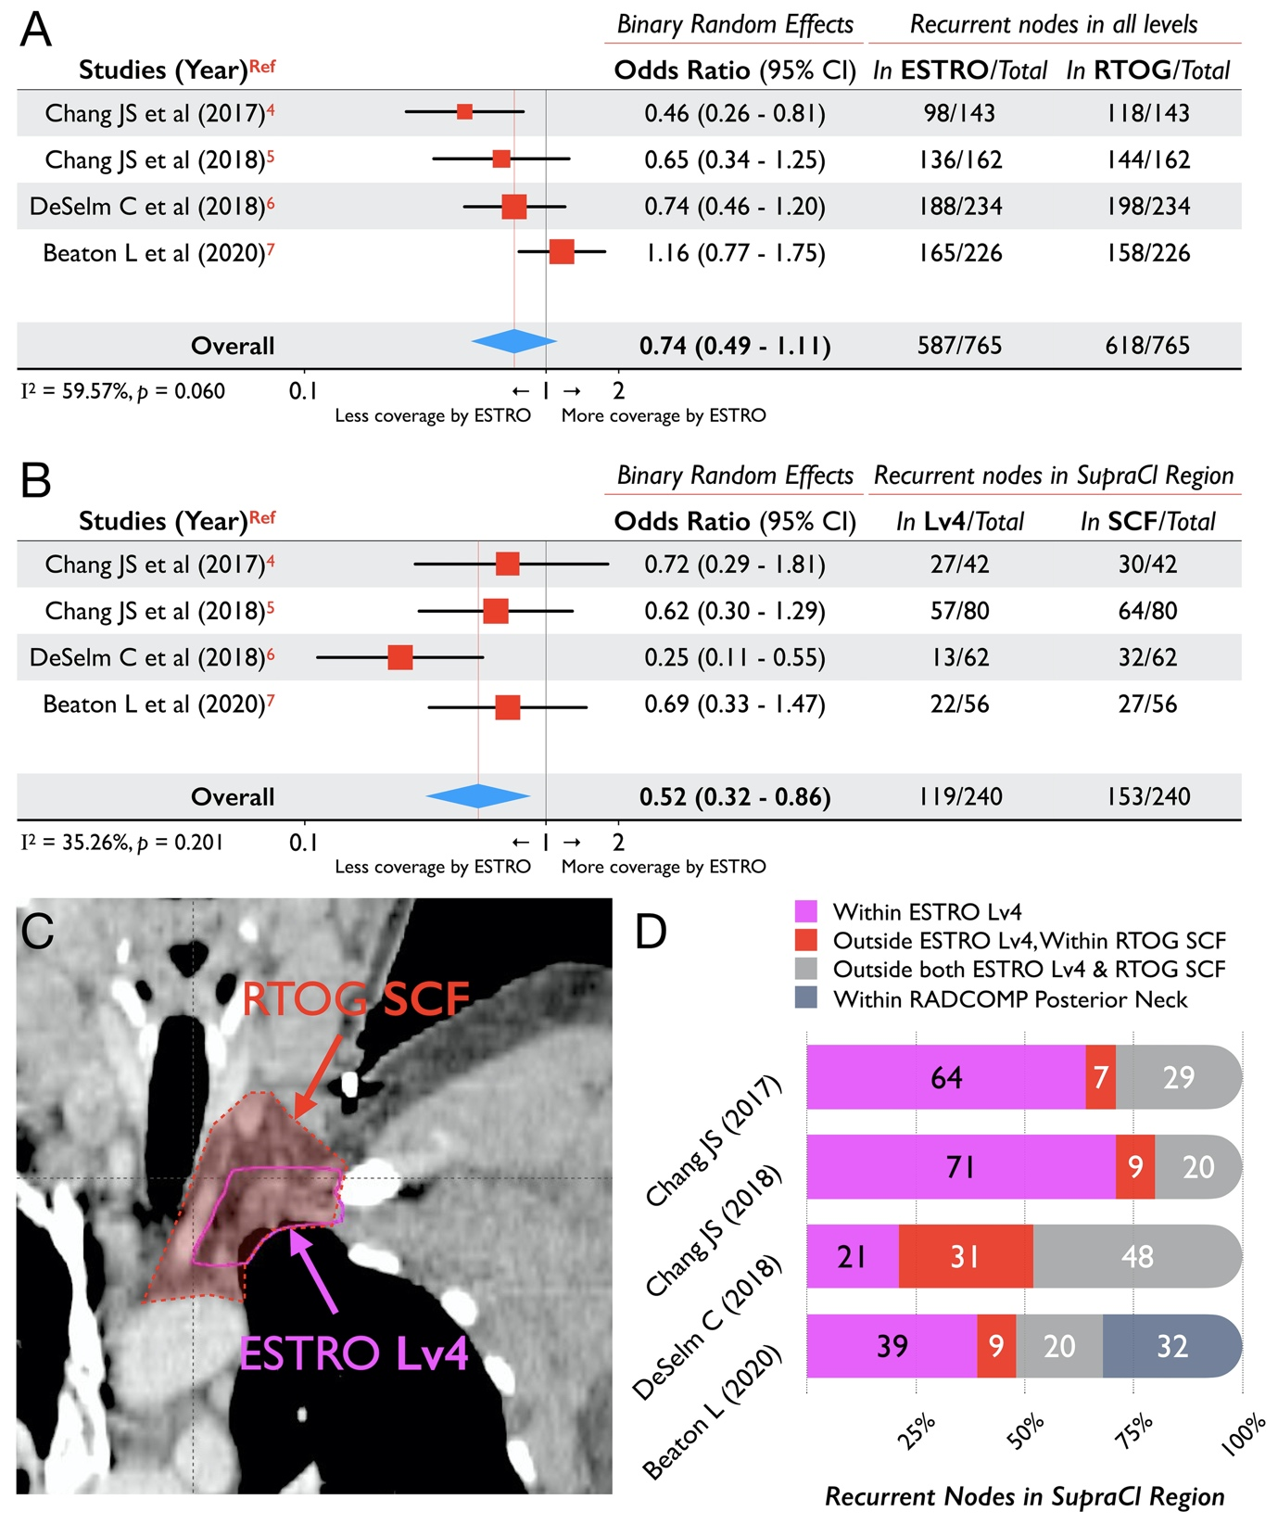
Figure 1. Pooled results of analyses reporting topography of nodal recurrences in relation to delineation guidelines for: (A) all nodal levels, and; (B) supraclavicular region (Both utilized binary outcomes, random effects modeling; Analyses reporting nodes ‘marginally outside’ either ESTRO or RTOG CTVs were counted as ‘outside’). (C) Coronal CT section of a patient demonstrating the extent of the ESTRO and RTOG contours for the supraclavicular region. (D) The extent of nodal coverage provided by delineation guidelines in the supraclavicular region, as reported in each analysis. Abbreviations: CI, Confidence Interval; ESTRO, European SocieTy for Radiotherapy & Oncology; Lv4; Level 4; Ref, Reference; RADCOMP, RADiotherapy COMParative effectiveness consortium; RTOG, Radiation Therapy and Oncology Group; SCF, Supraclavicular Fossa; SupraCl, Supraclavicular.
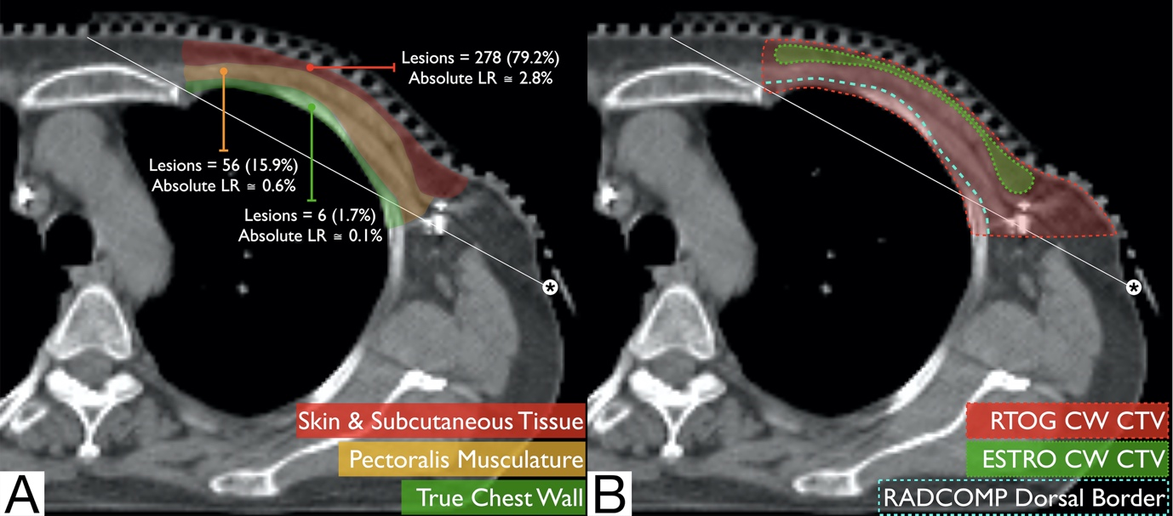
Figure 2. Axial Computed Tomography section of a patient after left-sided mastectomy demonstrating (A) risk of local recurrence (LR) in different regions of the chest wall (based on Kaidar-Person O et al.; Ref. 10), and (B) comparison of the CTV coverage of RTOG, ESTRO, and RADCOMP chest wall (CW) guidelines. A tangential line with (*) is also shown in both figures, representing the standard tangential field border. Abbreviations: CW, Chest Wall; ESTRO, European SocieTy for Radiotherapy & Oncology; RADCOMP, RADiotherapy COMParative effectiveness consortium; RTOG, Radiation Therapy and Oncology Group;
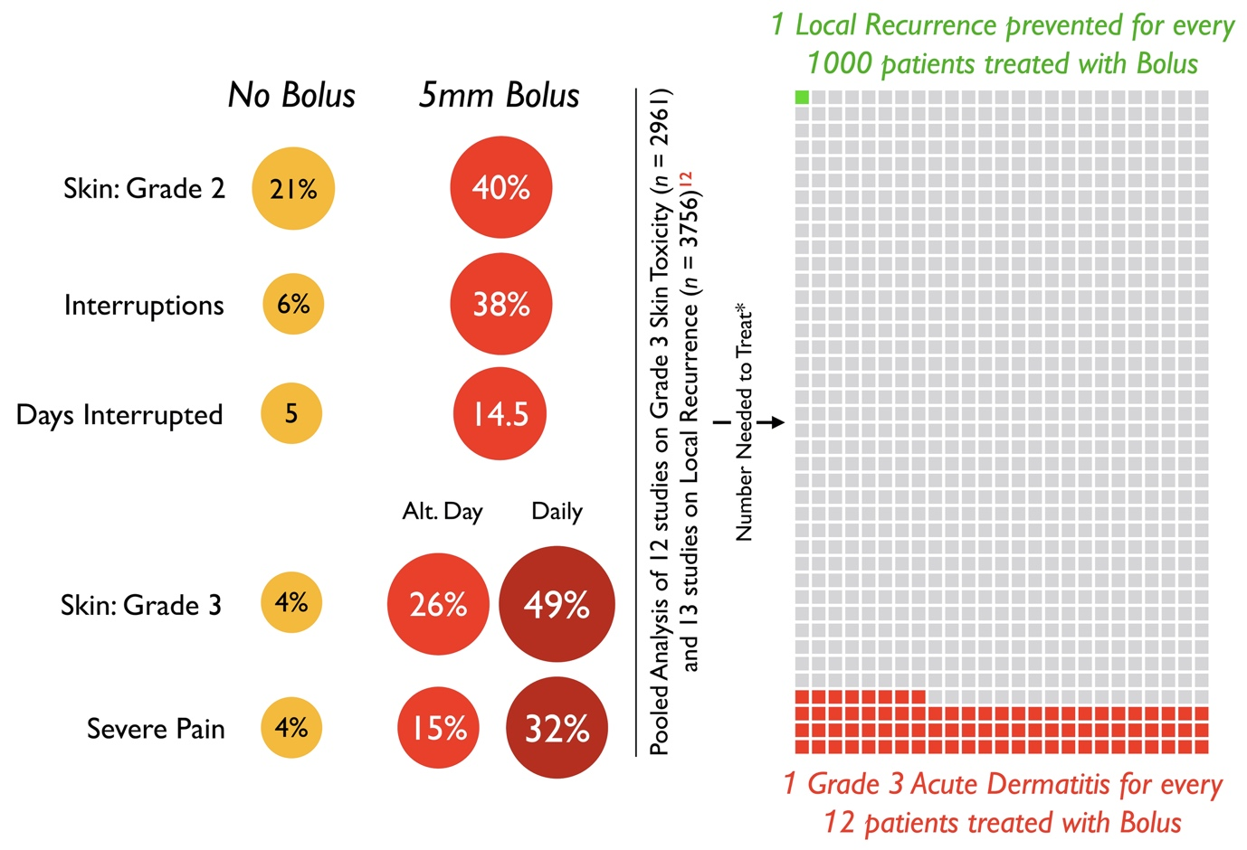
Figure 3. The left half of the figure depicts the results of selected analyses reporting on toxicity outcomes with the use of 5mm tissue-equivalent bolus, which were pooled by Dahn HM et al. (Ref. 12). The right half of the figure depicts a modified Cates plot unto which the benefit (green square)(reduction in local recurrence) and harm (red squares)(Grade 3 skin toxicity) with bolus use is depicted after unadjusted Number Needed to Treat (NNT) calculation. (*) NNT calculation utilized the pooled LR rate (with vs without bolus = 3.5% vs 3.6%; median follow up = 7.2 yrs) and pooled Acute Grade 3 dermatitis (with vs without bolus = 9.6% vs 1.2%).

