Novel Xanthate Complexes for the Size Controlled Synthesis of Copper Sulfide Nanorods

Mundher Al-Shakban,† Peter D. Matthews,‡ Geradius Deogratias,§ Paul D. McNaughter, ‡ James Raftery,‡ Inigo Vitorica-Yrezabal,‡ Egid B. Mubofu,§ and Paul O’Brien†‡*

†School of Materials, University of Manchester, Oxford Road, Manchester M13 9PL, UK

‡ School of Chemistry, University of Manchester, Oxford Road, Manchester, M13 9PL, UK

§ Chemistry Department, University of Dar es Salaam, P. O. Box 35061, Dar es Salaam, Tanzania

ABSTRACT: We present a simple, easily scalable route to monodisperse copper sulfide nanocrystals by the hot-injection of a series of novel copper(I) xanthate single-source precursors [(PPh3)2Cu(S2COR)] (R = *iso*-butyl, 2-methoxyethyl, 2-ethoxyethyl, 1-methoxy-2-propyl, 3-methoxy-1-butyl and 3-methoxy-3-methyl-1-butyl), whose crystal structures are also reported. We show that the width of the obtained rods is dependent on the length of the xanthate chain, which we rationalize through a computational study - where we show that there is a relationship between the ground state energy of the precursor and the copper sulfide rod width.

1. Introduction

The colloidal synthesis of semiconductor nanoparticles has become a key area of research, with much attention focused on II−VI, III−V and IV−VI compounds. However, many of these, such as Pb/Hg/Cd chalcogenides or In/Ga phosphide/arsenide contain toxic and/or rare and expensive elements making them undesirable for widespread production and mass utilisation. There remains a demand for simple, cheap semiconductor nanoparticles, consisting of earth abundant elements. Transition metal chalcogenides (TMC), such as copper sulfide, iron sulfide and tin sulfide are promising candidates,1 and amongst these, copper(I) sulfide is a promising material for photo-applications. It is an indirect band gap semiconductor with a band gap of 1.21 eV2,3 and additionally nanocrystals of Cu*x*S exhibit plasmonic properties4 – the result of oxidation leading to Cu vacancies. The net result is that copper sulfides, unlike other TMC semiconductors, have both electronic and photonic modes, allowing greater opportunities for light harvesting applications and quantum information processing.5–7 Copper sulfides have found extensive use in photovoltaics, as well as in biomedical applications as sensors8 and in theranostics.9

Copper sulfide (Cu*x*S) crystallizes in a number of different phases between the two end members of *x* = 1 (covellite) and *x* = 2 (chalcocite). There are at least 14 different phases of copper sulfide, each with a unique Cu:S ratio.10 These include yarrowite (Cu1.12S), spionkopite (Cu1.40S), geerite (Cu1.60S), roxybite (Cu1.74-1.82S), anilite (Cu1.75S), digenite (Cu1.80S) and djurleite (Cu1.97S).11–15 The vast range of accessible phases of bulk copper sulfides is also observed in the nanocrystal domain. This leads to the interesting range of properties demonstrated by Cu*x*S, but in order to exploit these it is necessary to be able to exert control over size and phase during the synthesis.

Copper sulfide has been prepared by a number of different routes,16 such as the ubiquitous hot-injection method,2,4,17–20 solvothermal synthesis21 and cation exchange.22,23 Previous attempts at phase control have been based on choice of solvent,24 sulfur choice,25 Cu:S ratio18 and reaction temperature.26 Many synthetic protocols require a complex mixture of reagents to generate monodisperse nanocrystals of copper sulfide, often including environmentally unfriendly ligands. Here we present a simple and easily scalable route to Cu*x*S nanocrystals using a series of copper(I) xanthates as single-source precursors. Single-source precursors (SSP) are an established route to nanodimensional metal chalcogenide semiconductors, though a true SSP has been rarely used to generate copper sulfide.10,27–29 Metal xanthates are an excellent SSP for nanoparticles and thin films of metal sulfide,30–32 as they breakdown via a Chugaev elimination producing volatile by-products that should be removed at the reaction temperature.33–36

2. Experimental section

**2.1 General** All chemicals were purchased from Sigma Aldrich, and were used as received. Elemental analysis (EA) and Thermogravimetric analysis (TGA) were carried out by the Microelemental Analysis service at the University of Manchester. EA was performed using a Flash 2000 Thermo Scientific elemental analyzer and TGA data was obtained with Mettler Toledo TGA/DSC1 stare system between the range of 30 - 600 °C at a heating rate of 10 °C min-1 under nitrogen flow. NMR spectra were recorded in CDCl3 and D2O solutions on a Bruker Ascend spectrometer operating at 400 MHz. Single crystal X-ray diffraction was performed using a Bruker diffractometer with a Cu-Kα source (λ = 1.5418 Å) at 100K and Agilent diffractometer with a Mo-Kα source (λ = 0.71073 Å) at 150K. For more information see ESI Tables S5.1 and S5.2. Crystallographic data available from the CCDC, numbers: 1550291-550300. Transmission electron microscope (TEM) images were collected at 300 keV using an FEI Tecnai TF30 equipped with a field emission gun. EDX measurements were performed using an FEI Quanta 200 SEM equipped with an EDAX Genesis spectrometer. Powder X-ray diffraction (pXRD) analyses were carried out using an X-Pert diffractometer with a Cu-Kα1 source (λ = 1.54059 Å), the applied voltage was 40 kV and the current 30 mA. UV-Vis spectra were collected on a Shimadzu UV-1800, using 1.57 mM solution of nanorods in toluene.

**2.2 Synthesis of Precursors** *Synthesis of Potassium n-Butylxanthate (****1****).* Potassium *n*-butylxanthate was prepared following a literature procedure.37 Potassium hydroxide (5.64 g, 0.10 mol) and *n*-butyl alcohol (50 ml) were stirred for 2 h at room temperature and then CS2 (7.73 g, 6.11 ml, 0.10 mol) was added dropwise to the reaction, resulting in an orange solution. The unreacted alcohol was removed *in vacuo* and the yellow solid product was dried and recrystallized from *n*-butyl alcohol to give [K(S2COnBu)] (13.5 g, 0.0717 mol, 71.7% yield). M.p. = 232‑235 °C. Calc. for C5H9KOS2 (%): C 31.9, H 4.82, S 34.0, K 20.8; found: C 32.2, H 4.83, S 33.8, K 20.4. FT-IR (cm-1): 2958 (m), 2869 (w), 1461 (m), 1445 (w), 1261 (s), 1149 (m), 1173 (m), 1062 (m), 1014 (m), 747.3 (m), 669.0 (s), 566.2 (s). 1H NMR (400 MHz, D2O) δ (ppm) = 0.85 (t, 3H, C*H*3), 1.35 (s, 2H, CH2C*H*2CH3), 1.65 (p, 2H, CH2C*H*2CH2), 4.37 (t, 2H, OC*H*2CH2).

*Synthesis of Potassium iso-Butylxanthate (****2****).* [K(S2COiBu)] was prepared via the same method, using *iso*-butanol (50 ml). The product was recrystallised from *iso*-butanol. (9.66 g, 65% yield). M.p. = 241-243 °C. Calc. for C5H9KOS2 (%): C 31.9, H 4.82, S 34.0, K 20.8; found: C 31.7, H 4.72, S 34.0, K 21.0. FT-IR (cm-1): 2958 (m), 2927 (w), 2870 (w), 1463 (w), 1386 (w), 1366 (w), 1179 (w), 1165 (w), 1141 (m), 1092 (s), 968.8 (m), 937.6 (w), 912.7 (w), 802.1 (w), 653.3(w), 571.9(w). 1H NMR (400 MHz, D2O) δ (ppm) = 0.89 (d, 6H, CH(C*H*3)2), 1.99 (s, 1H, C*H*(CH3)2), 4.16 (d, 2H, OC*H*2CH).

*Synthesis of Potassium 2-Methoxyethylxanthate**(****3****).* [KS2CO(CH2)2OMe] was synthesised by dissolving KOH (11.2 g, 0.20 mol) in (75 ml) of 2-methoxyethanol. The reactors were stirred for 6 h at 0 °C, and then a solution of CS2 (15.2 g, 12 ml, 0.20 mol) in 2-methoxyethanol (25 ml) was added dropwise, resulting in a clear yellow solution. [KS2CO(CH2)2OMe] was isolated from solution by adding THF (100 ml) and shaking the mixture for 15 min. The yellow solid product was dried in vacuo and recrystallized from 2-methoxyethanol to give [K(S2CO(CH2)2OMe)] (19.8g, 0.104 mol, 52.1% yield). M.p. = 216-219 °C. Calc. for C4H7KO2S2 (%): C 25.3, H 3.71, S 33.6, K 20.6; found: C 25.5, H 3.79, S 33.5, K 20.8. FT-IR (cm-1): 2935 (w), 2888 (w), 1442 (m). 1445 (w), 1230 (m), 1134 (m), 1099 (m), 1066 (s), 1018 (m), 844.3 (w), 676.7 (m), 532.5 (m). 1H NMR (400 MHz, D2O) δ (ppm) = 3.35 (s, 3H, OC*H*3), 3.72 (t, 2H, CH2C*H*2O), 4.50 (t, 2H, C*H*2CH2O).

*Synthesis of Potassium 2-Ethoxyethylxanthate (****4****).* [K(S2CO(CH2)2OEt)] was prepared via the same method, using 2-ethoxyethanol alcohol (75 ml). The product was recrystallised from 2-ethoxyethanol. (22.2 g, 0.108 mol, 54.3% yield). M.p. = 201-204 °C.Calc. for C5H9KO2S2 (%): C 29.4, H 4.44, S 31.3, K 19.2; found: C 29.4, H 4.38, S 30.9, K 19.6.FT-IR (cm-1): 2972 (w), 2859 (w), 1443 (m), 1421(w), 1290 (w), 1246 (w), 1107(m), 1053 (s), 934 (w), 826 (w), 795 (w). 1H NMR (400 MHz, D2O) δ (ppm) = 1.13 (t, 3H, CH2C*H*3), 3.57 (q, 2H, C*H*2CH3), 3.76 (t, 2H, CH2C*H*2O), 4.49 (t, 2H, C*H*2CH2O).

*Synthesis of Potassium 1-Methoxy-2-propylxanthate (****5****).* [K(S2COC(H)(Me)CH2OMe)] was prepared via the same method, using 1-methoxy-2-propanol (75 ml). The product was recrystallised from 1-methoxy-2-propanol to give **5** (27.1 g, 0.132 mol, 66.3% yield). M.p. = 221-226 °C. Calc. for C5H9KO2S2 (%): C 29.4, H 4.44, S 31.3, K 19.2; found: C 29.7, H 4.38, S 31.5, K 19.5. FT-IR (cm-1): 2974 (w), 2935(w), 2897 (w), 1442 (m), 1474(w), 1445 (w), 1247 (m), 1172 (m), 1108(m), 1045 (s), 949.6 (w), 938.7 (m), 628.2 (w), 572 (w). 1H NMR (400 MHz, D2O) δ (ppm) = 1.2 (d, 3H, CHC*H*3), 3.33 (s, 3H, OC*H*3), 3.58 (m, 2H, C*H*2O), 5.59 (m, 1H, C*H*CH3).

*Synthesis of Potassium 3-Methoxy-1-butylxanthate (****6****).* [K(S2CO(CH2)2C(H)(OMe)Me)] was prepared via the same method, using 3-methoxy-1-butanol (75 ml). The product was recrystallised from 3-methoxy-1-butanol to give **6** (30.7 g, 0.14 mol, 70.3% yield). M.p. = 202-206 °C. Calc. for C6H11KO2S2 (%): C 33.0, H 5.08, S 29.3, K 17.9; found: C 33.3, H 5.06, S 29.2, K 18.0. FT-IR (cm-1): 2963 (w), 2924(w), 2820 (w), 1449 (m), 1372(w), 1171 (m), 1131 (s), 1100 (s), 1060(s), 958.4 (w), 935.6 (w), 916.1 (w), 830.8(m), 780.4 (w), 559.2 (w). 1H NMR (400 MHz, D2O) δ (ppm) = 1.13 (d, 3H, CHC*H*3), 1.87 (m, 2H,C*H*2CHOCH3), 3.28 (s, 3H, CH2CHOC*H*3), 3.56 (s, 1H, CH2C*H*OCH3), 4.42 (m, 2H, C*H*2CH2CHOCH3).

*Synthesis of Potassium 3-Methoxy-3-methyl-1-butylxanthate (****7****).* [K(S2CO(CH2)2C(OMe)(Me)2)] was prepared via the same method, using 3-methoxy-3-methyl-1-butanol (75 ml). The product was recrystallised from 3-methoxy-3-methyl-1-butanol to give **7**. (29.2 g, 0.125 mol, 62.8% yield). M.p. = 237-240 °C. Calc. for C7H13KO2S2 (%): C 36.2, H 5.65, S 27.6, K 16.8; found: C 36.5, H 5.75, S 27.6, K 17.0. FT-IR (cm-1): 2973 (w), 2955 (w), 1463 (w), 1385 (w), 1366 (w), 1293 (w), 1157 (m), 1087 (s), 1050 (s), 988.4 (w), 945.7 (w), 870.3 (m), 779.4 (w), 754.6 (m). 1H NMR (400 MHz, D2O) δ (ppm) = 1.17 (s, 6H, CH2C(C*H*3)2OCH3), 1.95 (t, 2H, C*H*2C(CH3)2OCH3), 3.16 (s, 3H, CH2C(CH3)2OC*H*3), 4.44 (t, 2H,C*H*2CH2C(CH3)2OCH3).

*Synthesis of Triphenylphosphine Copper Chloride (****8****).* [(Ph3P)2CuCl]2.2CHCl3 was prepared through a modified literature method.38 PPh3 (21.5 g, 0.082 mol) and copper(I) chloride (3.96 g, 0.04 mol) were heated to reflux for 12h in chloroform (150 ml) under N2. After filtration the product was allowed to cool to give crystalline [(Ph3P)2CuCl]2. White crystals suitable for diffraction were obtained from a chloroform solution at -20 °C. (17.6 g, 0.011mol, 61.0% yield). M.p. = 214-217 °C. Calc. for C74H62Cl8Cu2P4 (%): C 59.8, H 4.21, P 8.34; found: C 59.4, H 4.21, P 8.05. FT-IR (cm-1): 3052 (w), 2969 (w), 1479 (w), 1432 (m), 1234 (w), 1183 (w), 1092 (m), 1069 (w), 1026 (w), 997.5 (w), 741.7 (s), 691.3 (s), 665.8 (w), 618.2 (w). 1H NMR (400 MHz, CDCl3) δ (ppm) = 7.13 – 7.35 (m, 30H, Ph). 31P NMR (400 MHz, CDCl3) δ (ppm) = -4.2.

**2.3 Synthesis of Copper Xanthates.** *Synthesis of Triphenylphosphine Copper(I) Ethylxanthate (****9****).* A solution of potassium ethylxanthate (0.641 g, 0.0040 mol) in chloroform (40 ml) was added to a solution of triphenylphosphine (2.09 g, 0.008 mol) and CuCl (0.40 g, 0.0040 mol) in the same amount of chloroform. A white precipitate was obtained after continuous stirring for 1 h at room temperature. The solution was filtered to obtain a clear yellow solution. Cooling the yellow solution to -20 °C gave yellow crystals of triphenylphosphine copper(I) ethylxanthate (2.40 g, 0.0033 mol, 82.5% yield). M.p. = 185‑191 °C. Calc. for C39H35CuOP2S2 (%): C 66.1, H 4.97, S 9.02, P 8.74, Cu 8.96; found: C 65.7, H 5.08, S 8.77, P 8.44, Cu 8.74. FT-IR (cm-1): 3048 (w), 2992 (w), 1478 (m) 1433 (m), 1290 (s), 1142 (m), 1041 (m), 1009 (s), 849.5 (s), 740.8 (m), 617.7 (s), 559.2 (s). 1H NMR (400 MHz, CDCl3) δ (ppm) = 1.27 (t, 3H,CH2C*H*3), 4.34 (q, 2H, OC*H*2CH3), 7.02 – 7.37 (m, 30H, Ph).

*Synthesis Triphenylphosphine Copper(I) n-Butylxanthate (****10****)*. [(Ph3P)2Cu(S2COBu)] was also synthesized by the same method using potassium butylxanthate (**1**, 0.75 g, 0.0040 mol), triphenylphosphine (2.09 g, 0.0080 mol) and CuCl (0.40 g, 0.0040 mol). Yield = 2.10 g, 0.0028 mol, 70.0%. M.p. = 131‑135 °C. Calc. for C41H39CuOP2S2 (%):C 66.8, H 5.33, S 8.67, P 8.40, Cu 8.62; found: C 66.9, H 5.34, S 8.44, P 8.72, Cu 8.80. FT-IR (cm-1): 3061 (w), 2998 (w), 1478 (m). 1433 (m), 1313 (s), 1168 (m), 1092 (m), 1052 (s), 996.1 (s), 743.6 (m), 618.5 (s), 574.1 (s). 1H NMR (400 MHz, CDCl3) δ (ppm) = 0.96(t, 3H, CH2CH2C*H*3 ), 1.45 (s, 2H, CH2C*H*2CH3), 1.75 (q, 2H, CH2C*H*2CH2), 4.38 (t, 2H, OC*H*2CH2), 7.11 – 7.47 (m, 30H, Ph).

*Synthesis of Triphenylphosphine Copper(I) iso-Butylxanthate (****11****).* [(Ph3P)2Cu(S2COiBu)] was synthesized by the same method using potassium *iso*-butylxanthate (**2**, 0.76 g, 4.00 mmol), triphenylphosphine (2.09 g, 8.0 mmol) and CuCl (0.40 g, 4.0 mmol) in a 1.94 g, 66.0% yield. M.p. = 133-136 °C. Calc. for C41H39CuOP2S2 (%): C 66.78, H 5.34, S 8.68, P 8.41, Cu 8.63; found: C 66.3, H 5.46, S 8.00, P 8.64, Cu 8.93. FT-IR (cm-1): 3054 (w), 2960 (w), 1583 (w), 1477 (m), 1433 (m), 1307 (w), 1167 (m), 1120 (m), 1062 (w), 1026 (w), 996.6 (s), 742.4 (m), 691.8 (s). 1H NMR (400 MHz, CDCl3) δ (ppm) = 0.99 (d, 6H, CH(C*H*3)2), 2.12 (s, 1H, *C*H(CH3)2), 4.17 (d, 2H, OC*H*2CH), 7.10 – 7.5 (m, 30H, Ph).

*Synthesis of Triphenylphosphine Copper(I) 2-Methoxyethylxanthate (****12****).* A solution of potassium methoxyethylxanthate [K(S2CO(CH2)2OMe)] (**3**, 0.76 g, 4.0 mmol) in chloroform (40 ml) was added to a solution of triphenylphosphine (2.09 g, 8.0 mmol) and CuCl (0.40 g, 4.0 mmol) in the same amount of chloroform. A white precipitate was obtained after continuous stirring for 1 h at room temperature. The solution was filtered to obtain a clear yellow solution. Cooling the yellow solution to -20 °C gave yellow crystals of triphenylphosphine copper(I) methoxyethylxanthate [(Ph3P)2Cu(S2CO(CH2)2OMe)] ((2.03 g, 0.0027 mol, 67.8% yield). M.p. = 139-143 °C. Calc. for C40H37CuO2P2S2 (%): C 65.0, H 5.05, S 8.66, P 8.38, Cu 8.60; found: C 64.5, H 4.99, S 8.39, P 8.01, Cu 8.25. FT-IR (cm-1): 3046 (w), 2930 (w), 1583 (m), 1478 (m), 1432 (m), 1307 (w), 1152 (m), 1169 (m), 1120 (m), 1091 (s), 1064 (m), 1015 (w), 996.9 (w), 844.3 (w), 745.3 (s), 619.9 (s), 574.4 (w). 1H NMR (400 MHz, CDCl3) δ (ppm) = 3.42 (s, 3H, OC*H*3), 3.69 (t, 2H, CH2C*H*2O), 4.52 (t, 2H, C*H*2CH2O), 7.05 – 7.47 (m, 30H, Ph).

*Synthesis of Triphenylphosphine Copper(I) 2-Ethoxyethylxanthate (****13****).* A solution of Potassium 2-Ethoxyethylxanthate (**4**, 0.82 g, 4.0 mmol) in chloroform (40 ml) was added to a solution of triphenylphosphine copper chloride (**8**, 2.89 g, 4.0 mmol) in the same amount of chloroform. A white precipitate was obtained after continuous stirring for 1 h at room temperature. The solution was filtered to obtain a clear yellow solution. Cooling the yellow solution to -20 °C gave yellow crystals of triphenylphosphine copper(I) ethoxyethylxanthate [(Ph3P)2Cu(S2CO(CH2)2OEt)] in an (1.89 g, 0.0025 mol, 62.9% yield). M.p. = 147-151 °C. Calc. for C41H39CuO2P2S2 (%): C 65.4, H 5.22, S 8.49, P 8.22; found: C 65.5, H 5.19, S 8.26, P 8.29. FT-IR (cm-1): 3039 (w), 2943 (w), 1584 (m), 1477 (m), 1432 (m), 1305 (w), 1188 (m), 1121 (m), 1092 (s), 1060 (m), 1018 (w), 850.3 (w), 746.7 (s), 691.4 (s), 618.6 (w). 1H NMR (400 MHz, CDCl3) δ (ppm) = 1.24 (t, 3H, CH2C*H*3), 3.57 (q, 2H, C*H*2CH3), 3.74 (t, 2H, CH2C*H*2O), 4.52 (t, 2H, C*H*2CH2O), 7.03 – 7.46 (m, 30H, Ph).

*Synthesis of Triphenylphosphine Copper(I) 1-Methoxy-2-propylxanthate (****14****).* [(Ph3P)2Cu(S2COC(H)(Me)CH2OMe)] was synthesized by the same method using potassium 1-methoxy-2-propylxanthate (**5**, 0.82 g, 4.0 mmol), triphenylphosphine copper chloride (**8**, 2.89 g, 4.0 mmol) in an (2.37 g, 0.0031 mol, 79.4 % yield). M.p. = 143‑148 °C. Calc. for C41H39CuO2P2S2 (%): C 65.4, H 5.22, S 8.49, P 8.23, Cu 8.44; found: C 66.2, H 5.25, S 7.90, P 7.91, Cu 7.99. FT-IR (cm-1): 3037 (w), 2949 (w), 1478 (m), 1434 (m), 1310 (w), 1180 (m), 1110 (m), 1027 (s), 997.6 (m), 969.4 (w), 746.8 (s), 692.7 (s), 618.7 (w). 1H NMR (400 MHz, CDCl3) δ (ppm) = 1.33 (d, 3H, CHC*H*3), 3.39 (s, 3H,OC*H*3), 3.43-3.63 (m, 2H, C*H*2O), 5.50 (m, 1H, C*H*CH3), 7.1 - 7.47 (m, 30H, Ph).

*Synthesis of Triphenylphosphine Copper(I) 3-Methoxy-1-butylxanthate (****15****).* [(Ph3P)2Cu(S2CO(CH2)2C(H)(OMe)Me)] was synthesized by the same method using potassium 3-methoxy-1-butylxanthate (**6**, 0.87 g, 4.0 mmol), triphenylphosphine copper chloride (**8**, 2.89 g, 4.0 mmol) in an (1.78 g, 0.0023 mol, 59.3% yield). M.p. = 141‑146 °C. Calc. for C42H41CuO2P2S2 (%): C 65.7, H 5.39, S 8.34, P 8.08, Cu 8.29; found: C 65.1, H 5.33, S 8.21, P 7.63, Cu 8.16. FT-IR (cm-1): 3041 (w), 2966 (w), 1479 (m), 1433 (m), 1376 (w), 1165 (m), 1093 (m), 1076 (s), 1047 (m), 997.5 (m), 969.4 (w), 743.7 (s), 693.4 (s), 618.3 (w). 1H NMR (400 MHz, CDCl3) δ (ppm) = 1.18 (d, 3H, CHC*H*3), 1.93 (m, 2H,C*H*2CHOCH3), 3.33 (s, 3H, CH2CHOC*H*3), 3.51 (s, 1H, CH2C*H*OCH3), 4.48 (m, 2H, C*H*2CH2CHOCH3), 7.17 - 7.59 (m, 30H, Ph).

*Synthesis of Triphenylphosphine Copper(I) 3-Methoxy-3-methyl-1-butylxanthate (****16****).* [(Ph3P)2Cu(S2CO(CH2)2C(OMe)(Me)2)] was synthesized by the same method using potassium 3-methoxy-3-methyl-1-butylxanthate (**7**, 0.93 g, 4.0 mmol), triphenylphosphine copper chloride (**8**, 2.89 g, 4.0 mmol) in an (1.92 g, 0.0024 mol, 61.4% yield). M.p. = 124-128 °C. Calc. for C43H43CuO2P2S2 (%): C 66.1, H 5.55, S 8.19, P 7.93, Cu 8.14; found: C 66.2, H 5.60, S 7.94, P 7.48, Cu 7.92. FT-IR (cm-1): 3062 (w), 2977 (w), 1479 (m), 1433 (m), 1366 (w), 1309 (w), 1167 (m), 1146 (m), 1090 (m), 1073 (s), 1043 (m), 996.7 (m), 917(w), 742.7 (s), 693.1 (s), 618.3 (w). 1H NMR (400 MHz, CDCl3) δ (ppm) = 1.22 (s, 6H, CH2C(C*H*3)2OCH3), 1.98 (t, 2H, C*H*2C(CH3)2OCH3), 3.22 (s, 3H, CH2C(CH3)2OC*H*3), 4.49 (t, 2H, C*H*2CH2C(CH3)2OCH3).

**2.4 Synthesis of Nanorods.** The copper sulfide nanorods were synthesised under an inert atmosphere of nitrogen gas. Olelyamine (15 ml) was heated to 270 °C for 30 min. The temperature was reduced to 260 °C and 0.40 g of the relevant copper(I) xanthate in olelyamine (6 ml) was injected into the hot reaction medium via a syringe. After a set period of time (5 s or 1 h), the solution was cooled to room temperature with the addition of *iso*-propyl alcohol and the rods separated by centrifugation. The nanorods were extracted by diluting the resultant product with methanol.

**2.3 Density Functional Theory Calculations.** The molecular geometry optimization and vibrational frequencies for **9**-**16** and two additional copper xanthate series [(PPh3)2Cu(S2CO(CH2)2OR)] (**17**-R, R = Me, Et, nPr, nBu) [(PPh3)2Cu(S2COR’)] (**18**-R’, R’ = nBu, nPen, nHex, nHep) were calculated by using the Gaussian0939 package at the M06/6-31(d,p) level of theory.

3. Results and discussion

**3.1 Xanthate Precursors.** Compounds **1**-**7** were synthesised from the reaction of the relevant potassium alkoxide with carbon disulfide to generate the xanthate ligand. We were able to obtain the structure of **3**-**5** from single crystal X-ray diffraction (ESI Figure S5.1). **9**-**12** wereformed via complexing commercially available potassium ethylxanthate or **1**-**3** respectively with copper(I) chloride in the presence of triphenylphosphine as a stabilising ligand. Compounds **13-16** were synthesised from reaction of xanthate ligands **4**-**7** with triphenylphosphine copper chloride (**8**, Figure 1a). Crystals suitable for X-ray diffraction were grown from a chloroform solution at -20 °C. We report the crystal structure of the triphenylphosphine *iso*-butyl (**11**, Figure 1b), 2-methoxyethyl (**12**,Figure 1c), 2-ethoxyethanol (**13**, Figure 1d), 1-Methoxy-2-propyl (**14**, Figure 1e), 3-methoxy-1-butyl (**15**, Figure 1f) and 3-methoxy-3-methyl-1-butyl (**16**, Figure 1g) copper xanthates for the first time, whilst the ethylxanthate (**9**) and *n*-butylxanthate (**10**) complexes have previously been reported.40,41

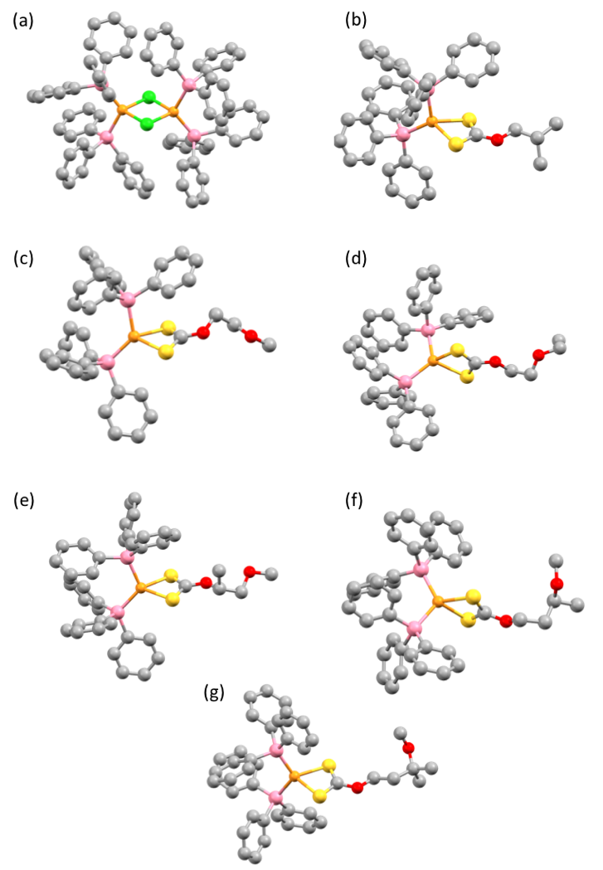

**Figure 1.** The structures of (a) triphenylphosphine copper chloride (**8**), triphenylphosphine copper(I) (b) *iso*-butylxanthate (**11**), (c) 2-methoxyethylxanthate (**12**), (d) 2-ethoxyethylxanthate (**13**), (e) 1-methoxy-2-propylxanthate (**14**), (f) 3-methoxy-1-butylxanthate (**15**) and (g) 3-methoxy-3-methyl-1-butylxanthate (**16**). Hydrogens omitted for clarity. Green = Cl, orange = Cu, yellow = S, pink = P, red = O, grey = C.

Compounds **11**-**16** all adopt a tetrahedral coordination arrangement around the central copper ion (Figure 1), in a manner analogous to the previously reported ethyl and n-butyl counterparts. The additional O as part of the alkoxy groups for **12**-**16** does not coordinate to any neighbouring coppers. The bond lengths for **11**-**16** are all very similar, with Cu-S bond lengths of 2.4083(7)-2.4312(6) Å, 2.3705(9)-2.4791(9) Å, 2.417(1)-2.420(1) Å, 2.417(1)-2.434(1) Å, 2.3903(8)-2.4468(8) Å and 2.3956(6)-2.4411(7) Å respectively.

For **11**-**16** the S-C-S bond angles are: 120.7(1)°, 121.5(2)°, 120.5(3)°, 119.7(3)°, 120.4(2)° and 121.1(1)°. The S-Cu-S bond angle is fairly consistent for **11**-**16** at 74.92(2)°, 74.82(3)°, 74.75(5)°, 74.41(4)°, 74.70(3)° and 74.94(2)° respectively.

The copper(I) xanthates’ decomposition pathway was observed by thermogravimetric analysis (Figure 2) and, with the exception of **1** which has a small weight loss between 150-200 °C, gave a clean, 1-step route. The major decomposition occurs 200-275 °C, with **3** fully breaking down by 270 °C. The final weight % of the residue indicates the conversion to CuS for all of the complexes **9**-**16**.

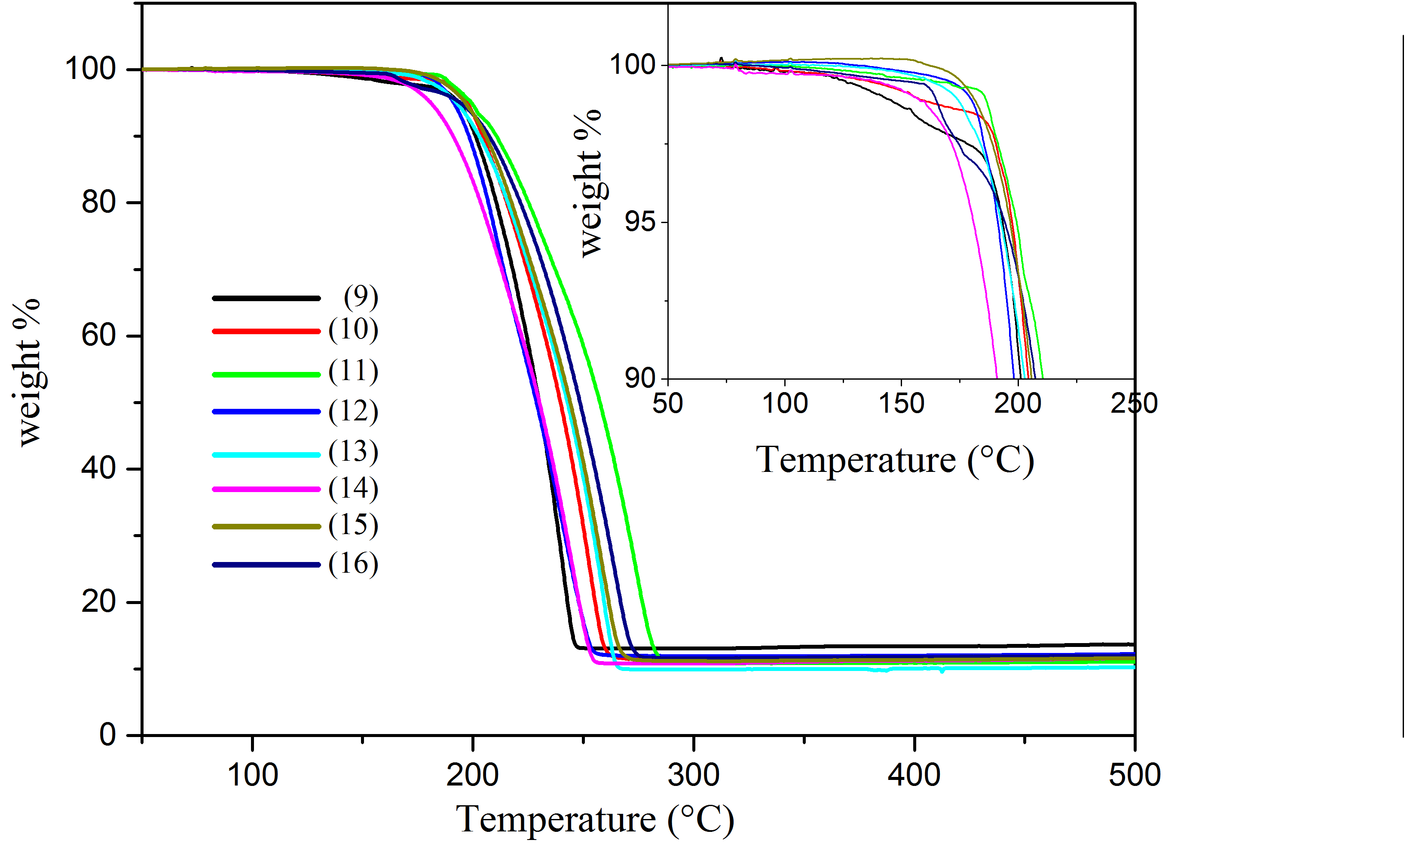

**Figure 2.** Thermogravimetric analysis of complexes **9**-**16** indicates that decomposition occurs between 200-250 °C leading to the formation of CuS. Inset is an expansion of the 50-250 °C region showing the onset of breakdown.

**3.3 Synthesis of Nanorods.** The copper(I) xanthates were utilised as single source precursors via decomposition in oleylamine to generate copper sulfide at 260 °C. We observed no ligand exchange during the dissolution of the xanthates in oleylamine (ESI Figure S4.21). At long reaction times (1 h) complexes **9**-**12** gave nanocrystals that were exclusively Cu2S (ESI Figure S1.1). At short reaction times (5 s) all eight precursors (**9**-**16**) generated Cu1.74S, with a pattern that matches that of roxbyite (JCPDS 00-064-0278, Figure 3). The unit cells for the nanocrystals are in good agreement with the literature values for the two phases (ESI Tables S1.1 and S1.2).

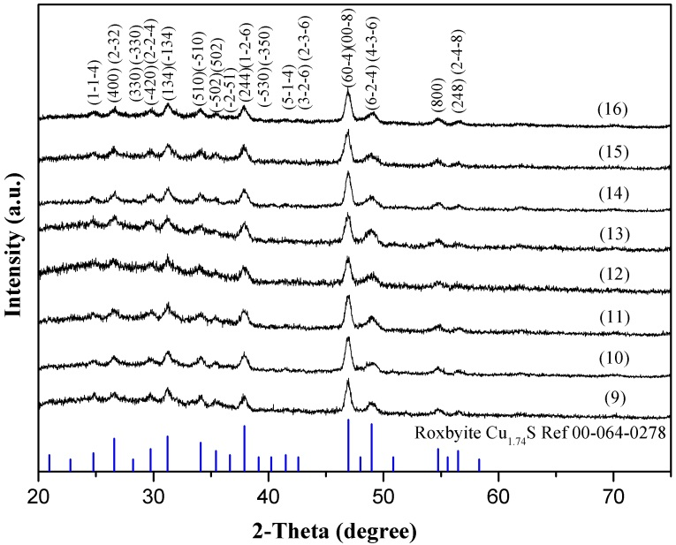

**Figure 3.** The powder XRD patterns of nanocrystals generated from the decomposition of **9-16** for a reaction time of 5 s.

The nanorods have a Cu:S stoichiometry of nearly 2:1, whilst the precursors have the reverse of this (1:2). This indicates that the precursors appear to decompose with the retention of the copper +1 oxidation state. One of the suggested mechanisms of metal xanthate decomposition is the Chugaev elimination mechanism, which results in the formation of CuSH units (Figure 4).35,42 This retains the copper in the +1 oxidation state that the precursor was in. In order for copper sulfide to crystallise there must be further loss of hydrogen and sulfur. In the idealised instance this would involve the loss of H2S from two “CuSH” units to give Cu2S, which keeps the +1 oxidation state. In the case of the 5 s instance we observe an incomplete loss of sulfur to give Cu1.74S roxybite whereas, as noted previously, for the longer reaction time we obtain Cu2S chalcocite.



**Figure 4.** Suggested initial breakdown of precursor by Chugaev elimination.

The elemental composition of the nanorods was determined by energy dispersive X-ray spectroscopy (EDS). The ratio of Cu : S is fairly consistent for all of the nanorods formed from the breakdown of **9**-**16** (ESI Table S3.1, ESI Figure 3.1), ranging from 1.83 : 1 (**9**) to 1.73 : 1 (**16**).

Initially the xanthates were decomposed over a long period of time (1 h), and whilst this generated clean Cu2S, analysis of the particle size via TEM indicated that there was excessive agglomeration of the nanocrystals (ESI Figure S2.1). Therefore a shorter time period of 5 s was chosen. This lead to the synthesis of nanorods of Cu1.74S, which align themselves along their long axis (Figure 5).

The choice of xanthate ligand appears to exert some control over the size of the obtained nanorod. Some of the precursors lead to highly uniform nanorods (i.e. **9**, **10**, **12**, **14** and **16**), whilst the others are a little more polydisperse (ESI Figures S2.2-S2.9). There are further examples of TEM images of the rods in the ESI (ESI Figures S2.10-2.17). The xanthate chains that have more carbon/oxygens in give slightly narrower particles (Figure 6), *i.e.* the obtained width of the copper sulfide nanorod has an inverse relationship with the chain length of the precursor. This is in agreement with a result that we have provisionally reported for PbS nanorod.35

The UV-vis spectra of the Cu1.74S nanorods are shown in Figure 6b. There is a slight variation in band gap in the rods obtained, and this correlates very well with the choice of xanthate ligand used in the precursor (Inset of Figure 6b).

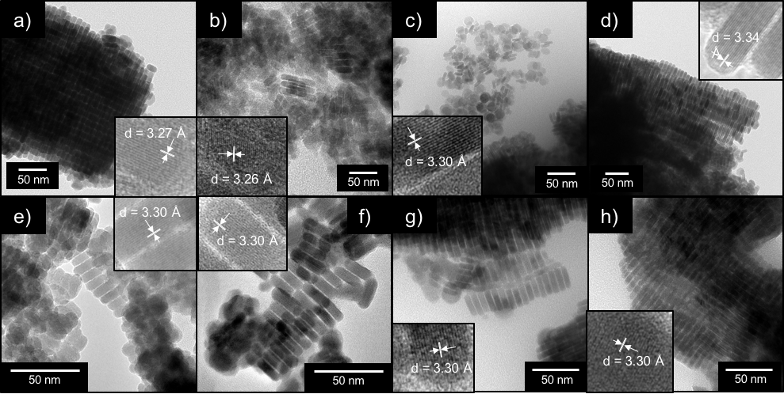

**Figure 5.** Transmission electron microscopy (TEM) images of the nanocrystals generated from the 5 s decomposition of triphenylphosphine copper(I) (a) ethylxanthate (**9**), (b) n-butylxanthate (**10)**, (c) iso-butylxanthate (**11**), (d) 2-methoxyethylxanthate (**12**), (e) 2-ethoxyethylxanthate (**13**), (f) 1-methoxy-2-propylxanthate (**14**), (g) 3-methoxy-1-butylxanthate (**15**) and (h) 3-methoxy-3-methyl-1-butylxanthate (**16**). Insets are the d-spacings measured for each. d-spacings of 3.27 Å, 3.26 Å, 3.30 Å, 3.34 Å, 3.30 Å, 3.30 Å, 3.30 Å and 3.30 Å correspond to the (400) reflection.

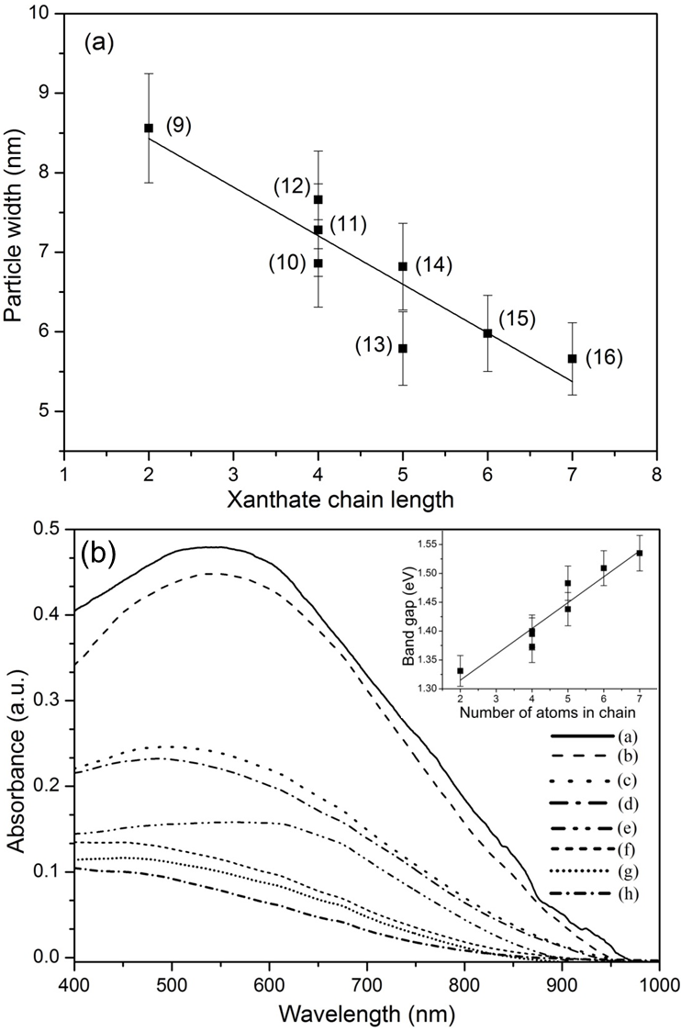

**Figure 6.** (a) Increasing the chain length of the xanthate ligand leads to a decrease in the width of the rods obtained. 1 standard deviation for each measurement is displayed. (b) The UV-Vis spectra for the copper sulfide nanorod – the number indicates the precursor. Inset is the correlation between band gap and the number of atoms in the xanthate chain.

**3.3 DFT Study.** In order to understand the way the xanthate ligand influences the size of the obtained nanorod, we turned to density functional theory (DFT). We optimised the geometry of **9**-**16** and obtained the ground state energies of these complexes (ESI Table S6.1). We also studied two series of linear chain xanthates [(PPh3)2Cu(S2CO(CH2)2OR)] (**17**-R, R = Me, Et, nPr, nBu) [(PPh3)2Cu(S2COR’)] (**18**-R’, R’ = nBu, nPen, nHex, nHep), which have comparable xanthate chain lengths (*i.e*. **17**-Me has the same chain length as **18**-nBu) (ESI Table S6.2).

For **17**-R and **18**-R’, there are some notable differences in the geometry optimized structures. For **17**-R, there is a loss of symmetry about the Cu centre with respect to the Cu-S bond lengths. For each complex in the **18**-R’ series, the two Cu-S bonds, and correspondingly the C-S bonds, are nearly identical (ESI Tables S6.3 and S6.4 ). However, for **17**-R one Cu-S lengthens, whilst one C-S contracts slightly. This is mirrored in the experimental crystal data, where **12** (which corresponds to **17**-Me) has Cu-S bond lengths of 2.3705(9) Å and 2.4791(9) Å, whilst **9** (*i.e.* **18**-nBu) has ones of 2.421(2) Å and 2.423(2) Å.41 This distinction between the two S atoms for **17**-R is also observed in a Mulliken population analysis, where the S that is most closely bonded to the Cu has a greater electronic charge. This suggests that there is decreased delocalisation across the S-C-S unit for **17**-R than **18**-R’, which must be brought about by the introduction of the second oxygen into the xanthate chain.

There is a good relationship between length of the xanthate chain and ground state energy, which is to be expected for **17**-R and **18**-R’ (ESI Figure S6.1) but is also true for **9**-**16** (Figure 7a). This clearly indicates that the longer chain complexes are lower in energy than the shorter chain ones. Additionally, we note that the introduction of an O into the alkyl chain of the xanthate results in a lowering of energy. This again is the expected result as an ‘O’ is lower in energy than a CH2 motif, and can be seen in ESI Figure S6.1, where **17**-R is lower in energy than **18**-R’ for each chain length.

(a)

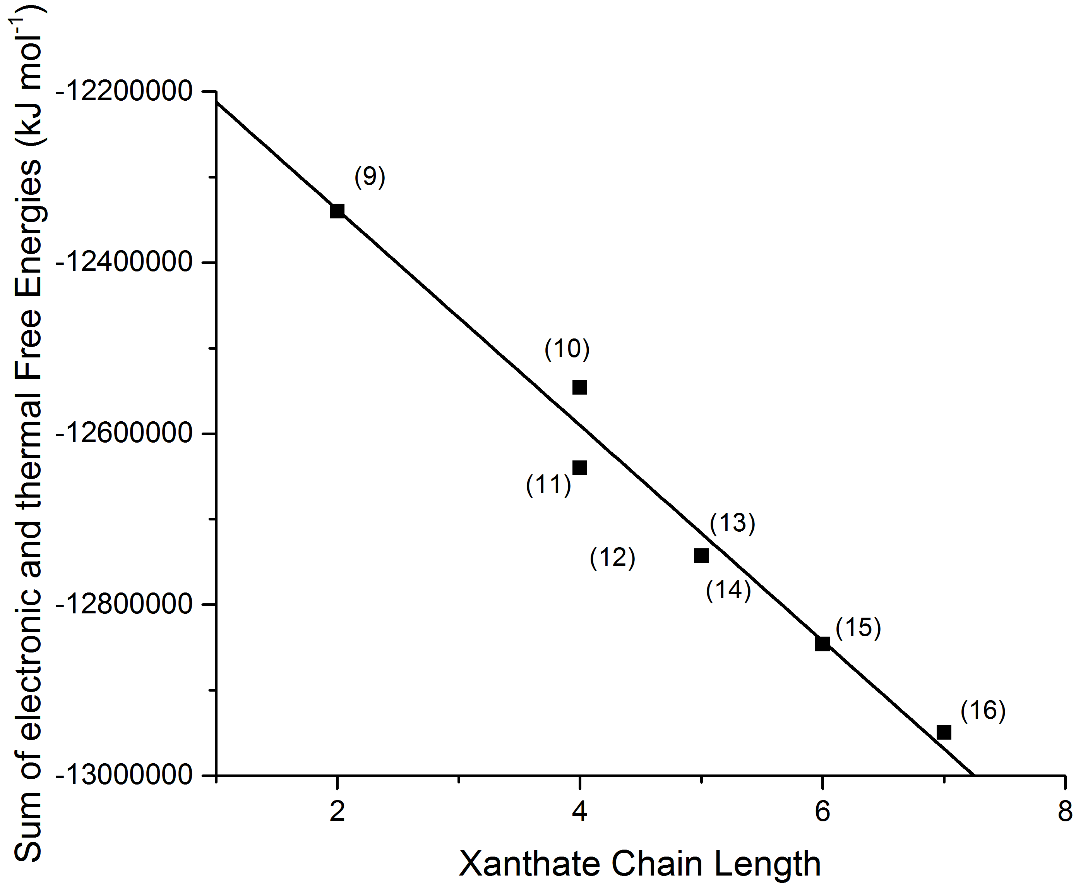

(b)

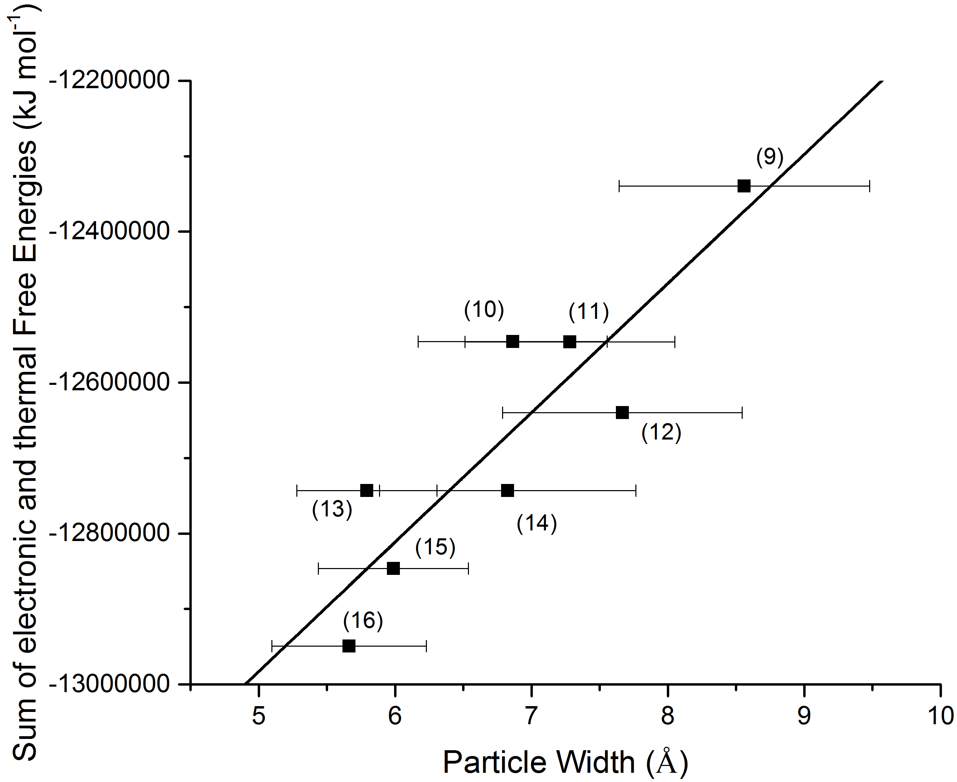

**Figure 7.** (a) The ground state energies of **9**-**16** as a function of the chain length. (b) The width of the obtained nanorod compared to the sum of the electronic and thermal energy of the xanthate precursor.

A plot of the ground state energy of **9**-**16** against width of the nanorods reveals a reasonable correlation (Figure 7b). The lower energy complexes appear to result in the formation of narrower nanorods, whilst the higher energy complexes give wider nanorods. This is presumably due to the complexes with a higher ground state energy being easier to decompose into copper sulfide. Additionally, this is in agreement with the previous assertion that the longer chain complexes give narrower rods (Figure 6), as they are also lower in energy. Therefore, it is possible to suggest that control over the size of the obtained nanorods may be exerted by the choice of xanthate ligand.

4. Conclusions

The synthesis and single-crystal characterisation of six novel triphenyl copper(I) xanthate complexes [*iso*-butylxanthate (**11**), 2-methoxyethylxanthate (**12**), 2-ethoxyethylxanthate (**13**), 1-methoxy-2-propylxanthate (**14**), 3-methoxy-1-butylxanthate (**15**) and 3-methoxy-3-methyl-1-butylxanthate (**16**)] has been reported. These six complexes, in addition to the ethyl and n-butyl analogues have been tested as single-source precursors for the formation of copper sulfide nanorods. At long reaction times heavily aggregated Cu2S is formed, whilst short times result in Cu1.74S nanorods. The longer chain xanthates lead to the formation of rods of decreased width, which has been confirmed with a DFT study.

ASSOCIATED CONTENT

Supporting Information

The Supporting Information is available free of charge on the ACS Publications website.

Unit cell parameters for the nanocrystals, TEM images, DFT calculation details, NMR spectra and crystallographic data (PDF).

Crystallographic data is available from the CCDC, numbers: 1550291-550300

AUTHOR INFORMATION

Corresponding Author

* Paul O’Brien. E-mail: paul.o’brien@manchester.ac.uk; Fax: +44 (0)161 275 4616; Tel: +44 (0)161 275 4653

ACKNOWLEDGMENT

The authors would like to acknowledge the Iraqi Culture Attaché in London for financial support (M.A.S.) and the EPSRC (Doctoral Prize for P.D.M., grant EP/M507969/1). G.D. thanks the Royal Society Leverhulme Grant for supporting his academic visit at the University of Manchester and his employer the University of Dar es Salaam. P.D.McN and P.O.B. acknowledge funding from EPSRC grant EP/K010298/1 and some of the equipment used in this study were provided by the EPSRC Core Capability in Chemistry grant EP/K039547/1. We thank Dr Mark Vincent for assistance with the calculations.

REFERENCES

(1) Matthews, P. D.; McNaughter, P. D.; Lewis, D. J.; O’Brien, P. Shining a Light on Transition Metal Chalcogenides for Sustainable Photovoltaics. *Chem. Sci.* **2017**, *8*, 4177–4187 DOI: 10.1039/C7SC00642J.

(2) Wu, Y.; Wadia, C.; Ma, W.; Sadtler, B.; Alivisatos, A. P. Synthesis and Photovoltaic Application of Copper(I) Sulfide Nanocrystals. *Nano Lett.* **2008**, *8*, 2551–2555 DOI: 10.1021/nl801817d.

(3) Grozdanov, I.; Najdoski, M. Optical and Electrical Properties of Copper Sulfide Films of Variable Composition. *J. Solid State Chem.* **1995**, *114*, 469–475 DOI: 10.1006/jssc.1995.1070.

(4) Dilena, E.; Dorfs, D.; George, C.; Miszta, K.; Povia, M.; Genovese, A.; Casu, A.; Prato, M.; Manna, L. Colloidal Cu2−x(SySe1−y) Alloy Nanocrystals with Controllable Crystal Phase: Synthesis, Plasmonic Properties, Cation Exchange and Electrochemical Lithiation. *J. Mater. Chem.* **2012**, *22*, 13023–13031 DOI: 10.1039/c2jm30788j.

(5) Zhao, Y.; Pan, H.; Lou, Y.; Qiu, X.; Zhu, J.; Burda, C. Plasmonic Cu2-xS Nanocrystals: Optical and Structural Properties of Copper-Deficient copper(I) Sulfides. *J. Am. Chem. Soc.* **2009**, *131*, 4253–4261 DOI: 10.1021/ja805655b.

(6) Xie, Y.; Carbone, L.; Nobile, C.; Grillo, V.; D’Agostino, S.; Della Sala, F.; Giannini, C.; Altamura, D.; Oelsner, C.; Kryschi, C.; Cozzoli, P. D. Metallic-like Stoichiometric Copper Sulfide Nanocrystals: Phase- and Shape-Selective Synthesis, near-Infrared Surface Plasmon Resonance Properties, and Their Modeling. *ACS Nano* **2013**, *7*, 7352–7369 DOI: 10.1021/nn403035s.

(7) Van Der Stam, W.; Berends, A. C.; De Mello Donega, C. Prospects of Colloidal Copper Chalcogenide Nanocrystals. *ChemPhysChem* **2016**, *17*, 559–581 DOI: 10.1002/cphc.201500976.

(8) Goel, S.; Chen, F.; Cai, W. Synthesis and Biomedical Applications of Copper Sulfide Nanoparticles: From Sensors to Theranostics. *Small* **2014**, *10*, 631–645 DOI: 10.1002/smll.201301174.

(9) Ku, G.; Zhou, M.; Song, S.; Huang, Q.; Hazle, J.; Li, C. Copper Sulfide Nanoparticles as a New Class of Photoacoustic Contrast Agent for Deep Tissue Imaging at 1064 Nm. *ACS Nano* **2012**, *6*, 7489–7496 DOI: 10.1021/nn302782y.

(10) Abdelhady, A. L.; Ramasamy, K.; Malik, M. A.; O’Brien, P.; Haigh, S. J.; Raftery, J. New Routes to Copper Sulfide Nanostructures and Thin Films. *J. Mater. Chem.* **2011**, *21*, 17888–17895 DOI: 10.1039/c1jm13277f.

(11) Djurle, S. An X-Ray Study on the System Cu-S. *Acta Chem. Scand.* **1958**, *12*, 1415–1426 DOI: 10.3891/acta.chem.scand.12-1427.

(12) Mumme, W. G.; Gable, R.; Petříček, V. The Crystal Structure of Roxybite, Cu58S32. *Can. Mineral.* **2012**, *50*, 423–430.

(13) Evans, H. T. The Crystal Structures of Low Chalcocite and Djurleite. *Zeitschrift fur Krist. - Cryst. Mater.* **1979**, *150*, 299–320 DOI: 10.1524/zkri.1979.150.1-4.299.

(14) Goble, R. J. Relationship Between Crystal Structure, Bonding and Cell Dimensions in the Copper Sulfides. *Can. Mineral.* **1985**, *23*, 61–76.

(15) Buerger, M. J.; Wuensch, B. J. Distribution of Atoms in High Chalcocite, Cu2S. *Science* **1963**, *141*, 276–277 DOI: 10.1126/science.141.3577.276.

(16) Saldanha, P. L.; Brescia, R.; Prato, M.; Li, H.; Povia, M.; Manna, L.; Lesnyak, V. Generalized One-Pot Synthesis of Copper Sulfide, Selenide-Sulfide, and Telluride-Sulfide Nanoparticles. *Chem. Mater.* **2014**, *26*, 1442–1449 DOI: 10.1021/cm4035598.

(17) Deka, S.; Genovese, A.; Zhang, Y.; Miszta, K.; Bertoni, G.; Krahne, R.; Giannini, C.; Manna, L. Phosphine-Free Synthesis of P-Type copper(I) Selenide Nanocrystals in Hot Coordinating Solvents. *J. Am. Chem. Soc.* **2010**, *132*, 8912–8914 DOI: 10.1021/ja103223x.

(18) Ghezelbash, A.; Korgel, B. A. Nickel Sulfide and Copper Sulfide Nanocrystal Synthesis and Polymorphism. *Langmuir* **2005**, *21*, 9451–9456 DOI: 10.1021/la051196p.

(19) Saunders, A. E.; Ghezelbash, A.; Smilgies, D. M.; Sigman, M. B.; Korgel, B. A. Columnar Self-Assembly of Colloidal Nanodisks. *Nano Lett.* **2006**, *6*, 2959–2963 DOI: 10.1021/nl062419e.

(20) Riha, S. C.; Johnson, D. C.; Prieto, A. L. Cu 2Se Nanoparticles with Tunable Electronic Properties due to a Controlled Solid-State Phase Transition Driven by Copper Oxidation and Cationic Conduction. *J. Am. Chem. Soc.* **2011**, *133*, 1383–1390 DOI: 10.1021/ja106254h.

(21) Lu, Q.; Gao, F.; Zhao, D. One-Step Synthesis and Assembly of Copper Sulfide Nanoparticles to Nanowires, Nanotubes, and Nanovesicles by a Simple Organic Amine-Assisted Hydrothermal Process. *Nano Lett.* **2002**, *2*, 725–728 DOI: 10.1021/nl025551x.

(22) Rivest, J. B.; Jain, P. K. Cation Exchange on the Nanoscale: An Emerging Technique for New Material Synthesis, Device Fabrication, and Chemical Sensing. *Chem. Soc. Rev.* **2013**, 89–96 DOI: 10.1039/c2cs35241a.

(23) de Mello Donegá, C. Synthesis and Properties of Colloidal Heteronanocrystals. *Chem. Soc. Rev.* **2011**, *40*, 1512–1546 DOI: 10.1039/c0cs00055h.

(24) Lim, W. P.; Wong, C. T.; Ang, S. L.; Low, H. Y.; Chin, W. S. Phase-Selective Synthesis of Copper Sulfide Nanocrystals. *Chem. Mater* **2006**, *18*, 6170–6177 DOI: 10.1021/cm061686i.

(25) Jia, L.; Ji, H.; Lai, J.; Wang, J.; Chen, H.; Zheng, X.; Liu, H.; Jin, Z. Morphology , Structure and Optical Absorption Properties of Copper Sul Fi Des by Different TEG Based Solution Processing. *Mater. Des.* **2017**, *123*, 39–45 DOI: 10.1016/j.matdes.2017.03.038.

(26) Akhtar, M.; Alghamdi, Y.; Akhtar, J.; Aslam, Z.; Revaprasadu, N.; Malik, M. A. Phase Controlled Synthesis of Copper Sulfide Nanoparticles by Colloidal and Non-Colloidal Methods. *Mater. Chem. Phys.* **2016**, *180*, 404–412 DOI: 10.1016/j.matchemphys.2016.06.024.

(27) Larsen, T. H.; Sigman, M.; Ghezelbash, A.; Doty, R. C.; Korgel, B. A. Solventless Synthesis of Copper Sulfide Nanorods by Thermolysis of a Single Source Thiolate-Derived Precursor. *J. Am. Chem. Soc.* **2003**, *125*, 5638–5639 DOI: 10.1021/ja0342087.

(28) Afzaal, M.; Rosenberg, C. L.; Malik, M. A.; White, A. J. P.; O’Brien, P. Phosphine Stabilized copper(I) Complexes of Dithiocarbamates and Xanthates and Their Decomposition Pathways. *New J. Chem.* **2011**, *35*, 2773 DOI: 10.1039/c1nj20586b.

(29) Wei, T.; Liu, Y.; Dong, W.; Zhang, Y.; Huang, C.; Sun, Y.; Chen, X.; Dai, N. Surface-Dependent Localized Surface Plasmon Resonances in CuS Nanodisks. *ACS Appl. Mater. Interfaces* **2013**, *5*, 10473–10477 DOI: 10.1021/am4039568.

(30) Ramasamy, K.; Malik, M. A.; Revaprasadu, N.; O’Brien, P. Routes to Nanostructured Inorganic Materials with Potential for Solar Energy Applications Routes to Nanostructured Inorganic Materials with Potential for Solar Energy Applications. *Chem. Mater.* **2013**, *25*, 3551–3569 DOI: 10.1021/cm401366q.

(31) Al-Shakban, M.; Xie, Z.; Savjani, N.; Malik, M. A.; O’Brien, P. A Facile Method for the Production of SnS Thin Films from Melt Reactions. *J. Mater. Sci.* **2016**, *51*, 6166–6172 DOI: 10.1007/s10853-016-9906-7.

(32) Matthews, P. D.; Akhtar, M.; Malik, M. A.; Revaprasadu, N.; O’Brien, P. Synthetic Routes to Iron Chalcogenide Nanoparticles and Thin Films. *Dalton Trans.* **2016**, *45*, 18803–18812 DOI: 10.1039/C6DT03486A.

(33) Afzaal, M.; Malik, M. A.; O’Brien, P. Chemical Routes to Chalcogenide Materials as Thin Films or Particles with Critical Dimensions with the Order of Nanometres. *J. Mater. Chem.* **2010**, *20*, 4031–4040 DOI: 10.1039/b923898k.

(34) Kemmler, M.; Lazell, M.; O’Brien, P.; Otway, D. J.; Park, J. H.; Walsh, J. R. The Growth of Thin Films of Copper Chalcogenide Films by MOCVD and AACVD Using Novel Single-Molecule Precursors. *J. Mater. Sci. Mater. Electron.* **2002**, *13* (9), 531–535 DOI: 10.1023/A:1019665428255.

(35) McNaughter, P. D.; Saah, S. A.; Akhtar, M.; Abdulwahab, K.; Malik, M. A.; Raftery, J.; Awudza, J. A. M.; O’Brien, P. lead(II) Xanthates and Their Decomposition to PbS in Melt Reactions. *Dalton Trans.* **2016**, *45*, 16345–16353 DOI: 10.1039/c6dt02859d.

(36) Lewis, E. A.; McNaughter, P. D.; Yin, Z.; Chen, Y.; Brent, J. R.; Saah, S. A.; Raftery, J.; Awudza, J. A. M.; Malik, M. A.; O’Brien, P.; Haigh, S. J. In Situ Synthesis of PbS Nanocrystals in Polymer Thin Films from Lead(II) Xanthate and Dithiocarbamate Complexes: Evidence for Size and Morphology Control. *Chem. Mater.* **2015**, *27*, 2127–2136 DOI: 10.1021/cm504765z.

(37) Mohamed, A. A.; Kani, I.; Ramirez, A. O.; Fackler, J. P. Synthesis, Characterization, and Luminescent Properties of Dinuclear Gold(I) Xanthate Complexes: X-Ray Structure of [Au2(nBu-xanthate)2]. *Inorg. Chem.* **2004**, *43*, 3833–3839 DOI: 10.1021/ic0349858.

(38) Bowmaker, G.; Camp, D.; Hart, R.; Healy, P.; Skelton, B.; White, A. No Title. *Aust. J. Chem.* **1992**, *45*, 1155–1166.

(39) Frisch, M. J.; Trucks, G. W.; Schlegel, H. B.; Scuseria, G. E.; Robb, M. A.; Cheeseman, J. R.; Scalmani, G.; Barone, V.; Mennucci, B.; Petersson, G. A.; Nakatsuji, H.; Caricato, M.; Li, X.; Hratchian, H. P.; Izmaylov, A. F.; Bloino, J.; Zheng, G.; Sonnenberg, J. L.; Hada, M.; Ehara, M.; Toyota, K.; Fukuda, R.; Hasegawa, J.; Ishida, M.; Nakajima, T.; Honda, Y.; Kitao, O.; Nakai, H.; Vreven, T.; Montgomery Jr., J. A.; Peralta, J. E.; Ogliaro, F.; Bearpark, M.; Heyd, J. J.; Brothers, E.; Kudin, K. N.; Staroverov, V. N.; Kobayashi, R.; Normand, J.; Raghavachari, K.; Rendell, A.; Burant, J. C.; Iyengar, S. S.; Tomasi, J.; Cossi, M.; Rega, N.; Millam, J. M.; Klene, M.; Knox, J. E.; Cross, J. B.; Bakken, V.; Adamo, C.; Jaramillo, J.; Gomperts, R.; Stratmann, R. E.; Yazyev, O.; Austin, A. J.; Cammi, R.; Pomelli, C.; Ochterski, J. W.; Martin, R. L.; Morokuma, K.; Zakrzewski, V. G.; Voth, G. A.; Salvador, P.; Dannenberg, J. J.; Dapprich, S.; Daniels, A. D.; Farkas, Ö.; Foresman, J. B.; Ortiz, J. V.; Cioslowski, J.; Fox, D. J. Gaussian 09, Revision D.01. Gaussian Inc.: Wallingford CT 2009.

(40) Bianchini, C.; Ghilardi, C. A.; Meli, A.; Medollini, S.; Orlandini, A. Reactivity of Copper(I) Tetrshydroborates toward CS2 and SCNPh. Structures of (PPh3)2Cu(mu-S2CSCH2SCS2)Cu(PPh3)2, (PPh3)2Cu(S2COEt), and (PPh3)2Cu(S2CNHPh).CHCl3. *Inorg. Chem.* **1985**, *24*, 932–939.

(41) Han, Q.; Wang, Y.; Yang, X.; Lu, L.; Wang, X. Structure and Characterization of (O-Butyldithiocarbonatio-S,S′) Bis(triphenylphosphine) copper(I) Complex. *Huaxue Tongbao* **2006**, *69*, 148–150.

(42) Buckingham, M. A.; Catherall, A. L.; Hill, M. S.; Johnson, A. L.; Parish, J. D. Aerosol-Assisted Chemical Vapor Deposition of CdS from Xanthate Single Source Precursors. *Cryst. Growth Des.* **2017**, *17*, 907–912 DOI: 10.1021/acs.cgd.6b01795.

Table of Contents Artwork and Synopsis

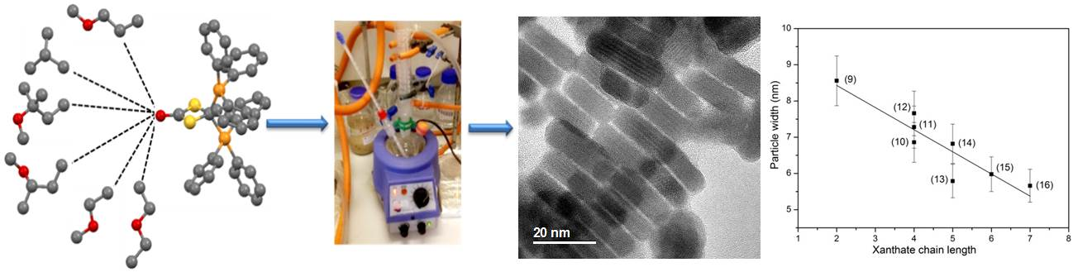

We present a simple route to monodisperse copper sulfide nanocrystals by the hot-injection of a series of novel copper(I) xanthate single-source precursors [(PPh3)2Cu(S2COR)] (R = *iso*-butyl, 2-methoxyethyl, 2-ethoxyethyl, 1-methoxy-2-propyl, 3-methoxy-1-butyl and 3-methoxy-3-methyl-1-butyl), whose crystal structures are also reported. We show that the width of the obtained nanorods is dependent on the length of the xanthate chain, which we rationalize through a computational study.