In-hospital Upper Gastrointestinal Bleeding Following Percutaneous Coronary Intervention
Short title: Gastrointestinal bleeding after PCI
Chun Shing Kwok,^{1,2} Alex Sirker,³ Adam D Farmer,⁴ Evangelos Kontopantelis,⁵ Jessica Potts,⁶ Muhammad Ayyaz Ul Haq,^{1,2} Peter Ludman,⁷ Mark de Belder,⁸ John Townend,⁷ Azfar Zaman,⁸ Adrian Large,² Tim Kinnaird,⁹ Mamas A Mamas^{1,2} on behalf of the British Cardiovascular Intervention Society (BCIS) and National Institute of Cardiovascular Outcomes Research (NICOR)
1. Keele Cardiovascular Research Group, Keele University, Stoke-on-Trent, United Kingdom
2. Royal Stoke University Hospital, Stoke-on-Trent, United Kingdom
3. Department of Cardiology, University College London Hospitals and St. Bartholomew's
Hospital, London, UK.
4. Department of Gastroenterology and Institute of Applied Clinical Sciences, Royal Stoke
University Hospital, Stoke-on-Trent, UK.
5. Faculty of Biology, Medicine and Health, University of Manchester, Manchester, UK.
6. Queen Elizabeth Hospital, Birmingham, UK.
7. The James Cook University Hospital, Middlesbrough, UK.
8. Department of Cardiology, Freeman Hospital and Institute of Cellular Medicine,
Newcastle University, Newcastle Upon Tyne, UK.
9. University Hospital of Wales, Cardiff, UK.

Corresponding author:
Dr Chun Shing Kwok
Keele Cardiovascular Research Group,
Keele University, Stoke-on-Trent, ST5 5BG, United Kingdom
Tel: +44(0)1782732911 Fax: +44(0)1782734719
Email: shingkwok@doctors.org.uk

Word count: 4,632
Keywords: bleeding; percutaneous coronary intervention; coronary artery disease

Abstract
Objectives: This study aims to examine in-hospital gastrointestinal (GI) bleeding, its predictors and clinical outcomes, including long-term outcomes, in a national cohort of patients undergoing percutaneous coronary intervention (PCI) in England and Wales.
Background: GI bleeding remains associated with significant morbidity, mortality and socioeconomic burden.
Methods: We examined the temporal changes in in-hospital GI bleeding in a national cohort of patients undergoing PCI between 2007-2014 in England and Wales, its predictors and prognostic consequences. Multivariate analysis was performed to identify independent risk factors between GI bleeding and 30-day mortality. Survival analysis was performed comparing patients with, and without, GI bleeding.
Results: There were 480 in-hospital GI bleeds in 549,298 patients (0.09%). Overall, rates of GI bleeding remained stable over time but a significant decline was observed for patients with ST segment elevation myocardial infarction (STEMI). The strongest predictors of bleeding events were STEMI - odds ratio (OR) 7.28 (95% confidence interval (95% CI) 4.82-11.00), glycoprotein IIb/IIIa inhibitor use OR 3.42 (95% CI 2.76-4.24) and use of circulatory support OR 2.65 (95% CI 1.90-3.71). Anti-platelets/coagulants (clopidogrel, prasugrel and warfarin) were not independently associated with GI bleeding. GI bleeding was independently associated with a significant increase in all-cause 30-day mortality (OR 2.08 (1.52-2.83)). Patients with in-hospital GI bleed who survived to 30-days had increased all-cause mortality risk at 1 year compared to non-bleeders (HR 1.49 (1.07-2.09)).
Conclusions: In-hospital GI bleeding following PCI is rare but is a clinically important event associated with increased 30-day and long-term mortality.

Introduction
Percutaneous coronary intervention (PCI) has transformed the management and outcomes in the management of acute coronary syndromes and coronary artery disease¹. Nevertheless, major bleeding is an important complication after PCI and is associated with a 3-fold increase in mortality, the causes of which can be broadly divided into access and non-access site related complications^{2,3}. Gastrointestinal (GI) bleeding is the most common source of non-access site related bleeding, accounting for 61.7% of all bleeds⁴. Rates of in-hospital GI bleed post PCI vary from 0.16% to 3.6%⁵⁻¹⁰. Factors that influence this variability include differences in the population studied, concomitant pharmacotherapy and the manner in which bleeding events are recorded. However, few studies have attempted to investigate long-term survival after GI bleed^{11,12} and there are no published studies of in-hospital GI bleed and its short and long-term prognostic impact using unselected data from a national PCI database that records both clinical characteristics as well as drug therapy. Furthermore, to date no studies have examined the temporal trends in GI bleeding.
We therefore aimed to address these knowledge gaps with particular reference to the temporal changes in in-hospital GI bleed, its predictors and clinical outcomes, including long-term outcomes, in a large unselected cohort of patients undergoing PCI in England and Wales.

Methods
The British Cardiovascular Intervention Society (BCIS) routinely collects data on all PCI procedures in the United Kingdom. In 2011 this database collected information on 99% of all PCI procedures performed in National Health Service Hospitals in England and Wales^{13,14}. Within this dataset 113 variables are recorded that includes demographic/clinical variables, procedural parameters and patient outcomes. For patients in England and Wales, mortality information is obtained from the Office of National Statistics using linkage with the patient’s unique National Health Service number.
We analyzed all patients who underwent PCI in England and Wales between 1 January 2007 and 31 December 2014. Patients were excluded if their records did not contain information for both mortality and in-hospital GI bleeding. We then classified patients into one of two groups, i.e. those with and without in-hospital GI bleeding. The two outcomes were 30-day mortality and in-hospital major adverse cardiovascular events (MACE). In-hospital GI bleed were cases of GI bleeding which occurred during the index admissions for PCI which were collected in the BCIS dataset as a specific data field under the in hospital major complications section of registry and is operator reported. In-hospital MACE was defined by the composite of in-hospital death, myocardial infarction or re-infarction. Additional data were collected on participant age, sex, body mass index, current smoking status, diabetes mellitus, hypertension, hypercholesterolemia, previous myocardial infarction, previous stroke, peripheral vascular disease, renal disease, valvular heart disease, previous PCI, previous CABG, left ventricular ejection fraction group (good, moderate, poor), use of radial access, cardiogenic shock, use of circulatory support, receipt of ventilation, diagnosis (stable angina, NSTEMI/unstable angina, STEMI), target vessel for PCI (left main, left anterior descending, left circumflex, right coronary artery and graft), multivessel disease, trip vessel disease, use of glycoprotein IIb/IIIa inhibitor, anti-platelet use (clopidogrel, prasugrel, ticagrelor, ticlopidine), warfarin use, thrombolysis, year of PCI and receipt of in-hospital blood transfusion.
Descriptive statistics are presented in tables by in-hospital GI bleed status. The in-hospital GI bleed rates over time were explored in the entire cohort and presented by subgroups based on age (<60 years, 60-80 years, >80 years), sex and diagnosis (stable angina, non-STEMI (NSTEMI)/unstable angina and STEMI). Continuous data are presented as mean and standard deviation and difference between the two groups was determined by analysis of variance. Categorical variables are presented as number and percentage and chi-squared tests were used to determine if there were differences between the two groups. We also examined trends in participants aged >80 years, female patients, diabetes and renal disease at baseline. Multiple imputations with chained equations were used to account for missing data. Using the mi impute chained function in Stata we generated 10 complete datasets with imputed data for missing data, see Supplementary Table 1. Using the imputed dataset, multiple logistic regressions were performed to identify predictors of in-hospital GI bleeding. All variables except blood transfusion and outcomes were included in this model. Ticlopidine was not included in this model because very few patients received this treatment and no bleeding events occurred in this small group. Subsequently, univariate and multivariate logistic regression was used to quantify the association of in-hospital GI bleeding with 30-day mortality and in-hospital MACE. Further subgroup analyses were performed to address those patients who received any transfusion (blood transfusion or platelet transfusion) and no transfusion. A survival analysis was determining by using Cox Proportional Hazards ratios for patients that survived to 30-days following a GI bleed and determined their mortality at 1 year compared to those without GI bleed who survived to 30-days. Two additional sensitivity analyses regarding predictors on in-hospital GI bleeding focused on patients who had renal disease at baseline and patients with STEMI. Statistical analysis was performed using propriety software (Stata/MP version 14.0, Stata Corp, College Station, Texas, USA). The reporting of the manuscript was done in according to STROBE statement (Supplementary Table 2). As an additional analysis, we examined the predictors of death a 1 year among survivors at 30-days.

Results
A total of 549,298 patients were included in the analysis with 480 in-hospital GI bleeding events recorded (0.09%), see Table 1. Supplementary Figure 1 shows the flow diagram of participant inclusion and Supplementary Table 2 describes the extent of missing data for individual variables included in the analysis.
Rates of GI bleed have remained stable over time in the overall cohort, 0.08% in 2007 and 0.07% in 2014 (p=0.58), as well as sub-groups, see Figure 1 and Supplementary Figure 2 and Supplementary Table 3. Temporal trends remained stable for participants in all the age subgroups <60 years (0.05% in 2007 and 0.04% in 2014, p=0.88), 60-80 years group (0.09% in 2007 and 0.07% in 2014, p=0.42) and >80 years (0.21% in 2007 and 0.18% in 2014, p=0.67). Similarly, temporal trends over time remained stable by sex, for example in-hospital GI bleed among women was 0.10% in 2007 and 0.07% in 2014 (p=0.52, across all years). In contrast, a marked decline was observed for in-hospital GI bleeding in patients with STEMI, in whom the bleeding rate declined from 0.52% in 2007 to 0.17% in 2014 (p<0.001, across all years). We observed demographic changes over time in our cohort, which included rises in the proportion of patients >80 years and the prevalence rates of diabetes and renal disease, see Supplementary Table 4.
Table 1 shows the baseline characteristics of participants according to in-hospital GI bleed status. Patients with GI bleeding were older (72 years vs 65 years, p<0.001), more likely to be female (31% vs 26%, p=0.005), more likely to have lower body mass index (27.7 vs 28.4 kg/m², p=0.009), more likely to have hypertension (61% vs 52%, p=0.004), previous stroke (7% vs 4%, p=0.005), peripheral vascular disease (10% vs 5%, p<0.001), renal disease (8% vs 3%, p<0.001) and valvular heart disease (4% vs 1%, p<0.001). These patients were also more likely to have hemodynamic instability, with a greater prevalence of cardiogenic shock (20% vs 2%, p<0.001), the requirement for circulatory support (18% vs 2%, p<0.001) or ventilatory support (6% vs 2%, p<0.001). However, they were less likely to have had a previous PCI (17% vs 23%, p=0.002) with radial access (43% vs 50%, p=0.003). Compared to other patients with different diagnoses, the proportion of patients presenting with STEMI was higher among patients with in-hospital GI bleeding complications (68% vs 23%). When differences in medications were considered, patients with an in-hospital GI bleed were less likely to receive clopidogrel (82% vs 85%) and more likely to receive glycoprotein IIb/IIIa inhibitors (63% vs 22%), prasugrel (9% vs 4%, p<0.001), warfarin (3% vs 1%, p=0.002) and thrombolysis (7% vs 1%, p<0.001). The patient characteristics according to GPI use is shown in Supplementary Table 5. The patients who received GPI were more likely to have a diagnosis of STEMI and had a higher crude 30-day mortality and in-hospital MACE.
In the entire cohort, in-hospital GI bleed was associated with a prolonged hospital stay 11.3±15.0 days vs 2.0±5.3 days (p<0.001). In all subgroups, the occurrence of in-hospital GI bleeding was associated with significantly longer stay, see Supplementary Table 6. Among patients age <60 years, the length of stay was 1.8±4.8 days in those without a GI bleed versus 9.0±10.1 days in those with a bleed; in those age >80 years the equivalent figures were 3.1±6.6 days and 15.1±17.0 days respectively. For stable angina patients' length of stay increased from 1.0±4.3 days to 5.3±7.7 days and for STEMI from 3.9±6.4 days to 11.3±15.1 days.
In-hospital GI bleed was associated with an increased mortality at 30 days (18.8% vs 2.2%, p<0.001), in-hospital MACE (19.0% vs 1.6%, p<0.001), blood transfusion (35.1% vs 0.2%, p<0.001) and platelet transfusion (2.5% vs 0.03%, p<0.001), see Table 1. Survival at 30 days, 1 year and 5 years was worse in patients with GI bleeding (p<0.001), see Figure 2.
Using a multivariate analysis, the strongest independent predictors of GI bleeding were STEMI, OR 7.28 (95% CI 4.82-11.00), glycoprotein IIb/IIIa inhibitor use, OR 3.42 (95% CI 2.76-4.24) and receipt of circulatory support, OR 2.65 (95% CI 1.90-3.71), see Table 2. The prognostic impact of in-hospital GI bleeding is shown in Table 3. After adjustment for confounding, GI bleeding was associated with an increased odds ratio of 30-day mortality (OR 2.08 (95% CI 1.53-2.83)) and 3.7-fold increase in in-hospital MACE (OR 3.68 (95% CI 2.75-4.93)). When the subgroup of patients who received a blood transfusion were analyzed, there was a significant increase in 30-day mortality (OR 2.35 (95% CI 1.60-3.45)) and in-hospital MACE (OR 3.66 (95% CI 2.52-5.31)). Similarly, amongst patients who did not receive transfusion there was a significant increase in 30-day mortality (OR 2.01 (95% CI 1.26-3.19)) and in-hospital MACE (OR 4.31 (95% CI 2.77-6.71)). Figure 3 examines whether a legacy effect exists following an in-hospital GI bleed, and shows that amongst patients that survived at 30 days, mortality was greater in those that sustained an in-hospital GI bleeding complication compared to those patients that did not. After adjustment, this association remained significant with an increased risk of mortality in patients who sustained an in-hospital GI bleed, in comparison to those with no GI bleeding event (HR 1.49, 95% CI 1.07-2.09; p=0.02). Several variables including gastrointestinal bleed, comorbidities, moderate or poor left ventricular ejection fraction, cardiogenic shock, receipt of circulatory support, receipt of ventilation, diagnosis of NSTEMI/UA, STEMI, left main PCI, triple vessel disease and warfarin use were predictors of mortality at 1 year among survivors at 30 days (Supplementary Table 7).
Discussion
Our results suggest that in England and Wales, in-hospital GI bleeding after PCI is a rare event, but with large variations in incidence amongst subgroups of patients, i.e. octogenarian, women and STEMI patients. However, this rate is markedly less than in other studies of patients undergoing PCI, where the reported rate is between 0.97%-1.2%^{7,15}. The overall rate of GI bleeding is stable over time, although GI bleeds that complicate PCI for STEMI have decreased significantly. This may relate to changes in pharmacotherapy, such as decline in use of thrombolysis and glycoprotein IIb/IIIa inhibitor use, during the period analyzed. In-hospital GI bleeding is independently associated with 30-day mortality with a legacy effect for increased mortality at 1-year which conferred a heightened risk even amongst those patients who survived at 30 days.
We observed that patients who have sustained GI bleeds were older with a greater prevalence of cardiovascular risk factors and with more unstable presentations (STEMI, cardiogenic shock and/or receiving circulatory support) and may relate to the physical stress of critical illness. The observation that the need for circulatory support is a predictor of in-hospital GI bleeding may be because shock and low cardiac output, in addition to the vasoconstrictive effect secondary to the administration of inotropic drugs, may inhibit GI motility¹⁶. Moreover, prolonged mechanical ventilation has been shown to be a predictor of stress ulcers which may result in a GI bleed¹⁷. Moreover, critically ill patients are at increased risk of developing stress-related GI mucosal ulceration¹⁸.
Patients who developed a GI bleed were more likely to be treated with anti-thrombotic medications (glycoprotein IIb/IIIa inhibitors, warfarin and thrombolysis) and the marked decline in bleeding amongst patients presenting with STEMI may be related to the decline in the use of thrombolysis (from 15.6% in 2007 to 0.6% in 2014) and glycoprotein IIb/IIIa inhibitor drugs (from 31.3% in 2007 to 15.5% in 2014), probably due to a change in guidelines¹⁹. Notably, patients who had not been exposure to PCI were at increased risk of in-hospital GI bleeds and may reflect that such new patients are “unprepared” for dual antiplatelet therapy and thus are at higher risk of GI bleed compared to patients with previous PCI²⁰. Furthermore, patients with a previous history of PCI may also be treated with a PPI prior to PCI that may protect against GI bleeds. However, it was interesting to note that clopidogrel and prasugrel were not independently associated with GI bleeding when controlling for confounding factors.
The long-term prognostic impact of GI bleeding has been examined in relation to GI bleeding per se and secondary PCI. With respect to the former, the reported excess mortality following GI bleeding varies from 2.5% at 28-days to 15.8 - 29% at 34 months²¹⁻²³. Following PCI, in the U.S. analysis of the Nationwide Inpatient Sample, GI bleeding was associated with an in-hospital mortality of 9.7% and an OR of 2.63 (95% CI 2.39-2.90).⁷ Our current study suggests a much higher crude mortality rate of 18% but after adjustments was associated with a 2-fold increase in odds for mortality and that this increased risk also extends into the longer term. The reasons for this excess long-term mortality remain an area of controversy although GI bleed may be a surrogate marker for an overall deterioration in health and coexisting comorbidities which in themselves are life limiting^{24,25}. Laursen et al., in case control study, compared the causes of death between those who had had an peptic ulcer bleeding and those that did not²⁶. They demonstrated that whilst patients with UGIB have an excess mortality due to higher levels of comorbidity, the causes of that mortality were similar between the two groups. The prognostic impact of GI bleeding after PCI depends on the severity of the bleed. In our study, we were not able to directly determine the severity of the GI bleeding event with a validated scoring system, such as the Glasgow Blatchford Score,²⁷ or the Rockall Score,²⁸ we postulate that receipt of transfusion of a blood product may represent a surrogate marker of bleeding severity. However, a recent study suggests that a restrictive red blood transfusion approach is associated with a reduction in all-cause mortality (relative risk 0.65, 95% CI 0.44-0.97, p=0.03) and re-bleeding rates (relative risk 0.58, 0.4-0.84, p=0.004).²⁹ Interestingly, the relationship between GI bleed and adverse outcomes (in-hospital MACE and 30-day mortality) was similar irrespective of whether the patient received transfusion of a blood product.
Putatively, there are several mechanisms why a GI bleed is associated with mortality in patients who have had PCI. Significant loss of blood from the GI bleeding in the context of PCI may cause hemodynamic compromise resulting in death, but may also worsen myocardial ischemia or cause renal injury. Treatment of a GI bleed may also involve receipt of a blood transfusion that is associated with increases in the risk of mortality or MACE independent of the bleeding event, or may lead to interruption of antiplatelet therapy and lead to risk of thrombotic events such as stent thrombosis.³⁰
We are the first to describe a legacy effect in which patients with in-hospital GI bleed who survived to 30 days, in that long-term mortality risk remained increased compared to those who did not sustain a GI bleed but survived to 30 days. Possible factors that may influence this include discontinuation of dual antiplatelet therapy or use of less potent dual anti-platelet regimes which lead to increased thrombotic risk and mortality which is in agreement with previous studies.²⁴ The Oxford Vascular Study evaluated first bleeding events amongst patients who were taking anti-platelet therapy for cardiovascular prevention following transient ischemic attack, ischemic stroke and myocardial infarction.²¹ In this prospective population-based cohort study of over 3,000 patients, PPI therapy was shown to be beneficial in the elderly population which may be at high risk for GI bleed, with a reported number needed to treat to avoid one bleeding event of 25. In our current study, information on PPI therapy was not available but it is likely that patients are not routinely started on PPI therapy after PCI. Published bleeding risk prediction scores have been developed to predict bleeding post PCI and acute coronary event.^{31,32} While these scores are not specifically risk stratify for GI bleeding per se, such scoring systems could be used to identify high risk individuals where less aggressive anti-thrombotic therapy may be considered as well as identifying those who may preferentially benefit from PPI therapy.
There are measures such as bleeding avoidance strategies³³ that may reduce incidence gastrointestinal bleeding and/or mortality rates. Use of bleeding risk scores^{31,32} and tailoring therapy is important as there are options to minimize glycoprotein IIb/IIIa inhibitors, use less potent antiplatelet drugs or a Biofreedom stent which does not require a full year of dual antiplatelet therapy for patients that are classified as high risk. The simplest measure may be to consider PPI therapy peri-PCI procedure. It is likely that there will be no singular management that will reduced incidence and/or outcomes after GI bleeding and specific management needs to be individualized.
Our study has several limitations, the most important of which is the likely under-reporting of subclinical in-hospital GI bleeding. This is due to the fact that GI bleed outcomes are self-reported in the BCIS database and the results of routine endoscopy or other investigations for covert GI bleeding that may have been performed in such cases are not recorded. Another important limitation is that the BCIS does not record information regarding the source, or severity, of GI bleeding. In addition, we were not able to determine the cause of death for patients with in-hospital GI bleeds. The BCIS dataset also does not collect information on drugs, such as the novel oral anticoagulants, which may influence rates of GI bleeding or PPI therapy received by patients although we believe that most patients who have been identified to have experienced a GI bleed would be prescribed PPI therapy. Therefore, our recommendations about use of PPI therapy as a part of bleeding avoidance strategies in high risk patients is only conjecture based on previous studies. A further limitation is that for some variables such as cardiogenic shock, circulatory support and receipt of ventilation we were unable to define if these occurred before or after GI bleed. Also, the current study lacks information about the duration of anticoagulant exposure. In addition to the increased risk from stress from critical illness, prolonged exposure to intravenous anticoagulation may be more prevalent among patients with cardiogenic shock requiring hemodynamic support and patients who are ventilated and have prolonged bed rest, which may contribute to the increased risks GI bleeding in this group. Finally, our dataset does not provide information regarding the severity of the bleed or treatment decisions made following the bleeding event.
In conclusion, in-hospital GI bleeding after PCI is a rare but clinically important event associated with heightened mortality. The overall incidence of in-hospital GI bleeds appears to be stable over the 8-year period that we have studied, we have observed significant decreases in GI bleeds complication PCI for STEMI, which may in part reflect changes in pharmacological therapy in this group. In-hospital GI bleeding is associated with increased mortality and adverse cardiovascular outcomes with a legacy effect for increased 1-year mortality risk even amongst those patients who survived at 30 days. PPI should be considered for patients who are identified to be at potential high risk of GI bleeding.

List of Supports/Grants Information: This study was supported through the award of a 50th anniversary research grant by the North Staffordshire Medical Institute. The study sponsor was not involved in the study design, data collection, data analysis and interpretation.

Acknowledgement: We would like to thank the British Cardiovascular Intervention Society, the National Institute of Cardiovascular Outcomes Research and the Office of National Statistics for the wealth of information they have collected and systematically organized, which made this study possible.

Conflicts of interest disclosures: The authors have no conflicts of interest to declare.
References
1. Keeley EC, Boura JA, Grines CL. Primary angioplasty versus intravenous thrombolytic therapy for acute myocardial infarction: a quantitative review of 23 randomised trials. Lancet. 2003;361:13-20.
2. Chhatriwalla AK, Amin AP, Kennedy KF, House JA, Cohen DJ, Rao SV, Messenger JC, Marso SP. Association between bleeding events and in-hospital mortality after percutaneous coronary intervention. JAMA. 2013;309:1022-1029.
3. Kwok CS, Rao SV, Myint PK, Keavney B, Nolan J, Ludman PF, de Belder MA, Loke YK, Mamas MA. Major bleeding after percutaneous coronary intervention and risk of subsequent mortality: a systematic review and meta-analysis. Open Heart. 2014;1:e000021.
4. Genereux P, Giustino G, Witzenbichler B, Weisz G, Stuckey TD, Rinaldi MJ, Neumann FJ, Metzger DC, Henry TD, Cox DA, Duffy PL, Mazzaferri E, Yadav M, Francese DP, Palmerini T, Kirtane AJ, Lintherland C, Mehran R, Stone GW. Incidence, Predictors, and Impact of Post-Discharge Bleeding After Percutaneous Coronary Intervention. J Am Coll Cardiol. 2015;66:1036-45.
5. Ergelen M, Uyarel H, Soylu O, Ayhan E, Cicek G, Akyuz S, Yildirim A, Nurkalem Z, Tezel T. [Gastrointestinal bleeding in patients undergoing primary angioplasty for acute myocardial infarction: incidence, risk factors and prognosis]. Turk Kardiyol Dern Ars. 2010;38:101-6.
6. Koskinas KC, Raber L, Zanchin T, Wenaweser P, Stortecky S, Moschovitis A, Khattabb AA, Pilgrim T, Blochlinger S, Moro C, Juni P, Meier B, Heg D, Windecker S. Clinical impact of gastrointestinal bleeding in patients undergoing percutaneous coronary interventions. Circ Cardiovasc Interv. 2015;8. pii:e002053.
7. Patel NJ, Pau D, Nalluri N, Bhatt P, Thakkar B, Kanotra R, Agnihotri K, Ainani N, Patel N, Patel N, Shah S, Kadavath S, Arora S, Sheikh A, Badheka AO, Lafferty J, Alonso C, Cohen M. Temporal Trends, Predictors, and Outcomes of In-Hospital Gastrointestinal Bleeding Associated With Percutaneous Coronary Intervention. Am J Cardiol. 2016;118:1150-7.
8. Chua SK, Liao CS, Hung HF, Cheng JJ, Chiu CZ, Chang CM, Lee SH, Lin SC, Liou JY, Lo HM, Kuan P, Shyu KG. Gastrointestinal bleeding and outcomes after percutaneous coronary intervention for ST-segment elevation myocardial infarction. Am J Crit Care. 2011;20:218-25.
9. Abbas AE, Brodie B, Dixon S, Marsalese D, Brewington S, O'Neill WW, Grines LL, Grines CL. Incidence and prognostic impact of gastrointestinal bleeding after percutaneous coronary intervention for acute myocardial infarction. Am J Cardiol. 2005;96:173-6.
10. Mamas MA, Nolan J, de Belder MA, Zaman A, Kinnaird T, Curzen N, Kwok CS, Buchan I, Ludman P, Kontopantelis E. Changes in Arterial Access Site and Association With Mortality in the United Kingdom: Observations From a National Percutaneous Coronary Intervention Database. Circulation. 2016;133:1655-67.
11. Rorbaek-Madsen M, Fischer L, Thomsen H, Wara P. Late outcome of bleeding gastric ulcer. Five to eight years' follow-up. Scand J Gastroenterol. 1994;29:983-7.
12. Smart HL, Langman MJ. Late outcome of bleeding gastric ulcers. Gut 1986;27:926-8.
13. Kwok CS, Kontopantelis E, Myint PK, Zaman A, Berry C, Keavney B, Nolan J, Ludman PF, de Belder MA, Buchan I, Mamas MA. Stroke following percutaneous coronary intervention: type-specific incidence, outcomes and determinants seen by the British Cardiovascular Intervention Society 2007-12. Eur Heart J. 2015;36:1618-28.
14. Kwok CS, Kontopantelis E, Kunadian V, Anderson S, Ratib K, Sperrin M, Zaman A, Ludman PF, de Belder MA, Nolan J, Mamas MA. Effect of access site, gender, and indication on clinical outcomes after percutaneous coronary intervention: Insights from the British Cardiovascular Intervention Society (BCIS). Am Heart J. 2015;170:164-72, 72 e1-5.
15. Chin MW, Yong G, Bulsara MK, Rankin J, Forbes GM. Predictive and protective factors associated with upper gastrointestinal bleeding after percutaneous coronary intervention: a case-control study. Am J Gastroenterol. 2007;102:2411-6.
16. van der Spoel JI, Schultz MJ, van der Voort PH, de Jonge E. Influence of severity of illness, medication and selective decontamination on defecation. Intensive Care Med. 2006;32:875-80.
17. Yang YX, Lewis JD. Prevention and treatment of stress ulcers in critically ill patients. Semin Gastrointest Dis. 2003;14:11-9.
18. Cook DJ, Reeve BK, Guyatt GH, Heyland DK, Griffith LE, Buckingham L, Tryba M. Stress ulcer prophylaxis in critically ill patients. Resolving discordant meta-analyses. JAMA. 1996;275:308-14.
19. Alhazzani W, Alshamsi F, Belley-Cote E, Heels-Ansdell D, Brignardello-Petersen R, Alquraini M, Perner A, Moller MH, Krag M, Almenawer S, Rochwerg B, Dionne J, Jaeschke R, Alshahrani M, Deane A, Perri D, Thebane L, Al-Omari A, Finfer S, Cook D, Guyatt G. Efficacy and safety of stress ulcer prophylaxis in critically ill patients: a network meta-analysis of randomized trials. Intensive Care Med. 2018;44:1-11.
20. Task Force on the management of ST-segement elevation acute myocardial infarction, Van de Werf F, Bax J, Betriu A, Blomstrom-Lundqvist C, Crea F, Falk V, Filippatos G, Fox K, Huber K, Kastrati A, Rosengren A, Steg PG, Tubaro M, Verheugt F, Weidinger F, Weis M. ESC guidelines on management of acute myocardial infarction in patients presenting with persistent ST-segment elevation. Rev Esp Cardiol. 2009;62:293, e1-47.
21. Li L, Geraghty OC, Mehta Z, Rothwell PM, Oxford Vascular S. Age-specific risks, severity, time course, and outcome of bleeding on long-term antiplatelet treatment after vascular events: a population-based cohort study. Lancet. 2017;390:490-9.
22. Ruigomez A, Garcia Rodriguez LA, Hasselgren G, Johansson S, Wallander MA. Overall mortality among patients surviving an episode of peptic ulcer bleeding. J Epidemiol Community Health. 2000;54:130-3.
23. Hudson N, Faulkner G, Smith SJ, Langman MJ, Hawkey CJ, Logan RF. Late mortality in elderly patients surviving acute peptic ulcer bleeding. Gut. 1995;37:177-81.
24. Nagata N, Sakurai T, Shimbo T, Moriyasu S, Okubo H, Watanabe K, Yokoi C, Yanase M, Akiyama J, Uemura N. Acute Severe Gastrointestinal Tract Bleeding Is Associated With an Increased Risk of Thromboembolism and Death. Clin Gastroenterol Hepatol. 2017;15:1882-1889 e1.
25. Kyaw MH, Lau JYW. High Rate of Mortality More Than 30 Days After Upper Gastrointestinal Bleeding. Clin Gastroenterol Hepatol. 2017;15:1858-1859.
26. Laursen SB, Hansen JM, Hallas J, Schaffalitzky de Muckadell OB. The excess long-term mortality in peptic ulcer bleeding is explained by nonspecific comorbidity. Scand J Gastroenterol. 2015;50:145-152.
27. Blatchford O, Murray WR, Blatchford M. A risk score to predict need for treatment for upper-gastrointestinal haemorrhage. Lancet. 2000;356:1318-1321.
28. Vreeburg EM, Terwee CB, Snel P, Rauws EA, Bartelsman JF, Meulen JH, Tytgat G. Validation of the Rockall risk scoring system in upper gastrointestinal bleeding. Gut. 1999;44:331-335.
29. Odutayo A, Desborough MJ, Trivella M, Stanley AJ, Doree C, Collins GS, Hopewell S, Brunskill SJ, Kahan BC, Logan RFA, Barkun AN, Murphy MF, Jairath V. Restrictive versus liberal blood transfusion for gastrointestinal bleeding: a systematic review and meta-analysis of randomised controlled trials. Lancet Gastroenterol Hepatol. 2017;2:354-360.
30. Kwok CS, Sherwood MW, Watson SM, Nasir SB, Sperrin M, Nolan J, Kinnaird T, Kiatchoosakun S, Ludman PF, de Belder MA, Rao SV, Mamas MA. Blood transfusion after percutaneous coronary intervention and risk of subsequent adverse outcomes: a systematic review and meta-analysis. JACC Cardiovasc Interv. 2015;8:436-446.
31. Rao SV, McCoy LA, Spertus JA, Krone RJ, Singh M, Fitzgerald S, Peterson ED. An updated bleeding model to predict the risk of post-procedure bleeding among patients undergoing percutaneous coronary intervention: a report using an expanded bleeding definition from the National Cardiovascular Data Registry CathPCI Registry. JACC Cardiovasc Interv. 2013;6:897-904.
32. Mehran R, Pocock SJ, Nikolsky E, Clayton T, Dangas GD, Kirtane AJ, Parise H, Fahy M, Manoukian SV, Feit F, Ohman ME, Witzenbichler B, Guagliumi G, Lansky AJ, Stone GW. A risk score to predict bleeding in patients with acute coronary syndromes. J Am Coll Cardiol. 2010;55:2556-2566.
33. Singh M. Bleeding avoidance strategies during percutaneous coronary interventions. J Am Coll Cardiol. 2015;65:2225-2238.

Figure 1: GI bleed events over time
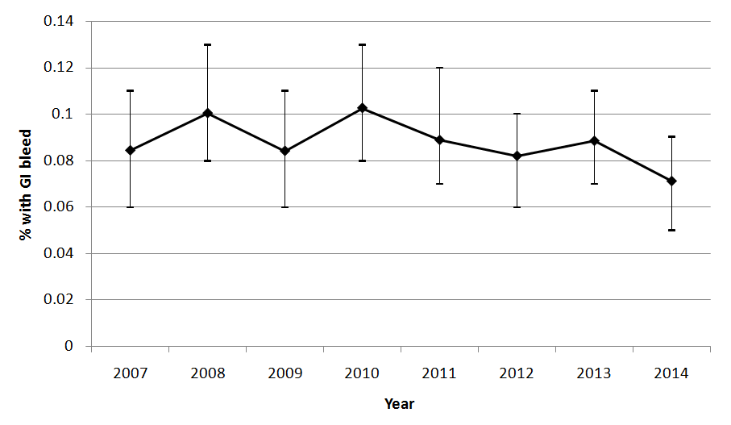
Figure 2: Kaplan-Meier survival curves at 30 days, 1 year and 5 years
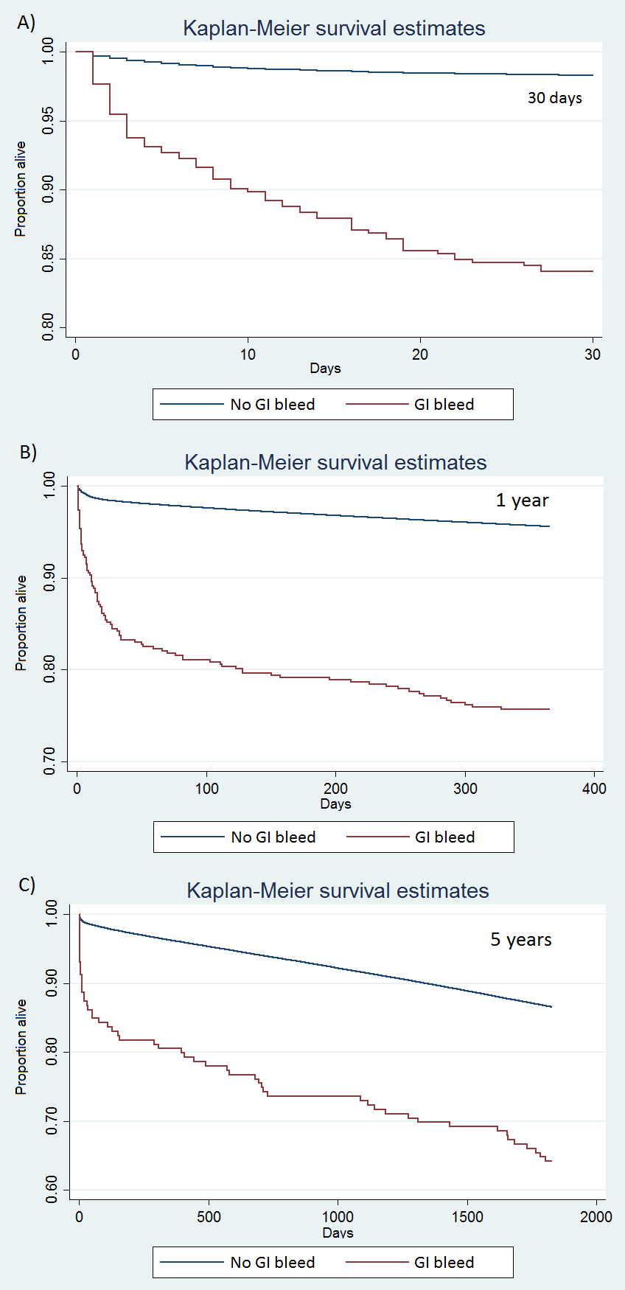

Figure 3: Legacy effect of GI bleed

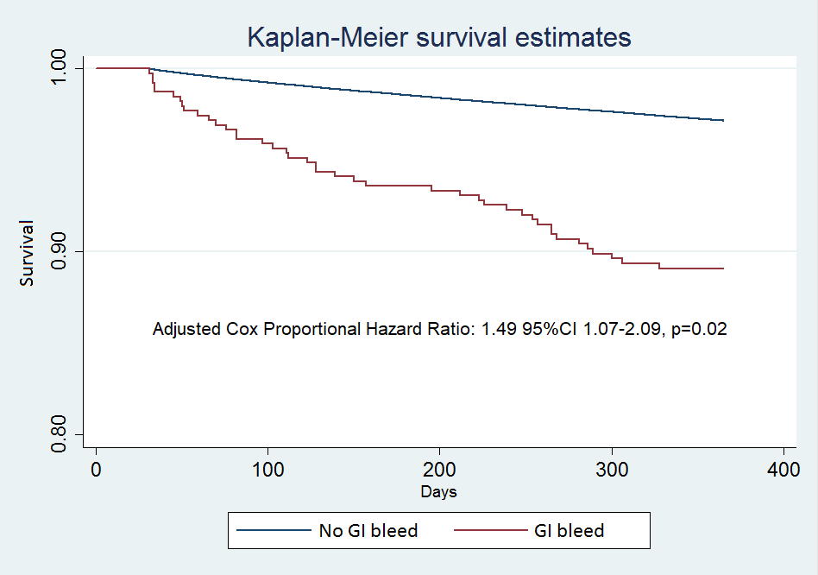

Table 1: Characteristics of participants
Variable | No GI bleed (n=548,818) | GI bleed (n=480) | p-value
Age | 65±12 | 72±11 | <0.001
Male sex | 406,824 (74%) | 327 (69%) | 0.005
Body mass index | 28.4±4.9 | 27.7±4.8 | 0.009
Current smoker | 118,168 (24%) | 97 (23%) | NS
Diabetes | 102,740 (20%) | 93 (20%) | NS
Hypertension | 285,338 (52%) | 289 (61%) | 0.004
Hypercholesterolemia | 294,867 (43%) | 274 (58%) | NS
Previous MI | 137,855 (28%) | 113 (25%) | NS
Previous stroke | 20,953 (4%) | 31 (7%) | 0.005
Peripheral vascular disease | 25,667 (5%) | 48 (10%) | <0.001
Renal disease | 14,262 (3%) | 37 (8%) | <0.001
Valvular heart disease | 6,905 (1%) | 20 (4%) | <0.001
Previous PCI | 120,412 (23%) | 80 (17%) | 0.002
Previous CABG | 45,112 (9%) | 36 (8%) | NS
Left ventricular ejection fraction  Good  Moderate  Poor | 187,555 (71%)  59,408 (23%)  16,293 (6%) | 77 (36%)  93 (44%)  42 (20%) | <0.001
Radial access | 266,660 (50%) | 202 (43%) | 0.003
Cardiogenic shock | 11,701 (2%) | 93 (20%) | <0.001
Circulatory support | 8,377 (2%) | 83 (18%) | <0.001
Receipt of ventilation | 7,263 (2%) | 29 (6%) | <0.001
Diagnosis  Stable angina  NSTEMI/UA  STEMI | 194,609 (37%)  204,222 (39%)  121,170 (23%) | 32 (7%)  116 (25%)  312 (68%) | <0.001
Target vessel  Left main  LAD  LCx  RCA  Graft | 19,420 (4%)  255,554 (47%)  131,015 (24%)  197,486 (36%)  20,774 (4%) | 44 (9%)  219 (46%)  87 (18%)  191 (40%)  20 (4%) | <0.001  0.68  0.003  0.08  0.66
Multivessel disease | 103,492 (19%) | 89 (19%) | 0.86
Triple vessel disease | 69,022 (13%) | 115 (24%) | <0.001
Glyoprotein IIb/IIIa inhibitor use | 111,658 (22%) | 292 (63%) | <0.001
Clopidogrel | 443,134 (85%) | 386 (82%) | 0.03
Prasugrel | 19,705 (4%) | 38 (9%) | <0.001
Ticagrelor | 24,059 (5%) | 23 (5%) | NS
Ticlopidine | 1,579 (0.3%) | 0 (0%) | NS
Warfarin | 5,366 (1%) | 12 (3%) | 0.002
Thrombolysis | 6,990 (1%) | 32 (7%) | <0.001
Year  2007  2008  2009  2010  2011  2012  2013  2014 | 58,022 (11%)  62,733 (11%)  65,305 (12%)  67,232 (12%)  70,875 (13%)  74,320 (14%)  74,560 (14%)  75,771 (14%) | 49 (10%)  63 (13%)  55 (11%)  69 (14%)  63 (13%)  61 (13%)  66 (14%)  54 (11%) | NS
30-day mortality | 11,863 (2%) | 90 (18%) | <0.001
In-hospital MACE | 8,581 (2%) | 91 (19%) | <0.001
Blood transfusion | 940 (0.2%) | 167 (35%) | <0.001
Platelet transfusion | 170 (0.03%) | 12 (3%) | <0.001
Table 1 – Characteristics of the patients. MI - myocardial infarction, PCI - percutaneous coronary intervention, CABG - coronary artery bypass graft, MACE - major adverse cardiovascular event, NS- not statistically significant.

Table 2: Univariable and multivariable predictors of GI bleed
Variable | Univariate odds ratio (95% CI) | p-value | Multivariate odds ratio (95% CI) | p-value
Age (per year) | 1.06 (1.05-1.06) | <0.001 | 1.05 (1.04-1.06) | <0.001
Male sex | 0.76 (0.62-0.92) | 0.005 | NS | NS
Body mass index | 0.97 (0.94-0.99) | 0.005 | NS | NS
Smoking status | 0.96 (0.77-1.20) | 0.71 | NS | NS
Diabetes | 1.01 (0.81-1.27) | 0.91 | NS | NS
Hypertension | 1.31 (1.09-1.58) | 0.004 | NS | NS
Hypercholesterolemia | 1.06 (0.89-1.28) | 0.51 | 1.37 (1.12-1.68) | 0.002
Previous MI | 0.84 (0.68-1.04) | 0.11 | NS | NS
Previous stroke | 1.70 (1.17-2.48) | 0.005 | NS | NS
Peripheral vascular disease | 2.19 (1.62-2.95) | <0.001 | 1.42 (1.03-1.96) | 0.032
Renal disease | 3.21 (2.30-4.47) | <0.001 | 2.02 (1.41-2.90) | <0.001
Valvular heart disease | 3.36 (2.16-5.23) | <0.001 | 2.63 (1.65-4.21) | <0.001
Previous PCI | 0.69 (0.54-0.87) | 0.002 | NS | NS
Previous CABG | 0.89 (0.63-1.25) | 0.49 | NS | NS
Left ventricular ejection fraction  Good  Moderate  Poor | 1.00 (ref)  3.08 (2.36-4.03)  5.98 (3.96-9.02) | <0.001 <0.001 | 1.00 (ref)  1.50 (1.11-2.02)  NS | 0.009 NS
Radial access | 0.77 (0.64-0.92) | 0.004 | NS | NS
Cardiogenic shock | 10.90 (8.69-13.68) | <0.001 | 1.73 (1.23-2.44) | 0.002
Circulatory support | 13.48 (10.66-17.03) | <0.001 | 2.65 (1.90-3.71) | <0.001
Receipt of ventilation | 4.36 (3.00-6.32) | <0.001 | NS | NS
Diagnosis  Stable angina  NSTEMI/UA  STEMI | 1.00 (ref)  3.44 (2.31-5.10)  15.72 (10.93-22.62) | <0.001 | 1.00 (ref)  2.47 (1.65-3.68)  7.28 (4.82-11.00) | <0.001
Target vessel  Left main  LAD  LCx  RCA  Graft | 2.75 (2.02-3.75)  NS  0.71 (0.56-0.89)  NS  NS | <0.001 NS  0.003  NS  NS | 1.61 (1.10-2.36)  NS  NS  NS  NS | 0.015  NS  NS  NS  NS
Multivessel disease | NS | NS | NS | NS
Triple vessel disease | 2.19 (1.78-2.70) | <0.001 | 1.27 (1.01-1.59) | 0.038
Glycoprotein IIb/IIIa inhibitor use | 5.97 (4.95-7.21) | <0.001 | 3.42 (2.76-4.24) | <0.001
Clopidogrel | 0.81 (0.64-1.02) | 0.07 | NS | NS
Prasugrel | 2.11 (1.52-2.94) | <0.001 | NS | NS
Ticagrelor | 1.02 (0.68-1.55) | 0.94 | NS | NS
Warfarin | 2.45 (1.36-4.40) | 0.003 | 1.86 (1.02-3.39) | 0.04
Thrombolysis | 4.89 (3.41-6.98) | <0.001 | 1.78 (1.20-2.63) | 0.004
Year | 0.98 (0.94-1.01) | 0.21 | NS | NS
Table 2 - Univariate and multivariate predictors of GI bleed. MI - myocardial infarction, PCI - percutaneous coronary intervention, CABG - coronary artery bypass graft, NS - not statistically significant.

Table 3: Risk of adverse outcome with GI bleed
Group | Analysis | n | Odds ratio (95% CI) | p-value
Whole cohort | Univariate 30-day mortality | 549,298 | 10.44 (8.30-13.14) | <0.001
Whole cohort | Multivariate 30-day mortality | 549,298 | 2.08 (1.53-2.83) | <0.001
Whole cohort | Univariate in-hospital MACE | 549,298 | 14.73 (11.71-18.52) | <0.001
Whole cohort | Multivariate in-hospital MACE | 549,298 | 3.68 (2.75-4.93) | <0.001
Receipt of transfusion | Univariate 30-day mortality | 549,131 | 9.86 (7.38-13.18) | <0.001
Receipt of transfusion | Multivariate 30-day mortality | 549,131 | 2.35 (1.60-3.45) | <0.001
Receipt of transfusion | Univariate in-hospital MACE | 549,131 | 13.13 (9.78-17.61) | <0.001
Receipt of transfusion | Multivariate in-hospital MACE | 549,131 | 3.66 (2.52-5.31) | <0.001
No transfusion | Univariate 30-day mortality | 548,989 | 12.93 (9.01-18.55) | <0.001
No transfusion | Multivariate 30-day mortality | 548,989 | 2.01 (1.26-3.19) | 0.003
No transfusion | Univariate in-hospital MACE | 548,989 | 19.86 (13.97-28.23) | <0.001
No transfusion | Multivariate in-hospital MACE | 548,989 | 4.31 (2.77-6.71) | <0.001
Table 3 – Risk factors associated with adverse outcomes in patients with GI bleeding. Any transfusion is the composite of blood transfusion and platelet transfusion. MACE=major adverse cardiovascular event.

Supplementary Figure 1: Flow diagram - England and Wales only, exclude missing GI bleed and outcomes.

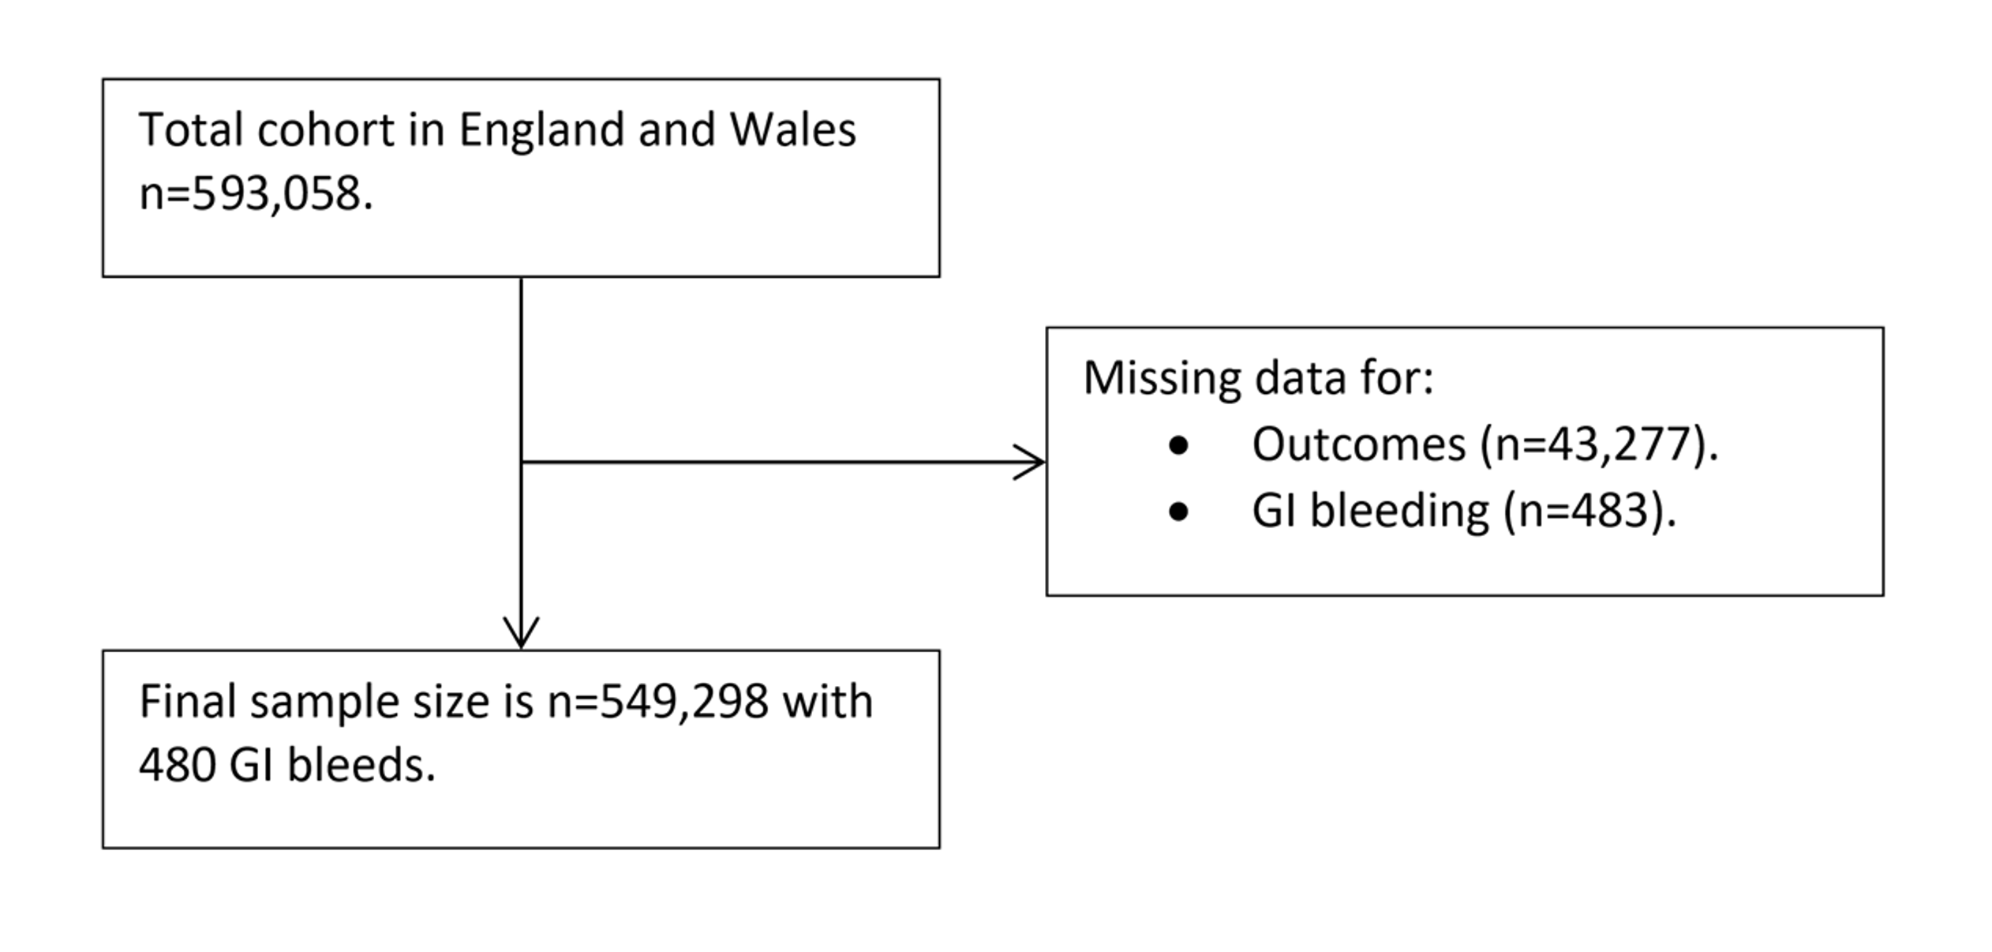
Supplementary Figure 2: Rates of GI bleed over time in according to A) age, B) gender and C) cardiovascular diagnosis.

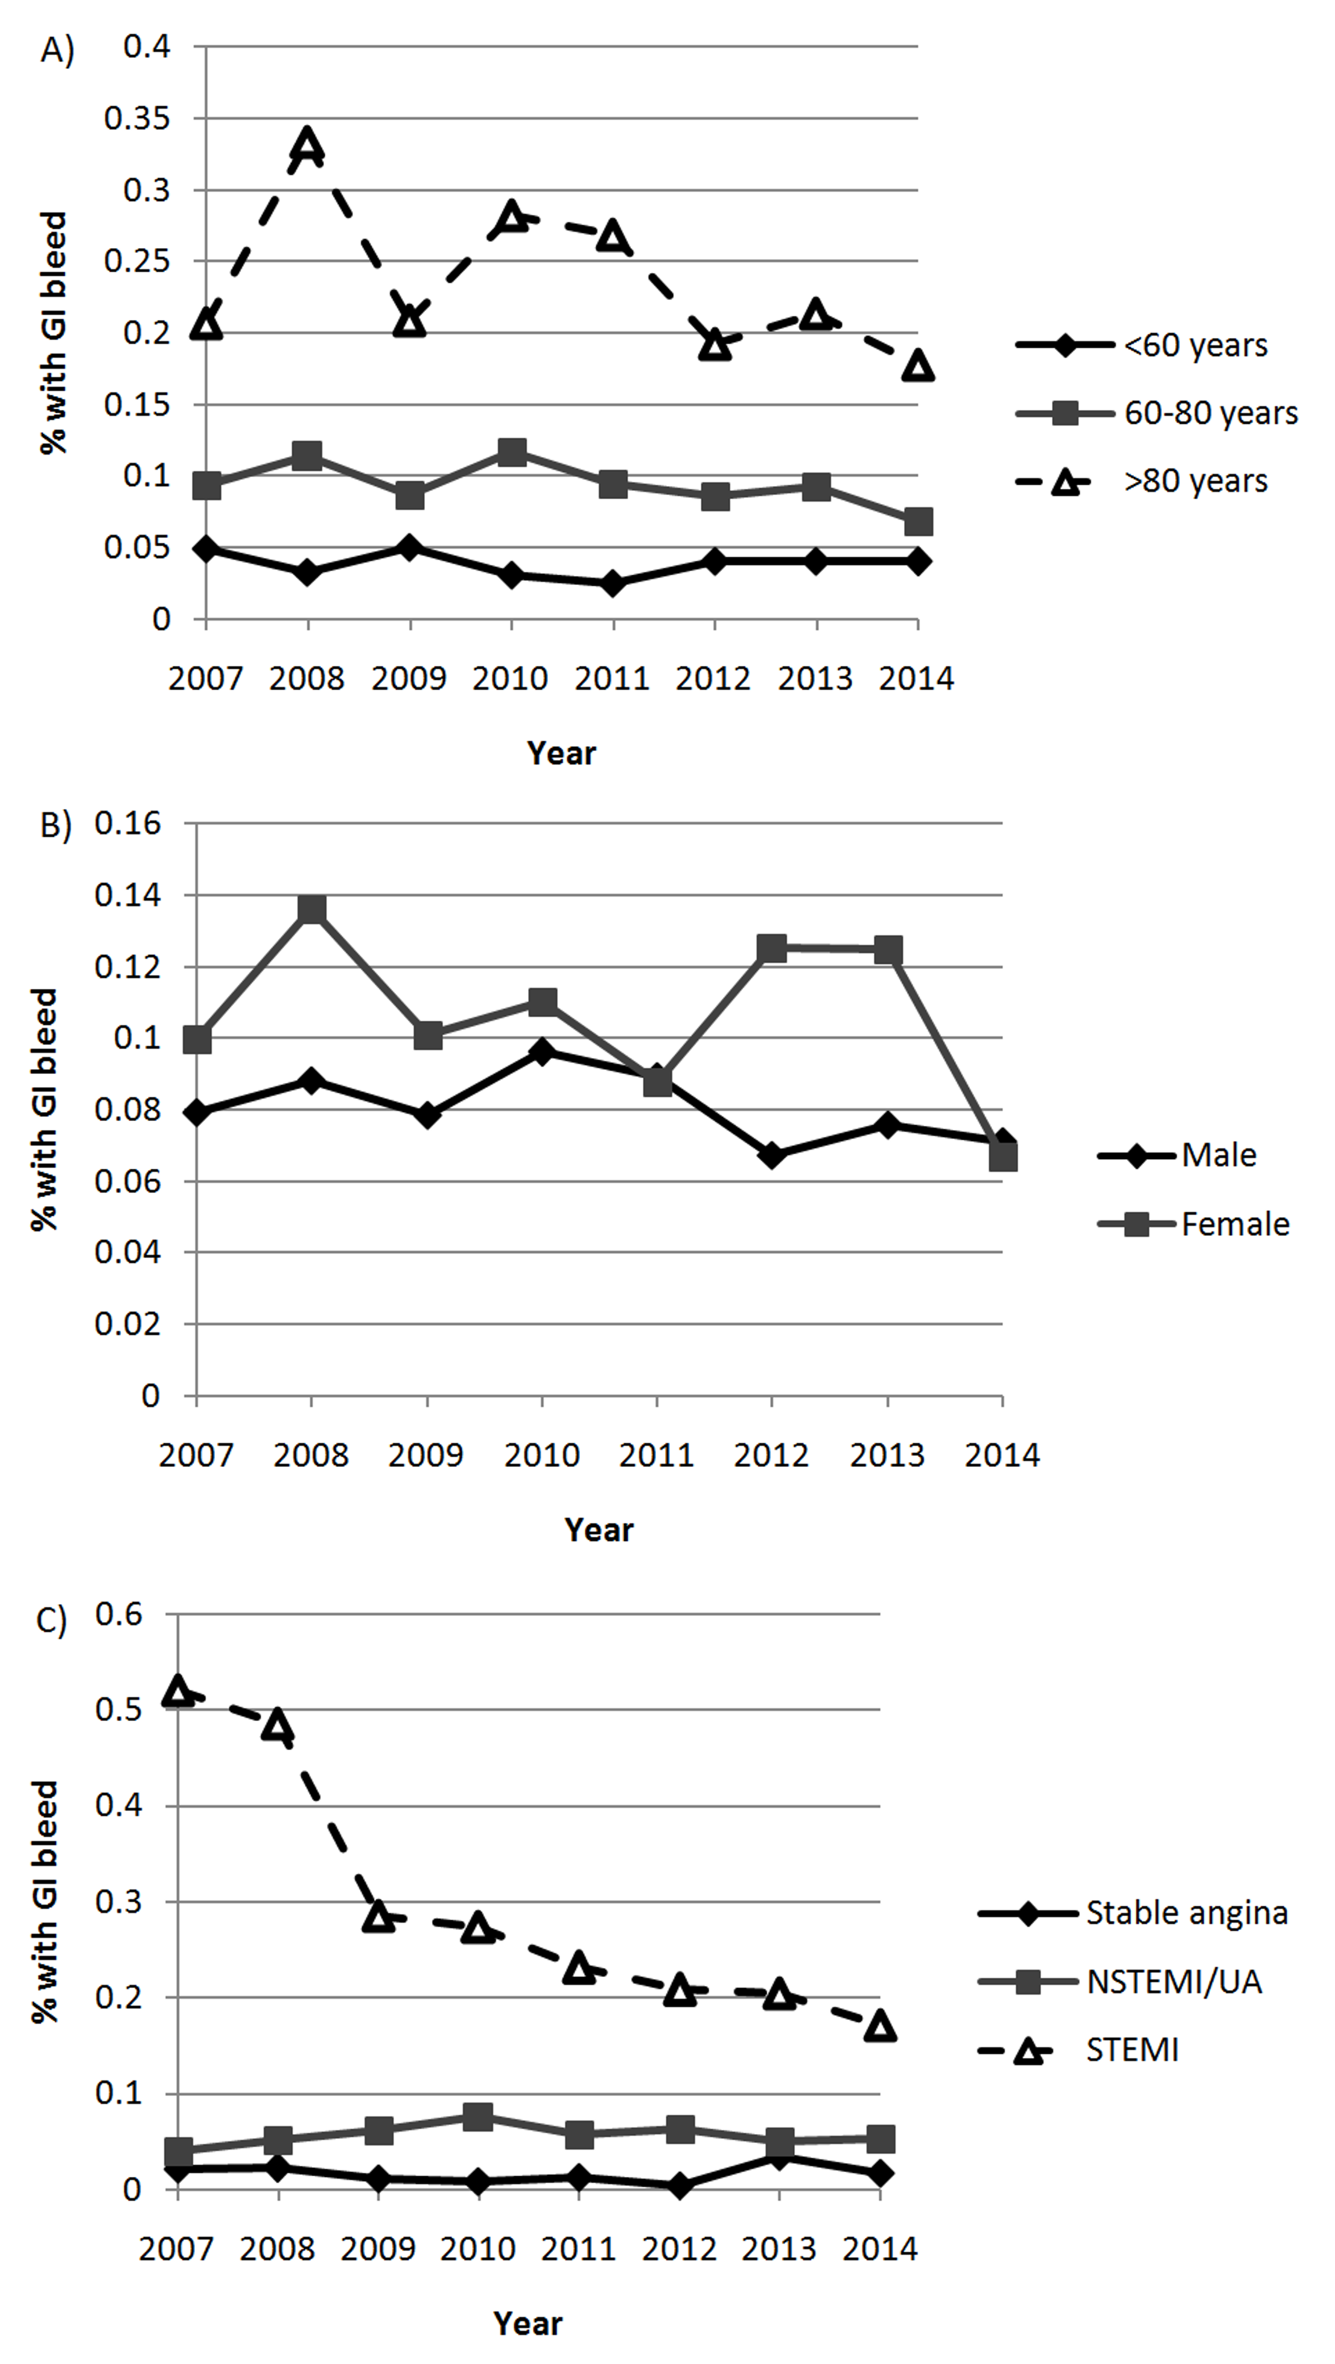

Supplementary Table 1: Missing data table.
Variable | Available | Missing | % Missing
Age | 549,169 | 129 | 0.02
Male sex | 548,492 | 806 | 0.2
Body mass index | 315.524 | 233,774 | 43
Current smoker | 486,811 | 62,487 | 11
Diabetes | 526,676 | 22,622 | 4
Hypertension | 522,839 | 26,459 | 5
Hypercholesterolaemia | 522,605 | 26,693 | 5
Previous MI | 498,143 | 51,155 | 9
Previous stroke | 521,284 | 28,014 | 5
Peripheral vascular disease | 521,250 | 28,048 | 5
Renal disease | 521,672 | 27,626 | 5
Valvular heart disease | 521,174 | 28,124 | 5
Previous PCI | 530,089 | 19,209 | 4
Previous CABG | 529,297 | 20,001 | 4
Left ventricular ejection fraction | 263,468 | 285,830 | 52
Radial access | 534,320 | 14,978 | 3
Cardiogenic shock | 516,060 | 33,238 | 6
Circulatory support | 515,845 | 33,453 | 6
Pre-procedural ventilation | 468,280 | 81,018 | 15
Diagnosis | 520,461 | 28,837 | 5
Target vessel | 549,298 | 0 | 0
Multivessel disease | 549,298 | 0 | 0
Triple vessel disease | 549,298 | 0 | 0
Glyoprotein IIb/IIIa inhibitor use | 503,463 | 45,835 | 8
Clopidogrel | 519,369 | 29,929 | 5
Prasugrel | 492,583 | 56,715 | 10
Ticagrelor | 492,752 | 56,546 | 10
Ticlopidine | 461,144 | 88,154 | 16
Warfarin | 461,656 | 87,642 | 16
Thrombolysis | 518,906 | 30,392 | 6
Year | 549,298 | 0 | 0

Supplementary Table 2: STROBE Statement—Checklist of items that should be included in reports of cohort studies
 | Item No | Recommendation | Page No
Title and abstract | 1 | (a) Indicate the study’s design with a commonly used term in the title or the abstract | 1,2
Title and abstract | 1 | (b) Provide in the abstract an informative and balanced summary of what was done and what was found | 2
Introduction
Background/rationale | 2 | Explain the scientific background and rationale for the investigation being reported | 3
Objectives | 3 | State specific objectives, including any prespecified hypotheses | 3
Methods
Study design | 4 | Present key elements of study design early in the paper | 3-5
Setting | 5 | Describe the setting, locations, and relevant dates, including periods of recruitment, exposure, follow-up, and data collection | 3-5
Participants | 6 | (a) Give the eligibility criteria, and the sources and methods of selection of participants. Describe methods of follow-up | 3-5
Participants | 6 | (b) For matched studies, give matching criteria and number of exposed and unexposed | -
Variables | 7 | Clearly define all outcomes, exposures, predictors, potential confounders, and effect modifiers. Give diagnostic criteria, if applicable | 3-5
Data sources/ measurement | 8* | For each variable of interest, give sources of data and details of methods of assessment (measurement). Describe comparability of assessment methods if there is more than one group | 3-5
Bias | 9 | Describe any efforts to address potential sources of bias | 3-5
Study size | 10 | Explain how the study size was arrived at | 3-5
Quantitative variables | 11 | Explain how quantitative variables were handled in the analyses. If applicable, describe which groupings were chosen and why | 3-5
Statistical methods | 12 | (a) Describe all statistical methods, including those used to control for confounding | 3-5
Statistical methods | 12 | (b) Describe any methods used to examine subgroups and interactions | 3-5
Statistical methods | 12 | (c) Explain how missing data were addressed | 3-5
Statistical methods | 12 | (d) If applicable, explain how loss to follow-up was addressed | 3-5
Statistical methods | 12 | (e) Describe any sensitivity analyses | 3-5
Results
Participants | 13* | (a) Report numbers of individuals at each stage of study—eg numbers potentially eligible, examined for eligibility, confirmed eligible, included in the study, completing follow-up, and analysed | 4-7
Participants | 13* | (b) Give reasons for non-participation at each stage | Supplementary Figure
Participants | 13* | (c) Consider use of a flow diagram | Supplementary Figure
Descriptive data | 14* | (a) Give characteristics of study participants (eg demographic, clinical, social) and information on exposures and potential confounders | 4-7
Descriptive data | 14* | (b) Indicate number of participants with missing data for each variable of interest | 4-7
Descriptive data | 14* | (c) Summarise follow-up time (eg, average and total amount) | 4-7
Outcome data | 15* | Report numbers of outcome events or summary measures over time | 4-7
Main results | 16 | (a) Give unadjusted estimates and, if applicable, confounder-adjusted estimates and their precision (eg, 95% confidence interval). Make clear which confounders were adjusted for and why they were included | 4-7
Main results | 16 | (b) Report category boundaries when continuous variables were categorized | 4-7
Main results | 16 | (c) If relevant, consider translating estimates of relative risk into absolute risk for a meaningful time period | 4-7
Other analyses | 17 | Report other analyses done—eg analyses of subgroups and interactions, and sensitivity analyses | 4-7
Discussion
Key results | 18 | Summarize key results with reference to study objectives | 7-10
Limitations | 19 | Discuss limitations of the study, taking into account sources of potential bias or imprecision. Discuss both direction and magnitude of any potential bias | 7-10
Interpretation | 20 | Give a cautious overall interpretation of results considering objectives, limitations, multiplicity of analyses, results from similar studies, and other relevant evidence | 7-10
Generalizability | 21 | Discuss the generalizability (external validity) of the study results | 7-10
Other information
Funding | 22 | Give the source of funding and the role of the funders for the present study and, if applicable, for the original study on which the present article is based | 10

*Give information separately for exposed and unexposed groups.

Note: An Explanation and Elaboration article discusses each checklist item and gives methodological background and published examples of transparent reporting. The STROBE checklist is best used in conjunction with this article (freely available on the Web sites of PLoS Medicine at http://www.plosmedicine.org/, Annals of Internal Medicine at http://www.annals.org/, and Epidemiology at http://www.epidem.com/). Information on the STROBE Initiative is available at http://www.strobe-statement.org.
Supplementary Table 3: Rates of bleeding over time.

Group | 2007 | 2008 | 2009 | 2010 | 2011 | 2012 | 2013 | 2014
Overall | 49 (0.08%) | 63 (0.10%) | 55 (0.08%) | 69 (0.10%) | 63 (0.09%) | 61 (0.08%) | 66 (0.09%) | 54 (0.07%)
Age <60 | 10 (0.05%) | 7 (0.03%) | 11 (0.05%) | 7 (0.03%) | 6 (0.03%) | 10 (0.04%) | 10 (0.04%) | 10 (0.04%)
Age 60-80 | 32 (0.09%) | 42 (0.11%) | 33 (0.09%) | 45 (0.12%) | 38 (0.09%) | 36 (0.09%) | 39 (0.09%) | 29 (0.07%)
Age >80 | 7 (0.21%) | 14 (0.33%) | 11 (0.21%) | 17 (0.28%) | 19 (0.27%) | 15 (0.15%) | 17 (0.21%) | 15 (0.18%)
Women | 15 (0.10%) | 22 (0.14%) | 17 (0.10%) | 19 (0.11%) | 16 (0.09%) | 24 (0.13%) | 24 (0.12%) | 13 (0.07%)
Men | 34 (0.08%) | 41 (0.09%) | 38 (0.08%) | 48 (0.10%) | 47 (0.09%) | 37 (0.07%) | 42 (0.08%) | 40 (0.07%)
Stable angina | 5 (0.02%) | 6 (0.02%) | 3 (0.01%) | 2 (0.01%) | 3 (0.01%) | 1 (<0.01%) | 8 (0.03%) | 4 (0.02%)
NSTEMI/UA | 9 (0.04%) | 12 (0.05%) | 15 (0.06%) | 19 (0.08%) | 15 (0.06%) | 17 (0.06%) | 14 (0.05%) | 15 (0.05%)
STEMI | 32 (0.52%) | 43 (0.49%) | 35 (0.29%) | 42 (0.27%) | 42 (0.23%) | 42 (0.21%) | 41 (0.20%) | 35 (0.17%)
Clopiodgrel | 49 (0.08%) | 63 (0.10%) | 55 (0.08%) | 69 (0.10%) | 41 (0.08%) | 40 (0.08%) | 41 (0.09%) | 28 (0.07%)
Prasugrel | 0  (0%) | 0  (0%) | 0  (0%) | 6  (0.4%) | 10 (0.21%) | 10 (0.18%) | 6 (0.14%) | 6 (0.17%)
Ticagrelor | 0  (0%) | 0  (0%) | 0  (0%) | 0  (0%) | 0  (0%) | 3 (0.12%) | 10 (0.11%) | 10 (0.08%)

Supplementary Table 4: Changes in the proportion of elderly, female, diabetes and renal disease in cohort over time.

Variable | 2007 | 2008 | 2009 | 2010 | 2011 | 2012 | 2013 | 2014 | Total | p-value
Age >80 years | 4,251 (7.3%) | 5,214 (8.3%) | 6,420 (9.8%) | 7,150 (10.6%) | 8,406 (11.9%) | 9,238 (12.4%) | 9,429 (12.6%) | 9,852 (13.0%) | 59,960 (10.9%) | <0.001
Female | 15,039 (26.0%) | 16,159 (25.8%) | 16,867 (25.8%) | 17,219 (25.6%) | 18,234 (25.7%) | 19,173 (25.8%) | 19,202 (25.8%) | 19,448 (25.7%) | 141,341 (25.8%) | 0.94
Diabetes | 9,453 (17.5%) | 11,091 (18.4%) | 11,731 (18.5%) | 12,254 (18.9%) | 13,210 (19.3%) | 14,358 (20.4%) | 15,035 (21.2%) | 15,701 (21.2%) | 102,833 (19.5%) | <0.001
Renal disease | 1,425 (2.7%) | 1,469 (2.5%) | 1,606 (2.5%) | 1,823 (2.9%) | 1,734 (2.6%) | 2,058 (2.9%) | 2,092 (3.0%) | 2.092 (2.9%) | 14,299 (2.9%) | <0.001

Supplementary Table 5: Patient characteristics according to use of glycoprotein IIb/IIIa inhibitors
Variable | No GPI (n=391,513) | GPI (n=111,950) | p-value
Age | 65±12 | 62±12 | <0.001
Male sex | 287,105 (73%) | 86,331 (77%) | <0.001
Body mass index | 28.5±5.0 | 28.2±4.8 | <0.001
Current smoker | 74,564 (21%) | 34,524 (35%) | <0.001
Diabetes | 76,659 (20%) | 17,782 (16%) | <0.001
Hypertension | 213,770 (57%) | 49,832 (47%) | <0.001
Hypercholesterolemia | 219,216 (59%) | 53,629 (50%) | <0.001
Previous MI | 107,090 (30%) | 20,932 (21%) | <0.001
Previous stroke | 15,985 (4%) | 3,476 (3%) | <0.001
Peripheral vascular disease | 18,948 (5%) | 4,329 (4%) | <0.001
Renal disease | 14,262 (3%) | 37 (8%) | <0.001
Valvular heart disease | 6,905 (1%) | 20 (4%) | <0.001
Previous PCI | 95,043 (25%) | 15,805 (15%) | <0.001
Previous CABG | 35,301 (9%) | 6,325 (6%) | <0.001
Left ventricular ejection fraction  Good  Moderate  Poor | 146,954 (74%)  41,615 (21%)  10,881 (5%) | 28,483 (62%)  13,711 (30%)  3,856 (8%) | <0.001
Radial access | 193,700 (51%) | 55,291 (50%) | 0.041
Cardiogenic shock | 5,739 (2%) | 5,250 (5%) | <0.001
Circulatory support | 3,963 (1%) | 4,018 (4%) | <0.001
Receipt of ventilation | 4,238 (1%) | 2,645 (3%) | <0.001
Diagnosis  Stable angina  NSTEMI/UA  STEMI | 164,661 (44%)  150,172 (40%)  56,871 (15%) | 14,190 (13%)  39,561 (36%)  54,663 (50%) | <0.001
Target vessel  Left main  LAD  LCx  RCA  Graft | 13,809 (4%)  183,065 (47%)  97,786 (25%)  139,677 (36%)  15,211 (4%) | 4,101 (4%)  53,449 (48%)  23,518 (21%)  42,977 (38%)  4,190 (4%) | 0.03 <0.001  <0.001  <0.001  <0.001
Multivessel disease | 74,765 (19%) | 21,034 (19%) | 0.021
Triple vessel disease | 49,507 (13%) | 16,532 (15%) | <0.001
Clopidogrel | 321,275 (86%) | 89,434 (83%) | <0.001
Prasugrel | 11,232 (3%) | 6,687 (7%) | <0.001
Ticagrelor | 17,301 (5%) | 5,180 (5%) | <0.001
Ticlopidine | 1,163 (0.3%) | 314 (0.3%) | NS
Warfarin | 4,489 (1.3%) | 612 (0.7%) | <0.001
Thrombolysis | 3,644 (1.0%) | 3,074 (3%) | <0.001
Year  2007  2008  2009  2010  2011  2012  2013  2014 | 34,962 (9%)  41,365 (11%)  43,722 (11%)  47162 (12%)  51,041 (13%0  56,582 (14%)  57,128 (15%)  59,551 (15%) | 15,948 (14%)  15,849 (14%)  16,597 (15%)  15,300 (14%)  14,010 (13%)  12,058 (11%)  11,301 (10%)  10,887 (10%) | <0.001
30-day mortality | 6,805 (2%) | 4,169 (4%) | <0.001
In-hospital MACE | 4,798 (1%) | 3,255 (3%) | <0.001
Blood transfusion | 617 (0.2%) | 437 (0.4%) | <0.001
Platelet transfusion | 80 (0.02%) | 98 (0.09%) | <0.001

Supplementary Table 6: Length of stay in entire cohort and in subgroups according to GI bleeding.

Group | Length of stay (days) | p-value
Overall  GI bleed (n=474)  No GI bleed (n=532,071) | 11.3±15.0  2.0±5.3 | <0.001
Age <60  GI bleed (n=70)  No GI bleed (n=179,682) | 9.0±10.1  1.8±4.8 | <0.001
Age 60-80  GI bleed (n=291)  No GI bleed (n=304,176) | 10.3±15.0  2.0±5.2 | <0.001
Age >80  GI bleed (n=113)  No GI bleed (n=48,213) | 15.1±17.0  3.1±6.6 | <0.001
Female  GI bleed (n=146)  No GI bleed (n=136,729) | 11.0±12.4  2.3±5.5 | <0.001
Male  GI bleed (n=339)  No GI bleed (n=394,606) | 11.4±16.1  2.0±5.2 | <0.001
Stable angina  GI bleed (n=32)  No GI bleed (n=188,433) | 5.3±7.7  1.0±4.3 | <0.001
NSTEMI/UA  GI bleed (n=114)  No GI bleed (n=198,026) | 13.0±16.0  2.0±5.1 | <0.001
STEMI  GI bleed (n=308)  No GI bleed (n=118,933) | 11.3±15.1  3.9±6.4 | <0.001
Clopidogrel  GI bleed (n=380)  No GI bleed (n=429,042) | 11.3±15.4  1.9±5.1 | <0.001
Prasugrel  GI bleed (n=38)  No GI bleed (n=19,427) | 12.5±13.2  3.4±6.0 | <0.001
Ticagrelor  GI bleed (n=23)  No GI bleed (n=23,668) | 11.5±18.9  2.6±5.4 | <0.001

Supplementary Table 7: Multivariable predictors of mortality at 1 year among survivors at 30 days
Variable | Odds ratio (95% CI) | p-value
Gastrointestinal bleed | 1.57 (1.08-2.29) | <0.001
Age (per year) | 1.07 (1.07-1.07) | <0.001
Male sex | NS | NS
Body mass index | 0.99 (0.98-0.99) | <0.001
Smoking status | 1.20 (1.14-1.27) | <0.001
Diabetes | 1.53 (1.47-1.60) | <0.001
Hypertension | NS | NS
Hypercholesterolemia | 0.90 (0.86-0.94) | <0.001
Previous MI | 1.27 (1.21-1.33) | <0.001
Previous stroke | 1.41 (1.31-1.50) | <0.001
Peripheral vascular disease | 1.59 (1.49-1.68) | <0.001
Renal disease | 2.91 (2.74-3.10) | <0.001
Valvular heart disease | 1.92 (1.74-2.12) | <0.001
Previous PCI | NS | NS
Previous CABG | NS | NS
Left ventricular ejection fraction vs Good  Moderate  Poor | 1.63 (1.55-1.72)  2.32 (2.17-2.48) | <0.001  <0.001
Radial access | 0.88 (0.85-0.92) | <0.001
Cardiogenic shock | 1.51 (1.34-1.69) | <0.001
Circulatory support | 1.52 (1.35-1.71) | <0.001
Receipt of ventilation | 1.55 (1.33-1.79) | <0.001
Diagnosis vs Stable angina  NSTEMI/UA  STEMI | 1.56 (1.49-1.63)  2.04 (1.92-2.18) | <0.001  <0.001
Target vessel  Left main  LAD  LCx  RCA  Graft | 1.39 (1.28-1.51)  NS  NS  NS  NS | <0.001 NS  NS  NS  NS
Multivessel disease | NS | NS
Triple vessel disease | 1.22 (1.16-1.28) | <0.001
Glycoprotein IIb/IIIa inhibitor use | 0.78 (0.74-0.82) | <0.001
Clopidogrel | NS | NS
Prasugrel | NS | NS
Ticagrelor | NS | NS
Warfarin | 1.41 (1.22-1.64) | <0.001
Thrombolysis | 0.73 (0.59-0.90) | 0.003
Year | NS | NS
MI - myocardial infarction, PCI - percutaneous coronary intervention, CABG - coronary artery bypass graft, NS - not statistically significant.

