**Optical photothermal infrared microspectroscopy discriminates for the first time different types of lung cells on histopathology glass slides.**

Mustafa Kansiz1, Lewis M. Dowling2, Ibraheem Yousef3, Olivier Guaitella4, Ferenc Borondics5 and Josep Sulé-Suso2,6,*

1. Photothermal Spectroscopy Corp., 325 Chapala St, Santa Barbara, CA, 93101, USA

2. School of Pharmacy and Bioengineering, Guy Hilton Research Centre, Keele University, Stoke-on-Trent, UK.

3. ALBA Synchrotron Light Source, Cerdanyola del Vallès, Barcelona, Catalonia.

4. Laboratoire de Physique des Plasmas, École Polytechnique-CNRS-Université Paris-Sud-Sorbonne Université 91128 Palaiseau, France.

5. Synchrotron SOLEIL, L'Orme des Merisiers Saint-Aubin, BP 48 91192 Gif-sur-Yvette Cedex, France.

6. Oncology Department, Cancer Centre, Royal Stoke University Hospital, University Hospitals of North Midlands, Stoke-on-Trent, UK.

*Corresponding author. E-mail: josep.sulesuso@uhnm.nhs.uk

**ABSTRACT**

The debate of whether glass substrate can be used in Fourier Transform Infrared spectroscopy is strongly linked to its potential clinical application. Histopathology glass slides of 1 mm thickness absorb the mid-IR spectrum in the rich fingerprint spectral region. Thus, it is important to assess whether emerging IR techniques can be employed to study biological samples placed on glass substrates. To this purpose, we used Optical Photothermal Infrared (O-PTIR) spectroscopy to study for the first time malignant and non-malignant lung cells with the purpose to identify IR spectral differences between these cells placed on standard pathology glass slides. The data in this feasibility study showed that O-PTIR can be used to obtain good quality IR spectra from cells from both the lipid region (3000-2700 cm-1) and the fingerprint region between 1770-950 cm-1 but with glass contributions from 1350 cm-1 to 950 cm-1. A new single unit dual range (C-H/FP) Quantum Cascade Laser (QCL) IR pump source was applied for the first time, delivering a clear synergistic benefit to the classification results. Furthermore, O-PTIR is able to separate between lung cancer cells and non-malignant lung cells both in the lipid and the fingerprint regions. However, when these two spectral ranges are combined, classification accuracies are enhanced with Random Forest modelling classification accuracy results ranging from 96%-99% across all three studied cell lines. The methodology here described for the first time with a single unit dual range QCL for O-PTIR on glass is another step towards its clinical application in pathology.

**Keywords:** Optical Photothermal Infrared (O-PTIR) spectroscopy, microspectroscopy, lung cancer, glass slides.

One of the emerging questions in the application of Fourier Transform Infrared (FTIR) microspectroscopy in clinical practice is, glass or no glass as substrate. The debate on whether glass could be used as substrate to study, using FTIR microspectroscopy, tissue and/or cellular samples in bio-medicine and in other fields of research has been going on for some time1,2. In medicine, like in other fields, marrying the way FTIR microspectroscopy can yield data from biological samples and the standard clinical practice in pathology is not an easy task. While infrared (IR) spectroscopists usually use IR transparent substrates across the bulk of the IR spectral region such as CaF2 or BaF2, or reflective substrates like low-E slides, pathologists use glass slides. Glass slides, when used for traditional FTIR spectroscopy suffer from significant IR absorbances in the fingerprint region3-5 essentially blocking out this most informative region between 1800-800 cm-1. On the other hand, CaF2 and BaF2 substrates are brittle, not as robust as glass and are significantly more expensive than glass. If we also take into account that pathologists prefer automated systems for sample preparation, the use of CaF2 and BaF2 substrates does not hold much promise for a full clinical application of FTIR microspectroscopy. Moreover, the extra cost of using hundreds if not thousands of these substrates in already economically stretched health services worldwide would make their use prohibitive from the health economics point of view. It has to be recognised also that the implementation of a new methodology in clinical practice such as FTIR microspectroscopy will have higher chances of success if it is able to cause minimal disruption of the standard working clinical practice. Thus, glass slides as substrates, in spite of the issues raised above, are one aspect that will aid the potential clinical adoption of FTIR spectroscopy.

In previous studies, we have shown that glass thickness and composition plays an important role in obtaining spectral data from the fingerprint region5,6. In fact, by using thin coverslips (0.13-0.17 mm thickness) used in pathology departments we showed for the first time it is possible to obtain data from the Amide I region5. More important, by choosing the right glass composition (soda-lime glass), spectral data down to 1350 cm-1 can also be obtained6.7. However, these thin coverslips are also fragile when used within the working requirements in pathology departments such as within automated systems for disease diagnosis. Thus, a big step towards bringing FTIR microspectroscopy into pathology would be to use as substrates for biological samples, glass slides of around 1 mm thickness, as already handled in pathology departments. To this purpose, emerging IR techniques such as Optical Photothermal Infrared (O-PTIR) microspectroscopy might offer the possibility of studying cell and/or tissue samples placed on glass substrates and provide good quality IR spectra.

O-PTIR microspectroscopy is a relatively new technique based on the principles of IR photothermal spectroscopy and can be described as a pump-probe optical spectroscopy technique. In short, the pump probe which is typically a pulsed and widely tuneable Quantum Cascade Laser (QCL) is used to excite vibrational modes in the sample. The pulsed absorption generates a local modulated heating event – the IR photothermal response. This manifests itself through subtle modulated thermal expansion and refractive index changes, that are both monitored via a short wavelength optical probe beam, typically at 532nm. The changes in reflected (or transmitted) probe beam intensity as a function of IR wavelength tuning of the QCL is then demodulated through a lock-in amplifier to generate what is essentially a pure IR absorbance spectrum. The recent advent of O-PTIR spectroscopy, has enabled for the first time, submicron infrared microscopy in far-field reflection mode, generating “FTIR transmission-like” spectral quality, without dispersive scatter artefacts and distortions such as Mie Scattering associated with traditional FTIR spectroscopy or other emerging QCL based IR microscopy systems, with the added benefit of being uniquely compatible with glass slides, a fact that has been exploited in this study.

Photothermal spectroscopy is not new and has been exploited for decades with techniques such as PhotoAcoustic Spectroscopy (PAS) and Atomic Force Microscopy-based infrared (AFM-IR) spectroscopy (nano-IR). Where O-PTIR differs to them is that it uses an optical (green laser) probe for detection, being analogous to the microphone in PAS and the AFM tip in AFM-IR. The use of this optical probe is the key enabling breakthrough in O-PTIR allowing for non-contact, submicron measurements, providing for advantages in capabilities relative to traditional FTIR/QCL microscopy but also in instrument architecture, thus enabling the first combined (correlative) IR and Raman (IR+Raman) platform that provides for simultaneous IR and Raman spectral information at the same time, and from the same spot, with the same submicron spatial resolution. These unique and exciting synergistic capabilities are now spawning interest in life science applications8,9.

On this basis, we have used O-PTIR microspectroscopy to study a non-malignant lung cell line and 2 lung cancer cell lines placed on standard 1 mm thickness glass slides. The working hypothesis in this feasibility study was to assess whether O-PTIR microspectroscopy could identify spectral differences between these cell lines prepared as cytospins on thick glass slides (nominal thickness of around 1 mm) with the long term goal of working towards a clinical pre-screening tool to rapidly and accurately identify malignant cells from non-malignant cells.

**EXPERIMENTAL SECTION**

Cells

The cells used in this study were CALU-1, an epidermoid lung cancer cell line from the European Collection of Cell Cultures (ECACC), A549, a lung adenocarcinoma cell line (ECACC), and NL20, a non-malignant lung epithelial cell line (ATTCC, UK). Lung cancer cell lines were cultured in Dulbecco’s Modified Eagle Medium (DMEM) while NL20 cell line was cultured in Ham's F12 culture according to provider’s instructions. For all three cell lines, cell growth was carried out in tissue culture flasks (Sarstedt, UK) at 37 °C and 5% CO2. The culture medium was changed every 3–4 days. CALU-1 and A549 cells were detached from the tissue culture flasks before reaching confluence (5 days after seeding) using trypsin/EDTA. NL20 cells were detached before reaching confluence (5 days after seeding) using Hanks’ Balanced Salt solution (HBSS) supplemented with foetal calf serum (FCS) and EDTA according to the provider's instructions. Cells were then collected and centrifuged at 1200 rpm for 5 min. Supernatant was discarded and the pellet resuspended in fresh medium. Cell viability for all three cell lines was determined with the standard trypan blue exclusion method.

Sample Preparation

Samples were prepared as cytospins. Cells were collected as described above, transferred into 15 mL tubes and centrifuged at 1200 rpm for 5 minutes at room temperature. The supernatant was then removed and the pelleted cells were resuspended in 0.9% NaCl. Cell concentration was brought to 106 cells/mL; 20 μL of this cell concentration were placed in a cytospin funnel and cells were then cytospun for 1 minute at 900 rpm on glass slides (24 x 50 mm x 1 mm thickness, Thermo Scientific, UK). Samples were fixed with 4% buffered paraformaldehyde in 0.9% NaCl for 20 minutes at room temperature. Excess formalin was removed by washing once with 0.9% NaCl and thrice rinsed with distilled water. Samples were then air dried at room temperature. For each cell line, 3 independent experiments, each of them in triplicate, were prepared. For each replicate, a minimum of 5 individual cells were studied.

Optical photothermal infrared microspectroscopy

A mIRage, O-PTIR Microsope from Photothermal Spectroscopy Corp. (PSC, Santa Barbara, CA) was used. A dual range (C-H/FP) QCL, covering 3000-2700 cm-1, 1800-914 cm-1 in a single unit was used as a pump beam operating at 100kHz pulse rate, 100% power at 2.5% duty cycle. The probe beam was a 532nm laser operated at 28% power. The standard room temperature silicon photodiode detector was used to record the reflected probe beam intensity. Spectra were collected at 6 cm-1 spectral resolution with a single scan (no averaging) per replicate spectra with each spectrum taking ~1sec to scan. Spectra were collected in reflection mode using an all reflective Cassegrain style objective (40x, 0.78NA, 8 mm working distance). A background QCL power spectrum was collected once per day off a clean Kevley Low-E slide. The system was purged with dry nitrogen gas to minimise water vapour interferences. Nine spectra for each individual cell were obtained mostly from the nuclear region of cells (Figure 1) based on our previous work showing that the main spectral differences between cells reside in the nucleus and not in the cytoplasm10,11. For each cell line, 50 cells were studied.

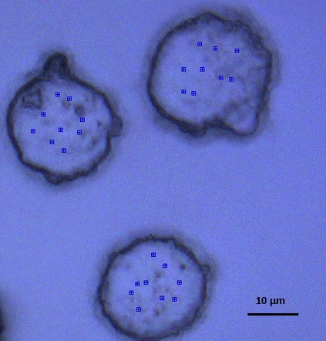

Figure 1. Representative example of lung cancer CALU-1 cells showing where O-PTIR spectra were randomly obtained from.

Data processing and analysis

All processing and data analysis was done using the Orange Spectroscopy (v0.5.6) [https://doi.org/10.1080/08940886.2017.1338424; https://doi.org/10.5281/zenodo.4287478] toolbox in Quasar (v0.9.0)[https://quasar.codes]12. With O-PTIR, since detection is via the visible beam (after IR excitation) and not the IR beam itself, IR Mie Scattering does not occur, hence no corrections for it were needed. Initially, a Savitsky-Golay filter (derivative order=2, polynomial order=2, window=15) was applied. To focus the modelling on spectral regions that are most information rich, spectra were cut to include only 3000-2800 cm-1 and 1770-1350 cm-1. This was followed by a Standard Normal Variate (SNV) normalisation using the full range, after spectral cutting. Intracellular replicate spectra (n=9) were then averaged to provide a single spectrum per cell.

Three different spectral regions (and combinations) were assessed. 1. The lipid region only, covering 3000-2800 cm-1, 2. The fingerprint region, 1770-1350 cm-1 and 3. A combination of lipid and fingerprint regions, 3000-2800 cm-1, 1770-1350 cm-1.

Average spectra were put through a Principal Component Analysis (PCA) for dimension reduction with the new transformed data (at the point of 99% explained variance) and were then fed into a Random Forest (RF) classifier (with 500 trees) and also a K-Nearest Neighbours (KNN) classifier (with 3 nearest neighbours, using Euclidean distance). Spectra were first divided 2/3 training and 1/3 testing for training before being fed into the classifiers. This random division between test and training data was repeated 100 times and each time fed into the classifiers to increase model robustness.

Modelling metrics were assessed through confusion matrix and Receiver Operator Characteristic (ROC) Curves. The processing flow diagram is shown in Figure 2. Quasar workflows and data are available upon reasonable request.

**Figure 2**. Flow diagram of data processing and modelling.

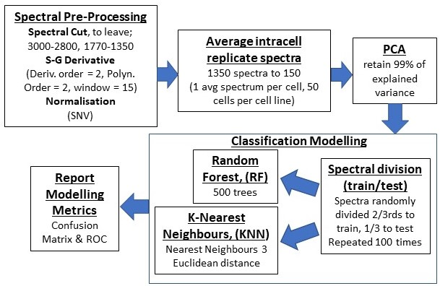

**RESULTS AND DISCUSSION**

This is the first study to use O-PTIR microspectroscopy on standard histopathology glass slides for thin cells. The first step of this work was to identify the areas within the IR spectrum from which biochemical information could be obtained. Standard FTIR microspectroscopy is unable to obtain spectral information within the fingerprint region (1800-900 cm-1) when samples are placed on glass slides of nominal value of 1 mm thickness3-5. However, and as can be seen in Figure 3, high quality spectra could be obtained in the fingerprint region down to ~900 cm-1. However, below ~1350 cm-1, a variable contribution from glass was superimposed over the biochemical information from cells. Potential for subtraction of this glass contribution that would allow to still identify spectral cell signals in this region is an area for investigation in a subsequent study. It is interesting to note that glass contribution to the spectrum and, thus, the shape of the whole spectral band ranging from 1350 cm-1 to 900 cm-1 was different for each of the cell lines studied, but with also greater variability as indicated by the greater spread in the dotted lines (denoting the one standard deviation spread, Figure 3). It is likely that differences in cell thickness have a role in the observed greater spectral variability in the 1350-950 cm-1 range (glass region). Such cell thickness differences are expected to generate differing degrees of glass contribution relative to cellular contributions. This variability is likely to appear with samples that are ~ <5 µm in thickness, with other O-PTIR studies showing that tissues sections of 5 µm thickness or greater do not show any glass contributions8. The relative insensitivity to glass that O-PTIR has shown is enabled by the reflection geometry. In this configuration, the IR beam interacts with the sample first, where it is attenuated and generates the photothermal IR effect. The visible (532nm)

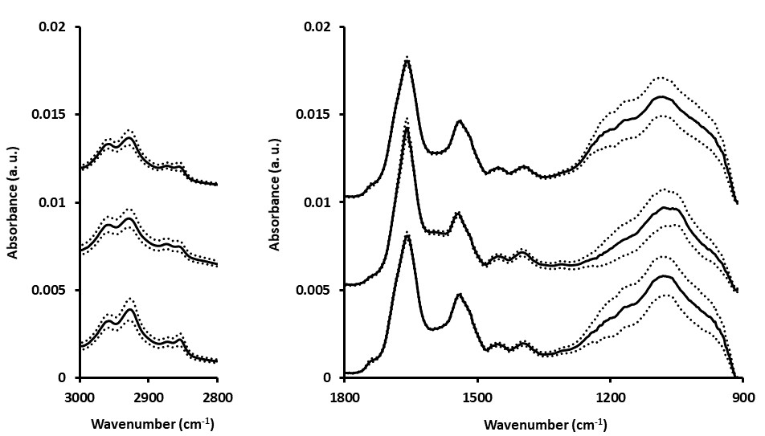

**Figure 3.** Mean spectra (± SD) for A549 (bottom spectrum), CALU-1 (middle spectrum) and NL20 (top spectrum) cells. Each spectrum is the mean of 50 spectra. Spectra are offset for clarity.

probe beam detects this IR photothermal effect, also in reflection mode. It is important to highlight here that the data acquired from the fingerprint region ranging from 1770 cm-1 to 1350 cm-1 opens up a whole array of possibilities to study cytology and/or tissue samples prepared at pathology departments on standard glass slides. Taking into account that good quality FTIR spectra can be obtained from cells placed on coverslips6,7, it could hypothesised that O-PTIR microspectroscopy could even study cells/tissues placed on 1 mm thickness glass slides and covered with 0.13-0.17 mm thickness coverslips as it is standard practice in pathology. However, work will be required to assess what extra glass contribution coming from the glass coverslip could affect the O-PTIR spectrum. Of note, pathology samples are also stained with Haematoxylin & Eosin (H&E) or Papanicolau as examples, and as it is standard practice in pathology. Although staining causes a reduction of the lipid bands in the lipid region and a decrease of the 1740 cm-1 band (C=O stretching mode of phospholipids13) due to the use of alcohol in the staining process, it only causes changes in the amide II and a stronger band at around 1305 cm-1 when cells are stained with H&E without affecting the amide I band14. Taken all this together, and although we are fully aware that further research is needed to bring this technique to a full clinical application in pathology, this work using O-PTIR microspectroscopy is another step towards bringing IR spectroscopy to clinical practice.

PCA using the lipid region between 3000 cm-1 and 2800 cm-1, the fingerprint region between 1770 cm-1 and 1350 cm-1 and the combination of these two regions was carried out. The best PCA scores plot for cell line separation was with the combination of these two regions (Figure 4a with the corresponding PC1 and PC2 loadings in Figures 4b and 4c of the lipid and fingerprint regions, respectively).

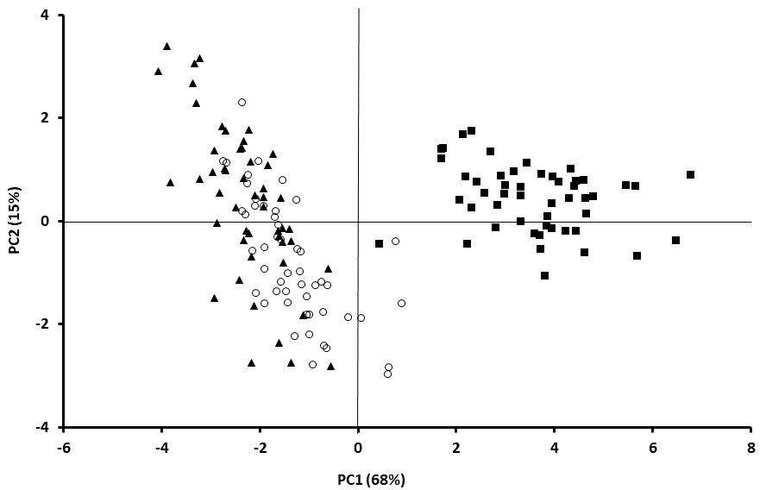

Figure 4a

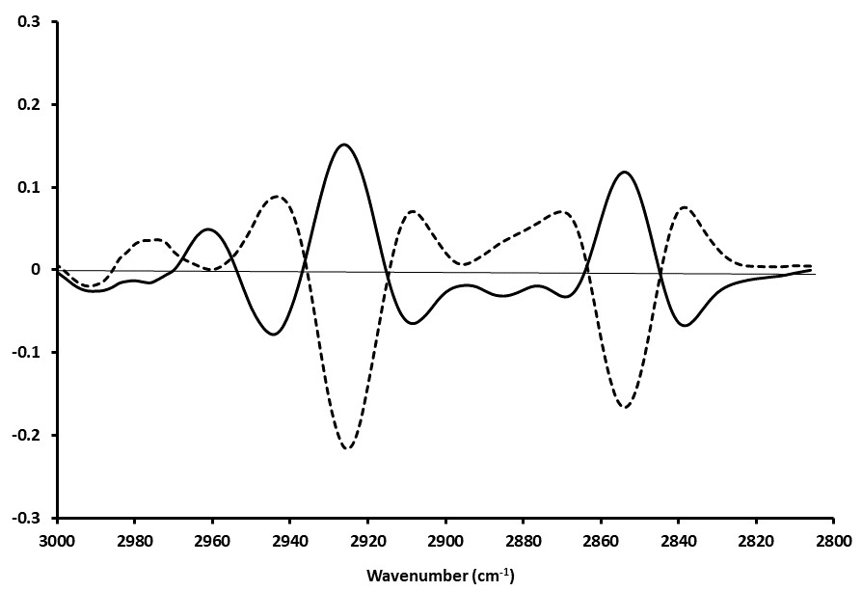

PC1

PC2

Figure 4b

Figure 4c

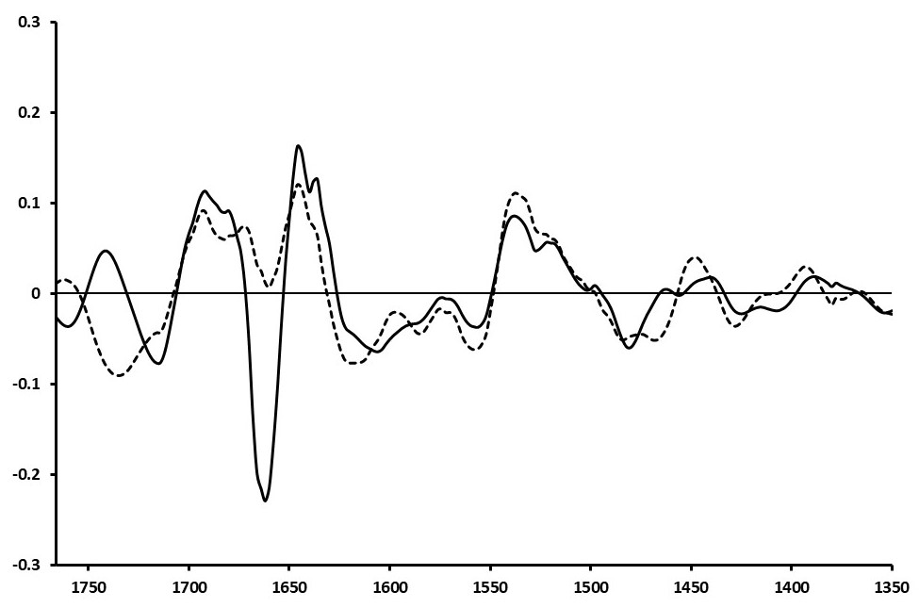

**Wavenumber (cm--1)**

PC1

PC2

**Figure 4.** PCA, PC1 vs PC2 scores plot of the combination of the fingerprint region (1770 cm-1 to 1350 cm-1) and the lipid region (3000 cm-1 to 2800 cm-1) for NL20 (open circles), A549 (filled triangles) and CALU-1 (filled squares) cells (a) and loadings for the lipid region (b) and fingerprint region (c).

Whilst the PC1 vs PC2 scores plot only accounts for 83% of the variance and thus the information content used in generating the PC1 vs PC2 score plot, it has provided enough separation to extract out some insightful chemical differences by examining the associated loadings plots. In figure 4b, the lipid region loadings plot, two relatively strong positive features are observed for PC1 at 2926 cm-1 and 2854 cm-1, originating from the C-H stretching vibrations of CH2 (asym) and CH2 (sym) respectively15-17. It is well known that changes in lipid metabolism and content indicate differences between malignant and non-malignant cells18-20. Within the fingerprint region, the main difference resides around the amide I (Figure 4c). Absorption in the Amide I region is sensitive to protein conformation, thus, changes in this band would indicate conformational changes in cell proteins and/or the expression of a new set of proteins. This links with the well-known fact that cancer cells are able to re-program its metabolism which enables them to acquire a biochemical profile different from their non-malignant cells of origin.

In order to assess the potential for using O-PTIR microspectroscopy for automated cell typing of these three cell lines, two different classification models - Random Forest and K-Nearest Neighbour were explored. We also explored the effects on the classification of not performing a second derivative (SG parameters were set to derivative order = 0, Polynomial order = 2, Window = 15) versus the “full” preprocessing as per Figure 2 in conjunction with comparing RF vs KNN and comparing the three spectral windows (fingerprint, lipid and fingerprint+lipid), and assessing how different spectral regions

|  |  |  |  |  |  |  |  |  |  |  |  |  |  |
| --- | --- | --- | --- | --- | --- | --- | --- | --- | --- | --- | --- | --- | --- |
|  |  | | SNV normalised spectra | | | | | | Second derivative | | | | |
|  |  | | AUC | CA | | | PCs at 99% | | AUC | CA | | PCs at 99% | |
| Fingerprint (1770-1350) | KNN | 0.964 | | | 0.899 | 7 | | 0.982 | | | 0.932 | 11 |
|  | RF | 0.997 | | | 0.959 |  | | 0.991 | | | 0.936 |  |
|  |  |  | | |  |  | |  | | |  |  |
| Lipid region (3000-2800) | KNN | 0.955 | | | 0.908 | 6 | | 0.953 | | | 0.886 | 11 |
|  | RF | 0.991 | | | 0.925 |  | | 0.991 | | | 0.938 |  |
|  |  |  | | |  |  | |  | | |  |  |
| Fingerprint + lipid | KNN | 0.954 | | | 0.870 | 8 | | **0.985** | | | **0.935** | **13** |
|  | RF | 0.989 | | | 0.926 |  | | **0.998** | | | **0.975** |  |

**Table I.** Model comparisons for FTIR spectra for fingerprint and lipid regions and combination of both regions (CA (classification accuracy); AUC (Area Under Curve), PC (Principal Component)) at the 99% explained variance point.

(lipid, fingerprint and lipid+fingerprint) impact on the classification accuracy. As can be seen in Table I, the best combination producing the highest classification accuracy was RF modelling when combining both the lipid and fingerprint regions, together with second derivative processing. As classification metrics, we utilised the average (across all three cell lines) “Area Under the Curve (AUC)” from all three ROC (one for each cell line), as well as the averaged (across all three cell lines) Classification Accuracy, CA (number of correct classifications as a percentage of total classifications). A summary of these results are presented in table I. It can be said that all combinations of spectral preprocessing, spectral range and classification model type, returned good CAs at >90%, with the highest achieved using second derivative, lipid+fingerprint and RF, returning excellent values for AUC at 0.998 and 0.975 (97.5%) for CA. It is interesting to note the apparent synergy in the addition of the lipid region, a novel capability enabled by the first demonstration of the single unit dual range (C-H/FP) QCL, with the combined Fingerprint+lipid second derivative data set, having a substantially better classification accuracy (97.5%) compared to the individual fingerprint and lipid regions with 93.6% and 93.8% respectively. Curiously, combining the two spectral regions with RF when a second derivative was not applied did not result in a better classification accuracy.

Taking the best performing combination of second derivative analysis, with combined fingerprint+lipid spectral regions and RF modelling, a more detailed assessment of its performance is presented through a confusion matrix in Table II. Here we can see that individual classification accuracies (sensitivities) range from ~97% for A549 and NL20 (non-malignant) up to ~99% for CALU, with specificities ranging from 98% to almost 100%. This further illustrates the remarkable cell identification accuracies of O-PTIR microspectroscopy, further enhanced by our use of the novel single unit dual range (C-H/FP) QCL, which has enabled the synergistic combination of two important spectral regions, the lipid and fingerprint. All of this is made even more clinically relevant by the fact that these results are achieved using samples on standard glass slides.

Finally, we present an overview of the three ROC curves in Figure 5. ROC curves are an excellent means to visualise the classification model performance as they show how the true positive rate changes with false positive rate. The AUC of a ROC curve is a measure of the classification model performance. With AUC values of 1 indicating a perfect classification and value of 0.5 indicating an essentially random classification. The results obtained here indicate an excellent classification results, with AUC values ranging from 0.997 for NL20 up to 1.000 for CALU.

**Table II.** Confusion matrix for random forest analysis for the combination of the fingerprint region (1770 cm-1 to 1350 cm-1) and the lipid region (3000 cm-1 to 2800 cm-1). Values in parenthesis are the instances expressed as a percentage of the total actual. The total number of predictions of 1500 comes from the fact that the 2/3:1/3 train:test randomised split is repeated 100 times. The software rounds this to 66% training and 34% test, with 34% of 150 providing for 51 test samples, which when multiplied by 100 repeats gives 5100.

|  |  |  |  |  |  |  |  |
| --- | --- | --- | --- | --- | --- | --- | --- |
|  |  | **Predicted** | | |  |  |  |
|  |  | **A548** | **CALU** | **NL20** | **Total Actual** | **Sensitivity** | **Specificity** |
| **Actual** | **A548** | **1640 (96.5%)** | 0 (0.0%) | 60 (3.5%) | 1700 | 96.5% | 98.6% |
| **CALU** | 10 (0.6%) | **1682 (98.9%)** | 8 (0.5%) | 1700 | 98.9% | 99.7% |
| **NL20** | 39 (2.3%) | 10 (0.6%) | **1651 (97.1%)** | 1700 | 97.1% | 98.0% |
|  | **Total Predicted** | 1689 | 1692 | 1719 | 5100 |  |  |



**Figure 5.** Receiver Operator Characteristic (ROC) Curves for all three cell lines, using the best performing classification model (second derivative, fingerprint+lipid, & RF). A) A549, B) CALU and C) NL20.

**CONCLUSIONS**

In order to bring IR spectroscopy towards a clinical application in pathology it is important that the technique fits as much as possible within the standard clinical practice and brings value to the routine and workflow of pathologists. We have demonstrated that the O-PTIR technique, which for the first time enables the use of standard glass substrates for cell characterisation and classification brings the adoption of IR spectroscopy a step closer towards clinical application by providing a path to the automated and objective screening of samples. This technique has shown potential to identify pathological from non-pathological samples, thereby relieving a substantial workload pressure from pathologists, allowing them to focus mainly on the pathological samples. On the other hand, being able to study cells at submicron level allows characterising different areas within the cell (nucleus, cytoplasm). As further enabling novelty, we have also shown the first application of a single unit dual range (lipid and fingerprint region) QCL, which has shown a synergistic benefit with substantial improvement in classification accuracies, relative to individual spectral regions. O-PTIR microspectroscopy, has shown separation between cancer cells (A549 and CALU) and non-malignant (NL20) cells placed on standard glass histopathology slides with classification accuracies ranging from 96% to 99%. Although we are fully aware that further research is needed to bring this technique to a full clinical application in pathology, this work paves the way towards IR spectroscopy as another tool in pathology for a rapid and objective sample screening and disease diagnosis.

**ACKNOWLEDGEMENTS**

LMD is partially supported by Alba Synchrotron Light Source, Barcelona, Catalonia. FB and OG acknowledge funding from the Ile de France region under project reference SESAME 2019 – SURFACES number EX047018 for the purchase of the dual range QCL.

**Notes**

The authors declare no competing financial interest.

**REFERENCES**

1. Baker, M.J.; Byrne H.J.; Chalmers J.; Gardner P.; Goodacre R.; Henderson A.; Kazarian S.G.; Martin F.L.; Moger J.; Stone N.; Sulé-Suso J. Clinical applications of infrared and Raman spectroscopy: state of play and future challenges. *Analyst*. 2018, 143, 1735-1757.

2. Finlayson D.; Rinaldi C.; Baker M.J. Is Infrared Spectroscopy Ready for the Clinic? *Anal. Chem*. 2019, 91, 12117–12128.

3. Bassan P.; Mellor J.; Shapiro J.; Williams K.J.; Lisanti M.P.; Gardner P. Transmission FT-IR Chemical Imaging on Glass Substrates: Applications in Infrared Spectral Histopathology. *Anal. Chem*. 2014, 86, 1648–1653.

4. Pilling M.J.; Henderson V.; Shanks J.H.; Brown M.D.; Clarke N.W.; Gardner P. Infrared spectral histopathology using haematoxylin and eosin (H&E) stained glass slides: a major step forward towards clinical translation. *Analyst* 2017, 142, 1258-1268.

5. Rutter A.V.; Crees J.; Wright H.; van Pittius D.G.; Yousef I.; Sulé-Suso J. Fourier Transform Infrared Spectra of Cells on Glass Coverslips. A Further Step in Spectral Pathology. *Analyst*, 2018, 143, 5711-5717.

6. Rutter A.V.; Crees J.; Wright H.; Raseta M.; van Pittius D.G.; Roach P.; Sulé-Suso J. Identification of a Glass Substrate to Study. Cells Using Fourier Transform Infrared Spectroscopy: Are We Closer to Spectral Pathology? *Appl. Spectrosc*. 2020, 74, 178-186.

7. Dowling L.M.; Roach P.; Rutter A.V.; Yousef I.; Pillai S.; Latham D.; van Pittius D.G.; Sulé-Suso J. Optimization of Sample Preparation Using Glass Slides for Spectral Pathology. *Appl Spectrosc*. 2020, DOI: 10.1177/0003702820945748.

8. Bakir G.; Girouard B.E.; Wiens R.; Mastel S.; Dillon E.; Kansiz M.; Gough K.M. Orientation Matters: Polarization Dependent IR Spectroscopy of Collagen from Intact Tendon Down to the Single Fibril Level. *Molecules,* 2020, 25, 4295.

9. Klementieva O.; Sandt C.; Martinsson I.; Kansiz M.; Gouras G.K.; Borondics F. SuperResolution Infrared Imaging of Polymorphic Amyloid Aggregates Directly in Neurons. *Adv. Sci*. 2020, 1903004.

10. Pijanka J.K.; Kohler A.; Yang Y.; Dumas P.; Chio-Srichan S.; Manfait M.; Sockalingum G.D.; Sulé-Suso J. Spectroscopic signatures of single, isolated cancer cell nuclei using synchrotron infrared microscopy. *Analyst,* 2009, 134, 1176-1181.

11. Pijanka J.K.; Stone N.; Rutter A.V.; Forsyth N.; Sockalingum G.D.; Yang Y.; Sulé-Suso J. Identification of different subsets of lung cells using Raman microspectroscopy and whole cell nucleus Isolation. *Analyst*, 2013, 138, 5052-5058.

12. Toplak M.; Birarda G.; Read S.; Sandt C.; Rosendahl S. M.; Vaccari L.; Demšar J.; Borondics F. Infrared Orange: Connecting Hyperspectral Data with Machine Learning. *Synchrotron Radiat News,* 2017, 30, 40-45.

13. Holman H.-Y.N.; Martin M.C.; Blakely EA; Bjornstad K.; McKinney W.R. IR spectroscopic characteristics of cell cycle and cell death probed by synchrotron radiation based Fourier transform IR spectromicroscopy. *Biopolymers*, 2000, 57, 329-335.

14. Pijanka J.; Sockalingum G.D.; Kohler A.; Yang Y.; Draux F.; Parkes G.; Lam K.-P.; Collins D.; Dumas P.; Sandt C.; van Pittius D.G.; Douce G.; Manfait M.; Untereiner V.; Sulé-Suso J. Synchrotron-based FTIR spectra of stained single cells. Towards a clinical application in pathology. *Lab. Invest*. 2010, 90, 797-807.

15. Gao T.; Feng J.; Ci Y. Anal. Human breast carcinomal tissues display distinctive FTIR spectra: implication for the histological characterization of carcinomas. *Cell. Pathol*. 1999, 18, 87-93.

16. Zhou J.; Wang Z.; Sun S.; Liu M.; Zhang H. A rapid method for detecting conformational changes during differentiation and apoptosis of HL60 cells by Fourier‐transform infrared spectroscopy. Biotechnol. *Appl. Biochem*. 2001, 33, 127-132.

17. Lasch P.; Boese M.; Pacifico A.; Diem M. FT-IR spectroscopic investigations of single cells on the subcellular level. *Vib. Spectrosc*. 2002, 28, 147-157.

18. Ray U.; Roy S.S. Aberrant Lipid Metabolism in Cancer Cells - The Role of Oncolipid Signaling. *FEBS J.* 2018, 285, 432-443.

19. Beloribi-Djefaflia S.; Vasseur S.; Guillaumond F. Lipid Metabolic Reprogramming in Cancer Cells. *Oncogenesis*, 2016, 5, e189.

20. Luanpitpong S.; Janan M.; Thumanu K.; Poohadsuan J.; Rodboon N.; Klaihmon P.; Issaragrisil S. Deciphering the Elevated Lipid via CD36 in Mantle Cell Lymphoma with Bortezomib Resistance Using Synchrotron-Based Fourier Transform Infrared Spectroscopy of Single Cells. *Cancers*, 2019, 11, e576.

**For Table of Contents Only**

This graphic is entirely original, unpublished artwork created by one of the co-authors

