SUPPLEMENTAL MATERIAL for "Increased radial access is not associated with worse femoral outcomes for PCI in the United Kingdom"

Figure A1a Predicted mortality against calendar year for non-complex procedures only, by FP2013 strata.
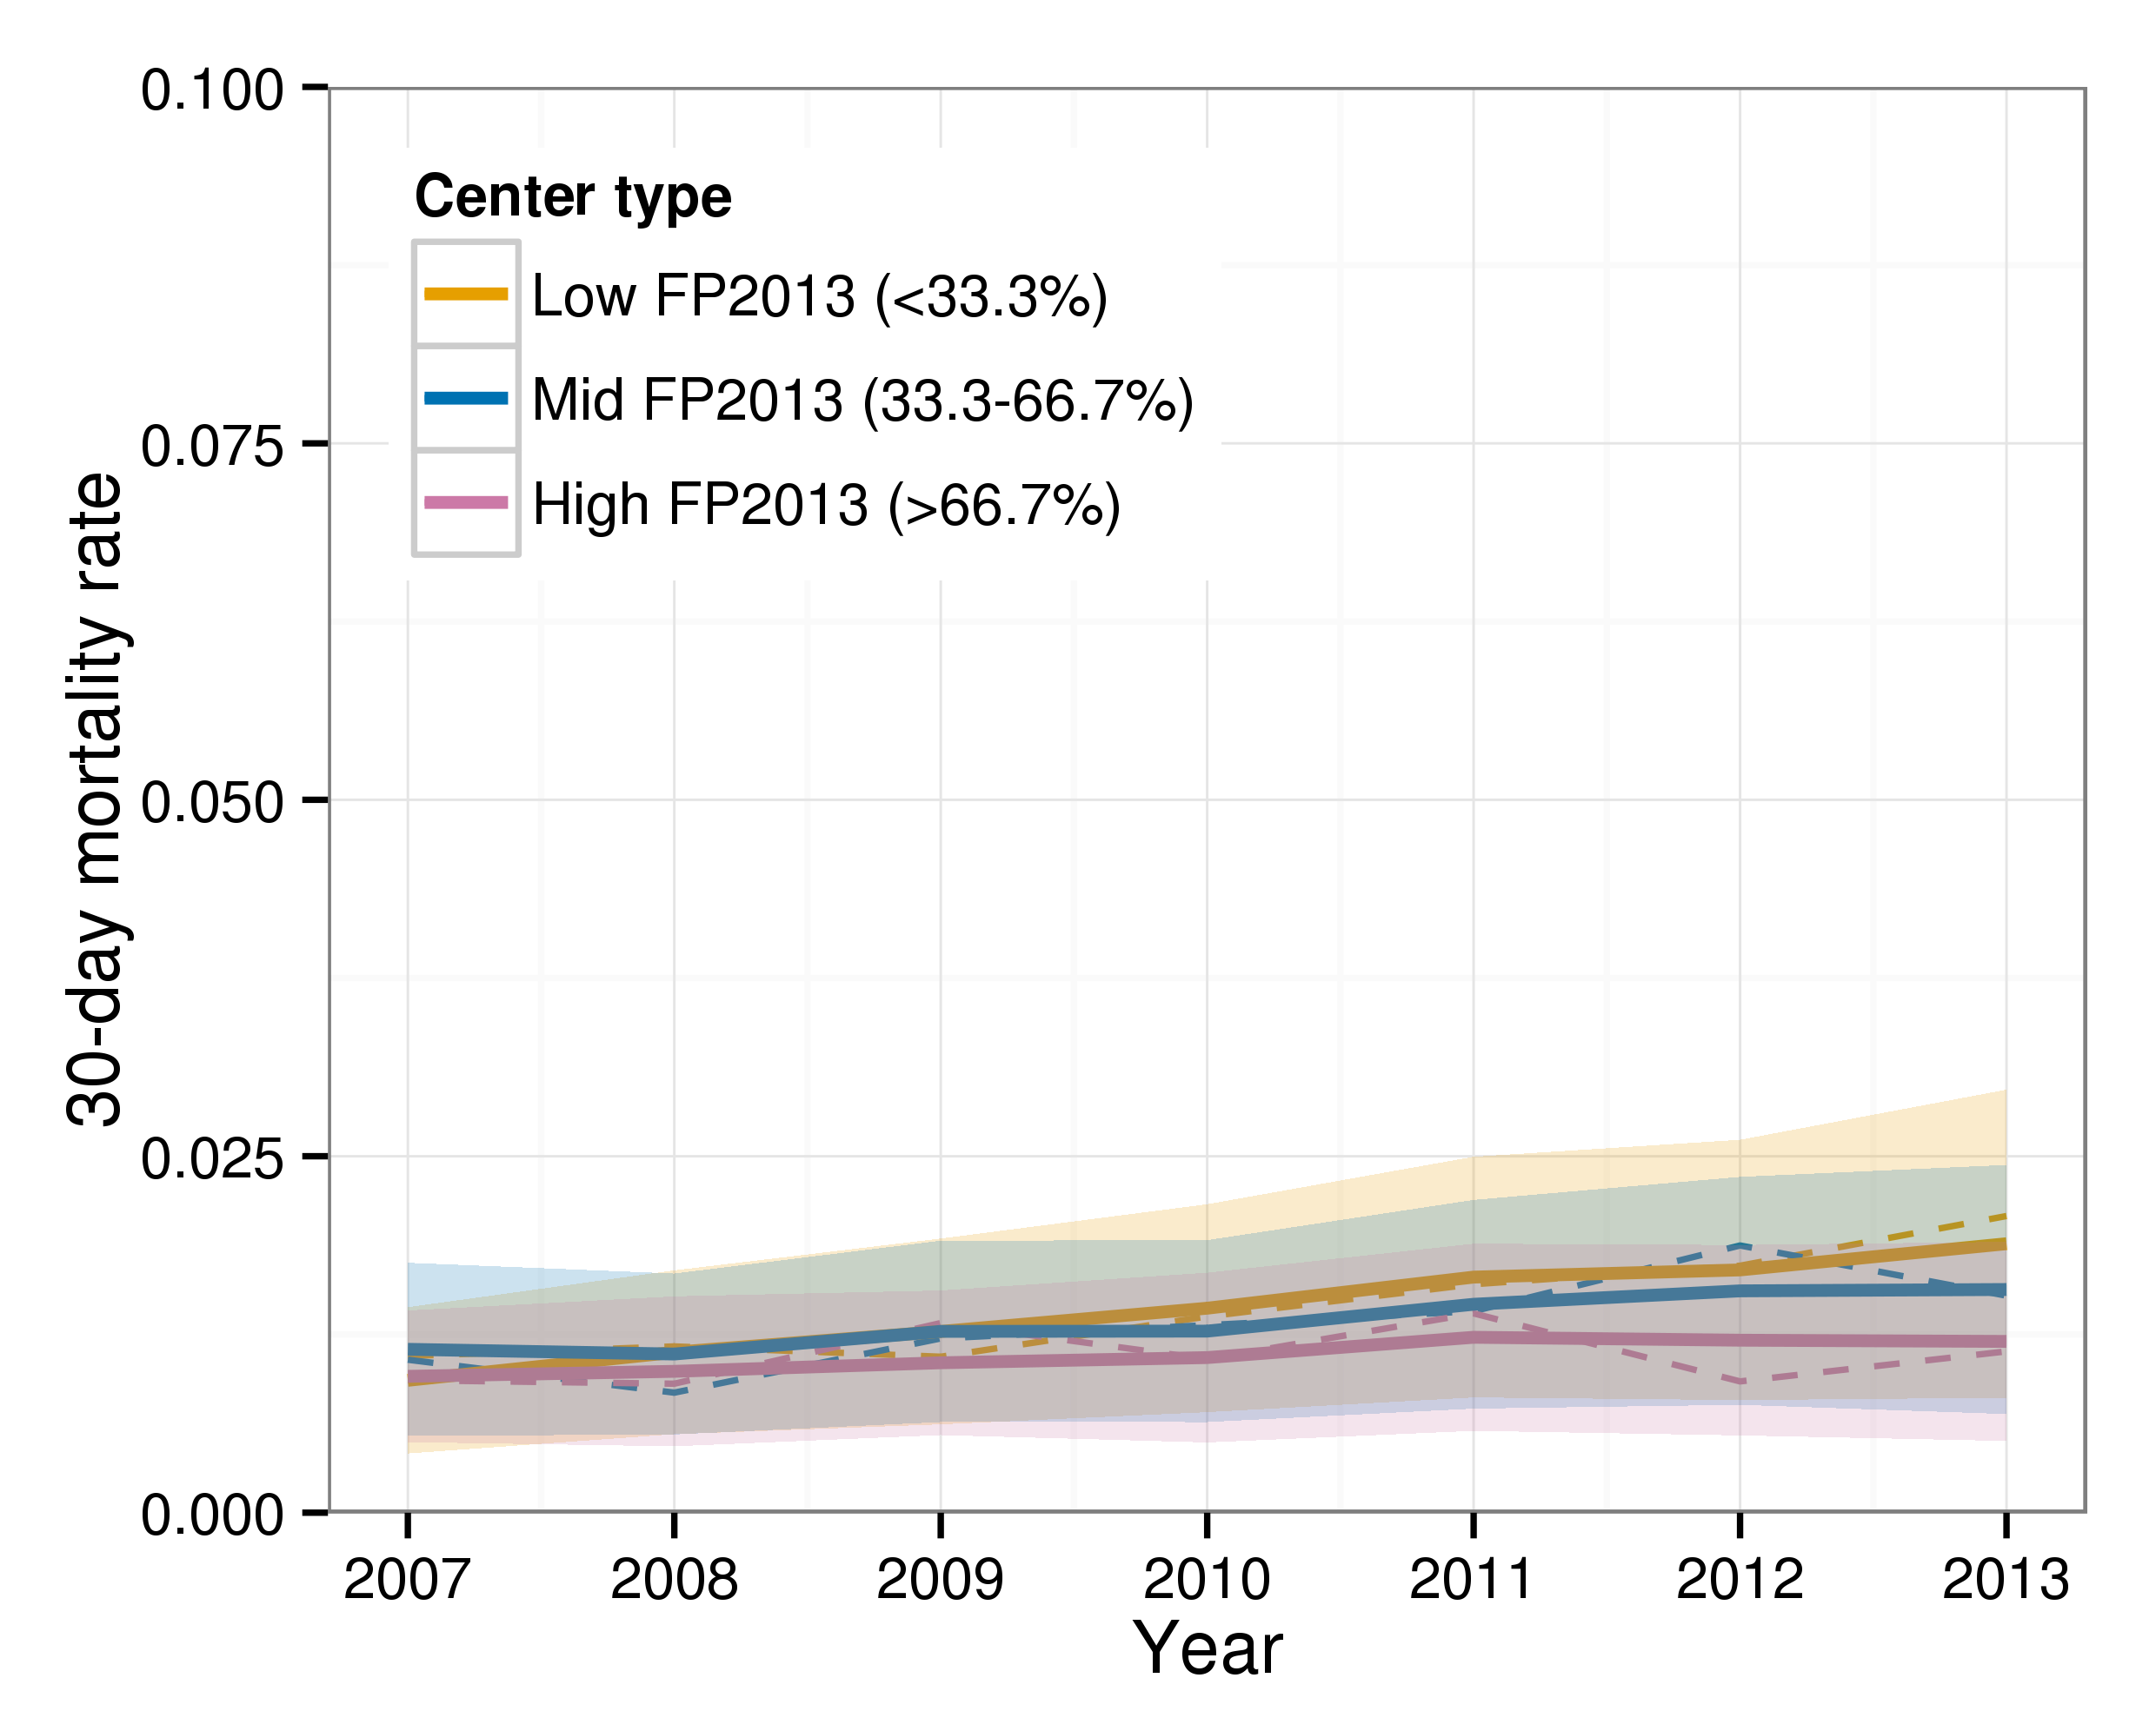
Dashed lines represent observed mortality

Figure A1b Observed/expected mortality against calendar year for non-complex procedures only, by FP2013 strata.
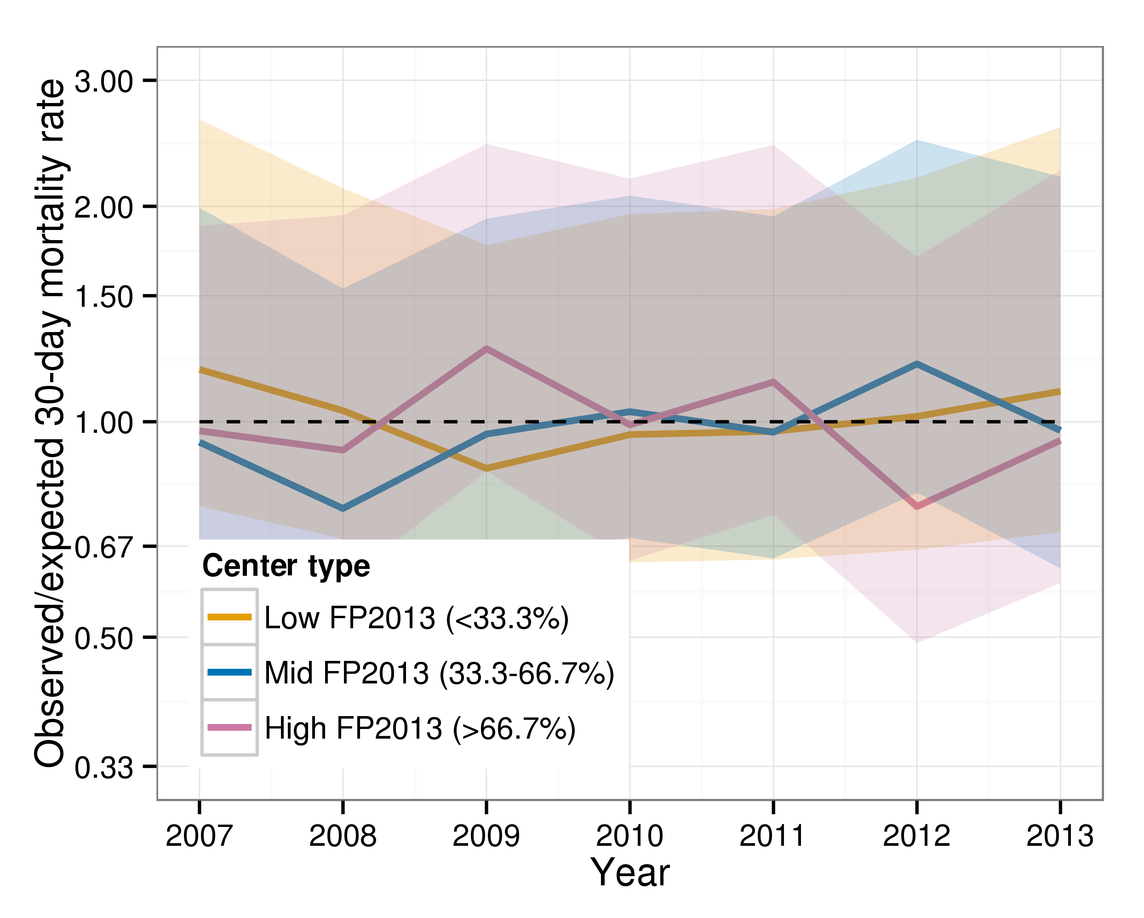
Dashed line represents observed=expected

Figure A2 Observed and risk-adjusted mortality rate (smoothed) for non-complex procedures only, against RFP.
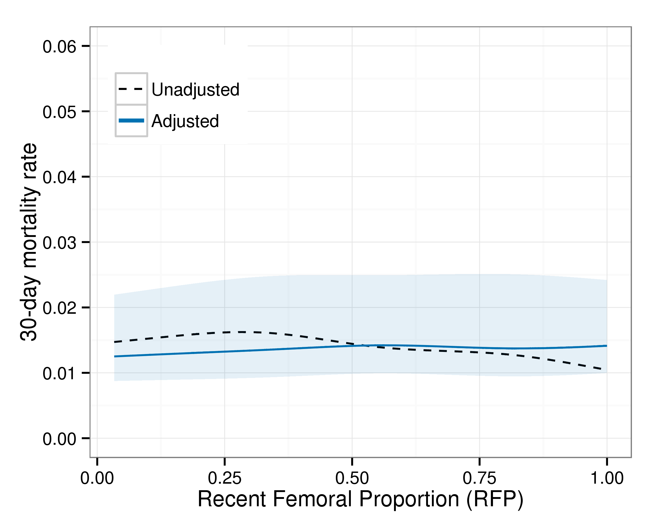
Minimum RFP=0.03, maximum RFP=1.

Figure A3a Predicted mortality against calendar year, by ‘top ten’ FP2013 strata.
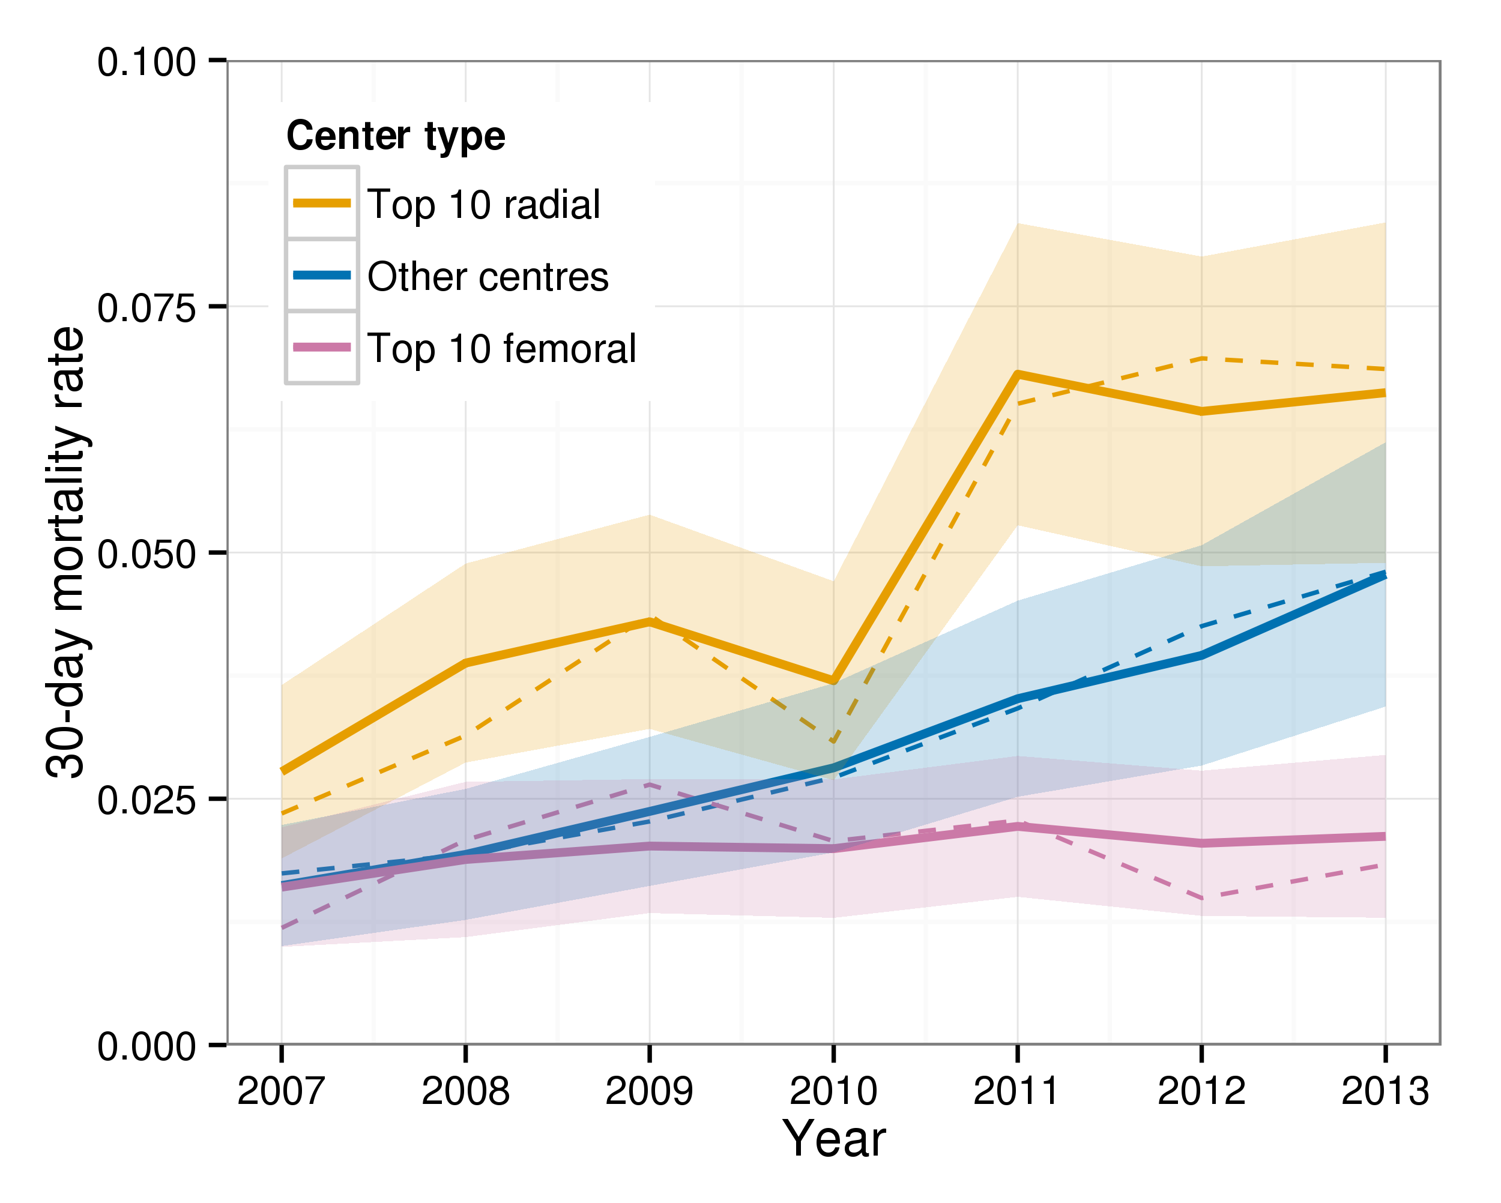
Dashed lines represent observed mortality

Figure A3b Observed/expected mortality against calendar year, by ‘top ten’FP2013 strata.
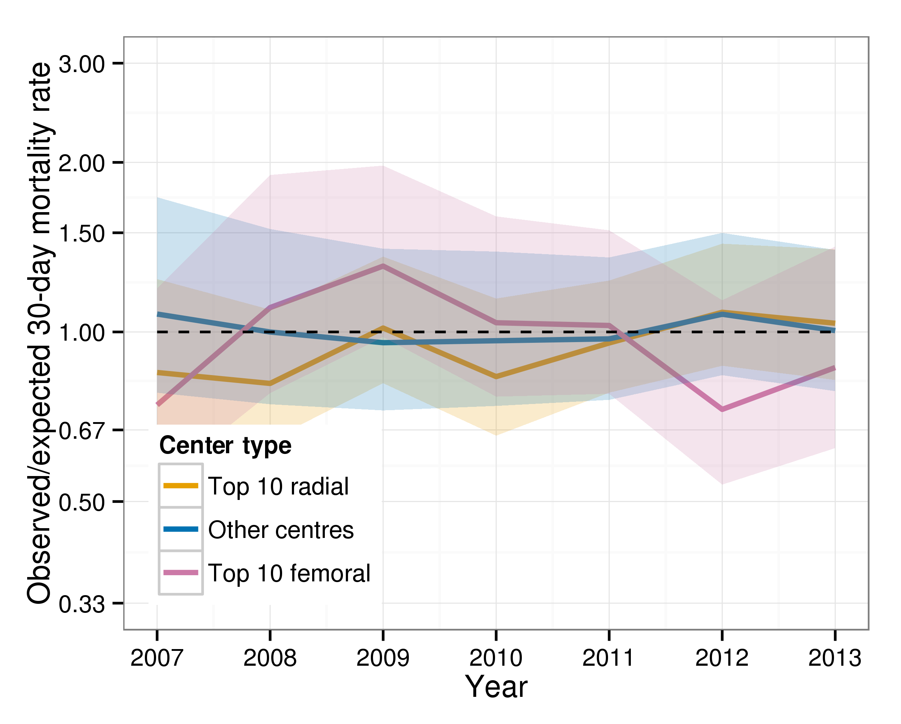
Dashed line represents observed=expected

Figure A4a Predicted vascular complication rate against calendar year, by FP2013 strata.
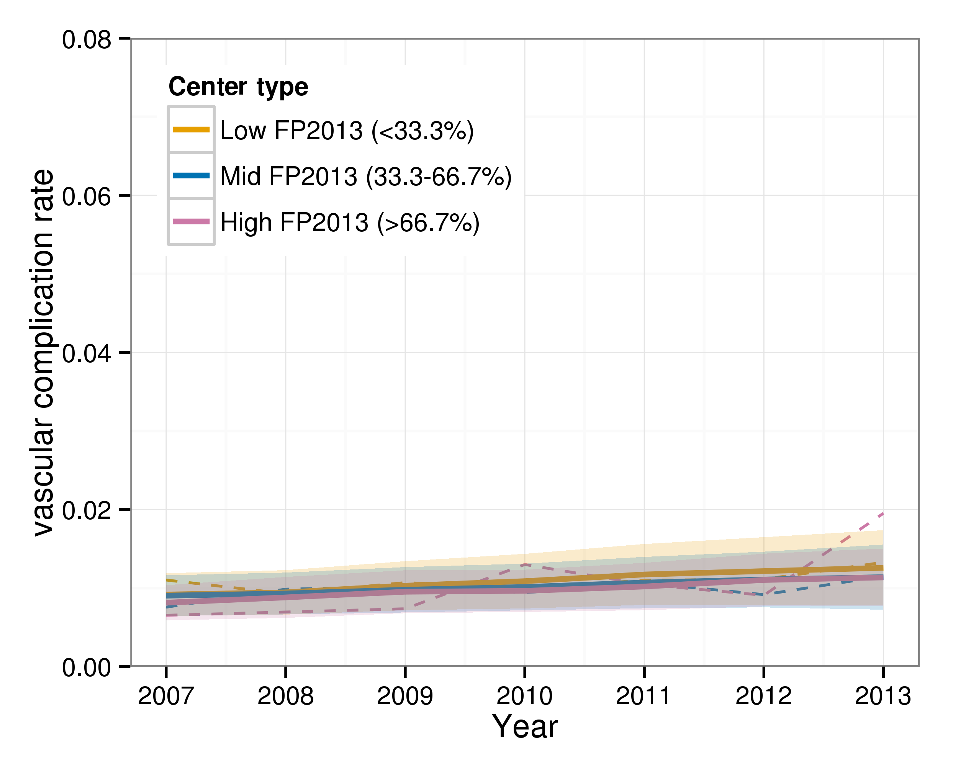
Dashed lines represent observed mortality

Figure A4b Observed/expected vascular complication rate against calendar year, by FP2013 strata.
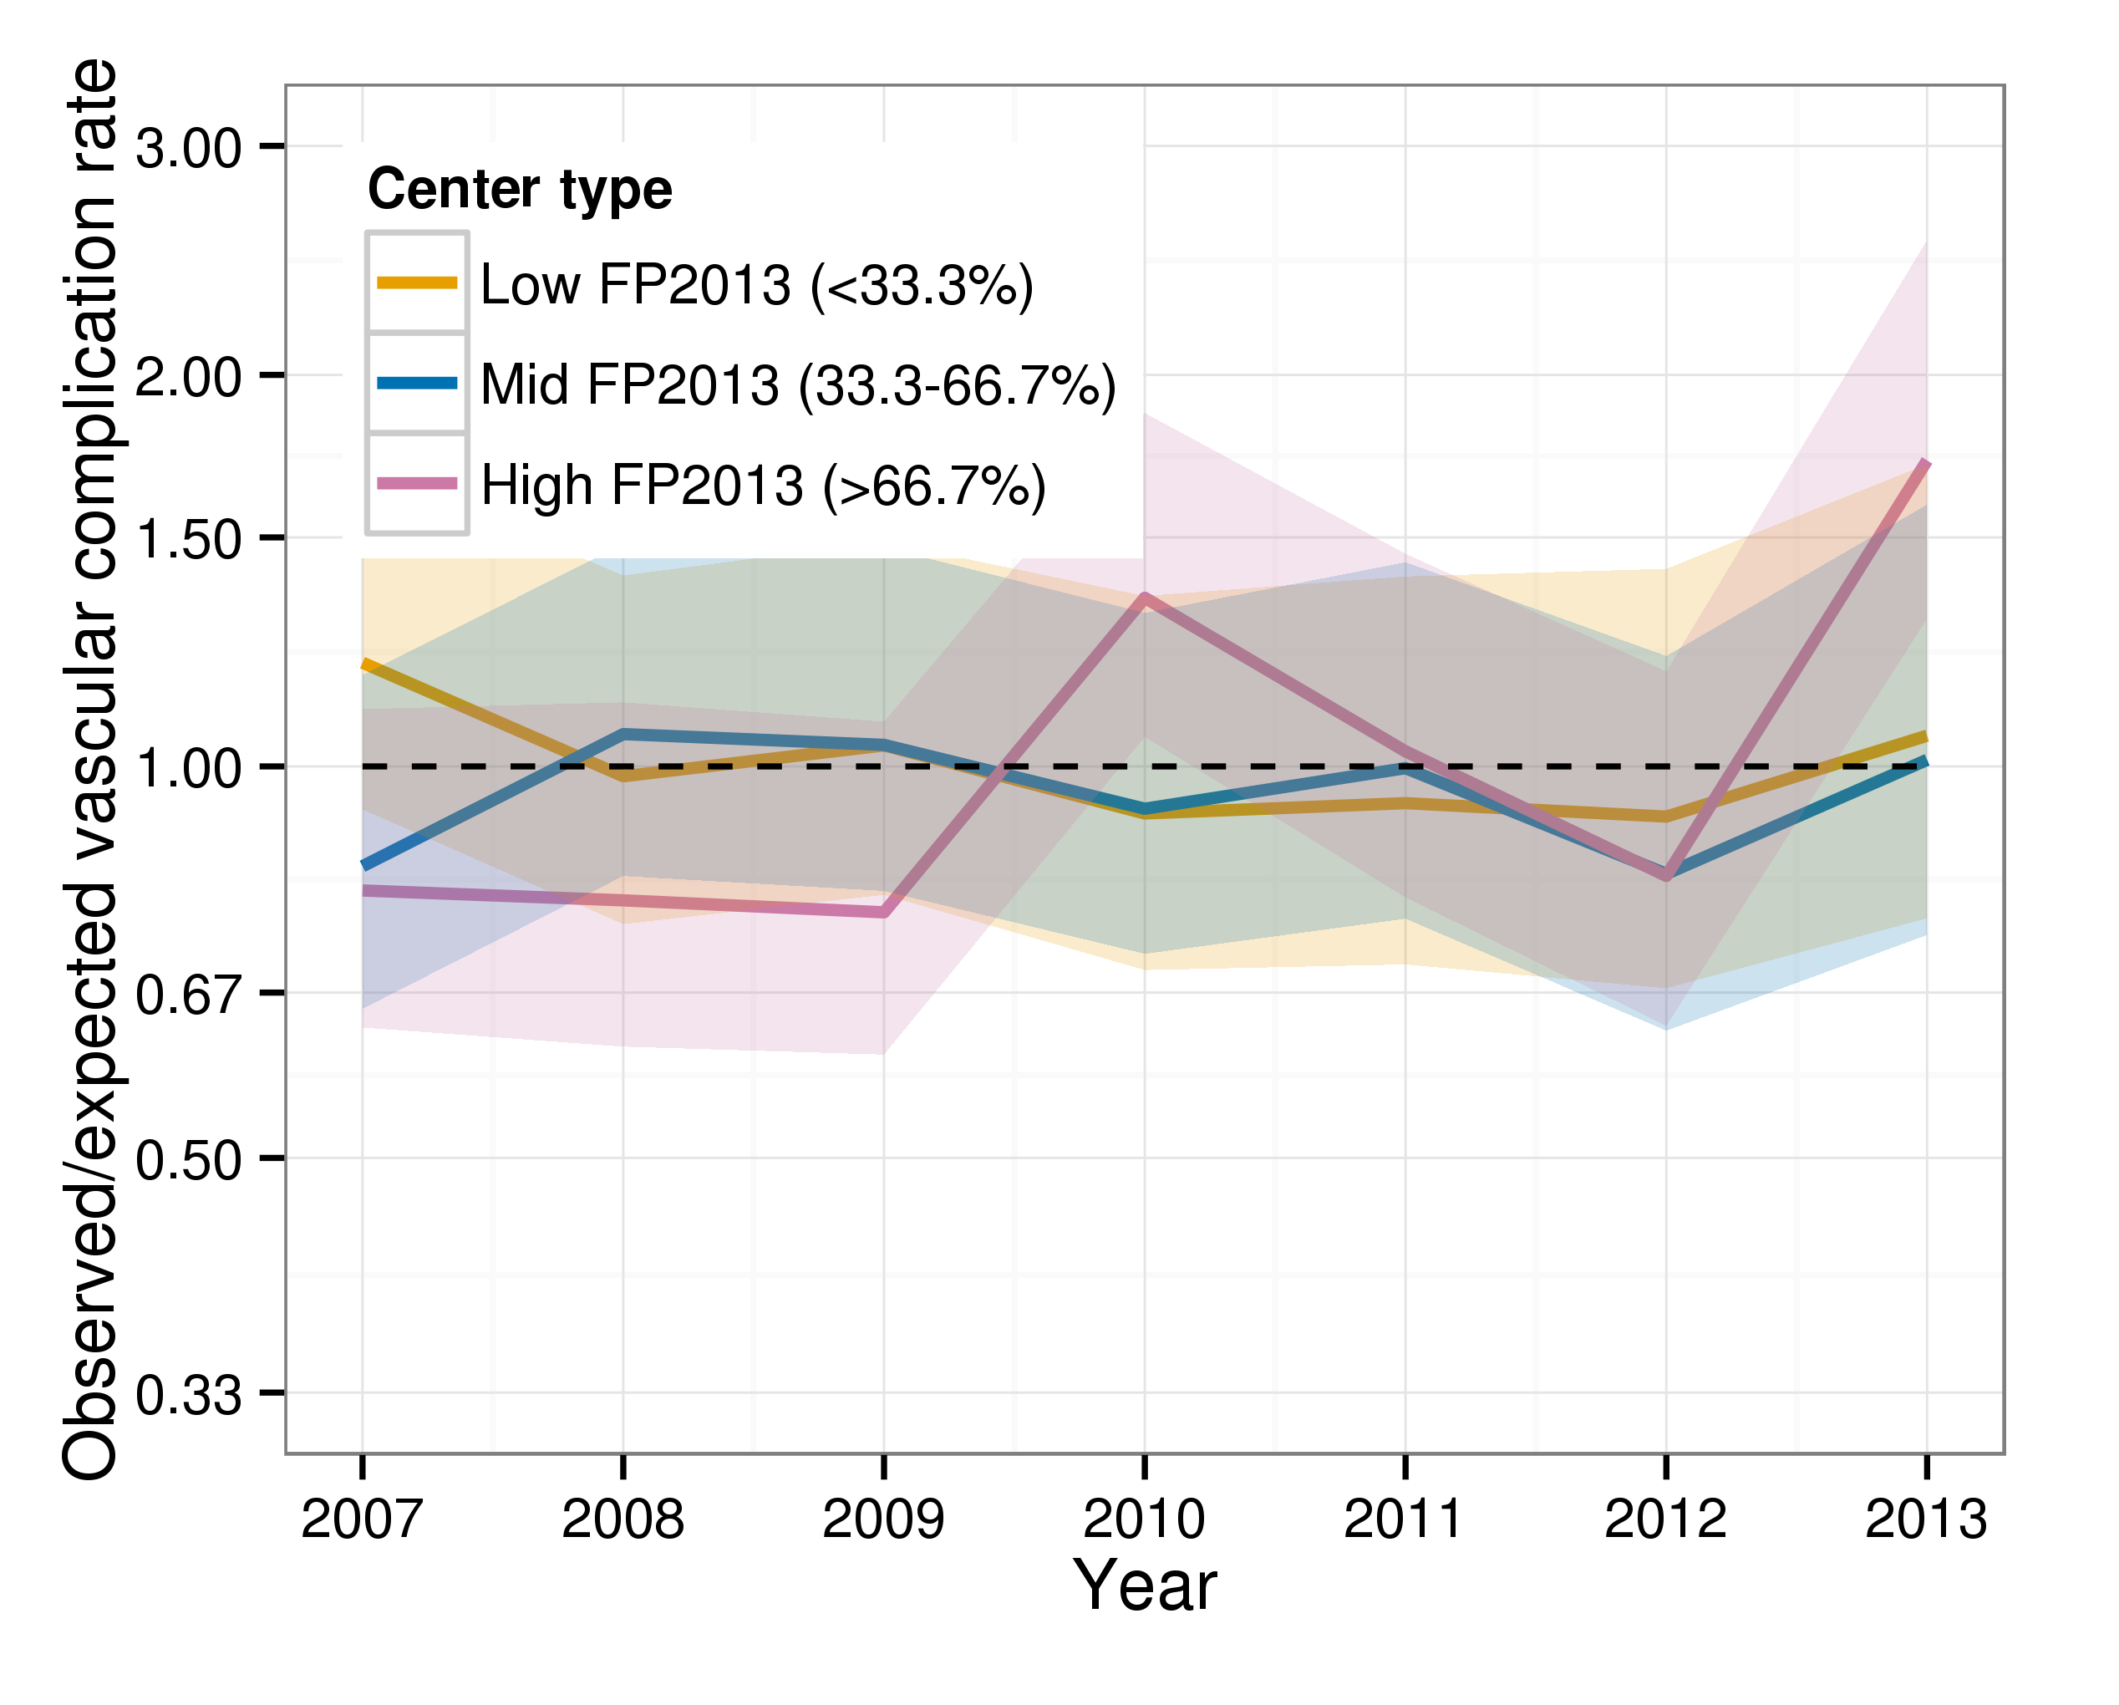
Dashed line represents observed=expected

Table A1 Missing data within the analysis cohort, by calendar year
 |  | 2007 | 2008 | 2009 | 2010 | 2011 | 2012 | 2013
Femoral-only procedures, N |  | 35,929 | 39,649 | 39,273 | 35,944 | 32,180 | 28,696 | 23,579
Variable* |  | Availability of data (%)
Shock |  | 97.0 | 98.9 | 99.1 | 98.9 | 98.7 | 99.2 | 99.0
IABP support |  | 86.6 | 91.0 | 92.0 | 92.5 | 93.8 | 95.0 | 95.1
CPS support |  | 86.6 | 91.0 | 92.0 | 92.5 | 93.8 | 95.0 | 95.1
Inotropic support |  | 86.6 | 91.0 | 92.0 | 92.5 | 93.8 | 95.0 | 95.1
Ventilated |  | 72.0 | 75.5 | 80.3 | 82.6 | 84.5 | 88.0 | 87.9
LVEF |  | 43.3 | 45.6 | 49.0 | 48.5 | 45.8 | 46.7 | 51.4
MI history |  | 79.9 | 81.5 | 85.9 | 88.6 | 89.5 | 90.9 | 92.2
CABG history |  | 59.9 | 68.1 | 72.7 | 76.8 | 77.8 | 77.1 | 77.1
Stroke |  | 94.4 | 95.6 | 96.3 | 96.0 | 95.1 | 95.0 | 94.6
Peripheral vascular disease |  | 94.4 | 95.6 | 96.3 | 96.0 | 95.1 | 95.0 | 94.6
Valvular heart disease |  | 94.4 | 95.6 | 96.3 | 96.0 | 95.1 | 95.0 | 94.6
High-cholesterol |  | 94.4 | 95.6 | 96.3 | 96.0 | 95.1 | 95.0 | 94.6
Hypertension |  | 94.4 | 95.6 | 96.3 | 96.0 | 95.1 | 95.0 | 94.6
Diabetes |  | 92.9 | 94.7 | 96.4 | 96.1 | 95.0 | 93.0 | 93.6
Renal status |  | 90.6 | 94.6 | 95.9 | 95.1 | 94.1 | 94.6 | 94.7
Smoking history |  | 81.1 | 85.8 | 87.8 | 87.8 | 87.4 | 87.2 | 88.7
GP IIb/IIIa inhibitors |  | 93.7 | 94.3 | 94.9 | 95.1 | 94.6 | 94.2 | 94.9
Anti-platelets |  | 68.8 | 75.5 | 78.1 | 77.5 | 76.7 | 77.2 | 78.1
Anti-coagulants |  | 90.6 | 91.2 | 93.6 | 95.5 | 96.5 | 96.6 | 96.1
Stent type |  | 94.3 | 94.7 | 94.2 | 95.3 | 95.3 | 94.4 | 95.6
30-day mortality |  | 98.4 | 98.6 | 98.1 | 98.7 | 98.0 | 98.1 | 95.9
* variables age, sex, indication, left-main stem, number of targeted vessels, RTV, RFV, and RFP are completely non-missing due to the cohort selection process

Table A2 Patient and procedural variables for femoral-only procedures in 2007 (N=35,929), 2010 (N=35,944), 2013 (N=23,579).
Stratified by recent femoral proportion of operating centre and calendar year.
 |  | Recent femoral proportion (RFP) of operating centre
 |  | <33% RFP  N=13,020 |  |  | 33.3-66.7% RFP  N=22,960 |  |  | >66.7% RFP  N=59,696 |  |  | P value for groups modifying time-trends
 |  | 2007 | 2010 | 2013 | 2007 | 2010 | 2013 | 2007 | 2010 | 2013
Procedures, N |  | 500 | 3,001 | 9,500 | 4,848 | 10,832 | 7,280 | 30,581 | 22,111 | 6,799 | -
(% of yearly total) |  | (1.4) | (8.3) | (40.3) | (13.5) | (30.1) | (30.9) | (85.1) | (61.5) | (28.8)
Variable |  | Continuous; mean (standard deviation)
Age, years |  | 66.7  (11.2) | 65.9  (12.0) | 66.6  (12.2) | 64.7  (11.3) | 65.2  (12.1) | 65.5  (12.2) | 64.2  (11.3) | 65.3  (11.8) | 66.7  (12.2) | <0.001
 |  | Categorical; N (% of non-missing within-strata total)
Sex -Male |  | 324 (64.80) | 2,009 (66.94) | 6,462 (68.02) | 3,340 (68.89) | 7,691 (71.00) | 5,204 (71.48) | 22,550 (73.74) | 16,407 (74.20) | 4,938 (72.63) | 0.003
-Female |  | 176 (35.20) | 992 (33.06) | 3,038 (31.98) | 1,508 (31.11) | 3,141 (29.00) | 2,076 (28.52) | 8,031 (26.26) | 5,704 (25.80) | 1,861 (27.37)
Indication-Elective |  | 210 (42.00) | 1,064 (35.45) | 3,596 (37.85) | 2,400 (49.50) | 4,312 (39.81) | 2,451 (33.67) | 14,323 (46.84) | 9,253 (41.85) | 2,937 (43.20) | <0.001
-UA/nSTEMI |  | 221 (44.20) | 1,124 (37.45) | 3,344 (35.20) | 1,861 (38.39) | 3,841 (35.46) | 2,455 (33.72) | 12,050 (39.40) | 7,493 (33.89) | 2,575 (37.87)
-STEMI |  | 69 (13.80) | 813 (27.09) | 2,560 (26.95) | 587 (12.11) | 2,679 (24.73) | 2,374 (32.61) | 4,208 (13.76) | 5,365 (24.26) | 1,287 (18.93)
Shock |  | 22 (4.40) | 171 (5.72) | 760 (8.04) | 77 (1.60) | 340 (3.17) | 378 (5.22) | 449 (1.52) | 482 (2.21) | 217 (3.26) | 0.024
IABP support |  | 22 (4.40) | 128 (4.43) | 383 (4.11) | 115 (2.47) | 293 (2.95) | 200 (3.07) | 515 (1.98) | 432 (2.11) | 142 (2.16) | 0.659
CPS support |  | 0 (0.00) | 11 (0.38) | 28 (0.30) | 2 (0.04) | 14 (0.14) | 18 (0.28) | 13 (0.05) | 35 (0.17) | 15 (0.23) | -
Inotropic support |  | 8 (1.60) | 59 (2.04) | 246 (2.64) | 27 (0.58) | 95 (0.96) | 122 (1.87) | 144 (0.55) | 198 (0.97) | 65 (0.99) | 0.010
Ventilated |  | 13 (3.50) | 84 (2.96) | 497 (5.77) | 48 (1.03) | 183 (2.07) | 232 (3.84) | 185 (0.89) | 313 (1.74) | 144 (2.38) | 0.012
LVEF -Good (>50%) |  | 219 (68.44) | 1,149 (63.52) | 3,209 (59.58) | 1,374 (69.85) | 3,804 (67.99) | 1,942 (67.97) | 9,530 (71.81) | 6,996 (69.84) | 2,984 (76.77) | <0.001
-Moderate (30-50%) |  | 72 (22.50) | 470 (25.98) | 1,538 (28.56) | 445 (22.62) | 1,394 (24.92) | 700 (24.50) | 2,729 (20.56) | 2,596 (25.92) | 744 (19.14)
-Poor (<30%) |  | 29 (9.06) | 190 (10.50) | 639 (11.86) | 148 (7.52) | 397 (7.10) | 215 (7.53) | 1,012 (7.63) | 425 (4.24) | 159 (4.09)
MI history |  | 127 (25.50) | 1,024 (35.16) | 3,308 (36.41) | 1,505 (32.39) | 3,065 (31.85) | 1,922 (28.34) | 7,395 (31.39) | 5,621 (29.10) | 1,737 (29.63) | <0.001
CABG history |  | 39 (16.96) | 396 (17.77) | 1,531 (19.54) | 1,423 (35.58) | 1,233 (14.72) | 959 (17.37) | 2,356 (13.64) | 1,888 (11.11) | 655 (13.55) | <0.001
Stroke history |  | 13 (3.25) | 206 (7.08) | 524 (6.01) | 108 (2.37) | 499 (4.83) | 272 (3.87) | 908 (3.13) | 707 (3.33) | 232 (3.54) | <0.001
Valvular heart disease |  | 6 (1.50) | 40 (1.38) | 206 (2.36) | 38 (0.83) | 142 (1.37) | 123 (1.75) | 194 (0.67) | 248 (1.17) | 147 (2.24) | 0.041
Peripheral vascular disease |  | 32 (8.00) | 241 (8.29) | 707 (8.10) | 174 (3.82) | 671 (6.49) | 374 (5.32) | 1,136 (3.92) | 902 (4.24) | 227 (3.47) | <0.001
High-cholesterol |  | 248 (62.00) | 1,774 (61.00) | 4,992 (57.22) | 2,116 (46.49) | 6,120 (59.19) | 3,674 (52.24) | 16,337 (56.37) | 12,241 (57.59) | 3,946 (60.26) | <0.001
Hypertension |  | 251 (62.75) | 1,777 (61.11) | 5,429 (62.23) | 2,122 (46.62) | 5,707 (55.20) | 3,856 (54.83) | 14,251 (49.17) | 11,622 (54.68) | 4,049 (61.84) | <0.001
Diabetes |  | 95 (19.00) | 637 (21.68) | 2,295 (26.09) | 927 (19.72) | 2,114 (20.06) | 1,553 (22.54) | 4,946 (17.56) | 4,060 (19.27) | 1,492 (23.35) | 0.016
Renal -no renal disease |  | 480 (96.58) | 2,760 (95.87) | 8,448 (95.47) | 4,479 (96.12) | 9,994 (96.13) | 6,622 (95.02) | 26,654 (97.35) | 20,393 (97.46) | 6,267 (96.39) | 0.013
-high creatinine |  | 8 (1.61) | 76 (2.64) | 219 (2.47) | 69 (1.48) | 253 (2.43) | 179 (2.57) | 427 (1.56) | 338 (1.62) | 146 (2.25)
-Dialysis |  | 9 (1.81) | 43 (1.49) | 182 (2.06) | 112 (2.40) | 149 (1.43) | 168 (2.41) | 298 (1.09) | 194 (0.93) | 89 (1.37)
Smoking -Non smoker |  | 177 (42.75) | 959 (35.23) | 3,193 (37.63) | 1,891 (42.40) | 3,556 (36.66) | 2,510 (39.35) | 7,636 (31.45) | 6,562 (34.27) | 2,491 (41.11) | <0.001
-Ex smoker |  | 153 (36.96) | 1,102 (40.48) | 3,551 (41.85) | 1,555 (34.87) | 3,808 (39.26) | 2,428 (38.07) | 11,026 (45.42) | 8,044 (42.01) | 2,361 (38.97)
-Current smoker |  | 84 (20.29) | 661 (24.28) | 1,742 (20.53) | 1,014 (22.74) | 2,336 (24.08) | 1,440 (22.58) | 5,615 (23.13) | 4,544 (23.73) | 1,207 (19.92)
GP IIb/IIIa inhibitors |  | 102 (20.40) | 881 (29.73) | 1,577 (16.99) | 1,626 (33.91) | 2,660 (26.85) | 1,313 (19.95) | 8,777 (30.95) | 4,634 (21.75) | 764 (11.75) | <0.001
Anti-platelets -Clopidogrel |  | 283 (100.00) | 2,187 (93.50) | 6,127 (80.55) | 3,499 (99.77) | 7,750 (96.24) | 3,979 (80.11) | 20,864 (99.66) | 17,224 (98.71) | 5,100 (87.39) | 0.019
-Prasugrel |  | 0  (0.00) | 143 (6.11) | 582 (7.65) | 0  (0.00) | 275 (3.41) | 276 (5.56) | 0  (0.00) | 182 (1.04) | 65 (1.11)
-Ticagrelor |  | 0  (0.00) | 1 (0.04) | 875 (11.50) | 0  (0.00) | 0  (0.00) | 692 (13.93) | 0  (0.00) | 6 (0.03) | 649 (11.12)
-Ticlopidine |  | 0  (0.00) | 8 (0.34) | 22 (0.29) | 8 (0.23) | 28 (0.35) | 20 (0.40) | 71 (0.34) | 37 (0.21) | 22 (0.38)
Warfarin |  | 1 (0.27) | 32 (1.10) | 99 (1.08) | 36 (0.75) | 87 (0.91) | 66 (0.98) | 210 (0.77) | 140 (0.64) | 94 (1.39) | 0.002
Bivalirudin |  | 0  (0.00) | 39 (1.34) | 563 (6.15) | 49 (1.02) | 186 (1.94) | 281 (4.18) | 426 (1.55) | 547 (2.51) | 230 (3.39) | <0.001
Stents -No stents used |  | 42 (8.42) | 361 (12.20) | 1,181 (12.85) | 520 (10.89) | 979 (9.61) | 534 (7.72) | 1,927 (6.74) | 1,521 (7.23) | 484 (7.53) | <0.001
-BMS only |  | 178 (35.67) | 732 (24.75) | 932 (10.14) | 1,529 (32.02) | 2,078 (20.40) | 632 (9.14) | 11,814 (41.32) | 4,870 (23.16) | 538 (8.37)
-DES only |  | 229 (45.89) | 1,765 (59.67) | 6,859 (74.64) | 2,378 (49.80) | 6,821 (66.96) | 5,613 (81.17) | 13,030 (45.57) | 13,942 (66.31) | 5,332 (82.91)
-BMS and DES |  | 50 (10.02) | 100 (3.38) | 218 (2.37) | 348 (7.29) | 308 (3.02) | 136 (1.97) | 1,822 (6.37) | 694 (3.30) | 77 (1.20)
Multi-vessel PCI |  | 111 (22.20) | 494 (16.46) | 1,505 (15.84) | 689 (14.21) | 1,657 (15.30) | 974 (13.38) | 4,883 (15.97) | 2,764 (12.50) | 935 (13.75) | <0.001
Left-main stem PCI |  | 23 (4.60) | 160 (5.33) | 869 (9.15) | 180 (3.71) | 490 (4.52) | 566 (7.77) | 853 (2.79) | 664 (3.00) | 319 (4.69) | 0.255
30-day mortality |  | 17 (3.41) | 132 (4.41) | 556 (6.05) | 93 (1.93) | 327 (3.04) | 296 (4.26) | 503 (1.67) | 490 (2.25) | 164 (2.54) | 0.108

Table A3 Multiple logistic regression model for all non-complex femoral only procedures
N=169,762; mortality rate = 1.3%.
Variable | Odds-ratio | 95% CI | p-value
Female | 1.16 | (1.06, 1.28) | 0.002
Age, per 10 years | - | - | <0.001*
1st order | 0.84 | (0.57, 1.22) | 0.346
2nd order | 1.06 | (1.03, 1.09) | <0.001
Indication (vs Elective) | 1 | - | <0.001*
UA/nSTEMI | 3.21 | (2.76, 3.75) | <0.001
STEMI | 9.57 | (8.12, 11.28) | <0.001
LVEF (vs Good, >50%) | 1 | - | <0.001*
Moderate, 30-50% | 1.81 | (1.59, 2.05) | <0.001
Poor, <30% | 3.90 | (3.32, 4.59) | <0.001
MI history | 0.95 | (0.85, 1.05) | 0.313
CABG history | 0.84 | (0.73, 0.97) | 0.018
Stroke history | 1.45 | (1.24, 1.70) | <0.001
Valvular heart disease | 1.58 | (1.22, 2.04) | <0.001
Peripheral vascular disease | 1.48 | (1.27, 1.73) | <0.001
Hypertension | 1.00 | (0.90, 1.10) | 0.938
High-cholesterol | 0.88 | (0.80, 0.97) | 0.013
Diabetes | 1.64 | (1.48, 1.82) | <0.001
Renal function (vs normal) | 1 | - | <0.001*
High creatinine | 2.16 | (1.79, 2.62) | <0.001
Dialysis | 2.34 | (1.83, 2.99) | <0.001
Smoking (vs non-smoker) | 1 | - | 0.427*
Ex-smoker | 0.96 | (0.86, 1.07) | 0.430
Current smoker | 1.05 | (0.92, 1.21) | 0.482
GP IIb/IIIa inhibitors | 1.14 | (1.02, 1.26) | 0.017
Anti-platelets (vs Clopidogrel) | 1 | - | 0.997*
Prasugrel | 0.98 | (0.76, 1.27) | 0.892
Ticagrelor | 0.97 | (0.70, 1.34) | 0.843
Ticlopidine | 0.98 | (0.41, 2.35) | 0.963
Warfarin | 0.83 | (0.54, 1.29) | 0.419
Bivalirudin (vs Heparin only) | 0.90 | (0.73, 1.13) | 0.377
Stent type (vs no stent) | 1 | - | <0.001*
BMS only | 0.63 | (0.55, 0.72) | <0.001
DES only | 0.45 | (0.39, 0.51) | <0.001
BMS and DES | 0.68 | (0.53, 0.88) | 0.003
Multi-vessel PCI | 1.37 | (1.20, 1.57) | <0.001
Left-main stem PCI | 1.80 | (1.50, 2.16) | <0.001
Years since 2007 | 1.03 | (1.00, 1.06) | 0.084
RTV, per 100 procedures | 1.01 | (0.99, 1.02) | 0.381
Recent Femoral experience | - | - | 0.237*
RFP, per 10% increase | 0.99 | (0.95, 1.02) | 0.461
RFV, per 100 procedures | 1.00 | (0.98, 1.02) | 0.772
* likelihood ratio test for variable inclusion

Table A4 Vascular complications multiple logistic regression model for all femoral-only procedures
N=233,270; vascular complication rate = 1.0%.
Variable | Odds-ratio | 95% CI | p-value
Female | 1.98 | (1.81, 2.15) | <0.001
Age, per 10 years | - | - | <0.001*
1st order | 0.90 | (0.66, 1.24) | 0.526
2nd order | 1.02 | (0.99, 1.04) | 0.132
Indication (vs Elective) | 1 | - | 0.006*
UA/nSTEMI | 1.09 | (0.99, 1.20) | 0.074
STEMI | 0.90 | (0.78, 1.03) | 0.136
Shock | 0.97 | (0.74, 1.25) | 0.788
Ventilated | 0.57 | (0.40, 0.82) | 0.002
IABP support | 2.10 | (1.67, 2.64) | <0.001
CP support | 1.24 | (0.56, 2.73) | 0.593
Inotropic support | 1.32 | (0.94, 1.85) | 0.114
LVEF (vs Good, >50%) | 1 | - | 0.178*
Moderate, 30-50% | 0.91 | (0.81, 1.04) | 0.156
Poor, <30% | 1.07 | (0.89, 1.30) | 0.461
MI history | 0.90 | (0.82, 0.99) | 0.039
CABG history | 0.89 | (0.78, 1.03) | 0.120
Stroke history | 1.18 | (0.98, 1.42) | 0.073
Valvular heart disease | 1.01 | (0.72, 1.40) | 0.973
Peripheral vascular disease | 1.32 | (1.12, 1.56) | <0.001
Hypertension | 1.17 | (1.07, 1.28) | <0.001
High-cholesterol | 1.11 | (1.01, 1.21) | 0.025
Diabetes | 0.83 | (0.75, 0.93) | 0.001
Renal function (vs normal) | 1 | - | 0.639*
High creatinine | 1.07 | (0.81, 1.41) | 0.625
Dialysis | 1.16 | (0.83, 1.62) | 0.397
Smoking (vs non-smoker) | 1 | - | 0.288*
Ex-smoker | 1.00 | (0.91, 1.10) | 0.970
Current smoker | 1.09 | (0.97, 1.24) | 0.151
GP IIb/IIIa inhibitors | 1.39 | (1.25, 1.54) | <0.001
Anti-platelets (vs Clopidogrel) | 1 | - | 0.125*
Prasugrel | 0.88 | (0.65, 1.18) | 0.384
Ticagrelor | 0.63 | (0.41, 0.96) | 0.034
Ticlopidine | 0.93 | (0.41, 2.11) | 0.869
Warfarin | 1.13 | (0.76, 1.69) | 0.536
Bivalirudin (vs Heparin only) | 1.21 | (0.95, 1.55) | 0.130
Stent type (vs no stent) | 1 | - | <0.001*
BMS only | 0.88 | (0.76, 1.03) | 0.113
DES only | 0.80 | (0.69, 0.92) | 0.002
BMS and DES | 1.07 | (0.85, 1.34) | 0.586
Multi-vessel PCI | 1.07 | (0.95, 1.21) | 0.250
Left-main stem PCI | 1.08 | (0.89, 1.31) | 0.455
Years since 2007 | 1.05 | (1.02, 1.08) | <0.001
RTV per 100 procedures | 1.00 | (0.98, 1.01) | 0.732
Recent Femoral experience | - | - | 0.051*
RFP per 10% increase | 0.97 | (0.94, 1.00) | 0.060
RFV per 100 procedures | 1.01 | (0.99, 1.03) | 0.537
* likelihood ratio test for variable inclusion

