A high-connectivity approach to a hydrolytically stable MOF for CO₂ capture from flue gas
Adrian J. Emerson, Chris S. Hawes,‡ Marc Marshall, Gregory P. Knowles, Alan L. Chaffee,
Stuart R. Batten* and David R. Turner*
School of Chemistry, Monash University, Clayton, VIC 3800, Australia
E-mail: stuart.batten@monash.edu, david.turner@monash.edu
Fax: +61 3 9905 4597; Tel: +61 3 9905 6293
‡ Current address: School of Chemical and Physical Sciences, Keele University, Staffordshire, ST5 5BG, United Kingdom
Electronic supplementary information (ESI) available: Experimental details; crystallographic information; thermogravimetric analysis plots for 1. For ESI and crystallographic data in CIF or other electronic format see DOI: XX
ABSTRACT: A Cd^{II}-based metal-organic framework (MOF) demonstrates that incorporation of a ligand with high-connectivity yields a material with remarkable hydrolytic stability that is able to capture CO₂ under simulated industrial flue gas conditions. A novel triaminepentacarboxylic acid ligand, isolated as its trihydrochloride salt N,Nʺ-di(4-carboxybenzyl)-N,N′,Nʺ-tri(acetic acid)-2,2′-diaminodiethylamine trihydrochloride (H₈L1)Cl₃, has been prepared, characterised and subsequently used in the formation of poly-[Cd_{2.5}(L1)(OH₂)]·DMF·4H₂O, a highly connected three-dimensional network, with 12 out of 13 donor atoms coordinating per ligand. After solvent exchange it was found that 1 absorbed 170 cm³(STP)/g of N₂ at 77 K and 66 cm³(STP)/g of CO₂ at 273 K. Hydrolytic experiments performed on 1 demonstrated that the material completely retained crystallinity after being immersed in boiling water for 72 hours, as well as after being exposed to a simulated flue gas stream at 150 °C.
There have been significant advances in the design and development of porous coordination polymers (PCPs), or metal-organic frameworks (MOFs), over the past two decades, since the initial design philosophy was outlined by Hoskins and Robson.¹ MOFs are of interest due to their high porosity with potential to be used in a wide range of applications including gas capture and storage, separations and catalysis.²⁻⁴ MOFs are often compared with zeolites as both classes of materials contain accessible internal void space, however the ability to chemically tune the ligands of MOFs allows for the inclusion of different functionalities. One of the advantages that zeolites hold over MOFs is their stability to a wider range of conditions, with MOFs being thermally stable but hydrothermally less stable. This restricts MOFs from being applied to processes such as post combustion CO₂ capture technologies as the flue gas contains 6-7 % water vapour.⁵⁻⁶ Thus, it is crucial that if MOFs are to be used for industrial applications, the problem with stability needs to be addressed and overcome, in this case for example via synthetic design. True hydrolytic stability is still relatively rare, typically arising from inert metal clusters.⁷
Work by Gelfand and Shimizu described a systematic method for parameterising the hydrolytic stability of MOFs by grading the kinetic and thermodynamic water stability, types of water exposure, methods of probing water stability and degrees of water stability.⁸ This analysis resulted in a grading system that compares the various levels of hydrolytic stability, using a number from 1-6 (1 = near ambient conditions, 6 = boiling water) to denote harshness of exposure and a letter from A-D (A = retention of crystallinity and porosity, D = loss of crystallinity and porosity) to denote proof of stability. The authors note that these definitions should be used as guidelines for discussion and not quantitative metrics.
There have been a few examples of MOFs such as HKUST-1,⁹ UiO-66,¹⁰ MIL-100,¹¹ and MIL-101¹²⁻¹³ which have been shown to not only be relatively stable in humid conditions, but to even have enhanced CO₂ sorption in humid environments.¹⁴⁻¹⁷ HKUST-1 was one of the frameworks listed as a case study by Shimizu, which when placed in water at 50 °C for 24 hours showed a change in the PXRD pattern and decrease in internal surface area from 1340 to 647 m²/g.¹⁸ This behaviour resulted in a classification of 4B stability, however when HKUST-1 was exposed to humidity it was found to degrade into a non-porous phase,¹⁹ which changes its classification to a 3D rating. Another material studied was the ZIF-8 network, which showed 6C stability when placed in boiling water for one week.²⁰ A comprehensive review by Li et al. covered applications other than adsorption of water stable MOFs, including membrane separation, sensing and proton conduction,²¹ and built on an earlier review by Garcia et al. on catalysis performed in water by MOFs.²²
For materials such as MOFs to be used towards separating CO₂ from gas mixtures (e.g. flue gas streams, natural gas etc.) hydrolytic stability is not the only desired property, with selectivity for CO₂ over the other components another key property. The incorporation of amines into MOFs has been shown to be a highly efficient strategy towards enhancing the CO₂ selectivity and capacity of these materials, as it is well known that amines interact favourably with CO₂ due to the polar nature of the C···N interaction.²³⁻²⁴A common approach to incorporating amine functionality is to add pendant groups to conventional ligands such as benzene
dicarboxylic acid (BDC) and other similar ligands.²⁵ There have been a few reports of MOFs containing amine functionality for the capture of CO₂ under humid conditions, one of which was reported by Yaghi et al., where the framework had identical uptakes in a humid environment (65 % relative humidity) as in a dry
environment.²⁶ Hydrolytically stabile MOFs are also vital in order to be used in other applications such as water extraction and purification.²⁷⁻²⁹
Previously we have reported the use of ligands derived from
polyamines that are traditionally good chelators, such as
ethylenediamine,³⁰⁻³¹ 1,3-diaminopropane³² and 1,4,7,10-tetraazacyclododecane³³ as a synthetic approach to incorporating amine functionality into MOFs. These ligands contain the amine functionality within the backbone of the ligand, instead of the pendant amine functionality often reported in the literature.²⁵ As an extension to this work the triamine 2,2′-diaminodiethylamine was chosen to investigate the effects of not only increasing the chelation effect of the amine core, but also how increasing the total number of coordinating groups on the ligand could affect the stability of the network formed.
Herein, we propose a new approach towards a hydrolytically stable MOF, namely the use of a ligand that is designed to offer a large number of donor atoms and therefore form a MOF with a very high degree of connectivity and hence stability. We report the synthesis of a new triaminepentacarboxylic acid ligand, isolated as its trihydrochloride salt N,Nʺ-di(4-carboxybenzyl)-N,N′,Nʺ-tri(acetic acid)-2,2′-diaminodiethylamine trihydrochloride (H₈L1)Cl₃ (Scheme 1), and its use in the formation of a hydrolytically stable, porous cadmium(II) coordination polymer.

Scheme 1. The pentacarboxylic acid H₅L1, which is isolated and used as its trihydrochloride salt.

Reaction of (H₈L1)Cl₃ with cadmium(II) chloride
hemipentahydrate in a 1:1 DMF : water mixture at 90 °C produced colourless, block-shaped crystals. The crystals were analysed by single crystal X-ray diffraction, with the data solved in the tetragonal space group P4₂/n, and were found to be of the form poly-[Cd_{2.5}(L1)(OH₂)]·DMF·4H₂O. The asymmetric unit contains one whole L1 ligand which is coordinated to three crystallographically unique Cd(II) metal centres, one of which is at half occupancy in the ASU as it resides on the 4₂ screw axis (Fig. 1). The network contains one-dimensional channels with a square cross-section of 9 x 9 Å which results in a calculated solvent-accessible void volume of 23 %. The diffuse electron density in the pores could not be modelled sensibly, and as such its contribution to the diffraction data was accounted for using the SQUEEZE routine within PLATON.³⁴ Overall each ligand coordinates to 8 metal ions, including one in a hexadentate binding mode, with all but one of the thirteen potential donor atoms coordinating (a detailed structural analysis is provided in Supporting Information). The material therefore has an exceptionally high degree of connectivity which was postulated to lead to high stability.
Thermogravimetric analysis (TGA) of compound 1 (see ESI) showed a steady mass loss of approximately 16 % in the temperature range 30-200 °C. This was followed by a plateau between 200-300 °C before the onset of decomposition. The mass loss is ascribed to the loss of four lattice water molecules, one aqua ligand and one lattice DMF molecule. The as-synthesised material was subjected to solvent exchange with acetonitrile over a period of 72 hours. TGA measurement of the solvent-exchanged sample showed a mass loss of approximately 13 % in the temperature range 30-150 °C (10 % < 80 °C), indicating that the lattice water and DMF molecules were successfully exchanged by MeCN. The stable plateau before the onset of decomposition at 300 °C remained.

Figure 1. The coordination environment of the L1 ligand (top) and the extended structure of 1, as viewed down the crystallographic c-axis (bottom). The three crystallographically unique Cd^{II} ions are shown in separate colours (purple, orange and green and hydrogen atoms are omitted. Symmetry operators: A) 3/2-x, 1/2-y, z; B) 1-x, 1/2+y, 1/2+z; C) 1-x, -y, 1-z; D) x, 1+y, z; E) x, 1/2-y, 1/2 -z.

The solvent-exchanged material was activated for N₂ and CO₂ adsorption experiments by heating at 100 °C under high vacuum for 24 hours. The evacuated sample showed rapid uptake of N₂ at 77 K in the pressure range 0-3 kPa (< 0.03 P/P₀), which is likely due to the filling of the micropores (Fig. 2). There is a steady increase of N₂ adsorption in the pressure range 3-90 kPa, attributed to the filling of larger mesopore space, followed by another sharp increase between 90-101 kPa reaching a total uptake of 170 cm³/g STP, which is likely due to condensation within the mesopores. There is a slight hysteresis observed in the N₂ desorption curve in the range 50-101 kPa. The calculated BET surface area is 350 m²/g. CO₂ adsorption at both 273 K and 301 K on the activated sample showed similar adsorption profiles, with total uptakes of 66 cm³/g STP and 36 cm³/g STP, respectively. Using the data obtained from these CO₂ adsorption isotherms the heat of adsorption was calculated using a Virial method,³⁵ and found to be – 28 kJ/mol.

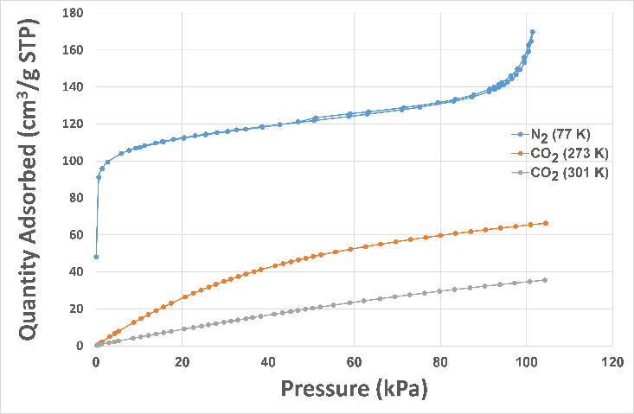
Figure 2. Gas adsorption isotherms for 1, showing N₂ uptake at 77 K in blue, and CO₂ uptake at 273 K and 301 K in orange and grey respectively. Graph of N₂ uptake vs. P/P₀ in ESI.

X-ray powder diffraction (PXRD) was performed on the sample immediately after the adsorption experiments, showing that the material had not lost any crystallinity during the adsorption/desorption processes (Fig 3). Since the network was stable under the adsorption conditions, it was tested to determine hydrolytic stability. For initial tests the sample was soaked in water at ambient temperature for 24 hours, with subsequent PXRD analysis showing that crystallinity was retained. This was an encouraging result as it is well known that MOFs traditionally have poor hydrolytic stability. The sample was then exposed to harsher conditions, first heated at 60 °C for 48 hours, then heating at 100 °C for 72 hours; in both cases complete crystallinity was maintained (Fig. 3). According to the criteria proposed by Shimizu,⁸ 1 should be classified as a class 6A material, as it has been shown using PXRD that it retained porosity and crystallinity when exposed to both boiling water and harsh humid conditions (see below).

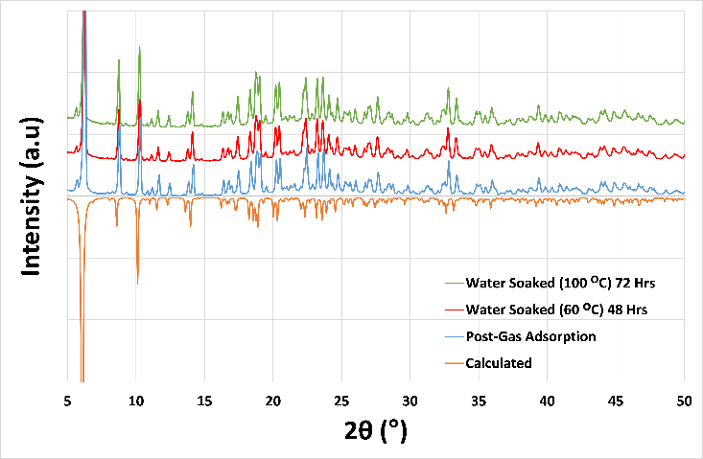
Figure 3. Powder X-ray diffraction (PXRD) results for 1 after gas adsorption experiments (blue), after soaking in water at 60 °C for 48 hours (red), after soaking in water at 100 °C for 72 hours (red), and the simulated pattern from single crystal data (inverted) in orange.

An experiment was then designed to simulate a flue gas atmosphere to determine the stability of material to water vapour using an Intelligent Gravimetric Analyzer (IGA). A CO₂ isotherm at 298 K was measured up to 5 atm as an initial benchmark, before heating the sample under vacuum at 150 °C and exposing it sequentially to 40 mbar of H₂O, 150 mbar of CO₂ and 850 mbar of N₂ (total pressure of ~ 1 atm, 3.9 % H₂O:14.4 % CO₂:81.7 % N₂ composition at 100 °C) and holding for 48 hours at (Fig. 4). The sample was then cooled back to room temperature and the CO₂ isotherm was measured twice to determine if there was any loss in uptake capacity. It was determined that after exposure to the flue gas-like mixture the material had only lost a small amount of its uptake capacity. Subsequent PXRD analysis on the sample showed that the material showed no detectable reduction in crystallinity during the flue gas simulation experiment, which is an encouraging result for potential industrial applications.

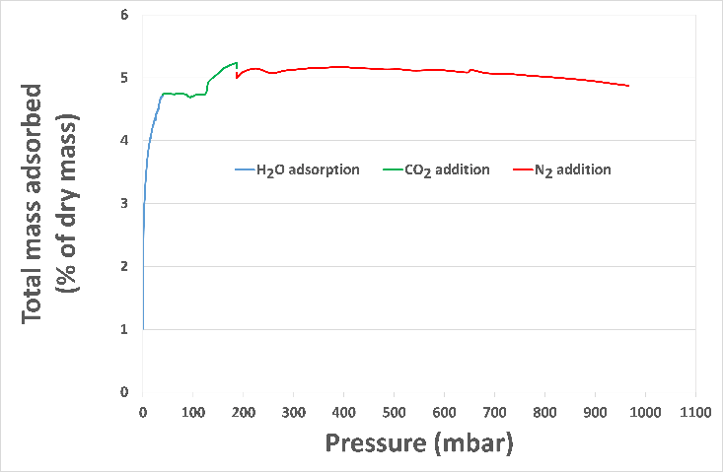
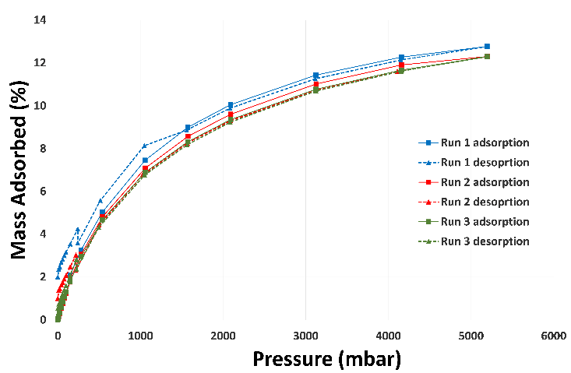
Figure 4. (Top) Intelligent gravimetric analysis (IGA) data from the flue gas simulation experiment. Initial addition of H₂O vapour to a pressure of 40 mbar (blue), followed by addition of 150 mbar of CO₂ (green), then addition of 850 mbar of N₂ to reach
approximately 1 atm of pressure. (Bottom) CO₂ isotherms performed prior to the IGA experiment (blue) and repeat isotherms after the IGA (red and green), showing no significant decrease in total uptake.

The IGA experiment shows a rapid uptake of the water vapour by 1 up to the determined 40 mbar. It was assumed that once CO₂ adsorption started, the mass of vapour in the atmosphere and the mass of water adsorbed on the sample did not change. As the CO₂ is introduced, initially there does not appear to be an increase in mass adsorbed until a total pressure of 120 mbar is reached, after which there is an increase from 4.7 % to 5.2 %, which is assigned to adsorption of CO₂. However, the limitations of the experiment do not allow for accurate determination in the composition of gases adsorbed into 1, and whether any H₂O vapour was displaced to accommodate the inclusion of CO₂. The small dip at the end of the CO₂ adsorption was due to movement of the equipment when the CO₂ stream was closed. In the third stage there is a gradual decrease in mass % adsorbed from 5.2 % when the CO₂ stream was closed to 4.9 % when addition of the N₂ to the system was completed. In order to perform the required buoyancy corrections, it was assumed that CO₂ was desorbed first, then H₂O, which allowed for adsorption of N₂. However it is more likely that this process was dynamic and the total amount desorbed versus the amount adsorbed was unable to be determined experimentally. While the total composition of gases adsorbed into 1 is unknown, the experiment does demonstrate that the material adsorbed water vapour in addition to CO₂ and N₂, and was able to retain crystallinity under these conditions.
In summary, we have demonstrated a novel high-connectivity approach to a hydrolytically stable MOF for CO₂ sorption. An unconventional triaminepentacarboxylate ligand forms a highly connected porous coordination polymer with Cd^{II} ions (1) in which twelve of the thirteen potential donor atoms from the -5 charged ligand are coordinated to eight separate metal centres; this exceptional connectivity yields a highly stable MOF. The network contains one-dimensional solvent channels of 9 x 9 Å. Gas adsorption experiments showed uptake of 170 cm³/g STP N₂ at 77 K, 66 cm³/g STP CO₂ at 273 K and 36 cm³/g STP CO₂ at 301 K. 1 retained crystallinity after the gas adsorption experiments and maintains structural stability in both boiling water and a simulated flue-gas stream. This result demonstrates a new approach towards overcoming the hydrolytic stability problems of MOFs by increasing the connectivity of the ligand and therefore the number of coordination bonds present within the network to form a highly robust material. Exploitation of this approach will allow MOFs to be designed that are stable and useful for real-world applications.

Acknowledgements
This work was supported by the Science and Industry Endowment Fund. Portions of this work were carried out on the MX1
beamline at the Australian Synchrotron, part of ANSTO.³⁶ A.J.E acknowledges the support from the Australian Government Research Training Program Scholarship.

References
1. Hoskins, B. F.; Robson, R., Design and construction of a new class of scaffolding-like materials comprising infinite polymeric frameworks of 3D-linked molecular rods. A reappraisal of the zinc cyanide and cadmium cyanide structures and the synthesis and structure of the diamond-related frameworks [N(CH₃)₄][Cu^{I}Zn^{II}(CN)₄] and Cu^{I}[4,4',4'',4'''-tetracyanotetraphenylmethane]BF₄.xC₆H₅NO₂. J. Am. Chem. Soc. 1990, 112 (4), 1546-1554.
2. Lin, R.-B.; Xiang, S.; Xing, H.; Zhou, W.; Chen, B., Exploration of porous metal–organic frameworks for gas separation and purification. Coord. Chem. Rev. 2017.
3. Kobielska, P. A.; Howarth, A. J.; Farha, O. K.; Nayak, S., Metal–organic frameworks for heavy metal removal from water. Coord. Chem. Rev. 2018, 358, 92-107.
4. Majewski, M. B.; Peters, A. W.; Wasielewski, M. R.; Hupp, J. T.; Farha, O. K., Metal–organic frameworks as platform materials for solar fuels catalysis. ACS Energy Letters 2018, 3 (3), 598-611.
5. Greathouse, J. A.; Allendorf, M. D., The interaction of water with MOF-5 simulated by molecular dynamics. J. Am. Chem. Soc. 2006, 128 (33), 10678-10679.
6. Han, S. S.; Choi, S.-H.; van Duin, A. C. T., Molecular dynamics simulations of stability of metal-organic frameworks against H₂O using the ReaxFF reactive force field. Chem. Commun. 2010, 46 (31), 5713-5715.
7. Burtch, N. C.; Jasuja, H.; Walton, K. S., Water stability and adsorption in metal–organic frameworks. Chem. Rev. 2014, 114 (20), 10575-10612.
8. Gelfand, B. S.; Shimizu, G. K. H., Parameterizing and grading hydrolytic stability in metal-organic frameworks. Dalton Trans. 2016, 45, 3668-3678.
9. Chui, S. S.-Y.; Lo, S. M.-F.; Charmant, J. P. H.; Orpen, A. G.; Williams, I. D., A Chemically functionalizable nanoporous material [Cu₃(TMA)₂(H₂O)₃]_{n}. Science 1999, 283 (5405), 1148-1150.
10. Cavka, J. H.; Jakobsen, S.; Olsbye, U.; Guillou, N.; Lamberti, C.; Bordiga, S.; Lillerud, K. P., A new zirconium inorganic building brick forming metal organic frameworks with exceptional stability. J. Am. Chem. Soc. 2008, 130 (42), 13850-13851.
11. Cychosz, K. A.; Matzger, A. J., Water stability of microporous coordination polymers and the adsorption of pharmaceuticals from water. Langmuir 2010, 26 (22), 17198-17202.
12. Hong, D.-Y.; Hwang, Y. K.; Serre, C.; Férey, G.; Chang, J.-S., Porous chromium terephthalate MIL-101 with coordinatively unsaturated sites: Surface functionalization, encapsulation, sorption and catalysis. Adv. Funct. Mater. 2009, 19 (10), 1537-1552.
13. Liang, Z.; Marshall, M.; Ng, C. H.; Chaffee, A. L., Comparison of conventional and HF-free-synthesized MIL-101 for CO₂ adsorption separation and their water stabilities. Energy & Fuels 2013, 27 (12), 7612-7618.
14. Yazaydın, A. Ö.; Benin, A. I.; Faheem, S. A.; Jakubczak, P.; Low, J. J.; Willis, R. R.; Snurr, R. Q., Enhanced CO₂ adsorption in metal-organic frameworks via occupation of open-metal sites by coordinated water molecules. Chem. Mater. 2009, 21 (8), 1425-1430.
15. Liu, J.; Wang, Y.; Benin, A. I.; Jakubczak, P.; Willis, R. R.; LeVan, M. D., CO₂/H₂O adsorption equilibrium and rates on metal−organic frameworks: HKUST-1 and Ni/DOBDC. Langmuir 2010, 26 (17), 14301-14307.
16. Soubeyrand-Lenoir, E.; Vagner, C.; Yoon, J. W.; Bazin, P.; Ragon, F.; Hwang, Y. K.; Serre, C.; Chang, J.-S.; Llewellyn, P. L., How water fosters a remarkable 5-fold increase in low-pressure CO₂ uptake within mesoporous MIL-100(Fe). J. Am. Chem. Soc. 2012, 134 (24), 10174-10181.
17. Kim, D.; Lim, H.-K.; Ro, H.; Kim, H.; Lee, H., Unexpected carbon dioxide inclusion in water-saturated pores of metal–organic frameworks with potential for highly selective capture of CO₂. Chem. Eur. J. 2015, 21 (3), 1125-1129.
18. Küsgens, P.; Rose, M.; Senkovska, I.; Fröde, H.; Henschel, A.; Siegle, S.; Kaskel, S., Characterization of metal-organic frameworks by water adsorption. Micropor. Mesopor. Mater. 2009, 120 (3), 325-330.
19. Majano, G.; Martin, O.; Hammes, M.; Smeets, S.; Baerlocher, C.; Pérez-Ramírez, J., Solvent-mediated reconstruction of the metal–organic framework HKUST-1 (Cu₃(BTC)₂). Adv. Funct. Mater. 2014, 24 (25), 3855-3865.
20. Park, K. S.; Ni, Z.; Côté, A. P.; Choi, J. Y.; Huang, R.; Uribe-Romo, F. J.; Chae, H. K.; O’Keeffe, M.; Yaghi, O. M., Exceptional chemical and thermal stability of zeolitic imidazolate frameworks. Proc. Nat. Acad. Sci. USA 2006, 103 (27), 10186-10191.
21. Wang, C.; Liu, X.; Keser Demir, N.; Chen, J. P.; Li, K., Applications of water stable metal-organic frameworks. Chem. Soc. Rev. 2016, 45 (18), 5107-5134.
22. Dhakshinamoorthy, A.; Asiri, A. M.; Garcia, H., Catalysis by metal-organic frameworks in water. Chem. Commun. 2014, 50 (85), 12800-12814.
23. Versteeg, G. F.; Van Dijck, L. A. J.; Van Swaaij, W. P. M., On the kinetics between CO₂ and alkanolamines both in aqueous and non-aqueous solutions. An overview. Chem. Eng. Commun. 1996, 144 (1), 113-158.
24. Rochelle, G. T., Amine scrubbing for CO₂ capture. Science 2009, 325, 1652.
25. Emerson, A. J.; Chahine, A.; Batten, S. R.; Turner, D. R., Synthetic approaches for the incorporation of free amine functionalities in porous coordination polymers for enhanced CO₂ sorption. Coord. Chem. Rev. 2018, 365, 1-22.
26. Fracaroli, A. M.; Furukawa, H.; Suzuki, M.; Dodd, M.; Okajima, S.; Gándara, F.; Reimer, J. A.; Yaghi, O. M., Metal–organic frameworks with precisely designed interior for carbon dioxide capture in the presence of water. J. Am. Chem. Soc. 2014, 136 (25), 8863-8866.
27. Fathieh, F.; Kalmutzki, M. J.; Kapustin, E. A.; Waller, P. J.; Yang, J.; Yaghi, O. M., Practical water production from desert air. Science Adv. 2018, 4 (6), eaat3198.
28. Kim, H.; Rao, S. R.; Kapustin, E. A.; Zhao, L.; Yang, S.; Yaghi, O. M.; Wang, E. N., Adsorption-based atmospheric water harvesting device for arid climates. Nat. Commun. 2018, 9 (1), 1191.
29. Kadhom, M.; Deng, B., Metal-organic frameworks (MOFs) in water filtration membranes for desalination and other applications. App. Mater. Today 2018, 11, 219-230.
30. Hawes, C. S.; Knowles, G. P.; Chaffee, A. L.; Turner, D. R.; Batten, S. R., Modulating porosity through conformer-dependent hydrogen bonding in copper(II) coordination polymers. Cryst. Growth Des. 2015, 15 (7), 3417-3425.
31. Hawes, C. S.; Chilton, N. F.; Moubaraki, B.; Knowles, G. P.; Chaffee, A. L.; Murray, K. S.; Batten, S. R.; Turner, D. R., Coordination polymers from a highly flexible alkyldiamine-derived ligand: structure, magnetism and gas adsorption studies. Dalton Trans. 2015, 44 (40), 17494-17507.
32. Emerson, A. J.; Hawes, C. S.; Knowles, G. P.; Chaffee, A. L.; Batten, S. R.; Turner, D. R., Coordination polymers from a flexible alkyldiamine-derived ligand. CrystEngComm 2017, 19 (34), 5137-5145.
33. Hawes, C. S.; Batten, S. R.; Turner, D. R., Self-assembly of discrete and polymeric metallosupramolecular architectures from cyclen-derived ligands. CrystEngComm 2014, 16 (18), 3737-3748.
34. Spek, A. L., PLATON SQUEEZE: A tool for the calculation of the disordered solvent contribution to the calculated structure factors. Acta Crystallogr., Sect C. 2015, 71, 9-18.
35. Hawes, C. S.; White, K. F.; Abrahams, B. F.; Knowles, G. P.; Chaffee, A. L.; Batten, S. R.; Turner, D. R., Structural chemistry and selective CO₂ uptake of a piperazine-derived porous coordination polymer. CrystEngComm 2015, 17 (10), 2196-2203.
36. Cowieson, N. P.; Aragao, D.; Clift, M.; Ericsson, D. J.; Gee, C.; Harrop, S. J.; Mudie, N.; Panjikar, S.; Price, J. R.; Riboldi-Tunnicliffe, A.; Williamson, R.; Caradoc-Davies, T., MX1: a bending-magnet crystallography beamline serving both chemical and macromolecular crystallography communities at the Australian Synchrotron. J. Synch. Rad. 2015, 22 (1), 187-190.

Table of contents figure
