High-resolution stratigraphy and physical property modelling of the Chalk
M. A Woods*1, A. J. Newell2 , A. R. Farrant1, R. B. Haslam1 and S. M. Clarke3
1 British Geological Survey, Nottingham, UK
2 British Geological Survey, Wallingford, UK
3 Keele University, Staffordshire, UK
* Corresponding Author

ABSTRACT A fortuitous combination of events in the last 30 years has positioned the Chalk as the most eligible geological unit for high-resolution 3D modelling at national, regional and local scales, allowing site-specific predictions and enabling characte-ristics to be seen in a wider geological context. Advances in stratigraphical understanding coincided with national re-mapping by the British Geological Survey (BGS). Adoption of digital cartography generated the high-resolution outcrop data to which sub-surface data could later be related in 3D models. Add to this systematic digitization and geographical indexing of national ar-chives of borehole logs, cores, samples and geophysical data, and all the ingredients are in place for 3D modelling of the Chalk.
Modelling the Chalk is helped by its relatively simple structure and stratigraphical continuity, and, because of its importance as an aquifer, abundant borehole data. Borehole geophysical logs provide invaluable data about subsurface stratigraphy which is not normally captured by written core logs. These geophysical log interpretations are ‘ground-truthed’ against cored and geo-physically logged boreholes in the national archive, showing precisely how stratigraphy and geophysics are related. Non-confidential hydrocarbons boreholes, where appropriately sited, often allow modelling through the entire Chalk succession, providing stratigraphical context for shorter boreholes.
Recent work by the BGS has focused on combining conventional volumetric and stratigraphical surface modelling with physical property modelling. This approach uses statistical algorithms to examine what the distributions of known data might tell us about the likely properties of Chalk in data sparse areas. Initially, our modelling has focused on a range of simple properties in-cluding marl-content, hardness and presence of hardgrounds, but we are also now beginning to explore fracture distributions and flint frequency. The data sources we have used to create our model (geophysical log data) do not easily allow direct des-cription of chalk properties in terms of their engineering parameters. However, a general indication of this could be achieved by loading engineering data for the Chalk at points where these data exist within the model, and statistically interpolating values across the physical property subdivisions we have recognised.

INTRODUCTION
High resolution geological modelling is an essential and routine procedure in the oil and gas industry, al-lowing 3D characterisation of reservoir units. This is understandable given that the target geological units are usually deeply buried and the high impact of geo-logical data on commercial outcomes. For the engi-neering industry, characterisation of subsurface ge-ology typically depends on site investigation studies in defined project areas and generally within a depth range of 100m. In these situations there is a much greater abundance of existing geological data that can provide a context for the interpretation of site investigation boreholes. Harnessing these data has advantages for: 1) more confident interpretation of site investigation boreholes; 2) more confident un-derstanding of likely ground conditions between site investigation boreholes; 3) provides knowledge of geological features beyond the immediate project site that may have a bearing on engineering activity within the site. As well as site-specific factors, geolog-ical models can also highlight regional trends within geological units (e.g. thickening/thinning or changes in physical properties) or areas where there may be a higher probability of discontinuities such as fault-ing/fracturing/dissolution. This knowledge allows site investigations to be focused where particular geologi-cal features are likely to have an impact on the risk associated with a project. For the Chalk, high-resolution geological models also have significant po-tential to enhance understanding of groundwater flow through this major aquifer; how groundwater extraction should be managed in different geological settings, and how pollutants may affect the quality of groundwater supply. The importance of the Chalk both as an aquifer, and as a source of raw materials for cement and agricultural lime, mean that it has been widely drilled and excavated, features that in combination with intensive mapping over recent decades, make it an ideal test bed for regional-scale physical property modelling.
MODELLING CHALK PHYSICAL PROPERTIES
Geological models that show the subsurface geome-try and structure of rock units (groups/formations/members/beds) have become commonplace in recent years (Burke et al., 2014; Gow et al., 2013). This trend reflects improvements in computing power and initiatives by organisations like the BGS to digitise analogue data holdings, such as outcrop geological linework on maps, and develop spatial indexes of borehole and geophysical log data. In combination with digital terrain models, these da-tasets provide the foundation for 3D geological models. However, a physical property model goes beyond tracing the subsurface boundaries of geolog-ical units, it attempts to predict the internal variabil-ity within those units. For example, detailed exami-nation of Chalk outcrops shows that whilst the estab-lished geological subdivisions are well-founded (Far-rant et al., this volume), the distribution of particular features such as clay- rich units (marls), indurated beds (hardgrounds, nodular chalk), and flints is not uniform within units, and that for particular units, some
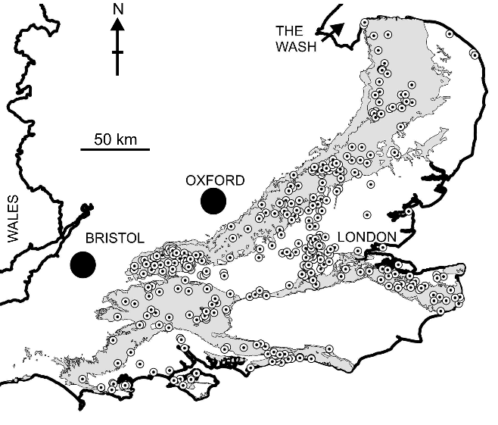

Figure 1. Location of borehole geophysical logs used to provide subsurface interpretations of Chalk stra-tigraphy and physical properties. Grey shading = out-crop of Chalk Group

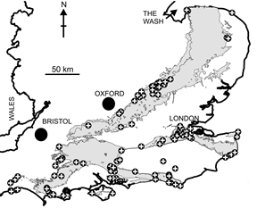
Figure 2. Location of outcrop section data used for stratigraphical and physical property modelling. Grey shading = outcrop of Chalk Group.

regions have a greater or lesser relative proportion of these compared to others. Recent 3D modelling work at the British Geological Survey (BGS) has focused on capturing this vertical and lateral variability with-in the Chalk (Woods et al., 2016).
The first phase of the BGS work aimed to create a model framework for the Chalk extending from The Wash in northern East Anglia to the south coast of England (Fig. 1). This framework, built in GOCAD-SKUATM modelling software, uses all of the available outcrop map data and a selection of subsurface data aimed at providing a minimum resolution of one borehole control point every 20km2. In many areas the density is significantly greater but in some re-gions, particularly where the Chalk is concealed by younger strata (for example, the eastern part of East Anglia) data are sparse (Fig. 1). The total amount of data that could be interpreted, particularly across the Chalk outcrop, is very large. Consequently, the reso-lution of this preliminary version of the model is cali-brated to be sufficient to allow large-scale inter-regional comparisons of stratigraphy and physical properties (Newell et al., in review), with the aim of increasing data density for specific project areas as required.
Borehole geophysical logs and large out-crops/excavations (Fig. 2) with detailed lithological logs are the raw data that underpin the Chalk physi-cal property model. Patterns of inflections on geo-physical logs (gamma, resistivity, sonic) are interpret-ed in terms of formational stratigraphy and physical properties (Fig. 3), the latter being depth/elevation coded in WELLCADTM based on the amplitude of geophysical log responses or data recorded on litho-logical logs (Fig. 4). Stratigraphical interpretations of geophysical logs follow Woods & Aldiss (2004), Woods (2006) and Woods & Chacksfield (2012). Broad intervals of higher resistivity and high sonic velocity reflect more cemented intervals of chalk, with highly cemented hardgrounds usually accentu-ated as narrow peaks. Conversely, softer chalk corre-sponds with lower resistivity log values, and concen-trations of clay-rich chalk (marls) are accentuated as narrow, low resistivity spikes. Gamma logs mainly re-spond to clay content, and can be used to identify marls and broader intervals of more clay-rich chalk. Gamma logs also respond to concentration of glau-conite and phosphate, often seen at hardground sur-faces, and also seen in silty/sandy units at levels in the lower and basal part of the Chalk Group (e.g. Glauconitic Marl). The particular spatial distribution of marker-beds that characterise individual Chalk units imparts distinctive patterns to geophysical logs, allowing them to be used to identify formational stratigraphy (Woods, 2006).
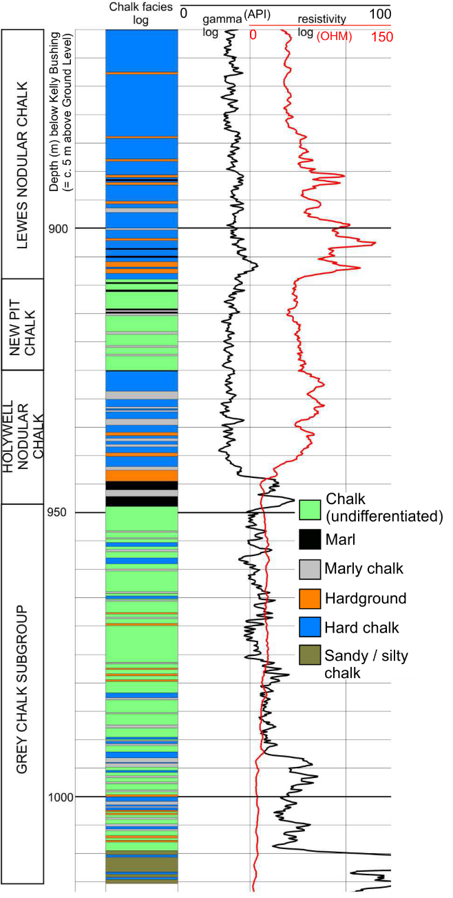
Figure 3. Stratigraphical and physical property (fa-cies) interpretation of borehole geophysical log in WELLCADTM. NB: Formations in Grey Chalk Sub-group not differentiated.

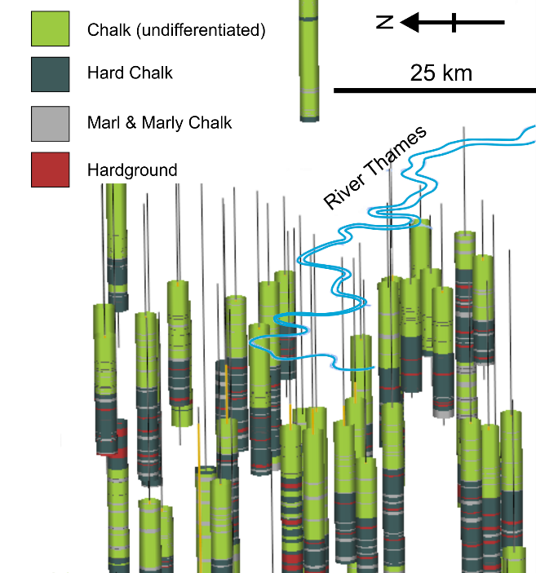
Figure 4. Facies-coded boreholes in the Thames Ba-sin displayed in modelling software.
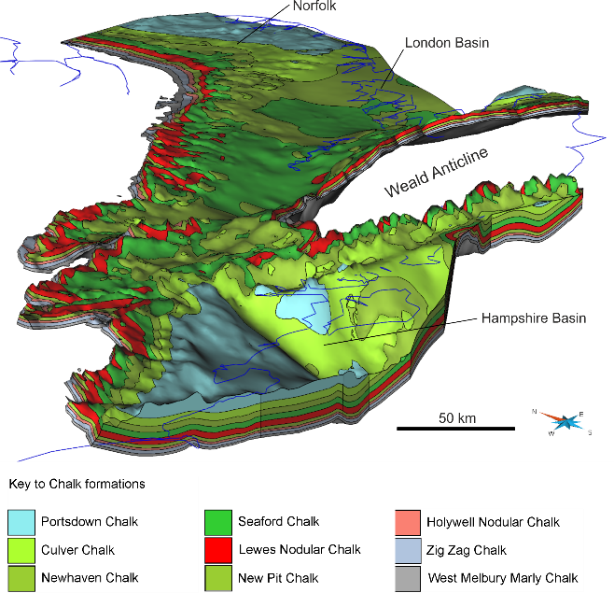

Figure 5. Modelled Chalk formational surfaces loaded into GOCAD-SKUATM

To allow maximum use of the data in the BGS geophysical log archive, which includes material from the 1960s, physical property data are restricted to simple, broad facies categories (for example: marl,

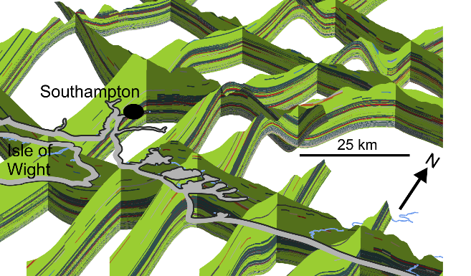

Figure 6. Modelled cross sections through the Chalk on the south coast of England showing interpreted physical property distribution as colour-coded units. Key to colours as for Fig. 4

marly chalk, hard chalk, hardground) that are capa-ble of consistent recognition. Stratigraphical data from the boreholes and outcrops are imported into GOCAD-SKUATM and used to build cross sections and model formational surfaces (Fig. 5). From these surfaces a 3D model grid is built. This grid is a three-dimensional meshwork filling the space between the modelled formational surfaces, allowing the sites of boreholes and outcrops to be depth coded with phys-ical property data. In this format, geostatistical tech-niques (kriging, variograms) allow the power of the raw data to be unleashed, and interpretations of the physical property data to be projected through the model grid (Fig. 6). As more data become available new and more confident predictions can be achieved.

MOVING FORWARD: GROUND-TRUTHING, INCREASING RESOLUTION AND ADDING NEW DATA TYPES
Having demonstrated the methodology for acquiring and manipulating physical property data, and creat-ed a Chalk model that is useful for exploring large scale basin architecture (Newell et al., in review), what is now needed is more rigorous real-world test-ing of the model outputs. This will require a model with a greater density of data, at least to the extent that the accuracy of the modelling outputs can be fairly judged. This last point touches on a significant
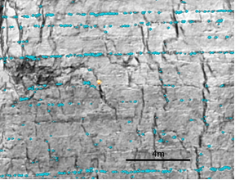
Figure 7. Laser scan image of Chalk cliff showing greyscale texture of chalk surface. Image analysed for intensity to highlight flint horizons

challenge for large scale physical property modelling – increasing model resolution and confidence of pre-diction at finer scales and determining the extent to which modelling can resolve facies changes con-trolled by local structure or basin architecture.
For the Chalk there is abundant additional data that could be interpreted, and the impact of these on model results and model reliability is currently being tested across a limited project area in the London – Kent region. Here, and in Sussex, modelling of the Chalk is being enhanced by laser scanning large coastal sections and inland quarries. The scans cre-ate high-resolution point clouds of outcrop surfaces draped with photographic images. These can be viewed and interpreted (using outcrop & borehole da-ta) in 3D using software packages such as Geovi-sionaryTM and directly imported as geo-referenced objects in modelling software. The detail of the scans is sufficient to identify individual marl seams and flints, and allow both stratigraphical and physical property data to be rapidly acquired for large and of-ten inaccessible outcrop successions. Laser scanning also overcomes the problem of assessing regional-scale lateral variability of physical properties close to the eroded top of the Chalk succession. The eleva-tions of intra-formational marker-beds (e.g. distinc-tive flint horizons) can be fixed and used as surfaces within the model against which to assess variability in facies and underlying stratigraphy.
Significant additional physical property data for the Chalk, from both a civil engineering and hydro-geological perspective, are flint and fracture frequen-cy, and work on both of these is in progress. Flint da-ta is being captured at formational level from litho-logical logs and by analysis of the intensity of the re-flections registered during the laser scanning of out-crop sections (Fig. 7).
The broad spatial distribution of fractures within the Chalk has been analysed through geomechanical restoration using a Mass-Spring approach (Terzopou-los et al., 1987; Provot, 1995 and Baraff and Witkin, 1998). For the Chalk, this involves the removal of each stage of deformation from the rockmass to al-low understanding of its structural deformation histo-ry, original geometry and record the strain that oc-curred during deformation. To achieve this, modelled surfaces are used to create a 3D tetrahedral mesh for each Chalk formation, assigning mean values of Young’s Modulus and Poisson Ratio to the mesh de-rived from BGS geotechnical databases. Midland Valley MoveTM software is used to flatten the Chalk formations, and the measured volumetric strain in the mesh is used to generate a theoretical normalised joint intensity. Finally, observational data are com-pared with the theoretical joint intensity to allow real-istic interpolation of fracture intensity throughout each formational volume. To avoid edge effects and to capture the strain associated with the Weald inver-sion, the Chalk formations were projected across the now eroded Weald Basin. The results (Figure 8A) show that there is little variation on the normalised fracture intensity between the formations which probably reflects the scale of the model and the range of Young’s Modulus and Poisson Ratio used. The model shows higher fracture frequency along the flanks of folds including the Vale of Pewsey, Vale of Wardour and Portsdown and along the southern margin of the Thames Basin and Hog’s Back and Hampshire basin. Further work will look at higher resolution models including hardgrounds and marl seams which will increase the rock property anisotro-py of the system. To validate this model at a local scale and established quantitative values of fracture intensity and density, as well as the true characteris-tics of the fracture network, including fracture length, shape and orientation, LiDAR and photogrammetry surveys have been completed and fracture statistics extracted semi-automatically from the point data (Figure 8B; Riquelme et al., 2014).

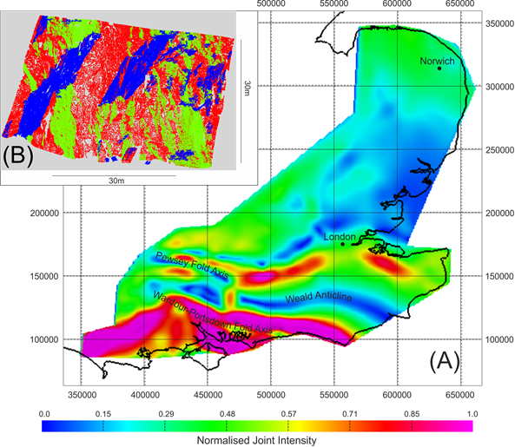
Figure 8. (A) Plan view of the Seaford Formation volume coloured for Normalised Joint Intensity from the geomechanical restoration of the Chalk with are-as in red to pink highlighting relatively high fracture intensities. (B) View to the west of a subsection of a LiDAR survey point cloud from coastal cliffs at St Margaret’s Bay classified into three fracture sets; two steep (Red (84/096) and Green (89/315) and one inclined (Blue (70/135).

CONCLUSIONS
High-resolution stratigraphy and physical property modelling of the Chalk offers the possibility of great-ly increased confidence for contextualized geological understanding of site investigation data. These mod-els also provide the potential for much better under-standing of the links between geology and groundwa-ter behaviour in the Chalk. It is hoped that a future version of the model will allow paramaterisation of some of our facies categories (e.g. hard chalk, marly chalk) and will be able to spatially interpret fracture and flint distributions, both significant for engineer-ing geology and hydrogeology.

ACKNOWLEDGEMENT
The authors acknowledge the use of the Move Soft-ware Suite granted by Midland Valley's Academic Software Initiative. This paper is published with the permission of the Executive Director of the British Geological Survey (NERC).

REFERENCES
Baraff, D. & Witkin, A. 1998. Large Steps in Cloth Simula-tion: Proceedings of the 25th Annual Conference on Computer Graphics and Interactive techniques 1998, 43 – 54.
Burke, H. Mathers, S. J. Williamson, J. P. Thorpe, S. Ford, J. & Terrington, R. L. 2014.The London Basin superficial and bedrock
Model. British Geological Survey Open Report, OR/14/029.
Farrant, A. R. Woods, M. A. & Haslam, R. This volume. The Chalk Revolution: Mapping out the Chalk for engineering and hazard assessment. Chalk2018 Conference Volume.
Gow, H. Cripps, C. Thorpe, S. Horabin, C. & Lee, J. R. 2013. Model metadata report for the Somerset Levels 3D geological model: British Geological Survey report. British Geological Survey Open Report, OR/13/050.
Newell, A. J. Woods, M. A. Farrant, A. R. Smith, H. & Has-lam, R. B. In press. Chalk thickness trends and the role of tectonic processes in the Upper Cretaceous of southern Eng-land. Proceedings of the Geologists’ Association.
Provot, X. 1995. Deformation Constraints in a Mass-Spring Model to Describe Rigid Cloth Behaviour. Proceedings Graphics Interface ‘95, p. 147 – 155.
Riquelme, A. J., Abellán, A., Tomás, R. & Jaboyedoff, M. 2014. A new approach for semi-automatic rock mass joints recognition from 3D point clouds. Computers & Geoscienc-es, 68 , 38 – 52.
Terzopoulos, D., Platt, J., Barr, A. & Fleischer, K. 1987. Elastically Deformable Models: Proceedings of ACM Sig-graph 1987. Computer Graphics 21, 205 – 214.
Woods, M. A. Newell, A. J. Haslam, R. Farrant, A. & Smith, H. 2016. Predicting the subsurface. Geoscientist 27, 10 – 15.
Woods, M. A. & Chacksfield, B. C. 2012. Revealing deep structural influences on the Upper Cretaceous Chalk of East Anglia (UK) through inter-regional geophysical log correla-tions. Proceedings of the Geologists' Association 123, 486 – 499.
Woods, M. A. 2006. UK Chalk Group stratigraphy (Cenoma-nian – Santonian) determined from borehole geophysical logs. Quarterly Journal of Engineering Geology and Hydro-geology 39, 83 – 96.
Woods, M. A. & Aldiss, D. T. 2004. The stratigraphy of the Chalk Group of the Berkshire Downs. Proceedings of the Geologists' Association 115, 249 – 265.

