Aggregation-Induced Emission (AIE) Fluorophore Exhibits a Highly Ratiometric Fluorescent Response to Zn²⁺ in vitro and in Human Liver Cancer Cells.
Hassan Mehdi,ª Weitao Gong,^{a*} Huimin Guo^{b}, Michael Watkinson^{c*}, Hua Ma^{b}, Ali Wajahatª and Guiling Ning^{a*}
[a] State Key Laboratory of Fine Chemicals, School of Chemical Engineering Dalian University of Technology, Dalian 610023. PR. China. Fax: +86 411- 8498-6065; Tel: +86-411-8498-6067 E-mail: wtong@dlut.edu.cn; ninggl@dlut.edu.cn.
[b] School of Chemistry, Dalian University of Technology, Dalian 610023. PR. China.
[c] The Joseph Priestley Building, School of Biological and Chemical Sciences, Queen Mary University of London, Mile End Road, London, E1 4NS, UK. Email: m.watkinson@qmul.ac.uk

Abstract: Two novel organic fluorophores 8AQ and 8WB have been designed and synthesized. Fluorophore 8AQ, containing an isobutylene unit, exhibits a significant AIE feature and a remarkable highly selective ratiometric fluorescence response towards Zn²⁺ in solution as well as in human liver cancer cells. The AIE behaviour of 8AQ was fully verified by fluorescence and UV-vis spectroscopies, quantum yield calculations and through single crystal X-ray diffraction, which revealed an intricate crystal packing system. Conversely, fluorophore 8WB, which lacks the isobutylene moiety, did not exhibit any significant fluorescent properties as a result of its more flexible molecular structure that presumably allows free intramolecular rotational processes to occur.
Introduction
The design and construction of new organic fluorescent materials has attracted considerable interest over the past few decades due to their widespread applications e.g. as sensors, in electroluminescent devices and in cell imaging.[1-4] Most of these organic materials exhibit highly emissive properties in dilute solution but are less emissive at high concentration due to the phenomenon of aggregation-caused quenching (ACQ),[5-7] which has proven to be a major obstacle in the advancement of luminescent materials.[8,9] To overcome these challenges Tang et al. introduced a novel phenomenon in 2001, aggregation-induced emission (AIE), which is exactly the reverse process of ACQ.[10-12] The AIE phenomenon has subsequently attracted considerable interest,[13-15] and has opened up many opportunities in the application of novel luminescent materials in a range of areas including optoelectronic devices, organic light-emitting diodes OLEDs, organic lasers, photovoltaic cells, chemo/biosensors and intracellular cell imaging to name a few.[16-18] As a result, the design and synthesis of fluorescent materials that can induce AIE continues to be a very active area of fundamental academic and industrial exploration.[19-22] The development of highly selective and sensitive fluorescent chemosensors for the imaging of ‘mobile’ or ‘free’ Zn²⁺ also remains a vibrant area of research due to the pivotal role it plays in a number of important biological processes, such as brain activity, gene transcription, immune function, and in reproductive systems.[23-27] Although a very wide variety of chemosensors have been reported for the detection and intracellular imaging of Zn²⁺, [28-35] most of them exhibit a simple non-ratiometric switch on fluorescence response. In addition the majority of the systems that do display a ratiometric response to Zn²⁺ suffer from interference with other heavy and transition metal ions like Fe²⁺, Co²⁺, Ni²⁺, Cu²⁺, Hg²⁺ and Cd²⁺.[36,37] Hence the development of efficient highly Zn²⁺ selective ratiometric chemosensors with rapid response times, accompanied by low detection limits remains an enduring challenge.[38-41] To address these issues, researchers have designed several fluorescent chemosensors for biological imaging of Zn²⁺ with different binding motifs.[42-44] Recent reports include molecular systems based on Schiff bases, peptide derivatives, hydroxyindole-Bodipy, bipyridine and hydroxynaphthylmethylene, which have been reported as highly sensitive ratiometric sensors for Zn²⁺ all with detection limits in the micromolar range of 1 µM, 0.8 µM, 0.97 µM, 10 µM and 11 µM respectively. [45-49]
Herein we report a new AIE-active fluorophore 8AQ that exhibits a rapid and highly selective ratiometric response to Zn²⁺ with a limit of detection (LOD) up to 2.6 nM which is amongst the most sensitive reported to date. Furthermore, the fluorophore 8AQ was successfully applied in ratiometric imaging of intracellular Zn²⁺ in human hepatoma cancer cells by fluorescence microscopy.
Results and Discussion
We have designed and synthesized two novel organic fluorophores 8AQ and 8WB. In fluorophore 8AQ, we rationally inserted an isobutylene moiety into the structural system in order to reduce energy loss through free intramolecular rotation, with the aim of generating an AIE system. Conversely, we expected fluorophore 8WB, without the isobutylene moiety, would not display such properties due to its more flexible molecular structure, should allow free intramolecular rotation and strong π-π-interactions among its aromatic moieties.
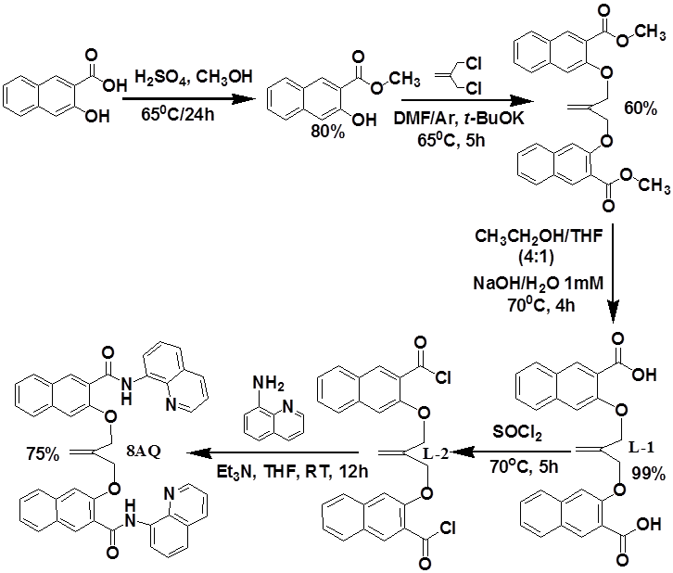
Scheme 1. Synthetic route to supramolecular organic fluorophore 8AQ.
The synthetic route towards the two organic fluorophore 8AQ and 8WB are shown in Scheme 1 and Scheme S1 (see ESI) respectively. Both organic fluorophores contain bis-naphthylamide moieties and two quinoline motifs with the only structural difference between them being the isobutenyl group. In both cases the syntheses proceeded in good yield.
Single crystal structure and supramolecular interactions
The single crystals of fluorophores 8AQ and 8WB were produced from CH2Cl2: C2H5OH solution via slow solvent evaporation at room temperature. The structures within the asymmetric units are displayed in Figure 1 and the crystallographic data are listed in Table 1.
As shown (Figure 1), the single crystal X-ray structure of fluorophore 8AQ contains two naphthylamide quinoline moieties connected to the isobutylene core. The structure contains two types of intramolecular hydrogen bonds between the H-atoms of the amide moieties with the O-atoms of the ethers and the N-atoms of quinoline moieties (Figure 1). This intramolecular hydrogen bonding network results in one naphthylamide quinoline moiety being connected to the isobutylene core with a dihedral angle C(38)-C(25)-C(17)-O(1) of 132.60 (2)o whilst the other displays a dihedral angle about C(38)-C(25)-C(18)-O(2) of 177.80 (3)º and results in 8AQ exhibiting the classical propeller conformation in the solid state required in fluorophores displaying AIE properties. In addition to the restricted molecular structure within the asymmetric unit, further examination of the crystal packing system of fluorophore 8AQ clearly reveals several kinds of intermolecular hydrogen bonding interactions (Figure 2a).
Table 1. Crystallographic data of fluorophores 8AQ and 8WB.
 | 8AQ | 8WB.H₂O
Molecular formula | C₄₄ H₃₂ N₄ O₄ | C₄₃ H₃₂ N₄ O₅
Formula weight | 680.74 | 684.73
Crystal system | Triclinic | Monoclinic
Space group | P-1 | P -21/c
a/Å | 10.2139 (4) | 9.811 (3)
b/Å | 13.8506 (5) | 23.316 (7)
c/Å | 14.8388 (6) | 14.883 (4)
α/° | 63.009 | 90.00
β/° | 89.818 | 98.66
γ/° | 69.710 | 90.00
V/Å³ | 1724.38 (12) | 3365.8(18)
Z | 2 | 4
Dc/(g cm⁻³) | 1.311 | 1.351
μ/mm−1 | 0.085 | 0.090
F(000) | 712 | 1432
No. of refs measured | 12565 | 21677
No. of unique refs (Rint) | 7810 [0.0286] | 7590 (0.0904)
R₁[I > 2σ(I)] | 0.0584 | 0.0809
wR₂ (all data) | 0.1409 | 0.2555
Goodness of fit | 1.021 | 1.023
CCDC number | 1496663 | 1511124

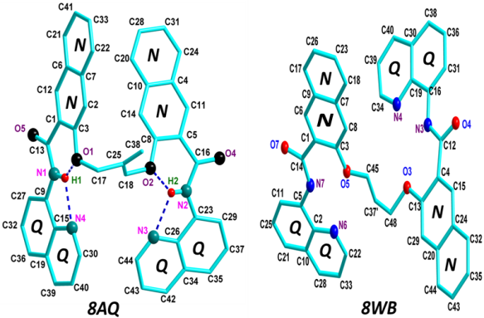
Figure 1. X-ray crystal structures of fluorophores 8AQ and 8WB
These include hydrogen bonds between the hydrogen bond acceptors O(4) and O(5) of one fluorophore with hydrogen bond donors of the naphthalene cores of another fluorophore (H (24) and H(21) respectively) with distances of 2.798 Å and 2.932 Å respectively. Similarly, weak intermolecular hydrogen bonding interactions are also observed between quinoline moieties of one molecule and adjacent naphthalene groups viz. between O(4) and H(37) and N(3) and H(28), with bond distances about 2.674 Å and 2.908 Å respectively. Additionally, the packing arrangement of 8AQ also displays two kinds of CH-π interactions, C(31)-H(31)-π (Q) and C(30)-H(30)-π (Q) with distances of 2.926 Å and 2.719 Å respectively (Figure 2a). Collectively these interactions generate a supramolecular assembly in the solid state which results in the restriction of intramolecular motion demonstrating that fluorophore 8AQ has the significant capability of displaying AIE properties in the solid state. In order to better understand the crucial role of the isobutylene core in generating the AIE phenomenon, analysis of the single crystal X-ray structure of 8WB (Figure 1) clearly shows that the two naphthalene amide quinoline arms are orthogonal as a result of the increased flexibility of the propyl spacer.
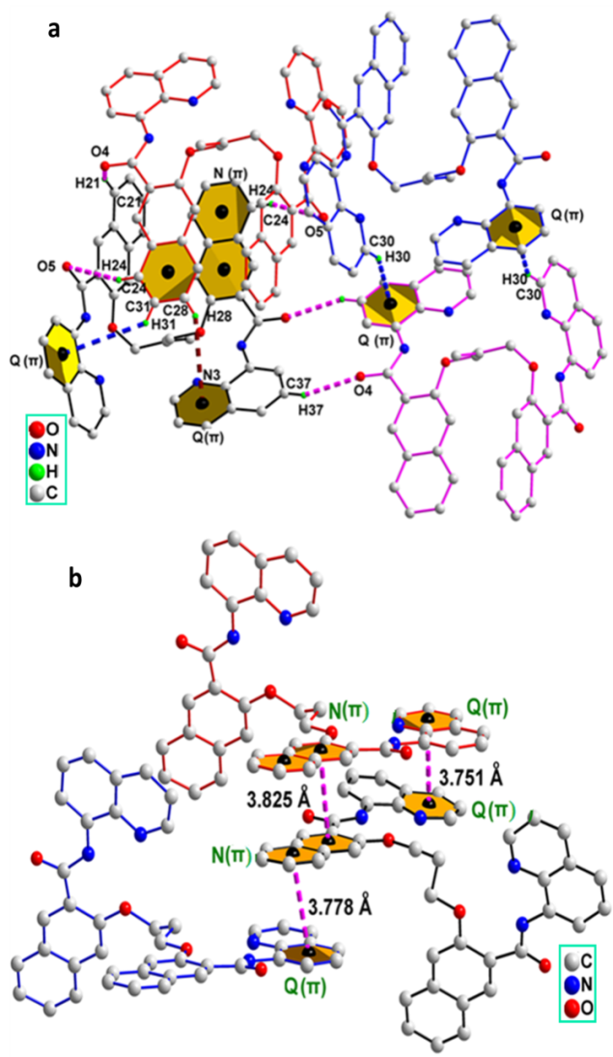
Figure 2. Packing system in the crystal structure of 8AQ, (a) Intermolecular hydrogen bonding N-H···O, N-H··N, (N) C-H-π (Q) and (Q) CH-π (Q) stacking (b) π-π stacking in the crystal structure of 8WB.
In addition, three different π-π-interactions are observed between closely packed molecules in the packing arrangements of 8WB (Figure 2b) with strong π-π interactions of 3.778 Å (Q-N), 3.825 Å (N-N), and 3.751 Å (Q-Q) which is likely to result in no AIE in its solid or aggregated form.
Aggregation-induced emission (AIE) behaviour of fluorophore 8AQ
Fluorophore 8AQ was readily soluble in common organic solvents such as C₂H₅OH, CH₃OH, CHCl₃, THF, CH₃CN and DMF. In order to investigate the AIE properties of 8AQ we conducted fluorescence and UV-vis titrations using 10 µM solution of 8AQ in C2H5OH/H2O mixtures (from 0% to 90 % water fractions) using 0.05 M Tris-HCl buffer at pH 7.5.
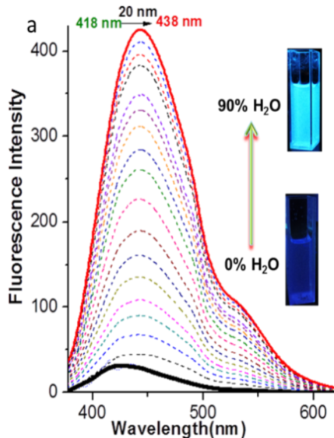
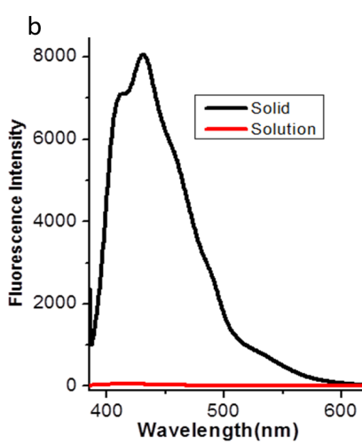
Figure 3. (a) Fluorescence spectra of fluorophore 8AQ (10 µM) in pure C2H5OH with gradual addition of 5% H2O fractions for each spectrum from 0-90 %.(b) Emission spectra of 8AQ in C2H5OH solution and the solid state
As shown in Figure 3a fluorophore 8AQ exhibited a weak fluorescence emission at 418 nm (λex = 366 nm) with a very low quantum yield (Ф= 0.004). Upon addition of water, the main emission band at 418 nm is red-shifted to 438 nm with incrementally increasing emission intensity along with a concomitant increase in quantum yield (Ф=0.040) (Figure S5). Similarly an intense fluorescence emission was observed in the solid state with an enhancement in quantum yield (Ф =0.25) (Figure 3b). Further the analogous UV-vis experiment reveals that 8AQ displays an absorption band centred at 333 nm in ethanol which after addition of 90% water displays a bathochromic shift of 16 nm (Figure S1). Hence these experiments indicate that the weak fluorescence of 8AQ in ethanolic solution is likely to be due to free intramolecular rotation, however, upon aggregation or in the solid state, a significant enhancement in emission is observed, as a result of bond rotation being prevented and the consequent blocking of non-radiative decay processes of the photo-excited molecules.
Absorption spectroscopic studies of 8AQ with various metal ions
To investigate the selective recognition properties of fluorophore 8AQ towards metal ions we measured UV-vis spectra with the perchlorate salts of a variety of common metal ions (Na₊, Ca²⁺, K⁺, Cr³⁺, Ce³⁺, Mg²⁺, Co²⁺, Ni²⁺, Cu²⁺, Pb²⁺, Mn²⁺, Ag⁺, Fe³⁺, Hg²⁺, Cd²⁺ and Zn²⁺) in C₂H₅OH/H₂O (1:1) solution in 0.05 M Tris-HCl buffer solution at pH 7.5 (Figure S2a).
The absorption spectrum of fluorophore 8AQ exhibits a characteristic absorption band at 333 nm, which may be attributed to a π–π* transition and the highly π–conjugated system existing in the fluorophore. Upon addition of 1 equivalent of the metal ions into the fluorophore 8AQ, only Zn²⁺ displayed a bathochromic shift of ca. 50 nm with a new absorption band emerging at 382 nm with a simultaneous decrease in the absorption band at 333 nm with a well-defined isosbestic point at 365 nm. In contrast, the other metals did not induce such changes (Figure S2a). This result indicates that Zn²⁺ coordination increases conjugation in fluorophore 8AQ which in turn leads to a sharp colour variation of the solution from blue to yellow-green under UV light at 360 nm Figure S2b. This result clearly demonstrates that fluorophore 8AQ shows highly selective and sensitive binding capability towards Zn²⁺.

Fluorescence response of fluorophore 8AQ with various metal ions
We also investigated the selective fluorescence recognition properties of fluorophore 8AQ towards the above mentioned common metal ions as well as 8WB (see Figure S3) in C2H5OH/H2O (1:1) solution in 0.05 M Tris-HCl buffer solution at pH 7.5 (Figure 4a). The fluorescence emission peak of fluorophore 8AQ occurs at 430 nm upon excitation at 366 nm at 25ºC. Addition of one equivalent of Zn²⁺ into the 8AQ solution induced a significant ratiometric fluorescence response with a new emission peak being exhibited with dramatically enhanced emission intensity at 536 nm with an additional shoulder at 493 nm. This represents a red shift of about 106 nm and is reflected in the dramatic variation in colour of the solution from blue to yellow-green upon the addition of Zn²⁺ observed under a UV-lamp at 360 nm, as shown in Figure 4. No such changes could be perceived upon the addition of the other metal ions.
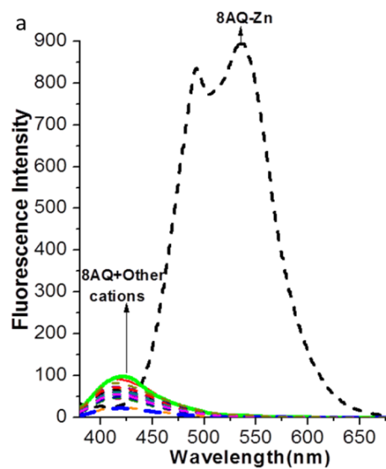
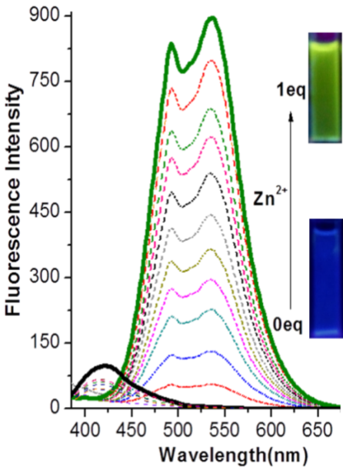
Figure 4. (a) Fluorescence spectra of 8AQ (10 μM, C₂H₅OH: H2O (1:0.05 to 1:1 ratios) in 0.05 M Tris-HCl buffer (pH=7.5) with 1 equivalent of various metal ions. (b) Fluorescence titration of 8AQ with increasing (0.05 eq. Zn²⁺) concentrations of Zn²⁺.
These fluorescence emission results indicate that 8AQ exhibits a highly selective ratiometric response towards the Zn²⁺ ion over the other metal ions tested. Furthermore as shown in Figure 4b, during the fluorescence titration of fluorophore 8AQ with Zn²⁺, an increase in fluorescence intensity could be observed with increasing Zn²⁺ concentrations until 1 equivalent was added, thereafter the emission intensity remains the same with further addition of Zn²⁺. This fluorescence titration result demonstrates that fluorophore 8AQ has a highly selective and sensitive ratiometric response towards Zn²⁺.
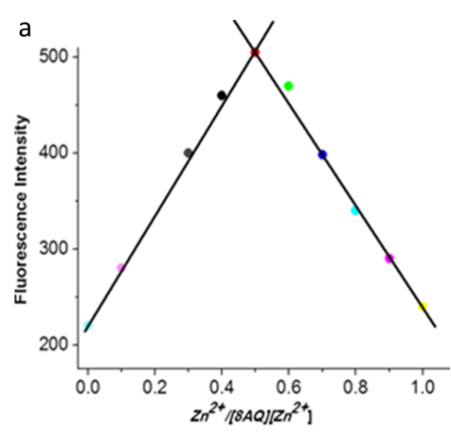
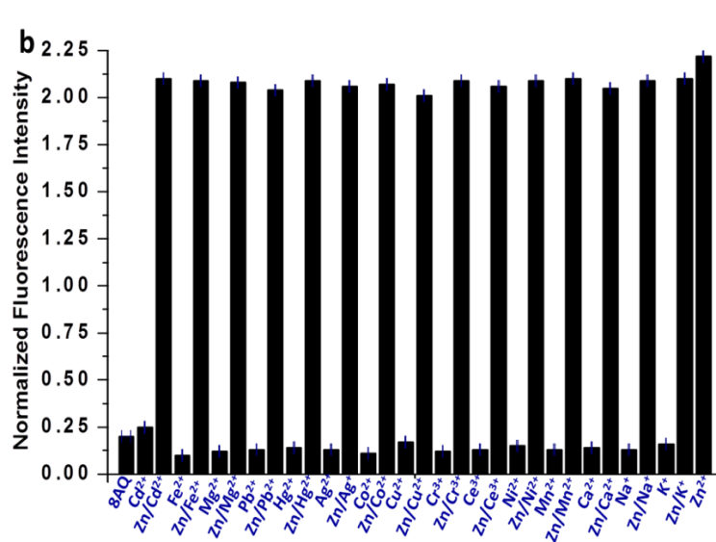
Figure 5. (a) Job’s plot for determining the stoichiometry of 8AQ with Zn²⁺. (b) Fluorescence response of 8AQ-Zn (10 μM) in the presence of 1 equivalent of various additional metal ions in 0.05 M Tris-HCl buffer solution at pH 7.
A Job's plot analysis indicated the expected 1:1 binding stoichiometry between fluorophore 8AQ and Zn²⁺ (Figure 5b). To further verify the high selectivity of fluorophore 8AQ as a ratiometric responsive sensor for Zn²⁺, we undertook competitive experiments by screening the addition of various interfering metal ions to fluorophore 8AQ in C₂H₅OH: H₂O solution, and then added 1 equivalent of Zn²⁺. No significant effect on fluorescence emission of 8AQ toward Zn²⁺ was observed. This result illustrates that fluorophore 8AQ displays robust selectivity and sensitivity toward Zn²⁺. In order to further validate the high selectivity and sensitivity of fluorophore 8AQ towards Zn²⁺, we determined the binding constant and detection limit from the fluorescence titration data. The binding constant of fluorophore 8AQ towards Zn²⁺ was calculated to be 5 ×10⁷ M⁻¹ with a good linear relationship value R²= 0.9929 (Figure S6). Moreover the LOD was calculated to be as low as 2.6 nM by the 3σ method.[42] As a final investigation into binding selectivity the effect of counter ions was investigated and Zn(NO₃)₂, ZnCl₂, and ZnSO₄ were used the same spectral characteristic were exhibited, indicating no anion dependence on binding or fluorescence response (Figure S7).

¹H NMR titration of fluorophore 8AQ with Zn²⁺ to study the binding mode and composition of metal complex 8AQ-Zn
To gain further insight into the binding mode of Zn²⁺ with fluorophore 8AQ, we conducted a ¹H NMR titration in CDCl₃ at room temperature (Figure S4). The ¹H NMR spectrum of the fluorophore 8AQ exhibits a singlet peak for the -NH protons of the amide groups at 11.90 ppm. Additionally, the protons of the quinoline scaffolds H-14, H-12, H-9, H-13, H-10, appear at 8.83 ppm, 8.58 ppm, 7.49 ppm, 7.47 ppm and 7.41 ppm respectively. The incremental addition of Zn²⁺ into the solution of 8AQ showed variations in the chemical shift values of protons present in the system. Upon addition of 0.5 to 1 equivalents of Zn²⁺ into fluorophore 8AQ, the -NH peak of the amide groups shifts downfield from 11.90 ppm to 11.97 ppm without an effect on the peak intensity. Furthermore all quinoline proton peaks shift downfield on zinc binding and broaden, while the isobutylene protons H-1 and H-2 are shifted upfield to 5.62 ppm and 5.20 ppm. In contrast minor changes in the naphthalene scaffold are observed, indicating that, as expected, this moiety is not involved in binding zinc. This result supports the coordination of Zn²⁺ with the N-atoms of quinoline molecules and O-atom of amide moieties of fluorophore 8AQ, furthermore the upfield shift of H-1 and H-2 provides solid evidence for the variation in molecular conformation and the structural rigidity resulting from Zn-coordination. Moreover no further spectral variation of any proton signals was recorded upon addition of excess Zn²⁺ (over 1 equivalent) confirming that metal: ligand binding stoichiometry is 1:1, consistent with the Job’s plot determinations and the fluorescence titration experiments.
ESI-MS experiment
The binding mode between 8AQ and Zn²⁺ was also investigated by ESI-MS. In the ESI-MS spectrum molecular ions were observed at m/z 743.3212 and m/z 843.2919 corresponding to [Zn(8AQ) + H]⁺ and [Zn(8AQ) + ClO₄]⁺ respectively. These values are in accordance with the expected isotopic distribution patterns centred as shown in Figure S13 and Fig S14 and also suggest the binding stoichiometry of 8AQ with Zn²⁺ is 1:1.
Signalling mechanism of fluorophore 8AQ with Zn²⁺
Fluorophore 8AQ exhibited very weak fluorescence in solution due to the free intramolecular rotation among rotatable moieties and the consequential loss of excited state energy via non-radiative relaxation.
In designing fluorophore 8AQ, amide groups were inserted into the molecular system to link the naphthalene moieties along with two quinoline groups. In fluorophore 8AQ, naphthalene scaffolds are used as the signalling part and the peripheral quinoline group served as a Zn²⁺ chelator. Upon addition of Zn²⁺ into the fluorophore a remarkable enhancement in emission intensity associated with a highly ratiometric red shifted response is observed. The ratiometric fluorescence behaviour of fluorophore 8AQ after coordinating with Zn²⁺ may be attributed to binary signalling mechanisms involving a change in molecular conformation and intermolecular charge transfer ICT mechanisms. As illustrated in the partial ¹H NMR titration (vide infra), upon addition of Zn²⁺ into 8AQ, Zn²⁺ strongly coordinates with two O-atoms of the amide groups along with two N-atoms of quinoline moieties. This result is fully consistent with theoretically optimized structures. The DFT optimized structure of complex 8AQ-Zn also shows that the O-atom of the naphthylamide and the N-atom of the quinoline moieties are strongly coordinated with Zn²⁺ which displays a tetrahedral geometry. Furthermore according to the optimised structure of 8AQ-Zn, one quinoline moiety is perpendicularly situated to the naphthylamide moiety Figure S16. These DFT calculations demonstrate that fluorophore 8AQ is strongly coordinated with Zn²⁺ which induces an enhancement in fluorescent emission behaviour as shown in Figure S16. Additionally due to the strong coordination of Zn²⁺ with the quinoline N-atoms intramolecular charge transfer to Zn²⁺ is promoted, resulting in the remarkable ratiometric response displayed. The calculations revealed that the HOMO-LUMO energy gap of the 8AQ-Zn complex was also lower (3.86 eV) compared to the fluorophore 8AQ (4.42 eV). In order to explain the appearance of two prominent emission peaks after binding with Zn²⁺, the TD-TDFT calculation demonstrated that the structural distortion induced in 8AQ by coordination with Zn²⁺ results in an approximately 20 nm difference in absorption wavelength of S1 and S2. It can thus be expected that the quenching from S1 and S2 will result in two vertical forms of electronic transitions with a more significant energy difference in the emission spectra. The calculated vertical emission bands based on TD-DFT optimized excited state structures are centred at 571 nm and 485 nm, which not only supports our proposed mechanism but are also consistent with the experimental findings.
Biological cell-permeability of 8AQ and intracellular ratiometic fluorescence response towards Zn²⁺
To evaluate the promising applications of fluorophore 8AQ in biological systems, we examined the effect of pH on the fluorescence intensity of fluorophore 8AQ and investigated its recognition properties towards Zn²⁺ in 0.05 M Tris-HCl buffer solution (Figure S8). Fluorophore 8AQ continued to display intense emissions in the presence of Zn²⁺ in the pH range 6 to 8 indicating that the fluorophore is suitable for biological imaging applications and monitoring intracellular Zn²⁺. In order to demonstrate this, its cell permeability, intracellular ratiometric fluorescence responsiveness towards Zn²⁺ and cytotoxicity were investigated in human hepatoma cancer cells (HepG2). A 1 mM stock solution of fluorophore 8AQ in C₂H₅OH/H₂O was initially prepared and then diluted using 0.05 M Tris-HCl buffer solution of pH 7.5 to 10 μM as the working concentration. We then investigated bio-imaging applications of HepG2 incubated with 8AQ at 10 μM in 0.05 M Tris-HCl buffer solution of pH 7.5 for 1 hour at 37°C. As shown in Figure 6b, fluorophore 8AQ was well-distributed and penetrated into live cells and exhibited blue fluorescence imaging showing that fluorophore 8AQ has excellent membrane permeability. Consequently HepG2 cells were incubated with fluorophore 8AQ followed by 10 μM ZnCl₂ to explore intracellular Zn-imaging which resulted in an intracellular ratiometric fluorescence response with the strong green fluorescence image shown in Figure 6 (c, d). Some differences in probe localisation were observed upon binding to zinc, which is perhaps not surprising given the fundamental differences in structure between the free ligand and its zinc complex. In addition the morphology of the cells treated with zinc is somewhat different, however, zinc is known to affect cell motility and differentiation and it is likely that cells are in different phases of the cell cycle or differentiation leading to the heterogeneity observed. [50] In order to evaluate the viability of HepG2 cells with fluorophore 8AQ and its corresponding complex 8AQ-Zn, HepG2 cells were treated with 8AQ and its zinc complex over a range of concentrations for 24 h and 12 h (Figure 6b) while treated with complex 8AQ-Zn for 24 h (Figure S19). These data revealed that HepG2 cells exhibit near 100% viability for 12 h and 24 h treatment with fluorophore 8AQ and complex 8AQ-Zn. These fluorescence bio-imaging experiments clearly demonstrate that fluorophore 8AQ has excellent cell permeability and could be suitable as a ratiometric fluorescence imaging sensor for intracellular Zn²⁺ in human liver cancer cells.
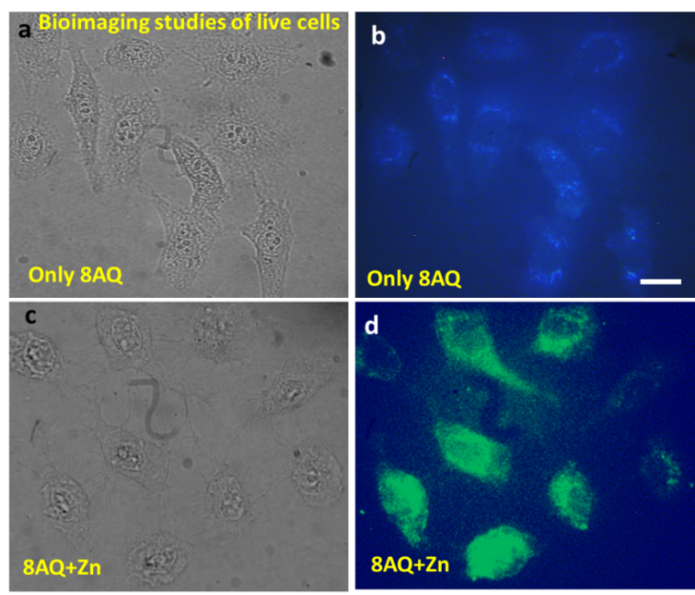
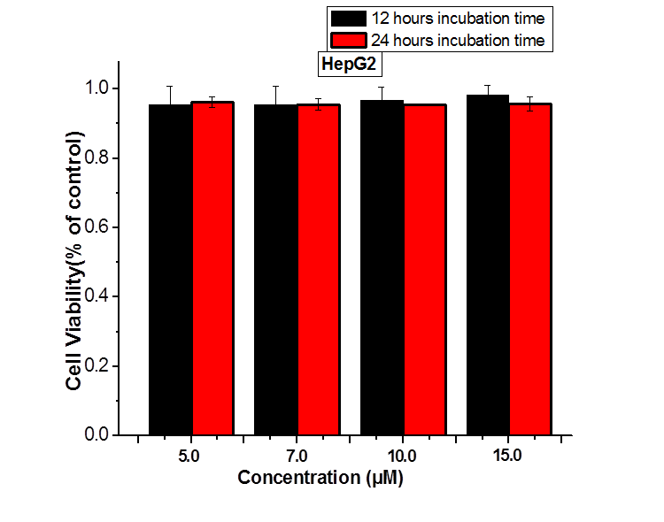

Figure 6. Fluorescence microscopy images of HepG2 cells. Bright-field transmission images of cells after incubation with (a) 10 μM 8AQ (c) 10 μM 8AQ and 10 μM Zn²⁺ for 2 hours at 37°C (b, d) Fluorescence transmission images of 8AQ, 8AQ-Zn (above) and cell viability values (%) estimated by MTT assay versus incubation concentrations of 8AQ (below).
Conclusions
In conclusion, we have designed and synthesized two novel organic fluorophores 8AQ and 8WB with and without an isobutylene group that display AIE and non-AIE characteristics respectively. Both fluorophores 8AQ and 8WB contain two naphthalene-amide groups connected to the quinoline moieties which act as the metal chelating sites for Zn²⁺. In fluorophore 8AQ, the isobutylene group is introduced into the system in order to produce a certain level of rigidity to reduce intramolecular molecular rotations. The AIE behaviour of 8AQ was clearly demonstrated by fluorescence spectroscopy, quantum yield calculations and in the solid state through single crystal X-ray diffraction, which revealed a crystal packing system with extensive intermolecular interactions. Furthermore fluorophore 8AQ displayed a highly ratiometric fluorescence response towards Zn²⁺. In contrast 8WB has a much more flexible molecular structure due to the lack of the isobutylene group and exhibits poor selectivity towards metal ions. The 8AQ-Zn complex stoichiometry ratio was confirmed to be 1:1 by Job’s plots analysis and was also supported by ¹H NMR titrations, DFT calculations and ESI-MS analysis. A binding constant of 5 ×10⁷ M⁻¹ and LOD of 2.6 nM were calculated by using linear fittings and standard deviation methods. Importantly fluorophore 8AQ also exhibited a highly ratiometric fluorescence response towards Zn²⁺ in human hepatoma cancer cells (HepG2). Investigations into the development of more sophisticated AIE active fluorophores, biosensors and chemosensors with comparable selectivity and sensitivity are in progress in our laboratories.
Experimental Section
Materials and Instrumentation: All commercially available chemicals were purchased from commercial suppliers except when specified. Solvents such as CH₂Cl₂, CHCl₃, CH₃OH, C₂H₅OH, and n-hexane and petroleum ether were used as obtained. Anhydrous solvents such as DMF, THF were also purchased from suppliers. All intermediates and target molecules were satisfactorily characterised by ¹H and ¹³C NMR spectroscopy, ESI-MS and in some cases single crystal structures. NMR spectra were recorded on Bruker AVANCE-400 NMR spectrometer at 400 MHz (¹H NMR) and 100 MHz (¹³C NMR). High resolution mass spectra were recorded on an Agilent 6310 MS spectrometer and a Q-TOF MS spectrometer. UV-vis spectra were recorded using a HITACHI U-4100 spectrophotometer. Fluorescence spectroscopic measurements and fluorescence quantum yields were measured on a JASCO FP-8500 spectrofluorimeter. Single-crystal X-ray diffraction experiments were performed with a Bruker SMART AXS CCD diffractometer. The fluorescent bioimaging assays were performed with a laboratory use luminescence microscopy.
UV-Vis and fluorescence measurements
For absorption and fluorescence measurements, 1 mM stock solutions of fluorophores 8AQ and 8WB were prepared in 50 ml graduated volumetric flasks. These stock solutions were diluted to 10 μM with CH₃CH₂OH/H2O (1:1 v/v) solution. Meanwhile, solutions of perchlorate salts of all tested metal ions were also prepared in water. The recognition properties of fluorophores 8AQ and 8WB towards metal ions were investigated through UV-vis and fluorescence spectroscopies in 0.05 M Tris-HCl buffer solution of CH₃CH₂OH/H₂O. The association constant and detection limit of fluorophore 8AQ towards Zn²⁺ was determined from the fluorescence emission intensity data. [51]
Theoretical Methods
We performed extensive Density Functional Theory/Time-dependent Functional Theory (DFT/ TD-DFT) based calculations to investigate the correlation between structure of 8AQ and its sensing behaviour towards Zn²⁺.[52,53] All the calculations were performed with B3LYP functional in combination with 6-31G(d) and Lanl2dz basis sets as implemented in Gaussian 09.[54-56] The molecular structures of ground states and low-lying excited states of both 8AQ and the corresponding zinc complex 8AQ-Zn were fully optimized and verified with frequency calculations. The CPCM polarizable conductor model was used to handle the impact solvent environment on geometric and electronic structures. [57]
Fluorescence imaging in living Cells
For fluorescence imaging experiments, all cultured human liver cancer cells HepG2 were obtained from Dalian Medical University. HepG2 cells cultured on a 35 mm glass-bottom culture dish (φ 20 mm) in RPMI-1640 medium containing 10% fetal bovine serum, 1% penicillin, and 1% streptomycin, cells were washed three times with an isotonic saline solution (140 mM NaCl, 10 mM glucose and 3.5 mM KCl). After that prepared 10 μM solutions of the fluorophore 8AQ in the isotonic saline solution was added to the culture medium and cells were incubated for 2 hours at 37 ºC in a 5% CO2/95% air incubator. For intracellular Zn²⁺ imaging experiments the fluorophore 8AQ loaded cells were washed three times with isotonic saline solution after 1 h incubation then incubated again in the presence of isotonic saline solution containing 10 μM Zn²⁺ and 0.5 mg/ml cremophor C040 for 2 h under identical conditions. The cells were washed five times with isotonic saline solution and then subjected to the fluorescence imaging using a fluorescent microscopy with an excitation wavelength of 360 nm.
MTT assay
The cytotoxicity of 8AQ and 8AQ-Zn to human liver cancer cells (HepG2) was tested by using a previously reported method of the MTT assay.[58,59] HepG2 cells cultured in DMEM medium, containing 10% FBS (fetal bovine serum) and antibiotics (100 units/ ml penicillin and 100 mg ml streptomycin), were washed with an isotonic saline solution (140 mM NaCl, 10 mM glucose and 3.5 mM KCl), and then incubated with various concentrations of 8AQ (5-15 μM) for 12 hours and 24 hours, in case of complex 8AQ-Zn (5-30 μM) for 24 hours at 37 ºC in a 5% CO₂/ 95% air incubator. After the culture medium was removed, the cells were further incubated with the PBS buffer containing 0.5 mg ml of MTT for 4 h in the incubator. The supernatants were removed, cells were suspended in 1% DMSO, and then the absorbance was measured at 490 nm.
Synthesis of fluorophore 8AQ
Intermediate compound L-2 was synthesised according to the literature and used as a starting material for construction of fluorophore 8AQ. [60] L-2 (0.23 g, 0.50 mmol) was dissolved in dried THF (10-15 ml) and added dropwise into 8-aminoquinoline (0.3 g, 1 mmol) containing triethylamine (0.2 g, 2 mmol) with continuous stirring at 0 ºC. Subsequently the reaction mixture was stirred for 12 hours at room temperature. The THF was evaporated under reduced pressure. Purification was performed by column chromatography using CH₂Cl₂/ethyl acetate (3:2) as the eluant giving pure 8AQ (75% yield). Single crystals of 8AQ were obtained CH₂Cl₂ /CH₃CH₂OH via slow evaporation within one week. Crystal Data are summarized in Table 1. ESI-MS m/z C₄₄H₃₂N₄O₄ : 730.23 [M+ Na]⁺, ¹H NMR (400 MHz, CDCl₃) δ 11.86 (s, 2H, -NH), 8.82 (d, J = 4.0 Hz, 2H, Q-H14), 8.67 (s, 2H, N-H8), 8.58 (d, J = 4.0 Hz, 2H, Q-H12), 7.98 (d, J = 8.0 Hz, 2H, N-H7), 7.84 (d, J = 8.0 Hz, 2H, N-H4), 7.46-740 (m, 4H, Q-H9, H10), 7.38-736 (m, 4H, Q-H11, H13), 7.18 (s, 2H, N-H3), 7.22-7.16 (m, 4 H, N-H6, H5), 5.67 (s, 2H, H-1), 5.24 (s, 4H, H-2). ¹³C NMR (100 MHz, CDCl₃) δ 163. 5, 153.3, 147.8, 139.2, 138.8, 136.1, 135.8, 135.6, 135.2, 134.0, 129.0, 128.4, 128.2, 127.9, 127.0, 126.4, 124.7, 123.9, 121.7, 118.2, 117.6, 108.2, 70.1 ppm.
Synthesis of compound 8WB
The synthetic procedure for compound 8WB is the same as fluorophore 8AQ. Single crystal of compound 8WB were produced from solution of CH₂Cl₂ /CH₃CH₂OH via slow evaporation within one week. Crystal Data are summarized in Table 1. ESI-MS m/z C₄₃H₃₂N₄O₄ : 691.23 [M+ Na]⁺, ¹H NMR (400 MHz, CDCl₃) δ 11.98 (s, 2H, -NH), 9.10 (d, J = 8.0 Hz, 2H, Q-H14), 8.82 (s, 2H, N-H8), 8.76 (d, J = 4.0 Hz, 2H, Q-H12), 7.93-7.88 (m, 4H, N-H7,H4), 7.54 (t, J = 8.0 Hz, 4H, Q-H13), 7.46 (t, J = 7.5 Hz, 2H, N-H5), 7.41-7.34 (m, 4H, Q-H11, H10), 7.20-7.17 (m, 2H, N-H6), 7.11 (s, 2H, N-H3), 4.67 (t, J = 6.0 Hz, 4H, H-2), 3.21 (Quintet, J = 4 Hz, 2H). ¹³C NMR (100 MHz, CDCl3) δ 163.7, 153.6, 147.8, 138.9, 136.1, 135.8, 135.5, 134.2, 129.1, 128.3, 128.0, 127.4, 126.2, 124.6, 123.4, 121.8, 121.4, 117.7, 107.3, 66.0, 44.9, 28.8 ppm.
Acknowledgements
The authors are grateful for financial support from the National Natural Science Foundation of China (NO.21206016) and the Fundamental Research Funds for the Central Universities (DUT14LK08). MW would like to acknowledge the contribution of the COST Action TD1304 Zinc-Net.
Keywords
Fluorophore• Ratiometric • Bioimaging • Sensing • AIE • Selectivity• Zinc.
[1] Z. Guo, A. Shao and W. H. Zhu, Mater. Chem. C. 2016, 4, 2640-2646.
[2] J. Mei , Y. Hong, J. W. Y. Lam, A. Qin , Y. Tang, and B. Z. Tang, Adv. Mater. 2014, 26, 5429-5479.
[3] Z. Ning, Z. Chen, Q. Zhang, Y. Yan, S. Qian, Y. Cao, and H. Tian, Adv. Funct. Mater., 2007, 17, 3799-3807.
[4] J. P. Yi, L. Zhao, W. Xu, C. F. Liu, W. Y. Lai and W. Huang, J. Mater. Chem. C. 2016, 4, 7546-7553.
[5] M. Irie, T. Fukaminato, T. Sasaki, N. Tamai, T. Kawai, Nature. 2002, 420, 759-760.
[6] S. J. Kang, S. Ahn, J. B. Kim, C. Schenck, A. M. Hiszpanski, S. Oh, T. Schiros, Y. L. Loo and C. Nuckolls, J. Am. Chem. Soc. 2013, 135, 2207-2212.
[7] M. Koenig, B. Storti, R. Bizzarri, D. M. Guldi, G. Brancato and G. Bottari, J. Mater. Chem. C. 2016, 4, 3018-3027.
[8] H. Sharma, N. Kaur, A. Singh, A. Kuwar and N. Singh, J. Mater. Chem. C. 2016, 4, 5154-5194.
[9] Z. Chi, Xi. Zhang, B. Xu, X. Zhou, C. Ma, Y. Zhang, S. Liua and J. Xu, Chem. Soc. Rev. 2012, 41, 3878-3896.
[10] Z. Chen, J. Zhang, M. Song, J. Yin, G. A. Yu and S. H. Liu, Chem. Commun. 2015, 51, 326-329.
[11] X. Wang, Y. Wu, Q. Liu, Z. Li, H. Yan, C. Ji, J. Duana and Z. Liu, Chem. Commun. 2015, 51, 784-787.
[12] R. T. K. Kwok, C. W. T. Leung, J. W. Y. Lam and B. Z. Tang, Chem. Soc. Rev. 2015, 44, 4228—4238.
[13] Y. Hong, J. W. Y. Lam and B. Z. Tang, Chem. Soc. Rev. 2011, 40, 5361-5388.
[14] M. Wang, G. Zhang, D. Zhang, D. Zhu and B. Z. Tang, J. Mater. Chem. 2010, 20, 1858–1867.
[15] Y. Zhang, H. Li, G. Zhang, X. Xu, L. Kong, X. Tao, Y. Tiana and J. Yang, J. Mater. Chem. C, 2016, 4, 2971-2978.
[16] C. Li, T. Wu, C. Hong, G. Zhang, and S. Liu, Angew. Chem. Int. Ed. 2012, 51, 455 -459.
[17] Z. Li, Y. Q. Dong, J. W. Y. Lam, J. Sun, A. Qin, M. Haubler, Y. P. Dong, H. H. Y. Sung, I. D. Williams, H. S. Kwok, and B. Z. Tang, Adv. Funct. Mater. 2009, 19, 905-917.
[18] J. Luo, Z. Xie, J. W. Y. Lam, L. Cheng, H. Chen, C. Qiu, H. S. Kwok, X. Zhan, Y. Liu, D. Zhu and B. Z. Tang, Chem. Commun. 2001, 18, 1740-1741.
[19] W. T. Neo, Q. Ye, S. J. Chua and J. Xu, J. Mater. Chem. C. 2016, 4, 7364-7376.
[20] W. Z. Yuan, P. Lu, S. Chen, J. W. Y. Lam, Z. Wang, Y. Liu, H. Kwok, Y. Ma, and B. Z. Tang, Adv. Mater. 2010, 22, 2159-2163.
[21] J. Yang, J. Huang, Q. Li and Z. Li, J. Mater. Chem. C. 2016, 4, 2663-2684.
[22] Y. Liu, Y. Lei, F. Li, J. Chen, M. Liu, X. Huang, W. Gao, H. Wu, J. Ding and Y. Cheng, J. Mater. Chem. C. 2016, 4, 2862-2870.
[23] Y. Ding, W. H. Zhu, and Y. Xie, Chem. Rev., DOI: 10.1021/acs.chemrev.6b00021
[24] J. J. Bryant and U. H. F. Bunz, Chem. Asian J. 2013, DOI:10.1002/asia.201300260
[25] Z. Xu, J. Yoon and D. R. Spring, Chem. Soc. Rev. 2010, 39, 1996-2006.
[26] K. Jobe, C. H. Brennan, M. Motevalli, S. M. Goldup and M. Watkinson, Chem. Commun. 2011, 47, 6036–6038
[27] K. P. Carter, A. M. Young, and A. E. Palmer, Chem. Rev. 2014, 114, 4564−4601
[28] H. Woo, Y. You, T. Kim, G. J. Jhon and W. Nam, J. Mater. Chem. 2012, 22, 17100-17112.
[29] Z. Zhang, Y. Shi, Y Pan, X. Cheng, L. Zhang, J. Chen, M. J. Li and C. Yi, J. Mater. Chem. B. 2014, 2, 5020-5027.
[30] X. Qian and Z. Xu, Chem. Soc. Rev. 2015, 44, 4487--4493
[31] N. Zhang, X. Tian, J. Zheng, X. Zhang, W. Zhu, Y. Tian, Q. Zhu, H. Zhou. Dyes and Pig. 2016, 124, 174-179.
[32] B. K. Datta, D. Thiyagarajan, S. Samanta, A. Ramesh and G. Das, Org. Biomol. Chem. 2014, 12, 4975-4982.
[33] Y. Chen, Y. Bai, Z. Han, W. He and Z. Guo, Chem. Soc. Rev. 2015, 44, 4517-4546
[34] Z. Xu, X. Liu, J. Panb and D. R. Spring, Chem. Commun. 2012, 48, 4764–4766
[35] D. W Domaille, E. L Que and Christopher J Chang, Nat. Chem. Bio. 2008, 4, 168-175
[36] J. Pancholi, D. J. Hodson, K. Jobe, G. A. Rutter, S. M. Goldup and M. Watkinson, Chem. Sci. 2014, 5, 3528–3535
[37] L. Xue, Q. Liu, H. Jiang, Org. Lett. 2009, 11, 3454-3457.
[38] Y. Mikata, A. Yamashita, A. Kawamura, H. Konno, Y. Miyamotod and S. Tamotsud, Dalton Trans. 2009, 19, 3800-3806.
[39] Y-H. Lau, P. J. Rutledge, M. Watkinson and M. H. Todd, Chem. Soc. Rev. 2011, 40, 2848–2866
[40] Y. L. Pak, K. M. K. Swamy and J. Yoon, Sensors. 2015, 15, 24374-24396
[41] D. Y. Zhang, M. Azrad, W. D. Wahnefried, C. J. Frederickson, S. J. Lippard, and R. J. Radford, ACS Chem. Biol. 2015, 10, 385-389.
[42] Y. Zhou, Z. X. Li, S. Q. Zang, Y. Y. Zhu, H. Y. Zhang, H. W. Hou and T. C. W. Mak, Org. Lett. 2012, 14, 1214-1217.
[43] D. Sarkar, A. K. Pramanik and T. K. Mondal, RSC Adv. 2014, 4, 25341–25347
[44] K. Sarkar, K. Dhara, M. Nandi, P. Roy, A. Bhaumik and P. Banerjee, Adv. Funct. Mater. 2009, 19, 223–234.
[45] K. P. Divya, S. Sreejith, P. Ashokkumar, K. Yuzhan, Q. Peng, S. K. Maji, Y. Tong, H. Yu, Y. Zhao, P. Ramamurthy and A. A ghosh, Chem. Sci. 2014, 5, 3469–3474
[46] M. Shyamal, P. Mazumdar, Samir. M, S. Samanta, G. P. Sahoo, A. Misra, ACS Sens. 2016, 1, 739−747.
[47] J. Yang, H. Rong, P. Shao, Y. Tao, J. Dang, P. Wang, Y. Ge, J. Wu, D. Liu, J. Mater. Chem. B. 2016, 4, 6065-6073
[48] J. Cao, C. Zhao, X. Wang, Y. Zhang, W. Zhu. Chem. Commun. 2012, 48, 9897-9899
[49] J. C. Qin, B. Wang, Z. Yang, K. Yu. Sens. Actuators B. 2016, 224, 892-898
[50] K.M. Taylor, I.A. Muraina, D. Brethour, G. Schmitt-Ulms, T. Nimmanon, S. Ziliotto, P. Kille and C. Hogstrand, Biochem. J, 2016,473, 2531-2544.
[51] B. K. Datta, D. Thiyagarajan, S. Samanta, A. Ramesh and G. Das, Org. Biomol. Chem. 2014, 12, 4975-4982
[52] C. Adamo and D. Jacquemin, Chem. Soc. Rev. 2013, 42, 845
[53] A. D. Laurent, C. Adamo, D. Jacquemin, Phys. Chem. Chem. Phys. 2014, 16, 14334-56.
[54] A. D. Becke, J. Chem. Phys. 1993, 98, 5648–5652.
[55] M. M. Francl, W. J. Pietro, W. J. Hehre, J. S. Binkley, M. S. Gordon, D. J. DeFrees and J. A. Pople, J. Chem. Phys. 1982, 77, 3654–3665;
[56] P. J. Hay and W. R. Wadt, J. Chem. Phys. 1985, 82, 299–310.
[57] M. Cossi, N. Rega, G. Scalmani, and V. Barone, J. Comp. Chem. 2003, 24, 669-681.
[58] B. Song, Z. Ye, Y. Yang, H. Ma, X. Zheng, D. Jin and J. Yuan, Sci. Rep. 2015, 5, 1-10
[59] H. Ma, B. Song, Y. Wang, D. Cong, Y. Jiang and J. Yuan Chem. Sci. 2017, 8, 150-159
[60] H. Houjou, S. K. Lee, Y. Hishikawa, Y. Nagawa and K. Hiratani, Chem. Commun. 2000, 22, 2197-2198.

