The influence of low-density granite bodies on extensional basins
Louis Howell¹, Stuart Egan¹, Graham Leslie², Stuart Clarke¹, Andrew Mitten¹, Jamie Pringle¹
¹School of Geography, Geology and the Environment, William Smith Building, Keele University, Keele, Staffordshire, ST5 5BG, UK.
²BGS Scotland, Lyell Centre, Research Avenue South, Edinburgh, EH14 4AP, UK.

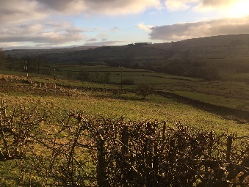

Abstract
The Carboniferous North Pennine Basin remains the type locality for the ‘block and basin’ tectonic framework model. It has been widely believed that during periods of tectonic extension, large low-density bodies within the basement permit buoyant blocks to resist isostatic subsidence. However, lithosphere-scale structural and geodynamic modelling experiments dispute this; suggesting instead that the formation of intra-basinal highs occurs prior to lithospheric extension. In northern England, this tectonic framework is controlled by a combination of tectonic stress, isostasy and the buoyancy forces of low-density granite, lithospheric flexure and, importantly, the inherited structural framework. It is hoped that further study can lead to a greater appreciation of the interplay of structural and geodynamic process that control the ‘block and basin’ framework.

Introduction
A long-held assumption, concerning the occurrence of buoyant granite bodies in the cores of intra-basinal highs, is now being challenged after recent numerical structural and geodynamic modelling by the Basin Dynamics Research Group (BDRG) at Keele University. These findings are based on a study of the Carboniferous-aged North Pennine Basin of northern England; an area where the geology has been debated for centuries. It had been widely believed that during periods of tectonic extension, normal faulting around the peripheral margins of large granite batholiths permitted relatively ‘buoyant’ and ‘rigid’ blocks to isostatically resist widespread faulting-induced subsidence. The results of this study have been recently published in the scientific journal Tectonophysics.
This traditional view is largely based on the strong correlation of negative gravitational anomalies in northern England and in the neighbouring offshore North Sea that are associated with low-density granite bodies, within largely Carboniferous-aged intra-basinal highs. Such features are also known as blocks in the classic ‘block and basin’ tectonic framework model. Professor Martin H.P. Bott of Durham University was the first to suggest this relationship after his geological interpretation of the Alston Block, Northumberland, based on a gravity survey carried out in 1957. The similarities of the negative anomaly over the Alston Block with the anomaly over exposed granitic intrusions in Cornwall, southern England, as well as the strong correlation of the anomaly with the occurrence of mineralisation zones, led him to postulate a concealed granite body was present at depth. It was suggested that the mass deficiency of the granite body could account isostatically for the general stability of the block since the early Carboniferous. The existence of the granitic North Pennine Batholith was proved in 1960-61 by the drilling of the Rookhope borehole by Durham University, when early Devonian-aged granite was encountered unconformably underlying Lower Carboniferous-aged sediment at ~390 m depth below ground level. The repeated occurrence of granite-cored block highs was later found to extend into the central and southern North Sea, which was by then a newly emerging hydrocarbon basin.
The implications for this ‘block and basin’ tectonic framework model have been well discussed. Seemingly, the occurrence of granite within the basement influences highs that would have acted as baffles or barriers to northerly-derived clastic supply during early Carboniferous rifting; effectively preserving the contemporaneous organic-rich shale formations currently being exploited in Lancashire and elsewhere across northern England.

Location
What was once the Alston Block during the Carboniferous Period provides the central focus for this study (Figure 1). This area now occupies the North Pennines, an area of north-eastern England characterised by rolling hills, rugged moorland and outstanding natural beauty. The present-day topography mimics the Carboniferous block and basin arrangement somewhat; the Alston Block is relatively elevated, whereas the Vale of Eden to the west and north Northumberland to the north are comparatively flat lying and on lower ground (Figure 2). This area of England is sparsely populated but can be accessed through a vast rights of way networks, cycle routes and youth hostels.

Basin Formation
The North Pennine Basin was one part of the greater North Western European Carboniferous intra-continental extensional basin (Figure 1). This basin system formed during a period of latest Devonian to early Carboniferous lithospheric extension and established the previously mentioned ‘block and basin’ framework, which is encountered throughout NW Europe. Relatively elevated blocks commonly provided the foundations for the evolution of shallow water carbonate systems, or were areas of no deposition. Intervening deeper water basins generally accumulated basinal mudstones. In the North Pennines, early Carboniferous basin fill is characterised by mixed carbonate-clastic ‘Yoredale’ successions (Figure 3). In general, these blocks are cored by large, low-density granite bodies (Figure 4).

Interpreting the role played by granite emplacement
In spite of the early suggestion that buoyant granite could help fault block highs resist subsidence during tectonic extension, the early Carboniferous succession is variably thick across the granite-cored Alston Block. The deep Harton Dome borehole drilled along the coast of County Durham in 1960 illustrates this further. Despite the Harton borehole, supposedly being situated on the Alston Block and not being separated from the Rookhope borehole by any significant structure, drilling of the Harton Dome borehole was abandoned at 1,749 m depth before any basement was encountered (Figure 5). This, as written in the Geological Completion Report for the well at the time, “left considerable uncertainty in the interpretation of the geology”.
Isostasy is the state of gravitational equilibrium between the Earth’s lithosphere and the underlying, more ductile, mantle asthenosphere. On geological time-scales, changes to the thickness or density of the lithosphere, due to tectonic activity or large igneous intrusions, are compensated by the lateral migration of this more ductile layer at depth. The notion that any load imposed on the lithosphere, such as that related to the relative buoyancy of granite, could remain uncompensated isostatically for the ~60 Ma between the intrusion of the North Pennine Batholith and early Carboniferous deposition in the North Pennines is doubtful. Simple one-dimensional isostatic mass balancing (Figure 6) suggests that, instead of low-density crust resisting subsidence during tectonic extension, low-density crust should instead subside at a greater rate. This is because the magnitude of isostatic compensation is proportional to the vertical loss of mass from the lithosphere. Instead, the generation of granite-cored highs should occur prior to tectonic extension.

Structural and geodynamic modelling
To investigate this relationship further, a two-dimensional structural and geodynamic modelling approach was adopted. Firstly, an undeformed 2D grid of individual cells is assigned a series of parameters to represent the lithosphere. A lower density value is assigned for the uppermost 35 km of the model, the crust, compared to the value assigned for the lowermost 90 km, the lithospheric mantle. This model also incorporates a 2D temperature grid so that thermal perturbations associated with tectonic episodes can also be modelled. To simulate the influence of large granite bodies on the North Pennine Basin, the density of the crust was recalculated according to the interpreted thickness of the low-density North Pennine Batholith based on a recent geophysical study by the BGS (Figure 7a). The isostatic compensation to this granite body was computed prior to the simulation of early Carboniferous tectonic extension, also taking into account the elasticity of the lithosphere. After this, a basin cross-section was forward modelled, incorporating fault displacement, lithosphere thinning and the model parameters taking into account the presence or absence of granite within the basement. A more detailed description of the modelling approach used can be found in Howell et al. (2019) (see further reading).
There is a striking similarity between the modelled cross-section and an observed cross-section across the North Pennine Basin from the interpretation of seismic data by BGS scientists (Figure 7b). Notably, there is a pronounced bulge overlying the concealed granitic North Pennine Batholith. This relates to the flexure or bending of the lithosphere in response to the forces imposed on it. In this instance, this force is due to the presence of the low-density granite body.

Role of inherited structure
There is a clear resemblance with tectonic fabrics from events prior to the early Carboniferous and the Carboniferous basins in northern England. In terms of its control on the nature of the inherited basement fabric, one of the most important events would have been the closure of the ancient Iapetus Ocean towards the end of the Caledonian orogeny. It is likely that the Carboniferous basins formed by reactivating previously formed discontinuities, including the Iapetus suture, which transects this part of northern England. Given the timing of the early-mid Devonian Acadian deformation throughout England in relation to the early-Devonian intrusion of the granitic North Pennine Batholith, it is likely that this episode of transtension, caused perhaps by the early closure of the ancient Rheic Ocean further south, may have also played an important role in weakening basement lineaments prior to tectonic extension and just after magmatism.
The comparative strength of the intruded North Pennine Batholith, with respect to the partially weakened surrounding ancient orogenic basement, may have been important for the distribution of major faults in the region. Across northern England and the North Sea, major basin-bounding faults are found along the peripheral margins of large concealed granite bodies. The North Pennine Batholith could have sealed some ancient orogenic lines of weakness that would have connected the upper and the mid-crust prior to its intrusion. In disconnecting lineaments between the upper and mid-crust, their potential for displacement during subsequent reactivation events is reduced. Areas with intruded granite would have been less susceptible to forming faulted basin margins.

Summary
The relationship between block highs, faulting, lithospheric flexure and large low-density granite bodies is complex and there is still much to be gained from further study (Figure 8). The North Pennines offers a fantastic case study for developing our understanding of this curious structural and geodynamic relationship that can, in turn, be applied to enhancing our understanding of similar examples in the geological record.
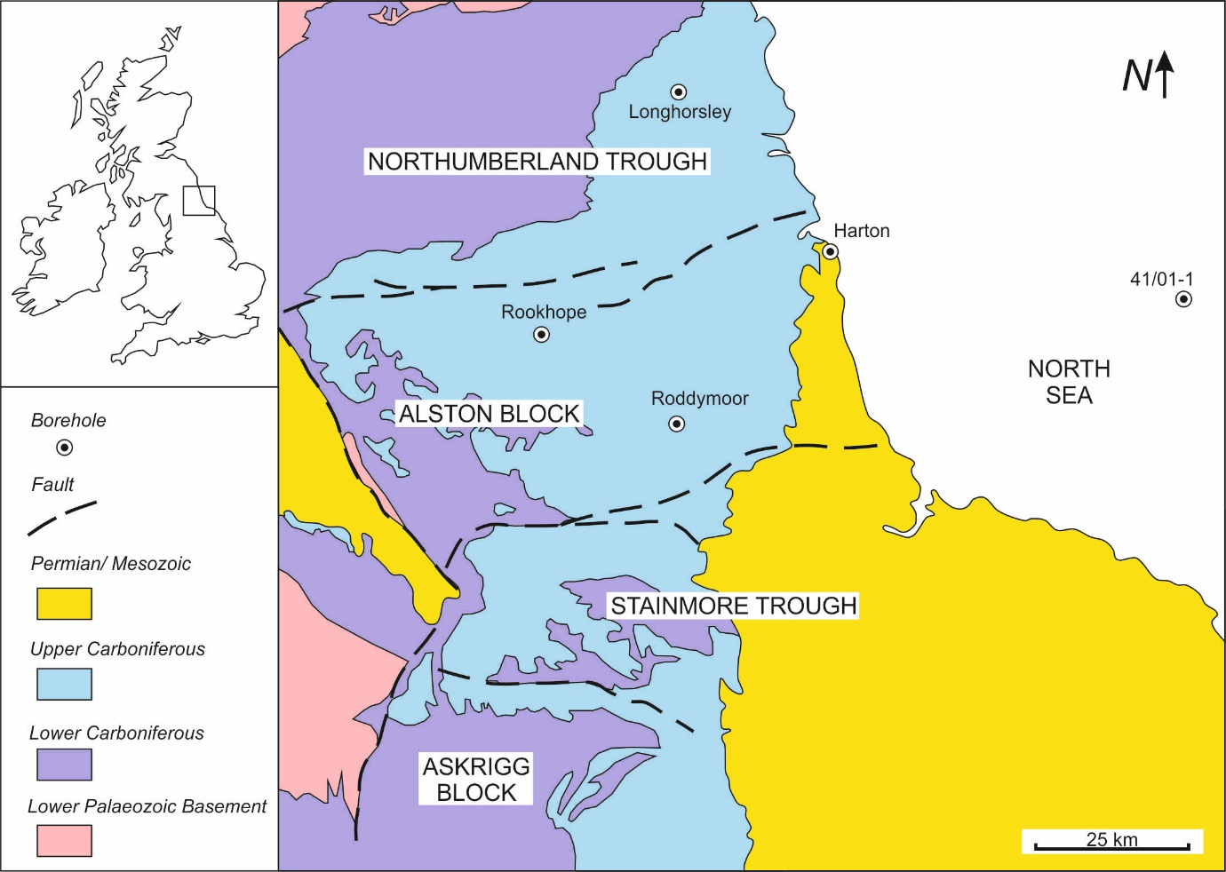
Figure 1. Outcrop and location map for the broader North Pennine Basin and some of its localised sub-basins and intra-basinal highs. Major basin-bounding faults are indicated. The sedimentary successions encountered in the boreholes can be seen in Figure 4. Geological map courtesy of the British Geological Survey.
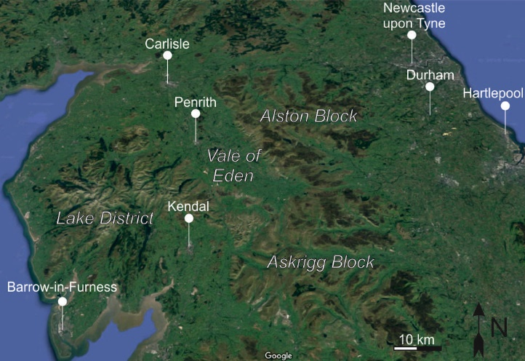
Figure 2. Satellite image of northern England showing the influence of the underlying geology on the present day regional geomorphology. In general, those areas underpinned by large granite bodies are relatively elevated and more uneven. Courtesy of Google. Displayed in 3D view.
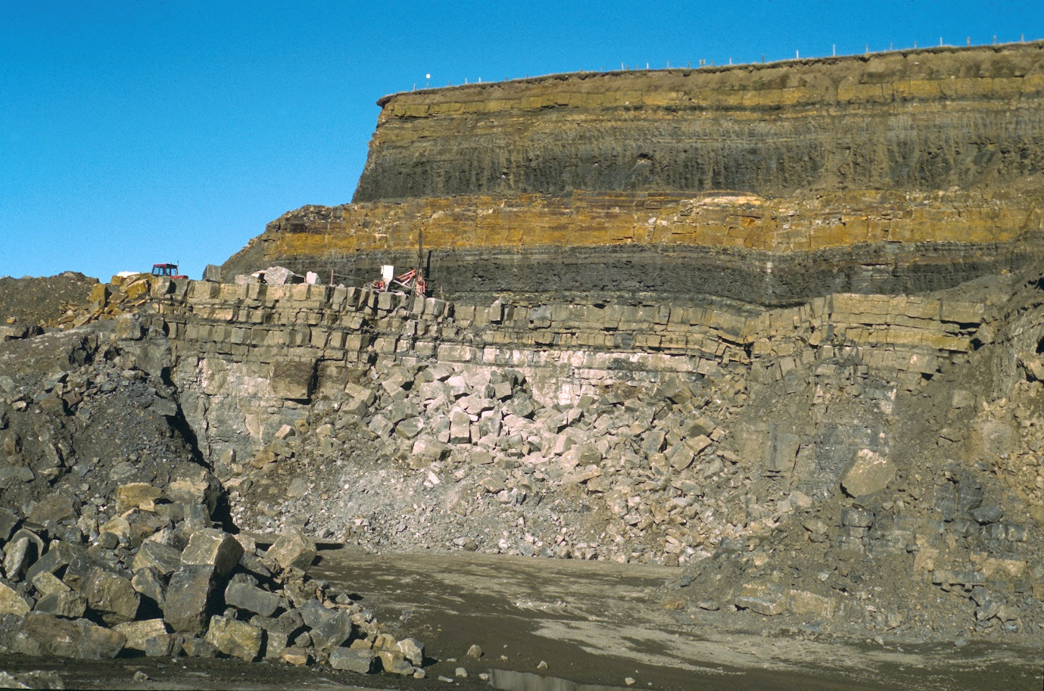
Figure 3. Classic Carboniferous-aged mixed clastic-carbonate Yoredale successions of the Alston Block, Northumberland, northern England. Image shows the Great Limestone Member of Alston Formation overlain by Yoredale cyclothems. Heights Quarry [NY 924 390]. [BGS Photograph, P548113].
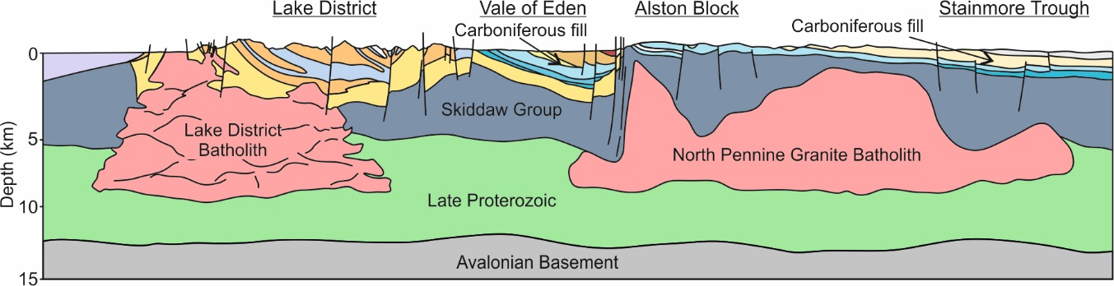
Figure 4. A cross-section through the Lake District and Alston Blocks that are underpinned by the Lake District Batholith and the North Pennine Batholith respectively. Courtesy of Dave Millward and Graham Leslie of the British Geological Survey.

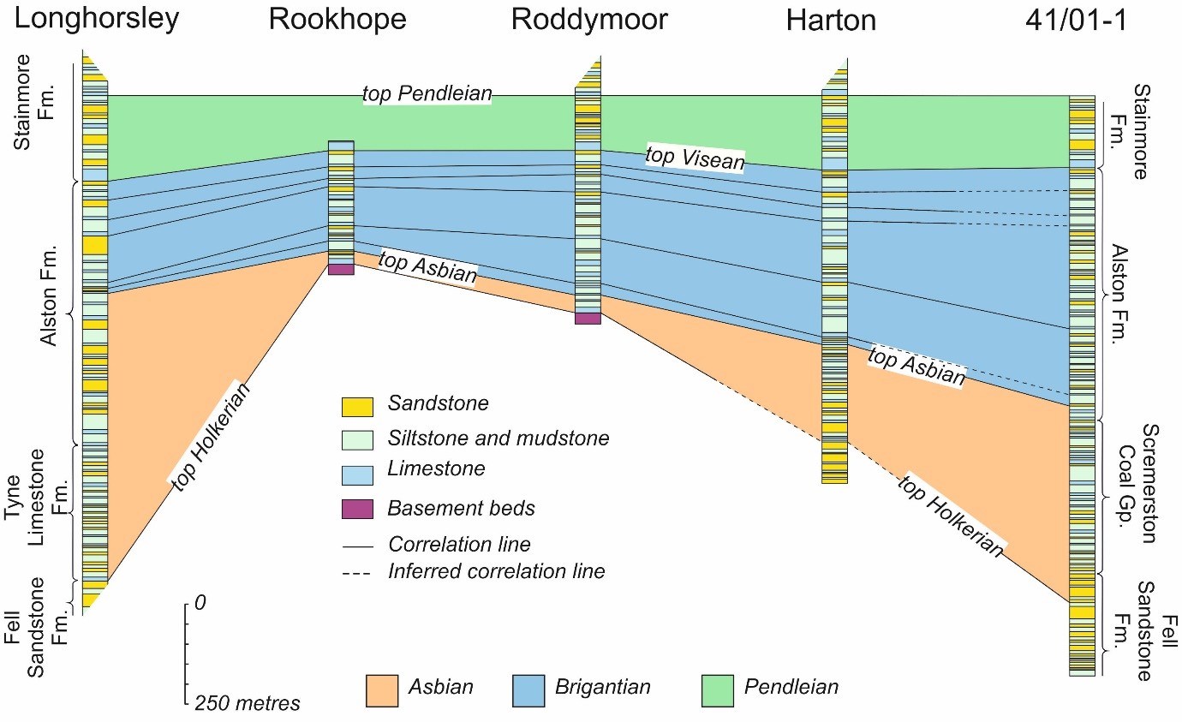
Figure 5. The early Carboniferous syn-extensional sedimentary successions encountered in the boreholes indicated in Figure 1. The Longhorsley borehole succession is separated from the successions of the other four boreholes by a significant east-west trending normal fault (see Figure 1). However, the progressively thicker early Carboniferous successions towards the east is perhaps better accounted for by the influence flexural response of the lithosphere to the low-density granite body on accommodation space. Data courtesy of the UK Onshore Geophysical Library (UKOGL) and the UK Oil and Gas Authority.

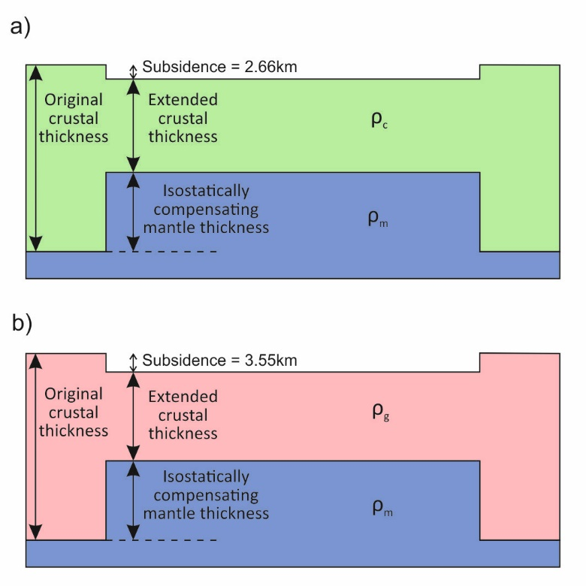
Figure 6. Schematic representations of one-dimensional mass balancing models. 6a. incorporates a uniform, standard crustal density of 2.8 g cm⁻³. 6b. incorporates a uniform granitic crustal density of 2.63 g cm⁻³. Mantle density = 3.3 g cm⁻³. Subsidence is calculated assuming equal mass distribution (6a and 6b).
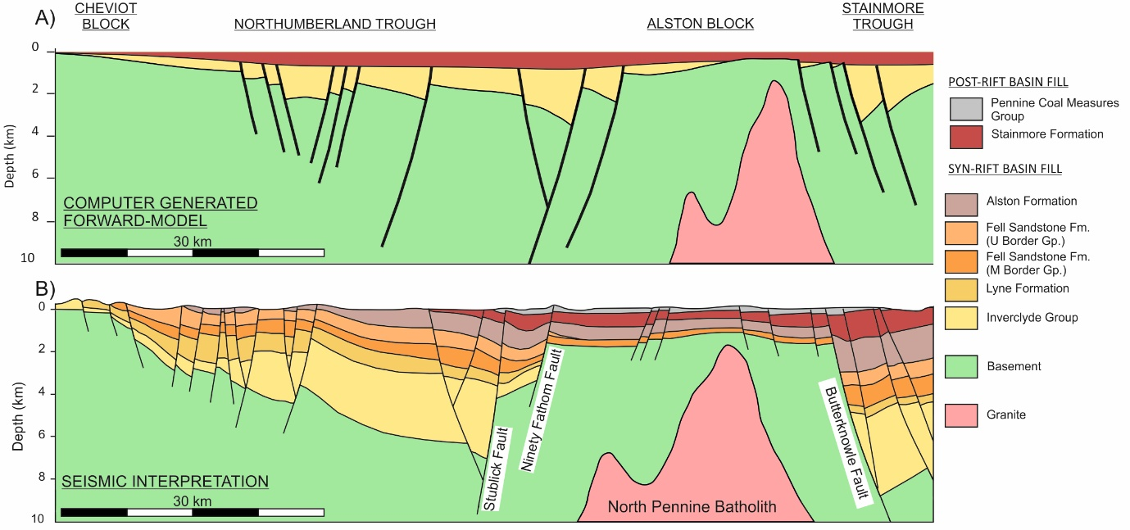
Figure 7a. A computer-generated forward model of the North Pennine Basin in northern England. Note the ‘flexural’ bulge directly above the granitic intrusion. 7b. An interpreted cross-section of the North Pennine Basin. Observed structural data courtesy of the British Geological Survey.
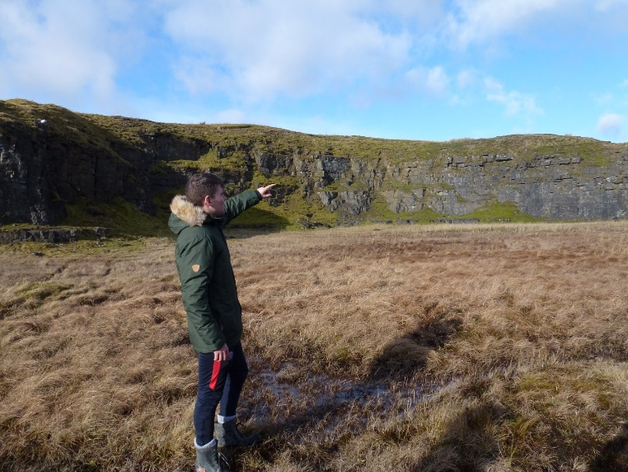
Figure 8a. A stream section of the Little Limestone Member of the Stainmore Formation in Northumberland. 8b. the characteristically dark grey coloured Great Limestone of the older Alston Formation in Northumberland. Both images show Keele University students on their third year sedimentology field trip.

Further reading
Bott, M.H.P. and Masson-Smith, D., 1957. The geological interpretation of a gravity survey of the Alston Block and the Durham Coalfield. Quarterly Journal of the Geological Society, 113(1-4), pp.93-118.
Chadwick, B.A., Holliday, D.W., Holloway, S., Hulbert, A.G. and Lawrence, D.J.D., 1995. The structure and evolution of the Northumberland-Solway Basin and adjacent areas. London: HMSO.
Howell, L., Egan, S., Leslie, G. and Clarke, S., 2019. Structural and geodynamic modelling of the influence of granite bodies during lithospheric extension: application to the Carboniferous basins of northern England. Tectonophysics, 755, pp. 47-63.
Kimbell GS, Young B, Millward D et al. 2010. The North Pennine batholith (Weardale Granite) of northern England: new data on its age and form. Proceedings of the Yorkshire Geological Society, 58, pp. 107–128.
Southern, S., Mountney, N.P. and Pringle, J.K., 2014. The Carboniferous Southern Pennine Basin, UK. Geology Today, 30(2), pp. 74-81.

