**Geophysical monitoring of simulated clandestine burials of murder victims to aid forensic investigators**

**GT Article:**

Jamie K. Pringle1, Ian G. Stimpson1, Kristopher D. Wisniewski2, Vivienne Heaton3, Ben Davenward1, Natalie Mirosch3, Francesca Spencer4, & Jon R. Jervis1

1School of Geography, Geology & Environment, Keele University, Staffs, ST5 5BG, U.K.

2Department of Criminal Justice & Forensics, Staffordshire University, Leek Road, Stoke on Trent, ST4 2DF, U.K.

3School of Chemical & Physical Sciences, Keele University, Keele, ST5 5BG, U.K.

4Department of Biochemistry, Carver College of Medicine, University of Iowa, Iowa City, IA 52242, United States of America.

**Locating murder victims, buried within clandestine graves, is one of the most important and difficult challenges for forensic search teams. This article details how applied geoscientists have been geophysically monitoring simulated clandestine burials, using pig cadavers as human proxies, for over 10 years, in order to discover the best geophysical methods to detect cadavers and how this might change over time. Low frequency ground penetrating radar and electrical resistivity methods could both locate the burials throughout the survey period, with winter/spring surveys producing better data and the style of burial also found to be important.**

**Introduction**

Available statistics for missing persons globally vary, but whilst numbers are relatively small compared to respective country populations, for the families of the missing, it is obviously of crucial importance for those missing to be found, if only for closure. If the missing have been the victim of a murder, discovery of the corpse may yield forensic evidence that could lead to prosecution of the perpetrator(s). However, current success rates to find the missing are low, especially if they have been hidden.

Forensic investigators use various techniques to try and find missing bodies, typically including large-scale remote sensing imagery, aerial photography, thermal imaging, ground-based vegetation/surface geomorphology variations, specialist search dogs, geophysics, ground-probing and topsoil removal to full excavations.

There are various different geophysical techniques, the most common being electromagnetic (including metal detectors and Ground Penetrating Radar (GPR)), electrical resistivity and magnetics. Geophysical methods rely on there being a detectable physical contrast between the target and host material. Geophysical surveys over simulated burials are undertaken to collect control data and to predict what geophysical responses could be in search cases, although the actual response will vary, depending on a variety of case-specific factors. A detailed understanding of the geophysical responses of burials over time remains unknown until now, due to the time and effort required to collect control data over many years. This paper briefly reports on a ten-year monitoring study over simulated clandestine graves on a university campus site, in order to determine geophysical detection effectiveness over such a period.

**Methods**

A small controlled test site on Keele University campus was used to bury a naked pig carcass, a pig carcass wrapped in tarpaulin and a third empty grave was dug for control, after the necessary ethical and site permissions had been given (Figure 1). Pig cadavers are commonly as human proxies, as they have similar chemical compositions, size, tissue:body-fat ratios and skin/hair type to humans.

Electrical resistivity surveys (2D, both in vertical slices and in surface area) and GPR 2D vertical sections were repeatedly collected every three months for the first six years and then annually to 10 years (see Figure 1 for profile locations). Trial magnetic surveys showed no anomalies, probably due to there being no metal buried with the pig cadavers so further surveys were not conducted.

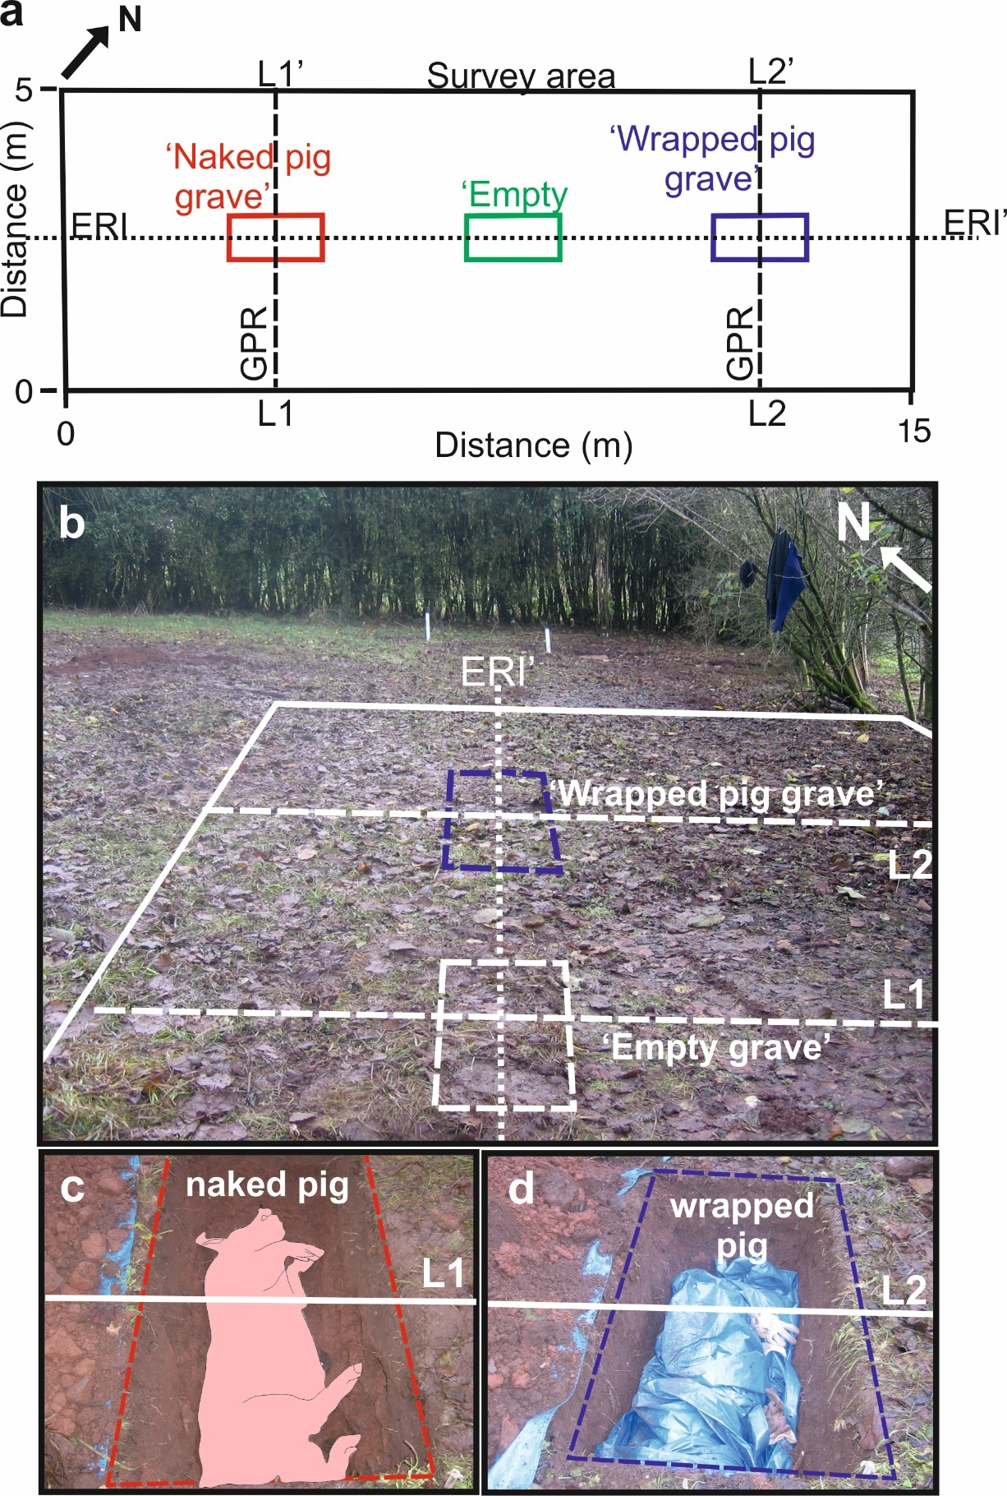

**Figure 1.** (**a**) Map of test site (rectangle) with graves and geophysical survey area/2D profile lines. (**b**) site photograph, (**c**) naked pig and (**d**) wrapped pig. Modified from Pringle et al. (2020).

**Results**

Electrical resistivity survey results (Figures 2 & 3) showed that the naked pig cadaver could be detected throughout the 10 year survey period in map-view data as a negative anomaly compared to background values, although this declined in size as the study continued, most noticeable after year 5 of burial. In contrast, the wrapped pig cadaver produced a smaller, positive anomaly when compared to background values. The refilled, empty control grave produced no anomaly throughout the survey period.

Results were interpreted as decomposition fluid being either allowed to migrate away from the body, or trapped within the wrapping respectively. This has implications for graves in different soil types; sandy soils would let fluid migrate away whereas a clay soil would keep fluid close to the grave cut. Analysing the data also showed that there were important seasonal effects observed between surveys, with the largest resistivity anomalies found in winter/spring and smaller ones in summer/autumn (Figure 4), with a continuous decline in anomaly size as the study period progressed. Consequently, it is recommended that electrical surveys should be collected in winter/spring as soon as possible after burial.

.

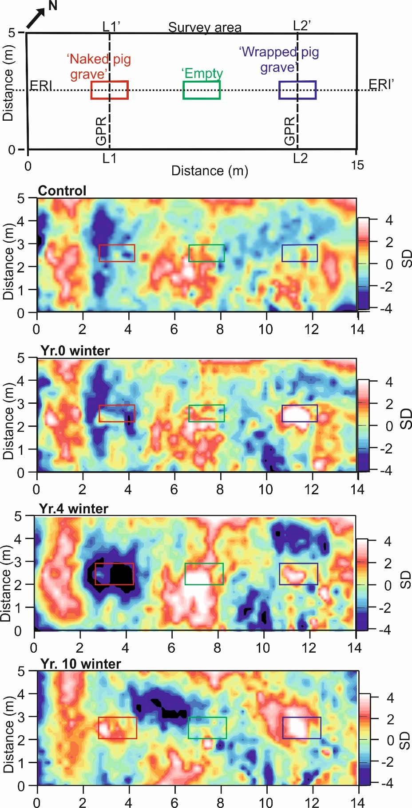

**Figure 2.** Electrode resistivity (map-view) datasets for the ten-year (see labels) study period. Naked pig (left), empty (centre) and wrapped pig (right) grave positions shown.

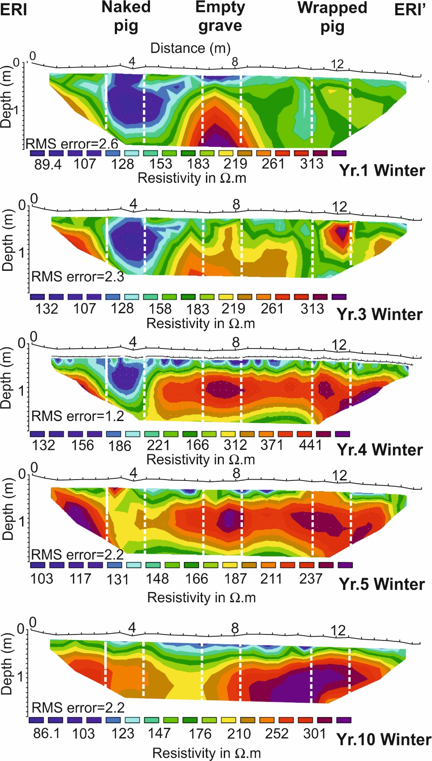

**Figure 3.** Electrical resistivity (2D) datasets for the ten-year (see labels) study period. Naked pig (left), empty (centre) and wrapped pig (right) grave positions shown.

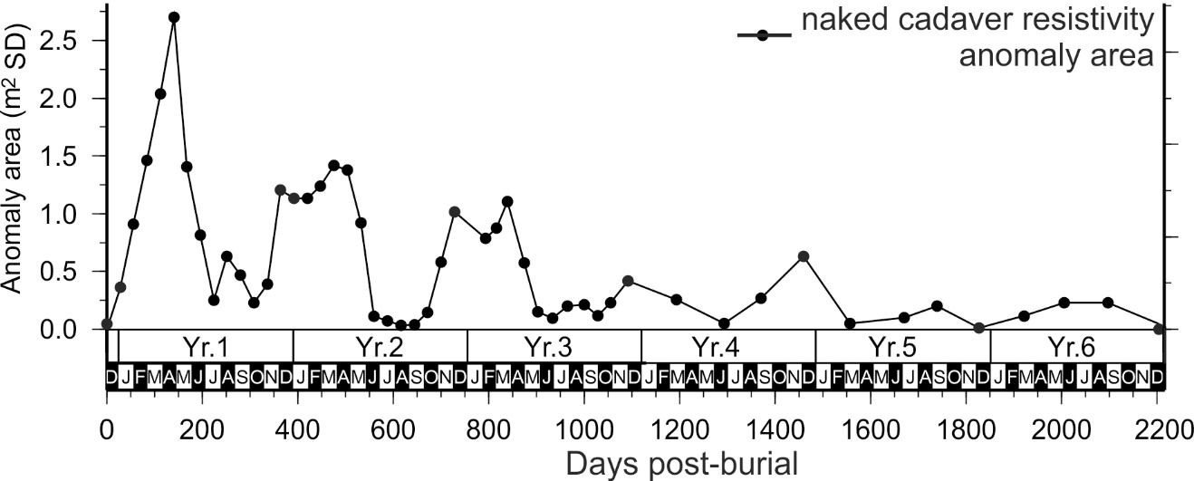**Figure 4.** Quantitative analysis of electrical resistivity (map-view) anomaly over the naked pig cadaver over 6 years of the study period.

GPR survey results (Figure 5) showed that the naked pig cadaver was poorly imaged up to 6 years after burial and then not detectable until the end of the survey duration on all antenna frequencies used, whereas the wrapped pig cadaver was consistently and clearly detectable as a large hyperbolic reflection anomaly throughout the survey period. Wrapping a cadaver should slow decomposition and thus allow the body to be detected for a longer period when compared to a naked burial. Lower antenna frequencies were deemed better due to: a) larger anomalies, b) significant penetration depth below the ground and c) fewer non-target features (e.g. tree roots/rocks) being imaged. There did not seem to be a seasonal effect for the GPR surveys, unlike the electrical survey results.

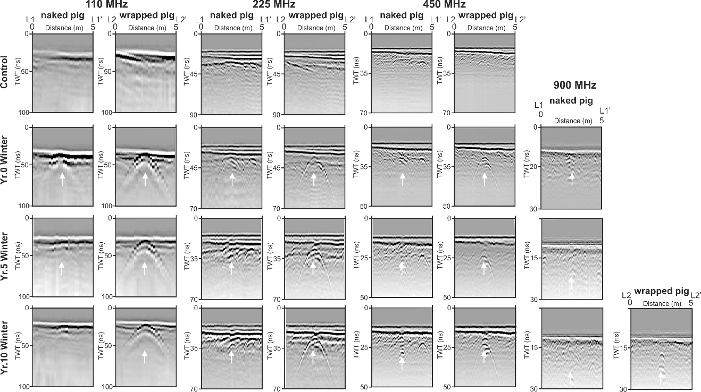

**Figure 5.** GPR selected 2D profiles (frequencies shown) across the naked and wrapped pig graves (see labels and Fig. 2a). White arrows (where present) show grave anomaly location. Modified from Pringle et al. (2020).

**Survey implications**

The long-term monitoring of the test site by repeated geophysical surveys has provided a unique insight into the optimal parameters for geophysical surveys for the detection of buried bodies. The style of burial (naked or wrapped) was found to be the most important controlling factor. A wrapped burial produces a relatively small, high resistive anomaly, but produces a consistent strong reflector on GPR surveys. In contrast, the naked burial produces a good electrical resistivity response but a relatively poor GPR one. There were also interesting variations as time after burial increases. Generally, anomalies decrease in amplitude and extent with time but wrapping the corpse prolongs the geophysical response. Winter/spring surveys were found to be better due to larger anomalies and fewer non-target related anomalies in resistivity data. For GPR the effect was less pronounced. Finally, low frequency GPR surveys was also found to be better than high frequency ones, which although have a better resolution, have a worse depth of penetration and show more anomalies not related to the corpse.

Figure 6 schematically summarises how different geophysical anomalies are important as decomposition progresses. Our longer term plans will be to repeat this study in different soil types, burial styles and depositional environments.

**Figure 6.** Schematic figures of typical clandestine grave of a murder victim showing (a) just deposited – surface walk-over optimal, (b) early stage – surface walk-over/dog teams optimal, (c) late-stage - resistivity optimal and (d) skeleton-stage-GPR optimal, decomposition with respective grave indicators/targets. Modified from Pringle et al. (2020).

**Suggestions for further reading**

Pirrie, D. 2009. Forensic geology in serious crime investigations. *Geology Today*, **25**, 188-192.

Pringle, J.K., Stimpson, I.G., Wisniewski, K.D., Heaton, V., Davenward, B., Mirosch, N., Spencer, F. & Jervis, J.R. 2020. Geophysical monitoring of simulated homicide burials for forensic investigations. *Nature Scientific Reports*. <https://doi.org/10.1038/s41598-020-64262-3>

Pringle, J.K., Ruffell, A., Jervis, J.R. Donnelly, L., McKinley, J., Hansen, J., Morgan, R., Pirrie, D. & Harrison, M. 2012. The use of geoscience methods for terrestrial forensic searches. *Earth Science Reviews*, **114**, 108-123.

<http://dx.doi.org/10.1016/j.earscirev.2012.05.006>

Ruffell, A., Pringle, J.K., Cassella, J.P., Morgan, R., Ferguson, M., Heaton, V.G. & Hope, C. 2017. The use of geoscience methods for aquatic forensic searches. *Earth Science Reviews,* **171**, 323-337.

<http://dx.doi.org/10.1016/j.earscirev.2017.04.012>

Ruffell, A. 2006. Forensic Geoscience. *Geology Today*, **22**, 68-70.