Intrinsic defects and non-stoichiometry in undoped cadmium silicate hosts
Eduily Benvindo Vaz Freire^{1,*}, Anderson Lira de Sales Santos¹, Giordano Frederico da Cunha Bispo², Maria de Andrade Gomes¹, Zélia Soares Macedo^{1,2}, Robert A Jackson³, and Mário Ernesto Giroldo Valerio^{1,}
¹Physics Department, Federal University of Sergipe, 49100-000, São Cristovão, SE, Brazil.
²Materials Science and Engineering Department, Federal University of Sergipe, 49100-000, São Cristovão - SE, Brazil.
³School of Chemical and Physical Sciences, Keele University, Keele, Staffordshire ST5 5BG, UK.
*E-mail: eduily.vaz@gmail.com

Abstract
Cadmium silicates, mainly the CdSiO₃ phase, are interesting materials due to their persistent and intrinsic luminescence, making them possible candidates for a number of applications. Although many of the luminescence properties of these materials are known from the experimental point of view, the current problem that still remains is to understand the origin of the intrinsic luminescence. Different types of point defects were considered in the literature and, most of them are contradictory and/or controversial and lack direct evidence for the assumptions. The aim of the present work is to investigate in depth the possible origin of the luminescence properties of cadmium silicates, focusing on the CdSiO₃ phase, considering not only the possibilities reported in the literature but all other mechanisms involving intrinsic defects in these materials. Our results predicted that CdSiO₃ tends to show stoichiometric deviation due to CdO pseudo-Schottky defects and the simulated structure for the deficient matrix is much closer to the experimental X-ray diffraction pattern than the stoichiometric one. This feature indicates that most of the available CdSiO₃ phases are truly CdO deficient. Additionally, it was found that this defect induces the formation Si-Si bonds that are responsible for the intrinsic luminescence in this matrix. The CdO deficiency also accounts for the presence of additional cadmium silicate phases, like Cd₂SiO₄ or Cd₃SiO₅, during the synthesis of CdSiO₃, a common feature found in many works in the literature. These results strongly indicate that CdO pseudo-Schottky defects, that trigger the CdO deficiency naturally present in cadmium silicate structures, should be considered not only in all luminescent models proposed, including intrinsic and extrinsic matrix, but also for the structural properties of these materials.

Keywords: Cadmium silicate, CdSiO₃, Intrinsic defects, Non-stoichiometry

Introduction
Cadmium silicate in its three different stoichiometries CdSiO₃ [1], Cd₂SiO₄ and Cd₃SiO₅ [2] has been studied since the early 20th century especially because of their luminescence properties [3]. This phenomenon, also known as persistent luminescence, is explored in several different applications, from bioimaging and optical data storage to decorative and emergency signalling [4,5]. Persistent luminescence for more than 5 hours has been reported for Dy³⁺ doped cadmium silicate material [6].
Despite the large spectral range of emission colours that have been obtained in undoped and doped cadmium silicate hosts produced by various synthesis methods, we still do not fully understand the intrinsic defects that help the luminescence of the material [7–9]. There is currently research to achieve a better understanding of the defects associated with the different emission colours, and the mechanism responsible for the emission. For example, we know that undoped CdSiO3 stoichiometry luminescence presents three bands, centred at 590 nm, 490 nm and 406 nm, and that their relative intensity can be tailored by varying the pH of the precursor solution [10]. Much is speculated about the origin of the intrinsic luminescence in cadmium silicate, and there are few studies that suggest the possible defects that would be involved in the creation of this phenomenon. Cadmium vacancies, interstitial oxygen, oxygen vacancies and Si-related defects are hypothesized as possible defects associated with the intrinsic luminescence of CdSiO₃ [8,10–12]. In this sense, a theoretical study would bring additional insight in this matter. Barboza and co-workers [13] performed DFT-type calculations for triclinic CdSiO₃ obtaining the electronic band structure and an estimation of the band gap for this particular polymorph. However, this methodology is not suitable for studying the formation of point defects in detail, which are directly related to the colour centres, traps and luminescence.
In order to make a contribution to this field, the present work proposes to estimate, by means of atomistic computer modelling, the most probable intrinsic defects that can occur in cadmium silicate hosts. The three stoichiometries of cadmium silicate family, namely, CdSiO₃, Cd₂SiO₄ and Cd₃SiO₅ were addressed in this study. Although only the stoichiometric CdSiO₃ has proven to have persistent intrinsic luminescence, the comparative study among the stoichiometries is relevant in order to verify if the three compounds follow a default preference for certain types of defects, or if a defect can influence the appearance of others in all structures. This study also verified how stoichiometric deviations can harbour secondary phases of cadmium silicates or CdO deficiencies without compromising, for example, the X-ray diffraction pattern.
At room temperature, cadmium silicates adopt the following structures: monoclinic CdSiO₃, orthorhombic Cd₂SiO₄, and tetragonal Cd₃SiO₅. The first structure (CdSiO₃, see figure 1(a)) belongs to the space group P121/c1 with three non-symmetric distorted (CdO₆)⁴⁻ octahedra, which are arranged in slabs parallel to the (0 1 0) plane separated from each other by unbranched silicate chains [1]. Such chains are formed by regular corner-sharing (SiO₄)⁴⁻ tetrahedra [1]. The second structure (Cd₂SiO₄, see figure 1(b)) belongs to the space group Fddd with only one non-symmetric distorted (CdO₆)⁴⁻ octahedron located between very regular (SiO₄)⁴⁻ tetrahedra [2]. The last structure (Cd₃SiO₅, see figure 1(c)) belongs to the space group P4/nmm with two well-defined symmetric (CdO₆)⁴⁻ octahedra located between the regular (SiO₄)⁴⁻ tetrahedra [2,14].
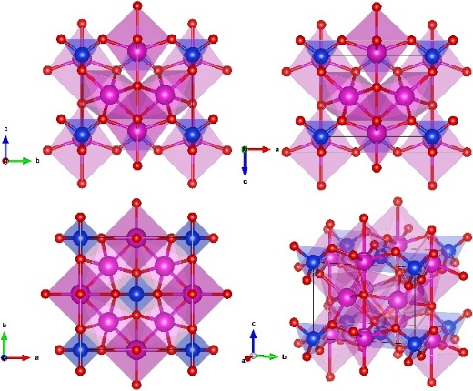
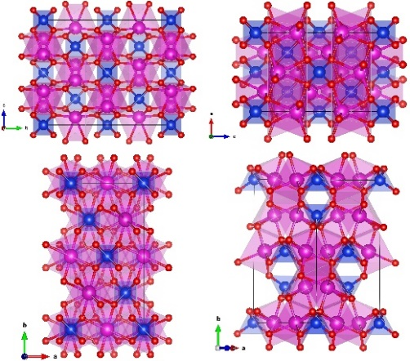
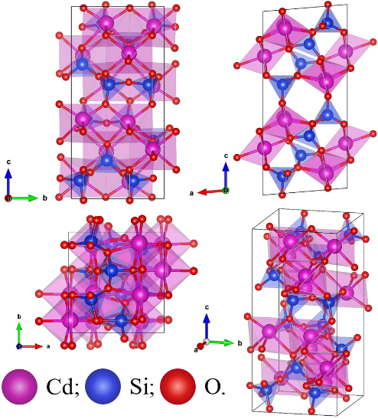
(a) (b) (c)
Figure 1: (a) matrix of CdSiO₃, (b) matrix of Cd₂SiO₄ and (c) matrix of Cd₃SiO₅.
The materials were studied by classical, static and periodic computer modelling [15,16]. This atomistic model has been successfully used to obtain most probable defects and local structure displacement caused by defects [16]. Empirical fitting of existing interatomic potentials was used in order to reproduce all structures at 0 K and also at room temperature (300 K). The great advantage of using this method is the possibility of analysing a wide range of possible defects, such as isolated point defects, as well as defects sharing the same unit cell. It is also possible to simulate deficiencies of specific ions in the matrix, using a relatively quick and efficient procedure.

- Simulation methods
Atomistic modelling based on interatomic potentials and static lattice energy minimisation was employed in this work. The calculation was performed using the General Utility Lattice Program (GULP) [17]. The interactions of ions were described through Buckingham and three-body potentials. The shell model was included to describe the polarisability of the oxygen ions.
The Buckingham potential is a potential for short-range interaction between two bodies, and it is the sum of two terms. The exponential term describes the repulsion between the electronic clouds due to Coulomb repulsion and also Pauli Exclusion Principle terms. The term, proportional to r⁻⁶, corresponds to the attractive part of the potential, and accounts for the dispersion (van der Waals) interaction. Equation (1) shows the potentials used for the interactions between two ions, including Coulombic and Buckingham interaction terms, where r_{ij} is the distance between the ions i and j, Z_{i} and Z_{j} are the valences of the chemical species and A_{ij}, C_{ij} and ρ_{ij} are adjustable parameters, which have to be determined for each interaction type:
$U_{ij}=\frac{Z_{i}Z_{j}e^{2}}{r_{ij}}+A_{ij} exp\left(\frac{{-r}_{ij}}{ρ_{ij}}\right)-\frac{C_{ij}}{r_{ij}^{6}}.$ (1)
One of the key features of almost all silicates is that the silicate polyhedra are quite regular. In the modelling strategy, one way of represent these common features is to include a three body potential (see Equation 2), which introduces an energy cost if the O-Si-O bond angles are displaced from the equilibrium value. In Equation (2), K is a constant, θ is the O-Si-O angle for the particular group of atoms in a polyhedron and θ₀ is the equilibrium angle or the expected angle.
$U_{O-Si-O}=\frac{K}{2}{\left(θ-θ_{0}\right)}^{2}.$ (2)
The shell model [18], included for oxygen ions, considers the polarisability of an ion, increasing the mobility of the electronic cloud. This model considers that the ion is divided into core and shell, which are connected to each other by springs of negligible mass with coupling constant $k_{cs}$ and shell charge $q_{s}$, given by equation (3),
$α=\frac{q_{s}^{2}}{k_{cs}}$ (3)
The calculations were performed at two temperatures, 0 K and 300 K for the three cadmium silicate stoichiometries. The 0 K calculation provides a standard theoretical reference because the vibration terms from external perturbation is not considered, while the calculations at 300 K are closer to the vast majority of experimental studies, including those used in the crystallographic database used in this work. It is expected that an increase in the temperature causes changes in the crystalline structure, including bond lengths and bond angles, since the material undergoes thermal expansion. Therefore, inclusion of temperature can lead to a slightly deformed structure changing the x-ray diffraction pattern of the relaxed structure. We use these temperatures, precisely because of the comparison with the literature that will be given in the results and discussion section. A theoretical discussion of the implementation of temperature in modelling can be found in [19], where Helmholtz free energy is calculated as a function of temperature by perturbation theory. An important aspect of cadmium silicates is the stoichiometric deviations caused by Cd evaporation, and we propose to calculate how much this deviation is necessary to change the XRD pattern, so temperature is an important variable in this study.
The well-established Mott-Littleton method [20] was used to model the defects in cadmium silicates. In this method, the defect of interested is generated embedded in an infinite crystal that is divided in two spherical regions centred around the defect. In region I, the region closest to the defect, all chemical species are treated explicitly, with all interactions being taken into account in the calculation of the final positions, while in region II the problem is treated using a continuum approach. In order to promote a fast calculation and better convergence, region II is subdivided into regions IIa and IIb, where region IIa represents the spherical shell of ions in the boundary of region I, and region IIb represents the rest of the crystal extending to infinity as a continuous dielectric. Consistent cut-off radii of $16 Å$ and $22 Å$ have been used for regions I, and IIa respectively. These values were obtained after testing various values for the cut-off radii. The criteria adopted is that region I radius should be large enough so the average difference between the values of the initial and final coordinates near the boundary of region I would be less than 0.1%. With this condition, all the displacements in region IIa, near the edge of the region I, are small enough so all displacements in IIa can be treated within the harmonic approximation.

- Results and discussion
  - Potential Parameter Set
Any atomistic modelling is based on the fact that the material of interest can be described by a set of potentials whose parameters have to be obtained. Although there are nowadays good potential sets for many materials, and many potential parameters sets have already been used, it is fairly rare that a potential set obtained for a particular material in one particular situation, even for the same pair of ions, can be used directly for a different material. Normally, these parameter sets can be used as a starting point, but some degree of fitting has to be done. In the present case, the interest is to model three cadmium silicates, as described above, and the focus is to obtain the energetic properties of different types of defects. Therefore, a good potential set has to describe not only the three cadmium silicates but also the parent oxides, namely, CdO and SiO₂. It is required that the potential set describes the crystalline structure of CdSiO₃ in the monoclinic phase, Cd₂SiO₄ in the orthorhombic phase and Cd₃SiO₅ in the tetragonal phase, and also the crystal structure of CdO and SiO₂. Furthermore, the potential parameters must reproduce oxide precursor and cadmium silicate structures with discrepancy between calculated and experimental lattice parameters close to 5% and 2%, respectively. These values were chosen based on previous experiences and on the literature and to assure a good agreement between theory and experiment, with the intention that the simulated structure presents only minimal changes, both in ion positions and bond lengths and also in the angles between ions. We are more rigorous with cadmium silicate structures, because all calculations performed in the present work are based on the optimized cadmium silicates. Secondly, using the solid-state reaction that describes the cadmium silicate formation from the parent oxides (Eq. 4), (Eq. 5) and (Eq. 6), we calculate the Gibbs free energy (see Eq. 7) that must be negative, otherwise the modelling would predict that the materials of interest are not stable and the segregation of the precursors could happen, a result that is obviously not correct. Lastly, an additional criterion used here is that the Si-O polyhedra, which are observed to be quite regular, maintain their structural characteristics, i.e., angles and distances between the Si ion and the neighbouring O ions, as close as possible to the original values found for the cadmium silicates of interest [2].
$CdO+SiO_{2}⇄CdSiO_{3}$ (4)
$2CdO+SiO_{2}⇄{Cd}_{2}SiO_{4}$ (5)
$3CdO+SiO_{2}⇄{Cd}_{3}SiO_{5}$ (6)
${ΔG}_{Reaction}={ΔG}_{Products}-{ΔG}_{Reactants}$ (7)
The adjustable parameters of the potential given by equations (1), (2) and (3) were obtained empirically and will be presented in Table 1. The agreement between the calculated lattice parameters and the observed ones[1,2,14] for the three cadmium silicates and the oxide precursors are presented in Table 2 at 0 K and room temperature (300 K). All lattice parameters were reproduced within acceptable limits. In addition, it can be noticed that there is an increase of the simulated lattice parameter for room temperature when compared to the values at 0 K. This expansion in lattice parameters is expected since normally interatomic spacing expands with increase in temperature.
Table 1: Parameters of the potentials used for crystal lattice modelling.
Buckingham ($cut-off = 12 Å$)
Interaction | $A_{ij}$ [eV] | $ρ_{ij}$ [Å] | $C_{ij}$ $[eVÅ^{6}]$
${\text{Cd}}_{\text{core}} \text{-} {\text{O}}_{\text{shell}}$ [21]  ${\text{Si}}_{\text{core}} \text{-} {\text{O}}_{\text{shell} }$[22]  ${\text{O}}_{\text{shell}} \text{-} {\text{O}}_{\text{shell}}$ [23] | 868.30000  1305.24780  22764.00000 | 0.35000  0.31776  0.14900 | 0.00000  10.14112  46.08400
Three-body ($cut-off = 1.8, 1.8, 3.2 Å$)
Interaction |  | $K$ $[eV{\text{rad}}^{-2}]$ | $θ$ [rad]
${\text{Si}}_{\text{core}}\text{-}{\text{O}}_{\text{shell}}\text{-}{\text{O}}_{\text{shell} }$[23] |  | 4.09724 | 109.47
Shell model $(eVÅ^{-2})$
Spring ${\text{O}}_{\text{core}}\text{-}{\text{O}}_{\text{shell}}$[23] |  | 74.92
Charge of the ions [e]
${\text{Cd}}_{\text{core}}$ [21] | ${\text{Si}}_{\text{core}}$ [23] | ${\text{O}}_{\text{core}}$ [23] | ${\text{O}}_{\text{shell}}$ [23]
2.0000 | 4.0000 | 0.86902 | -2.86902
Table 2: Comparison between experimental and calculated crystal lattice and oxide precursor parameters at 0 K and 300 K.
Parameter | Experimental | Calc. 0 K | ∆% | Calc. 300 K | ∆%
 |  | CdSiO₃ [1]
a | 6.9463 | 6.9645 | 0.26 | 6.9710 | 0.35
b | 7.2563 | 7.3233 | 0.92 | 7.3304 | 1.02
c | 15.0697 | 15.1613 | 0.61 | 15.1783 | 0.72
α = γ | 90.0000 | 90.0000 | 0.00 | 90.0000 | 0.00
β | 94.7910 | 94.0892 | -0.74 | 94.0746 | -0.76
 |  | Cd₂SiO₄ [2]
a  b  c | 6.0400  11.8500  9.7500 | 6.0070  11.8938  9.9529 | -0.55  0.37  2.08 | 6.0159  11.9177  9.9950 | -0.40  0.57  2.51
α = γ = β | 90.0000 | 90.0000 | 0.00 | 90.0000 | 0.00
 |  | Cd₃SiO₅ [14]
a = b | 6.8350 | 6.8914 | 0.83 | 6.9061 | 1.04
c | 4.9540 | 4.9089 | -0.91 | 4.9127 | -0.83
α = γ = β | 90.0000 | 90.0000 | 0.00 | 90.0000 | 0.00
 |  | CdO [24]
a = b = c | 4.6958 | 4.6759 | -0.42 | 4.6929 | -0.06
α = γ = β | 90.0000 | 90.0000 | 0.00 | 90.0000 | 0.00
 |  | SiO₂ [25]
a = b | 4.9149 | 4.6900 | -4.58 | 4.7097 | -4.18
c | 5.4063 | 5.1728 | -4.32 | 5.1888 | -4.02
α = β | 90.0000 | 90.0000 | 0.00 | 90.0000 | 0.00
γ | 120.0000 | 120.0000 | 0.00 | 120.0000 | 0.00

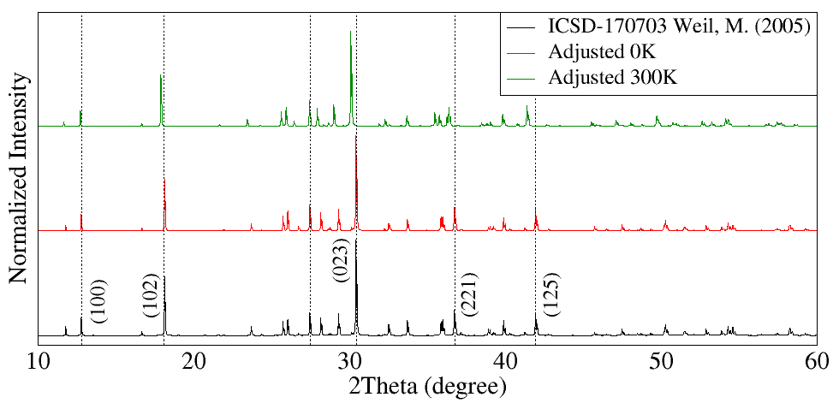
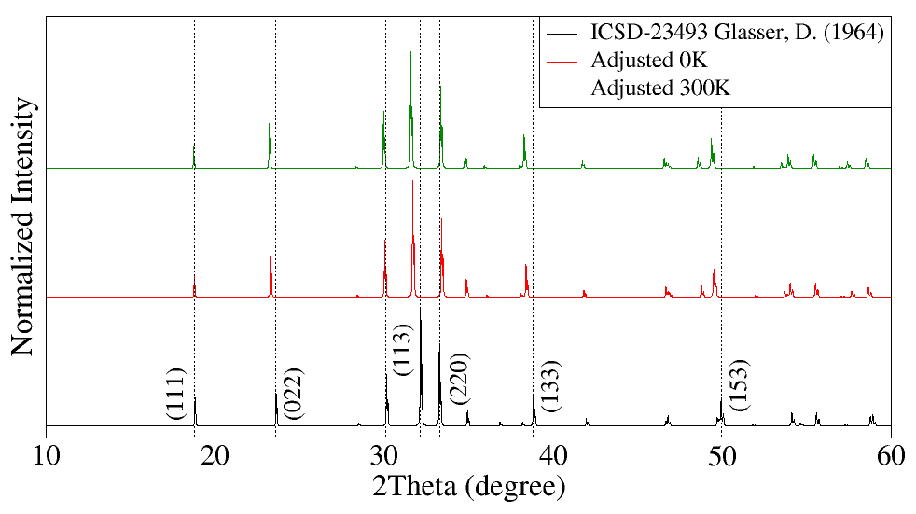
Another important test that can be done to validate the potential model is to compare the simulated X-ray powder diffraction (XRD) patterns with the experimental pattern deposited in one of the available crystalline databases. In the present work the XRD patterns were simulated using the VESTA [26] program for CdSiO₃, Cd₂SiO₄ and Cd₃SiO₅ structures and compared to the ICSD cards 170703, 23943, 23170 (Figures 2(a), 2(b) and 2(c)).
(a)
(b)

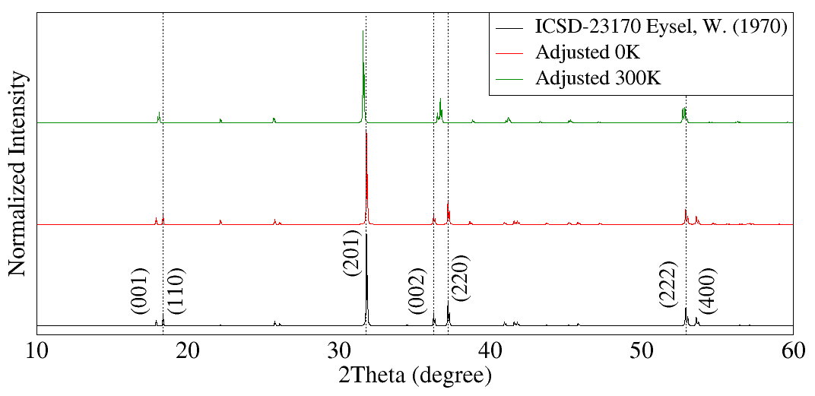
(c)
Figure 2: Comparison between the standard X-ray diffraction patterns and calculated at 0 K and 300 K in CdSiO₃ (a), Cd₂SiO₄ (b) and Cd₃SiO₅ (c). The X-ray diffraction pattern was calculated by the VESTA program using the Cu alpha line in all calculations.

For the CdSiO₃ structure, the XRD pattern was reproduced with good agreement regardless of the associated temperature, see Figure 2(a). In the Cd₂SiO₄ structure, the XRD pattern shows that the main peaks presented a shift to the left for both temperatures due to increase in the size of the c axis in relation to the reference diffraction pattern, see Figure 2(b). This expansion, which is approximately 2% higher than predicted experimentally, changes interplanar distances and shifts the peaks at low-angle as a consequence. For the Cd₃SiO₅ structure, the XRD pattern was reproduced at 0 K. Otherwise, there is a difference for the non-main peaks at 300 K compared to the reference, see Figure 2(c). In this case, the peaks shifted their angular positions to higher or lower angles demonstrating a nonsingular displacement of interplanar distances. As a consequence, some peaks (see 002 and 220 peaks, for instance) are overlapped, meaning that their interplanar distances are closer than the actual distance in the real crystal. This divergence occurs due to the increase of the lattice vectors a and b, caused by increase in bond lengths between cadmium and oxygen ions, as the temperature increases. Such increase causes an expansion of the cadmium polyhedral volume resulting in different interplanar distances.
The next aspect that should be tested is the calculated Gibbs free energy in the formation of all structures of interest. The formation energies of the materials (see Table 3), were obtained via equation (7) from the computer simulation values () of the lattice energies of the precursors oxides (SiO₂ and CdO) in the proportions described in equations (4), (5 ) and (6) for the three cadmium silicate matrices (CdSiO₃, Cd₂SiO₄ and Cd₃SiO₅). The Gibbs free energies for all structures simulated at both temperatures are negative, as expected, indicating that the three cadmium silicates are stable. Comparing the Gibbs formation energies of the compounds per unit formula, one may think that Cd₂SiO₄ and Cd₃SiO₅ would be more stable than CdSiO₃. However, that is not the case since this comparison does not take into account the fact that the compounds have different number of atoms. Another possible way is comparing the Gibbs free energy necessary to produce 1g of each compound, as presented in Table 3. This is a much fairer comparison, in which the amount of atoms per formula unit will be already accounted for in the conversion to masses. The values shown in Table 3 indicate that, in fact, CdSiO₃ is more easily formed, that is, it is more stable than Cd₂SiO₄ and Cd₃SiO₅.

Table 3: Lattice energy and free Gibbs formation energy calculated for cadmium silicate matrices and their oxides.
Material | Lattice Energies at 0 K |  | Lattice Energies at 300 K
 | $$kJ/mol$$ | $$kJ/g$$ | $$kJ/mol$$ | $$kJ/g$$
$$\text{CdSi}{\text{O}}_{\text{3}}$$  $${\text{Cd}}_{\text{2}}\text{Si}{\text{O}}_{4}$$  $${\text{Cd}}_{\text{3}}\text{Si}{\text{O}}_{5}$$  $$\text{CdO}$$  $$\text{Si}{\text{O}}_{2}$$ | -16249.17  -19880.46  -23425.41  -3540.14  -12554.44 | -86.21  -62.73  -52.60  -27.57  -208.96 | -16222.24  -19849.65  -23390.69  -3538.51  -12527.78 | -86.06  -62.64  -52.52  -27.56  -208.52
Material | ΔG at 0 K |  | ΔG at 300 K
 | $$kJ/mol$$ | $$kJ/g$$ | $$kJ/mol$$ | $$kJ/g$$
$${∆G}_{\text{Formation}} (\text{CdSi}{\text{O}}_{3})$$  $${∆G}_{\text{Formation}} ({\text{Cd}}_{\text{2}}\text{Si}{\text{O}}_{4})$$  $${∆G}_{\text{Formation}} ({\text{Cd}}_{\text{3}}\text{Si}{\text{O}}_{5})$$ | -8201.88  -13335.55  -17631.69 | -43.51  -42.08  -39.59 | -8189.09  -13314.72  -17604.86 | -43.45  -42.02  -39.53

Another important point is the bond distances and angles in the Si-O polyhedra for all cadmium silicate structures. It is important to remember here that a three-body potential, acting on the O-Si-O angle, was explicitly included to preserve the arrangement of these ions on the Si-O polyhedra. Thus, to check the validity of such approach, it is important to compare the final values of the bond distances and angles in the simulated polyhedra with the values obtained experimentally. A good potential set must reproduce Si-O polyhedra, keeping angles and distances close to the original values. An important point to note is that for the CdSiO₃ matrix we have three symmetrically non-equivalent positions for the Cd and Si ions. In the Cd₂SiO₄ matrix we have only one position for the Cd and Si ions, and in the Cd₃SiO₅ matrix we have only one position for the Si ion and two symmetrically non-equivalent positions for the Cd ion. Because of the peculiarity of each matrix, variation in the bond lengths and volume of the polyhedron were obtained for matrices that have more than one symmetrically non-equivalent position. Results given in Table 4 shown that Si-O polyhedron values are very close to the reference values for both calculated temperatures and for all structures. Therefore, the proposed potential set was very successful in reproducing the main features of all silicates and, having a good set of potential parameters, it is possible now to move forward with the calculations of intrinsic defects in the materials of interest.

Table 4: Polyhedron parameters, average bond length and polyhedral volume for all structures of cadmium silicate.
Structure | Parameter | Experimental | Calculated
 |  |  | 0 K | 300 K
$\text{CdSi}{\text{O}}_{3}$ [1] | Silicon-oxygen
 | Average bond length [Å] | $$1.62±0.01$$ | $$1.60±0.01$$ | $$1.61±0.01$$
 | Polyhedral volume $[Å^{3}]$ | $$2.17±0.01$$ | $$2.07±0.01$$ | $$2.10±0.01$$
 | Cadmium - oxygen
 | Average bond length $[Å]$ | $$2.33±0.01$$ | $$2.35±0.02$$ | $$2.39±0.02$$
 | Polyhedral volume $[Å^{3}]$ | $$15.9±0.4$$ | $$16.3±0.3$$ | $$16.8±0.4$$
${Cd}_{2}\text{Si}{\text{O}}_{4}$ [2] | Silicon-oxygen
 | Average bond length [Å] | $$1.62$$ | $$1.62$$ | $$1.62$$
 | Polyhedral volume $[Å^{3}]$ | $$2.20$$ | $$2.16$$ | $$2.15$$
 | Cadmium - oxygen
 | Average bond length $[Å]$ | $$2.37$$ | $$2.37$$ | $$2.38$$
 | Polyhedral volume $[Å^{3}]$ | $$14.38$$ | $$14.56$$ | $$14.77$$
${Cd}_{3}\text{Si}{\text{O}}_{5}$ [14] | Silicon-oxygen
 | Average bond length [Å] | $$1.62$$ | $$1.61$$ | $$1.61$$
 | Polyhedral volume $[Å^{3}]$ | $$2.18$$ | $$2.12$$ | $$2.14$$
 | Cadmium - oxygen
 | Average bond length $[Å]$ | $$2.36±0.00$$ | $$2.35±0.02$$ | $$2.37±0.03$$
 | Polyhedral volume $[Å^{3}]$ | $$14.61±0.07$$ | $$15.9±0.8$$ | $$16.3±0.9$$

  - Defect Calculations
Intrinsic defects are formed, in the atomistic modelling approach, via combinations of basic defects, vacancies and interstitials, in the crystal lattice. Frenkel and Schottky type defect formation energies were determined using isolated point defect (vacancy and interstitial) energies and relevant lattice energies calculated previously. The set of reactions used to obtain the intrinsic defects in cadmium silicates are shown in the Table 5. The calculations were performed at 0 K and at room temperature (300 K). Two conditions were used to model the defects. In the first one, the basic defects are supposed to be so far apart that there is no interaction between the basic constituents of the desired intrinsic disorder. This is called the unbound condition. As an example, let us consider the oxygen Frenkel pair formed by a combination of an O²⁻ in an interstitial site and an O²⁻ vacancy. In the unbound case, both basic defects (interstitial and vacancy) were individually calculated and figures for the energetic process of forming an O²⁻ vacancy and an O²⁻ interstitial were obtained. These numbers were combined using the proper solid-state reaction and the energy to produce a single oxygen Frenkel pair is obtained. This type of defect calculation was applied to all matrices.

Table 5: Chemical equation for intrinsic defects in CdSiO₃, Cd₂SiO₄ and Cd₃SiO₅.
Schottky
$${\text{Cd}}_{\text{Cd}}\text{+}{\text{Si}}_{\text{Si}}\text{+}{\text{O}}_{\text{O}}\text{→}{\text{V}}_{\text{Cd}}^{''}\text{+}{\text{V}}_{\text{Si}}^{''''}\text{+}{\text{V}}_{\text{O}}^{••}\text{+}\text{Cd}\text{Si}{\text{O}}_{\text{3}}$$
$${\text{2Cd}}_{\text{Cd}}\text{+}{\text{Si}}_{\text{Si}}\text{+}{\text{4O}}_{\text{O}}\text{→}{\text{2V}}_{\text{Cd}}^{''}\text{+}{\text{V}}_{\text{Si}}^{''''}\text{+}{\text{4V}}_{\text{O}}^{••}\text{+}{\text{Cd}}_{\text{2}}\text{Si}{\text{O}}_{\text{4}}$$
$${\text{3}\text{Cd}}_{\text{Cd}}\text{+}{\text{Si}}_{\text{Si}}\text{+}{\text{5O}}_{\text{O}}\text{→}{\text{3V}}_{\text{Cd}}^{''}\text{+}{\text{V}}_{\text{Si}}^{''''}\text{+}{\text{5V}}_{\text{O}}^{••}\text{+}{\text{Cd}}_{\text{3}}\text{Si}{\text{O}}_{\text{5}}$$
Pseudo-Schottky
$${\text{Cd}}_{\text{Cd}}\text{+}{\text{O}}_{\text{O}}\text{→}{\text{V}}_{\text{Cd}}^{''}\text{+}{\text{V}}_{\text{O}}^{••}\text{+}\text{CdO}$$
$${\text{Si}}_{\text{Si}}\text{+}{\text{2O}}_{\text{O}}\text{→}{\text{V}}_{\text{Si}}^{''''}\text{+}{\text{2V}}_{\text{O}}^{••}\text{+Si}{\text{O}}_{\text{2}}$$
Anti-Schottky
$$\text{Cd}\text{Si}{\text{O}}_{\text{3}}\text{→}{\text{Cd}}_{\text{i}}^{••}\text{+}{\text{Si}}_{\text{i}}^{••••}\text{+}{\text{3O}}_{\text{i}}^{''}$$
$${\text{Cd}}_{\text{2}}\text{Si}{\text{O}}_{\text{4}}\text{→}{\text{2}\text{Cd}}_{\text{i}}^{••}\text{+}{\text{Si}}_{\text{i}}^{••••}\text{+}{\text{4O}}_{\text{i}}^{''}$$
$${\text{Cd}}_{\text{3}}\text{Si}{\text{O}}_{\text{5}}\text{→}{\text{3}\text{Cd}}_{\text{i}}^{••}\text{+}{\text{Si}}_{\text{i}}^{••••}\text{+}{\text{5O}}_{\text{i}}^{''}$$
Frenkel
$${\text{O}}_{\text{O}}\text{→}{\text{O}}_{\text{i}}^{''}\text{+}{\text{V}}_{\text{O}}^{••}$$
$${\text{Si}}_{\text{Si}}\text{→}{\text{Si}}_{\text{i}}^{••••}\text{+}{\text{V}}_{\text{Si}}^{''''}$$
$${\text{Cd}}_{\text{Cd}}\text{→}{\text{Cd}}_{\text{i}}^{••}\text{+}{\text{V}}_{\text{Cd}}^{''}$$

The unbound energetic costs for all possible intrinsic defects were obtained, and the intrinsic defects that produced the lower total energetic costs were chosen for the second type of intrinsic defect calculation, that is, the bound condition. In this case, all constituents of the defect in focus are included in the same unit cell. Since the individual parts are usually charged, this strategy includes explicitly the interaction among the basic defects that in turn tends to reduce the total energy cost [27]. Calculations for the bound condition were performed only for the CdSiO₃ matrix.
The interstitial positions were chosen by inspecting the empty volumes in the unit cell for all structures and taking into account a minimum distance of $1.5 Å$ from the first neighbours. Figure 3 and Table 6 show the interstitial positions considered for the three cadmium silicates.
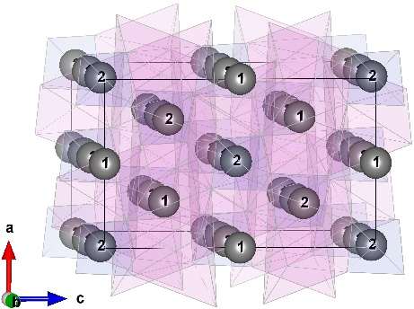
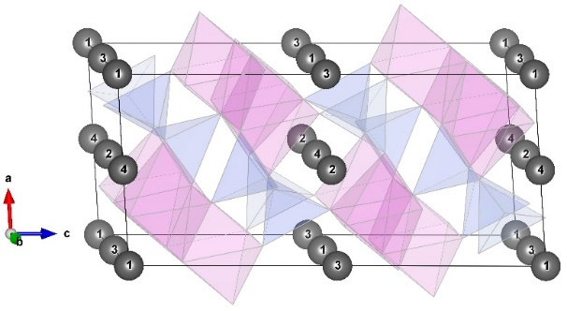
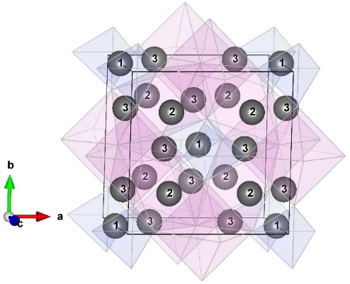
(a) (b) (c)
Figure 3: Interstitial sites identified by gray spheres in (a) CdSiO₃, (b) Cd₂SiO₄ and (c) Cd₃SiO₅. The numbered positions in the figure are described in Table 6.

Table 6: Coordinates of the interstitial positions.
CdSiO₃ |  |  |  |  | Cd₂SiO₄ |  | Cd₃SiO₅
1 |  | 2 | 3 | 4 | 1 | 2 | 1 | 2 | 3
x | 0.00 | 1/2 | 0.00 | 1/2 | 1/2 | 0.00 | 0.00 | 1/4 | 1/4
y | 0.00 | 0.00 | 0.00 | 1/2 | 1/2 | 0.875 | 0.00 | 1/4 | 0.00
z | 0.00 | 0.00 | 1/2 | 0.00 | 1/2 | 0.00 | 1/2 | 0.00 | 1/4

There is one important issue that should be carefully considered and this is related to the fact that in cadmium silicates (CdSiO₃ and Cd₃SiO₅) there are more than one type of Cd, Si and O site that are symmetrically non-equivalent and each one of the sites should be considered when a vacancy of one of the chemical species is modelled. Using again the oxygen Frenkel pair as an example, for the CdSiO₃ structure there are nine different oxygen sites and each one of them were calculated separately. In addition, for CdSiO₃ these were calculated with four different interstitial positions generating 36 different combinations of unbound oxygen Frenkel pairs. The same happens for all other types of intrinsic disorder and quite a large number of individual calculations had to be done to cover all possibilities. It would be very confusing and very long if all numbers were quoted in the present paper, so a summarised plot was produced instead, where all values were grouped according to the type of defect representing the spread of energy values. Different from the other two matrices, the Cd₂SiO₄ has only one symmetrically non-equivalent position for the Cd, Si and O ions, so it will only have one type of Cd, Si and O vacancy. After optimizing the structures that contained the isolated point defect (vacancy and interstitial) we calculate all combinations for the solution energies of the unbound intrinsic defects and the results are shown in figure 4. The solution energies were normalised by the number of basic defects present in the final defect configuration according to the related reaction (see Table 5). Using again the example of the oxygen Frenkel pair, the final solution energy was divided by two since two types of defects form the Frenkel pairs. This plot gives an overview of intrinsic defect behaviour in all compounds and at two different temperatures. The bars represent the solution energy range for each defect, as explained before. Table 7 shows the average solution energy and the number of different configurations calculated.
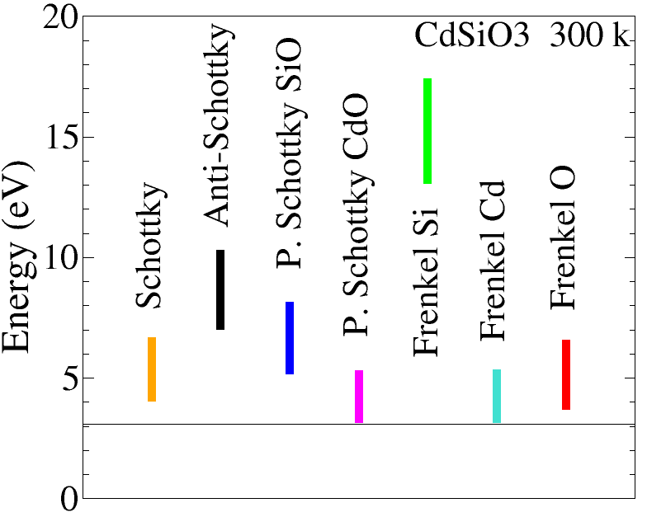
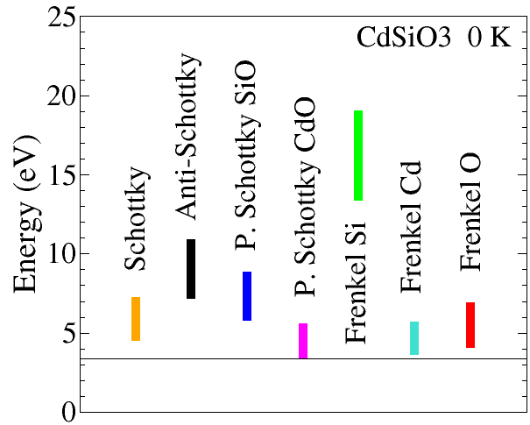
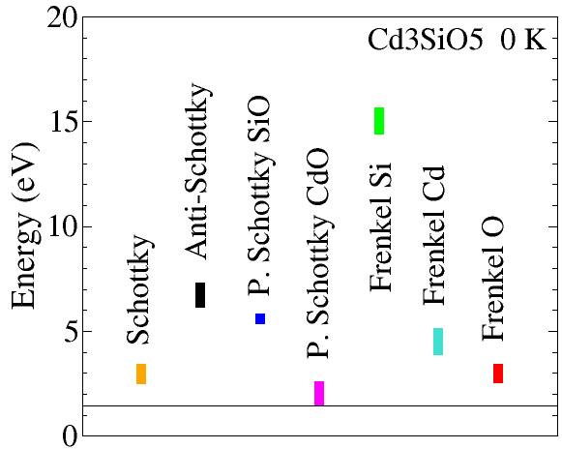
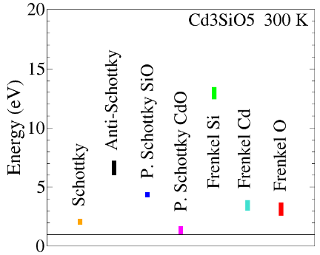
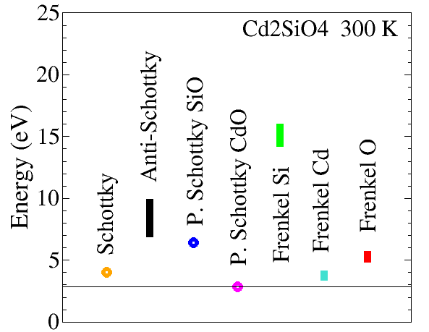
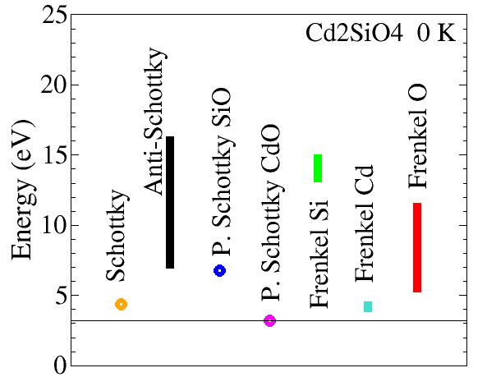
Figure 4: Range of values of normalised energies for each type of defect (a) CdSiO₃ at 0 K, (b) CdSiO₃ at 300 K, (c) Cd₂SiO₄ at 0 K, (d) Cd₂SiO₄ at 300 K, (e) Cd₃SiO₅ at 0 K and (f) Cd₃SiO₅ at 300 K.
(a)
(b)
(e)
(f)
(c)
(d)
Table 7: Values of lowest solution energies for unbound defects in the CdSiO₃, Cd₂SiO₄ and Cd₃SiO₅. The values were normalised to the total number of basic defects, as explained in the text.
Defect type | 0K [eV] | 300K [eV] | Nº of config.
$$\text{CdSi}{\text{O}}_{3}$$
Schottky
$${\text{V}}_{\text{Cd}}^{''}{\text{V}}_{\text{Si}}^{''''}{\text{5V}}_{\text{O}}^{••}$$ | 4.48 | 4.02 | 6561
Pseudo- Schottky
$${\text{V}}_{\text{Cd}}^{''}{\text{V}}_{\text{O}}^{••}$$  $${\text{V}}_{\text{Si}}^{''''}{\text{2V}}_{\text{O}}^{••}$$ | 3.37  5.74 | 3.12  5.72 | 27  243
Anti- Schottky
$${\text{Cd}}_{\text{i}}^{••}{\text{Si}}_{\text{i}}^{••••}{\text{3O}}_{\text{i}}^{''}$$ | 7.11 | 7.00 | 1024
Frenkel
$${\text{O}}_{\text{i}}^{''}{\text{V}}_{\text{O}}^{••}$$  $${\text{Si}}_{\text{i}}^{••••}{\text{V}}_{\text{Si}}^{''''}$$  $${\text{Cd}}_{\text{i}}^{••}{\text{V}}_{\text{Cd}}^{''}$$ | 4.02  13.33  3.62 | 3.67  13.22  3.31 | 36  12  12
$${\text{Cd}}_{\text{2}}\text{Si}{\text{O}}_{4}$$
Schottky
$${\text{2}\text{V}}_{\text{Cd}}^{''}{\text{V}}_{\text{Si}}^{''''}{\text{4V}}_{\text{O}}^{••}$$ | 4.40 | 4.05 | 1
Pseudo- Schottky
$${\text{V}}_{\text{Cd}}^{''}{\text{V}}_{\text{O}}^{••}$$  $${\text{V}}_{\text{Si}}^{''''}{\text{2V}}_{\text{O}}^{••}$$ | 3.23  6.80 | 2.87  6.46 | 1  1
Anti- Schottky
$${\text{2}\text{Cd}}_{\text{i}}^{••}{\text{Si}}_{\text{i}}^{••••}{\text{4O}}_{\text{i}}^{''}$$ | 8.04 | 7.95 | 128
Frenkel
$${\text{O}}_{\text{i}}^{''}{\text{V}}_{\text{O}}^{••}$$  $${\text{Si}}_{\text{i}}^{••••}{\text{V}}_{\text{Si}}^{''''}$$  $${\text{Cd}}_{\text{i}}^{••}{\text{V}}_{\text{Cd}}^{''}$$ | 5.51  13.34  4.09 | 5.06  14.45  3.63 | 2  2  2
$${\text{Cd}}_{\text{3}}\text{Si}{\text{O}}_{5}$$
Schottky
$${\text{3V}}_{\text{Cd}}^{''}{\text{V}}_{\text{Si}}^{''''}{\text{5V}}_{\text{O}}^{••}$$ | 2.67 | 1.81 | 256
Pseudo- Schottky
$${\text{V}}_{\text{Cd}}^{''}{\text{V}}_{\text{O}}^{••}$$  $${\text{V}}_{\text{Si}}^{''''}{\text{2V}}_{\text{O}}^{••}$$ | 1.65  5.56 | 0.99  4.29 | 4  4
Anti- Schottky
$${\text{3Cd}}_{\text{i}}^{••}{\text{Si}}_{\text{i}}^{••••}{\text{5O}}_{\text{i}}^{''}$$ | 11.04 | 10.83 | 19683
Frenkel
$${\text{O}}_{\text{i}}^{''}{\text{V}}_{\text{O}}^{••}$$  $${\text{Si}}_{\text{i}}^{••••}{\text{V}}_{\text{Si}}^{''''}$$  $${\text{Cd}}_{\text{i}}^{••}{\text{V}}_{\text{Cd}}^{''}$$ | 2.70  14.59  3.85 | 2.74  12.58  2.98 | 6  3  6

An important point to be highlighted is that cadmium silicate in the Cd₃SiO₅ phase has a unique configuration that differentiates it from other matrices, that is the existence of oxygen ions bonds between two cadmium ions. This matrix has two symmetrically non-equivalent sites for both cadmium ions and for the oxygen ions. One of these symmetrically non-equivalent sites on Cd₃SiO₅ makes Cd-O-Si type bonding. In all the cadmium silicate stoichiometries studied in this article (CdSiO₃, Cd₂SiO₄ and Cd₃SiO₅), this is the standard bond type for all cadmium ions. With these characteristics in mind, it was identified that the ions that form the less energetic CdO pseudo-Schottky defect in the Cd₃SiO₅ phase are exactly the ions that form the Cd-O-Cd bond. This is due to the fact that the Si-O bond has a higher degree of covalence, while the Cd-O bond is more ionic, therefore, the Si-O bond is more strongly linked than the Cd-O bound, facilitating the formation of oxygen vacancy that bonds only to cadmium ions. We can see in table 7 that the least energetic defect is the CdO pseudo-Schottky defect in all cadmium silicate matrices. In the Cd₃SiO₅ phase, the formation energy is around 1.5 eV, while in the other two phases the values are about twice as big. That difference in the value of formation energy is due to the fact that the CdO pseudo-Schottky defect is formed based on the ions that participates in the Cd-O-Cd ionic bond.
It is quite clear from Figure 4 that Si Frenkel pairs are the highest energy defects and the CdO pseudo-Schottky defects have the lowest energies for all structures in both temperatures. These results corroborate some experimental reports about the formation of cadmium vacancies ($V_{Cd}^{''}$) during the synthesis of cadmium silicates at high temperatures, which is plausible considering the high vapour pressure of CdO [6,11,12,28]. That has been reported in literature [21], one possible mechanism that triggers the formation of Cd₂SiO₄ and Cd₃SiO₅, despite the fact that the starting reactants were mixed in [CdO]/[SiO₂]=1, is that cadmium silicate phases can accommodate reasonable amounts of CdO pseudo-Schottky defects, leaving extra amounts of CdO available to form a richer CdO phase with the same starting amount of SiO₂. The explanation for this is that all phases can be formed with less CdO than expected, since the fact that the pseudo-Schottky CdO defect is the most energetically favorable defect in all 3 phases of cadmium silicate favours the formation of multiple phases. In addition, the low CdO vapour pressure, compared to SiO₂, increases this effect by adding extra CdO deficiency in the matrices. At the same time, the intrinsic luminescence frequently observed in CdSiO₃ is assigned to CdO pseudo-Schottky defects. In a previous paper from our group [10], a decrease in the overall intensity of luminescence when the samples were thermally treated in a Cd saturated atmosphere was observed, evidencing that all luminescent channels are related to trap centres induced by Cd vacancies. The lowest values of the energies for each intrinsic defect are shown in table 7 and also, the total number of configurations found for each defect type. For all conditions the pseudo-Schottky defect of CdO was the most probable defect displaying the lowest energy costs among all calculated defects.
The above results indicate the main type of intrinsic defect from the energetic point of view, but they do not give information about which is the actual defect in the systems in terms of the lattice configuration.
Taking the case of the CdO pseudo-Schottky defect, which is the defect that involves the lowest energy cost, one should consider where the two vacancies are going to be in the lattice and if they are going to be in neighbouring sites or further apart. This can be addressed by modelling the bound defect and simulating all possible configurations of the two vacancies. For each configuration, a calculation should be done and the lattice relaxation would account for the distortions induced by the presence of the vacancies.
This procedure was done for CdSiO₃. A Cd vacancy was generated and set at the central position in the origin of the modelling structure. Since there are three non-equivalent Cd sites, the Cd vacancy was created using the Cd3 site, and that site was chosen because the energy cost to produce the Cd vacancy is the smallest of the three possible sites. From the central position, the oxygen vacancies were created, one at a time, firstly in the first coordination shell (up to $2.39 Å$) followed by the ones in the second (up to $6.55 Å$) coordination shells and so on. The initial oxygen vacancy position and solution energies obtained for each one of the configurations are presented in Table 8. The calculations were performed at 0 K. Positions from 1 to 5 represent the vacancies in the first coordination shell while those from 6 up to 11 represent the second and higher order coordination shells. Results show that for the configurations with the two vacancies and higher distances, the energy costs increased. The results represented in this table are just part of the configurations that were calculated, but for all the defects where the oxygen vacancy is further apart from the Cd vacancy, the energies are higher than the ones shown in the Table 8. It is interesting to notice, however, that for shortest distances, there is clearly a preferable optimum distance that is in between the first and second coordination shell, represented by position 6 in Table 8. Such a position is not directly linked to the original polyhedron from where the Cd was removed to create the Cd vacancy.
The effect of the lattice relaxation in the region immediately surrounding the defect with smallest energy cost, i.e. the Cd vacancy and O vacancy in position number 6, was investigated via direct inspection of the lattice configuration before and after the lattice relaxation. The chosen region next to the defect was plotted before and after the relaxation process and this can be seen in Figure 5, where the two vacancies are represented as dark spheres. The oxygen position number 6 represents the unique symmetric site for oxygen ions linking two Si polyhedra. It is interesting to notice that the CdO pseudo-Schottky defect with smallest energy cost, causes an attraction between the two neighbouring Si favouring silicon-silicon bounds, precisely because the oxygen removed connect the two silicon polyhedra. Our calculations demonstrated that CdO pseudo-Schottky defect induces Si-Si bounds due to the presence of a specific oxygen vacancy.
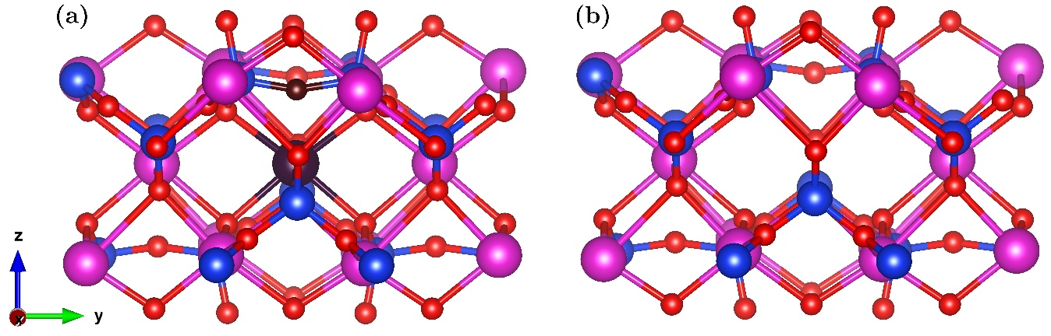
Figure 5: Configuration with smallest energy cost for a bound CdO pseudo-Schottky defect. In this configuration, we can observe that the oxygen ion only bonds with the two silicon ions and its removal can favour the Si-Si bond (only this symmetrically non-equivalent site has this configuration). Cadmium and oxygen vacancy sites are illustrated by the dark spheres in (a) representing the geometry of the lattice before relaxation. The final position of the neighbouring ions, after relaxation of the lattice, is represented in (b).

The present result also helps to support what is observed in the luminescence of CdSiO₃ samples produced by using sol-gel precursors with different pH values [10]. The blue emission, more intense in the low pH-sample, was associated with self-trapped excitons, while the red emission, more intense in the high pH-sample, was assigned to defects in the Si network. The CdO pseudo-Schottky defects play the role of e⁻-h⁺ traps, creating the self-trapped excitons, and the specific oxygen vacancy induce Si-Si bounds, as demonstrated by our calculation, which are responsible for the red emission. Similar experimental results were observed in SiO₂ samples with a deficiency of oxygen [29,30]. The results indicate that the pH of the sample interferes with the rate of polycondensation of TEOS (tetraethyl orthosilicate), the Si source in sol-gel methodology, and acts as a parameter of emission colour control. The fact that Cd and O vacancies located in neighbouring sites are energetically more favourable is another fact to be considered. In this case, it is important to consider a possible charge transfer process between centre defects, each acting as sensitive and/or activator centres. However, such a proposition is strictly theoretical and only can be confirmed by experimental observations.
Table 8: Values of normalised energies of bound defects in CdSiO₃.
Position | Energy (eV) | Distance (˚A) | Crystallographic Site
1 | 3.12 | 2.30 | O₁
2 | 2.91 | 2.32 | O₉
3 | 4.25 | 2.32 | O₂
4 | 3.21 | 2.35 | O₁
5 | 3.88 | 2.39 | O₂
6 | 2.09 | 2.90 | O₅
7 | 4.43 | 3.96 | O₈
8 | 3.26 | 4.21 | O₉
9 | 3.49 | 4.64 | O₇
10 | 4.25 | 5.87 | O₇
11 | 3.07 | 6.55 | O₅
12 | 4.73 | 7.07 | O₅
13 | 4.71 | 10.03 | O₅
14 | 4.71 | 11.25 | O₅

  - CdO Deficiency
Up to this point, it seems quite clear, from the energetic point of view, that CdO deficiency would be an important feature in all cadmium silicate phases. An important question immediately arises: if that is so, one should expect that most of the CdSiO₃, Cd₂SiO₄ and Cd₃SiO₅ reported in the literature would have some degree of CdO deficiency. Why was this feature never reported in the XRD powder pattern, although most of the authors reported that the luminescence of their apparently stoichiometric material has quite strong “intrinsic luminescence” due to Cd vacancies and F centres? Maybe the amount of CdO deficiency, that is the basic defects that generates the two emitting species, is not enough to be seen in the XRD powder diffraction pattern. Another issue that would trigger that CdO deficiency is due to high CdO vapour pressure [10] associated with the fact that to synthesise the material normally high temperatures are needed, enhancing this effect of loss of CdO content.
One way of testing this is by calculating the expected XRD powder pattern that would be produced if a certain amount of CdO vacancy pairs are created in the material. Since the binding energy of the defect is quite high, to do so both vacancies have to be created simultaneously. Atomistic modelling can handle this by the use of the mean field method [31], where an occupation factor of a particular site can be set, meaning that, on average, there would be a lack of the particular chemical species in that particular site. The atomistic code computes the contribution to the energies as a fraction of the contribution of a full chemical species. This can be done with the pair of CdO vacancies and the sites used are the ones that had the smallest energy cost, as discussed earlier. The deficient lattice is now energy minimised and the relaxation of the species inside the lattice would account for the contribution of the CdO vacancies formed. From the final position of the ions in the deficient unit cell, a XRD powder pattern can be calculated and compared to the crystallographic pattern deposited in databases. This procedure was done for all cadmium silicate phases under investigation.
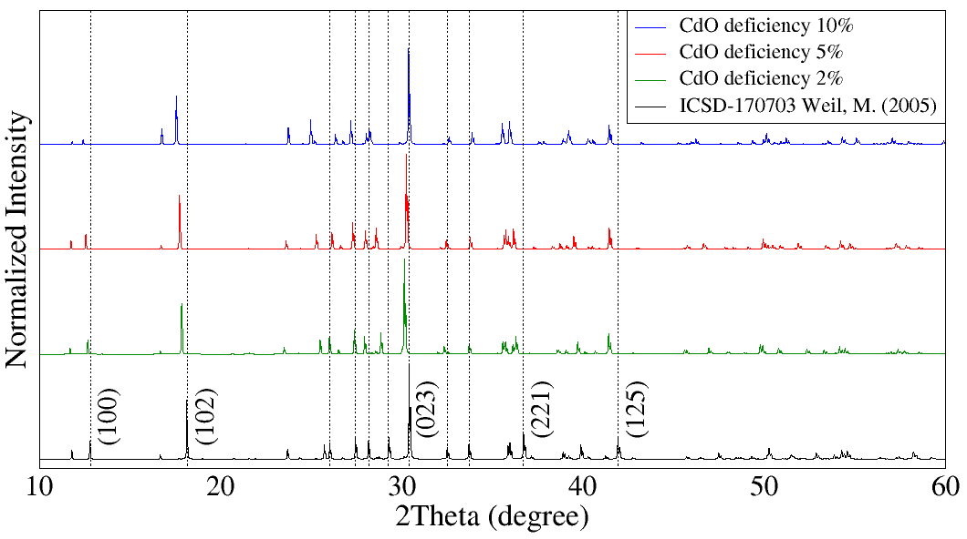
Figures 6, 7 and 8 display the simulated XRD powder patterns for CdO deficient CdSiO₃, Cd₂SiO₄ and Cd₃SiO₅ structures, respectively, calculated at 300 K, compared to the typical standard CdSiO₃, Cd₂SiO₄ and Cd₃SiO₅ stoichiometric structure found in the crystallographic database. It can be observed that all simulated deficient structures are comparable to the standard structures, particularly the low deficiency ones. For CdSiO₃ the 2% and 5% CdO deficient calculated structures can be misinterpreted as a stoichiometric ones, as compared to the standard pattern meaning that depending on the CdO deficient level, it will not be detected in a XRD measurement and most of the results may actually be related to a deficient structure, explaining both, why they usually showed luminescence coming from the CdO vacancy centres and also accommodated an amount of the Cd₂SiO₄ and Cd₃SiO₅ phase.
Figure 6: Comparison between the standard X-ray diffraction patterns in black and calculated with occupancy factor (O.F.) reduced by 2% in green, 5% in red and 10% in blue, up to 300 K in CdSiO₃.
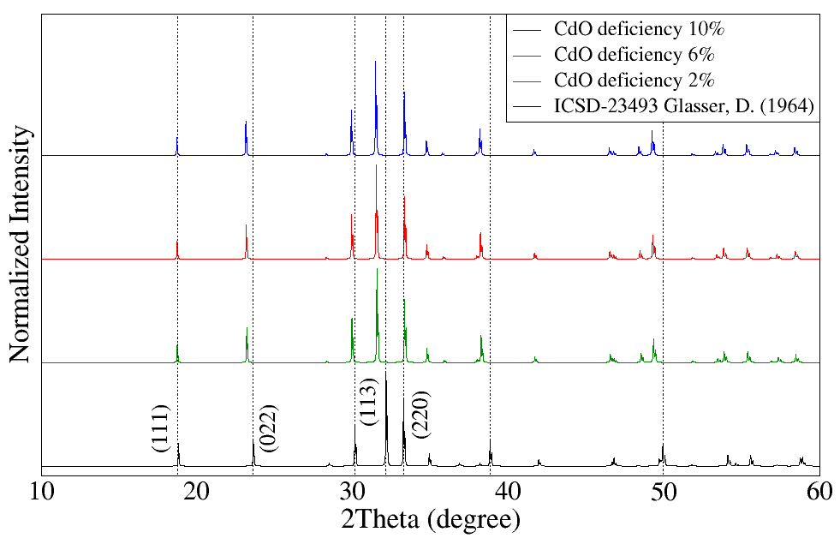
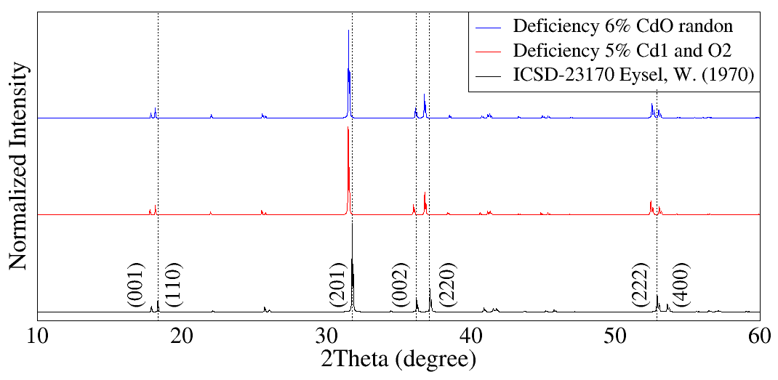
Figure 7: Comparison between the standard X-ray diffraction patterns in black and calculated with occupancy factor (O.F.) reduced by 2% in green, 6% in red and 10% in blue, up to 300 K in Cd₂SiO₄.
Figure 8: Comparison between the standard X-ray diffraction patterns in black and calculated with occupancy factor (O.F.) reduced by 5% in blue and 6% in red, up to 300 K in Cd₃SiO₅.
Looking in more detail the X-ray diffraction pattern of the CdSiO₃ matrix, one may ask how sensitive would be XRD to changes in CdO deficiency. Table 9 shows that, for the main peaks (identified according to the respective Miller indices), there is an increasing variation both for the values of interplanar distances as well as in the position and intensity of the peak. In figure 9, showed that, as a general behaviour, the greater the deficiency, the greater the variation in all observed parameters. Important points to note: i-) peak positions tend to shift to lower angle, except peak 125, which varies minimally and approaches the reference peak with increased CdO deficiency; ii-) the increase in deficiency, in general, increases the intensity of the peaks in relation to the reference peak, except peak 202, which, the greater the deficiency, the lower the peak in relation to the reference peaks; iii-) the lattice parameters b, c and beta decrease the greater the CdO deficiency. We observed that the CdSiO₃ matrix with a 2% CdO deficiency has a variation of around 1% in all observed parameters. This indicates that the XRD pattern may not be sensitive enough to detect a CdO deficiency even at this concentration (2%), unless the measurements have very good signal to noise ratio, with very small background and no additional phases are present. This last point is particular difficult to fulfill and almost all papers found in the literature reported the presence of at least one of the other cadmium silicate phase and even the papers that reports “single phase” are found to present variations in the relative peak intensities that may represents CdSiO₃ with a certain degree of deficiency. Another observation is that peak 221 (located at 2θ = 36º), from 5% CdO deficiency, has greater intensity than peak 202. This fact can be seen in [10], where all samples have the peak located at 2θ = 36º more intense than the peak located at 2θ = 29º, so the samples may have a quite high level of CdO deficiency. Finally, we emphasize that the data in Table 9 and Figure 9 were simulated using the unique wavelength of the Cu, Kα₁ (1.54059 Å). Furthermore, the data in figures 2, 6, 7 and 8, were simulated with the wavelengths of the Cu, Kα₁ (1.54059 Å) with relative intensity 1 and Kα₂ (1.54432 Å) with relative intensity 0.5.

Table 9: Values of interplanar distance, peak location and peak intensity for the CdSiO₃ matrix with 0%, 2%, 5% and 10% CdO deficiency.
Miller indices | Interplanar distance (Å) |  |  |  | 2Theta (degree) |  |  |  | Intensity
 | 0% | 2% | 5% | 10% | 0% | 2% | 5% | 10% | 0% | 2% | 5% | 10%
0 2 3 | 2.96 | 2.96 | 2.95 | 2.94 | 30.14 | 30.14 | 30.24 | 30.37 | 100 | 100 | 100 | 100
1 0 2 | 4.94 | 4.97 | 5.00 | 5.05 | 17.93 | 17.84 | 17.73 | 17.55 | 42.37 | 42.60 | 44.20 | 46.06
1 2 5 | 2.17 | 2.18 | 2.18 | 2.18 | 41.49 | 41.41 | 41.44 | 41.43 | 27.00 | 27.18 | 27.50 | 27.56
2 0 -2 | 3.25 | 3.26 | 3.27 | 3.28 | 27.46 | 27.37 | 27.29 | 27.18 | 24.54 | 25.15 | 25.69 | 26.19
2 0 2 | 3.07 | 3.09 | 3.12 | 3.16 | 29.02 | 28.84 | 28.58 | 28.19 | 21.82 | 21.32 | 20.55 | 19.70
2 2 1 | 2.47 | 2.47 | 2.48 | 2.50 | 36.42 | 36.30 | 36.16 | 35.95 | 20.79 | 21.51 | 22.88 | 24.62

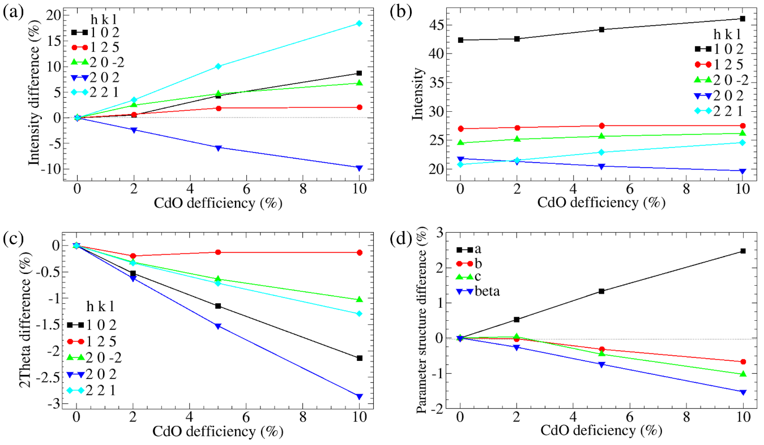
Figure 9: Variation of the XRD pattern for CdSiO₃ matrix with CdO deficiency. (a) Variation in the intensity of the main peaks according to the degree of CdO deficiency. (b) Absolute values for the intensities of the main peaks according to CdO deficiency. (c) Variation in the position of the main peaks according to CdO deficiency. (d) Variation of the lattice parameters of the CdSiO₃ matrix according to CdO deficiency.

- Conclusions
The intrinsic defects of cadmium silicates (CdSiO₃, Cd₂SiO₄ and Cd₃SiO₅) have been investigated by atomistic computational modelling and considering experimental reports of optical properties and defects. A potential parameter set was found, and structures were reproduced with discrepancy between experimental and simulated structures better than 2%. Intrinsic defects were calculated using the unbound condition for all matrices and at two different temperatures (0 K and 300 K). The pseudo-Schottky CdO defect was the most probable kind of defect for all cadmium silicates at both temperatures. For CdSiO₃ calculations were also performed in bound conditions at 0 K. Results demonstrated that the pseudo-Schottky defect induces a Si-Si bond in presence of an oxygen vacancy, and there is a possibility of a charge transfer process due to defects being located close to each other, a possible explanation for some of the intrinsic luminescence features in this material, already reported by the experimental literature. Based on the fact that the CdO pseudo-Schottky defect is the main form of intrinsic disorder, CdO deficient lattices were modelled and their calculated XRD powder diffraction patterns were shown to be comparable to the standard XRD powder pattern deposited in the crystallographic database for the stoichiometric structures. This last result may explain both the stabilisation of CdO vacancies reported as responsible for the intrinsic luminescence of CdSiO₃ and also the common result that CdSiO₃, Cd₂SiO₄ and Cd₃SiO₅ are found coexisting in the same sample, regardless the fact that the starting oxides were mixed in a [CdO]/[SiO₂]=1 ratio.

Acknowledgments
The authors are grateful to the Federal University of Sergipe (UFS), to the LPCM group, to the funding agency CAPES, and to the CENAPAD-SP.

References
[1] M. Weil, Parawollastonite-type Cd3[Si3O9], Acta Crystallogr. Sect. E Struct. Reports Online. 61 (2006) 102–104. https://doi.org/10.1107/S1600536805015278.
[2] L.S.D. Glasser, F.P. Glasser, The Preparation and Crystal Data of the Cadmium Silicates CdSiO 3 , Cd 2 SiO 4 , and Cd 3 SiO 5, Inorg. Chem. 3 (1964) 1228–1230. https://doi.org/10.1021/ic50019a005.
[3] B. Lei, Y. Liu, Z. Ye, C. Shi, Luminescence properties of CdSiO3:Mn2+ phosphor, J. Lumin. 109 (2004) 215–219. https://doi.org/10.1016/j.jlumin.2004.02.010.
[4] K. Van den Eeckhout, P.F. Smet, D. Poelman, Persistent Luminescence in Eu2+-Doped Compounds: A Review, Materials (Basel). 3 (2010) 2536–2566. https://doi.org/10.3390/ma3042536.
[5] T. Aitasalo, J. Hölsä, H. Jungner, M. Lastusaari, J. Niittykoski, Thermoluminescence Study of Persistent Luminescence Materials: Eu 2+ - and R 3+ -Doped Calcium Aluminates, CaAl 2 O 4 :Eu 2+ ,R 3+, J. Phys. Chem. B. 110 (2006) 4589–4598. https://doi.org/10.1021/jp057185m.
[6] Y. Liu, B. Lei, C. Shi, Luminescent properties of a white afterglow phosphor CdSiO 3:Dy3+, Chem. Mater. 17 (2005) 2108–2113. https://doi.org/10.1021/cm0496422.
[7] H. Nagabhushana, D.V. Sunitha, S.C. Sharma, S.C. Prashantha, B.M. Nagabhushana, R.P.S. Chakradhar, CdSiO3:Eu3+ red nanophosphors prepared by low temperature solution combustion technique, its structural and luminescent properties, J. Alloys Compd. 616 (2014) 284–292. https://doi.org/10.1016/j.jallcom.2014.05.228.
[8] S. Lai, Z. Yang, J. Liao, J. Qiu, Z. Song, Y. Yang, D. Zhou, Investigation of persistent luminescence property of Bi 3+ , Dy 3+ co-doped CdSiO 3 phosphor, Mater. Res. Bull. 60 (2014) 714–718. https://doi.org/10.1016/j.materresbull.2014.09.049.
[9] X. Qu, L. Cao, W. Liu, G. Su, P. Wang, I. Schultz, Sol–gel synthesis of long-lasting phosphors CdSiO3: Mn2+, RE3+ (RE=Tb, Eu, Nd) and luminescence mechanism research, Mater. Res. Bull. 47 (2012) 1598–1603. https://doi.org/10.1016/j.materresbull.2011.08.012.
[10] D.F. Farias, C.M. de Abreu, S.M. V. Novais, Z.S. Macedo, Tailoring luminescent colour and life persistence of undoped CdSiO3, J. Lumin. 194 (2018) 535–541. https://doi.org/10.1016/j.jlumin.2017.10.082.
[11] Z. Yang, J. Liao, T. Wang, H. Wu, J. Qiu, Z. Song, D. Zhou, Ultraviolet long afterglow emission in Bi3+ doped CdSiO3 phosphors, Mater. Express. 4 (2014) 172–176. https://doi.org/10.1166/mex.2014.1158.
[12] J. Kuang, Y. Liu, Observation of energy transfer from host to rare earth ions in Pr3+-doped CdSiO3 long-lasting phosphor, Chem. Phys. Lett. 424 (2006) 58–62. https://doi.org/10.1016/j.cplett.2006.04.033.
[13] C.A. Barboza, J.M. Henriques, E.L. Albuquerque, V.N. Freire, J.A.P. Da Costa, E.W.S. Caetano, Triclinic CdSiO3 structural, electronic, and optical properties from first principles calculations, J. Phys. D. Appl. Phys. 42 (2009). https://doi.org/10.1088/0022-3727/42/15/155406.
[14] W. Eysel, Kristallchemie von Oxyorthoverbindungen, A3O (BO4), Neues Jahrb. Miner. Monatsh. 1970 (1970) 534–547.
[15] Q. Lin, X. Feng, Z. Man, Computer simulation of intrinsic defects in PbWO4, Phys. Rev. B - Condens. Matter Mater. Phys. 63 (2001) 1–6. https://doi.org/10.1103/PhysRevB.63.134105.
[16] G.F.C. da Bispo, R.A. Jackson, M.E.G. Valerio, Modelling of intrinsic defects in CaYAl3O7, Acta Phys. Pol. A. 133 (2018) 781–784. https://doi.org/10.12693/APhysPolA.133.781.
[17] J.D. Gale, GULP: A computer program for the symmetry-adapted simulation of solids, J. Chem. Soc. Faraday Trans. 93 (1997) 629–637. https://doi.org/10.1039/a606455h.
[18] B.G. Dick, A.W. Overhauser, Theory of the Dielectric Constants of Alkali Halide Crystals, Phys. Rev. 112 (1958) 90–103. https://doi.org/10.1103/PhysRev.112.90.
[19] J.D. Gale, Analytical free energy minimization of silica polymorphs, J. Phys. Chem. B. 102 (1998) 5423–5431. https://doi.org/10.1021/jp980396p.
[20] N.F. Mott, M.J. Littleton, Conduction in polar crystals. I. Electrolytic conduction in solid salts, Trans. Faraday Soc. 34 (1938) 485. https://doi.org/10.1039/tf9383400485.
[21] G. V. Lewis, C.R. A Catlow, Potential models for ionic oxides, J. Phys. C Solid State Phys. 18 (1985) 1149–1161. https://doi.org/10.1088/0022-3719/18/6/010.
[22] G. Sastre, J.D. Gale, Derivation of an Interatomic Potential for Germanium- and Silicon-Containing Zeolites and Its Application to the Study of the Structures of Octadecasil, ASU-7, and ASU-9 Materials, Chem. Mater. 15 (2003) 1788–1796. https://doi.org/10.1021/cm021262y.
[23] C.A.L. and C.R.A.C. A. T. J. Hope, The sorption of krypton in silicalite, Proc. R. Soc. London. A. Math. Phys. Sci. 424 (1989) 57–79. https://doi.org/10.1098/rspa.1989.0069.
[24] A. Cimino, M. Marezio, Lattice parameter and defect structure of cadmium oxide containing foreign atoms, J. Phys. Chem. Solids. 17 (1960) 57–64. https://doi.org/10.1016/0022-3697(60)90175-X.
[25] J.D. Jorgensen, Compression mechanisms in α‐quartz structures—SiO 2 and GeO 2, J. Appl. Phys. 49 (1978) 5473–5478. https://doi.org/10.1063/1.324517.
[26] K. Momma, F. Izumi, VESTA 3 for three-dimensional visualization of crystal, volumetric and morphology data, J. Appl. Crystallogr. 44 (2011) 1272–1276. https://doi.org/10.1107/S0021889811038970.
[27] R.M. Araujo, K. Lengyel, R.A. Jackson, L. Kovács, M.E.G. Valerio, A computational study of intrinsic and extrinsic defects in LiNbO 3, J. Phys. Condens. Matter. 19 (2007). https://doi.org/10.1088/0953-8984/19/4/046211.
[28] C.M. Abreu, R.S. Silva, M.E.G. Valerio, Z.S. Macedo, Color-control of the persistent luminescence of cadmium silicate doped with transition metals, J. Solid State Chem. 200 (2013) 54–59. https://doi.org/10.1016/j.jssc.2012.11.031.
[29] L.-S. Liao, X.-M. Bao, N.-S. Li, X.-Q. Zheng, N.-B. Min, Blue-, green-, and red-light emission from Si+-implanted thermal SiO2 films on crystalline silicon, J. Lumin. 68 (1996) 199–204. https://doi.org/10.1016/0022-2313(96)00023-3.
[30] L. Skuja, Optically active oxygen-deficiency-related centers in amorphous silicon dioxide, J. Non. Cryst. Solids. 239 (1998) 16–48. https://doi.org/10.1016/S0022-3093(98)00720-0.
[31] J.B. Amaral, J.R. de Moraes, S.L. Baldochi, R.A. Jackson, M.E.G. Valerio, Computer modelling of undoped and Eu 3+ -doped LiLa(WO 4 ) 2, Phys. Status Solidi. 10 (2013) 165–167. https://doi.org/10.1002/pssc.201200510.

