Article
Bridge foundation river scour and infill characterisation using Water Penetrating Radar
K.E.J. Campbell1 ¹, A. Ruffell ¹, J. Pringle ², D. Hughes ¹, S. Taylor ¹, B. Devlin ^{3,}
¹ Department for Infrastructure (Northern Ireland), Clarence Court, Belfast, Northern Ireland, BT2 8GB, UK
² School of the Natural Built Environment, Queens University, Belfast, Northern Ireland, BT7 1NN, UK
³ School of Geography, Geology & Environment, Keele University, Keele, Staffordshire, ST5 5BG, UK
⁴ Bedford House, 16-22 Bedford Street, Belfast, BT2 7FD, UK
Abstract: Inspections of engineered structures below water level are essential to ensure the long-term serviceability of bridge infrastructure and to avoid major damage or failure. This research aimed to investigate integrated geophysical technologies for the underwater inspection of bridge foundation-related scour and erodible scour-based infill. Survey methods focused on Water Penetrating Radar (WPR), supplemented by sonar. Whilst the survey benefits of sonar imaging water-sediment interface and structures are well known, WPR is not. However it is ideally suited to the survey of the water base and sub-sediment in shallow (>10 m) freshwater, especially where suspended sediment, weed-infestation or methane impede sonar results. Our work produced good WPR imagery acquired from small, maneuverable boats that allowed bathymetric profiles to be plotted as well as the likely locations of soft-sediment scour in future high-water flow events. This study provides clear benefits for integrated sonar and WPR surveys in quantitative assessment of engineered structures within freshwater.
Keywords: Bridge monitoring; sonar; Water Penetrating Radar; River Scour

1. Introduction
The failure of bridges may be due to incorrect geotechnical evaluation, over-loading, concrete/metal corrosion or lack of inspection (Biezma and Schanack, 2007) and rarely, poor design. Water-scour of foundations is a significant and often unpredictable cause of problems in bridge supports (Ettema et al, 2011; Sathurusinghe et al, 2020). Deng & Cai (2010) consider it to be one of the main causes of failure, presenting over 1,000 cases from 1961-1991 in the United States alone, with an attendant annual maintenance cost of over $30 million. Whilst modern design practices take increased flood events into account, future climate change is not currently reliably predicted. Older bridges, which would benefit from closer monitoring, typically did not consider these factors at the design stage and so rarely benefit from the mitigatory construction of modern structures, such as that seen in flexi-arch bridges (Sathurusinghe et al, 2021).
Deng & Cai (2010, p.125) state that “Scour is the result of the erosive action of flowing water, which excavates and carries away materials from the bed and banks of streams, and from around the piers and abutments of bridges”. They observed (also p.125) that “there are generally three types of scour that affect the performance and safety of bridges, namely, local scour, contraction scour, and degradational scour”. These are common in the gyratory currents of the marine realm (see the Railway Accident Investigation Unit [RAIU], 2010 report on the collapse between Belfast and Dublin [Ireland] for instance), but also occur in rivers, and to some extent lakes: in this work, we focus on a fluvial system with two different bridge types.
Sonar surveys have been typically applied to quantify water depths, water-sediment interfaces and identify/locate objects (Topszewski et al., 2016). Sonar does however have limitations, including: the inability to penetrate beneath the sediment-water interface; rocky substrates; weed infestation and gas bubbles (Ruffell et al., 2017). Ground Penetrating Radar (GPR) is commonly used to investigate terrestrial engineering structures and the surrounding environment, but has rarely been used when surveying in fresh water.
The aim of this paper is to firstly evaluate previous studies where water penetrating radar (WPR from hereon) was used for the inspection of sub-bottom channel profiles around structures such as bridge piers in freshwater; secondly to detail a case study where we have used both WPR and sonar to investigate bridge scour and infill, and thirdly to combine results to create a 3D model of the study site as an exemplar.
  - Ground Penetrating Radar (GPR) applied to Water Penetrating Radar (WPR)
It is beyond the scope of this paper to review in detail all GPR and electrical geophysical survey methodologies; only a brief introduction to the relevant concepts is given here and the interested reader is referred to geophysical textbooks such as Reynolds (2011); Sharma (1997) or Daniels (2004) for details. GPR uses the transmission and reflection of electro-magnetic waves (typically 25 MHz to 1000 MHz depending on desired resolution and depth penetration) in soil, rock, water/ice and sediment. A GPR system requires source and receiving antennas (measuring the same central frequency). The transmitter-receiver array is typically moved along a survey profile and radar traces are collected against pre-set time or distance interval to produce a time-distance cross-section (in some literature called a radargram): these maybe collated into plan views typical of other geophysical surveys. Alternatively, one antenna may be moved away from a static antenna to create a moveout profile. Radargrams possess two properties that are of particular interested here: [a] reflections at interfaces between two geological media of differing dielectric permittivity; and [b] radar wave attenuation (or signal loss) as a function of fluid electrical conductivity and wavelength (Reynolds, 2011). A number of key features of GPR antennas relevant to this study are summarised. Antenna may be built to transmit and receive a range of frequencies, from low (e.g. 25 MHz) to very high (e.g. 2-3GHz). Most common for subsurface surveying (including in freshwater) would be antennae in the 50 MHz to 500 MHz range.
This study tested 50 MHz, 100 MHz, 200 MHz and 250 MHz antennas, the results of which are outlined below. Antennas may be left unshielded, making the results of GPR surveying prone to non-target artefacts (e.g. metal poles, power lines, out-of-plane objects) but leaving a lightweight and flexible design. Shielding of the antennae partly removes this problem of such interference, but creates a relatively inflexible design. Antenna orientation can influence results, with different orientations achieving varied subsurface resolution, balanced with being prone to out-of-plane reflections (Kruk & van der Slob, 2004). For boat-borne GPR surveying, the dimensions of the vessel often determines antenna size and orientation for lower frequency antenna like 100 MHz or lower (Gorin & Haeni, 1989). GPR data can be extensively processed to remove artefacts and improve clarity: a full description of what processing steps are available and what they do can be found in Reynolds (2011); Sharma (1997) and Daniels (2004). Freshwater GPR surveys are generally successful (Beres & Haeni, 1991; Nobes et al., 2006), although like all geophysical surveys there is the choice of improved resolution at shallow depths (in GPR with higher frequency antenna) vs. poorer resolution but with greater depth range (in GPR with lower frequency antennas). Most surveys of sediment thickness/type deploy lower frequency antennas, attempting to image subsurface sediments (Haeni, 1996; Haeni, et al., 1987; Kovacs, 1991; Sellman et al., 1992). The primary difference between terrestrial GPR and aqueous WPR is antenna deployment: in GPR these are used in assessing ground conditions, with antenna moved across the surface of the area to be investigated. In WPR such antenna are positioned in contact with fresh water, be it within a non-metallic, single-skin boat, or on/within the water (water-proofed as necessary). Some work (see above) has trialled suspending antennas above water, with a resultant air-gap that may diminish results. Variations in water conductivity (e.g. salt content in brackish/coastal waters) and type(s) of suspended matter affect radar wave propagation and reflection (Parker et al., 2010) such that in some brackish lakes and lagoons, WPR will not work well. This is because fresh- and saltwater have similar dielectric properties (~80 each) and radar velocities (fresh is 0.033 m/ns, saltwater is 0.01 m/ns) but very different conductivities (freshwater is 0.5 mS/m, saltwater is 30,000 mS/m). This results in low radar wave attenuation in freshwater and high deterioration in saltwater, which simply absorbs radar waves at the frequencies needed. Parker et al. (2010) give a summary of what they term water penetrating radar or WPR: they suggest that because water is relatively homogeneous, radar waves penetrate easily but slowly. Radar wave transmission is facilitated along the water – air interface, causing out-of-plane anomalies when floating objects are present. Conversely, excellent cross-sections of water depth, with suspended objects, as well as sediment subsurface are obtained using WPR in fresh water. Two WPR data outputs are possible: commonest are 2D radargrams (vertical soundings of water and sediment) and more rarely, 3D plan views at various depths. These map–like outputs comprise digital data and can be subjected to manipulation in a Geographic Information System such as ARC-GIS, but require accurate geolocation on a grid or by GPS. Although WPR has been used to successfully image scour around bridge supports (e.g. Gorin & Haeni, 1989 and see below), the current work shows 2D radargrams, digitised 3D plan views and selected processed data of bridge scours, and makes an evaluation of each data output type. A critical factor in WPR data acquisition is the mode of antenna deployment (in water/out of water; within boat/type of vessel and base; antenna orientation): Ruffell & Parker (2021) reviewed previous methods of WPR surveying for a range of applications, and commented that many authors do not state this, something we (here) do explicitly.

2. Previous Work
A pioneering study by Gorin & Haeni (1989) used low-frequency 80 MHz WPR data, compared to three seismic (or acoustic) methods (black & white fathometer; colour fathometer; tuned transducer), in their study of sediment scour around road bridge supports along the Connecticut River (USA). In their study, WPR suffered less sidescan anomalies and penetrated the sub-bottom sediments more effectively than the acoustic methods but few details on WPR data acquisition were provided (e.g. antenna orientation). Davidson et al. (1995) and Forde et al. (1999) had similar intentions to Gorin & Haeni (1989) in assessing scour around bridge supports in rivers: their work compared both their own 100 MHz and 450 MHz antenna profiles to those from literature and the water conductivities/water depths in each. These both show clearly the interplay between low frequency and better depth penetration, vs. higher antenna frequencies with improved stratigraphic detail, but less penetration: both limited by increasing water conductivities. Forde et al. (1999) also show how an initial review of the location, water conductivity, engineering, river flow, previous work and local geology are essential in planning a WPR survey. They also elucidate some of the issues in WPR surveying in that objects/surfaces not directly under the boat may be imaged, due to the high transmissivity of radar waves at the air-water interface (surface out-of-plane reflections such as jetties, piers, buoys); water-bottom multiples may dominate the sub-bottom reflections without processing (see below) and the limits of water depth.
Olimpio (2000) used a 300 MHz radar antenna array to gather 22 lines around 16 bridges in New Hampshire (USA), documenting pre- and post-flood scour holes plus infilled scour at 7 locations. Where possible, the results were verified by insertion of a steel rod, for both water depth and sub-bottom sediment thickness. A similar deployment method was used as in this study, by placing a commercially-available GPR system in the base of an inflatable boat: water levels (and thus changing depths) were elucidated. WPR data processing included migration and signal amplification (gain) on profiles on deeper water, in order to enhance sediment reflections.
Anderson et al. (2007) and Park et al. (2004) followed the work of Webb et al. (2000) with evaluations of the use of WPR in assessing bridge-support related scour. Webb et al. (2000) acquired WPR data from ten bridge sites over shallow water in Missouri (USA), using boat-borne methods or lowering the radar antenna from bridge decks. Their 2D profiles successfully imaged the base of each water body, some at peak flood times. Both works consider the use of 2D profiling before and during floods as a predictive tool in risk management, as well as WPR surveys over time, to build up a model of changing fluvial processes that they consider superior to reflection seismic 2D profiling, echo sounding, and electrical conductivity profiling. Anderson et al. (2007) make the contentious comment that the radar system does not need to be in contact with water, which is correct (see Haeni et al., 2000) although naturally, optimal coupling between antenna and water is desirable.
Following abundant publications on the use of WPR in assessing scour through the 1980s and 1990s, there appears fewer mainstream publications until 2020, when Ebrahimi et al. (2020) consider the complicating issue of wood debris accumulating at bridge supports, which may accelerate circulatory scour by expanding the effective footprint of the bridge pier, as well as setting up internal vortices between wooden objects, especially tree trunks and branches. Ruffell & Parker (2021) summarise many of the above articles, and comment that: advances in radar technology (e.g. the wide use of multiplexer systems); the use of borehole antennas in deep (over 20-30 metres) water; a conjunctive approach with sonar (especially remotely-deployed sidescan systems such as the Codaoctpus), and CHIRPS; data processing and visualisation may still further advance the use of WPR in assessing bridge scour:.

3. Site Description
This site was used for two reasons. Firstly, because within a relatively short distance of 40 m there is both a road and rail bridge, crossing a navigable section of the River Bann, on the southern outskirts of Portadown, County Armagh (N.Ireland): Figure 1 shows a satellite image of the two bridges. The road bridge is a reinforced concrete deck bridge supported over the river on four circular reinforced concrete piers (in the foreground of Figure 2). The railway bridge is seen in the background of Figure 2 and consists of a metal truss deck on circular metal supports on top of two piled foundation reinforced concrete piers.. Secondly, the River Bann is one of the longest rivers in Ireland, with this section being adjacent to a slipway facility: this section of river experiences a significant volume of water as well as wash effects from powerboats and other river activities. At the location of these two bridges, the River Bann narrows and becomes slightly shallower which leads to pressurized flow at the supports which in conjunction with motorized boat movements may encourage scouring action at these structures (Cumberlidge, 2002; Delany, 2004).
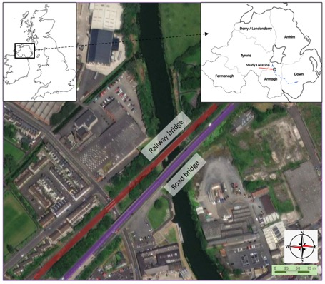
Figure 1. Location of the study site in the British Isles (top left) and Northern Ireland (with location and route of River Bann marked, top right); modified GeoEye satellite image of the two railway and road bridges and river studied (bottom).
The A3 Northway Dual Carriageway Bridge (road bridge built in two phases through the early 1970’s) has four circular reinforced concrete vertical supports (Figure 2) whilst the Belfast – Dublin railway bridge (current construction 1958-1960, replacing an 1848 wooden structure) has two, elongate vertical reinforced piled concrete support (lozenge-shaped, or rectangular, with acute ends) piers (Figure 2).

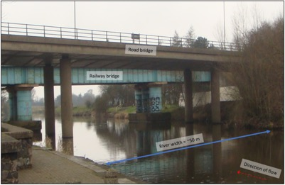
Figure 2. Annotated oblique view of the River Bann and the railway and road bridges studied, taken from the southwest bank (see Figure 1 for plan view map).
This location presented a good opportunity to consider the scouring effects around two separate bridge pier types of two separate bridges adjacent to each other in the same short stretch of river. The main caveat to this is the relative proximity of each implies the possibility of alterations in current flow from the upstream road bridge supports may influence scour around the downstream railway bridge structures (Figure 2). Conversely, for infrastructural and topographic reasons, road, rail and other (e.g. pipeline) bridges are often constructed side-by-each, making this study relevant. The road bridge comprises a multi-span reinforced concrete bridge which carries 3 lanes of arterial route traffic. There are four circular piers located in the water: two are near the edge of the river-bank (flood conditions depending) each consisting of circular concrete columns of 1.5 m diameter. These columns are spaced ~10 m apart and the span between the four piers is ~20 m (approximate distances as the sides of the river are not linear and are sometimes arcuate). The railway bridge has two tracks (North-East Bound and South-West Bound) with two 15 m long and 2 m wide piers, founded on piled foundations in the river bed, but closer (1 – 2 m) to the river bank than the central roadway piers, leaving a clear navigable channel down the centre of the watercourse.
The River Bann is typically 30 m – 60 m wide at the study location and is popular for both fishing and water-sports, with 30% ‘good’ 55% ‘moderate’ and 10% ‘poor’ 5% annual water quality classification by the Department of Agriculture and Economic Affairs/Northern Ireland Environment Agency (DAERA/NIEA, 2019). Conductivities were measured for both survey times (March and September) at between 0.02 µS/m and 0.04 µS/m; pH was consistently measured at 6.5 and eH at +20, reflecting the iron-rich Palaeogene basaltic (Antrim Lava Group) river hinterlands, underlying Palaeogene Lough Neagh Clay Group and red, oxidised glacial till of the river and it’s catchment in this area.
There is no marine influence, as the site is inland, with the river draining north to Lough Neagh, Europe’s largest freshwater lake and being fed by rainfall riverine catchments upstream. Depth-soundings using a plumb bob indicated that the river has variable depth in and around the bridges, from 0 m at the banks, to an average of 3 m, with isolated locations up to 5 m (see Methods, below). This variability makes hydrographic surveying particularly relevant, as physical soundings (such as rods or plum-bob) are specific to discrete locations and may not be representative of the entire area.

4. Methods
Visual examination of the river bed from the bank and dinghy, plus indications from plumb-bob soundings, suggest the riverbed to comprise both rocks and soft silt/mud. A carbon-fibre peat probe (Van Walt Ltd., 75 cm extension lengths) was also deployed and like the plumb-bob, no obvious firm substrate could be felt in the river centre by the user: rocks were detected adjacent to the river-banks. The use of WPR is very relevant in such mixed subsurface conditions as sediment type may be indicated, buried objects located and sediment depth (or indeed lack of sediment, say rock at surface) determined.
Three phases are considered in WPR surveys; air/gas; water and sediment/rock. Of the three phases present, air/gas bubbles were only present when sediment was disturbed, and has negligible effect on radar waves; freshwater is considered here and the boundary between it and underlying rock/sediment was always imaged. In order to study the efficacy of the two main data outputs in WPR (i) 2D profiles and (ii) 3D fence diagram views were generated (see below). A Sidescan Sonar survey using a Lowrance Elite 12Ti Totalscan was also conducted in order to further calibrate/compare to WPR depths and to identify any submerged hazards for health and safety considerations.
Initial tests used 50 MHz, and 100 MHz rough terrain (unshielded) antennas, housed in thick plastic sheathing and towed behind the electric motor-powered (MinKota Ltd. 12v Trolling engine) inflatable rib (Figure 3A). These antennas proved hard to maneuvre in the 30 m – 60 m-wide river, showed limited detail in the 0 m – 6 m of water depth and suffered from numerous out-of-plane reflections from the bridge piers, metal river-bank signage, subsurface debris and trees.
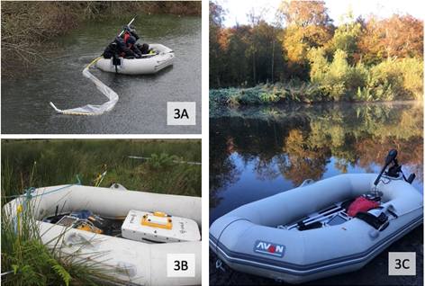
Figure 3. Methods of WPR deployment. A: the 100 MHz rough terrain antenna (straightens out on boat movement), housed in plastic sheathing. B: 250 MHz antenna, positioned in the dinghy (wooden foot-slats removed for optimal antenna to water contact); C: dinghy with electric outboard engine, in preparation for deployment with radar and GPS aboard.
100 MHz and 250 MHz shielded antennas in parallel and broadside endfire mode were then used for the bulk of the surveys, with an unshielded 200 MHz antenna (also in both parallel endfire and parallel broadside mode) deployed to compare with data from the 250 MHz shielded antenna. A grid of survey data around all six piers was gathered and positioned using a Leica Icon Total Station, checked by dead-reckoning of landmarks such as bridge piers: differential GPS was only accurate for the start and end points of the river-parallel survey lines, when not under either bridge, a common problem also encountered when surveying under buildings and tree cover.
Each radar antenna was placed in the base of a 4 person, 6 m long, 3 m-wide (Avon Boats Ltd.) inflatable plastic dinghy with foot-slats removed (Figure 3), propelled by an electric outboard engine. Running a survey with the engine off (drifting in the wind or current) and then running one with the motor on had negligible effect on the radar data (noted on figures, where present). The radar antennas were set directly onto the rubber floor of the dinghy, allowing for the contact with the water through a minimal thickness of 5 mm of rubber. We considered mounting unshielded antennas outside of the dinghy, but this was precluded by the decreased maneuverability around bridge piers and the presence of 5-10 cm amplitude waves from wind, passing vessels and our own survey.
Problems encountered included (Table 1): loss of positioning information around both bridge piers (the total station could only be placed on the west bank footpath, the east bank was inaccessible due to industrial wire fence and thick vegetation); drift in the dinghy during windy conditions; the need to stop or re-run cross-river survey lines when other water craft approached and the presence of debris in shallow water, adjacent to river banks such as tree branches, shopping trollies [carts], discarded metal work [railings] and dumped bicycles. If wind-generated drift of more than the width of the dinghy (and thus for all antenna used, roughly the radarwave footprint at the boat-deck to water interface) was recorded, the particular survey line was deleted and re-recorded.

Problems encountered | Effect
Loss of positioning information around both bridge piers | Total station could only be placed on the west bank footpath, the east bank was inaccessible due to industrial wire fence and thick vegetation.
Drift in the dinghy during windy conditions; | If wind-generated drift of more than the width of the dinghy (and thus for all antenna used, roughly the radarwave footprint at the boat-deck to water interface) was recorded, the particular survey line was deleted and re-recorded.
The need to stop or re-run cross-river survey lines when other water craft approached | Resultant issue of accurately re-locating survey lines under bridges with no line of sight to total station or shore markers.
Presence of debris in shallow water, adjacent to river banks | Tree branches, shopping trollies [carts], discarded metal work [railings] and dumped bicycles.
Table 1. Summary of the problems encountered in this WPR survey: similar issues can be anticipated by others doing similar work, local environment depending (for instance, no significant water flow was encountered here, but in turbulent conditions will require a higher-power vessel, or suspension of radar antennas above the water).
The WPR data was initially viewed on site and later in Mala Geoscience MV Groundvision (Version 1.4) software in which clear images of both the river bed and sub-bottom sediment profiles were obvious, even when air-water multiples, causing ringing in the data were prevalent. Data was also viewed in Sandmeier’s ReflexW (Version 7.2.4) software for comparison. Both Gain and Background Removal filters were applied to all 2D profile data (for consistency) with no further requirement for other data processing steps. Velocity could only be calculated to the water depths (as normal moveout requires two dinghies in water and hyperbola-fitting needs accurate distance measurement), calibrated against plumb-bob and probe estimates. Depths to water-bottom and sediment reflectors were interpreted and digitised for import to ARC-GIS and AutoCAD visualisation software. The latter outputs allowed secondary import to Google SketchUp to visualise the bridge support scour and sub-scour sediment geometries (Table 2 and see Results, below). A complimentary sidescan sonar survey of the study site was also collected using a Lowrance Elite 12Ti Totalscan, operating at 10 Hz in continuous data collection mode, with no data processing.

WPR Profile | WPR Characteristic
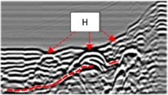 | Three hyperbolas (H), buried in draped sediment, overlying glacial till. Typical digitized subsurface reflection (red dash).
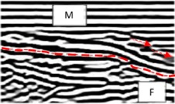 | Horizontal water-bottom multiples (M), two layers {red arrows } of dipping sediments. Unconformably draped over folded (f) sediments.
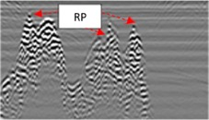 | Submerged rock pinnacles (RP) with no internal layering (speckled appearance) and no substantial overlying sediment drape.
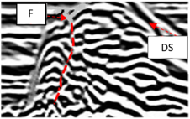 | Submerged and faulted (red dashed line – F) sediment mound, with draped sediment (DS)
Table 2. Typical WPR reflection characteristics seen in 2D profiles, used to interpret and digitise the datasets collected in this study.

5. Results
The sidescan sonar data was successfully acquired, detailing any potential submerged hazards present in the water for the subsequent WPR surveys, and showed the sides of the bridge piers effectively (an example in Figure 4), and imaged some river-bed objects, but suffered from gas bubble interference and from sonar scattering from rocks that is typically observed at such shallow water depths.
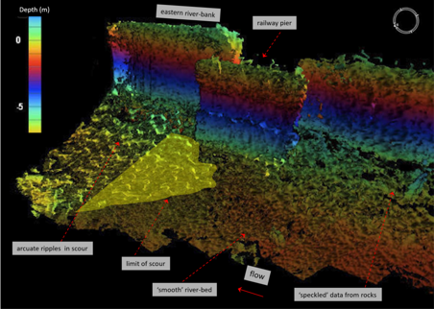
Figure 4. Annotated sidescan sonar image (Lowrance Elite 12Ti Totalscan) of the eastern river Bann margin, with elongated railway bridge pier support also being imaged.
100 MHz data showed the best balance between resolution and depth, so these were deployed for the bulk of the survey area, in conjunction with 250 MHz data, especially in shallow waters on the river bank sides of the bridge piers where deeper water penetration was not needed (Figure 5).
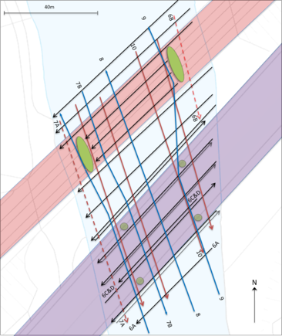
Figure 5. Survey grid line map of the WPR 2D profiles gathered within the River Bann shaded (blue). Numbers shown refer to figures in this paper. Profile solid lines = 100 MHz data; profile dashed lines = 250 MHz data. Green lozenges are railway bridge supports, green circles are the road bridge supports. River flow is ~south to ~north, coloured bridge decks included to indicate Road (purple) and Railway (red).
The short cross-lines (all original data is available, on request) shown in Figure 6 show changes in bathymetry across the river, as well as some detail below the water-sediment surface. Processing of the data, as shown in the examples of figures 6 and 7, improves the data quality, allowing rocky outcrops; hollows (from scour) around bridge piers; subsurface objects and an indication of sediment thickness to be observed.
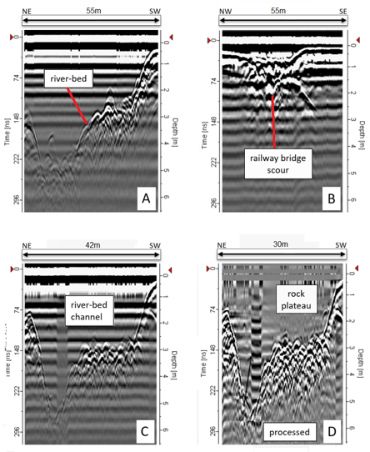
Figure 6. Example WPR 2D profile data collected. A: 100 MHz; B: 250 MHz; C and D: 100 MHz raw and processed 2D profile (see Figure 5 for respective locations).
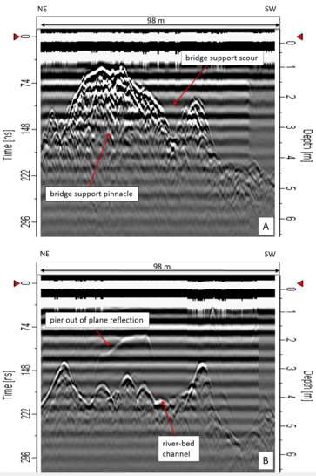
Figure 7. 100 MHz WPR 2D profile data, gathered along the side of the River Bann, adjacent to the western bridge pier. A: adjacent to the pier; B: 5 m from the southwestern pier on Figure 5.
The longer river-parallel lines (Figures 7-9) show more subtle changes in riverbed topography, with similar improvement in sub-riverbed imaging on the processed data (Figures 7-9).
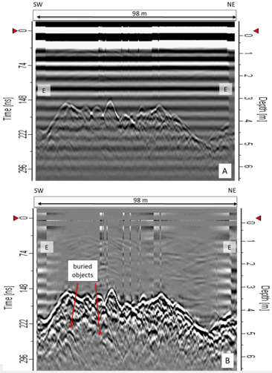
Figure 8. Raw and processed (gain and background removal) WPR 100 MHz 2D profile data. E = change in engine speed at start and end of survey line. See Figure 4 for location.
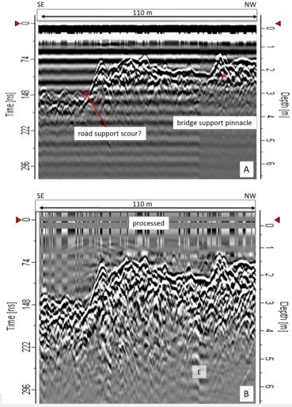
Figure 9. Raw and processed (gain and background removal) WPR 100 MHz 2D profile data. E = change in engine pitch. See Figure 4 for location.
Data interpretation followed the methods of Daniels (2004) in picking strong, continuous reflections for digitising: these surfaces separate distinct radar facies (see Table 2). When interpreted and digitised, these 2D profiles were then combined (Figure 10), which allowed a crude view of the area under both the road bridge and its four supports as well as the railway bridge with the two elongated piers plus deeper areas of water and a central rock outcrop (Figure 11) to be determined. The plan view of water depth in the same survey area (Figure 11) shows greater detail, with the deep water area now resolved as two ~5m deep hollows with a third area not detected from looking at the 2D WPR profiles alone.

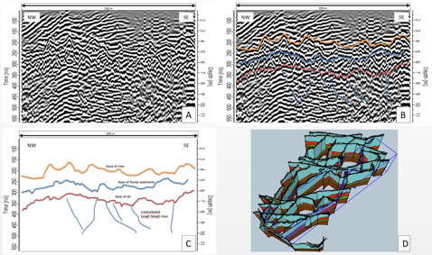
Figure 10. Method diagrams to show: A, processed 2D profile data; B: interpretation of 2D profile data; C, digitised 2D profile data output; D, fence diagram of digitised 2D profiles, for subsequent export and 3D visualisation (see Figure 11).
These depressions in the river floor are adjacent to the circular bridge supports. In order to gain some insight into the nature of these hollows, each were examined in detail and sediment thickness mapped: all depocentres were aligned SW-NE in parallel to the main flow direction of the river in this location. Significant scour was detected adjacent to, and upstream of the elongated railway piers. Scour was also observed upstream of the circular roadway supports. This was anticipated: contributory factors may be that the railway piers are positioned in shallower water, with attendant higher current flow. The road piers are positioned in similar conditions to the railway piers however it is located adjacent to the slipway used by motorised river craft and the railway bridge constricts flow. No obstructions are present for another 100m upstream.
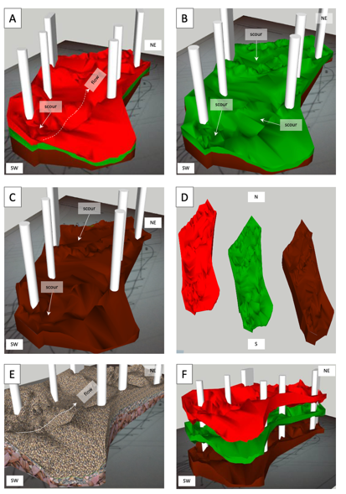
Figure 11. Visualisation of WPR data around the 6 bridge piers surveyed (white vertical bridge piers), plotted by colour to correspond to the interpreted WPR reflection in Figure 10. A: 3D schematic with all surfaces marked (red = river floor, fluvial sediments; green = fluvial sediments; purple = Lough Neagh Clays. B: top surface of the second layer of fluvial sediments, with water and top layer removed. C: top surface of the Lough Neagh Clays, with river water and fluvial sediments removed. D: All three layers, visualised separately. E: colours replaced by textures for easy understanding and translation to geotechnical properties if further work is to be undertaken. F: image capture of an interactive display in Google SketchUp, showing the three surface layers, artificially separated.

6. Discussion
This paper firstly reviewed the typical equipment set up and previous use of Water Penetrating Radar (WPR) for bridge engineering studies, with different antenna configurations, shielded/unshielded antenna types and different boat deployments all having significant effects on the datasets collected by earlier authors. By far the dominant collection strategy is the collection of multiple 2D profile datasets using low frequency radar antenna, which may or may not need to be combined into 3D datasets. For simple rural surveys with little geophysical cultural noise, unshielded antenna on non-conductive boats may be optimal, but in urban areas with above-ground conductive items present, then shielded antenna are recommended.
This paper has secondly detailed a case study of surveying a navigable section of river around two bridges (a railway and road bridge) with different shaped vertical supports. WPR results showed that the two bridges had correspondingly different river sediment scour geometries associated with them, that could be both detected and characterised by relatively closely-spaced 2D profiles being collected, processed (with simple gain filters) and combined into a 3D dataset with interpreted riverbed scours, below water-sediment interface boundaries and bedrock all being imaged.
One area of deep water within the survey site, with an adjacent platform of rock outcrop, was identified from the 2D data: this was resolved using the 3D fence diagram data as three+ areas of deep water, each with 4 m – 5 m of sediment infill. Areas of riverbed infill were found to be adjacent to both bridge supports, and oriented along the axis of river flow. They could be due to scour-fills from the bridge supports, or possibly locations of fossil scours where the bridge piles were originally sunk when bridge construction took place. Results largely agree with Olimpio (2000) and Webb et al. (2000) who performed similar WPR surveys around bridges, with data from 100 MHz shielded antenna providing optimal 2D profile data. Side-scan sonar data was also collected to compare with WPR data which was favourable, as well as to identify any submerged hazards to the data acquisition stage. Limited intrusive 1D investigations, using plumb bob/metal probe, can also give some ground truth of results but is relatively slow and spatially unrepresentative: side scan sonar was evidenced in this study to be more effective for bathymetry.

7. Conclusions
This paper briefly reviews Water Penetrating Radar (WPR) surveys, equipment configurations and relevant case studies to evidence what is currently known and the potential major variables associated with data collection in such challenging environments.
Whilst physical depth sounding with a plumb bob or probe may be quick and inexpensive, it might not provide the comprehensive coverage of a hydrographic survey using echo sounding or WPR. For estimates of sediment thickness, buried objects, rock outcrops, in confined locations such as our study location, WPR appears to be advantageous when compared to other methods such as side-scan sonar.
The WPR 2D datasets collected in the case study allowed the interpretation of the survey site water bathymetry, the presence of rock vs. sediment on the riverbed floor, and some estimate of the likely distribution of water and sediment depths. Combining 2D profiles into 3D datasets were deemed less useful here on likely sub-bottom conditions, but did give an accurate image of the distribution of both water depths and sediment thicknesses. The unshielded antennae were not suitable for such an urban small site with above-ground conductive objects present, so 100 MHz shielded antenna were determined to be optimal and were used for the main survey.
The nature of interpreting radar traces is open for debate and the accuracy difficult to ascertain without physical excavations to validate assumptions on site. The analysis largely relies on the experience of the user and the quality of the radar data to determine interfaces between distinct geological/sedimentary features. The challenges faced with undertaking an accurately positioned grid of radar traces from a small inflatable boat are considered and more work would be required in improving this element of the data retrieval. As such, the accuracy of the positioning and interpretation of these WPR surfaces is somewhat unknown without further investigation. However the principal of identifying bed level and potential scour features subsurface has been demonstrated in this work and warrants further consideration.
This work demonstrates the applicability of the WPR technique using existing non adapted technology (terrestrial GPR) to give good indicative results useful for bridge managers in order to decide on a suitable maintenance plan. It can be seen that WPR can be used for the identification of sub bottom profiling around bridges. Although this concept of using GPR on water or around bridges is not new in itself, there is still a clear opportunity to exploit this technology and develop it further as a useful tool for bridge inspections and 3D channel profiling.
Supplementary Materials: can be found at: https://researchdata.keele.ac.uk/30/
Author Contributions: AR - project coordination and writing; JP – writing; KC – data acquisition, processing and visualisation; DH – bridge foundations and scour; ST – bridge design and maintenance; BD – scour measurement.
Funding: Knowledge Transfer Partnership Grant 090519 between Collins CEI Engineering and Queen’s University Belfast.
Acknowledgments: Mary Hart of the Queen’s University Belfast KTP; Conor Graham (QUB) for use of GPS; Mike Langton (GuidelineGeo/Mala) for loan of GPR equipment; Keith Bennett (University of St. Andrews) and Lisa Coyle-McLung (Queen’s, Belfast) for the use of the dinghy. Karl Sandmeier is thanked for providing Queen’s University, Belfast (under licence) ReflexW data processing software.
Conflicts of Interest: none.

References
- Anderson, N.L.; Ismael, A.M.; Thitimakorn, T. Ground penetrating radar: a tool for monitoring bridge scour. Environ. and Eng. Geosci. 2007, 13, 1-10.
- Beres, M.; Haeni, F.P. Application of ground-penetrating radar methods in hydrological studies. Ground Water 1991, 29, 375-386.
- Biezma, M.V.; Schanack, F. Collapse of steel bridges. J. Perf. Cons. Fac. 2007, 21, 398-405.
- Cumberlidge, J. The Inland Waterways of Ireland. 2002, Imray, Laurie, Norie & Wilson Publishers Limited. p.135.
- Delany, R. Ireland’s Inland Waterways – Celebrating 300 Years. 2004, Appletree Press, p.216.
- Daniels, D.J. Ground Penetrating Radar, 2nd Edition. 2004, The Institution of Engineering and Technology. 725pp.
- DAERA/NIEA (Department of Agriculture, Environment and Rural Affairs /Northern Ireland Environment Agency). Planning for the Third Cycle River Basin Management Plan 2021-2027, Appendix 2: Overall water quality status interim results 2018 and pressure analysis. 2019, 22p.
- Davidson, N. C.; Hardy, M. S.A.; Forde, M.C. Bridge scour assessment. by impulse radar. Institution of Electrical Engineers (IEE) Colloquium on Radar and Microwave. Techniques for Non-Destructive Evaluation, 1995, 8-1–8-8.
- Deng, L.; Cai, C.S. Bridge scour: prediction, modeling, monitoring and countermeasures – review. Prac. Period. Struct. Des. Cons. (Am. Soc. Civ. Eng.), 2010, 15, 125-134.
- Ebrahimi, M.; Djordjevic, S.; Panici, D.; Tabor, G.; Kripakaran, P. A method for evaluating local scour depth at bridge piers due to debris accumulation. Proc. Inst. Civ Eng. 2020, 173, 86-99.
- Ettema, R.; Melville, B.W.; Constantinescu, G. Evaluation of Bridge Scour Research: Pier Scour Processes and Predictions. The National Academies Press, Washington, D.C., 2011.
- Forde, M.C.; McCann, D.M.; Clark, M.R.; Broughton K.J.; Fenning P.J.; Brown A. Radar Measurement of Bridge Scour, NDT&E Int. 1999, 32, 481-492.
- Gorin, S.R.; Haeni, F.P. Use of surface-geological methods to assess riverbed scour at bridge piers. U.S. Geol. Surv. Water Res. Invest., 1989, Report 88-4212.
- Haeni, F.P. Use of ground-penetrating radar and continuous seismic reflection profiling on surface water bodies in environmental and engineering studies. J. Env. Eng Geophy. 1996, 1, p.27.
- Haeni, F.P.; McKeegan, D.K.; Capron, D.R. Ground-penetrating radar study of the thickness and extent of sediments beneath Silver Lake, Berlin & Meriden, Connecticut. U.S. Geol. Surv. Water Res. Inv. Rep., 1987, 85-4108.
- Kovacs, A. Impulse radar bathymetric profiling in weed-infested fresh water. U.S.A. Cold Reg. Res Eng Lab. (CRREL) Rep, 1991, 91-10.
- Kruk, J. van der; Slob, E.C. Reduction of reflections from above surface objects in GPR data. J. App. Geophys. 2004, 55, 271-278.
- Nobes, D.C.; Rother, H.; Kruk, J.; Jol, H.M. Radar ‘lensing’ by a small river: can a layer of surface water improve the signal? In: GPR 2004, Spec. Iss. Near-surf. Geophys, 2006, 4, 69-74.
- Olimpio, J. R., Use of a ground-penetrating radar system to detect pre and post-flood scour at selected bridge sites in New Hampshire, 1996–98. U. S. Geol. Surv. Water Res. Inv. Rep., 2000. 00-4035.
- Parker, R.; Ruffell, A.; Hughes, D. Geophysics and the search of freshwater bodies: a review. Sci. & Just, 2010, 50, 141-149.
- Park, I.; Lee, J.; Cho, W. Assessment of bridge scour and riverbed variation by a ground penetrating radar. Proc. Tenth Intl Conf. Ground Penetrating Radar. GPR 2004, Delft, The Netherlands, 2004, pp. 411-414.
- Reynolds, J.M. An Introduction to Applied and Environmental Geophysics. 2nd edition, 2011. John Wiley and Sons Inc. Chichester. 696pp.
- Ruffell, A.; Parker, R. Water penetrating radar. J. Hydrol. 2021, 597, 126300, in press. https://doi.org/10.1016/j.jhydrol.2021.126300
- Ruffell, A.; Pringle, J.K.; Cassella, J.P.; Morgan, R.; Ferguson, M.; Heaton, V.G.; Hope, C. The use of geoscience methods for aquatic forensic searches. E. Sci. Rev. 2017, 171, 323-337.
- RAIU (Railway Accident Investigation Unit). Malahide Viaduct Collapse on the Dublin to Belfast Line, on the 21st August 2009, RAIU, Blackrock, Ireland, 2010–R004.
- Sellmann, P.V.; Delaney, A.J.; Arcone, S.A. Sub-bottom surveying in lakes with ground-penetrating radar. U.S. Army Corps of Engineers Cold Regions Research & Engineering Laboratory (CRREL) Report 1992, 92-8. 18pp.
- Sathurusinghe, P.; Hamill, G.; Taylor, S; Robinson, D.. Foundation scour and its effect on the performance of FlexiArch™ modern arch bridge system. Struc. H. Mon. Inf. HMII 2021 Bi. Conf. SHMII, Proc. 2021, (in press).
- Sathurusinghe, P.; Hamill, G.; Taylor, S; Robinson, D. Hydraulics of scour in the vicinity of a FlexiArch bridge, Proc. Civ. Eng. Res. Ire. 2020. p.83-86.
- Sharma, P.V. Environmental and Engineering Geophysics. Cambridge University Press. 1997, 349pp.
- Topczewski, L.; Ciesla, J.; Mikolajeski, P.; Adamski, P.; Markowski, Z.. Monitoring of scour around bridge piers and abutments. Trans. Res. Proc., 2016, 14, 3963-3971.
- Webb, D. J.; Anderson, N.L.; Newton, T.; Cardimona, S. Bridge scour: Application of ground penetrating radar. Proc. First Int. Conf. App. Geophys. Method. NDT. Trans. Faci. Inf., Federal Highway Commission and Missouri Department of Transportation, 2000.

