SUPPLEMENTAL MATERIALS

Common Genetic Variants and Peritoneal Solute Transfer Rate in People with Kidney Failure Treated with Peritoneal Dialysis

A Genome Wide Association Study
Rajnish Mehrotra, MD, MS, Ian B. Stanaway, PhD, Gail P. Jarvik, MD, PhD, Mark Lambie, BM BCh, PhD, Johann Morelle, MD, PhD, Jeffrey Perl, MD, SM, Jonathan Himmelfarb, MD, Olof Heimburger, MD, PhD, David W. Johnson, PhD, Talha Imam, MD, Bruce Robinson, MD, MS, Peter Stenvinkel, MD, PhD, Olivier Devuyst, MD, PhD, Simon Davies, FRCP, on behalf of the Bio-PD Consortium

Supplemental Materials Table of Contents
Supplemental Methods: DNA Extraction and Approach to winsorization of PD start-PET interval variable
Supplemental Table 1: Number of participants, stratified by country, at each sequential step to be included in the analytic cohort
Supplemental Table 2: Number of participants with missing data on covariates stratified by ancestry
Supplemental Table 3: Comparison of summary characteristics of covariates in sub-group with complete data and with each of the five sets of multiple imputation used in the analyses
Supplemental Table 4: Comparison of demographic and clinical characteristics of participants excluded with those included in the analyses
Supplemental Table 5: Association of single nucleotide variants with suggestive associations identified in the meta-analysis, by ancestry
Supplemental Table 6: Association of single nucleotide variants with suggestive associations identified in the meta-analysis, in sub-groups of individuals of European ancestry from the largest enrolling centers
Supplemental Table 7: Gene function related biology in the reported suggestive genes identified either in the meta-analyses of ancestry-stratified data, or in participants of European ancestry
Supplemental Table 8: GWAS analyses in the entire cohort, adjusted for principal components for ancestry
Supplemental Figure 1: Identity by descent (IBD) plot of all pair-wise comparisons of genetic relatedness
Supplemental Figure 2: Principal component analysis (PCA) of the autosomal variants to determine genetic ancestry
Supplemental Figure 3: QQ plot of GWAS in participants of European ancestry, adjusted for principal components of ancestry in the group using the GCTA software with the -mlma-loco option.
Supplemental Figure 4: Regional association plot of 14 genomic regions with single nucleotide variants with suggestive associations (panels A-F)
Supplemental Figure 5: Box plots for PSTR by genotype of variants identified to have suggestive associations in either the meta-analysis or in GWAS in participants of European ancestry (panels A-F)
Supplemental Figure 6: Results of genome wide association study (GWAS) in the entire cohort, adjusted for principal components of ancestry as - log p plot (Manhattan plot).
Contributors: List of key contributors from each participating center
Supplemental Methods
DNA Extraction
DNA was purified from either whole blood collected and stored frozen in PAXgene Blood DNA tubes, or from buffy coats. Blood tubes and buffy coats were thawed and red blood cells lysed in buffer containing 150mM NH₄Cl, 10mMNaHCO₃ and 1.3mM EDTA. The samples were vigorously mixed, incubated for 10 minutes at room temperature, then centrifuged at 800 x g for 10 minutes. The supernatant was carefully removed. The nuclear pellet was resuspended in 10 ml of Cell Lysis Buffer containing 10mMTris , 10 mM potassium chloride, 10m magnesium chloride, 400mM sodium chloride, 2mM EDTA, and 0.63% SDS. Sample was vortexed at full speed for 20 seconds. Protein was precipitated by addition of 3.3 ml 5M NaCl. The mixture was vortexed at full speed for 20 seconds then centrifuged at 3200 x g for 10 minutes. The supernatant was transferred into a new tube and DNA precipitated with 10 ml isopropanol. The tube was gently rocked until DNA was visible. The DNA was pelleted by centrifugation at 3200 x g for 10 minutes. The pellet was transferred into a 1.5 tube with 1ml of 70% ethanol and spun at full speed in a microcentrifuge. After removal of the supernatant, the pellet was air dried for 10 minutes and resuspended in 500 µl TE. DNA was measured using Quant-iT™ PicoGreen™ dsDNA Kit.
Approach to winsorization of PD start-PET interval variable
First, we took low values of PD start-PET interval (< -45d) and scaled these values, then multiplied by a factor of 6 to spread them out, and then took these values minus 45 plus the scaled and factored values to fix the minimum value to -45 while spreading the other values in the tail towards zero with a maximum of -19.2 days. Similarly, with the high values of PD start-PET interval (> 365), we scaled and factored these outliers fixing them in the tail of the distribution with a maximum value possible of 365. We did this in two batches, one batch in the range of 365-1500 days, and a second batch with values > 1500 days. These two batches of outlier high PD start-PET interval values were necessary to tune the spreading factor of the scaled values to not have artificial peaks visible in the histogram of the transformed distribution. For the batch in the range of 365-1500 days we scaled these values, then multiplied by a factor of 60 to spread them out and then took these values plus 365 minus the scaled and factored values to fix the minimum value to 138.38 while spreading the other values in the tail towards zero with a maximum of 365 days. Similarly, for the PD start-PET interval >1500 days we scaled these values, then multiplied by a factor of 30 to spread them out and then took these values plus 365 minus the scaled and factored values to fix the minimum value to 249.2 while spreading the other values in the tail towards zero with a maximum of 365 days.

Supplemental Table 1. Number of participants, stratified by country, at each sequential step to be included in the analytic cohort.

Country | No. of Centers | Enrolled | DNA Collected | Passed Genotyping Quality Control | Phenotype Data Available | 4-h D/P creatinine 0.30-1.15 | Genetically Unrelated Participants*
Australia | 2 | 74 | 72 | 65 | 65 | 65 | 63
Belgium | 3 | 314 | 314 | 264 | 264 | 264 | 258
Canada | 5 | 292 | 266 | 223 | 221 | 221 | 215
Sweden | 1 | 215 | 214 | 192 | 192 | 192 | 190
UK | 43 | 1958 | 1955 | 1693 | 1611 | 1605 | 1575
USA | 15 | 708 | 648 | 573 | 568 | 565 | 549
TOTAL | 69 | 3561 | 3469 | 3010 | 2921 | 2912 | 2850
*Analytic Cohort for the GWAS

Supplemental Table 2: Number of participants with missing data on covariates, stratified by ancestry
 | European (n=2212) | African (n=181) | Asian (n=109) | Admixed/Other (n=348) | Total (n=2850)
Age, n (%) | 3 (< 1%) | 2 (1%) | 2 (2%) | 0 | 7 (< 1%)
Diabetes, n (%) | 348 (16%) | 8 (4%) | 4 (4%) | 41 (12%) | 401 (14%)
Body Mass Index, n (%) | 55 (3%) | 19 (10%) | 15 (14%) | 25 (7%) | 114 (4%)
PD Start-PET Inter, n (%) | 5 (< 1%) | 0 | 0 | 1 (< 1%) | 6 (< 1%)

Supplemental Table 3: Comparison of summary characteristics of covariates in sub-groups with complete data and with each of the five sets of multiple imputations used in the analyses. Standardized mean difference (SMD), SMD = (Mean_{complete} – Mean_{imputation})/Std. Dev._{complete}
Variable | Complete Data | Imputation One | Imputation Two | Imputation Three | Imputation Four | Imputation Five
Age, years  n  Median  Mean  Std. Dev.  SMD | 2843  60  58.5  15.8  NA | 2850  60  58.5  15.8  0 | 2850  60  58.6  15.8  -0.006 | 2850  60  58.5  15.8  0 | 2850  60  58.5  15.8  0 | 2850  60  58.5  15.8  0
Diabetes  n  Yes  % | 2449  906  37.0 | 2850  1057  37.1 | 2850  1045  36.7 | 2850  1030  36.1 | 2850  1025  36.0 | 2850  1023  35.9
Body Mass Index, kg/m²  n  Median  Mean  Std. Dev.  SMD | 2736  26.2  27.2  6.0  NA | 2850  26.2  27.3  6.0  -0.016 | 2850  26.2  27.2  6.0  0 | 2850  26.2  27.2  6.0  0 | 2850  26.2  27.2  6.0  0 | 2850  26.2  27.3  6.0  -0.016
Log PD Start-PET Interval  n  Median  Mean  Std. Dev.  SMD | 2813  -0.29  0  1  NA | 2850  -0.21  0  1  0 | 2850  -0.21  0  1  0 | 2850  -0.21  0  1  0 | 2850  -0.21  0  1  0 | 2850  -0.21  0  1  0

Supplemental Table 4. Comparison of demographic and clinical characteristics of participants excluded with those included in the analyses.
 | Excluded  (N=620) | Included  (N=2850) | Total  (N=3470) | p value
COUNTRY, n (%) |  |  |  | < 0.001
N-Miss | 11 | 0 | 11
Australia | 6 (1) | 63 (2) | 69 (2)
Belgium | 63 (10) | 258 (9) | 321 (9)
Canada | 29 (5) | 215 (8) | 244 (7)
Sweden | 25 (4) | 190 (7) | 215 (6)
UK | 409 (67) | 1575 (55) | 1984 (57)
USA | 77 (13) | 549 (19) | 626 (18)
Sex Female, n (%) |  |  |  | 0.03
N-Miss | 44 | 0 | 44
Female | 247 (43) | 1084 (38) | 1331 (39)
Age years |  |  |  | 0.02
N-Miss | 53 | 7 | 60
Mean ± SD | 56.9 ± 17.3 | 58.5 ± 15.8 | 58.3 ± 16.1
Race, n (%) |  |  |  | < 0.001
White | 479 (77) | 2293 (81) | 2772 (80)
Black | 29 (5) | 189 (7) | 218 (6)
Asian | 38 (6) | 194 (7) | 232 (7)
Native American/Pacific Islander  Pacific Islander | 9 (2) | 29 (1) | 38 (1)
Not Reported | 52 (8) | 145 (5) | 197 (6)
Other | 13 (2) | 0 (0) | 13 (0.4)
Diabetes, n (%) |  |  |  | 0.58
N-Miss | 146 | 401 | 547
Yes | 169 (36) | 906 (37) | 1075 (37)
Cause of Kidney Failure, n (%) |  |  |  | < 0.001
Diabetes | 51 (8) | 659 (23) | 710 (21)
Glomerular Disease | 44 (7) | 578 (20) | 622 (18)
Hypertension | 26 (4) | 316 (11) | 342 (10)
Cystic kidney disease | 20 (3) | 258 (9) | 278 (8)
Other/Unknown | 479 (77) | 1039 (37) | 1518 (44)
BMI, kg/m² |  |  |  | 0.91
N-Miss | 165 | 114 | 279
Mean ± SD | 27.3 ± 6.3 | 27.2 ± 6.0 | 27.2 ± 6.0
Dialysate Dextrose for PET, n (%) |  |  |  | 0.48
N-Miss | 184 | 0 | 184
2.5% | 333 (77) | 2249 (79) | 2582 (79)
1.5% | 31 (7) | 177 (6) | 208 (6)
4.25% | 72 (16) | 424 (15) | 496 (15)
4hr D/P Creatinine |  |  |  | 0.50
N-Miss | 185 | 0 | 185
Mean ± SD | 0.71 ± 0.13 | 0.70 ± 0.13 | 0.70 ± 0.13

Supplemental Table 5: Association of single nucleotide variants with suggestive associations identified in the meta-analysis, by ancestry
rsID | European Ancestry (n=2212) |  |  | African Ancestry (n=181) |  |  | Asian Ancestry (n=109) |  |  | Admixed/Other (n=348)
 | Estimate  (95% CI) | SE | P | Estimate (95% CI) | SE | P | Estimate (95% CI) | SE | P | Estimate (95% CI) | SE | P
rs76108553 | 0.05  (0.03, 0.07) | 0.011 | 9x10⁻⁷ | NA | NA | NA | NA | NA | NA | NA | NA | NA
rs111976243 | 0.05  (0.03, 0.07) | 0.011 | 2x10⁻⁶ | NA | NA | NA | NA | NA | NA | NA | NA | NA
rs2901257 | -0.02  (-0.02, -0.01) | 0.004 | 1x10⁻⁵ | -0.02  (-0.05, 0.01) | 0.015 | 0.16 | 0.01  (-0.02, 0.04) | 0.015 | 0.64 | -0.01  (-0.03, 0.004) | 0.009 | 0.11
rs117559199 | 0.04  (0.02, 0.06) | 0.01 | 3x10⁻⁵ | NA | NA | NA | NA | NA | NA | 0.06  (0, 0.11) | 0.028 | 0.049
rs28644184 | 0.02  (0.01, 0.02) | 0.004 | 1x10⁻⁴ | 0.02  (-0.01, 0.04) | 0.014 | 0.29 | 0.01  (-0.01, 0.04) | 0.013 | 0.35 | 0.02  (0.003, 0.04) | 0.009 | 0.02
NA – the association of the SNVs was not tested as the number of individuals with the minor allele in the ancestry group were ≤ 10

Supplemental Table 6: Association of single nucleotide variants with suggestive associations identified in the meta-analysis, in sub-groups of individuals of European ancestry from the largest enrolling centers
rsID | Alleles |  | Meta-Analyses (n=2850) | Belgium (n=258) | Sweden (n=190)
 | A1 | A2 | Estimate | Estimate | Estimate
rs76108553 | T | C | -0.05  (-0.07, -0.03) | -0.06  (-0.14, 0.03) | -0.10  (-0.17, -0.02)
rs2901257 | A | G | 0.02  (0.01, 0.02) | 0.02  (0.04, -0.002) | 0.01  (0.05, -0.02)
rs117559199 | A | C | -0.04  (-0.06, -0.03) | -0.10  (-0.17, -0.03) | -0.01  (-0.13, 0.12)
rs28644184 | T | C | 0.02  (0.01, 0.02) | 0.01  (-0.01, 0.03) | 0.01  (-0.02, 0.04)

Supplemental Table 5: Gene function related biology in the reported suggestive genes. For the reported genes, alternative gene names are provided and the findings from the literature search are summarized.
Gene Name(s) | Approved Gene Symbol [HGNC] | GeneID [NCBI] | Approved gene name (HGNC) | Current knowledge about this gene (PMID)
Suggestive associations in meta-analyses as well as GWAS in participants of European ancestry
LINC01800 | LINC01800 | 101927438 | long intergenic non-protein coding RNA 1800 | None
Suggestive associations in meta-analyses only
LINC01561 | LINC01561 | 404216 | long intergenic non-protein coding RNA 1561 | Involved in breast cancer progression (29890225)
PLPP4; DPPL2; PPAPDC1; PPAPDC1A | PLPP4 | 196051 | phospholipid phosphatase 4 | PLPP4 promotes proliferation and tumorigenesis in lung carcinoma (28851360)
KCNC2; KV3.2 | KCNC2 | 3747 | potassium voltage-gated channel subfamily C member 2 | KCNC2 has been associated with childhood obesity and diabetes risk (27623749). A family with deletions of the generegion showed neurodevelopmental delay and ataxia (23475819).
KDM2B; CXXC2; Fbl10; PCCX2; FBXL10; JHDM1B | KDM2B | 84678 | lysine demethylase 2B | KDM2B is a epigenetic regulator in several types of cancer (31941533; 29408056; 28506929; 24853546; 31218831; etc.) and involved in epithelial-mesenchymal transition (29772566).
Suggestive associations in GWAS in participants of European ancestry only
GIMAP6; IAN2; IAN6; IAN-2; IAN-6 | GIMAP6 | 474344 | GTPase, IMAP family member 6 | GIMAP6 may have roles in cell survival regulation (NCBI EntrezGene). These include apoptosis (28381553) and phagocytosis (24204963).
LINC01505 | LINC01505 | 100996590 | long intergenic non-protein coding RNA 1505 | None
PCDH9 | PCDH9 | 5101 | protocadherin 9 | Downregulation is associated with cellular invasion by myxofibrosarcoma (32523124). It has been shown to be a regulator in many cancers including glioblastoma (29267965), hepatocellular carcinoma (28791409) and ovarian (31632082) as well as other cancers (31059116).
'None' means a PubMed search revealed no articles, or those articles were not related to specific biology possibly related to peritoneal dialysis.

Supplemental Table 8: GWAS analyses in the entire cohort, adjusted for principal components for ancestry
Genomic Region | Variant ID | Chromosome | Position | P value | Beta  (95% CI) | R²* | Minor Allele Frequency, % | Minor Allele | Major Allele
LINC01800 5’40kb | rs76108553 | 2 | 65039700 | 4.1 x 10⁻⁶ | -0.05  (-0.07, -0.03) | 0.996 | 2.6 | T | C
LINC01561, PLPP 3’ 5kb | rs2901257 | 10 | 122358463 | 6.2 x 10⁻⁷ | -0.02  (-0.02, -0.01) | 0.998 | 47.4 | G | A
KCNC2 5’ 20kb | rs117559199 | 12 | 75424551 | 4.0 x 10⁻⁶ | -0.04  (-0.06, -0.03) | 0.874 | 3.4 | A | C
KDM2B intron | rs28644184 | 12 | 121961947 | 4.0 x 10⁻⁷ | 0.02  (0.01, 0.02 | 0.999 | 43.6 | T | C
BAZ1A intron | rs10146956 | 14 | 35267326 | 2.6 x 10⁻⁶ | 0.05  (0.03, 0.07) | 0.994 | 2.8 | A | G
LOC284240 ncRNA | rs515754 | 18 | 77346682 | 4.7 x 10⁻⁶ | 0.02  (0.01, 0.02) | 0.998 | 49.2 | G | A

Supplemental Figure 1: Identity by descent (IBD) plot of all pair-wise comparisons of genetic relatedness. IBD0 is the probability that the two pairwise individuals represented by each point share zero alleles by descent. IBD1 is the probability that the two pairwise individiauls are represented by each point share one allele by descent. The points near the origin (0,0) are twins and/or sample duplicates and were removed from analysis. The points near (0,1) are parent-child pairs and the points near (0.2, 0.5) are siblings.
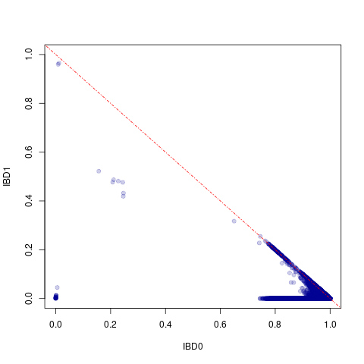
Supplemental Figure 2: Principal component analysis (PCA) of the autosomal variants to determine genetic ancestry. The plotted points represent the first two principal components (PC1 and PC2) that explain genomic variability in the population. The point label colors are based on the self-reported ancestry as indicated in the figure legend.
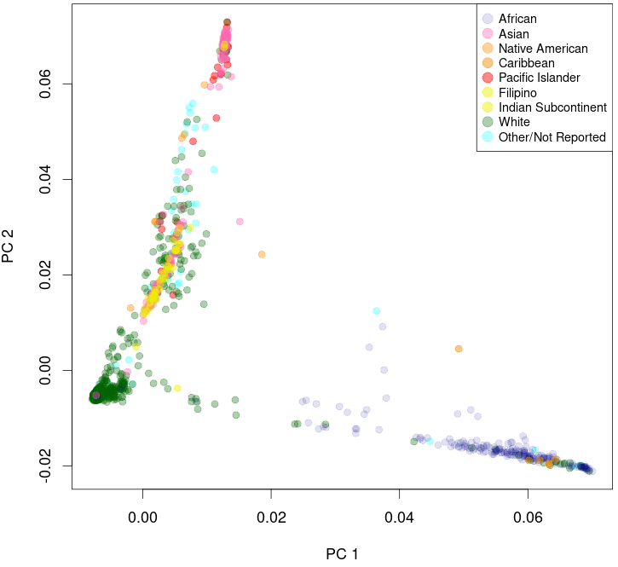

Supplemental Figure 3: QQ plot of GWAS in participants of European ancestry, adjusted for principal components of ancestry in the group using the GCTA software with the -mlma-loco option.

Supplemental Figure 4 (page 1 of 2): Regional association plot of 6 genomic regions with single nucleotide variants with suggestive associations in the meta-analyses or in GWAS of participants of European ancestry (panels A-F).
(A) rs76108553 in LINC01800 region on chromosome 2 (meta-analyses and in GWAS in participants of European ancestry); (B) rs2901257 near PLPP4 and LINC01561 on chromosome 10 (meta-analyses only); (C) rs117559199 near KCNC2 on chromosome 12 (meta-analyses only); and (D) rs73474862 in GIMAP6 intron on chromosome 7 (in GWAS in participants of European ancestry only).
A B
C D

Supplemental Figure 4 (page 2 of 2): Regional association plot of 6 genomic regions with single nucleotide variants with suggestive associations in the meta-analyses or in GWAS of participants of European ancestry (panels A-F).
(E) rs11789496 in LINC01505 intron on chromosome 9 (in GWAS in participants of European ancestry only); and (F) rs7337043 in PCDH9 region on chromosome 13 (in GWAS in participants of European ancestry only).

E F

Supplemental Figure 5 (page 1 of 2): Box plots for PSTR by genotype of variants identified to have suggestive associations in either the meta-analysis or in GWAS in participants of European ancestry (panels A-F).
(A) rs76108553 in LINC01800 region on chromosome 2 (meta-analyses and in GWAS in participants of European ancestry); (B) rs2901257 near PLPP4 and LINC01561 on chromosome 10 (meta-analyses only); (C) rs117559199 near KCNC2 on chromosome 12 (meta-analyses only); and (D) rs73474862 in GIMAP6 intron on chromosome 7 (participants of European ancestry ).
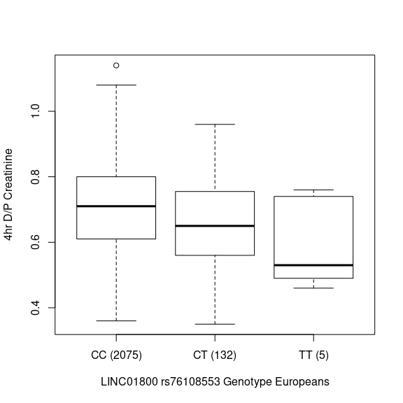
A. B.
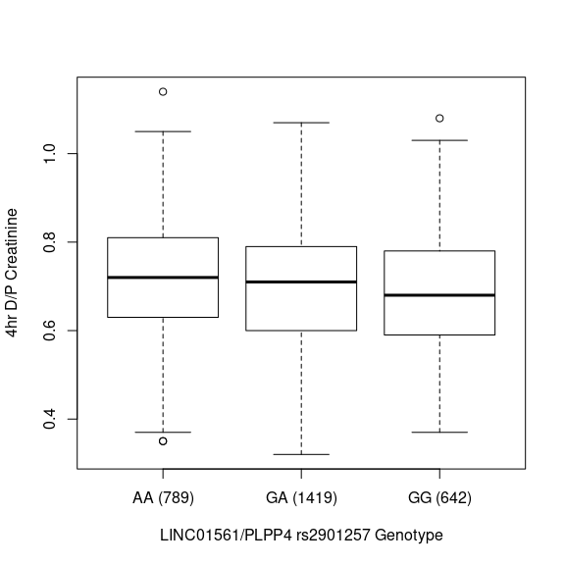
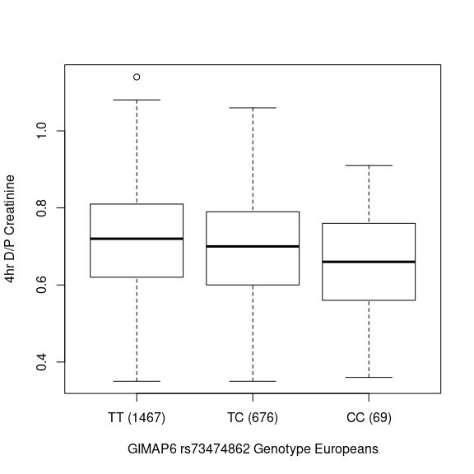
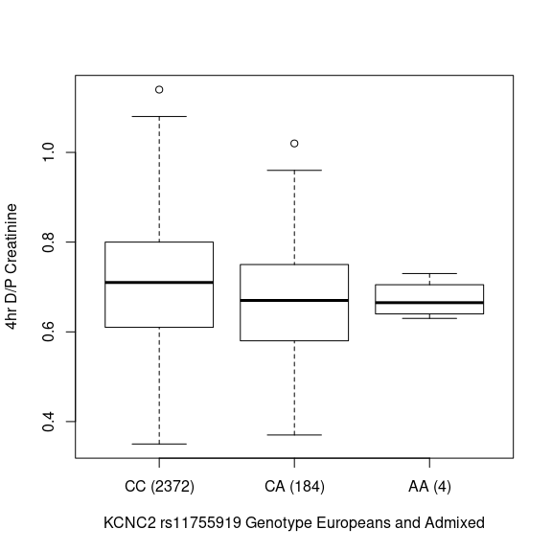
C. D.
Supplemental Figure 5 (page 2 of 2): Box plots for PSTR by genotype of variants identified to have suggestive associations in either the meta-analysis or in GWAS in participants of European ancestry (panels A-F).
(E) rs11789496 in LINC01505 intron on chromosome 9 (in participants of European ancestry); and (F) rs7337043 in PCDH9 region on chromosome 13 (in participants of European ancestry).

E. F.
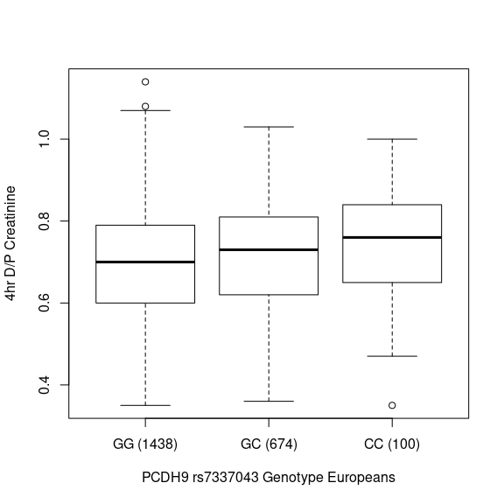
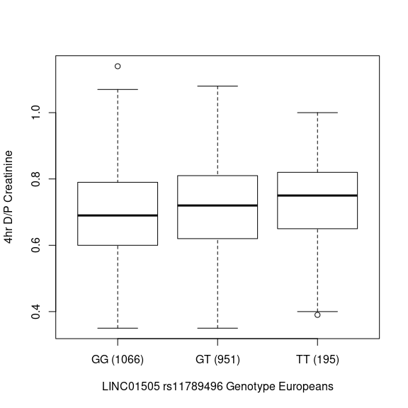
Supplemental Figure 6: Results of genome wide association study (GWAS) in the entire cohort, adjusted for principal components of ancestry as - log p plot (Manhattan plot).

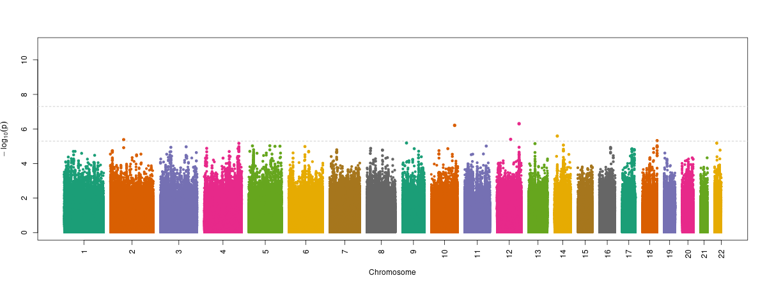

Key Contributors from Participating Centers

Australia
Princess Alexandra Hospital, Brisbane Kylie Pegg, Josie Mellick, Rhonda Watt
Royal Northshore Hospital, Sydney Anna Tam, Margery Chan, Samantha Hand, Helen Clayton
Belgium
Cliniques universitaires Saint-Luc, Brussels Emmanuelle Carrie, Yvette Cnops, Sebastien Druart
University Hospitals, Leuven Henriette de Loor
Canada
St. Joseph’s Hospital, Hamilton Manreet Padwal
St. Michael’s Hospital, Toronto Prakruthi Palepu, Janine Farragher
St. Paul’s Hospital, Vancouver Katy Vela
Victoria Hospital, London Kathleen Koyle
University Health Network, Toronto Prakruthi Palepu, Janine Farragher
Sweden
Karolinska Hospital, Stockholm Anna Witasp
United Kingdom
Staff at the following participating clinical centers:
Altnagelvin Area Hospital, Londonderry, N. Ireland
Antrim Area Hospital, Antrim, N. Ireland
Birmingham Heartlands Hospital, Birmingham
Bradford Royal Infirmary, Bradford
Broomfield Hospital, Chelmsford
Churchill Hospital, Oxford
Cumberland Infirmary, Carlisle
Daisy Hill Hospital, Newry, Northern Ireland
Derriford Hospital, Plymouth
Dumfries and Galloway Royal Infirmary, Dumfries
Freeman Hospital, Newcastle upon Tyne
Hammersmith Hospital, London
Hull Royal Infirmary, Hull
Ipswich Hospital NHS Trust, Ipswich
Kent and Canterbury Hospital, Canterbury
Kings College Hospital, London
Lister Hospital, Stevenage
Manchester Royal Infirmary, Manchester
Morriston Hospital, Swansea
New Cross Hospital, Wolverhampton
Northern General Hospital, Sheffiel
Ndottingham University Hospital, Nottingham
Queen Alexandra Hospital, Portsmouth
Queen Elizabeth Hospital, Birmingham
Queen Margaret Hospital, Dunfermline
Raigmore Hospital, Inverness
Royal Bournesmouth, Dorset
Royal Cornwall Hospital, Cornwall
Royal Derby Hospital, Derby
Royal Devon and Exeter Hospital, Exeter
Royal Liverpool & Broadgreen Univ. Hospital, Liverpool
Royal Preston Hospital, Preston
Royal Shrewsbury Hospital, Shrewsbury
Royal Sussex County Hospital, Brighton
Salford Royal, Manchester
Southmead Hospital, Bristol
St. James’s University Hospital, Leeds
University Hospital Aintree, Liverpool
University Hospital Coventry & Warwikshire, Coventry
University Hospital, Liecester
University Hospital of North Midlands, Stoke-on-Trent
University Hospital of Wales, Cardiff, Wales
York Hospital, York
United States
Arbor Research Institute, Ann Arbor Lalita Subramanian, Stephen Kress
Dialysis Clinic, Inc. Nashville Beth Estes
Houston Street Dialysis Center, San Antonio Christie Cruz
Kaiser Foundation Hospital, Fontana Harpreet Thakar, Sean S. Anand, Gildy Lopez
Massachusetts General Hospital, Boston Maria Luongo, Scott Krinsky
San Diego Institute of Medical Research, San Diego Claudia Ulloa, Ena Ramirez, Maria Juarez
Tufts University, Boston Eamon Fleming
University of California-Irvine, Irvine Hewon Jeong, Kenny Nguyen
University of Southern California, Los Angeles Norma Chavez, Astrid Sotamayor, Sunee Park, Theresa Kossack, Katie Ventura, Christina Dobkin
University of Texas Southwestern, Dallas Tammy Lightfoot, Zhengan Wang
University of Utah, Salt Lake City Hailey Nelson, Chelsie Ford
University of Washington, Seattle Anne Goodling, John Kundzins, Lori Linke, Linda Manahan, John Ruzinski, Jane Ranchalis
Vanderbilt University, Nashville Sonya Williams, Craig Cornelison, Kristina Herrington
Wake Forest University, Winston-Salem Angie Graham, Philip Greene, Sarah Morton, Dana Burkhart
Washington University, St. Louis Kathy Ehrhard, Tiffany Dulaney, Lana Torrey
Yale University, New Haven Lauren Liberti, Erin Murphy, Stephanie Rosenberg

