Title: MASTREE+: time-series of plant reproductive effort from six continents

Running Title: Database of plant reproduction time-series

List of Authors
Andrew Hacket-Pain ¹ *, Jessie J. Foest ¹, Ian S. Pearse ², Jalene M. LaMontagne ³, Walter D. Koenig ⁴, Giorgio Vacchiano ⁵, Michał Bogdziewicz ^{6,7}, Thomas Caignard ⁸, Paulina Celebias ⁶, Joep van Dormolen ⁹, Marcos Fernández-Martínez ¹⁰, Jose V. Moris ¹¹, Ciprian Palaghianu ¹², Mario Pesendorfer ¹³, Akiko Satake ¹⁴, Eliane Schermer ¹⁵, Andrew J. Tanentzap ¹⁶, Peter A. Thomas ¹⁷, Davide Vecchio ¹¹, Andreas Wion ¹⁸, Thomas Wohlgemuth ¹⁹, Tingting Xue ²⁰, Katherine Abernethy ^{21,22}, Marcelo Daniel Barrera ²³, Jessica H. Barton ³, Stan Boutin ²⁴, Emma R. Bush²⁵, Sergio Donoso Calderón ²⁶, Felipe S. Carevic²⁷, Carolina Volkmer de Castilho ²⁸, Juan Manuel Cellini ²³, Colin A. Chapman ^{29,30,31,32}, Hazel Chapman ^{33,34}, Francesco Chianucci ³⁵, Patricia da Costa ³⁶, Luc Croisé ³⁷, Andrea Cutini ³⁵, Ben Dantzer ³⁸, R. Justin DeRose ³⁹, Jean Thoussaint Dikangadissi ⁴⁰, Edmond Dimoto ⁴⁰, Fernanda Lopes da Fonseca ⁴¹, Leonardo Gallo ⁴², David F. Greene ⁴³, Martín A. Hadad ⁴⁴, Alejandro Huertas Herrera ^{45,46}, K.J. Jeffery ²¹, Jill F. Johnstone ⁴⁷, Urs Kalbitzer ^{48,49}, Władysław Kantorowicz ⁵⁰, Christie A. Klimas ⁵¹, Jonathan G.A. Lageard ⁵², Jeffrey Lane ⁵³, Katharina Lapin ⁵⁴, Mateusz Ledwon ⁵⁵, Abigail Leeper ³, Maria Vanessa Lencinas ⁵⁶, Ana Cláudia Lira-Guedes ⁵⁷, Michael C. Lordon ³, Paula Marchelli ⁴², Shealyn Marino ⁵⁸, Harald Schmidt Van Marle ²⁶, Andrew G. McAdam ⁵⁹, Ludovic R.W. Momont ⁶⁰, Manuel Nicolas³⁷, Lúcia Helena de Oliveira Wadt ⁶¹, Parisa Panahi ⁶², Guillermo Martínez Pastur ⁵⁶, Thomas Patterson ⁶³, Pablo Luis Peri ⁶⁴, Łukasz Piechnik ⁶⁵, Mehdi Pourhashemi ⁶⁶, Claudia Espinoza Quezada ²⁶, Fidel A. Roig ^{67,68}, Karen Peña Rojas ²⁶, Yamina Micaela Rosas ⁵⁶, Silvio Schüler ⁵⁴, Barbara Seget ⁶⁵, Rosina Soler ⁵⁶, Michael A. Steele ⁵⁸, Mónica Toro-Manríquez ^{45,46}, Caroline E.G. Tutin ²¹, Tharcisse Ukizintambara ⁶⁹, Lee White ^{21,22,70}, Biplang Yadok ^{34, 71}, John L. Willis ⁷², Anita Zolles ⁵⁴, Magdalena Żywiec ⁶⁵, Davide Ascoli ¹¹

Institutional affiliations
- Department of Geography and Planning, School of Environmental Sciences, University of Liverpool, Liverpool, United Kingdom
- U.S. Geological Survey, Fort Collins Science Center, Fort Collins, Colorado, USA
- Department of Biological Sciences, DePaul University, Chicago, IL, 60614, USA
- Hastings Reservation, University of California Berkeley, Carmel Valley CA 93924 USA
- Department of Agricultural and Environmental Sciences, University of Milan, via Celoria 2, 20133 Milan Italy
- Institute of Environmental Biology, Faculty of Biology, Adam Mickiewicz University in Poznań, Poland
- INRAE, LESSEM, University Grenoble Alpes, France
- Univ. Bordeaux, INRAE, BIOGECO, 33615 Pessac, France
- Department of Computing, University of London, London, WC1B 5DN, United Kingdom
- CREAF, Cerdanyola del Vallès, 08193 Barcelona, Catalonia, Spain
- Department of Agricultural, Forest and Food Sciences (DISAFA), University of Torino, Largo Paolo Braccini 2, 10095, Grugliasco, Torino, Italy
- Stefan cel Mare Univ Suceava, Forestry Fac, Appl Ecol Lab, Suceava, Romania
- Institute of Forest Ecology, Department of Forest and Soil Sciences, University of Natural Resources and Life Sciences Vienna, Gregor-Mendel-Strasse 33, A-1180 Vienna, Austria
- Kyushu University, 819-0395, Fukuoka, Japan
- Aix Marseille Univ, Avignon Université, CNRS, IRD, IMBE, Marseille, France
- Ecosystems and Global Change Group, Department of Plant Sciences, University of Cambridge, Cambridge, CB2 3EA, United Kingdom
- School of Life Sciences, Keele University, Staffordshire ST5 5BG, UK
- Graduate Degree Program in Ecology and The Department of Forest and Rangeland Stewardship, 1472 Campus Delivery, Colorado State University, Fort Collins, Colorado, 80526, USA
- Swiss Federal Institute for Forest, Snow and Landscape Research WSL, Birmensdorf, Switzerland
- College of Civil and Architecture and Engineering, Chuzhou University, China
- Faculty of Natural Sciences, University of Stirling, Stirling, UK
- Institut de Recherche en Ecologie Tropicale, CENAREST, Libreville, Gabon
- Universidad Nacional de la Plata (UNLP). Calle 60 y 118 (1900) La Plata, Buenos Aires, Argentina
- Department of Biological Sciences, University of Alberta, Edmonton, AB, T6G 2E9, Canada
- Royal Botanic Garden Edinburgh, Edinburgh, UK
- Universidad de Chile, Facultad de Ciencias Forestales y de la Conservación de la Naturaleza (FCFCN), La Pintana, 8820808 Santiago, Chile
- Facultad de Recursos Naturales Renovables, Universidad Arturo Prat, Iquique, Chile.
- Embrapa Roraima, Boa Vista 69301-970, RR, Brazil
- Wilson Center,1300 Pennsylvania Avenue NW, Washington, DC 20004,
- Department of Anthropology, George Washington University, Washington DC, USA
- School of Life Sciences, University of KwaZulu-Natal, Pietermaritzburg, South Africa
- Shaanxi Key Laboratory for Animal Conservation, Northwest University, Xi’an, China,
- School of Biological Sciences, University of Canterbury, New Zealand
- Nigerian Montane Forest Project, Yelway State, Nigeria
- CREA - Research Centre for Forestry and Wood, Arezzo, Italy
- Embrapa Meio Ambiente, Jaguariúna 13918-110, SP, Brazil
- Office National des Forêts, Département Recherche-Développement-Innovation, Bâtiment B, Boulevard de Constance, 77300 Fontainebleau, France
- Department of Psychology, Department of Ecology and Evolutionary Biology, University of Michigan, Ann Arbor, MI 48109, USA
- Department of Wildland Resources and Ecology Center, Utah State University, 5230 Old Main Hill, Logan, UT, 84322-5230, USA
- Agence Nationale des Parcs Nationaux (ANPN), Libreville, Gabon
- Embrapa Acre, Rio Branco – Acre, Brazil
- Instituto de Investigaciones Forestales y Agropecuarias Bariloche (IFAB) (INTA - CONICET) Instituto Nacional de Tecnología Agropecuaria - Consejo Nacional de Investigaciones Científicas y Técnicas. Modesta Victoria 4450, 8400, Bariloche, Argentina
- Department of Forestry and Wildland Resources, Humboldt State University, Arcata, CA, 95521, USA
- Laboratorio de Dendrocronología de Zonas Áridas, CIGEOBIO (CONICET-UNSJ), Av. Ignacio de la Roza 590 (oeste), J5402DCS, Rivadavia, San Juan, Argentina
- Ulterarius Consultores Ambientales y Científicos Ltda, Río de Los Ciervos 5862, Loteo D, km 6 ½ Sur, 6200000 Punta Arenas, Chile
- Departamento de Ciencias Agropecuarias y Acuícolas, Universidad de Magallanes, Av. Bulnes 01855, 6210427 Punta Arenas, Chile
- University of Alaska Fairbanks, Institute of Arctic Biology, Fairbanks, AK 99775, USA
- Department for the Ecology of Animal Societies, Max Planck Institute of Animal Behavior, Radolfzell, Germany
- Department of Biology, University of Konstanz, Konstanz, Germany
- Department of Silviculture and Genetics of Forest Trees, Forest Research Institute, Raszyn, Poland
- Environmental Science and Studies Department, DePaul University, McGowan South 203, 1110 West Belden Ave., Chicago, IL 60614, USA
- Department of Natural Sciences, Manchester Metropolitan University, Manchester M1 5GD, UK
- Department of Biology, University of Saskatchewan, Saskatoon, SK S7N 5E2, Canada
- Austrian Research Centre for Forests, Department Forest Biodiversity & Nature Conservation, Vienna, Austria
- Institute of Systematics and Evolution of Animals, Polish Academy of Sciences, ul. Sławkowska 17, 31-016 Kraków, Poland
- Centro Austral de Investigaciones Científicas (CADIC), Consejo Nacional de Investigaciones Científicas y Técnicas (CONICET). Houssay 200 (9410) Ushuaia, Tierra del Fuego, Argentina
- Embrapa Amapá, Macapá, AP, Brazil; 68903-419
- Department of Biology and Institute of Environmental Science and Sustainability, Wilkes University, Wilkes-Barre PA, USA 18766
- Department of Ecology and Evolutionary Biology, University of Colorado, Boulder, CO, 80309, USA
- Independent researcher, Saint-Maur-des-Fossés, France
- Embrapa Rondônia, Porto Velho 76815-800, RO, Brazil
- Botany Research Division, Research Institute of Forests and Rangelands, Agricultural Research, Education and Extension Organization, Tehran, Iran
- School of Biological, Environmental, and Earth Sciences, The University of Southern Mississippi, Hattiesburg, MS, 39406, USA
- Instituto Nacional de Tecnología Agropecuaria (INTA), Universidad Nacional de la Patagonia Austral (UNPA), Consejo Nacional de Investigaciones Científicas y Técnicas (CONICET). cc 332 (9400) Río Gallegos, Santa Cruz, Argentina
- W. Szafer Institute of Botany, Polish Academy of Sciences, ul. Lubicz 46, 31-512 Kraków, Poland
- Forest Research Division, Research Institute of Forests and Rangelands, Agricultural Research, Education and Extension Organization, Tehran, Iran
- Laboratorio de Dendrocronología e Historia Ambiental, IANIGLA - CONICET-Universidad Nacional de Cuyo, Mendoza, Argentina
- Hémera Centro de Observación de la Tierra, Escuela de Ingeniería Forestal, Facultad de Ciencias, Universidad Mayor, Santiago, Chile
- Stony Brook University, Long Island, New York
- Ministère des Eaux, des Forêts, de la Mer, de l’Environnement chargé du Plan Climat, des Objectifs de Development Durable et du Plan d’Affectation des Terres, Boulevard Triomphale, Libreville, Gabon
- Biosecurity NZ, Ministry for Primary Industries, Wellington 6011, New Zealand
- USDA Forest Service, Auburn, AL, United States

Contact Information: andrew.hacket-pain@liverpool.ac.uk

Abstract
Significant gaps remain in understanding the response of plant reproduction to environmental change, partly because measuring reproduction in long-lived plants requires direct observation over many years, and such datasets have rarely been made publicly available. Here we introduce MASTREE+, a dataset that collates reproductive time-series data from across the globe and makes these data freely available to the community.
MASTREE+ includes 73,772 georeferenced observations of annual reproduction (e.g., seed and fruit counts) in perennial plant populations worldwide. These observations consist of 5,968 population-level time-series from 974 species in 66 countries. The median time-series length is 10 years (mean = 12.4years), and the dataset includes 1122 series that extend over at least two decades (>=20 years of observations). For a subset of well-studied species, MASTREE+ includes extensive replication of time-series across geographical and climatic gradients. Here we describe the open-access dataset, available as a .csv file, and we introduce an associated web-based app for data exploration. MASTREE+ will provide the basis for improved understanding of the response of long-lived plant reproduction to environmental change. Additionally, MASTREE+ will enable investigation of the ecology and evolution of reproductive strategies in perennial plants, and the role of plant reproduction as a driver of ecosystem dynamics.

Keywords
Plant reproduction, masting, mass flowering, general flowering, demography, regeneration, recruitment

Introduction
Climate change and other anthropogenic drivers are altering plant demographics, with reported changes in plant mortality, growth, and reproduction (Allen et al. 2010; McDowell et al. 2020; Senf et al. 2018; Pearse, LaMontagne, and Koenig 2017). These demographic shifts are changing the composition and structure of vegetation, with far-reaching effects on ecosystem functioning and services, including complex effects on biodiversity and terrestrial carbon sinks (Ruiz-Benito et al. 2017; Chen et al. 2019; Carnicer et al. 2011; Clark et al. 2016). In most plant species, seed production is a key process limiting sexual reproduction. However, our understanding of climate-driven changes in seed production lags behind other key demographic processes such as growth and mortality (Clark et al. 2021), where inventory data, tree-ring networks and remote sensing have transformed understanding of responses to environmental change (Buras, Rammig, and Zang 2020; Changenet et al. 2021; Klesse et al. 2020). Reproduction and other processes associated with plant recruitment require direct and intensive field-based observation over many years. However, there have been few previous attempts to collate, archive and make available original data from long-term monitoring studies across taxa and wide geographic areas (Koenig and Knops 2000; Ascoli, Maringer, et al. 2017; Pearse et al. 2020). Consequently, the response of plant reproduction to ongoing environmental change remains poorly understood, and paucity of data compromises the parameterisation of reproduction in models used to predict future vegetation dynamics (Fisher et al. 2018; Vacchiano et al. 2018).
Recent analysis of long-term datasets indicates that seed production may be sensitive to climate change. Where increases in temperature favour reproduction, warming is linked to increased seed production (Buechling et al. 2016; Caignard et al. 2017; Bogdziewicz et al. 2020), whereas in drought-limited populations seed production has declined in association with warming (Redmond, Forcella, and Barger 2012). Additionally, environmental change may alter the interannual variability and spatial synchrony of reproduction (Pearse, LaMontagne, and Koenig 2017; Hacket-Pain and Bogdziewicz 2021). These shifts in reproduction have consequences for recruitment and wider ecosystem dynamics (Pau et al. 2018; Redmond, Forcella, and Barger 2012; Schupp et al. 2019). For example, long-term reductions in tropical rainforest fruit production have been linked with declining vitality of herbivorous megafauna (Bush et al. 2020), and low seed availability can limit forest recovery after large-scale mortality events (Redmond et al. 2018). Beyond changes in mean seed and fruit production, shifts in the spatiotemporal variability of flowering and fruiting (i.e. masting) will also have impacts on key ecosystem services and habitat management (Pearse et al. 2021) including commercial and subsistence food crops (Ladio and Lozada 2004; Calama et al. 2011; Shelef, Weisberg, and Provenza 2017), seed-eating animal population dynamics (Touzot et al. 2020), and human health through the trophic interactions that drive vector-borne zoonotic disease dynamics (Bregnard, Rais, and Voordouw 2020; Bennett et al. 2010). However, the direction and magnitude of reported changes in masting are inconsistent, and this variability in response remains poorly understood (Hacket-Pain and Bogdziewicz 2021).
As the magnitude of plant reproduction is highly variable across time and space (Figure 1), multi-decadal time-series of plant reproductive effort with high replication and sampling across environmental gradients are needed to derive meaningful inferences and predictions from modelling efforts (Vacchiano et al. 2018; Pennekamp et al. 2019; Pearse et al. 2021; Clark et al. 2021). The availability of such data will enable robust estimates of the response of plant reproduction to recent environmental change, and through identification of the underlying drivers, prediction of future trends. MASTREE+ provides these time-series of plant reproductive effort, and will enable testing of changes in masting patterns associated with recent environmental change across multiple species and geographical regions (Pearse, LaMontagne, and Koenig 2017; Hacket-Pain and Bogdziewicz 2021; LaMontagne et al. 2021). Such datasets will also enable new insights into the ecology and evolution of perennial plant reproduction (Dale et al. 2021), and the role of plant reproduction as a driver of other ecological processes including plant recruitment and animal population dynamics (Schupp et al. 2019; Brumme et al. 2021; Curran and Leighton 2000; Connell and Green 2000).
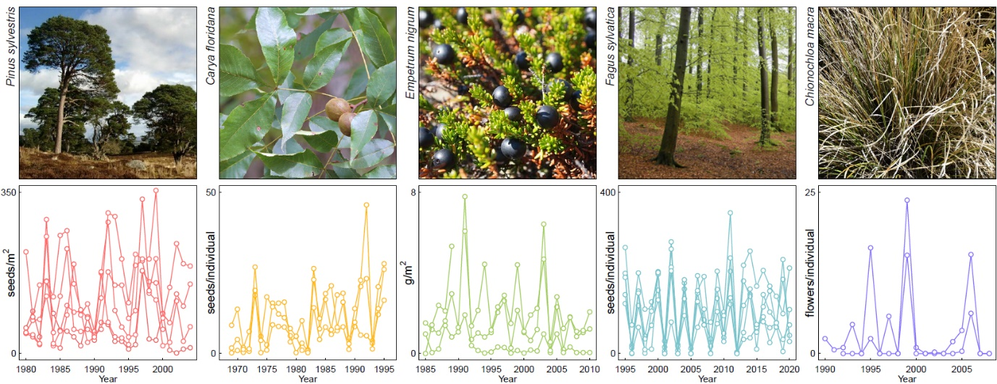
Figure 1. Examples of population-level time-series of reproductive effort from MASTREE+. For five diverse plant species, data from several local populations are plotted to illustrate the range of spatiotemporal variation in reproduction that is typical in long-lived plants. Note that axes scales vary between plots.

MASTREE+
Here we introduce a project to collate data of perennial plant reproductive time-series. Time-series originate from diverse sources, including 17th century European forestry records of seed production (“mast years”) (Ascoli, Vacchiano, et al. 2017), data from ongoing plant reproductive biology and phenology monitoring programmes (e.g. RENECOFOR, LTER, California Acorn Survey), and projects studying the dynamics of ecosystems including the relationships between seed production and animal demographics (Boutin et al. 2006). Many of these datasets record the number or mass of flowers, seeds, fruits or cones per individual or unit area on a continuous scale. We also include ordinal time-series which record annual reproduction output according to an ordered categorical scale (e.g. failure/partial/full crop) which can be successfully used to investigate the variability and synchrony of plant reproduction (Bogdziewicz et al. 2021).
The current version of MASTREE+ currently includes 5,968 species-specific and georeferenced time-series representing 73,772 annual observations of reproductive effort in perennial plant populations, and the project is designed to continue to assemble and update records (see Section 4 and 5). Mean and median time-series length are 12.6 and 10 years respectively. 2,843 series are based on continuous measures of reproductive effort, and 3,125 are ordinal series. Ordinal series originate mainly from Europe. Importantly, MASTREE+ contains 1122 time-series ⋝20 years, of which 187 time-series exceed 40 years of observations. Such records will enable quantification of recent changes in plant reproduction, including mean reproductive effort and spatiotemporal variability, and the identification of key drivers of change.
In total, 974 species are represented, drawn from 136 families across the plant Tree of Life. This increases species representation by 168 % compared to the largest previously available compilation (Pearse et al. 2020), which is incorporated into MASTREE+. This expands the potential to quantify reproductive traits that describe the spatiotemporal variability of reproduction (i.e., masting) with other life-history traits to better understand the evolution of plant reproductive strategies (Fernandez-Martinez et al. 2019; Dale et al. 2021; Pesendorfer et al. 2021). For example, we have 67 species overlap with the plant demographic database COMPADRE (Salguero-Gomez et al. 2015), 442 species overlap with seed mass data from the Kew Seed Information Database (Royal Botanic Gardens Kew 2021), and 82 species overlap with the seed germination database SylvanSeeds (Fernandez-Pascual 2021). Reflecting a bias in sampling to temperate forests, woody species from the genera Quercus (60 species), Nothofagus (10), Pinus (25), Abies (13), Acer (13) and Eucalyptus (15) are highly represented, but other well-represented genera include Acacia (11), Shorea (9) and Chionochloa (11). We include data from66 countries and from six continents (Figure 2), and from all the major vegetated biomes (Figure 3). Importantly, we increase data representation from regions that have been unrepresented in previous datasets (Pearse et al. 2020; Ascoli, Maringer, et al. 2017), including south and central America, Africa, and Asia, although these regions remain strongly under-represented.
Sampling intensity varies between species. For example, 71% of species are represented by a single time-series, but other species have high replication, often covering large parts of their geographical distribution. 51 species are represented by at least 10 location-specific time-series. The most replicated species are Fagus sylvatica (912 site-specific time-series), Picea abies (843), Pinus sylvestris (419), Larix decidua (395), Abies alba (392), Quercus robur (188), Quercus petraea (161), Pinus cembra (135) and Picea glauca (108). These and other well-replicated species include data from across large climatic gradients (Figure 3). These records will enable investigation of intraspecific variation in plant reproduction across climate space and time, including trends in the spatiotemporal variability of reproduction. It will also enable comprehensive assessments of intraspecific variability of masting characteristics (i.e. interannual variability, autocorrelation), including variation with environmental conditions that are predicted by theory but have rarely been tested (Pearse et al. 2020; Pesendorfer et al. 2021), and analysis of interspecific variation in spatial synchrony of reproduction (Dale et al. 2021), and its drivers, in functionally diverse plant species.

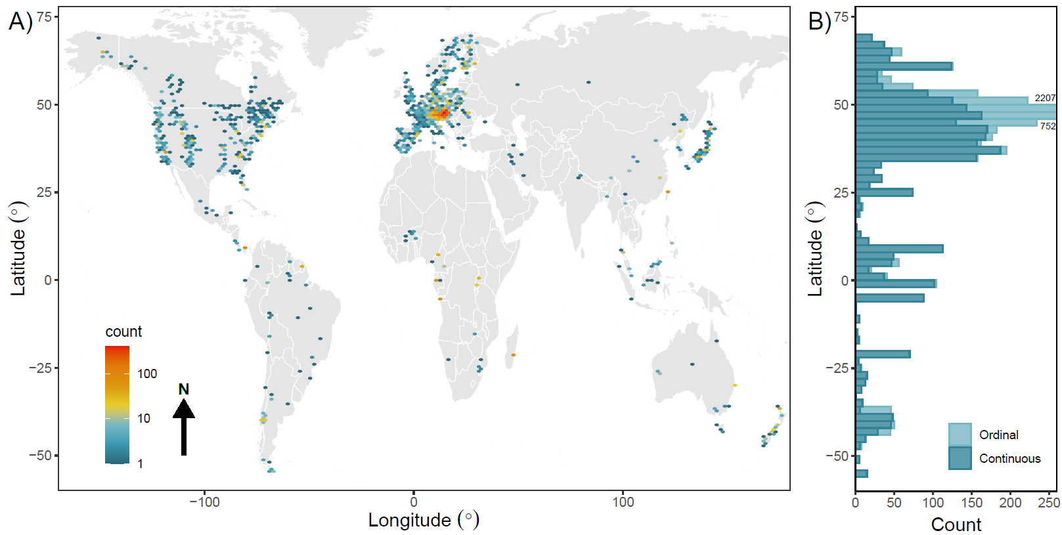
Figure 2. The geographical distribution of time-series within MASTREE+. The A) spatial and B) latitudinal distribution of species-specific time-series. For B), series are stacked and coloured according to the variable type (Continuous, Ordinal). Plotting of counts for ordinal data in the northern mid-latitudes are truncated due to high sampling intensity in central Europe. Unprojected map, datum = WGS84.

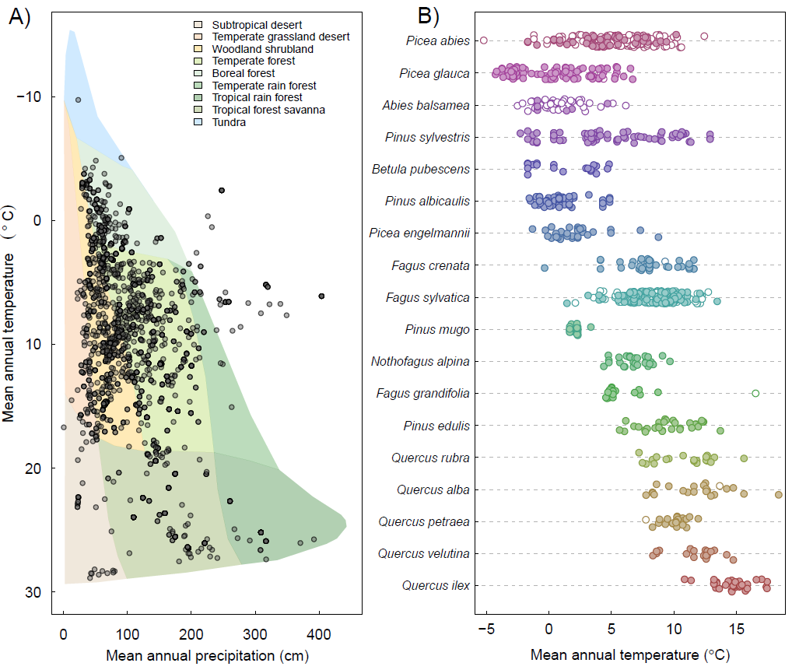
Figure 3. Distribution of time-series according to local climate (Worldclim v2.1, 30 arcsecond resolution, Mosier, Hill, and Sharp 2014). Only time-series representing reproduction at the stand or patch scale are plotted (regional records are excluded, as local climate data based on coordinates may not be representative). A) Series plotted according to Whittaker biomes (Whittaker 1970), and B) Species with high replication (>=20 species-specific time-series), plotted according to local mean annual temperature. Species are labelled according to the first three characters of the genus followed by the first three characters of the species name, and species are ordered according to the sample site with the lowest mean annual temperature. Unfilled points represent ordinal time-series and filled points represent continuous time-series.

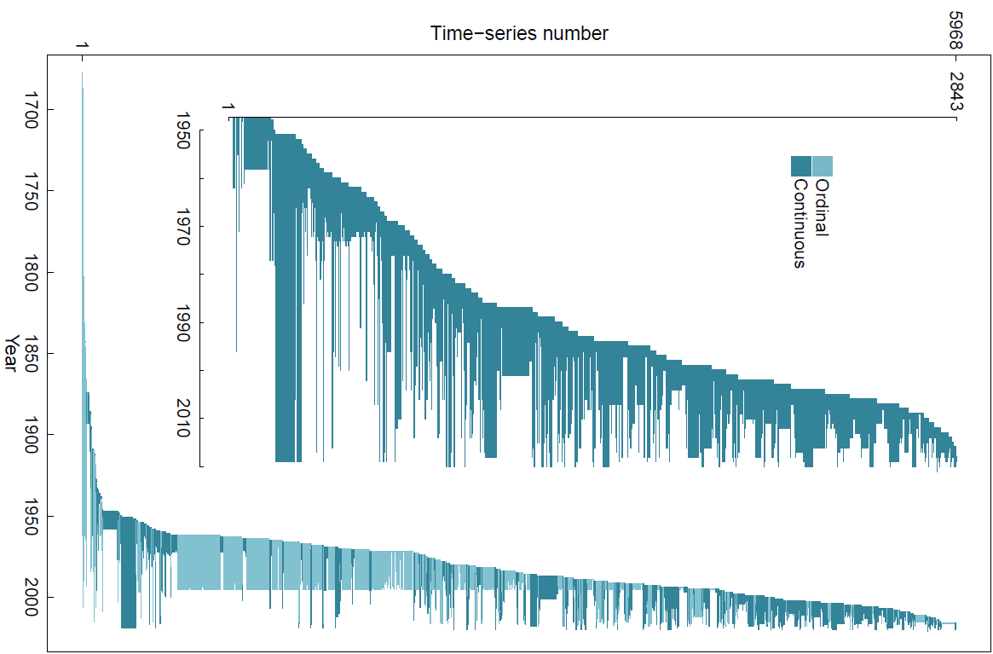
Figure 4. Timespans covered by species-specific time-series, coloured by data class. Inset plot shows continuous data since 1950 when time-series replication is highest.

Applications of MASTREE+
MASTREE+ provides the datasets to establish how fecundity, and specifically seed masting, responds to environmental change. It includes the high replication of long time-series required to isolate climate change effects on plant reproductive effort (Mundo, Sanguinetti, and Kitzberger 2021; Hacket-Pain and Bogdziewicz 2021), while high spatial replication across environmental gradients (e.g. Figure 3B) provides the opportunity for a complementary space-for-time substitution approach (Wion et al. 2020). The expected response of masting to climate change remains unresolved, and MASTREE+ will enable testing of contrasting predictions that masting will be unresponsive to trends in mean temperature (Kelly et al. 2013), or will shift predictably based on climate-driven changes in resource limitation (Bogdziewicz 2021). Resolving this uncertainty is a priority because changes in seed masting will impact plant reproductive success, and more widely affect ecosystem services and habitat management (Pearse et al. 2021; Touzot et al. 2020; Ida 2021).
In systems where seed production limits recruitment, MASTREE+ can be utilised to understand the drivers of plant reproduction and regeneration (Abraham et al. 2018; Oliva, Collantes, and Humano 2013; Manríquez et al. 2016). Intraspecific differences in fecundity and masting influence regeneration success, determining species composition and vegetation structure, including during the colonisation of new habitats (Joubert, Smit, and Hoffman 2013), and after natural and anthropogenic disturbance (Martin-DeMoor, Lieffers, and Macdonald 2010; Peters, MacDonald, and Dale 2005; Mokake et al. 2018). Masting characteristics of hundreds of species can be investigated using MASTREE+, and integration with plant trait and demographic databases will enable deeper integration of masting (and reproductive strategies more generally) within life history theory (Salguero-Gomez et al. 2016). Many ecologically and economically important species show highly variable investment in reproduction between years, and the ability to accurately forecast occasional years of high seed production is a priority for habitat management, with wide ranging applications (Pearse et al. 2021; Chiavetta and Marzini 2021; Pukkala, Hokkanen, and Nikkanen 2010). Predictive models of masting developed and tested using MASTREE+ data may enable more effective seed collection for afforestation and restoration schemes (Kettle et al. 2010; Fargione et al. 2021), inform wildlife and conservation management (Fujiki 2018; Ida 2021; Choquenot and Ruscoe 2000; O'Donnell and Hoare 2012) and enable forecasting of periods of elevated infection risk from tick-borne disease, which predictably follow years of high seed production in many systems (Heyman et al. 2012; Cunze et al. 2018; Brugger et al. 2018).
The availability of seed and fruit production datasets in MASTREE+ will be broadly relevant when paired with existing animal population datasets. The pulses of resources associated with large reproductive events are key drivers of the population dynamics of seed-eating insects, mammals, and birds, with cascading impacts through ecosystems (Selonen, Wistbacka, and Korpimaki 2016; Kanamori et al. 2017; Bouchard, Regniere, and Therrien 2018). Time-series in MASTREE+ can be combined with existing long time-series of animal populations and behaviour to identify the drivers of population dynamics, both in seed-dependent species and further down the trophic cascade (Kleef and Wijsman 2015; Lithner and Jönsson 2002). Where species are well replicated in MASTREE+, the spatial synchrony of masting can also be quantified, allowing researchers to determine where regional estimates of masting can be appropriately used as indicators of local variability in seed or fruit availability. The scale of spatial synchrony of masting appears to be highly variable between species (Bogdziewicz et al. 2019), but this has only been quantified of a handful of species so far (LaMontagne et al. 2020; Koenig and Knops 2013).
In masting species, highly variable allocation to reproduction has wider effects on plant resource allocation, and on carbon and nutrient cycling through ecosystems, but this remains poorly explored (Muller-Haubold, Hertel, and Leuschner 2015; Brumme et al. 2021; Khanna et al. 2009). Data in MASTREE+ can be combined with existing field and remote-sensing datasets of plant growth or productivity, and with datasets of whole-ecosystem or soil carbon and nutrient fluxes to understand how variable allocation to reproduction influences carbon sequestration above and belowground, and how this varies between species and across environmental gradients (Bajocco et al. 2021; Oddou-Muratorio et al. 2021; Zhang et al. 2022; Nussbaumer et al. 2021). Related work can use MASTREE+ data combined with existing or retrospective sampling (e.g. tree-rings) to address outstanding question regarding resource allocation between growth, reproduction and defence, particularly how this varies interspecifically and with environmental stress, and how this may shape species and community responses to environmental change (Lauder, Moran, and Hart 2019; Redmond et al. 2019).

Data sources, acquisition, and compilation
We collected species-specific time-series of annual reproductive effort for terrestrial perennial plant populations, including trees, shrubs, herbs, and grasses. We included data from unmanaged and managed populations, but excluded agricultural crop species subject to selective breeding. Where reproduction was monitored under experimentally manipulated conditions (e.g., fertilisation, warming, rainfall exclusion) we only included data from control plots.
Data were collected for reproductive effort at different stages of the reproductive cycle (e.g., flowers or inflorescences, pollen abundance, number of fruits, cones, or seeds), but 90% of data were mature seed, fruit or cone production. We did not set a minimum time-series length but prioritised compiling effort on time-series ≥4 years. All time-series represent reproductive effort at the population level, ranging from local populations with <10 individuals to regional estimates of reproduction, and we recorded information on the number of monitored individuals in each population and the spatial scale represented by the time-series (Table 1). We also included information on the original data collection methods, which included litter traps (19.3% of all records), seed, cone and fruit counts (18.3%), other methods including estimates of cone production using cone or fruit scars and categorical classification of seed and fruit crops by wildlife managers or foresters.
Data were collected from several sources. We harmonised data from existing published compilations of plant reproductive effort displaying differences in data architecture (Pearse et al. 2020; Ascoli, Maringer, et al. 2017; Ascoli et al. 2020). To identify other time-series, we searched Google Scholar and Scopus with multiple combinations of search terms (See Appendix 2). Spanish- and French-language searches was used to increase data representation from South America and Africa. An initial screen was based on the title and abstract to exclude irrelevant sources. Then, potential sources were classified based on the inclusion of useful data (time-series of reproductive effort) available as either data tables, figures, descriptions in the text or in supplementary data files, or in online data repositories. Finally, we solicited contributions of previously unpublished datasets from our research networks. Time-series were extracted from the original sources. In the case of values published in tables, in the text, or in online data repositories or supplementary data files, we extracted values directly from the source. In cases where data were contained in figures we used the WebPlotDigitizer tool (Rohatgi 2020). Metadata associated with each time-series was also extracted from the sources, or directly from dataset contributors, and copies of original sources were archived.

Dataset variables
For each monitored population we recorded annual observations of reproductive effort, the units of measurement, the method used to assess reproductive output and the number of monitored individuals (Table 1). Where multiple measures of reproductive output were measured for the same population (e.g., where seeds and cones were recorded separately), this was recorded to enable filtering of the dataset for pseudoreplicates (Table 1). For ordinal series, we maintained the original number of classes, but we rescaled to integer scales starting at 1 (lowest reproductive output). For continuous series, where possible we converted data into a common unit (e.g. we converted “seeds/ha” to “seeds/m²”). Years with missing observations are not recorded, and time-series that would otherwise have gaps consist of a set of segments. The Start and End year corresponds to the first and last observation year for each time-series, including all segments. The Length is the number of observations within each time-series, and can therefore be lower than the number of years between the Start and End. The location (decimal degrees), site name, elevation and country of each time-series were recorded. The spatial scale represented by the time-series was estimated on a four-point scale, from individual stand to region, based on information contained in the original source. Information on the nature of the source, and reference information was also recorded. Full details of data variables are listed in Table 1. Each time-series can be uniquely defined by combining Alpha_Number, Site_number, Variable_number and Species_code.
Table 1. Overview of the data variables in the MASTREE+ dataset. A more detailed description of the variables is included in Appendix 5.
Variable | Description
Alpha_Number | Unique code associated with each original source of data, i.e. the publication, report or thesis containing extracted data, or the previously unpublished dataset included in MASTREE+
Segment | Temporal segment of a time-series containing gaps (note that years with no observations are not recorded). Individual time-series can consist of multiple segments.
Site_number | Code to differentiate multiple sites from the same original source (Alpha_Number/Study_ID)
Variable_number | Code to differentiate multiple measures of reproductive output from the same species-site combination (e.g. where seeds and cones were recorded separately)
Year | Year of observation
Species | Species identifier, standardised to the The Plant List nomenclature. “spp.” is used to indicate a record identified to the genus level only. “MIXED” indicates a non-species-specific community-level estimate of annual reproductive effort
Species_code | Six-character species identifier
Mono_Poly | Monocarpic (semelparous) or Polycarpic (iteroparous) species
Value | The measured value of annual reproductive output
VarType | Continuous or Ordinal data. Continuous timeseries are recorded on a continuous scale. Ordinal series are recorded on an ordered categorical scale. All ordinal series are rescaled to start at 1 (lowest reproductive effort) and to contain only integer values
Unit | The unit of measurement, where VarType is continuous
Max_Value | The maximum value in a time-series
Variable | Categorical classification of the measured variable. Options limited to: cone, flower, fruit, seed, pollen, total reproduction organs.
Collection_method | Classification of the method used to measure reproductive effort. Options are limited to: cone count, cone scar count, flower count, fruit count, fruit scar sound, seed count, seed trap, pollen count, lake sediment pollen count, harvest record, visual crop assessment, other quantification, dendrochronological reconstruction
Latitude | Latitude of the record, in decimal degrees
Longitude | Longitude of the record, in decimal degrees
Coordinate_flag | A flag to indicate the precision of the latitude and longitude.  A = coordinates provided in the original source  B = coordinates estimated by the compiler based on a map or other location information provided in the original source  C= coordinates estimated by the compiler as the approximate centrepoint of the smallest clearly defined geographical unit provided in the original source (e.g. county, state, island), and potentially of low precision
Site | A site name or description, based on information in the original source
Country | The country where the observation was recorded
Elevation | The elevation of the sample site in metres above sea level, where provided in the original source
Spatial_unit | Categorical classification of spatial scale represented by the record, estimated by the compiler based on information provided in the original source.  stand = <100 ha  patch = 100-10,000 ha  region = 10,000-1,000,000 ha  super-region = >1,000,000 ha
No_individuals | Either the number of monitored individual plants, or the number of litter traps. NA indicates no information in the original source, and 9999 indicates that while the number of monitored individuals was not specified, the source indicated to the compiler that the sample size was likely >=10 individuals or litter traps
Start | The first year of observations for the complete time-series, including all segments
End | The final year of observations for the complete time-series, including all segments
Length | The number of years of observations. Note that may not be equal to the number of years between the Start and End of the time-series, due to gaps in the time-series.
Reference | Identification for the original source of the data, see Appendix 4 for the complete list of references
Record_type | Categorisation of the original source.  Peer-reviewed = extracted from peer reviewed literature  Grey = extracted from grey literature  Unpublished = unpublished data
ID_enterer | Identification of the original compiler of the data  AHP = Andrew Hacket-Pain; ES = Eliane Schermer; JVM = Jose Morris; XTT = Tingting Xue; TC = Thomas Caignard; DV = Davide Vecchio; DA = Davide Ascoli; IP = Ian Pearse; JL = Jalene LaMontagne; JVD = Joep van Dormolen
Date_entry | Date of data entry into MASTREE+ in the format yyyy-mm-dd
Note on data location | Notes on the location of the data within the original source, such as page or figure number
Comments | Additional comments
Study_ID | Unique code associated with each source of data. M_ = series extracted from published literature; A_ = series incorporated from Ascoli et al. (2017, 2020); PLK_ = series incorporated from Pearse et al (2017); D_ = unpublished datasets

Technical validation and quality control
A two-stage approach was adopted to validate time-series data. Initially, we standardised attribute data and checked for errors and inconsistencies within time-series. Species names were checked and standardised to The Plant List nomenclature, using the “Taxonstand” package for R (v. 2.3) (Cayuela et al. 2021). Country names were converted to the English short name (ISO3166-1), using the “countrycode” package for R (v. 1.2.0) (Arel-Bundock, Enevoldsen, and Yetman 2018). Automatic checks were performed to ensure that each time-series was uniquely identified by the identification variables, and that time-series’ observations were uniquely identified by Year. Species_code was assigned by automatically combining the first three characters from the TPL-standardised genus and species names. Where separate species shared a Species_code, a unique combination was manually created. The final character of Species_code for populations of a hybrid origin was changed to “X”. We ran various automatic checks to ensure all observations in a time-series had uniform attribute data where such uniformity was expected (i.e., within a time-series, there was only a single value for variables such as Unit). Interrelated variables were checked to ensure consistency; for example, checking that time-series spatial data (Latitude, Longitude) fell within the boundaries of the indicated Country. Time-series duration variables (i.e., Segment, Start, End, Length) were directly calculated from time-series.
The second stage involved the detection and removal of duplication problems between time-series, i.e., series added multiple times, including with partial overlap, usually when data was published in more than one source. First, we created ‘potential duplication groups’ that contained sets of time-series that shared the same study species and approximate location (using a ± 0.1 decimal degree buffer between pairs of time-series). PDGs containing time-series from multiple sources (Alpha_Number) were then inspected further. Suspect pairs of time-series within PDGs were initially identified based on a correlation test (Spearman's ρ > 0.97), and we then inspected manually for duplication using information including location, units, and collection methods to identify possible duplication. To supplement the semi-automated detection of duplicates, we performed a further manual check, examining groups of time-series that shared the same country and species. Suspect pairs of series might, for example, share matching spatial references, matching site descriptions, and/or matching author names.
Where duplicated series were identified, or where independence could not be confirmed, we selected a single time-series for inclusion in MASTREE+. Generally, the longest time-series was prioritised, unless there were clear signs that a shorter time-series was of higher quality (e.g., the data was directly shared by the author and not extracted from a graph).

Dataset availability and MASTREE+ Data Explorer
The dataset is provided as a csv file in the online supporting information (Appendix 1), and is distributed under a CC-BY-4.0 licence so that the dataset can be freely used, shared and modified so long as appropriate credit is given. The dataset will be expanded and updated over time, so users are encouraged to check for the latest version of the dataset on GitHub (https://github.com/JJFoest/MASTREEplus) and via associated updates to the MASTREE+ Data Explorer. The MASTREE+ Data Explorer allows users to explore the MASTREE+ dataset, and provides an alternative for downloading the dataset, including user-defined subsets of the full dataset. The MASTREE+ Data Explorer was created using the shiny package in R (Chang et al. 2021), and can be accessed at https://mastreeplus.shinyapps.io/mastreeplus/. Time-series are plotted on a zoomable visualisation of the world, with updating summary plots showing the time-series lengths and species/genera for the selected region, and scaled time-series for initial visualisation of the data within the selected region of interest (Figure 5). Individual time-series can be selected on the map to reveal associated meta-data, including the location, species, and original source. Various filter options allow the user to subset the full dataset. An R script is provided in Appendix 6 that illustrates how to load. manipulate and visual the dataset.

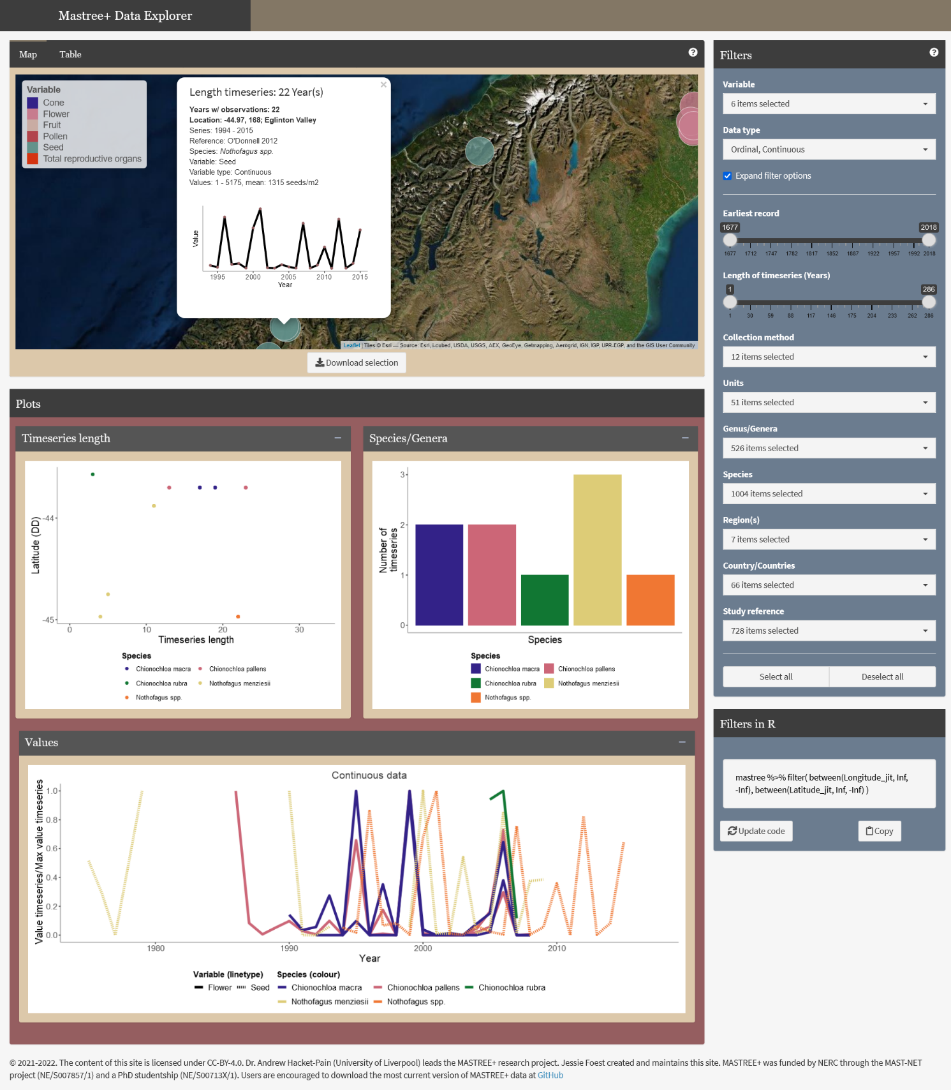
Figure 5. Example of the MASTREE+ Shiny Data Explorer, showing data from the South Island of New Zealand. The Data Explorer allows the user to explore data availability within MASTREE+, and download the full or user-defined subsets of the dataset.

Call for data
We have increased taxonomic and geographic representation in MASTREE+, but many gaps remain in the coverage of our dataset. Our goal is to provide a global platform for sharing data on long-lived plant reproduction, and we encourage scientists to submit time-series of annual reproductive effort in perennial plant populations for inclusion in MASTREE+ (Table 2). We will consider all species-specific time-series of four or more years, including continuous and ordinal observations. We include data on flower, seed, fruit, and cone production. Time-series must include geographical coordinates. We can include data that represents small local populations through to large regional-scale assessments of reproductive effort. Note that we only record annual reproductive effort. Where data is collected at sub-annual timesteps, this means that reproduction must be aggregated to annual units (e.g., April-March).
Potential contributors of data are encouraged to search the latest version of the dataset to check whether the data is already included in MASTREE+, either by downloading the latest version from GitHub (Section 4) or via the MASTREE+ Data Explorer. If the data are not already included, potential contributors are encouraged to contact the corresponding author to discuss arrangements for sharing data. The minimum data requirements are included in Table 2.

Table 2. Minimum data requirements for submissions to MASTREE+. For further details see Table 1.
Minimum data requirements and metadata
Minimum of four consecutive measurements of annual reproductive output
Measurement at the population level (local population through regional scale estimates acceptable)
Species name according to The Plant List. Records identified to the genus level are acceptable, and measurements of non-species-specific community reproductive effort may be included.
Spatial coordinates of the monitored population
Details of the method used to measure reproductive effort (e.g., litter traps, seed counts, visual crop estimate, see Table).

Data licence
MASTREE+ is published under a CC-BY-4.0 licence, which enables users to copy and redistribute, adapt and modify the dataset in any medium or format and for any purpose, including commercial. You must give appropriate credit by citing this publication, provide a link to the license, and indicate if changes were made (see https://creativecommons.org/licenses/by/4.0/ for further details). Publications using the RENECOFOR data (Reference = RENECOFOR_2020) are requested to acknowledge the RENECOFOR network, and send copies of publications to manuel.nicolas@onf.fr. Publications using the Lopé data (Reference = Bush_2021) are requested to cite the original dataset http://hdl.handle.net/11667/152), acknowledge The National Parks Agency of Gabon (ANPN) and the University of Stirling, and send copies of any resulting publications to science@parcsgabon.ga and k.a.abernethy@stir.ac.uk.

Author contributions

Conceptualisation: Andrew Hacket-Pain, Ian S. Pearse, Walter D. Koenig, Giorgio Vacchiano, Michał Bogdziewicz, Mario Pesendorfer, Akiko Satake, Andrew J. Tanentzap, Peter A. Thomas, Thomas Wohlgemuth, Davide Ascoli
Methodology, including literature search, source classification, data extraction and compilation: Andrew Hacket-Pain, Jessie J. Foest, Ian S. Pearse, Jalene M. LaMontagne, Walter D. Koenig, Giorgio Vacchiano, Michał Bogdziewicz , Thomas Caignard, Paulina Celebias, Joep van Dormolen, Marcos Fernández-Martínez, Jose V. Moris, Ciprian Palaghianu, Mario Pesendorfer, Akiko Satake, Eliane Schermer, Andrew J. Tanentzap, Peter A. Thomas, Davide Vecchio, Andreas Wion, Thomas Wohlgemuth, Tingting Xue, Davide Ascoli
Methodology, including data validation: Andrew Hacket-Pain, Jessie F. Foest
Data Explorer: Jessie J. Foest
Data contribution: Andrew Hacket-Pain, Ian S. Pearse, Jalene M. LaMontagne, Walter D. Koenig, Michał Bogdziewicz, Peter A. Thomas, Katherine Abernethy, Marcelo Daniel Barrera Jessica H. Barton, Stan Boutin, Emma R. Bush, Sergio Donoso Calderón, Felipe S. Carevic, Carolina Volkmer de Castilho, Juan Manuel Cellini, Hazel Chapman, Colin A. Chapman, Francesco Chianucci, Patricia da Costa, Luc Croisé, Andrea Cutini, Ben Dantzer, R. Justin DeRose, Jean Thoussaint Dikangadissi, Edmond Dimoto, Fernanda Lopes da Fonseca, Leonardo Gallo, David F. Greene, Martín A. Hadad, Alejandro Huertas Herrera, K.J. Jeffery, Jill F. Johnstone, Urs Kalbitzer, Władysław Kantorowicz, Christie A. Klimas, Jonathan G.A. Lageard, Jeffrey Lane, Katharina Lapin, Mateusz Ledwon, Abigail Leeper, Maria Vanessa Lencinas, Ana Cláudia Lira-Guedes, Michael C. Lordon, Paula Marchelli, Shealyn Marino, Harald Schmidt Van Marle, Andrew G. McAdam, Ludovic R.W. Momont, Manuel Nicolas, Lúcia Helena de Oliveira Wadt, Parisa Panahi, Guillermo Martínez Pastur, Thomas Patterson, Pablo Luis Peri, Łukasz Piechnik, Mehdi Pourhashemi, Claudia Espinoza Quezada, Fidel A. Roig, Karen Peña Rojas, Yamina Micaela Rosas, Silvio Schüler, Barbara Seget, Rosina Soler, Michael A. Steele, Mónica Toro-Manríquez, Caroline E.G. Tutin, Tharcisse Ukizintambara, Lee White, Biplang Yadok, John L. Willis, Anita Zolles, Magdalena Żywiec, Davide Ascoli
Writing – original draft: Andrew Hacket-Pain
Writing – Review and editing: all authors
Supervision and Project administration: Andrew Hacket-Pain
Funding acquisition: Andrew Hacket-Pain, Andrew J. Tanentzap, Peter A. Thomas

Acknowledgements
We thank Mark Green and Esther Dale. This study was funded by the UK Natural Environment Research Council grant no. NE/S007857/1 to AHP, AJT and PAT. JJF was supported a PhD studentship under Natural Environment Research Council grant number NE/S00713X/1. Original data collection was supported by many funders, including the Natural Sciences and Engineering Research Council of Canada (SB, AM, BD, JL) the National Science Foundation (AM, BD), the Austrian Climate Research Program (ACRP) of the “Klima- und Energiefonds” (9th Call, project: MoreSeedsAdapt - KR16AC0K13339), the Brazilian Agricultural Research Corporation (EMBRAPA) through the Kamukaia III Project “Appreciation of non-timber forest products in the Amazon” (grant number SEG 12.13.07.007.00.00), the W. Szafer Institute of Botany of the Polish Academy of Sciences and the Polish National Science Foundation (2019/33/B/NZ8/01345), the French ministry of Agriculture and Food, the French ministry and the French agency for Ecological Transition, the French national forest office, and the European Commission (under successive regulations from No 1091/94 until No 2152/2003). As the French part of the ICP Forests intensive (Level II) monitoring programme, the RENECOFOR network has benefited from its scientific framework and shared expertise. Data from Bonanza Creek LTER comes from a partnership between the University of Alaska Fairbanks and the U.S. Forest Service, with funding from the National Science Foundation Long-Term Ecological Research program (NSF Grant numbers DEB-1636476, DEB-1026415, DEB-0620579, DEB-0423442, DEB-0080609, DEB-9810217, DEB-9211769, DEB-8702629) and by the USDA Forest Service, Pacific Northwest Research Station (Agreement # RJVA-PNW-01-JV-11261952-231). The contribution of TX was supported by the National Natural Science Foundation (Grant No. 32001310) and Chuzhou University Start-up Foundation for Research (2021qd05). Data from Italian Central Apennines were available thanks to the support of the research project “Monitoraggio della produzione di seme di specie forestali, rinnovazione naturale e relazioni con la fauna selvatica (Pasciona)” funded by the Foreste Casentinesi, Monte Falterona e Campigna National Park. The contribution from RJD would not have been possible without the effort of Dr. Theodore W. (“Doc”) Daniel. Doc Daniel had the long-term vision to commence and oversee the annual cone counts for hundreds of trees from 1947-1981 on the Utah State Agricultural College (now Utah State University) School Forest, later named in his honour as the T.W. Daniel Experimental Forest. We thank Charley Krebs, Rudy Boonstra, Dennis Murray for sharing unpublished data, and we gratefully acknowledge the scientists responsible for the following open-access datasets that were incorporated into MASTREE+: doi.org/10.5061/dryad.4qrfj6q9m, doi.org/10.5061/dryad.1s625, doi.org/10.5061/dryad.v6wwpzgrb, doi.org/10.5061/dryad.772g3, doi.org/10.5061/dryad.pv608, doi.org/10.5061/dryad.stqjq2c0c, doi.org/10.5061/dryad.61m318c, doi.org/10.5061/dryad.75v7c. We thank the many collaborators, students, friends and family who have helped to support long-term data collection. Any use of trade, firm, or product names is for descriptive purposes only and does not imply endorsement by the U.S. Government. The findings and conclusions of this publication are those of the author(s) and should not be construed to represent an official USDA, Forest Service, or United States Government determination or policy.

Supplementary information files
Appendix 1: The MASTREE+ dataset as a .csv file
Appendix 2: Literature search for potential sources of masting data
Appendix 3: Data cleaning and removal of duplicated time-series
Appendix 4: Full reference list for sources included MASTREE+
Appendix 5: Extended description of database variables
Appendix 6: Example R script to load, manipulate and visual MASTREE+

References

Abraham, E. M., P. Sklavou, A. Loufi, Z. M. Parissi, and A. P. Kyriazopoulos. 2018. "The Effect of Combined Herbivory by Wild Boar and Small Ruminants on the Regeneration of a Deciduous Oak Forest." Forests 9 (9):10. doi: 10.3390/f9090580.
Allen, C. D., A. K. Macalady, H. Chenchouni, D. Bachelet, N. McDowell, M. Vennetier, T. Kitzberger, A. Rigling, D. D. Breshears, E. H. Hogg, P. Gonzalez, R. Fensham, Z. Zhang, J. Castro, N. Demidova, J. H. Lim, G. Allard, S. W. Running, A. Semerci, and N. Cobb. 2010. "A global overview of drought and heat-induced tree mortality reveals emerging climate change risks for forests." Forest Ecology and Management 259 (4):660-684. doi: 10.1016/j.foreco.2009.09.001.
Arel-Bundock, V., N. Enevoldsen, and C.J. Yetman. 2018. "countrycode: An R package to convert country names and country codes." Journal of Open Source Software 3 (28):848. doi: https://doi.org/10.21105/joss.00848.
Ascoli, D., A. Hacket-Pain, J. M. LaMontagne, A. Cardil, M. Conedera, J. Maringer, R. Motta, I. S. Pearse, and G. Vacchiano. 2020. "Climate teleconnections synchronize Picea glauca masting and fire disturbance: Evidence for a fire-related form of environmental prediction." Journal of Ecology 108 (3):1186-1198. doi: 10.1111/1365-2745.13308.
Ascoli, D., J. Maringer, A. Hacket-Pain, M. Conedera, I. Drobyshev, R. Motta, M. Cirolli, W. Kantorowicz, C. Zang, S. Schueler, L. Croise, P. Piussi, R. Berretti, C. Palaghianu, M. Westergren, J. G. A. Lageard, A. Burkart, R. G. Bichsel, P. A. Thomas, B. Beudert, R. Overgaard, and G. Vacchiano. 2017. "Two centuries of masting data for European beech and Norway spruce across the European continent." Ecology 98 (5):1473-+. doi: 10.1002/ecy.1785.
Ascoli, D., G. Vacchiano, M. Turco, M. Conedera, I. Drobyshev, J. Maringer, R. Motta, and A. Hacket-Pain. 2017. "Inter-annual and decadal changes in teleconnections drive continental-scale synchronization of tree reproduction." Nature Communications 8. doi: 10.1038/s41467-017-02348-9.
Bajocco, S., C. Ferrara, M. Bascietto, A. Alivernini, R. Chirichella, A. Cutini, and F. Chianucci. 2021. "Characterizing the climatic niche of mast seeding in beech: Evidences of trade-offs between vegetation growth and seed production." Ecological Indicators 121:9. doi: 10.1016/j.ecolind.2020.107139.
Bennett, E., J. Clement, P. Sansom, I. Hall, S. Leach, and J. M. Medlock. 2010. "Environmental and ecological potential for enzootic cycles of Puumala hantavirus in Great Britain." Epidemiology and Infection 138 (1):91-98. doi: 10.1017/s095026880999029x.
Bogdziewicz, M. 2021. "How will global change affect plant reproduction? A framework for mast seeding trends." New Phytologist Early View.
Bogdziewicz, M., A. Hacket-Pain, D. Ascoli, and J. Szymkowiak. 2021. "Environmental variation drives continental-scale synchrony of European beech reproduction." Ecology 102 (7):10. doi: 10.1002/ecy.3384.
Bogdziewicz, M., D. Kelly, P. A. Thomas, J. G. A. Lageard, and A. Hacket-Pain. 2020. "Climate warming disrupts mast seeding and its fitness benefits in European beech." Nature Plants 6 (2):88-94. doi: 10.1038/s41477-020-0592-8.
Bogdziewicz, M., J. Szymkowiak, M. Fernández-Martínez, J. Peñuelas, and J. M. Espelta. 2019. "The effects of local climate on the correlation between weather and seed production differ in two species with contrasting masting habit." Agricultural and Forest Meteorology 268:109-115. doi: 10.1016/j.agrformet.2019.01.016.
Bouchard, M., J. Regniere, and P. Therrien. 2018. "Bottom-up factors contribute to large-scale synchrony in spruce budworm populations." Canadian Journal of Forest Research 48 (3):277-284. doi: 10.1139/cjfr-2017-0051.
Boutin, S., L. A. Wauters, A. G. McAdam, M. M. Humphries, G. Tosi, and A. A. Dhondt. 2006. "Anticipatory reproduction and population growth in seed predators." Science 314 (5807):1928-1930. doi: 10.1126/science.1135520.
Bregnard, Cindy, Olivier Rais, and Maarten Jeroen Voordouw. 2020. "Climate and tree seed production predict the abundance of the European Lyme disease vector over a 15-year period." Parasites & Vectors 13 (1). doi: 10.1186/s13071-020-04291-z.
Brugger, Katharina, Melanie Walter, Lidia Chitimia-Dobler, Gerhard Dobler, and Franz Rubel. 2018. "Forecasting next season’s Ixodes ricinus nymphal density: the example of southern Germany 2018." Experimental and Applied Acarology:1-8.
Brumme, R., B. Ahrends, J. Block, C. Schulz, H. Meesenburg, U. Klinck, M. Wagner, and P. K. Khanna. 2021. "Cycling and retention of nitrogen in European beech (Fagus sylvatica L.) ecosystems under elevated fructification frequency." Biogeosciences 18 (12):3763-3779. doi: 10.5194/bg-18-3763-2021.
Buechling, A., P. H. Martin, C. D. Canham, W. D. Shepperd, and M. A. Battaglia. 2016. "Climate drivers of seed production in Picea engelmannii and response to warming temperatures in the southern Rocky Mountains." Journal of Ecology 104 (4):1051-1062. doi: 10.1111/1365-2745.12572.
Buras, A., A. Rammig, and C. S. Zang. 2020. "Quantifying impacts of the 2018 drought on European ecosystems in comparison to 2003." Biogeosciences 17 (6):1655-1672. doi: 10.5194/bg-17-1655-2020.
Bush, E. R., R. C. Whytock, L. Bahaa-El-Din, S. Bourgeois, N. Bunnefeld, A. W. Cardoso, J. T. Dikangadissi, P. Dimbonda, E. Dimoto, J. E. Ndong, K. J. Jeffery, D. Lehmann, L. Makaga, B. Momboua, L. R. W. Momont, C. E. G. Tutin, L. J. T. White, A. Whittaker, and K. Abernethy. 2020. "Long-term collapse in fruit availability threatens Central African forest megafauna." Science 370 (6521):1219-1221. doi: 10.1126/science.abc7791.
Caignard, T., A. Kremer, C. Firmat, M. Nicolas, S. Venner, and S. Delzon. 2017. "Increasing spring temperatures favor oak seed production in temperate areas." Scientific Reports 7:8. doi: 10.1038/s41598-017-09172-7.
Calama, R., S. Mutke, J. Tome, J. Gordo, G. Montero, and M. Tome. 2011. "Modelling spatial and temporal variability in a zero-inflated variable: The case of stone pine (Pinus pinea L.) cone production." Ecological Modelling 222 (3):606-618. doi: 10.1016/j.ecolmodel.2010.09.020.
Carnicer, J., M. Coll, M. Ninyerola, X. Pons, G. Sanchez, and J. Penuelas. 2011. "Widespread crown condition decline, food web disruption, and amplified tree mortality with increased climate change-type drought." Proceedings of the National Academy of Sciences of the United States of America 108 (4):1474-1478. doi: 10.1073/pnas.1010070108.
Taxonstand: Taxonomic Standardization of Plant Species Names. https://CRAN.R-project.org/package=Taxonstand.
shiny: Web Application Framework for R 1.6.0, https://CRAN.R-project.org/package=shiny.
Changenet, Alexandre, Paloma Ruiz-Benito, Sophia Ratcliffe, Thibaut Fréjaville, Juliette Archambeau, Annabel J. Porte, Miguel A. Zavala, Jonas Dahlgren, Aleksi Lehtonen, and Marta Benito Garzón. 2021. "Occurrence but not intensity of mortality rises towards the climatic trailing edge of tree species ranges in European forests." Global Ecology and Biogeography 30 (7):1356-1374. doi: https://doi.org/10.1111/geb.13301.
Chen, J. M., W. M. Ju, P. Ciais, N. Viovy, R. G. Liu, Y. Liu, and X. H. Lu. 2019. "Vegetation structural change since 1981 significantly enhanced the terrestrial carbon sink." Nature Communications 10. doi: 10.1038/s41467-019-12257-8.
Chiavetta, U., and S. Marzini. 2021. "foreMast: an R package for predicting beech (Fagus sylvatica L.) masting events in European countries." Annals of Forest Science 78 (4):10. doi: 10.1007/s13595-021-01109-5.
Choquenot, David, and Wendy A Ruscoe. 2000. "Mouse population eruptions in New Zealand forests: the role of population density and seedfall." Journal of Animal Ecology 69 (6):1058-1070.
Clark, J. S., R. Andrus, M. Aubry-Kientz, Y. Bergeron, M. Bogdziewicz, D. C. Bragg, D. Brockway, N. L. Cleavitt, S. Cohen, B. Courbaud, R. Daley, A. J. Das, M. Dietze, T. J. Fahey, I. Fer, J. F. Franklin, C. A. Gehring, G. S. Gilbert, C. H. Greenberg, Q. F. Guo, J. HilleRisLambers, I. Ibanez, J. Johnstone, C. L. Kilner, J. Knops, W. D. Koenig, G. Kunstler, J. M. LaMontagne, K. L. Legg, J. Luongo, J. A. Lutz, D. Macias, E. J. B. McIntire, Y. Messaoud, C. M. Moore, E. Moran, J. A. Myers, O. B. Myers, C. Nunez, R. Parmenter, S. Pearse, S. Pearson, R. Poulton-Kamakura, E. Ready, M. D. Redmond, C. D. Reid, K. C. Rodman, C. L. Scher, W. H. Schlesinger, A. M. Schwantes, E. Shanahan, S. Sharma, M. A. Steele, N. L. Stephenson, S. Sutton, J. J. Swenson, M. Swift, T. T. Veblen, A. V. Whipple, T. G. Whitham, A. P. Wion, K. Zhu, and R. Zlotin. 2021. "Continent-wide tree fecundity driven by indirect climate effects." Nature Communications 12 (1):1242. doi: 10.1038/s41467-021-22025-2.
Clark, J. S., L. Iverson, C. W. Woodall, C. D. Allen, D. M. Bell, D. C. Bragg, A. W. D'Amato, F. W. Davis, M. H. Hersh, I. Ibanez, S. T. Jackson, S. Matthews, N. Pederson, M. Peters, M. W. Schwartz, K. M. Waring, and N. E. Zimmermann. 2016. "The impacts of increasing drought on forest dynamics, structure, and biodiversity in the United States." Global Change Biology 22 (7):2329-2352. doi: 10.1111/gcb.13160.
Connell, J. H., and P. T. Green. 2000. "Seedling dynamics over thirty-two years in a tropical rain forest tree." Ecology 81 (2):568-584. doi: 10.1890/0012-9658(2000)081[0568:sdotty]2.0.co;2.
Cunze, S., J. Kochmann, T. Kuhn, R. Frank, D. D. Dorge, and S. Klimpel. 2018. "Spatial and temporal patterns of human Puumala virus (PUUV) infections in Germany." Peerj 6:20. doi: 10.7717/peerj.4255.
Curran, L. M., and M. Leighton. 2000. "Vertebrate responses to spatiotemporal variation in seed production of mast-fruiting Dipterocarpaceae." Ecological Monographs 70 (1):101-128. doi: 10.1890/0012-9615(2000)070[0101:VRTSVI]2.0.CO;2.
Dale, E.E., J Foest, J., A. Hacket-Pain, M. Bogdziewicz, and A. Tanentzap. 2021. "Macroevolutionary consequences of mast seeding." Philosophical Transactions of the Royal Society 376:2020372.
Fargione, J., D. L. Haase, O. T. Burney, O. A. Kildisheva, G. Edge, S. C. Cook-Patton, T. Chapman, A. Rempel, M. D. Hurteau, K. T. Davis, S. Dobrowski, S. Enebak, R. De La Torre, A. A. R. Bhuta, F. Cubbage, B. Kittler, D. W. Zhang, and R. W. Guldin. 2021. "Challenges to the Reforestation Pipeline in the United States." Frontiers in Forests and Global Change 4:18. doi: 10.3389/ffgc.2021.629198.
Fernandez-Martinez, M., I. Pearse, J. Sardans, F. Sayol, W. D. Koenig, J. M. LaMontagne, M. Bogdziewicz, A. Collalti, A. Hacket-Pain, G. Vacchiano, J. M. Espelta, J. Penuelas, and I. A. Janssens. 2019. "Nutrient scarcity as a selective pressure for mast seeding." Nature Plants 5 (12):1222-+. doi: 10.1038/s41477-019-0549-y.
Fernandez-Pascual, E. 2021. "SylvanSeeds, a seed germination database for temperate deciduous forests." Journal of Vegetation Science 32:e12960. doi: 10.1111/jvs.12960.
Fisher, R. A., C. D. Koven, W. R. L. Anderegg, B. O. Christoffersen, M. C. Dietze, C. E. Farrior, J. A. Holm, G. C. Hurtt, R. G. Knox, P. J. Lawrence, J. W. Lichstein, M. Longo, A. M. Matheny, D. Medvigy, H. C. Muller-Landau, T. L. Powell, S. P. Serbin, H. Sato, J. K. Shuman, B. Smith, A. T. Trugman, T. Viskari, H. Verbeeck, E. S. Weng, C. G. Xu, X. T. Xu, T. Zhang, and P. R. Moorcroft. 2018. "Vegetation demographics in Earth System Models: A review of progress and priorities." Global Change Biology 24 (1):35-54. doi: 10.1111/gcb.13910.
Fujiki, Daisuke. 2018. "Can frequent occurrence of Asiatic black bears around residential areas be predicted by a model-based mast production in multiple Fagaceae species?" Journal of Forest Research 23 (5):260-269.
Hacket-Pain, A., and M. Bogdziewicz. 2021. "Climate change and plant reproduction: trends and drivers of mast seeding change." Philosophical Transactions of the Royal Society B 376:20200379.
Heyman, Paul, Bryan R Thoma, Jean-Lou Marié, Christel Cochez, and Sandra Simone Essbauer. 2012. "In search for factors that drive hantavirus epidemics." Frontiers in physiology 3:237.
Ida, H. 2021. "A 15-year study on the relationship between beech (Fagus crenata) reproductive-organ production and the numbers of nuisance Japanese black bears (Ursus thibetanus japonicus) killed in a snowy rural region in central Japan." Landscape and Ecological Engineering 17 (4):507-514. doi: 10.1007/s11355-021-00472-9.
Joubert, D. F., G. N. Smit, and M. T. Hoffman. 2013. "The influence of rainfall, competition and predation on seed production, germination and establishment of an encroaching Acacia in an arid Namibian savanna." Journal of Arid Environments 91:7-13. doi: 10.1016/j.jaridenv.2012.11.001.
Kanamori, T., N. Kuze, H. Bernard, T. P. Malim, and S. Kohshima. 2017. "Fluctuations of population density in Bornean orangutans (Pongo pygmaeus morio) related to fruit availability in the Danum Valley, Sabah, Malaysia: a 10-year record including two mast fruitings and three other peak fruitings." Primates 58 (1):225-235. doi: 10.1007/s10329-016-0584-5.
Kelly, D., A. Geldenhuis, A. James, E. Penelope Holland, M. J. Plank, R. E. Brockie, P. E. Cowan, G. A. Harper, W. G. Lee, M. J. Maitland, A. F. Mark, J. A. Mills, P. R. Wilson, and A. E. Byrom. 2013. "Of mast and mean: Differential-temperature cue makes mast seeding insensitive to climate change." Ecology Letters 16 (1):90-98. doi: 10.1111/ele.12020.
Kettle, Chris J, Jaboury Ghazoul, Peter S Ashton, Charles H Cannon, Lucy Chong, Bibia Diway, Eny Faridah, Rhett Harrison, Andrew Hector, and Pete Hollingsworth. 2010. "Mass fruiting in Borneo: a missed opportunity." Science 330 (6004):584-584.
Khanna, P. K., H. Fortmann, H. Meesenburg, J. Eichhorn, and K. J. Meiwes. 2009. "Biomass and Element Content of Foliage and Aboveground Litterfall on the Three Long-Term Experimental Beech Sites: Dynamics and Significance." In Functioning and Management of European Beech Ecosystems, edited by R. Brumme and P. K. Khanna, 183-205. New York: Springer.
Kleef, Hans L, and HJ Wijsman. 2015. "Mast, mice and pine marten (Martes martes): the pine marten’s reproductive response to wood mouse (Apodemus sylvaticus) fluctuations in the Netherlands." Lutra 58:23-33.
Klesse, S., R. J. DeRose, F. Babst, B. A. Black, L. D. L. Anderegg, J. Axelson, A. Ettinger, H. Griesbauer, C. H. Guiterman, G. Harley, J. E. Harvey, Y. H. Lo, A. M. Lynch, C. O'Connor, C. Restaino, D. Sauchyn, J. D. Shaw, D. J. Smith, L. Wood, J. Villanueva-Diaz, and M. E. K. Evans. 2020. "Continental-scale tree-ring-based projection of Douglas-fir growth: Testing the limits of space-for-time substitution." Global Change Biology 26 (9):5146-5163. doi: 10.1111/gcb.15170.
Koenig, W. D., and J. M. H. Knops. 2000. "Patterns of annual seed production by northern hemisphere trees: A global perspective." American Naturalist 155 (1):59-69. doi: 10.1086/303302.
Koenig, W. D., and J. M. H. Knops. 2013. "Large-scale spatial synchrony and cross-synchrony in acorn production by two California oaks." Ecology 94 (1):83-93. doi: 10.1890/12-0940.1.
Ladio, A. H., and M. Lozada. 2004. "Patterns of use and knowledge of wild edible plants in distinct ecological environments: a case study of a Mapuche community from northwestern Patagonia." Biodiversity and Conservation 13 (6):1153-1173. doi: 10.1023/b:bioc.0000018150.79156.50.
LaMontagne, J.M., M. Redmond, D. Greene, and W.D. Koenig. 2021. "An assessment of temporal variability in mast seeding of North American Pinaceae." Philosophical Transactions of the Royal Society B 376:20200373.
LaMontagne, Jalene M., Ian S. Pearse, David F. Greene, and Walter D. Koenig. 2020. "Mast seeding patterns are asynchronous at a continental scale." Nature Plants 6 (5):460-+. doi: 10.1038/s41477-020-0647-x.
Lauder, J. D., E. V. Moran, and S. C. Hart. 2019. "Fight or flight? Potential tradeoffs between drought defense and reproduction in conifers." Tree Physiology 39 (7):1071-1085. doi: 10.1093/treephys/tpz031.
Lithner, S., and I. Jönsson. 2002. "Abundance of owls and Bramblings Fringilla montifringilla in relation to mast seeding in south-eastern Sweden." Ornis Svecica 12 (1):35-45.
Manríquez, Mónica Toro, Luciana Mestre, María Vanessa Lencinas, Álvaro Promis, Guillermo Martínez Pastur, and Rosina Soler. 2016. "Flowering and seeding patterns in pure and mixed Nothofagus forests in Southern Patagonia." Ecological Processes 5 (1):21.
Martin-DeMoor, J., V. J. Lieffers, and S. E. Macdonald. 2010. "Natural regeneration of white spruce in aspen-dominated boreal mixedwoods following harvesting." Canadian Journal of Forest Research-Revue Canadienne De Recherche Forestiere 40 (3):585-594. doi: 10.1139/x10-016.
McDowell, N. G., C. D. Allen, K. Anderson-Teixeira, B. H. Aukema, B. Bond-Lamberty, L. Chini, J. S. Clark, M. Dietze, C. Grossiord, A. Hanbury-Brown, G. C. Hurtt, R. B. Jackson, D. J. Johnson, L. Kueppers, J. W. Lichstein, K. Ogle, B. Poulter, T. A. M. Pugh, R. Seidl, M. G. Turner, M. Uriarte, A. P. Walker, and C. G. Xu. 2020. "Pervasive shifts in forest dynamics in a changing world." Science 368 (6494):964-+. doi: 10.1126/science.aaz9463.
Mokake, Seraphine Ebenye, George Bindeh Chuyong, Andrew Enow Egbe, Pascal Tabi Tabot, Blaise Jumbam, Bruno Jacques Ngotta Biyon, and Siegfried Didier Dibong. 2018. "Plant reproductive phenology following selective logging in a semideciduous tropical forest in the East Region of Cameroon." Journal of Applied Biosciences 128:12901-12919.
Mosier, T. M., D. F. Hill, and K. V. Sharp. 2014. "30-Arcsecond monthly climate surfaces with global land coverage." International Journal of Climatology 34 (7):2175-2188. doi: 10.1002/joc.3829.
Muller-Haubold, H., D. Hertel, and C. Leuschner. 2015. "Climatic Drivers of Mast Fruiting in European Beech and Resulting C and N Allocation Shifts." Ecosystems 18 (6):1083-1100. doi: 10.1007/s10021-015-9885-6.
Mundo, I. A., J. Sanguinetti, and T. Kitzberger. 2021. "Multi-centennial phase-locking between reproduction of a South American conifer and large-scale drivers of climate." Nature Plants 7 (12):1560-+. doi: 10.1038/s41477-021-01038-1.
Nussbaumer, A., A. Gessler, S. Benham, B. de Cinti, S. Etzold, M. Ingerslev, F. Jacob, F. Lebourgeois, T. Levanic, H. Marjanovic, M. Nicolas, M. Z. O. Sever, T. Priwitzer, P. Rautio, P. Roskams, T. G. M. Sanders, M. Schmitt, V. Sramek, A. Thimonier, L. Ukonmaanaho, A. Verstraeten, L. Vesterdal, M. Wagner, P. Waldner, and A. Rigling. 2021. "Contrasting Resource Dynamics in Mast Years for European Beech and Oak - A Continental Scale Analysis." Frontiers in Forests and Global Change 4:17. doi: 10.3389/ffgc.2021.689836.
O'Donnell, C. F. J., and J. M. Hoare. 2012. "Quantifying the benefits of long-term integrated pest control for forest bird populations in a New Zealand temperate rainforest." New Zealand Journal of Ecology 36 (2):131-140.
Oddou-Muratorio, S., C. Petit-Cailleux, V. Journe, M. Lingrand, J. A. Magdalou, C. Hurson, J. Garrigue, H. Davi, and E. Magnanou. 2021. "Crown defoliation decreases reproduction and wood growth in a marginal European beech population." Annals of Botany 128 (2):193-204. doi: 10.1093/aob/mcab054.
Oliva, Gabriel, Marta Collantes, and Gervasio Humano. 2013. "Reproductive effort and seed establishment in grazed tussock grass populations of Patagonia." Rangeland ecology & management 66 (2):164-173.
Pau, S., D. K. Okamoto, O. Calderon, and S. J. Wright. 2018. "Long-term increases in tropical flowering activity across growth forms in response to rising CO2 and climate change." Global Change Biology 24 (5):2105-2116. doi: 10.1111/gcb.14004.
Pearse, I. S., J. M. LaMontagne, and W. D. Koenig. 2017. "Inter-annual variation in seed production has increased over time (1900-2014)." Proceedings of the Royal Society B-Biological Sciences 284 (1868). doi: 10.1098/rspb.2017.1666.
Pearse, I.S., A. Wion, A. Gonzalez, and M.B. Pesendorfer. 2021. "Understanding masting for conservation and land management." Philosophical Transactions of the Royal Society B 376:20200383.
Pearse, Ian S., Jalene M. LaMontagne, Michael Lordon, Andrew L. Hipp, and Walter D. Koenig. 2020. "Biogeography and phylogeny of masting: do global patterns fit functional hypotheses?" New Phytologist 227 (5):1557-1567. doi: 10.1111/nph.16617.
Pennekamp, F., A. C. Iles, J. Garland, G. Brennan, U. Brose, U. Gaedke, U. Jacob, P. Kratina, B. Matthews, S. Munch, M. Novak, G. M. Palamara, B. C. Rall, B. Rosenbaum, A. Tabi, C. Ward, R. Williams, H. Ye, and O. L. Petchey. 2019. "The intrinsic predictability of ecological time series and its potential to guide forecasting." Ecological Monographs 89 (2). doi: 10.1002/ecm.1359.
Pesendorfer, M.B., D. Ascoli, M. Bogdziewicz, A. Hacket-Pain, I.S. Pearse, and G. Vacchiano. 2021. "The ecology and evolution of synchronized reproduction in long-lived plants." Philosophical Transactions of the Royal Society B 376:20200369.
Peters, V. S., S. E. MacDonald, and M. R. T. Dale. 2005. "The interaction between masting and fire is key to white spruce regeneration." Ecology 86 (7):1744-1750. doi: 10.1890/03-0656.
Pukkala, T., T. Hokkanen, and T. Nikkanen. 2010. "Prediction Models for the Annual Seed Crop of Norway Spruce and Scots Pine in Finland." Silva Fennica 44 (4):629-642. doi: 10.14214/sf.131.
Redmond, M. D., T. S. Davis, S. Ferrenberg, and A. P. Wion. 2019. "Resource allocation trade-offs in a mast-seeding conifer: pinon pine prioritizes reproduction over defence." Aob Plants 11 (6). doi: 10.1093/aobpla/plz070.
Redmond, M. D., F. Forcella, and N. N. Barger. 2012. "Declines in pinyon pine cone production associated with regional warming." Ecosphere 3 (12):14. doi: 10.1890/es12-00306.1.
Redmond, M. D., P. J. Weisberg, N. S. Cobb, and M. J. Clifford. 2018. "Woodland resilience to regional drought: Dominant controls on tree regeneration following overstorey mortality." Journal of Ecology 106 (2):625-639. doi: 10.1111/1365-2745.12880.
WebPlotDigitizer 4.4, http://arohatgi.info/WebPlotDigitizer.
Royal Botanic Gardens Kew, . 2021. Seed Information Database (SID). Available from: http://data.kew.org/sid/.
Ruiz-Benito, P., S. Ratcliffe, M. A. Zavala, J. Martinez-Vilalta, A. Vila-Cabrera, F. Lloret, J. Madrigal-Gonzalez, C. Wirth, S. Greenwood, G. Kandler, A. Lehtonen, J. Kattge, J. Dahlgren, and A. S. Jump. 2017. "Climate- and successional-related changes in functional composition of European forests are strongly driven by tree mortality." Global Change Biology 23 (10):4162-4176. doi: 10.1111/gcb.13728.
Salguero-Gomez, R., O. R. Jones, C. R. Archer, Y. M. Buckley, J. Che-Castaldo, H. Caswell, D. Hodgson, A. Scheuerlein, D. A. Conde, E. Brinks, H. de Buhr, C. Farack, F. Gottschalk, A. Hartmann, A. Henning, G. Hoppe, G. Roemer, J. Runge, T. Ruoff, J. Wille, S. Zeh, R. Davison, D. Vieregg, A. Baudisch, R. Altwegg, F. Colchero, M. Dong, H. de Kroon, J. D. Lebreton, C. J. E. Metcalf, M. M. Neel, I. M. Parker, T. Takada, T. Valverde, L. A. Velez-Espino, G. M. Wardle, M. Franco, and J. W. Vaupel. 2015. "The COMPADRE Plant Matrix Database: an open online repository for plant demography." Journal of Ecology 103 (1):202-218. doi: 10.1111/1365-2745.12334.
Salguero-Gomez, R., O. R. Jones, E. Jongejans, S. P. Blomberg, D. J. Hodgson, C. Mbeau-Ache, P. A. Zuidema, H. de Kroon, and Y. M. Buckley. 2016. "Fast-slow continuum and reproductive strategies structure plant life-history variation worldwide." Proceedings of the National Academy of Sciences of the United States of America 113 (1):230-235. doi: 10.1073/pnas.1506215112.
Schupp, E. W., R. Zwolak, L. R. Jones, R. S. Snell, N. G. Beckman, C. Aslan, B. R. Cavazos, E. Effiom, E. C. Fricke, F. Montano-Centellas, J. Poulsen, O. H. Razafindratsima, M. E. Sandor, and K. Shea. 2019. "Intrinsic and extrinsic drivers of intraspecific variation in seed dispersal are diverse and pervasive." Aob Plants 11 (6):20. doi: 10.1093/aobpla/plz067.
Selonen, V., R. Wistbacka, and E. Korpimaki. 2016. "Food abundance and weather modify reproduction of two arboreal squirrel species." Journal of Mammalogy 97 (5):1376-1384. doi: 10.1093/jmammal/gyw096.
Senf, C., D. Pflugmacher, Z. Q. Yang, J. Sebald, J. Knorn, M. Neumann, P. Hostert, and R. Seidl. 2018. "Canopy mortality has doubled in Europe's temperate forests over the last three decades." Nature Communications 9. doi: 10.1038/s41467-018-07539-6.
Shelef, O., P. J. Weisberg, and F. D. Provenza. 2017. "The Value of Native Plants and Local Production in an Era of Global Agriculture." Frontiers in Plant Science 8. doi: 10.3389/fpls.2017.02069.
Touzot, Laura, Eliane Schermer, Samuel Venner, Sylvain Delzon, Cyril Rousset, Eric Baubet, Jean-Michel Gaillard, and Marlene Gamelon. 2020. "How does increasing mast seeding frequency affect population dynamics of seed consumers? Wild boar as a case study." Ecological Applications 30 (6). doi: 10.1002/eap.2134.
Vacchiano, G., D. Ascoli, F. Berzaghi, M. E. Lucas-Borja, T. Caignard, A. Collalti, P. Mairota, C. Palaghianu, C. P. O. Reyer, T. G. M. Sanders, E. Schermer, T. Wohlgemuth, and A. Hacket-Pain. 2018. "Reproducing reproduction: How to simulate mast seeding in forest models." Ecological Modelling 376:40-53. doi: 10.1016/j.ecolmodel.2018.03.004.
Whittaker, R. 1970. Communities and ecosystems. New York, USA: Macmillan.
Wion, A. P., P. J. Weisberg, I. S. Pearse, and M. D. Redmond. 2020. "Aridity drives spatiotemporal patterns of masting across the latitudinal range of a dryland conifer." Ecography 43 (4):569-580. doi: 10.1111/ecog.04856.
Zhang, W. Y., Y. Wang, J. Y. Xiao, and L. X. Lyu. 2022. "Species-specific coupling of tree-ring width and litter production in a temperate mixed forest." Forest Ecology and Management 504:9. doi: 10.1016/j.foreco.2021.119831.

