**Georgian Playbills in the Samuel Johnson Birthplace Museum**

*Nicholas Seager, Keele University*

Playbills were posted on the walls, doorways, and shopwindows of London and provincial towns in the Age of Johnson, or they were hawked for a penny by women (who might also be selling oranges) within and around the playhouses. Advertising the night’s entertainments, they made a burgeoning theatrical culture a part of the ordinary, pedestrian life of urban folk, especially in London. Though the men and women who lived through the illustrious careers of David Garrick and Richard Brinsley Sheridan, Peg Woffington and Sarah Siddons, were unable to ignore these ubiquitous objects, they remain largely overlooked by social historians and literary and theatrical scholars. In this short essay, I want to draw attention to the historical interest of the humble playbill—an ephemeral genre that paradoxically has survived in large quantities—and to do so by focusing on two representative examples held by the Samuel Johnson Birthplace Museum.

Playbills are dualistic items. They were both static and mobile: taken in visually by some while passing by or entering in the playhouse, but taken in hand or trampled underfoot by others while walking around the town. They were both collectible and disposable: cherished and preserved by some as memorabilia but subjected by others to the kind of further use to which we all put ephemera like flyers and leaflets. (Paper was extensively recycled in the eighteenth century, as anything from hair-curling paper to gun wadding; there is also evidence of poorer people using playbills to teach children to read). Playbills both anticipated and outlasted the event they publicised. Furthermore, they are at once particular and general, advertising a specific play, one production in an exact time and location, but also promoting theatregoing as an *event* and drama as a cultural phenomenon more widely. Finally, they are artefacts of a *theatrical* *culture* that speaks to the uniqueness and impermanence of performance, but they are products of a *print* *culture* that operated through mechanical reproduction. The wording of playbills was substantially replicated in newspaper advertisements. ‘Those Papers which contain the greatest Number of PLAY-BILLS, and other Accounts of Publick Diversions, are always most called for’, stated *The London Daily Post* on 4 November 1734. The temporal rhythms of the stage and the press were mutually reinforcing in a society with a newly diurnal culture industry: from the morning onwards, the papers and bills advertised the evening’s entertainments. And the bills helped to record it to posterity.

First and foremost, playbills gave the what, where, and when of stage productions. Their function was practical as much as promotional. They list the principal performers and their roles, the star names that drew crowds to the playhouse. And they establish the rules of the house, including physical arrangements (‘Part of the Pit will be laid into the Boxes’), access instructions (‘Ladies are desir’d to send their Servants by Three o’Clock’), ticket prices and where they could be obtained (‘to be had of Mr. VARNEY, at the Stage-door…’). They were not prolix; they did not require a great deal of reading proficiency to attract the eye or convey the needful details.

Like a modern film poster (but usually without images until the nineteenth century), playbills had their own semiotics: they communicated meaning through the ordering of information, the size and placement of text, and typography (capitals and italics). A pamphlet called *A Letter to David Garrick, Esq; on Opening the Theatre* (1759) says that ‘the bill may be looked upon as a sort of scale of theatrical merit, and the public has thus a criterion to judge of the abilities of performers. The importance of the part, and the size of the letters in which the names are printed, are sufficient to put the talents of a performer out of all dispute’. It continues with a bit of sarcasm at Garrick’s expense: ‘Without this admirable expedient of large letters, the town might, perhaps, not have discernment enough to perceive that Richard is the chief part in the tragedy of that name’ (p. 23). In *An Impartial Examen of the Present Contests between the Town and the Manager of the Theatre* (1744), a ‘Mr. Neither-Side’ writes that a theatre manager is like a ‘Jockey’, handicapping his authors in typeface just as one might load a racehorse with weights: ‘If one favorite Actor’s or Actress’s NAME is in CAPITAL LETTERS in the Play-bills for the Day, ’tis sufficient to bring a House’ (p. 7). People pored over playbills and became accustomed to their semantics, as they built anticipation for the night’s entertainment.

Thespian sensitivity meant that playgoers were perhaps not the most ardent scrutinisers of playbills. The actor Thomas King complained to Garrick about his treatment in a bill: ‘I asked for a bill of “The Merchant of Venice;” for I thought I recollected, that character, song, and name of the performer, were contained in one line. I found it to be true. I should not have made the remark, but as I came to the house, the first name that struck me was that of [Samuel] Reddish, which took up to itself the whole line. I could hardly believe that it was intended to be first in the bill. On examination, I found it was not the first; but really, to make room for the lines devoted to him, my character and name were thrust so close under the title of the play, that it required some attention to find them. I made the remark to the prompter (thinking him only to blame) and added—“These things have ever been, in my opinion, below notice; but as I find other performers think them of consequence, I shall henceforth endeavour to have my right!”’ (*Private Correspondence* *of David Garrick*, ed. Boaden, vol. 1, p. 497). King (portraying Shylock) demanded precedence and space and begrudged Reddish (playing Antonio, the eponymous merchant) his visual prominence.

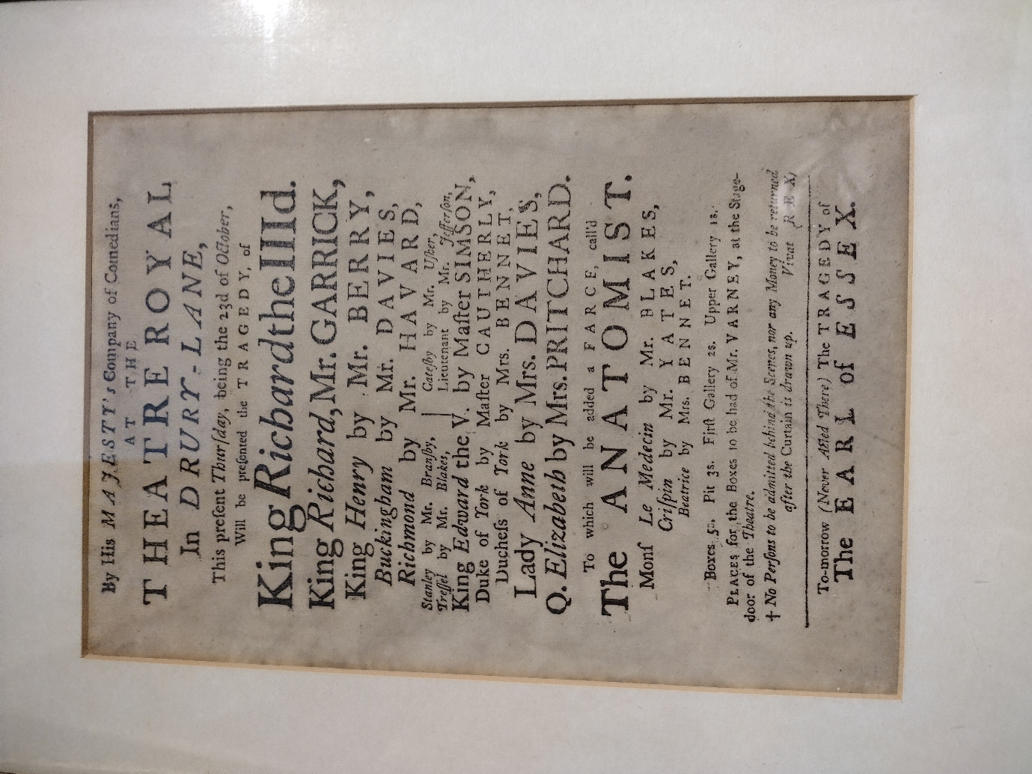

**FIGURE 1: Playbill, *Richard III*, 23 October 1755, Samuel Johnson Birthplace Museum**

The first of the Johnson Birthplace’s two bills is for *The Tragedy of King Richard III* at Drury Lane on Thursday 23 October [1755]. **FIGURE 1.** It is a chance to reflect on the remarkable rise of Garrick, because it is the same role in which he made his London debut at Goodman’s Fields in 1741, though on the playbill for that performance is he is identified simply as ‘a gentleman (who never appeared on any Stage)’. Debuts were often handled like this: if they ‘fetched’ the public, the actor’s identity was revealed, so it was a way of building hype, but with the option of letting them fade into obscurity instead. Garrick had earlier been billed in provincial productions under the pseudonym ‘Mr. Lydall’. Richard III was one of the roles for which he became renowned, as in Hogarth’s famous painting. **FIGURE 2.**

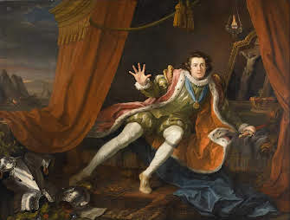

**FIGURE 2: William Hogarth, *David Garrick as Richard III* (1745)**

On the *Richard III* playbill, Garrick enjoys top billing of course. Those familiar with printed plays in both the early modern period and eighteenth century will be accustomed to the division of the players by gender, and they may notice on this playbill that the larger type comes for the bottom-most names, [Susanna] Davies and [Hannah] Pritchard, who were famous performers, capable like Garrick of drawing large crowds. Audiences, then as now, would be interested in relationships between the players, such as the recent marriage of Thomas Davies to Susanna Yarrow. Thomas, who played Buckingham, was a popular performer in his own right, but in his mock-heroic satire on the London stage, *The Rosciad* (1761), Charles Churchill derided him as ‘*mighty Davies*’ and wrote: ‘*On my life* / *That Davies hath a very pretty wife!* / *Statesman all over – in plots famous grown* / *He mouths a sentence as curs mouth a bone*’. Davies gave up acting soon after this! This playbill is also interesting for highlighting the presence of child actors, Masters Simson and Cautherly, as the doomed princes in the tower, which would have stoked sentimental (or ghoulish) interest.

What else catches the eye on the *Richard III* playbill? One thing is the striking omission of Shakespeare’s name. Fiona Ritchie and Peter Sabor in *Shakespeare in the Eighteenth Century* (2012) show that *Richard III* was the third most frequently performed Shakespeare play in eighteenth-century London (after *Hamlet* and *Macbeth*). Of the English history plays, only *Henry IV, Part I* (thanks to Falstaff’s popularity) joins it in the top twelve. Shakespeare’s meteoric rise in popularity in this period meant that he hardly needed to be named on publicity materials, though it is common to prioritise the cast list over the playwright in playbills (much as a modern cinemagoer may care more to know which actors she will see than the film’s director). Badging *Richard III* as a ‘tragedy’ (in capitals but not on the same line as the main title) is significant, too: it appears in the First Folio (1623) as a History but was first published in 1597 as *The Tragedy of King Richard the Third*.

In this period, an afterpiece accompanied the main production, which theatre managers often used as a chance to complement something old with something new, or something serious with something more lighthearted. In 1755, *Richard III* was followed by a farce, *The Anatomist*. The cast shows some overlap with the main play, which was common. The farce is a 1697 satire on physicians by Edward Ravenscroft, which remained in print during the eighteenth century. Presumably some playgoers would have known it was an old play and some would have assumed it was something new.

What else? The theatres after a 1737 act of parliament were licensed by royal authority. ‘Vivat REX’ accordingly appears towards the end of the bill. Earlier bills, closer to 1737, featured the royal coat of arms, but that was gradually considered superfluous. Below it, we see the common strategy of advance advertisement: ‘To-morrow’ the theatre is doing *The Tragedy of the Earl of Essex*’ (never acted at this theatre before). The author is again unidentified, but his name was Henry Jones; the play had debuted at Covent Garden two years earlier.

Practical information comes near the bottom, too: the prices for the different parts of the theatre, ranging from 5s in boxes (with Mr. Varney on hand to assist the elite clientele) to 1s in the upper gallery, and the specification that ‘*No Persons to be admitted behind the Scenes*’. This prohibition shows an entertainment industry still trying to assert its respectability and freeing itself of the association with sexwork, which is how certain disreputable establishments had operated in the past, ever since the reopening of the theatres at the Restoration in 1660, when actresses were first permitted. More generally, the wording of the playbill, its orderly layout, and its formal naming conventions (Mr. and Mrs.) convey an orderliness and dignity which may or may not belie the actual experience of the theatre, which could be more raucous, especially in the galleries. Some playbills advise ladies to get there early, so they can get to their places with greater ‘conveniency’. The specification of the refund policy speaks to a customer base not shy of demanding value for their money: we might think of the salty Captain Mirvan in Frances Burney’s *Evelina* (1778) decrying what he is being charged for a lot of silly prancing and pretence, and his scorn for more ‘polite’ men like Mr Lovel, who barely regard what is being performed, thinking of theatregoing primarily as a sociable and fashionable activity, not a chance to engage with art or culture.

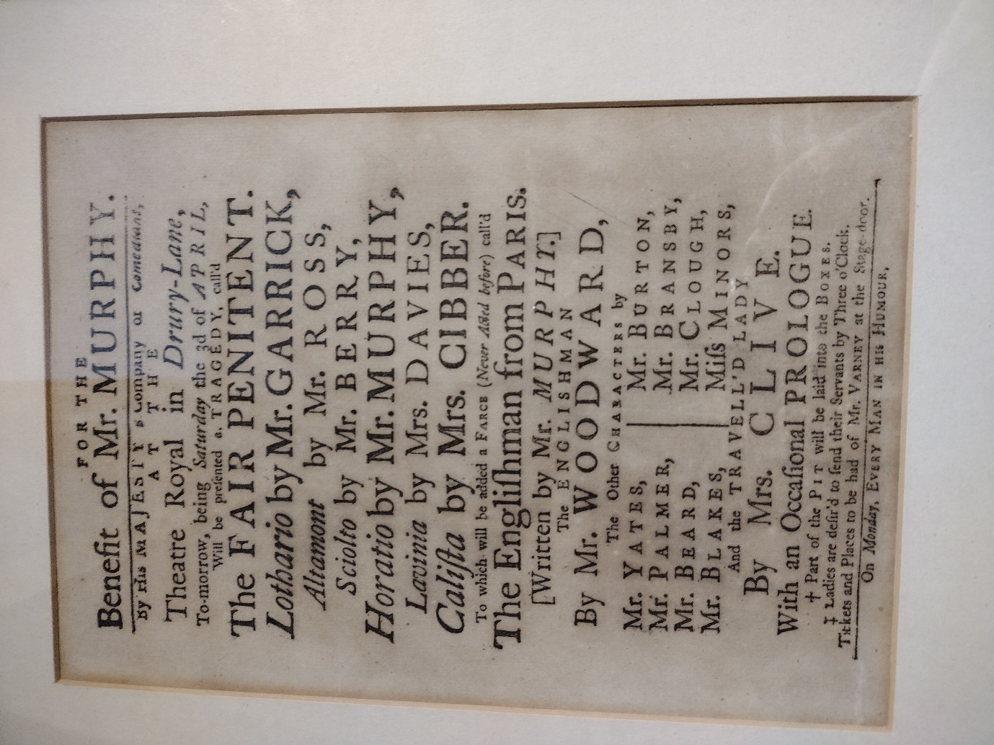

**FIGURE 3: Playbill, *The Fair Penitent*, 3 April 1756, Samuel Johnson Birthplace Museum**

The second playbill in the Birthplace Museum is for a performance of *The Fair Penitent* on Saturday 3 April 1756, again at Drury Lane. **FIGURE 3.** This 1702 play, by Nicholas Rowe (one of Shakespeare’s eighteenth-century editors), will be far less familiar to modern readers than *Richard III*, but it was an extremely popular play in the eighteenth century. Johnson labelled it ‘one of the most pleasing tragedies on the stage, where it still keeps its turns of appearing, and probably will long keep them, for there is scarcely any work of any poet, at once, so interesting by the fable and so delightful by the language’. Aside from Shakespeare’s, it was the sixth most performed tragedy in the period 1702–1800. Again, however, there is no identification of the author on the playbill, which could be because it was very common knowledge but suggests more probably that audiences cared more about the title of the play and even the main roles and performers than about who wrote it. The protagonist of Thomas Holcroft’s novel *The Adventures of Hugh Trevor* (1794–7) remarks that ‘I happened in the afternoon to stray through Brydges-street, and saw a croud of people gathered round the play-house doors, who on inquiry I found were waiting to get in. The play bills were pasted in large letters, red and black, against the walls. I read them, and their contents told me it was one of my most favourite tragedies, Rowe’s Fair Penitent, and that Mrs. Siddons was to act’. Though fictional, this suggests the popularity of Rowe’s play and the function of the playbill as information and promotion (plus the clamour for early entry). Red ink had been used since the start of the century: a letter to the *Adventurer* on 27 January 1753 highlighted its use, deriding a multicolour playbill as a ‘pompous page’!

It is also noteworthy that this is a benefit performance, meaning that takings in excess of the house’s costs went to the beneficiary. If one had enjoyed Arthur Murphy’s plays and performances, one may have been inclined to attend to support him. Many Garrick productions were for the benefit of individuals but also for various charities. The afterpiece is new, though the main play is old: *The Englishman from Paris* is by Murphy, the beneficiary. We know that the receipts for the night were £240, which indicates a large audience. However, the afterpiece was never performed again or published, and it survives in manuscript in a copy alienated from the Lord Chamberlain’s records, now in the Newberry Library, Chicago. Murphy’s farce is a sequel to one of Samuel Foote’s, *The Englishman in Paris* (1753), about a boorish squire comically out of his element in the capital of *politesse*. Actually, Foote supplanted his one-time friend and protégé, Murphy, by writing his own, more enduring sequel to the first farce, *The Englishman Return’d from Paris*. Both Murphy’s and Foote’s sequels imagined the oafish Englishman returned from Paris as a Frenchified fop, but Foote’s piece edged out Murphy’s.

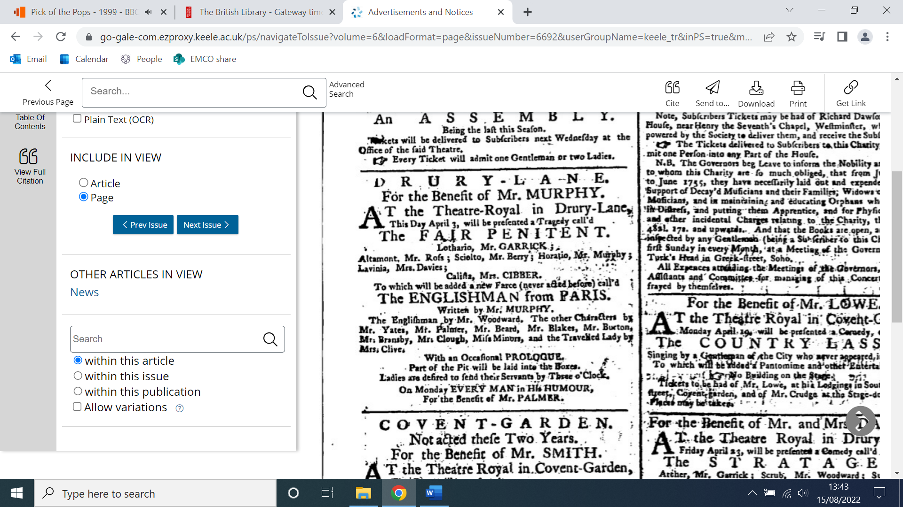

**FIGURE 3: *The Public Advertiser*, 3 April 1756**

A brief comparison of the *Fair Penitent* playbill with its equivalent in *The Public Advertiser* for the same date, 3 April 1756, is instructive. **FIGURE 4.** The newspaper advert, cramped into the first of three columns, on the first page of the paper, uses space more economically, yet still reserves for Garrick and Susannah Cibber their separate lines (Kitty Clive, appearing in the afterpiece, loses some prominence in the newspaper compared to the playbill.) For whatever reason, the information that the upcoming performance of Ben Jonson’s *Every Man in his Humour* (1598) is a benefit for the actor John Palmer is omitted from the playbill. Both pieces of publicity give the practical information about the layout of the theatre and how to procure tickets. The prologue, they indicate, will be ‘occasional’, so probably responded in some way to current events. Perhaps the rising inevitability of war with France attracted commentary to set up the gallophobic farce that followed.

* * *

‘The casual sight of an old play-bill, which I picked up the other day—I know not by what chance it was preserved so long – tempts me to call to mind a few of the players who make the principal figure in it’, recalls Charles Lamb’s Elia in the 1820s. ‘It presents the cast of parts in the Twelfth Night, at the old Drury-Lane Theatre, two-and-thirty years ago’, he continues. ‘There is something very touching in these old remembrances. They make us think how we *once* used to read a play-bill—not, as now peradventure, singling out a favourite performer, and casting a negligent eye over the rest; but spelling out every name, down to the very mutes and servants of the scene’. The bill’s survival is not so surprising given what we know about the culture of collection around the Georgian theatre, which included the pursuit of unique items such as letters from leading actors and signed playbills. But Lamb’s essay captures the charm and nostalgia that these documents continue to evoke. They give us not just the factual information of what was performed, when, where, and what it cost, but also an understanding of drama as a part of urban cultural experience, theatres as socially significant spaces that reflected a hierarchical, commercial society, and audiences as consumers, connoisseurs, and collectors.