Cite this: DOI: 10.1039/x0xx00000x
Received 00th January 2012,
Accepted 00th January 2012
DOI: 10.1039/x0xx00000x
www.rsc.org/
A folded [2×2] metallo-supramolecular grid from a bis-tridentate (1,2,3-triazol-4-yl)-picolinamide (tzpa) ligand
Dawn E. Barry,ª* Chris S. Hawes,ª* Joseph P. Byrne,ª Bjørn la Cour Poulsen,ª Manuel Ruether,^{b} John E. O’Brien^{b} and Thorfinnur Gunnlaugsson*ª
A flexible ditopic ligand 1 containing two N,N,O-tridentate (1,2,3-triazol-4-yl)-picolinamide) chelating pockets is reported and the formation of multimetallic architectures is explored in the solid and the solution phase. The self-assembled Zn^{II} complex [Zn₄(1)₄](ClO₄)₈ exhibited a folded [2×2] square grid supramolecular architecture that selectively assembled in MeCN solution as shown using various spectroscopic techniques. The closely related Fe^{II} complex shows equivalent behaviour in the solid state, while a discrete dinuclear species [Cu₂(NO₃)₄1]·5MeCN was the sole product observed in the solid state from the reaction between 1 and Cu^{II} under similar conditions.

Introduction
The preparation of complex, multi-component architectures through supramolecular self-assembly processes remains an area of extremely active research in chemistry.¹ Metal coordination is often harnessed for the self-assembly process,² as well as for the templated assembly of the constituent ligands, particularly useful in the formation of polynuclear assemblies.³ By using metal ions to dictate binding geometry and nuclearity, an aspect of geometric control and reversibility can be engineered, which is not easily achievable in purely organic assemblies.⁴ More generally speaking, the controllable assembly of polynuclear complexes is appealing particularly in the area of host-guest chemistry, and subsequently for applications in sensing, catalysis and magnetism.⁵
In the design and preparation of such systems, a continuing need exists for the discovery of new ligand classes and binding motifs with the view of establishing reliable archetypal bases from which to build families of functional materials through modular precursors. In this regard, ligands containing the 1,2,3-triazole motif, which are relatively easily accessed through the copper-catalysed azide-alkyne cycloaddition (CuAAC) reaction, are becoming extremely popular.⁶ Substantial work by Flood, Crowley and others has shown how the 1,2,3-triazole motif, in conjunction with pyridyl or other heterocyclic functionalities, can lead to effective and modular chelating ligands useful in the preparation of a wide range of metallosupramolecular architectures and materials.^{7,8} Recently, we have developed a series of multi-functional materials based on the 2,6-bis-(1,2,3-triazol-4-yl)pyridine btp motif, including coordination polymers, luminescent metallogels and organic self-templated catenanes.⁸ Ligands based on the readily available dipicolinic acid (dpa) motif have also been widely explored in many functional metallo-supramolecular systems to these ends, including in our own work.⁹ However, ligands designed by combining elements of both of these binding motives (btp and dpa) within a single symmetrical structure has, to the best of our knowledge, not been achieved to date. Herein, we report the preparation of such a new class of bis-tridentate ligands. These, named (1,2,3-triazol-4-yl)-picolinamide (or tzpa) have heterotopic binding pockets derived from aspects of both btp and dpa, e.g. ligand 1. The coordination chemistry of this new and versatile ligand type is explored in detail with various d-block metal ions, these forming intricate multimetallic architectures in both the crystalline and solution states.
Results and Discussion
The synthesis of ligand 1 is shown in Scheme 1. Precursor 2 was formed in 94% yield using a peptide-coupling reaction between 6-bromopyridine-2-carboxylic acid and m-xylylenediamine. X-ray quality single crystals of compound 2 were obtained by evaporation from dichloromethane. Analysis by single crystal X-ray diffraction provided a structural model in the tetragonal space group P4₃2₁2, and the presence of a heavy atom (Br) allowed absolute structure determination using Mo Kα radiation through anomalous dispersion effects. The asymmetric unit contains half of one molecule of 2 with a crystallographic twofold screw axis overlapping the center of the xylyl ring, imparting C2 symmetry to the molecule. Hydrogen bonding interactions between equivalent amide groups (N···O distance 2.912(4) Å) propagate a three-dimensional hydrogen bonding network within the structure, exhibiting the dia topology. Face-to-face π-π interactions are also observed between the xylyl and pyridyl rings of adjacent molecules, at plane-to-plane angle 13.9° and with minimum inter-atomic distance (N1···C8) of 3.430(5) Å. The structure and intermolecular interactions of 2 are shown in Figure 1.
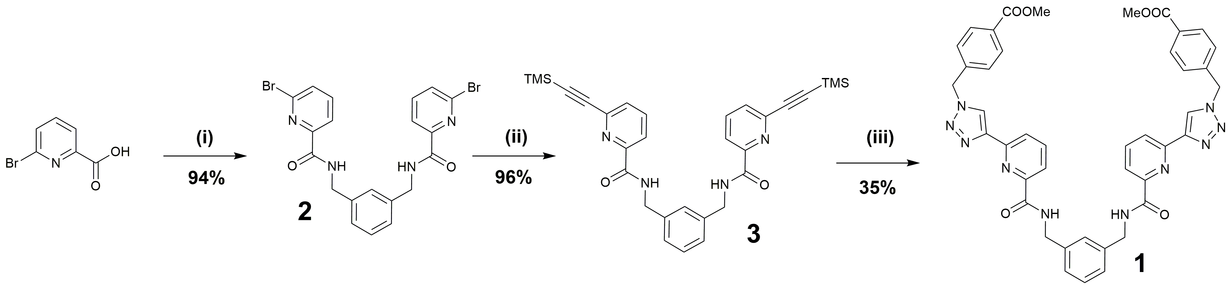
Scheme 1 Synthesis and structure of compound 1. Reagents and conditions: (i) m-xylylenediamine, HOBt, EDCI·HCl, TEA, 4:1 DCM:DMF; (ii) TMS-acetylene, CuI, Pd(PPh₃)₂Cl₂, THF:TEA; (iii) (a) Methyl 4-bromomethylbenzoate, NaN₃, DMF; (b) CuSO₄·5H₂O, K₂CO₃, sodium ascorbate.
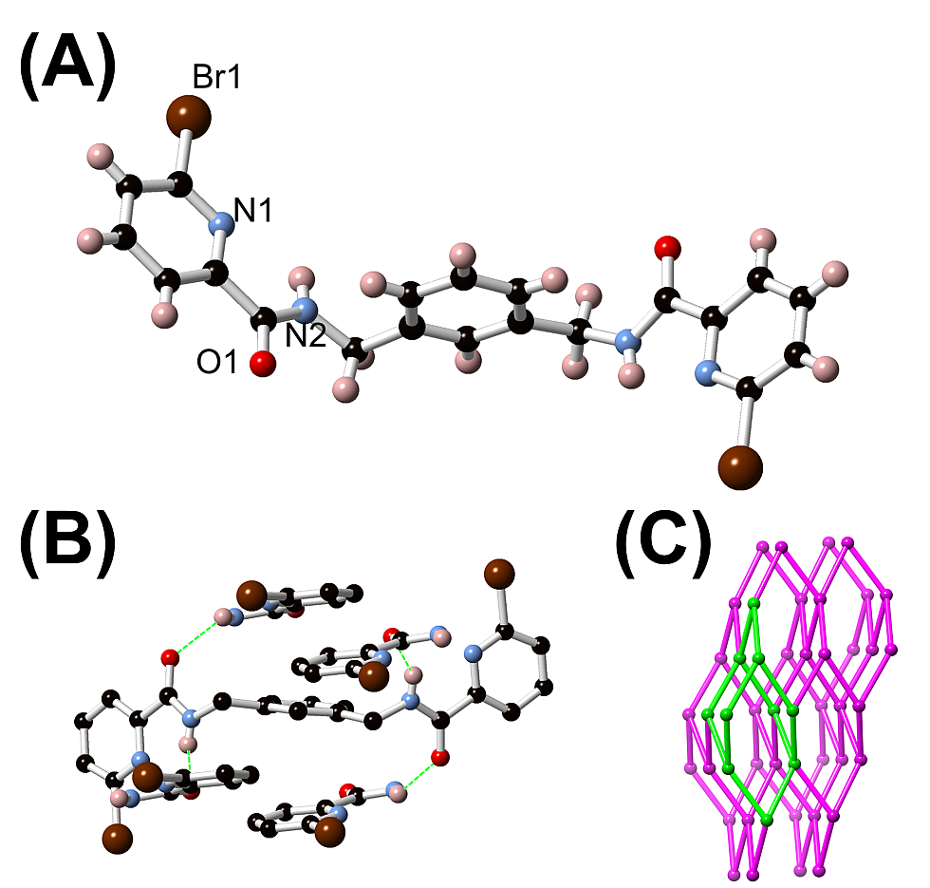
Figure 1 (A) Structure of compound 2 with labelling scheme for unique heteroatoms; (B) Hydrogen bonding and π-π stacking interactions in the structure of 2; (C) The extended hydrogen bonding network of 2 with a single adamantoid cage highlighted.
A Sonagashira reaction between 2 and ethynyl-trimethylsilane gave 3 in 96% yield, after which a one pot CuAAC¹⁰ reaction gave 1 in 35% yield. All compounds were fully characterized by NMR, MS, IR and elemental analysis (See ESI). The coordination chemistry of 1 was next explored in both the solid and solution states. Reaction of 1 with zinc perchlorate hexahydrate in CH₃CN at room temperature gave a colourless solution from which colourless octahedral crystals could be grown by diffusion of toluene vapour, or equivalently, by slow evaporation of CH₃CN in air. The crystals proved extremely sensitive to drying, and were observed to lose single crystallinity within a matter of seconds following removal from the mother liquor. Nonetheless, analysis of a crystal of suitable quality by single crystal X-ray diffraction provided a structure model of [Zn₄(1)₄](ClO₄)₈ in the tetragonal space group I4₁/a. The asymmetric unit of [Zn₄(1)₄](ClO₄)₈ contains a single 1 ligand coordinated to one Zn^{II} ion, and two ClO4- anions. Two full-occupancy CH₃CN molecules were also located within the asymmetric unit. Electron density attributed to a further 1.66 CH3CN molecules per Zn^{II} ion could not be modelled sensibly without introducing excessive additional parameters and was accounted for using PLATON/SQUEEZE.¹¹
Expansion of the asymmetric unit through crystallographic symmetry elements revealed a tetrameric assembly consisting of four equivalent six-coordinate Zn^{II} ions, each coordinated by two non-equivalent ends of 1 ligands, as seen in Figure 2. The Zn^{II} ion resides within the two N,N,O-tridentate binding pockets and adopts a moderately distorted octahedral geometry (Σ = 128°) typical of d¹⁰ metal ions with tridentate donors.¹² Each ligand bridges two Zn^{II} ions in a syn fashion with respect to the central xylyl spacer, and presents a Zn-Zn distance of 10.7493(7) Å. The distance between the pyridine nitrogen atoms on each strand of 9.633(3) Å is considerably shorter than the equivalent distance in 2 (11.613(6) Å) indicating a substantial reorganization of the central xylyl unit upon Zn^{II} binding.
The syn orientation of the two binding pockets of each ligand dictates the overall topology of the tetranuclear species as a [2×2] grid rather than a circular helicate, with alternate corners folded inwards. The central region of the complex is occupied by the four xylyl groups engaged in edge-to-face C-H···π interactions, with no internal void volume or encapsulated guest molecules. The extended structure of [Zn₄(1)₄](ClO₄)₈ is dictated by hydrogen bonding interactions between the amide N-H groups of 1 and the associated ClO₄⁻ anions. One of the two ClO₄ anions (Cl2) accepts two unique N-H···O hydrogen bonds, while the other (Cl1) is involved in only C-H···O interactions, originating from the triazole C-H and other aromatic and aliphatic C-H groups within the molecule.
Figure 2 Representations of the X-ray crystal structure of the complex [Zn₄(1)₄](ClO₄)₈: (A) Structure of the Zn^{II} coordination sphere with partial labelling scheme. (B) Geometry and coordination of the 1 fragment within the structure; (C) Complete structure of the tetrameric [Zn₄(1)₄]⁸⁺ cation. (D) Simplified connectivity of the folded square grid in [Zn₄(1)₄](ClO₄)₈ with each ligand coloured separately. Hydrogen atoms and anions are omitted for clarity. Symmetry code used to generate equivalent atoms: (i) 3/4+Y, 5/4-X, 5/4-Z
The coordination chemistry of 1 was also explored in the crystalline phase with other first-row d-block metal ions. Based on the well-known literature precedent for multinuclear Fe^{II} complexes,¹³ 1 was reacted with iron(II) perchlorate hexahydrate under equivalent conditions. The red crystals obtained by toluene diffusion displayed extremely poor diffraction characteristics preventing the construction of a sensible structural model. However, the unit cell could be unambiguously indexed with equivalent cell parameters to those observed for [Zn₄(1)₄](ClO₄)₈, indicating that the divalent iron species is structurally related. Unfortunately, in both the Zn^{II} and Fe^{II} cases, the crystalline material was not sufficiently stable on removal from the mother liquor to measure meaningful X-ray powder diffraction patterns.
The reaction of 1 with various copper(II) salts was also examined. Crystalline material was obtained from the reaction between 1 and copper nitrate trihydrate in CH₃CN, yielding a structural model in the monoclinic space group P2₁/n. The dinuclear complex has the formula [Cu₂(NO₃)₄1]·5CH₃CN and was the sole isolable product regardless of the reaction stoichiometry, which may indicate a solubility-driven equilibrium process. A structure analogous to the above tetranuclear species could not be achieved using copper salts under any reaction conditions investigated. The asymmetric unit contains the complex in its entirety, with five lattice acetonitrile molecules located from the Fourier difference map – one of these five acetonitrile molecules exhibits disorder over two nearby sites at 60:40 occupancy and sharing the terminal CH₃ carbon atom. The complex is a dinuclear species in which one molecule of the 1 ligand coordinates in a bis-tridentate fashion to two crystallographically unique copper ions (See Figure 3).
The coordination sphere of each copper ion is completed by two monodentate nitrato ligands. Both copper ions display regular square pyramidal coordination geometry with lengthening of the axial Cu-ONO₂ bonds to 2.227(3) and 2.228(3) Å for Cu1-O10 and Cu2-O13, respectively, compared with the equivalent equatorial Cu-ONO₂ distances of 1.939(3) and 1.953(3) Å, respectively. The ligand itself displays a pseudo-C2 symmetric conformation for the central segment, with symmetry disrupted by the nonequivalent conformation of the terminal benzyl arms. The folded anti orientation for the two coordination sites provides a Cu-Cu distance of 8.5981(9) Å, considerably shorter than the intermetallic distance observed in the Zn complex (10.7493(7) Å). The two amide groups are implicated in the conformation of the ligand as a whole through intramolecular N-H···O hydrogen bonding interactions with the oxygen atoms of the nitrato ligands (N···O distances 2.929 and 3.016 Å, N-H···O angles 133 and 134 Å for N6-H6···O12 and N5-H5···O14, respectively). The lack of strong intermolecular hydrogen bonding in the structure of [Cu₂(NO₃)₄1]·5MeCN leaves the extended structure to be largely defined by myriad relatively weak C-H···O and π-π interactions.
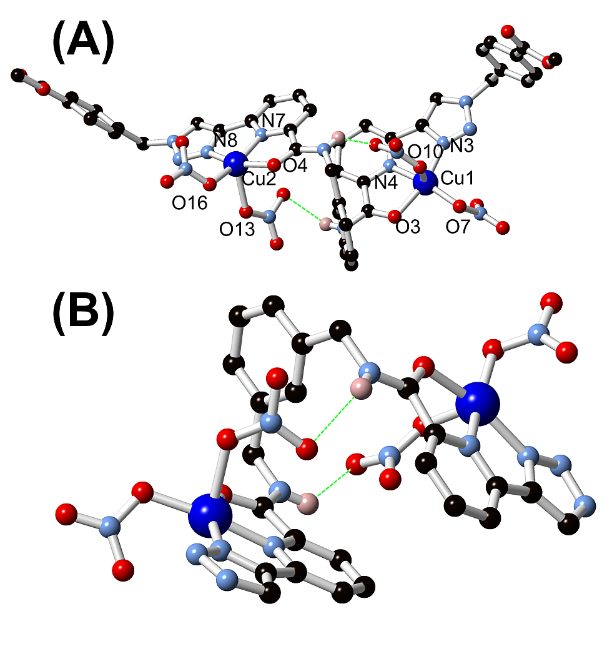
Figure 3 (A) Structure of [Cu₂(NO₃)₄1]·5MeCN with labelling scheme for coordination heteroatoms; (B) Intramolecular hydrogen bonding motif present in the structure of [Cu₂(NO₃)₄1]·5MeCN. Selected hydrogen atoms and acetonitrile solvent molecules are omitted for clarity.
The coordination chemistry of 1 in solution was also investigated, by carrying out a series of spectroscopic measurements, focusing on the diamagnetic Zn^{II} species to allow collection and comparison of UV-Vis. absorption spectroscopy and mass spectrometric data with ¹H NMR spectroscopic information. Analysis of the [Zn₄(1)₄](ClO₄)₈ system by either ESI or MALDI mass spectrometry (using solution samples) gave only a complex mixture of fragments (See ESI). In particular, the [M+L]²⁺ fragment observed at m/z = 420.11 (calculated 420.11), and fragments corresponding to [M+2L]²⁺ (m/z 808.26, calc. 808.25), [M+3L]²⁺ (m/z 1196.89, calc. 1196.89), and [M+L+ClO₄]⁺ overlapped with [2M+2L+2ClO₄]²⁺ (m/z 939.17, calc. 939.16). No larger fragments were conclusively identified at any meaningful level.
To probe the behaviour of the complex in solution under milder conditions, a 1 x 10⁻⁵ M CH₃CN solution of 1 was titrated with Zn^{II} solution (in CH₃CN), and the changes in the absorption and the fluorescence spectra were analysed. The absorption spectrum of 1 displayed two bands centred at 235 nm (logϵ = 4.66) and 292 nm (logϵ = 4.1). The changes in absorbance of 1 during the Zn^{II} titration, Figure 4, showed an enhancement in the absorbance with a concomitant (minor) red shift in the 292 nm transition, until 1 equiv. of Zn^{II}. Concurrently, a minor blue shift and slight increase in absorbance was also observed for the 235 nm transition; with no further changes observed beyond 1 equiv. (c.f. Fig. 4 inset).
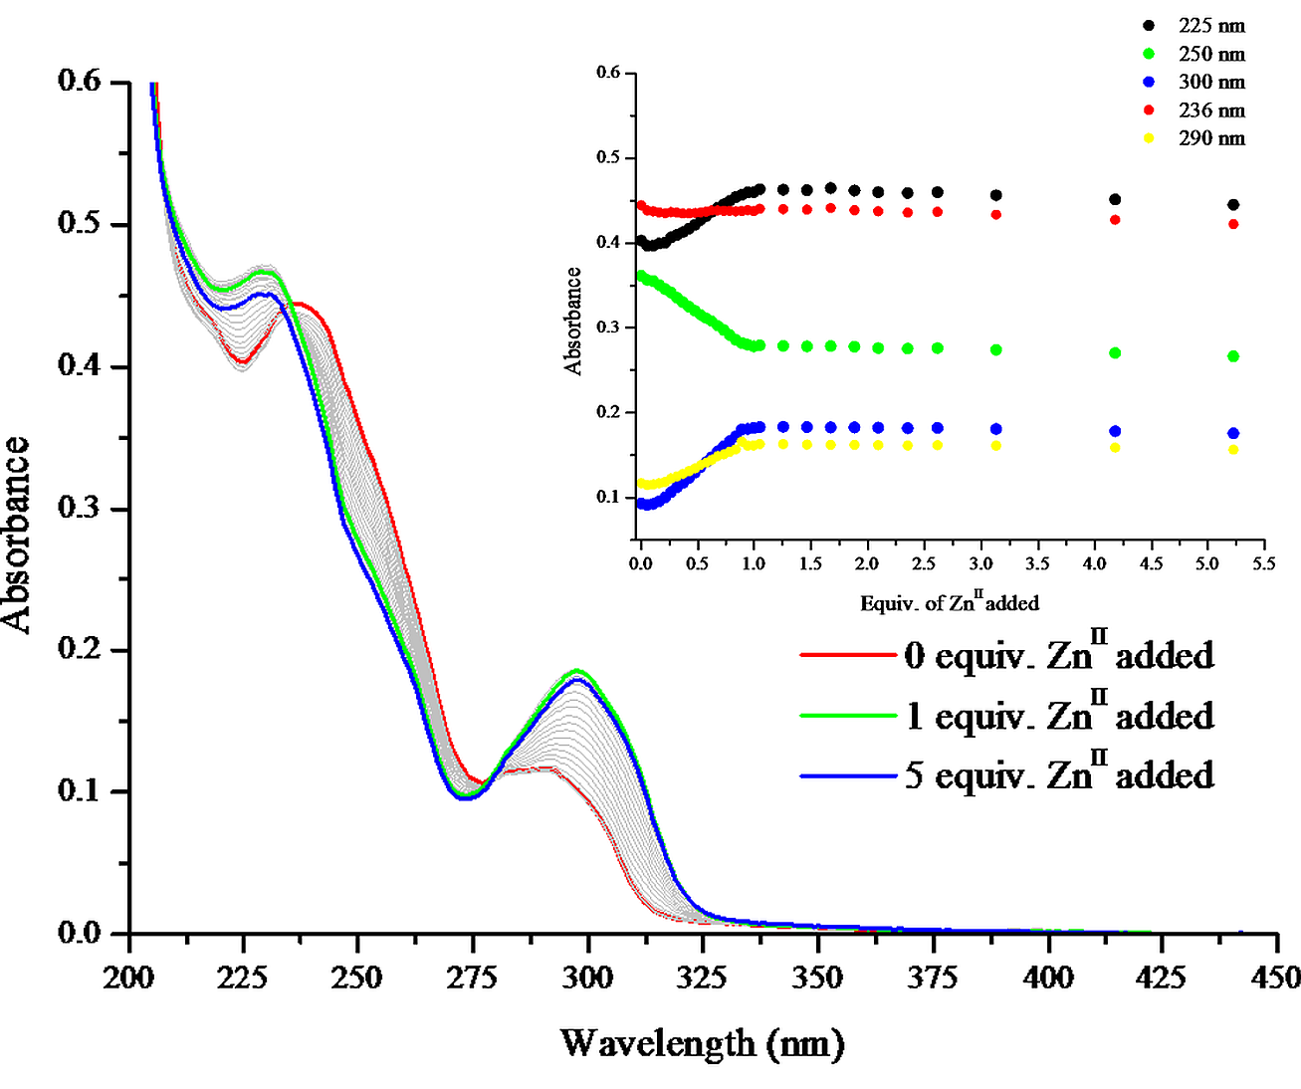
Figure 4 The overall changes in the UV-visible absorption spectra upon titrating 1 (1 x 10⁻⁵ M) against Zn(ClO₄)₂.6H₂O (0→5 equiv.) in CH₃CN at RT. Inset: corresponding experimental binding isotherms of absorbance at λ = 225, 236, 250, 290 and 300 nm.
To probe the self-assembly process in solution and determine both stoichiometry and associated binding constants, the above changes were fitted using non-linear regression analysis¹⁴ (See ESI, Figure S4). The distribution of two absorbing species in solution, namely 1 and a 4:4 species, [Zn₄1₄]⁸⁺, were estimated from this analysis. From the binding constant of logβ₄₄ = 48.8 ± 1.0, [Zn₄1₄]⁸⁺ was identified as the dominant species in solution, being formed in 99% abundance after the addition of 1 equiv. Zn^{II}. Upon excitation of 1 (at the isosbestic point, λ_{ex} = 280 nm, c.f. Figure 4), a fluorescence emission was observed with λ_{max} centered at 354 nm (See ESI Figure S2). The addition of Zn^{II} resulted in emission quenching until the addition of 1 equiv. of Zn^{II}, after which no further changes occurred. Analysis of these changes confirmed the exclusive formation of the [Zn₄1₄]⁸⁺ species in solution.
Further solution studies were undertaken, using ¹H NMR titrations, where the changes in the ¹H NMR spectrum of 1 (1 x 10⁻³ M, Figure 5a) were evaluated as a function of [Zn^{II}] in CD₃CN (See ESI Figure S3). Throughout the titration the resonances were seen to be in fast exchange. Initially, between the additions of 0 0.8 equiv. of Zn^{II}, broadening was observed, and the ligand protons became poorly resolved, indicating the presence of several exchanging species in solution. However, after the addition of 0.8 equiv. the ¹H spectrum became resolved, showing the formation of a single species in solution after the addition of 1 equiv. of Zn^{II}. The resonances for the complex associated with the protons in close proximity to the binding sites appear noticeably downfield compared to their equivalent positions in 1. For example, the amide and pyridine resonances in the ¹H NMR spectrum of the [Zn₄(1)₄]⁸⁺ were shifted downfield relative to 1 (from 8.74 to 9.22 ppm for proton (i) and from 8.13, 7.86 and 7.86 to 8.29, 8.54 and 8.24 for protons (f), (g) and (h), respectively) as seen in Figure 5. This is characteristic of Zn^{II}, binding within this region upon formation of the grid complex. The ¹H NMR titration data was also compared to re-dissolved crystalline material of [Zn₄(1)₄]⁸⁺ (c.f. Figure 5b,c), which confirmed the same solution-state structure in both cases.
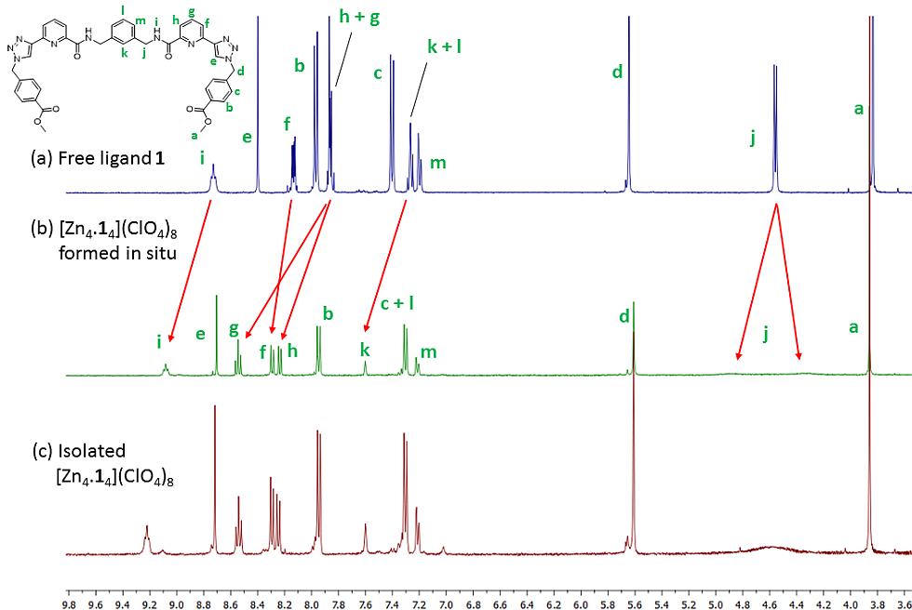
Figure 5 Comparison of the ¹H NMR spectra (400 MHz, CD₃CN) of (a) free ligand 1 (b) [Zn₄(1)₄](ClO₄)₈ formed in situ and (c) [Zn₄(1)₄](ClO₄)₈ isolated as a solid. Peak assignments were made on the basis of 2D experiments (See ESI)
Interestingly, despite the tightly bundled conformation of the [Zn₄1₄]⁸⁺ complex in the crystalline phase, no significant upfield shifts, corresponding to nuclear shielding from ring currents of nearby π systems,¹⁵ were observed in the ¹H NMR. While the peak shape/splitting was largely retained for the aromatic signals and the signals corresponding to the pendant methyl 4-carboxybenzyl groups in 1, the resonance attributed to the methylene groups of the xylyl bridge [i.e. signal (j), Figure 5a] become extremely broad upon Zn^{II} coordination, and showed evidence of splitting into two distinct but overlapping peaks. In order to investigate whether any anion encapsulation could occur with the assembled complex, an equivalent complex was also prepared in situ using Zn(BF₄)₂·6H₂O, and the ¹⁹F NMR spectrum was recorded.¹⁶ In this case, however, only one signal was observed in the ¹⁹F NMR (See ESI, Figure S14), suggesting that no long-lived encapsulated anion was bound within this system.
The broadening of the methylene resonance was quantified by measuring the spin-lattice relaxation time T₁ for each resonance of 1 and [Zn₄1₄]⁸⁺. Shown in Table S2 (See ESI), a trend towards shorter relaxation for nuclei closer to the zinc centres was observed, which is consistent with an enhanced quadrupolar relaxation through the Zn nuclei. However, the signal corresponding to the central methylene group experienced a reduction in T₁ [from 0.57(4)s to 0.37(4)s], while the adjacent phenyl protons exhibit lengthened T₁ values. This effect is seemingly independent from quadrupolar relaxation involving the metal ions, and may be related to the geometric constraints imposed on the core segment when anchored between two metal ions (vs. that seen in free 1). The broadening and splitting of the methylene signal may also be indicative of a loosely defined inequivalence between the endo and exo-oriented nuclei, also consistent with a conformational restriction. Variable temperature experiments (-2525 °C, See ESI) failed to coalesce this signal, while DOSY experiments on both [Zn₄1₄]⁸⁺ and 1 in CD₃CN (See ESI) showed only a small difference in their diffusion coefficient. The monotonic downfield shifts of the resonances, and the broadening of the central methylene protons, indicate a geometric variation for [Zn₄1₄]⁸⁺ in solution compared to the tightly bound form observed in the solid state. To explore this difference, computational geometry optimization studies on [Zn₄1₄]⁸⁺ in either vacuum or CH₃CN (using a simplified version of the crystal structure model that lacked the pendant benzyl groups) was undertaken (See ESI). The results demonstrated that in the absence of crystal packing forces, both of these models showed conformations with looser packing about the central xylyl groups. In these forms, no overlap would necessarily be expected between ¹H nuclei and adjacent π systems. Hence, the solution conformation of [Zn₄1₄]⁸⁺ species may be best described by the combination of these structural models.
Conclusions
In summary, the synthesis of a new C_{2V} symmetric tzpa-type ligand and the tetranuclear complexes [M₄1₄]⁸⁺ (M =Zn or Fe) and [Cu₂(NO₃)₄1]·5MeCN are presented. The structural studies are supported with confirmation of the formation and stability of the Zn^{II} species in solution using a combination of spectroscopic methods. We show that 1 can be easily prepared at moderate scale and exhibits great potential as a building block for future functionalization with the understanding of its fundamental coordination chemistry presented herein. Tzpa is a promising new motif for constructing supramolecular polynuclear architectures, and we are currently exploring the chemistry of various other tzpa ligands.

Experimental Section
Materials and Methods
All reagents, solvents and starting materials were purchased from Sigma-Aldrich, Merck or Fisher Scientific, were of reagent grade or better, and were used as received. Mass spectra were acquired using a Micromass time of flight mass spectrometer (tof), interfaced to a Waters 2690 HPLC. The instrument was operated in positive or negative mode as required. Leucine Enkephalin was used as an internal lock mass. Elemental analyses were carried out at the Microanalytical Laboratory, School of Chemistry and Chemical Biology, University College Dublin. NMR data were recorded in commercially available deuterated solvents on a Bruker Avance II 600MHz spectrometer which operates at 600 MHz for ¹H and 150 MHz for ¹³C resonances, or a Bruker Avance III spectrometer which operates at 400.13 MHz for ¹H NMR and 100.6 MHz for ¹³C NMR. Tetramethylsilane (TMS) was used as an internal standard and shifts were referenced relative to the internal solvent signals with chemical shifts expressed in parts per million (ppm / δ). Infrared spectra were recorded on a Perkin Elmer Spectrum 100 FTIR spectrometer with universal ATR sampling accessory, in the range 4000 – 550 cm⁻¹.

X-ray Crystallography
Structural and refinement parameters are presented in Table 1. All diffraction data were collected using a Bruker APEX-II Duo dual-source instrument using microfocus Cu Kα (λ = 1.54178 Å) or Mo Kα (λ = 0.71073 Å) radiation as specified. Datasets were collected using ω and φ scans with the samples immersed in oil and maintained at a constant temperature of 100 K using a Cobra cryostream. The data were reduced and processed using the Bruker APEX suite of programs.¹⁷ Multi-scan absorption corrections were applied using SADABS.¹⁸ The diffraction data were solved using SHELXT and refined by full-matrix least squares procedures using SHELXL-2015 within the OLEX-2 GUI.¹⁹⁻²¹ The functions minimized were Σw(F²_{o}-F²_{c}), with w=[σ²(F²_{o})+aP²+bP]⁻¹, where P=[max(F_{o})2+2F²_{c}]/3. All non-hydrogen atoms were refined with anisotropic displacement parameters. All carbon-bound hydrogen atoms were placed in calculated positions and refined with a riding model, with isotropic displacement parameters equal to either 1.2 or 1.5 times the isotropic equivalent of their carrier atoms. Where appropriate and as discussed, the positions of hydrogen atoms involved in hydrogen bonding interactions were refined to provide the best fit for the residual Fourier peaks and assigned a Uiso value equal to 1.5 times that of the nearest associated atom, with the appreciation that the exact positions of these atoms cannot be meaningfully inferred from X-ray diffraction data. Specific refinement strategies are outlined in the text and also in the refine_special_details section of the combined crystallographic information file (cif). As outlined in the text, the SQUEEZE routine within PLATON²² was used to account for approximately 600 electrons, suggesting an additional occupancy of ca. 1.66 acetonitrile molecules or four water molecules per Zn^{II} ion (the former more likely than the latter under the synthesis conditions) in addition to the two crystallographically located acetonitrile molecules in the asymmetric unit of [Zn₄(1)₄](ClO₄)₈. At least five overlapping orientations for the additional solvent species could be modelled, but with no meaningful benefit to the overall model. Due to the extremely rapid decomposition of the crystals upon removal from the mother liquor, we cannot distinguish with total confidence between acetonitrile or water molecules for these species using supporting methods, which showed only water molecules in the air-dried samples. Because of this uncertainty, the contribution from the non-localised solvent molecules was not included in the crystallographic formula, absorption coefficient, density or F₀₀₀ calculation.

Synthesis of organic compounds
α,α′-m-Xylylenebis(N-(6-bromopicolinamide)) 2

HOBt (1.80 g, 13.3 mmol, 2 equiv.), 1,3-xylylenediamine (0.89 mL, 6.8 mmol, 1.00 equiv.) and NEt₃ (2.06 mL, 14.0 mmol, 2.1 equiv.) were added to a solution of 6-bromopyridine-2-carboxylic acid (3.00 g, 14.8 mmol, 2.2 equiv.) in DMF: DCM (1:4, 120 mL) under an argon atmosphere. The reaction mixture was cooled to 0 ºC with stirring for 30 mins. EDCI∙HCl (3.88 g, 20.3 mmol, 3 equiv.) was then added and the suspension was left stirring at 0 ºC for a further 30 mins. The reaction mixture was then allowed to reach RT and stirred for another 48 hrs. Solvent was removed under reduced pressure to give the crude product as a yellow oil. The impure product was taken up in DCM and washed with 1.0 M HCl, sat. aq. NaHCO₃, H₂O and brine. The organic layer was then dried over MgSO₄ and the solvent was removed under reduced pressure yielding the pure product as a white solid. Yield 3.21 g, 94%. m.p. 168 - 170 ºC. HRMS (m/z) (ES⁺) Calculated for C₂₀H₁₆N₄O₂Br₂Na⁺ m/z = 524.9538 [M + Na]⁺. Found m/z = 524.9535; ¹H NMR (600 MHz, CDCl₃) δ_{H:} 8.23 (1H, br, NH), 8.17 (2H, dd, J = 7.6, 1.0 Hz, pyridine-H x 2), 7.71, (2H, t, J = 7.7 Hz, pyridineH x 2), 7.59 (2H, dd, J = 7.9, 0.7 Hz, pyridine-H x 2), 7.33 – 7.27 (4H, m, benzyl-H x 4), 4.63 (4H, d, J = 6.3 Hz, CH₂ x 2); ¹³C NMR (150 MHz, CDCl₃) δ_{C:} 162.48, 150.88, 140.53, 139.66, 138.48, 130.74, 129.10, 127.33, 127.07, 121.43, 43.37; ν_{max}(ATR, cm⁻¹) 3349, 3003, 2925, 1658, 1580, 1553, 1526, 1423, 1360, 1305, 1251, 1175, 1152, 1120, 1071, 1008, 988, 904, 840, 817, 779, 761, 714, 657, 638, 527, 519, 506. Single crystals of the title compound were prepared by subsequent slow evaporation from dichloromethane.

α,α′-m-Xylylenebis(N-(6-(trimethylsilylethynylpicolinamide)) 3

CuI (0.032 g, 0.17 mmol, 0.04 equiv.) and Pd(PPh₃)Cl₂ (0.12 g, 0.17 mmol, 0.04 equiv.) were added to a stirring solution of 2 (2.13 g, 4.23 mmol, 1 equiv.) in TEA:THF (1:1, 30 mL) under an argon atmosphere. Ethynyltrimethylsilane (1.32 mL, 9.30 mmol, 2.2 equiv.) was slowly added dropwise over a period of 30 mins and the reaction mixture stirred at RT for 24 hrs. The resulting orange solution was filtered through a plug of celite after which EDTA/NH₄OH solution was added. The product was extracted into DCM, washed with H₂O (x2) and dried over MgSO₄. Solvent was removed under reduced pressure yielding an off-white solid. Yield 2.19 g, 96%. m.p. 128 - 134 ºC. HRMS (m/z) (ES⁺) Calculated for C₃₀H₃₅N₄O₂Si₂⁺ m/z = 539.2299 [M + H]⁺. Found m/z = 539.2307; ¹H NMR (600 MHz, CDCl₃) δ_{H:} 8.34 (1H, br, NH), 8.16 (2H, dd, J = 7.9, 1.0 Hz, pyridine-H x 2), 7.80 (2H, t, J = 7.8 Hz, pyridine-H x 2), 7.56 (2H, dd, J = 7.7, 1.1 Hz, pyridine-H x 2), 7.34 – 7.28 (4H, m, benzyl-H x 4), 4.65 (4H, d, J = 6.3 Hz, CH₂ x 2), 0.27 (18H, s, CH₃ x 6); ¹³C NMR (150 MHz, CDCl₃) δ_{C:} 163.72, 150.10, 141.65, 138.74, 137.55, 129.99, 129.15, 127.66, 127.15, 121.91, 103.10, 95.96, 43.43, -0.32; ν_{max}(ATR, cm⁻¹) 3335, 3062, 3004, 2960, 2927, 2164, 2108, 1985, 1772, 1660, 1611, 1582, 1554, 1522, 1443, 1424, 1360, 1305, 1250, 1175, 1152, 1120, 1074, 1055, 1008, 992, 904, 840, 760, 734, 697, 679, 641, 567, 540, 510, 503.

α,α′-m-Xylylenebis(N-(6-(1-(methyl-4-carboxybenzyl)-1,2,3-triazol-4-yl)picolinamide)) 1

To a solution of methyl 4-(bromomethyl)benzoate (0.339 g, 1.48 mmol, 2.5 equiv.) in DMF:H₂O (4:1) NaN₃ (0.096 g, 1.48 mmol, 2.5 equiv.) was added and the reaction stirred at RT for 1 hr. To this, 3 (0.319 g, 0.6 mmol, 1 equiv.), CuSO₄.5H₂O (0.059 g, 0.24 mmol, 0.4 equiv.), sodium ascorbate (0.094 g, 0.47 mmol, 0.8 equiv.), followed by K₂CO₃ (0.164 g, 1.18 mmol, 2 equiv.) were added and the reaction stirred at RT for a further 48 hrs. The reaction mixture was diluted with DCM and washed with an EDTA/NH₄OH solution, H₂O and brine. The organic layer was dried over MgSO₄ and solvent removed in vacuo yielding an impure brown oil. The methyl 4-(bromomethyl)benzoate starting material was removed by silica column chromatography (gradient DCM:CH₃OH) and the impure fraction was then purified by dissolving the brown solid in DCM and slowly adding it drop-wise to a swirling flask of ether, affording an off-white solid which was isolated by gravity filtration. Yield 163mg, 35%. m.p. 108 - 112 ºC. HRMS (m/z) (ES⁺) Calculated for C₄₂H₃₆N₁₀O₆Na⁺ m/z = 799.2717 [M + Na]⁺. Found m/z = 799.2722; Elemental analysis for C₄₂H₃₆N₁₀O₆∙H₂O Calculated: C 63.47, H 4.82, N 17.62; Found C 63.50, H 4.50, N 17.38%; ¹H NMR (400 MHz, DMSO-d₆) δ_{H:} 9.44 (2H, t, J = 6.4 Hz, NH), 8.96 (2H, s, triazole-CH), 8.17 (2H, d, J = 7.84 Hz, pyridine-H x 2), 8.03 (2H, t, J = 7.8 Hz, pyridine-H x 2), 7.96 (4H, d, J = 8.12 Hz benzyl-H x 4), 7.90 (2H, d, J = 7.64 Hz, pyridine-H x 2), 7.40 (4H, d, J = 8.08 Hz, benzyl-H x 4), 7.29 – 7.18 (4H, central benzyl-H), 5.83 (4H, s, CH₂ x 2), 4.51 (4H, d, J = 6.2 Hz, CH₂ x 2), 3.83 (6H, s, CH₃ x 2); ¹³C NMR (100 MHz, DMSO-d₆) δ_{C:} 165.80, 163.69, 149.61, 148.65, 147.16, 141.09, 139.57, 138.80, 129.70, 129.37, 128.33, 127.80, 125.71, 125.60, 124.71, 121.58, 120.77, 52.65, 52.18, 42.24; ¹H NMR (400 MHz, CD₃CN) δ_{H:} 8.74 (2H, t, J = 6.36 Hz, NH), 8.40 (2H, s, triazole-CH), 8.13 (2H, dd, J = 2.96, 6.08 Hz, pyridine-H x 2), 7.97 (4H, d, J = 8.36 Hz, benzyl-H x 4), 7.86 (4H, m, pyridine-H x 4), 7.41 (4H, d, J = 8.3 Hz, benzyl-H x 4), 7.27 (2H, m, central benzyl-H) 7.20 (2H, d, J = 8.32 Hz, central benzyl-H), 5.65 (4H, s, CH₂ x 2), 4.56 (4H, d, J = 6.5 Hz, CH₂ x 2), 3.83 (6H, s, CH₃ x 2); ¹³C NMR (100 MHz, CD₃CN) δ_{C:} 167.11, 164.88, 150.56, 149.91, 148.54, 141.41, 140.74, 139.40, 131.24, 130.79, 129.46, 129.08, 126.68, 126.08, 124.46, 122.82, 121.62, 54.19, 52.74, 43.13; ν_{max}(ATR, cm⁻¹) 3363, 2951, 1718, 1666, 1601, 1572, 1518, 1434, 1351, 1278, 1180, 1108, 1044, 1020, 996, 832, 803, 768, 744, 726, 700, 646, 554.

Synthesis of the complexes
[Zn₄1₄](ClO₄)₈

CAUTION: Perchlorate salts are well-known to present an explosive hazard, particularly on drying, heating or grinding. While no difficulties were encountered in this preparation, all care should be taken to avoid handling perchlorate salts in large quantities, or in dry or powdered forms, and heat or excessive friction should be avoided. For this reason, thermal stability studies were not carried out.

An insoluble suspension of 1 (20 mg, 26 μmol, 1 equiv.) in 2 mL of CH₃CN was added to a solution of zinc perchlorate hexahydrate (10 mg, 26 μmol, 1 equiv.) in 2 mL of CH₃CN. Upon reacting together, a clear solution resulted which was filtered and then subjected to vapour diffusion of toluene, yielding colourless crystals after 24 hrs. The crystals were isolated by filtration, washed with CH₃CN, and dried in air. Yield 11 mg, 41%. Elemental analysis for C₁₆₈H₁₄₄Cl₈N₄₀O₅₆Zn₄·3H₂O Calculated: C 47.83, H 3.58, N 13.28; Found C 47.59, H 3.32, N 13.19%. ¹H NMR (400 MHz, CD₃CN) δ_{H:} 9.22 (2H, t, J = 6.24 Hz, NH), 8.72 (2H, s, triazole-CH), 8.54 (2H, t, J = 7.92 Hz, pyridine-H x 2), 8.29 (2H, d, J = 7.92 Hz, pyridine-H x 2), 8.24 (2H, m, pyridine-H x 2), 7.94 (4H, d, J = 8.28 Hz, benzyl-H x 4), 7.6 (1H, s, central benzyl-H),7.30 (5H, benzyl-H x 4, central benzyl-H x 1), 7.21 (2H, d, J = 7.12 Hz, central benzyl-H), 5.61 (4H, s, CH₂ x 2), 4.59 (4H, br, CH₂ x 2), 3.86 (6H, s, CH₃ x 2); ¹³C NMR (100 MHz, CD₃CN) δ_{C:} 166.97, 166.78, 145.81, 145.76, 145.60, 142.78, 139.34, 138.06, 131.72, 130.83, 129.68, 129.28, 127.56, 127.31, 126.59, 126.26, 123.81, 55.54, 52.84, 45.22; ν_{max}(ATR, cm⁻¹): 3338, 3107, 1720, 1642, 1608, 1560, 1471, 1433, 1281, 1218, 1059, 1020, 827, 787, 752, 726, 673. An equivalent procedure was used to generate the Fe^{II} analogue using iron perchlorate hexahydrate; single crystals were prepared by toluene diffusion but were not isolated in bulk.

[Cu₂(NO₃)₄1]·5MeCN

An insoluble suspension of 1 (20 mg, 26 μmol, 1 equiv.) in 2 mL of CH₃CN was added to a solution of Cu(NO₃)₂·3H₂O (12 mg, 52 μmol, 2 equiv.) in 2 mL of CH₃CN. Upon reacting together, a clear solution resulted which was filtered and then allowed to concentrate by slow evaporation, yielding green crystals after 24 hrs. The crystals were isolated by filtration, washed with CH₃CN, and dried in air. Yield 14 mg, 40%. m.p. 215-218 °C (decomp); Elemental analysis for C₄₂H₃₆Cu₂N₁₄O₁₈ (loss of lattice acetonitrile) Calculated: C 43.79, H 3.15, N 17.02; Found C 43.79, H 3.05, N 16.90%. ν_{max}(ATR, cm⁻¹): 3093, 1702, 1638, 1605, 1554, 1489, 1425, 1387, 1347, 1281, 1200, 1165, 1117, 1092, 1048, 1023, 1003, 836, 772, 750, 677.

Acknowledgements
The authors gratefully acknowledge Science Foundation Ireland (SFI PI Award 13/1A/1865 to TG), the Irish Research Council (IRC GOIPD/2015/446 to CSH and GOIPG/2013/633 to BCP), The Irish Centre for High-End Computing Research IT, Dr Cristina Trujillo, and the School of Chemistry, TCD. We thank Dr. M. Feeney and Dr. G. Hessman for MS characterisation.

Notes and References
ªSchool of Chemistry and Trinity Biomedical Sciences Institute, The University of Dublin, Trinity College Dublin, Dublin 2, Ireland. Email: barryd5@tcd.ie; hawescs@tcd.ie; gunnlaut@tcd.ie
^{b}School of Chemistry, The University of Dublin, Trinity College Dublin, Dublin 2, Ireland.
† CCDC 1540136-1540138
Electronic Supplementary Information (ESI) available: Additional figures, additional NMR spectra and tabulated data, computational figures and tables. See DOI: 10.1039/ x0xx00000x.

- D. Barry, D. F. Caffrey and T. Gunnlaugsson, Chem. Soc. Rev., 2016, 45, 3244-3274; A. Aliprandi, M. Mauro, L. De Cola, Nature. Chem. 2016, 8, 10-15; T. Gunnlaugsson, Nature Chem., 2016, 8, 6-7; M. J. Webber, E. A. Apple, E. W. Meijer, R. Langer, Nature Mat. 2016, 15, 13-26; A. J. McConnell, C. S. Wood, P. P. Neelakandan and J. R. Nitschke, Chem. Rev. 2015, 115, 7729-7793; S. I. Stupp and L. C. Palmer, Chem. Mater. 2014, 26, 507-518.
- L. Chen, Q. Chen, M. Wu, F. Jiang and M. Hong, Acc. Chem. Res. 2015, 48, 201-210; B. H. Northrop, H.-B. Yang and P. J. Stang, Chem. Commun. 2008, 5896-5908; D. J. Cooke, J. M. Cross, R. V. Fennessy, L. P. Harding, C. R. Rice and C. Slater, Chem. Commun. 2013, 49, 7785-7787.
- F. J. Rizzuto, W. Y. Wu, T. K. Ronson and J. R. Nitschke, Angew. Chem. Int. Ed. 2016, 55, 7958-7962; S. M. Jansze, G. Cecot, M. D. Wise, K. O. Zhurov, T. K. Ronson, A. M. Castilla, A. Finelli, P. Pattison, E. Solari, R. Scopelliti, G. E. Zelinskii, A. V. Vologzhanina, Y. Z. Voloshin, J. R. Nitschke and K. Severin, J. Am. Chem. Soc. 2016, 138, 2046-2054; A. Ferguson, M. A. Squire, D. Siretanu, D. Mitcov, C. Mathionère, R. Clérac and P. E. Kruger, Chem. Commun. 2013, 49, 1597-1599.
- D. Fujita, Y. Ueda, S. Sato, N. Mizuno, T. Kumasaka and M. Fujita, Nature 2016, 540, 563-566; A. J. Metherell and M. D. Ward, Chem. Sci. 2016, 7, 910-915.
- S. Shanmugaraju, C. Dabadie, K. Byrne, A. J. Savyasachi, D. Umadevi, W. Schmitt, J. A. Kitchen and T. Gunnlaugsson, Chem. Sci., 2017, 8, 1535–1546; J. I. Lovitt, C. S. Hawes, A. D. Lynes, B. Haffner, M. E. Möbius and T. Gunnlaugsson, Inorg. Chem. Front., 2017, 4, 296-308; A. Fernandez, J. Ferrando-Soria, E. M. Pineda, F. Tuna, I. J. Vitorica-Yrezabal, C. Knappke, J. Ujma, C. A. Muryn, G. A. Timco, P. E. Barran, A. Ardavan and R. E. P. Winpenny, Nature Commun. 2016, 7, 10240; R. A. Faulkner, L. P. Harding, J. Higginson, C. R. Rice and C. Slater, Angew. Chem. Int. Ed. 2014, 53, 13540-13543.
- A. S. Vasdev, D. Preston and J. D. Crowley, Dalton Trans. 2017, 46, 2402-2414; G. Aromi, L. A. Barrios, O. Roubeau and P. Gamez, Coord. Chem. Rev. 2011, 255, 485-546.
- D. Preston, R. A. J. Tucker, A. L. Garden and J. D. Crowley, Inorg. Chem. 2016, 55, 8928-8934; Y. Li, J. C. Huffman and A. H. Flood, Chem. Commun. 2007, 2692-2694; U. R. Pokharel, F. R. Fronczek and A. W. Maverick, Nature Commun. 2014, 5, 5883; D. Wang, D. Denux, J. Ruiz and D. Astruc, Adv. Synth. Catal. 2013, 355, 129-142; E. P. McCarney, C. S. Hawes, S. Blasco and T. Gunnlaugsson, Dalton Trans. 2016, 45, 10209-10221.
- J. P. Byrne, J. A. Kitchen and T. Gunnlaugsson, Chem. Soc. Rev. 2014, 43, 5302-5325; E. P. McCarney, J. P. Byrne, B. Twamley, M. Martinez-Calvo, G. Ryan, M. E. Möbius and T. Gunnlaugsson, Chem. Commun. 2015, 51, 14123-14126; J. P. Byrne, J. A. Kitchen, J. E. O’Brien, R. D. Peacock and T. Gunnlaugsson, Inorg. Chem. 2015, 54, 1426-1439; S. J. Bradberry, J. P. Byrne, C. P. McCoy and T. Gunnlaugsson, Chem. Commun. 2015, 51, 16565-16568; J. P. Byrne, S. Blasco, A. B. Aletti, G. Hessman and T. Gunnlaugsson, Angew. Chem. Int. Ed. 2016, 55, 8938-8943.
- P. Kumar and R Gupta, Dalton Trans. 2016, 45, 18769-18783; J. A. Kitchen, Coord. Chem. Rev. 2017, In Press, DOI: 10.1016/j.ccr.2017.01.012; D. A. Leigh, P. J. Lusby, R. T. McBurney, A. Morelli, A. M. Z. Slawin, A. R. Thomson and D. B. Walker, J. Am. Chem. Soc. 2009, 131, 3762-3771; O. Kotova, J. A. Kitchen, C. Lincheneau, R. D. Peacock and T. Gunnlaugsson, Chem. Eur. J. 2013, 19, 16181-16186; F. Stomeo, C. Lincheneau, J. P. Leonard, J. E. O’Brien, R. D. Peacock, C. P. McCoy and T. Gunnlaugsson, J. Am. Chem. Soc. 2009, 131, 9636-9637; C. Lincheneau, C. Destribats, D. E. Barry, J. A. Kitchen, R. D. Peacock and T. Gunnlaugsson, Dalton Trans. 2011, 40, 12056-12059.
- J. P. Byrne, M. Martinez-Calvo, R. D. Peacock and T. Gunnlaugsson, Chem. Eur. J. 2016, 22, 486-490.
- A. L. Spek, Acta Crystallogr., Sect. C: Struct. Chem. 2015, 71, 9-18.
- M. G. B. Drew, C. J. Harding, V. McKee, G. G. Morgan and J. Nelson, J. Chem. Soc., Chem. Commun. 1995, 1035-1038.
- F. Tuna, M. R. Lees, G. J. Clarkson and M. J. Hannon, Chem. Eur. J. 2004, 10, 5737-5750; D. A. Leigh, R. G. Pritchard and A. J. Stephens, Nature Chem. 2014, 6, 978-982; E. C. Constable, G. Zhang, C. E. Housecroft, M. Neuburger and J. A. Zampese, Eur. J. Inorg. Chem. 2010, 13, 2000-2011; C. R. K. Glasson, G. V. Meehan, M. Davies, C. A. Motti, J. K. Clegg and L. F. Lindoy, Inorg. Chem. 2015, 54, 6986-6992.
- JPlus Consulting, ReactLab Equilibria, Freemantle, Australia, 2016. See also: O. Kotova, B. Twamley, J. O’Brien, R. D. Peacock, S. Blasco, J. A. Kitchen, M. Martinez-Calvo and T.Gunnlaugsson, Chem. Sci., 2015, 6, 457–471; S. J. Bradberry, A. Jayant Savyasachi, R. D. Peacock and T.Gunnlaugsson, Faraday Discuss., 2015, 185, 413 – 431
- C. S. Hawes, C. M. Fitchett and P. E. Kruger, Supramol. Chem. 2012, 24, 553-562.
- A. W. Ferguson, R. W. Staniland, C. M. Fitchett, M. A. Squire, B. E. Williamson and P. E. Kruger, Dalton Trans. 2014, 43, 14550-14553; K. Pandurangan, J. A. Kitchen, S. Blasco, E. M. Boyle, B. Fitzpatrick, M. Feeney, P. E. Kruger and T. Gunnlaugsson, Angew. Chem. Int. Ed. 2015, 54, 4566-4570.
- Bruker APEX-3, Bruker-AXS Inc., Madison, WI, 2016.
- SADABS, Bruker-AXS Inc., Madison, WI, 2016.
- G. M. Sheldrick, Acta Crystallogr. Sect. A, 2015, 71, 3-8.
- G. M. Sheldrick Acta Crystallogr. Sect. C, 2015, 71, 3-8.
- O. V. Dolomanov, L. J. Bourhis, R. J. Gildea, J. A. K. Howard and H. Puschmann, J. Appl. Crystallogr., 2009, 42, 339-341.
- A. L. Spek, Acta Crystallogr., Sect. C: Struct. Chem. 2015, 71, 9-18.

Table 1 Crystallographic and refinement Information for all compounds
Identification code | [Zn₄(1)₄](ClO₄)₈ | [Cu₂(NO₃)₄L]·5MeCN | 2
Empirical formula | C₁₈₄H₁₆₈Cl₈N₄₈O₅₆Zn₄ | C₅₂H₅₁Cu₂N₁₉O₁₈ | C₂₀H₁₆Br₂N₄O₂
Formula weight | 4492.73 | 1357.2 | 504.19
Temperature/K | 100(2) | 100(2) | 100(2)
Crystal system | tetragonal | monoclinic | tetragonal
Space group | I4₁/a | P2₁/n | P4₃2₁2
a/Å | 24.8871(8) | 12.4413(8) | 8.5949(3)
b/Å | 24.8871(8) | 29.901(2) | 8.5949(3)
c/Å | 34.3819(14) | 15.8843(10) | 27.0385(14)
α/° | 90 | 90 | 90
β/° | 90 | 91.688(2) | 90
γ/° | 90 | 90 | 90
Volume/Å³ | 21295.0(16) | 5906.6(7) | 1997.40(17)
Z | 4 | 4 | 4
ρ_{calc}g/cm³ | 1.401 | 1.526 | 1.677
μ/mm⁻¹ | 2.199 | 0.809 | 4.082
F(000) | 9248 | 2792 | 1000
Crystal size/mm³ | 0.12 × 0.12 × 0.07 | 0.14 × 0.12 × 0.05 | 0.16 × 0.14 × 0.1
Radiation | CuKα (λ = 1.54178) | MoKα (λ = 0.71073) | MoKα (λ = 0.71073)
2Θ range for data collection/° | 4.382 to 137.026 | 2.904 to 51.998 | 4.974 to 55.996
Index ranges | -27 ≤ h ≤ 29, -29 ≤ k ≤ 29, -41 ≤ l ≤ 41 | -15 ≤ h ≤ 15, -36 ≤ k ≤ 36, -19 ≤ l ≤ 15 | -8 ≤ h ≤ 11, -11 ≤ k ≤ 11, -35 ≤ l ≤ 35
Reflections collected | 84206 | 75015 | 49792
Independent reflections | 9768 [R_{int} = 0.0660, R_{sigma} = 0.0407] | 11613 [R_{int} = 0.0822, R_{sigma} = 0.0639] | 2413 [R_{int} = 0.0525, R_{sigma} = 0.0246]
Reflections Obs. [I>=2σ (I)] | 7952 | 2085 | 8111
Data/restraints/parameters | 9768/0/707 | 11613/38/849 | 2413/1/132
Goodness-of-fit on F² | 1.018 | 1.119 | 1.058
Final R indexes [I>=2σ (I)] | R₁ = 0.0477, wR₂ = 0.1355 | R₁ = 0.0626, wR₂ = 0.1438 | R₁ = 0.0344, wR₂ = 0.0808
Final R indexes [all data] | R₁ = 0.0597, wR₂ = 0.1479 | R₁ = 0.1013, wR₂ = 0.1580 | R₁ = 0.0451, wR₂ = 0.0860
Largest diff. peak/hole / e Å⁻³ | 0.75/-0.74 | 0.71/-0.89 | 0.91/-0.57
Flack Parameter | N/A | N/A | 0.013(5)
CCDC Number | 1540136 | 1540137 | 1540138

