Comparison of geophysical and botanical results in simulated clandestine graves in rural and tropical environments in Colombia, South America

Molina, Carlos Martin^{1,2} and Pringle, Jamie K.³

¹Facultad de Ingeniería Ambiental, Universidad Antonio Nariño, Bogotá, Colombia
²Laboratorio de Evidencia Traza, Instituto Nacional de Medicina Legal y Ciencias Forenses, Bogotá, Colombia

³School of Geography, Geology and the Environment, Keele University, Staffordshire, ST5 5BG, UK

*corresponding author. Email: martin.molina@uan.edu.co

Abstract

In most Latin American countries there are significant numbers of both missing people and forced disappearances, ~84,000 alone in Colombia. Successful detection of buried human remains by forensic search teams can be difficult in varying terrain and climates. This paper reports on the geophysical and botanical monitoring of simulated clandestine graves in two different environments over 24 months to establish optimal detection methods and equipment configurations. Twelve clandestine burials were simulated at three different burial depths (0.5m, 0.8 m and 1.2 m) commonly encountered in Latin America. The simulated targets were three pig carcasses, three human skeletons, three graves with burnt human beheaded skeletons and finally three empty graves to act as control. Geophysical detection methods included ground penetrating radar, magnetic susceptibility, bulk ground conductivity and electrical resistivity. Geophysical results showed apparent electrical resistivity was optimal to detect targets (85% success) in semi-rural areas and GPR was optimal to detect targets (92%) in tropical rainforest areas, followed by magnetic susceptibility and bulk ground conductivity. Botanical results evidenced variations in both study sites which should be noted by forensic search investigators, with rapid growth of Raphanus in the tropical rainforest graves and Malvaceae and Petiveria in the rural study site respectively. This paper shows the importance of conducting long-term controlled studies to assist forensic search teams with expected results and optimum equipment configuration(s).

Key Words: Forensic geoscience, geophysics forensic botany Colombia.
Introduction

In many South American countries there are significant numbers of people both missing and those who have been subjected to forced disappearances (www.desaparecidos.org). In Colombia there are currently ~84,000 people missing, of whom it has been estimated that ~25,000 are forced disappearances (www.medicinalegal.gov.co). Clandestine grave victims discovered in South America have been reported to be isolated (Iscan & Solla, 2005), co-mingled and in mass burial styles (Varas & Leiva, 2012), at different burial depths below ground level and in a variety of depositional environments (Solla & Işcan, 2001;Varas, & Leiva, 2012 ). Other relevant published case studies of atrocity victims have been reported, for example, in 19th Century Irish mass burials (Ruffell et al, 2009), USA race riot victims (Witten et al., 2001;), Spanish Civil War mass burials (Ríoz &. Overjero, 2010; Ríoz et al, 2012,), World War Two burials (Fiedler et al., 2009, Ossokoswki et al., 2013), in post-WW2 Polish repression mass burials (Szleszkowski et al., 2014), the Northern Ireland ‘Troubles’ albeit mostly isolated burials (http://www.iclvr.ie/), the 1990s Balkan wars mass burials (Brown, 2006; Dajuric et al., 2007), and sadly in current civil wars with both isolated and mass burials (www.syriahr.com).

Current forensic search methods to detect both isolated and mass clandestine burials of murder victims are highly varied and have been reviewed elsewhere (Pringle et al., 2012; Parker eta al., 2010), with best practice suggesting a phased approach, moving from large-scale remote sensing methods (Kalacska et al., 2009) to initial site reconnaissance (Rufell and McKinley, 2014) and control studies before full ground searches are initiated (Harrison & Donnelly, 2009; Larson et al., 2011).

Recent forensic geophysical research has used simulated clandestine graves to work out optimal detection method(s) and equipment configuration(s). Results have been found to be highly variable, depending upon a host of factors, the most important determined are time since burial, burial style, local soil type, vegetation and climate (France, 1992; Strongman, 1992; Schultz et al., 2006; Pringle et al., 2008; Jervis et al., 2009; Schultz and Martin, 2011; Pringle et al., 2012a; Schultz and Martin, 2012; Pringle et al., 2012b; Pringle et al., 2015b; Pringle et al., 2016).). This paper presents the comparison of semi-quantitative results of GPR, surface magnetic susceptibility, bulk ground conductivity and electrical resistivity datasets from twenty-four months post-burial in Colombia, South America (Molina, et al., 2015; 2016a; 2016b). Brief discussions on these techniques in forensic searches are now given and related with environmental variables.

This paper has three aims: first, to document the long-term geophysical results from two different controlled sites in Colombia, second to use published methods to qualitatively rank the geophysics results success at target detection and third, to discuss the main environmental variables that affect geophysical target detection of clandestine graves of murder victims.

2. Material and Methods

2.1 Study site

2.1.1 Marengo Agricultural Center of the National University of Colombia
The experimental site is located in a rural area to ~ 14 km north of the capital Bogota (Fig. 1a). The study site was in a rural environment with dense vegetation that was cleared, typical of those encountered in Colombia (Fig. 1b). The site was situated ~ 2,500 m above sea level. Geologically the site is underlain by fluvial-lacustrine deposits of the Sabana Formation of Middle and Late Pleistocene age (Table 1). The local soil type is a red clay-rich andisol loam, formed from lacustrine sediments and volcanic ash (Fig 1c.), with an organic topsoil horizon ~ 5 cm to ~60 cm thick.

The Tibaitatá Centre for Agricultural research had a meteorological weather observation station ~1 km from the test site, which continually recorded rainfall and temperature data. The site was observed to have an average temperature of 14 ºC and annual rainfall rates of between 500 mm – 1,000 mm per year (www.marengo.unal.edu.co) with little seasonal variation as would be expected in this latitude (Figure 2).

2.1.2 Experimental Farm Barcelona of the Los Llanos University, Colombia
The research site is located in a semi-rural area to ~100 km east of the capital Bogota (Fig. 3a). The study site is in a semi-rural tropical densely vegetated environment that is typical of those encountered in Colombia (Fig. 3b). The site is situated ~391 m above sea level. Geologically the site is underlain by alluvial rocks of Holocene age. The local soil type is a 50 cm thick sandy entisol composed of light brown alluvial sediments of fine grain size and isolated rock fragments (Fig 3c).

The nearby University meteorological weather observation station was situated ~0.5 km from the test site, which continually recorded rainfall and temperature data. The site has an average temperature of 26 °C and annual rainfall averages of 3,000 mm per year, with a dry period from December to March and a rainy period from April to November (IGAC, 2004) Figure 4.

2.2 Simulated graves
It was decided to use freshly dispatched domestic pig cadavers to simulate clandestine graves of murder victims as they are commonly used in such monitoring experiments (Jervis et al., 2009; Schultz and Martin, 2011, 2012; Pringle et al., 2015a; Pringle et al., 2016; Molina et al., 2015, 2016a, 2016b), comprising similar chemical compositions, body size, tissue: body fat ratios and skin/hair types to humans (Pringle et al., 2016). An experimental design was made where the bones and pigs placed in the mass graves represent some of the most common conditions in which missing people have been found in Colombia.
The National Charter for the Protection of Animals (1989) covers biomedical use of animals in Colombia (Ministry of Health, 1993). As per Molina et al. (2015), for this study it was also able to use human remains using Resolution 8430 of the Colombian Ministry of Health (1993). Donated skeletonised remains were used to represent historic clandestine graves after a historical archaeological rescue by the Colombian Association of Forensic Anthropology (ACAF), as the time frame that modern human remains would take to skeletonize would be too long, typically years post-burial. The National University of Colombia Faculty of Science ethics committee had also approved the project with proceedings 03, 17th June 2013.

2.2.1 Marengo Agricultural Center of the National University of Colombia
Eight simulated clandestine graves were excavated on 19th June 2013. For each grave, the overlying vegetation was removed and c. 2 m x 2 m holes were dug in a regular pattern (Fig. 5a). Four graves were dug to ~0.8 m below ground level (bgl): i-using freshly dispatched domestic pig cadaver (Fig 5b), ii-empty grave control (Fig. 5c), iii-skeleton in dorsal position (Fig 5d), iv-burned and beheaded skeleton (Fig 5e); and four dug to ~1.2 m bgl respectively with the same targets, These depths have been commonly encountered in discovered clandestine graves in Colombia (Molina, et al., 2015). Two simulated graves (Pig1/2) at 0.8 m and 1.2 m bgl had humanely dispatched (electrocuted and bled <6 h before burial) ~70 kg domestic pig carcasses procured from a local butcher emplaced in the centre, with them both having their lower half wrapped with cloth as discovery of half-naked remains are a common burial scenario in Colombia (www.fiscalia.gov.co). Best practice was followed on the use of animals, namely non-conscious, minimal numbers and also minimizing any pain and/or animal discomfort (Osorio, 2006). It was unfortunate that the animals were bled prior to burial, as the lack of blood may reduce any subsequent leachate plume from developing and results would, most likely, be different to an intact cadaver. A further two graves (Cont1/2) were empty, acting as control, and were refilled by the excavated soil. The next two graves (Skel1/2) contained the simulated historic skeletonised human remains together with various small arms shell casings, and the final two graves (Burnt1/2) contained the simulated historic beheaded and burnt skeletonized human remains, these burial style scenarios sadly are also common in Colombia (see www.centrodememoriahistorica.gov.co). Note that the soil will be freshly disturbed, will have higher porosities and not contain decompositional products as might be expected from true historic graves, but these were deemed important to provide a variety of burial targets in the time frame of the study. All graves were then refilled with excavated soil back to ground level. Observed surface botanical changes were documented in Molina et al. (2015).

2.2.2 Experimental Farm Barcelona at Los Llanos University, Colombia.
Four simulated clandestine graves were excavated on 23rd October 2014. For each grave, the overlying vegetation was removed and c. 1.7 m × 0.7 m holes were dug in a regular pattern (Fig. 6). All graves were dug to ~0.5 m below ground level (bgl), this depth is commonly encountered in discovered clandestine graves in Colombia (Molina et al., 2015, 2016b). One simulated grave (Pig) had a humanely dispatched (electrocuted and bled 6 h before burial) ~70 kg domestic pig carcass, sourced from a local butcher, put in the centre with it having its lower half wrapped with cloth (Fig 6a), as discovery of half-naked remain are a common burial scenario in Colombia (see www.fiscalia.gov.co). A further grave (Cont) was empty which acted as control and was refilled by the excavated soil (Fig 6b). The next grave (Skel) contained the simulated historic donated skeletonised human remains (Fig 6c), and the last (Burnt) contained a simulated historic beheaded and burnt skeletonised human remains (Fig 6d), together with various small arms shell casings, as these were also a common burial scenario in Colombia (www.centrodememoriahistorica.gov.co). These were deliberately the same as those reported in Molina et al. (2015), Molina et al. (2016a) and Molina et al. (2016b) for comparison purposes. All graves were then refilled with excavated soil back to ground level.

2.3 Ground penetrating radar data collection and processing

Repeat GPR survey datasets were collected within the both survey area (Fig. 5 and 6) by a Mala™ ProEx model at c. 1-monthly intervals after burial continuing the surveys shown in (Molina et al., 2015, 2016b). In addition to the reported 250 MHz frequency data, 500 MHz frequency antennae datasets were also collected from nine months post-burial as the equipment became available. A 20 m x 10 m and 7 m x 17 m grid were collected for GPR surveyed and in each place (Marengo and Llanos) on both north-south and east-west oriented, 0.25 m spaced, parallel survey lines with 0.02 m radar trace spacings throughout, using a 30 ns time window.

Once the 2D GPR profiles were acquired by the Mala RadExplorer™ data collection software, they were downloaded and imported into GSSI‘s RADAN™ v6.6 data processing software. For each profile, standard sequential processing steps were undertaken as in (Molina et al., 2015, 2016b) to optimize image quality. These were; (i) DC removal; (ii) time-zero adjustment to make all traces consistent, this adjustment eliminates the time zero; (iii) 2D spatial filtering; (iv) bandpass filtering to reduce noise; (v) amplitude correction to boost deeper reflection amplitudes, and; (vi) deconvolution. Once completed and with all GPR 2D profiles having their known spatial position added, horizontal time-slices of the GPR data were generated for each repeat GPR survey.

2.4 Magnetic susceptibility/conductivity data collection and processing

The Slingram method, in which both the primary field (transmitter coil) as the (receiving coil) move together at a constant separation (Nobes, 1999; Thesson, 2011) was used to simultaneously obtain magnetic susceptibility and conductivity measurements with GSSI’s 400 Profiler™ equipment. Data collection began after a year post-burial up until 24 months post-burial, with some monthly gaps in data collection due to equipment availability and the tropical rainy season making data collection impossible. A 20 m x 10m and 7 m x 17 m grid were collected for each survey and in each place (Marengo and Llanos) composed of north-south parallel lines separated every 0.5 m, with sample intervals of 0.5 m and 1 s sample position time. After initial trials and equipment calibration following best practice (Pringle et al., 2012; Kalacska et al., 2009; Harrison and Donnelly, 2009; Reynolds, 2011), the vertical component (VMD) and frequencies of 11,000 Hz, 13,000 Hz and 15,000 Hz were chosen to be optimal at the test site.

Once the data was collected onto a hand-held portable logging device and downloaded, data was input into Microsoft Excel and was (i) despiked to eliminate anomalous data outliers before exporting into Generic Mapping Tools (GMT) software to (ii) undertake detrending to remove long wavelength site trends before (iii) digital gridded, colour contoured surfaces of magnetic susceptibilities and bulk ground conductivity were both generated.

2.5 Electrical resistivity data collection and processing

Electrical resistivity surface datasets were acquired in the same survey grid as described in section 2.4, using a Geoelectric Abem™ Terrameter in a pole-pole mobile equipment configuration, with remote probes spaced 1 m apart and ~15 m away from the survey area following standard practice (Reynolds, 2011; Jervis and Pringle, 2014). Datasets were collected from 12 to 21 months post-burial following equipment availability, and comprised of fifteen east-west parallel lines of 17 m in length, separated every 0.5 m, with sample intervals of 0.25 m along survey lines.

Once the data was downloaded, it was input into Microsoft Excel and (i) was despiked to eliminate anomalous data outliers before being exported into Generic Mapping Tools (GMT) software to be (ii) detrended to remove long wavelength site trends and a (iii) digital gridded, colour contoured surface was generated.
3. Results

Geophysical survey results were initially presented in Molina et al., (2015; 2016a; 2016b), with selected 250 MHz 2D GPR profiles shown in Figure 7, electrical resistivity results in Figure 8 and bulk ground conductivity results in Figure 9 for both studies respectively. Overall for the GPR results, the simulated modern clandestine graves with pig cadavers were the best imaged of all the scenarios undertaken, showing as clear half-hyperbolic reflection events, with the historic skeletonised remains the hardest to identify (Fig. 7). Both the electrical resistivity and bulk ground conductivity datasets generally showed relative low anomalies over target positions, compared to background values, with the modern graves again most obviously resolved (cf. Figs. 8 and 9). This is further discussed in Molina et al., (2015; 2016a; 2016b).

For this report, it was not possible to quantify the quality of geophysical anomalies over known grave positions. Seismic semblance analysis methods has been used on GPR anomalies over simulated clandestine graves (Booth and Pringle, 2016), but in this dataset the many minor non-target anomalies present were too problematic. Instead a four-fold qualitative Excellent, Good, Poor and None grade was given for known grave positions in the three graveyards, based on a visual comparison of anomalies, as first detailed by Schultz and Martin (2012). Excellent and Good refers to very clear and clear anomalies being imaged, Poor refers to just discernible anomalies being imaged and None refers to no anomalies being imaged at known grave locations. Other authors have successfully used this method to describe target anomalies in forensic geophysical datasets (see, for example, Pringle et al. 2016). This anomaly ranking method has been undertaken on all the collected geophysical datasets (Tables 2-3).

For the Marengo Agricultural Center semi-rural study, apparent electrical resistivity surveys were consistently optimal throughout the 12 month survey period, resolving 85% of the graves (Table 3). GPR was the next most successful (<50%) although gradually becoming less good at resolving targets with increasing time (Table 2). Magnetic susceptibility gradually got worse and finally bulk ground conductivity was deemed not worthwhile to collect (Table 2). The shallower buried (0.8 m) targets were also consistently easier to detect than the relatively deeper (1.2 m) ones (Table 2). For the individual control targets, the most easily detected were the simulated clandestine graves using the pig carcasses.

For the Los Llanos Orientales tropical rainforest study, GPR surveys were consistently optimal throughout the 12 month survey period, resolving over 85% of the graves (Table 3). Magnetic susceptibility and bulk ground conductivity were the next most successful (~70%) and finally apparent resistivity. For the individual control targets, the most easily detected were the simulated clandestine graves using the pig carcasses.

Forensic botany results evidenced vegetation growing over the control graves varied, the plant classified as Raphanus raphanistrum L., whose common name is horseradish, only grew at first on the simulated graves at ~ 0.80 metres in the first months in the tropical environment, and then on those that were at depth of ~ 1.20 metres; it was thus very possible that growth had been influenced by the aeration of the graves at the moment of being excavated (Figure 9). There wasn´t vegetation after 4 weeks (Fig 10a), wild radish growing over graves after 8 weeks of burial (Fig 10b), lush vegetation growing over graves after 16 weeks (Fig 10c), with kikuyo grass growing between simulated graves all of the time (Fig 10d).

In contrast, in the tropical rainforest environment, plants classified as Malvaceae and Petiveria grew over the simulated graves, took comparatively more time to grow than in the rural area study, perhaps due to the dryer conditions there (Figure 11). There wasn´t any surface vegetation observed after 5 weeks of burial (Fig. 11a), with the Brachiaria decumbens grass growing over the simulated graves after 17 weeks of burial (Fig. 11b), and Malvaceae and Petiveria alliacea growing over the simulated clandestine graves after 34 weeks of burial (Fig. 11c).

4. Discussion

Clearly it is critical to rank forensic geophysical survey anomalies over controlled sites, in order to determine the optimal detection technique(s) and equipment configuration(s) and to see if they temporally vary, as others have done (see, e.g. Schultz & Martin, 2012). As expected, relatively shallow buried targets were easier to detect than deeper ones (as seen in the Marengo semi-rural study). Interestingly, although not all surveys were possible at all time periods for both study sites, the results still showed differences at the same time periods, for the same targets at the same burial depths. The local soil type and depositional environment must be causing these major variations. Control empty graves were also consistently not being detected, as reported by Jervis (2010), which gave some confidence in these results.

Magnetic susceptibility respective survey success rates generally declined as post-burial time periods increased, in agreement with other authors (e.g. Pringle et al. 2015b) as the disturbed soil variations declined. This was also true for electrical resistivity surveys that were also found in graves of known age in a recent study (see Dick et al., 2017). Note magnetic susceptibility values were higher over the burnt skeleton remains, as others have reported (Pringle et al., 2015b). GPR results were variable, whilst the pig graves were generally the easiest detected, presumably due to their size, the simulated skeletonised graves were detected by the grave soil rather than the target objects themselves. Other authors have used rapid loss of GPR signal attenuation as a proxy for grave detection (see Fernandez-Alvarez et al., 2016).

The study site soil type was also deemed important in these studies; the semi-rural area had a clay loam which may explain why the graves could not be clearly imaged with GPR, as others have shown (e.g. Nobes, 2000). When GPR has been successful to locate graves (see France, 1992; Schultz, 2006), usually the soil was sandy. Comparison of the two study site differences may indicate that improved target detection could be due to the differences in rainfall and therefore respective soil moisture percentages. This was also observed with the higher electrical resistivity measurements of the semi-rural of 124 Ω.m (Molina et al., 2016a), compared to the tropical of 993 Ω.m (Molina et al., 2016b) during similar study periods.

The forensic botany results observed varied vegetation growth over time post-burial at both locations; this has been shown by other authors (e.g. see Ruffell & McKinley, 2014) to be used to pinpoint clandestine graves of murder victims, and thus will be important to be identified by Latin American forensic search investigators looking for such graves in these depositional environments. In particular the wild radish rapidly growing over graves in the tropical rainforest and kikuyu grass.

As a result of these studies, GPR and electrical resistivity forensic geophysical surveys have been used to investigate suspected burial sites in the tropical rainforest in Colombia. This investigative stage is usually after an extensive desk study and initial site reconnaissance surveys had been undertaken.

5. Conclusions

This paper presents the qualitative analysis of two Colombian simulated clandestine grave studies, quantifying the optimum forensic geophysical method(s) and equipment configuration(s) and their potential change over 2 years post-burial. Two depositional environments were identified, a semi-rural and tropical rainforest study sites, with differing optimum techniques (GPR and electrical resistivity respectively). Generally relatively shallow (0.5m) buried clandestine graves were easier to detect than deeper (1.2m) ones, consist with other researchers findings. Surface botanical variations were also observed over clandestine graves, with wild horse radish and Kikuyo grass rapidly growing over grave sites in the tropical rainforest, and delayed vegetation, Brachiaria grass and Malvaceae and Petiveria growing over graves in the semi-rural site, which will be important for forensic investigators to identify when looking for such grave sites.

Further work should continue to geophysical monitor these surveys until the simulated clandestine graves can no longer be detected which will provide an important time-line for forensic search teams undertaking searches. These simulated graves should also be created in other soil types and depositional environments in Latin America. Simulated mass human burials should also be created and geophysically monitored over time, as this is also sadly a common burial scenario encountered in South America. The detection techniques used in this study should also be used in real forensic search scenarios in Latin America to investigate their effectiveness at burial target detection.
6. Role of the funding source

There was no involvement of any funding sources with this project.

7. Acknowledgements

The authors would like to thank the Universidad Nacional de Colombia for the support to undertake the study. The Granja Experimental Barcelona that belongs to the Universidad de Los Llanos is thanked for providing the study site. The Instituto Nacional de Medicina Legal y Ciencias Forenses is acknowledged for giving time for the lead author to undertake research. GeoSense are acknowledged for loaning of the GPR equipment and Sandox for loan of the EMI equipment. The Instituto Geografico Agustin Codazzi is acknowledged for providing soil analysis and the Estación Unillanos-IDEAM is thanked for providing meteorological datasets. Finally the authors would like to thank two anonymous reviewers who have greatly improved the manuscript.

8. References

Booth, A., and J.K. Pringle, 2016. Semblance analysis to assess GPR data from a five-year study of simulated clandestine graves. Journal of Applied Geophysics, 125, 37-44.

Brown, A.G. 2006. The use of forensic botany and geology in war crimes investigations in NE Bosnia. Forensic Science International, 163, 204-210.

Centro Agropecuario Marengo at the Universidad Nacional de Colombia. Available online at: http://www.marengo.unal.edu.co Last accessed: 20th August 2017.

Centro Nacional de Memoria Histórica. Available online at http://www.centrodememoriahistorica.gov.co Last Accessed: 9th June 2015.

Dajuric, M., Dunjic, D., Djonic, D., Skinner, M. 2007. Identification of victims from two mass-graves in Serbia: a critical evaluation of classical markers of identity. Forensic Science International, 172, 125-129.

Dick, H.C., Pringle, J.K., Wisniewski, K.D., van der Putten, R., Evans, G., Goodwin, J., Cassella, J.P. & Hansen, J.D. 2017. Determining geophysical responses from burials in graveyards and cemeteries. Geophysics. 82(6), DOI: 10.1190/GEO2016-0440.1.

Fernandez-Alvarez, J-P, Rubio-Melendi, D., Martinez-Velasco, A., Pringle, J.K. & Aguilera, D. 2016. Discovery of a mass grave from the Spanish Civil War using GPR and forensic archaeology. Forensic Science International, 267, e10-e17.

Fiedler, S., Berger, J., Stahr, K., Graw, M. 2009. Localization of a mass grave from the Nazi era—a case study, in: K. Ritz, L. Dawson, D. Miller, (Eds.), Springer Pub, pp. 303–314.

Fiscalía General de la Nación. Available online at http://www.fiscalia.gov.co Last Accessed: 09/06/2015.

France, D.L.; Griffin, T.J.; Swanburg, J.G.; Lindemann, J.W; Davenport, G.C. ; Trammell V. ; et al., 1992. A multidisciplinary approach to the detection of clandestine graves. Journal of Forensic Sciences, 37, 1445–1458.

Harrison, M. and Donnelly, L.J. 2009. Locating concealed homicide victims: developing the role of geoforensics, in: K. Ritz, L. Dawson, D. Miller, (Eds.), Criminal and Environmental Soil Forensics, Springer, pp. 197–219.

Independent Commission for the Location of Victims Remains, Accessible online at: http://www.iclvr.ie/ Last Accessed: 26th April 2014.

Işcan, M.Y., Solla, H.E., McCabe, B.Q. 2005. Victim of a dictatorial regime: identification of Mr. Roberto Gomensoro Josman. Forensic Science International, 151, 213-220.

Jervis, J. 2010. The detection of clandestine graves using electrical resistivity surveys: results from controlled experiments and a case study. Unpublished PhD Thesis, Keele University.

Jervis, J.R. and Pringle, J.K. 2014. A study of the affect of seasonal climatic factors on the electrical resistivity response of three experimental graves. Journal of Applied Geophysics, 108, 53-60.

Jervis, J.R. and Pringle, J.K., Tuckell, G.W. 2009. Time-lapse resistivity surveys over simulated clandestine graves, Forensic Science International, 192, 7–13.

Juerges, A., Pringle, J.K., Jervis, J.R., Masters, P. (2010). Comparisons of magnetic and electrical resistivity surveys over simulated clandestine graves in contrasting burial environments, Near Surface Geophysics, 8, 529–539.

Kalacska, M., Bell, L.S., Sanchez-Azofeifa, G.A., Caelli, T. 2009. The application of remote sensing for detecting mass graves: an experimental animal case study from Costa Rica. Journal of Forensic Sciences, 54, 159-166.

Molina, C.M., Pringle, J.K., Saumett, M., Hernandez, O. 2015. Preliminary results of sequential monitoring of simulated clandestine graves in Colombia, South America, using ground penetrating radar and botany. Forensic Science International, 248, 61-70.

Molina, C.M., Pringle, J., Saumett, M.; Evans, G.T. 2016a. Geophysical monitoring of simulated graves with resistivity, magnetic susceptibility, conductivity and GPR in Colombia, South America. Forensic Science International, 261, 106-115.

Molina, C.M., Pringle, J., Saumett, M., Evans, G.T. 2016b Geophysical and botanical monitoring of simulated graves in a tropical rainforest, Colombia, South America. Journal of Applied Geophysics, 135, 232-242.

National Institute of Legal Medicine and Forensic Sciences, Colombia. Available online at www.medicinalegal.gov.co Last accessed: 30th August 2017.

Nobes, D.C. 1999. Geophysical surveys of burial sites: a case study of the Oaro Urupa site. Geophysics, 64, 357–367.

Nobes, D.C. 2000. The search for ‘‘Yvonne’’: a case example of the delineation of a rave using near-surface geophysical methods, Journal of Forensic Sciences, 45, 715–721.

Osorio, M. 2006. Ética en la investigación con modelos animales experimentales, Alternativas y las 3 RS de Russel, Una responsabilidad y un compromiso ético que nos compete a todos, 163-183.

Ossokoswki, A., Kuś, M., Brzeziński, P., Prüffer, J., J. Piatek, J., Zielińska, G. et al. 2013. Example of human individual identification from World War II gravesite. Forensic Science International, 233, 179-192.

Parker, R., Ruffell, A., Hughes, D., Pringle, J. 2010. Geophysics and the search of freshwater bodies: a review, Science and Justice, 50, 141-149.

Pringle, J.K., Jervis, J.R., Roberts, D., Dick, H.C., Wisniewski, K.D., Cassidy, N.J., Cassella, J.P. 2016. Geophysical monitoring of simulated clandestine graves using electrical and ground penetrating radar methods: 4-6 years. Journal of Forensic Sciences, 61, 309-321.

Pringle, J.K., Cassella, J.P., Jervis, J.R., Williams, A., Cross, P., Cassidy, N.J. 2015a. Soilwater conductivity analysis to date and locate clandestine graves of homicide victims. Journal of Forensic Sciences, 60, 1052-1060.

Pringle, J.K, Wisniewski, K., Giubertoni, M., Cassidy, N.J., Hansen, J.D., Linford, N.J. & Daniels, R.M. 2015b. The use of magnetic susceptibility as a forensic search tool. Forensic Science International, 246, 31-42.

Pringle, J.K., Holland, C., Szkornik, K., Harrison, M. 2012a. Establishing forensic search methodologies and geophysical surveying for the detection of clandestine graves in coastal beach environments, Forensic Science International, 219, e29-e36.

Pringle, J.K., Ruffell, A., Jervis, J.R., Donnelly, J.D., McKinley, J., Hansen, J.D. Morgan, R., Pirrie, D.; Harrison, M. 2012b. The use of geoscience methods for terrestrial forensic searches. Earth Science Reviews, 114, 108-123.

Pringle, J.K., Jervis J.R., Cassella, J.P., Cassidy, N.J. 2008. Time-lapse geophysical investigations over a simulated urban clandestine grave. Journal of Forensic Sciences, 53, 1405–1417.

Proyecto Desaparecidos. Por la Memoria, la Verdad y la Justicia. Available online at http://www.desaparecidos.org Last accessed: 24th July 2017.

Reynolds, J.M. An introduction to applied and environmental geophysics, 2nd ed., Wiley, 2011.

Ríoz, L., García-Rubio, V., Martínez, V., Alonso, A., Puente, J. 2012. Identification process in mass graves from the Spanish Civil War II. Forensic Science International, 219, e4-e9.

Ríoz, L., Overjero, J.I.C., Prieto, J.P. 2010. Identification process in mass graves from the Spanish Civil War I, Forensic Science International, 199, e27-e36.

Ruffell A, McKinley J. 2014. Forensic geomorphology. Geomorphology, 206, 14–22.

Ruffell, A.; McCabe, A.; Donnelly, C.; Sloan, B. 2009. Location and assessment of an historic (150–160 years old) mass grave using geographic and ground penetrating radar investigation, NW Ireland, Journal of Forensic Sciences, 54, 382–394.

Schultz, J.J., Martin, M.M. 2012. Monitoring controlled graves representing common burial scenarios with ground penetrating radar. Journal of Applied Geophysics, 83, 74–89.

Schultz, J.J., Martin, M.M. 2011. Controlled GPR grave research: comparison of reflection profiles between 500- and 250-MHz antennae, Forensic Science International, 209, 64–69.

Schultz, J.J., Collins, M.E., Falsetti, A.B. 2006. Sequential monitoring of burials containing large pig cadavers using ground-penetrating radar, Journal of Forensic Sciences, 51, 607–616.

Solla, H.E. and Işcan M.Y. 2001. Skeletal remains of Dr. Eugenio Berrios Sagredo, Forensic Science International, 116, 201-211.

Strongman,K.B. 1992. Forensic applications of ground penetrating radar, in: J. Pilon (Ed.) Ground penetrating radar, Geological Survey of Canada Paper, 90-4, 203–211.

Syrian Observatory for Human Rights, Available online at www.syriahr.com, Last accessed: 8th June 2015.

Szleszkowski, L., Thannhäuser, A., Szwagrzyk, K., Konczewski, P., Kawecki, J., Światek, B. 2014. Exhumation research concerning the victims of political repressions in 1945-1956 in Poland: a new direction in forensic medicine, Forensic Science International, 235, e1-e6.

Thiesson, J.; Rousselle, G.; Simon, F.; Tabbagh, A. 2011. Slingram EMI prospection: Are vertical orientated devices a suitable solution in archaeological and pedological prospection? Journal of Applied Geophysics, 75, 731-737.

Varas, C.G.; Leiva, M.I. 2012. Managing comingled remains from mass graves: considerations, implications and recommendations from a human rights case in Chile, Forensic Science International, 219, e19-e24.

Witten, A., Brooks, R., Fenner, T., 2001. The Tulsa Race Riot of 1921: a geophysical study to locate a mass grave. Leading Edge, 20, 655–660.

9. Figure Captions:
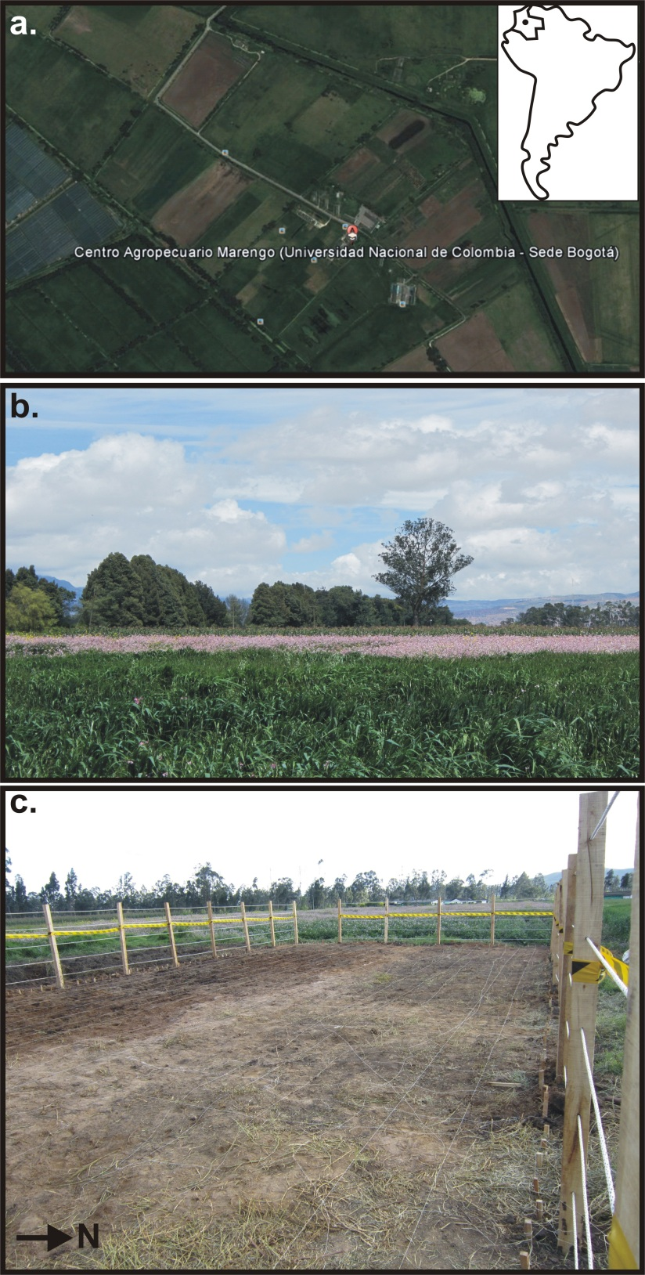
Figure 1. (a) Aerial photograph of the Marengo Agricultural Center of the National University of Colombia with location (inset). (b) General site photograph. (c) Fenced test site with cleared vegetation photograph.
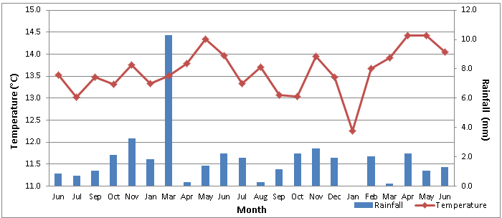
Figure 2. Summary of monthly study site statistics of total rainfall (bars) and average temperature (line) data over the study period in Marengo, Colombia.

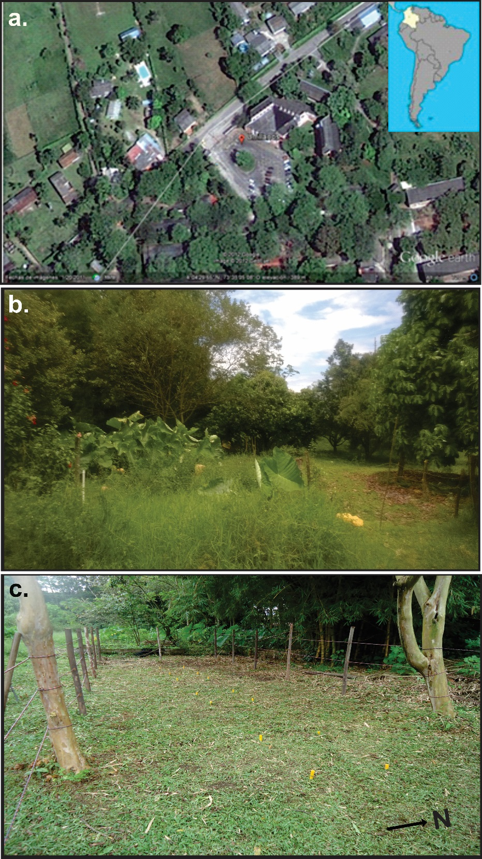
Figure 3. (a) Aerial photograph at the University of Los Llanos, Colombia, with location (inset). (b) General study site photograph of Experimental Farm Barcelona. (c) Fenced test site with orange stakes denoting grave positions.

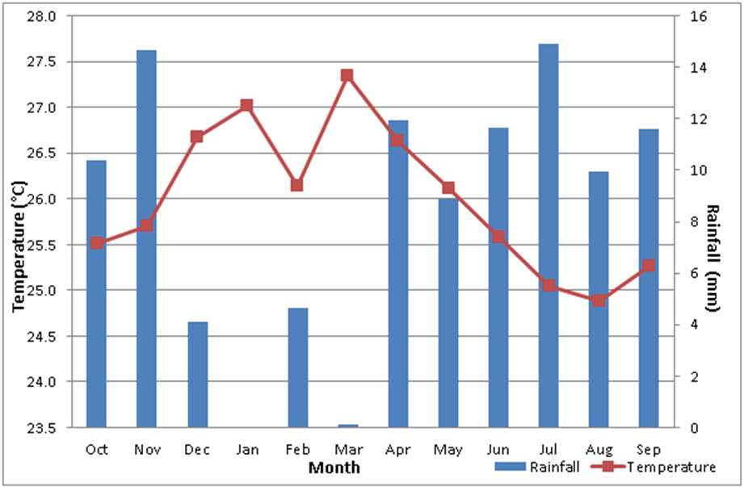
Figure 4. Summary of monthly study site statistics of total rainfall (bars) and average temperature (line) data over the study period in the Llanos, Colombia.

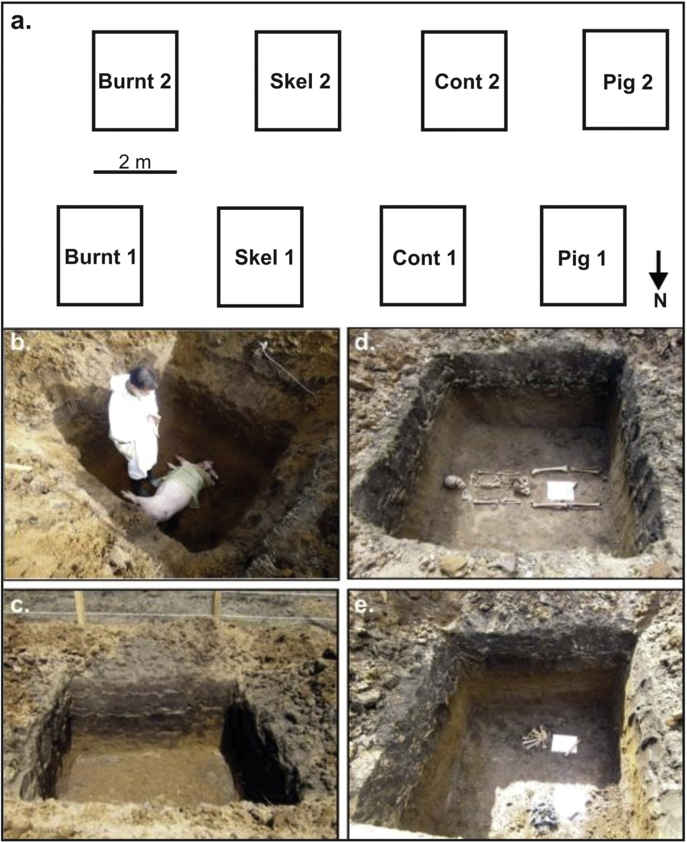
Figure 5. (a) Plan-view of control test site showing positions of eight simulated clandestine graves (annotated) with top row depths 0.8 m and bottom row 1.2 m below ground level (bgl). (b) Simulated clandestine grave with 1/2 clothed domestic pig cadaver. (c) Simulated clandestine empty grave for control. (d) Simulated historic clandestine grave with skeletonised human remains and bullet casings. (e) Simulated historic clandestine grave with beheaded and burnt skeletonised human remains.

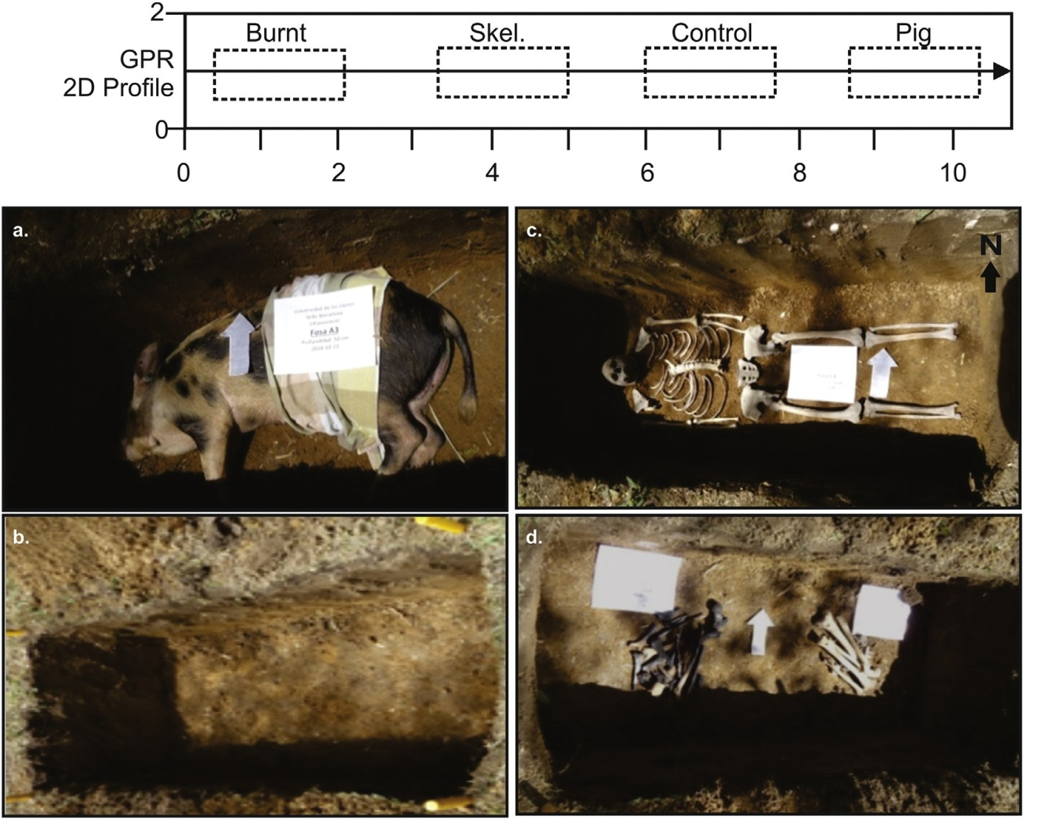
Figure 6. Plan-view of control test site showing positions of four simulated clandestine graves (annotated) buried at 0.5 m below ground level (bgl) and GPR 2D profile location and orientation. (a) Simulated clandestine grave with partially clothed domestic pig cadaver. (b) Simulated clandestine empty grave for control. (c) Simulated historic clandestine grave with skeletonized human remains. (d) Simulated historic clandestine grave with beheaded and burnt skeletonized human remains.
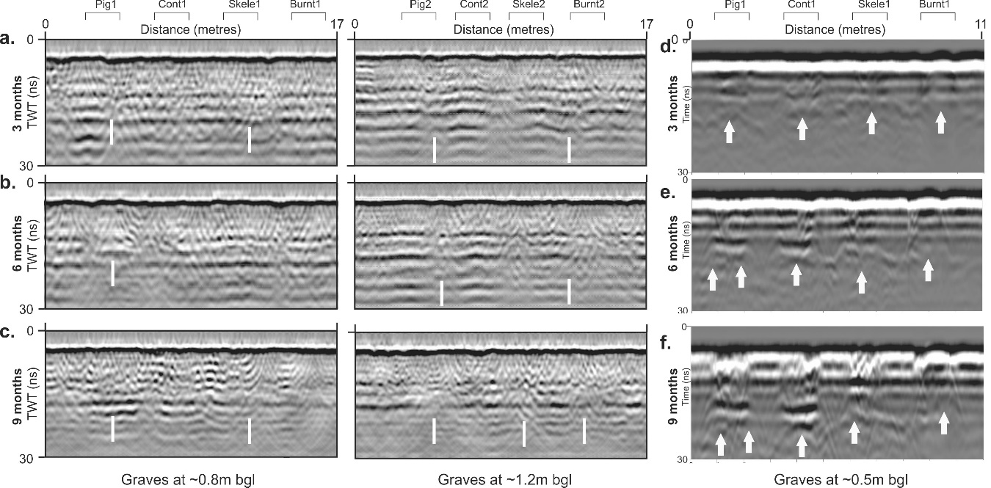
Figure 7. Sequential selected GPR 250 MHz 2D profiles taken over the simulated clandestine grave sites at (a-c) the Marengo Agricultural Center of the National University of Colombia and (d-f) the Experimental Farm Barcelona at the University of Los Llanos, Colombia, with post-burial months shown. Buried simulated named grave positions (see Table 1 for detail), burial depths bgl and any resulting ½ hyperbolic reflection events (arrows) are marked (see text for details and Figs. 1 and 3 for respective locations).
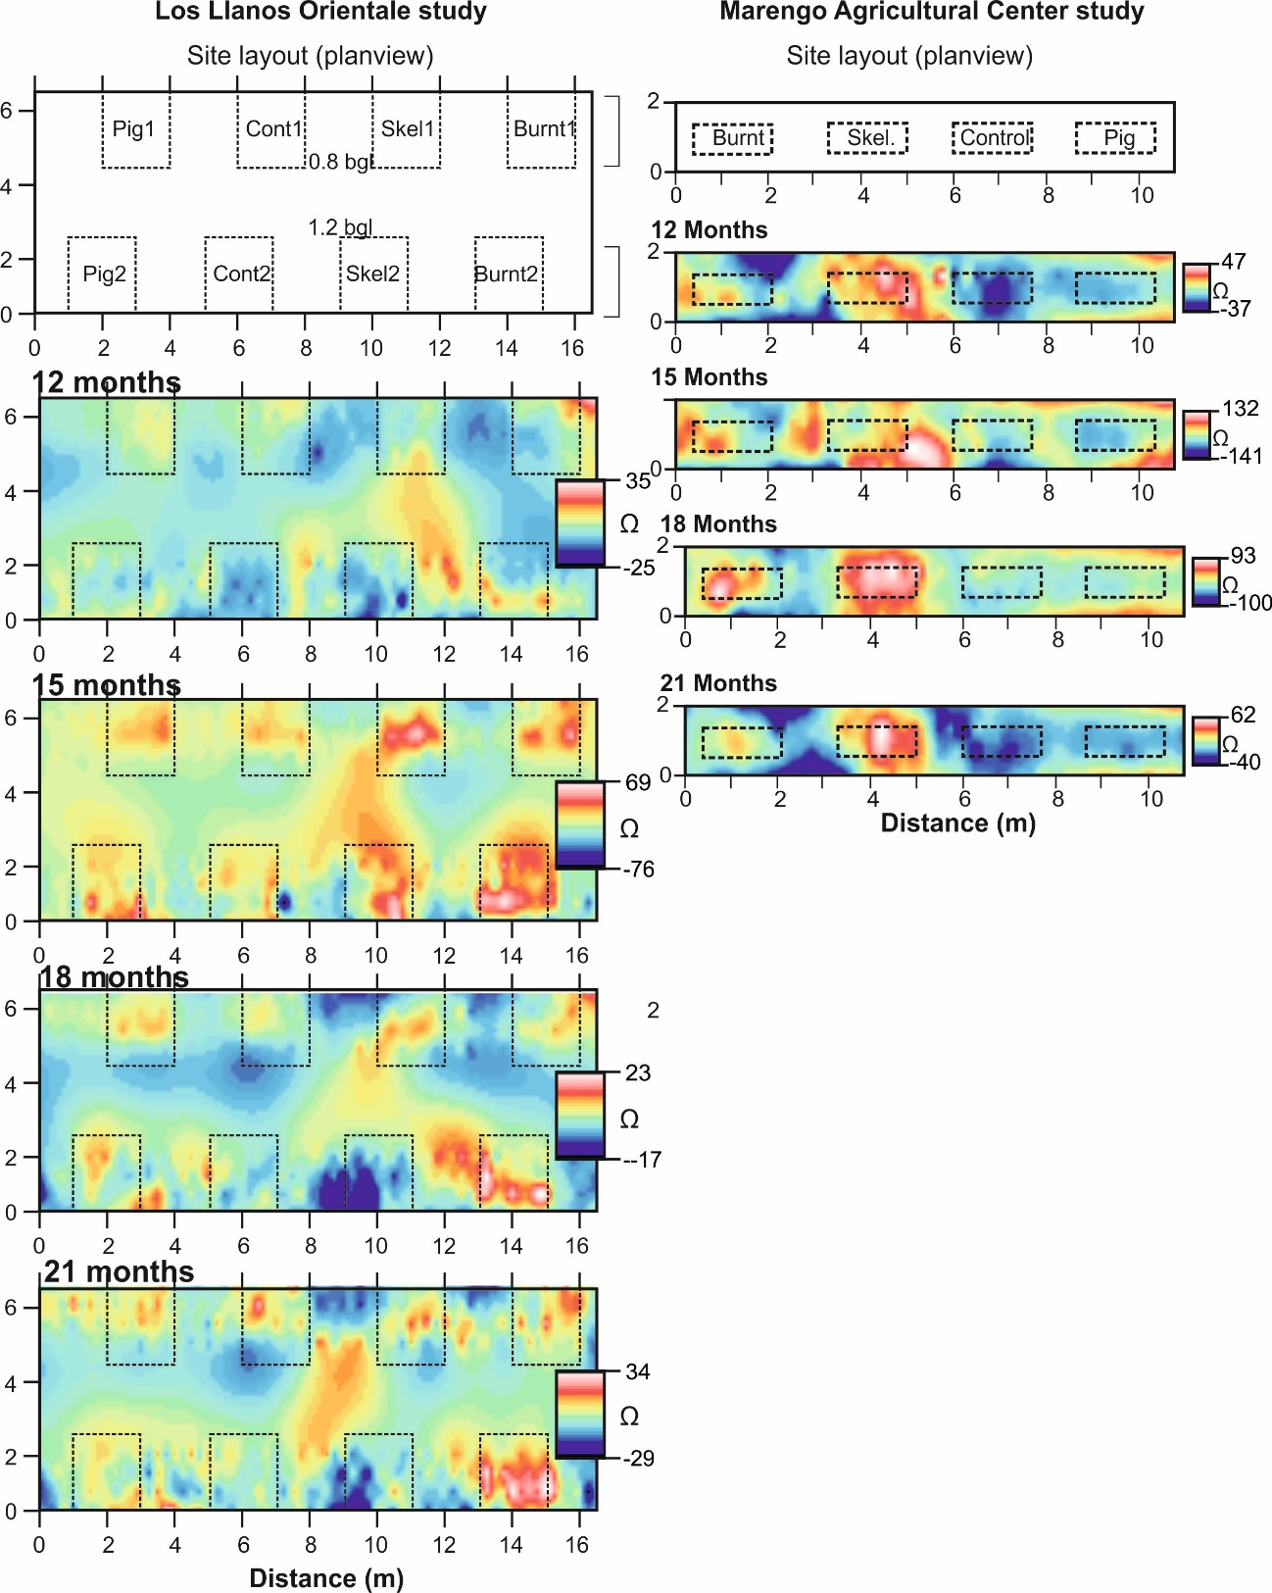
Figure 8. Selected sequential electrical resistivity (mapview) processed datasets from the two study site over the study period (see respective keys). Buried simulated grave positions shown at top and dotted lines in resulting datasets (see text for details).
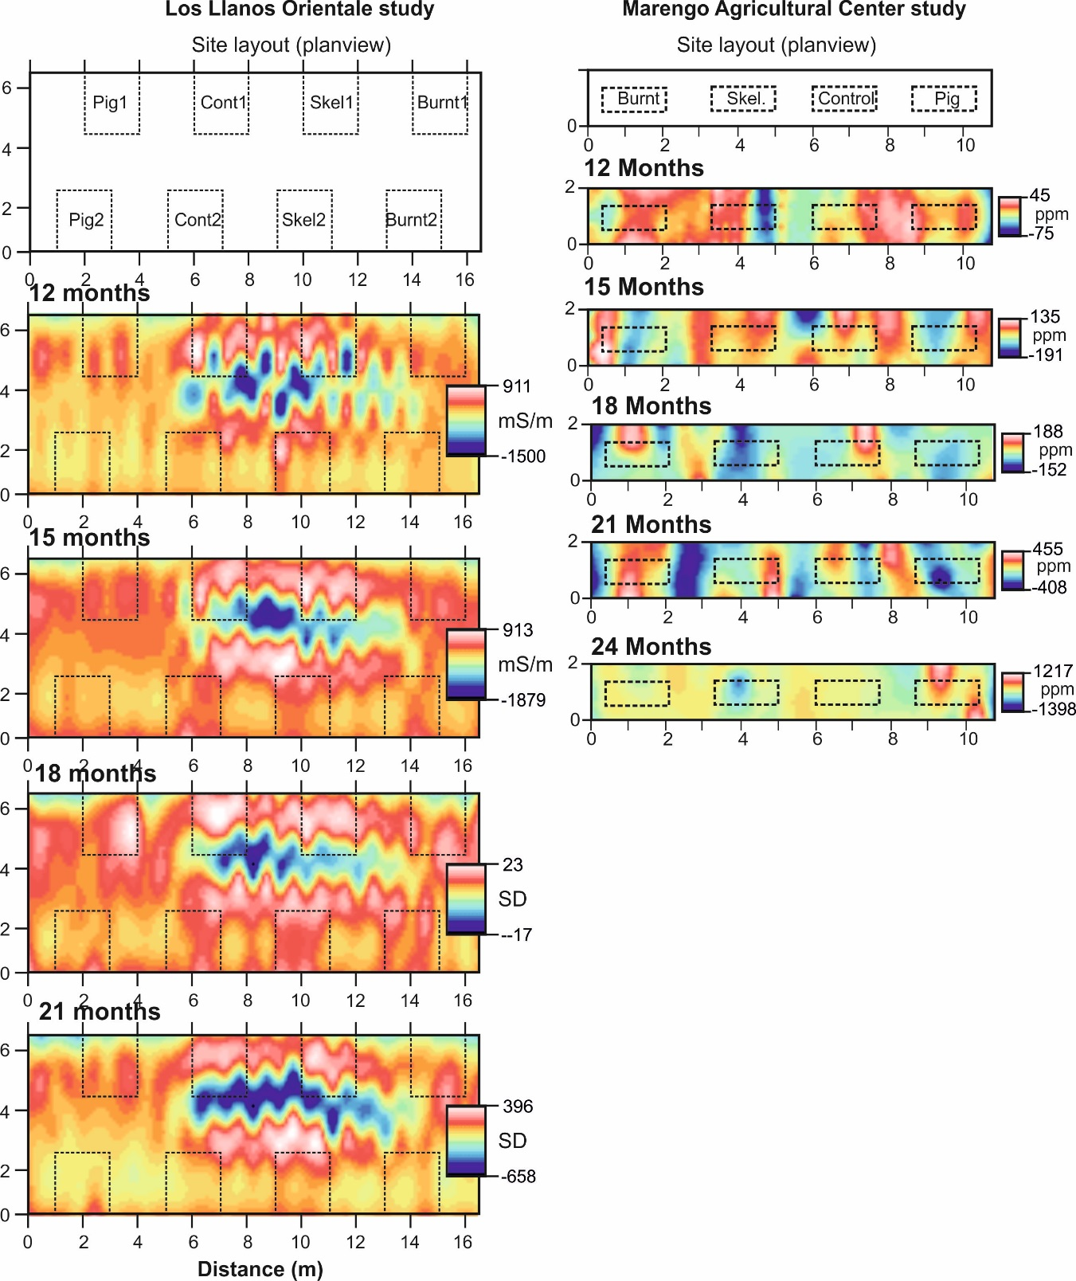Figure 9. Selected sequential bulk ground conductivity (mapview) processed datasets from the two study site over the study period (see respective keys). Buried simulated grave positions shown at top and dotted lines in resulting datasets (see text for details).
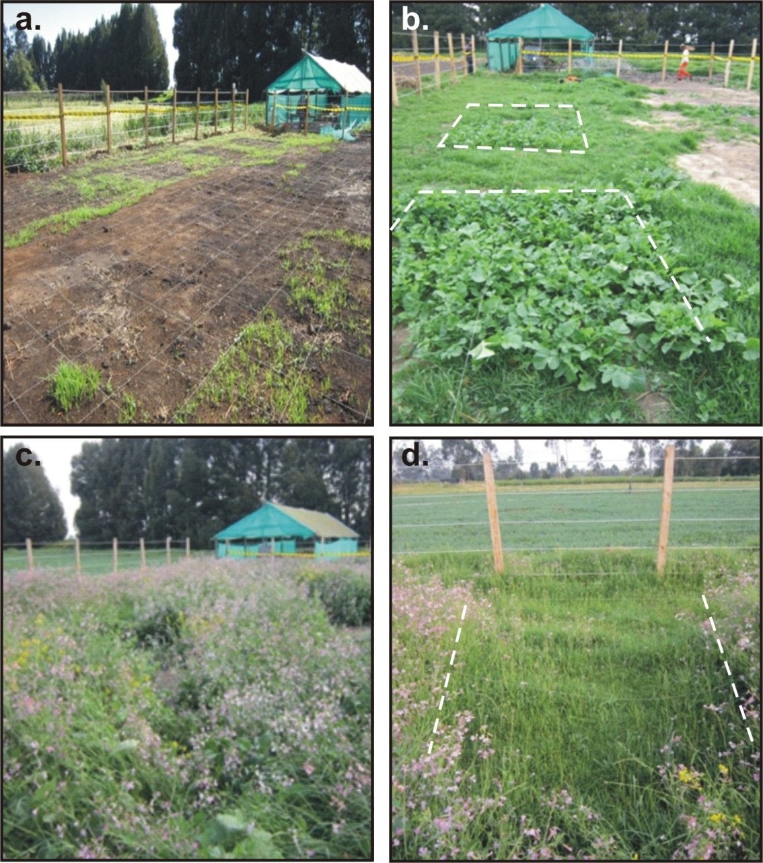
Sept 26th 2013
Sept 26th 2013
July 15th 2013
August 2013

Figure 10. Sequential photographs of surface botany over simulated clandestine graves at the tropical study site. (a) No vegetation after 4 weeks of burial. (b) Brassicaceae (wild radish) preferentially growing over graves after 8 weeks of burial. (c) Lush vegetation (Raphanus raphanistrum) growing over simulated clandestine graves after 16 weeks of burial and (d) Kikuyo grass growing between simulated graves.

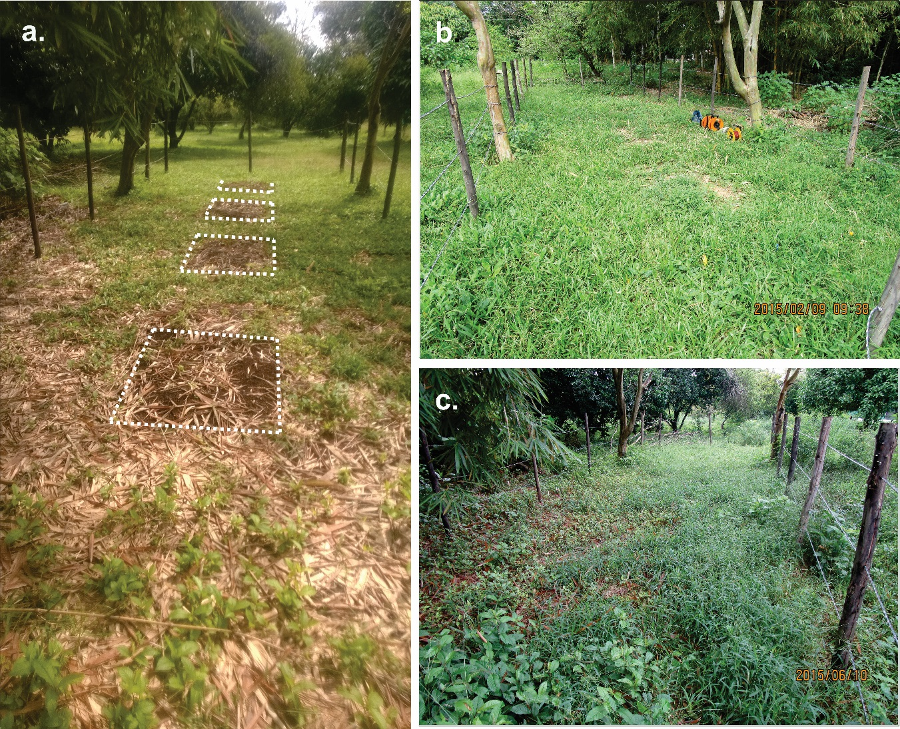
June 10th 2015
November 19th 2014
February 11th 2015

Figure 11. Sequential photographs of surface botany over simulated clandestine graves at the semi-rural study site. (a) No vegetation after 5 weeks of burial. (b) Brachiaria decumbens grass growing over simulated graves after 17 weeks of burial. (c) Malvaceae and Petiveria alliacea growing over simulated clandestine graves after 34 weeks of burial.

