# Structural and geodynamic modelling of the influence of granite bodies during lithospheric extension: application to the Carboniferous basins of northern England

## Louis Howell1*, Stuart Egan1, Graham Leslie2 and Stuart Clarke1

1School of Geography, Geology and the Environment, William Smith Building, Keele University, Keele, Staffordshire, ST5 5BG, UK.

2BGS Scotland, Lyell Centre, Research Avenue South, Edinburgh, EH14 4AP, UK.

*Corresponding author: [l.p.howell@keele.ac.uk](mailto:l.p.howell@keele.ac.uk)

# Abstract

Intra-basinal highs within classic ‘block and basin’ style tectonic frameworks are underpinned by large granite bodies. This is widely believed to relate to the relative ‘rigidity’ and ‘buoyancy’ of granite in relation to accommodating basement. It has been suggested that during periods of tectonic extension, normal faulting around the peripheral regions of granite batholiths permits granite-cored blocks to isostatically resist subsidence, thus forming stable areas during periods of widespread faulting-induced subsidence. However, one-dimensional modelling indicates that relatively less dense crust is incapable of resisting subsidence in this way. Instead, when local isostasy is assumed, the occurrence of granite-cored, intra-basinal highs relates to initial isostatic compensation following granite emplacement. Differential sediment loading during extensional tectonism exaggerates this profile. An integrated two-dimensional lithospheric numerical modelling approach highlights the role of flexural rigidity in limiting the amplitude whilst increasing the wavelength of isostatic deflection. In light of these models, it is suggested that such a response leaves residual second-order stresses associated with the under-compensated buoyancy of the granite body and flexural tension. The observed basin geometries of the Carboniferous North Pennine Basin can be replicated by incorporating a density deficiency within the crust, flexural rigidity, simple shear deformation within the shallower subsurface and pure shear deformation within the deeper subsurface. In adopting this technique, the regional flexural profile in response to underlying granite bodies and large extensional faults can be reproduced and thus, to an extent, validated. It is proposed that the interaction of three factors dictate the tectonic framework within a partially granitic, brittle-ductile lithosphere and the occurrence of inter-basinal highs: 1) non-tectonic, ‘second-order’ stresses such as the flexural response of the lithosphere and residual, under-compensated buoyancy forces in relation to granite bodies; 2) extensional tectonic stress and importantly; 3) inherited basement fabric.

# Introduction

There has been a longstanding consensus that the relative ‘buoyancy and rigidity’ of solid granite promotes the stability and relative uplift of the accommodating basement during lithospheric extension (Bott et al., 1958). This is generally in response to a plethora of examples where large granite bodies, often identified through gravity and magnetic surveys, have been found to spatially correlate strongly with basement highs or horst structures. Multiple late Palaeozoic highs across the UK continental shelf (Bott et al., 1967; Bott et al., 1978; Donato et al., 1983; Donato and Megson, 1990; Donato, 1993; Kimbell and Williamson, 2015), Early Cretaceous highs along the Atlantic conjugate margin of NE Brazil (the Rio do Piexe Basin, De Castro et al., 2007; the Iguatu Basin, De Castro et al., 2008) and roughly coeval highs along the Atlantic margin of southern Africa (the Orange Basin, offshore South Africa, Scrutton and Dingle, 1976; and the Lüderitz Basin and Columbine/Agulhas arches, offshore Namibia, Dingle, 1992) constitute just some currently publicised examples where significantly older granite bodies have influenced regional tectonic structure within extensional basins. Whilst the recurrence of this relationship suggests granite bodies have a significant influence upon post-emplacement structural development of extensional regimes, the lack of a convincing forward model accounting for this relationship warrants further investigation.

Very large, typically hundred-kilometre-scale, felsic-intermediate batholiths are widely known to underpin stable cratons around the margins of rift basins and passive margins – such as the Kaapvaal and Zimbabwe cratons of southern Africa (Thomas et al., 1993; Schoene et al., 2008) and the Pilbara craton of NW Australia (Veevers, 2006). Although the mechanical processes behind this relationship may bear similarities, this work concerns itself with slightly smaller granite bodies, tens-of-kilometres, which form the cores of intra-basinal highs. These highs are often bound by regional scale normal faulting; however, the structural framework surrounding these features is often more complex (Chadwick et al., 1995). There are varying degrees of interaction between more recent extensional structures and the inherited structural framework, of which large granite bodies are very much a part (Corfield et al., 1996). Understanding this framework is key to a greater appreciation of sediment routing, fluid migration pathways and potential reservoir distribution during the syn-rift and throughout the post-rift phases of basin evolution when greater emphasis is likely to be placed upon differential subsidence due to compaction (Besly, 2018).

In this paper, we aim to provide a series of viable structural and geodynamic models that help to explain why large granitic bodies so often occur in the core of relatively uplifted basement highs. A lithospheric-scale numerical modelling approach is adopted in order to replicate granite emplacement, extensional tectonism, and any changes in the physical state of the lithosphere and basin architecture these processes are likely to incur in order to validate this unique structural and geodynamic relationship. A northern England Carboniferous case study is used as both a means of scrutinising the proposed model and as a tool to help analyse the structural trends associated with deeper granite bodies. Finally, the implications of our findings and the possibility of further case studies are discussed.

# The effects of granite during lithosphere extension: insights from past studies

Bott et al. (1958) were first to propose the possible tectonic influences of large granite bodies. They suggested that during periods of tectonic extension, normal faulting around the peripheral regions of granite batholiths permits relatively buoyant and rigid blocks to maintain isostatic equilibrium and resist subsidence, thus forming stable areas during periods of widespread faulting induced subsidence (Donato and Megson, 1990). There are now numerous further publications documenting the possible tectonic influences of granites, all of which broadly agree with those seminal ideas (e.g. Bott 1987; Bott et al. 1978; Chroston et al. 1987; Dimitropoulos & Donato 1981; Donato et al. 1983; Donato et al., 1981; Donato and Megson, 1990; Kimbell and Williamson, 2015; Arsenikos et al., 2018).

The portrayal of a ‘buoyant’ and ‘rigid’ granite body appears to have somewhat over-simplified a more complex process. Furthermore, the buoyancy and rigidity of granite alone cannot explain intra-basinal highs – a forward model is required. Buoyancy, in this instance, refers to the density deficiency associated with crystalline granite by comparison with typical, variably metamorphosed basement. The term ‘buoyancy’ however, perhaps inadvertently invokes similarities between rather more dynamic salt bodies, which are known to actively resist subsidence via halokinesis. ‘Old and cold’ granite batholiths are instead fixed entities within a heterogeneous basement which reduce the overall bulk density of the crust. Likewise, rigidity could also perceivably imply brittleness; increasing the likelihood of fracture nucleation and fault propagation. Perhaps describing younger granite bodies as lacking the same internal heterogeneities and inherited weaknesses as older deformed continental crust (e.g. Chadwick et al., 1989) would be a more plausible way of accounting for the general absence of significant through-going faults within granite-cored basement, albeit another over-simplification (Bouchez, 1997; de Saint-Blanquat et al., 2001). However, this alone does not account in itself for the numerous occurrences of granite bodies within the cores of basement highs.

The assumption that a density deficiency within a defined volume of the crust can promote stability compared with adjacent crust and an inherent ability to resist subsidence during lithospheric extension contradicts some of the fundamentals of mantle and lithosphere dynamics. During lithospheric extension, regional-scale subsidence occurs in response to net density changes resulting from crustal thinning as well as from thermal re-equilibration (McKenzie, 1978). Fundamental principles of isostasy imply that in order to maintain evenly distributed mass at a depth of compensation, upwelling asthenosphere compensates for the loss of lithospheric mass due to stretching and thinning (Karner and Watts, 1982). As the compensating asthenosphere is denser than the crust, this results in a negative deflection in surface elevation (e.g. Kooi et al., 1992). Put simply, this negative deflection, S, can be calculated using either equation 2.1 or 2.2 (see tables 1 and 2 for an explanation of model parameters). In this instance, subsidence is proportional to the original thickness of the crust ($C_{o}$) and the magnitude of extension ($β$), as well as the density of the crust ($ρ_{c}$) and that of the mantle ($ρ_{m}$). Note that whilst this calculation applies only to thinning of the crustal lithosphere, it remains valid providing the density of the asthenosphere and mantle lithosphere are assumed equal ($ρ_{m}$).

$$S=C_{o}-\frac{C_{o}}{β}-\left(C_{o}-\frac{C_{o}}{β}\right)×\frac{ρ_{c}}{ρ_{m}}$$

2.1

Or $S=\left(C_{o}-\frac{C_{o}}{β}\right)×\left(1-\frac{ρ_{c}}{ρ_{m}}\right)$

2.2

Given that crustal thickness lost due to thinning = $C_{o}-\frac{C_{o}}{β}$

2.3

And the isostatic response to this thinning = ${(C}_{o}-\frac{C_{o}}{β})×\frac{ρ_{c}}{ρ_{m}}$

2.4

Figure 1 predicts the depth of two basins in granitic and non-granitic crust when the lithosphere is stretched to twice its original horizontal extent, representing a magnitude of extension ($β$) of 2. Using the parameters displayed in table 2, the subsidence produced from extending non-granitic crust ($ρ_{c}$) is 2.66 km, compared with 3.55 km for a crust composed entirely of granitic material ($ρ_{g}$). The mass of overburden lost when lower density lithosphere is thinned is less than that lost when higher density lithosphere is thinned, providing the magnitude of thinning is the same. Therefore, the volume of isostatically compensating asthenosphere is less for lower density thinned crust and net subsidence is actually greater.

An alteration in overall bulk crustal density, however, causes a separate isostatic adjustment (Fig. 2). In the case of density deficiency due to granite emplacement, this implies uplift. When the complete substitution of crustal rock with a granite body of the same volume is assumed (rather than addition to the crust), the uplift, IR, can be given by:

$$IR={GR}_{o}×\frac{ρ_{c}-ρ_{g}}{ρ_{m}}$$

2.5

Examples of the isostatic responses to magmatic emplacement are common (e.g. Brodie and White, 1994; Maclennan and Lovell, 2002). Where granite bodies have been inferred on the basis of gravity anomalies, the deficiency in the gravitational field compared with background values has been used to calculate localised isostatic rebound (e.g. Donato et al., 1983). Nonetheless, fully integrated numerical modelling of the influences of granite induced crustal heterogeneities on lithosphere behaviour and any resultant basin architecture are lacking.

# 3.0 A revised 1D model of lithospheric extension and granite emplacement

This section describes a 1D modelling approach, assuming local isostasy (e.g. Airy, 1855; Pratt, 1858), in order to provide useful approximations for subsidence behaviour in response to extensional tectonics (e.g. McKenzie, 1978). Readers should refer to table 2 for a summary of model parameters.

### 3.1 Numerical replication of granite emplacement

Replicating granitic emplacement in order to quantify isostatic uplift can be performed in a number of ways. Equation 2.5 assumes the complete substitution of crustal rock with less dense granitic rock and no thermal expansion (e.g. Donato et al., 1983). However, a more accurate portrayal of isostatic uplift due to magmatic emplacement is perhaps achieved by the *addition* of less dense material to the crust; an approach that is similar to that adopted in the numerical modelling of magmatic underplating (e.g. Maclennan and Lovell, 2002):

$$IR={GR}_{o}-{GR}_{o}×\frac{ρ_{c}-ρ_{g}}{ρ_{m}}$$

3.1

Both calculations are approximations of the local isostatic adjustment to one of two simplified, end-member magmatic bodies; one derived entirely from partial melting of the crust (equation 2.5), and the other derived entirely from the mantle that eventually adds material to the crust (equation 3.1). Unless there is a significant contrast in the depth to the Moho, as is not the case in the studied offshore area surrounding northern England (Soper et al., 1992), then re-calculating the bulk density of the crust assuming total substitution of crustal material with granitic material (equation 2.5) is deemed more appropriate. Although the melting of crustal material along with the assumptions of retention of volume combined with an alteration in density is unfeasible, it offers a justifiable simplification of a far more complex process.

The emplacement of large granite bodies is associated with significant thermal perturbations. These may be in response to the initial upwelling of hot magma, to the isostatic compensation of the hotter asthenosphere, or to the elevated radiogenic heat production associated with the resulting granite. However, our one-dimensional model assumes no thermal fluctuations are associated with the granite pluton(s). Essentially, the effects of a thermally re-equilibrated granite body are modelled. Changes in the elevation of the lithosphere-asthenosphere boundary, due to isostatic adjustment, are transient and not permanent (McKenzie, 1978), so to replicate a thermally re-equilibrated lithosphere profile, the thickness of the entire lithosphere (i.e. the sum of crustal and mantle lithosphere) is adjusted. This can be accounted for by adding the calculated isostatic rebound (equation 2.5) to the lithospheric thickness value:

$$A_{og}=A_{o}+{GR}_{o}×\frac{ρ_{c}-ρ_{g}}{ρ_{m}}$$

3.2

### 3.2 Numerical replication of lithospheric extension

If uniform lithospheric extension solely via pure shear is assumed, the original height and width of the granite body (${GR}_{o}$) are altered according to the magnitude of extension ($β$). Taking this into account, the method for solving the subsidence of granite-cored basement ($S_{g}$) can be given one of two ways (equations 3.3 and 3.4). Again, the potential implications of heat flow fluctuations are ignored at this stage.

$$S_{g}=\left(C_{o}-\frac{C_{o}}{β}\right)×\left(1-\frac{ρ_{c}}{ρ_{m}}\right)-\frac{{GR}_{o}}{β}×\frac{ρ_{c}-ρ_{g}}{ρ_{m}}$$

Or $S_{g}=\left(C_{o}-\frac{C_{o}}{β}\right)×\left(1-\frac{ρ_{gc}}{ρ_{m}}\right)-IR$

3.3

Where $ρ_{gc}= ρ_{c}-\frac{{GR}_{o}}{C_{o}}×\left(ρ_{c}-ρ_{g}\right)$

3.4

Changes in the vertical thicknesses of relatively less dense crust due to stretching or compression prompts relatively less isostatic compensation (e.g. Fig. 1). Therefore, with increased extension, the initial uplift of granite-cored crust is cancelled out progressively by extension-driven subsidence when compared with non-granite-cored crust (Figs. 2 and 3).

### 3.3 Isostatic loading due to basin infill

If the starting elevation of non-granite-cored or granite-cored basement prior to emplacement is assumed to be at infill base level, then providing subsidence is greater than zero such that accommodation space is generated, the subsidence of an infilled basin can be given by the following:

$$S=S_{g}+\left(S_{g}×\frac{ρ_{i}}{ρ_{m}-ρ_{i}}\right)$$

3.5

The incorporation of basin fill into the model has important implications for generating vertical relief. Where $β$ > 1, but not sufficient enough to subside initially uplifted granite-cored crust below base level, differential loading occurs and exaggerates basement relief (e.g. Figs. 2 and 3). The magnitude of extension ($β$) required for infill to occur on the granite-cored block can be determined by rearranging equation 3.3:

$$β=\frac{C_{o}×\left(ρ_{m}-ρ_{gc}\right)}{C_{o}×\left(ρ_{m}-ρ_{gc}\right)-IR×ρ_{m}}$$

3.6

### 3.4 The effects of erosion of uplifted material

Figures 2 and 3 suggest that differential loading can have an important role in generating basin relief. However, if the initial uplift due to granite emplacement were met with complete erosion to sea level of the uplifted proportion of the block, producing a flat basement topography prior to extension, then the effects of differential loading would be nullified. Erosion implies an additional negative load and a further positive isostatic response generating additional uplift. The total erosion required to generate a flat surface topography across granite-cored and non-granite cored basement ($e$) can be defined as:

$$e= \frac{{C_{o}(ρ}_{c}-ρ_{gc})}{ρ_{m}-ρ_{gc}}$$

3.7

Given that $C_{o}×ρ_{c}=\left(C_{o}-e\right)×ρ_{gc}+e×ρ_{m}$.

Any erosion implies a reduction in crustal thickness ($C_{o}$) prior to stretching. When the uplifted portion of the crust is eroded in its entirety to sea level and the transient asthenosphere-lithosphere boundary re-equilibrates fully, lithospheric thickness remains the same. Less dense crust subsides more than denser crust (Fig. 1). However, thinner crust subsides less for any amount of extension as less vertical thickness due to crustal thinning is lost in comparison to thicker crust.

Figure 4 presents the subsidence in response to the extension of ‘standard’ lithosphere (i.e. $C_{0}$ = 35 km and $ρ_{c}$ = 2800 kg m-3) and a lithosphere which has undergone granite emplacement, isostatic compensation, full thermal re-equilibration and erosion sufficient enough to generate a flat basement profile. Ignoring any thermal perturbations, which could enhance uplift and further erosion of thinner lithosphere, when the same stretching factor is applied the calculated subsidence is identical. In other words, where $z=C_{o}-e$ is the eroded granite-cored crustal thickness with the same isostatically compensated surface elevation as the original crust ($C_{o}$):

$$S=\left(C_{o}-\frac{C_{o}}{β}\right)\left(1-\frac{ρ_{c}}{ρ_{m}}\right)$$

3.8

$$=\left(z-\frac{z}{β}\right)\left(1-\frac{ρ_{gc}}{ρ_{m}}\right)$$

3.9

In order for granites to influence basin architecture during lithospheric extension, there needs to be some uplifted basement topography prior to extension. The overall bulk crustal density reduction associated with the emplacement of a 5 km thick granite pluton is ~0.9%. To replicate a flat topography at sea level in this scenario requires 1.62 km of erosion. Without considering the mechanics of denudation, it is conceivable that this amount of erosion is achievable over an extended period of tectonic quiescence. Nonetheless, the model presented here will assume no erosion prior to lithospheric extension as ultimately uplift is restricted by lithospheric elasticity (Watts, 2001).

### 3.5 The effects of thermal expansion and contraction

McKenzie (1978) states that compensation of the asthenosphere in response to crustal thinning invokes an elevation in the lithosphere-asthenosphere boundary and thus reduces overall initial subsidence. For the sake of mathematical simplicity, instantaneous deformation and thermal expansion is assumed here. After extension, the lithospheric temperature field undergoes gradual thermal recovery back to an equilibrated state. Crustal density has little *direct* influence on thermal expansion or decay (McKenzie, 1978) and thus the severity of uplift in response to thermal perturbations does not vary significantly between granite-cored and non-granite cored crust. In increasing the total lithospheric thickness (e.g. equation 3.2), the volume increase due to thermal expansion is marginally greater. When a denudated, flat basement topography is modelled (e.g. equation 3.7), lithospheric thickness remains the same yet the ratio of crustal to mantle lithosphere changes. In each instance, the contrast in thermal expansion is rather insignificant. An additional alteration to Parsons and Sclater’s (1977) thermal time constant ($τ$) is made (see equation 3.10), which helps govern the rate of thermal decay. Despite this, lateral variations in the density of the crust have little to no influence on subsidence during post-rift, thermally driven subsidence and any observed contrasts in subsidence rates during this period are more likely due to differential compaction.

$$τ=\frac{{A_{o}}^{2}}{π^{2}×i}$$

3.10

One-dimensional numerical modelling does not support the suggestion that a granite-cored crust can isostatically ‘resist’ subsidence during lithospheric extension. Instead, in a lithosphere with no rigidity, the generation of a high is a result of initial isostatic compensation in response to the presence of a more buoyant granite body prior to lithospheric extension. The addition of sediment exaggerates any pre-existing topography.

# 4.0 The flexural isostatic response to low-density granite

The one-dimensional models presented above give an indication of the isostatic and subsidence behaviour in response to granite emplacement and lithospheric extension. In reality, the lithosphere has significant elastic strength or flexural rigidity; sufficient to prevent localised features from being *completely* compensated for (Watts, 2001).

Assuming the lithosphere has a finite flexural rigidity, figure 5 illustrates the flexural responses to the emplacement of a 5 km deep by 15 km wide granite body into a lithosphere with varying elastic thicknesses ($Te$). The local (Airy) isostatic response represents a lithosphere with an elastic thickness of 0 km. The resulting topography imitates that of the granite body at depth. To incorporate lithospheric flexure, the solution representing the local isostatic response of the lithosphere presented previously (2.5) is rearranged and solved using a Fast Fourier Transform technique (Cooley and Tukey, 1965; Watts, 2001). Where the flexural response to a density deficiency in the crust, and not thermal expansion, due to granite emplacement is modelled, the load at a given point ($x$) can be given by:

$${Load}_{(x)}=\left({GR}_{(x)}×1000\right)×\left(ρ_{g}-ρ_{c}\right)×g$$

4.1

Before calculating the flexural response to this load, the flexural rigidity of the lithosphere must be defined. Flexural rigidity ($D$) is proportional to the elastic thickness ($Te$) of the lithosphere (*cf.* Watts, 2001):

$$D=\frac{E×{Te}^{3}}{12\left(1-v^{2}\right)}$$

4.2

Where $E$ is Young’s modulus and $v$ represents Poisson’s ratio.

Within the frequency domain the flexural response ($resp$) to this load can be determined by:

$$resp=\frac{{Load}_{(x)}}{\left(ρ_{m}×g\right)+\left(D+{resp}_{1}\right)}$$

4.3

$${resp}_{1}={\left(\frac{2×π×k}{N×2×1000}\right)}^{4}$$

4.4

Where $k$ is the wave number and $N$ is the width of the profile.

As elastic thickness ($Te$) increases, maximum uplift decreases at a rapid rate at first which then decays exponentially with increased Te; whilst the width or wavelength of the flexural deflection increases (Fig. 5). With an elastic thickness of 10 km, maximum uplift is ~64 m compared with an Airy isostatic response of ~258 m. However, the width of the flexural uplift increases to approximately 120 km for an elastic thickness of 10 km compared to 15 km for Airy isostasy, which matches the width of the granite body. Various authors have pointed out that flexural stress can be relaxed over time since the lithosphere acts as a viscoelastic material (Stein et al., 1989; Watts and Zhong, 2000) and that elastic thickness can vary according to the thermal state of the lithosphere (Burov and Diament, 1995). Nevertheless, the incorporation of flexure within a two-dimensional model significantly limits the influence of a granite body on basement topography. Therefore, the implications of incorporating flexure include limiting isostatic uplift and as well as limiting the potential influence of pre-extensional erosion and differential loading.

Two-dimensional numerical modelling suggests that initial isostatic compensation due to granite emplacement is incomplete when lithospheric rigidity is incorporated. Depending on the flexural rigidity and effective elastic thickness ($Te$) of the lithosphere, a regional flexural profile is generated prior to lithospheric extension. As isostatic compensation is incomplete, a likely residual under-compensated ‘buoyancy force’ remains beyond granite emplacement and the subsequent thermal re-equilibration of the lithospheric temperature profile along with forces related to flexural tension (both of which are referred to as ‘second-order forces’ by Sonder, 1990 and Zoback et al., 1992).

In order to investigate the relationship between low-density granite bodies and rift basin architecture further, a 2D lithosphere-scale geodynamic modelling approach is adopted. Our northern England case study provides our models with constraint.

# 5.0 Application of modelling the effects of granite emplacement to the Carboniferous basins of northern England

## 5.1 Geological background

The ‘block and basin’ tectonic framework of the Carboniferous North Pennine Basin, northern England (Fig. 6) is underpinned by granite-cored highs and is generally interpreted as being indicative of a classic rift basin (Leeder, 1982). It represents an ideal case study to which to apply the modelling theory presented in earlier sections, especially given the wealth of geological and geophysical data available for the region.

The Carboniferous succession of northern England is characterised by a prolonged rifting period (<40 My; Fig. 7), beginning during the latest Devonian, during which sediment deposition was largely confined to the basins surrounding granite-cored highs (Fraser and Gawthorpe, 1990). Rifting gave way to post-rift thermal subsidence during the latest Viséan to mid-Namurian (Fraser and Gawthorpe, 2003; Stone et al., 2010). The true timing of this transition is unclear; it is most likely diachronous. The post-rift sequence is marked by the delocalisation of depocentres and a more uniformly thick succession (Waters et al., 2007). Deposition during the Carboniferous was ended by widespread (Variscan) inversion; although the effects of this event were only felt mildly in the area investigated here, by comparison with areas further south (Corfield et al., 1996).

Recent studies of the early Carboniferous succession of NW Europe are torn between two models: 1) NW European Carboniferous basins formed under dominant N-S orientated extension relating to the northward subduction of the Rheic Ocean (Leeder, 1982; Kombrink et al., 2008) or; 2) they formed under transtension relating to the eastward expulsion of the extended Baltic plate (Coward, 1993). Much of the pre-Variscan Carboniferous basin architecture of the British Isles has been either inverted by Variscan compression (Corfield et al., 1996), or reactivated during later extensional episodes (Coward, 1995).

The Alston Block is underlain by a suite of cone-, or possibly pipe, shaped early Devonian (Emsian) granitic plutons that reach up to as little as 1 km below the present day surface. Geophysical data suggests that these plutons, collectively referred to as the North Pennine Batholith, comprise a continuous intrusive sheet at around 10 km depth (Bott et al., 1967; Fig. 6). The block is separated from the Northumberland Trough on its northern side by the eastern extent of the complex Maryport-Stublick-Ninety Fathom fault system, and from the Stainmore Trough on its southern side by the Closehouse-Lunedale and Butterknowle Fault complexes (Stone et al., 2010). Directly to the west lies the partially exhumed Lake District Block which is underlain by the Lake District Batholith. To the south of the Stainmore Trough, the Wensleydale Granite underpins the Askrigg Block. The Cheviot Granite does not form a faulted high but marks the northern limit of the Northumberland Trough.

Modern studies of the onshore succession of the UK benefit from a high volume of regional geophysical data and previous outcrop studies. Figure 6 shows the distribution of mapped, surface exposed faults in northern England at 1: 250,000 scale (after British Geological Survey, 2008). Overlain is an interpreted granite thickness map (Kimbell et al., 2006). This was calculated from the regional gravitational anomaly when the effects of surface elevation and basin fill, amongst further gravitational effects, are removed – see Kimbell et al. (2010) for more information. Those faults with the greatest displacement within the region strongly correlate with the margins of concealed, or partially concealed, granite bodies (Fig. 6).

The two cross-sections displayed in figures 8a and 8b (see Fig. 8 for locations) incorporate the structural interpretations of the Carboniferous-recent basin fill made by Chadwick et al (1995) based on seismic and well data constraints (e.g. Fig. 9). Both sections appear only mildly deformed, by Variscan compression. However, more recent modifications due to Permian-Mesozoic subsidence events are apparent in the thin veneer of Permian succession preserved in the Vale of Eden Basin and to the east of the Alston Block (Fig. 8b). Widely observed, but generally poorly understood, Neogene regional south-eastwards tilting, which contributed to kilometre-scale erosion in the Irish Sea (e.g. Green, 2002; Holford et al., 2008), is best illustrated in figure 9b.

# 5.2 Application of the modelling of lithospheric extension and granite emplacement

Our 2D models (Figs. 10 and 11) are applied to the Alston Block and the adjacent Northumberland and Stainmore basins. Forward modelling is performed in an attempt to replicate the interpreted basin geometries. The effects of the underlying igneous bodies are investigated by simulating extensional basin profiles with and without the granite-induced density contrast. In so doing, we seek to integrate and test the models and ideas previously outlined, and to help gain a greater understanding of the deeper processes, which ultimately govern basin architecture.

### 5.2.1 Modelling principles

The structural and geodynamic modelling approach used in this study represents a section of lithosphere as a numerical model and then simulates its deformation by a variety of processes. A typical starting condition for the modelling is a regional cross-section of undeformed lithosphere. The crustal component of this lithosphere is assumed to be 35 km thick with a density of 2800 kg m-3, while the mantle lithosphere is assumed to be 90 km thick with a density of 3300 kg m-3. The modelled lithosphere is thermally conditioned with a geotherm, which has a surface temperature of 0 °C and a temperature at the lithosphere-asthenosphere boundary of 1333 °C. These parameters can be varied. Once the lithosphere is defined it is then possible to model its deformation via a variety of geological and geodynamic processes. These processes can be numerically defined as loads, to which the response of the lithosphere is calculated (equations 4.1-4.4). More comprehensive descriptions of the modelling approach utilised here are presented in Kusznir and Egan (1989), Egan (1992), Egan and Urquhart (1993) and Meredith and Egan (2002), and will not be repeated here.

The model assumes a brittle-ductile transition at a depth of 20 km within the crust (e.g. Kusznir and Park, 1987). Above this boundary, the lithosphere is brittle and deforms by simple shear with subsidence controlled by fault heave and the underlying fault geometry. In the brittle crust, crustal thinning is calculated using the Chevron or vertical shear construction (Verrall, 1982; White et al., 1986). All faults are assumed to have a common detachment depth coinciding with the brittle-ductile transition. The locations and horizontal displacements of faults (see table 3) are based on the interpretations of Chadwick et al. (1995). As the models are purely 2D, the orientation of maximum extension is assumed to be parallel to the cross-section. Over the length of the modelled section (Fig. 10), the total heave is 8.5 km, equating to an overall magnitude of extension ($β$) of 1.09. This value is lower than that cited by Kimbell et al. (1989: $β$ = 1.19) for the same basin; as their magnitude of extensional so accounted for inclined simple shear. Our extensional factor is also lower than that proposed by the same authors ( $β$ = 1.3) based on the magnitude of post-rift thermal subsidence. It is very unlikely, however, that the cross-section presented in figure 10a includes all of the fault-controlled deformation in the area, which may explain this mismatch.

The models assume that the lithosphere deforms via pure shear extension below the brittle-ductile transition at 20 km. Both the lateral position and magnitude of pure shear can be defined independently of the overlying simple shear deformation so as to simulate depth-dependent extension (e.g. Royden and Keen, 1980). To compensate for a low value of upper crustal extension and widely postulated regional out of plane extension (Dewey, 1982; Coward, 1993), a maximum pure shear extension value of $β$ = 1.25 is applied. Pure shear is unevenly distributed across the model; subsiding laterally from the maximum value at 75 km to $β$ = 1 at 0 km and 150 km. The isostatic responses to the thinning of the lithosphere due to simple and pure shear are calculated.

The geometry of the modelled basement and syn-rift fill is mainly a product of the underlying fault geometry and heave. The basement profiles portrayed in Figures 8a and b are based upon the interpretation of deep and relatively low-resolution seismic data (Chadwick et al., 1995), and are not necessarily structurally balanced. Nonetheless, this basement profile is replicated best by incorporating listric faults with a near-surface dip of 55⁰ (Fig. 10; table 3). Such structures may reflect inheritance from the pre-Carboniferous Caledonian basement, which is exposed to the north of the study area in the Southern Uplands of Scotland (Pharoah et al., 1995). Much of the Carboniferous structure in northern England is believed to have been derived from the reactivation of late Caledonian compressional structures and the shallowly dipping, deep Iapetus suture zone (Soper et al., 1992).

Following the rift phase, the models include 40 My of post-rift, thermal subsidence. If deformation is assumed to have begun during the latest Devonian (~360 Ma; as suggested by Chadwick et al., 1995; Monaghan and Parrish, 2006), the model then effectively calculates sedimentation until the late Namurian or early Bashkirian (~320 Ma) Stage, after which the rate of sedimentation increases during the Westphalian or late Bashkirian stages (Peace and Besly, 1997). Post-rift basin fill is more uniformly distributed than syn-rift basin fill. Whereas syn-rift basin fill is controlled predominantly by faulting, post-rift is controlled by more uniformly distributed pure shear, which is responsible for thinning the lower lithosphere and raising the lithosphere-asthenosphere boundary.

The modelled maximum basin thickness is ~3.5 km (Fig. 10d), which is less than the ~5 km succession of preserved early-mid Carboniferous succession observed in the Northumberland Trough (Fig. 10a; Day, 1970). Incorporating greater heave within the model would dishonour the interpretations of Chadwick et al. (1995), utilising greater pure shear values would invoke perhaps unrealistic depth-dependent extension and ‘space issues’ (e.g. Egan and Meredith, 2007). This discrepancy could be attributed to a number of factors: 1) fault heave beyond model resolution (250 m); 2) out-of-plane extension (e.g. Coward, 1993); 3) possible misinterpretation of the poorly imaged top Caledonian basement; or 4) the likely uneven nature of the post-Caledonian, thrusted palaeo-topography. Although a discrepancy in basin depth is recognised, the model is deemed satisfactory for the purposes of this study.

As expected, the differences between the modelled basin geometries with and without incorporating granite-induced density contrasts (Figs. 10a and 10b, respectively) can be observed on the Alston Block. When no granite is incorporated within the model (Fig. 10a), top basement forming the Alston Block is characterised by two inwardly dipping margins. This geometry represents the flexural response to lithosphere unloading along regions of crustal thinning due to the two dominant fault systems, which have opposing dip directions (Kusznir et al., 1991). In the absence of granite, the modelled thickness of the sedimentary succession on the Alston Block is ~1500 m. This is significantly greater than the ~700 metre-thick Viséan-Namurian succession preserved along the western extent and centre of the Alston Block, despite a lower magnitude of extension being utilised in the modelled example.

### 5.2.2 Modelling the effects of granite emplacement – cross-line

The model presented in figure 10b incorporates a 2D granite thickness profile (Figs. 8a and 10c) based on prior interpretation of geophysical data (Kimbell et al., 2006). This cross-line section is taken along the same trend as Figure 8a. The granite thickness value is used to calculate the overall bulk crustal density at a given point, $ρ_{{gc}_{\left(x\right)}}$ (equation 2.5), as well as the imposed load on the lithosphere (equation 3.4).

A relatively low elastic thickness ($Te$) value of 5 km is assumed. This is partly justified in order to replicate the generally low elastic thicknesses estimated in extensional tectonic settings that relate in part to the associated elevated geotherm (Kusznir et al., 1991). Additionally, a low elastic thickness value is adopted to approximate the partial detachment and failure of the lithosphere associated with faulting. Prior to faulting, a more cohesive lithosphere is likely to limit the isostatic compensation due to the granite body (Fig. 5). As basin-scale faults propagate, the crust becomes less cohesive and the ability of the lithosphere to limit localised isostatic uplift reduces. Elastic thickness is however, independent of faulting.

The most obvious difference observed when granite is incorporated into calculations (Fig. 9b) is the significantly thinner sedimentary succession (~400 m) modelled over the centre of the Alston Block. This coincides with the thickest part of the North Pennine Batholith (Fig. 10). This arrangement better replicates the thin Carboniferous succession that is observed on the Alston Block (Day, 1970; Stone et al., 2010). A further significant difference observed in the granite model is the drape-like, broad monocline shape of the top basement along the north of the block (Fig. 10b). This geometry is likely exaggerated in the model compared with the cross-section as a consequence of the solely two-dimensional nature of the model. Figure 6 shows the adopted trend-line intersecting two cupolas of the North Pennine Batholith towards the north-east of the block which are likely to have invoked further out-of-plane uplift and flexure. This monocline mimics the trends of the uplifted flanks portrayed in Figure 5.

Interestingly, the basement monocline observed when incorporating granite (Fig. 10b) echoes the north-eastern and offshore margins of the Alston Block (e.g. Murchison, 2004; also see Fig. 8b). Various authors have stated that the margins of the granite-cored highs are characterised by ‘hinge-lines’ onto which early Carboniferous strata onlap (George, 1958; Bott, 1967; Johnson, 1967; Leeder, 1975). These hinge lines are commonly faulted but are also locally characterised by monoclines similar to those observed in Figures 5 and 9b. Both types of structure are believed to form in crust relatively free from granite that is immediately adjacent to granite-cored crust (Leeder, 1975). Constraints on the deeper concealed stratigraphy of the Alston Block are sparse so perhaps the best illustration of this basement monocline are the early-mid Carboniferous thickness trends. Despite anticipating a thin cap of mid-late Carboniferous stratigraphy akin to the ~390 m encountered in the Rookhope borehole (Fig. 8b; Dunham et al., 1965), ~1800 m of Viséan-Westphalian (Bashkirian) stratigraphy was encountered at Harton Dome without reaching basement before drilling finally ceased (Ridd et al., 1970).

### 5.2.3 In-line

The effects of granite emplacement have been further investigated by the generation of an additional forward model (Fig. 11) representing the approximately E-W in-line section across the Lake District Block, Vale of Eden Basin and Alston Block (Fig. 8b). As the section is oriented roughly parallel to the dominant structural trend, faulting is largely removed. A uniform pure shear beta-value of 1.25 is applied that is consistent with the cross-line section. Permian fill of the Vale of Eden Basin is bound to the east by the Pennine Fault; however, as Carboniferous strata shows no significant thickening across the fault, only 0.25 km of horizontal displacement is modelled. 40 My of post-rift thermal subsidence is included in the model which produces an evenly distributed, uniformly thick succession of ~1.3 km due to a combination of assuming a uniform beta-value, no crustal density variations and a single fault with small displacement (Fig. 11a).

When crustal density is varied according to the thickness of the underlying granite bodies, a highly undulose basement topography is generated (Fig. 11b). Despite modelling limited faulting, the general absence of low-density granite underlying the Vale of Eden compared with the surrounding Alston Block and Lake District Block predicts a narrow, trough-shaped basin. Along the eastern extent of the model, syn-rift basin fill thickness increases significantly, again mimicking the thickness trends encountered in the Harton Dome borehole compared with the Rookhope borehole (Fig. 8b). As only minimal amounts of crustal thinning are calculated due to the absence of large Carboniferous faults along the section, post-rift basin fill thickness is largely uniform except for where syn-rift subsidence alone is not sufficient to lower the basement elevation below sea level.

Top basement monoclines and significant sediment thickness variations related to the underlying thicknesses of granite bodies are predicted in our numerical modelling experiments. It is suggested therefore that early Carboniferous thickness discrepancies in the North Pennine Basin are, in part, due to the flexural response of the lithosphere to low density granite bodies and the later superimposed effects of lithospheric extension.

# 6.0 Discussion

Numerical modelling of lithospheric extension and basin formation has provided evidence that large basement granite bodies can strongly influence basin architecture and form areas of strong relief through their buoyancy, as was first proposed by Bott (1958). By accounting for large, low-density granite bodies, it is possible to replicate some of the geometries observed in the North Pennine Basin. However, contrary to common perception, relatively buoyant granite-cored crust is not capable of resisting subsidence during lithospheric extension.

The emplacement of typically low-density granite prompts an incomplete isostatic response; even when associated temperature fluctuations are ignored. This generates a regional flexural profile prior to lithospheric extension and leaves residual second-order stresses associated with the under-compensated buoyancy of the granite and flexural tension (e.g. Sonder, 1990; Zoback *et al*., 1992; Fig. 12). The, up until now, neglected pre-existing structural framework of the region probably plays an important role in determining the geometry of the granite body and effective elastic thickness of the lithosphere ($Te$); both of which have a direct influence on our numerical simulations of this flexural profile.

The depth of emplacement of a granitic body is likely to influence subsidence and structural partitioning within the crust. The incorporation of a bulk crustal density value, such as is the case here, effectively assumes the proportion of granitic and non-granitic crustal material deforming by simple and pure shear is equal. However, if the granite body were to reside solely within the upper crust, then the granite body would not deform via the mechanism of pure shear at all. Crustal material removed from the lower lithosphere overburden by means of pure shear therefore, would have the same density as ‘standard’ crustal material, regardless of the presence or absence of granite in the upper crust. The calculated subsidence in response to pure shear would be identical to that of ‘standard’ lithosphere. Alternatively, if a granite body were to reside solely within the lower, more ductile crust, thinning of the granite body due to pure shear would be underestimated when utilising a bulk crustal density value ($ρ_{gc}$), as would subsidence.

Regional-scale extensional faulting is another feature strongly linked with this tectonic framework. There is a strong link between the flexural response to granite and the localisation of extensional strain along the hinges of the flexural profile (Fig. 5) or peripheral margins of the granite body at depth (Fig. 6). Figure 13 illustrates how tectonic stresses due to extensional tectonism and second-order stresses, due to the incomplete isostatic compensation of the low-density granite body and flexural tension, could constructively interfere. However, at the regional scale, large basin-bounding faults, particularly their orientation, are not so apparently guided by the subsurface granite extent. With our northern England case study for example, it is likely that older inherited Caledonian lineaments are more important here (e.g. Coward, 1993; Corfield et al., 1996). Nonetheless, the interaction of these stress fields could perceivably impose the localisation of stress conditions more favourable to the normal reactivation of ancient lineaments within basement surrounding intruded granite.

Where exposed, crystalline granite bodies of northern England lack the internal inconsistencies of the ancient orogenic basement (Allsop, 1987). The granite-cored blocks do not easily develop normal faults during extension because they have an undeformed, relatively homogenous mid-crust. The lateral continuity of the North Pennine Batholith of the Alston Block, and that of the batholiths underpinning the Lake District and Askrigg blocks, at around 10 km depth inhibits the local connectivity of pre-existing structures between the upper- and mid-level crust and limits displacement. Conversely, the surrounding crust that lacks this intruded granite sealant has uninterrupted connecting lineaments which are more easily reactivated.

Second-order stresses are capable of driving preferential propagation of basin-bounding faults during early stage extension, which along with the likely decrease of the effective elastic thickness of the lithosphere is likely to prompt more complete isostatic compensation of granite-cored blocks and relax these stresses. The absence of faults surrounding the largest fault structures may be explained by a ‘strain shadow’ effect (e.g. Nicol et al., 2005), whereby tensile stress is relieved by large fault structures, negating the need for further brittle failure in the immediately surrounding area.

This geodynamic and structural framework has a number of potentially important implications for basin evolution and the modelling of a potential hydrocarbon system. The relief of a granite-cored high during the early stages of rifting has important implications for sediment routing, whereas the predicted subsidence of this high during later stages of rifting (Figs. 2 and 3) is more likely to influence palaeo-basin topography and the distribution of potential reservoir facies. The depth to top basement has a significant impact on a region’s thermal structure (Bayer et al., 1997) which, even without considering the typically high radiogenic heat production of granite bodies such as those modelled (Busby et al., 2011), is likely to have a pronounced impact on source rock maturation as well as geothermal potential.

There are a number of further documented examples where large granite bodies, similar to those modelled here, influence intra-basinal highs in extensional basins (Fig. 6; 13). Palaeo-structure maps for the late Palaeozoic, onshore and offshore UK are commonly accompanied with a map of interpreted and proven Caledonian granite bodies (Fig. 6; Coward, 1993; Corfield et al., 1996; British Geological Survey, 21CXRM). Further examples of this structural and geodynamic relationship can be found along the Atlantic margins of southern Africa and South America (Fig. 13a). A number of buoyant granite-cored highs are alluded to along the Early Cretaceous western margin of southern Africa (the Luderitz and Columbine/Agulhas arches, offshore Namibia; Dingle, 1992; the southern margin of the Orange Basin, South Africa; Scrutton and Dingle, 1976), (see Figs. 13b and 13c); although, despite the possible correlation with exposed onshore Proterozoic and Cambrian granite batholiths (Harris et al., 1997; Jung et al., 2000), not all examples are proven. In addition, some of the potential influences the ‘tensile strength’ of proven and suggested Neoproterozoic granite bodies have on the architecture of the Early Cretaceous Rio do Peixe and Iguatu wrench basins of NE Brazil are discussed by De Castro et al (2007; 2008), (Fig. 13d).

The location for this case study was chosen preferentially over others for a number of reasons: 1) the numerical constraint on the thickness of the granite body is an important model parameter (Kimbell et al., 2006); 2) the sedimentary cover acts as a record of subsidence over time and space and; 3) despite this sedimentary cover, the underlying granite bodies are proven (Dunham et al., 1961; Bott et al., 1967). The availability of these constraining factors has enabled this study to be carried out. The true extent of further examples of granite-cored intra-basinal highs in extensional basins is not clear. Their identification and the examination of their influence on local tectonic evolution would rely heavily on geophysical analyses such as those referenced throughout this work (e.g. Kimbell et al., 2006).

# 7.0 Conclusions

In this study, we have used lithospheric scale numerical modelling of extensional tectonics to investigate the possible influences of low-density granite bodies on extensional basins. Model results have provided the following important insights:

* It is possible to generate basement relief by incorporating density contrasts within the crust such as those due to the presence of large granitic body. However, contrary to common beliefs, the relatively buoyant granite bodies are not capable of resisting subsidence during lithospheric extension.
* Prior to lithospheric extension, the flexural rigidity of the lithosphere reduces isostatic compensation in response to buoyant granite bodies in terms of amplitude but increase the wavelength of isostatic deflection, depending on the elastic thickness of the lithosphere (e.g. Watts, 2001). A region of uplift, unbound by faults, is generated prior to lithospheric extension and residual second-order stresses associated with the under-compensated buoyancy of the granite, as well as flexural tension, remain.
* There is a strong correlation between the distribution of large extensional faults and concealed granite bodies. These faults generally coincide with areas of non-granite cored crust immediately adjacent to concealed granite bodies. The interaction of tectonic forces, second-order isostatic (relating to the granite’s buoyancy) or flexural forces and inherited basement fabric is suggested to justify this relationship.
* It is proposed that the interaction of three factors ultimately dictate the tectonic framework within a partially granitic, brittle-ductile lithosphere and the occurrence of intra-basinal highs: 1) non-tectonic, ‘second-order’ stresses generated by the flexural response of the lithosphere and residual, under-compensated buoyancy forces in relation to granite bodies; 2) extensional tectonic stress; and importantly 3) inherited basement fabric, of which granite bodies are very much a part of.

It is hoped that this more conceptual-based study will lend itself to more evidence-based investigations concerning structure, geodynamics and the influence of large granite bodies on sedimentary basins.

# Acknowledgements

The authorship would like to thank the valuable contributions of Editor-in-Chief Rob Govers and reviewer Nigel Woodcock.

We thank the UK Onshore Geophysical Library (UKOGL) for permission to show their seismic data. The Basin Dynamics Research Group at Keele University and the British Geological Survey are thanked for stimulating discussion during the preparation of the manuscript. In particular, the authorship would like to acknowledge the contributions of Bernard Besly. Noel Howell is thanked for benefiting us with his expertise in mathematics.

The work contained in this paper contains work conducted during a PhD study undertaken as part of the Natural Environment Research Council (NERC) Centre for Doctoral Training (CDT) in Oil & Gas [grant number NEM00578X/1]. It is sponsored by NERC, the Keele University Acorn Fund and the National Productivity Investment Fund (NPIF) whose support is gratefully acknowledged.

# Tables

Table 1. Model parameters.

|  |  |
| --- | --- |
| Parameters | Abbreviation |
| Basement elevation (km) | $${Basement}_{(x)}$$ |
| Basin infill density (kgm-3) |  |
| Constant used for Fast Fourier Transform representing width of model in frequency domain. | $$N$$ |
| Crustal thinning due to simple shear (km) | $${CTS}_{(x)}$$ |
| Density of granite-cored crust (kg m-3) |  |
| Density of granite-cored crust (kg m-3) |  |
| Depth to fault (km) | $${Fd}_{(x)}$$ |
| Elastic thickness (km) | $$Te$$ |
| Magnitude of extension | $$β$$ |
| Flexural rigidity (N m) | $$D$$ |
| Vertical granite body thickness at a given point (km) | $${GR}_{(x)}$$ |
| Horizontal extension or heave (km) | $$h$$ |
| Load at a given point (N) | $${Load}_{(x)}$$ |
| Local isostatic rebound due to granite emplacement (km) | $$IR$$ |
| Original granite height/thickness (km) | $${GR}_{o}$$ |
| Original lithosphere thickness for granite-cored lithosphere (km) | $$A_{og}$$ |
| Subsidence (km) | $$S$$ |
| Subsidence of granite-cored crust (km) | $$S_{g}$$ |
| Thermal diffusivity | $$i$$ |
| Thermal time constant (Myr; Parsons and Sclater, 1977) | $$τ$$ |
| Wavenumber of the load in the frequency domain | $$k$$ |

Table 2. Model constants with abbreviations and source.

|  |  |  |  |
| --- | --- | --- | --- |
| Constants | Abbreviation | Value | Reference |
| (Non-granite cored/original) crustal density | $ρ_{c}$* | 2800kg m-3 | Parsons and Sclater (1977) |
| Acceleration due to gravity |  | 9.81m s-2 |  |
| Air density |  | 0kg m-3 |  |
| Brittle-ductile transition (crust) | $$Zd$$ | 20km | Kusznir and Park (1987) |
| Granite density | $$ρ_{g}$$ | 2630kgm-3 | Eskdale granite; Bott and Smithson (1967) |
| Mantle density (asthenosphere and mantle lithosphere) | $ρ_{m}$* | 3300kg m-3 | Parsons and Sclater (1977) |
| Original crustal thickness | $$C_{o}$$ | 35km |  |
| Original lithosphere thickness | $$A_{o}$$ | 125km |  |
| Poisson’s ratio | $$v$$ | 0.25 | e.g. Watts et al. (1980) |
| Sediment density | $$ρ_{s}$$ | 2500kg m-3 |  |
| Temperature at the base of the lithosphere | $$T_{0}$$ | 1333⁰C | Parsons and Sclater (1977) |
| Volumetric coefficient of thermal expansion |  | 3.2810-5⁰C-1 | Parsons and Sclater (1977) |
| Water density | $$ρ_{w}$$ | 1000kg m-3 |  |
| Young’s modulus |  | 71010 Pa | e.g. Egan (1992) |

*densities correct at 0⁰C.

Table 3. Coordinates, orientation, horizontal displacement (heave) values and dip values for faults used in two-dimensional modelling (Fig. 11).

|  |  |  |  |  |
| --- | --- | --- | --- | --- |
| Fault | x-coordinate (km) | Antithetic/ Synthetic | Heave (km) | Dip (⁰) |
| 1 | 28 | S | 0.25 | 55 |
| 2 | 32 | S | 0.25 | 55 |
| 3 | 34 | S | 0.5 | 55 |
| 4 | 41 | A | 0.25 | 55 |
| 5 | 43 | A | 0.25 | 55 |
| 6 | 45 | A | 0.25 | 55 |
| 7 | 56 | A | 0.5 | 55 |
| 8 | 70 | S | 0.25 | 55 |
| 9 | 79 | A | 1.5 | 55 |
| 10 | 85 | A | 1.0 | 55 |
| 11 | 111 | S | 0.25 | 55 |
| 12 | 116 | S | 0.25 | 55 |
| 13 | 118 | S | 2.5 | 55 |
| 14 | 124 | S | 0.5 | 55 |

# Figures

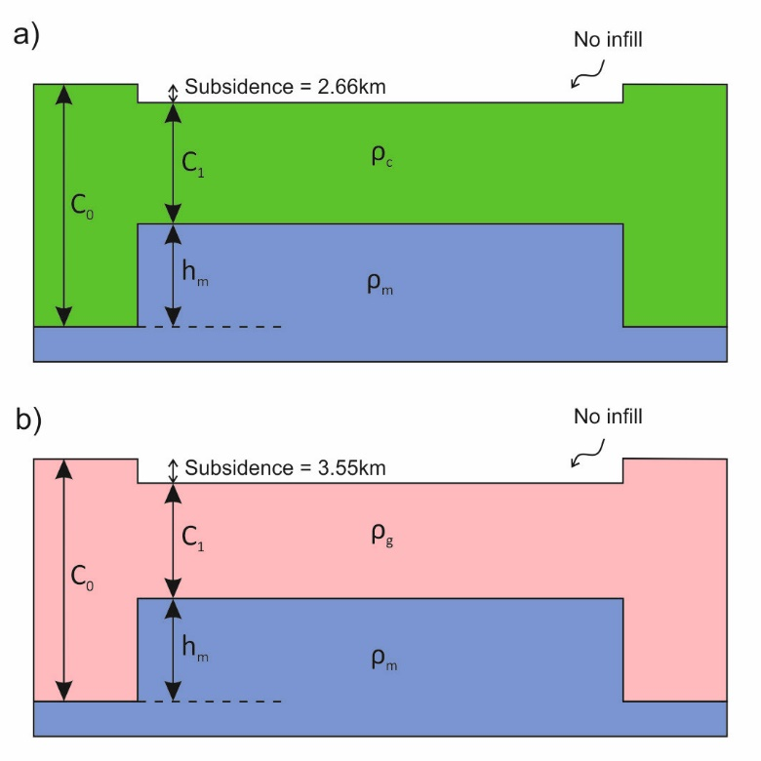

Figure 1. Schematic cross-sections through extensional basins within a) non-granitic crust and b) entirely granitic crust. Fully compensated local isostasy is assumed. In other words $C_{0}×ρ_{c}=h_{m}×ρ_{m}+C_{1}×ρ_{c}$*. $ρ_{m}$*  = 3300 kg m-3, = 2800 kg m-3, = 2630 kg m-3.

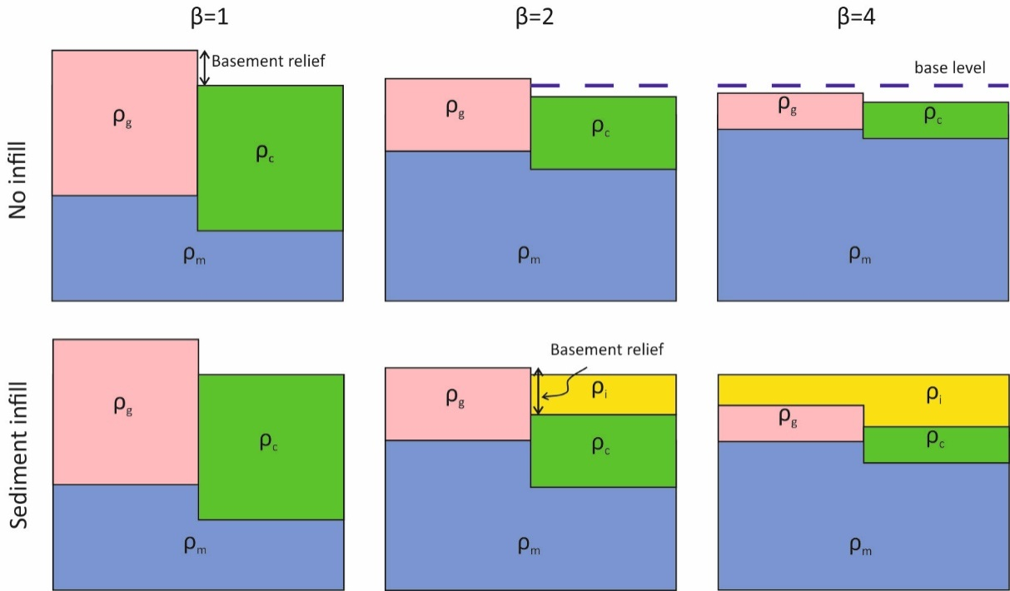

Figure 2. Schematic illustration indicating how the influence of a density contrast on basement relief reduces with increased crustal thinning. The pink and green blocks represent granitic and non-granitic crust, respectively. The addition of sediment below base level, represented by yellow shading, exaggerates basement relief (also see Fig. 4). Fully compensated local isostasy is assumed. To better illustrate the effects of a granitic basement, the density contrast between granite ($ρ_{g}$) and ‘standard’ crustal rock ($ρ_{c}$) is exaggerated such that $ρ_{c}$ = 2800 kg m-3 and = 2000 kg m-3. = 3300 kg m-3, = 2500 kg m-3.

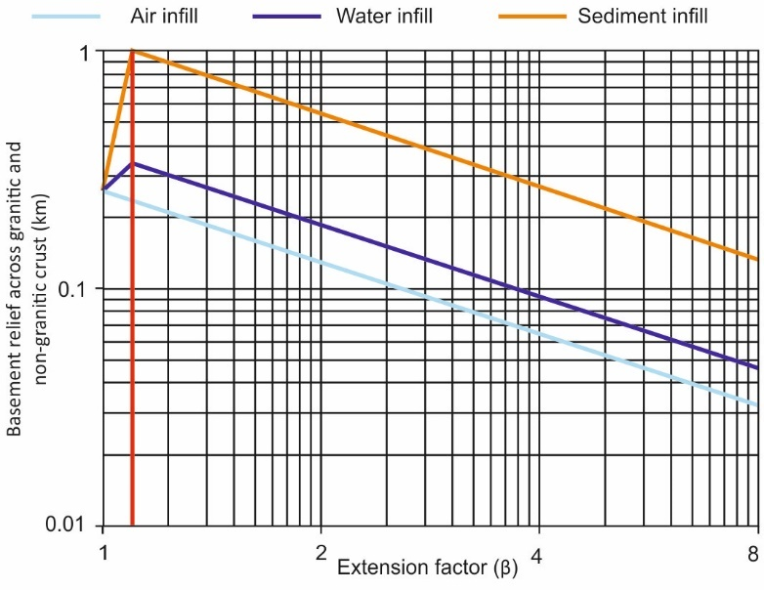

Figure 3. Basement relief (the difference in basement elevation; see Fig. 2) between non-granitic and granite-cored basement at different magnitudes of extension ($β$). The influence of a density contrast on basement relief reduces with increased extension. However, basin infill exaggerates relief. ${GR}_{0}$ = 5 km, $C_{0}$ = 35 km, $ρ_{m}$ = 3300 kg m-3, = 2800 kg m-3, = 2630 kg m-3, = 2500 kgm-3.

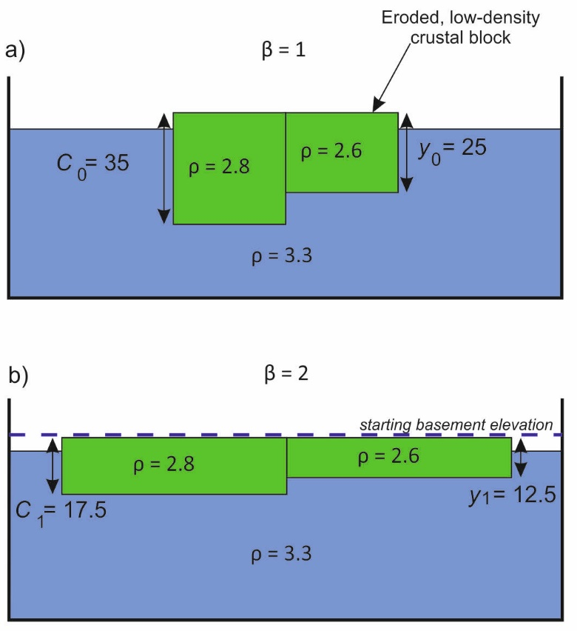

Figure 4. Schematic illustration indicating the influence of pre-tectonic denudation of isostatically compensated lithosphere on the basement topography of a) un-extended and b) extended lithosphere. Fully compensated local isostasy is assumed.

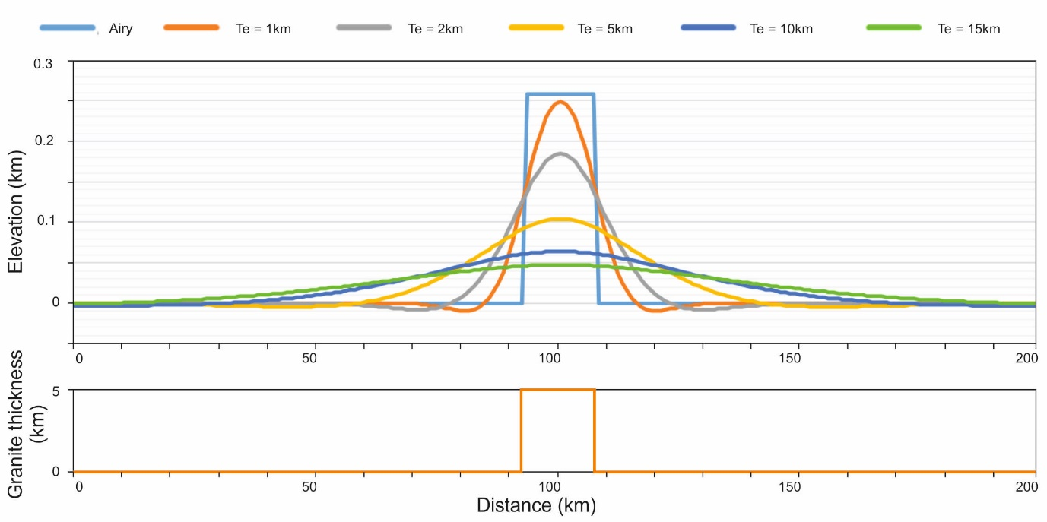

Figure 5. The varying flexural responses to an added granite body, 15km wide x 5km high, into a lithosphere with different elastic thicknesses ($Te$). When the lithosphere is assumed to have elastic strength, isostatic compensation is reduced in amplitude but increased in width with respect to Airy (local) isostatic compensation. $C_{0}$ = 35 km, $ρ_{m}$ = 3300 kg m-3, = 2800 kgm-3, = 2630 kg m-3.

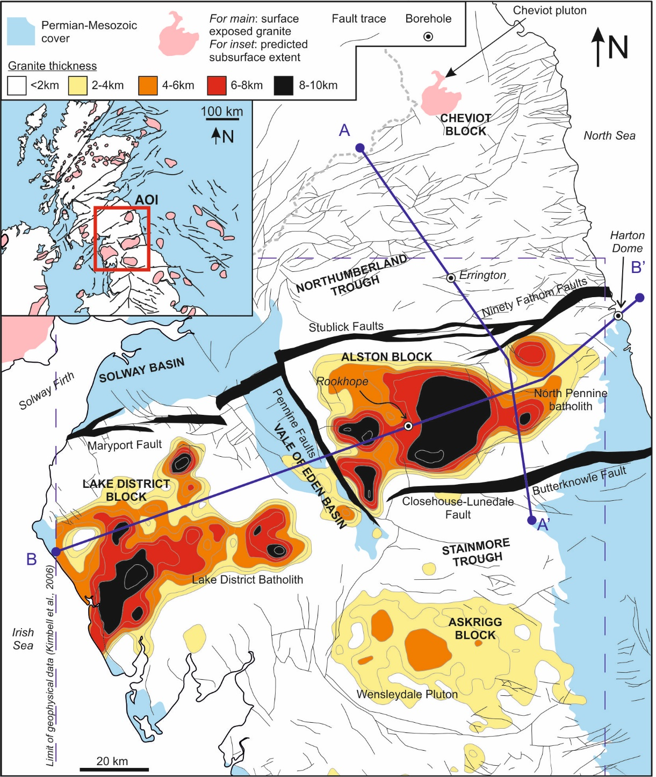

Figure 6. A topographic structural map of northern England and southern Scotland (British Geological Survey, 2008) superimposed with a deep structural map of northern England (Chadwick et al., 1995) and a buried granite thickness map based on the interpretations of gravity and magnetic anomaly data (Kimbell et al., 2006). A-A’ and B-B’ represent the locations of the cross-sections presented in figure 8. Inset: The locations of interpreted and proven Caledonian granite bodies across the UK continental shelf and Ireland and area of interest. Based on work by Donato et al. (1983), Donato and Megson (1990), Donato (1993), Corfield et al. (1996) and Kimbell and Williamson (2015).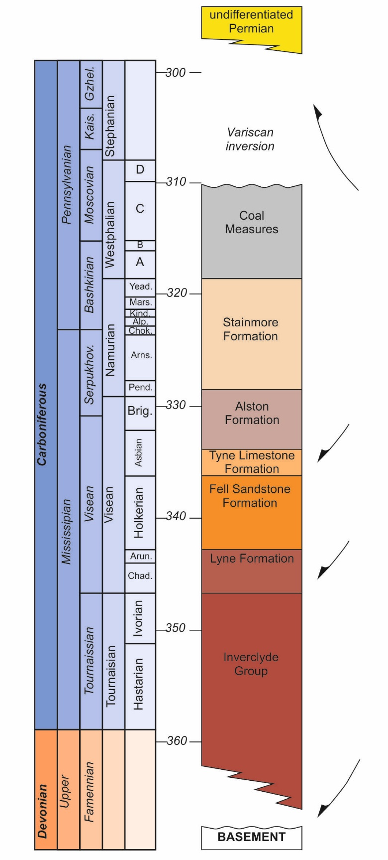

Figure 7. Tectonostratigraphic section of northern England (modified after Fraser and Gawthorpe, 1990 and Chadwick et al., 1995). Lithostratigraphic nomenclature from Waters et al. (2007). Ages from Davydov et al. (2012).

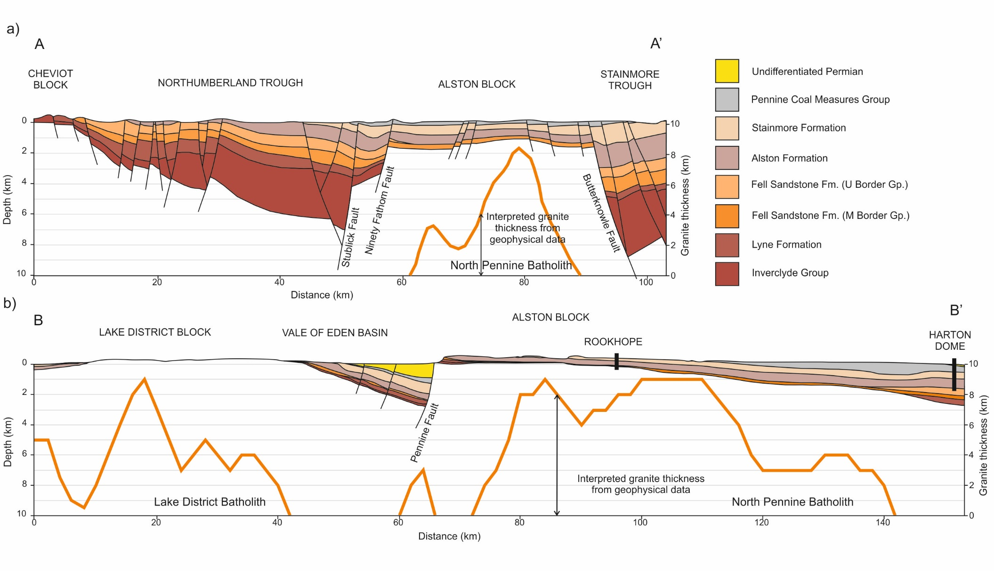

Figure 8 Cross-sections through northern England based on the structural interpretations of Chadwick et al. (1995). Granite thicknesses are based on the interpretations of gravity and magnetic anomaly data (Kimbell et al., 2006). 3D shapefiles courtesy of Terrington and Thorpe (2013). See figure 1 for a map view, including the locations of the cross-sections, and refer to figure 8 for a summary of the tectonostratigraphy of the study area. The true characteristics of a top or base granite profile are poorly constrained by geophysical data. The bases of both the Lake District and North Pennine Batholiths are widely assumed flat at around 9-12 km depth (Kimbell et al., 2010).

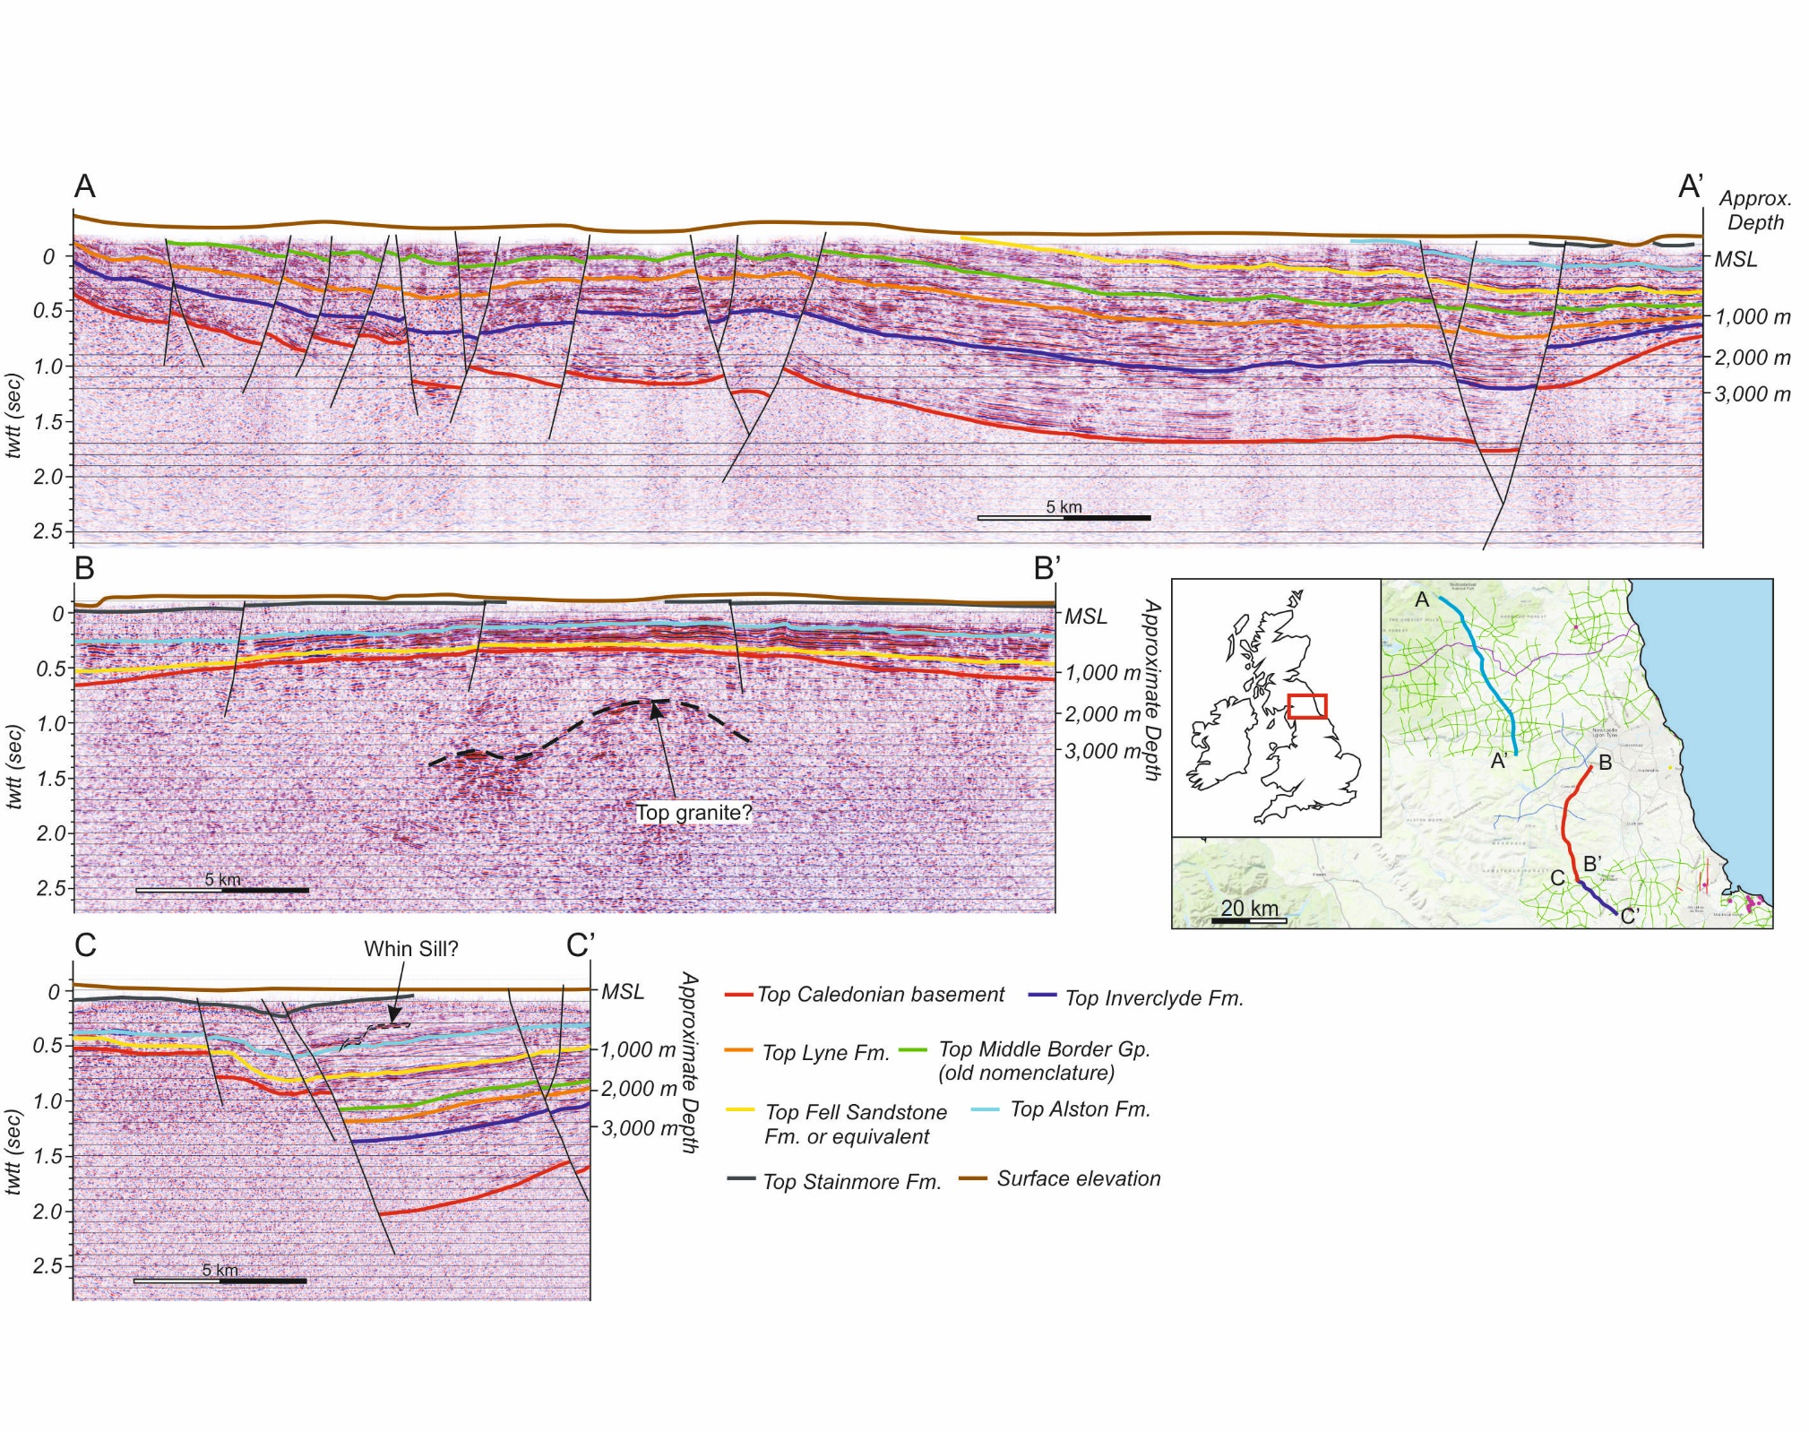

Figure 9. Seismic interpretations of the Northumberland Basin (A-A’), Alston Block (B-B’) and Stainmore Basin (C-C’) based on interpretations by Collier (1991), Chadwick et al (1995) and Butler and Jamieson (2013); Seismic lines TOC 86-V103, BGS-86-03 and UK 86-454 respectively. The location map shows the extent of onshore seismic within the study area. Seismic data and location map both come courtesy of the UK Onshore Geophysical Library (UKOGL).

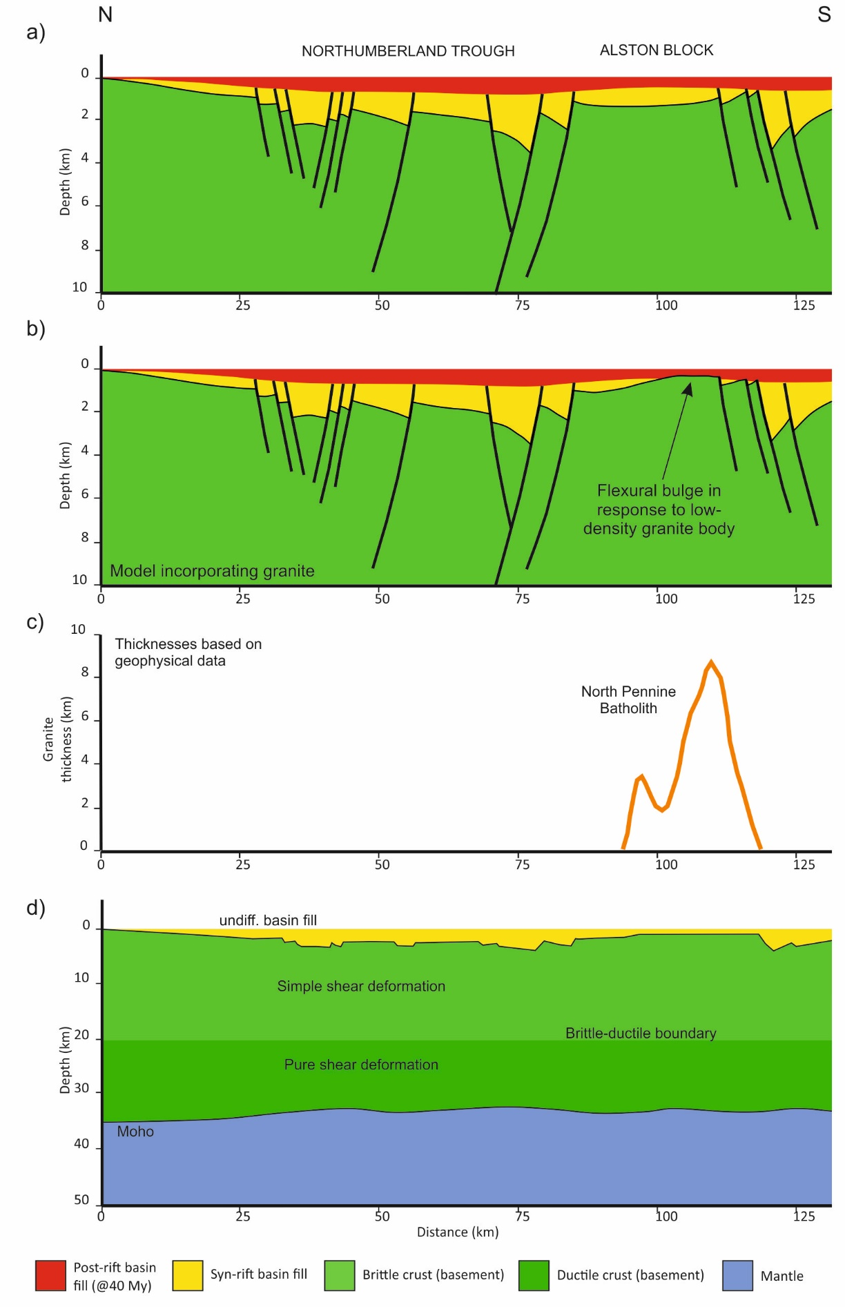

Figure 10. Model generated along the line of the cross-section presented in figure 8a across the Northumberland Trough and Alston Block. Fault locations and offsets (10a and b) are displayed in table 3 and are based upon the deep structural interpretations made by Chadwick et al. (1995). 10-b incorporates a granite thickness profile (10c) based upon the interpretations of gravity and magnetic anomaly data (Kimbell et al., 2006). 10d shows the modelled lithosphere scale profile.

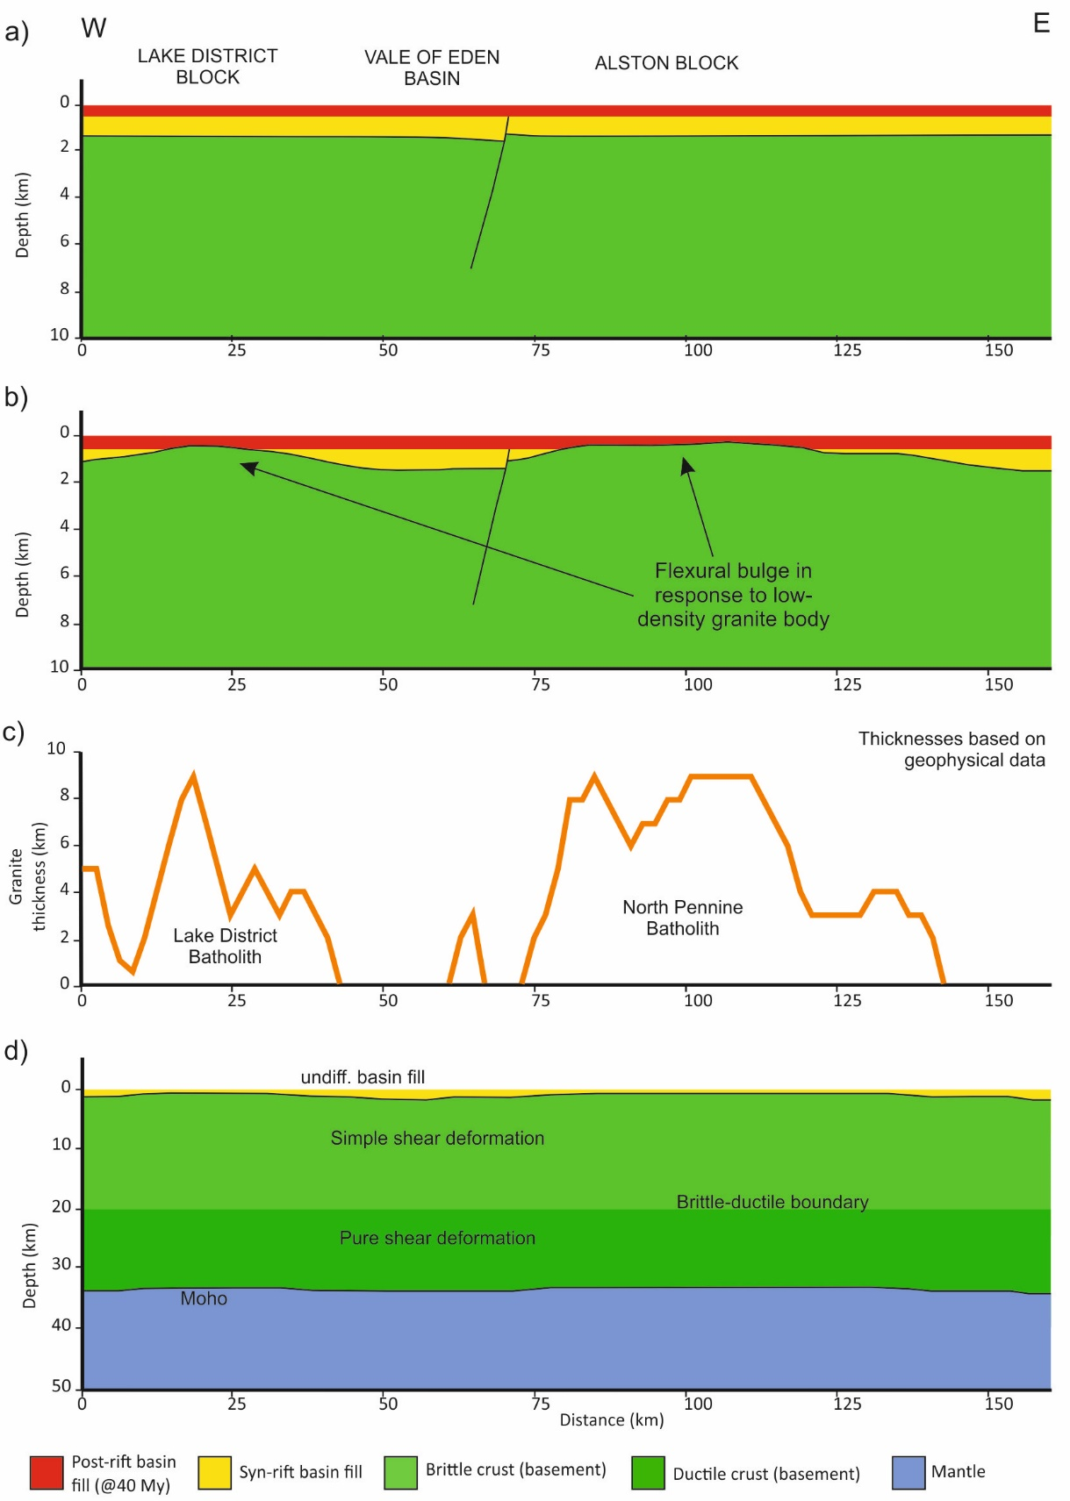

Figure 11. Model generated along the line of the cross-section presented in figure 8b. The only fault included within the model is the Pennine Fault, across which the Carboniferous strata barely thicken, suggesting little displacement during this period. Profile b incorporates a granite thickness profile (c) based upon the interpretations of gravity and magnetic anomaly data (Kimbell et al., 2006). Profile d shows the modelled lithosphere-scale profile.

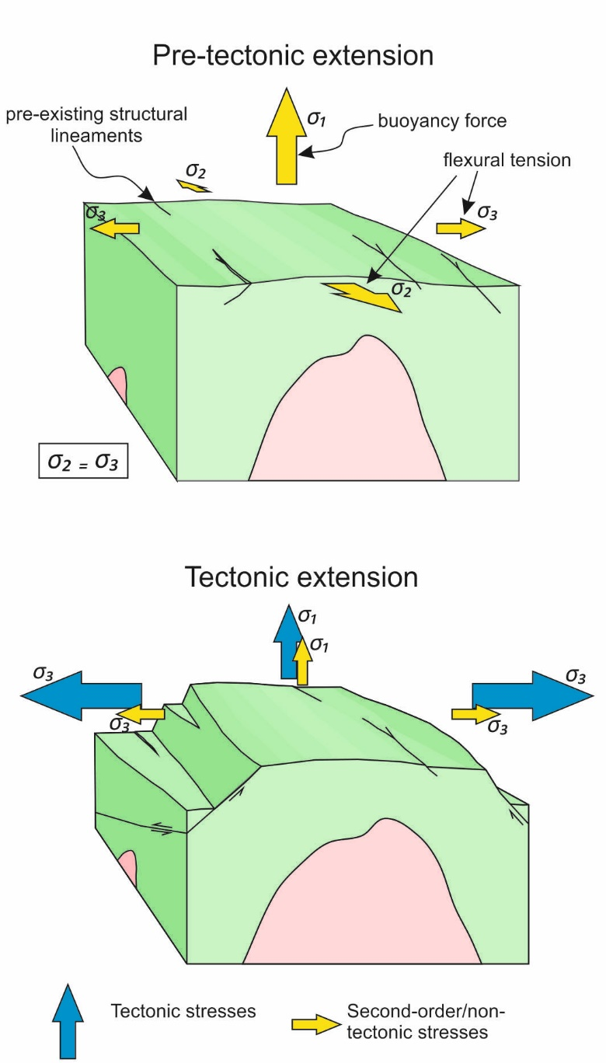

Figure 12. A schematic illustration of the stress conditions before (top) and after (bottom) tectonically-induced extensional faulting. Yellow arrows indicate ‘second-order’ stresses (e.g. Sonder, 1990; Zoback, 1992) whilst blue arrows indicate tectonic stresses. It is proposed that the combination of ‘buoyancy’ forces, flexural tensile stress and horizontal tectonically-induced extensional stress constructively interfere during extensional tectonism, creating localised stress conditions favourable to the reactivation of inherited (i.e. Caledonian) lineaments. Buoyancy-related second-order stresses are at least partially relieved during tectonic extension, which permits more complete isostatic compensation of the granite-cored block.

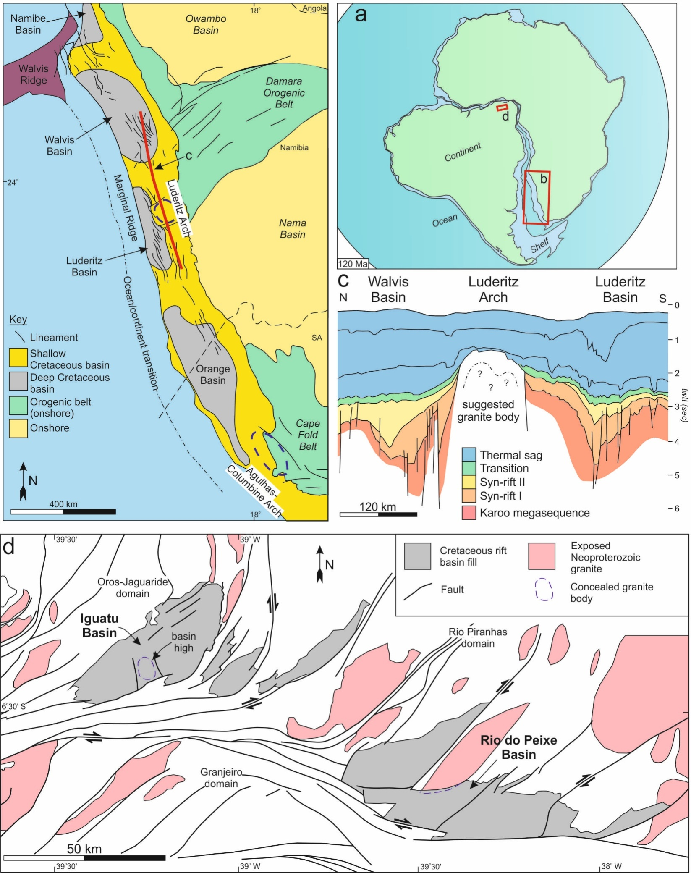

Figure 13a. A palaeo-tectonic reconstruction of the African and South American margin during the Creataceous and location map. 13b. A location and structure map for the western margin of southern Africa. The two highs highlighted are believed to be underpinned by ‘buoyant’ granite (Scrutton and Dingle, 1976; Dingle, 1992). Modified after Light et al. (1993), Clemson et al. (1997) and de Vera et al. (2010). 13c. A cross-section intersecting the Luderitz arch, which is suggested to be underpinned by buoyant granite (Dingle, 1992). Modified after Light et al. (1993). A cross-section intersecting the Luderitz arch, which is suggested to be underpinned by buoyant granite (Dingle, 1992). Modified after Light et al. (1992). 13d. A simplified geological map of the Iguatu and Rio do Peixe Basins of NE Brazil. Modified after De Castro et al. (2007; 2008).

# References

Airy, G.B., 1855. On the computation of the effect of the attraction of mountain-masses, as disturbing the apparent astronomical latitude of stations in geodetic surveys. Philosophical Transactions of the Royal Society of London, 145, pp.101-104.

Allsop, J.M., 1987. Patterns of late Caledonian intrusive activity in eastern and northern England from geophysics, radiometric dating and basement geology. *Proceedings of the Yorkshire Geological Society*, 46(4), pp.335-353.

Arsenikos, S., Quinn, M., Kimbell, G., Williamson, P., Pharaoh, T., Leslie, G. and Monaghan, A., 2018. Structural development of the Devono-Carboniferous plays of the UK North Sea. *Geological Society, London, Special Publications*, *471*, pp.SP471-3.

Arthaud, M.H., Vasconcelos, A.M., Nogueira Neto, J.A., Oliveira, F.V.C., Parente, C.V., Monié, P., Liégeois, J.P., Caby, R. and Fetter, A.H., 1998. Main structural features of Precambrian domains from Ceará (NE Brazil). In *International Conference on Basement Tectonics, 14th, Ouro Preto, Abstracts* (pp. 84-85).

Besly, B.,2018. Exploration and development in the Carboniferous of the southern North Sea: a 30 year retrospective. To Palaeozoic Plays of NW Europe, In: Monaghan, A.A., Underhill, J.R., Marshall, J., Hewett, A., (Eds.), Geological Society of London, Special Publication.

Bott, M.H.P., Day, A.A. and Masson-Smith, D., 1958. The geological interpretation of gravity and magnetic surveys in Devon and Cornwall. Phil. Trans. R. Soc. Lond. A, 251(992), pp.161-191.

Bott, M.P. and Smithson, S.B., 1967. Gravity investigations of subsurface shape and mass distributions of granite batholiths. Geological Society of America Bulletin, 78(7), pp.859-878.

Bott, M.H.P., Robinson, J. and Kohnstamm, M.A., 1978. Granite beneath Market Weighton, east Yorkshire. Journal of the Geological Society, 135(5), pp.535-543.

British Geological Survey, 2008. DiGmapGB-250 [SHAPE geospatial data], Scale 1:250000, Tiles: sd,sc,sj,sh,se,tf,sk,ta, Updated: 1 November 2008, BGS, Using: EDINA Geology Digimap Service, <http://digimap.edina.ac.uk>, Downloaded: 2018-02-16 09:11:02.065.

Brodie, J. and White, N., 1994. Sedimentary basin inversion caused by igneous underplating: Northwest European continental shelf. Geology, 22(2), pp.147-150.

Bouchez, J.L., 1997. Granite is never isotropic: an introduction to AMS studies of granitic rocks. In *Granite: from segregation of melt to emplacement fabrics* (pp. 95-112). Springer, Dordrecht.

Burov, E.B. and Diament, M., 1995. The effective elastic thickness (T e) of continental lithosphere: what does it really mean? *Journal of Geophysical Research: Solid Earth*, *100*(B3), pp.3905-3927.

Butler, M. and Jamieson, R., 2013. Preliminary Interpretation of Six Regional Seismic Profiles Across Onshore Basins of England.

Chadwick, R.A., Pharaoh, T.C. and Smith, N.J.P., 1989. Lower crustal heterogeneity beneath Britain from deep seismic reflection data. *Journal of the Geological Society*, *146*(4), pp.617-630.

Chadwick, B.A., Holliday, D.W., Holloway, S., Hulbert, A.G. and Lawrence, D.J.D., 1995. *The structure and evolution of the Northumberland-Solway Basin and adjacent areas*. London: HMSO.

Chroston, P.N., Allsop, J.M. and Cornwell, J.D., 1987. New seismic refraction evidence on the origin of the Bouguer anomaly low near Hunstanton, Norfolk. *Proceedings of the Yorkshire Geological Society*, *46*(4), pp.311-319.

Clemson, J., Cartwright, J. and Booth, J., 1997. Structural segmentation and the influence of basement structure on the Namibian passive margin. *Journal of the Geological Society*, *154*(3), pp.477-482.

Collier, R.L., 1991. The Lower Carboniferous Stainmore Basin, N. England: extensional basin tectonics and sedimentation. *Journal of the Geological Society*, *148*(2), pp.379-390.

Cooley, J.W. and Tukey, J.W., 1965. An algorithm for the machine calculation of complex Fourier series. *Mathematics of computation*, *19*(90), pp.297-301.

Corfield, S.M., Gawthorpe, R.L., Gage, M., Fraser, A.J. and Besly, B.M., 1996. Inversion tectonics of the Variscan foreland of the British Isles. *Journal of the Geological Society*, *153*(1), pp.17-32.

Coward, M.P., 1993. The effect of Late Caledonian and Variscan continental escape tectonics on basement structure, Paleozoic basin kinematics and subsequent Mesozoic basin development in NW Europe. In *Geological Society, London, Petroleum Geology Conference series* (Vol. 4, No. 1, pp. 1095-1108). Geological Society of London.

Coward, M.P., 1995. Structural and tectonic setting of the Permo-Triassic basins of northwest Europe. Geological Society, London, Special Publications, 91(1), pp.7-39.

Cowie, P.A., Gupta, S. and Dawers, N.H., 2000. Implications of fault array evolution for synrift depocentre development: insights from a numerical fault growth model. *Basin Research*, *12*(3-4), pp.241-261.

Davydov, V.I., Korn, D., Schmitz, M.D., Gradstein, F.M. and Hammer, O., 2012. The carboniferous period. In *The geologic time scale* (pp. 603-651).

Day, J.B.W., 1970. Geology of the country around Bewcastle. *Memoires of the Geological Survey of Great Britain*, pp.95-99.

Dean, M.T., Browne, M.A.E., Waters, C.N. and Powell, J.H., 2011. A lithostratigraphical framework for the Carboniferous successions of northern Great Britain (onshore). British Geological Survey.

Dewey, J.F., 1982. Plate tectonics and the evolution of the British Isles: Thirty-fifth William Smith Lecture. *Journal of the Geological Society*, *139*(4), pp.371-412.

de Saint-Blanquat, M., Law, R.D., Bouchez, J.L. and Morgan, S.S., 2001. Internal structure and emplacement of the Papoose Flat pluton: An integrated structural, petrographic, and magnetic susceptibility study. Geological Society of America Bulletin, 113(8), pp.976-995.

de Castro, D.L., de Oliveira, D.C. and Branco, R.M.G.C., 2007. On the tectonics of the Neocomian Rio do Peixe Rift Basin, NE Brazil: Lessons from gravity, magnetics, and radiometric data. Journal of South American Earth Sciences, 24(2-4), pp.184-202.

de Castro, D.L., Bezerra, F.H. and Branco, R.M.C., 2008. Geophysical evidence of crustal-heterogeneity control of fault growth in the Neocomian Iguatu basin, NE Brazil. Journal of South American Earth Sciences, 26(3), pp.271-285.

De Vera, J., Granado, P. and McClay, K., 2010. Structural evolution of the Orange Basin gravity-driven system, offshore Namibia. *Marine and Petroleum Geology*, *27*(1), pp.223-237.

Dimitropoulos, K. and Donato, J.A., 1981. The inner moray firth central ridge, a geophysical interpretation. *Scottish Journal of Geology*, *17*(1), pp.27-38.

Dingle, R.V., 1992. Structural and sedimentary development of the continental margin off southwestern Africa. *Communications of the Geological Survey of Namibia*, *8*, pp.35-43.

Donato, J.A., Tully, M.C., Illing, L.V. and Hobson, G.D., 1981. A regional interpretation of North Sea gravity data. *Petroleum geology of the continental shelf of North-West Europe*, pp.65-75.

Donato, J.A., Martindale, W. and Tully, M.C., 1983. Buried granites within the Mid North Sea High. *Journal of the Geological Society*, *140*(5), pp.825-837.

Donato, J.A. and Megson, J.B., 1990. A buried granite batholith beneath the East Midland Shelf of the Southern North Sea Basin. Journal of the Geological Society, 147(1), pp.133-140.

Donato, J.A., 1993. A buried granite batholith and the origin of the Sole Pit Basin, UK Southern North Sea. Journal of the Geological Society, 150(2), pp.255-258.

Dunham, K.C., Johnson, G.A.L., Bott, M.H.P. and Hodge, B.L., 1961. Granite beneath the northern Pennines. *Nature*, *190*(4779), p.899.

Dunham, K.C., Dunham, A.C., Hodge, B.L. and Johnson, G.A.L., 1965. Granite beneath Viséan sediments with mineralization at Rookhope, northern Pennines. *Quarterly Journal of the Geological Society*, *121*(1-4), pp.383-414.

Egan, S.S., 1992. The flexural isostatic response of the lithosphere to extensional tectonics. *Tectonophysics*, *202*(2-4), pp.291-308.

Egan, S.S. and Urquhart, J.M., 1993. Numerical modelling of lithosphere shortening: application to the Laramide erogenic province, western USA. *Tectonophysics*, *221*(3-4), pp.385-411.

Egan, S.S. and Meredith, D.J., 2007. A kinematic modelling approach to lithosphere deformation and basin formation: application to the Black Sea. *Geological Society, London, Special Publications*, *282*(1), pp.173-198.

Fraser, A.J. and Gawthorpe, R.L., 1990. Tectono-stratigraphic development and hydrocarbon habitat of the Carboniferous in northern England. *Geological Society, London, Special Publications*, *55*(1), pp.49-86.

Fraser, A.J. and Gawthorpe, R.L., 2003. *An atlas of Carboniferous basin evolution in northern England*. Geological Society.

George, T.N., 1958. Lower Carboniferous palaeogeography of the British Isles. *Proceedings of the Yorkshire Geological Society*, *31*(3), pp.227-318.

Green, P.F., 2002. Early Tertiary paleo-thermal effects in Northern England: reconciling results from apatite fission track analysis with geological evidence. *Tectonophysics*, *349*(1-4), pp.131-144.

Harris, C., Faure, K., Diamond, R.E. and Scheepers, R., 1997. Oxygen and hydrogen isotope geochemistry of S-and I-type granitoids: the Cape Granite suite, South Africa. *Chemical Geology*, *143*(1-2), pp.95-114.

Haszeldine, R.S., 1984. Carboniferous North Atlantic palaeogeography: stratigraphic evidence for rifting, not megashear or subduction. Geological Magazine, 121(5), pp.443-463.

Holford, S.P., Green, P.F., Turner, J.P., Williams, G.A., Hillis, R.R., Tappin, D.R. and Duddy, I.R., 2008. Evidence for kilometre-scale Neogene exhumation driven by compressional deformation in the Irish Sea basin system. *Geological Society, London, Special Publications*, *306*(1), pp.91-119.

Johnson, G.A.L., 1967. Basement control of Carboniferous sedimentation in northern England. *Proceedings of the Yorkshire Geological Society*, *36*(2), pp.175-194.

Jung, S., Hoernes, S. and Mezger, K., 2000. Geochronology and petrogenesis of Pan-African, syn-tectonic, S-type and post-tectonic A-type granite (Namibia): products of melting of crustal sources, fractional crystallization and wall rock entrainment. *Lithos*, *50*(4), pp.259-287.

Karner, G.D. and Watts, A.B., 1982. On isostasy at Atlantic‐type continental margins. Journal of Geophysical Research: Solid Earth, 87(B4), pp.2923-2948.

Kimbell, G.S., Chadwick, R.A., Holliday, D.W. and Werngren, O.C., 1989. The structure and evolution of the Northumberland Trough from new seismic reflection data and its bearing on modes of continental extension. Journal of the Geological Society, 146(5), pp.775-787.

Kimbell, G., Carruthers, R.M., Walker, A. and Williamson, J.P., 2006. Regional geophysics of southern Scotland and Northern England.

Kimbell, G.S., Young, B., Millward, D. and Crowley, Q.G., 2010, November. The North Pennine batholith (Weardale Granite) of northern England: new data on its age and form. Geological Society of London.

Kimbell, G.S. and Williamson, J.P., 2015. A gravity interpretation of the Central North Sea.

Kombrink, H., Leever, K.A., Van Wees, J.D., Van Bergen, F., David, P. and Wong, T.E., 2008. Late Carboniferous foreland basin formation and Early Carboniferous stretching in Northwestern Europe: inferences fromquantitative subsidence analyses in the Netherlands. *Basin Research*, *20*(3), pp.377-395.

Kooi, H., Cloetingh, S. and Burrus, J., 1992. Lithospheric necking and regional isostasy at extensional basins 1. Subsidence and gravity modeling with an application to the Gulf of Lions margin (SE France). Journal of Geophysical Research: Solid Earth, 97(B12), pp.17553-17571.

Kusky, T.M. and Polat, A., 1999. Growth of granite–greenstone terranes at convergent margins, and stabilization of Archean cratons. *Tectonophysics*, *305*(1-3), pp.43-73.

Kusznir, N.J. and Park, R.G., 1987. The extensional strength of the continental lithosphere: its dependence on geothermal gradient, and crustal composition and thickness. *Geological Society, London, Special Publications*, *28*(1), pp.35-52.

Kusznir, N.J. and Egan, S.S., 1989. Simple-Shear and Pure-Shear Models of Extensional Sedimentary Basin Formation: Application to the Jeanne d'Arc Basin, Grand Banks of Newfoundland: Chapter 20: North American Margins.

Kusznir, N.J., Marsden, G. and Egan, S.S., 1991. A flexural-cantilever simple-shear/pure-shear model of continental lithosphere extension: applications to the Jeanne d’Arc Basin, Grand Banks and Viking Graben, North Sea. Geological Society, London, Special Publications, 56(1), pp.41-60.

Leeder, M.R., 1975. Pedogenic carbonates and flood sediment accretion rates: a quantitative model for alluvial arid-zone lithofacies. *Geological Magazine*, *112*(3), pp.257-270.

Leeder, M.R., 1982. Upper Palaeozoic basins of the British Isles—Caledonide inheritance versus Hercynian plate margin processes. Journal of the Geological Society, 139(4), pp.479-491.

Light, M.P.R., Maslanyj, M.P. and Banks, N.L., 1992. New geophysical evidence for extensional tectonics on the divergent margin offshore Namibia. *Geological Society, London, Special Publications*, *68*(1), pp.257-270.

Maclennan, J. and Lovell, B., 2002. Control of regional sea level by surface uplift and subsidence caused by magmatic underplating of Earth's crust. Geology, 30(8), pp.675-678.

McKenzie, D., 1978. Some remarks on the development of sedimentary basins. *Earth and Planetary science letters*, *40*(1), pp.25-32.

Meredith, D.J. and Egan, S.S., 2002. The geological and geodynamic evolution of the eastern Black Sea basin: insights from 2-D and 3-D tectonic modelling. *Tectonophysics*, *350*(2), pp.157-179.

Monaghan, A.A. and Parrish, R.R., 2006. Geochronology of Carboniferous–Permian magmatism in the Midland Valley of Scotland: implications for regional tectonomagmatic evolution and the numerical time scale. *Journal of the Geological Society*, *163*(1), pp.15-28.

Murchison, D., 2004. Aberrations in the coalification patterns of the offshore coalfields of Northumberland and Durham, United Kingdom. *International journal of coal geology*, *58*(3), pp.133-146.

Nicol, A., Walsh, J.J., Manzocchi, T. and Morewood, N., 2005. Displacement rates and average earthquake recurrence intervals on normal faults. Journal of Structural Geology, 27(3), pp.541-551.

Parsons, B. and Sclater, J.G., 1977. An analysis of the variation of ocean floor bathymetry and heat flow with age. Journal of geophysical research, 82(5), pp.803-827.

Peace, G.R. and Besly, B.M., 1997. End-Carboniferous fold-thrust structures, Oxfordshire, UK: implications for the structural evolution of the late Variscan foreland of south-central England. *Journal of the Geological Society*, *154*(2), pp.225-237.

Pharaoh, T., England, R. and Lee, M., 1995. The concealed Caledonide basement of eastern England and the southern North Sea—a review. *Studia geophysica et geodaetica*, *39*(3), pp.330-346.

Pratt, J.H., 1858. The deflection of the plumb-line in India and the compensatory effect of a deficiency of matter below the Himalaya mountains. Philos Trans R So London, 149, pp.745-778.

Ridd, M.F., Walker, D.B. and Jones, J.M., 1970. A deep borehole at Harton on the margin of the Northumbrian Trough. *Proceedings of the Yorkshire Geological Society*, *38*(1), pp.75-103.

Royden, L. and Keen, C.E., 1980. Rifting process and thermal evolution of the continental margin of eastern Canada determined from subsidence curves. Earth and Planetary Science Letters, 51(2), pp.343-361.

Schoene, B., de Wit, M.J. and Bowring, S.A., 2008. Mesoarchean assembly and stabilization of the eastern Kaapvaal craton: A structural‐thermochronological perspective. *Tectonics*, *27*(5).

Scrutton, R.A. and Dingle, R.V., 1976. Observations on the processes of sedimentary basin formation at the margins of southern Africa. In *Developments in Geotectonics* (Vol. 12, pp. 143-156). Elsevier.

Sonder, L.J., 1990. Effects of density contrasts on the orientation of stresses in the lithosphere: Relation to principal stress directions in the Transverse Ranges, California. *Tectonics*, *9*(4), pp.761-771.

Stein, S., Cloetingh, S., Sleep, N.H. and Wortel, R., 1989. Passive margin earthquakes, stresses and rheology. In *Earthquakes at North-Atlantic Passive Margins: Neotectonics and Postglacial Rebound* (pp. 231-259). Springer, Dordrecht.

Stone, P., Millward, D., Young, B., Merritt, J., Clarke, S., McCormac, M. and Lawrence, D., 2010. Northern England. British Geological Survey.

Terrington, R.L. and Thorpe, S., 2013. Metadata report for the Northumberland and Solway Basin 1: 250 000 geological model.

Thomas, R.J., Von Veh, M.W. and McCourt, S., 1993. The tectonic evolution of southern Africa: an overview. *Journal of African Earth Sciences (and the Middle East)*, *16*(1-2), pp.5-24.

Veevers, J.J., 2006. Updated Gondwana (Permian–Cretaceous) earth history of Australia. *Gondwana Research*, *9*(3), pp.231-260.

Verrall, P., 1982. Structural interpretation with applications to North Sea problems: Geological Society of London Course Notes No 3. *JAPEC (UK)*.

Waters, C., Browne, M., Dean, M. and Powell, J., 2007. *Lithostratigraphical framework for Carboniferous successions of Great Britain (onshore)*. British Geological Survey.

Watts, A.B., Bodine, J.H. and Steckler, M.S., 1980. Observations of flexure and the state of stress in the oceanic lithosphere. *Journal of Geophysical Research: Solid Earth*, *85*(B11), pp.6369-6376.

Watts, A.B. and Zhong, S., 2000. Observations of flexure and the rheology of oceanic lithosphere. *Geophysical Journal International*, *142*(3), pp.855-875.

Watts, A.B., 2001. *Isostasy and Flexure of the Lithosphere*. Cambridge University Press.

White, N.J., Jackson, J.A. and McKenzie, D.P., 1986. The relationship between the geometry of normal faults and that of the sedimentary layers in their hanging walls. *Journal of Structural Geology*, *8*(8), pp.897-909.

Ziegler, P.A., Cloetingh, S. and van Wees, J.D., 1995. Dynamics of intra-plate compressional deformation: the Alpine foreland and other examples. *Tectonophysics*, *252*(1-4), pp.7-59.

Zoback, M.L., 1992. First‐and second‐order patterns of stress in the lithosphere: The World Stress Map Project. *Journal of Geophysical Research: Solid Earth*, *97*(B8), pp.11703-11728.