**Quantification of interlinked environmental footprints on a sustainable university campus: a nexus analysis perspective [1]**

Yifan Gua, Hongtao Wanga, Jin Xua, Ying Wanga, Xin Wangc,*, Zoe P. Robinsonb,*, Fengting Lia,d,*, Jiang Wuc, Jianguo Tand, Xing Zhid

aState Key Laboratory of Pollution Control and Resource Reuse, College of Environmental Science and Engineering, Tongji University, 1239 Siping Road, Shanghai 200092, China

bSchool of Geography, Geology and the Environment, Keele University, Keele, Staffordshire ST5 5BG, UK

cCollege of Architecture and Urban Planning, Tongji University, 1239 Siping Road, Shanghai 200092, China

dKey Laboratory of Cities Mitigation and Adaptation to Climate Change in Shanghai (CMACC), Shanghai Climate Center, Shanghai Meteorological Service, Shanghai, 200030, China

*Corresponding author:

Xin Wang: xin_wang@tongji.edu.cn

Zoe P.Robinson: z.p.robinson@keele.ac.uk

Fengting Li: fengting@tongji.edu.cn

Abstract: Developing a nexus approach to the quantitative analysis of different environmental sectors including energy, water and carbon emissions is important for promoting integrated sustainable management at a community scale. Universities can be considered small communities in themselves, providing access to data at the community scale, as well as contributing to global sustainability through their education, research and the operation of their own estate. In this study, we developed a conceptual nexus analytical framework based on the combination of different environmental footprints to assess how universities, as an example of a small community, interact with the hydrological cycle, energy resources and climate, through their operations and food procurement. Using Keele University in the United Kingdom as an example, the total energy footprint, carbon footprint and water footprint in the 2015/16 academic year was 42,202 MWh, 14,393 tonnes of CO2e and 532,415 m3. Through the quantification of these interlinked environmental footprints, the nexus across water, energy, waste disposal, food procurement, and corresponding carbon emissions at Keele University have been explored. Based on the results of the nexus analysis and identifying the areas of greatest environmental benefit studied, policy suggestions are provided including: implementing energy control systems; maximising the development of wind energy and solar photovoltaic; increasing the availability of vegetable-based options in food procurement decisions; and collecting all of the food waste for anaerobic digestion. The findings serve as a reference for policy-makers and practitioners making decisions on the basis of sustainability in universities and other communities.

Keywords: Environmental impacts; Nexus analysis; Energy footprint; Water footprint; Carbon footprint; Sustainable campus

|  |  |
| --- | --- |
| **Abbreviations:** | |
| CEWEP | Confederation of European Waste-to-Energy Plants |
| CF | Carbon footprint |
| CHP | Combined heat and power |
| CRC | Carbon Reduction Commitment |
| DEF | Direct energy footprint |
| DWF | Direct water footprint |
| EC | Amount of energy consumed |
| EnF | Energy footprint |
| EU | European Union |
| HEFCE | Higher education funding council for England |
| FP | Amount of each kind of food procured |
| IEF | Indirect energy footprint |
| LCA | Life cycle analysis |
| PV | Photovoltaic |
| SCP | Sustainable consumption and production |
| SDG | United Nation’s Sustainable Development Goal |
| SEND | Smart energy network demonstrator |
| UCWE | Unit consumptive water footprint of different energy |
| UCWF | Unit consumptive water footprint of different food |
| UK | The United Kingdom |
| WF | Water footprint |

# **1 Introduction**

The importance of sustainable development with respect to environmental and social issues has been recognised for several decades [1]. Considering the global resource consumption challenges we face, development of more sustainable consumption and production (SCP) practices is an essential part of the sustainable development agenda as discussed at the United Nations’ Conference on Sustainable Development (‘Rio + 20’) in 2012 [2] and reflected in the United Nations’ Sustainable Development Goals (SDGs) 12 ‘Responsible Consumption and Production’ [3]. In addition, the development of sustainable cities and communities features as another SDG (SDG 11), aimed at reducing environmental impacts and adopting integrated policies towards (amongst others) resource efficiency and climate change mitigation and adaptation at the city and community scale [3]. Achieving a more sustainable future at the community or wider scale based on resource efficiency and sustainable consumption practices requires integrated consideration of multiple interlinked sectors (e.g. energy, water and food) [4]. Therefore, comprehensive understanding of the nexus across these sectors in order to jointly improve their performance can be considered as an important conceptual tool for achieving sustainable development at from the local community to global scale [5].

Although nexus analysis is recognised as a potentially effective approach to comprehensively determine interactions across different environmental sectors, nexus analysis approaches are still in their infancy and need to be further developed [6]. To date, diverse methods, including environmental footprint methodologies [7], input-output analysis [8], life cycle analysis (LCA) [9] and integrated ecosystem management [10] have been proposed and developed as nexus analysis approaches. Among them, environmental footprint methodologies have proved a valuable quantitative nexus-analysis tool. Over recent decades, various forms of ‘environmental footprints’ have been widely used to quantitatively assess different anthropogenic pressures associated with different environmental dimensions [11]. For example, a particular human activity under investigation, a water footprint (WF) quantifies fresh water use and water pollution [12], an energy footprint (EnF) maps the energy directly and indirectly required [13], and a carbon footprint (CF) measures CO2 emissions, or total greenhouse gas emissions normalised to CO2 and presented as CO2 equivalents (CO2e) [14]. None of the indicators mentioned above can substitute one another, as each one provides specific information on one environmental dimension [11]. Previous researchers have made efforts to improve footprint methodologies from LCA perspective to address the nexus among different sectors (e.g. energy for water treatment [15] and water for energy production [16]). However, each footprint indicator only focuses on one environmental concern and therefore cannot comprehensively assess the full complexity or multi-dimensional environmental impacts of human activities [7]. To fill this knowledge gap, integration of different environmental footprints into one consistent analytical framework provides a potential approach to better determine the trade-offs and synergies across multiple sectors [11].

The majority of research looking at the nexus between different footprints, has been focused at a national scale [17, 18] or speciﬁc production process (e.g. electricity generation [19] and urban water system [20, 21]), with little research at the community scale, and the breadth of integrated footprints occurring at this scale [22, 23]. Three and a half billion people (half of the world’s population) live in cities [24]. Cities occupy just 3% of the Earth’s land but account for 60-80% of energy consumption and 75% of carbon emissions [24], highlighting the role of city-based sustainability solutions. However, smaller communities have also often been at the forefront of sustainable transitions, for example, the now global Transition Town movement has pioneered community-scale integrated approaches to addressing the energy, climate, and food crises that the world faces [25]. In addition, since many environmental issues often manifest at a local level, community-scale sustainable practices are important for achieving global sustainability [26]. Universities are substantial organisations equivalent to the scale of small to medium towns in terms of the numbers in their communities and their physical size, and their complex mix of services and functions including education, commercial activities, catering, retail, medical and recreational facilities, as well as their sizeable infrastructure. As universities often own their own infrastructure and collect their own data across these many services and functions, they make ideal ‘living laboratories’ to study environmental impacts, interactions and solutions, at the community/small town-scale. With over 13,000 universities worldwide and growing numbers of higher education institutions particularly in developing countries with pressing environmental problems, the environmental impacts of universities cannot be ignored [27]. Despite the significant impact on natural resource use associated with universities worldwide, there is also growing awareness of the significant role that universities have to play through their education and research activities in contributing to sustainable development objectives [28, 29]. Developing ‘sustainable universities’ therefore has a significant role to play in achieving the SDGs, and the focus of ‘sustainable campuses/universities’ takes into account the educational and research missions of universities as well as their operational aspects [30]. In addition, there is growing interest in how universities provide useful ‘test beds’ for understanding and developing more sustainable practices and designs with their access to data across the scale of a town [31, 32].

In order to ensure optimal efficiency in reducing the resource use and environmental impacts of a university’s operations, a wide range of aspects needs to be considered including carbon emissions, energy and water efficiency, wastewater discharge and treatment, waste management, as well as indirect impacts related to other activities such as procurement of food for university catering outlets [33]. These sectors are closely related and impact each other, yet the integrated management and nexus across these sectors has yet to be explored in the context of university campuses, meaning that management focused on one sector can overlook impacts elsewhere. For example, Ozawa-Meida et al. [34] studied the carbon footprint of De Montfort University to gain a better understanding of their major greenhouse gas emissions and to give recommendations to reduce these emissions. But they did not link this to other environmental concerns such as water. Therefore, focused management on a single are of environmental impact may lead to less effective decision making, because the complex interdependencies between these different aspects are not considered. This lack of research into the nexus across energy, water, waste, food, and carbon emissions and integrated environmental decision making on university campuses, as well as the significant worldwide impact of this sector, make it important to establish a comprehensive evaluation system and methodology to assess the sustainability of university campus operations, and develop a methodology that can be used at a community scale.

In this study, a conceptual nexus analytical framework based on the interlinked environmental footprints of energy, water and carbon is proposed to systematically and comprehensively understand the nexus across five core sectors (energy, water, waste, food procurement and carbon emissions) in a university campus. Quantification of these interlinked environmental footprints is carried out to assess how universities interact with the hydrological cycle, energy resources and climate, through both their direct infrastructure (waste, water energy) management and the major operational area of food procurement. This study uses Keele Unversity in the United Kingdom (UK) as a case study to explore the use of this integrative environmental footprint framework analysis to assess the environmental sustainability of the university and its operations, as an analogue to a small town community. This selected case university owns its own services and utilities across its large mixed-use campus, allowing data access relating to different environmental footprints to be captured at the scale of a more heterogeneously managed and monitored small town. To the best of our knowledge, this paper represents the first example to assess the holistic environmental impacts of a university campus through an integrative nexus analysis based on a footprint framework. Policy suggestions for sustainable campus development are provided based on the nexus analysis results in this work. We believe that this method will contribute to the development of environmental footprint assessments and nexus approaches, and the findings could serve as reference for policy makers interested in assessing the more complete environmental impacts of analogous institutions and small towns, as well as for those interested in developing more sustainable campuses or other communities.

# **2 Material and methods**

# **2.1 Description of case study**

Keele University is a public research university located in North Staffordshire, England. Keele University occupies an independent 2,500,000 m2 (615 acre) rural campus with extensive lawns, woodlands and lakes (as shown in Figure 1). With academic, administrative, leisure and retail facilities across 341 buildings including student resident buildings with almost 3000 study bedrooms for students and 189 staff residential properties from flats to detached houses for staff residents, plus 20 business in varying industries in five commercial buildings, Keele University provides an important case study environment as it is similar to a small-town ecosystem, but as a single organisation, monitors and manages all of the services used by the university. In the academic year of 2015/16 (from August 1st 2015 to July 31st, 2016) for which data for this study was used, Keele University had a population of 9641 students and 1687 staff in total.

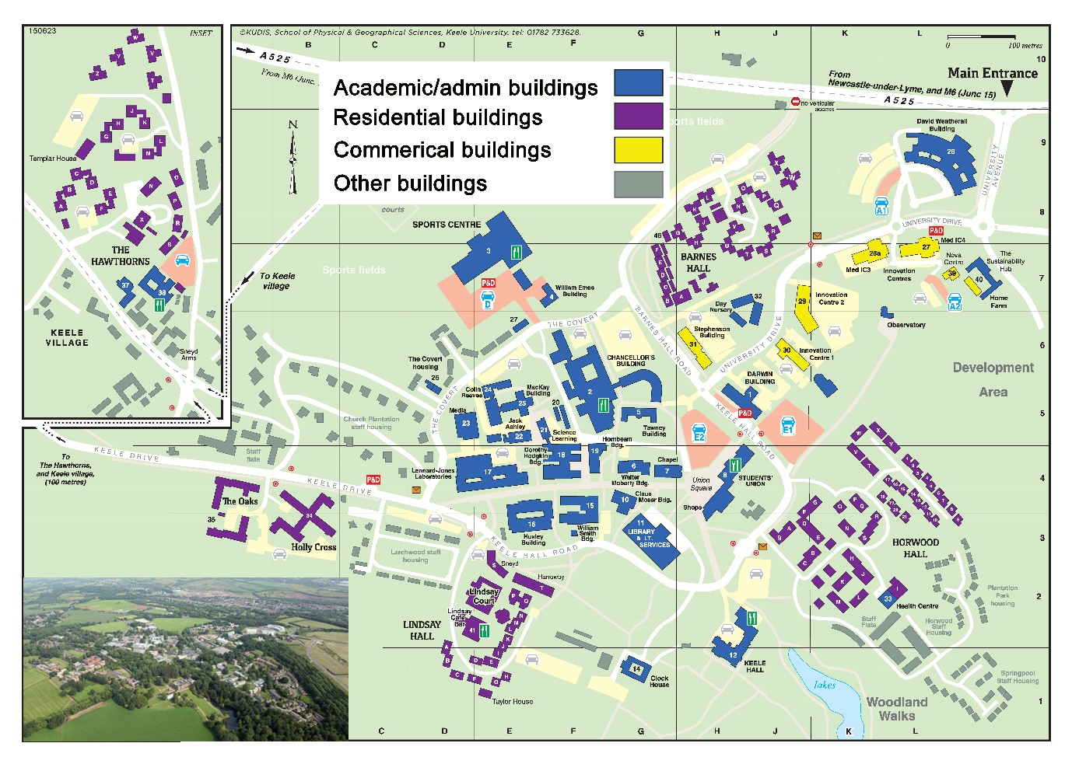

Figure 1. Map of Keele University (inset: aerial picture of Keele University)

The university has implemented an accredited Environmental Management System (Acorn Standard-BS 8555) which provides a framework for managing the university’s environmental impact and directing continual improvement. In addition, Keele University is also developing significant energy infrastructure projects including a campus-wide ‘smart energy network demonstrator (SEND)’ designed to allow the testing of different smart energy technologies and governance structures, the integration of substantial renewable and low-carbon energy technologies [including wind power, solar photovoltaic (pv) and combined heat and power (CHP) and detailed high-resolution monitoring and control]. In addition, a one-year live trial, named HyDeploy, trialling the blending of 20% hydrogen into the gas grid will take place in 2018/19. The scale of this smart energy ‘test bed’ will be a European first and will allow other comparable communities to assess ways to install more efficient, sustainable, and smart energy networks. Therefore, due to the similarity to a small-town ecosystem, ownership of the independent management system and infrastructure, and the in progress campus-wide sustainable energy infrastructure projects, Keele University is selected as case for this study.

# **2.2 The nexus analytical framework based on environmental footprints and system boundaries.**

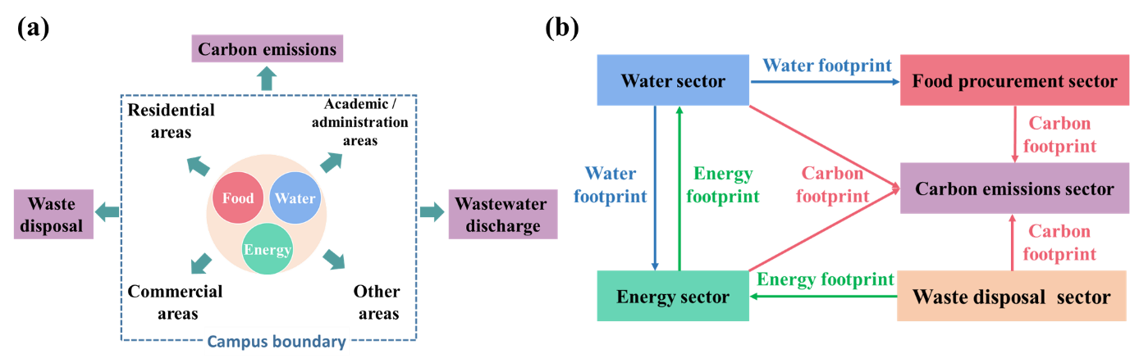

Figure 2. (a) System boundaries of this research, (b) nexus analytical framework across energy, water, food, waste and carbon emissions sectors based on environmental footprints

Figure 2a shows the system boundaries of this research. To understand the environmental impacts of a university based on a life cycle perspective, not only the energy, water and food-related consumption and procurement within the university are considered, but also the water, energy and food supply upstream, as well as wastewater and waste treatment outside the university are studied. Any life cycle analysis needs to decide on the boundaries of analysis, and given the long-life span of most universities and their building stock, environmental inputs and outputs associated with the construction and decommission of buildings on the university campus are considered to be a small fraction of the overall environmental footprint, and thus are not considered here. Figure 2b shows the nexus analytical framework based on the combination of environmental footprints proposed for analysis across five core sectors of sustainable campus management: energy supply, water supply and wastewater treatment, waste disposal, food procurement and carbon emissions. The energy and water sectors are inextricably intertwined, and are closely linked to the carbon emissions associated with the university campus. The production of water supply, water transportation and the treatment of wastewater all require significant energy consumption [35]. On the other hand, energy production needs significant fresh water consumption as well as causing thermal and chemical water pollution [36]. Hence the water footprint for energy production and the energy footprint for water supply and wastewater treatment are used to determine the energy-water nexus. Carbon emissions associated with energy consumption are a major concern in terms of climate change, with significant developments in national and international policy focussed on the requirement to rapidly reduce carbon emissions from all sectors [37, 38]. Both energy and carbon emissions are also connected closely to the waste management sector, as one of the best waste disposal method (after reduction and recycling) is recovering energy from wastes [39]. This synergistic link between energy and carbon emissions linked to the university’s operations and waste management practices is analysed within the energy footprint and carbon footprint. In addition, the environmental impact of universities is also significantly affected by their procurement decisions, of which food with its significant water consumption, energy input and carbon emission will contribute substantially, yet this is an area which is rarely considered in the universities’ management of environmental impacts. Hence, the food-water-carbon nexus can be determined by the water, energy and carbon footprints.

**2.3 Methods of environmental footprint calculations and data sources**

### 2.3.1 Energy footprint calculation

The total energy footprint (*EFtotal*) of Keele University calculated in this study is comprised of two components:

*EFtotal* =*DEF*+*SEF*

Where DEF is the direct energy footprint (energy consumed directly within campus), and SEFis the energy footprint of the supply chain associated with water supply, waste disposal and wastewater treatment. The energy footprint of the water sector is calculated based on reported water-energy nexus data from the UK [40]. Detailed results are shown in Table S1 in the supplementary material. The energy footprint of food waste used for anaerobic digestion is obtained from Biffa, the company which handled the food waste from Keele University in 2015/2016. The energy footprint of waste disposed of through incineration is calculated based on the “Cewep Energy Report III” provided by the Confederation of European Waste-to-Energy Plants (CEWEP) [41]. Details of the energy footprint from the waste treatment calculation results are shown in Table S2 in the supplementary material.

### 2.3.2 Carbon footprint calculation

The term ‘carbon footprint’ is used here to refer to total greenhouse gas emissions in carbon dioxide equivalents or CO2e. The total carbon footprint (CFtotal) of Keele University calculated here is composed of three components:

*CFtotal* =*CFscope*1 +*CFscope*2 +*CFscope*3

Where CFscope1 is the scope 1 carbon footprint referring to the direct emissions caused by fossil fuel consumption within the campus, associated with heating and organisation-owned transport (but omitting fugitive emissions, which would be included in a full scope 1 footprint). CFscope2 is the scope 2 carbon footprint referring to the indirect emissions caused by the electricity consumed by the university. The carbon footprint for scopes 1 (emissions from natural gas consumption) and 2 in the 2015/16 academic year was obtained from Keele University’s Carbon Reduction Commitment (CRC) report. The CRC is a national scheme which requires large organisations in the UK to measure and monitor their carbon emissions. The carbon footprint for scope 1 emissions from diesel and petrol consumption for owned transportation is calculated (as shown in Table S3 in the supplementary material) based on emission factors from *“Greenhouse gas reporting - conversion factors 2016”* provided by the Department for Business, Energy and Industrial Strategy, UK [42]. CFscope3 is the scope 3 carbon footprint including other indirect emission. This study only includes scope 3 emissions from water supply, wastewater treatment and waste disposal, as well as a measure from food procurement, due to the limitation of data availability of other areas of scope 3 emissions. The CFscope3 is calculated by:

CFscope3 =activity/consumption data × emissions factor

Emission factors for the calculation of emissions from water supply and wastewater treatment are based on *“Greenhouse gas reporting - conversion factors 2016”* provided by the Department for Business, Energy and Industrial Strategy, UK [42]. Detailed results are shown in Table S4 in the supplementary material. Emission factors for the calculation of emissions associated with food procurement are based on Stephen Clune et al.’s studies [43]. Details of the carbon footprint of food procurement calculation results are shown in Table S5-7 in the supplementary material. Emission factors for the calculation of emissions from waste disposal are based on “*Measuring scope 3 carbon emissions-water and waste: a guide to good practice”* provide by Higher Education Funding Council for England (HEFCE) [44]. Detailed results are shown in Table S8 in supplementary material.

### 2.3.3 Water footprint calculation

The total water footprint (*WFtotal*) of Keele University calculated in this study is composed of three components:

*WFtotal* =*DWF* +*WFenergy* +*WFfood*

Where DWF is the direct water footprint (water consumed directly within campus), WFenergy is the water footprint of energy and WFfood is the water footprint of food procurement.

The WFenergy is calculated by summing the consumptive water footprint of the main kinds of energy supplied:



Where *EC* is the amount of each kind of energy consumed and *UCWE* is the unit consumptive water footprint of each kind of energy. The *UCWE* values used in this study are the reported water footprint of energy carriers [36, 45, 46] and the electricity generation structure of the UK [47]. Details of the water footprint of energy calculation results are shown in Table S9 in the supplementary material.

The WFfood is calculated by summing-up the consumptive water footprint of the major food types procured by the university refectory in 2015/16:



Where *FP* is the amount of each kind of food procured by the university and *UCWF* is the unit consumptive water footprint of each kind of food. The *UCWF* used in this study is based on Mekonnen et al.’s studies [48, 49]. Details of the water footprint of food calculation results are shown in Table S10-12 in supplementary material.

### 2.3.4 Data sources and limitation of this study

Data on energy, water, carbon emissions and waste treatment sectors were collected from the environmental manager and energy manager from Keele University and used to calculate energy, water and carbon footprints. For a truly comprehensive study, all of the energy, water consumption and carbon emissions associated with the university’s activities and operations should be taken into account. However, due to the limitation of data availability in other sectors, only energy supply, water supply and treatment, waste disposal and food procurement are included in this research. However, these four sectors can be considered as the core sectors controlled and managed by environmental policy and decision makers on the university campus. Data on procurement of food was collected from the Head of Catering and Retail from Keele University. The top 40 food types procured by the university catering team and served in multiple university-owned catering outlets were included in the data. Only food procured by the central university was used in this study because the food purchased and consumed by staff and students outside of the campus is unable to be tracked. There are also some small independently owned and the Students’ Union catering outlets on campus that were not included in the calculations. However, the universities’ food procurement decisions are under the control of the university and still have a significant impact on the university’s water and carbon footprint. Another limitation of this study is that some global average carbon emission factors and unit consumptive water footprint values cited from related research are used for carbon and water footprints calculation due to lack of UK average data. Due to the lack of database of unit energy footprint values for various food production, the detailed energy footprint of food procured by Keele University could not be presented in this study. Nevertheless, the proposed nexus analytical framework can still be applied to other communities and may become more accurate if more detailed databases of footprint intensity become available in the future.

### **3 Results and discussion**

### 3.1 Energy footprint assessment

With a campus of more than 340 buildings and over 11,300 students and staff, Keele University is a significant energy user. As shown in Figure 3a, the total direct energy footprint of Keele University was 42,817 MWh during the 2015/16 academic year, mainly including 11,973 MWh of grid electricity energy consumption and 28,595 MWh of grid gas energy consumption. The grid electricity and gas consumption per capita in Keele University was 1,057 KWh and 2,524 KWh respectively (based on 2015/16 staff and student numbers of 11,328). The grid electricity consumption per capita for the entire UK Higher Education (HE) sector during the 2015/16 academic year was 1,516 KWh, 43.42% higher than that of Keele University [50]. It is likely that efforts to reduce electricity consumption by Keele University through various energy efficiency and generation projects have made important contributions to the lower grid electricity consumption results compared to the national average. To reduce the grid electricity energy demand by 2015/16, 150 KWp of solar PV has been installed, producing 119,276 KWh of electricity in the 2015/16 academic year. In addition, a 60 KW biomass boiler is operated, producing 46,726 kWh of electricity in the 2015/16 academic year. To improve energy production efficiency, Keele University uses a CHP engine generating 140 KWp of electricity and 200 KWp heat from natural gas, which produced 1,309 MWh of heat energy and 774 MWh of electricity in the 2015/16 academic year. Note that significant further developments in on-site energy generation have been made since 2015/16.

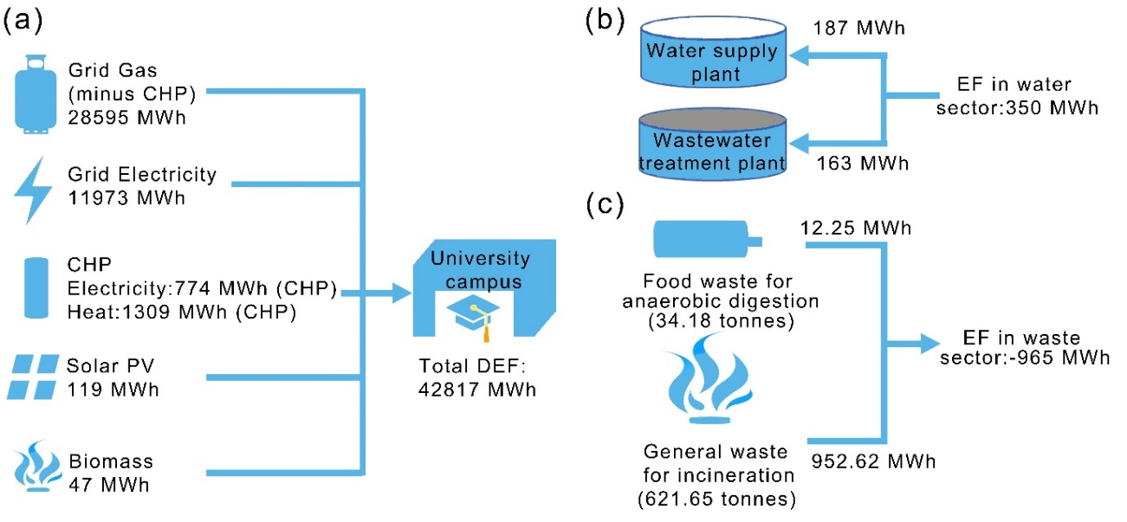

Figure 3. (a) Direct energy footprint of Keele University in the 2015/16 academic year, (b) energy footprint of water supply and wastewater treatment for Keele University in the 2015/16 academic year, (c) energy footprint recovery in waste treatment sector at Keele University in the 2015/16 academic year. (Note that significant further developments in on-site energy generation have been made since 2015/16)

Although water supply, wastewater treatment and waste disposal are outside the scope of the direct energy footprint outlined above, these important sectors of the campus operation are dependent on energy. Figure 3b and Table S1 show the calculated energy footprint of the water sector at Keele University and the energy-water nexus from an energy consumption perspective. It took 163 MWh of energy to treat the 290,925 m3 of water which was supplied to the campus, and 187 MWh of energy to treat the 247,879 m3 of wastewater produced in the 2015/2016 academic year. Therefore, the direct energy footprint contributed significantly to the total energy footprint of Keele University compared with the energy footprint input for the water sector. Waste management within the university also plays a key role in meeting the university’s sustainability objectives. As shown in Figure 3c, in the 2015/16 academic year, 655.8 tonnes of waste mass [41.01% of the total waste produced (1,599.18 tonnes)] was directly used for energy recovery. Within these figures, 34.18 tonnes of food waste were collected and sent for anaerobic digestion, recovering 12.25 MWh of energy, and 621.65 tonnes of general waste were collected and sent for incineration, producing 952.62 MWh of energy (Figure 3c and Table S2). Thus, the indirect energy footprint was -615 MWh with more energy being recovered through generation of energy from waste than was used in water supply and wastewater treatment, resulting in a total energy footprint of 42,202 MWh for Keele University in the 2015/16 academic year (Table 1). In addition, the waste to energy system has contributed to the reduction of the energy footprint.

Table 1. Energy footprint of Keele University in 2015/16 academic year

|  |  |  |
| --- | --- | --- |
|  | Sectors | Energy footprint (MWh) |
| Direct energy footprint | Campus operation | 42,817 |
| Indirect energy footprint | Water sector | 350 |
| Waste treatment sector | -965 |
| Total energy footprint | - | 42,202 |

### 3.2 Carbon footprint assessment

With the increasing international attention on climate issues and greenhouse gas mitigation, Keele University has monitored the greenhouse gas emissions from its use of natural gas (scope 1) and electricity consumption (scope 2) annually since 2009. As shown in Figure4, the carbon footprint of natural gas consumption in the 2015/16 academic year was 6,654 tonnes of CO2e. While the carbon footprint of grid and on-site generated electricity from CHP was 5,229 and 401 tonnes CO2e respectively. As shown in Table S3, 22,172 litres of diesel and 1,153 litres of petrol were consumed in university-owned transportation in the 2015/16 academic year, resulting in a carbon footprint of 60 tonnes of CO2e. The total scope 1 and 2 carbon footprint from energy consumption in the 2015/16 academic year was 12,344 tonnes of CO2e, accounting for 85.77% of the total carbon footprint (14,393 tonnes of CO2e). Therefore, the natural gas and electricity consumption were key sectors contributing to the university’s carbon emissions. There are regular projects aimed at reducing the carbon footprint of the university campus. Some examples include, low carbon emission electricity produced by the solar PV on campus, by 2015/16 avoiding emissions exceeding 66 tonnes of CO2e per year. The university campus library was upgraded with new efficient lighting along with the use of presence detection controls to ensure that lights are only on when needed. This project was started in July 2014 and the building electricity consumption has since decreased by 15%; equating to 180 MWh and 85 tonnes of CO2e per annum. In order to reduce the carbon emission from natural gas consumption sector, Keele University is part of a series of trials as part of the ‘HyDeploy’ project, aiming to introduce a blend of 20% carbon-free hydrogen into the natural gas network, allowing the decarbonisation of gas services without changing the existing pipework or appliances [51]. There is also significant additional renewable generation planned on campus.



Figure 4. Components of the carbon footprint of Keele University in the 2015/16 academic year (on-site generation refers to the CHP system within campus).

The carbon footprint for some areas of scope 3 emissions (including water supply, wastewater treatment, waste disposal and food procurement) of Keele University has also been calculated. As shown in Figure 4 and Table S4, the carbon footprint associated with water supply and wastewater treatment was 100 and 175 tonnes respectively. The total carbon footprint associated with the water sectors was relatively low due to the relatively low energy consumption in the water sector. The carbon footprint for food procurement and food waste disposal was further explored based on a life cycle perspective. As shown in Figure 5a, in 2015/16, 37,403 kg of meat (30.43% of the total food procured), 29,885 kg of fruit and vegetable (24.31% of the total food procured) and 46,833 kg of dry and frozen food (45.26% of the total food procured) were purchased by the university’s central catering team. The detailed carbon footprints of different kinds of food are shown in Figure 5b-d and Table S5-7. The carbon footprint of meat procured was 430.51 tonnes of CO2e (Figure 5b and Table S5), accounting for 88.98% of the total carbon footprint of food procurement (483.81 tonnes of CO2e) as the carbon footprint intensity of meat is much higher than other kinds of food, especially for beef and lamb [43]. The carbon footprint of fruit and vegetables procured was only 9.82 tonnes of CO2e (Figure 5c ad Table S6), accounting for only 2.03% of the total carbon footprint of food procurement. Therefore, a switch to a more vegetable-based diet may have a positive effect on reducing the university’s scope 3 carbon emissions. Although the procured weight of dry store and frozen food was higher than meat, the carbon footprint of the dry store and frozen food was 43.48 tonnes of CO2e, much lower than meat (Figure 5d and Table S6). All food waste produced (34.18 tonnes) in the university’s major catering outlets, is treated by anaerobic digestion for energy recovery. Based on the emission factors from “*Measuring scope 3 carbon emissions-water and waste: a guide to good practice”* [44], the carbon footprint associated with the anaerobic digestion of this food waste was -5.54 tonnes, which indicates that 5.54 tonnes of carbon footprint were saved due to the energy recovered by the anaerobic digestion process. Thus, the life cycle carbon footprint of food procurement and food waste disposal at Keele University was 478.27 tonnes of CO2e in the 2015/16 academic year, accounting for 3.32% of the total carbon footprint of Keele University.



Figure 5. (a) Weight composition ratio of food procurement (left) and carbon footprint composition ratio of central university food procurement (right) at Keele University in the 2015/16 academic year; detailed weight procured and carbon footprint of (b) meat, (c) fruit and vegetable, (d) dry store and frozen food.

One key environmental improvement made by Keele University is that none of the university’s waste is sent direct to landfill but is either reused, recycled or recovered for energy by the waste contractor. Besides food waste for anaerobic digestion, the life cycle carbon footprint of other waste production and disposal options is shown in Table 2 and Table S8. During 2015/16, 247.72 tonnes of green waste (due to the large rural campus) were collected for composting, which resulted in -10.40 tonnes of life cycle carbon footprint as there were no carbon emissions during production. The carbon footprint of the production and disposal of the 621.65 tonnes of general waste during the 2015/16 academic year were 1,276.25 and -230.01 tonnes respectively, hence resulting in a life cycle carbon footprint of 1,046.25 tonnes. In addition, 695.63 tonnes of waste paper, cardboard, plastics, cans and other recyclable materials associated with 1,428.13 tonnes of CO2e of production carbon footprint were collected for recycling, which helped to save 1,167.96 tonnes of carbon footprint during the recycling process and resulted in a life cycle carbon footprint of only 260.17 tonnes. Thus, the total life cycle carbon footprint associated with waste in 2015/16 was 1,413.17 tonnes of CO2e. The incorporation of recycling, composting and energy recovery by incineration and anaerobic digestion from waste into the waste management system at Keele University resulted in a carbon footprint saving of 1,413.91 tonnes of CO2e in 2015/16. Benefiting from this waste disposal system, the scope 3 carbon footprint of Keele University (of the sectors included) in the 2015/16 academic year was only 2,049 tonnes of CO2e, accounting for 14.24% of the total carbon footprint (14,393 tonnes of CO2e).

Table 2. Life cycle carbon footprint for Keele University’s waste production and disposal in the 2015/16 academic year

|  |  |  |  |  |
| --- | --- | --- | --- | --- |
|  | Weight (tonnes) | Production carbon footprint (tonnes CO2e) | Disposal/treatment carbon footprint (tonnes CO2e) | Life cycle carbon footprint (tonnes CO2e) |
| Green waste for composting | 247.72 | 0 | -10.40 | -10.40 |
| General waste for incineration and energy recovery | 621.65 | 1,276.25 | -230.01 | 1,046.25 |
| Mixed recycling | 695.63 | 1,428.13 | -1,167.96 | 260.17 |
| Total | 1,565 | 2,704.38 | -1,408.37 | 1,296.02 |

### 3.3 Water footprint assessment

In Keele University, drinking quality water is supplied to all buildings on campus. As shown in Figure 6a the total water withdrawal of Keele University was 290,925 m3 during the 2015/16 academic year. In the early 2000s, Keele University introduced water efficiency measures which resulted in 92,000 m3 of water being saved. The water efficiency measures included an active leak detection and management plan, combined with careful monitoring of water use to reduce demand. However, water loss still constituted approximately 30,000 m3 of the total water withdrawal during the 2015/16 academic year due to the antiquated pipe system. All the wastewater produced (247,879 m3 in the 2015/16 academic year) at Keele University was treated by a wastewater treatment plant operated by a third-party before discharge. Therefore, there was no grey water footprint and the direct water footprint of Keele University in 2015/16 academic year was 13,046 m3 (Table 3). Considering the energy-water-carbon emissions nexus, the cost of a zero grey water footprint was the 187 MWh of energy footprint and 175 tonnes CO2e of carbon footprint corresponding to the third-party wastewater treatment process.

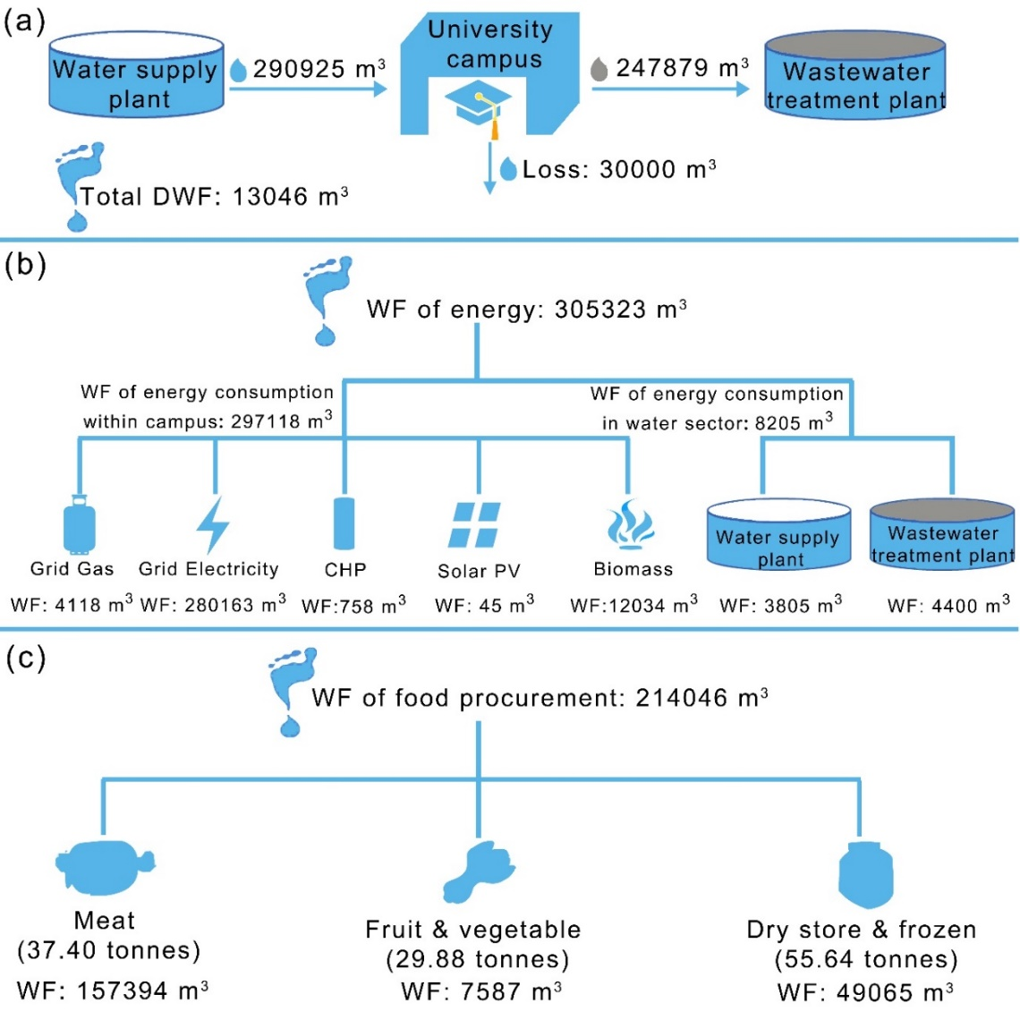

Figure 6. (a) Direct water footprint of Keele University in the 2015/16 academic year, (b) energy water footprint of Keele University in the 2015/16 academic year, (c) food water footprint of Keele University in the 2015/16 academic year.

Figure 6b and Table S9 shows the energy water footprint of the various sources of energy consumption in the 2015/16 academic year. The energy water footprint is quantified to analyse the energy-water nexus from a water consumption perspective. As shown in Figure 5b, the water footprint associated with the direct energy consumption within the campus, which includes grid electricity, gas, solar PV, CHP and biomass energy, was 297,118 m3 in total, much higher than the direct water footprint (13,046 m3) of Keele University. Therefore, the water footprint input for the production of directly energy consumption within campus is a key sector contributing to the university’s water footprint. The water footprint of the energy consumption associated with water supply and wastewater treatment in the water sector was 3,805 and 4,400 m3 respectively. Thus, the total energy water footprint was 305,323 m3 and the total water footprint associated with energy input for water supply and treatment was 8,205 m3 in the 2015/16 academic year. As shown in Table 3, the energy water footprint accounts for 57.3% of the total water footprint (532,415 m3), indicating that improving energy efficiency at Keele University will have significant impacts on water footprint reduction when considering the energy-water nexus.



Figure 7. (a) Weight composition ratio of food procurement (left) and water footprint composition ratio of central university food procurement (right) in Keele University in the 2015/16 academic year; detailed weight procured and water footprint of (b) meat, (c) fruit and vegetable, (d) dry store and frozen food.

The water footprint for food procurement was further explored based on a life cycle perspective (Table S10-12). As shown in Figure 6c, in 2015/16, the weight of the top 40 items procured by the university’s central catering totalled 122,923 kg associated with 214,046 m3 of total food water footprint (Table 3). Such high value indicates that food procurement is another key sector contributing to the university’s water footprint. As shown in Figure 7a, in the 2015/16 academic year, although only 37,403 kg of meat (30.43% of the total food procurement) was procured by the university refectory, the total water footprint of meat consumption was 157,394 m3, representing 73.53% of the total water footprint of food procurement. Figure 7b and Table S10 shows the consumptive water footprint of the main meat consumption. The consumption of beef burgers required the biggest water footprint consumption (34,408 m3), followed by chicken and beef (32,816 m3 and 24,225 m3 respectively). Although the procurement of fruits and vegetables was higher than meat by weight, their water footprint was much lower than meat consumption due to the generally lower water footprint intensity of fruits and vegetables. [48, 49]. In the 2015/16 academic year, the water footprint of fruit and vegetable procurement was only 7,587 m3 (3.54% of the total water footprint of food procurement) for a total of 29,885.32 kg procurement (24.31% of total food procurement). Figure 7c and Table S11 display the detailed water footprint of the main categories of fruit and vegetables procured. Most kinds of fruit and vegetable show a relatively low water footprint consumption particularly compared to meat. 55,635 kg of dry store and frozen food, which mainly consisted of wraps, vegetable oil, fries and bread, were procured in 2015/16 and resulted in a water footprint of 49,065 m 3 (22.92% of the total water footprint of food and drink consumption). Dry store and frozen food procurement has a higher consumptive water footprint than fruit and vegetables, with particularly high consumption associated with vegetable oil (12,741 m3) and tortilla wraps (19,351 m3), accounting for 25.97 and 39.44 % of the total consumptive water footprint for dry store and frozen goods (Figure 7d). This was due to the large consumption amount (6,564 kg and 18,350 kg respectively) and relative higher water footprint intensity of vegetable oil (1,941 m3/ton, refer to Table S12 in the supplementary material) [49]. In contrast to the carbon footprint of food procurement, the water footprint of food procurement contribute to a higher proportion of the total water footprint of Keele University. As shown in Table 3, the water footprint of food procured accounts for 40.2% of the university’s total water footprint (532,415 m3), indicating the huge potential for water footprint reduction by optimising food procurement decisions based on reducing different environmental impacts.

Table 3. Water footprint of Keele University in the 2015/16 academic year

|  |  |  |
| --- | --- | --- |
|  | Sectors | Water footprint (m3) |
| Direct water footprint | Campus operation | 13,046 |
| Energy water footprint | Energy consumption within campus | 297,118 |
| Energy consumption of water supply | 3,805 |
| Energy consumption of wastewater treatment | 4,400 |
| Total energy water footprint | 305,323 |
| Food water footprint | Meat procurement | 157,394 |
| Fruit and vegetable procurement | 7,587 |
| Dry store and frozen food procurement | 49,065 |
| Total food water footprint | 214,046 |
| Total water footprint |  | 532,415 |

### 3.4 Nexus analysis based on environmental footprints

Figure 8a illustrates the energy-water-carbon emissions nexus at Keele University in the 2015/16 academic year. 3,845 m3 of freshwater was required to produce the energy input of 163 MWh which was needed for 290,925 m3 of water supply, and 100 tonnes of CO2e was emitted during this process. 247,879 m3 of wastewater was discharged to the wastewater treatment plant for further treatment. During the treatment process, 4,405 m3 of freshwater was required to produce the energy input of 188 MWh which was needed for wastewater treatment, and 175 of tonnes CO2e were emitted. With respect to the direct energy footprint input to the campus, 297,118 m3 of water footprint was required to produce an energy consumption of 42,817 MWh within the campus, and 11,284 tonnes of CO2e (78.4% of the total carbon footprint) was emitted, indicating the strong correlation between direct energy consumption within the university and carbon footprints. The high proportion of the water footprint (55.8% of the total water footprint) from the direct energy sector suggests the huge potential associated with considering the energy-water nexus and the integrated optimization of water and energy by improving energy efficiency and seeking alternative energy sources. Therefore, both the carbon footprint and water footprint of alternative energy sources need to be taken into account when determining the relative environmental impacts of using alternative energy sources. This inextricably intertwined energy-water-carbon emissions nexus reinforces the importance of the integrated management of energy and water.



Figure 8. (a) Energy-water-carbon nexus at Keele University in the 2015/16 academic year, (b) food-water-energy nexus and corresponding carbon emissions at Keele University in the 2015/16 academic year

Figure 8b illustrates the food-water-energy nexus and corresponding carbon emissions at Keele University. In the 2015/16 academic year 214,046 m3 of water was consumed for the production of 122.92 tonnes of the top 40 foods procured by the university’s central catering with a carbon footprint of 484 tonnes of CO2e. 34.18 tonnes of food waste was collected for anaerobic digestion. Subsequently, 12.25 MWh energy was recovered saving 5.54 tonnes of carbon footprint (equivalent). The large size of the water footprint associated with the food procured suggests the huge water footprint reduction potential by sustainable procurement decision optimization and changes in menu planning. Notably, although the energy input for the production of foods procured cannot be presented in this study due to the limitations of available databases, the significance of energy consumption should also be considered in sustainable procurement decision optimization. At a global scale, about 30% of total energy consumption is for food production and its related supply chain [52]. In 2013, the energy input into the food sector of European Union (EU) countries accounted for 17 % of the EU’s gross energy consumption [53]. Therefore, sustainable food procurement decision optimization also can contribute greatly to energy footprint and corresponding carbon footprint reduction.

The nexus across waste disposal, energy and carbon emissions can also be quantified through using energy and carbon footprints. Benefiting from the more sustainable waste disposal system, 965 MWh of energy footprint was recovered and 1,413.91 tonnes of CO2e of carbon footprint was saved in the 2015/16 academic year.

### 3.5 Policy suggestions

This paper includes the measures taken by Keele University up to and including 2015/16 to reduce its environmental footprints, and has analysed the impact of these measures on the university’s environmental footprints. These measures could equally be applied to other universities and communities. For example, solar PV and CHP technologies can be installed to reduce the grid electricity energy demand and improve energy production efficiency, and hence also reduce an organisation of community’s indirect water footprint. The study has also shown the environmental footprint benefit of sustainable waste treatment management system as used at Keele University, where none of the university’s waste is sent to landfill but is either reused, recycled or recovered for energy which can reduce greatly the energy and corresponding water footprint and carbon footprint. Such practices are recommended for other universities and communities.

In order to make genuinely sustainable decisions as universities work towards having ‘greener’ campuses, the integrated environmental impacts of changes in operations need to be considered. The nexus analytical framework based on environmental footprints as proposed in this paper provides a tool for more comprehensive understanding of the environmental impacts of a university’s operations and food procurement, thus allowing the improvement of strategies for future sustainable campus developments and assessment. Drawing on learning from the environmental impacts and nexus analysis from Keele University in the academic year 2015/16, policy suggestions for the reduction of integrated environmental footprints in universities and other communities are provided here:

* The energy-water-carbon emission nexus analysis results in Figure 8a, demonstrates that improving energy efficiency has great potential for the optimization of the reduction of integrated energy, water and carbon emission footprints. With respect to energy consumption, enhancing monitoring and control systems is one way to increase energy efficiency, at Keele University this is being supported by the development of smart energy systems through the Smart Energy Network Demonstrator (SEND) on the Keele University campus.
* With respect to alternative clean energy developments for reducing carbon emissions, considering the lower water footprint intensities of electricity generated from wind energy (0.2-12 m3/TJ ) and solar PV (6.4-303 m3/TJ ) than other ‘clean’ energy sources (7.3-759 m3/TJ for geothermal, 300-850,000 for hydropower and 76-1,250 m3/TJ for nuclear energy) [36], maximising the development of wind energy and solar PV as the major sources of clean energy generation at the university or community scale are recommended. Keele University is currently proposing additional large-scale renewable energy development utilising wind energy and solar PV and on-site battery storage.
* Our results of the food-water-energy nexus and corresponding carbon emissions in Figure 8b, have shown that more sustainable food procurement decisions can be a key way to reduce an organisation’s water footprint. Since the water footprint and carbon footprint intensity of vegetables is lower than meat, increasing the availability of vegetable-based options will reduce the water footprint and carbon footprint simultaneously [43, 54]. Meanwhile, some products with lower water footprints can easily replace products with higher water footprints. For example, turkey could partly replace chicken as the water footprint intensity of turkey is only 1.77 m3/kg, compared to that of chicken which has a water footprint intensity of 3.86 m3/kg [48]. However, the carbon footprint intensity of turkey is 7.17 kg CO2e/kg, which is higher than that of chicken (3.65 kg CO2e/kg) [43]. Under this circumstance, trade-off between the water footprint and carbon footprint should be balanced. Any changes in procurement decisions and menu offering, will also be strongly linked to behavioral and consumer preferences and the degree to which the ‘consumer’ is willing to have a change in the options available to them.
* In relation to the waste-energy-carbon emissions nexus, at Keele University only food waste from the central university catering outlets is collected for anaerobic digestion so far. Collecting food waste from all areas where food waste is generated, including student halls of residence and other dining venues would improve further improve energy recovery and reduce carbon emissions across the university or other communities.

## 4 Conclusion

In this study which examines an integrated environmental footprint framework, energy footprint, carbon footprint and water footprint analyses are comprehensively performed to understand how universities interact with the hydrological cycle, energy resources and climate. The total energy footprint, carbon footprint and water footprint of Keele University in the 2015/16 academic year was 42,202 MWh, 14,393 tonnes of CO2e and 532,415 m3, respectively. Based on the quantification of these interlinked environmental footprints, the nexus across water, energy, waste disposal, food procurement, and corresponding carbon emissions at Keele University were investigated. The nexus analysis results reveal that the great amount of energy consumption directly within the campus is the key sector for integrated optimization of energy, water and carbon emissions due to the great contribution of direct energy consumption to both the total water footprint (57.3%) and carbon footprint (85.8%). Food procurement in the university is another key sector for water footprint reduction due to its relatively large contribution to the total water footprint (40.2%). However, choices need to balance differences in water and carbon footprints between different food types. The sustainable waste treatment and disposal system in Keele University contributes to energy footprint recovery (965 MWh) and carbon footprint reduction (1,413.91 tonnes of CO2e). Policy suggestions arising from these integrated environmental footprint and nexus analysis results include implementing energy control systems to maximise energy efficiency, maximising the development of wind energy and solar photovoltaic for localised clean energy generation, increasing the availability of vegetable-based options in food procurement decisions, and collecting all generated food waste for anaerobic digestion. These recommendations can be applied to other universities and other communities seeking to develop more sustainable operation and decision making systems. In addition, many universities in China and other countries are relatively independent campuses similar to Keele University. Therefore, the methodology proposed in this paper is relevant to those wishing to conduct similar research on other independent campuses. This work is expected to contribute to an improvement in the planning and operation of ‘green universities’, as well as other ecological communities.

**Acknowledgement**

This work is supported by 2017 Key Project of Shanghai Municipal Science and Technology Commission (No.17DZ1202100 and No.17DZ1203200), Chinese National Postdoctoral Program for Innovative Talents (No.BX20180217), and China Postdoctoral Science Foundation Funded Project (No. 2018M642082). This work was also partially supported by the Royal Academy of Engineering under the UK-China Industry Academia Partnership Programme Scheme "Global water scarcity: a case study on urban water crisis and its relation to businesses in China and UK. The support of several key personnel in the provision of data at Keele University is gratefully acknowledged.

**Reference**

[1] Hopwood B, Mellor M, O'Brien G. Sustainable development: mapping different approaches. Sustainable Development. 2005;13:38-52.

[2] Vergragt P, Akenji L, Dewick P. Sustainable production, consumption, and livelihoods: global and regional research perspectives. Journal of Cleaner Production. 2014;63:1-12.

[3] United Nations. Sustainable developmey goals: 17 Goals to Transform Our World, https://www.un.org/sustainabledevelopment/; [accessed 28 November 2018].

[4] Bazilian M, Rogner H, Howells M, Hermann S, Arent D, Gielen D, Steduto P, Mueller A, Komor P, Tol RSJ, Yumkella KK. Considering the energy, water and food nexus: Towards an integrated modelling approach. Energy Policy. 2011;39:7896-906.

[5] Howells M, Rogner HH. Assessing integrated systems. Nature Climate Change. 2014;4:246.

[6] Liu J, Hull V, Godfray HCJ, Tilman D, Gleick P, Hoff H, Pahl-Wostl C, Xu Z, Chung MG, Sun J, Li S. Nexus approaches to global sustainable development. Nature Sustainability. 2018;1:466-76.

[7] Hoekstra AY, Wiedmann TO. Humanity’s unsustainable environmental footprint. Science. 2014;344:1114-7.

[8] Wang S, Cao T, Chen B. Urban energy–water nexus based on modified input–output analysis. Applied Energy. 2017;196:208-17.

[9] Feng K, Hubacek K, Siu YL, Li X. The energy and water nexus in Chinese electricity production: A hybrid life cycle analysis. Renewable and Sustainable Energy Reviews. 2014;39:342-55.

[10] Pujadas Botey A, Garvin T, Szostak R. Interdisciplinary Research for Ecosystem Management. Ecosystems. 2014;17:512-21.

[11] Fang K, Heijungs R, de Snoo GR. Theoretical exploration for the combination of the ecological, energy, carbon, and water footprints: Overview of a footprint family. Ecological Indicators. 2014;36:508-18.

[12] Aldaya MM, Chapagain AK, Hoekstra AY, Mekonnen MM. The water footprint assessment manual: Setting the global standard: Routledge; 2012.

[13] Wiedmann T. A first empirical comparison of energy Footprints embodied in trade — MRIO versus PLUM. Ecological Economics. 2009;68:1975-90.

[14] Wiedmann T, Minx J. A definition of ‘carbon footprint’. Ecological economics research trends. 2008;1:1-11.

[15] Gu Y, Dong Y-n, Wang H, Keller A, Xu J, Chiramba T, Li F. Quantification of the water, energy and carbon footprints of wastewater treatment plants in China considering a water–energy nexus perspective. Ecological Indicators. 2016;60:402-9.

[16] Pacetti T, Lombardi L, Federici G. Water–energy Nexus: a case of biogas production from energy crops evaluated by Water Footprint and Life Cycle Assessment (LCA) methods. Journal of Cleaner Production. 2015;101:278-91.

[17] Siddiqi A, Anadon LD. The water–energy nexus in Middle East and North Africa. Energy Policy. 2011;39:4529-40.

[18] Conway D, van Garderen EA, Deryng D, Dorling S, Krueger T, Landman W, Lankford B, Lebek K, Osborn T, Ringler C, Thurlow J, Zhu T, Dalin C. Climate and southern Afric's water–energy–food nexus. Nature Climate Change. 2015;5:837.

[19] Ackerman F, Fisher J. Is there a water–energy nexus in electricity generation? Long-term scenarios for the western United States. Energy Policy. 2013;59:235-41.

[20] Nair S, George B, Malano HM, Arora M, Nawarathna B. Water–energy–greenhouse gas nexus of urban water systems: Review of concepts, state-of-art and methods. Resources, Conservation and Recycling. 2014;89:1-10.

[21] Wang H, Yang Y, Keller AA, Li X, Feng S, Dong Y-n, Li F. Comparative analysis of energy intensity and carbon emissions in wastewater treatment in USA, Germany, China and South Africa. Applied Energy. 2016;184:873-81.

[22] Fang D, Chen B. Linkage analysis for the water–energy nexus of city. Applied Energy. 2017;189:770-9.

[23] Perrone D, Murphy J, Hornberger GM. Gaining Perspective on the Water−Energy Nexus at the Community Scale. Environmental Science & Technology. 2011;45:4228-34.

[24] United Nations Development Programme. GOAL 11: SUSTAINABLE CITIES AND COMMUNITIES, https://www.undp.org/content/undp/en/home/sustainable-development-goals/goal-11-sustainable-cities-and-communities.html. 2019; [accessed 13, March 2019].

[25] Seyfang G, Haxeltine A. Growing Grassroots Innovations: Exploring the Role of Community-Based Initiatives in Governing Sustainable Energy Transitions. Environment and Planning C: Government and Policy. 2012;30:381-400.

[26] Maida CA, Beck S. Towards communities of practice in global sustainability. Anthropology in Action. 2016;23:1-5.

[27] Lukman R, Tiwary A, Azapagic A. Towards greening a university campus: The case of the University of Maribor, Slovenia. Resources, Conservation and Recycling. 2009;53:639-44.

[28] Tan H, Chen S, Shi Q, Wang L. Development of green campus in China. Journal of Cleaner Production. 2014;64:646-53.

[29] Velazquez L, Munguia N, Platt A, Taddei J. Sustainable university: what can be the matter? Journal of Cleaner Production. 2006;14:810-9.

[30] Disterheft A, Ferreira da Silva Caeiro SS, Ramos MR, de Miranda Azeiteiro UM. Environmental Management Systems (EMS) implementation processes and practices in European higher education institutions – Top-down versus participatory approaches. Journal of Cleaner Production. 2012;31:80-90.

[31] Waghorn T. John Robinson: Universities as societal test-beds for sustainability, https://www.forbes.com/sites/terrywaghorn/2012/07/03/john-robinson-universities-as-societal-test-beds-for-sustainability/#13184ee278a8; 2012 [accessed 28 November 2018].

[32] Green A. Sustainability Self-Help for Universities: the campus as a test bed for research, https://blogs.ucl.ac.uk/bseer/2015/03/20/sustainability-self-help-universities-campus-test-bed-research/; 2015 [accessed 28 November 2018].

[33] Paul Osmond MD, Deo Prasad, Fengting Li. Greening universities toolkit: Transforming universities into green and sustainable campuses: United Nations Environment Programme; 2013.

[34] Ozawa-Meida L, Brockway P, Letten K, Davies J, Fleming P. Measuring carbon performance in a UK University through a consumption-based carbon footprint: De Montfort University case study. Journal of Cleaner Production. 2013;56:185-98.

[35] Larsen TA, Hoffmann S, Lüthi C, Truffer B, Maurer M. Emerging solutions to the water challenges of an urbanizing world. Science. 2016;352:928-33.

[36] Mekonnen MM, Gerbens-Leenes PW, Hoekstra AY. The consumptive water footprint of electricity and heat: a global assessment. Environmental Science: Water Research & Technology. 2015;1:285-97.

[37] Dincer I. Renewable energy and sustainable development: a crucial review. Renewable and Sustainable Energy Reviews. 2000;4:157-75.

[38] Omer AM. Energy, environment and sustainable development. Renewable and Sustainable Energy Reviews. 2008;12:2265-300.

[39] Lombardi L, Carnevale E, Corti A. A review of technologies and performances of thermal treatment systems for energy recovery from waste. Waste Management. 2015;37:26-44.

[40] Ajiero I, Campbell D. Water-energy nexus: problems and prospects for the UK. Water Efficiency Conference;2014. p. 1-17.

[41] Reimann D. CEWEP energy report III. Scientific & Technical Advisor to CEWEP, Bamberg Dezember. 2012.

[42] Department for Business, Energy & Industrial Strategy, UK. Greenhouse gas reporting - Conversion factors 2016, https://www.gov.uk/government/publications/greenhouse-gas-reporting-conversion-factors-2016; 2016 [accessed 28 November 2018].

[43] Clune S, Crossin E, Verghese K. Systematic review of greenhouse gas emissions for different fresh food categories. Journal of Cleaner Production. 2017;140:766-83.

[44] Higher Education Funding Council for England. Measuring scope 3 carbon emissions – water and waste: A guide to good practice, https://webarchive.nationalarchives.gov.uk/20180322111355/http://www.hefce.ac.uk/pubs/year/2012/201201/; 2012 [accessed 28 November 2018].

[45] Gerbens-Leenes P, Hoekstra AY, van der Meer TH. Water footprint of bio-energy and other primary energy carriers: UNESCO-IHE; 2008.

[46] Rio Carrillo AM, Frei C. Water: A key resource in energy production. Energy Policy. 2009;37:4303-12.

[47] Department for Business, Energy & Industrial Strategy,UK. Energy Trends: electricity, https://www.gov.uk/government/statistics/electricity-section-5-energy-trends; 2013 [accessed 28 November 2018].

[48] Mekonnen MM, Hoekstra AY. A Global Assessment of the Water Footprint of Farm Animal Products. Ecosystems. 2012;15:401-15.

[49] Mekonnen MM, Hoekstra AY. The green, blue and grey water footprint of crops and derived crop products. Hydrol Earth Syst Sci. 2011;15:1577-600.

[50] Higher Education Statistics Agency (HESA). Estates Management Record: Finance, Student and Staff 2015/16, https://www.hesa.ac.uk/data-and-analysis/publications/estates-2015-16; 2017 [accessed 28 November 2018].

[51] Keele University. Pioneering UK Gas Project Aims to Reduce Domestic CO2 Emissions, https://www.keele.ac.uk/discover/news/2018/february/pioneeringukgasprojectaimstoreducedomesticco2emissions/hydeploy-gas-project.php; 2018 [accessed 28 November 2018].

[52] Food and Agriculture Organization of the United Nations (FAO). “Energy-smart” food for people and climate – issue paper. Rome, Italy: Food and Agriculture Organization of the United Nations; 2011.

[53] Monforti-Ferrario F, Dallemand J-F, Pascua IP, Motola V, Banja M, Scarlat N, Medarac H, Castellazzi L, Labanca N, Bertoldi P, Pennington D, Goralczyk M, Schau EM, Saouter E, Sala S, Notarnicola B, Tassielli G, Renzulli. P. Energy use in the EU food sector: State of play and opportunities for improvement: Publications Office of the European Union; 2015.

[54] Vanham D, Comero S, Gawlik BM, Bidoglio G. The water footprint of different diets within European sub-national geographical entities. Nature Sustainability. 2018;1:518-25.

1. The short version of the paper was presented at CUE2018, Jun 5-7, Shanghai, China. This paper is a substantial extension of the short version of the conference paper.