Received 00th January 20xx,
- School of Chemistry and Trinity Biomedical Science Institute, University of Dublin, Trinity College Dublin, Dublin 2, Ireland. Email : gunnlaut@tcd.ie
- School of Chemical and Physical Sciences, Keele University, Keele ST5 5BG, UK
†Electronic Supplementary Information (ESI) available: Experimental section, structure and properties of [Cu₄(H₂1)₄](NO₃)_{8,} and [Cu₄(H1)₄](PF₆)_{4,} additional figures, crystallographic data, X-ray powder diffraction patterns and spectroscopic data. CCDC 1905243-1905246. For ESI and crystallographic data in CIF or other electronic format see DOI:
Accepted 00th January 20xx
DOI: 10.1039/x0xx00000x
www.rsc.org/
Unexpected linkage isomerism in chiral tetranuclear bis-tridentate (1,2,3-triazol-4-yl)-picolinamide (tzpa) grids
Isabel N. Hegarty,ª Hannah L. Dalton,ª Adam F. Henwood,ª Chris S. Hawes,^{b} and Thorfinnur Gunnlaugsson *ª

The synthesis of a chiral bis-tridentate (1,2,3-triazol-4-yl)-picolinamide (tzpa) ligand is described and its coordination chemistry with Cu(NO₃)₂ and [Cu(MeCN)₄]PF₆ is explored in the crystalline phase as well as in solution. Chiral [2×2] tetranuclear square grid complexes [Cu₄(H₂1)₄](NO₃)₈ and [Cu₄(H1)₄](PF₆)₄ were observed, and crystallographically analysed, these being linkage isomers with N₄O₂ and N₅O coordination spheres, respectively. These come about by an unusual in-situ amide deprotonation and coordination, which accompanies a Cu^{I}→Cu^{II} oxidation process.
The construction of complex molecular assemblies through non-covalent interactions is the central concern of supramolecular chemistry.¹ Self-assembly processes can generate novel functional materials with applications across a wide range of disciplines. The use of coordination chemistry to influence and control the self-assembly process has been key to the development of this area with the binding of metal ions providing geometric control which is not easily accessible through the use of purely organic assemblies.¹ In addition, coordination driven self-assembly also provides metal-centred functionality, useful in the formation of responsive materials with catalysis and sensing applications.^{1e-f,2}
Modular ligands, upon which a family of analogues can be easily synthesised, are important for formulating structure-function relationships in complex polynuclear systems. The copper-catalysed azide-alkyne cycloaddition (CuAAC) reaction is particularly versatile in this regard.³ The resulting 1,2,3-triazole species can be readily conjugated to other coordinating functionalities such as pyridine, with chelation leading to a variety of discrete metallo-supramolecular architectures.^{4,5} Recently we have reported a new class of bis-tridentate (1,2,3-triazol-4-yl)-picolinamide (tzpa) ligands by combining the 2,6-bis(1,2,3-triazol-4-yl)pyridine (btp) and 2,6-dipicolinamide (dpa) binding motifs, two important and versatile coordinating motifs in their own right.^{1e,f,6,7} Here we report the preparation of a new tzpa ligand with the introduction of chirality to the triazole “arms”. In doing so, we reveal unexpected linkage isomerism, where an in-situ amide deprotonation promotes an unsymmetric binding mode under remarkably mild conditions.
Following the principle of modular ligand synthesis, the preparation of H₂1 was devised based on reliable and efficient chemistry, being prepared in three linear steps from 6-bromopicolinic acid (Scheme S1, ESI). X-ray quality crystals were obtained of the trimethylsilyl alkyne precursor (compound 4 Scheme 1, ESI) from slow evaporation of hexane following the Sonogashira coupling (Figure S1, ESI). With H₂1 in hand, the coordination chemistry of H₂1 with Cu(NO₃)₂ and [Cu(MeCN)₄]PF₆ was investigated both in solution and in the solid state, but the chiroptical nature of H₂1 was confirmed using CD-spectroscopy in CH₃CN.
Our rationale was that the flexible coordination geometry of Cu^{II} would allow more ligand influence into the structure and topology of the final assembly. Reacting H₂1 with copper nitrate trihydrate in methanol gave a blue solution which, on concentration by slow evaporation, yielded single crystals of [Cu₄(H₂1)₄](NO₃)₈. Single crystal X-ray diffraction revealed a tetranuclear supramolecular M₄L₄ assembly, with a structure closely related to our previously reported Zn^{II} tetranuclear grid⁶ with an achiral tzpa ligand (Ligand 2, Figure S3, ESI). However, and in keeping with the homochiral pendant groups in 1, the diffraction data were solved in the tetragonal space group P4₃, with the entire complex present within the asymmetric unit.
Figure 1 Structure of ligand H21 developed in this study
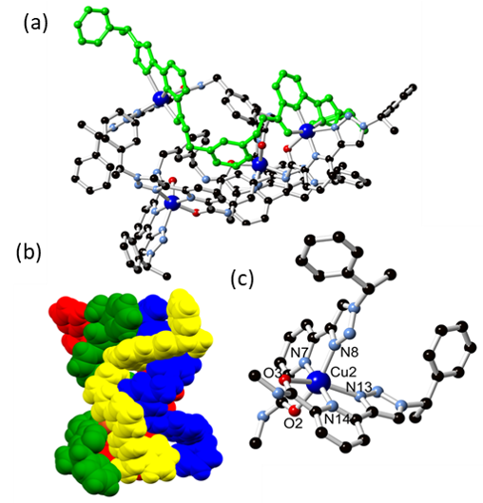
Figure 2 (a) Complete structure of [Cu₄(H₂1)₄](NO₃)₈ with a single ligand strand highlighted in green; (b) Space filling model of [Cu₄(H₂1)₄](NO₃)₈; (c) Representative coordination geometry of [Cu₄(H₂1)₄](NO₃)₈ with ligand molecule truncated for clarity
Each metal ion is bound in a bis-tridentate fashion by two H₂1 molecules in a distorted octahedral environment, and coordinated by two pyridyl nitrogen atoms, two triazolyl nitrogen atoms and two amide oxygen atoms. As expected for six-coordinate Cu^{II} species, a prominent Jahn-Teller axis is observed along one N_{triazolyl}-Cu-O_{amide} vectors at each metal; the equatorial M-L bonds all lie in the distance range 1.92–2.10 Å, while the axial bonds fall in the distance range 2.26–2.45 Å. As was the case with the achiral Zn^{II} complex, the assembly is a [2×2] square grid, rather than the other possible circular helicate topology. Although the ligand is inherently chiral, the inner structure of the assembly essentially retains the achiral S₄ symmetry of its achiral predecessor (ESI, Figure S3), with the chiral groups seemingly not offering any strong influence on the structure of the metal binding sites themselves.
Complex [Cu₄(H₂1)₄]⁸⁺ acts as an eight-connected hydrogen bond donor by virtue of its amide N-H groups. Each donates a hydrogen bond to one NO₃⁻, with four localised NO₃⁻ accepting two hydrogen bonds each, bridging two complexes. Only the four NO₃⁻ involved in hydrogen bonding, and one involved in a localised hydrogen bonding interaction with a lattice water molecule, could be crystallographically resolved. The remaining three anions overlap crystallographic symmetry elements among diffuse pockets of electron density; their electron density contribution was accounted for using SQUEEZE.⁸ Their presence was unambiguously ascertained through supporting bulk-phase characterisation methods (See experimental, ESI). With each grid linked to four others through two two-connected NO₃⁻ bridges, the overall network is best considered as a three-dimensional hydrogen bonded network with dia topology.
On reacting H₂1 with cuprous salts, our expectation was either to form a bis-bidentate analogue of the above complexes, displaying the usual N₄ tetrahedral coordination of many Cu^{I} species,⁹ or for immediate oxidation of the cupric species to form an analogous complex to [Cu₄(H₂1)₄](NO₃)₈ above. However, to our surprise, diffusion of toluene vapour into a clear methanolic solution of [Cu(MeCN)₄](PF₆) and H₂1 gave blue crystals of [Cu₄(H1)₄](PF₆)₄, a complex which shows similar connectivity to [Cu₄(H₂1)₄](NO₃)₈, but exhibits linkage isomerism at the metal site. The diffraction data were solved and refined in the monoclinic space group C2, with halves of two unique complexes within the asymmetric unit. In [Cu₄(H1)₄](PF₆)₄, each of the four metal ions is coordinated in a six-coordinate N₅O coordination sphere, where one amide oxygen atom has been replaced by a deprotonated amide nitrogen atom. Each ligand molecule is singly deprotonated, with one of each N,N,N and N,N,O coordination modes. Unsurprisingly, given the increase in ligand field strength of the deprotonated amide, the desymmetrisation of the coordination sphere also switches the Jahn-Teller axis of elongation to be fixed along the single N_{triazolyl}-Cu-O_{amide} axis at each coordination site. Mixed N,O-donation from pyridylamide groups such as this is a particularly rare observation, with single linkage isomers exhibiting coordination through purely anionic nitrogen or neutral oxygen donors being far more common.¹⁰ Even more surprisingly, the overall connectivity and topology of the complex is unchanged and can still be described as a tetranuclear [2×2] square grid. This is despite significant geometric changes in the internuclear distances and angular disposition of the central xylyl bridge; a reduction in intrastrand Cu-Cu distance is accompanied by a comparable increase in diagonal (interstrand) Cu-Cu distance, compared to [Cu₄(H₂1)₄]⁸⁺ (Table S2, ESI). The reduction in ligand symmetry caused by deprotonation adds directionality to each strand, reducing the symmetry of the tetranuclear core to C₂. With directionality along the rotation axis provided by the orientation of the chiral side chains, it can be seen that the cores of both fragments adopt the same handedness. As such, for this complex the chirality of the side chains appears to play some role in the internal configuration. The tetracation also adopts a more compact arrangement facilitated by four intramolecular
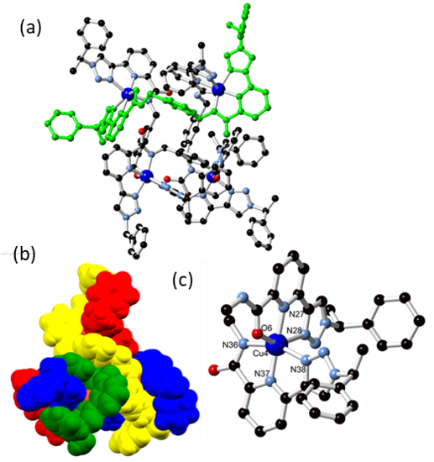
Figure 3 (a) Complete structure of [Cu₄(H1)₄](PF₆)₄ with a single ligand strand highlighted in green; (b) Space filling model of [Cu₄(H1)₄](PF₆)₄; (c) Representative coordination geometry of [Cu₄(H1)₄](PF6)₄ with ligand molecules truncated for clarity showing both modes of amide coordination through oxygen atom O6 and nitrogen atom N36
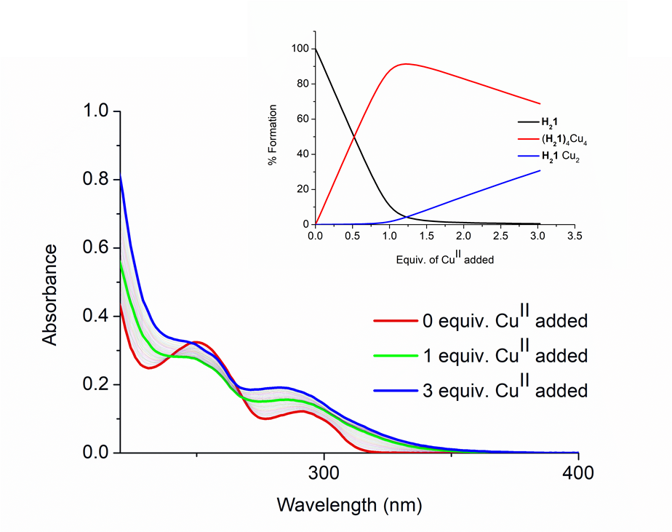
Figure 4 The changes in the UV-visible absorption spectra upon titrating H₂1 (1 x 10⁻⁵ M) against Cu(NO₃)₂ (0–4 equiv.) in MeOH at RT. Inset: Speciation distribution diagram
hydrogen bonding interactions. Rather than involving the lattice anions, these are exclusively formed between the remaining protonated amide nitrogen atoms and the non-coordinated amide oxygen atoms from adjacent strands. While the total molecular volume of the assembly remains essentially unchanged, the volume of the tetrahedron defined by the four central copper ions undergoes a reduction of ca. 16%.
With all hydrogen bond donors accounted for in intramolecular interactions, the extended structure of [Cu₄(H1)₄](PF₆)₄ shows only C-H···X hydrogen bonding interactions and π-π stacking interactions. Four toluene molecules spread over six discrete orientations were located from the Fourier residuals, while all four unique anions were well-ordered, and show C-H···F interactions originating from the triazolyl C-H groups. Pockets of diffuse electron density remained within the model which could not be suitably modelled and were again accounted for using the SQUEEZE routine; elemental analysis and thermogravimetric analysis showed a formula of [Cu₄(H1)₄(PF₆)₄] ·4PhMe·12H₂O for the bulk material. (Figure S15, ESI). We were unable to generate analogous systems using [Cu(MeCN)₄]⁺ salts of BF₄⁻ or CF₃SO₃⁻; reliance on crystallisation in these systems may mean the different steric requirements of these anions tends towards other outcomes. Reacting H₂1 with Cu(NO₃)₂ in MeCN in the same 1:1 molar ratio also yielded blue crystals upon slow evaporation. These crystals scattered poorly, but nonetheless a connectivity model of [Cu₂H₂1(NO₃)₄]MeCN could be elucidated (Figure S2, ESI). This suggested a dinuclear complex analogous to a dinuclear complex prepared with an achiral tzpa ligand previously.^{6a} (Ligand 2, ESI)
The coordination chemistry of H₂1 with Cu(NO₃)₂, [Cu(MeCN)₄](PF₆) and also Cu(ClO₄)₂·6H₂O in solution was also investigated. Analysis of the [Cu₄(H1)₄](PF₆)₄ system by MALDI mass spectrometry showed various M+L fragments, including [4M+3L+PF₆] (m/z 2459.55, calc. 2459.57). Unfortunately, neither the parent tetracation or octacation were detected, suggesting that the higher-order assemblies are unstable under the harsh MALDI fragmentation conditions. Solution studies of Cu(NO₃)₂ with H₂1 were examined under milder conditions where solutions of H₂1 at 1 x 10⁻⁵ M in MeOH were analysed by absorbance and fluorescence spectroscopy upon addition of aliquots of Cu(NO₃)₂ solution in MeOH. The absorption spectrum of H₂1 displayed two main bands centred at 291 nm and 250 nm (likely π–π∗ transitions). Initially, the 250 nm band decreased up to the addition of 1 equivalent of Cu(NO₃)₂, however, thereafter a hyperchromic effect was observed. The band centred at 290 nm saw an increase in absorbance and concomitant redshift upon addition of Cu(NO₃)₂.†
To probe both the stoichiometry and binding constants in solution the titration data was fit using non-linear regression analysis.¹¹ The distribution of three main species in solution (H₂1, 2:1 metal:ligand and 4:4 metal:ligand) were estimated from this analysis. From this model the dominant species in solution, up to the addition of 1.0 equiv. of metal, is the 4:4 species with 90% abundance at 1.0 equiv. After this point the abundance of this 4:4 species decreases and the 2:1 species becomes the main structure in solution upon addition of excess Cu(NO₃)₂. Binding constants were determined with a global fit; the 4:4 metal:ligand assembly formed with logβ₄₄ = 42.28±0.32, which is comparable to that seen for the similar achiral system with Zn(ClO₄)₂. A logβ₂₁ = 11.26±0.08 was observed for the second (2:1) species, likely related to the crystallised [Cu₂H₂1(NO₃)₄]MeCN complex (ESI). Solution studies of H₂1 with [Cu(MeCN)₄](PF₆) in MeOH were also conducted and revealed the presence of multiple species in solution. Due to the complexity of the speciation the data could not be fit to a one or two-species model. Absorbance and fluorescence titrations of H₂1 with Cu(ClO₄)·6H₂O revealed, however, the sole formation of a 4:4 metal:ligand species (Figures S7–S9, ESI).
The electrochemical properties of [Cu₄(H₂1)₄](NO₃)₈, [Cu₄(H1)₄](PF₆)₄, and H₂1 were studied by cyclic voltammetry (CV) at ca. 1 × 10⁻² M in MeCN. The ferrocene/ferrocenium redox couple was used as the internal standard. As expected, the CV traces of the ligand and the [Cu₄(H₂1)₄](NO₃)₈ complex show significant differences to that of the [Cu₄(H1)₄](PF₆)₄ complex in their redox potentials. The ligand exhibits an
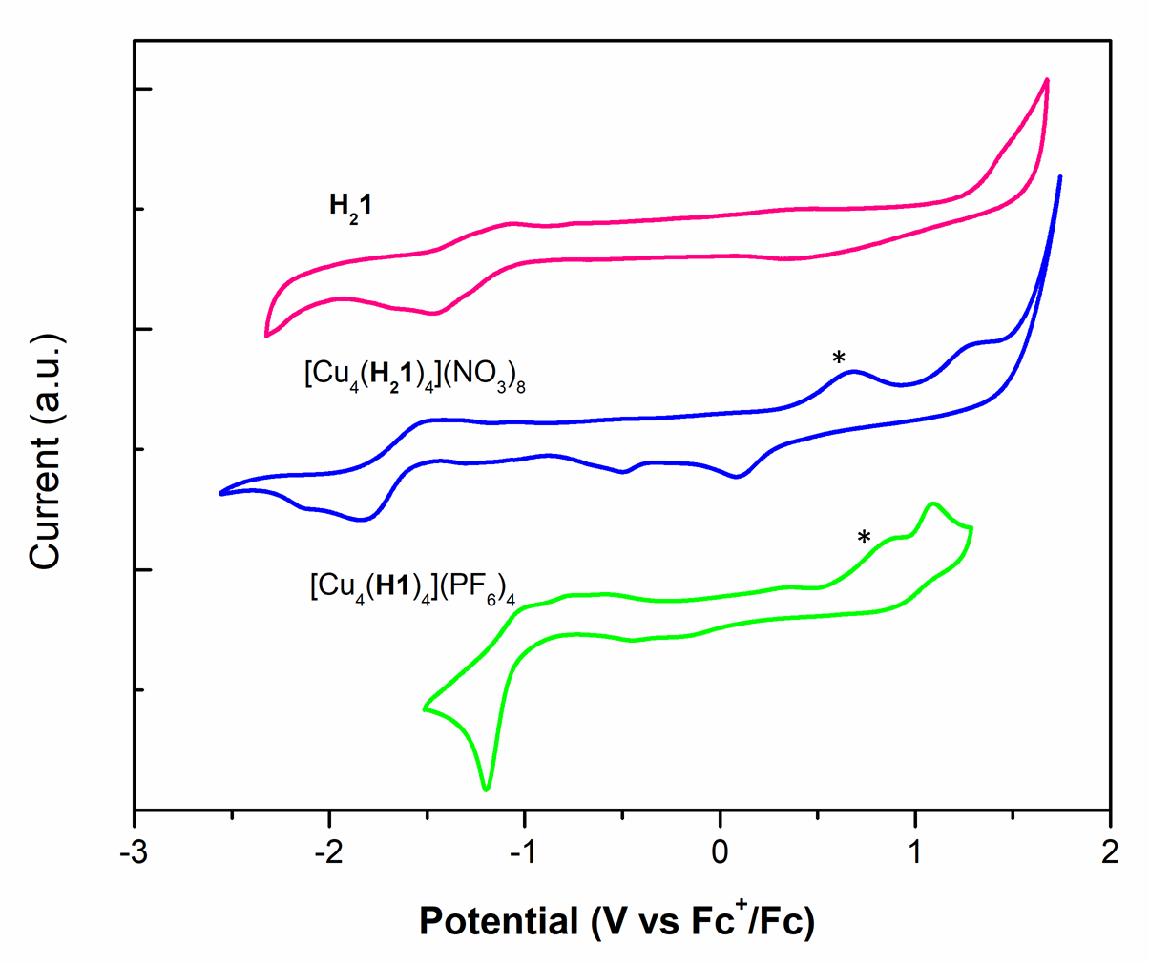
Figure 5 Cyclic voltammetry for H₂1, [Cu₄(H₂1)₄](NO₃)₈ and [Cu₄(H1)₄](PF₆)₄ recorded in deaerated acetonitrile; supporting electrolyte TBAPF₆ 0.1 M. The Fc⁺/Fc couple was used as an internal standard. Scan rates were at 100 mV s⁻¹ and were in the negative scan direction. * These waves are electrochemical side-products generated from scanning the reduction. See Figures S20 and 21 ESI for cathodic and anodic traces, where these waves disappear.
irreversible reduction at an electrochemical onset of -1.15 V, and a second irreversible reduction, the onset of which occurs at approximately -2.50 V (Figure S22, ESI). No discernible oxidation is detected for the ligand in the observable solvent window. The [Cu₄(H₂1)₄](NO₃)₈ CV trace exhibits a small cathodic shift in the reduction wave, with an onset of -1.61 V which is similar to the reduction process observed for the ligand. In contrast to the ligand, an oxidation is observed for [Cu₄(H₂1)₄](NO₃)₈ at +1.13 V. It is difficult to definitively discern whether this is a Cu^{II/III} or ligand-based process, but we note the lack of any oxidation for the ligand at similar potentials.
By contrast, the reduction of [Cu₄(H1)₄](PF₆)₄ is significantly anodically shifted, with an onset of reduction of -0.91 V that we have tentatively ascribed to a Cu^{II/I} process, based on similar systems reported by Sauvage et al. for octahedral Cu(II)/Cu(I) catenane systems.^{12,13} This irreversible Cu^{II/I}, which is not observed for the ligand or for [Cu₄(H₂1)₄](NO₃)₈, points towards the unstable nature of the Cu^{I} species and is indicative of its spontaneous oxidation to Cu^{II} in the reaction of [Cu(MeCN)₄]PF₆ with H₂1 to form [Cu₄(H1)₄](PF₆)₄.
In summary, we have developed a new chiral tzpa-type ligand and two tetranuclear Cu complexes which retain equivalent [2×2] grid topology despite linkage isomerism and differences in folding. Partial deprotonation under mild conditions at the amide nitrogen concurrent with Cu^{I}/Cu^{II} redox processes is a novel route to this mixed-donor species with potential relevance to catalysis, and provides a new entry point into complex metallosupramolecular architectures.
Acknowledgements
The authors gratefully acknowledge Science Foundation Ireland (SFI PI Award 13/1A/1865 to TG) and the School of Chemistry, Trinity College Dublin for financial support. We thank Dr. Gary Hessman for MS characterisation.
Notes and references
† CD titrations were also carried out which showed Cu(II) induced changes in H₂1. However, these did change slowly over time and could not be easily interpreted. Consequently we also carried out CD-titration using Fe(II) which confirmed that the resulting self-assembly was chiral.
- (a) J.-P. Sauvage and C. Dietrich-Buchecker, Molecular Catenanes, Rotaxanes and Knots, Wiley-VCH, Weinheim, 1999; (b) J. E. Beves, B. A. Blight, C. J. Campbell, D. A. Leigh and R. T. Mcburney, Angew. Chem. Int. Ed., 2011, 50, 9260–9327; (c) D. J. Hoffart and S. J. Loeb, Angew. Chem. Int. Ed., 2005, 44, 901–904; (d) O. Kotova, S. J. Bradberry, A. J. Savyasachi, and T. Gunnlaugsson, Dalton Trans., 2018, 47, 16377-16387; (e) O. Kotova, S. Comby, K. Pandurangan, F. Stomeo, J. E. O’Brien, M. Feeney, R. D. Peacock, C. P. McCoy and T. Gunnlaugsson, Dalton Trans., 2018, 47, 12308–12317; (f) A. J. Savyasachi, O. Kotova, S. Shanmugaraju, S. J. Bradberry, G. M. Ó Máille and T. Gunnlaugsson, Chem, 2017, 3, 764–811.
- (a) R. Yerushalmi, A. Scherz, E. Van Der Boom and H. Kraatz, J. Mater. Chem., 2005, 15, 4480-4487; (b) F. Niess, V. Duplan and J. -P. Sauvage, J. Am. Chem. Soc; (c) J. B. Beck and S. J. Rowan, J. Am. Chem. Soc., 2003, 125, 13922–13923; (d) J. Lovitt, C. S. Hawes, A. D. Lynes, B. Haffner, M. E. Mobius and T. Gunnlaugsson, Inorg. Chem. Front., 2017, 4, 296–308; (e) E. P. Beaumier, A. J. Pearce, X. Y. See and I. A. Tonks, Nat. Rev. Chem., 2019, 3, 15–34, (f) C. S. Hawes, A. D. Lynes, K. Byrne, W. Schmitt, G. Ryan, M. E. Möbius and T. Gunnlaugsson, Chem. Commun., 2017, 53, 5989-5992.
- (a) R. A. S. Vasdev, D. Preston and J. D. Crowley, Dalton. Trans., 2017, 46, 2402–2414; (b) J. P. Byrne, M. Martínez-Calvo, R. D. Peacock and T. Gunnlaugsson, Chem. Eur. J., 2016, 22, 486–490.
- (a) J. A. Findlay, C. J. McAdam, J. J. Sutton, D. Preston, K. C. Gordon and J. D. Crowley, Inorg. Chem., 2018, 57, 3602–3614; (b) Y. Li, J. C. Huffman and A. H. Flood, Chem. Commun., 2007, 26, 26922694; (c) U. R. Pokharel, F. R. Fronczek and A. W. Maverick, Nat. Commun., 2014, 5, 1–5; (d) R. A. S. Vasdev, D. Preston, S. Scottwell, H. J. L. Brooks, J. D. Crowley and M. P. Schramm, Molecules, 2016, 21, 1–13; (e) B. Jana, L. Cera, B. Akhuli, S. Naskar, C. A. Schalley and P. Ghosh, Inorg. Chem., 2017, 56, 12505–12513.
- (a) E. P. Mccarney, C. S. Hawes and S. Blasco, Dalton Trans., 2016, 45, 10209–10221; (b) E. P. Mccarney, C. S. Hawes, J. A. Kitchen, K. Byrne and W. Schmitt, Inorg. Chem., 2018, 57, 3920–3930; (c) J. P. Byrne, J. A. Kitchen, J. E. O'Brien, R. D. Peacock and T. Gunnlaugsson, Inorg. Chem., 2015, 54, 1426–1439; (d) J. P. Byrne, S. Blasco, A. B. Aletti, G. Hessman and T. Gunnlaugsson, Angew. Chem. Int. Ed., 2016, 55, 8938–8943.
- (a) D. E. Barry, C. S. Hawes, J. P. Byrne, B. la Cour Poulsen, M. Ruether, J. E. O’Brien, T. Gunnlaugsson, Dalton Trans., 2017, 46, 6464-6472; (b) J. P. Byrne, J. a Kitchen and T. Gunnlaugsson, Chem. Soc. Rev., 2014, 43, 5302–5325; (c) J. P. Byrne, J. a Kitchen, O. Kotova, V. Leigh, A. P. Bell, J. J. Boland, M. Albrecht and T. Gunnlaugsson, Dalton Trans., 2014, 43, 196–209; (d) E. P. McCarney, J. P. Byrne, B. Twamley, M. Martínez-Calvo, G. Ryan, M. E. Möbius and T. Gunnlaugsson, Chem. Commun., 2015, 51, 14123–14126; (e) J. A. Kitchen, Coord. Chem. Rev., 2017, 340, 232–246; (f) O. Kotova, J. A. Kitchen, C. Lincheneau, R. D. Peacock and T. Gunnlaugsson, Chem. Eur. J., 2013, 19, 16181–16186.
- (a) R. M. Meudtner, M. Ostermeier, R. Goddard, C. Limberg and S. Hecht, Chem. Eur. J., 2007, 13, 9834–9840; (b) D. Zornik, R. M. Meudtner, T. Ela Malah, C. M. Thiele and S. Hecht, Chem. Eur. J., 2011, 17, 1473–1484; (c) R. M. Meudtner and S. Hecht, Angew. Chem. Int. Ed., 2008, 47, 4926–4930; (d) R. M. Meudtner and S. Hecht, Macromol. Rapid Commun., 2008, 29, 347–351; (e) P. Kumar and R. Gupta, Dalton. Trans., 2016, 45, 18769–18783; (f) J. Andres and A. Chauvin, Inorg. Chem., 2011, 50, 10082–10090.
- A. Spek, Acta. Crystallogr., 2015, 71, 9–18.
- (a) C. He, B. Zhang, C. Duan, J. Li and Q. Meng, Eur. J. Inorg. Chem., 2000, 2549–2554; (b) M. Ruben, J. Rojo, F. J. Romero-salguero, L. H. Uppadine and J. Lehn, Angew. Chem. Int. Ed., 2004, 43, 3644–3662; (c) B. M.-T. Youinou, N. Rahmouni, J. Fischer and J. A. Osborn, Angew. Chem. Int. Ed., 1992, 31, 733–735.
- D. W. Boyce, D. J. Salmon, W. B. Tolman, Inorg. Chem., 2014, 53, 5788–5796; (b) L. Rostami and H. Golchoubian, Inorganica Chim. Acta, 2017, 462, 215–22; (c) S. H. Van Rijt, A. J. Hebden, T. Amaresekera, R. J. Deeth, G. J. Clarkson, S. Parsons, P. C. Mcgowan and P. J. Sadler, J. Med. Chem., 2009, 52, 7753–7764; (d) H. Sigel and B. Martin, Chem. Rev., 1982, 82, 385–426; (e) H. Miyake, M. Hikita, M. Itazaki, H. Nakazawa, H. Sugimoto and H. Tsukube, Chem. Eur. J., 2008, 3, 5393–5396; (f) V. Dremov, F. W. Heinemann, P. Müller and R. Alsfasser, Angew. Chem. Int. Ed., 2005, 44, 803–806.
- JPlus Consulting, ReactLab Equililbria, Freemantle, Australia, 2016.
- D. J. Cárdenas, A. Livoreil, J. -P. Sauvage, J. Am. Chem. Soc., 1996, 118, 11980-11981.
- E. Coronado, P. Gaviña, J. Ponce and S. Tatay, Chem. Eur. J., 2014, 20, 6939–6950.

