# Who controls the city? A micro-historical case study of the spread of rioting across North London in August 2011

Roger Ball,1, 2, 3 Clifford Stott,1 John Drury,2 Fergus Neville,4 Stephen Reicher,5 and Sanjeedah Choudhury2

1 School of Psychology, Keele University – Staffordshire, UK

2 School of Psychology, University of Sussex – Falmer, UK

3. School of Sociology, University of Sussex – Falmer, UK

4School of Management, University of St Andrews – Fife, UK

5 School of Psychology and Neuroscience, University of St Andrews – Fife, UK

Corresponding author: Clifford Stott, School of Psychology, Keele University, StaffordshireST5 5BG [c.stott@keele.ac.uk](mailto:c.stott@keele.ac.uk)

This research was funded by a grant to John Drury, Clifford Stott and Steve Reicher from the Economic and Social Research Council, grant number ES/N01068X/1. We would like to thank Professors Tim Newburn and Rob Procter for access to the Guardian/LSE “Reading the Riots” interview and social media data sets, Trevor Adams of the Metropolitan Police Service for assistance with access to arrestee figures and Richard Grove for graphic design of the figures. All base maps are © OpenStreetMap contributors.

# Abstract

In August 2011, over four days, rioting spread across several cities in England. Previous accounts of these riots have indicated the roles of police racism, class disadvantage, and spatial affordance. However what remains unclear is how these structural factors interacted with crowd processes spatially over time to govern the precise patterns of spread. The present paper provides a micro-historical analysis of the patterns and sequences of collective behaviour as the 2011 riots spread across North London, drawing upon multiple data-sets (archive, interview, video, official report, news coverage). The analysis suggests that initial stages of escalation in the broader proliferation were the result of protagonists deliberately converging from areas of relative deprivation in order to create conflict, but that they did so as a meaningful social identity-based expression of power. We show how over time these motivations and patterns of collective action changed within the riot as a function of intergroup interactions and emergent affordances. On this basis we provide support for the argument that political, social and economic geography were key determining factors involved in the pattern of spread of the 2011 riots. However, we also suggest that an adequate explanation must correspondingly take into account the interplay between social identity, the dynamics of intergroup interaction, and empowerment process that develop during riots themselves.

# Keywords

Crowds, contagion, social identity, riots, rational choice

**Introduction**

Urban riots are profoundly significant both to the societies that experience them and to those who are involved. While the term “riot” tends to convey the idea of chaotic and formless crowd violence, close examination shows that such events are typically actually highly structured and complex (Thompson, 1971). Far from being disordered, they display evidence of the norms of the collective or crowd involved, which typically relate to the social context within which they occur (McClelland 1989; Reddy 1977; Rudé 1964; Tilly, Tilly & Tilly 1975). For example, like other major urban riots, such as those that swept across France in 2005 (Body-Gendrot, 2013; Bonnasse-Gahot et al, 2017; Moran & Waddington, 2015; Waddington & King, 2009) and the USA in 2014 (Chaney & Davis, 2015; Gershenson & Hayes, 2016), the widespread and multiple confrontations across several English cities in August 2011 displayed two features. First, there was geographical spread, initially across London, and then to some but not all major urban centres in the Midlands and the north-west of England across the next few days (Guardian/LSE, 2011; Newburn, 2016). Second, although portrayed in much of the British media as mindless or simply “criminal,” studies of the disturbances evidence a pattern of targets of the crowd that reflected complex underlying motives (Ball and Drury 2012; Baudains, Braithwaite, and Johnson 2012, 2013; Baudains, Johnson, and Braithwaite 2013; Guardian/LSE, 2011; Newburn et al. 2016; Reicher and Stott 2011; Stott et al, 2016, 2018; Tiratelli, 2017).

It is widely acknowledged that the precipitating riot developed on Saturday 6th August 2011 following a peaceful protest on Tottenham High Road two days after the shooting by police of a mixed-heritage man, Mark Duggan, in the London borough of Haringey. However, the riots were significant precisely because they spread beyond Haringey over the next four days. The initial conflict began in a district of London (Tottenham) with a relatively large Black population[1], and police racism (both in the killing and in patterns of “stop and search”) have been cited as causal factors (Gilroy, 2013; Guardian/LSE, 2011). However, as the rioting spread to other districts in London and across the country, so the composition became more diverse, with increasing numbers of white (and to a lesser degree Asian) people participating.

One of the first signs of the continuing disorder occurred the following day as rioting and looting developed in the adjacent borough of Enfield. These disturbances began with the convergence of hundreds of people in the early afternoon into Enfield Town centre and culminated in the collective looting of a nearby retail park later that evening. In the present study, we draw upon an extensive corpus of primary and secondary data to reconstruct the event in detail in order to analyse the factors that may have governed the spread of rioting into the borough.

## Understanding the 2011 English riots

The 2011 English riots were widely characterized by politicians and mass media as an expression of “mindless criminality” spreading through “copycat” behaviour (Reicher and Stott 2011). These characterizations of riots echo irrationalist classical crowd psychology, according to which rioting is due to loss of the conscious self, and hence self-control, in the crowd (Le Bon [1895] 2002; see Ball and Drury 2012) or to the convergence of those already predisposed toward criminality (see Stott & Drury 2017). Similar reductionist explanations were the basis of some of the UK Government’s policy responses to the 2011 riots, such as the ‘Troubled Families’ programme, which was premised on an assumption of lack of moral character among the rioters caused by poor parenting (Riots Communities and Victims Panel 2011; cf. Back, 2013; Bridges, 2012; Crossley, 2016; Lambert & Crossley, 2016; Lightowlers, 2015; Slater, 2011, 2015; Solomos, 2013). These accounts lack an empirical base and cannot explain the coherent patterns of action - such as selection of targets, evident in urban rioting (Ball and Drury 2012; Reicher 1984; Stott and Drury 2016).

Among scholarly accounts, racist policing is one explanation that has been offered for the many urban riots in the UK, both in 2011 (Gilroy, 2013; Guardian/LSE 2011; Newburn 2016) and in earlier waves. Thus the English riots of 1980/81 and 1985 were associated with racist police street operations (e.g., “Operation Swamp” in 1981 in which police flooded the streets of Brixton), deaths or serious injury of Black people at the hands of police (e.g., the shooting of Dorothy “Cherry” Groce and the death of Cynthia Jarrett during police searches in 1985) as well as racist legislation, employment practices and housing policies (Andrews, 2019; Scarman, 1981). However, as Kettle and Hodges (1982: 22) point out in their analysis of the riots of 1980 and 81 “that in trying to place the riots in context, some note must be taken of the charactersitics of crowd behaviour. What is it that draws people into crowds? What changes come over people in crowds?”.

Tottenham and Brixton rioters who were interviewed in 2011 often cited police racism, in the form of disproportionate “stop and search”, as a cause of their anger and involvement (Drury et al. submitted; Stott et al. 2018). Black and Asian Muslim ethnic groups are disproportionately targeted in stop and search (Dodd 2019) and Metroplitan Police data show that those London boroughs that saw rioting in 2011 had significantly higher levels of police “stop and searches”, as well as more negative views of the police, than those boroughs that did not (Drury et al. 2019).

However, the association between policing and the riots could equally well be explained in terms of social class. Thus studies immediately prior to the 2011 riots also showed that “men, younger people… the unemployed, those not in good health, and those not in the managerial/professional social classes were all more likely to have been stopped and searched” (Bradford and Loader, 2016). Indeed the boroughs in London that experienced rioting had significantly greater levels of deprivation than those that didn’t, on a variety of measures, including the Index of Multiple Deprivation[2] overall score (Drury et al. 2019; Kawalerowicz and Biggs, 2015).

Thus while Black (young) people were disproportionately involved in the 2011 riots, the following figures support Dikeç’s (2017) argument that these events, like those of the Los Angeles riot in 1992, cannot be reduced merely to a Black experience. The Ministry of Justice estimated that 46% of those brought before the courts for participation in the 2011 riots were Black or of mixed heritage while 42% were white, and 7% were from an Asian or mixed Asian background. In addition, the proportions varied around the country. In Birmingham, 46% were from a Black background, 33% white and 15% were Asian, while in Salford, 94% of those taken to court were white, with just 6% from a Black or mixed background (Muir and Adegoke 2011). Slater (2011, 2015) positions systematic failures of politics and lack of civic regard as primary factors in the 2011 riots, with financial cuts from Government creating indignity and dishonour among communities relegated to stigmatised neighbourhoods.

The combination of police racism and class deprivation help explain some of the spatial and geographical patterns of the 2011 riots. Thus, Tiratelli’s (2017) analysis of offences recorded during the riots in London suggests that choice of location reflected disadvantaged participants taking control of urban spaces within which they normally felt disempowered. Similarly, Gilroy (2013: 533) argues that a key characteristic of the 2011 riots is that they occurred in locations “uniquely saturated with histories of conflict between community and police”.

While police racism, class, and geographical factors clearly played an important explanatory role, they are insufficient to fully account for the spatial and temporal patterns evident in the *spread* of the 2011 riots from one urban location to another. To begin to address this, Baudains, Johnson et al. (2013) provide an account of riot spread which focuses not just on structurally-created collective grievances but also the affordances of public space. They analyse arrest statistics and crime data from the riots in London to show that the spread across the city was not random. Drawing upon Routine Activity and Crime Pattern Theories, they argue that the spread into specific areas was because people sharing grievances with the rioters in the first locations to riot made the rational choice to target locations that they were routinely familiar with (Baudains, Braithwaite et al. 2013: 255). Correspondingly, unfamiliar locations created difficulties which impeded the likelihood of travel. Baudains, Braithwaite et al. also suggest that convergence into a particular location created “safety in numbers, whereby the perceived risk of arrest is likely to be lower in those areas where rioters substantially outnumber law enforcement” (257-58). The co-presence of other rioters thus created a normative context whereby “those who live near to, or happen to pass by, riots are encouraged to engage in the disorder” (258).

Other researchers have also argued for the role of shared social identity in explaining aspects of riots in urban areas (e.g., Newburn 2016; Reicher 1984). Specifically, the *social identity* *approach* helped explain how local and racialized anti-police identities informed the norms and hence limits of crowd behaviour evident in the St Pauls riot of 1980 (Reicher, 1987). We suggest that this approach offers a way of enriching those theoretical accounts of spread that emphasise individual rational choice in riot behaviour (Baudains et al. 2012, 2013; Myers and Przybysz 2010). While rational choice approaches assume a single unitary identity, the social identity approach suggests that people each have *multiple* identities that vary over social and historical context (Turner et al. 1987). Accordingly, collective behaviour in urban riots is made possible through participants sharing a social identity, and the relationship with outgroups (such as police) defines both the content of that identity and the form of collective action (e.g., common targets). When power relationships with those outgroups reverse through collective action, this is experienced as empowering, and hence new collective actions (and new collective “rational choices”) become appropriate and possible (Reicher 1996, 2001).

The utility of the social identity approach has recently been demonstrated in relation to the Haringey and Hackney riots in London during August 2011 (Stott, Drury, and Reicher 2016; Stott et al., 2018), where it helped explain the emergence of violence and the shift from targeting police to looting. In the present study, we seek to extend the literature by using a micro-historical approach to explore how the political and economic geography of North London articulated with the dynamics of identity, intergroup interaction and empowerment to understand why the rioting in August 2011 spread into the borough of Enfield. We suggest that it is through a methodological approach which combines analysis of demographic data, participants’ experiences, and detailed evidence on what actually took place in different locations over time that new insights can be created on the question of riot spread.

## The present study

Detailed empirical studies of the 2011 riots are extremely limited as are studies of the spread of urban rioting within cities more generally (Baudains, Johnson et al. 2013; Kawalerowicz and Biggs 2015). As such, there is a dearth of research on the nature of the first stages of the escalation of the rioting and a need to understand what impact this may have had on the processes governing wider conflagration. Moreover, existing research on spread in the riots relies predominantly on aggregate crime data recorded by the police (e.g., Baudains, Braithwaite et al. 2013); there is the need to triangulate these crime statistics with other data on local patterns of diffusion. By taking a micro-historical case study approach we will begin to address the call by Tiratelli (2017) and Lightowlers (2015) for an account that explains how macro or structural factors interact with the micro-situational dynamics of urban riot.

In the foregoing, we first present analysis of demographic data for Enfield borough, which exposes geographic divisions in relation to deprivation, ethnicity and local politics. We then provide a detailed account of the disturbances in Enfield, triangulated from multiple sources, to identify patterns of mobilization, initiation, and the nature of targets (cf. Kawalerowicz and Biggs 2015). Next, we analyse the Metropolitan Police Service’s (MPS) crime data to ascertain the typical distances travelled by the Enfield rioters and their demographic composition in comparison with their counterparts in Tottenham, where the rioting began the day before. Finally, we present an analysis of participant accounts, taken from *the Guardian*/LSE *Reading the Riots* corpus (2011), that examines how they may have experienced the events and some of their motivations. Together, these analyses allow us to explore what may have led rioters to choose Enfield Town as a target, and if the *form* of rioting changed as rioting spread - here examining looting in relation to other motives, such as confronting police, enacting power, and attacking wealth.

# Methodology

The methodological approach in this paper comprises four types of analysis: a comparative examination of demographic data for the borough of Enfield, triangulation of diverse sources, analysis of MPS crime data, and phenomenological analysis of participant accounts.

## Demographic analysis

We conducted spatial comparisons of relative socio-economic deprivation from a national, city, borough and Lower Super Output Area (LSOA) perspective, and analysed statistics on ethnicity and local council voting patterns within the borough of Enfield, to understand its demographic and political geography. This quantitative data analysis was integrated with qualitative evidence provided by participant accounts and residents’ perceptions of the borough of Enfield, Enfield Town and their “home” areas (see below, Phenomenological Analysis).

## Triangulation

The triangulated account of the disturbance in Enfield was based on the following sources: published reports by the MPS and Enfield Borough Council; 50 news articles; Her Majesty’s Inspectorate of Constabulary (HMIC) review (2011) report; and transcripts of the hearings given to the House of Commons Home Affairs Committee (2011); 25 online videos; contemporaneous blogposts and Twitter messages[3]; online lists of damaged and looted properties in Enfield borough; transcripts of interviews with participants; and a field trip and interviews with local officials and residents. A complete list of sources, comprehensive details of the procedure, and the full triangulated account itself can be found in the Supplementary Materials.[4]

## Crime data

Arrestee data in the boroughs of Enfield and Haringey was provided by the MPS.[5] For comparative purposes, our analysis compared the distances travelled by samples of “rioters” who participated in the Tottenham and Enfield disorders and the composition of these crowds by age, gender and ethnicity.

## Phenomenological analysis

The study draws from participant testimonies (*N* = 13) of a sample of people involved in the Enfield disturbances obtained from the *Guardian*/LSE *Reading the Riots* project (2011). Interviewers utilised local contacts to trace people who had been involved, the majority of whom had not at that point been arrested. Interviews were semi-structured; each interviewee was asked how they first heard about the riots, how they became involved, how they communicated, what they did, why they thought the riots stopped and how they felt about their actions now. Each interview lasted on average approximately 45 minutes. The transcripts were redacted to remove identifying information and then coded thematically (Braun and Clarke 2006).

**Enfield borough demographics**

The borough of Enfield lies immediately to the north of Haringey. Of the 33 London boroughs ranked highest to lowest in 2010 by Indices of Multiple Deprivation (IMD), Haringey was placed fourth and Enfield fourteenth, locating them amongst the more deprived areas of the capital. From a national perspective, Enfield ranked 64 and Haringey 13, out of 326 local authorities in 2010.

The IMD for the borough of Enfield in 2015,[6] divided into LSOA, is shown in Figure 1. There are differences apparent between the lower rankings for the east (relatively deprived in darker shade) and west (relatively affluent in lighter shade) parts of the borough, with the Great Cambridge Road (A10), running north-south, marking a sharp demarcation between these two zones. To the east of the A10 lies a strip of less affluent neighbourhoods, squeezed against the Chingford reservoirs, running south through Ponders End and into the more deprived areas of Edmonton and Tottenham. Enfield Town, the centre of civic power for the borough, lies adjacent to the A10, effectively a gateway to the middle-class suburbs to the west.

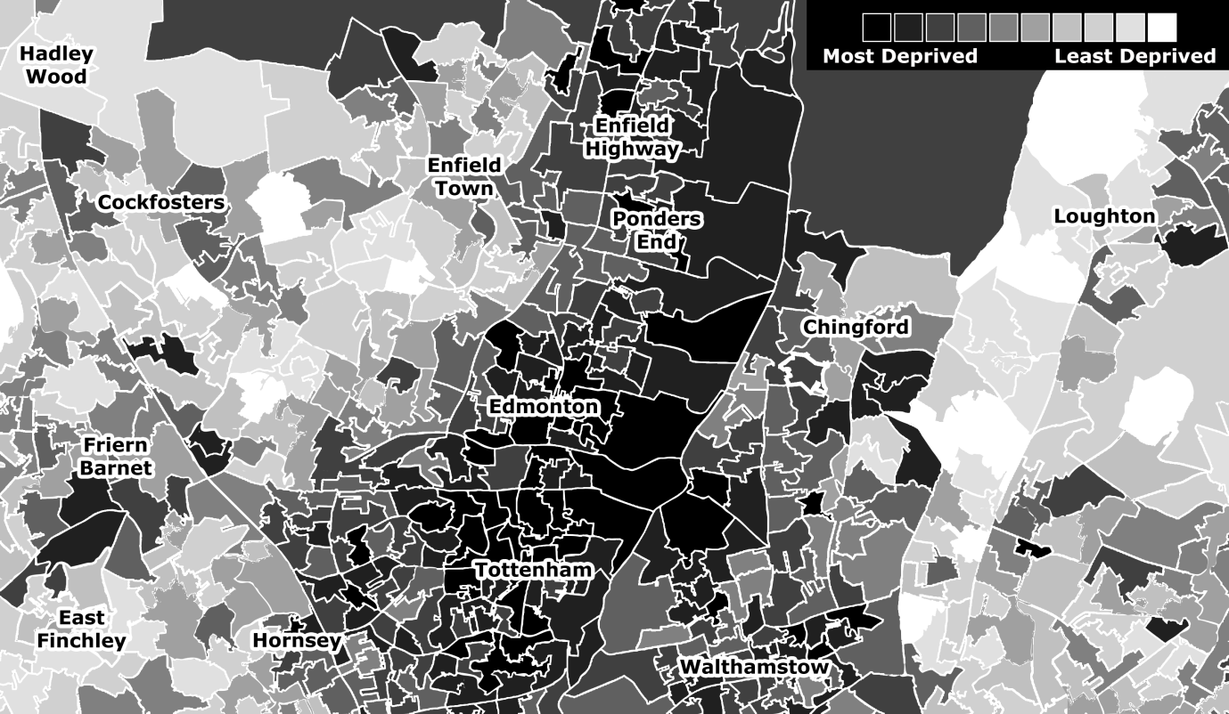

**Figure 1: Index of Multiple Deprivation (2015) by LSOA for North London boroughs of Enfield and Haringey.**

The stark divisions in wealth between the East and West of the borough are mirrored by the distribution of non-White ethnic groups by electoral ward shown in Figure 2 and by political affiliation. Figure 3 displays the results of the 2010 local elections for the borough, with Labour victories in black and Conservative in grey.

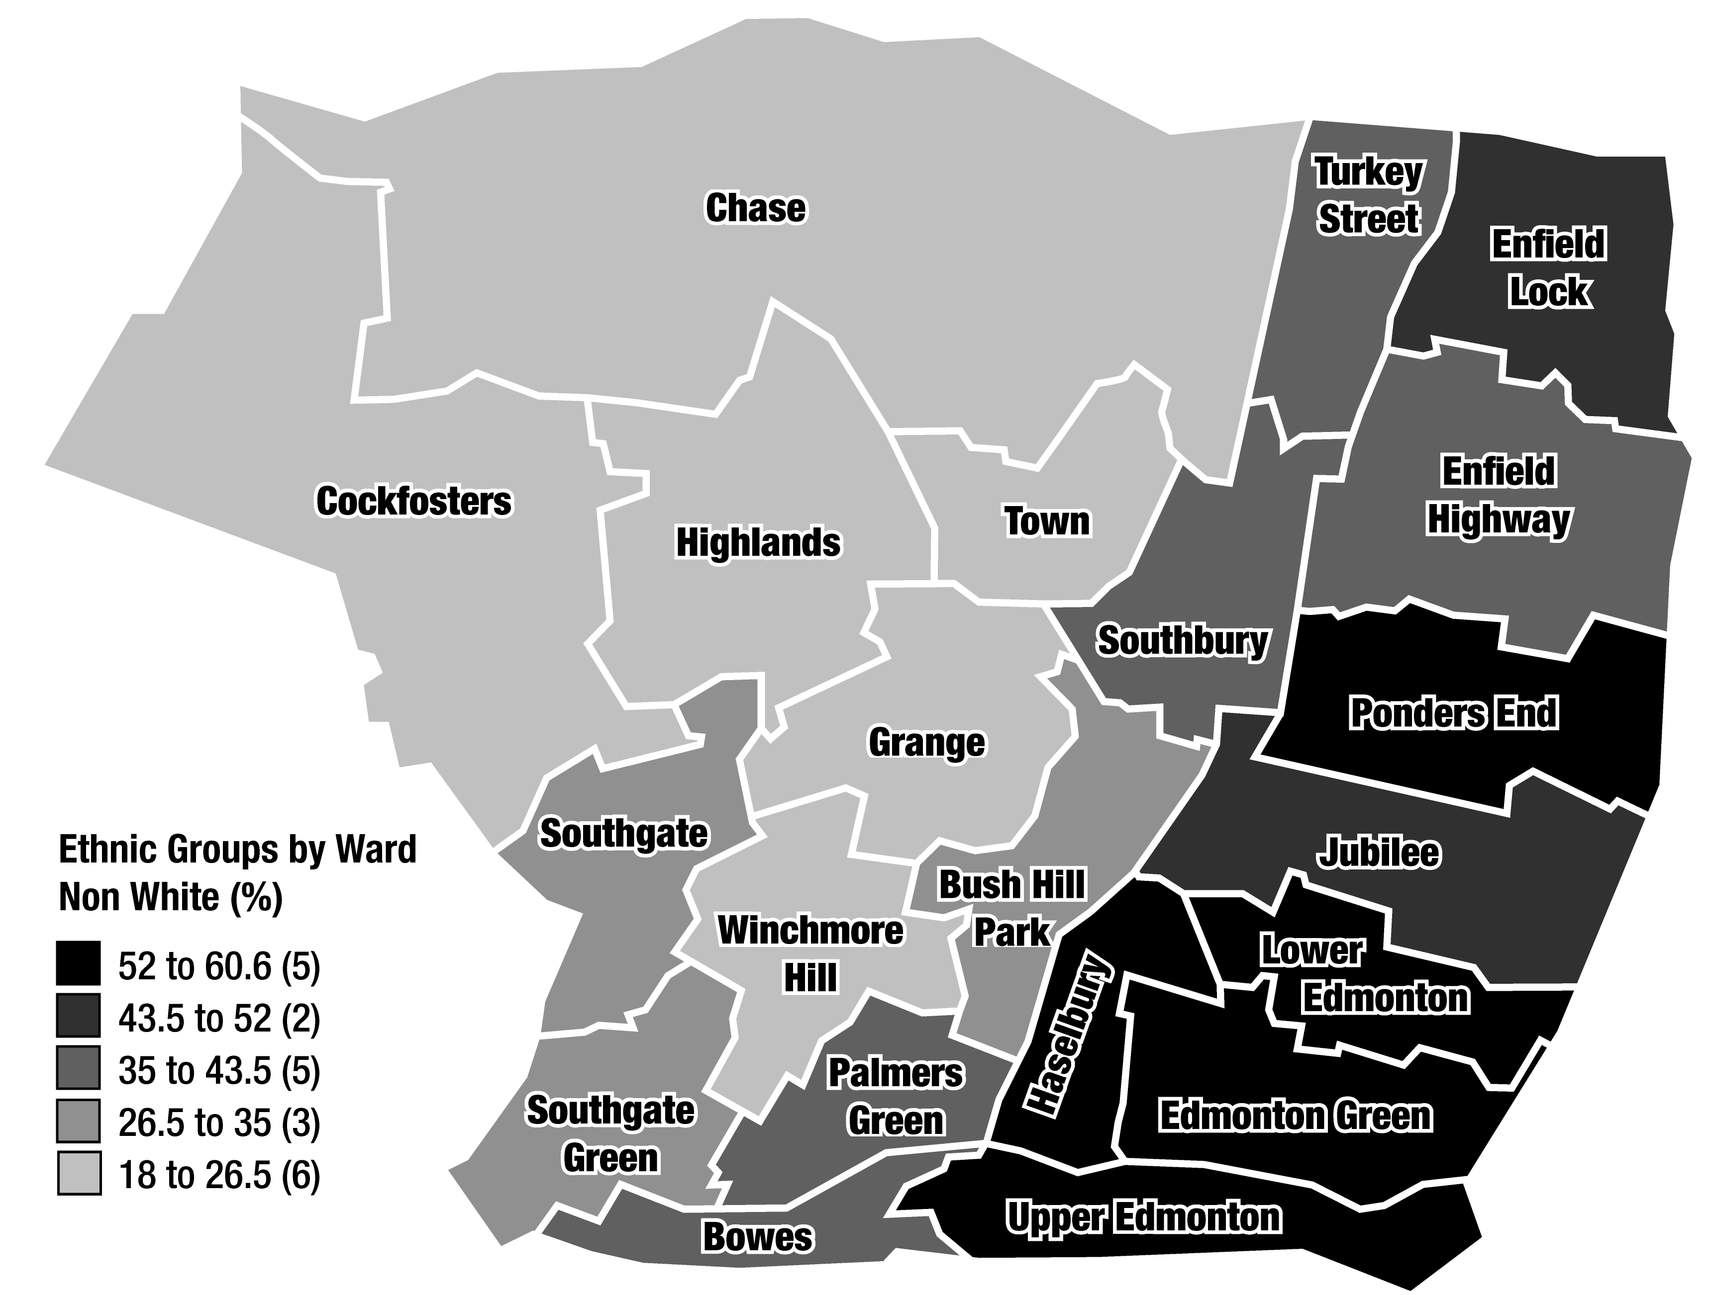

**Figure 2: Distribution of Non-white ethnic groups by electoral ward in the London borough of Enfield (2011 census).**

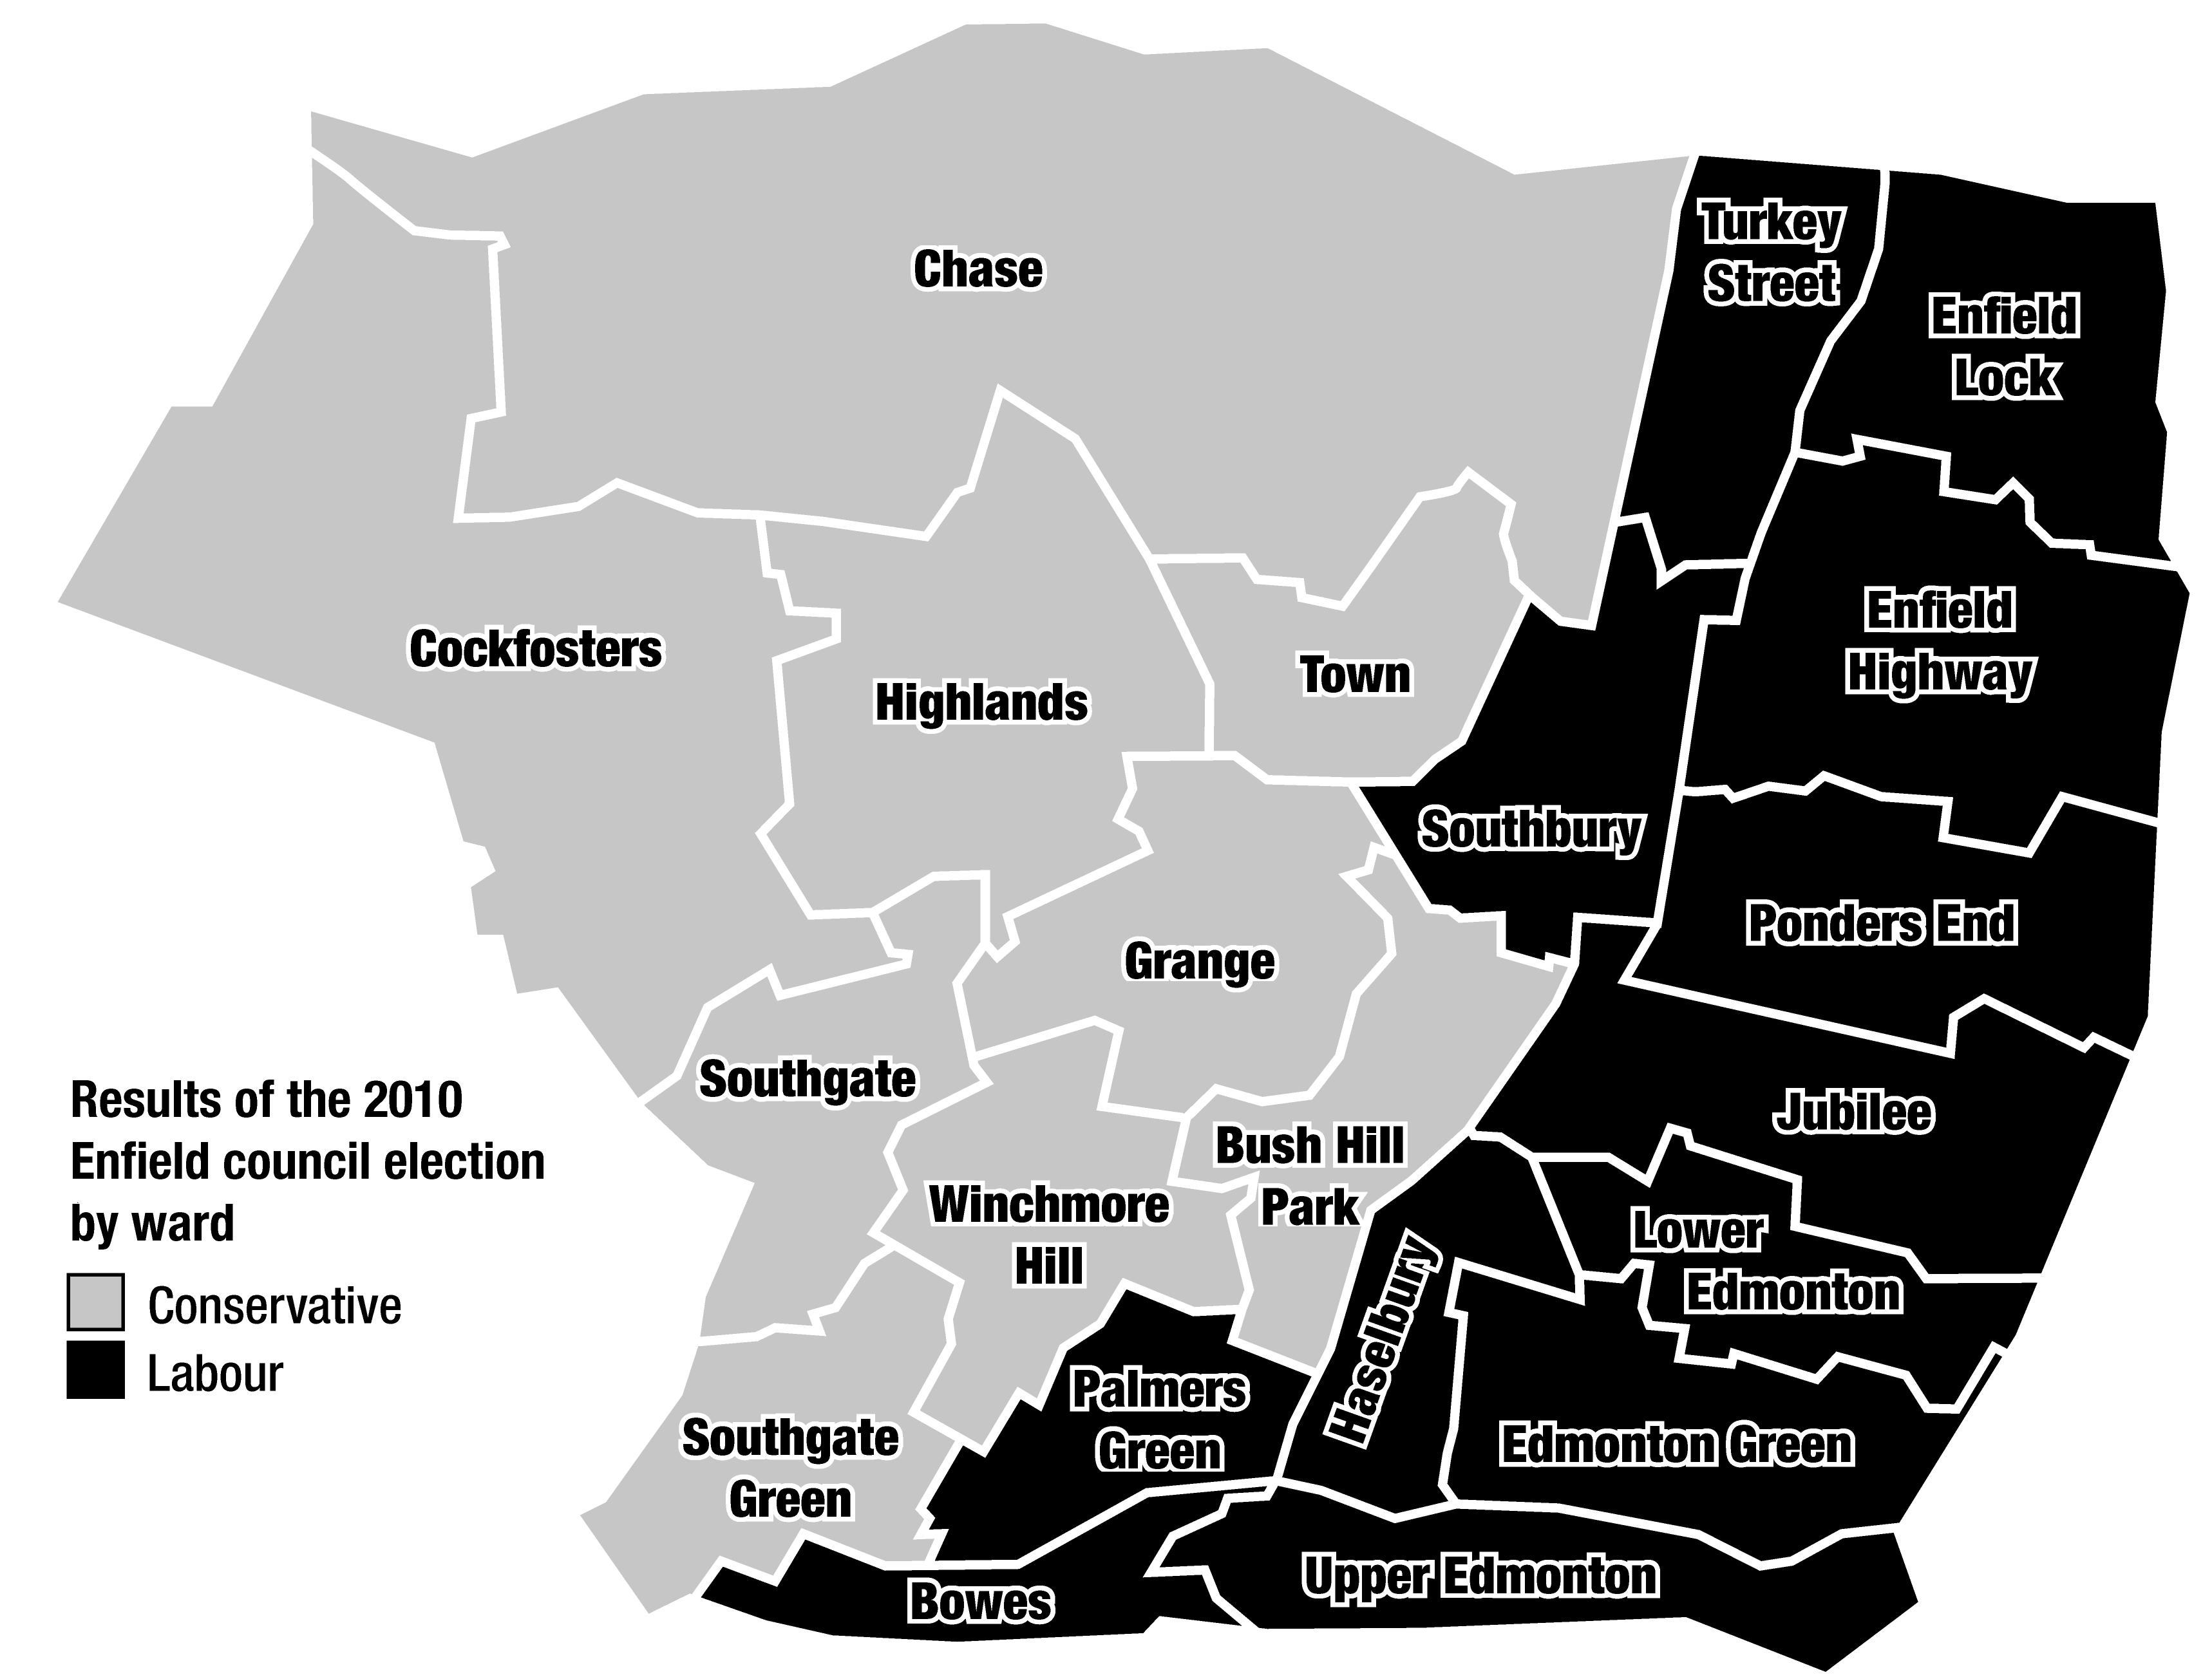

**Figure 3: Local election results for Enfield Borough Council (2010).**

The consequences of the differences in socio-economic conditions in the borough were alluded to by a long-term resident:

*Statisticians say people who reside in affluent western Enfield live ten years longer on average than people from Enfield's poorer east. It's an east-west divide mirrored by a similar socio-economic chasm in Enfield's southern neighbour, Haringey, where Muswell Hill and Crouch End contrast starkly with Tottenham.* (Coleman, 2011)

The socio-economic divisions in the borough are reflected in the micro-geography of Enfield Town. To the west of the main shopping street are the predominantly middle-class avenues of Chase Side followed by green belt land interspersed with affluent suburbs (such as World’s End, Oakwood, Southgate and Cockfosters), country parks and golf courses. In contrast, east from Enfield Town Centre along Southbury Road (A110), are retail parks and trading estates clustered around the dividing line of the A10; further on lies Ponders End and the junction with the Hertford Road, the southern route to the poorer neighbourhoods of Edmonton and Tottenham to the east and south.

# Triangulated account of events

The first riot developed in Tottenham in the London borough of Haringey on the evening of Saturday 6th August 2011 following a peaceful protest two days after the shooting dead by police of a local mixed-heritage man, Mark Duggan. For eight hours, serious rioting against the police involving hundreds of people took place along a mile stretch of Tottenham High Road. Among targets damaged or destroyed by fire were a duty solicitor’s, Neighbourhood Police Office, Council office, Job Centre, Magistrates Courts and the Probation service. However, the most dramatic instance of arson was the huge blaze set in the Carpetright department store which eventually destroyed 26 flats above the shop. In the early hours of Sunday morning, hundreds of people broke away from the rioting to loot a nearby retail park in Tottenham Hale and Wood Green shopping centre. The anti-police violence in Tottenham eventually petered out at dawn after the deployment of mounted police, low-flying helicopters, an armoured vehicle and significant numbers of public order units. Sporadic looting continued in Wood Green, close to Tottenham High Road, until about 9.45 Sunday morning.(Guardian / LSE 2011; Stott et al. 2016, 2018)

The MPS state that the first intelligence they received referring to Enfield Town as a potential target came from BBM[7] messages passed onto them just after midday on Sunday 7th August. Specifically, the following communication was broadcast in the morning and afternoon:

*Everyone in edmonton enfield woodgreen everywhere in north link up at enfield town station 4 o clock sharp!!!! Start leaving ur yards [houses] n linking up with you niggas [friends]. Guck da feds [police], bring your ballys [mask up] and your bags trollys, cars vans, hammers the lot!! Keep sending this around to bare man [lots of people], make sure no snitch boys [informers] get dis!!! Whatever ends [home areas] your from put your ballys on link up and cause havoc, just rob everything. Police can't stop it. Dead [stop] the fires though!! Rebroadcast!!!!!* (Anon, 2011)

At 2.00pm, a police Safer Neighbourhoods Team (SNT) were sent to patrol Enfield Town Centre and two marked police cars were deployed to keep watch on Enfield Town railway station (Locations 5 and 1, Figure 4). Between 3.00pm and 3.30pm, the SNT informed the security teams in two shopping malls and larger shops of the potential for unrest. One of these malls was subsequently closed and shuttered. As businesses began to shut, police encouraged members of the public to leave the town centre. Finally, at 3.25pm, Section 60 of the Criminal Justice and Public Order Act 1994 was authorised for the borough of Enfield, which allowed police to order the removal of facial coverings and to stop and search pedestrians and vehicles at will. Thus, what would have otherwise been a busy town centre populated with shoppers now became a largely closed and unusually deserted space.

## Initial convergence

At 3.30pm, groups of youths began arriving at Enfield Town via the railway and bus stations. As people arrived, police used the Section 60 powers to search and identify some of them. However, this failed to stop a crowd developing in the otherwise empty town centre and the following three hours were marked by what appears to have been a tense “stand-off” between a crowd of approximately 300 people and an increasingly heavy police presence.

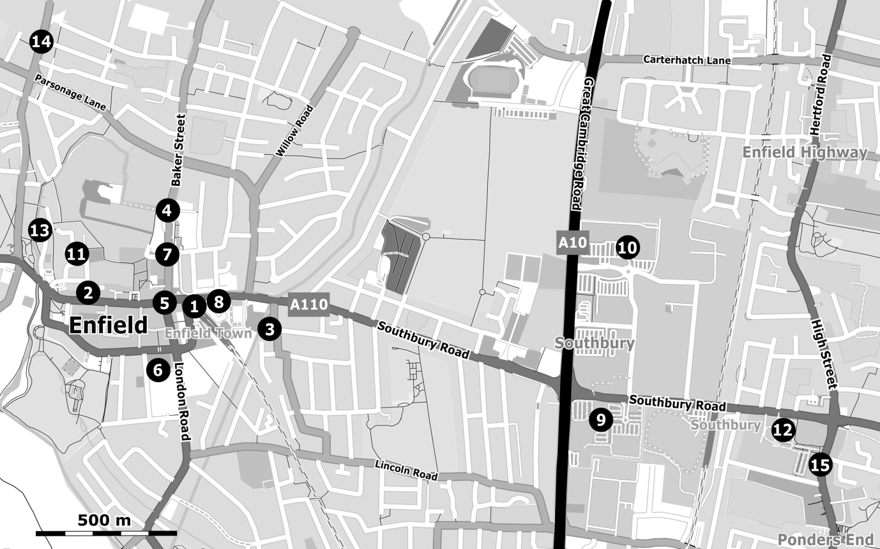

**Figure 4: Enfield Town and Ponders End**.

During this stand-off, there was no looting and very little if any substantive conflict. It was not until approximately 5.00pm, after reports of a crowd of 50-100 youths were breaking shop windows several miles away in Edmonton, that MPS Central Command sent four Police Support Units (PSUs)[8] to assist the borough, one of which arrived in Enfield Town at about 5.45pm.

## Emergence of conflict

At around 6.30pm, a crowd of 80-100 people first began breaking the windows of an HMV store and an adjacent mobile phone shop on Church Street (Location 2, Figure 4), which they proceeded to loot. At the same time, others began building a makeshift barricade out of rubbish bins and roadwork barriers outside the nearby Post Office. Further up the road, another group smashed the windows of Starbucks and a large department store. The property damage and looting attracted a police car which was attacked with bricks, concrete blocks and roadworks barriers. Twenty minutes after the incidents on Church Street, security guards reported that 30-50 masked youths were attempting to break into the Tesco Superstore to the rear of Enfield Town railway station (Location 3, Figure 4). A PSU rushed to the scene and dispersed them along nearby residential streets towards Southbury Road.

## Secondary convergence

In response to the escalation, two further PSUs were sent by the MPS along with a Public Order Commander[9] to Enfield Town. However, after the conflict in Enfield Town there was a lull for over an hour, with no reported attacks on property or police officers. But by 8.00pm CCTV footage showed an increase in the arriving crowds congregating near Enfield Town railway station to several hundred. A separate group of a hundred youths also gathered close to Enfield Town Police station (Location 4, Figure 4).

The pause in the violence gave time for the MPS to deploy reinforcements, including PSUs from the City of London police and the Territorial Support Group (TSG) along with dog-handlers. At about 8.20pm, collective violence once again developed as a large group attacked a police van close to the railway station. In response, police in full protective clothing charged at the crowd, who fled into the town centre. Some elements of the crowd then began tearing open the shutters of a jewellery shop and a neighbouring betting shop (Location 5, Figure 4). More than £40,000 of jewellery was stolen before a PSU dispersed the crowd using batons and dogs, also making several arrests.

The dispersal of the crowd did not reduce the violence. As dusk fell, a crowd of 150 attacked police lines on London Road and then smashed the shop-front of Argos with bricks and rubble (Location 6, Figure 4). Simultaneously, a second group of 50-100 people, several hundred metres away on Silver Street, looted a chemist and then began to wreck a bathroom department store (Location 7, Figure 4). Having attracted a PSU, they then set about bombarding them with bricks, until the police charged. The to and fro of the battle on Silver Street continued for about ten minutes before the police drove the rioters into Enfield Grammar School playing fields where they scattered over fences and into the backstreets of the west end of Enfield Town.

At this point, the police operation to secure Enfield Town centre was joined by a helicopter and a mounted police unit. Sometime after 9.00pm, the police began to push the remaining people from the town centre and outside the railway station eastwards down the Southbury Road. Breaking into smaller groups, many of the rioters left the police to defend the now empty Enfield Town centre and headed towards the retail parks situated on the junction with the A10 (Great Cambridge Road). As a parting gesture, one group smashed a line of small retailers including a pharmacy, a betting shop and an empty sandwich bar (Location 8, Figure 4) with apparent impunity.

As the police secured the town centre and most of the rioters made their way east along Southbury Road, others, who had dispersed through the school playing fields, were now in some of the wealthiest avenues of Enfield Town. Their route, a wide arc skirting the west and north of Enfield Town through fashionable and affluent Chase Side, was marked by a burning Audi (Location 11, Figure 4) and Ford (Location 13, Figure 4), vandalism to other private vehicles and homes, followed by several smashed and looted shops (Location 14, Figure 4). Acting on intelligence that petrol bombs had been thrown, the MPS Public Order Commander deemed it unsafe for the Fire Brigade to intervene and the cars were left to burn.

## Looting in retail parks

The first signs that the MPS tactic to drive the main body of the rioters along Southbury Road was improvident came at around 9.30pm with reports of police vehicles being attacked with missiles by a crowd of over 100. This was followed half an hour later by news that the De Mandeville and Enfield retail parks lying south and north respectively of the A10-Southbury Road junction (Locations 9 and 10, Figure 4) were being invaded by groups of “looters.” Several commercial outlets were targeted, including Argos, PC World, Comet and Curry’s (electrical goods), JB Sport and Sports Direct (clothing) and Sainsbury’s (general grocery). Other stores, such as Toys R Us and Pets at Home, were untouched. It wasn’t until after 10.00pm that the MPS Public Order Commander felt confident enough to release police resources from Enfield Town. By that stage, most of the looters had moved on from the retail parks, leaving only small numbers of late-comers and stragglers to be arrested and, in some cases, violently dealt with by the arriving PSUs.

The principal route of the retreating rioters became clear at around 10.20pm when the Tesco store in Ponders End was looted by 60-70 people of ~£100,000 of stock including DVDs, computer games, televisions, sports equipment and some food (Location 12, Figure 4). By 10.30pm, most of those on foot were now heading south along Hertford Road through Ponders End, towards Edmonton and the boundary with the borough of Haringey. PSUs sent to intercept looters in Ponders End were attacked, shops along the Hertford Road were damaged and looted, and at 10.40pm shops were being attacked in Edmonton. At approximately 11.00pm, PSUs blocked Fore Street, the main thoroughfare from Ponders End to Edmonton with police vans, whilst rioters created their own barricade of a burning vehicle.

The remainder of the evening and the early hours of Monday morning were marked by sporadic incidents of property damage, looting and violence throughout the borough of Enfield. It was not until 3.00am that the MPS could claim that they had “regained control,” though there were isolated incidents of looting reported until dawn.

# Analysis of crime data

## Distances travelled by participants

The triangulated account suggests that one of the key characteristics of the spread of rioting from Haringey to Enfield was that many participants travelled to Enfield Town centre. To explore this assumption, and for comparative purposes, we examined the characteristics of two samples from the MPS crime data of those accused of disorder-related offences in the Tottenham (*N* = 92) and Enfield (*N* = 138) riots.[10] Euclidian distances (in km) between the site of crimes and the home address of the alleged perpetrator (designated C-A) were calculated for both samples based on postcodes converted into latitude and longitude. The results are plotted as histograms in Figure 5.

**Figure 5: Distances (km) between arrestee residence and location of disorder related offence in Tottenham (London postal district N17) and Enfield (postal districts EN1, EN2, EN3 and N9), for disturbances on 6-8 August 2011 in the respective Boroughs of Haringey and Enfield.**

A visual comparison of the histograms indicates a difference in the shapes of the distributions, Tottenham showing decay with distance, and Enfield more normally distributed with a peak at approximately 4km. The distance from home address to crime location was greater for Enfield (*Mdn* = 3.90km) than for Tottenham (*Mdn* = 2.50km) and a Mann-Whitney test demonstrates a statistically significant difference in the distributions (*U* = 8,183.00, *z* = 3.71, *p* < .001, *r* = .24). This suggests that participants travelled further from their homes to engage in crimes in Enfield borough than in Tottenham. Moreover, this observation is supported by the spatial distribution of crime locations (stars) and home locations of the accused (circles) for the Enfield sample shown in Figure 6.[11] This shows that most of the participants in the sample travelled from places either in the east of the borough of Enfield or south from Haringey, with very few living in the immediate environs of Enfield Town.

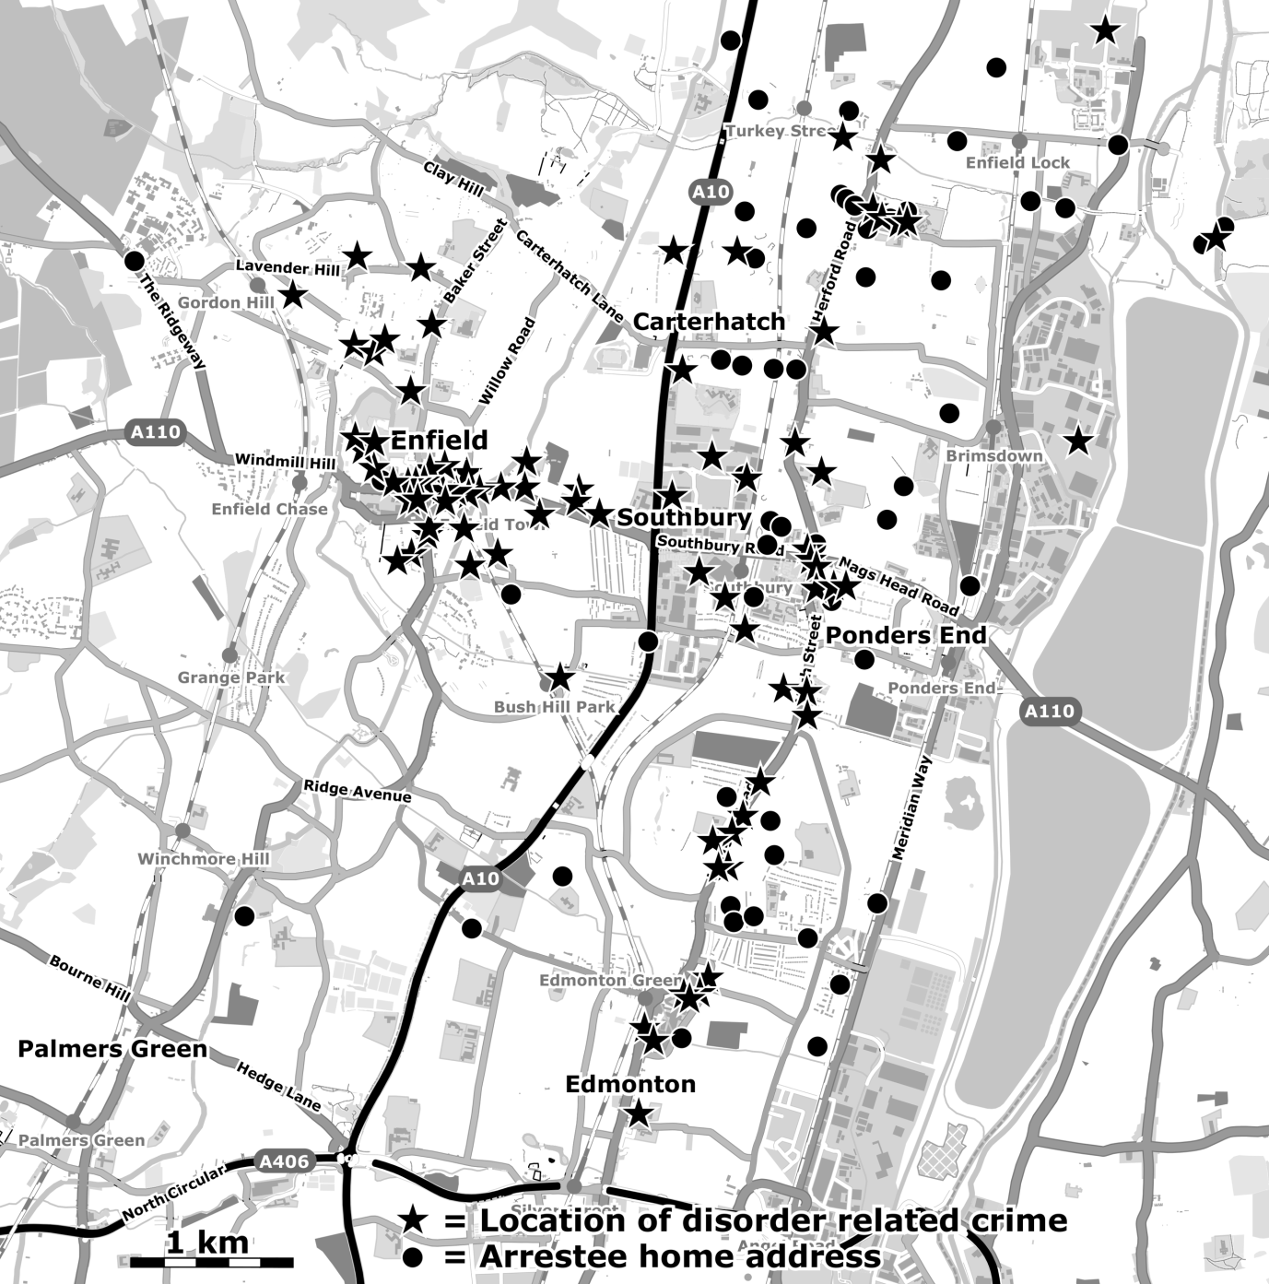

**Figure 6: Locations of disorder related crimes and homes of arrestees for disturbances in the London borough of Enfield on 7th-8th August 2011.**

## Age, ethnicity, gender

The crime data also provides an opportunity to compare demographics of the crowds in Enfield (*N* = 138) and Tottenham (*N* = 97). Statistical comparison of the two age distributions using Welch’s *t*-test with a null hypothesis of equal means produced a (two-tailed) *p*-value of .845. This confirms that the means of the age distributions for Enfield (Median = 20, M = 20.43 and SD = 4.86) and Tottenham (Median = 18, M = 20.58 and SD = 6.33) samples are significantly similar.

There was a significant difference in the self-reported ethnicities of the samples between Enfield and Tottenham, *χ2*(4)= 40.57, *p* < .001. Post-hoc *z*-score comparisons with Bonferroni corrections revealed significantly different proportions of Black (44% in Enfield and 81% in Tottenham) and White participants (46% in Enfield and 7% in Tottenham) in the two areas, but no difference for Asian, mixed, or other ethnic group categories. There was no substantial difference in the gender distributions between the two areas (89% and 96% male in Enfield and Tottenham respectively).

This analysis of the sample of arrestees suggests Enfield Town on Sunday 7th August 2011 was subject to the convergence of a predominantly young and male, ethnically mixed crowd who travelled some distance from the poorer wards either in the east of the borough or neighbouring Haringey. Moreover, the distance travelled by rioters was significantly larger to that witnessed during the disturbance in Tottenham the preceding day.

# Phenomenological analysis

To further understand the processes that led to spread into Enfield we turn now to an analysis of interviews with those who had directly participated in the disorders in the borough. Interestingly, nine of the 13 interviewees had also participated in the disturbances in Haringey the night before. One of these refers to discussions during the Tottenham riot about how to spread the disorder:

A. Yeah at that point um, it was quite late and people started slowly dispersing the High Road and um…from there I just like, went home and ignored any stupid phone calls people gave me and stayed at home.

Q. What do you mean, stupid phone calls?

A. There was people saying do you want to do this, do you want to do that? I was like that’s not my interest thanks.

Q. Yeah, but like people suggesting?

A. Going other places. And I was like, nah, defeats the point for me.

Q. What places were they suggesting?

A. Wood Green, Enfield, just making it go further.

[LON0111110703:163-175][12]

Some evidently felt empowered sufficiently by the riot in Tottenham to actively seek to spread the disturbance the next day:

There was a lot of people from Edmonton or Enfield, or even people from wider areas thinking OK, where’s the next area they can hit? And that was Enfield, you know it didn’t go to the same extent but they done it and that’s how it kept spreading…

[LON1110111004:227-230]

Most of the sample (*N* = 11) claim that they became aware of Enfield Town as a target on Sunday through word of mouth or social media (BBM) devices. One described how Enfield Town was attractive because it represented “neutral ground” for several inter-neighbourhood (“postcode”) rivalries:

A lot of people from my area didn’t go [to the Tottenham riot] because of the rivalries. They all went to Enfield.

[LON1510114302:110-111]

In addition, others acknowledged that Enfield Town was an area characterized by large retail outlets selling “high-end” goods and that if they moved collectively into the area this might afford opportunities that would not be available to them in less “affluent” areas, like Tottenham or Edmonton:

Q. in terms of as you said, going to Enfield was just a case of making money, do you think the fact that that happened in Enfield had anything to do with an organised element?

A. It was organised because there was loads of people from Tottenham telling you, “come to Enfield” we can make money from this, so we went to make some money [ ][13]

Q. So did you go with a big group of people?

A. Yeah, we just went to take whatever. ‘Cause I thought there’s big shops, whereas in Tottenham there’s just small ones...

[LON2210110829:305-319]

The perception of Enfield Town and the other suburbs in the west of the borough as affluent was confirmed by several respondents in the sample. One had travelled to the area with a group of prospective looters:

We did get to the areas that we hoped to reach, it wasn’t Tottenham or Edmonton, it was other areas in North London that are, you know, more upmarket, be it, you know, even if it’s just Oakwood[14] or somewhere like that…[LON1110111004:64-66]

This contrasted with less affluent areas. For example, in comparing their home neighbourhood of Edmonton to Enfield Town a respondent added:

Edmonton ain’t got shit.

[LON1110111004:325]

Another discussed how an awareness that potential rioters would travel to Enfield en masse acted as a further catalyst:

Q: Um why did you specifically, why did you choose Enfield?

A: Cos I heard it was going to be one of the biggest places and obviously, it was one of the first places to start it off I think, so I wanted to be one of the first people to do it before it got too bad so when they started nicking people obviously, I didn’t want to be there cos obviously, I didn’t want to get caught, so I decided to go to the biggest one. I knew people there would be like angry so obviously, there’s going to be more people there and of the area so I won’t get spotted as easily, so I don’t want to get caught and like obviously there’s loads of shops around there, there’s loads of things to rob…

[LON3010110848:16-23]

Another described how they became aware through social media that Enfield town had been shut down:

Everyone go Enfield, it's empty.

[LON0610111404:209]

While people did converge into other areas of the borough to the east of Enfield Town, such as Edmonton, it is apparent that they did not do so in large numbers and incidents in those areas failed to escalate to the same extent. One participant described how people in these smaller gatherings to the east felt less empowered:

Q. What was Edmonton like?

A. Edmonton wasn’t that serious. It was just like people were all standing there. They were all kind of half-hearted like they weren’t, it wasn’t like the Tottenham one. Like the Edmonton one, they were like, it’s like, you know, when you’ve got a group and they want to do something but they ‘aint got that heart, but they want to do it but they were all just standing there like who’s going to do it and all that.

[LON0610111405:278-285]

As crowds gathered in the otherwise empty Enfield Town centre, there followed a lull for around two hours prior to any confrontation or looting. One participant recalled how during this “stand-off” there was an apparent sense of anticipation:

To be honest Enfield it was like, when’s it going to start? Come on, who’s dashing the first rock…

[LON1510114302:317-318]

When the conflict did develop, it was in the form of an attack that appears to have been as much about provoking a police response as it was about stealing property. As one Enfield participant stated:

They had their own issues with the police by setting fire to a building or breaking into a store that was a way of getting a police officer’s attention. You could say it was attention seeking but it worked, they got the attention that they wanted.

[LON1210110820:483-486]

During the first escalation, a police car was badly damaged and officers were forced to flee. It seems significant, then, that shortly afterwards more people converged into Enfield town centre, perhaps attracted to the area because of this first attack. After a further lull, there was a second intensification with an attack on a jewellery shop. The incident was described as rapidly becoming collective as well as empowering:

A: Enfield started slowly. There was like a big standoff. In the end, like one thing got thrown and it just went mad. Just exactly like the Tottenham one. Not as much like fire and stuff, or the numbers.

Q. I was not really familiar with what happened in Enfield. Can you give me a step-by-step breakdown of what happened in Enfield?

A. Well everyone knew they had to be there at 4, 5 o’clock so everyone was there.

Q. PM or AM?

A. PM. Everyone was there waiting. There was 500 people, no probably 400 and just waiting... standing off. The police were down the road where HMV is and we arrived where Nandos are... something gets thrown like at the jewellery shop, there is this whole buzz everyone runs in.

[LON1510114302:111-124]

When the looting in the town centre escalated, several factors appear to have interacted. On the one hand, the postcode rivalries were superseded by a common oppositional identity, enabling a coordinated and cohesive form of collective mobilisation. On the other, there was a shifted power dynamic in relationship to the now disempowered police:

Q: And did you…when you got the BBM did you go to Enfield?

A: At first, nah, but then my friend called me saying aah are you going, and I was like naah I’m not on it, but I was like I’ll drive down there and see what’s going on, so we drove down there, parked like not in Enfield, but outside Enfield and we walked up, then literally, it was still light, I remember, it was still light and people were looting and people were just robbing, and the police were there and couldn’t do nuttin, cos there was too many people, so yeah...and it wasn’t even a thing where it was ah, cos ah I’m from Tottenham, you’re from Enfield so let’s go and do something gang ting, everyone linked up, every single gang that was in a fight, just stopped it, locked it off for that day and just looted, stole...

Q: This was...

A: In Enfield.

[LON2710114309:119-130]

The experiences of Tottenham informed some on how to recreate the dynamics of empowerment in Enfield:

A. But now, obviously, I know what to expect. If you’re going to have a riot, riot properly. [LON1510114302:319-320]

The reversed power relations were in turn associated with a sense of joy comparable to a carnival:

A: it was actually an experience like it was just like, you see Carnival it was just like Carnival

[LON1210110820:326-331]

However, the looting itself was not always seen as simply for material gain but rather was linked by some participants to surrounding structural grievances. For one, it was a way of attacking the government:

Q: So how did you feel about it personally?

A: I felt that erm I don’t like the government to be honest, but we have to live here init, but they need to know that they can’t just do things and get away with it and like hide things from the public cos obviously we have a right to know what’s going on…[ ]

Q: So did their anger transfer into wanting to take more/the ability to take?

A: Nah I don’t think it was, they just wanted, to be honest I don’t think it was just for their own gain, I just think they wanted the government to know init

Q: So it wasn’t taking to gain, it was taking just to take?

A: Yeah cos basically it was the government that put us in the recession init, bankrupt put us in the recession all of that stuff init so we’ve been paying for the banks all of that so it’s basically taking what is ours if you think about it.

[LON0610111701:126-129, 301-308]

For others, looting was exercising power, and was given legitimacy in the context of historically illegitimate forms of policing:

Q: What kind of things were the youngsters saying? What were their opinions?

A: Their opinions was basically a free for all, opportunity time you know. Opportunity in the aspects of where right now this situation happened, the police are taking the liberties so why should we not take the liberties?

[LON2410111009: 21-25]

# Discussion

A primary objective of this paper was to provide a micro-historical analysis of the Enfield riot to better understand the processes and factors that may have led to the spread of rioting beyond Haringey. Our analysis suggests that Enfield may have been among a series of potential foci in north London, but was targeted because it was a relatively accessible “upmarket” area that provided opportunities to confront police, damage property, and appropriate commodities.

If the crime figures are representative, then the sample of arrestees were not typical of the demographics of the immediate locale, their ethnic profile instead reflecting distinct east-west structural divisions in the borough. The interview and crime data confirm that the Enfield rioters travelled from poorer suburbs to the east and south, in contrast to the riot in Tottenham which appears to have involved people who lived significantly closer to the main sites of disorder. The analysis reinforces the suggestion that many of the rioters, some of whom had been involved in rioting the night before, were not from Enfield Town but travelled to that location to deliberately initiate another riot. The location was perhaps chosen because those from the poorer areas to the east and south were aware of it as a “frontier-town” to the affluent suburbs of the west. In other words, those that mobilised into the town travelled from areas of relative deprivation to a location that was meaningful to them in terms of an economic, political and ethnic divide. In this sense, the town centre may have been an ideal location for a “raid.”

Some have interpreted the 2011 riots as the result of a disenfranchised working class seeking to access the otherwise unattainable consumerist benefits of neo-liberal society (Bauman 2011; Briggs 2012; Moxon 2011; Treadwell et al., 2013; Zizek, 2011). Critics have argued that this “consumerist ideology” explanation ignores structural determinants such as racist policing and class inequality (Newburn 2016; Stott et al. 2016; Tiratelli 2017).

On “race” and racism, while the arrest figures suggest that Black people were still overrepresented in the Enfield riot (compared to the general population), and the language of the BBM message rallying people to that location (i.e., “niggas”) suggested shared Black identity, it is worth noting that the evidence suggests that proportionately many more white people were involved in Enfield than participated in Tottenham. Thus, in addition to the experiences of racism that drove some of the participants from Tottenham, our analysis suggests that class division was also key.

Further, while racism and class were predictors, an adequate understanding of the spread of rioting into that neighbourhood also needs to take account of the proximal intergroup context. For some, Enfield Town may have been attractive as neutral ground that facilitated an initial convergence of protagonists, because it was a place where rival “postcode” groups could (re)unite psychologically (Stott et al. 2018). Moreover, those who arrived in the first phase of convergence were confronted with a closed and largely empty town centre; the authorities to some extent inadvertently “set the stage”, whereby it must have been easier to identify others and coalesce into a cohesive and powerful crowd.

Nonetheless, despite the occupation of the town centre, looting did not develop for at least two hours, a fact that does not sit neatly with the idea that these people had come to Enfield merely to “mindlessly” appropriate commodities. Moreover, even though the gathering would have confirmed earlier police intelligence, the crowd does not appear to have provoked a particularly significant police response. Indeed, for most of the afternoon there was only a local neighbourhood policing unit supported by a relatively small contingent of public order trained officers. It is also apparent that when conflict was instigated by the crowd, the initial attacks on shops appear to have been as much an expression of power and an attempt to provoke a police response as they were an attempt to appropriate or “loot”. It should be noted that this pattern of evidence of attacks on property does not fit well with either the “rational choice” approach or with the “consumerist” explanation for the riots.

It was only after the first attack on the police that the MPS appear to have defined the situation as a public order incident and sent further reinforcements. However, the subsequent more serious outbreak again occurred following a second lull of a further two hours and after a second phase of convergence of protagonists into Enfield Town centre. This pattern is consistent with the idea that news of the first instances of confrontation, and of a disempowered police force, had reached others, possibly via social media networks. Perhaps this was “the next place” where the opportunity for confrontation and appropriation, that many across North London were seeking, was to be found. The convergence of more people into the town centre, would certainly have further empowered the rioters. As analysis of participant accounts across the 2011 riots as a whole has shown, empowerment was a prominent theme in people’s experience (see Newburn et al. 2016)

As the riot reignited, it began with attacks on police but quickly involved the looting of a jewellers and expressive damage to a bathroom showroom, which our analysis suggests further encouraged the rioters. The ensuing dispersal by police westwards into the wealthier areas of Enfield Town, and a larger group eastward towards the retail parks, produced what appear to be differing behaviours. The former can be considered as a “class riot,” with the practice of “*discriminating indiscrimination*” (Ball and Drury 2012: 17) characterised by location-specific arson attacks on cars and damage to residential property, both identifiable as symbols of affluence. The rioting in the retail parks, however, was focused on collective looting in areas dominated by large commercial outlets. As the police concentrated on securing the town centre, they did so by dispersing rioters toward the retail parks. In the absence of any protection, these rioters (and others converging directly onto the parks) were then free for some time to systematically loot the higher-end retailers of clothing and electrical goods with relative impunity. Our analysis suggests therefore that the systematic looting of the retail parks was an *outcome* of processes of interaction and escalating empowerment that took place earlier within the town centre. The pattern of conflict later that evening also suggests that many of the rioters were returning toward the south and east of the borough, engaging in sporadic confrontation with the police as they did so.

Before drawing out the theoretical implications of the present analysis, we must acknowledge the study’s limitations. Our analysis of demographic characteristics and home locations of participants in Enfield relied on the MPS crime data. While this is the most comprehensive dataset of crime incidents for the riots, it is subject to certain distortions, not least of all those created by the ways in which the police targeted arrestees because they were already known to them (Ball and Drury 2012) or focused on specific types of crime likely to secure convictions (Tiratelli 2017). Also, the numbers of crimes recorded that involve attacks on police are small considering the relatively high levels of violence against the police that our data suggests actually occurred. Our analysis of this data should therefore be treated with caution. However, we have not used this data to make claims about the (supposedly) criminal composition of the rioters as a whole or the predominant types of offences; we argue merely that it helps makes sense of the patterns of collective action in our triangulated account because our micro-historical case study approach has allowed us to cross reference this with other forms of data.

In addition, our sample of interviews with participants was very small, their accounts of their involvement in Enfield relatively partial, and the snowballing recruitment technique mean the sample potentially come from a subgroup of the population. Thus, we must be cautious about making generalisations from these data.

Nonetheless, a key strength of the present study is the large amount and variety of data, which has allowed this case study to produce a detailed micro-historical analysis of the riot in Enfield, one of the first locations after Tottenham where serious rioting reoccurred in 2011. Taken together, the analysis has several implications. First our study adds empirical weight against those claims that the 2011 riots were “mindless” consumerism or were merely a form of criminality driven by a breakdown in morality (Back, 2013; Bridges, 2012, Gilroy, 2013; Solomos, 2011; Slater, 2011, 2015). The early stages were characteristic of an expression of power; looting was relatively limited and appears as motivated, initially at least, as much to provoke the police as it was by appropriation. Moreover, the large-scale looting of the retail parks emerged only after a significant period of time and series of interactions, not least of all the forceful police dispersal of those in the town centre directly toward the otherwise unguarded shops.

Second, taken together our analysis confirms the idea that Enfield was not a random target but the site of what we will term a *proactive riot*. In this sense, the spread beyond Haringey reflected a meaningful choice of location, perhaps in part because it was a transport hub for bus networks and therefore within the “awareness space” of the rioters (Baudains, Braithwaite et al. 2012, 2013; Baudains, Johnson et al. 2013). The spread also followed a pattern that is largely consistent with Baudains, Braithwaite et al.'s (2013; Baudains, Johnson et al. 2013) analysis of social and geographical “contagion,” but our depth of data allows us to suggest more detail of the underlying dynamics through which the spread occurred and behaviour began to change. On the one hand, our data supports Kawalerowicz and Biggs’s (2015) conclusions that people converged into the riots from areas of relative deprivation. In this case we show that they mobilised into a location symbolic of – and a gateway to – wealth, and effectively occupied it for some considerable duration. Their capacity to do this may have been because of common grievances, such as police “stop and search” practices; but our analysis is consistent with the contention of Stott et al. (2016, 2018) that rioters “grievances” are usefully understood as the basis of a shared (anti-police) *identity* that was empowered *during and because of* the rioting in Haringey the night before. Moreover, the occupation and attacks in the town centre may not only have led to further psychological change it may also have confirmed to others that Enfield was the next neighbourhood within which power-relations with the authorities were being reversed. When others converged, it may have further empowered a capacity to act out this identity through confrontation and looting. Moreover, when the rioters were eventually dispersed, the behavioural outcomes were different depending on the affordances. Those scattered into the affluent residential areas expressed their newly-acquired power in terms of destructive attacks on symbols of middle-class wealth - effectively enacting a class riot. Those driven toward the retail parks could utilise their power to raid upmarket retail outlets and continue confronting police. But we would agree with the Metropolitan Police Service (2012: 60) who stated that the *“disorder was perhaps ‘expressive’ rather than acquisitive”* and Tiratelli with (2017: 10) that looting throughout “*seems to be a public and collective act of defiance and celebration.*”

Finally, through our micro-historical analysis of the events in Enfield, we have also provided additional evidence of the need for an interdisciplinary approach to understanding the complex processes through which urban riots develop and spread. In this study, we contend that the spread into Enfield cannot be interpreted as irrational copycat rioting or the acting out of a pre-existing narrow rationality. While the structural context of racial and class disadvantage explains demographic composition, these are insufficient to explain the intergroup dynamics of the event. Yet nor was it a *reactive riot* born as a response of police intervention (Stott et al. 2018). In the wake of the rioting in Haringey the preceding night, a constituency of people, many of whom were from relatively disenfranchised communities, appear to have felt sufficiently empowered to travel to an accessible location that was given meaning by its social, economic and political geography (Kawalerowicz and Biggs 2015). In that location, they then found and actively created another platform for crowd empowerment, affordances that were created, shaped and reshaped during the event through social media and the social identity-based interactions among crowd participants and with the police. While further detailed case studies of other locations that also experienced rioting are needed, we contend that an understanding of how political and economic geography interact with proximal micro-historical and social psychological dynamics in this event is important because it begins to build a fuller account of the patterns of how the riots in general spread across the urban environment in August 2011.

# REFERENCES

Andrews, Kehinde. 2019,. “Britain criminalising young BME people could spark a new crisis on the streets.” *Guardian*, January 30.

Anon. 2011. “Communities, Commodities and Class in the August 2011 Riots (2011).” *Aufheben* 20: 1-20.

Back, Les. 2013. “The Summer 2011 Riots: A New Politics of Generation.” *The Sociology Teacher*. 3 (1): 14-19.

Ball, Roger, and John Drury. 2012. "Representing the Riots: The (Mis)Use of Statistics to Sustain Ideological Explanation." *Radical Statistics* 106: 4-21.

Baudains, Peter, Alex Braithwaite, and Shane D. Johnson. 2012. "Spatial Patterns in the 2011 London Riots." *Policing: A Journal of Policy and Practice* 7 (1): 21-31. doi:10.1093/police/pas049.

Baudains, Peter, Alex Braithwaite, and Shane D. Johnson. 2013. "Target Choice During Extreme Events: A Discrete Spatial Choice Model of the 2011 London Riots." *Criminology* 51 (2): 251-285. doi:10.1111/1745-9125.12004.

Baudains, Peter, Shane D. Johnson, and Alex Braithwaite. 2013. "Geographic Patterns of Diffusion in the 2011 London Riots." *Applied Geography* 45: 211-219. doi:10.1016/j.apgeog.2013.09.010.

Bauman, Zygmunt. 2011. *Collateral Damage: Social Inequalities in a Global Age.* Cambridge: Polity.

Body-Gendrot, Sophie. 2013. "Urban violence in France and England: comparing Paris (2005) and London". (2011). *Policing and Society 2*3 (1), 6-25.

Bonnasse-Gahot, Laurent, Henri Berestycki, Marie-Aude Depuiset, Mirta B. Gordon, Sebastian Roché, Nancy Rodriguez, and Jean-Pierre Nadal. 2018. "Epidemiological modelling of the 2005 French riots: a spreading wave and the role of contagion." *Scientific reports* 8 (1): 107. arXiv:1701.07479v1. [physics.soc-ph].

Bradford, Ben, and Ian Loader. 2016. "Police, crime and order: the case of stop and search." Ben Bradford, Beatrice Jauregui, Ian Loader and Jonny Steinberg (eds.) *The Sage handbook of global policing*. London: Sage Publications

Braun, Virginia, and Victoria Clarke. 2006. "Using Thematic Analysis in Psychology." *Qualitative Research in Psychology* 3: 77-101. doi:10.1191/1478088706qp063oa.

Bridges, Lee. 2012. "Four days in August: the UK riots." *Race & Class* 54: 1-12

Briggs, Daniel. 2012. "What We Did When It Happened: A Timeline Analysis of the Social Disorder in London." *Safer Communities* 11 (1): 6-16. doi:10.1108/17578041211200065.

Chaney, Cassandra, and Dannielle Joy Davis. 2015. "Introduction:" No Justice, No Peace:" Social Unrest in Ferguson." *Western Journal of Black Studies* 39 (4): 267-271.Coleman, Paul. 2011. "Tottenham to Enfield Town and Beyond: Looting Across London*." Paul Coleman's London Intelligence*, 08 August edn.

Crossley, Stephen. 2016. 'Realising the (troubled) family', 'crafting the neo-liberal state'. Families, Relationships and Societies. 5 (2):263-279.

Lambert, Michael and Crossley, Stephen. 2017. 'Getting with the (troubled familes) programme': a review. Social Policy and Society. 16 (1):87-97.

Dikeç, Mustafa.2017. *Urban Rage: The Revolt of the Excluded.* New Haven: Yale University Press.

Dodd, Vikram .2019,. "Met police 'disproportionately' use stop and search powers on black people." *Guardian*, January 26.

Drury, John, Clifford, Stott, Roger, Ball, Steve, Reicher, Fergus, Neville, Linda, Bell, Michael, Biddlestone, Max, Lovell, Sanjeedah, Choudhury and Caoimhe, Ryan (submitted). "A social identity model of urban riot diffusion: From injustice to empowerment in the 2011 London riots."

Drury, John, Roger, Ball, Fergus, Neville, Steve, Reicher and Clifford, Stott. 2019. *Re-reading the 2011 riots: ESRC Beyond Contagion interim report.* University of Sussex.

Drury, John, and Steve Reicher. 2000. "Collective Action and Psychological Change: The Emergence of New Social Identities." *British Journal of Social Psychology* 39 (4): 579­-604. doi:10.1348/014466600164642.

Enfield Borough Council. 2012. *Enfield Council Commission to Examine the August 2011 Disturbances in Enfield: Final Report.* Enfield Borough Council.

Paul Gilroy. 2013. "1981 and 2011: From Social Democratic to Neoliberal Rioting." *The South Atlantic Quarterly* 112 (3): 550-558.

Guardian and LSE. 2011. "*Reading the Riots: Investigating England’s Summer of Disorder." The Guardian* and LSE.

Gershenson, Seth, and Michael Hayes. 2016. *Short run externalities of civic unrest: evidence form Ferguson, Missouri*. Discussion Paper No. 10091. Institute for the Study of Labor, Bonn. http://ftp.iza.org/dp10091.pdf

Her Majesty’s Inspectorate of Constabulary. 2011. *The Rules of Engagement: A Review of the August 2011 Disorders.* Her Majesty’s Inspectorate of Constabulary.

House of Commons Home Affairs Committee. 2011. *Policing Large Scale Disorder: Lessons from the Disturbances of August 2011. Sixteenth Report of Session 2010–12 Volume II: Oral and Written Evidence.*HC 1446-II edn. The Stationery Office Limited.

Kawalerowicz, Juta, and Michael Biggs. 2015. "Anarchy in the UK: Economic Deprivation, Social Disorganisation, and Political Grievances in the London Riot of 2011." *Social Forces* 94 (2): 673-698. doi:10.1093/sf/sov052.

Kettle, Martin and Lucy Hodges. 1982. *Uprising! The Police, the People and the Riots in Britain's Cities*. London: Pan Books.

Le Bon, Gustave. [1895] 2002. *The Crowd: A Study of the Popular Mind.* Dover.

Lightowlers, Carly. 2015. "Let’s get real about the ‘riots’: Exploring the relationship between deprivation and the English summer disturbances of 2011." *Critical Social Policy* 35 (1): 89-109.

McClelland, John S. 1989. *The Crowd and the Mob: From Plato to Canetti*. London: Unwin Hyman.

Metropolitan Police Service. 2012. *Four Days in August: Strategic Review into the Disorder of August 2011 - Final Report.* Metropolitan Police Service.

Metropolitan Police Service. 2017. *MPS August 2011 Disorders Crime Data.* Excel spreadsheet edn. Metropolitan Police Service.

Moran, Matthew, and David Waddington. 2015. "Recent Riots in the UK and France: Causes and Commonalities." *Contention: The Multidisciplinary Journal of Social Protest* 2 (2): 57-73.

Moxon, David. 2011. "Consumer culture and the 2011 'riots'." *Sociological Research Online* 16 (4): 1-5. doi:10.5153/sro.2539.

Muir, Hugh and Adegoke, Yemisi. 2011. "Were the riots about race?" *Guardian*, December 8.

Myers, Daniel, and Przybysz, J. 2010. "The Diffusion of Contentious Gatherings in the Captain Swing Uprising." In *Captain Swing Reconsidered: Forty Years of Rural History From Below*, edited bySteve Poole and Andrew Spicer, Southern History Society 32: 62-84.

Newburn, Tim. 2016. "Reflections On Why Riots Don’t Happen." *Theoretical Criminology* 20 (2): 125-144. doi:10.1177/1362480615598829.

Newburn, Tim, Kerris Cooper, Rachel Deacon, and Rebekah Diski. 2015. "Shopping for Free? Looting, Consumerism and the 2011 riots." *British Journal of Criminology* 55 (5): 987-1004. doi:10.1093/bjc/azv007.

Newburn, Tim, Rachel Deacon, Beka Diski, Kerris Cooper, Maggie Grant, and Alex Burch. 2016. "‘The Best Three Days of My Life’: Pleasure, Power and Alienation in the 2011 Riots." *Crime, Media, Culture* 14 (1): 41-59. doi: 10.1177/1741659016667438.

Reddy, William M. 1977. "The textile trade and the language of the crowd at Rouen, 1752–1871." *Past & Present* 74: 62–89.

Reicher, Stephen D. 1984. "The St. Pauls' Riot: An Explanation of the Limits of Crowd Action in Terms of a Social Identity Model." *European Journal of Social Psychology* 14: 1-21. doi: 10.1002/ejsp.2420140102.

Reicher, Stephen D. 1987. "Crowd Behaviour as Social Action." In *Rediscovering the Social Group: A Self-categorization Theory* edited by Turner, John C., Michael A. Hogg, Penelope J. Oakes, Stephen D. Reicher, and Margaret S. Wetherell. 1987. Oxford: Basil Blackwell.

Reicher, Stephen D. 1996. "‘The Battle of Westminster’: Developing the Social Identity Model of Crowd Behaviour in Order to Explain the Initiation and Development of Collective Conflict." *European Journal of Social Psychology* 26 (1): 115­-134. doi:10.1002/(SICI)1099-0992(199601)26:1<115::AID-EJSP740>3.0.CO;2-Z.

Reicher, Stephen D. 2001. "The Psychology of Crowd Dynamics." In *Blackwell Handbook of Social Psychology: Group Processes*, edited by Michael Hogg and Scott Tindale, 182-208. Oxford: Blackwell.

Reicher, Stephen. D, and Clifford Stott. 2011. *Mad Mobs and Englishmen?: Myths and Realities of the 2011 Riots.* London: Hachette UK.

Riots Communities and Victims Panel. 2012. *After the Riots: Final Report of the Riots Communities and Victims Panel.* Riots Communities and Victims Panel.

Rudé, G. 1964. *The Crowd in History*. New York, NY: Wiley.

Scarman, Lord J. 1981. *The Brixton Disorders, 10–12th April* (1981), London: HMSO.

Scarman, Leslie George. 1981. *The Brixton Disorders 10-12 April 1981: Report of an Inquiry*. London: HMSO Books.

Slater, Tom. 2011. "From ‘criminality’ to marginality: Rioting against a broken state." *Human Geography* 4 (3): 106-115.

Slater, Tom. 2016. "The Neoliberal State and the 2011 English Riots: A Class Analysis." In *Urban uprisings* edited by Mayer, Margit, Catharina Thörn, and Håkan Thörn.. London: Palgrave Macmillan.

Solomos, John. 2011. "Race, Rumours and Riots: Past, Present and Future." *Sociological Research Online*, 16 (4): 1-6.

Stott, Clifford, and John Drury. 2017. "Contemporary understanding of riots: Classical crowd psychology, ideology and the social identity approach." *Public Understanding of Science*, 26 (1), 2-14. doi: 10.1177/0963662516639872

Stott, Clifford, Roger Ball, John Drury, Fergus Neville, Steve Reicher, Andrea Boardman, and Sanjeedah Choudhury. 2018. "The Evolving Normative Dimensions of ‘Riot’: Toward an Elaborated Social Identity Explanation." *European Journal of Social Psychology* 48 (6): 834-849. doi:10.1002/ejsp.2376.

Stott, Clifford, and John Drury. 2000. "Crowds, Context and Identity: Dynamic Categorization Processes in the 'Poll Tax Riot'." *Human Relations* 53 (2): 247-273. doi:10.1177/a010563.

Stott, Clifford, John Drury, and Steve Reicher. 2016. "On the Role of a Social Identity Analysis in Articulating Structure and Collective Action: The 2011 Riots in Tottenham and Hackney." *British Journal of Criminology* 57 (4): 964-981. doi:10.1093/bjc/azw036.

Tajfel, Henri. 1978. *Differentiation Between Social Groups.* Cambridge, M.A.: Academic Press.

Thompson, Edward P. 1971. "The moral economy of the English crowd in the eighteenth century." *Past & Present* 50: 76-136.

Tilly, Charles, Louise A. Tilly, and Richard H. Tilly. 1975. *The rebellious century: 1830-1930*. London: J.M. Dent & Sons Ltd.

Tiratelli, Matteo. 2017. "Reclaiming the Everyday: The Situational Dynamics of the 2011 London Riots." *Social Movement Studies* 17 (1): 64-84. doi:10.1080/14742837.2017.1348942.

Treadwell, James, Daniel Briggs, Simon Winlow, and Steve Hall. 2013. "Shopocalypse Now: Consumer Culture and the English Riots of 2011." *British Journal of Criminology* 53 (1): 1-17. doi:10.1093/bjc/azs054.

Turner, John C., Michael A. Hogg, Penelope J. Oakes, Stephen D. Reicher, and Margaret S. Wetherell. 1987. *Rediscovering the social group: A self-categorization theory*. Oxford: Basil Blackwell.

Dave, Waddington, Fabien Jobard, and Mike King. 2009. *Rioting in the UK and France: A Comparative Analysis*, Devon: Willan.

Zizek, Slavoj. 2011. "Shoplifters of the World Unite." *London Review of Books* 19: 8-11.

1. Tottenham is located in the London Borough of Haringey where, according to the 2011 National Census, 65.3% of the population are non-white British Ethnic Groups. This is higher than both London (55.1%) and England and Wales (19.5%). The top three of these ethnic groups are: Other White (23.0%); Black African (9.0%); Black Caribbean (7.1%)
2. The IMD is a UK government qualitative analysis of deprived areas in English local councils considering income, employment, health deprivation and disability, education skills and training, barriers to housing and services, crime and living environment. Low ranks mean high levels of relative deprivation.
3. A database of 2.6 million “riot-related” tweets collected during the August 2011 disturbances by the *Guardian /* LSE “*Reading the Riots”* project was filtered for all instances where the word “Enfield” was present producing a subset of approximately 72,000 relevant tweets.
4. <https://doi.org/10.25377/sussex.6263816>
5. Arrestee here refers to the term “accused person”. These are people who were “proceeded against” by the MPS. This is defined by the Home Office as being charged and summoned to court, cautioned or some other action taken which is considered to allow police to show a crime as being “cleared up” but does not necessarily mean that an individual was tried and convicted in a court for the offence.
6. Visual representation of IMD data at LSOA level was not available for 2010.
7. Blackberry Messenger (BBM) was a mobile phone-based messaging system that operates across a “closed” network only available to people who have been invited to join that specific network, making it difficult for police to monitor.
8. A PSU is a unit of police officers trained to deal with public disorder. Each PSU consists of three police carriers, 21 police constables, three sergeants, and an Inspector. These officers have protective or ‘riot’ equipment and are trained to deal with violent crowd events.
9. We assume it to mean that a Bronze Commander was appointed, which is an indication that this is when the MPS first defined the situation as a “public order incident”, some three and a half hours after the initial convergence.
10. The Tottenham riot was chosen as it was the first to have taken place at that time and is defined here as disorder related crimes occurring in the London postcode area N17 over the evening of 6th and morning of 7th August 2011. The Enfield riot is defined by disorder related crimes occurring in the postcode areas EN1, EN2, EN3 and N9 over the evening of 7th and morning of 8th August 2011.
11. It should be noted that the markers in Figure 6 are not exact locations, instead they represent the centroids of postcode areas where crimes were committed or arrestees lived.
12. Reference denotes number of the transcript in the *Reading the Riots* archive, plus line numbers.
13. [ ] indicates material removed for brevity.
14. Oakwood lies approximately three miles to the west of Enfield Town.