Novel Cell Penetrating Peptide Conjugated Proteasome Inhibitors: Anticancer and Antifungal Investigations

Kamal D Patel¹, Gayan Heruka De Zoysa¹, Manju Kanamala², Krunal Patel¹, Lisa Pilkington¹, David Barker¹, Jóhannes Reynisson⁴, Zimei Wu² and Vijayalakshmi Sarojini^{1,3,*}

¹School of Chemical Sciences and the Centre for Green Chemical Science, University of Auckland, Auckland, New Zealand

²School of Pharmacy, University of Auckland, Auckland 1142, New Zealand
³The MacDiarmid Institute for Advanced Materials and Nanotechnology, Wellington 6140, New Zealand
⁴School of Pharmacy and Bioengineering, Hornbeam Building, Keele University, Staffordshire ST5 5BG, United Kingdom
*Corresponding Author: v.sarojini@auckland.ac.nz

Abstract:
Cell penetrating peptide conjugated peptide aldehydes Tat-A and Tat-B showed low micromolar anticancer and antifungal activities and synergistic action in combination with cisplatin and amphotericin B against cancer and fungal cells respectively. Tat-A and Tat-B were significantly more potent than Ixazomib in inhibiting the human 20S proteasomes with IC₅₀ values in the low nanomolar range. Treatment with Tat-A and Tat-B caused membrane disruption and pore formation in HeLa and BE(2)-C cells and inhibition and eradication of C. albicans biofilms. Apoptotic cell death of the treated HeLa and BE(2)-C cells was demonstrated by Annexin V/PI staining. Flow cytometry analyses showed that more than 78% (HeLa) and 92% (BE(2)-C cells showed signs of apoptosis and necrosis upon treatment with Tat-A and Tat-B. This study forms the first report that documents the benefits of cell penetrating peptide conjugation to enhance the potential of peptide aldehydes as therapeutics.

Introduction:
Destruction of cell cycle regulatory proteins forms the basis for cell growth associated with cancer.^{1,2} The ubiquitin-proteasome pathway, the pathway responsible for the majority of cellular protein degradation is also responsible for the degradation of cell cycle regulatory proteins.^{1,2} In this pathway, cellular proteins are ubiquitinated and are presented to 20s proteasomes for further degradation. Tumour suppressor protein p53, apoptosis protein Bax and NF-_{K}B activation protein which help control the proliferation of cancer cells are degraded by proteasome enzymes.¹⁻³ Proteasome inhibitors are known to promote apoptosis and therefore the search for novel proteasome inhibitors as potential anti-cancer drugs is an active area of research.^{1,4}

Peptide aldehydes were among the first proteasome inhibitors to be developed.^{5,6} Since then, newer generations of peptide aldehydes (e.g. MG-132) and various other classes of peptide based inhibitors like peptide vinyl sulphones, boronates and epoxyketones (e.g. oprozomib) with an “electrophilic warhead” were developed targeting a threonine residue in the proteasome to block the proteolytic activity⁷⁻⁹ (and reviewed in^{1,3,4}). Bortezomib and ixazomib (peptide boronates) are the first drugs approved for the treatment of multiple myeloma and mantle cell lymphoma.^{4,10-13} Despite the discovery of several such anticancer drugs, systemic toxicity of classic anticancer drugs as well as resistance development is still a challenge in cancer therapy and therefore research efforts directed at developing anticancer drugs without such systemic toxicity is of utmost importance in the discovery of novel anticancer drugs.

The Ubiquitin-26S proteasome pathway in fungal strains such as S. cerevisiae and C. albicans is highly similar to the mammalian pathway and these enzymes are implicated in the pathogenicity of fungal species.^{14,15} Therefore, targeting the ubiquitin-proteasome pathway can also be of promise in the development of novel antifungal drugs and provide a potential alternative to the classical antimicrobial mechanism of membrane lysis against human fungal pathogens such as C. albicans, the biofilms of which are difficult to treat.

Fellutamides C and fellutamides D are peptide aldehydes derived from natural products found to be active against fungal proteasomes in the micromolar range.¹⁶ However, fellutamides have solubility issues and therefore lack enough safety and efficacy data as well as any conclusive cell-based assay results. Cbz-L-L-Lal (MG132), the synthetic peptide aldehyde referred to above, and natural product peptide aldehydes like chymostatin and leupeptin have been found to inhibit 20S proteasomes extracted from C. albicans,¹⁴ a human opportunistic pathogenic fungi which can cause life-threatening infections in patients with a compromised immune system such as in HIV patients or those undergoing chemotherapy.¹⁷ Additionally, C. albicans also colonises host tissues, urinary catheters and other medical implants as drug resistant biofilms which are challenging to eradicate.¹⁸

While the membrane lytic antifungal drug amphotericin B (AmB) is still used against fungal infections, its use is associated with many pharmacological complications and side effects such as fever, vomiting, dose-dependent nephrotoxicity and haemolysis.^{19,20} Combination of AmB with drugs capable of penetrating biofilms appears to be promising in addressing resistance development shown by AmB.²¹ Novel antifungal drugs with alternate mechanisms of action that eradicate fungal biofilms and without the unwanted side effects of AmB are essential.

Given the promising potential of peptide aldehydes as both anticancer and antifungal drugs, the purpose of this study was to develop peptide aldehyde drugs with superior activity against human and fungal 20S proteasomes and their synergistic drug combinations with classic anticancer and antifungal drugs to widen current therapeutic windows. With this goal in mind, we undertook the first syntheses and biological evaluation of novel peptide aldehyde based proteasome inhibitors A, and B and their CPP conjugates Tat-A and Tat-B. The superior potential of these Tat conjugates in proteasome inhibition as well as in killing cancer and fungal cells has been established using a range of cell based and enzyme based experiments. The potential of the Tat-peptide aldehyde conjugates to act in synergy with cisplatin and AmB and their ability inhibit and eradicate C. albicans biofilms has also been demonstrated. None of these peptide aldehydes were haemolytic to mouse blood cells.
Results and Discussion
Design of Peptide Aldehydes
Peptides having hydrophobic amino acid residues adjacent to the C-terminal functional groups are known to be better inhibitors of the chymotrypsin-like activity of human and fungal proteasomes.^{14,22} Analyses of literature data showed that hydrophobic amino acids like leucine (e.g. MG132) and/or norleucine (e.g. MG101) at positions AA₂ and AA₄ (Figure 1) as well as bulky and aromatic amino acids like phenylalanine at positions AA₃ (e.g. Bortezomib, currently in phase 2 clinical trials and Carfilzomib) and tyrosine (e.g. YL₃VS) at AA₁ enhance the proteasome inhibitory activity.²²⁻²⁴

Figure 1. General sequence characteristics (top left) and chemical structures of proteasome inhibitors MG101, MG132, Bortezomib and Carfilzomib with functional groups responsible for proteasome inhibition marked in red.
However, efficient crossing of the cell membrane barrier is important to enable the inhibitors accessing the intracellular proteasomes for better inhibition and efficacy. In order to develop peptide aldehyde inhibitors with enhanced activity we synthesized the tripeptide aldehyde Ac-Leu-Leu-Leu-CHO (A), the tetrapeptide aldehyde Ac-Tyr-Leu-Phe-Leu-CHO (B) and their Tat conjugates (Tat-A and Tat-B) (Figure 2).
Figure 2. Chemical structures of peptide aldehydes A, B, and their Tat conjugates Tat-A and Tat-B. Gly-Gly-Gly was used as a linker for conjugating A and B with Tat.

Tat is one of the well-explored cationic CPPs originally derived from HIV-1 protein with the peptide sequence YGRKKRRQRRR²⁵, which has been widely used for the delivery of peptide-based protein kinase inhibitors and for delivering peptide nucleic acids.²⁶ Conjugation of CPPs to peptides using simple amino acids like glycine and serine as linkers is often used as it does not affect peptide secondary structure and imparts flexibility to the peptide chain.²⁷ The majority of peptide aldehyde syntheses reported in the literature have short sequences (Figure 1). To the best of our knowledge, this is the first report where designed peptide aldehydes have been conjugated to CPPs to enhance their interaction with intracellular targets. The conjugates were synthesized using Solid-phase peptide synthesis (SPPS) on Weinreb amide resin. The reduction of Weinreb amides on the solid support is a widely used method for the synthesis of peptide aldehydes.²⁸⁻³⁰ Commercially available Weinreb amide resin was loaded with amino acids following standard solid phase peptide synthesis protocols. Cleavage of the peptide from Weinreb resin was done using 10-12 equivalents of LiAlH₄ which was found to provide optimal reduction without any side reactions. The amount of LiAlH₄ has to be optimal as we observed that the use of higher than 10-12 equivalents of LiAlH₄ reduced the peptide bonds giving rise to side products whereas lower than 10-12 equivalents gave incomplete reduction. It was also observed that the optimal amount of LiAlH₄ is also dictated by the length of the peptide chain (see experimental). After reduction, the side chain protected peptide aldehydes were extracted into dichloromethane (DCM) and the side chain protecting groups removed using 95% TFA in DCM to give the desired peptide aldehydes (Figure 2). Removal of side chain protection before the reduction step would expose the guanidine group of arginine to the highly reactive LiAlH₄ giving rise to undesired side products. Therefore, the reduction step needs to be undertaken before the removal of side chain protecting groups.

Determination of IC₅₀ against HeLa and BE (2)-C Cell Lines and Synergistic Study in Combination with Cisplatin
Considering the role of proteasome inhibitors in apoptosis against HeLa cells³¹ and their effectiveness against neuroblastoma,³² these peptide aldehydes were tested for cytotoxicity against HeLa and BE(2)-C cell lines (Figure 3 and Table 1). The IC₅₀ values of Tat-A against HeLa and BE(2)-C cell lines were 10.21 and 10.32 µM respectively while those of Tat-B were 4.74 and 4.71 µM. The non-conjugated derivatives exhibited cytotoxicity at concentrations significantly higher (A 39.1 µM and 61.3 µM and B 29.4 µM and 43.3 µM) against HeLa and BE(2)-C cells respectively as compared to their Tat conjugates (Table 1). The Tat peptide itself only exhibits moderate to low cytotoxic activity against the HeLa (62.5 µM) and BE(2)-C (94 µM). Our results have shown that peptide aldehyde B is slightly more active (~ 1.2 to 1.4 fold) than the aldehyde A against the two cell lines and both of the aldehydes (in the absence of Tat conjugation) were slightly more selective (1.5 fold) towards the HeLa cell lines. Tat conjugation to peptide aldehyde A led to four - and six- fold increase in activity against HeLa and BE(2)-C cell lines respectively. Tat conjugation to peptide aldehyde B also led to six- and nine - fold increase in activity against HeLa and Be(2)-C cell lines respectively. Interestingly, the cytotoxic activity of the two peptide aldehydes after Tat conjugation was identical against the two cell lines. The increase in the activity of the Tat conjugates can be attributed to increased absorption and cell permeability facilitated by Tat which is well known for its membrane permeability because of it cationicity. Cisplatin showed IC₅₀ of 6.34 and 5.30 µM respectively against Hela and BE(2)-C (Table 1). These values are in agreement with IC₅₀ reported for cisplatin in the literature.³³⁻³⁵.

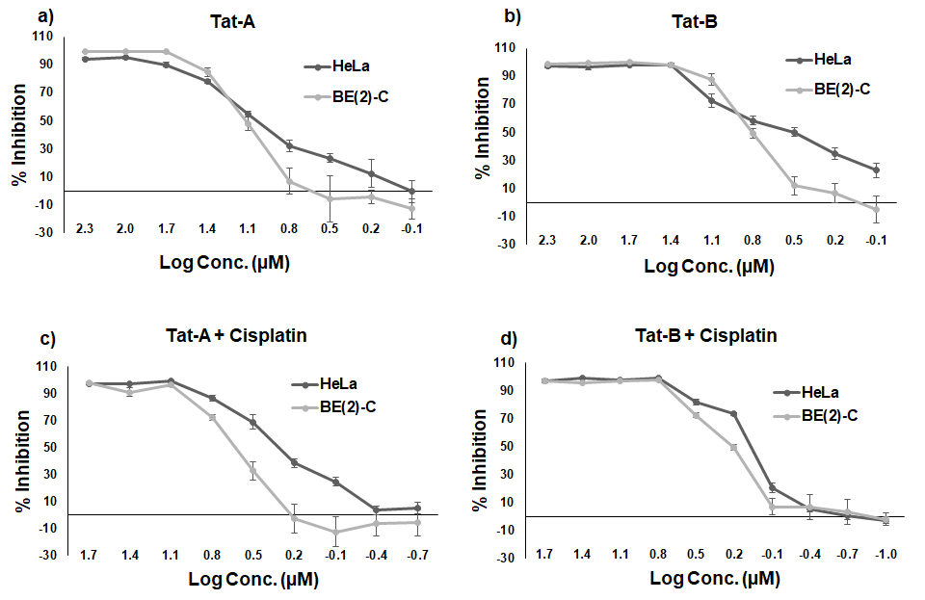
Figure 3. IC₅₀ against HeLa and BE(2)-C cell lines of (a) and (b) Tat conjugated peptide aldehydes alone; (c) and (d) in combination with cisplatin. Experiments were done in triplicate with 2-3 individual repeats. Error bars represent standard deviation.

Table 1. IC₅₀ of Synthetic Peptide Aldehydes and Tat compared with Cisplatin against HeLa and BE(2)-C Cell Lines and Results from the Synergistic Study.
Peptide | Net charge at pH 7 | IC₅₀(µM)* |  | IC₅₀(µM) obtained when Peptide and Cisplatin are combined |  | FICI
 |  | HeLa | BE(2)-C | HeLa | BE(2)-C | HeLa | BE(2)-C
A | 0 | 39.1 ± 1.9 | 61.3 ± 0.4 | ND | ND | ND | ND
Tat-A | 8 | 10.2 ± 2.0 | 10.3 ± 1.5 | (Tat-A)  1.90 ± 0.03  (Cisplatin) 0.95 ± 0.03 | (Tat-A)  4.19 ± 1.33  (Cisplatin)  2.09 ± 0.66 | 0.34 | 0.79
B | 0 | 29.4 ± 1.0 | 43.3 ± 2.1 | ND | ND | ND | ND
Tat-B | 8 | 4.7 ± 0.6 | 4.7 ± 1.6 | (Tat-B)  1.16 ± 0.05  (Cisplatin)  0.58 ± 0.03 | (Tat-B)  1.58 ± 0.26  (Cisplatin)  0.78 ± 0.13 | 0.33 | 0.49
Tat | 8 | 62.5** | 94** | ND | ND | ND | ND
Cisplatin | 0 | 6.3 ± 0.8 | 5.3 ± 0.1
*Experiments were done in triplicate with 2-3 individual repeats. **Tat alone showed only 70% inhibition at a concentration of 1000 µM. FICI represents fractional inhibitory combination index. ND represents not determined.

Cisplatin is still the drug of choice and clinically proven against cancers like sarcoma, cancers of soft tissue, bone and blood vessels. However, its use is associated with severe side effects such as nephrotoxicity, low blood counts, ototoxicity, etc.³⁶ Co-treatment of different drugs can help lower the dose of individual drugs potentially reducing toxicity. The proteasome inhibitor bortezomib has been studied for its synergistic activity with other drugs against a variety of cancers.³⁷

In the current study, the synergistic effects of Tat conjugated peptide aldehydes with cisplatin were investigated (Figure 3 and Table 1). FICI (fractional inhibitory combination index) was used to quantify the interaction between the drugs, wherein FICI < 1, FICI = 1 and FICI >1 are considered as synergistic, additive and antagonist respectively. In combination with cisplatin the IC₅₀ of Tat-A was 5 and 2.5 times lower against HeLa (1.90 µM) and BE(2)-C (4.19 µM ) cell lines respectively (Table 1). Tat-B in combination with cisplatin showed IC₅₀ values of 1.16 µM (4 times lower) and 1.58 µM (4 times lower) against HeLa and BE(2)-C cell lines respectively (Table 1). The FICI of Tat-A against HeLa and BE(2)-C cell lines were 0.34 and 0.79 respectively whereas those of Tat-B against these cell lines were 0.33 and 0.49 (Table 1), thus proving the synergistic effect of the conjugated peptide aldehydes with cisplatin.
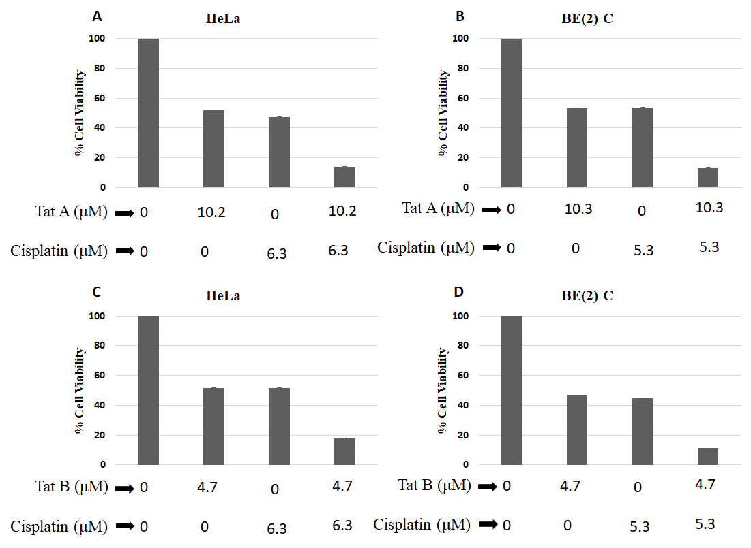
Figure 4 Cytotoxicity of Tat-A on (A) HeLa cells and (B) BE(2)-C cells and Tat-B on (C) HeLa cells and (D) BE(2)-C cells in combination with cisplatin. The experiments were done in triplicates and repeated twice. Error bars represent standard deviation.

To confirm that the combination of peptide aldehydes with cisplatin could potentiate the inhibitory effect on cell growth, the percentage cell viability assay (Figure 4) was done on both HeLa and BE(2)-C cells. As shown in Figure 4, Tat-A alone at its IC₅₀ of 10.2 μM showed 52% cell viability on HeLa cells but when used in combination with cisplatin the cell viability reduced to 14%, indicating the higher cytotoxicity of the these two drugs in combination. Treatment with Tat-A-cisplatin combination reduced the cell viability of the BE(2)-C cells from more than 50% (Tat-A alone) to 13% (combination). Similarly, Tat-B at its IC₅₀ of 4.7 μM when combined with cisplatin showed 18% and 11% cell viability against HeLa and BE(2)-C cells respectively which on its own was > 50% in both cases (Figure 4).

Cisplatin is a DNA intercalating drug which ultimately causes apoptosis and cell death. Whereas proteasome inhibitors mediate cytotoxicity by binding to 26S proteasome subunits affecting the proteolytic mechanism and thereby promoting apoptosis.³⁸ The improved activity of the drug combinations can be attributed to the two different mechanisms of action of DNA intercalation and proteasome inhibition acting together in synergy on the cells.

Inhibition of the Human 20S Proteasome
The potential of the synthetic peptide aldehydes to inhibit the 20S proteasome enzyme was evaluated in comparison to the clinically approved proteasome inhibitor drug Ixazomib (Figure 5). The cell-free 10-dose IC₅₀ experiment on 20S proteasome enzyme was performed by Reaction Biology Corp, USA. Both Tat conjugates proved to be potent inhibitors of the human 20S proteasome enzymes than Ixazomib. Tat-A was particularly potent and proved to be approximately 6 times stronger (2.5 nM) than Ixazomib (15 nM) and Tat-B (4.28 nM) was approximately 4 times active than Ixazomib (Figure 5).
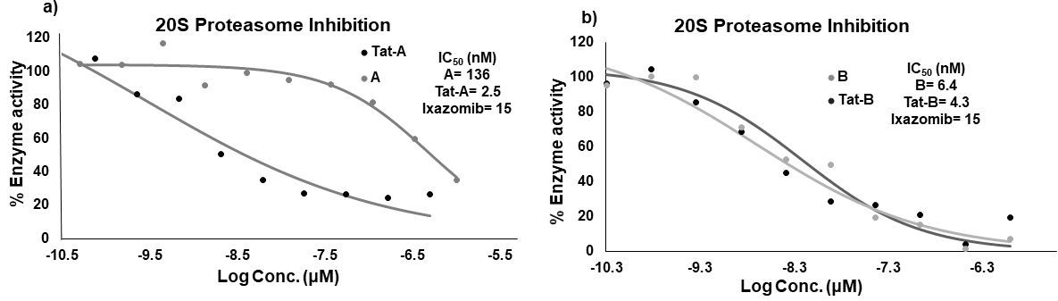
Figure 5. Results from the cell-free assay on the human 20S proteasome enzyme inhibition by the synthetic peptide aldehydes and their Tat conjugates. The assay was done once with three-fold dilution, by Reaction Biology Corp, PA, USA.

Cell based 20S proteasome inhibition assays on HeLa and BE(2)-C were further undertaken using Tat-A and Tat-B at their 2 × IC₅₀ concentration in the presence of the natural substrate LLVY-R110 for specific time periods (Figure 6). Cleavage of LLVY-R110 by the cellular proteasomes would release the green fluorescent R110, the fluorescence intensity of which can be correlated to the extent of 20S proteasome activity. As shown in Figure 6, the control samples showed increasing fluorescence which plataued at 36 hours, whereas peptide treated cells showed negligible rise in fluorescence during this time period indicating that the cellular proteosome activity has been inhibited by the Tat conjugated peptide aldehydes which prevents the proteasome from cleaving its natural substrate.

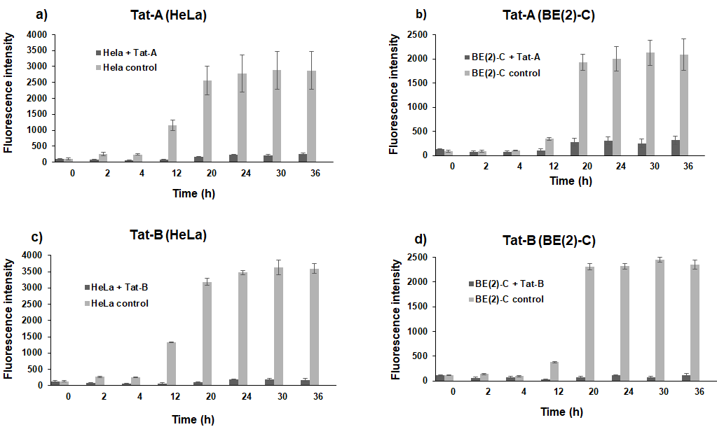
Figure 6. Effect of peptide aldehydes at 2 × IC₅₀ on HeLa and BE(2)-C cellular 20S proteasomes in comparison to the control. The experiment was performed in triplicate and the mean of values taken. Error bar represents standard deviation.

Effect on Cancer Cell Membranes and DNA
The combination of the membrane permeable dyes SYTO 9 and propidium iodide (PI) is widely used to study the effects of drugs on membranes. SYTO 9 permeates both eukaryotic and prokaryotic membranes and stains live and dead cells with green fluorescence. In contrast, PI is a membrane impermeable dye, which only penetrates cells with compromised membrane integrity, giving rise to red fluorescence through binding to DNA. Thus when stained with PI and SYTO 9, intact cells show green fluorescence whereas membrane damaged cells show red fluorescence.

HeLa and BE(2)-C cells were treated with Tat-A and Tat-B at 2 × IC₅₀, the cells then stained with an SYTO9 and PI combination and imaged to determine their effect on cancer cell membranes (Figure 7). Untreated cells had intact membranes and thereby the merged control images showed green fluorescent cells, with an intact nucleus and no obvious sign of nuclear condensation. However, cells treated with the Tat-peptide aldehyde conjugates showed red fluorescence and had lysed membranes, membrane blebbing and compressed/damaged DNA (signs of apoptosis). Comparison of the images (Figure 7) clearly show significant reduction in the number of green cells between the control and those after treatment with the Tat conjugates.
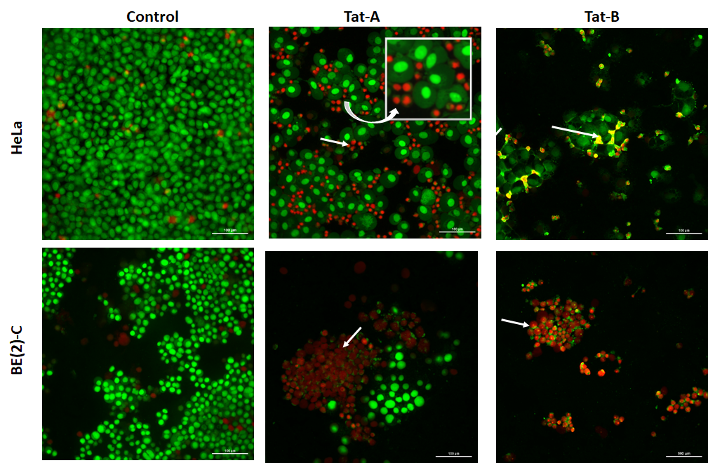
Figure 7. PI and SYTO 9 merged images of HeLa cells and BE(2)-C cells after treatment with the Tat conjugates at 2 × IC₅₀ concentration. Arrows represent lysed cells and compact DNA which are clearly evident in dead cells. Inset shows an expanded view of the nuclear component of the healthy cells and compressed nucleus of the dead cells. Scale bars represent 100 μm.

Chromatin Condensation/Apoptosis using Hoechst staining and Annexin V alexa fluor 488/PI dye.
Ubiquitin-20S proteasome is primarily located in the nucleus and cytoplasm. Changes in the activity of 20S proteasomes, affect nuclear stability and chromatin structure resulting in apoptosis, by its association with p53/PUMA pathway.^{39,40} Changes in nuclear morphology can be studied using Hoechst staining. Hoechst is a membrane permeable DNA intercalating dye which stains healthy cells evenly but less intensely, whereas, cells with condensed DNA show intense staining which can be quite prominent indicative of apoptosis.⁴¹
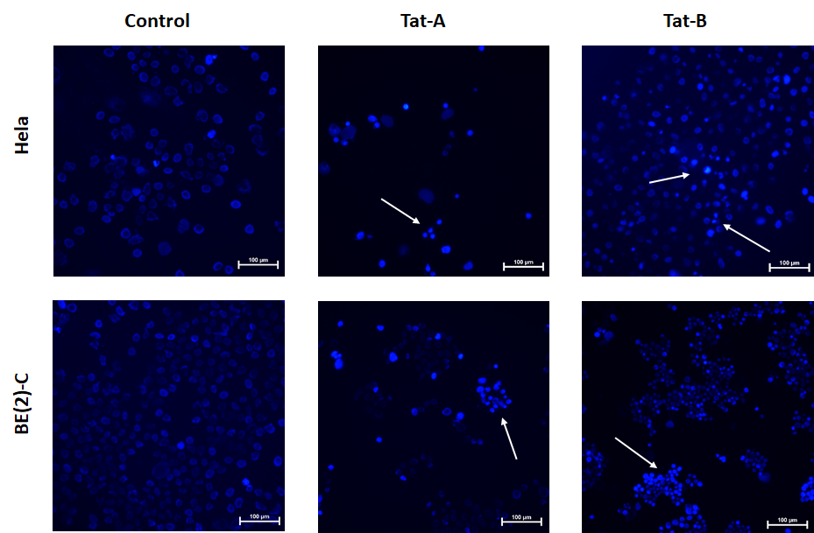
Figure 8. Hoechst staining of HeLa and BE(2)-C cells showing condensed chromatin. Arrows represent intense staining with condensed chromatin characteristic of apoptosis. The scale bar represents 100 μm.

Results from Hoechst staining experiment (Figure 8) show intense staining with condensed chromatin and DNA damage in the presence of the Tat conjugates (2 × IC₅₀) whereas the untreated cells showed much less intense blue fluorescence, further proving apoptosis caused upon treatment with these molecules.

Healthy cells are characterised by asymmetrical distribution of phospholipids on the outer and inner leaflet of the plasma membrane; however, during apoptosis, the phospholipid phosphatidylserine (PS) gets exposed to the outer side of the plasma membrane.⁴² Annexin V is a cellular protein of the annexin family that binds to PS in the presence of calcium. Since the transfer of PS from the inner to the outer leaflet is the result of apoptosis, Annexin V can be used to detect early stages of apoptosis.⁴² Annexin V is non-fluorogenic in nature, therefore these are usually conjugated to fluorophores. Various fluorophores like FITC, alexa fluor 488, RPE, pacific blue, biotin etc. are used for conjugation depending on the signals desired. Alexa fluor 488 is better than commonly used FITC fluorophore in terms of providing brighter and photostable conjugates. PI is also used in conjunction with annexin V to distinguish necrotic cells from apoptotic cells. Therefore, the alexa fluor 488/PI combination was used in our study to determine cell apoptosis and necrosis caused upon treatment with the peptide aldehyde-Tat conjugates as explained below.

HeLa and BE(2)-C cells were treated with Tat-A and Tat-B at 2 × IC₅₀, the cells then stained with Annexin V alexa fluor 488/PI combination and imaged to determine their effect on cancer cell membranes (Figure 9). Untreated cells are not apoptotic and thereby the merged control images showed no evident fluorescence. However, cells treated with the Tat-peptide aldehyde conjugates showed blue fluorescence representing apoptotic and red fluorescence representing necrotic cells.

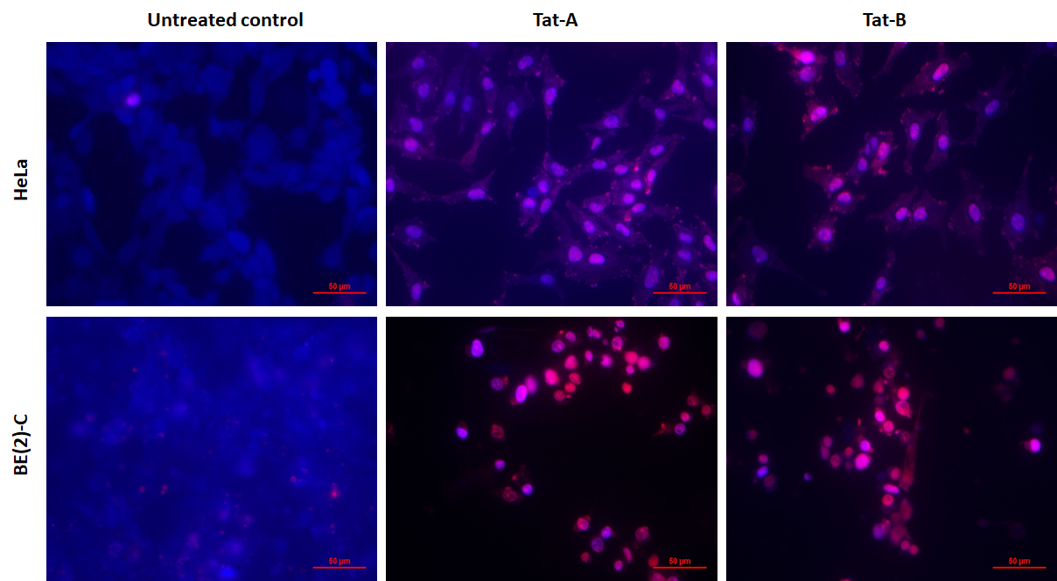
Figure 9. Annexin V alexa fluor 488/PI staining of HeLa and BE(2)-C cells. Scale bars represent 50 μm.

Apoptosis of HeLa and BE(2)-C cells induced by Tat-A and Tat-B was additionally confirmed by flow-cytometry using Annexin V alexa fluor 488/PI dye (Figure 10). HeLa cells showed 72.9 % and 80.5 % apoptosis respectively upon treatment with 2 × IC₅₀ of Tat-A and Tat-B. The percentages of necrotic HeLa cells upon treatment with Tat-A and Tat-B were 4.8 and 2.8 respectively. BE(2)-C cells showed 27.2 % and 28.3 % apoptosis upon treatment at 2 × IC₅₀ of Tat-A and Tat-B, whereas the necrotic cells observed were significantly higher in percentage (64.9 and 65.4 respectively). The significantly higher percentage of necrotic BE(2)-C cells observed upon treatment with the conjugated peptide aldehydes indicate that membrane rupture caused by these molecules on the BE(2)-C cells is much more than in the case of HeLa cells. This observation correlates well with scanning electron microscopy (SEM) results (discussed later). To mention briefly, comparatively higher level of membrane disruption to the BE(2)-C cell lines upon treatment with Tat-A and Tat-B is clearly evident in the SEM images (Figure 12). The total percentage of apoptotic and necrotic cells upon treatment with the peptide aldehydes were HeLa: 77.7 and 83.3 and BE(2)-C 92.1 and 93.7 respectively with Tat-A and Tat-B which establishes the ability of these molecules to cause significant damage to the cancer cells tested here. These results also indicate that membrane disruption is more for the BE(2)-C cell lines.
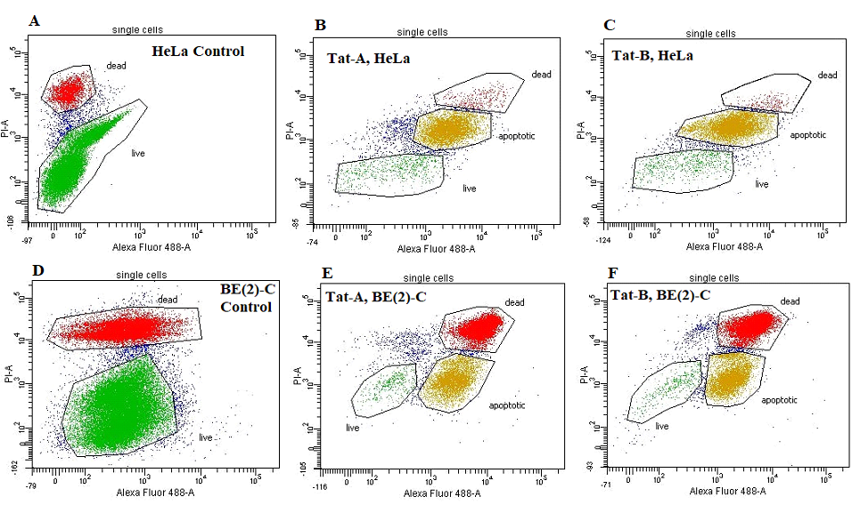
Figure 10. Effect of treating HeLa cells and BE(2)-C cells with Tat-A and Tat-B at 2 × IC₅₀ and apoptosis analysed using flow-cytometry

Determination of ROS Production
Drugs modulating intracellular levels of reactive oxygen species (ROS) are known to reduce the proliferation of cancer cells.⁴³ The elevated level of oxidative stress by drug treatment results in the oxidation of proteins, lipids and DNA ultimately resulting in tumour suppression and tumor cell death.⁴⁴
The ability of the Tat conjugates to induce ROS production was studied using the fluorescent dye 2’7’-dichlorodihydrofluorescein diacetate (DCF-DA). DCF-DA upon oxidation by ROS releases the highly fluorescent moiety dichlorofluorescein (DCF). HeLa and BE(2)-C cells were treated with a range of concentrations of the Tat conjugates (0 μM – 200 μM) for 24 hours, at the end of which DCF-DA was added, and fluorescence intensities measured (Figure 11). A dose-dependent increase in fluorescence intensity indicating increase in ROS production was observed which was more prominent from 12.5 μM of the Tat conjugates in both HeLa and BE(2)-C cells (Figure 11). In the presence of ascorbic acid (a known quencher of ROS), this concentration-dependent increase in fluorescence was not observed.

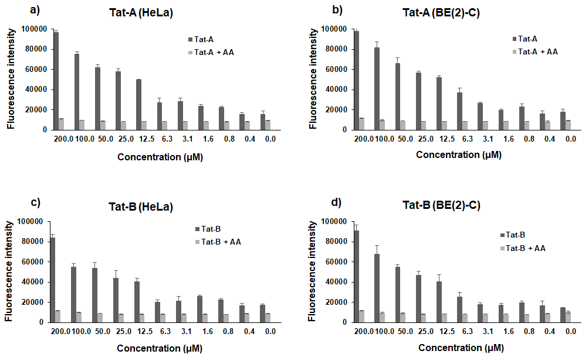
Figure 11. Effect of peptide aldehydes on the endogenous generation of ROS after 24 hours of drug treatment with and without ascorbic acid (AA). The experiment was done in triplicate twice and values averaged out. Error bar represents standard deviation.
HeLa and BE(2)-C cells showed time dependent increase in the ROS generation (Figure S3) upon treatment with Tat-A and Tat-B at 2 × IC₅₀ concentration. As shown in Figure S3, ascorbic acid treated cells showed decreased fluorescence due to quenching of ROS.

Cancer Cell Morphology
Morphological changes to HeLa and BE(2)-C cells upon treatment with Tat-A and Tat-B were investigated using scanning electron microscopy (SEM) in comparison to untreated cells (control) and cells treated with Tat alone. Untreated HeLa and BE(2)-C cells were round in shape with distinctly intact membranes, whereas, peptide treated cells showed characteristic holes and membrane blebs (Figure 12). Such pore formations are characteristic of secondary necrosis, a phenomenon where apoptotic cells lose their plasma membrane integrity.^{39,45} As expected, Tat treated cells showed some signs of membrane disruption characteristic of cationic peptide interaction with membranes. However, the clear pore formation and membrane blebbing caused by peptide aldehyde treatment was not imparted upon treatment with Tat alone, further proving that cell damage and apoptosis is the result of the action of the peptide aldehydes which got transported to their targets by the cell penetrating Tat molecule. A closer examination of the images in Figure 12 clearly shows that there are noticeable differences in the extent of membrane damage, caused by the Tat conjugates, between BE(2)-C and HeLa cells. Significantly more cell debris and membrane disruption is evident on the treated BE(2)-C cells as compared to the treated HeLa cells. This observation supports the higher (than HeLa) percentage of necrotic BE(2)-C cells observed upon treatment with the peptide aldehyde conjugates (discussed under flow cytometry). Subtle differences between the membrane composition of different cell types is not unsurprising and could be the reason for the differences observed between the two cell lines in this study. Further exploration of this aspect is beyond the scope of the current investigations.
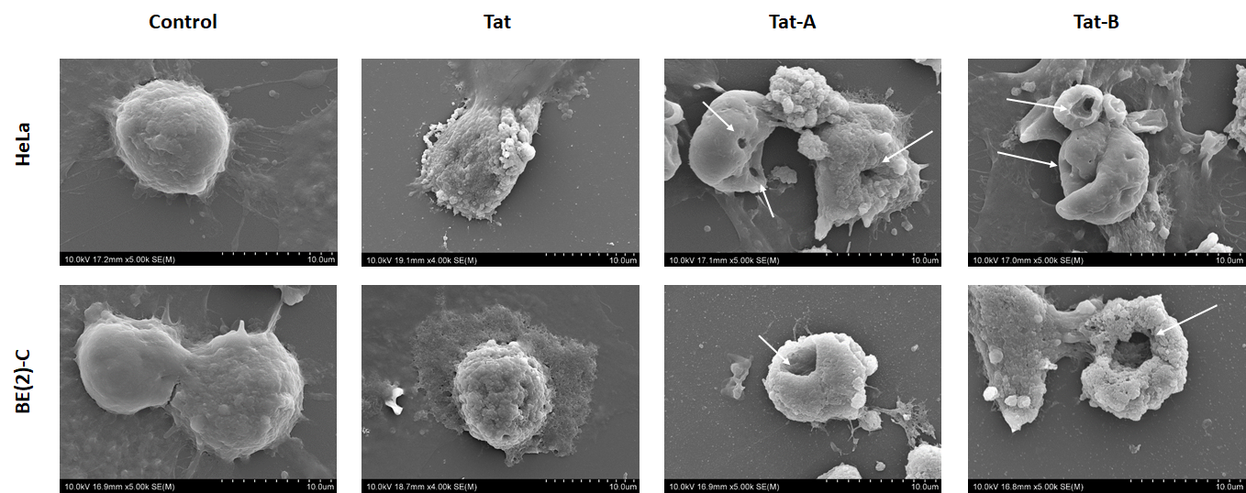
Figure 12. SEM images of HeLa and BE(2)-C in the presence and absence of 2 × IC₅₀ concentration of Tat-A and Tat-B. Arrows point to membrane disruption and pore formation. Membrane blebbing is evident in peptide treated cells. Scale bar represents 10 μm.

Antifungal Activity of the Tat-Peptide Aldehyde Conjugates and Synergistic Effect with Amphotericin b
The Tat conjugates showed low micromolar activity against C. albicans (Table 2) with MICs in the range of 15.62-31.25 µM (Tat-A) and 7.8-15.62 µM (Tat-B) compared to the non-conjugated derivatives having MIC > 100 µM. Tat itself was not active against C. albicans even at 100 µM. The increased cationic nature because of Tat conjugation together with the hydrophobic nature of the peptide aldehydes makes the conjugates permeate the fungal membranes better imparting potency against the fungal cells. We and others have reported that a combination of chain length, hydrophobicity and cationic nature are parameters that influence the antifungal activity of peptides.⁴⁶⁻⁴⁸ These conjugates also showed fungal proteasome inhibition at the MIC of 31.25 µM for Tat-A and 15.62 µM for Tat-B (Figure S4).
Synergy testing by checkerboard assay⁴⁹ was used to determine the effect of Tat-A and Tat-B in combination with the standard antifungal drug AmB on C. albicans. The MIC values of Tat-A and Tat-B in combination with AmB were five times lower than when these peptides were tested alone. The MIC value of AmB in combination with Tat-A and Tat-B was also lowered by six times compared to AmB alone. FICI values of 0.36 and 0.35 were observed for the combination of AmB with Tat-A and Tat-B respectively which are well within the limit of synergistic category (Table 2). Our previous work on antifungal lipopeptides showed that AmB is haemolytic at 1.56 µM and non-haemolytic at 0.25 µM.⁴⁸ The fact that the combination of Amb with the conjugated peptide aldehydes show antifungal activity at concentrations significantly lower than the haemolytic concertation of Amb is encouraging and opens the possibility of developing antifungal drug formulations that may help to overcome the current toxicity issues associated with AmB.

Table 2. MIC of the Peptide Aldehydes in combination with AmB against C. albicans.
Peptide | MIC* of Peptides alone  (µM) | Concentration (µM) of AmB and Peptides showing potency  in Combination | FICI** | Effect
A | > 100 | ND | ND | ND
Tat-A | 31.25 | 0.25 (AmB)/6.25 (Tat-A) | 0.36 | Synergic
B | > 100 | ND | ND | ND
Tat-B | 15.62 | 0.25 (AmB)/3.12 (Tat-B) | 0.35 | Synergic
AmB | 1.56

* MIC experiments were done in triplicate and repeated on three independent days. **The fractional inhibitory concentration index (FICI) showed synergistic effect and these experiments were repeated twice on two independent days. ND represents assays which were not performed.

Activity of Peptide Aldehydes against C. albicans Biofilms
Treating fungal biofilms and their progression is challenging.⁵⁰ Biofilms in yeasts like C. albicans progress in stages of cell adhesion, germination, budding, filamentation, monolayer development, proliferation and final stage of mature biofilm formation taking a total of 24-48 hours depending on the conditions to which they are exposed. C. albicans strain SC5314 is widely used to study the biofilm forming properties and forms an excellent model for testing antifungal drugs.⁵¹ The efficacy of the Tat conjugates to inhibit and eradicate C. albicans biofilms was investigated by determining MBIC (the lowest concentration of drug required to inhibit visible biofilm mass) and MBEC (lowest concentration required to eradicate visible biofilm mass) through a quantitative colorimetric assay using 2,3-bis(2-methoxy-4-nitro-5-sulfophenyl)-2H-tetrazolium-5-carboxanilide (XTT) dye (Figure 13). The MBIC of Tat-A and Tat-B (Figure 13 a) were 15.6 µM and 7.8 µM respectively which correspond to their MIC values (Table 3) thus confirming that these peptide aldehydes inhibit C. albicans biofilms at their MICs.

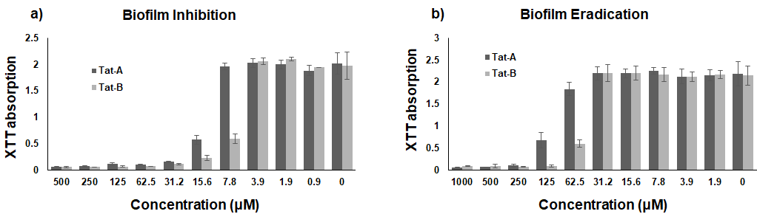
Figure 13. Effect of various concentrations of Tat-A and Tat-B on inhibition of biofilm formation (a) and the eradication (b) of 24-hour biofilms. The experiment was done in triplicate and repeated on two independent days. Error bars represent standard deviation.

Upon treating 24-hour preformed biofilms of C. albicans with Tat-A and Tat-B more than 50% of the biofilm cells (Figure 13b) were eradicated at 125 µM and 62.5 µM respectively. We further investigated the effect of the Tat conjugated peptide aldehydes on the cell morphology of the fungal biofilms at 2 x MBEC using SEM which clearly showed significant pore formation and hyphae disruption (Figure S4). AmB only showed pore formation of the fungal membranes and had no effect on fungal hyphae. A large amount of debris from hyphal disruption was very evident in the Tat-B treated images. (Figure S5)

Molecular Docking Studies
The chymotrypsin like activity of catalytic β5 subunit is important for 20S proteasome catalytic activity. β1, β2 and β5 subunits play important roles in protein degradation, in particular, β5 is widely explored for its proteolytic properties. Catalytic activity of these β subunits are dependent on the N-terminal threonine residue with these acting like threonine proteases with participation from neighbouring water molecules resulting in hydrolysis of the peptide bonds. The unconjugated peptide aldehydes were docked with the yeast 20S proteasomes (PDB code 3MG0; resolution 2.68 Å)[Ref: Blackburn, C., Gigstad, K.M., Hales, P., Garcia, K., Jones, M., Bruzzese, F.J., Barrett, C., Liu, J.X., Soucy, T.A., Sappal, D.S., Bump, N., Olhava, E.J., Fleming, P., Dick, L.R., Tsu, C., Sintchak, M.D., Blank, J.L. (2010) Biochem.J. 430: 461-476] using GOLD v5.2 software suite (Figure S7). Peptides A and B showed interactions with active site Thr1, Thr21 and Gly47. The tetrahedral intermediate is additionally stabilized through its interaction with Thr1 amine atom. Additional interactions like alkyl-alkyl (in peptide aldehyde A) and Pi-alkyl/cation/sulphur (in peptide aldehyde B) were seen. The computational scores for peptide aldehyde A were GS-60.9, CS-28.3, PLP-66.6 and ASP-26.2 and for peptide aldehyde B were GS-65.3, CS-33.2, PLP-89.6 and ASP-35.6. These scores show better interactions of peptide aldehyde B with the compared to peptide aldehyde A.

Haemolysis of Mouse Blood Cells
Due to the presence of zwitterionic phospholipids such as phosphatidylcholine and sphingomyelin on red blood cell (RBC) membranes, an increase in cationic and hydrophobic nature of the peptides can increase its affinity towards RBC.⁵² Results from the haemolysis study (Figure S6), prove that the conjugates are not haemolytic to mouse RBC up to 500 µM. Tat-A showed 1% haemolysis and Tat-B and 12% haemolysis at 500 µM establishing a promising therapeutic window for these conjugates which are cytotoxic and antifungal at significantly lower concentrations

Conclusions
Our investigations have identified two novel cell penetrating peptide conjugated peptide aldehyde inhibitors of the human 20S proteasomes which are up to 6 and 4 times more potent than the known inhibitor ixazomib. These conjugates also showed fungal proteasome inhibition at their MIC values. Cell based assays showed that Tat conjugation enhances the potency against both cancer cell lines and C. albicans compared to non-conjugated peptides. Tat-B with aromatic amino acids at positions AA1 and AA3 proved to be more effective than Tat-A against both cancer cell lines and fungi including in the eradication of fungal biofilms. Tat-B treated BE(2)-C showed complete abolition of healthy green cells as was observed in the SYTO-PI staining experiments. Disruption of the fungal hyphae by Tat-B was evident in the SEM images, unlike in the case of Tat-A or AmB. Combination of the Tat conjugated peptide aldehydes with cisplatin (for cytotoxicity) and AmB (for antifungal activity) proved to be synergistic. Treatment with Tat-A and Tat-B caused significant apoptosis and necrosis of the two cancer cell lines tested. Results from the present study establish the potential of these peptide aldehydes as therapeutic agents against multiple diseases. Investigations involving more drugs in conjugation with proteasome inhibitors can be beneficial against recurrent and resistant cancers and fungal diseases. Further exploration of proteasome inhibitors like boronic acid and vinyl sulphonyl derivatives in conjugation with CPPs could be a breakthrough in treating cancer and fungal infections.

Experimental Section
Chemicals and Reagents
Weinreb AM resin was purchased from Merck Novabiochem, coupling reagents and Fmoc-protected amino acids were purchased from GL Biochem (Shanghai, China). Lithium aluminium hydride solution (LiAlH₄ 0.1% in THF) was purchased from Sigma-Aldrich. The fluorescent dye 2’7’-dichlorodihydrofluorescein diacetate (DCF-DA), 2,3-bis(2-methoxy-4-nitro-5-sulfophenyl)-2H-tetrazolium-5-carboxanilide (XTT), 2-methyl-1,4-naphthoquinone (menadione) were purchased from AK scientific (California, USA). Human cervical carcinoma cells (HeLa), human neuroblastoma cells (BE(2)-C) and proteasome 20S activity assay kit was purchased from Sigma-Aldrich. Hoechst 33342 dye, SYTO 9, PI and Alexa Fluor 488 annexin V/PI apoptosis kit was purchased from Thermo Fisher Scientific. C. albicans strains (SC5314) were obtained from the School of Biological Sciences, University of Auckland. Growth media RPMI was purchased from Gibco Life Technologies, yeast extract was purchased from Oxoid and peptone was purchased from BD Biosciences. Solvents used for synthesis and purification were of analytical grade and were used without further purification.

Syntheses and Characterization of Peptide Aldehydes
General Procedure for the Syntheses of Peptide Aldehydes A, B, Tat-A and Tat-B
The peptide aldehydes were synthesized from commercially available Weinreb amide resin.⁵³ After swelling the Weinreb resin (substitution level of 0.62 mmol/g) in DCM for an hour, the Fmoc group was removed with 20% piperidine. After washing the resin with DMF thoroughly, Fmoc-Leu-OH (4 equiv.) was coupled for 6 h using HATU (3.8 equiv.) as the coupling reagent and DIPEA (10 equiv.) as the base. The remaining amino acids were coupled to the resin following a series of Fmoc removal and coupling steps using HATU and DIPEA as above. N-terminal acetylation was done using a cocktail of acetic anhydride: pyridine: DMF (1:2:3) for 1 h.

The peptides were cleaved from Weinreb amide resin by reduction using LiAlH₄, the amount of which was critical for the success of the reduction. For peptide aldehydes A and B, 5 equivalents of LiAlH₄ was used whereas for Tat-A and Tat-B, 10-12 equivalents of LiAlH₄ was necessary for complete reduction. Reduction was carried out under dry conditions at 0 ºC for 45 minutes. At the end of the reduction, excess LiAlH₄ was quenched with saturated ammonium chloride solution. The crude side chain protected peptides were extracted into DCM. After evaporating the solvent under vacuum, the side chain protecting groups were removed using TFA: DCM (95:5 v/v) solvent mixture. Evaporation of TFA:DCM under a stream of N₂ followed by precipitation of the crude peptides using cold diethyl ether gave the crude side chain unprotected peptides as fluffy solids. The crude peptides were purified to > 95% purity using reversed-phase HPLC (RP-HPLC) on a GE AKTA purifier 10 on Phenomenex Luna 5 µm C₁₈ 100 Aº (250 × 21.2 mm) column using a gradient solvent system of 0.1%TFA in water as solvent A and 99% acetonitrile, 1% water and 0.1% TFA mixture as solvent B at a flow rate of 10 mL/min with UV detection at 214 nm.

Purity of the peptides was confirmed by analytical RP-HPLC (Figure S1) using a Phenomenex Luna 5 μm C₁₈ 100 Å (250 × 4.6 mm) column with the same solvent system as above at a flow rate of 1 mL/min. The identity of the purified peptides was confirmed using matrix-assisted laser desorption/ ionization−time-of-flight mass spectrometry (MALDI-TOF MS) recorded on a Bruker Ultraftlextreme MALDI/TOF mass spectrometer (Figure S2). All peptides used in this study had ≥ 95% purity as judged by analytical HPLC (Table S1 and Figure S1).

Cancer Cell viability Assay and Determination of IC₅₀
Human cervical carcinoma (HeLa) cells and human neuroblastoma cells (BE(2)-C) cells were cultured in DMEM media with additional Ham’s F12 nutrient mixture for neuroblastoma cells. Media was supplemented with PSG mixture (100 units/mL penicillin, 100 μg/mL streptomycin, 2 μg/mL L-glutamine and 10% foetal bovine serum (FBS). Cells were maintained at 37 ºC in 5% CO₂ incubator in T-25 flasks.

IC₅₀ values were determined using standard MTT assays.⁵⁴ Briefly, the cells were seeded at the seeding density of 5 × 10⁴ cells /mL in 96 well tissue culture plates for 24 h at 37 ºC / 5% CO₂. After 24 h, the media was discarded carefully, and the cells treated with a serial concentration of peptides aldehydes with 2-fold dilution for 48 h at 37 ºC/5% CO₂. At the end of the incubation period, 20 μL MTT (0.5 mg/mL in each well) was added and incubated for 2-4 h. MTT was then removed carefully and 100 μL of DMSO was added to solubilise formazan crystals. The absorbance was then measured at 570 nm, and IC₅₀ values were calculated with Sigma Plot 11.0.

Synergistic Study in Combination with Cisplatin
The HeLa and BE(2)-C cells were plated in 96-well plates at a seeding density of 5 x 10⁴ cells/mL and allowed to incubate for 24 h at 37 ºC / 5% CO₂. After 24 h of seeding, HeLa and BE(2)-C cells were treated with Tat-A and Tat-B at the concentration ranging from 50 to 0.09 μM in combination with cisplatin which was present at a concentration range of 25-0.04 μM. The cell viability was measured after 48 h of treatment as discussed previously. At least 4 × IC₅₀ was used as the starting concentration for peptide aldehydes and cisplatin.
FICI was calculated using the following equation.^{55,56}
FICI= (IC_{50 (A+B)}/IC_{50A}) + (IC_{50 (A+B)}/IC_{50B})
where IC_{50 (A+B)} is the IC₅₀ value of the drugs in combination and IC_{50A} and IC_{50B} are the IC₅₀ values of compounds alone. FICI <1 is considered synergistic, FICI=1 additive and FICI>1 is antagonist effects.

The % cell-viability assay was carried out on HeLa and BE(2)-C cells. The cells were seeded and cultured as described in cancer cell viability assay. HeLa and BE(2)-C cells were plated in 96-well plates at a seeding density of 5 × 10⁴ cells/mL and allowed to incubate for 24 h at 37 ºC / 5% CO₂ as described above. HeLa cells and BE(2)-C cells were treated with respective IC₅₀ concentrations of Tat-A, Tat-B and cisplatin alone as well as in combinations. The cell viability was measured after 48 hours as described previously.

20S Proteasome Inhibition Assay
The 20S proteasome inhibition assay was performed by Reaction Biology Corp. (USA). Compounds A, Tat-A, B and Tat-B were tested in a 10-dose IC₅₀ with a 3-fold dilution starting at 1 μM against 20S proteasome enzyme. The 20S proteasome enzymes (2 nM) were activated with PA28 (20 nM) following treatment with the peptide aldehydes. The peptide stock solutions were prepared in DMSO and diluted further in Tris buffer (20 mM Tris-HCl, pH 8.0, 0.5 mM EDTA, 0.05% CHAPS, 1 mM DTT and 1%DMSO. The substrate Suc-LLVY-AMC (10 μM) was the added. 20S activity was monitored as a time-course measurement of the increase in fluorescence every 5 minutes for 120 minutes. Percentage enzyme activity (no inhibitor control was considered as 100 % activity) and IC₅₀ values were calculated. Curve fits were performed when the activities at the highest concentration of compounds were less than 65%.

The cell-based inhibition of 20S proteasomes on HeLa and BE(2)-C cells was studied using the commercial assay kit purchased from Sigma-Aldrich. The assay was performed according to the manufacturer’s instructions with modifications done to suit the test. Briefly, HeLa and BE(2)-C cells at the concentration of 5 x 10⁴ cells/mL were incubated with 50 μL of 2 x IC₅₀ concentration of Tat-A and Tat-B and 50 μL of proteasome assay loading solution containing the substrate LLVY-R110. Fluorescence intensity was recorded up to 36 h with intensity recorded at several time points (0, 2, 4, 12, 20, 24, 30 and 36 h). The controls were prepared by incubating proteasome assay loading solution containing the substrate with HeLa and BE(2)-C cells without any drug treatment.

Cancer Cell Membrane Permeability Assay Using Live-Dead Staining
Cells at the seeding density of 5 x 10⁴ cells/mL were seeded in 12 well tissue-culture treated plates for 24 h. Media was removed, wells were carefully washed with phosphate buffer and treated with 2 x IC₅₀ concentration of Tat-A and Tat-B for 24 h. After this treatment, peptide solution was removed, cells washed with phosphate buffer and stained with Live/Dead stain (enough volume to cover the wells) containing 3.34 μM SYTO 9 and 20 μM PI diluted 1:1000 in phosphate buffer. Cells were then imaged at 20 x magnification under Nikon Digital Sight DS-Ri2 CMOS sensor colour camera in Nikon TE2000E inverted fluorescence microscope (Biomedical Imaging Research Unit, The University of Auckland). The stained cells were viewed separately using GFP filter set for Syto9 and Texas filter set for PI and the images were then merged.
Chromatin Condensation/Apoptosis using Hoechst staining and Annexin V alexa fluor 488/PI dye.
HeLa and BE(2)-C cells were seeded in 12 well plates, and subsequent steps of drug treatment were followed according to the procedure discussed in the Live/Dead staining section. After drug treatment and washing with phosphate buffer, cells were stained with 500 μL of Hoechst 33342 (10.0 mg/mL, 16.23 mM prepared in deionised H₂O and was further diluted 1:2,000 in phosphate buffer). Cells were then imaged at 20 x magnification under Nikon Digital Sight DS-Ri2 CMOS sensor colour camera in Nikon TE2000E inverted fluorescence microscope (Biomedical Imaging Research Unit, The University of Auckland). The stained cells were viewed using a filter with excitation of 350 nm and emission of 460 nm (standard DAPI filter sets).

For the Annexin V alexa fluor 488/PI staining, the cells were seeded on 6 well plates with poly-lysine coated cover slips and subsequent steps of drug treatment and washings was same as described above for Hoechst staining. After washing the cover slips with PBS, the cells were stained with 5 μL Alexa Fluor 488 annexin V and 1 μL 100 μg/ml PI and then incubated for 15 minutes in the dark. The stained coverslips were then inverted on clean slides and the imaged at 40 x magnification under DS-UI camera using fluorescence microscope. The stained cells were viewed using a filter with excitation of 488 nm and emission of 530 nm. For flow cytometry, the cells at 1 x 10⁶ cells/ml concentration were seeded in 6 well plates for 24 hours, followed by treatment with 2 x IC₅₀ concentration of Tat-A and Tat-B for 24 h. After the treatment, the supernatant was collected in Eppendorf tubes. Cells were then trypsinized and collected in the Eppendorf tubes containing the supernatant. Cells were washed twice by centrifugation using cold PBS. The cells were then thoroughly re-suspended in 100 μL annexin-binding buffer. Staining was done using 5 μL Alexa Fluor 488 annexin V and 1 μL 100 μg/ml PI followed by incubation for 15 minutes in the dark. After the incubation period, 400 μL annexin-binding buffer was added and analysed using flow cytometry by measuring the fluorescence emission at 530 nm and excitation at 488 nm on FACSDiva Version 6.1.3.

Measurement of Reactive Oxygen Species (ROS) Production in HeLa and BE(2)-C Cells
Concentration-dependent endogenous production of ROS in HeLa and BE(2)-C cells was measured using fluorescent dye 2’7’-dichlorodihydrofluorescein diacetate (DCF-DA). Cells were seeded in 96-black well plates and treated with peptide aldehydes following the same procedure as discussed in the MTT assay. However, peptide dilutions with concentration range (200-0.4 µM) were prepared in cell growth medium devoid of FBS (foetal bovine serum) as FBS can react with DCF-DA and give false positive results. After the drug treatment, DCF-DA (100 µL, 25 µM) was added to each well and incubated for 2-3 h at 37 ºC. Fluorescence intensities were measured at excitation and emission wavelength of 492 nm and 525 nm respectively. Time-dependent endogenous ROS generation was studied on HeLa and BE(2)-C cells following treatment with 2 x IC₅₀ concentration of Tat-A and Tat-B. Cells at their seeding density of 5 x 10⁴ were seeded in 96-well black well plates for 24 h. Media was removed and cells were washed with phosphate buffer. Peptide solution in phosphate buffer and DCF-DA (1:1) was added to the wells and fluorescence intensities were measured at 0, 3, 12, 17, 21 and 24 h.

Structural Morphology of HeLa and BE(2)-C Cells Using SEM⁴⁵
For SEM, HeLa and BE(2)-C cells at the seeding density of 5 x 10⁴ were incubated for 24 h on cell culture thermonax coverslips embedded in 12-well plates. After 24 h of incubation, growth medium was removed and the cells washed with phosphate buffer. Cells were treated with 2 x IC₅₀ concentration Tat-A and Tat-B for 12 h. Cells were washed with buffer, fixed with 4% glutaraldehyde for 1 h, and dehydrated with graded ethanol (10%, 25%, 50% and 100%) prior to drying at 60 ºC for 10 min. Dried coverslips were platinum coated for 2 min. at 20 mA before viewing under high vacuum with FEI Quanta 200 F ESEM microscope at 10 kV.

Antifungal Assay⁴⁵
C. albicans were grown on YPD agar (1%yeast, 2% peptone, 2% glucose and 2 % agar) for routine subculture. Few distinct colonies from overnight cultures grown on agar plates were inoculated in 5 mL of RPMI media (pH 7.0) until it reached density equal to 0.5 McFarland standard (prepared freshly protected from light) and was then further diluted 1:100 to obtain the final yeast stock solution of 10⁶ CFU/mL. Peptide aldehyde stock solution was prepared in RPMI media, AmB stock was prepared in DMSO and was then further diluted to get a range of concentrations (1000-1.9 µM) with RPMI in polypropylene coated 96-well plates (two-fold serial dilution methodology). The antifungal assay was performed by adding 50 µL of diluted C. albicans to 50 µL of peptide solution. The plates were then incubated at 35 ºC for 48 h to determine Minimal Inhibitory Concentration (MIC) and compared with suitable growth and sterility controls.⁵⁷

Synergistic Assay of Peptide Aldehyde in Combination With AmB on C. albicans⁴⁵
C. albicans at 10⁶ CFU/mL density were used in the assay. Stock solutions of peptide aldehydes were diluted two-folds to generate a concentration range of 50-0.39 µM in polystyrene 96 well plates (tissue culture treated) along the ordinate whereas amphotericin dilutions (4-0.03 µM) were prepared along the abscissa. Double the MIC was used as the starting concentration for peptide aldehydes and AmB. 50 µL of diluted C. albicans were added to the 50 µL of peptide/AmB solution. Growth control and sterility controls were prepared for comparison. The plates were then incubated for 24-48 hours at 37 ºC.
The effect of the combination on antifungal activity was determined by calculating fractional inhibitory concentration index (FICI). FICI was calculated using the following equation (same as in the cancer assay).
FICI = (MIC_{A+B}/MIC_{A}) + (MIC_{B+A}/MIC_{B})
where, MIC_{A} and MIC_{B} are the MICs of antifungal compounds alone and MIC_{A+B} and MIC_{B+A} and the MIC of antifungal compounds in combination. FICI of ≤ 0.5 is defined as a synergistic effect, FICI between 1.0 and 4.0 is partial synergistic and FICI of ≥ 4.0 is called antagonist effect.

C. albicans Biofilm Inhibition Assay⁴⁵
Briefly, 10⁶ CFU/mL C. albicans cells in RPMI 1640 medium were incubated with two-fold serially diluted peptides (1000-1.9 µM) for 24 h at 35 ºC in polystyrene tissue culture treated 96-well plates. Growth control and sterility control were prepared for comparison. After 24 h, planktonic cells were carefully removed without disturbing the biofilms and washed with PBS. Biofilm formed were treated with 100 µL of XTT (0.5 g/L) and menadione (1 µM) in PBS buffer for 2 h (incubated in dark at 35 ºC with shaking). The absorbance was then measured at 490 nm and minimum biofilm inhibition concentration (MBIC) was determined.⁵⁷

C. albicans Biofilm Eradication Assay⁴⁵
C. albicans biofilms were grown in polystyrene tissue culture treated 96-well plates in RPMI 1640 media at 35ºC without the peptides. Biofilms were allowed to form for 24 h. The 24-hour biofilms were washed carefully with PBS buffer and treated with various concentration of peptides (1000-1.9 µM) for 24 h at 35 ºC. The biofilm eradication was quantified using the same procedure as described in biofilm inhibition section and minimum biofilm eradication concentration (MBEC) was determined.

Docking of Peptide Aldehydes with Yeast 20s Proteasomes
Peptide aldehydes A and B were docked to the crystal structure of yeast 20S proteasome (PDB ID: 3MG0, resolution 2.68 Å),[Ref: Blackburn, C., Gigstad, K.M., Hales, P., Garcia, K., Jones, M., Bruzzese, F.J., Barrett, C., Liu, J.X., Soucy, T.A., Sappal, D.S., Bump, N., Olhava, E.J., Fleming, P., Dick, L.R., Tsu, C., Sintchak, M.D., Blank, J.L. (2010) Biochem.J. 430: 461-476] which was downloaded from the Protein Data Bank (PDB).⁵⁸ The Scigress Ultra version 2.6 program was used to prepare the crystal structures for docking, i.e., hydrogen atoms added, the co-crystallised ligand was removed from protein as well as crystallographic water molecules. The Scigress software suite was also used to build the structures and optimization using the MM2 force field.⁵⁹ The centre of the binding was defined on the co-crystallised ligand with coordinates (x = 11.747, y = -138.228, z = 12.344) with 10 Å radius. For the docking phase of molecular modelling 100% efficiency was used in conjunction with fifty docking runs. The Gold Score (GS), ChemScore (CS), ChemPLP (Piecewise Linear Potential) and ASP (Astex Statistical Potential) scoring functions were implemented to validate the predicted binding modes and relative energies of the ligands using GOLD v5.2 software suite. The robustness of the protocol was tested by re-docking the co-crystallised ligand with these results: RMSD (root-mean-square deviation) 2.954 Å.

Haemolysis

Freshly collected blood cells were centrifuged at 1000g for 5 min. to remove buffy coat. Blood cells (pellet) were washed thrice with Tris buffer (10 mM Tris, 150 mM NaCl, pH 7.4) and re-suspended in 2 % (V/V) Tris buffer. Peptide inhibitor solutions were prepared in Tris buffer (concentration range of 500 - 0.97 µM). The peptide solutions (100 µL) were added to each well of the 96-well plates containing100 µL blood cells and the plates were incubated for 1 h at 37⁰ C without agitation. 100 µL of 0.5% Triton X was used as positive control and Tris buffer as negative control. The plates were centrifuged at 3500g for 10 min. Supernatant from each sample (100 µL) was transferred to new plates and absorbance was measured at 540 nm. % haemolysis at each concentration was calculated using the following equation,

% haemolysis = (A_{exp} – A_{Tris}) / (A_{100%} - A_{Tris}) X 100

Where, A_{exp} is the absorbance of peptide sample at 540 nm, A_{Tris} is the absorbance of negative control, A_{100%} is absorbance of 0.1% Triton X-100

Abbreviations

AmB, Amphotericin B; ASP, astex statistical potential; CHAPS, (3-((3-cholamidopropyl) dimethylammonio)-1-propanesulfonate); CPP, cell-penetrating peptide; CS, ChemScore; DCF-DA, 2’7’-dichlorodihydrofluorescein diacetate; DTT, dithiothreitol; DNA, deoxyribonucleic acid; EDTA, ethylenediaminetetraacetate; FICI, fractional inhibitory concentration index; FBS, foetal bovine serum; GS, GoldScore; HATU, 1-(bis-(dimethylamino)methylene)-1H-1,2,3-triazolo[4,5-b]-pyridinium 3-oxide hexafluorophosphate; IC₅₀, inhibitory concentration at 50% inhibition ; LiAlH₄, lithium aluminium hydride; MALDI, matrix assisted laser desorption/ionisation; MIC, minimal inhibitory concentration; MTT, 3-(4,5-dimethylthiazol-2-yl)-2,5-diphenyltetrazolium bromide; PI, propidium iodide; PLP, piecewise linear potential; RBC, red blood cells; ROS, reactive oxygen species; RP-HPLC, reversed phase high pressure liquid chromatography; SEM, scanning electron microscopy; SPPS, solid phase peptide synthesis; TFA, trifluoroacetic acid; XTT, (2,3-Bis-(2-Methoxy-4-Nitro-5-Sulfophenyl)-2H-Tetrazolium-5-Carboxanilide).

Supplementary Information
Physical characteristics of all compounds, analytical HPLC traces, MADLI spectra, ROS graph, SEM images, haemolysis graphs, molecular docking images and molecular formula strings (CSV)

References
(1) Adams, J. The development of proteasome inhibitors as anticancer drugs. Cancer Cell 2004, 5, 417-421.
(2) Adams, J. The proteasome: A suitable antineoplastic target. Nat. Rev. Cancer 2004, 4, 349-360.
(3) Kisselev, A. F.; Goldberg, A. L. Proteasome inhibitors: from research tools to drug candidates. Chem. Biol. 2001, 8, 739-758.
(4) Manasanch, E. E.; Orlowski, R. Z. Proteasome inhibitors in cancer therapy. Nat. Rev. Clin. Oncol. 2017, 14, 417-433.
(5) Wang, K. K. Developing selective inhibitors of calpain. Trends Pharmacol. Sci. 1990, 11, 139-142.
(6) Figueiredo-Pereira, M. E.; Banik, N.; Wilk, S. Comparison of the effect of calpain inhibitors on two extralysosomal proteinases: the multicatalytic proteinase complex and m-calpain. J. Neurochem. 1994, 62, 1989-1994.
(7) Demo, S. D.; Kirk, C. J.; Aujay, M. A.; Buchholz, T. J.; Dajee, M.; Ho, M. N.; Jiang, J.; Laidig, G. J.; Lewis, E. R.; Parlati, F.et al. Antitumor activity of PR-171, a novel irreversible inhibitor of the proteasome. Cancer Res. 2007, 67, 6383-6391.
(8) Zhou, H. J.; Aujay, M. A.; Bennett, M. K.; Dajee, M.; Demo, S. D.; Fang, Y.; Ho, M. N.; Jiang, J.; Kirk, C. J.; Laidig, G. J.et al. Design and synthesis of an orally bioavailable and selective peptide epoxyketone proteasome inhibitor (PR-047). J. Med. Chem. 2009, 52, 3028-3038.
(9) Adams, J.; Behnke, M.; Chen, S. W.; Cruickshank, A. A.; Dick, L. R.; Grenier, L.; Klunder, J. M.; Ma, Y. T.; Plamondon, L.; Stein, R. L. Potent and selective inhibitors of the proteasome: Dipeptidyl boronic acids. Bioorg. Med. Chem. Lett. 1998, 8, 333-338.
(10) Chen, D.; Frezza, M.; Schmitt, S.; Kanwar, J.; Dou, Q. P. Bortezomib as the first proteasome inhibitor anticancer drug: Current status and future perspectives. Curr. Cancer Drug Tar. 2011, 11, 239-253.
(11) Kane, R. C.; Dagher, R.; Farrell, A.; Ko, C. W.; Sridhara, R.; Justice, R.; Pazdur, R. Bortezomib for the treatment of mantle cell lymphoma. Clin. Cancer Res. 2007, 13, 5291-5294.
(12) Kane, R. C.; Bross, P. F.; Farrell, A. T.; Pazdur, R. Velcade: U.S. FDA approval for the treatment of multiple myeloma progressing on prior therapy. Oncologist 2003, 8, 508-513.
(13) US FDA. Ninlaro (ixazomib) capsules: NDA approval. http://www.accessdata.fda.gov/drugsatfda_docs/appletter/2015/208462Orig1s000ltr.pdf. 2015, Accessed 4 March, 2019.
(14) Murray, P. F.; Biscoglio, M. J.; Passeron, S. Purification and characterization of Candida albicans 20S proteasome: Identification of four proteasomal subunits. Arch Biochem Biophys 2000, 375, 211-219.
(15) Liu, T. B.; Xue, C. The ubiquitin-proteasome system and F-box proteins in pathogenic fungi. Mycobiology 2011, 39, 243-248.
(16) Xu, D. M.; Ondeyka, J.; Harris, G. H.; Zink, D.; Kahn, J. N.; Wang, H.; Bills, G.; Platas, G.; Wang, W. X.; Szewczak, A. A.; Liberator, P.; Roemer,T. and Singh, S.B. Isolation, structure, and biological activities of fellutamides C and D from an undescribed metulocladosporiella (Chaetothyriales) using the genome-wide Candida albicans fitness test. J. Nat. Prod. 2011, 74, 1721-1730.
(17) Pfaller, M. A.; Diekema, D. J. Epidemiology of invasive candidiasis: a persistent public health problem. Clin. Microbiol. Rev. 2007, 20, 133-163.
(18) Soll, D. R.; Daniels, K. J. Plasticity of Candida albicans biofilms. Microbiol. Mol. Biol. Rev. 2016, 80, 565-595.
(19) Brajtburg, J.; Powderly, W. G.; Kobayashi, G. S.; Medoff, G. Amphotericin B: current understanding of mechanisms of action. Antimicrob. Agents Chemother. 1990, 34, 183-188.
(20) Gallis, H. A.; Drew, R. H.; Pickard, W. W. Amphotericin-B - 30 Years of clinical-experience. Rev. Infect. Dis. 1990, 12, 308-329.
(21) Troskie, A. M.; Rautenbach, M.; Delattin, N.; Vosloo, J. A.; Dathe, M.; Cammue, B. P. A.; Thevissen, K. Synergistic activity of the tyrocidines, antimicrobial cyclodecapeptides from Bacillus aneurinolyticus, with amphotericin B and caspofungin against Candida albicans biofilms. Antimicrob. Agents Chemother. 2014, 58, 3697-3707.
(22) Ma, Y. H.; Xu, B.; Fang, Y.; Yang, Z. J.; Cui, J. R.; Zhang, L. R.; Zhang, L. H. Synthesis and SAR tudy of novel peptide aldehydes as inhibitors of 20S proteasome. Molecules 2011, 16, 7551-7564.
(23) Zhu, Y. Q.; Pei, J. F.; Liu, Z. M.; Lai, L. H.; Cui, J. R.; Li, R. T. 3D-QSAR studies on tripeptide aldehyde inhibitors of proteasome using CoMFA and CoMSIA methods. Bioorg. Med. Chem. 2006, 14, 1483-1496.
(24) Bogyo, M.; Shin, S.; McMaster, J. S.; Ploegh, H. L. Substrate binding and sequence preference of the proteasome revealed by active-site-directed affinity probes. Chem. Biol. 1998, 5, 307-320.
(25) Ziegler, A.; Nervi, P.; Durrenberger, M.; Seelig, J. The cationic cell-penetrating peptide Cpp(TAT) derived from the HIV-1 protein TAT is rapidly transported into living fibroblasts: Optical, biophysical, and metabolic evidence. Biochemistry-Us 2005, 44, 138-148.
(26) van Wandelen, L. T. M.; van Ameijde, J.; Ismail-Ali, A. F.; van Ufford, H. C. Q.; Vijftigschild, L. A. W.; Beekman, J. M.; Martin, N. I.; Ruijtenbeek, R.; Liskamp, R. M. J. Cell-penetrating bisubstrate-based protein kinase C inhibitors. ACS Chem. Biol. 2013, 8, 1479-1487.
(27) van Rosmalen, M.; Krom, M.; Merkx, M. Tuning the flexibility of glycine-serine linkers to allow rational design of multidomain proteins. Biochemistry-US 2017, 56, 6565-6574.
(28) Moulin, A.; Martinez, J.; Fehrentz, J. A. Synthesis of peptide aldehydes. J. Pept. Sci. 2007, 13, 1-15.
(29) Paris, M.; Pothion, C.; Goulleux, L.; Heitz, A.; Martinez, J.; Fehrentz, J. A. Synthesis of peptide aldehydes on solid support. React. Funct. Polym. 1999, 41, 255-261.
(30) Fehrentz, J. A.; Paris, M.; Heitz, A.; Velek, J.; Winternitz, F.; Martinez, J. Solid phase synthesis of C-terminal peptide aldehydes. J. Org. Chem. 1997, 62, 6792-6796.
(31) Han, Y. H.; Moon, H. J.; You, B. R.; Park, W. H. The effect of MG132, a proteasome inhibitor on HeLa cells in relation to cell growth, reactive oxygen species and GSH. Oncol. Rep. 2009, 22, 215-221.
(32) Naumann, I.; Kappler, R.; von Schweinitz, D.; Debatin, K. M.; Fulda, S. Bortezomib primes neuroblastoma cells for TRAIL-induced apoptosis by linking the death receptor to the mitochondrial pathway. Clin. Cancer Res. 2011, 17, 3204-3218.
(33) Mohanty, S.; Huang, J.; Basu, A. Enhancement of cisplatin sensitivity of cisplatin-resistant human cervical carcinoma cells by bryostatin 1. Clin. Cancer Res. 2005, 11, 6730-6737.
(34) Gill, M. R.; Harun, S. N.; Halder, S.; Boghozian, R. A.; Ramadan, K.; Ahmad, H.; Vallis, K. A. A ruthenium polypyridyl intercalator stalls DNA replication forks, radiosensitizes human cancer cells and is enhanced by Chk1 inhibition. Sci. Rep. 6, 31973, 2016.
(35) Minagawa, Y.; Kigawa, J.; Itamochi, H.; Kanamori, Y.; Shimada, M.; Takahashi, M.; Terakawa, N. Cisplatin-resistant HeLa cells are resistant to apoptosis via p53-dependent and -independent pathways. Jpn. J. Cancer Res .1999, 90, 1373-1379.
(36) Dasari, S.; Tchounwou, P. B. Cisplatin in cancer therapy: molecular mechanisms of action. Eur. J. Pharmacol. 2014, 740, 364-378.
(37) Valla, K.; Kaufman, J. L.; Gleason, C.; Boise, L. H.; Heffner, L. T.; Manubolu, S.; Bisht, A. S.; Watson, M.; Nooka, A. K.; Lonial, S. Bortezomib in combination with dexamethasone, cyclophosphamide, etoposide, and cisplatin (V-DCEP) for the treatment of multiple myeloma. Blood 2014, 124, 2139-2139.
(38) Manasanch, E. E.; Orlowski, R. Z. Proteasome inhibitors in cancer therapy. Nat Rev Clin Oncol 2017, 14, 417-433.
(39) Zhang, Y. Y.; Chen, X.; Gueydan, C.; Han, J. H. Plasma membrane changes during programmed cell deaths. Cell Res. 2018, 28, 9-21.
(40) Concannon, C. G.; Koehler, B. F.; Reimertz, C.; Murphy, B. M.; Bonner, C.; Thurow, N.; Ward, M. W.; Villunger, A.; Strasser, A.; Kogel, D. and Prehn, J.H.M. Apoptosis induced by proteasome inhibition in cancer cells: predominant role of the p53/PUMA pathway. Oncogene 2007, 26, 1681-1692.
(41) Ulukaya, E.; Acilan, C.; Ari, F.; Ikitimur, E.; Yilmaz, Y. A glance at the methods for detection of apoptosis qualitatively and quantitatively. Turkish J. Biochem. 2011, 36, 261-269.
(42) Crowley, L. C.; Marfell, B. J.; Scott, A. P.; Waterhouse, N. J. Quantitation of apoptosis and necrosis by annexin V binding, propidium iodide uptake, and flow cytometry. Cold Spring Harb. Protoc. 2016, 11, 953-957.
(43) Wang, J. K.; Luo, B. L.; Li, X. B.; Lu, W. H.; Yang, J.; Hu, Y. M.; Huang, P.; Wen, S. J. Inhibition of cancer growth in vitro and in vivo by a novel ROS-modulating agent with ability to eliminate stem-like cancer cells. Cell Death Dis. 2017, 8, e2887.
(44) Schumacker, P. T. Reactive oxygen species in cancer: A dance with the devil. Cancer Cell 2015, 27, 156-157.
(45) Indran, I. R.; Tufo, G.; Pervaiz, S.; Brenner, C. Recent advances in apoptosis, mitochondria and drug resistance in cancer cells. Biochim. Biophys. Acta-Bioener. 2011, 1807, 735-745.
(46) Jiang, Z.; Kullberg, B. J.; van der Lee, H.; Vasil, A. I.; Hale, J. D.; Mant, C. T.; Hancock, R. E.; Vasil, M. L.; Netea, M. G.; Hodges, R. S. Effects of hydrophobicity on the antifungal activity of alpha-helical antimicrobial peptides. Chem. Biol. Drug Des. 2008, 72, 483-495.
(47) Stark, M.; Liu, L. P.; Deber, C. M. Cationic hydrophobic peptides with antimicrobial activity. Antimicrob. Agents Chemothe.r 2002, 46, 3585-3590.
(48) De Zoysa, G. H.; Glossop, H. D.; Sarojini, V. Unexplored antifungal activity of linear battacin lipopeptides against planktonic and mature biofilms of C. albicans. Eur. J. Med. Chem. 2018, 146, 344-353.
(49) Orhan, G.; Bayram, A.; Zer, Y.; Balci, M. Synergy tests by E test and checkerboard methods of antimicrobial combinations against Brucella melitensis. J. Clin. Microbiol. 2005, 43, 140-143.
(50) Lohse, M. B.; Gulati, M.; Johnson, A. D.; Nobile, C. J. Development and regulation of single- and multi-species Candida albicans biofilms. Nat. Rev. Microbiol. 2018, 16, 19-31.
(51) Ramage, G.; Saville, S. P.; Wickes, B. L.; Lopez-Ribot, J. L. Inhibition of Candida albicans biofilm formation by farnesol, a quorum-sensing molecule. Appl. Environ. Microb. 2002, 68, 5459-5463.
(52) Matsuzaki, K. Control of cell selectivity of antimicrobial peptides. Biochim. Biophys. Acta-Biomembranes 2009, 1788, 1687-1692.
(53) Giltrap, A. M.; Cergol, K. M.; Pang, A.; Britton, W. J.; Payne, R. J. Total Synthesis of fellutamide B and deoxy-fellutamides B, C, and D. Mar. Drugs 2013, 11, 2382-2397.
(54) Tolosa, L.; Donato, M. T.; Gomez-Lechon, M. J. General Cytotoxicity Assessment by Means of the MTT Assay. Methods Mol. Biol 2015, 1250, 333-348.
(55) Chen, W. Q.; Zou, P.; Zhao, Z. W.; Chen, X.; Fan, X. X.; Vinothkumar, R.; Cui, R.; Wu, F. Z.; Zhang, Q. Q.; Liang, G.et al. Synergistic antitumor activity of rapamycin and EF24 via increasing ROS for the treatment of gastric cancer. Redox Biol. 2016, 10, 78-89.
(56) Wang, F.; Dai, W. Q.; Wang, Y. G.; Shen, M.; Chen, K.; Cheng, P.; Zhang, Y.; Wang, C. F.; Li, J. J.; Zheng, Y. Y.et al. The synergistic in vitro and in vivo antitumor effect of combination therapy with salinomycin and 5-fluorouracil against hepatocellular carcinoma. PLOS One 2014, 9, e97414.
(57) Pierce, C. G.; Uppuluri, P.; Tristan, A. R.; Wormley, F. L., Jr.; Mowat, E.; Ramage, G.; Lopez-Ribot, J. L. A simple and reproducible 96-well plate-based method for the formation of fungal biofilms and its application to antifungal susceptibility testing. Nat. Protoc. 2008, 3, 1494-1500.
(58) Blackburn, C.; Gigstad, K. M.; Hales, P.; Garcia, K.; Jones, M.; Bruzzese, F. J.; Barrett, C.; Liu, J. X.; Soucy, T. A.; Sappal, D. S.; BUMP, N.; OLHAVA, E.J.; FLEMING, P.; DICK, L.R.; TSU, C.; SINTCHAK, M.D. and BLANK, J.L. Characterization of a new series of non-covalent proteasome inhibitors with exquisite potency and selectivity for the 20S beta5-subunit. Biochem. J. 2010, 430, 461-476.
(59) Allinger, N. L. Conformational-Analysis.130. MM2. A hydrocarbon force-field utilizing V1 and V2 torsional terms. J. Am. Chem. Soc. 1977, 99, 8127-8134.

