Title:

Characterisation of soft tissue tumours with ultrasound, shear wave elastography and MRI

Keywords
Soft tissue tumour
Shear wave elastography
Ultrasound
MRI

Abstract
Objective: To predict accurately whether a soft tissue mass was benign or malignant and to characterize its type using ultrasound, shear wave elastography and MRI. We hypothesized that with the addition of shear wave elastography, it would be possible to determine a threshold velocity value to classify a lesion as benign or malignant.
Materials and Methods: 151 consecutive, consenting adult patients were prospectively recruited to this study in a tertiary referral musculoskeletal oncology centre. All lesions were assessed with ultrasound, including B mode, doppler and shear wave elastography measurements. 138 patients also underwent MRI of the lesion. A histological diagnosis was obtained for all lesions.
Results: Malignant lesions were larger than benign lesions and had a greater Doppler activity.
There was no useful threshold shear wave velocity to differentiate between benign and malignant lesions. Longitudinal and transverse shear wave velocities were strongly positively correlated with each other. An inverse correlation was shown with lesion size and depth, regardless of whether it was benign or malignant.
A logistic regression model combining the ultrasound and MRI characteristics did not confidently classify a lesion as benign or malignant and was inferior to expert opinion.
Conclusion: The strongest predictors of malignancy are large lesion size and high vascularity. The combination of all ultrasound characteristics (including shear wave elastography) and MRI features does not confidently classify a lesion as benign or malignant and histological diagnosis remains the gold standard.

Introduction
The diagnostic imaging work-up of soft tissue lesions begins with ultrasound [1] and magnetic resonance imaging [2] (MRI). In cases where the imaging features are not typical for a specific lesion (such as lipoma or ganglion cyst), imaging is insufficient to provide a definitive diagnosis and these patients ultimately require a tissue sample by percutaneous or excisional biopsy to guide further management. Improved confidence differentiating benign from malignant lesions on non-invasive imaging would reduce biopsy rates and their associated costs and complications.
In ultrasound, an emerging technique is elastography which provides information on the stiffness of tissues. There are two main techniques, namely strain elastography and shear wave elastography. In strain, or compression elastography, a force is applied to the tissues from the transducer by repetitive manual pressure and the displacement (strain) is calculated from the return velocities of the tissues with respect to time [3]. This creates a qualitative (colour coded) map of the elastic properties of the tissues. In shear wave elastography, a vibration is applied to the tissues through a focussed ultrasound pulse, creating transverse shear waves in the tissues, the velocities of which can then be measured [4][5]. Thus shear wave elastography is a quantitative technique, and the one we use in our institution.
Elastography is established in the assessment of liver fibrosis [6–12], breast lesions[13] [14], thyroid nodules [15] and more recently, prostate lesions [16]. In the field of musculoskeletal sports imaging, elastography has been used mainly to assess tendon [17–20] and fascial pathologies [21]. In musculoskeletal oncology, recent studies have been published on the use of strain and shear wave elastography in the interrogation of soft tissue masses [22–26], however, the number of studies is relatively few and more research in this field would add to the strength of the published data. The most recent, comprehensive paper published in 2019 by the Leeds group [23] assessed 208 lesions, of which 79 were malignant. Within this patient cohort, shear wave elastography increased the diagnostic accuracy for lesions classified as benign or probably benign by ultrasound, however, it did not provide diagnostic information for lesions classified as malignant or probably malignant. In this study, there was no threshold shear wave velocity value differentiating between benign and malignant lesions.
Our objective was to predict accurately whether a soft tissue mass was benign or malignant, and to characterize its type, using ultrasound, shear wave elastography and MRI. We hypothesized that with the addition of shear wave elastography, it may be possible to determine a threshold velocity value to classify a lesion as benign or malignant, either confirming or refuting the recently published data.

Subjects and Methods
Patients:
This prospective study was undertaken at a tertiary referral, musculoskeletal oncology institution. Ethical approval was granted by the hospital and the national research ethics committee (REC reference number 15/NW/0954, North West – Greater Manchester East Ethics Committee, NHS Health Research Authority, UK). Consecutive adult patients with capacity to consent who were referred with a soft tissue mass considered indeterminate on outside clinical and imaging assessment were invited to take part in this study, between May 2016 and November 2017. 154 patients were invited to take part in the study, of whom 151 agreed.
B mode imaging:
All consenting patients underwent ultrasound assessment of their lesion with the same Siemens Acuson 2000 scanner, using a 9-4 MHz probe. Lesions were assessed for location (subcutaneous, intra-muscular, intra-articular, other), depth (cm) from skin to the most superficial edge of the lesion, volume (ml), predominant echogenicity in comparison with normal adjacent tissues (hypoechoic, intermediate, hyperechoic, mixed echogenicity), border (well defined, poorly defined), power Doppler activity (none, similar to adjacent tissues, mild, moderate and extensive with reference to the adjacent normal tissues) and the presence or absence of posterior acoustic enhancement.
All lesions were scanned by a single fellowship trained consultant musculoskeletal radiologist with seven years post-fellowship experience. A subset of 85 lesions was also scanned by five fellows in musculoskeletal radiology and a trained musculoskeletal sonographer, to provide inter-observer data. A subset of 132 patients was also re-scanned by the primary radiologist at the same attendance and prior to biopsy to provide intra-observer data.

Elastography imaging:
Shear wave elastography data was collected following B-mode assessment and prior to biopsy. The longitudinal and transverse planes of a lesion were ascertained with reference to its shape and size, with the longest axis regarded as the longitudinal plane and perpendicular to this, the transverse plane. Initially in the transverse plane of the lesion and using the 9-4 MHz probe, a region of interest was sized to encompass the largest area of the lesion, without extending beyond the lesion edge. Within this region of interest, 4x4 systematic data points were sampled, without reference to the underlying anatomy, to control for bias and to provide a representative sample of all the lesion. (Fig 1 ) The transducer was then rotated through 90 degrees and the same measurements were taken in the longitudinal plane. A quality map was also obtained for each lesion, colour coded to represent adequacy of the elastography map. If the initial assessment was below standard, as per the quality map, the measurements were re-taken to obtain the best quality map. 29 lesions did not give rise to shear wave values throughout the entirety of the lesion. For these lesions, the velocity measurements were taken from the areas that did produce shear waves, without being able to follow the idealised schematic data collection sample. The range of velocities measurable by the scanner is 0-10 m/s. If the velocity within an area of interest was greater than 10 m/s, this was recorded by the scanner as “high.” In these instances (3 lesions), the recorded velocity was taken as 10 m/s.
The shear wave velocities were again measured in a subset of lesions to provide inter-observer and intra-observer data.
Following the initial ultrasound scanning assessment, the lesions were sampled with ultrasound guidance and utilising a 14G core biopsy needle, thus obtaining a histological diagnosis in all lesions.

Imaging review:
Following the real-time ultrasound data collection, the ultrasound images were anonymised and assessed again six months after initial acquisition by three fellowship trained musculoskeletal radiology consultants, all with at least seven years post-fellowship experience. The lesions were qualitatively assessed, taking account of B mode and Doppler images and a global impression was formed (definitely benign, indeterminate favoured to be benign, indeterminate favoured to be malignant, and definitely malignant). The shear wave velocities were not reviewed in this assessment and the readers were blinded to the histological diagnosis.
MRI without gadolinium enhancement was performed prior to biopsy on all patients without contraindications to MRI. 13 patients could not undergo MRI owing to claustrophobia or incompatible implants. MRI scans were frequently undertaken in an external hospital and thus the sequences performed were not standardised. However, they included multi-planar T1, T2 and fat suppressed imaging. MR images were assessed without reference to the ultrasound images and more than 4 weeks after review of the ultrasound images. Blinded to histology and ultrasound / shear wave elastography findings, MR images were reviewed by the same observers to form an MRI global impression in the same categories as the ultrasound global assessment. The lesions on MRI were also assessed for T1 signal with reference to muscle (high, intermediate, low), whether the lesion was perceived as solid (solid, mostly solid, mostly cystic or cystic), the border characteristics (poorly defined versus well defined), shape (round, oval, long) and whether there was any oedema surrounding the lesion (yes or no).

Statistics
Statistical tests were performed using R (version 3.5.2). Lesion volume was calculated by π/6 x length x width x depth, on the assumption of an ellipsoid shape. Statistical significance was tested with the chi-squared test for categorical variables and student's t-test for numerical variables. Bivariate Pearson correlation coefficients were computed for the longitudinal and transverse shear wave velocities. The Shapiro-Wilk test was used to determine if the data could be modelled with a normal distribution. Because the shear wave velocities were right-skewed, they were log-transformed for modelling by a normal distribution and this was confirmed with the Shapiro-Wilk test. Bland-Altman plots and intra-class correlation coefficients were used to assess reliability. Logistic regression was performed on the data with Statistical Package for Social Sciences (SPSS) Version 25.

Power calculation
Our main study objective was to determine whether shear wave elastography could significantly improve accuracy of prediction of benign vs. malignant lesions. Ideally, shear wave elastography could detect a 20% difference in prevalence of malignancy in the studied population, for example, between the expected prevalence of malignant lesions at our tertiary referral centre (35%) and a prevalence more typical of assessment at a secondary hospital (15%). Using the normal approximation to the binomial distribution, at α = 0.05 and β = 0.80, the chi-squared test yields the required study n = 145 [27]. We aimed for n = 150.

Results:
151 patients were recruited in total, with the first three patients regarded as training cases and excluded from the final analysis, thus leaving 148 patients for analysis. There were 72 women and 76 men, with an age range from 18 to 91years. There were 87 benign and 61 malignant lesions. The high proportion of malignant lesions was a result of excluding all lesions which were clearly benign on previous imaging (such as a simple lipoma or ganglion cyst), as per the current standard of care in this tertiary referral centre. The diagnosis for all the lesions is provided in Table 1.
Regarding lesion location: there were 10 intra-articular, 62 intra-muscular, 64 subcutaneous and 12 “other” locations (along the neurovascular bundles, arising from tendons and within the inguinal canal). The proportion of benign vs. malignant tumours was not significantly different between locations.
Malignant lesions were significantly larger than benign lesions (mean volume 79.3 ml vs. 19.6 ml, p = 0.001).
Malignant lesions had significantly greater Doppler activity compared to benign lesions (p<0.001).
Malignant lesions were found at greater depth (mean depth 7.7 mm) compared with benign lesions (6.3 mm). However, this small difference did not meet statistical significance (p = 0.2).
There was no difference in lesion border characteristics (well defined versus poorly defined) between benign (Fig 2) and malignant lesions (Fig 3).
There was no difference in the frequency of posterior acoustic enhancement between benign (Fig 4) and malignant lesions (Fig 5).
There was no difference in echogenicity (hypoechoic, intermediate, hyperechoic, mixed echogenicity with reference to adjacent normal muscles) between benign (Fig 6) and malignant lesions (Fig 7).
There was no difference in shape between benign and malignant lesions.

Shear wave elastography data
The longitudinal and transverse shear wave velocities were strongly positively correlated (r = 0.88). Transverse measurements were taken as the representative values for further analysis, on the assumption that longitudinal values may be affected by anisotropy, such as in muscles and tendons [28].
The transverse shear wave velocities were right skewed. Log-transformation confirmed an outcome variable that could be modelled with a normal distribution (Shapiro-Wilk test).
Malignant lesions trended towards a slower shear wave velocity (3.73 m/s, ln 1.25 m/s) compared with benign lesions (4.36 m/s, ln 1.37 m/s), however, this did not meet statistical significance (on the log-transformed data) owing to the overlap between the groups (p = 0.06) (Fig 8).
To ascertain if sarcomas (42 lesions) behaved differently compared with other malignant lesions (19 lesions), a sub-category analysis was performed with these two groups and benign lesions. This showed a trend towards a slower log transformed transverse shear wave velocity in sarcomas (1.18 m/s) versus other malignant lesions (1.30 m/s) and benign lesions (1.35 m/s). However, there was no statistically significant difference between the groups (t-test, p = 0.056).
At histology, 18 out of the 148 lesions were fatty. These 18 fatty lesions had significantly lower log-transformed transverse mean shear wave elastography velocity than the non-fatty lesions (1.01 vs. 1.34 m/s, p = 0.01). Within the fatty lesions, nine were malignant and nine benign. Log-transformed shear wave elastography velocities did not differ significantly between these (1.05 vs. 0.96 m/s, p = 0.69).
There was no statistical difference between log-transformed transverse mean shear wave elastography velocities in fibrous lesions (n = 23, 1.39 m/s) vs. non-fibrous lesions (n = 125, 1.29 m/s, p = 0.34), or fibrous benign (n =11) and fibrous malignant (n = 12) lesions (1.54 m/s vs. 1.25 m/s, p=0.14).
Larger lesions had slower velocities than smaller lesions (r = -0.27, p < 0.0001), with a similar trend shown in benign and malignant lesions and overlap between the two groups.
Velocities were strongly inversely correlated with lesion depth in benign and malignant lesions (r = -0.40, p < 0 .001). Deeper lesions had a slower velocity compared to more superficially located lesions. (Fig 9).
There was no difference in velocity measurements depending on the lesion’s location in muscle vs. subcutaneous tissue.
The patient’s age did not affect velocity measurements (Fig 10).

Repeatability
Inter-rater and intra-rater reliability for acquisition of shear wave velocity measurements were assessed with Bland-Altman plots [29]. Plots of differences against the mean showed consistent reproducibility and variance through the range of velocity measurements between different readers (inter-reader variation) (Fig 11) and by the same reader (intra-reader variation) (Fig 12).
For 132 repeated readings by the primary reader, the intra-class correlation co-efficient was 0.92 (95% confidence interval 0.89 - 0.94). The intra-class correlation co-efficient was 0.91 (95% confidence interval 0.87 - 0.94) for a sample of 85 lesions by a set of second readers, confirming excellent repeatability and reproducibility.

Logistic Regression
The ultrasound (B mode and shear wave elastography values) and MRI data were analysed with logistic regression to assess if any combination of these features could determine if a lesion was benign or malignant. The best predictor was the volume of the lesion. Weaker predictors were echogenicity, power doppler signal and the absence of oedema surrounding the lesion on MRI. Posterior acoustic enhancement was not useful, as most benign lesions gave rise to acoustic shadowing, thus skewing the data. This model gives an accuracy of 86%, a sensitivity of 80% and a specificity of 91%. However, the model is to be used with caution as it could be ‘over-fitting’ the data. Furthermore, there were insufficient data to validate the model with a test set.
Guidelines for further assessment on clinical grounds are lesions greater than 5 cm [30]. An analysis was performed, excluding lesions greater than 5 cm, to determine if any of the remaining lesions indeterminate on clinical assessment could be further classified into benign or malignant and thus potentially exclude biopsy. This further analysis did not improve the model.
The data was inputted into a backward likelihood logistic regression model, with 14 steps sequentially excluding the classifiers which were not useful. This model again showed that the best classifier is volume of the lesion. Further significant classifiers were power doppler, echogenicity and the absence of oedema around a lesion, as per the previous model. This model gives an accuracy of 82%, a sensitivity of 73% and a specificity of 87%.

Expert opinion
The majority opinion between the three readers was condensed into either benign or malignant.
Expert opinion of the lesions on static ultrasound appearances gave a sensitivity of 82%, specificity of 85%, a positive predictive value 79% and a negative predictive value 87%.
Expert opinion of MRI assessment of the lesion gave a sensitivity of 83%, a specificity of 88%, a positive predictive value of 83% and a negative predictive value 88%.
Thus, the over-all impression of a lesion when assessing ultrasound and MRI independently are very similar.

Discussion
In this study we correlated ultrasound, MRI and shear wave elastography findings with histologic diagnosis in soft tissue tumours. Similar to a recent study by the Leeds group [23], we found that all three modalities left substantial uncertainty as to benign vs. malignant diagnosis. We confirmed several of the findings in that study and others, for example that the strongest predictors of malignancy are large lesion size and vascularity, in concordance with previous studies [31] [1,32–34] This may be expected, given the aggressive nature of malignant lesions, their prolific blood vessels [35] and lack of regulating factors [36].
Compared to other studies, and with a view to generating a composite scoring system similar to BI-RADS or TI-RADS for soft tissue tumours, we added a more detailed assessment of ultrasound and MRI features in a large patient group. We found that other than size and vascularity, these features on their own, such as border characteristics or posterior acoustic enhancement, did not predict malignancy. A linear regression model combining these with shear wave elastography showed no additional role for elastography values in this patient group. The regression model identified the classifiers of echogenicity and the absence of surrounding oedema on MRI as being further useful features, however, the clinical relevance of this is likely to be negligible.
The spread of both benign and malignant lesions in all anatomical locations is in keeping with the diverse nature of tumours of the musculoskeletal system, with origin from many tissue types, also including metastatic lesions.
The border characteristics of both benign and malignant lesions are worth noting. Benign tumours are often regarded as well defined and malignant lesions are poorly defined, however, in this population we found no difference between the two groups. There are benign lesions which are infiltrative, such as fibromatosis, and malignant lesions which are well defined, such as fibromyxoid sarcoma. Thus, the lesions are very heterogeneous and the border characteristics cannot accurately be used to determine the underlying nature.
The shape of a lesion was not useful to differentiate between benign and malignant, owing to the heterogeneous nature of the lesions.
Posterior acoustic enhancement is often regarded as a feature of benign lesions, for example, in the musculoskeletal system it may be used to try and characterise a ganglion cyst. However, in this patient group, this effect is also frequently seen in malignant lesions and cannot reliably be used to define benignity. Posterior acoustic enhancement has also been shown in other malignancies, such as the breast [37] or lymphoma [38]. The phenomenon arises because of differences in acoustic impedance of tissues. If a tumour with few interfaces lies on a tissue with multiple interfaces, such as muscle and fascia, a large proportion of sound will be transmitted through the lesion and reflected by the muscle interfaces at the deep aspect, thus giving rise to posterior acoustic enhancement.

Shear wave velocities
The strong correlation between transverse and longitudinal velocities found in this patient cohort has also been demonstrated in previous studies ²³. Unlike muscles and tendons, soft tissue tumours are assumed to demonstrate limited anisotropy and therefore minimal interference between the transverse versus longitudinal velocities. This could be explained by the lack of organisation of the tissues into ordered sheaths, such as the collagen bundles found in tendons.
Malignant musculoskeletal lesions trended towards a slower shear wave velocity compared with benign lesions. The opposite trend has been found in breast lesions [14] whereby malignant lesions trend towards a faster velocity. In the breast, malignant lesions tend to be firm to palpation and dense, thus explaining the faster shear wave velocities. Amongst soft tissue tumours, many firm lesions are benign (such as fibromatosis) and many softer lesions are malignant, potentially explaining this difference. The heterogeneous nature of soft tissue tumours, with many different cell lines and tissues, may account for the disparity between the findings within breast lesions and soft tissue lesions. The same trend towards slower shear wave velocities in malignant lesions has also been shown in other studies [25].
The opposite trend has been shown with strain / compression elastography however. An early prospective study from 2014 looking at strain elastography demonstrated a firmer / blue colouration in malignant lesions compared with benign lesions [22]. A further retrospective study from 2017 looking at strain elastography showed a similar trend, with malignant lesions tending to be firmer than benign lesions [39] . The different trends between strain elastography and shear wave elastography could potentially be explained by the difference in consistency between the techniques. Shear wave elastography is more reproducible compared with strain elastography, being less operator dependent. Other factors may be due to the patient groups and lesion sub-categories.
Fatty lesions showed a slower shear wave velocity compared with non-fatty lesions. This may be expected intuitively, given that fatty lesions tend to be softer to palpation compared with non-fatty tissue. Within the fatty lesions, the velocities could not be used to differentiate between a benign and malignant aetiology. Differentiating between atypical lipomatous tumours and benign simple lipomata on imaging grounds alone is difficult and the same finding is replicated with shear wave velocities in this patient group [40]. Thus, the difference in velocities is presumed to be representative of the fatty tissue type, rather than any other characteristics, in particular malignant tissues.
Fibrous lesions could not be differentiated between benign and malignant on the basis of their velocities. This has important clinical implications, as a frequently seen fibrous malignant lesion is myxofibrosarcoma and thus this cannot be reliably differentiated from a benign counterpart (such as fibromatosis) on shear wave velocities.
A previous study looking at benign soft tissue tumours showed a difference in the shear modulus between epidermoid cysts, lipomatous lesions and ganglia [41].This was a relatively small study (n = 48) and did not take account of lesion size or include any malignant lesions, thus the findings should be interpreted with caution.
The trend towards slower velocities in lesions that were both larger and deeper suggests attenuation of the shear waves by a volume of tissue, either owing to lesion size, or the greater bulk of tissue in the larger lesions. This finding was independent of whether the lesion was benign or malignant, suggesting that the tissue type was not exerting an effect on the velocities, rather, the amount of tissue. The same effect has been demonstrated in other studies and replication of this finding adds weight to its relevance. Further studies are needed to clarify the effect of depth on attenuation of the shear waves.
Aside from the depth, the tissue the lesion was situated in (such as intra-muscular, or subcutaneous) did not have any effect on the velocity measurements. In this patient group, the surrounding tissues are unlikely to be exerting an effect on the measurements from within the lesion. This is in contrast to the study from the Leeds group which showed that subcutaneous lesions with a higher velocity were more likely to be malignant [23]. The difference may be explained by the difference in classifying lesions, with the Leeds group having an additional category of “mixed” lesion positions. The applied probe pressure or sampling may also create differences in the velocities of the more superficial, subcutaneous lesions.
The patient group contained a wide spread of ages, and the patient’s age did not have any effect on the measurements. In our study group, this argues against the theory that ageing tissue may be stiffer and less elastic, therefore potentially expected to have a greater velocity. The Leeds group demonstrated no association in the younger age group (less than 43 years), but an association in the older age group. The difference may be accounted for by the patient population, or differences in the tumour subtype.
In 29 lesions there were some areas that did not give any shear wave measurements. These lesions contained areas of cystic degeneration / necrosis, with pockets of fluid. Shear waves are not generated in fluids [42], therefore any lesions with cystic degeneration will not give rise to shear wave measurements within the cystic areas, a recognised limitation of the technique.

Expert opinion
Expert opinion on assessing a lesion with MRI and ultrasound were similar to each other and, with ultrasound, comparable with those quoted by Pass et al in a study from 2016 [25].
Compared with the backwards logistic regression model, the specificity of expert readers is broadly similar, however, expert readers have a greater sensitivity. This indicates that expert readers are better at correctly identifying those lesions which are malignant (true positive rate) compared with a logistic regression model. Thus, there must be more, intangible factors which cannot be directly measured playing a role in human decision making compared with computer modelling.

Reliabilities
This study confirms that shear wave elastography is a reproducible and repeatable technique, with good agreement within and between the readers. The range of ICC values is very similar to those reported by Tavare et al from Leeds [23].

Limitations
Limitations of the study include the restrictions from the equipment, in particular, the range of measured velocities from 0-10 m/s. 29 out of 148 lesions did not create any measurable shear waves within the entirety of the lesion and thus only the part of the lesion which created waves could be measured, potentially introducing bias. However, this was only a small sample within the cohort and a similar effect has also been shown in the two major similar studies [23] .
Imaging assessment was performed with a 9-4MHz probe, as this was the only probe which had shear wave elastography capabilities. The spatial resolution of this probe is less than that of higher frequencies probes (such as an 18MHz probe), thus potentially reducing the image detail and the recorded B mode characteristics.
Within the malignant group of lesions, there were insufficient numbers to include an analysis by histological grade, thus potentially introducing bias in the results.
The standard of care in our musculoskeletal oncology unit is to make an imaging diagnosis of a small simple lipoma and not proceed to biopsy of these lesions. The diagnosis is based on small lesion size, superficial location, peripheral capsule and purely fatty content. Fatty lesions which were larger or deeper underwent biopsy, accounting for the diagnoses of lipoma in our study group, as shown in Table 1. However, a limitation of the study is that there may still be overlap in the imaging features of simple lipoma versus atypical lipomatous tumour, thus potentially introducing bias in our data set in the “simple lipomas” which were excluded from the study [43].

Conclusions
The strongest conclusions from the study are that lesion size and increased vascularity are the best predictors of malignancy. The addition of other B mode characteristics, including posterior acoustic enhancement, and shear wave velocities cannot confidently classify soft tissue lesions and are not useful in clinical practice. There is evidence that the echogenicity of a lesion and the absence of surrounding oedema on MRI further classifies it, however, this is weak and does not alter current clinical practice. Expert opinion exceeded that of a logistic regression model, showing that experience and other less easily measured factors play a major role in decision making. In this study, and in other studies assessing shear wave elastography in soft tissue tumours, there is a trend towards a slower shear wave velocity in malignant lesions compared with benign, however, this does not reach statistical significance. Biopsy with histological diagnosis therefore remains the gold standard.

Compliance with Ethical Standards
All procedures performed were in accordance with the ethical standards of the institutional and national research committee and with the 1964 Helsinki declaration and its later amendments or comparable ethical standards. Written and informed consent was obtained from all individual participants included in the study.
The authors declare that they have no conflict of interest.

References
1. Lakkaraju A, Sinha R, Garikipati R, Edward S, Robinson P. Ultrasound for initial evaluation and triage of clinically suspicious soft-tissue masses. Clin Radiol [Internet]. 2009;64(6):615–21. Available from: http://dx.doi.org/10.1016/j.crad.2009.01.012
2. Kransdorf MJ, Murphey MD. Radiologic evaluation of soft-tissue masses: a current perspective. AJR Am J Roentgenol [Internet]. 2000 Sep;175(3):575–87. Available from: http://www.ncbi.nlm.nih.gov/pubmed/10954433
3. Winn N, Lalam R, Cassar-Pullicino V. Sonoelastography in the musculoskeletal system: Current role and future directions. World J Radiol. 2016 Nov;8(11):868–79.
4. Drakonaki E. Ultrasound elastography for imaging tendons and muscles. J Ultrason. 2012 Jun;12(49):214–25.
5. Drakonaki E, Allen GM, Wilson D. Ultrasound elastography for musculoskeletal applications. Br J Radiol. 2012;85(November):1435–45.
6. Monti L, Tomà P, Pompili M, Gasbarrini A. Liver Stiffness in Pediatric Patients with Fatty Liver Disease : Diagnostic Accuracy and Reproducibility of Shear-Wave. Radiology. 2017;000(0):1–8.
7. Frulio N, Trillaud H. Ultrasound elastography in liver. Diagn Interv Imaging [Internet]. 2013 May [cited 2013 Sep 22];94(5):515–34. Available from: http://www.ncbi.nlm.nih.gov/pubmed/23623211
8. Friedrich-Rust M, Buggisch P, de Knegt RJ, Dries V, Shi Y, Matschenz K, et al. Acoustic radiation force impulse imaging for non-invasive assessment of liver fibrosis in chronic hepatitis B. J Viral Hepat [Internet]. 2013 Apr [cited 2013 Sep 22];20(4):240–7. Available from: http://www.ncbi.nlm.nih.gov/pubmed/23490368
9. Hanquinet S, Courvoisier D, Kanavaki A, Dhouib A, Anooshiravani M. Acoustic radiation force impulse imaging-normal values of liver stiffness in healthy children. Pediatr Radiol [Internet]. 2013 Mar [cited 2013 Sep 22];43(5):539–44. Available from: http://www.ncbi.nlm.nih.gov/pubmed/23247632
10. Zhang P, Zhou P, Tian S-M, Qian Y, Deng J, Zhang L. Application of acoustic radiation force impulse imaging for the evaluation of focal liver lesion elasticity. Hepatobiliary Pancreat Dis Int [Internet]. 2013 Apr [cited 2013 Sep 22];12(2):165–70. Available from: http://linkinghub.elsevier.com/retrieve/pii/S1499387213600272
11. Madhok R, Tapasvi C, Prasad U, Gupta AK, Aggarwal A. Acoustic radiation force impulse imaging of the liver: measurement of the normal mean values of the shearing wave velocity in a healthy liver. J Clin Diagn Res [Internet]. 2013 Jan [cited 2013 Sep 22];7(1):39–42. Available from: http://www.pubmedcentral.nih.gov/articlerender.fcgi?artid=3576746&tool=pmcentrez&rendertype=abstract
12. Şirli R, Sporea I, Bota S, Raţiu I. Liver elastography for the diagnosis of portal hypertension in patients with liver cirrhosis. Med Ultrason [Internet]. 2012 Sep;14(3):225–30. Available from: http://www.ncbi.nlm.nih.gov/pubmed/22957328
13. Evans A, Purdie CA, Jordan L, Macaskill EJ, Flynn J, Vinnicombe S. Stiffness at shear-wave elastography and patient presentation predicts upgrade at surgery following an ultrasound-guided core biopsy diagnosis of ductal carcinoma in situ. Clin Radiol [Internet]. 2016;71(11):1156–9. Available from: http://dx.doi.org/10.1016/j.crad.2016.07.004
14. Barr RG. Shear-Wave Elastography of the Breast : Value of a Quality Measure and Comparison with Strain. Radiology. 2015;275(1):45–53.
15. Bojunga J, Dauth N, Berner C, Meyer G, Holzer K, Voelkl L, et al. Acoustic radiation force impulse imaging for differentiation of thyroid nodules. PLoS One [Internet]. 2012 Jan [cited 2013 Sep 22];7(8):e42735. Available from: http://www.pubmedcentral.nih.gov/articlerender.fcgi?artid=3430659&tool=pmcentrez&rendertype=abstract
16. Barr RG, Cosgrove D, Brock M, Cantisani V, Correas JM, Postema AW, et al. WFUMB Guidelines and Recommendations on the Clinical Use of Ultrasound Elastography: Part 5. Prostate. Ultrasound Med Biol. 2017 Jan;43(1):27–48.
17. Şendur HN, Cindil E, Cerit M, Demir NB, Şendur AB, Oktar SÖ. Interobserver variability and stiffness measurements of normal common extensor tendon in healthy volunteers using shear wave elastography. Skeletal Radiol. 2018;3–7.
18. Payne C, Watt P, Cercignani M, Webborn N. Reproducibility of shear wave elastography measures of the Achilles tendon. Skeletal Radiol. 2018;779–84.
19. Domenichini R, Pialat J, Podda A, Aubry S. Ultrasound elastography in tendon pathology : state of the art. Skeletal Radiol. 2017;1643–55.
20. Payne C, Webborn N, Watt P, Cercignani M. Poor reproducibility of compression elastography in the Achilles tendon : same day and consecutive day measurements. Skeletal Radiol. 2017;889–95.
21. Wu C, Chen W, Wang T. Plantar fascia softening in plantar fasciitis with normal B-mode sonography. Skeletal Radiol [Internet]. 2015;(7):1603–7. Available from: http://dx.doi.org/10.1007/s00256-015-2215-4
22. Magarelli N, Carducci C, Bucalo C, Filograna L, Rapisarda S, Waure C De, et al. Sonoelastography for qualitative and quantitative evaluation of superficial soft tissue lesions : a feasibility study. Eur Radiol. 2014;566–73.
23. Tavare AN, Alfuraih FAM, Hensor EMA, Alfuraih AM, Hensor EMA, Astrinakis E, et al. Shear-Wave Elastography of Benign versus Malignant Musculoskeletal Soft-Tissue Masses : Comparison with Conventional US and MRI. Radiology. 2019 Nov;00:1–8.
24. Bradley M. The role of sonoelastography in planning percutaneous biopsy of soft tissue tumours. Ultrasound. 2015 Nov;23(4):212–5.
25. Pass B, Jafari M, Rowbotham E, Hensor EMA, Gupta H, Robinson P. Do quantitative and qualitative shear wave elastography have a role in evaluating musculoskeletal soft tissue masses ? Eur Radiol [Internet]. 2016;June. Available from: http://dx.doi.org/10.1007/s00330-016-4427-y
26. Magarelli N, Carducci C, Bucalo C, Filograna L, Rapisarda S, De Waure C, et al. Sonoelastography for qualitative and quantitative evaluation of superficial soft tissue lesions: A feasibility study. Eur Radiol. 2014;24:566–73.
27. Eng J. Sample size estimation: how many individuals should be studied? Radiology. 2003 May;227(2):309–13.
28. Aubry S, Risson J-R, Kastler A, Barbier-Brion B, Siliman G, Runge M, et al. Biomechanical properties of the calcaneal tendon in vivo assessed by transient shear wave elastography. Skeletal Radiol [Internet]. 2013 Aug [cited 2013 Sep 22];42(8):1143–50. Available from: http://www.ncbi.nlm.nih.gov/pubmed/23708047
29. Bland JM, Altman DG. Statistical methods for assessing agreement between two methods of clinical measurement. Lancet (London, England). 1986 Feb;1(8476):307–10.
30. Dangoor A, Seddon B, Gerrand C, Grimer R, Whelan J, Judson I. UK guidelines for the management of soft tissue sarcomas. Clin Sarcoma Res [Internet]. 2016;6(1):20. Available from: http://clinicalsarcomaresearch.biomedcentral.com/articles/10.1186/s13569-016-0060-4
31. Wook Jin, Gou Young Kim, So Young Park, Young Soo Chun-, Deok Ho Nam, Ji Seon Park KNR. The Spectrum of Vascularized Superficial Soft-Tissue Tumors on Sonography With a Histopathologic Correlation: Part 1, Benign Tumors. Am J Roentgenol. 2010;195(August):446–53.
32. Nagano S, Yahiro Y, Yokouchi M, Setoguchi T, Ishidou Y. Doppler ultrasound for diagnosis of soft tissue sarcoma : efficacy of ultrasound-based screening score. Radiat Oncol. 2015;49(2):135–40.
33. Tagliafico A, Truini M, Spina B, Cambiaso P, Zaottini F, Bignotti B, et al. Follow-up of recurrences of limb soft tissue sarcomas in patients with localized disease : performance of ultrasound. Eur Radiol. 2015;25:2764–70.
34. Nagano S, Yahiro Y, Yokouchi M, Setoguchi T, Ishidou Y. Doppler ultrasound for diagnosis of soft tissue sarcoma : efficacy of ultrasound-based screening score. Radiol Oncol. 2015;49(2):135–40.
35. Verstraete KL, De Deene Y, Roels H, Dierick A, Uyttendaele D, Kunnen M. Benign and malignant musculoskeletal lesions: dynamic contrast-enhanced MR imaging--parametric “first-pass” images depict tissue vascularization and perfusion. Radiology. 1994 Sep;192(3):835–43.
36. Goubran HA, Kotb RR, Stakiw J, Emara ME, Burnouf T. Regulation of tumor growth and metastasis: the role of tumor microenvironment. Cancer Growth Metastasis [Internet]. 2014 Jun 2;7:9–18. Available from: https://www.ncbi.nlm.nih.gov/pubmed/24926201
37. Yoon GY, Cha JH, Kim HH, Shin HJ, Chae EY, Choi WJ. Sonographic features that can be used to differentiate between small triple-negative breast cancer and fibroadenoma. Ultrasonography [Internet]. 2018 Apr 4;37(2):149–56. Available from: https://doi.org/10.14366/usg.17036
38. Ahuja AT, Ying M, Ho SY, Antonio G, Lee YP, King AD, et al. Ultrasound of malignant cervical lymph nodes. Cancer Imaging [Internet]. 2008 Mar 25;8(1):48–56. Available from: https://www.ncbi.nlm.nih.gov/pubmed/18390388
39. Hahn S, Lee YH, Lee SH, Suh J-S. Value of the Strain Ratio on Ultrasonic Elastography for Differentiation of Benign and Malignant Soft Tissue Tumors. J Ultrasound Med. 2017 Jan;36(1):121–7.
40. Kransdorf MJ, Bancroft LW, Peterson JJ, Murphey MD, Foster WC, Temple HT. Imaging of Fatty Tumors: Distinction of Lipoma and Well-differentiated Liposarcoma. Radiology [Internet]. 2002 Jul 1;224(1):99–104. Available from: https://doi.org/10.1148/radiol.2241011113
41. Yeoh HJ, Kim T, Ryu JA. The feasibility of shear wave elastography for diagnosing superficial benign soft tissue masses. Ultrasonography. 2018;1–7.
42. Hachemi, Elkateb CS, Remenieras J. Transient displacement induced in shear wave elastography: Comparison between analytical results and ultrasound measurements. Ultrasounics. 2006;44:e221–5.
43. Brisson M, Kashima T, Delaney D, Tirabosco R, Clarke A, Cro S, et al. MRI characteristics of lipoma and atypical lipomatous tumor/well-differentiated liposarcoma: retrospective comparison with histology and MDM2 gene amplification. Skeletal Radiol. 2013 May;42(5):635–47.

Figure Legends
Fig. 1a Schematic representation of the four sets of four regions of interest within a lesion for sampling the shear wave measurements
Fig. 1b Shear wave velocity measurements within a typical lesion
Fig. 2 Nodular fasciitis in biceps brachii. Fig 2a Transverse ultrasound image showing poorly defined margins in this benign lesion. Fig 2b Transverse ultrasound image with power doppler, showing intense vascularity within the lesion. Fig 2c Transverse ultrasound image with shear wave velocity measurements. Fig 2d Coronal STIR, Fig 2e transverse proton density fat suppressed and Fig 2f transverse T1 MRI images of the same lesion showing poorly defined margins and surrounding oedema.
Fig. 3 Synovial sarcoma in the forearm. Fig 3a Transverse ultrasound image showing poorly defined margins in this malignant lesion. Fig 3b Transverse ultrasound image with power doppler, showing intense vascularity within the lesion. Fig 3c Transverse proton density fat suppressed and Fig 3d transverse T1 MRI images of the same lesion showing poorly defined margins in this infiltrative, aggressive tumour.
Fig. 4 Schwannoma in biceps brachii. This benign lesion demonstrates posterior acoustic enhancement.
Fig. 5 Myxofibrosarcoma in gracilis. This large, malignant tumour also demonstrates posterior acoustic enhancement.
Fig 6 Haemangioma on the distal quadriceps tendon. This small, benign lesion shows mixed echogenicity on ultrasound. Fig 6a Longitudinal ultrasound image shows a small lesion abutting the tendon of quadriceps. Fig 6b Longitudinal ultrasound image with power doppler shows only mild vascularity. Fig 6c Shear wave velocity elastogram shows a heterogeneous, relatively low velocity lesion (blue colour representation). Fig 6d Transverse proton density fat suppressed and Fig 6e sagittal T1 MRI images show a small lesion with areas of fat signal within.
Fig 7 A metastatic neuroendocrine tumour. Fig 7a, longitudinal and Fig 7b transverse ultrasound images showing mixed echogenicity in this malignant lesion and a well defined capsule. Fig 7c Ultrasound image with power doppler showing large vascularised channels within the lesion. Fig 7d Shear wave velocity ultrasound map showing a heterogeneous lesion and very fast shear waves at the interface with the rib deep to the lesion (red colour).
Fig 8 Box plot of transverse shear wave velocities in benign and malignant lesions. There is a difference in mean transverse velocities between the benign lesions (4.36m/s) and the malignant lesions (3.73m/s) however, there is overlap of the spread of data in the groups and this does not meet statistical significance.
Fig 9. Graph of transverse velocity and tumour depth. Like the effect seen with tumour size, a lesion at greater depth shows a slower transverse shear wave velocity compared with a more superficially located lesion, suggesting an effect from the volume of tissue the waves must travel through, rather than the histological type of the tumour.
Fig 10. Graph of transverse velocity and age, showing no discernible trend.
Fig 11 Bland-Altman plot showing negligible difference between the mean transverse shear wave velocities measured of the primary radiologist and the other operators (inter-reader repeatability).
Fig 12 Bland-Altman plot showing negligible difference between the two sets of measured mean transverse shear wave velocities by the primary radiologist (intra-reader repeatability).

Tables and Figures
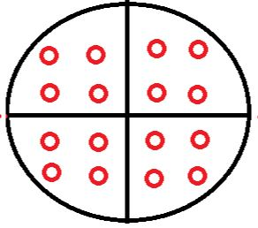
Figure. 1a

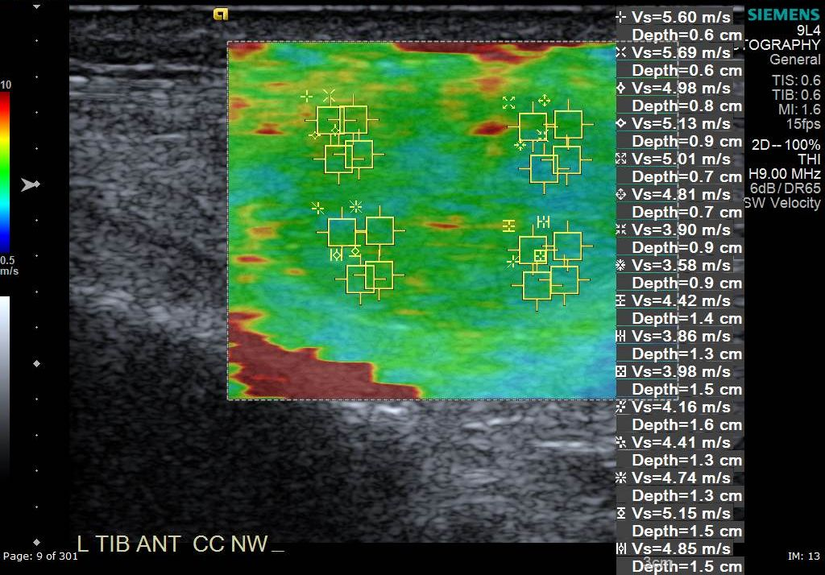
Figure. 1b
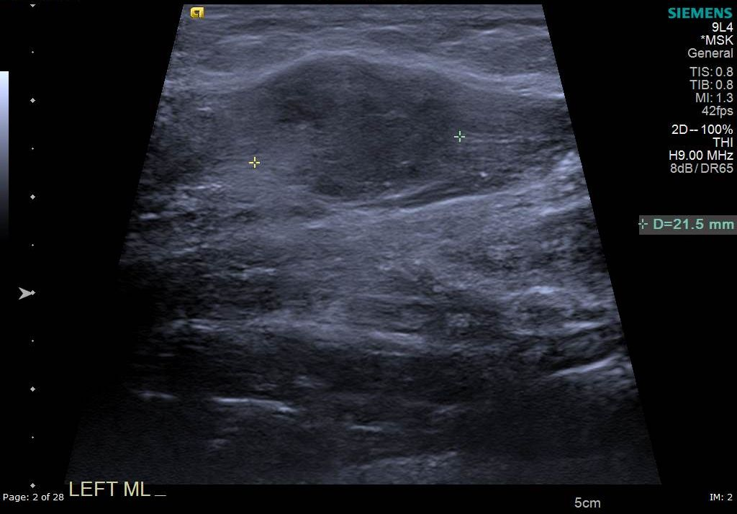
Figure. 2a
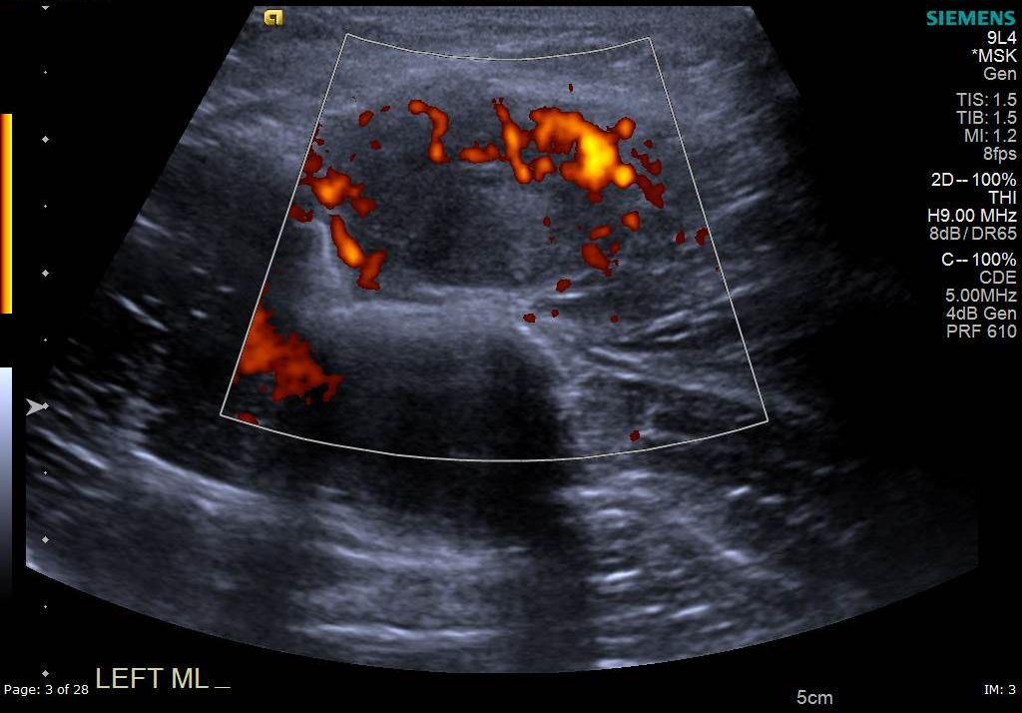
Figure. 2b
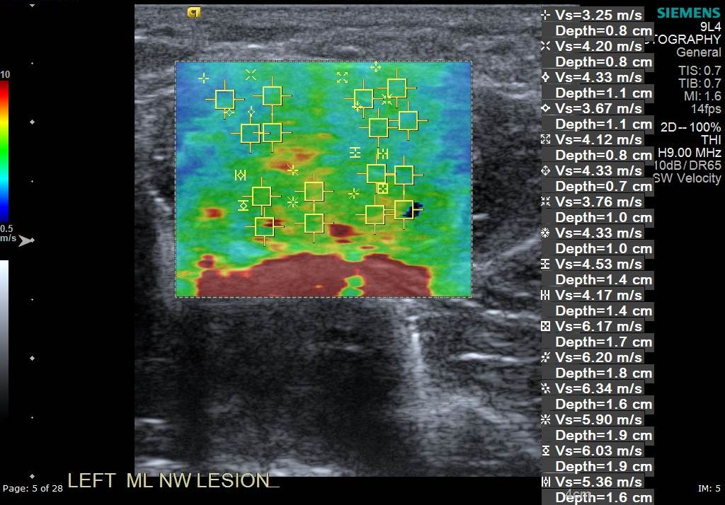
Figure. 2c

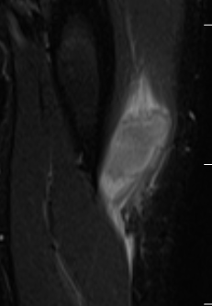
Figure. 2d

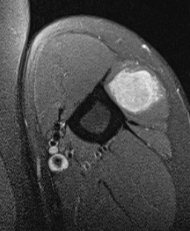
Figure. 2e

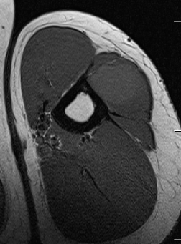
Figure. 2f
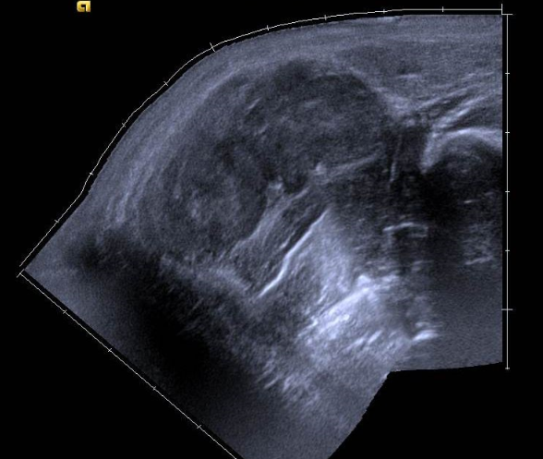
Fig 3a
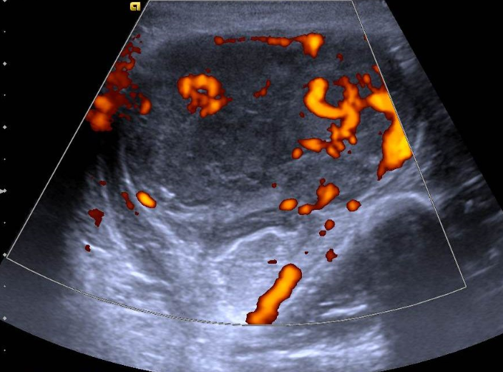
Fig 3b

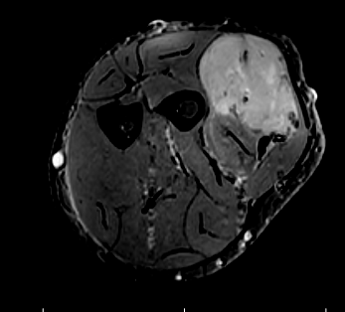
Fig 3c
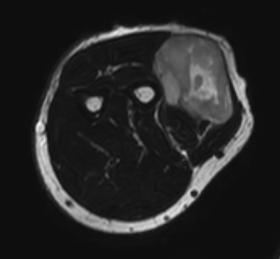
Fig 3d

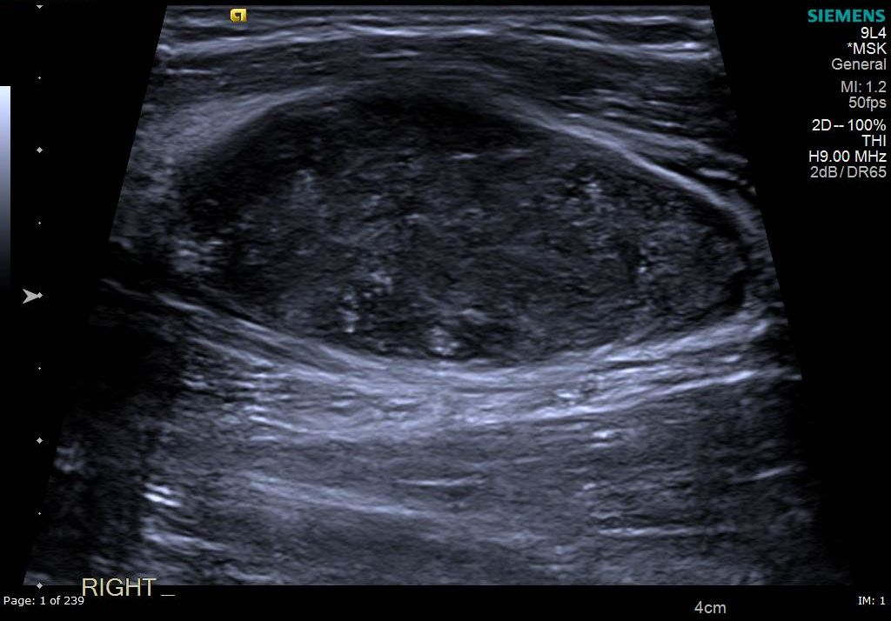
Fig 4

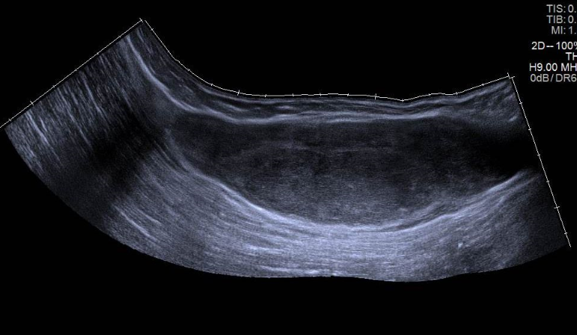
Fig 5

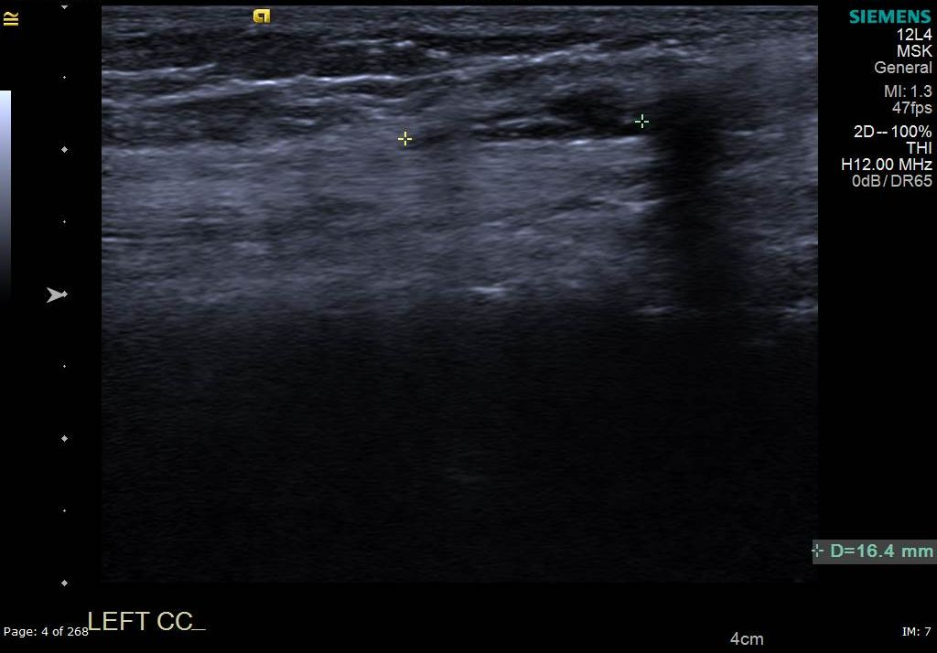
Fig 6a
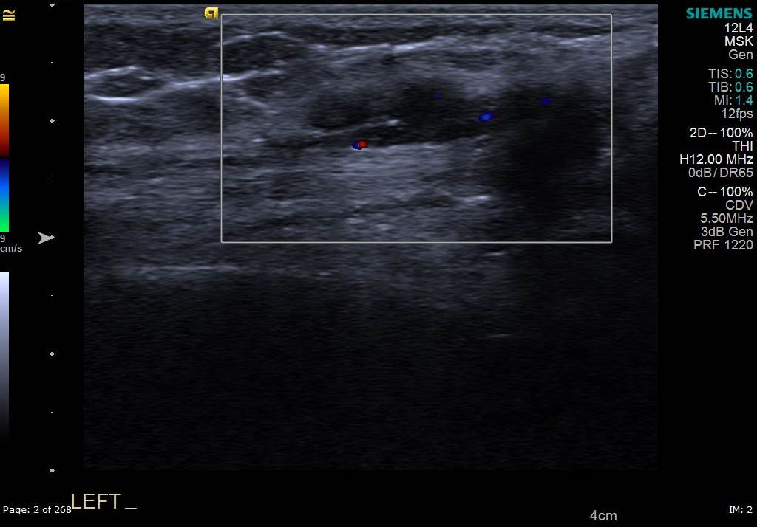
Fig 6b
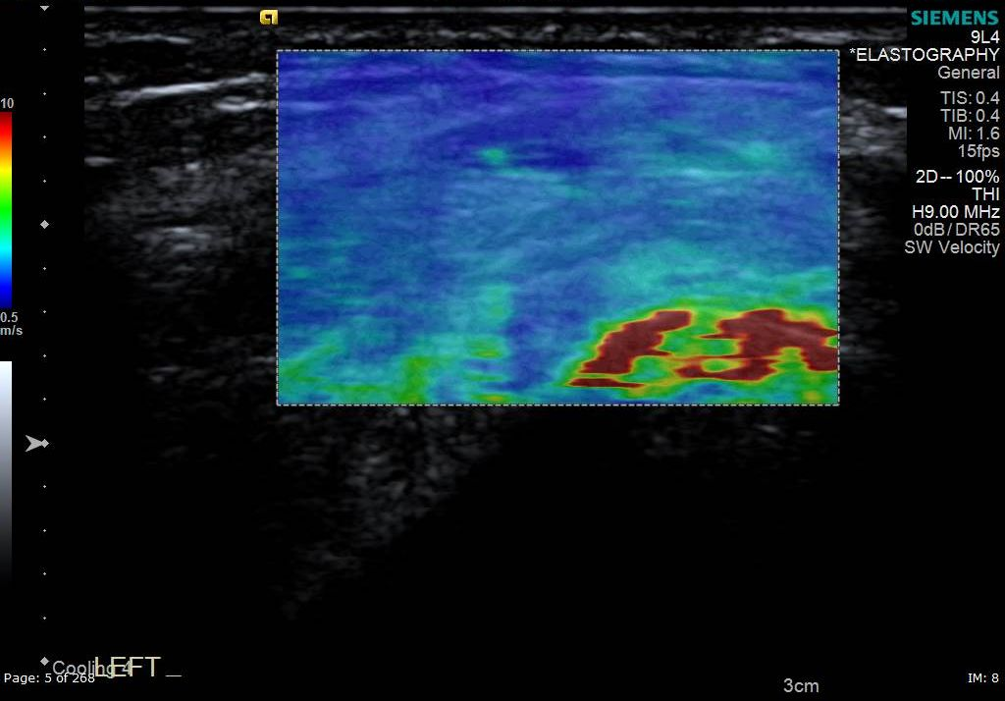
Fig 6c
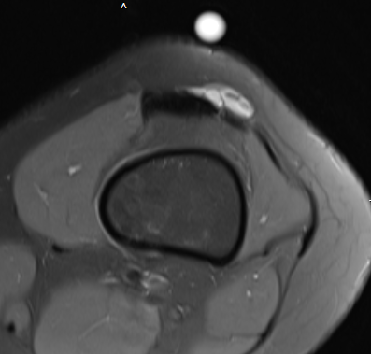
Fig 6d

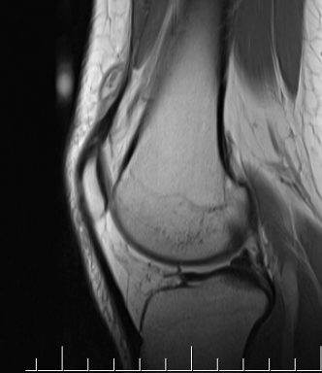
Fig 6e
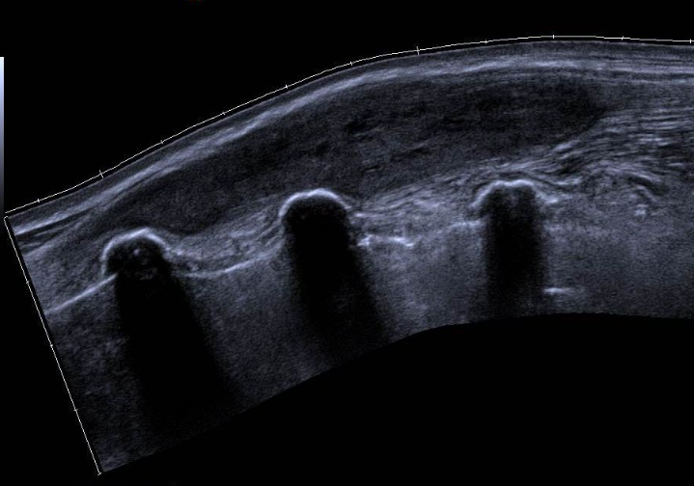
Fig 7a
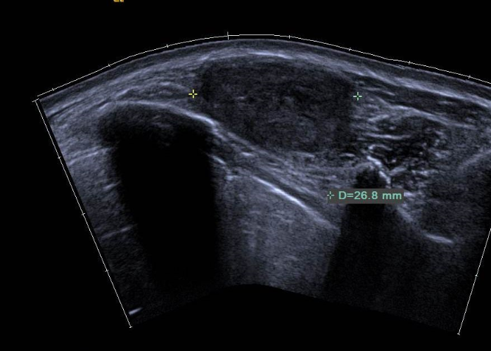
Fig 7b

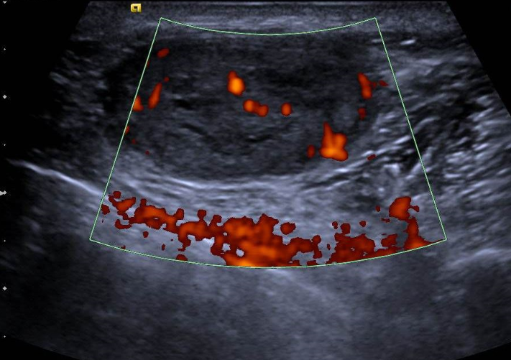
Fig 7c

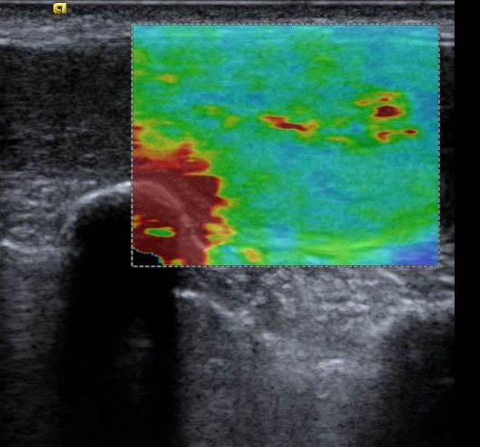
Fig 7d
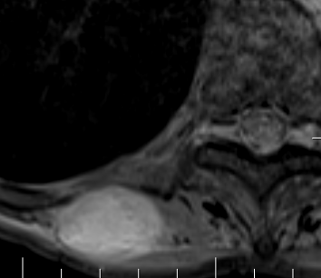
Fig 7e
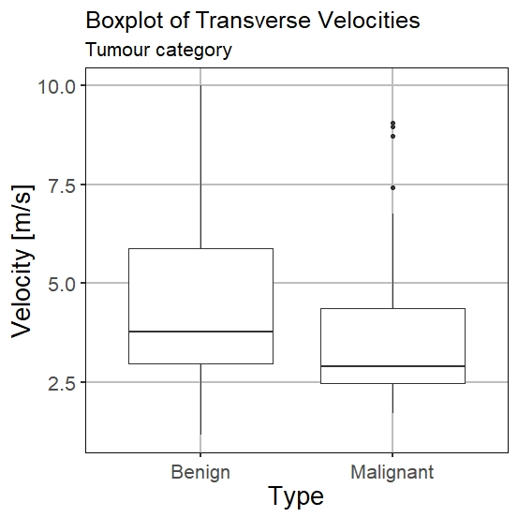
Fig 8

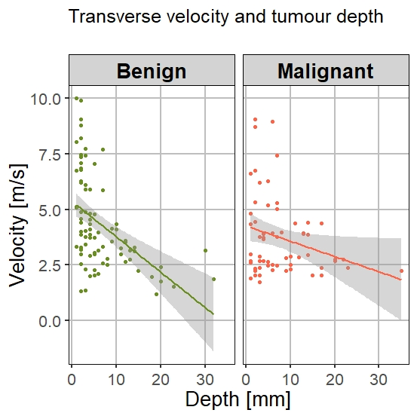
Fig 9

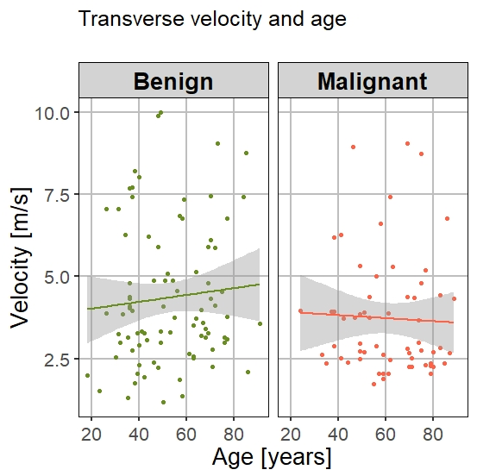
Fig 10

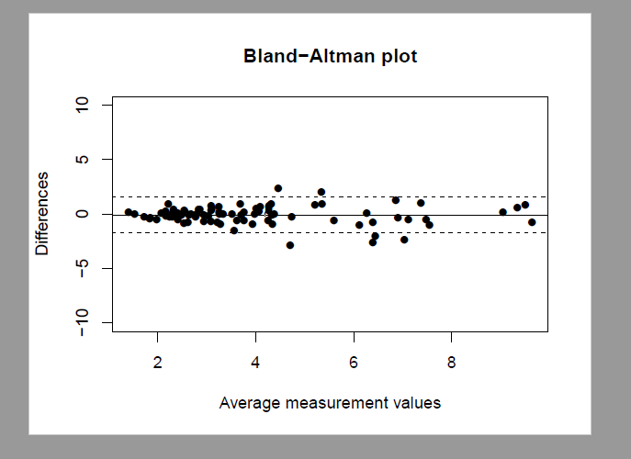
Fig 11

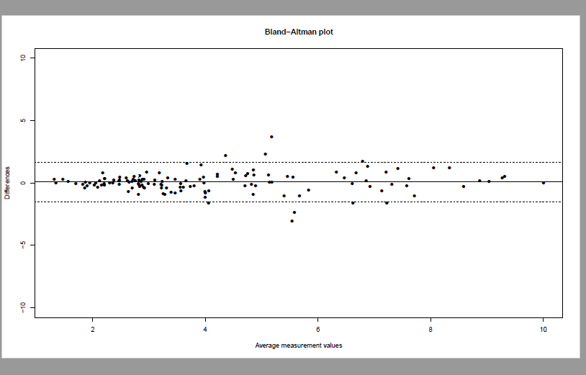
Fig 12
 | All lesions (number) | Sarcoma | Other Malignant (not sarcoma) | Fatty subgroup | Fibrous subgroup
Benign | 87  Schwannoma (13)  Intra-muscular myxoma (9)  Localised tenosynovial giant cell tumour of joint (9)  Haemangioma (7)  Angioleiomyoma (6)  Granulation tissue (5)  Sarcoid (3)  Epidermoid cyst (3)  Giant cell tumour of tendon sheath (2)  Complex ganglion (2)  Neurofibroma (2)  Synovial osteochondromatosis (1)  Myopericytoma (1)  Gout (1)  Reactive lymph node (1)  Abscess (1)  Endometriosis (1) |  |  | 9  Spindle cell lipoma (6)  Hibernoma (2)  Fat necrosis (1) | 11  Fibromatosis (4)  Nodular fasciitis (4)  Benign fibroblastic tumour (3)
Malignant | 61 | 42  Myxofibrosarcoma (12)  Pleiomorphic sarcoma (8)  De-differentiated liposarcoma (4)  Leiomyosarcoma (3)  Synovial sarcoma (3)  Spindle cell sarcoma (3)  Well-differentiated liposarcoma (2)  Pleiomorphic liposarcoma grade 3 (2)  Myxoid liposarcoma (1)  Malignant peripheral nerve sheath tumour (1)  Undifferentiated sarcoma (1)  Soft tissue Ewing’s sarcoma (1)  Extra-skeletal myxoid chondrosarcoma (1) | 19  Metastatic carcinoma (7)  Lymphoma (7)  Malignant melanoma (3)  Merkel cell carcinoma (2) | 9  De-differentiated liposarcoma (4)  Well-differentiated liposarcoma (2)  Pleiomorphic liposarcoma grade 3 (2)  Myxoid liposarcoma (1) | 12  Myxofibrosarcoma grade 1 (6)  Myxofibrosarcoma grade 2 (6)

Table 1

