Chemisorption and Physisorption at the Metal-Organic Interface: Bond Energies of Naphthalene and Azulene on Coinage Metal Surfaces

Stefan R. Kachel,^{⧧a} Benedikt P. Klein,^{⧧a} Juliana M. Morbec,^{b§} Maik Schöniger,ª Mark Hutter,ª Martin Schmid,ª Peter Kratzer,^{b} Bernd Meyer,^{c} Ralf Tonner,ª J. Michael Gottfried*ª

ªFachbereich Chemie, Philipps-Universität Marburg, Hans-Meerwein-Straße 4,
35032 Marburg, Germany
^{b}Fakultät für Physik, Universität Duisburg-Essen, Lotharstraße 1, 47048 Duisburg, Germany
^{c}Interdisciplinary Center for Molecular Materials (ICMM) and Computer-Chemistry-Center (CCC), Friedrich-Alexander-Universität Erlangen-Nürnberg,
Nägelsbachstraße 25, 91052 Erlangen, Germany

Abstract
Organic-inorganic hybrid interfaces play a prominent role in organic (opto)electronics, heterogeneous catalysis, sensors, and other current fields of technology. The performance of the related devices and processes depends critically on the nature and strength of the interfacial interaction. Here, we use the molecular isomers naphthalene and azulene on the Ag(111) and Cu(111) surfaces as model systems that cover different bonding regimes from physisorption to chemisorption. Azulene serves here also as a model for nonalternant molecular electronic materials and for topological 5-7 defects in graphene. The interaction energies are determined from quantitative analysis of temperature-programmed desorption (TPD) data. On both surfaces, azulene (Az) binds more strongly than naphthalene (Nt), with zero-coverage desorption energies (in kJ/mol) of 120 for Az/Ag and 179 for Az/Cu, compared to 103 for Nt/Ag and 114 for Nt/Cu. The integrated experimental energies are compared to adsorption energies from density-functional theory (DFT) calculations, which include van der Waals contributions using four different correction schemes for the PBE functional: (1) DFT-D3 scheme with Becke-Johnson damping, (2) vdW^{surf} correction based on DFT-TS, (3) many-body dispersion correction scheme, and (4) D3^{surf} scheme. Differences in the performance of these methods are discussed. Periodic energy decomposition analysis (pEDA) reveals details of the surface chemical bond and confirms that Az/Cu forms a chemisorptive bond, while the other systems are physisorbed. The variation of the adsorbate-substrate interaction with the topology of the π-electron systems and the type of surface can be employed to modify interface properties in graphene-based and organic electronic devices.

Introduction
Hybrid interfaces between organic and inorganic materials play a prominent role in modern technology and the related fundamental research.¹⁻² These interfaces carry multiple functionalities and possess properties different from those of the adjacent pristine phases.^{1, 3} With the advent of organic (opto)electronics,⁴⁻⁵ interfaces between organic semiconductors (OSCs) and metals have come into focus, because they control charge injection as a crucial performance-determining process at the metal/OSC contacts. However, the fundamental understanding of these interfaces is still lacking, because reliable quantitative investigations are methodologically challenging.
The nature of the metal/organic interaction depends on the electronic structure of the OSC, especially its frontier orbitals, which are typically part of the π-electron system. Within the framework of the Hückel molecular orbital (HMO) theory, the electronic structure of a π-electron system is related to its topology as expressed by the topological matrix, which reflects the connectivity pattern of the atoms within the π-system.⁶⁻⁷ Molecular OSCs usually contain benzenoid aromatic π-systems (i.e., their aromatic backbone consist of hexagonal benzene rings) and thus have alternant (or bipartite⁸) topologies. In contrast, aromatic backbones with nonalternant (or nonbipartite) topologies have only recently gained interest in the context of organic (opto)electronics.⁹ Nonalternant structural elements are also used for the topological design of graphene derivatives.¹⁰
Recently, it has been shown that the strength of the surface chemical bond can depend on the topology of the π-electron system: while naphthalene on Cu(111) is physisorbed, its nonalternant isomer azulene forms a chemisorptive bond.⁷ Even when both azulene and naphthalene are chemisorbed to the more reactive Pt(111) surface, there remains a large difference in the interaction strength.¹¹ The observation that these two closely related molecules–both are bicyclic aromatic hydrocarbons with the same number of carbon and hydrogen atoms–bind so differently to surfaces make them a very interesting model system for quantitative studies of the metal-organic interfacial interaction, both in experiment and theory.
In extension of previous work,^{7, 12} we study here the interaction of both molecules with the (111) surfaces of silver and copper for various coverages in the submonolayer regime. The different systems (and coverages) provide us with a gradational change of the molecule-metal interaction from physisorption to chemisorption. Since both isomers desorb as intact molecules from both surfaces, temperature-programmed desorption (TPD, Figure 1) is the method of choice to assess the strength of the adsorbate-substrate bond. To obtain reliable and reproducible data, a dedicated setup including a Feulner cup cryo shroud for line-of-sight conditions, along with precise temperature calibration and sample positioning¹³ was employed. The resulting data were subjected to extended analysis with several suitable methods.
The different bond strengths of the isomer pair makes it especially suitable for benchmarking current methods for the correction of dispersion interaction within the density-functional theory (DFT) approach. Therefore, we compare here four different correction schemes for the PBE functional: (1) the DFT-D3 scheme¹⁴ with Becke-Johnson damping function,¹⁵⁻¹⁶ (2) the vdW^{surf} correction¹⁷ based on DFT-TS,¹⁸⁻²⁰ (3) a many-body dispersion (MBD) correction scheme,²¹⁻²² and (4) the D3^{surf} scheme.¹²
Our results reveal the critical role of the topology of the conjugated π-electron system in controlling the chemical bond at the metal/organic interface and show that the dispersion correction schemes perform quite differently with respect to the metal-organic bond energies.
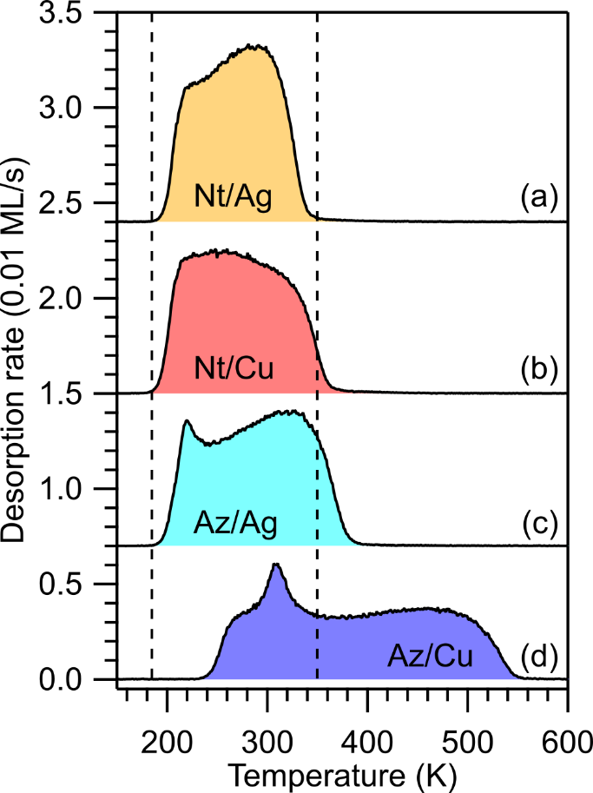
Figure 1. Monolayer TPD traces for (a) naphthalene/Ag(111), (b) naphthalene/Cu(111), (c) azulene/Ag(111), (d) azulene/Cu(111), measured with a heating rate of 1 K/s by mass spectrometric detection of m/z = 128 amu. The vertical dashed lines indicate the desorption range for naphthalene/Ag(111) as a guide to the eye and for comparison with the other systems.

Methods
Experimental Methods. TPD was carried out in a dedicated ultrahigh-vacuum (UHV) apparatus with a base pressure in the low 10⁻¹⁰ mbar regime. The apparatus hosts a HIDEN EPIC 1000 quadrupole mass spectrometer mounted inside a differentially pumped cryo shroud cooled to 80 K with l-N₂. This setup is a variant of line-of-sight mass spectrometry²³ and ensures that molecules impinging on the inner wall of the cryo shroud are permanently adsorbed (or condensed) there, such that the mass spectrometer detects mainly molecules with a straight trajectory from the sample. This leads to improved quality of the TPD traces and is the basis for their quantitative analysis. Temperatures were precisely measured inside the sample using a calibrated type K thermocouple. Azulene (Sigma-Aldrich, purity >99.0%) and naphthalene (Sigma-Aldrich, purity >99.7%) were introduced into the UHV systems through leak valves after repeated freeze-pump-thaw cycles of the reservoirs. Polished Ag(111) and Cu(111) single-crystal surfaces (purity >99.9999%, roughness <0.03 μm, orientation accuracy <0.1°, from MaTecK/Germany) were prepared by iterated sputtering with Ar⁺ (0.5 keV, 5-7 μA, 30 min) and annealing (850 K, 15 min). For each system, monolayer coverage (1 ML) corresponds to the integral of the saturated first-layer desorption trace. For the adjustment of the different (sub)monolayer coverages, partial thermal desorption of an initial excess dosage was used as described in the supporting information (SI), Figure S1. A coverage of 1 ML corresponds to 2.28⋅10¹⁴ molecules/cm², according to previous work.^{7, 12}
Density Functional Theory Calculations. DFT calculations with periodic boundary conditions were performed to compute the adsorption energies of azulene and naphthalene on Ag(111) and Cu(111). We used the generalized gradient approximation (GGA) proposed by Perdew, Burke, and Ernzerhof (PBE)²⁴ for the exchange-correlation functional in combination with four different methods to treat the van der Waals (vdW) interactions: (1) the DFT-D3 scheme¹⁴ with Becke-Johnson damping function,¹⁵⁻¹⁶ (2) the vdW^{surf} correction¹⁷ based on DFT-TS,¹⁸⁻²⁰ (3) a many-body dispersion (MBD) correction scheme,²¹⁻²² and (4) the D3^{surf} scheme.¹²
The DFT-D3 scheme proposed by Grimme et al. uses atomic pairwise contributions to the dispersion interaction energy based on the polarization of the respective atoms in their chemical environment of the system.¹⁴ The energy contributions are based on tabulated C₆ coefficients taking into account the fractional coordination number of the atom under consideration and a damping function for close interatomic distances following a proposal by Becke and Johnson.¹⁵⁻¹⁶
The vdW^{surf} approach¹⁷ includes the collective electronic response of the substrate in the determination of the vdW parameters (C₆ coefficients, polarizabilities and vdW radii) by combining the pairwise Tkatchenko-Scheffler (TS) method¹⁸ with the Lifshitz-Zaremba-Kohn theory.¹⁹⁻²⁰
The MBD method²¹⁻²² accounts for collective vdW effects beyond the pairwise approximation by representing the atomic response functions (within the random phase approximation) by a set of quantum harmonic oscillators interacting via the dipole–dipole interaction potential.
The D3^{surf} scheme is an extension of the original DFT-D3 method proposed by Grimme et al. in which the parameter set of coordination-dependent C₆ coefficients is extended by additional values for Cu and Ag at the higher coordination numbers of the surface and bulk atoms.
Calculations with the DFT-D3 scheme were performed with the Vienna Ab Initio Simulation Package (VASP).²⁵⁻²⁸ The PBE functional,²⁴ the projector-augmented wave (PAW) ansatz²⁹⁻³⁰ for the atomic cores, a plane-wave cutoﬀ energy of 350 eV, and a vacuum layer of 30 Å were used. For all calculations a 24×24×1 Monkhorst-Pack k-point mesh was adjusted to the supercell of a 4-layer slab. The fcc bulk lattice parameters were obtained with the same method and were 4.072 Å for silver and 3.568 Å for copper. The frequency calculations for the thermodynamic corrections were also performed in VASP using a finite differences approach, where only the atoms of the molecule and the first surface layer were allowed to relax. The calculation of the enthalpies follows the literature.³¹
Calculations with the vdW^{surf} and the MBD methods were performed using the FHI-aims code,³² an all-electron code that uses numeric atom-centered orbitals as basis functions. We used “tight-tier2” basis sets for the Ag, Cu and H atoms, and the “tight-tier3” basis set for the C atoms. Convergence criteria of 10⁻⁵ electrons/Å³ and 10⁻⁵ eV were applied for the charge density and the total energy, respectively. Both Cu(111) and Ag(111) surfaces were modeled using a (2√3 × 2√3)-R30º unit cell, with a five-layer slab and a vacuum region of 130 Å. In the geometry optimizations, the molecules and the top two metal layers were allowed to relax while the remaining bottom layers were constrained to their bulk positions; a force convergence criterion of 10⁻² eV/Å was applied for structural relaxations. We used a 4×4×1 Monkhorst-Pack k-point mesh to sample the Brillouin zone. The fcc bulk lattice parameters were obtained with vdW^{surf} were also used for the MBD calculations and were 4.014 Å for silver and 3.601 Å for copper. The vibrational frequencies for the calculation of the zero point energies and thermodynamic corrections were computed using the PHONOPY package³³ in conjunction with the FHI-aims code.
The D3^{surf} calculations were performed with the PWscf code of the Quantum Espresso software package.³⁴ As in the D3 calculations we use the PBE functional²⁴ and the Becke-Johnson damping function within the dispersion correction scheme.¹⁵⁻¹⁶ Atomic cores were represented by Vanderbilt ultrasoft pseudopotentials³⁵ and the wave functions were expanded in a plane wave basis with cutoff energy of 30 Ry. With this setup and the D3^{surf} dispersion correction scheme, we obtain fcc bulk lattice constants for silver and copper of 4.101 Å and 3.606 Å, respectively. Surfaces were represented by periodically repeated slabs with a thickness of 5 atomic layers and a (2√3 × 2√3)-R30º surface unit cell. The optimized bulk lattice constants were used for the lateral dimensions of the slabs. In the structure optimization the force convergence criterion was set to 0.003 eV/Å. Only the upper three surface layers and the adsorbate were allowed to relax, while the bottom two layers were kept frozen at their bulk positions. k-point sampling was done with a Γ-centered 7×7×1 Monkhorst-Pack mesh. Further details can be found in Tables S5 and S6 in the supporting information (SI).
The energy decomposition analysis using periodic boundary conditions (pEDA) was performed using the PBE functional²⁴ and the DFT-D3 dispersion correction scheme,¹⁴ a TZ2P basis set³⁶ and considering relativistic effects with the zeroth order regular approximation (ZORA),³⁷ with the pEDA as implemented in the ADF-BAND package 2017.³⁸⁻⁴⁰ The optimized (2√3 × 2√3)-R30º structures were taken from the PBE-D3 calculations in VASP. In ADF-BAND a 7×7 k-grid and 2-dimensional periodic boundary conditions were used. The integration accuracy of the used Becke-grid was set to quality “normal”.⁴¹ The charge transfer was derived via Bader’s atoms-in-molecules (AIM) scheme and was calculated in ADF-BAND 2017. The same values were already reported in previous work.^{7, 12}
The pEDA method allows to decompose the bond energy into several physically well-defined terms, thus permitting a more detailed interpretation of the character of the chemical bond between two fragments.⁴² In our case, the fragments are chosen to be the molecule and the surface in their respective singlet electronic states. The convergence of the pEDA values with the k-space sampling density is non-trivial for metal surfaces³⁸ and has been checked thoroughly, as explained in detail in Tables S7 and S8 in the SI. Further details for all DFT calculations can be found in the SI. A comparison of the calculation parameters of all employed DFT methods can be found in Table S9.

Results and Discussion
TPD Coverage Series. TPD traces of all four systems at complete monolayer coverage are compared in Figure 1. Depending on the pairing of adsorbate (azulene, naphthalene) and substrate (Ag(111), Cu(111)), desorption occurs over different temperature ranges. Naphthalene on Ag(111) has the narrowest desorption range from 190 K to 350 K, whereas azulene on Cu(111) has the widest range from 240 K to 550 K. The temperatures, at which desorption is complete, also vary considerably. On both surfaces, azulene requires a higher temperature for complete desorption than naphthalene (550 K vs. 370 K on Cu(111); 400 K vs. 350 K on Ag(111)), suggesting that the nonalternant isomer binds more strongly to both metal surfaces.
To gain further insight into the coverage dependence of the desorption rate and to acquire data for the quantitative analysis, desorption traces for different initial coverages Θ₀ were measured, as shown in Figures 2 and 3. All systems experience substantial peak broadening towards lower temperatures with increasing Θ₀. This effect is frequently observed in TPD curves of organic molecules and can be attributed to coverage-dependent lateral repulsion between surface dipoles.⁴³ The vertical dipoles mainly arise from the "pillow", "cushion" or Pauli push-back effect, which describes the redistribution of electron density near the surface due to the Pauli repulsion with the electrons in the molecule.^{12, 44-45} Additional dipole contributions may result from electron transfer between the molecules and the surface⁴⁶ or deformation of the molecule in the case of chemisorption.
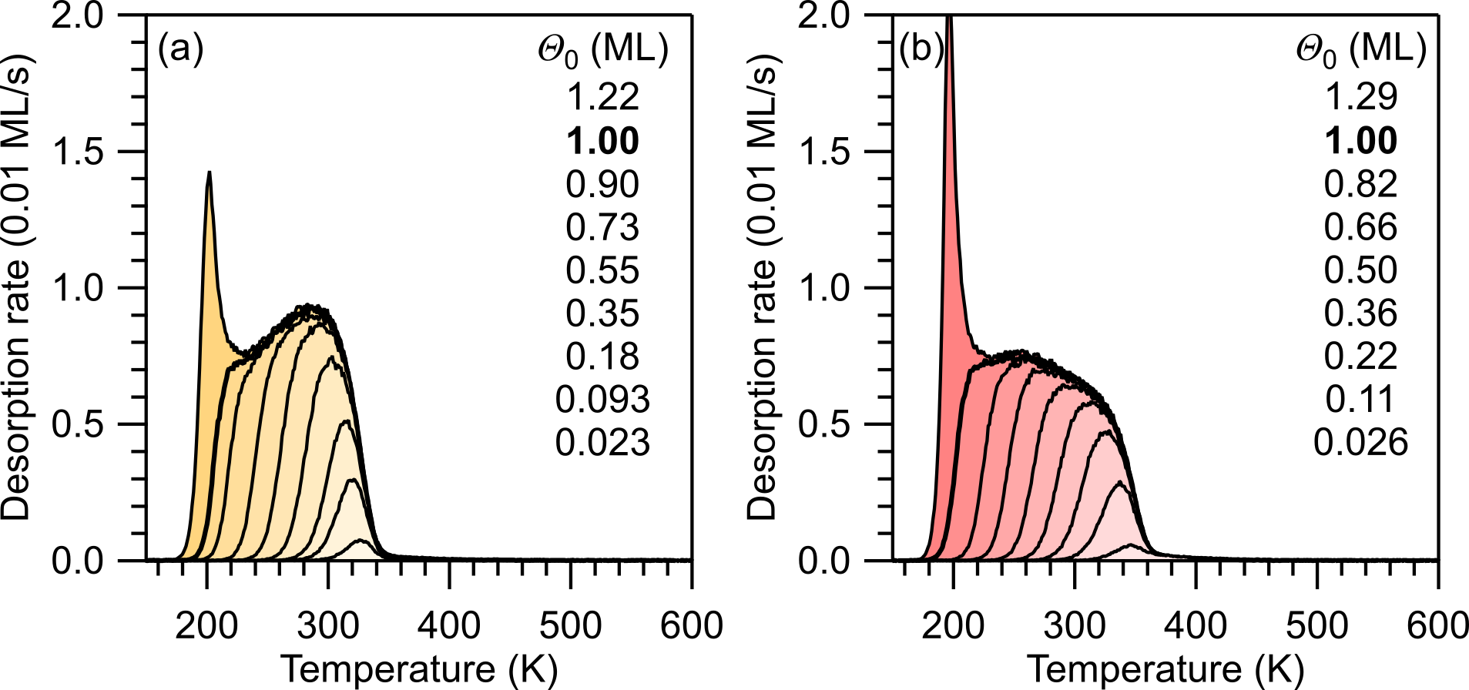
Figure 2. Series of TPD traces for different initial coverages Θ₀ of naphthalene on (a) Ag(111) and (b) Cu(111). Initial coverages listed in the graphs from top to bottom correspond to the TPD traces from left to right. The monolayer spectra (1.00 ML) are indicated by bold lines. The measurements were performed with a heating rate of 1 K/s by mass spectrometric detection of m/z = 128 amu.

The TPD traces of azulene on Cu(111) in Figure 3b show a peak around 300 K, which appears at initial coverages between 0.7 and 0.9 ML. This peak is attributed to desorption from a compressed, incommensurate submonolayer azulene phase, which was previously observed by nc-AFM.⁷ Less pronounced, this decompression peak also occurs for azulene/Ag(111) around 220 K, but it is absent from the spectra of naphthalene. Apparently, the occurrence of the decompression peak correlates with the strength of the adsorbate-substrate interaction. Above monolayer coverage, second- and multilayer desorption peaks occur, which are not displayed.
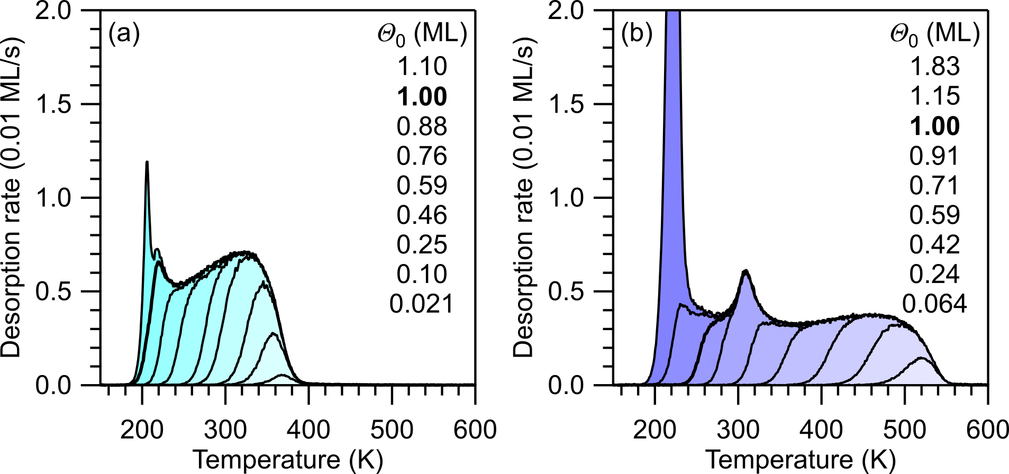
Figure 3. Series of TPD traces for different initial coverages Θ₀ of azulene on (a) Ag(111) and (b) Cu(111). Initial coverages listed in the graphs from top to bottom correspond to the TPD traces from left to right. The monolayer spectra (1.00 ML) are marked by bold lines. The measurements were performed with a heating rate of 1 K/s by mass spectrometric detection of m/z = 128 amu.
Quantitative Analysis of the TPD Data. The desorption activation energy E_{d} as a measure of the adsorbate-substrate bond energy is obtained by quantitative analysis of the TPD data using the Polanyi-Wigner rate equation:⁴⁷⁻⁴⁹
(1)
Here, r_{d} is the desorption rate, Θ is the coverage, ν_{d} is the pre-exponential factor for desorption (prefactor), T is the temperature, and R is the universal gas constant.
If the adsorption is nonactivated for all Θ, E_{d} can be equated in good approximation to the negative differential adsorption energy.⁵⁰ For comparison with DFT calculations, which provide integral adsorption energies, the experimental energies must be integrated:
(2)
The so-called "complete" methods for TPD analysis⁵⁰⁻⁵¹ are not suitable here because of the strong lateral repulsion.⁴⁹ Instead, we use alternative and, in combination, similarly effective methods. A straight-forward approach that provides the coverage-dependent desorption activation energy E_{d}(Θ) from a single TPD trace was first proposed by Nieskens et al. and is based on rewriting Equation 1 as follows:^{49, 52}
(3)
It should be noted that Equation 3 is strictly only applicable when the prefactor is independent of the coverage, which is not necessarily the case.⁵³⁻⁵⁴ In practice, moderate changes have a small effect on the estimate of E_{d}. Even if the prefactor varies by as much as one order of magnitude over the coverage range, E_{d} changes by only a few percent.⁴⁹ In addition to this analysis, we employ here heating-rate variation analysis,⁵⁵ a direct fitting procedure of the TPD data, and a modified leading-edge analysis method that provides coverage-dependent prefactors.⁵⁶⁻⁵⁷
Desorption prefactors. The prefactors required for application in Equation 3 were determined by heating-rate variation (HRV) analysis according to:⁴⁷
(4)
In this equation β is the heating rate and is defined as dT/dt. This method can be used in the low-coverage range, where the peaks have a regular first-order shape, because the broadening due to intermolecular repulsion is small. A representative data set for azulene on Ag(111) is shown in Figure 4; the data for the other adsorbate systems are shown in the SI, Figures S2-S5. The obtained experimental prefactors are shown in Table 1 (mean values) and Table S1 in the SI (individual values). The prefactors are highest for azulene on Cu(111) and lowest for naphthalene on both surfaces. A higher prefactor can indicate a reduced mobility of the precursor to desorption due to a more localized surface chemical bond.⁵⁸⁻⁵⁹ Equation 4 shows that the HRV analysis also provides the desorption energies E_{d}, which will be discussed later.
In the literature, analysis of TPD data is frequently performed with estimated, not measured, prefactors ν_{d}. For a rough estimate of the desorption energy from a single desorption maximum, the prefactor is usually assumed to be 1⋅10¹³ s⁻¹, which can be reasonably accurate for atoms or diatomic molecules.⁶⁰ However, much higher prefactors have been reported for the desorption of larger molecules.⁶¹⁻⁶² In such cases, estimates on the basis of transition state theory (TST) are more reasonable.⁶²⁻⁶⁴
As shown in detail in the SI, we have used TST to calculate prefactors for two limiting cases of the translational and rotational degrees of freedom (DOF) of the adsorbate (Table S2). In the mobile limit, the adsorbed molecule possesses two translational DOF parallel to the surface and one rotational DOF around an axis perpendicular to the molecular plane, which is assumed to be parallel to the surface. In the immobile limit, the adsorbed molecule has no rotational or translational DOF. At the desorption temperature and especially in the low-coverage regime, the mobile limit is more realistic. The resulting TST prefactors are shown in Table 1.
Table 1. Desorption prefactors (in s⁻¹) for the (sub)monolayer and multilayer regimes.¹
 | Az/Cu(111) | Az/Ag(111) | Nt/Cu(111) | Nt/Ag(111)
Expt. (HRV) | 3.2⋅10¹⁶ | 1.5⋅10¹⁶ | 1.7⋅10¹⁴ | 3.4⋅10¹⁵
TST ν_{d,mobile} | 3.2⋅10¹⁶ | 1.6⋅10¹⁶ | 1.3⋅10¹⁶ | 1.2⋅10¹⁶
TST ν_{d,im} | 6.1⋅10²² | 1.8⋅10²² | 7.1⋅10²¹ | 5.8⋅10²¹
Entropy ν_{d} | 1.3⋅10¹⁸ | 1.0⋅10¹⁷ | 7.5⋅10¹⁶ | 5.4⋅10¹⁶
Multilayer ν_{d} | 1.6⋅10¹⁸ |  | 3.2⋅10¹⁷
¹(Sub)monolayer prefactors from the experiment (HRV mean values, for detailed data see Table S1 in the SI), from TST in the mobile and immobile limit, and from entropy considerations. Multilayer prefactors from the Clausius-Clapeyron equation (see Tables S2-S4 in the SI).
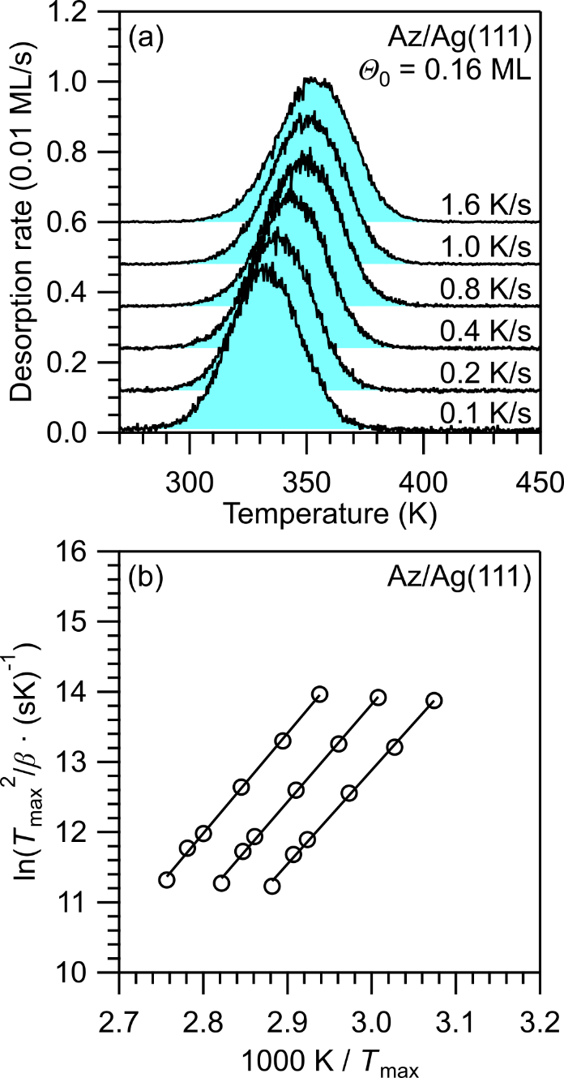
Figure 4. (a) Heating-rate variation (HRV) series for azulene (Az) on Ag(111) for heating rates from 0.1 to 1.6 K/s and an initial coverage of 0.16 ML. (b) Analysis of the HRV series for coverages of 0.08, 0.16 and 0.28 ML according to Equation 4, yields desorption activation energies and pre-exponential factors. Corresponding data for the other systems can be found in the SI.

Another approach, which is also based on the TST, uses the activation entropy of the desorption process to calculate the prefactor.^{54, 65} The entropy in the transition state is approximated by the gas phase entropy minus the entropy of the one-dimensional translation perpendicular to the surface.⁶⁵ This is equivalent to the mobile limit considered above. The adsorbate entropy can be estimated from the gas-phase entropy by a relation that was originally proposed for alkanes, but was later successfully applied to larger aromatic molecules such as coronene.⁵⁴ The detailed calculations are presented in the SI, Table S3. As expected, the resulting prefactors (Table 1) are similar to those obtained with TST in the mobile limit. Prefactors for multilayer desorption were estimated by another method based on the Clausius-Clapeyron equation (see Table 1 and the SI (Table S4) for the details of the calculation). Note that the limitations inherent in TST in the calculations of prefactors cannot be overcome by using normal modes frequencies calculated by DFT; thus DFT turns out not helpful in determining reliable prefactors.⁶⁵⁻⁶⁶
Desorption energies. Inverted Polanyi-Wigner Equation (IPW). The inverted Polanyi-Wigner equation (IPW) (Equation 3) provides coverage-dependent differential desorption energies from a single TPD trace. Here, we used the monolayer TPD traces of all four systems and employed the average experimental prefactors obtained by HRV as well as the TST prefactors (Table 1). The energies obtained by IPW analysis are presented in Figure 5 (solid lines). Since HRV and TST deliver almost identical prefactors for azulene, only one energy curve is shown, while for naphthalene, two separate energy curves are shown corresponding to the HRV and TST prefactors. On both surfaces, azulene shows higher desorption energies than naphthalene over the whole coverage range up to one monolayer. The desorption energies of azulene also drop faster with increasing coverage, indicating stronger intermolecular repulsion. These differences between the two isomers are especially pronounced on Cu(111).
The coverage dependencies of the differential desorption energies E_{d} based on the HRV prefactors are well described by the following second-order polynomial fits (in kJ/mol, Θ in ML): azulene/Cu: 179 – 65Θ – 39Θ², azulene/Ag: 120 – 27Θ – 25Θ², and naphthalene/Ag: 103 – 18Θ – 19Θ². (The case naphthalene/Cu will be discussed separately below.) These polynomial fits are shown as black dashed lines in Figure 5. This figure also shows the energies obtained from the HRV analysis as open circles in the low-coverage range. The agreement with the IPW results is very good. For later comparison with the integral adsorption energies calculated by DFT, the integral desorption energies are needed. They were obtained by integration (Equation 2) of the corresponding IPW curves and are included as colored dashed lines in Figure 5.
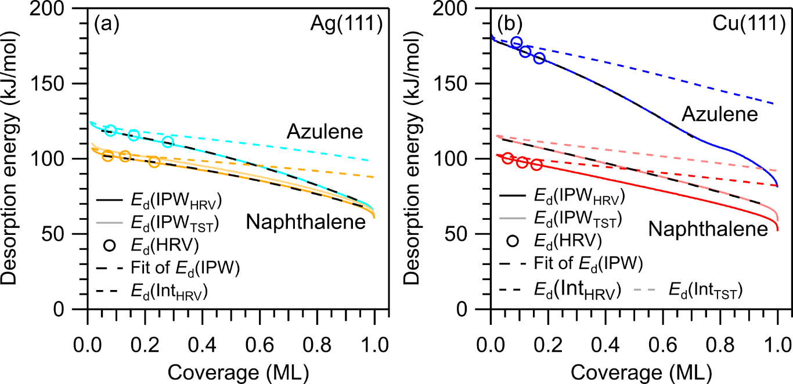
Figure 5. Desorption activation energies as a function of coverage for azulene (cyan and blue) and naphthalene (orange and red) on (a) Ag(111) and (b) Cu(111). Solid lines: differential desorption energies (opaque: ν_{d}(HRV), pale: ν_{d}(TST)); colored dashed lines: integral energies (for comparison with DFT calculations); black dashed lines: fits of the differential desorption energies with the fits in the text; circles: desorption energies from HRV.

For naphthalene, the DFT methods discussed below predict a stronger bonding to Cu(111) than to Ag(111), contrary to the experimental energies based on the HRV prefactors. This disagreement requires special consideration and critical discussion of the desorption prefactors used in the analysis. As can be seen in Table 1, naphthalene on Cu(111) is the only system with a very substantial deviation between the experimental prefactor (from HRV) and the TST prefactor for the mobile limit. Interestingly, the experimental HRV prefactor (1.7⋅10¹⁴ s⁻¹) is here almost two orders of magnitude lower than its theoretical TST counterpart (1.3⋅10¹⁶ s⁻¹). This is a rather unusual finding, because the prefactor in the mobile limit represents the smallest possible prefactor (within the framework of TST). Using the TST prefactor instead of the HRV prefactor for the IPW analysis results in substantially higher energies, which are well described by the second-order polynomial 114 – 40Θ – 7Θ² (in kJ/mol, Θ in ML, see also Figure 5b). Later, we will show that the TST prefactor agrees better with that obtained from a modified leading-edge analysis methods. Therefore, we will use the TST prefactor for naphthalene on Cu(111) in the following.

Fit of the TPD Traces. Using the IPW method, we found that the coverage dependence of the desorption energy is well described by a second-order polynomial. However, this method uses only one TPD trace for the analysis (here, the trace corresponding to monolayer coverage). To use the full data sets shown in Figures 2 and 3, the TPD data were fitted using the Polanyi-Wigner equation (Equation 1) with a second-order polynomial for the desorption energy, E_{d} = a – bΘ – cΘ². The prefactors obtained from the HRV analysis were used, except for naphthalene on Cu(111), for which the TST prefactor was used (see above). The computed TPD traces are shown in Figure 6 along with the experimental TPD data. The desorption energies obtained by the fit are in excellent agreement with the results from the IPW analysis, especially for coverages below 0.6 ML, as can be seen in the direct comparison in Figure 7.
The simulated TPD traces in Figure 6 show good agreement with the experimental data in the leading-edge range, especially at higher coverages. However, the high-temperature (low-coverage) sides of the peaks are broader in reality than in the fits. This can be attributed to the presence of defect sites, which lead to higher desorption temperatures at very low coverages, but are not considered in the fits.
Note that second-order polynomials a – bΘ – cΘ² have been used in previous work to describe the coverage dependence of adsorption energies.^{62, 67-68} The constant a is the desorption energy at zero coverage, while b is qualitatively related to the intermolecular repulsion, which depends linearly on the coverage. The constant c is related to relaxation, which occurs when the molecules move away from their preferred adsorption sites to lower the repulsion.^{62, 67-69}
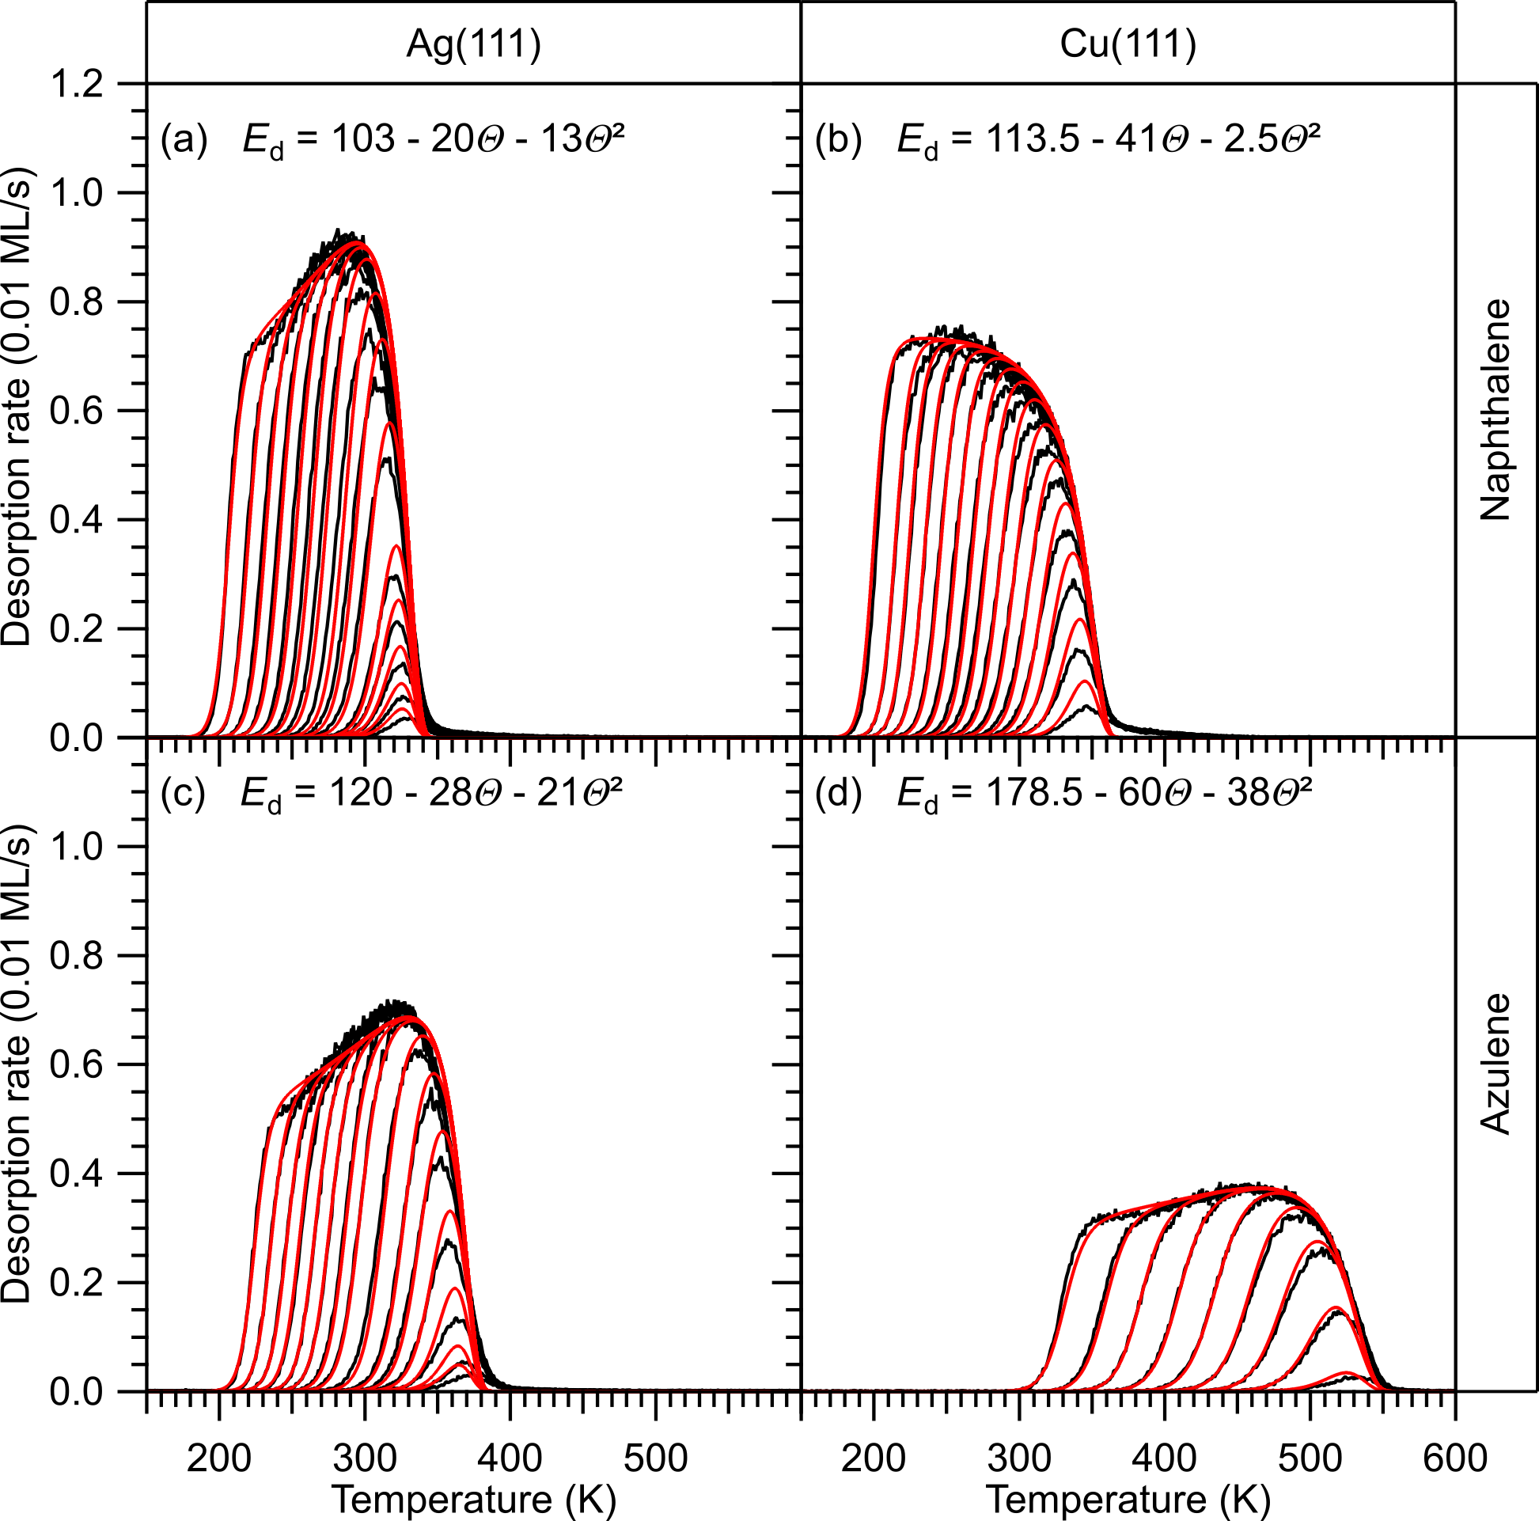
Figure 6. TPD coverage series of (a, b) naphthalene and (c, d) azulene on (a, c) Ag(111) and (b, d) Cu(111) (black lines) and simulated TPD traces (red lines) using a quadratic function for the desorption energy (shown in the graphs, in kJ/mol). Constant prefactors as obtained by the HRV were used, except for naphthalene on Cu(111), where the TST prefactor was used (see Table 1). Coverage ranges: (a) 0.03–1.0 ML, (b) 0.01–1.0 ML, (c) 0.01–0.88 ML, (d) 0.01–0.68 ML.
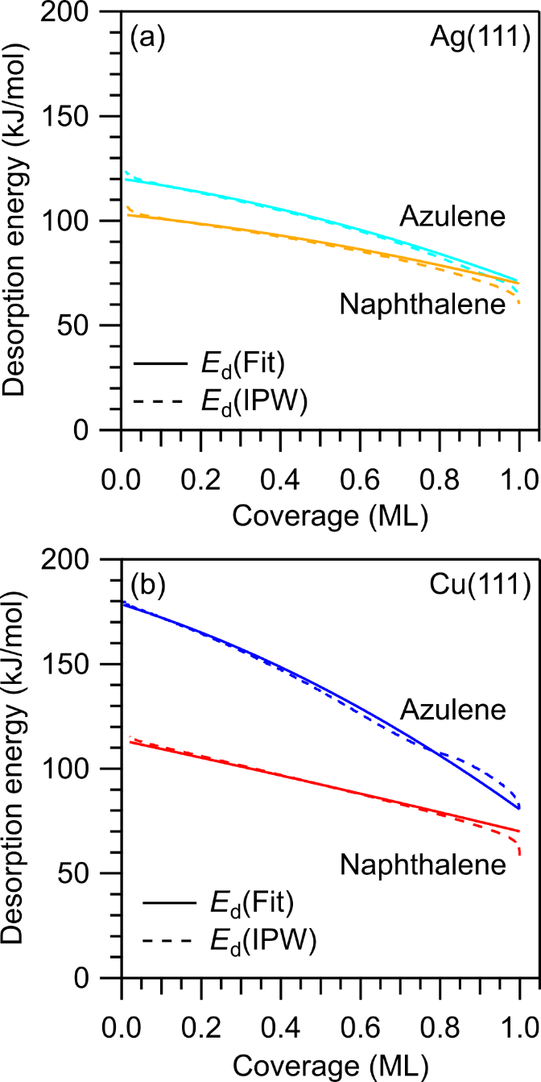
Figure 7. Desorption activation energies as functions of coverage for azulene (cyan, blue) and naphthalene (orange, red) on (a) Ag(111) and (b) Cu(111). Solid lines: desorption energies obtained by fitting of the TPD spectra according to Figure 6; dashed lines: desorption energies obtained by IPW for comparison. The energies are based on the TST prefactor for naphthalene on Cu(111) and the HRV prefactors otherwise.

Leading-Edge Analysis for Coverage-Dependent Prefactors (LNR). The analysis above is based on the assumption of coverage-independent prefactors. In the following, we will use a modified leading-edge analysis (LEA) to obtain coverage-dependent prefactors and thus more reliable coverage-dependent energies. In the original work by Habenschaden and Küppers,⁵⁶ the analysis uses only a small section at the low-temperature side of each TPD trace. For this section, ln r_{d} is plotted vs. 1/T. According to Equation 1, rearranged to
(5)
this procedure should result in a straight line with the slope -E_{d}/R and an intercept that depends on ν_{d}. This only holds true if the relative coverage change is negligible, i.e., if the term n⋅ln Θ is approximately constant in the the analyzed section. A clear disadvantage of the original LEA lies in the low signal/noise (S/N) ratio in the low-rate range used for the analysis. Extension of the analyzed region to the range of higher rates improves the S/N ratio, but introduces more errors due to the neglected temperature dependence of the coverage.
A complementary approach was suggested by Parker et al.⁵⁷ According to Equation 1, rearranged to
, (6)
plotting a single TPD trace as ln (r_{d}/Θ^{n}) vs. 1/T results in a straight line if the correct value for the desorption order n is chosen. The slope and the intercept of this line provide E_{d} and ν_{n}, respectively. A disadvantage is that these values are only mean values averaged over the whole coverage range of the TPD trace. In the case of strong coverage dependence of E_{d} and ν_{n}, not even a straight line is obtained. As an advantage, the statistical errors are much lower than in the case of LEA, because the entire TPD trace is used.
To combine the advantages of both approaches while avoiding their disadvantages, we explicitly take the coverage dependence of Θ into account using Equation 6, but consider a reasonably small part of the leading edge. In this way, we avoid errors from neglecting the temperature dependence of Θ, while achieving a good balance between statistics and coverage resolution. In practice, coverage variations between 0.2 and 4% (absolute up to 0.006 ML) were allowed. If the four lowest initial coverages are excluded, the allowed coverage variations are even smaller and in the range of 0.2-1%.
The results of this analysis (short: LNR) are shown in Figure 8 (triangles) along with the results from IPW (dashed line) and HRV (circles). All methods show remarkably good agreement up to 0.7 ML for naphthalene and 0.5 ML for azulene. These coverage ranges coincide for the most part with those for which theoretical adsorption energies calculated by DFT are available (ranges illustrated by grey arrows in Figure 8). At higher coverages, the LNR energies exceed the IPW energies and the desorption prefactors increase. Increased prefactors can generally be attributed to the reduced lateral mobility of the desorption precursor at high coverages.
The most pronounced deviations between IPW and LNR energies in the high-coverage range are found for azulene on Cu(111). For this system, the LNR energy decreases up to 0.6 ML. In the range from 0.6 to 0.8 ML, the energy remains nearly constant (Figure 8c), while the prefactor increases and reaches almost 10²¹ s⁻¹ (Figure 8d). This value is in agreement with that for the immobile limit of the TST (Table 1) and thus agrees with a densely-packed adsorbate structure. A corresponding compressed incommensurate phase has previously been observed by nc-AFM.⁷ The same effect, but less pronounced, is also visible for the other systems. The steeply increasing prefactor for azulene on copper seems also related to the appearance of the additional peak in the monolayer spectrum above 0.7 ML.
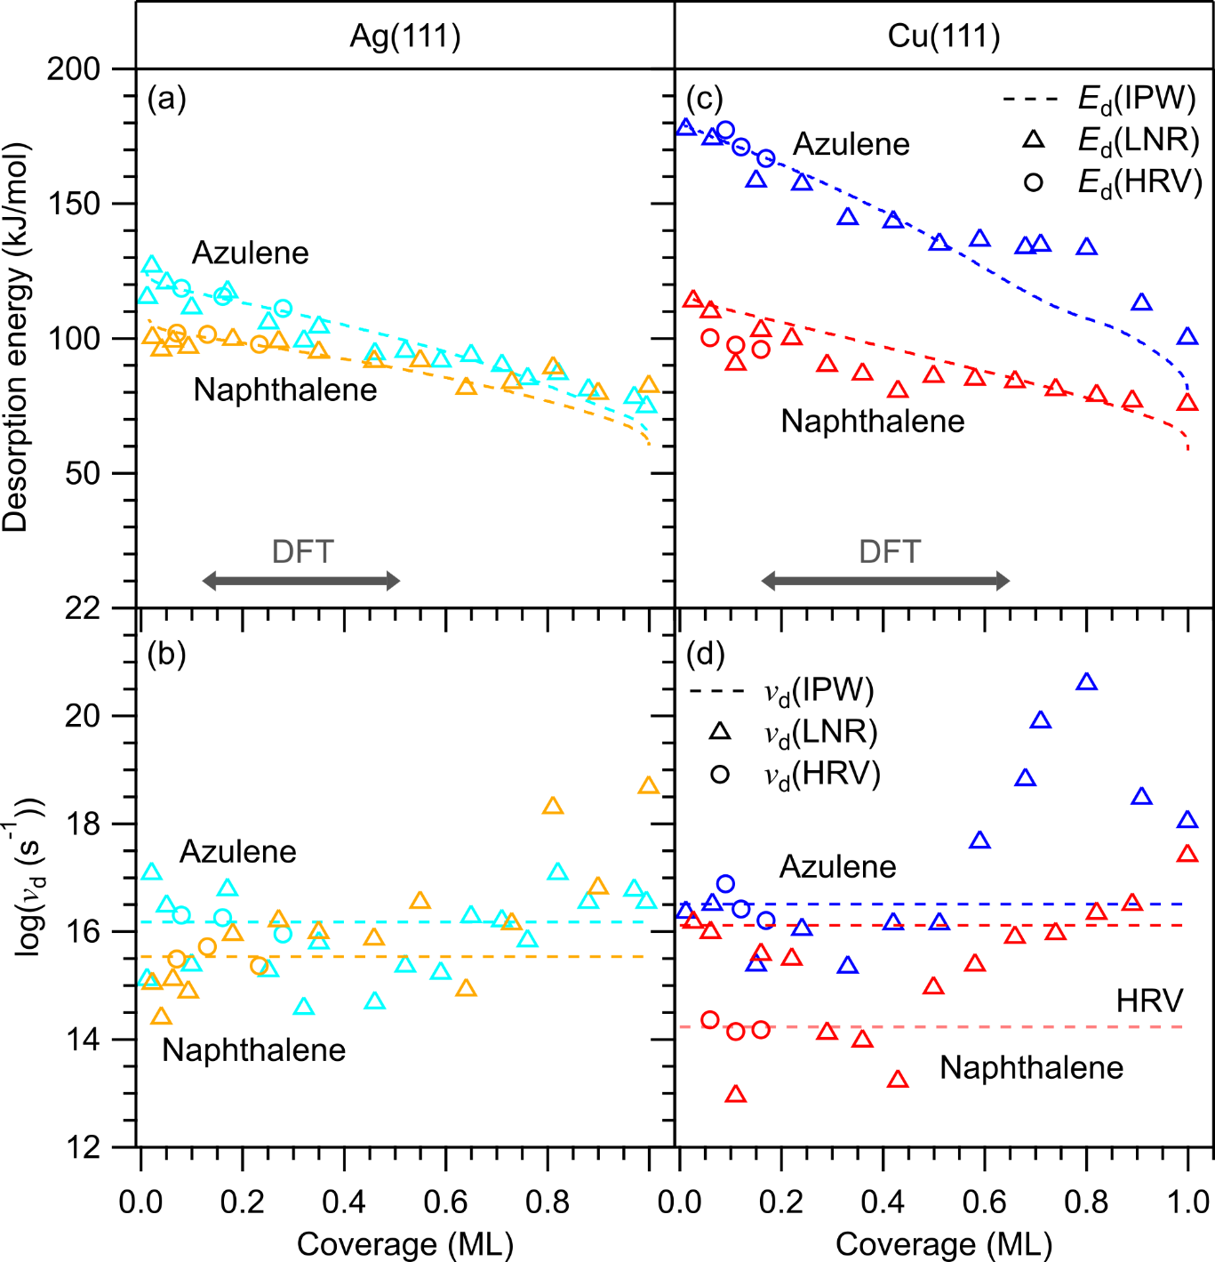
Figure 8. Coverage-dependent desorption energies and prefactors obtained by the modified leading-edge analysis (LNR). (a, c) Desorption energies E_{d} and (b, d) prefactors ν_{d} for azulene (cyan and blue triangles) and naphthalene (orange and red triangles) on (a, b) Ag(111) and (c, d) Cu(111). Results of HRV (circles) and IPW (dashed lines) are shown for comparison. IPW energies with HRV prefactor, for naphthalene on Cu(111) with TST prefactor. The HRV prefactor for naphthalene is indicated as faint dashed line. The dark grey arrows indicate the coverage ranges for which DFT calculations were performed (Ag: 0.12–0.51 ML; Cu: 0.16–0.65 ML).

For naphthalene on Cu(111), note that the IPW energy curve based on the TST prefactor (see Figure 5b and related discussion of the prefactors) is in good agreement with the LNR values in the low-coverage range up to 0.25 ML, while the HRV energies are too low (Figure 8c). In addition, the prefactors from the LNR analysis in this coverage range are substantially higher than the HRV prefactor and closer to the TST prefactor for the mobile limit. This retrospectively justifies our choice of the TST prefactor in the IPW and TPD-fit analysis above. Apparently, the HRV analysis does not provide a reliable value for naphthalene on Cu(111). The reason for this apparent failure of the HRV analysis for this system is unclear, but the case shows that a critical consideration of the desorption prefactors and the application of several independent analysis methods is indispensable for obtaining reliable desorption energies from TPD experiments.

DFT Calculations. We will now compare the experimental energies with theoretical adsorption energies obtained from DFT calculations. Since DFT provides integral adsorption energies, here denoted as E_{ads}, while the energies derived from the TPD data are differential desorption energies E_{d}, it is necessary to integrate the latter using Equation 2 up to the coverage used in the DFT calculation. As noted above, E_{d} can be equated to the negative differential adsorption energy if the adsorption is nonactivated.⁵⁰ It is reasonable to assume that this is the case here, because the molecules stay intact and no intramolecular bonds are dissociated. For the experimental energies, we use here the IPW values, which mostly agree well with the values from the other methods in the relevant coverage range. Note that desorption energies are positive, while adsorption energies are negative. Therefore, we compare here the negative integral desorption energy -E_{d,i} (Equation 2) and E_{ads}. In the DFT calculations, the following methods were used to treat van der Waals interactions: (1) the DFT-D3 scheme¹⁴ with Becke-Johnson damping function,¹⁵⁻¹⁶ (2) the vdW^{surf} correction¹⁷ based on DFT-TS¹⁸⁻²⁰, (3) a many-body dispersion (MBD) correction scheme,²¹⁻²² and (4) the D3^{surf} scheme.¹² All methods were combined with the PBE exchange-correlation functional. In Table 2 and Figure 9, the electronic adsorption energies from all four DFT methods are compared to each other and to the experimental energies. Qualitatively, all DFT methods correctly predict the larger adsorption energy of azulene compared to naphthalene on both surfaces, as well as a larger adsorption energy for both molecules on Cu(111) than on Ag(111). On a quantitative level, the D3 and vdW^{surf} schemes substantially overestimate all adsorption energies, whereas the MBD and the D3^{surf} methods overestimate the energies for some systems and underestimate them for others. Comparison of the D3 and vdW^{surf} schemes reveals that D3 shows a smaller deviation for the strongly bonded system Az/Cu and larger deviations for the other three systems, which are more weakly bonded. In contrast, vdW^{surf} produces the larger deviation for the strongly bonded system and better agreement for the weakly bonded systems. The MBD scheme leads to a slightly smaller overestimation for the strongly bonded Az/Cu and even an underestimation for the other, weakly bonded systems. D3^{surf} shows good agreement for the weakly bonded systems, but a small underestimation for Az/Cu. Overall, D3^{surf} comes closest to the experimental values with an average deviation of 5 kJ/mol, whereas D3 deviates the most by an average of 23 kJ/mol. The agreement of D3^{surf} with the experimental values is even better if thermodynamic corrections are included (see below). Very recently, an extension to the D3 scheme (termed DFT-D4) was put forward that could lead to an improvement of the DFT-D values in future investigations.⁷⁰⁻⁷¹
The adsorption heights calculated for the same systems with the same dispersion correction methods were already discussed in previous work.¹² There, all methods showed comparable average errors of 0.04 to 0.07 Å.¹² The vdW^{surf} method consistently produced smaller adsorption heights than the other methods, while MBD and D3^{surf} yielded larger values.¹² This finding is in agreement with the performance regarding the adsorption energies discussed above.

Table 2. Comparison of the DFT adsorption energies E_{ads} (in kJ/mol) with different methods for the vdW corrections.¹
 | Nt/Ag | Nt/Cu | Az/Ag | Az/Cu
Expt. | -97 | -100^{TST} | -111 | -153
D3 | -118 | -135 | -128 | -173
vdW^{surf} | -104 | -118 | -119 | -194
MBD | -74 | -81 | -88 | -166
D3^{surf} | -97 | -97 | -108 | -141
¹The coverage for the experimental energies -E_{d,i} (from TPD, integrated IPW results, HRV prefactors) is 0.65 ML on Cu(111) and 0.51 ML on Ag(111) corresponding to the (2√3×2√3)-R30° structure used for both surfaces in the DFT calculations. The value for Nt/Cu marked with "TST" is based on the TST prefactor.

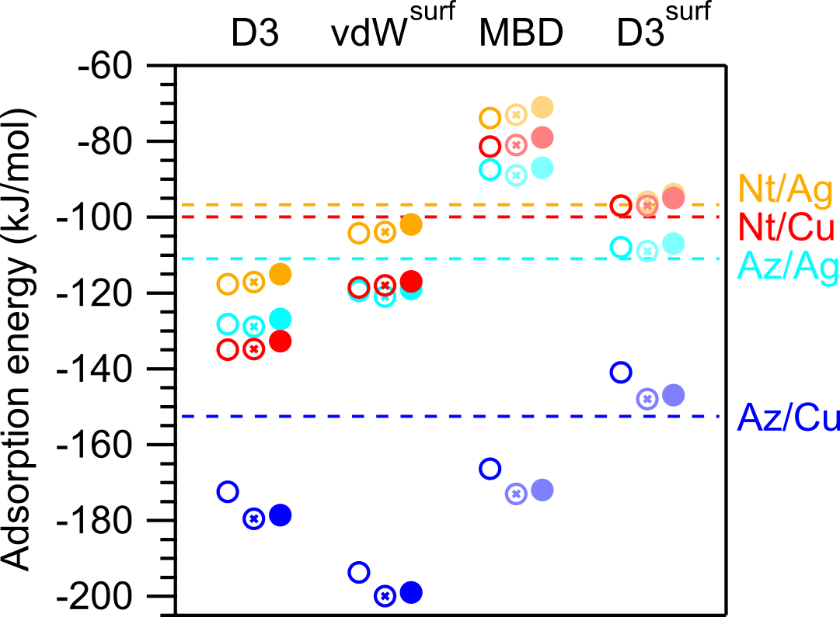
Figure 9. Comparison of the DFT adsorption energies E_{ads} obtained with different methods for the vdW corrections with the experimental values -E_{d,i} (Equation 2) derived by TPD (included as dotted lines). For Nt/Cu, the experimental value based on the TST prefactor was used. The coverage for the experimental energies is 0.65 ML on Cu(111) and 0.51 ML on Ag(111) corresponding to the (2√3×2√3)-R30° structure used for both surfaces in the DFT calculations. Open circles are electronic adsorption energies, half-filled circles include a harmonic ZPVE correction, and filled circles have harmonic thermodynamic corrections; both are in the mobile limit. For MBD and D3^{surf}, no calculations for thermodynamic corrections were performed, but the ZPVE and thermodynamic corrections obtained for D3 (in light colors) were included for better comparability.
To include corrections for the finite temperature during the measurements, harmonic thermodynamic corrections were performed for the D3 and vdW^{surf} calculations (Table 3). The simplest correction is the inclusion of the differences in the harmonic zero-point vibrational energy (ZPVE). Somewhat more complicated is the conversion to the standard enthalpy of adsorption ΔH_{ads}.³¹ For both corrections, assumptions about the molecular degrees of freedom in the adsorbed state are necessary. In the following, we consider only two limiting cases: First, the mobile limit with two translational and one rotational degrees of freedom on the surface, then the immobile limit with only vibrational degrees of freedom. For the thermodynamic corrections, a pressure of 1 bar and a temperature of 298 K was used to get the standard enthalpies; the area available for the translation of the molecule on the surface was chosen to be the size of one unit cell at the corresponding coverage.
Noteworthy, the corrections lead to a minor improvement for the weakly bonded systems, whereas larger effects are found for the strongly bonded system Az/Cu. In the latter case, the corrections lead to an improvement only for D3^{surf}. Only harmonic corrections were performed, but as the molecule-surface potential is anharmonic, additional anharmonic finite temperature effects may contribute.⁷² However, because of the stiffness of the molecules, only very small effects are expected.

Table 3. Compilation of the D3 and vdW^{surf} adsorption energies E_{ads} (in kJ/mol) with ZPVE correction and harmonic thermodynamic corrections.¹
 | Nt/Ag | Nt/Cu | Az/Ag | Az/Cu
Experiment | -97 | -100 | -111 | -153
E(D3) | -118 | -135 | -128 | -173
E(D3)+ZPVE | -117 (-117) | -135 (-135) | -129 (-129) | -180 (-180)
ΔH(D3) | -115 (-114) | -133 (-131) | -127 (-126) | -179 (-177)
E(vdW^{surf}) | -104 | -119 | -120 | -194
E(vdW^{surf})+ZPVE | -104 (-104) | -118 (-118) | -121 (-121) | -200 (-200)
ΔH(vdW^{surf}) | -102 (-101) | -117 (-115) | -119 (-118) | -199 (-198)
¹The coverage for the experimental energies -E_{d,i} (from TPD, integrated IPW results, HRV prefactors, for Nt/Cu TST prefactor) is 0.65 ML on Cu(111) and 0.51 ML on Ag(111) corresponding to the (2√3×2√3)-R30° structure used for both surfaces in the DFT calculations. The values for the ZPVE-corrected energies and enthalpies are given in the mobile limit; the values obtained for the immobile limit are given in parentheses. For all thermodynamic corrections a temperature of 298 K was used.

To evaluate whether the DFT calculations reproduce the coverage dependency of the adsorption energies, calculations for six different coverages were performed with the DFT-D3 scheme. In Figure 10, these calculated energies are compared to the coverage-dependent integral energies from TPD, -E_{d,i} (Equation 2). As expected for this type of vdW correction, the DFT-D3 results show an overestimation for all coverages. The deviation is especially large in the case of Nt/Cu(111) with an average of 39 kJ/mol, while the energies of the other systems are overestimated by averages of 17 to 24 kJ/mol. Nevertheless, the general coverage dependency, especially the decrease of the adsorption energy with increasing coverage, is well reproduced for all four adsorbate systems. The largest gradient is observed for the most strongly bonded system Az/Cu. When the experimental and theoretical data for Au/Cu are each fitted with a linear function, the gradients of these linear fits differ by only 2%. For the more weakly bonded systems, the adsorption energies are less dependent on the coverage, the gradients are smaller and the relative deviations between theoretical and experimental gradients are larger (12% to 53%).
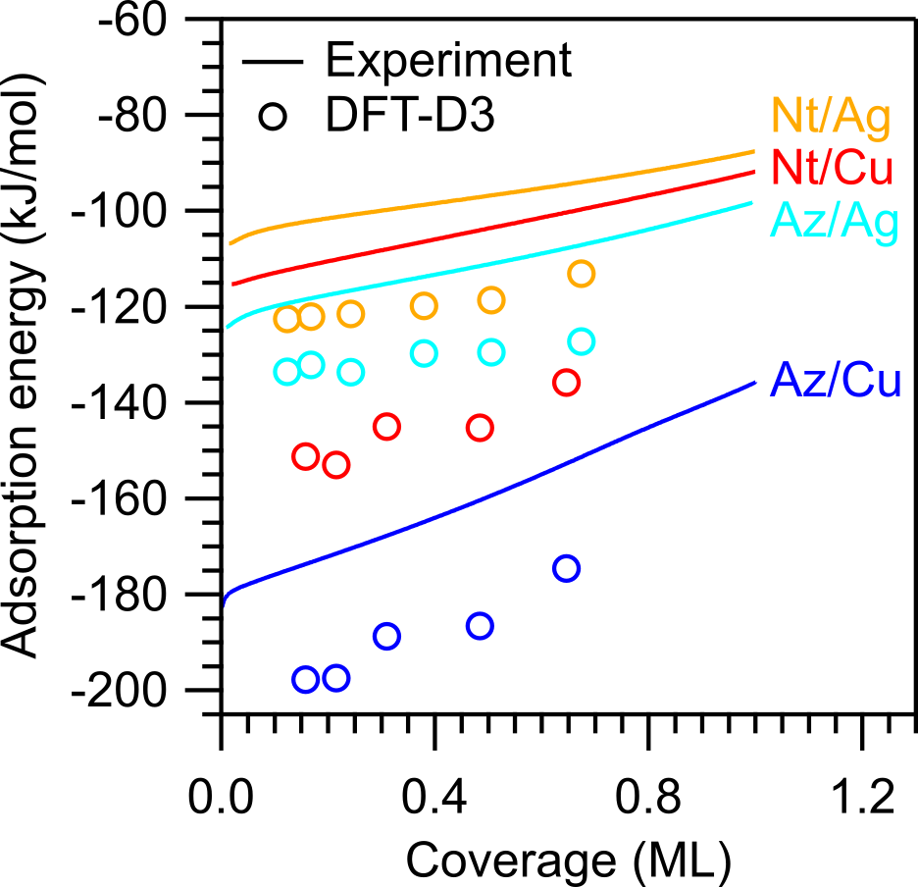
Figure 10. Experimental coverage-dependent integral desorption energies -E_{d,i} (lines) compared with DFT-D3 adsorption energies (open circles).

Energy Decomposition Analysis. Further information on the nature of the surface chemical bond was obtained from a periodic energy decomposition analysis (pEDA) on the PBE-D3 level of theory. In this method, the adsorbate structure is divided into two fragments, one containing the molecule and the other the surface. The total interaction energy can then be divided into different terms, which reveal details of the surface-adsorbate bonding (Table 4).³⁸
The bond of azulene with the Cu(111) surface is qualitatively different from the bonds in the other systems. Only for Az/Cu, the electronic interaction energy is attractive with ∆E_{int} (elec) = -52 kJ/mol, which is the result of large attractive electrostatic (∆E_{elstat} = -1138 kJ/mol) and orbital (∆E_{orb} = -958 kJ/mol) terms, partly counterbalanced by a large Pauli repulsion term (∆E_{Pauli} = +2044 kJ/mol). Remarkably, these terms are almost fivefold larger than in the other three adsorbate systems. Although the dispersion term (∆E_{int} (disp) = -181 kJ/mol) makes up a large part of the total interaction energy (∆E_{int} = -233 kJ/mol), it would be misleading to conclude that the azulene-copper bond is mainly of dispersive nature. In a more appropriate interpretation, the molecule is attracted both by dispersive and electronic contributions until it gets so close to the surface that the Pauli repulsion balances both attractive forces and an equilibrium is established. The electronic interaction energy then includes both attraction and repulsion, whereas the dispersive interaction energy only includes the (necessarily) attractive contribution of the semi-empirical vdW correction. Further indications of a chemisorptive bond include the large positive preparation energies ∆E_{prep}, which are caused by the considerable distortion of both the azulene molecule and the Cu surface in the adsorbed state, and the substantial charge transfer from the surface to the molecule (0.49 elementary charges).

Table 4. Compilation of the pEDA results for all four adsorbate systems; energies in kJ/mol, charges in elementary charges (e).¹
 | Nt/Ag | Nt/Cu | Az/Ag | Az/Cu
∆E_{int} | -123 | -146 | -137 | -233
∆E_{int} (disp) | -129 | -154 | -140 | -181
∆E_{int} (elec) | +6 | +8 | +3 | -52
∆E_{Pauli} | +280 | +392 | +426 | +2044
∆E_{elstat} | -164 | -213 | -251 | -1138
∆E_{orb} | -110 | -171 | -172 | -958
∆E_{prep}(mol,in cell) | -3 | -7 | -2 | +24
∆E_{prep}(mol,free) | +0 | +1 | +2 | +35
∆E_{prep}(surf) | +0 | +1 | +1 | +12
∆E_{bond} | -126 | -153 | -138 | -196
∆E_{bond} (PAW) | -119 | -136 | -130 | -175
q_{mol} (AIM) | +0.06 | +0.06 | +0.01 | -0.49
¹A negative value of q_{mol} derived via Bader’s atoms-in-molecules (AIM) scheme indicates charge transfer from the surface to the molecule. To check the consistency of the pEDA calculations, the total bond energies ∆E_{bond} are compared to results obtained by a plane-wave code ∆E_{bond} (PAW), in this case the PBE-D3 calculations used above. The pEDA terms for the total bond energy agree with the plane-wave results, but show an error of about 20 kJ/mol on Cu(111) and 10 kJ/mol on Ag(111).

The other three systems (Nt/Ag, Nt/Cu, Az/Ag) show weaker bonds between surface and molecule, in line with previous work for Nt/Cu.¹² The constituent electrostatic, orbital, and Pauli terms of the interaction energy are again larger than the total interaction energy and compensate each other, but their magnitude is much smaller than in the case of Az/Cu(111). For all three systems, the total electronic interaction energy is now repulsive. In addition, the preparation energies are very small; in fact, they are even slightly negative, which is an artefact of the calculations and discussed in the SI. The overall conclusion is that the molecule-surface bonds in these three systems should be classified as purely physisorptive, in accordance with the negligible charge transfer and the large adsorption heights as described in previous work.¹² It should be noted, however, that the orbital and electrostatic interaction energies are largest for the Az/Ag(111) system, even as the overall bond is predicted to be stronger for Nt/Cu(111). Thus, even on the less reactive Ag(111) surface, the nonalternant π-topology of the azulene molecule gives rise to an increased, if still weak, involvement of the molecular orbitals in the bond to the surface.

Conclusion
The interaction of the isomers naphthalene and azulene with the (111) surfaces of Ag and Cu was studied with TPD and dispersion-corrected DFT calculations. The different π-topologies of the molecules result in different bonding energetics to the two metal surfaces. On both surfaces, the nonalternant azulene forms a stronger bond than the alternant naphthalene, in line with previous structural data showing shorter adsorption heights for azulene.¹² Detailed quantitative TPD analysis with several complementary methods provides reliable coverage-dependent desorption energies and pre-exponential factors. The latter are shown to play a critical role in assessing the reliability of the experimental energies. In the monolayer range, the differential desorption energies are well described by the following second-order polynomials (in kJ/mol, Θ in ML): naphthalene/Ag: 103 – 18Θ – 19Θ², naphthalene/Cu: 114 – 40Θ – 7Θ², azulene/Ag: 120 – 27Θ – 25Θ², and azulene/Cu: 179 – 65Θ – 39Θ². Slightly different coverage-dependencies were found by a modified leading-edge analysis. The DFT calculations qualitatively reproduce the general trends in the adsorption energies and their coverage dependencies. In particular, they correctly predict the substantially larger adsorption energy of azulene on both metals and the larger adsorption energies of both isomers on Cu(111) than on Ag(111). On a quantitative level, the D3 and vdW^{surf} schemes overestimate all adsorption energies, with D3 performing better for the chemisorbed system and vdW^{surf} performing better for the physisorbed systems. MBD underestimates the adsorption energy in the physisorbed systems and shows only a slight overestimation for the chemisorbed system. The D3^{surf} method is in good agreement with the physisorbed systems and only very slightly underestimates the adsorption energy for the chemisorbed system. Overall, D3^{surf} shows the smallest deviation in absolute values. The pEDA analysis provides a detailed picture of the surface chemical bond and confirms the interpretation that azulene on copper forms a chemisorptive bond, while the other three systems are physisorbed.

ASSOCIATED CONTENT
Supporting Information
The Supporting Information is available free of charge on the ACS Publications website at DOI: xxxx. Details of the TPD measurements and analysis, heating-rate variation analysis, estimation of desorption prefactors, details of the DFT calculations. (PDF)

AUTHOR INFORMATION
Corresponding Author
*michael.gottfried@chemie.uni-marburg.de
ORCID
Stefan R. Kachel: 0000-0003-0323-2440
Benedikt P. Klein: 0000-0002-6205-8879
Juliana M. Morbec: 0000-0002-1672-3575
Maik Schöniger: 0000-0001-6462-8903
Peter Kratzer: 0000-0001-5947-1366
Bernd Meyer: 0000-0002-3481-8009
Ralf Tonner: 0000-0002-6759-8559
J. Michael Gottfried: 0000-0001-5579-2568
Author Contributions
⧧ Stefan R. Kachel and Benedikt P. Klein contributed equally to this work.
Present address
§ School of Chemical and Physical Sciences, Keele University, Keele ST5 5BG, UK.
Notes
The authors declare no competing financial interest.

Acknowledgments
Funded by the Deutsche Forschungsgemeinschaft (DFG) via 223848855-SFB 1083. J.M.M. gratefully acknowledges the computing time granted by the John von Neumann Institute for Computing (NIC) and provided on the supercomputer JURECA{, 2018 #496} at Jülich Supercomputing Centre (JSC). We further acknowledge computational resources from HLR Stuttgart, CSC-LOEWE Frankfurt, RRZ Erlangen, and HRZ Marburg. We thank Reinhard Maurer for discussion.

References
1. Gottfried, J. M. Quantitative Model Studies for Interfaces in Organic Electronic Devices. New J. Phys. 2016, 18, 111002.
2. Liu, W.; Maaß, F.; Willenbockel, M.; Bronner, C.; Schulze, M.; Soubatch, S.; Tautz, F. S.; Tegeder, P.; Tkatchenko, A. Quantitative Prediction of Molecular Adsorption: Structure and Binding of Benzene on Coinage Metals. Phys. Rev. Lett. 2015, 115, 036104.
3. Kroemer, H. Nobel Lecture: Quasielectric Fields and Band Offsets: Teaching Electrons New Tricks. Rev. Mod. Phys. 2001, 73, 783-793.
4. Organic Electronics II: More Materials and Applications; Klauk, H., Ed.; Wiley-VCH: Weinheim, 2012.
5. Organic Optoelectronics; Hu, W., Ed.; Wiley-VCH: Weinheim, 2013.
6. Rüdenberg, K. Quantum Mechanics of Mobile Electrons in Conjugated Bond Systems. III. Topological Matrix as Generatrix of Bond Orders. J. Chem. Phys. 1961, 34, 1884-1891.
7. Klein, B. P.; van der Heijden, N. J.; Kachel, S. R.; Franke, M.; Krug, C. K.; Greulich, K. K.; Ruppenthal, L.; Müller, P.; Rosenow, P.; Parhizkar, S., et al. Molecular Topology and the Surface Chemical Bond: Alternant Versus Nonalternant Aromatic Systems as Functional Structural Elements. Phys. Rev. X 2019, 9, 011030.
8. Trinajsti, N. Graph Theory and Molecular Orbitals. In Chemical Graph Theory: Introduction and Fundamentals, Bonchev, D.; Rouvray, D. H., Eds. Gordon and Breach Science Publishers: New York, Philadelphia, London, Paris, Montreux, Tokyo, Melbourne, 1991.
9. Xin, H.; Gao, X. Application of Azulene in Constructing Organic Optoelectronic Materials: New Tricks for an Old Dog. ChemPlusChem 2017, 82, 945-956.
10. Ni, B.; Zhang, T.; Li, J.; Li, X.; Gao, H. Topological Design of Graphene. In Handbook of Graphene, Celasco, E.; Chaika, A. N.; Stauber, T.; Zhang, M.; Ozkan, C.; Ozkan, C.; Ozkan, U.; Palys, B.; Harun, S. W., Eds. Wiley: New York, 2019.
11. Klein, B. P.; Harman, S. E.; Ruppenthal, L.; Ruehl, G. M.; Hall, S. J.; Carey, S. J.; Herritsch, J.; Schmid, M.; Maurer, R. J.; Tonner, R., et al. Enhanced Bonding of Pentagon–Heptagon Defects in Graphene to Metal Surfaces: Insights from the Adsorption of Azulene and Naphthalene to Pt(111). Chem. Mater. 2020, 32, 1041-1053.
12. Klein, B. P.; Morbec, J. M.; Franke, M.; Greulich, K. K.; Sachs, M.; Parhizkar, S.; Bocquet, F. C.; Schmid, M.; Hall, S. J.; Maurer, R. J., et al. Molecule-Metal Bond of Alternant Versus Nonalternant Aromatic Systems on Coinage Metal Surfaces: Naphthalene Versus Azulene on Ag(111) and Cu(111). J. Phys. Chem. C 2019, 123, 29219-29230.
13. Schlichting, H.; Menzel, D. Techniques for Wide Range, High Resolution and Precision, Thermal Desorption Measurements: I. Principles of Apparatus and Operation. Surf. Sci. 1993, 285, 209-218.
14. Grimme, S.; Antony, J.; Ehrlich, S.; Krieg, H. A Consistent and Accurate Ab Initio Parametrization of Density Functional Dispersion Correction (DFT-D) for the 94 Elements H-Pu. J. Chem. Phys. 2010, 132, 154104.
15. Becke, A. D.; Johnson, E. R. A Density-Functional Model of the Dispersion Interaction. J. Chem. Phys. 2005, 123, 154101.
16. Grimme, S.; Ehrlich, S.; Goerigk, L. Effect of the Damping Function in Dispersion Corrected Density Functional Theory. J. Comput. Chem. 2011, 32, 1456-1465.
17. Ruiz, V. G.; Liu, W.; Zojer, E.; Scheffler, M.; Tkatchenko, A. Density-Functional Theory with Screened Van Der Waals Interactions for the Modeling of Hybrid Inorganic-Organic Systems. Phys. Rev. Lett. 2012, 108, 146103.
18. Tkatchenko, A.; Scheffler, M. Accurate Molecular Van Der Waals Interactions from Ground-State Electron Density and Free-Atom Reference Data. Phys. Rev. Lett. 2009, 102, 073005.
19. Lifshitz, E. M. The Theory of Molecular Attractive Forces between Solids. Soviet Physics JETP 2 1956, 2, 73-83.
20. Zaremba, E.; Kohn, W. Van Der Waals Interaction between an Atom and a Solid Surface. Phys. Rev. B 1976, 13, 2270-2285.
21. Tkatchenko, A.; DiStasio, R. A.; Car, R.; Scheffler, M. Accurate and Efficient Method for Many-Body Van Der Waals Interactions. Phys. Rev. Lett. 2012, 108, 236402.
22. Ambrosetti, A.; Reilly, A. M.; DiStasio, R. A.; Tkatchenko, A. Long-Range Correlation Energy Calculated from Coupled Atomic Response Functions. J. Chem. Phys. 2014, 140, 18A508.
23. Hessey, S. G.; Jones, R. G. Line-of-Sight Mass Spectrometry: Principles and Practice. Surf. Interface Anal. 2015, 47, 587-600.
24. Perdew, J. P.; Burke, K.; Ernzerhof, M. Generalized Gradient Approximation Made Simple. Phys. Rev. Lett. 1996, 77, 3865-3868.
25. Kresse, G.; Hafner, J. Ab Initio Molecular Dynamics for Liquid Metals. Phys. Rev. B 1993, 47, 558-561.
26. Kresse, G.; Hafner, J. Ab Initio Molecular-Dynamics Simulation of the Liquid-Metal-Amorphous-Semiconductor Transition in Germanium. Phys. Rev. B 1994, 49, 14251-14269.
27. Kresse, G.; Furthmüller, J. Efficient Iterative Schemes for Ab Initio Total-Energy Calculations Using a Plane-Wave Basis Set. Phys. Rev. B 1996, 54, 11169-11186.
28. Kresse, G.; Furthmüller, J. Efficiency of Ab-Initio Total Energy Calculations for Metals and Semiconductors Using a Plane-Wave Basis Set. Comput. Mater. Sci. 1996, 6, 15-50.
29. Blöchl, P. E. Projector Augmented-Wave Method. Phys. Rev. B 1994, 50, 17953-17979.
30. Kresse, G.; Joubert, D. From Ultrasoft Pseudopotentials to the Projector Augmented-Wave Method. Phys. Rev. B 1999, 59, 1758-1775.
31. Pecher, J.; Tonner, R. Precursor States of Organic Adsorbates on Semiconductor Surfaces Are Chemisorbed and Immobile. Chem. Phys. Chem. 2017, 18, 34-38.
32. Blum, V.; Gehrke, R.; Hanke, F.; Havu, P.; Havu, V.; Ren, X.; Reuter, K.; Scheffler, M. Ab Initio Molecular Simulations with Numeric Atom-Centered Orbitals. Comput. Phys. Commun. 2009, 180, 2175-2196.
33. Togo, A.; Tanaka, I. First Principles Phonon Calculations in Materials Science. Scripta Materialia 2015, 108, 1-5.
34. Giannozzi, P.; Baroni, S.; Bonini, N.; Calandra, M.; Car, R.; Cavazzoni, C.; Ceresoli, D.; Chiarotti, G. L.; Cococcioni, M.; Dabo, I., et al. Quantum Espresso: A Modular and Open-Source Software Project for Quantum Simulations of Materials. J. Phys.: Condens. Matter 2009, 21, 395502.
35. Vanderbilt, D. Soft Self-Consistent Pseudopotentials in a Generalized Eigenvalue Formalism. Phys. Rev. B 1990, 41, 7892-7895.
36. van Lenthe, E.; Baerends, E. J. Optimized Slater-Type Basis Sets for the Elements 1-118. J. Comput. Chem. 2003, 24, 1142-1156.
37. van Lenthe, E.; Baerends, E. J.; Snijders, J. G. Relativistic Regular Two‐Component Hamiltonians. J. Chem. Phys. 1993, 99, 4597-4610.
38. Raupach, M.; Tonner, R. A Periodic Energy Decomposition Analysis Method for the Investigation of Chemical Bonding in Extended Systems. J. Chem. Phys. 2015, 142, 194105.
39. BAND 2017, SCM, Theoretical Chemistry, Vrije Universiteit, Amsterdam, the Netherlands, http://www.scm.com.
40. te Velde, G.; Baerends, E. J. Precise Density-Functional Method for Periodic Structure. Phys. Rev. B 1991, 44, 7888.
41. Franchini, M.; Philipsen, P. H. T.; Visscher, L. The Becke Fuzzy Cells Integration Scheme in the Amsterdam Density Functional Program Suite. J. Comput. Chem. 2013, 34, 1819-1827.
42. Pecher, L.; Tonner, R. Deriving Bonding Concepts for Molecules, Surfaces, and Solids with Energy Decomposition Analysis for Extended Systems. WIREs Comput Mol Sci. 2019, 9, e1401.
43. Winkler, A. Thermal Desorption of Organic Molecules. In Interface Controlled Organic Thin Films, Al-Shamery, K.; Horowitz, G.; Sitter, H.; Rubahn, H.-G., Eds. Springer: Berlin, Heidelberg, 2009; pp 29-36.
44. Witte, G.; Lukas, S.; Bagus, P. S.; Wöll, C. Vacuum Level Alignment at Organic/Metal Junctions: “Cushion” Effect and the Interface Dipole. Appl. Phys. Lett. 2005, 87, 263502.
45. Vázquez, H.; J. Dappe, Y. J.; Ortega, J.; Flores, F. Energy Level Alignment at Metal/Organic Semiconductor Interfaces: “Pillow” Effect, Induced Density of Interface States, and Charge Neutrality Level. J. Chem. Phys. 2007, 126, 144703.
46. Fernandez-Torrente, I.; Monturet, S.; Franke, K. J.; Fraxedas, J.; Lorente, N.; Pascual, J. I. Long-Range Repulsive Interaction between Molecules on a Metal Surface Induced by Charge Transfer. Phys. Rev. Lett. 2007, 99, 176103.
47. Christmann, K. Introduction to Surface Physical Chemistry. Steinkopff Verlag, Springer-Verlag: Darmstadt, New York, 1991.
48. de Jong, A. M.; Niemantsverdriet, J. W. Thermal Desorption Analysis: Comparative Test of Ten Commonly Applied Procedures. Surf. Sci. 1990, 233, 355-365.
49. Nieskens, D. L. S.; van Bavel, A. P.; Niemantsverdriet, J. W. The Analysis of Temperature Programmed Desorption Experiments of Systems with Lateral Interactions; Implications of the Compensation Effect. Surf. Sci. 2003, 546, 159-169.
50. King, D. A. Thermal Desorption from Metal Surfaces: A Review. Surf. Sci. 1975, 47, 384-402.
51. Bauer, E.; Bonczek, F.; Poppa, H.; Todd, G. Thermal Desorption of Metals from Tungsten Single Crystal Surfaces. Surf. Sci. 1975, 53, 87-109.
52. Tait, S. L.; Dohnálek, Z.; Campbell, C. T.; Kay, B. D. N-Alkanes on MgO(100). I. Coverage-Dependent Desorption Kinetics of N-Butane. J. Chem. Phys. 2005, 122, 164707.
53. Roos, M.; Breitruck, A.; Hoster, H. E.; Behm, R. J. Entropic Stabilization of Large Adsorbates on Weakly Binding Substrates – a Thermal Desorption and Scanning Tunneling Microscopy Study. Phys. Chem. Chem. Phys. 2010, 12, 818-822.
54. Thrower, J. D.; Friis, E. E.; Skov, A. L.; Nilsson, L.; Andersen, M.; Ferrighi, L.; Jørgensen, B.; Baouche, S.; Balog, R.; Hammer, B., et al. Interaction between Coronene and Graphite from Temperature-Programmed Desorption and DFT-vdW Calculations: Importance of Entropic Effects and Insights into Graphite Interlayer Binding. J. Phys. Chem. C 2013, 117, 13520-13529.
55. Falconer, J. L.; Madix, R. J. Flash Desorption Activation Energies: DCOOH Decomposition and CO Desorption from Ni (110). Surf. Sci. 1975, 48, 393-405.
56. Habenschaden, E.; Küppers, J. Evaluation of Flash Desorption Spectra. Surf. Sci. 1984, 138, L147-L150.
57. Parker, D. H.; Jones, M. E.; Koel, B. E. Determination of the Reaction Order and Activation Energy for Desorption Kinetics Using TPD Spectra: Application to D₂ Desorption from Ag(111). Surf. Sci. 1990, 233, 65-73.
58. Dresser, M. J.; Madey, T. E.; Yates, J. T. The Adsorption of Xenon by W(111), and Its Interaction with Preadsorbed Oxygen. Surf. Sci. 1974, 42, 533-551.
59. Gottfried, J. M.; Schmidt, K. J.; Schroeder, S. L. M.; Christmann, K. Oxygen Chemisorption on Au(110)-(1×2) I. Thermal Desorption Measurements. Surf. Sci. 2003, 525, 184-196.
60. Redhead, P. A. Thermal Desorption of Gases. Vacuum 1962, 12, 203-211.
61. Paserba, K. R.; Gellman, A. J. Kinetics and Energetics of Oligomer Desorption from Surfaces. Phys. Rev. Lett. 2001, 86, 4338-4341.
62. Gottfried, J. M.; Vestergaard, E. K.; Bera, P.; Campbell, C. T. Heat of Adsorption of Naphthalene on Pt(111) Measured by Adsorption Calorimetry. J. Phys. Chem. B 2006, 110, 17539-17545.
63. Masel, R. I. Principles of Adsorption and Reaction on Solid Surfaces, Wiley Series in Chemical Engineering. 1996.
64. Eyring, H. The Activated Complex in Chemical Reactions. J. Chem. Phys. 1935, 3, 107-115.
65. Campbell, C. T.; Sellers, J. R. V. The Entropies of Adsorbed Molecules. J. Am. Chem. Soc. 2012, 134, 18109-18115.
66. Campbell, C. T.; Árnadóttir, L.; Sellers, J. R. V. Kinetic Prefactors of Reactions on Solid Surfaces. In Z. Phys. Chem., 2013; Vol. 227, p 1435.
67. Ihm, H.; Ajo, H. M.; Gottfried, J. M.; Bera, P.; Campbell, C. T. Calorimetric Measurement of the Heat of Adsorption of Benzene on Pt(111). J. Phys. Chem. B 2004, 108, 14627-14633.
68. Zhu, J. F.; Diaz, S. F.; Heeb, L. R.; Campbell, C. T. Adsorption of Pb on NiAl(110): Energetics and Structure. Surf. Sci. 2005, 574, 34-42.
69. Persson, B. N. J. On the Nature of Adsorbate Phase Diagrams: Beyond Lattice Gas Models. Surf. Sci. 1991, 258, 451-463.
70. Caldeweyher, E.; Ehlert, S.; Hansen, A.; Neugebauer, H.; Spicher, S.; Bannwarth, C.; Grimme, S. A. Generally Applicable Atomic-Charge Dependent London Dispersion Correction. J. Chem. Phys. 2019, 150, 154122.
71. Caldeweyher, E.; Ehlert, S.; Hansen, A.; Neugebauer, H.; Spicher, S.; Bannwarth, C.; Grimme, S. A. Generally Applicable Atomic-Charge Dependent London Dispersion Correction Scheme. ChemRxiv 2018, DOI: 10.26434/chemrxiv.7430216.v2
72. Maurer, R. J.; Liu, W.; Poltavsky, I.; Stecher, T.; Oberhofer, H.; Reuter, K.; Tkatchenko, A. Thermal and Electronic Fluctuations of Flexible Adsorbed Molecules: Azobenzene on Ag(111). Phys. Rev. Lett. 2016, 116, 146101.
TOC Graphic
