Fourier Transform Infrared spectra of cells on glass coverslips. A further step in spectral pathology.

Rutter A. V.1, Crees J.2, Wright H.3, van Pittius D G.2, Yousef I.4, and Sulé-Suso J.1,5

1. Keele University, Guy Hilton Research Centre, Thornburrow Drive, Stoke on Trent ST4 7QB, U. K.

2. Histopathology Department, Royal Stoke University Hospital, University Hospitals of North Midlands (UHNM), Newcastle Rd, Stoke on Trent, Staffordshire ST4 6QG, U. K.

3. Research and Development Department, Royal Stoke University Hospital, University Hospitals of North Midlands, Newcastle Rd, Stoke on Trent, Staffordshire ST4 6QG, U. K.

4. ALBA Synchrotron, Carrer de la Llum 2-26, 08290 Cerdanyola del Vallès, Barcelona, Catalonia.

5. Oncology Department, Royal Stoke University Hospital, University Hospitals of North Midlands, Newcastle Rd, Stoke on Trent, Staffordshire ST4 6QG, U. K.

Running title: Infrared spectra of cells on glass.

Keywords: FTIR microspectroscopy, lung cancer, leukaemia, peripheral blood mononuclear cells, glass coverslips.

Corresponding author:

Professor Josep Sulé-Suso MB ChB, PhD

Oncology Department

Royal Stoke University Hospital

University Hospitals of North Midlands (UHNM)

Newcastle Rd, Stoke on Trent, Staffordshire ST4 6QG, U. K.

Tel: ##-44-1782-672571

Fax: ##-44-1782-672601

E-mail: josep.sulesuso@uhnm.nhs.uk

**ABSTRACT**

Over the last few years, great effort has been placed on developing Fourier Transform Infrared (FTIR) microspectroscopy as a tool to help in the histopathological diagnosis of cancer. The ever increasing workload in pathology departments is calling for a technique that could identify the presence of cancer cells in cytology and tissue samples in an objective, fast and automated way. However, pathologists use glass slides which absorb infrared (IR) radiation thus removing important mid-IR spectral data in the fingerprint region (proteins, DNA, RNA; 1800 cm-1 to 900 cm-1). To this purpose, we hypothesised whether using thinner glass slides, i. e., glass coverslips, would allow us to obtain spectral data not only from the lipid region (3100 cm-1 to 2700 cm-1) but also from the fingerprint region. To this purpose, we studied peripheral blood mononuclear cells (PBMC), a leukaemia cell line (K562) and a lung cancer cell line (CALU-1). Cells were placed on DAKO coverslips and their FTIR spectra obtained at MIRAS beamline, Alba synchrotron light source (Barcelona, Catalonia). The data presented here not only shows for the first time that it is possible to obtain spectral data from most of the amide I region (1800 cm-1 to 1570 cm-1) of cells placed on glass coverslips but more important, Principal Component Analysis was able to separate between the three types of cells for both the lipid and the amide I regions. The methodology here described is a further step in the application of FTIR microspectroscopy in histopathology departments.

**INTRODUCTION**

The ever increasing workload in pathology departments worldwide will lead to an increase in the turnaround time to reach a pathological diagnosis. This is crucial in cancer diagnosis as longer periods of time between biopsy and reaching a histological diagnosis leads to delays in treatment and increases patients’ anxiety. Furthermore, it is important from the treatment and prognosis point of view to identify not only the type of cancer but also the possibility of the tumour having spread outside the tumour bed. The latter could pose further pressure in pathology departments when, as is the case in many types of cancer, pathologists receive not only the primary tumour tissue but also lymph nodes removed during the surgical procedure.

The involvement of lymph nodes by tumour cells alters not only the tumour stage but also changes the management and prognosis. There is a marked variation for the examination of lymph nodes by different centres1. It has to be acknowledged that sectioning lymph nodes to identify all micrometastases would be too time consuming and cost prohibitive2. On the other hand, it would seem that using 20 µm or 150 µm interval step sectioning produces similar results when detecting metastatic deposits in lymph nodes3. Moreover, it has been described that detecting all micrometastases might not be necessary for a therapeutic decision in some cases such as axillary lymph nodes in breast cancer and that the aim should be detecting macrometastases2.

Regarding cytology, fine needle aspiration cytology (FNAC) has been recommended as the first line diagnostic tool for palpable masses4. Additionally, screening of certain tumours using cytology has led to decreases of incidence and mortality in some types of cancer such as cervical cancer5. With the ever increasing incidence of cancer, cytology samples will also increase, further stretching pathology departments. Therefore, it would be ideal to have an automated system that could identify the presence of abnormal cells in pathological specimens, thus pathologists would not need to spend so much time looking at samples deemed negative for cancer. Such a system could entail placing glass slides containing cytology samples in racks which could then be placed in an automated mode under an FTIR microscope which will provide spectral data confirming or not the presence of malignant cells.

Over the last few years, Fourier Transform Infrared (FTIR) microspectroscopy has been used to identify spectral changes between cancer cells and their normal counterparts showing potential for a clinical application6,7 even when studying stained cells8. However, one of the problems in its application in pathology is the substrate onto which samples are placed. Glass slides used in pathology are not ideal in FTIR microspectroscopy as glass absorbs IR radiation. However, in spite of this, information could still be obtained from the lipid region9 (from 3100 cm-1 to 2700 cm-1). On the other hand, for tissue samples, paraffin poses a further problem as paraffin bands fall in the same region as lipid bands. Therefore, it would be ideal to have a glass substrate which would not only allow the acquisition of spectral information on the lipid region but also from the whole or a section of the fingerprint region (proteins, DNA and RNA amongst others).

In general terms, pathologists place cytology or tissue samples on thick glass slides (1 mm thickness compared to a typical FTIR substrate of 0.5 mm thickness), these are then stained and covered with a coverslip. The coverslip is made of glass but thinner. Therefore, we hypothesised that the thinner coverslip would partially allow the study of the fingerprint region. Should this be the case, samples could then be placed on coverslips, studied using FTIR microspectroscopy and then stained and placed on the standard histopathology glass slide for further pathology analysis. To this purpose, we carried out the present work to assess whether using coverslips as a substrate in cellular samples could allow to study not only the lipid region but also a section of the fingerprint region of cells using synchrotron based FTIR (S-FTIR) microspectroscopy. We took advantage of the new FTIR MIRAS beamline at Alba synchrotron to carry out this work. This would allow us a better comparison with our previous work using also S-FTIR microspectroscopy8. Obviously, the final clinical application would entail using benchtop spectrometers.

**MATERIALS AND METHODS**

Cells. The cells used in this study were:

CALU-1, an epidermoid lung cancer cell line. This cell line was kept in culture in Dulbecco’s Modified Eagle Medium (DMEM) with 10% foetal bovine serum. Cells were incubated at 37 °C in 5% CO2 in tissue culture flasks (Sarstedt, Leicester, UK). Media was changed every 3–4 days and cells passaged before reaching confluence.

K562, a chronic myelogenous leukaemia cell line. Cells were grown in suspension in RPMI 1640 culture medium supplemented with 10% foetal bovine serum, 1% L-glutamine, 1% hepes buﬀer, and 1% antibiotic/antimycotic (complete medium) in culture flasks (Sarstedt, UK) at 37 °C and 5% CO2. The growth medium was changed every 3–4 days and cells were split 1:3.

Peripheral blood mononuclear cells (PBMC) (AMSBIO, UK). PBMC were thawed and kept in culture for 24 hours in RPMI prior to preparing samples for FTIR analysis.

Cell viability for all cells was determined with the standard trypan blue exclusion method.

Lymph node. A lymph node was obtained from AMSBIO, UK. The aim here was not to use S-FTIR microspectroscopy to identify different types of cells within lymph nodes but rather to assess whether a DAKO coverslip as a substrate could still be used to obtain spectral data not only from the lipid region but also form areas within the fingerprint region. The lymph node sample had been fixed, kept in paraffin and cut to a thickness of 5 µm prior to placing the sample on DAKO coverslips.

Sample preparation. Following cell incubation, cells were collected, transferred into Eppendorf tubes and centrifuged at 950 rpm for 3 minutes at room temperature. Supernatant was then removed and the pelleted cells were re-suspended in 0.9% NaCl. Cells were then cytospun on CaF2 (26 × 22 × 0.5 mm, Crystan Ltd, UK), glass coverslips (24 x 50 mm and 0.12-0.17 mm thickness, DAKO, UK) or glass slides (76 x 26 x 1 mm, Thermo Scientific, UK) for 1 minute at 550 rpm and fixed with 4% buﬀered paraformaldehyde in 0.9% NaCl for 20 minutes at room temperature. Excess formalin was removed by washing once with NaCl 0.9% and thrice rinsed with distilled water. Samples were then air dried at room temperature. Spectra of 100 individual cells were obtained.

Synchrotron based Fourier Transform Infrared microspectroscopy. S-FTIR spectra were recorded in transmission mode at the Infrared beamline MIRAS of the ALBA synchrotron light source (Barcelona, Catalonia). S-FTIR measurements were performed using the Hyperion 3000 microscope coupled to Vertex 70 spectrometer (Bruker, Germany). This microscope is equipped with a liquid nitrogen-cooled mercury cadmium telluride 50 microns MCT-A detector. The microscope used a 36X Schwarzschild objective (NA=0.65) and a matching 36X condenser. Spectra were collected at 4 cm-1 resolution, with 256 co-added scans using an aperture size of 15 x 15 µm centered on the cell nucleus based on our previous work10. Spectra were cropped to the area to be analyzed and normalized using standard normal variate (SNV) which subtracts the mean spectrum and then divides by the standard deviation for each spectrum removing the effect of different sample thickness and spectrum baseline offsets. The spectral analysis of cells on DAKO coverslips included the areas between 3100 cm-1 and 2700 cm‑1 for the lipid region, and between 1800 cm-1 and 1570 cm-1 for the amide I region.

Data analysis. Principal component analysis (PCA) was performed using Unscrambler X software (CAMO). We carried out a Levene’s test which showed that the variance in the three groups of cells was not equal. As there was no homogeneity of variance, the non-parametric Kruskal-Wallis test using IBM SPSS v. 24 was carried out to identify statistically significant differences between cell spectra. The test was applied on the Principal Components.

**RESULTS**

The first step in this project was to assess whether 2 glass substrates different mainly in thickness would affect the S-FTIR spectra of single cells in the same way, or, as hypothesised, that the thinner substrate would allow getting some information from areas within the fingerprint region. We first acquired S-FTIR spectra of cells on a CaF2 slides which we have previously used in order to confirm that the spectra obtained was similar to previous recorded data11,12. Figure 1 shows the S-FTIR spectra of PBMC, K562 and CALU-1 cells on CaF2 slides (mean of 100 cells for each cell line). The major differences between the malignant cells and the PBMC reside in the lipid region with higher intensity of the peaks at 2920 cm-1 and at 2850 cm-1, as well as a higher intensity of the peak at 1740 cm-1 for malignant cells. S-FTIR spectra of cells on DAKO coverslips had a cut-off at around 1570 cm-1 while S-FTIR spectra of cells on glass slides had a cut-off at around 2160 cm-1. The main advantage of DAKO coverslips over standard glass slides is the possibility of being able to obtain data from the amide I region (Figure 2). Interestingly, when DAKO coverslips and standard glass slides were used as substrate, the intensity of the peaks at 2920 cm-1, 2850 cm-1 and 1740 cm-1 (the latter for DAKO coverslips) remained higher for malignant cells when compared to PBMC (Figures 2 and 3).

The possibility of using glass substrates to study cells and/or tissues could pave the way towards an application of FTIR microspectroscopy in pathology. To this purpose, we also studied sections of a lymph node tissue sample that was formalin fixed, and paraffin embedded as is the usual standard practice in histopathology departments. As can be seen in Figure 4, the S-FTIR spectra of this lymph node sample was able to provide information not only on the lipid region but, as seen with single cells, on the amide I region. As expected, the data showed high intensity for the peaks at 2920 cm-1 and 2850 cm-1 caused by the presence of paraffin. However, no major interference from either paraffin or glass could be seen in the amide I region and, furthermore, the peak at 1740 cm-1 could also be characterised.

The next step was to assess whether differences between cells placed on DAKO coverslips could be identified using Principal Component Analysis (PCA). Two separate regions were studied, the lipid region from 3100 cm-1 to 2700 cm-1 and the amide I region from 1800 cm-1 to 1570 cm-1. Figures 5a and 5b show the PCA and loading plots, respectively, for all three study cells placed on DAKO coverslips for the lipid region. Figures 6a and 6b show the PCA and loading plots, respectively, for all three study cells placed on DAKO coverslips for the amide I region. The data presented in these figures show a clear separation between the three cell types for both the lipid and the amide I regions, being the difference clearer for the lipid region. The Kruskal-Wallis test was used in order to assess whether the differences in the PCA between the three types of cells for both the lipid and the amide I regions were statistically significant. As can be seen in Table I, the separation between the three possible pairs of cells (PBMC-K562, PBMC-CALU-1 and K562-CALU-1) was statistically significant for PC1 for both the lipid and the amide I regions. For PC2 in the lipid region, the separation for the cell pairs PBMC-CALU-1 and K562-CALU-1 was statistically significant. This was not the case for the cell pair PBMC-K562. For PC2 in the amide I region, the separation for the cell pair K562-CALU-1 was statistically significant while this was not the case for the cell pairs PBMC-K562 and PBMC-CALU-1. Taking into account all these data together, it could be stated that DAKO coverslips could be used as a substrate when using S-FTIR microspectroscopy to identify different types of cells, especially when analysing the lipid region.

The next step was to assess whether a different substrate could cause small changes in the spectra of the different cell types (no major changes were seen in the spectra of these cells for the lipid and amide regions regardless of the substrate used). To this purpose, PCA of all three cell types on CaF2 slides and DAKO coverslips was carried out for the lipid (Figures 7a and b) and the amide I regions. As can be seen in Figure 7a, PCA showed grouping of the individual cell type regardless of the substrate used and, furthermore, separation between the three cell types. The reason why the groupings might not be very tight could be due to differences between cells within the same cell line. Perhaps, cloning of the cancer cells might have produced a tighter clustering when studying individual clones composed of more uniform cells as we have previously described11,12. On the other hand, the PCA for the amide I region did not show grouping of the individual cell type regardless of the substrate used (data not shown).

Taking FTIR microspectroscopy into a clinical setting to identify cancer will require the standardisation on sample collection and preparation, and data collection and analysis. In fact, similar samples should provide similar results in different laboratories or when spectra are obtained on different days. While testing this was not the aim of this work, we tried to assess whether the differences between the cancer cells could have been caused, and if so to what extent, by the fact that the spectra of these cells had been obtained on different days during the beamtime at ALBA synchrotron. To this purpose, two different samples of the same cell line were prepared and the S-FTIR spectra obtained on different days. Figures 8a and 8b show the PCA of two samples of CALU-1 cells, whose spectra (50 cells for each sample) were obtained on different days, for the lipid and amide I regions, respectively. The data indicate that there is no clear separation between the spectra of CALU-1 cells obtained on different days. The same data can be seen for K562 cell line (Figures 9a and 9b). This would indicate that the differences between cells are due to true biochemical differences rather than to sample preparation or spectral acquisition.

**DISCUSSION**

Over the last few years there has been a plethora of articles highlighting the potential of FTIR microspectroscopy in the diagnosis of cancer in tissues and bodily fluids13,14. However, one of the main problems of FTIR microspectroscopy within a clinical setting in histopathology departments is the type of substrate where samples are placed. If FTIR spectra of good quality were obtained and provide enough information from samples on glass, this would then help pathologists in their daily work. Examples could be to better characterise those cells deemed suspicious of cancer but not overtly malignant and as a tool that could screen samples on an automated way, separating normal versus abnormal samples. The latter would reduce pathologists’ time as they would just need to concentrate on those samples considered abnormal by the IR system.

The work presented here indicates that good quality FTIR spectral data can be obtained from cells placed on glass coverslips. This allows for the acquisition of information not only from the lipid region but also from the amide I region. The lipid region is an important area when differentiating cancer cells from their normal counterparts. An increase in membrane lipids has been seen in viable cancer cells and it was suggested it could be a feature of the malignant phenotype15. Lipogenesis, production of fatty acids, has been reported to be a characteristic of various cancer types16 and it could be an extra source of energy for the higher proliferation of tumour cells in order to maintain their membrane synthesis and other associated functions during enhanced growth16. The excess of lipids and cholesterol in cancer cells is stored in lipid droplets. A high content of lipid droplets in tumours is considered a hallmark of cancer aggressiveness (reviewed by Beloribi-Djefaflia17). Thus, this excess of lipids in cancer cells could be identified with FTIR spectroscopy. Figures 1 to 3 show a higher intensity of the peaks at 2850 cm-1 and 2920 cm-1 in the two malignant cell lines when compared to PBMC regardless of what substrate was used to prepare the samples. These two peaks correspond mainly to the CH2 stretching modes of methylene chains in membrane lipids18-20. Furthermore, the peak at 1740 cm-1, which corresponds to the C=O stretching mode of phospholipids21,22, had also an increased intensity for the malignant cells when compared to PBMC when cells were placed both on CaF2 slides and DAKO coverslips (Figures 1 and 2). No information on that region could be obtained from cells placed on standard glass slides. PCA confirmed that leukaemia cells (K562) and lung cancer cells (CALU-1) could be easily separated from PBMC using both the lipid region and the amide I region, the latter containing the peak at 1740 cm-1 (Figures 5 and 6). For the lipid region, the separation was statistically significant for PC1 and PC2 except for the cell pair PBMC-K562. This could be due to the fact that K562 cells (tumour cells originating from the bone marrow) are more similar to PBMC when compared to CALU-1 cells, which have an epithelial origin. Furthermore, although the spectra of these cells on DAKO coverslips did not include the whole of the amide I region, there was a statistically significant difference between all cells for PC1. Further work is needed to confirm whether spectral information of lipid content in cells alone or the combination of lipid spectral information and amide I spectral information could be used in the cytological diagnosis of cancer.

Another important set of samples in histopathology is tissue. One of the limitations here is the presence of paraffin in tissue samples. Figure 4 shows the high intensity of the paraffin peaks in the lipid region. Physically removing paraffin with xylene and alcohol also entails removing lipids and thus making samples devoid of important spectral data regarding lipids. Another possibility is to remove paraffin digitally from FTIR spectra which makes them adequate for further analysis23,24. However, this entails further data pre-processing which could lengthen the times when considering a clinical application in pathology. Thus paraffin makes the adoption of FTIR spectroscopy to study tissues in clinical practice more difficult when compared to cytology samples. Finally, although paraffin does not affect the spectra in the amide I region, it is not possible to be certain that this region alone might be enough to identify cancer cells in tissues.

**CONCLUSIONS**

The use of glass slides as substrate in pathology has hampered the application of FTIR spectroscopy in histopathology. Glass absorbs IR radiation hindering the study of the fingerprint area. However, the work presented here shows for the first time that using glass coverslips, spectral information can be obtained from the Amide I region. This is an important further step in the application of FTIR spectroscopy for the histopathological diagnosis of cancer. While paraffin present in tissues could still cause difficulties in interpreting part of the spectral data, the methodology described here where DAKO glass coverslips are used as substrate for cells could be easily applied, even in an automated way, to study cytology samples.

**ACKNOWLEDGEMENTS**

The support from the Cancer Centre and University Hospital of North Midlands charities, and the North Staffordshire Medical Institute is greatly acknowledged. The beamtime awarded at Alba synchrotron MIRAS BL01 beamline (2017082312) is highly appreciated.

**DISCLOSURE/CONFLICT OF INTEREST**

All authors declare no conflict of interest.

**REFERENCES**

1. G. Viale, M. G. Mastropasqua, E. Maiorano and G. Mazzorol, *Virchows Arch.*, 2006, **448**, 241.

2. B. T. Harrison and J. E. Brock, *Am. J. Clin. Pathol.*, 2018, **150**, 4.

3. S. Kanngurn, S. Chewatanakornkul, T. Prempraphaand P. Thongsuksai, *Arch. Pathol. Lab. Med.*, 2009, **133**, 1437.

4. B. D. Florentine, B. Staymates, M. Rabadi, J. Barstis and A. Black, *Cancer*, 2006, **107**, 406.

5. P. Basu, A. S. Mittal, D. B. Vale and Y. C. Kharaji, *Best Pract. Res. Clin. Obstet. Gynaecol.*, 2018, **47**, 73.

6. H. J. Byrne, M. Baranska, G. J. Puppels, N. Stone, B. Wood, K. M. Gough, P. Lasch, P. Heraud, J. Sulé-Suso and G. D. Sockalingum, *Analyst*, 2015, **140,** 2066.

7. M. J. Baker, H. J. Byrne, J. Chalmers, N. Stone, B. Wood, K. M. Gough, P. Lasch, P. Heraud, J. Sulé-Suso and G. D. Sockalingum, *Analyst*, 2018, **143**, 1735.

8. J. Pijanka, G. D. Sockalingum, A. Kohler, Y. Yang, F. Draux, P. Dumas, C. Sandt, G. Parkes, D. G. van Pittius, G. Douce, V. Untereiner and J. Sulé-Suso, *Lab Invest*, 2010, **90**, 797.

9. M. J. Pilling, A. Henderson, J. H. Shanks, M. D. Brown, N. W. Clarke and P*.* Gardner, *Analyst*, 2017, **142**, 1258.

10. Pijanka J, Kohler A, Yang Y, Dumas, S. Chio-Srichan, M. Manfait, G. D. Sockalingum and J. Sulé-Suso, *Analyst*, 2009, **134**, 1176.

11. A. V. Rutter, M. R. Siddique, J. Filik, C. Sandt, P. Dumas, G. Cinque, G. D. Sockalingum, Y. Yang and J. Sulé-Suso, *Cytometry A*, 2014, **85A**, 668.

12. M. R. Siddique, A. V. Rutter, K. Wehbe, G. Cinque, G. Bellisola and J. Sulé-Suso, *Analyst*, 2017, **142**, 1299.

13. A. A. Bunaciu, V. D. Hoang and H. Y. Aboul-Enein, *Crit. Rev. Ana.l Chem.*, 2017, **47**, 194.

14. A. L. Mitchell, K. B. Gajjar, G. Theophilou, F. L. Martin and P. L. Martin-Hirsch, *J. Biophotonics*, 2014, **7**, 153.

15. C. E. Mountford and L. C. Wright, *Trends Biochem. Sci.* 1988, **13**, 172.

16. U. Ray and S. S. Roy, *FEBS J*.*,* 2018, **285,** 432.

17. S. Beloribi-Djefaflia, S. Vasseur and F. Guillaumond, *Oncogenesis*, 2016, **5,** e189.

18. T. Gao, J. Feng and Y. Ci, *Anal. Cell Pathol.*, 1999, **18**, 87.

19. J. Zhou, Z. Wang, S. Sun, M. Liu and H. Zhang, *Biotechnol. Appl. Biochem.*, 2001, **33**, 127.

20. P. Lasch, M. Boese, A. Pacifico and M. Diem, *Vibrat. Spectrosc.*, 2002, **28**, 147.

21. M. Jamin, P. Dumas, J. Moncuit, W.-H. Fridman, J.-L. Teillaud, G. L. Carr and G. P. Williams, *PNAS USA*, 1998, **95**, 4837.

22. H. N. Holman, M. C. Martin, E. A, Blakely, K. Bjornstad and W. R. McKinney, *Biopolymers*, 2000, **57**, 329.

23. E. Ly, O. Piot, R. Wolthuis, A. Durlach, P. Bernard and M. Manfait, *Analyst*, 2008, **133**, 197.

24. F. A. de Lima, C. Gobinet, G. D. Sockalingum, S. Britto-Garcia, M. Manfait, V. Untereiner, O. Piot and L. Bachmann, *Analyst*, 2017, **142**, 1358.

**LEGENDS TO FIGURES**

Figure 1. Mean spectra of PBMC, CALU-1 and K562 cells on CaF2 slides.

Figure 2. Mean spectra of PBMC, CALU-1 and K562 cells on DAKO coverslips.

Figure 3. Mean spectra of PBMC, CALU-1 and K562 cells on glass slides.

Figure 4. Mean S-FTIR spectra of a lymph node (mean of 200 spectra).

Figure 5. PCA (A) and loadings (B) for the lipid region for PBMC (open squares), K562 (filled triangles) and CALU-1 (filled squares) cells on DAKO coverslips.

Figure 6. PCA (A) and loadings (B) for the Amide I region for PBMC (open squares), K562 (filled triangles) and CALU-1 (filled squares) cells on DAKO coverslips.

Figure 7. PCA (A) and loadings (B) for the lipid region for PBMC (squares), K562 (circles) and CALU-1 (triangles) cells on CaF2 slides (filled squares, circles and triangles) and on DAKO coverslips (open squares, circles and triangles).

Figure 8. PCA for the lipid region (A) and amide I region (B) for two CALU-1 cells samples on DAKO coverslips obtained at 2 different time points (filled and open squares).

Figure 9. PCA for the lipid region (A) and amide I region (B) for two K562 cells samples on DAKO coverslips obtained at 2 different time points (filled and open squares).

**Table 1. Statistical significance between cells for the PCA using the Kruskal-Wallis test.**

|  |  |  |  |  |
| --- | --- | --- | --- | --- |
|  | Lipid region | | Amide I region | |
|  | PC1 | PC2 | PC1 | PC2 |
| PBMC vs K562 | **p<0.001** | P=0.253 | **p<0.001** | P=0.129 |
| PBMC vs CALU-1 | **p<0.001** | **p<0.001** | **p<0.001** | p=0.531 |
| K562 vs CALU-1 | **p<0.001** | **p<0.001** | **p<0.001** | **p=0.003** |

**Figure 1.**

**Absorbance (a. u.)**

**Wavenumber (cm-1)**

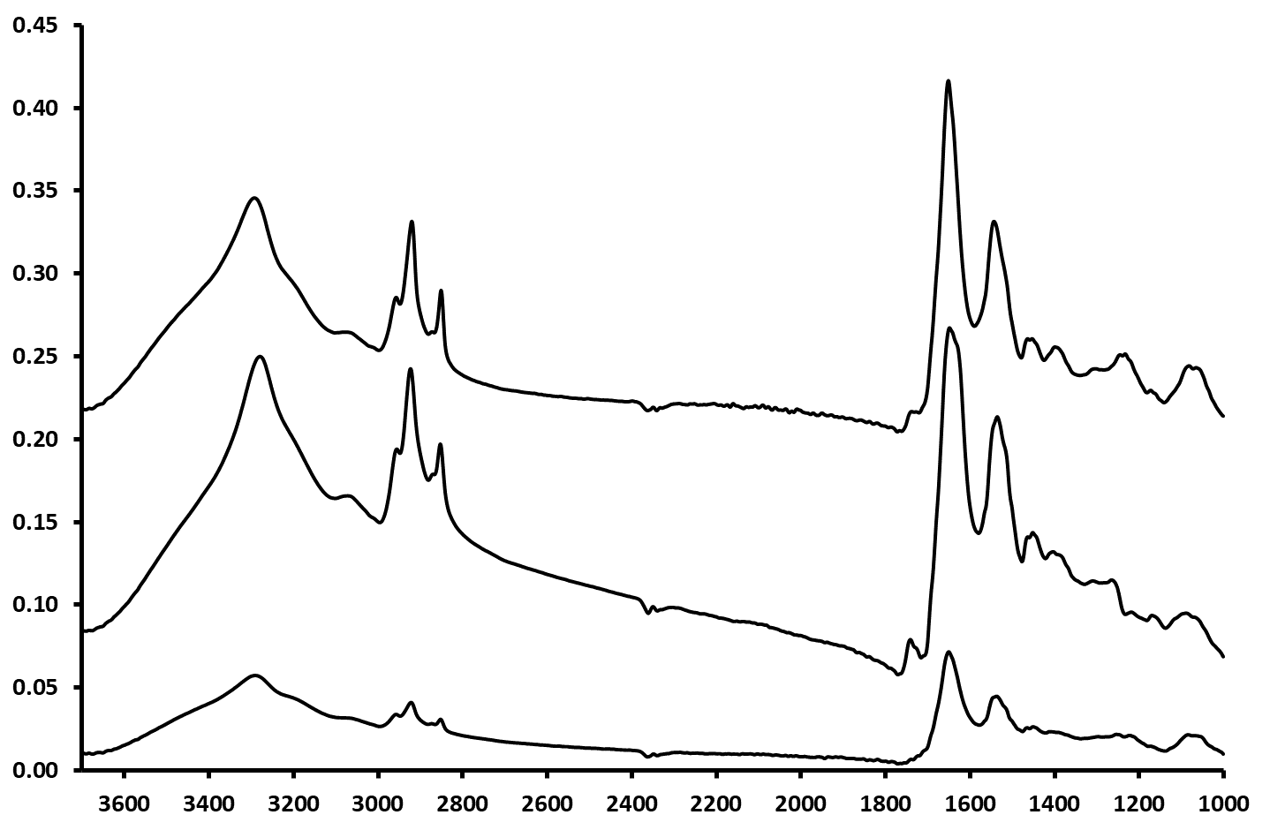

**CALU-1**

**K562**

**PBMC**

**2920 cm-1**

**2850 cm-1**

**1740 cm-1**

**Figure 2.**

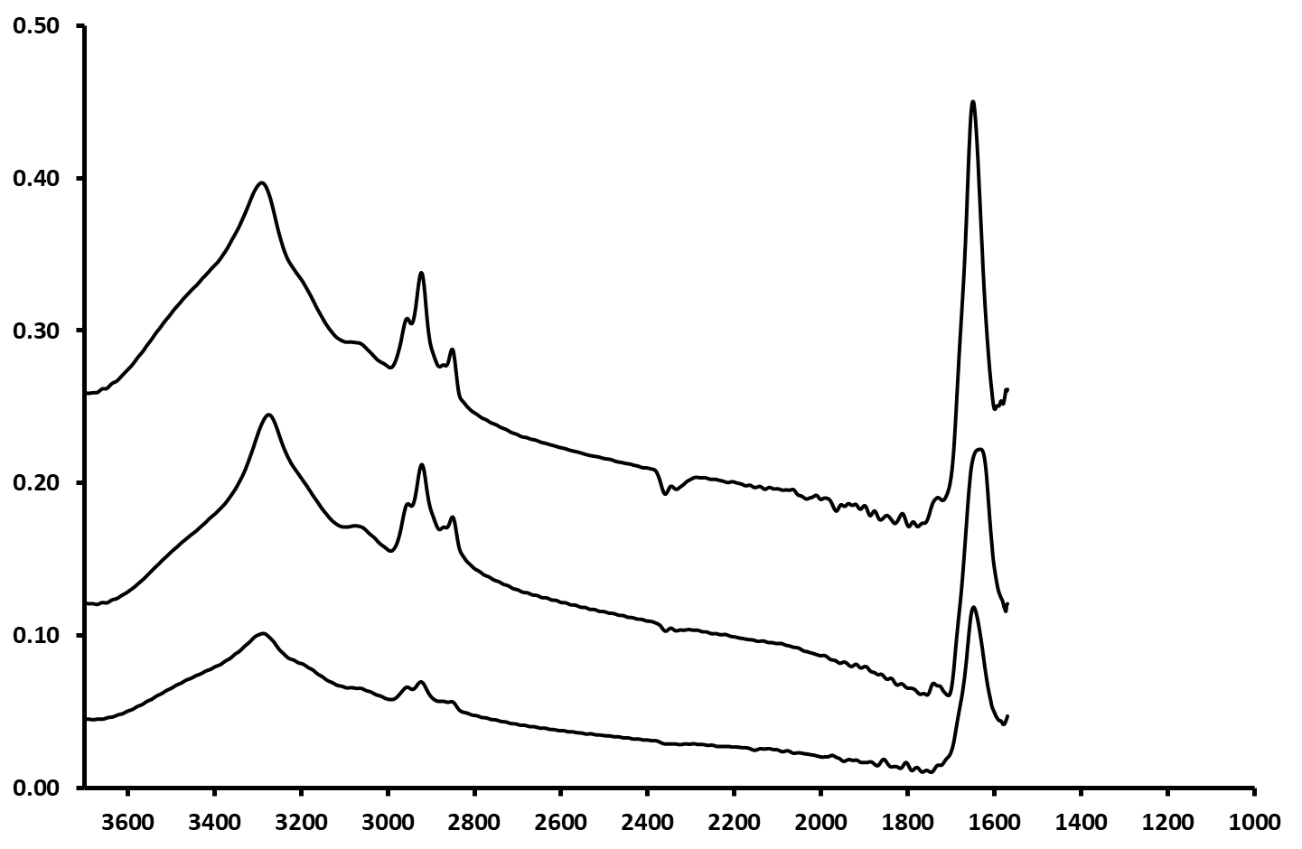

**Wavenumber (cm-1)**

**Absorbance (a. u.)**

**CALU-1**

**K562**

**PBMC**

**2920 cm-1**

**2850 cm-1**

**1740 cm-1**

**igure 1. Mean spectra of PBMC, CALU-1 and K562 cells on Caf2 slides.**

**Figure 3.**

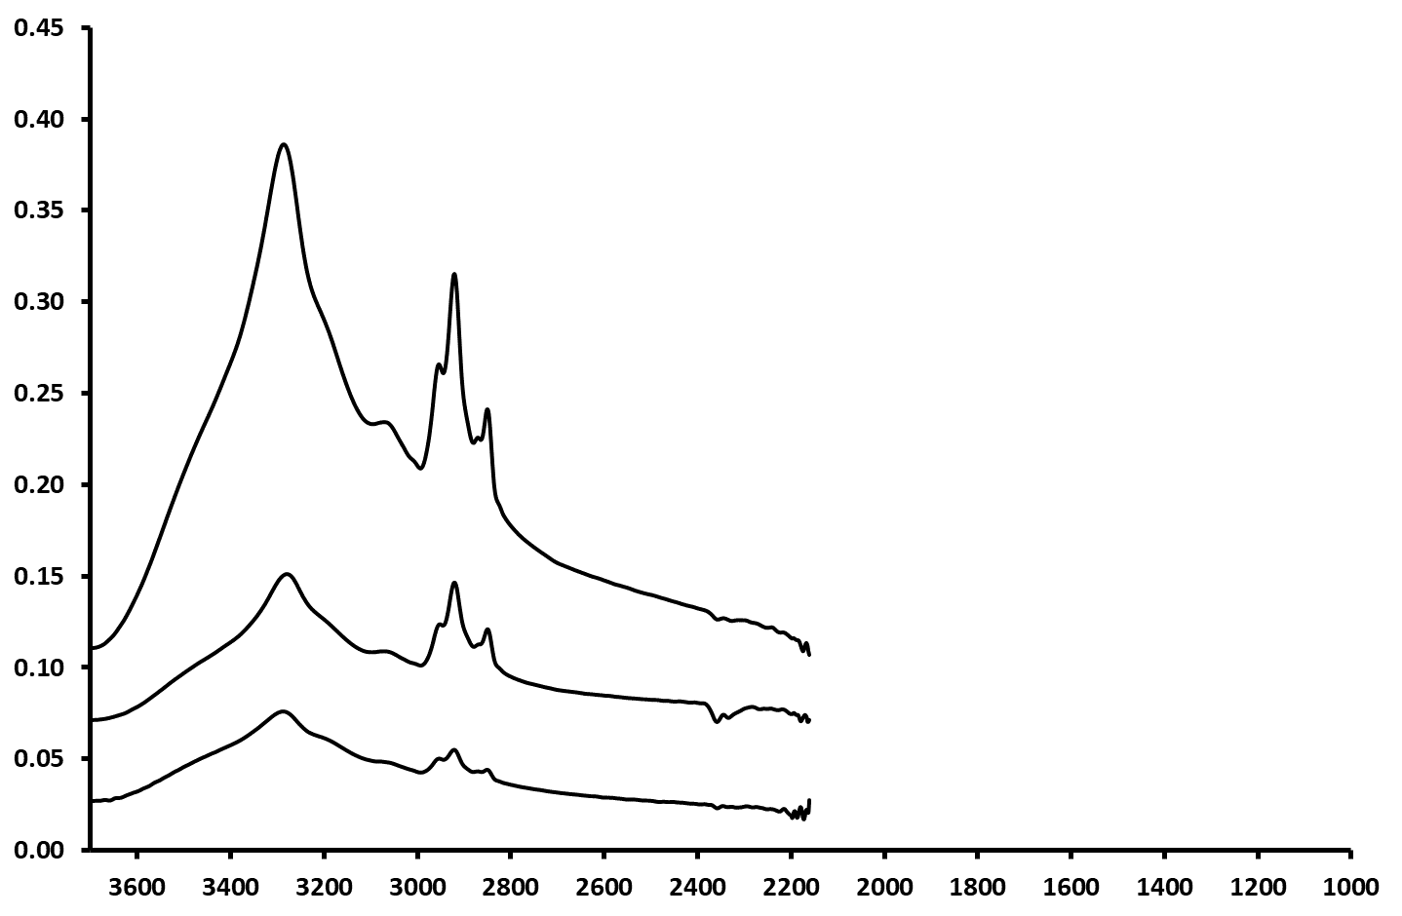

**CALU-1**

**K562**

**PBMC**

**Wavenumber (cm-1)**

**Absorbance (a. u.)**

**2920 cm-1**

**2850 cm-1**

**Figure 4.**

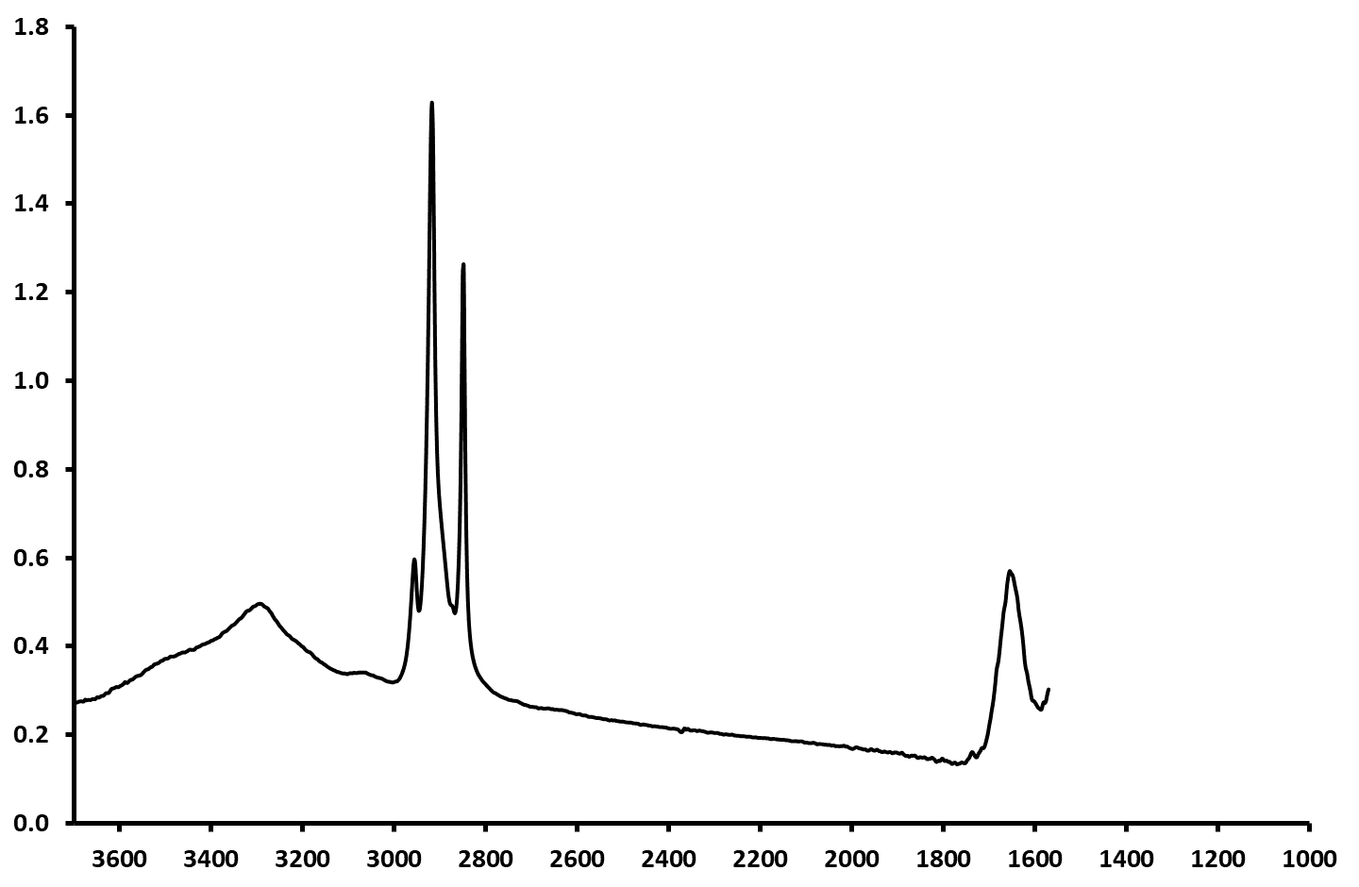

**Wavenumber (cm-1)**

**Absorbance (a. u.)**

**Figure 5a.**

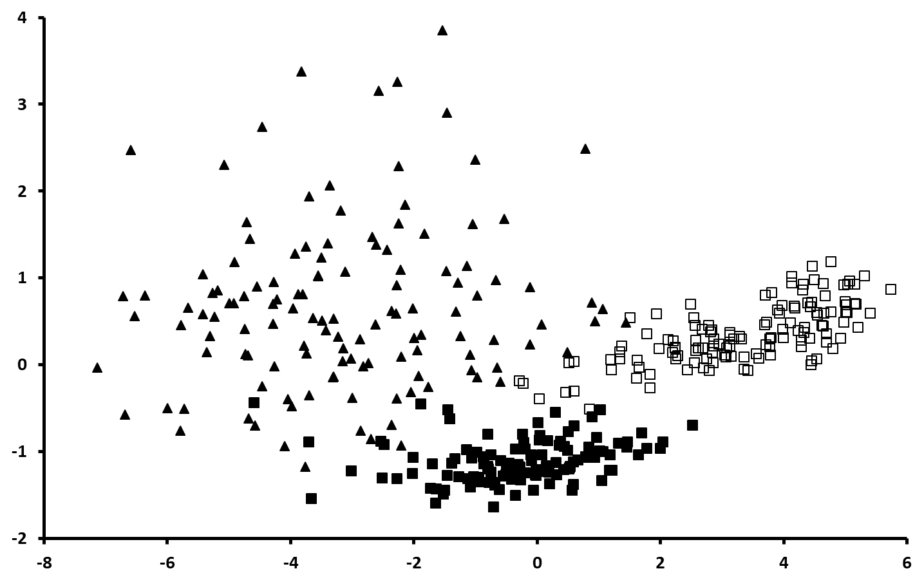

**PC1 (88%)**

**PC2 (9%)**

**Figure 5b.**

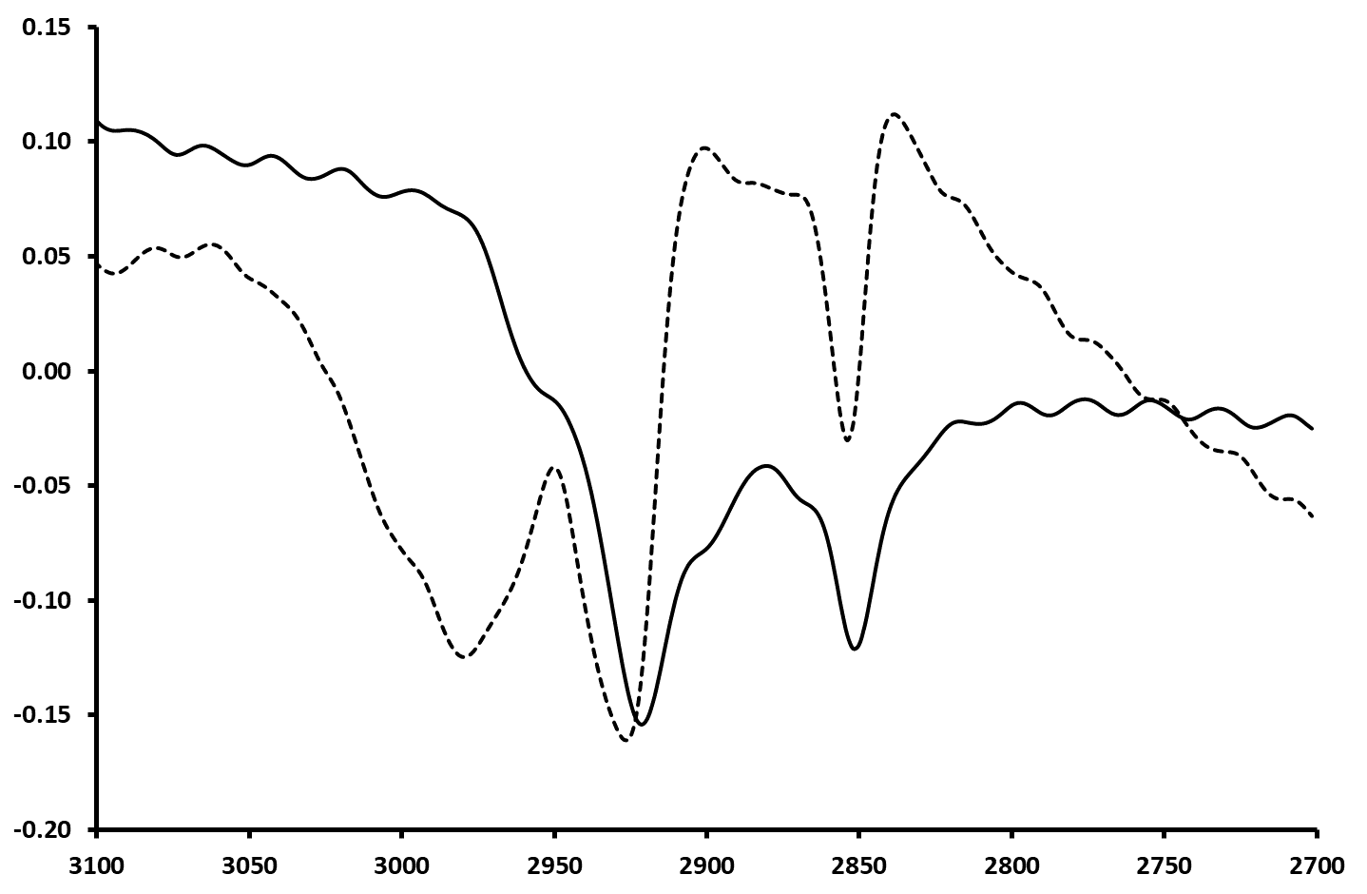

**PC1**

**PC2**

**Wavenumber (cm-1)**

**Figure 6a.**

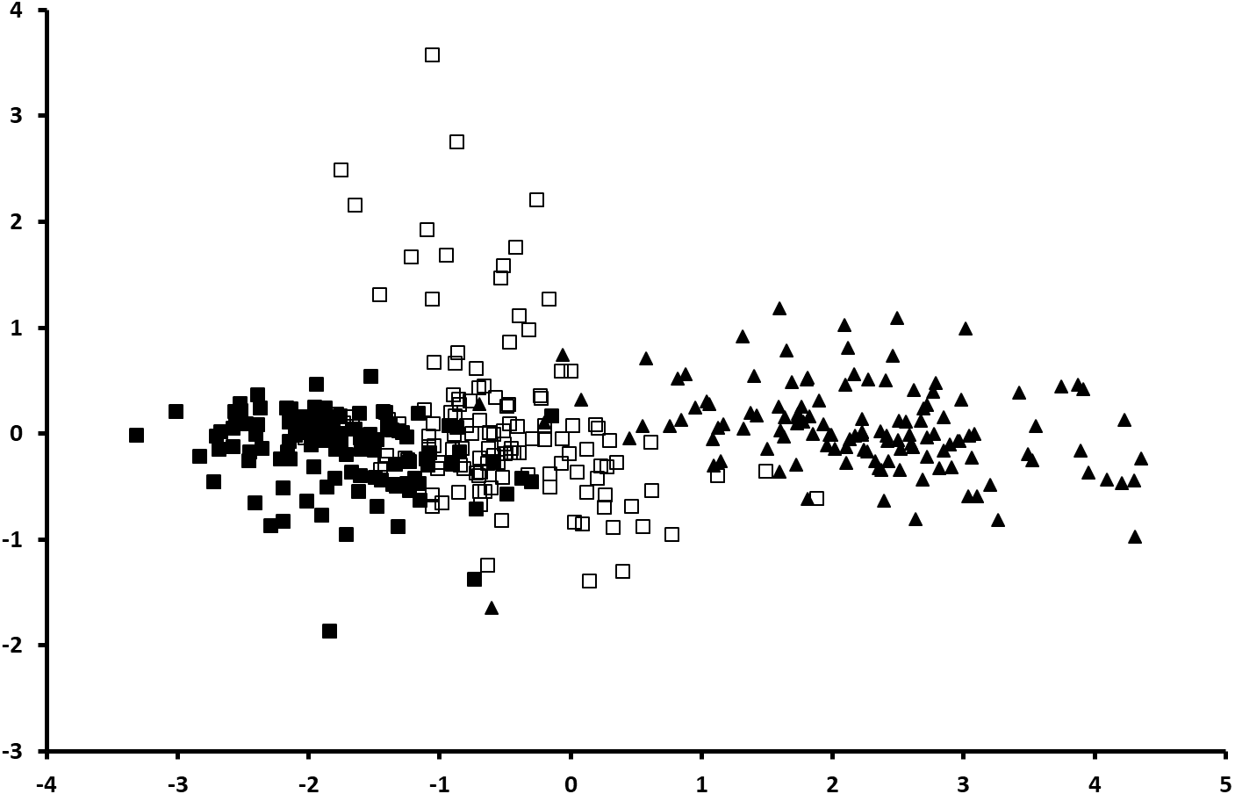

**PC1 (58%)**

**PC2 (6%)**

**Figure 6b.**

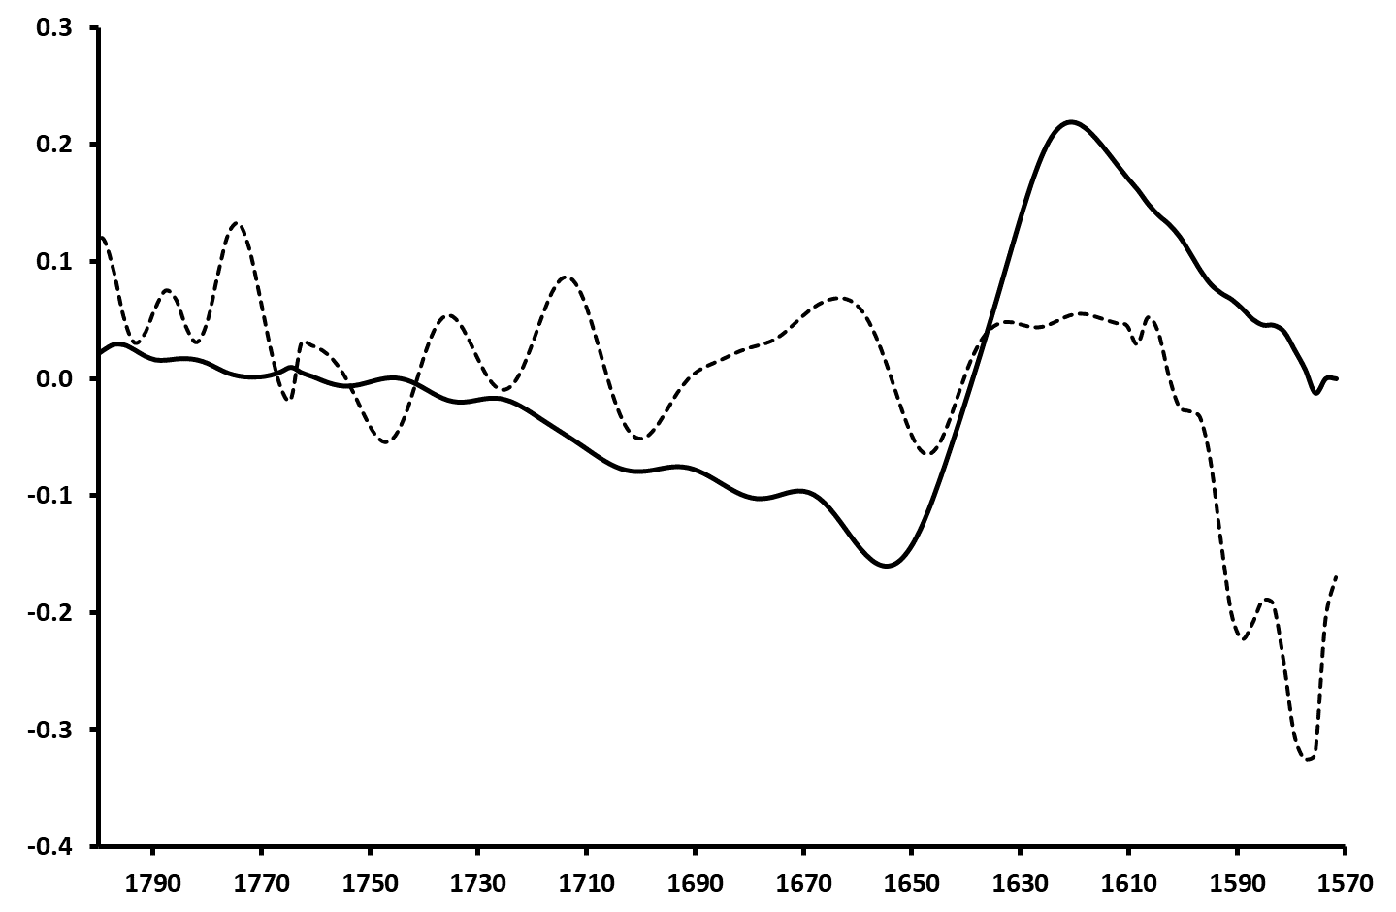

**PC1**

**PC2**

**Wavenumber (cm-1)**

**Figure 7a**

**PC1 (83%)**

**PC2 (8%)**

**PC1 (83%)**

Figure 7b

**PC2**

**PC1**

**Wavenumber (cm-1)**

**Figure 8a.**

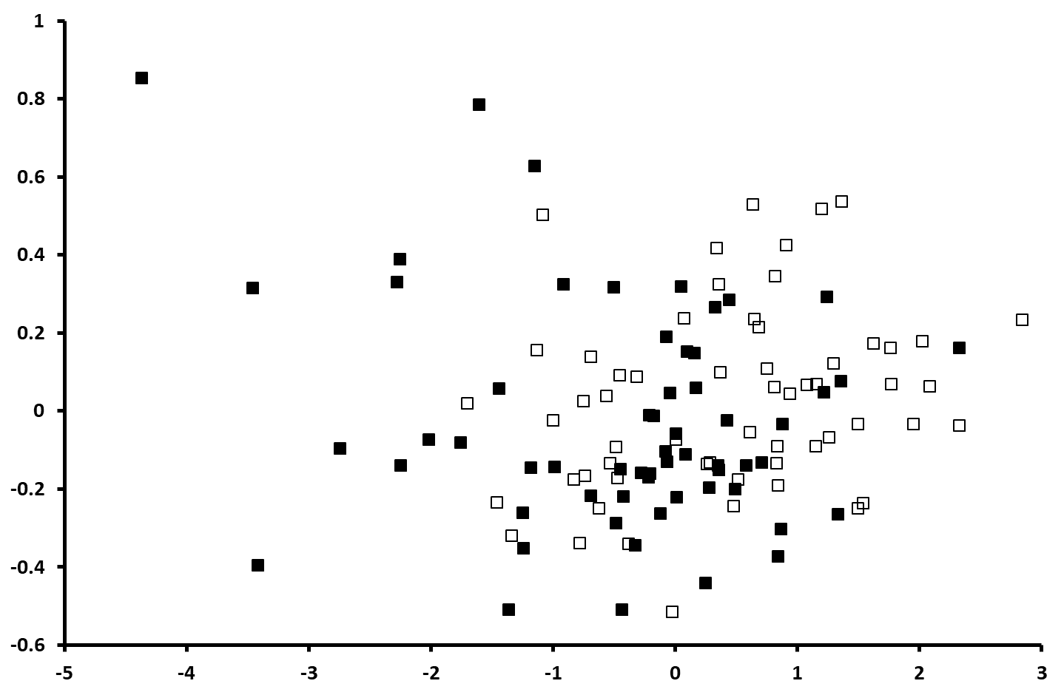

**PC1 (91%)**

**PC2 (4%)**

**Figure 8b.**

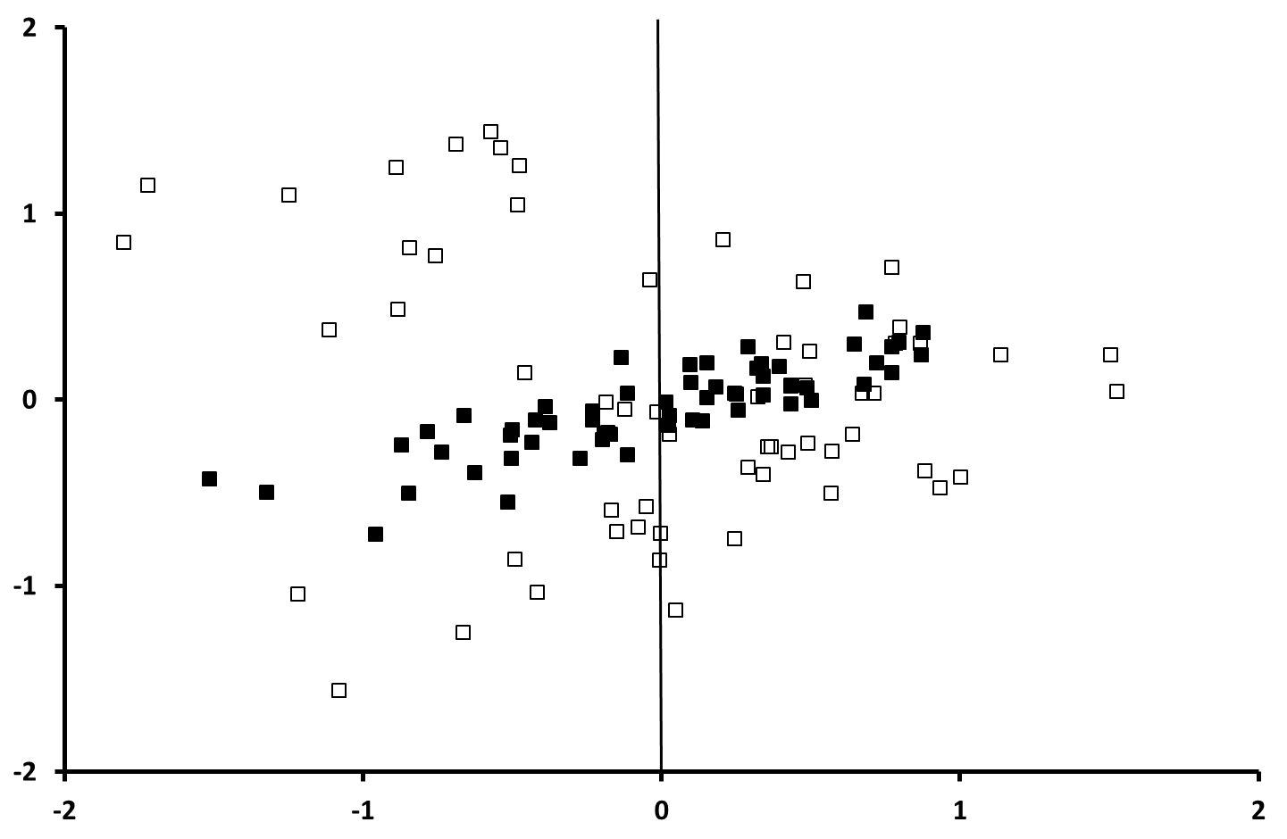

**PC1 (19%)**

**PC2 (13%)**

**Figure 9a.**

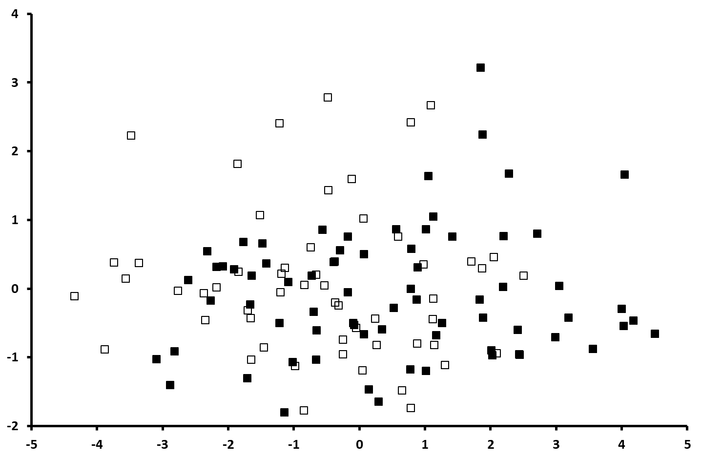

**PC1 (74%)**

**PC2 (21%)**

**Figure 9b.**

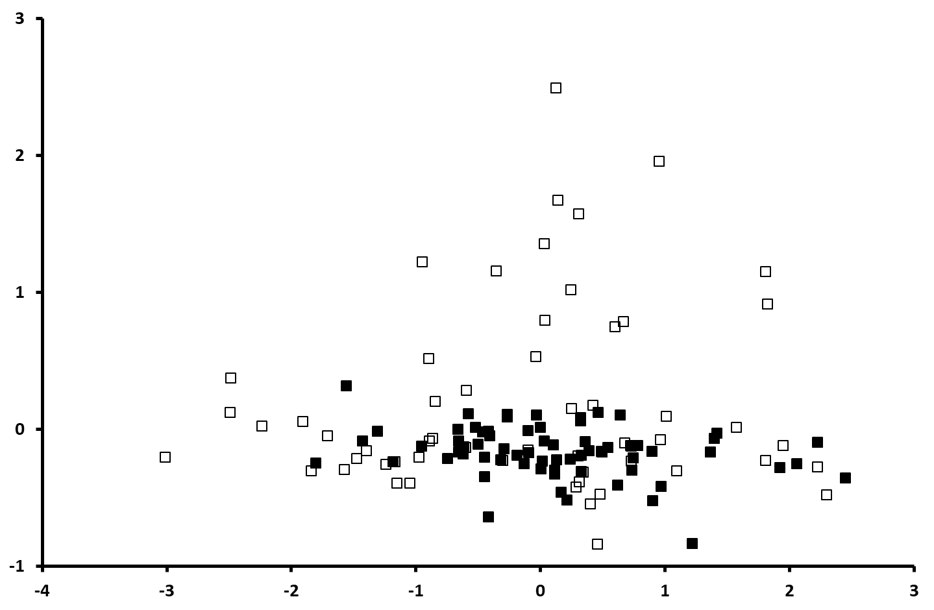

**PC1 (50%)**

**PC2 (12%)**