Table S1: Mean water chemistry data for each sampling occasion during the six-week study
Parameter | Week 1 | Week 2 | Week 3 | Week 4 | Week 5 | Week 6
Chloride (ppm) | 31.12 | 29.32 | 31.37 | 31.37 | 80.27 | 30.73
SD | 0.708 | 3.576 | 0.121 | 0.052 | 40.535 | 0.052
Sulphate (ppm) | 30.78 | 29.88 | 31.43 | 31.49 | 95.75 | 31.10
SD | 0.547 | 2.592 | 0.072 | 0.027 | 30.399 | 0.063
Nitrate (ppm) | 18.91 | 17.778 | 18.44 | 17.94 | 39.12 | 17.6
SD | 0.235 | 0.950 | 0.095 | 0.032 | 10.719 | 0.063

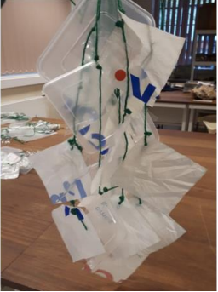
Figure S1: A photograph of the sampling apparatus used prior to deployment in Knypersley reservoir, showing replicates of each piece of plastic. One of these pieces of apparatus was removed each week.

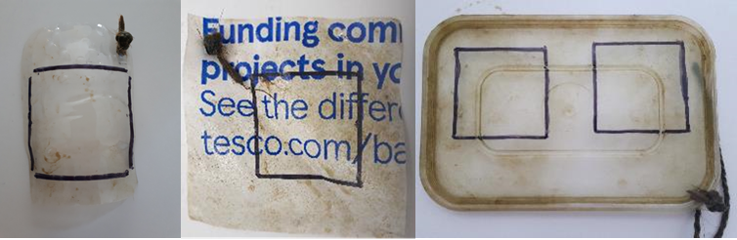
Figure S2: Photographs of the 10x10cm squares from which biofilms were removed for analysis

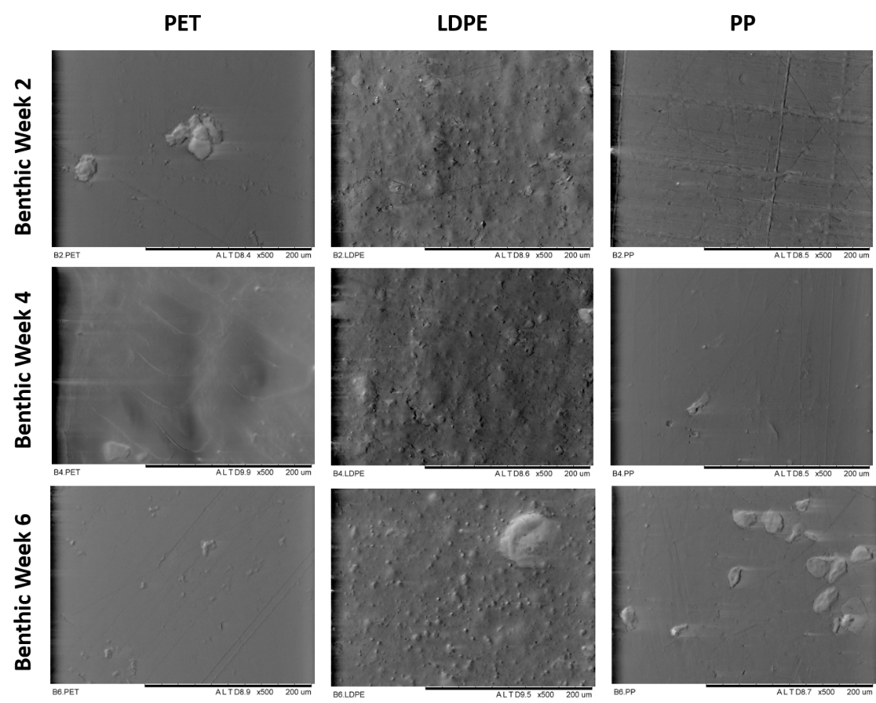
Aphotic Week 2
Aphotic Week 6
Aphotic Week 4
Figure S3: SEM micrographs showing the progression of polymer surface degradation after 2, 4 and 6 of submersion in the aphotic zone of Knypersley Reservoir
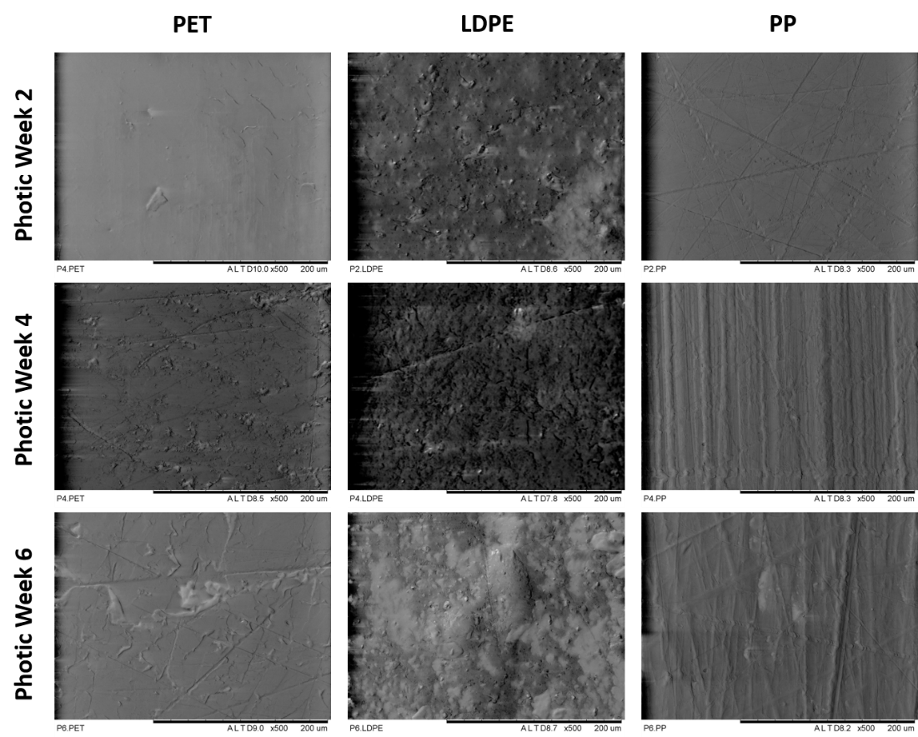
Figure S4: SEM micrographs showing the progression of polymer surface degradation after 2, 4 and 6 of submersion in the photic zone of Knypersley Reservoir

