Seismic and borehole-based mapping of the late Carboniferous succession in the Canonbie Coalfield, SW Scotland: evidence for a ‘broken’ Variscan foreland?
Louis Howell, Bernard Besly, Surika Sooriyathasan, Stuart Egan, Graham Leslie
ABSTRACT
Local seismic and borehole-based mapping of the late Carboniferous succession in the Canonbie Coalfield (SW Scotland) provides evidence of repeated episodes of positive inversion, syn-depositional folding and unconformities within the Westphalian (Bashkirian-Moscovian) to Stephanian (Kasimovian) Pennine Coal Measures and Warwickshire Group successions. An initial (early Westphalian) episode of dextral wrench faulting along NE-SW orientated lineaments is recognised, based on onlapping seismic reflector geometries against NE-trending mild positive inversion structures, contemporaneous NNE-trending syn-depositional growth folding, and ENE-WSW trending normal faulting. Higher magnitude, late Westphalian-Stephanian N-S orientated shortening, is recognised based upon tightening of these inversion structures and further onlapping reflector geometries. The basin history thus revealed at Canonbie is somewhat at variance with generally accepted models in neighbouring northern England that state basins, such as the Northumberland-Solway Basin, subsided due to post-rift thermal subsidence during the late Carboniferous. A late Westphalian-Stephanian unconformity recognised within the Warwickshire Group succession in the area signifies c. 10% local basin shortening at a time when major basin shortening is recorded throughout the late Carboniferous Variscan foreland and the Cantabrian and Iberian oroclines, southern Europe, are believed to have formed. This observation further contradicts suggestions that maximum Variscan shortening at this time had minimal impact on late Carboniferous basins in northern England and Scotland. Local inversion structures appear to have strongly influenced the evolution of local Westphalian-Stephanian depocentres. In this respect, the local Variscan foreland at Canonbie may have resembled a ‘broken’ foreland system such as the eastern Andean retro-arc foreland of Patagonia, South America. Local variations in crustal rheology, inherited fault strengths and their variation over time, fault orientation with respect to the evolving dominant stress field and mid-crustal detachments are all suggested to have played important roles in strain localisation and ultimately the nature of Westphalian-Stephanian depocentres in the Canonbie Coalfield.
INTRODUCTION
One of UK coal mining’s legacies is the vast quantity of subsurface data that we inherit. These data record an important chapter of the Earth’s history, the amalgamation of Pangaea, and have the potential to be widely repurposed as the UK seeks to decarbonise and fulfil its energy needs through more sustainable resources (Watson et al., 2019). We present a study based on subsurface (seismic and borehole) data from the Canonbie Coalfield in SW Scotland (see Fig. 1 for location). These coal-bearing strata were deposited in the northern British part of an expansive late Carboniferous Variscan foreland basin system, the complex characteristics of which have been debated for decades (Leeder, 1982; Coward, 1993; Ziegler, 1993; Woodcock and Rickards, 2003; Underhill et al., 2008). In both modern and ancient foreland systems, syn-kinematic sedimentary sequences can indirectly reveal the nature of the various tectonic episodes that influenced the basin and its regional setting. In ancient foreland systems, these sequences are often absent due to later uplift and denudation. In contrast, a near complete record of the late Carboniferous syn-kinematic megasequence (Besly et al., 1993; Peace and Besly, 1997) is locally preserved at the Canonbie Coalfield (Chadwick et al., 1995; Waters et al., 2011; Jones et al., 2011).
Using archived seismic and borehole datasets curated by the UK Onshore Geophysical Library (UKOGL) and the British Geological Survey (BGS), we investigate the characteristics of the preserved late Carboniferous syn-kinematic sedimentary sequence preserved in the Canonbie Coalfield, and the tectonic controls that were exerted upon its depositional and post-depositional deformation. Widely held perceptions of ancient foreland basin systems such as the Variscan foreland, often portray these systems in a broadly two-dimensional perspectives on tectonic scales. These systems include a single collision zone adjacent to a region of subsidence occurring primarily along a restricted, laterally migrating flexure-induced foredeep depozone. Deposition also occurs to lesser extents within forebulge and backbulge depozones. A simplistic laterally dissipating compressional stress field is typically derived from a short-lived contractional episode (e.g. DeCelles and Giles, 1996; DeCelles, 2012; Catuneanu, 2019). However, at Canonbie we demonstrate syn-depositional faulting, folding and positive inversion exerted strong controls on early Westphalian (Bahkirian) through to Stephanian (Kasimovian) depocentres. Such behaviour is not just at variance with generally accepted models for late Carboniferous basin development in neighbouring northern and central England therefore, but also with many conceptual models for generic foreland basin systems. Evolution of the Canonbie Coalfield and its regional setting is perhaps more akin to ‘broken’ foreland systems such as in the eastern Andean retro-arc foreland of Patagonia where sedimentation is controlled by local tectonism (e.g. Schwartz, 1982; Strecker et al., 2011; Bilmes et al., 2013). We attempt to reconcile competing tectonic models for the northern British part of the Variscan foreland and demonstrate the importance of inherited crustal structures, the relative susceptibilities of these structures to reactivation and the influence of an evolving stress field on the characteristics of the syn-kinematic sedimentary sequence preserved at Canonbie.
REGIONAL GEOLOGICAL SETTING
In northern Britain, there are two models for late Carboniferous tectonic evolution. The first focuses upon inversion tectonics following early Carboniferous rifting and post-rifting (Leeder, 1982; Howell et al., 2019), relating to a dissipating stress field derived from the Variscan collision zone of central-southern Europe (Leeder, 1982; Corfield et al., 1996). The Variscan orogen formed in southern-central Europe in response to approximately northward accretion of early Palaeozoic island arcs and continental fragments and later Gondwanan-derived elements onto Laurussia during the prolonged late Palaeozoic assembly of Pangaea (Warr, 2012; Murphy et al., 2016; Shaw and Johnston, 2016; Edel et al., 2018). The orogen reached its maximum intensity during the late Carboniferous, culminating with the closure of the Palaeotethys Ocean and the formation of the Cantabrian and central Iberian oroclines (c. 310-295 Ma) (Murphy et al., 2016). The northern margin of this belt can be traced approximately east-west across southern England where it separates the late Carboniferous foreland basin of southern Wales (Burgess and Gayer, 2000) from the low-grade metamorphic external Variscan thrust belt and early Carboniferous foredeep (Woodcock and Strachan, 2012; Murphy et al., 2016). Within the British Variscan foreland region, the magnitude of dominantly oblique contemporaneous thrust and fold inversion structures generally increases towards the Variscan Front (Fraser and Gawthorpe, 1990; Corfield et al., 1996; Woodcock and Rickards, 2003; Warr, 2012). This style of deformation is analogous to modern day shortening exerted between orogenic collision zones and adjacent foreland regions (Copley et al., 2011; Assumpcao, 1992), such as with the Himalayas and northern India (Powers et al., 1998).
However, a tectonic model that revolves solely around northward-vergent Variscan compressional stresses does not readily incorporate parallel to oblique late Carboniferous fold and thrust structures such as those that characterise both the Canonbie Coalfield and the northern British Variscan foreland (Fig. 1). Copley and Woodcock (2016) calculate that such discontinuities must have been significantly weaker (with an effective co-efficient of friction at least less than 30% lower) than intact country rock for them to have reactivated during Variscan compression rather than new faults initiate. Coward’s (1993) alternative tectonic model for the Variscan foreland highlights the influences of dextral strike-slip movement along pre-existing and long-lived NW-SE trending thick-skinned faults; wrench movement along structures such as the Southern Upland Fault Zone in southern Scotland accommodated westwards reinsertion of Baltica between North America and central-southern Europe. Reinsertion is believed to have been a response to the contemporaneous, but distal, Uralian Orogeny. The Uralian Orogeny formed as the result of accretion of the Siberian and Kazakh plates against Baltica’s eastern (Laurussian) margin and the closure of the Ural Ocean; orogeny began during the late Carboniferous and continued into the early Jurassic (Bea et al., 2002; Brown et al., 2006).
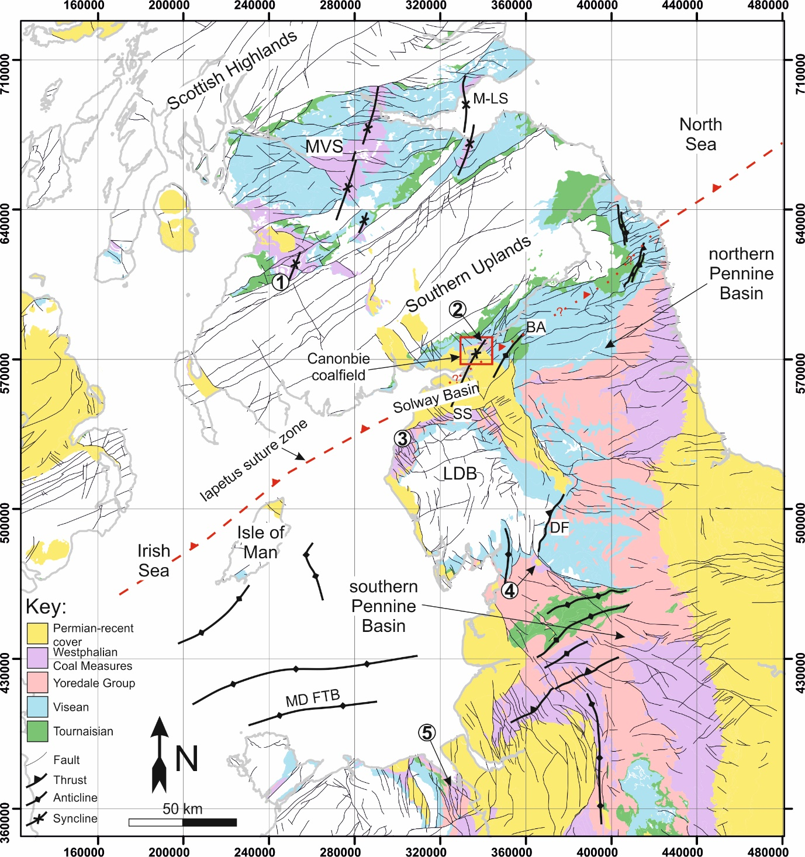
Fig. 1: A simplified onshore geological map of northern Britain depicting the outcropping Carboniferous succession. Major compressional structures are annotated in bold, many of which in northern England and southern Scotland are oblique with respect to roughly north-south orientated Variscan compressional stress (Corfield et al., 1996). Numbered annotations indicate areas of northern Britain where Warwickshire Group (or age equivalent stratigraphy) has been observed cropping out (Powell et al., 2000; Waters et al., 2007; Jones et al., 2011) (also see Fig. 3). 1: South-west Ayrshire; 2: Canonbie; 3: West Cumbria; 4: Ingleton; 5: North Wales. MVS = Midland Valley of Scotland; M-LS = Midlothian-Leven Syncline; BA = Bewcastle Anticline; SS = Solway Syncline; DF = Dent Fault; MD FTB = Môn-Deemster Fold and Thrust Belt. Mapping data courtesy of the British Geological Survey.
SEISMO-STRATIGRAPHIC ANALYSIS OF THE CANONBIE COALFIELD
Datasets
A number of datasets have been utilised in the study of the late Carboniferous succession at Canonbie (Fig. 2). These include 12 UK Oil and Gas Authority and 7 UK Coal Authority onshore digital 2D seismic reflection profiles. Seismic surveys for coal exploration are shot at higher frequencies (<125 Hz) and with lower depths of penetration than surveys for oil and gas exploration (20-80 Hz; Gochioco, 1990). Seismic reflection profiles shot for coal exploration therefore enable detailed mapping of onlapping and truncated seismic reflection geometries within sedimentary units at shallow depths, helping to constrain the timing of various deformation events. Note that the seismic reference datum from which the seismic reflection profiles are plotted for British coal exploration surveys often varies from the sea level datum typically used for oil and gas surveys. Where the coal exploration datum was flat but shot above sea level, the reflection profile was shifted vertically in two-way travel time, assuming a constant near surface velocity of 2400 ms⁻¹. Where the reference datum was sloping, the reflection profile was not used for mapping in this study. These data are supported by 19 borehole penetrations, all of which provide stratigraphic constraints and some of which are associated with petrophysical (mainly gamma ray and acoustic) data and time-depth calibration data. These boreholes were drilled between 1854 and 2008 for coal, oil and gas and coalbed methane exploration purposes (Picken, 1988; Creedy, 1991; Chadwick et al., 1995). The quality of data associated with each borehole varies accordingly.
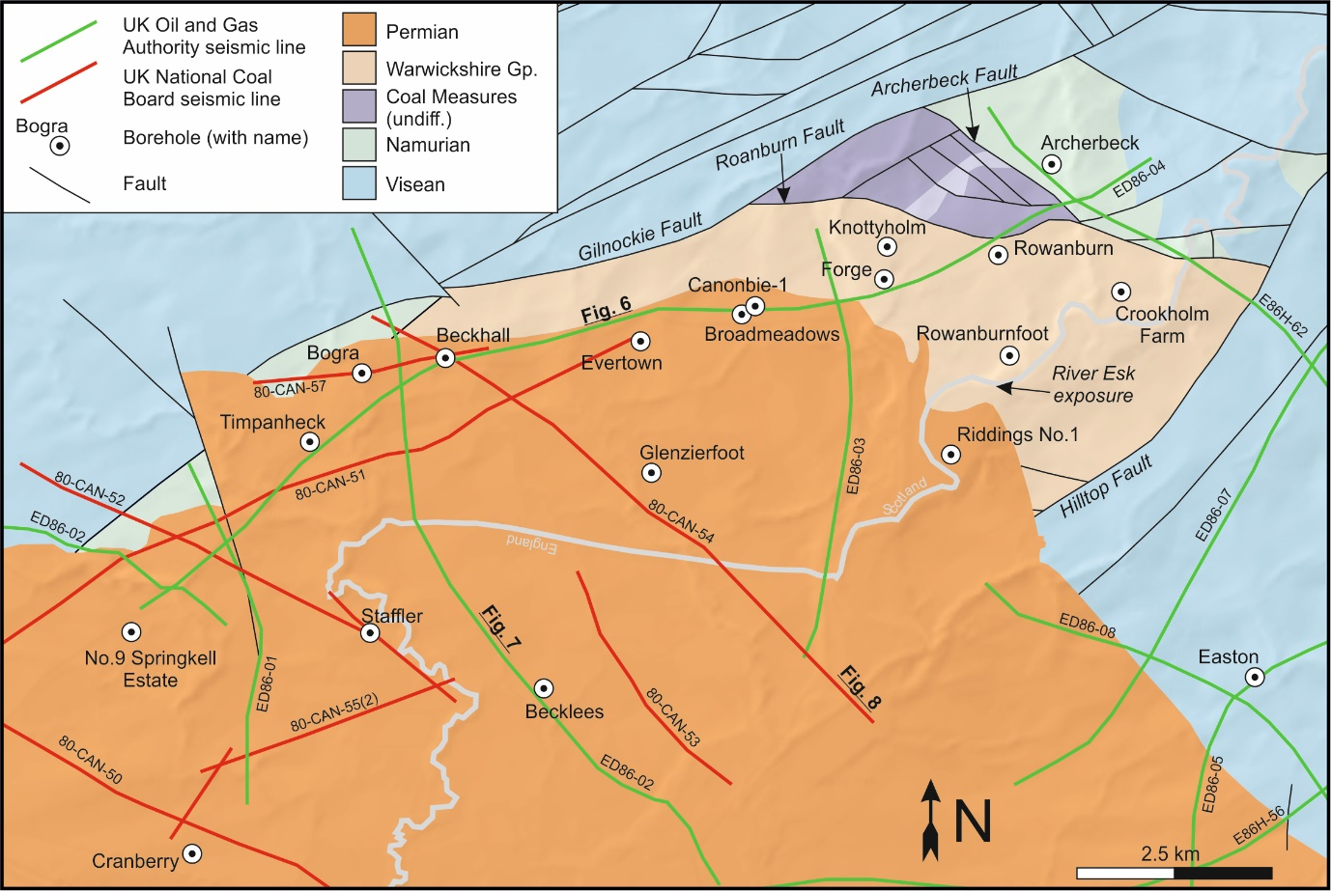
Fig. 2: A summary of the seismic and borehole data from the Canonbie Coalfield used in this study. All seismic data was accessed through UKOGL (UK Onshore Geophysical Library). Borehole data was accessed through the UK OGA (Oil and Gas Authority), IHS Markit and the BGS’s (British Geological Survey) archives at Keyworth.
Stratigraphy
In accordance with previously published UK literature and industrial reports, the traditional NW European Carboniferous chronostratigraphic subdivisions have been adopted (Waters et al., 2011; Davydov, 2004); these subdivisions and the current international subdivisions are correlated in Figure 3.
The Canonbie Coalfield is situated on the Scottish-English border within the northern Solway Carboniferous Basin. The coalfield is one of few places in the UK that preserves a near complete Westphalian stratigraphic record (Fig. 3). There is no time equivalent to the Stephanian succession at Canonbie preserved across northern England and Scotland (Jones et al., 2011). The Canonbie stratigraphic succession consists of <300 m of Langsettian-Duckmantian (Westphalian) Pennine Lower and Middle Coal Measures Formations (herein: PLCM and PMCM). Ordinarily, in north-western Europe, the base of this succession is defined by the Subcrenatum Marine Band (Waters et al., 2011). This unit is absent at Canonbie, and across the entirety of the Midland Valley of Scotland (Cameron and Stephenson, 1985; Dean et al., 2011) such that the Pennine Coal Measures Group (PCM) rests disconformably upon the underlying Namurian succession. The PCM succession is correlatable, across both the coalfield and NW Europe, based on frequent stratigraphically defined coal seams and marine bands. The Pennine Upper Coal Measures Formation (PUCM) is poorly documented in accounts of Canonbie and contains only limited amounts of coal-bearing strata that provide stratigraphic control. Similarly- aged stratigraphy can be recognised further afield in southern Scotland as well as in Cumbria, courtesy of inter-bedded Spirorbis-bearing limestone beds (Mykura, 1967).
Overall upwards-coarsening and primarily ‘red-bed’ Warwickshire Group strata (cf. Waters et al., 2007), conformably overlie PCM strata at Canonbie (Fig. 3). Given the poor likeness of the Warwickshire Group strata at Canonbie with the Warwickshire Group Whitehaven Sandstone Formation of West Cumbria (Jones et al., 2011), and the paucity of stratigraphically correlatable strata from both locations, three locally-defined formations are used to describe the succession at Canonbie (Waters et al., 2007). These are the Eskbank Wood, Canonbie Bridge Sandstone and Becklees Sandstone formations. A chronostratigraphic correlation of the late Westphalian-Stephanian succession preserved at Canonbie across southern Scotland and northern England is presented in figure 3. Uncertainties surrounding this correlation, based primarily on recent petrographical work conducted by Jones et al (2011), are however acknowledged.
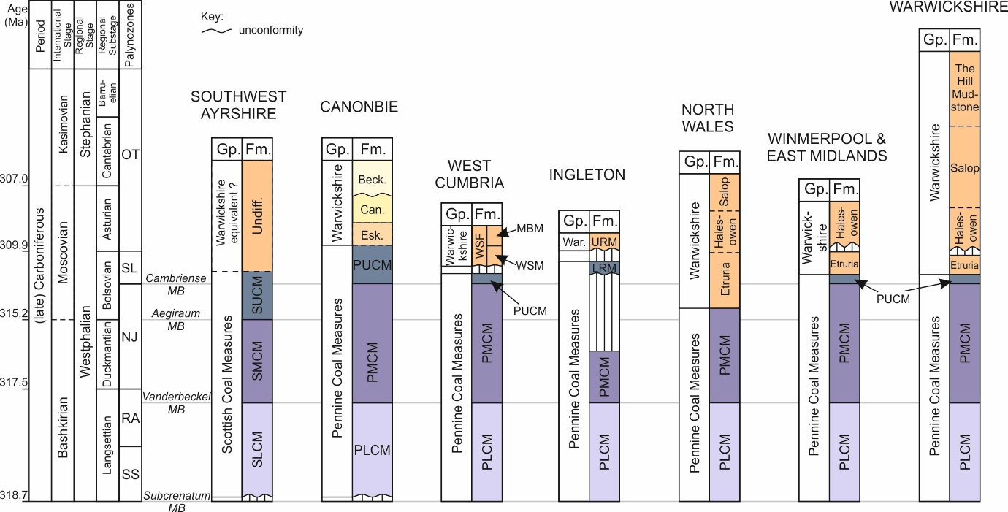
Fig. 3: (left) Stratigraphic columns showing international and regional Stage units of the late Carboniferous. (right) Chronostratigraphic correlation of the Pennine and Scottish Coal Measures, and Warwickshire Group from the Canonbie coalfield to southern Scotland, north-west England and the English Midlands; the Stephanian Stage is incomplete. Based primarily on petrographical work conducted by Jones et al. (2011), augmented by the seismic interpretations of this study and data presented in Picken (1988), Powell et al. (2000) and Waters et al. (2007).The correlation of regional Carboniferous stages of Davydov (2004) is adopted, along with the palynozone subdivisions of Waters et al. (2011). SLCM = Scottish Lower Coal Measures (Fm.); SMCM = Scottish Middle Coal Measures; SUCM = Scottish Upper Coal Measures; PLCM = Pennine Lower Coal Measures; PUCM = Pennine Upper Coal Measures; Esk. = Eskbank Wood; Can. = Canonbie Bridge Sandstone; Beck. = Becklees Sandstone; WSF = Whitehaven Sandstone Formation; WSM = Whitehaven Sandstone Member; MBM = Millyeat Beds Member.
Seismic horizons and time-depth conversion
A number of latest Devonian to Permian-aged seismo-stratigraphic horizons were mapped in two-way travel time. The most consistent mappable surface is the base Permian angular unconformity against which Carboniferous reflectors truncate upwards. The Westphalian-Stephanian succession is characterised by strong, semi-continuous seismic reflectors due to the presence of thick inter-bedded channel sands (Jones et al., 2011) and low-density coals (Picken, 1988). Based on similar studies within the region (Kimbell et al., 1989; Chadwick et al., 1995), a single strong, positive, continuous reflector is believed to mark the Great Limestone Member (Yoredale Group) at the base of the Canonbie Namurian succession. Below this unit, similar inter-bedded limestone-derived reflectors characterise the Visean succession of the Yoredale Group and the (upper) Border Group. The top Caledonian (lower Palaeozoic) basement horizon is interpreted as being represented by a series of strong positive continuous reflectors that are believed to represent subsurface equivalents of the Birrenswark Volcanics or Kelso Lavas (Inverclyde Group) (cf. Kimbell et al., 1989).
Bulk sonic velocities for the Permian succession (2900 ms⁻¹), the Westphalian-Stephanian succession (3600 ms⁻¹) and the latest Devonian-Namurian succession (4500 ms⁻¹) were used to construct a simple velocity model. These values were derived from sonic velocity log data for the Easton, Timpanheck and Becklees boreholes. A seismic velocity of 5000 ms⁻¹ was used for the basement (cf. Evans, 1994). The velocity model was used to convert the seismic surveys from time to depth domain. A comparison between a synthetically produced seismic section using borehole data derived from the Becklees borehole and an Oil and Gas Authority seismic profile is presented in figure 4. Although uncertainty surrounding the time-depth conversion process is acknowledged, the velocity model is deemed adequate for the purposes of the structural interpretation reported in this study. Stratigraphic data derived from borehole reports was used to better constrain structural interpretations of the depth converted seismic survey.
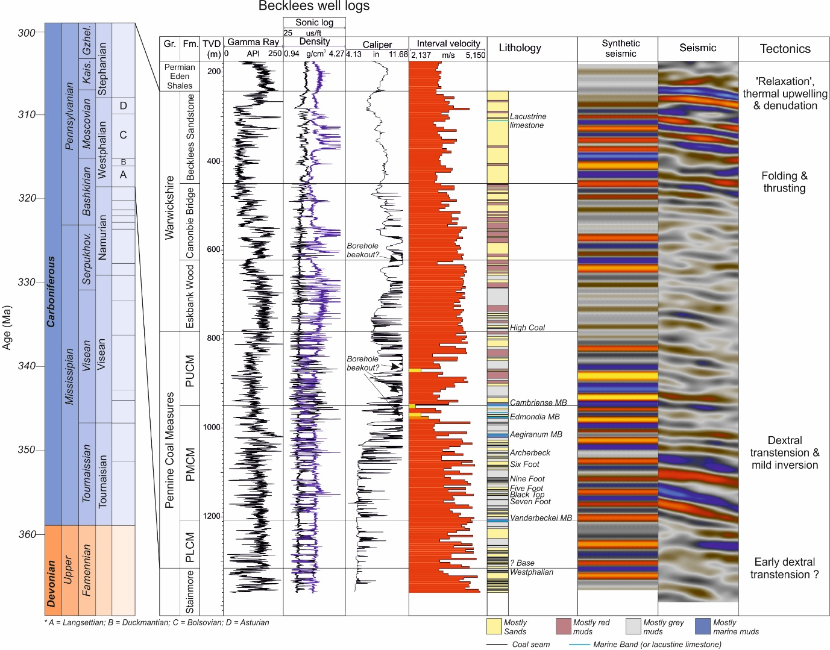
Fig. 4: (left) Stratigraphic columns showing international and regional Stage units. (right) A seismic well tie for the Becklees borehole. Gamma ray, density, sonic and lithological logs (based on Jones and Holliday, 2006; Jones et al., 2011) are shown along with synthetic and observed seismic traces. A = Langsettian; B = Duckmantian; C = Bolsovian; D = Asturian; Gr. = Group; Fm. = Formation; TVD = True Vertical Depth.
STRUCTURE OF THE CANONBIE COALFIELD
To better understand the late Carboniferous kinematic evolution of the Canonbie Coalfield, we present an integrated interpretation of the depth-converted seismic dataset, borehole data and outcropping geology. A number of key structures have been identified as a result of that analysis (Fig. 5a). These include: 1) the NE-SW trending Bewcastle anticline and Hilltop Fault; 2) the NNE-SSW trending Solway syncline; 3) the NE-SW trending Gilnockie Fault; 4) ENE-WSW and E-W trending normal faults such as the Archerbeck, Rowanburn, Woodhouselees and Glenzierfoot Faults, and; 5) (N)NW-(S)SE trending strike-slip faults such as those exposed at surface laterally offsetting the coalfield’s Permian cover. We describe the Westphalian-Stephanian succession through a series of time-slices, focussing upon how this succession was influenced by the combined effects of these key structures during its deposition.
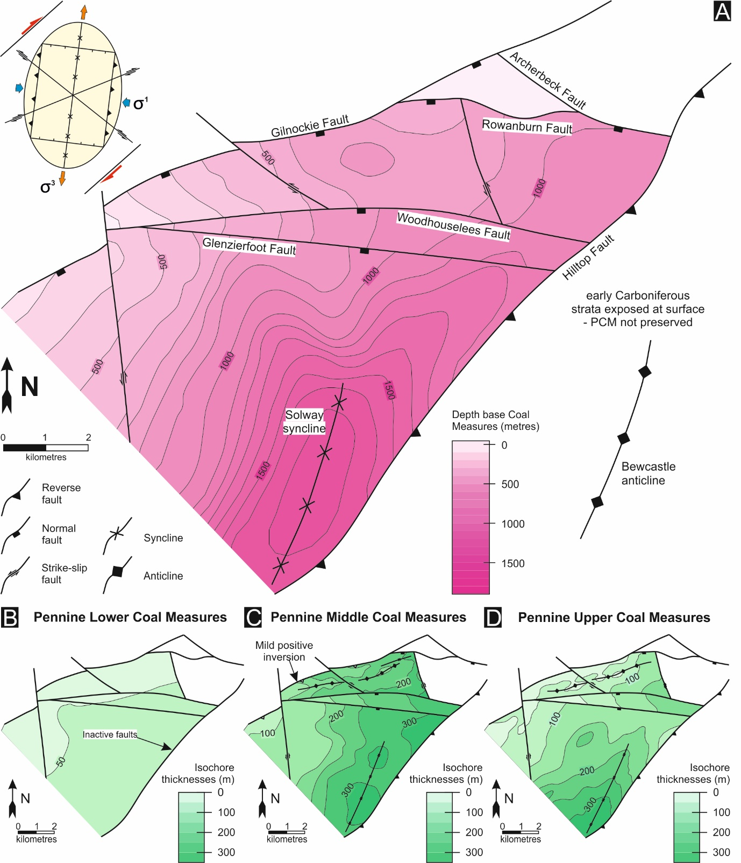
Fig. 5a: Depth map to base Pennine Coal Measures Formation in metres in the Canonbie coalfield. The dominant structural trends interpreted in the Canonbie Coalfield can be accounted for by dextral wrenching along NE-SW orientated faults (inset top-left; 2D strain ellipse illustrating predicted discontinuity trends after dextral wrench on NE-SW orientated faults). 5b, c and d: Isochore thickness maps for the Pennine Lower, Middle and Upper Coal Measures Formations respectively, based on the seismic interpretation for this study. Thickening during deposition of the Pennine Middle and Upper Measures Formations is controlled dominantly by growth within the Solway Syncline structure.
Namurian and Pennine Lower Coal Measures (PLCM)
Based on isochore thickness maps (Fig. 5 b-d), and unlike the general case across the Midland Valley of Scotland (Ritchie et al., 2003; Underhill et al., 2008), Namurian and PLCM stratigraphy at Canonbie shows little evidence of varying significantly in thickness across the coalfield (Fig. 5b). The local PCM subcrop is bound to the northwest by the Gilnockie Fault and to the southwest by the Hilltop Fault that both dip towards the southeast and display net normal and reverse displacement respectively. From seismic data, Picken (1988) interpreted a known local basal Westphalian break in deposition (represented by the absence of the Subcrenatum marine band) as a low-angle overstepping unconformity that resulted from syn-depositional anticlinal growth along a c. N-S compressional axis (e.g. Fig. 10 in Picken, 1988; see also Fig. 42 in Stone et al., 2012). The originally observed outcropping example of this unconformity was argued to represent low-angle unconformable onlap and overstep (Lumsden et al., 1967) but has recently been reinterpreted as, instead, representing a localized sedimentary feature, resulting from multiple phases of river channel-bank collapse (Jones and Holliday, 2016). After careful re-examination of this seismic dataset however, we now interpret the PLCM onlap surface of Picken (1988) as actually representing the Gilnockie Fault, along a 2D seismic profile parallel to the fault, which offsets late Carboniferous strata as well as the strata below it (Fig. 6). The absence of basal Westphalian stratigraphy at Canonbie, we believe, represents a parallel disconformity.
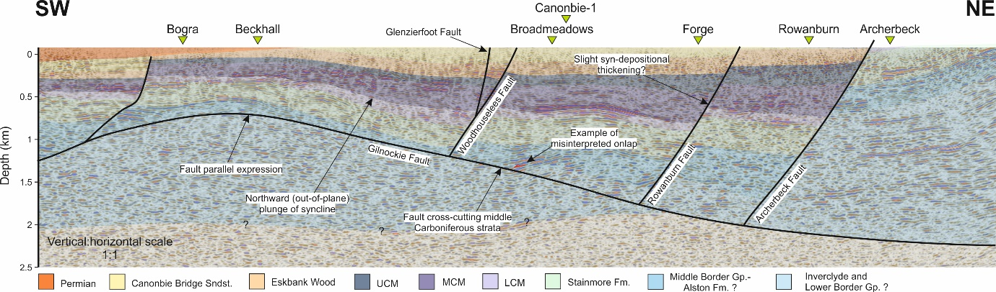
Fig. 6: An interpreted SW-NE orientated seismic profile from the Canonbie Coalfield (Seismic line ED86-04), depicting normal faulting and strike-parallel plunge of the Solway Syncline. Uninterpreted profiles for all the seismic sections included in this study can be previewed at www.ukogl.org.uk. For section location, see Fig. 2.
Pennine Middle and Upper Coal Measures (PMCM and PUCM)
Variations in the thickness of PMCM and PUCM stratigraphy (Figs. 5c, d) suggest that the NNE-SSW trending Solway Syncline acted as a significant depocentre for Duckmantian and younger Westphalian stratigraphy. Throughout the coalfield, these units also thicken gradually towards the Hilltop Fault, within the fault’s footwall, but are at their thickest (<700 m) within the Solway Syncline axial zone. This structure forms a broad, slightly asymmetrical syncline in the south-eastern part of the coalfield (Fig. 5a). To the immediate south, a ‘minor early Carboniferous high’ (Picken, 1988) or local strike-parallel northwards plunge of the Solway syncline marks the southern margin of the Canonbie coalfield. The Solway Syncline continues to the south beyond this ‘high’, (Chadwick et al., 1995). Whilst the syncline’s eastern limb is cross-cut by the Hilltop Fault, its western limb shallows progressively towards the north and west. In the north-western part of the coalfield, a series of bright reflectors within the PMCM can be seen gently onlapping against similarly bright reflectors along the syncline’s western limb (Fig. 7, and inset Fig. 7b). Based on borehole stratigraphy, the reflector that most closely resembles the surface of onlap is thought to represent the Archerbeck coal seam (also PMCM) (Fig. 4).
Synthetic and antithetic faults that merge with the Gilnockie Fault at 1-2 km depth, spatially correlate with the upper limit of the Solway Syncline’s western limb (Fig. 7), onto which the Upper Coal Measures and younger Westphalian stratigraphy thin gently (Fig. 5c, d). The Cambriense Marine Band (locally referred to as the Skelton Marine Band) that marks the base of the PUCM succession is locally absent in borehole penetrations along the north-western margin of the Canonbie Coalfield (Timpanheck, Bogra and Beckhall; Fig. 2). The underlying stratigraphic units form a series of mild, together <2 km wide, parallel trending anticlines, which are overstepped by younger Westphalian stratigraphy (Fig. 7). These mild folds are together tilted south-eastwards by the coalfield wide Solway syncline. As with the Hilltop Fault, along the south-eastern margin of the coalfield, latest Devonian-Visean units (Inverclyde and Border Groups) within the hangingwall of the Gilnockie Fault thicken gently towards the fault, indicating normal movement at the time of latest Devonian-Visean deposition.
Evidence from borehole stratigraphy suggests that minor thickness increases in PMCM and PUCM units towards the ENE-WSW to E-W trending Archerbeck, Rowanburn, Woodhouselees and Glenzierfoot Faults within their hanging walls may be tentatively interpreted based on seismic reflection profiles, although growth of the Solway Syncline appears to have had a greater influence on thickness distribution of Westphalian stratigraphy. These structures all appear to dip steeply towards the south, displacing Carboniferous stratigraphy in a normal sense (Fig. 6). Latest Devonian to early Carboniferous-aged units (Inverclyde and Border Groups) are offset normally by and may be tentatively interpreted as gently thickening towards the Archerbeck, Rowanburn, Woodhouselees and Glenzierfoot Faults within their hanging walls, as they do towards the major parallel fault systems that bound the Solway Basin to the south (Chadwick et al., 1995).
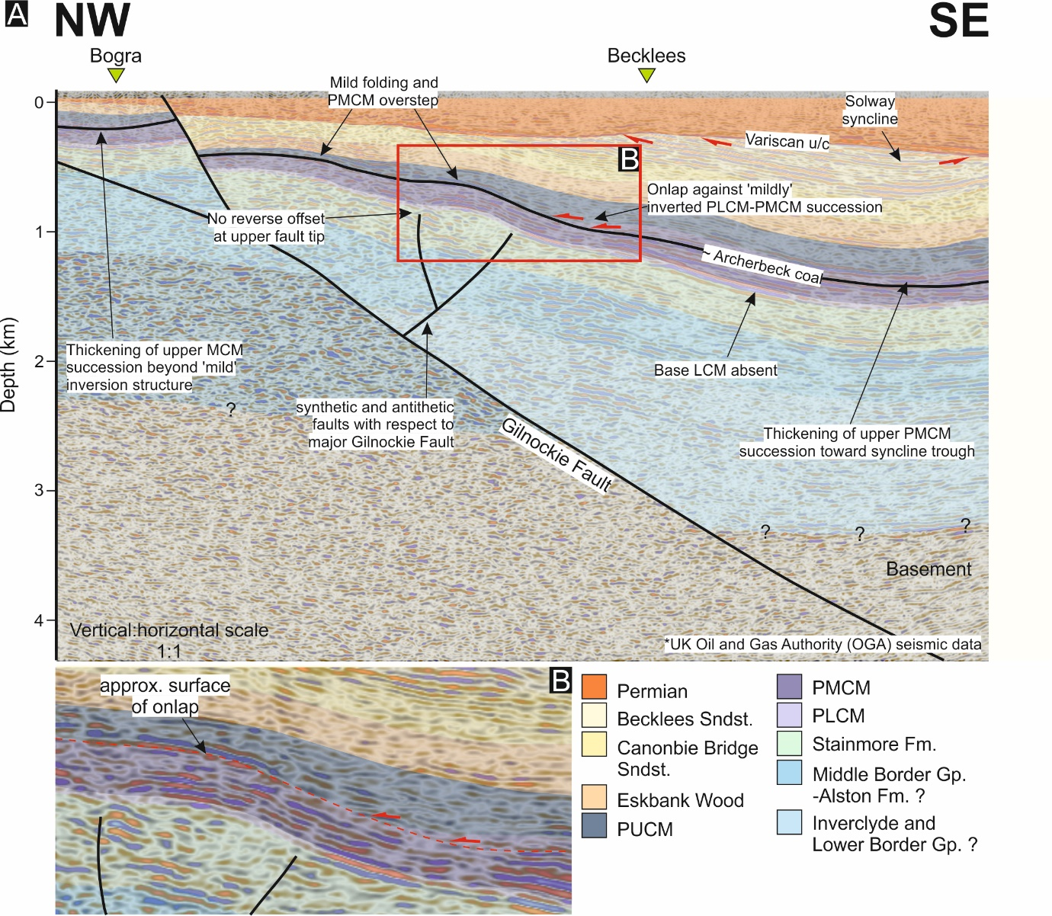
Fig. 7: An interpreted NW-SE seismic profile (Seismic line ED86-02) depicting folding of the Solway Syncline, mild inversion along antithetic and synthetic normal faults of the Gilnockie Fault, onlapping Pennine Middle Coal Measures (PMCM) against mild inversion folds and normal offset along the Gilnockie Fault. Uninterpreted profiles for all the seismic sections included in this study can be previewed at www.ukogl.org.uk. For section location, see Fig. 2.
Warwickshire Group
Although much of the subcropping Warwickshire Group succession has been partly eroded prior to Permian deposition, thus limiting further use of isochore thickness maps, reflector geometries observed within the Canonbie Bridge and Becklees Sandstone Formations in the Solway syncline trough suggest that the nature of this depocentre was altered during deposition of the Becklees Sandstone Formation. In higher resolution coal exploration seismic reflection profiles, a thick succession (< 200 m) of Becklees Sandstone Formation can be observed showing a significant degree of onlap against the Canonbie Bridge Sandstone Formation stratigraphy within the Solway syncline’s western limb (Fig. 8). In addition, reflectors belonging to the Canonbie Bridge Sandstone Formation within the syncline’s western limb are slightly truncated against the surface of onlap (marked u/c 3; Fig. 8b). This surface of onlap is interpreted as an angular, partially erosional, unconformity. An additional unconformable horizon can be observed from the seismic data and is downcutting into younger Becklees Sandstone stratigraphy within the Solway syncline, truncating underlying reflectors (u/c 4; Fig. 8b). Given that the Becklees Sandstone Formation has been interpreted as having been deposited in a fluvial environment (Jones et al., 2011) and given the broad U-shape geometry of the unconformity, this feature is interpreted as representing an erosive and, most likely, confined fluvial channel set (cf. Ramos et al., 2002). Above angular unconformity u/c 3 (Fig. 8b), the axis of the Solway syncline appears to have migrated south-eastwards towards the Hilltop Fault. Given the discordance between reflectors within the Canonbie Bridge and Becklees Sandstone Formations in the syncline’s western limb (Fig. 8a), this eastwards migration of the Solway syncline depocentre is most likely associated with a steepening of this western limb. In addition, and along the syncline’s north-western limb, the entirety of the Carboniferous succession forms a high amplitude (<1 km) anticline with a shorter and shallowly dipping north-western limb (Fig. 8a). This anticline correlates spatially with the Gilnockie Fault, which dips more shallowly, at least locally, within the uppermost 800 m of the subsurface. The onlapping reflector geometries described here within the Becklees Sandstone Formation of the Solway syncline (Fig. 8a), constrain the timing of the formation of this anticline to Westphalian D- early Stephanian (cf. Fig. 3) (Jones et al., 2011).
The NNE-trending Bewcastle anticline occurs within the hanging wall block of the parallel Hilltop Fault. Unlike the comparatively minor anticlines along the north-western margin of the coalfield, there are no timing constraints for the formation of this anticline but it is assumed that they formed at similar times. The Hilltop Fault tips out within the Solway Basin around the southern margin of the coalfield (Chadwick et al., 1995).
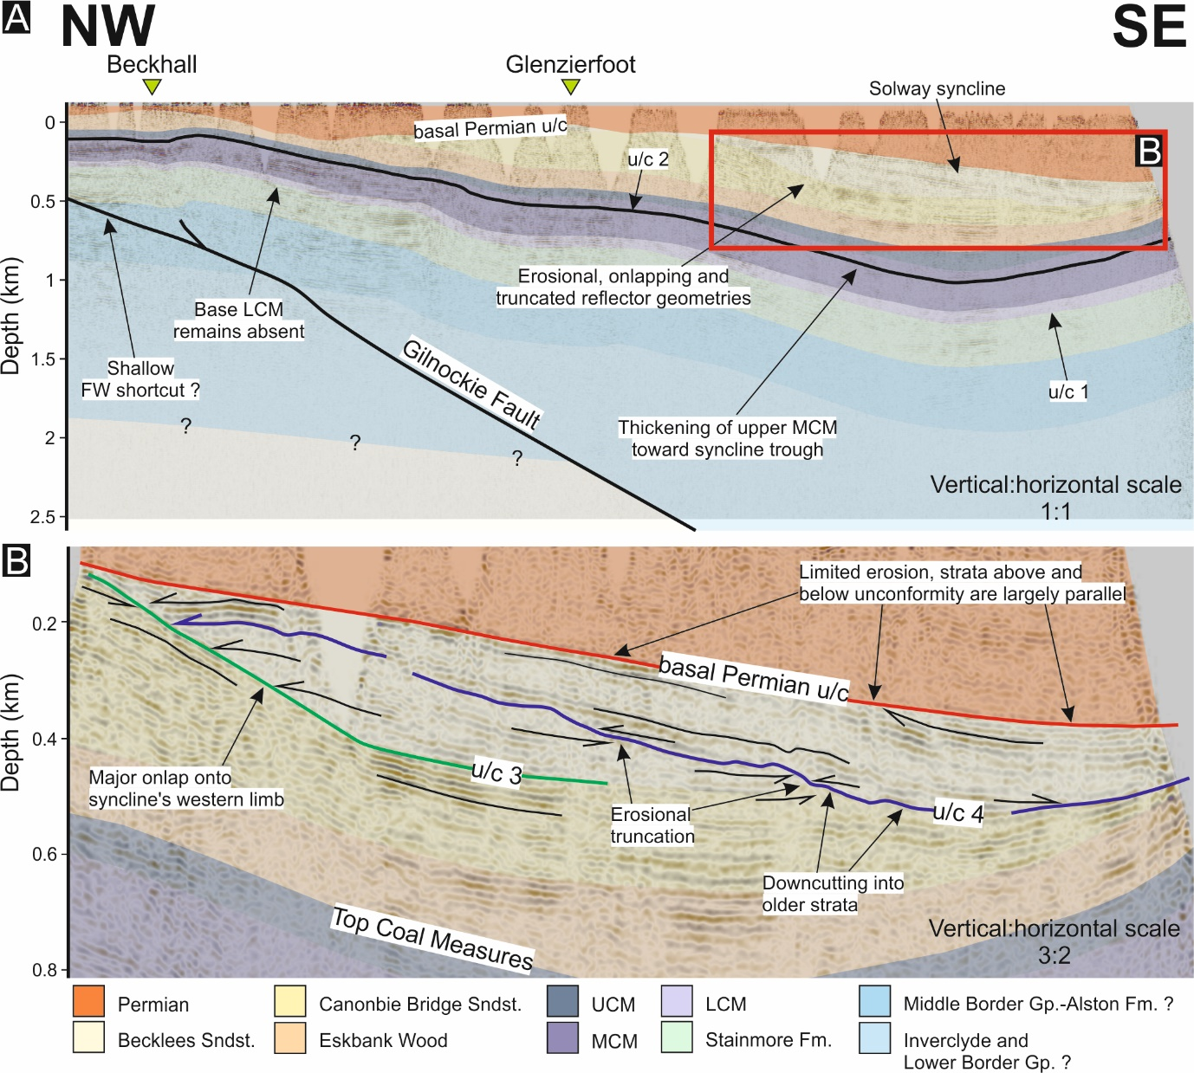
Fig. 8a: An interpreted NW-SE orientated seismic profile depicting folding of the Solway Syncline (Seismic line 80-CAN-54). 8b: A closer look at the reflector geometries belonging to the Becklees Sandstone Formation (Warwickshire Group) within the axis of the Solway Syncline. A series of reflectors are shown onlapping against the western limb of the Solway Syncline. Erosional truncation of reflectors occurs within the axis of the Solway Syncline and is interpreted as representing down cutting, fluvial strata. Uninterpreted profiles for all the seismic sections included in this study can be previewed at www.ukogl.org.uk. For section location, see Fig. 2.
Stephanian-early Permian
Later Stephanian to early Permian deposits are absent from the Canonbie Coalfield, as is generally the case in the rest of north-western Europe (see Besly and Cleal, in press). Both Permian strata and older Carboniferous strata are offset normally by one of the steeper synthetic faults to the Gilnockie Fault as well as ENE- to east-trending faults (Figs. 6, 7). Older Westphalian strata are offset by a greater magnitude along this structure than Permian strata, suggesting that an episode of normal faulting preceded Permian deposition. At least two (N)NW-(S)SE trending faults cut, with apparent dextral offset, the Gilnockie Fault as well as the Permian-aged cover by <500 m along the western margin of the coalfield (Fig. 5a); this pattern is consistent all across the Northumberland-Solway Basin (de Paola et al., 2005). This group of structures is difficult to identify within seismic reflection profiles, suggesting that their vertical displacement is minimal. A strong degree of uncertainty surrounding the timing of these structures is acknowledged.
TECTONIC CONTROLS ON LATE CARBONIFEROUS EVOLUTION OF THE CANONBIE COALFIELD
We believe that the fragmented late Carboniferous kinematic evolution of the Canonbie Coalfield can be constrained by three episodes of deformation (Fig. 9). These three episodes of deformation can be represented by unconformities described in the PMCM and the Warwickshire Group respectively (Figs. 7 and 8) as well as later normal fault movement prior to deposition of the basal Permian succession at Canonbie (Fig. 6).
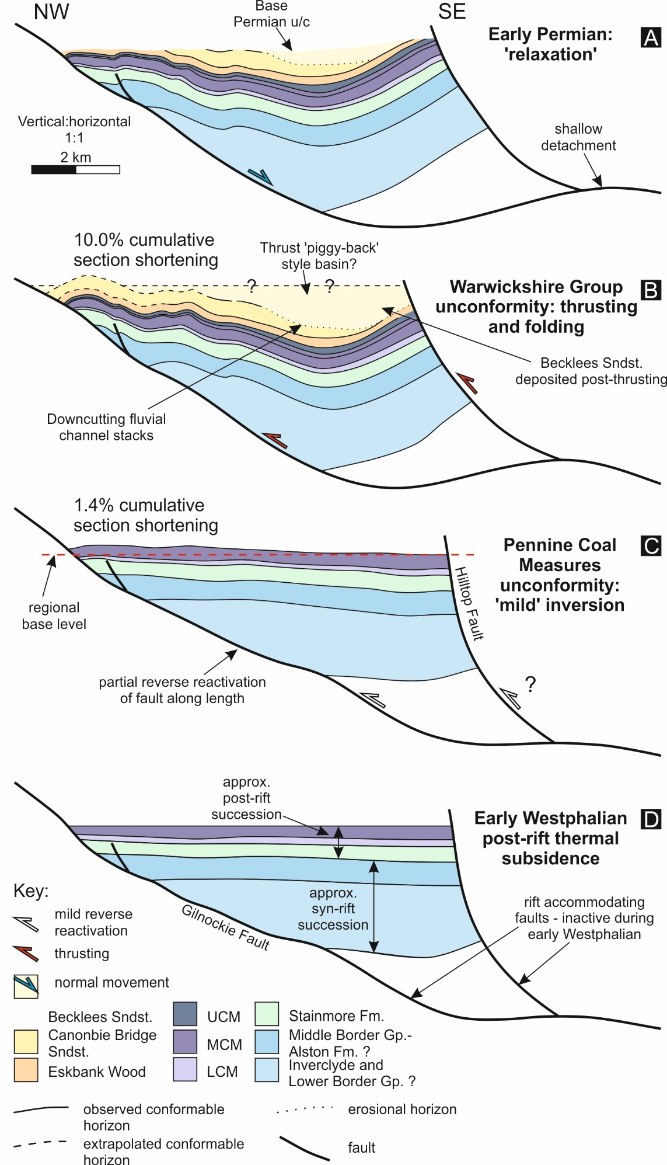
Fig. 9: Two-dimensional palinspastic cross-section restorations for the NW-SE orientated section presented in figure 8. Timings of deformation events are constrained by onlapping reflector geometries. The cross-section can be restored by incorporating a sub-horizontal detachment at around 6-7 km depth. Restorations are performed using the unfolding, move-on-fault and decompaction modules in MOVE (Petroleum Experts) structural model building software.
Pennine Coal Measures (PCM) unconformity
Based on isochore thickness distributions for PMCM and PUCM and asymmetric, low-amplitude folding correlating spatially with the Gilnockie Fault, the local PMCM unconformity is interpreted to indicate significant syndepositional tectonism. Although folding of the entire Carboniferous succession beneath the base Permian unconformity has ultimately distorted the nature of the PMCM unconformity, 2D palinspastic cross-section restoration of a NE-SW section through the Canonbie Coalfield and Gilnockie Fault reveals that low amplitude folding occurred at the same time as this unconformity (Fig. 9c), resulting in 1.4% along length shortening. Along strike, the steeper sided limbs of asymmetric, low-amplitude folds correlate laterally with the steeply dipping synthetic and antithetic normal faults of the Gilnockie Fault (Fig. 7), although there is interference between adjacent folds. Previous studies of inverted basins suggest that similar asymmetric, low-amplitude folding can be indicative of ‘mild’ positive fault inversion (sensu Song, 1997) - where the ‘null point’ or the point along an inverted fault’s length at which there is zero net displacement (sensu Williams et al., 1989) remains at the fault’s upmost tip (cf. Bally, 1984; Butler, 1998; Jackson et al., 2013). Mild inversion structures are strongly dominated by folding due to partial reverse reactivation of a fault along its length, where thrusting does not accommodate a significant amount of shortening (Jackson et al., 2013). Compressional stress at the time of folding is insufficient to prompt full reverse reactivation of these faults. The asymmetrical nature of the local PMCM and PUCM depocentre in the Canonbie Coalfield can be explained by these asymmetric and mild inversion structures (Figs. 5 and 7). Oblique-slip (dextral) movement along similar NE-SW trending structures, such as the Gilnockie and Hilltop Faults, may have contributed to the slightly oblique NNE-SSW trending growth of the Solway syncline with respect to these faults. The Solway syncline has traditionally been associated with Variscan shortening (Chadwick et al., 1995). Attributing early Westphalian growth of the NNE-SSW trending syncline to a roughly north-south shortening axis (σ¹) (cf. Copley and Woodcock, 2016) during simultaneous mild extension along WNW-ESE trending normal faults (Fig. 5a), clearly creates a series of geometric problems, particularly so in a lower strain setting (cf. Coward, 1993; De Paola et al., 2005; Caldwell and Young, 2013).
Simultaneous extension and shortening along these two contrasting structural trends may have alternatively been accommodated by dextral movement along NE-SW trending thick-skinned structures and kinematic strain partitioning (cf. De Paola et al., 2005; Leslie et al., 2015). The schematically illustrated two-dimensional strain ellipse for dextral strike-slip movement along NE-SW orientated deep basement faults incorporates simultaneous broadly east-west shortening and broadly north-south extension, echoing early Westphalian growth of the NNE-SSW trending Solway Syncline and mild inversion of the Gilnockie Fault as well as extension across the broadly east-west trending Rowanburn, Woodhouselees and Glenzierfoot faults (inset Fig. 5a). The structural framework represented by this strain ellipse also accommodates simultaneous strike-slip movement of conjugate faults oblique to the main NE-SW trending faults (e.g. Fig. 6). The localised stress field may have been caused by dextral movement along the seemingly more thin-skinned (Fig. 9) Gilnockie and Hilltop Faults or by distant movement along major thick-skinned faults such as the Southern Upland and Highland Boundary fault systems to the north (Fig. 1). If so, what would have aided the great (over 1000 km; Domeier and Torsvik, 2014) extent of the effects of this stress field remains unresolved.

Warwickshire Group unconformity
The Warwickshire Group unconformity appears to represent a more significant rearrangement of the local foreland basin system. Two-dimensional palinspastic restoration of the NW-SE striking cross-section illustrated in figure 9 suggests that the Warwickshire Group unconformity, seen in seismic data along the buried axis of the Solway syncline (Fig. 8), formed because of anticlinal folding due to thin-skinned thrusting along the Gilnockie Fault. This second basin reorganisation episode resulted in at least 10% shortening (Fig. 9b). Unlike prior inversion that occurred during the deposition of the PMCM, shortening occurring during deposition of the younger Warwickshire Group succession appears to have been partly accommodated by the most shallow, comparatively shallowly-dipping part of the Gilnockie Fault (cf. Fig. 8a). As this part of the fault does not appear to have accommodated significant extension or shortening prior to this later episode of basin inversion, this part of the fault may have originated as a footwall short-cut (cf. Hayward and Graham, 1989). Folding and thrusting coeval with the Warwickshire Group unconformity appears to have caused a significant rearrangement in the nature of the local Solway Syncline depocentre (Fig. 8a). Folding and thrusting appears to have caused a steepening of the syncline’s north-western limb, and perhaps in doing so, confined the local longitudinal fluvial system causing it to become more erosive (cf. Turner, 1992; Ramos et al., 2002; Suriano et al., 2015). Major reverse movement along the Hilltop Fault at this time and the resulting uplift of the hanging wall may have constituted a minor lithospheric load along the coalfield’s south-western margin (cf. Karner and Watts, 1983). This would have perhaps prompted additional localised flexure-induced accommodation and restricted uplift of the Solway syncline’s eastern limb. The minor Carboniferous high, that marks the southern limit of the coalfield (Picken, 1988; Chadwick et al., 1995), may be attributed to the Hilltop Fault pinching out laterally at a similar latitude if the depocentre immediately to the north (the coalfield) were partly attributed to local flexure-induced subsidence.
The unconformity observed in seismic cross-section crops out along the River Esk, within the study area, and was recognised by Jones et al (2011) who observed polygonal cracks penetrating the underlying Canonbie Bridge Sandstone filled by markedly more quartz-rich arenitic Becklees Sandstone Formation, suggesting a time-gap. This unconformity, previously only recognised in outcrop, has been argued to correlate with a regional unconformity (the Symon unconformity; Arkhurst et al., 1997; Dean et al., 2011; Waters et al., 2011) and the formation of the Catabrian and Iberian oroclines in southern Europe (c. 310-295 Ma; Murphy et al., 2016) that is believed to represent a major phase of Variscan inversion (Peace and Besly, 1997; Corfield et al., 1996; Powell et al., 2000; Pharaoh et al., 2019). The regional stratigraphic correlation for the Canonbie Warwickshire Group strata of Jones et al. (2011) may appear to contradict this, although constraints on the local Warwickshire Group at Canonbie are notoriously poor (Waters et al., 2007). Similar ‘tightening’ of the Midlothian-Leven syncline has been observed further north in the Midland Valley of Scotland (Ritchie et al., 2003; Underhill et al., 2008); albeit without the same degree of timing constraint. In this instance, tightening, as opposed to fold nucleation, was attributed to approximately N-S Variscan shortening.
Basal Permian unconformity and latest Westphalian-early Permian relaxation
The post-Westphalian kinematic evolution of the coalfield, prior to deposition of the Permian succession appears to be represented by a ‘relaxation’ in compressional stresses (cf. Dempsey, 2016). Normal offset occurs primarily along pre-existing E-W orientated faults, perhaps indicating continued dextral transtension (cf. Coward, 1993; Monaghan and Pringle, 2004; De Paola et al., 2005; Pharaoh et al., 2019) but also along the Gilnockie Fault (Fig. 7). The basal Permian angular unconformity cuts stratigraphy below it, perhaps suggesting further uplift prior to Permian deposition following the late Westphalian-Stephanian (cf. Underhill and Brodie, 1993), although this uplift event appears not to have been accommodated by fault movement.
DISCUSSION
Regional tectonic implications
The evidence reported here suggests that both Variscan (cf. Fraser and Gawthorpe, 1990; Corfield et al., 1996) and Uralian tectonic forces (cf. Coward, 1993) contributed towards the multiple stages of late Carboniferous kinematic evolution affecting the Canonbie Coalfield. This kinematic evolution is characterised by syn-sedimentary faulting, folding and positive inversion. The early Westphalian onset of this deformation occurred during a period when Carboniferous basins in neighbouring northern England are widely believed to have been subsiding due to post-rift thermal relaxation (cf. McKenzie, 1978; Leeder, 1982; Kimbell et al., 1989; Fraser and Gawthorpe, 1990). Given the timing and mild characteristics of early Westphalian deformation, we attribute an initial episode of basin reorganisation to widespread dextral wrenching along NE-trending faults, perhaps due to the distant E-W closure of the Ural Ocean. We argue that the early onset of wrenching occurred prior to maximum Variscan basin shortening in the northern British foreland. Contrary to some late Carboniferous tectonic models (Coward, 1993; De Paola et al., 2005), Variscan basin shortening is believed to have been important, even in northern Britain. This is due to the close timing relationship between basin shortening in the Canonbie Coalfield, in central England (Peace and Besly, 1997) and the formation of the central Iberian and Catabrian oroclines (c. 310-295 Ma; Murphy et al., 2016). Both episodes of basin shortening, despite their apparent contrasting stress fields, were accommodated by similar structures. We suggest that syn-depostional faulting, folding and positive inversion influenced late Carboniferous depocentres in the Canonbie Coalfield. In this respect the coalfield, which was situated in the distal Variscan foreland system, evokes similarities between the northern British part of the Variscan foreland basin system and the ‘broken’ Andean foreland system of northern Patagonia (Fig. 10, Bilmes et al., 2013). Further work with similar datasets across the British Variscan foreland, studying the nature of local unconformities and thickness trends within the late Carboniferous succession is however, undoubtedly required before previous assumptions regarding the British Isles at this time can be made.
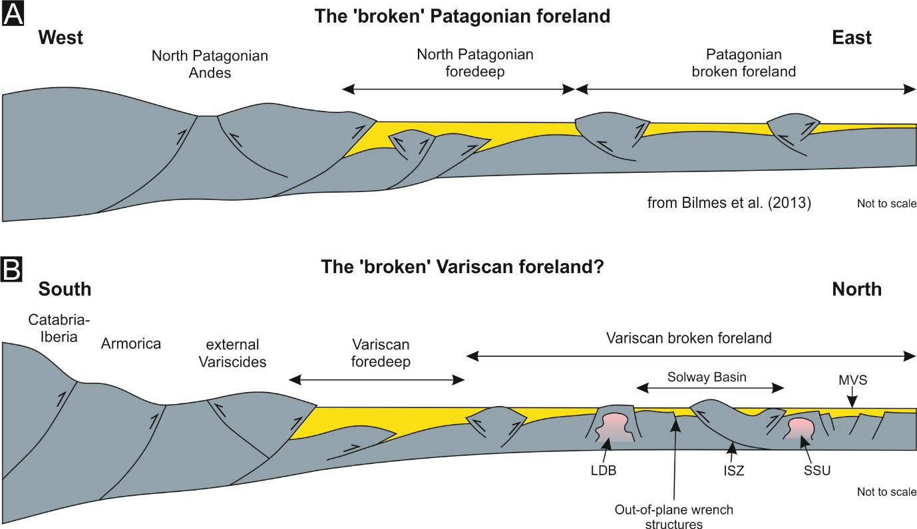
Fig. 10a: Schematic cross-section of the North Patagonian Andes, the North Patagonian fold and thrust belt (FTB), North Patagonian foredeep and the North Patagonian broken foreland (from Bilmes et al., 2013). 10b: A schematic late Westphalian reconstruction of the Variscan collision zone, external Variscides, Variscan fordeep and the northern British broken foreland. LDB = Lake District Block; ISZ = Iapetus Suture Zone; SSU = Scottish Southern Uplands; MVS = Midland Valley of Scotland.
Strain localisation along obliquely orientated structures
Given the important role that faulting, folding and positive inversion appears to have played in determining the characteristics of late Carboniferous depocentres in the Canonbie Coalfield, we consider the localisation of strain along depocentre defining structures. In northern Britain, the localisation of strain along obliquely orientated structural trends with respect to the apparent, approximately N-S compressional stress orientation requires fault damage zones significantly weaker (>30%) than intact bedrock (Copley and Woodcock, 2016). Having undergone reverse (dextral) reactivation during deposition of the PMCM, albeit only partial reactivation along fault length (Fig. 6), NE-SW trending faults such as the Gilnockie Fault are likely to have remained susceptible to further reverse reactivation, even in a contrasting lateral sense, during deposition of the Warwickshire Group. There is limited evidence to suggest that approximately E-W trending structures that were roughly perpendicular to the orientation of maximum compressional stress, at Canonbie or in the immediately surrounding region, accommodated significant basin shortening during this period (Fig. 6) (De Paola et al., 2005). Three-dimensional sandbox models and modern day analogues for inverted basins suggest that steep faults orientated perpendicular to the orientation of maximum compressive stress are unlikely to accommodate significant shortening in low-strain settings (Keller and McClay, 1995; Di Domenica et al., 2014). With this in mind, E-W structures, perpendicular with respect to compressional stress, may have remained ‘frozen’ during this period, leaving more oblique, recently active and, therefore, mechanically weaker structures to accommodate preferentially shortening.
Strain location within rheologically weaker crustal rock
Line-length restoration suggests that at least 10% cumulative shortening occurred along a NW-SE axis throughout the prolonged late Carboniferous inversion phase (Fig. 9). In reality, basin shortening is likely to have been larger due to both sub-seismic scale shortening and out-of-plane deformation. This shortening occurred in a region widely regarded as having occupied a low-strain setting within the Carboniferous foreland (Corfield et al., 1996; De Paola et al., 2005). In the Midland Valley of Scotland, steeply dipping faults such as the Highland Boundary and Southern Upland fault systems are believed to have exerted a strong control on the magnitude of shortening (Ritchie et al., 2003; Underhill et al., 2008). A dissipating stress field derived from these faults may have contributed towards the localised stress field at Canonbie. However, despite their shared proximities to these fault systems, as well their similarly orientated structural fabrics, based on regional studies subsurface studies and accounts of outcropping geology (cf. Chadwick et al., 1995; Lumsden et al., 1967), there is a large disparity between the high magnitude of basin shortening observed at Canonbie compared with the Scottish Southern Uplands or the Lake District (Fig. 1). The Solway Basin and the Canonbie Coalfield is underpinned by relatively weak upper crustal rock, composed predominantly of thick Carboniferous sediment and weakly metamorphosed Ordovician-Silurian slate and phyllite (Rickards and Woodcock, 2005; Stone et al., 2012). This contrasts with the thinner Carboniferous successions and mechanically stronger, granitoid dominant shallow crust that underpins the areas immediately to the north and south of the coalfield in the Scottish Southern Uplands and the Lake District (Bott et al., 1967; Allsop et al., 1987; Howell et al., 2019; Howell et al., 2020). As a result, the Solway Basin may have therefore also accommodated shortening for a wider region, including those mechanically stronger regions that were less able to accommodate basin shortening, just as the Solway Basin likely accommodated early Carboniferous extension for a wider region.
High magnitude seismic-scale folding and thrusting is often accommodated by a shallow to mid-level crustal detachment (Coward et al., 1999). The northwards dipping Iapetus suture zone that, prior to Caledonian collision of Avalonia and Laurentia, separated present day Scotland from northern England (cf. Freeman et al., 1988; Soper et al., 1992) constitutes such a detachment. This detachment is undoubtedly at a relatively shallow depth beneath the Canonbie Coalfield and Solway Basin, regardless of the contrasting interpolations of the onshore Iapetus suture zone (Fig. 1) (Chadwick et al., 1995; De Paola et al., 2005). Furthermore, our cross-section restorations of the Solway Syncline through the Canonbie Coalfield suggest a detachment at 6 to 7 km depth below surface (Fig. 9) that may reflect this suture. Along with the locally mechanically weak crustal rock underpinning the region, the favourable (slightly oblique) structural fabric orientation and the weak (following dextral reactivation) accommodating NE-trending faults, this detachment may therefore have also been able to aid the accommodation of greater localised basin shortening with respect to adjacent areas.
Implications for decarbonisation and low carbon subsurface energy resources in northern England and southern Scotland
Over the past century, coal including that sourced from the Canonbie Coalfield fuelled the bulk of the UK’s electricity and heating. Due to both the increased availability of domestic natural gas and the UK’s recent effort to decarbonise its energy supply, this is no longer the case. On the contrary, the use of coal is widely condemned by western media as coal is now regarded as the ‘dirtiest’ fossil fuel because of the associated CO₂ and other pollutant emissions. However, UK coal mining has left a legacy of abandoned infrastructure that has the potential to be repurposed as the UK seeks to further decarbonise its energy supply. At the time of writing, the British Geological Survey are constructing and operating a research site in Glasgow to further understand the potential of water from abandoned coalmines for geothermal energy (Watson et al., 2019). Coupled CO₂ sequestration and enhanced coal bed methane recovery offers a further, if riskier, low carbon subsurface energy prospect for northern England and southern Scotland (Jones et al., 2004). This technology remains in its infancy although the Canonbie Coalfield itself was investigated as recently as 2015 for coal bed methane purposes. Development plans were abandoned due to, amongst other factors, the ‘structural complexity’ of the coalfield. To date, three deliberate deep geothermal wells have been drilled in neighbouring northern England, penetrating Carboniferous strata (Gluyas et al., 2018). Thus far, the most encouraging of these wells was the Eastgate borehole which intersected high permeability basement faults and fractures (Manning et al., 2007). Carboniferous tectonism is widely believed to have been underpinned by thick-skinned, basement involved faults such as those intersected by the Eastgate borehole (Corfield et al., 1996). Our cross-section restorations for the Canonbie Coalfield, however, suggest that deformation in this area was instead accommodated by thin-skinned structures that shallow at c. 6-7 km depth. Given that this study has revealed inconsistencies between past assumptions made regarding the bedrock that hosts these potential resources and reality, and that investments such as those highlighted are already being made, would it therefore not be worth investing time exploring pre-existing and publicly available datasets in order to reduce uncertainties surrounding the UK subsurface?
CONCLUSIONS
- Local seismic and borehole-based mapping of the late Carboniferous succession in the Canonbie Coalfield (SW Scotland) provides evidence of repeated episodes of positive inversion, syn-depositional folding and unconformities within the Westphalian (Bashkirian-Moscovian) to Stephanian (Kasimovian) Pennine Coal Measures and Warwickshire Group successions.
- Positive inversion and syn-depositional folding dictated Westphalian-Stephanian depocentres at Canonbie. The basin history thus revealed at Canonbie is at variance with generally accepted models in neighbouring northern England that state these basins subsided due to post-rift thermal subsidence during the late Carboniferous.
- A late Westphalian-Stephanian unconformity within the Warwickshire Group succession at Canonbie, which approximately correlates with ~10% local basin shortening at Canonbie, documented further major basin shortening throughout the late Carboniferous Variscan foreland and the formation of the Cantabrian and Iberian oroclines in southern Europe, also contradicts observations that maximum Variscan shortening at this time had minimal impact on late Carboniferous basins in northern England.
- Our mapping of the Westphalian-Stephanian succession at Canonbie evokes similarities between the local Variscan foreland basin system and ‘broken’ foreland systems, where sedimentation is controlled by local tectonism, such as the eastern Andean retro-arc foreland of Patagonian, South America.
- Local variations in crustal rheology, inherited fault strengths and their variation over time, fault orientation with respect to the evolving dominant stress field and mid-crustal detachments are suggested to play important roles in strain localisation and ultimately the nature of Westphalian-Stephanian depocentres at the Canonbie Coalfield.

References
Allsop, J.M., 1987. Patterns of late Caledonian intrusive activity in eastern and northern England from geophysics, radiometric dating and basement geology. Proceedings of the Yorkshire Geological Society, 46(4), pp.335-353. https://doi.org/10.1144/pygs.46.4.335
Assumpcao, M., 1992. The regional intraplate stress field in South America. Journal of Geophysical Research: Solid Earth, 97(B8), pp.11889-11903. https://doi.org/10.1029/91JB01590
Bea, F., Fershtater, G.B. and Montero, P., 2002. Granitoids of the Uralides: Implications for the evolution of the orogen. Washington DC American Geophysical Union Geophysical Monograph Series, 132, pp.211-232. https://doi.org/10.1029/132GM11
Besly, B.M., Burley, S.D. and Turner, P., 1993, January. The late Carboniferous ‘Barren Red Bed’play of the Silver Pit area, Southern North Sea. In Geological Society, London, Petroleum Geology Conference series (Vol. 4, No. 1, pp. 727-740). Geological Society of London. https://doi.org/10.1144/0040727
Bilmes, A., D'Elia, L., Franzese, J.R., Veiga, G.D. and Hernández, M., 2013. Miocene block uplift and basin formation in the Patagonian foreland: the Gastre Basin, Argentina. Tectonophysics, 601, pp.98-111. https://doi.org/10.1016/j.tecto.2013.05.001
Bott, M.H.P., 1967. Geophysical investigations of the northern Pennine basement rocks. Proceedings of the Yorkshire Geological Society, 36(2), pp.139-168. https://doi.org/10.1144/pygs.36.2.139
Brown, D., Juhlin, C., Tryggvason, A., Friberg, M., Rybalka, A., Puchkov, V. and Petrov, G., 2006. Structural architecture of the southern and middle Urals foreland from reflection seismic profiles. Tectonics, 25(1). https://doi.org/10.1029/2005TC001834
Burgess, P.M. and Gayer, R.A., 2000. Late Carboniferous tectonic subsidence in South Wales: implications for Variscan basin evolution and tectonic history in SW Britain. Journal of the Geological Society, 157(1), pp.93-104. https://doi.org/10.1144/jgs.157.1.93
Caldwell, W.G.E. and Young, G.M., 2013. Structural controls in the western offshore Midland Valley of Scotland: implications for Late Palaeozoic regional tectonics. Geological Magazine, 150(4), pp.673-698. https://doi.org/10.1017/S0016756812000878
Cameron, I.B. and Stephenson, D., 1985. British Regional Geology: The Midland Valley of Scotland (Fifth edition). London: HMSO.
Catuneanu, O., 2019. First-order foreland cycles: Interplay of flexural tectonics, dynamic loading, and sedimentation. Journal of Geodynamics, 129, pp.290-298. https://doi.org/10.1016/j.jog.2018.03.001
Chadwick, B.A., Holliday, D.W., Holloway, S., Hulbert, A.G. and Lawrence, D.J.D., 1995. The structure and evolution of the Northumberland-Solway Basin and adjacent areas. Subsurface memoir of the British Geological Survey. London: HMSO.
Corfield, S.M., Gawthorpe, R.L., Gage, M., Fraser, A.J. and Besly, B.M., 1996. Inversion tectonics of the Variscan foreland of the British Isles. Journal of the Geological Society, 153(1), pp.17-32. https://doi.org/10.1144/gsjgs.153.1.0017
Copley, A. and Woodcock, N., 2016. Estimates of fault strength from the Variscan foreland of the northern UK. Earth and Planetary Science Letters, 451, pp.108-113. https://doi.org/10.1016/j.epsl.2016.07.024
Coward, M.P., 1993. The effect of Late Caledonian and Variscan continental escape tectonics on basement structure, Paleozoic basin kinematics and subsequent Mesozoic basin development in NW Europe. In Geological Society, London, Petroleum Geology Conference series (Vol. 4, No. 1, pp. 1095-1108). Geological Society of London. https://doi.org/10.1144/0041095
Coward, M.P., De Donatis, M., Mazzoli, S., Paltrinieri, W. and Wezel, F.C., 1999. Frontal part of the northern Apennines fold and thrust belt in the Romagna‐Marche area (Italy): Shallow and deep structural styles. Tectonics, 18(3), pp.559-574. https://doi.org/10.1029/1999TC900003
Crampton, S.L. and Allen, P.A., 1995. Recognition of forebulge unconformities associated with early stage foreland basin development: example from the North Alpine Foreland Basin. AAPG bulletin, 79(10), pp.1495-1514.
Creedy, D.P., 1991. An introduction to geological aspects of methane occurrence and control in British deep coal mines. Quarterly Journal of Engineering Geology and Hydrogeology, 24(2), pp.209-220. https://doi.org/10.1144/GSL.QJEG.1991.024.02.04
Davydov V., Wardlaw B.R., Gradstein F.M., 2004. The Carboniferous Period. In: Gradstein F.M., Ogg J.G., Smith A.G., (Eds.). A geologic time scale 2004. Cambridge: Cambridge University Press. p. 222–248.
Dean, M.T., Browne, M.A.E., Waters, C.N., and Powell, J.H., 2011. A lithostratigraphical framework for the Carboniferous successions of northern Great Britain (Onshore). British Geological Survey Research Report, RR/10/07. 174pp.
DeCelles, P.G. and Giles, K.A., 1996. Foreland basin systems. Basin research, 8(2), pp.105-123. https://doi.org/10.1046/j.1365-2117.1996.01491.x
DeCelles, P.G., 2012. Foreland basin systems revisited: Variations in response to tectonic settings. Tectonics of sedimentary basins: Recent advances, pp.405-426. https://doi.org/10.1002/9781444347166.ch20
Dempsey, E. 2016. The North Pennines Orefield: a major regional phase of mantle sourced mineralisation, magmatism and transtension during the earliest Permian. Proceedings of the Open University Geological Society, 2, pp. 33-37.
De Paola, N., Holdsworth, R.E., McCaffrey, K.J. and Barchi, M.R., 2005. Partitioned transtension: an alternative to basin inversion models. Journal of Structural Geology, 27(4), pp.607-625. https://doi.org/10.1016/j.jsg.2005.01.006
Di Domenica, A., Bonini, L., Calamita, F., Toscani, G., Galuppo, C. and Seno, S., 2014. Analogue modeling of positive inversion tectonics along differently oriented pre-thrusting normal faults: an application to the Central-Northern Apennines of Italy. Bulletin, 126(7-8), pp.943-955. https://doi.org/10.1130/B31001.1
Domeier, M. and Torsvik, T.H., 2014. Plate tectonics in the late Paleozoic. Geoscience Frontiers, 5(3), pp.303-350. https://doi.org/10.1016/j.gsf.2014.01.002
Edel, J.B., Schulmann, K., Lexa, O. and Lardeaux, J.M., 2018. Late Palaeozoic palaeomagnetic and tectonic constraints for amalgamation of Pangaea supercontinent in the European Variscan belt. Earth-science reviews, 177, pp.589-612. https://doi.org/10.1016/j.earscirev.2017.12.007
Ellen, R., Browne, M.A.E., Mitten, A.J., Clarke, S.M., Leslie, A.G. and Callaghan, E., 2019. Sedimentology, architecture and depositional setting of the fluvial Spireslack Sandstone of the Midland Valley, Scotland: insights from the Spireslack surface coal mine. Geological Society, London, Special Publications, 488, pp.SP488-2. https://doi.org/10.1144/SP488.2
Evans, D.J., Rowley, W.J., Chadwick, R.A., Kimbell, G.S. and Millward, D., 1994. Seismic reflection data and the internal structure of the Lake District batholith, Cumbria, northern England. Proceedings of the Yorkshire Geological Society, 50(1), pp.11-24. https://doi.org/10.1144/pygs.50.1.11
Fraser, A.J. and Gawthorpe, R.L., 1990. Tectono-stratigraphic development and hydrocarbon habitat of the Carboniferous in northern England. Geological Society, London, Special Publications, 55(1), pp.49-86. https://doi.org/10.1144/GSL.SP.1990.055.01.03
Freeman, B., Klemperer, S.L. and Hobbs, R.W., 1988. The deep structure of northern England and the Iapetus Suture zone from BIRPS deep seismic reflection profiles. Journal of the Geological Society, 145(5), pp.727-740. https://doi.org/10.1144/gsjgs.145.5.0727
Gluyas, J.G., Adams, C.A., Busby, J.P., Craig, J., Hirst, C., Manning, D.A.C., McCay, A., Narayan, N.S., Robinson, H.L., Watson, S.M. and Westaway, R., 2018. Keeping warm: a review of deep geothermal potential of the UK. Proceedings of the Institution of Mechanical Engineers, Part A: Journal of Power and Energy, 232(1), pp.115-126. https://doi.org/10.1177/0957650917749693
Gochioco, L.M., 1990. Seismic surveys for coal exploration and mine planning. The Leading Edge, 9(4), pp.25-28. https://doi.org/10.1190/1.1439738
Green, P.F., 1986. On the thermo-tectonic evolution of Northern England: evidence from fission track analysis. Geological Magazine, 123(5), pp.493-506. https://doi.org/10.1017/S0016756800035081
Hayward, A.B. and Graham, R.H., 1989. Some geometrical characteristics of inversion. Geological Society, London, Special Publications, 44(1), pp.17-39. https://doi.org/10.1144/GSL.SP.1989.044.01.03
Howell, L., Egan, S., Leslie, G. and Clarke, S., 2019. Structural and geodynamic modelling of the influence of granite bodies during lithospheric extension: application to the Carboniferous basins of northern England. Tectonophysics, 755, pp.47-63. https://doi.org/10.1016/j.tecto.2019.02.008
Howell, L., Egan, S., Leslie, G., Clarke, S., Mitten, A. and Pringle, J., 2020 (in press). The influence of low-density granite bodies on extensional basins. Geology Today.
Jackson, C.L., Chua, S.T., Bell, R.E. and Magee, C., 2013. Structural style and early stage growth of inversion structures: 3D seismic insights from the Egersund Basin, offshore Norway. Journal of Structural Geology, 46, pp.167-185. https://doi.org/10.1016/j.jsg.2012.09.005
Jones N.S., Holloway S., Creedy D.P., Garner K., Smith N.J.P., Browne, M.A.E. and Durucan S. 2004. UK Coal Resource for New Exploitation Technologies. Final Report. British Geological Survey Commissioned Report CR/04/015N.
Jones, N.S. and Holliday, D.W., 2016. Intra-Carboniferous deformation and unconformity at Gilnockie Bridge, SW Scotland, reinterpreted as the result of multiple channel-bank collapse. Scottish Journal of Geology, 52(1), pp.43-54. https://doi.org/10.1144/sjg2015-009
Jones, N. S. and Holliday, D. W., 2006. The stratigraphy and sedimentology of Upper Carboniferous Warwickshire Group red-bed facies in the Canonbie area of S.W. Scotland. British Geological Survey Internal Report, IR/06/043. 75pp.
Jones, N.S., Holliday, D.W. and McKervey, J.A., 2011. Warwickshire Group (Pennsylvanian) red-beds of the Canonbie Coalfield, England–Scotland border, and their regional palaeogeographical implications. Geological Magazine, 148(1), pp.50-77. https://doi.org/10.1017/S001675681000035X
Karner, G.D. and Watts, A.B., 1983. Gravity anomalies and flexure of the lithosphere at mountain ranges. Journal of Geophysical Research: Solid Earth, 88(B12), pp.10449-10477. https://doi.org/10.1029/JB088iB12p10449
Keller, J.V.A. and McClay, K.R., 1995. 3D sandbox models of positive inversion. Geological Society, London, Special Publications, 88(1), pp.137-146. https://doi.org/10.1144/GSL.SP.1995.088.01.09
Kimbell, G.S., Chadwick, R.A., Holliday, D.W. and Werngren, O.C., 1989. The structure and evolution of the Northumberland Trough from new seismic reflection data and its bearing on modes of continental extension. Journal of the Geological Society, 146(5), pp.775-787. https://doi.org/10.1144/gsjgs.146.5.0775
Leeder, M.R., 1982. Upper Palaeozoic basins of the British Isles—Caledonide inheritance versus Hercynian plate margin processes. Journal of the Geological Society, 139(4), pp.479-491. https://doi.org/10.1144/gsjgs.139.4.0479
Leslie, A.G., Millward, D., Pharaoh, T., Monaghan, A.A., Arsenikos, S. and Quinn, M., 2015. Tectonic synthesis and contextual setting for the Central North Sea and adjacent onshore areas, 21CXRM Palaeozoic Project.
Liu, S., Nummedal, D. and Liu, L., 2011. Migration of dynamic subsidence across the Late Cretaceous United States Western Interior Basin in response to Farallon plate subduction. Geology, 39(6), pp.555-558. https://doi.org/10.1130/G31692.1
Lumsden, G.I., 1967. The geology of the neighbourhood of Langholm (Vol. 11). HM Stationery Office.
Manning, D.A.C., Younger, P.L., Smith, F.W., Jones, J.M., Dufton, D.J. and Diskin, S., 2007. A deep geothermal exploration well at Eastgate, Weardale, UK: a novel exploration concept for low-enthalpy resources. Journal of the Geological Society, 164(2), pp.371-382. https://doi.org/10.1144/0016-76492006-015
McKenzie, D., 1978. Some remarks on the development of sedimentary basins. Earth and Planetary science letters, 40(1), pp.25-32. https://doi.org/10.1016/0012-821X(78)90071-7
Monaghan, A.A. and Pringle, M.S., 2004. 40Ar/39Ar geochronology of Carboniferous-Permian volcanism in the Midland Valley, Scotland. Geological Society, London, Special Publications, 223(1), pp.219-241. https://doi.org/10.1144/GSL.SP.2004.223.01.10
Murphy, J.B., Quesada, C., Gutiérrez-Alonso, G., Johnston, S.T. and Weil, A., 2016. Reconciling competing models for the tectono-stratigraphic zonation of the Variscan orogen in Western Europe. Tectonophysics, 681, pp.209-219. https://doi.org/10.1016/j.tecto.2016.01.006
Mykura, W., Calver, M.A. and Wilson, R.B., 1967. The Upper Carboniferous rocks of south-west Ayrshire. Bulletin of the Geological Survey of Great Britain, 26, pp.23-98.Nance, R.D., Gutiérrez-Alonso, G., Keppie, J.D., Linnemann, U., Murphy, J.B., Quesada, C., Strachan, R.A. and Woodcock, N.H., 2012. A brief history of the Rheic Ocean. Geoscience Frontiers, 3(2), pp.125-135.
Peace, G.R. and Besly, B.M., 1997. End-Carboniferous fold-thrust structures, Oxfordshire, UK: implications for the structural evolution of the late Variscan foreland of south-central England. Journal of the Geological Society, 154(2), pp.225-237. https://doi.org/10.1144/gsjgs.154.2.0225
Pharaoh, T., Haslam, R., Hough, E., Kirk, K., Leslie, G., Schofield, D. and Heafford, A., 2019. The Môn-Deemster-Ribblesdale Fold-Thrust Belt, Central UK: a concealed variscan inversion belt located on weak caledonian crust. Geological Society, London, Special Publications, 490, pp.SP490-2018. https://doi.org/10.1144/SP490-2018-109
Picken, G.S., 1988. The concealed coalfield at Canonbie: an interpretation based on boreholes and seismic surveys. Scottish Journal of Geology, 24(1), pp.61-71. https://doi.org/10.1144/sjg24010061
Powell, J.H., Chisholm, J.I., Bridge, D.M., Rees, J.G., Glover, B.W. and Besly, B.M., 2000. Stratigraphical framework for Westphalian to Early Permian red-bed successions of the Pennine Basin. British Geological Survey Research Report, RR/00/01.
Powers, P.M., Lillie, R.J. and Yeats, R.S., 1998. Structure and shortening of the Kangra and Dehra Dun reentrants, sub-Himalaya, India. Geological Society of America Bulletin, 110(8), pp.1010-1027. https://doi.org/10.1130/0016-7606(1998)110<1010:SASOTK>2.3.CO;2
Ramos, E., Busquets, P. and Vergés, J., 2002. Interplay between longitudinal fluvial and transverse alluvial fan systems and growing thrusts in a piggyback basin (SE Pyrenees). Sedimentary Geology, 146(1-2), pp.105-131. https://doi.org/10.1016/S0037-0738(01)00169-5
Ritchie, J.D., Johnson, H., Browne, M.A.E. and Monaghan, A.A., 2003. Late Devonian–Carboniferous tectonic evolution within the Firth of Forth, Midland Valley; as revealed from 2D seismic reflection data. Scottish Journal of Geology, 39(2), pp.121-134. https://doi.org/10.1144/sjg39020121
Shaw, J. and Johnston, S.T., 2016. Oroclinal buckling of the Armorican ribbon continent: An alternative tectonic model for Pangaean amalgamation and Variscan orogenesis. Lithosphere, 8(6), pp.769-777. https://doi.org/10.1130/L559.1
Song, T., 1997. Inversion styles in the Songliao basin (northeast China) and estimation of the degree of inversion. Tectonophysics, 283(1-4), pp.173-188. https://doi.org/10.1016/S0040-1951(97)00147-9
Soper, N.J., England, R.W., Snyder, D.B. and Ryan, P.D., 1992. The Iapetus suture zone in England, Scotland and eastern Ireland: a reconciliation of geological and deep seismic data. Journal of the Geological Society, 149(5), pp.697-700. https://doi.org/10.1144/gsjgs.149.5.0697
Stone, P., McMillan, A.A., Floyd, J.D., Barnes, R.P. and Phillips, E.R., 2012. British Regional Geology: South of Scotland (Fourth edition). Keyworth, Nottingham: British Geological Survey.
Strecker, M.R., Hilley, G.E., Bookhagen, B. and Sobel, E.R., 2011. Structural, geomorphic, and depositional characteristics of contiguous and broken foreland basins: examples from the eastern flanks of the central Andes in Bolivia and NW Argentina. Tectonics of sedimentary basins: Recent advances, pp.508-521. https://doi.org/10.1002/9781444347166.ch25
Suriano, J., Limarino, C.O., Tedesco, A.M. and Alonso, M.S., 2015. Sedimentation model of piggyback basins: Cenozoic examples of San Juan Precordillera, Argentina. Geological Society, London, Special Publications, 399(1), pp.221-244. https://doi.org/10.1144/SP399.17
Underhill, J.R. and Brodie, J.A., 1993. Structural geology of Easter Ross, Scotland: implications for movement on the Great Glen fault zone. Journal of the Geological Society, 150(3), pp.515-527. https://doi.org/10.1144/gsjgs.150.3.0515
Underhill, J.R., Monaghan, A.A. and Browne, M.A., 2008. Controls on structural styles, basin development and petroleum prospectivity in the Midland Valley of Scotland. Marine and Petroleum Geology, 25(10), pp.1000-1022. https://doi.org/10.1016/j.marpetgeo.2007.12.002
Warr, L.N., 2012. The Variscan Orogeny: the welding of Pangaea. In: Woodcock, N. and Strachan R. (Eds.) Geological history of Britain and Ireland. Wiley-Blackwell.
Waters, C.N, Browne, M.A.E, Dean, M.T, and Powell, J.H, 2007. Lithostratigraphical framework for Carboniferous successions of Great Britain (Onshore). British Geological Survey Research Report, RR/07/01. 60pp.
Waters, C.N., Somerville, I.D., Stephenson, M.H., Cleal, C.J., Long, S. L. 2011. Biostratigraphy. In: A Revised Correlation of Carboniferous Rocks in the British Isles, C. N. Waters; I. D. Somerville; N. S. Jones; C. J. Cleal; J. D. Collinson; R. A. Waters; B. M. Besly; M. T. Dean; M. H. Stephenson; J. R. Davies; E. C. Freshney; D. I. Jackson; W. I. Mitchell; J. H. Powell; W. J. Barclay; M. A. E. Browne; B. E. Leveridge; S. L. Long; D. McLean (Eds.), Special Report 26. The Geological Society: London; 11–22. https://doi.org/10.1144/SR26
Watson, S.M., Westaway, R. and Burnside, N.M., 2019. Digging deeper: The influence of historical mining on Glasgow's subsurface thermal state to inform geothermal research. https://doi.org/10.1144/sjg2019-012
Williams, G.D., Powell, C.M. and Cooper, M.A., 1989. Geometry and kinematics of inversion tectonics. Geological Society, London, Special Publications, 44(1), pp.3-15. https://doi.org/10.1144/GSL.SP.1989.044.01.02
Woodcock, N.H. and Rickards, B., 2003. Transpressive duplex and flower structure: Dent fault system, NW England. Journal of Structural Geology, 25(12), pp.1981-1992. https://doi.org/10.1016/S0191-8141(03)00057-9
Ziegler, P.A., 1993. Late Palaeozoic—Early Mesozoic plate reorganization: Evolution and demise of the Variscan Fold Belt. In Pre-Mesozoic geology in the Alps (pp. 203-216). Springer, Berlin, Heidelberg.

