The Road to Total Knee Replacement - Utilisation of Knee Surgeries up to 10 Years Before TKR in England and Sweden

Andrea Dell'Isola PhD^{1*#}, Tom Appleyard MBChB MPhi ^{2*}, Dahai Yu PhD ², Clara Hellberg MD ¹, Geraint Thomas MD ², Aleksandra Turkiewicz PhD¹, George Peat PhD ^{2, 3 †}, Martin Englund PhD MD ^{1 †}

Affiliation:

- Department of Clinical Sciences Lund, Clinical Epidemiology Unit, Orthopaedics, Lund University, Lund, Sweden

- Primary Care Centre Versus Arthritis, School of Medicine, Keele University, Staffordshire, the United Kingdom, ST5 5BG

- Centre for Applied Health and Social Care Research, Sheffield Hallam University, Sheffield, United Kingdom, S10 2BP

* contributed equally as first author
† contributed equally as senior/corresponding author

# Correspondence:
Andrea Dell’Isola PhD
Department of Clinical Sciences Lund,
Orthopaedics, Clinical Epidemiology Unit,
Faculty of Medicine, Lund University,
Remissgatan 4, 221 85,
Lund, Sweden
Email:andrea.dellisola@med.lu.se

Running head: The Road to Total Knee Replacement
Word count: 3791

Funding
DY holds, and GP held Honorary Academic Consultant Contracts from Public Health England. The study was funded by the Swedish Research Council, Greta and Johan Kock Foundations, The
Swedish Rheumatism Association, Österlund Foundation, Governmental Funding of Clinical
Research within National Health Service (ALF) and the Faculty of Medicine, Lund University,
Sweden.

Competing interests
This study had no financial competing interests.
The authors declare that they have no conflict of interest.

Abstract (249/250 words)
Objectives
To compare the prevalence and timing of knee surgery (including meniscal, ligamentous, synovial and osteotomy) in the ten years prior to primary total knee replacement (TKR) between England and Sweden.
Methods
This was a population-based, case-control study within England and southern Sweden using electronic healthcare databases. Cases underwent primary TKR between 2015 and 2019. Risk-set sampling identified general population controls matched 1:1 by age, sex and practice/municipality. The annual prevalence and prevalence ratio (PR) of having at least one recorded surgery in each of the 10 years preceding TKR was estimated using Poisson regressions.
Results
We included 6,308 and 47,010 TKR cases in Sweden and England, respectively. Meniscal surgeries were the most frequent procedure prior to TKR in both countries - prevalence was higher in England across all time points. The prevalence of meniscal surgery increased in both countries in the years approaching TKR, reaching 33.2 (95% confidence interval 31.6-34.9) per 1,000 persons in England, and 9.83 (7.66, 12.61) in Sweden. In England, we observed a decrease from 2014 to 2018 in the utilisation of this procedure in the four years preceding a TKR. The prevalence of all analysed surgeries was consistently lower in controls.
Conclusions
There are comparable trends in the use of knee surgery in the years preceding TKR across England and Sweden. Of note, meniscal surgeries remain common, even within the year prior to TKR, highlighting that these patients may experience low-value care. Careful consideration of knee surgery in those with late-stage disease is required.

Significance and Innovation
- Our comparative study shows that the utilisation of knee surgery rises substantially one to two years prior to a primary total knee replacement (TKR) in both England and Sweden, two high-income countries with publicly funded healthcare systems.
- The trend showing higher utilisation of knee operations when nearing TKR was particularly evident for meniscus surgery which is not recommended for the treatment of people with OA or degenerative change. Stratified analyses showed a larger discrepancy in the prevalence of meniscus surgery between age groups in England with higher prevalence in people aged < 65 suggesting a strong referral pattern.
- We highlighted a period effect signifying a decrease in the utilisation of meniscal surgery in England from 2014 to 2018, exclusively in the two years prior to TKR. Despite this decrease, the trend of increased utilisation in the year preceding TKR is still observable and the prevalence in England is still higher than in Sweden.

Background
Primary total knee replacement (TKR) is one of the most common orthopaedic procedures in the world, performed in 95% of cases for end-stage osteoarthritis (OA)(1). In the UK alone, more than 100,000 TKR are performed each year (2). Despite being common, there are no definitive and shared recommendations for the timing at which patients should be considered for TKR, potentially resulting in differences in referral patterns, for instance by geographical area or the preferences of clinicians and patients (3-5). The National Institute for Health & Care Excellence (NICE) in England and the National Board of Health and Welfare (Socialstyrelsen) in Sweden describe a schematic care pathway commencing with a diagnosis of OA, and proceeding through a holistic approach and self-management to core non-surgical treatments (information, exercise, weight loss) and then a wide range of conservative and pharmacological treatments (including adjuncts) along with a referral for consideration of joint surgery (6, 7).

Studies have shown an underutilisation of first-line interventions such as exercise and education in favour of pharmacological and surgical management in the years preceding TKR (8, 9). Nevertheless, the use of arthroscopies in people with knee OA is not recommended due to a lack of evidence supporting its effectiveness in improving symptoms or reducing the rates of subsequent TKR (10, 11). In contrast, multiple studies have shown an increased risk of structural progression and TKR after arthroscopic partial meniscectomy (12-15). In addition, recent reports have suggested that arthroscopies may negatively influence the subsequent joint replacement including higher rates of complication, revision, and periprosthetic joint infection (16, 17). Overall, arthroscopies have a yearly rate of progression to TKR of 2.6%, with this figure nearly doubling in cohorts aged ≥65 years or in those with more severe OA (18). Considering this, the proportion of patients undergoing knee arthroplasty within a year of knee arthroscopy has previously been proposed as an indicator of potential overuse of knee arthroscopy in patients with OA (10). Thus, in light of the lack of shared decision rules guiding TKR referrals and evidence supporting the use of arthroscopies, more information regarding the management of people with OA is strongly needed. International comparative studies offer precious insights into how patients are managed in different healthcare systems, permitting opportunities to compare and contrast the care of patients. England and Sweden are two high-income countries with publicly funded healthcare systems where healthcare for OA including surgery, prescribed drugs and physiotherapy are free of charge or, as is the case in Sweden, requires a contribution from the patient that can reach up to a maximum of 1,200 Swedish Krona (equivalent to≈ 120$) a year(19). Previous literature suggests a lower rate of arthroscopies in Sweden than in other European countries including England (10, 20, 21), although it remains unclear whether this trend is also seen in patients that undergo TKR. Establishing aspects of management that differ between countries may suggest that change is not only required, but may be feasible to implement.

In this study, we aimed to investigate the prevalence pattern of common knee surgeries in the ten years prior to TKR, comparing England vs Sweden and also to the general population who do not undergo TKR.

Patients and Methods
Study design and data source
This was a multi-national, population-based, case-control study. The study was set within English and Swedish healthcare databases. Sweden and England are two European countries with similar health system structures - both countries provide free healthcare at the point of use, funded via taxation (Supplementary File 1). Furthermore, whilst both countries have subtle differences in the recording of information, both provide comprehensive data available for analysis and comparable rates of TKR and OA management strategies (22).

In Sweden, we used three registers comprising the entire population of Skåne, the southernmost region in Sweden with approximately 1.4 million inhabitants (13% of the total Swedish population as of December 2020)(23). From the Swedish Population Register, we retrieved data on age, sex, residential address, and deaths, whilst individual-level data on income, education, marital status, and country of birth were retrieved from the Longitudinal Integration Database for Health Insurance and Labour Market Studies (LISA by Swedish acronym). Lastly, from the Skåne Healthcare Register (SHR) we extracted information about diagnoses provided at healthcare visits to a physician. Data from the three registers were linked using patients’ pseudo-anonymised personal unique identification number, which is assigned to all residents in Sweden by the Swedish Tax Agency. In England, anonymised data of patients newly undergoing TKR and with linkage consent to Hospital Episode Statistics (HES) Admitted Patient Care (APC) were extracted from the Clinical Practice Research Datalink’s (CPRD) Aurum and HES APC data. The CPRD Aurum database includes routinely collected primary care data from general practices using the EMIS software system, and at time of extraction included data on 23.1 million patients, of which 2.5 million were active(24). Surgical procedures in the study period prior to TKR were identified using Office of Population Censuses and Surveys Classification of Surgical Operations and Procedures (OPCS) codes, extracted from the HES APC database (25, 26).

The study was approved by the Regional Ethical Review Board in Lund, Sweden, and scientific and ethical approval was received for use of CPRD data in England from the Independent Scientific Advisory Committee (ISAC; Protocol 20_000099). We reported the study according to the STrengthening the Reporting of OBservational studies in Epidemiology (STROBE) guidelines (27).

Case definition
ICD-10 codes and KVÅ codes in Sweden and Medcodes (coded using a combination of SNOMED CT (UK edition) and Read codes) in England were used to identify subjects aged 45 years and over who underwent primary TKR between 1st January 2015 and 31st December 2019 (code lists available in Supplementary File 2A-B). To be eligible for inclusion in both England and Sweden, subjects had to be registered in the healthcare database for a minimum of 10 years prior to their TKR (i.e. index date). To reduce the inclusion of subjects with prevalent TKR, those who received a TKR between 2000 and 2014 were excluded.

Control definition
Population controls were selected to establish the overall prevalence of surgery in the general population. One control for each case was randomly selected, matched by 5-year age strata (45-49, 50-54, 55-59, 60-64, 65-69, 70-74, 75-79, 80-84 and ≥85 years), sex and general practice (in England) or residential area (in Sweden). We selected controls using risk set-sampling, resulting in controls having equivalent risk-free time compared to matched cases (28). Controls were assigned the same index date as their 1:1 matched cases (or the last day of the index year identical to that of corresponding cases in the UK) and, as cases, had no primary TKR within the 10-year lookback period.

Exposure definition
OPCS codes in England and ICD-10 codes in Sweden were used to identify meniscal, ligamentous (e.g. reconstruction, suture, transposition, incision) and synovial (i.e. synovectomy) knee surgeries as well as knee osteotomy (Supplementary File 3-7). Moreover, we analysed all knee surgeries in combination to explore the overall cumulative trend. Finally, we used total hip replacement as a control exposure, to assess possible differences in knee procedures prior to TKR explained by different attitudes and approaches to surgery between Sweden and England.

Patient characteristics / covariates
Besides the matched variables (age, sex and practice/region), index year, presence of common comorbidities (cardiovascular diseases, cancer, and diabetes), as well as lower back pain, and other musculoskeletal disorders (all musculoskeletal disorders except OA in the English data and knee OA in the Swedish data) were presented to allow comparisons between cases and controls. Comorbidities were defined by the presence of codes in patients’ health records throughout the 10-year study period. Codes for comorbidities had been previously developed and used in prior studies (22).

Statistical analysis
Contingency tables were generated for both populations to describe the frequency of cases and controls by sex, age-stratification, and index year. Yearly prevalence with 95% confidence intervals of having at least one recorded meniscal surgery, ligament surgery, synovial surgery, osteotomy, any knee surgery and THR overall and in each of the 10 years preceding TKR was estimated using Poisson regression models and presented as number of surgeries per 1,000 people. For single procedures with an overall prevalence >200 over the study time, we estimated the overall prevalence ratio (PR) between cases and controls (reference group: prevalence in the control group) and period effects on prevalence in cases and controls based on the year of TKR (2015 to 2019), age-group at time of index date and sex.

Results
We identified 6,308 and 47,010 subjects who received a TKR between 2015 and 2019 in southern Sweden and England, respectively (Table 1). In both countries, the age and gender distributions were similar and the annual number of new primary TKR cases remained stable throughout the study period. The comorbidity profile among cases and controls was also similar with the exception of musculoskeletal conditions, including back pain and OA in other joints, that were more common among cases. In Sweden, the prevalence of cardiovascular disease, cancer and depression in both cases and controls was higher than in England.

Overall, knee surgeries in the ten years prior to TKR among cases were more commonly performed in England (Prevalence 19.62 (95% confidence interval: 19.23, 20.03) per 1,000 persons) than in Sweden ( 10.1 (9.4, 10.9)) (Table 2). Meniscal surgeries were the most common knee procedure performed in cases in the 10 years prior to TKR in both countries, but overall proportion among cases was more than three times higher in England (18.4 (18.04, 18.81)) than in Sweden ( 5.8 (5.3, 6.5)). Among the case group, the prevalence of ligament surgery was similar in the two countries while synovial surgery and osteotomy were more common in Sweden. The prevalence of all analysed surgeries was consistently lower among controls. Nevertheless, knee surgeries were more common among controls in England than in Sweden. PRs were thus comparable between Sweden and England for all the analysed surgeries.

Among cases, temporal trends showed a similar prevalence of knee surgeries up to seven years before TKR when the prevalence in England began to increase (Figure 1, Supplementary File 8). In Sweden the prevalence of surgeries appeared stable throughout the study time only to increase in the last year before TKR. Similarly, meniscal surgery was more prevalent in England than in Sweden throughout the studied period, with a greater than two-fold increase in prevalence in the three years prior to TKR, increasing from 16.1 (15.0, 17.3) to 33.2 (31.6, 34.9) surgeries per 1,000 people. In Sweden, the prevalence of meniscal surgery fluctuated between 3.5 (2.3,5.3) and 6.3 (6.6, 8.6) surgeries per 1,000 people until the last year prior to TKR when the prevalence increased to 9.8 (7.7, 12.6) surgeries per 1,000 people. Among controls, no trend was detectable throughout the study time in England or Sweden, although the prevalence of meniscus surgery was higher in England at most timepoints.

Osteotomy, synovial and ligament surgeries were much less frequent than meniscal surgery. Due to the low number of procedures, we were not able to estimate the prevalence of osteotomy and ligament surgeries in the 10 years prior TKR. synovial surgery had a higher prevalence in Sweden. Nevertheless, a temporal trend with an increase in prevalence in the last year before TKR was detectable in both countries (Supplementary file 9). Due to the low number of procedures, we were not able to estimate the prevalence of osteotomy, ligament and synovium surgeries stratified by calendar year (2015-2018) age group or sex.

Overall, the PR for having received any knee surgery increased from 11.6 (5.0, 26.7) to 29.9 (9.4, 94.4), and from 6.7 (5.3, 8.4) to 26.8 (21.0, 34.2), between 10 and 1 year before index date, in Sweden and England, respectively (; Supplementary file 10, 11). The PR for having received meniscal surgery followed the same pattern as meniscal surgeries were the most common knee procedures reported prior to TKR. The PR of having received a THR increased from 1.2 (0.7, 2.0) to 2.9 (2.0, 4.2) in Sweden, whereas it increased from 1.5 (1.2, 1.9) to 4.3 (3.7, 5.0) in England (supplementary file 12). Analyses stratified by age, calendar year and sex were performed only for meniscal surgery (the most frequent type of surgery). In both countries age had a strong influence on prevalence of meniscal surgery prior to TKR (Figure 2). Among people aged <65 years, the prevalence of meniscal surgery in Sweden remained relatively stable over the study time (Supplementary File 13). In England, the prevalence at the beginning of the study time was similar to Sweden. However, over the 10-year leading up to TKR, the risk of meniscal surgery increased three-fold, peaking two years before TKR and remaining stable through the last year. Among people aged ≥65 years, similar trends characterised by an increase in prevalence in the last year prior to TKR were observed in both countries. The prevalence of meniscal surgery in men and women in Sweden was similar throughout the study time (Figure 3, (Supplementary File 14)). In England, men had a higher prevalence of meniscal surgeries 10 years before TKR (men: 14.05 (12.53, 15.75), women: 8.37 (7.33, 9.56)). This difference decreased up to five years before TKR from when differences in the prevalence of this procedure were no longer detectable. The pattern of surgery for each calendar year followed what was observed in the main analysis (Figure 4). Only in England, we could detect a period effect showing a decrease in the utilisation of meniscal surgery from 2014 to 2018, exclusively in the two years prior to TKR.

The prevalence of THR was similar in England and southern Sweden overall and at all time points, showing an increase most noticeable in the three years before TKR (Supplementary File 15). In both countries, THR was more commonly performed in people aged ≥65 years, within which the above temporal trend was more marked (Supplementary File 16). Prevalence of THR in men and women was similar throughout the follow up in both countries (Supplementary File 17, 18). Nevertheless, in England, women showed a higher prevalence of THR between four and two years prior to TKR.

Discussion
Our comparative study, set within two high-income countries with publicly funded healthcare systems, shows that the likelihood of undergoing a knee operation rises substantially one to two years prior to a primary TKR. This trend was particularly evident for meniscus surgery. Moreover, stratified analyses showed a larger discrepancy in the prevalence of meniscus surgery between age groups in England with higher prevalence in people aged < 65 and a period effect signifying a decrease in the utilisation of meniscal surgery in England from 2014 to 2018, exclusively in the two years prior to TKR.

These findings may have different interpretations depending on the type of surgery considered. Meniscus surgery was the most common knee procedure performed in both countries in the ten years prior to TKR. Knee arthroscopies have been shown to be unable to slow the progression of OA or delay joint replacement and may even have a negative impact (12-15, 29, 30). There is also considerable controversy regarding the utilisation of knee arthroscopy in patients with degenerative changes in the knee, as studies have shown no benefit compared to physical therapy, or placebo/sham procedures (11, 31). With prior studies demonstrating that close to 10% of patients undergoing arthroscopy underwent TKR within one year [10, 29], it is therefore reasonable to scrutinise the use of such procedures in patietnts with degenerative disease. Our findings further reinforce this.

It could be argued that the use of arthroscopic surgery in younger subjects may be advisable if able to postpone TKR, although evidence of the clinical benefits, even in these age groups, is scarce (32, 33). This may explain the higher prevalence of meniscal surgery in patients aged <65 years, a trend particularly noticeable in England. A further reason for meniscal surgery may be acute knee injury. Whilst previous reports have suggested that arthroscopies performed due to injury progress less often and more slowly to TKR than those performed due to OA (34, 35), we were not able to assess the reason for which the meniscus surgery was performed due to coding limitations. Nonetheless, we would expect that only a minority of subjects would undergo rapid joint degeneration progressing to TKR within a few years from an injury, in line with previous evidence (36). Finally, with advances in other diagnostic modalities, such as magnetic resonance imaging, it is unlikely that the arthroscopic procedures prior to TKR were performed for diagnostic purposes, particularly in recent years.

Interestingly, the pattern of meniscus surgery in England was strongly influenced by the calendar year in which the TKR was performed. The observed pattern shows a decrease from 2014 to 2018 in the utilisation of meniscus surgery in the four years preceding a TKR. The observed reduction may coincide with growing high-quality evidence showing a lack of clinical improvement and cost-effectiveness of arthroscopies performed to treat degenerative meniscal pathology (11, 31, 33, 37, 38). Whilst this decrease is reassuring, the use of meniscal surgery remains higher than in Sweden. This may suggest England is lagging behind Sweden where utilisation of meniscal surgery in OA patients has been shown to be lower than in other countries (21). In 2012, the Swedish Board of Health and Welfare issued the first national guideline containing recommendations against the use of arthroscopies in people with OA or degenerative meniscal lesions which resulted in a 29% and 35% reduction in knee arthroscopies, respectively(20). In addition, the observed differences may potentially reflect the efficacy of nationally-implemented management approaches focusing on exercise and education as first-line interventions for patients with OA in Sweden (39-41). Despite more conclusive evidence being needed, this exercise intervention has been found to be associated with a reduction in a person’s willingness to undergo surgery while a similar exercise programme has been shown to be able to delay TKR up to two years in people on a waiting list for the procedure (1, 42-44). This temporal trend seems to justify our hypothesis that many of the observed arthroscopies performed shortly before a TKR may have been inappropriate. Finally, the PRR between cases and control were similar in Sweden and England both overall and for each of the years preceding TKR. The large confidence intervals associated with the estimates from Sweden make interpretation of these findings challenging. Nevertheless, the similar PRR together with the higher prevalence of procedures in both cases and controls in England seem to suggest that the observed trend of utilisation of surgical procedure may not be specific for OA but rather reflect an overall higher use.

The prevalence of ligament and synovial surgeries, as well as osteotomy, was rare in the 10 years prior to a TKR. These findings suggest that these surgeries are not part of the management process of people with OA nearing TKR. This is not surprising for ligament surgery which is more often performed after an injury which we expect to be less common in people aged 45 or older. Synovial surgery was more common than osteotomy and ligament surgery, especially in Sweden. Conditions of the synovium (e.g. synovial plica syndrome, synovitis) can cause knee pain. Nevertheless, their surgical management is debated which may explain the relatively low prevalence. Osteotomy, on the other hand, is a major surgical procedure used to re-establish correct biomechanics in case of important deformities or misalignment of the lower limb (45). For this reason, osteotomy is also a relatively rare procedure and thus the observed prevalences appear compatible with its indication.

The comparable prevalence of THR between England and Sweden suggest a similar approach to OA surgery of the lower limb, and serve to reinforce the observed trends in knee procedures as being due to differences in management, rather than general attitudes to surgical intervention. OA is known to affect multiple joints, thus it is not surprising that people received a THR in the 10 years prior to TKR.

Other factors that may influence the observed prevalence of surgery are patient preference and expectations. Reports have shown a person's willingness to undergo surgery to be the strongest predictor of TKR, more so than pain or disability (46). Furthermore, people willing to undergo surgery appear to experience less improvement after undergoing exercise for OA (42, 47). In this context, it is possible that people undergoing surgery (either THR or meniscus surgery) become more familiar and comfortable with the process of undergoing surgical therapy and may be more inclined to undergo TKR, potentially influencing the referral process and explaining the close occurrence of surgeries. On the other hand, people that feel less ready to undergo a major surgery such as TKR may request arthroscopy in the hope of avoiding or delaying the replacement of the joint.

There are some notable limitations in the current study. In the English dataset we were unable
to restrict TKR cases to those being performed for knee OA, but such misclassification
would affect less than 3% of cases. Established codelists for TKR in England include joint resurfacing, but again this is unlikely to influence results. Similarly, we could not attribute the reason for the other surgeries analysed in this manuscript. Despite the extensive work done to match diagnostic and surgical codes between Sweden and England, differences in the way surgeries are coded and recorded may have influenced the results. Another important limitation was the inability to match the surgeries to the knee that underwent TKR. This implies that the prevalence of surgeries performed on the knee receiving TKR may be lower than estimated. Nevertheless, we expect most of the surgery to be performed in the most symptomatic knee which is the one receiving a primary TKR. Further, even the surgeries perfomed on the contralateral knee are part of the patient’s experience prior to TKR and contribute to the disease burden, especially when comparing with the controls from the general population. Limited by the study design, other individual-level confounders (such as injury or psychological disorders) were not further investigated in the study as the study was aimed to describe prevalence patterns at a population-level.

Conclusions
Overall, we observed a higher prevalence of meniscus surgery and THR when nearing a primary TKR while ligament and synovial surgeries, as well as osteotomy, were rare and stable over the study time. In both Sweden and England, the risk of meniscal surgery increases in the years leading up to TKR, particularly for patients aged < 65 years. Although decreasing over time, the prevalence of meniscal surgery within 12 months prior to TKR – a proposed indicator of low-value care - were higher in England than in Sweden. These differences in meniscus surgery were in stark contrast to the close similarities observed for patterns of THR prior to TKR. Our findings reinforce the need for continued efforts, particularly in England, to reduce low-value meniscus surgery, including providing access to cost-effective alternatives
Contributor and guarantor information
AD: 1a, 1c, 2, 3
TA: 1a, 2, 3
DY: 1a, 1b, 1c, 2C, 3
CH: 1a, 2, 3
GT: 1a, 2, 3
AT: 1a, 1b, 1c, 2, 3
GP: 1a, 2, 3
ME: 1a, 2, 3

Competing interests
This study had no financial competing interests.
The authors declare that they have no conflict of interest.

Funding
DY and GP hold Honorary Academic Consultant Contracts from Public Health England. The
study was funded by the Swedish Research Council, Greta and Johan Kock Foundations, The
Swedish Rheumatism Association, Österlund Foundation, Governmental Funding of Clinical
Research within National Health Service (ALF) and the Faculty of Medicine, Lund University,
Sweden.

Role of the funding sources
The sponsors did not participate in the design and conduct of the study; collection, management, analysis, and interpretation of the data; or preparation, review, or approval of the manuscript and the decision to submit the manuscript for publication.

Studies involving humans or animals
No direct participant recruitment was done for the study. This study was approved by the
independent scientific advisory committee for CPRD research (ISAC reference: 20_000099).

Data sharing statement
We used anonymised data on individual patients on which the analysis, results, and conclusions
reported in the paper are based. The CPRD data is not distributable under license. However, the
relevant data can be obtained directly from the agency (https:// www.cprd.com/). Data from Sweden can be obtained directly from the agency (https://www.skane.se).

Acknowledgement
This study (ISAC reference: 20_000099) is based in part on data from the Clinical Practice Research Datalink obtained under license from the UK Medicines and Healthcare products Regulatory Agency. The data is provided by patients and collected by the NHS as part of their care and support. We would also like to acknowledge Region Skåne, and the National Board of Health and Welfare, Sweden, for accessing their databases. The interpretation and conclusions contained in this study are those of the authors alone.

References

1. Skou ST, Roos EM, Laursen MB, Rathleff MS, Arendt-Nielsen L, Simonsen O, et al. A Randomized, Controlled Trial of Total Knee Replacement. N Engl J Med. 2015;373(17):1597-606.
2. Price AJ, Alvand A, Troelsen A, Katz JN, Hooper G, Gray A, et al. Knee replacement. Lancet. 2018;392(10158):1672-82.
3. Dreinhofer KE, Dieppe P, Sturmer T, Grober-Gratz D, Floren M, Gunther KP, et al. Indications for total hip replacement: comparison of assessments of orthopaedic surgeons and referring physicians. Ann Rheum Dis. 2006;65(10):1346-50.
4. Mandl LA. Determining who should be referred for total hip and knee replacements. Nat Rev Rheumatol. 2013;9(6):351-7.
5. Hawker GA, Wright JG, Coyte PC, Williams JI, Harvey B, Glazier R, et al. Determining the need for hip and knee arthroplasty: the role of clinical severity and patients' preferences. Med Care. 2001;39(3):206-16.
6. Socialstyrelsen. Nationella riktlinjer för rörelseorganens sjukdomar. Reumatoid artrit, axial spondylartrit, psoriasisartrit, artros och osteoporos. Socialstyrelsen Stockholm; 2021.
7. National Institute of Clinical E. Osteoarthritis: care and management Clinical guideline. 2014(February):37-. Available at: nice.org.uk/guidance/cg177.
8. Gore M, Tai KS, Sadosky A, Leslie D, Stacey BR. Use and costs of prescription medications and alternative treatments in patients with osteoarthritis and chronic low back pain in community-based settings. Pain Pract. 2012;12(7):550-60.
9. Cronstrom A, Dahlberg LE, Nero H, Hammarlund CS. "I was considering surgery because I believed that was how it was treated": a qualitative study on willingness for joint surgery after completion of a digital management program for osteoarthritis. Osteoarthritis Cartilage. 2019;27(7):1026-32.
10. Hawker G, Guan J, Judge A, Dieppe P. Knee arthroscopy in England and Ontario: patterns of use, changes over time, and relationship to total knee replacement. J Bone Joint Surg Am. 2008;90(11):2337-45.
11. Moseley JB, O'Malley K, Petersen NJ, Menke TJ, Brody BA, Kuykendall DH, et al. A controlled trial of arthroscopic surgery for osteoarthritis of the knee. N Engl J Med. 2002;347(2):81-8.
12. Katz JN, Shrestha S, Losina E, Jones MH, Marx RG, Mandl LA, et al. Five-Year Outcome of Operative and Nonoperative Management of Meniscal Tear in Persons Older Than Forty-Five Years. Arthritis Rheumatol. 2020;72(2):273-81.
13. Rongen JJ, Rovers MM, van Tienen TG, Buma P, Hannink G. Increased risk for knee replacement surgery after arthroscopic surgery for degenerative meniscal tears: a multi-center longitudinal observational study using data from the osteoarthritis initiative. Osteoarthritis Cartilage. 2017;25(1):23-9.
14. Sihvonen R, Paavola M, Malmivaara A, Itälä A, Joukainen A, Kalske J, et al. Arthroscopic partial meniscectomy for a degenerative meniscus tear: a 5 year follow-up of the placebo-surgery controlled FIDELITY (Finnish Degenerative Meniscus Lesion Study) trial. British journal of sports medicine. 2020;54(22):1332-9.
15. Roemer FW, Kwoh CK, Hannon MJ, Hunter DJ, Eckstein F, Grago J, et al. Partial meniscectomy is associated with increased risk of incident radiographic osteoarthritis and worsening cartilage damage in the following year. European radiology. 2017;27(1):404-13.
16. Liu Q, Tian Z, Pian K, Duan H, Wang Q, Zhang H, et al. The influence of prior arthroscopy on outcomes of primary total lower extremity arthroplasty: A systematic review and meta-analysis. Int J Surg. 2022;98:106218.
17. Ma JN, Li XL, Liang P, Yu SL. When can total knee arthroplasty be safely performed following prior arthroscopy? BMC Musculoskelet Disord. 2021;22(1):2.
18. Winter AR, Collins JE, Katz JN. The likelihood of total knee arthroplasty following arthroscopic surgery for osteoarthritis: a systematic review. BMC Musculoskelet Disord. 2017;18(1):408.
19. Skåne R. [last accessed 23/08/2022]. Available from: https://www.1177.se/en/Skane/other-languages/other-languages/soka-vard/patientavgifter-i-varden-i-skane/.
20. Kiadaliri A, Bergkvist D, Dahlberg LE, Englund M. Impact of a national guideline on use of knee arthroscopy: An interrupted time-series analysis. Int J Qual Health Care. 2019;31(9):G113-G8.
21. Mattila VM, Sihvonen R, Paloneva J, Felländer-Tsai L. Changes in rates of arthroscopy due to degenerative knee disease and traumatic meniscal tears in Finland and Sweden. Acta orthopaedica. 2016;87(1):5-11.
22. Yu D, Hellberg C, Appleyard T, Dell'Isola A, Thomas GER, Turkiewicz A, et al. Opioid use prior to total knee replacement: comparative analysis of trends in England and Sweden. Osteoarthritis Cartilage. 2022.
23. Skåne R. Uppföljning av Skånes utveckling. Available at: https://www.skane.se/organisation-politik/om-region-skane/statistik-om-skane/.
24. Wolf A, Dedman D, Campbell J, Booth H, Lunn D, Chapman J, et al. Data resource profile: Clinical Practice Research Datalink (CPRD) Aurum. Int J Epidemiol. 2019;48(6):1740-g.
25. Herbert A, Wijlaars L, Zylbersztejn A, Cromwell D, Hardelid P. Data Resource Profile: Hospital Episode Statistics Admitted Patient Care (HES APC). Int J Epidemiol. 2017;46(4):1093-i.
26. (NHS) NHS. Office of Population Censuses and Surveys Classification of Surgical Operations and Procedures (OPCS) NHS; [21/03/2022]. Available from: https://www.datadictionary.nhs.uk/data_elements/opcs-4_code.html#:~:text=OPCS%2D4%20CODE%20is%20the%20same%20as%20attribute%20CLINICAL%20CLASSIFICATION,identify%20the%20CODED%20CLINICAL%20ENTRY.
27. von Elm E, Altman DG, Egger M, Pocock SJ, Gotzsche PC, Vandenbroucke JP, et al. Strengthening the Reporting of Observational Studies in Epidemiology (STROBE) statement: guidelines for reporting observational studies. BMJ. 2007;335(7624):806-8.
28. Wacholder S, Silverman DT, McLaughlin JK, Mandel JS. Selection of controls in case-control studies. II. Types of controls. Am J Epidemiol. 1992;135(9):1029-41.
29. Steadman JR, Briggs KK, Matheny LM, Ellis HB. Ten-year survivorship after knee arthroscopy in patients with Kellgren-Lawrence grade 3 and grade 4 osteoarthritis of the knee. Arthroscopy. 2013;29(2):220-5.
30. Collins JE, Losina E, Marx RG, Guermazi A, Jarraya M, Jones MH, et al. Early Magnetic Resonance Imaging-Based Changes in Patients With Meniscal Tear and Osteoarthritis: Eighteen-Month Data From a Randomized Controlled Trial of Arthroscopic Partial Meniscectomy Versus Physical Therapy. Arthritis Care Res (Hoboken). 2020;72(5):630-40.
31. Kirkley A, Birmingham TB, Litchfield RB, Giffin JR, Willits KR, Wong CJ, et al. A randomized trial of arthroscopic surgery for osteoarthritis of the knee. N Engl J Med. 2008;359(11):1097-107.
32. Skou ST, Hölmich P, Lind M, Jensen HP, Jensen C, Garval M, et al. Early Surgery or Exercise and Education for Meniscal Tears in Young Adults. NEJM Evidence. 2022;1(2):EVIDoa2100038.
33. Sihvonen R, Paavola M, Malmivaara A, Itala A, Joukainen A, Nurmi H, et al. Arthroscopic partial meniscectomy versus sham surgery for a degenerative meniscal tear. N Engl J Med. 2013;369(26):2515-24.
34. Fedorka CJ, Cerynik DL, Tauberg B, Toossi N, Johanson NA. The relationship between knee arthroscopy and arthroplasty in patients under 65 years of age. J Arthroplasty. 2014;29(2):335-8.
35. Johanson NA, Kleinbart FA, Cerynik DL, Brey JM, Ong KL, Kurtz SM. Temporal relationship between knee arthroscopy and arthroplasty: a quality measure for joint care? The Journal of Arthroplasty. 2011;26(2):187-91.
36. Driban JB, Eaton CB, Lo GH, Ward RJ, Lu B, McAlindon TE. Association of knee injuries with accelerated knee osteoarthritis progression: data from the Osteoarthritis Initiative. Arthritis Care Res (Hoboken). 2014;66(11):1673-9.
37. Marsh JD, Birmingham TB, Giffin JR, Isaranuwatchai W, Hoch JS, Feagan BG, et al. Cost-effectiveness analysis of arthroscopic surgery compared with non-operative management for osteoarthritis of the knee. BMJ open [Internet]. 2016 2016/01//; 6(1):[e009949 p.]
38. Thorlund JB, Juhl CB, Roos EM, Lohmander LS. Arthroscopic surgery for degenerative knee: systematic review and meta-analysis of benefits and harms. BMJ. 2015;350:h2747.
39. Dell'Isola A, Jonsson T, Ranstam J, Dahlberg LE, Ekvall Hansson E. Education, Home Exercise, and Supervised Exercise for People With Hip and Knee Osteoarthritis As Part of a Nationwide Implementation Program: Data From the Better Management of Patients With Osteoarthritis Registry. Arthritis Care Res (Hoboken). 2020;72(2):201-7.
40. Jonsson T, Eek F, Dell'Isola A, Dahlberg LE, Ekvall Hansson E. The Better Management of Patients with Osteoarthritis Program: Outcomes after evidence-based education and exercise delivered nationwide in Sweden. PLoS One. 2019;14(9):e0222657.
41. Dahlberg LE, Dell'Isola A, Lohmander LS, Nero H. Improving osteoarthritis care by digital means - Effects of a digital self-management program after 24- or 48-weeks of treatment. PLoS One. 2020;15(3):e0229783.
42. Dell'Isola A, Jonsson T, Rolfson O, Cronstrom A, Englund M, Dahlberg L. Willingness to Undergo Joint Surgery Following a First-Line Intervention for Osteoarthritis: Data From the Better Management of People With Osteoarthritis Register. Arthritis Care Res (Hoboken). 2021;73(6):818-27.
43. Bannuru RR, Osani MC, Vaysbrot EE, Arden NK, Bennell K, Bierma-Zeinstra SMA, et al. OARSI guidelines for the non-surgical management of knee, hip, and polyarticular osteoarthritis. Osteoarthritis Cartilage. 2019;27(11):1578-89.
44. Skou ST, Roos EM, Laursen MB, Rathleff MS, Arendt-Nielsen L, Rasmussen S, et al. Total knee replacement and non-surgical treatment of knee osteoarthritis: 2-year outcome from two parallel randomized controlled trials. Osteoarthritis Cartilage. 2018;26(9):1170-80.
45. Peng H, Ou A, Huang X, Wang C, Wang L, Yu T, et al. Osteotomy Around the Knee: The Surgical Treatment of Osteoarthritis. Orthop Surg. 2021;13(5):1465-73.
46. Hawker GA, Wright JG, Badley EM, Coyte PC. Perceptions of, and willingness to consider, total joint arthroplasty in a population-based cohort of individuals with disabling hip and knee arthritis. Arthritis Rheum. 2004;51(4):635-41.
47. Dell'Isola A, Jonsson T, Nero H, Eek F, Dahlberg L. Factors Associated With the Outcome of a First-Line Intervention for Patients With Hip or Knee Osteoarthritis or Both: Data From the BOA Register. Phys Ther. 2020;100(10):1771-81.

Table 1: Basic demographic data and number of surgeries in cases and controls
 | Sweden |  | England
Variables | Cases  (n=6,308) | Controls  (n=6,308) | Cases  (n=47,010) | Controls  (n=47,010)
Age, mean (SD) | 69.0 (8.9) | 68.9 (9.1) | 69.6 (9.6) | 69.6 (9.6)
<65 years, n (%) | 1,993 (31.6%) | 1,978 (31.4%) | 19,954 (42.4%) | 19,954 (42.4%)
≥65 years, n (%) | 4,315 (68.4%) | 4,330 (68.6%) | 27,091 (57.6%) | 27,091 (57.6%)
Females, n (%) | 3,618 (57.3%) | 3,618 (57.3%) | 26,154 (55.6%) | 26,154 (55.6%)
TKR performed by year, n (%)
2015 | 1,165 (18.5%) | - | 9,160 (19.5%) | -
2016 | 1,254 (19.9%) | - | 9,442 (20.0%) | -
2017 | 1,306 (20.7%) | - | 9,751 (20.7%) | -
2018 | 1,273 (20.2%) | - | 9,189 (19.5%) | -
2019 | 1,310 (20.8%) | - | 9,468 (20.1%) | -
Surgeries, n*
Any knee surgery | 639 (10.1%) | 55 (0.9) | 9,225 (19.6%) | 879 (1.9%)
Meniscus | 368 (5.8%) | 33 (0.5%) | 8,659 (18.0%) | 833 (1.8%)
Ligaments | 17 (0.3%) | 2 (<0.1%) | 90 (0.1%) | 11 (<0.1%)
Synovial | 158 (2.5%) | 11 (0.2%) | 369 (0.8%) | 30 (0.00%)
Osteotomy | 96 (1.5%) | 9 (0.1%) | 107 (0.2%) | 5 (<0.1%)
Hip replacement | 553 (8.8%) | 303 (4.8%) | 3,933 (8.4%) | 1,889 (4.0%)
Comorbidities,
Cancer | 1,183 (18.8%) | 1,159 (18.7%) | 4,514 (9.6%) | 5,148 (10.9%)
Cardiovascular | 1,315 (20.8%) | 1,400 (22.6%) | 5,022 (10.2%) | 5,738 (11.7%)
Diabetes | 897 (14.2%) | 883 (14.3%) | 6,710 (14.3%) | 6,828 (14.5%)
Depression | 1,016 (16.1%) | 907 (14.7%) | 5,365 (11.4%) | 4,505 (9.6%)
Other OA | 2,776 (44.0%) | 1,141 (18.5%) | 20,543 (43.7%) | 5,849 (12.4%)
Back pain | 2,176 (34.5%) | 1,581 (25.6%) | 18,321 (38.9%) | 14,498 (30.8%)
Other MSK conditions | 5,463 (86.6%) | 4,192 (67.8%) | 37,922 (80.6%) | 29,264 (62.2%)
* Total number of surgeries per group during the whole study period, an individual may have received more than one surgery of the same type.
n: number; SD: standard deviation; TKR: Total Knee Replacement

Table 2: Overall prevalence of surgeries per 1,000 people over 10 years preceding TKR.
 | Sweden |  |  | England
Surgery | Cases  Prevalence (95%CI) | Controls  Prevalence (95%CI) | Prevalence ratio  Ratio* (95%CI) | Cases  Prevalence (95%CI) | Controls  Prevalence (95%CI) | Prevalence ratio  Ratio* (95%CI)
Any knee surgery | 10.13  (9.37, 10.95) | 0.87  (0.67, 1.14) | 11.6  (8.8,15.3) | 19.62  (19.23, 20.03) | 1.87  (1.75, 2.00) | 11.7  (10.9, 12.5)
Meniscus | 5.83  (5.27, 6.46) | 0.52  (0.37, 0.74) | 11.2  (7.8,15.9) | 18.42  (18.04, 18.81) | 1.77  (1.66, 1.90) | 11.4  (10.7, 12.2)
Ligaments | 0.27  (0.17, 0.43) | 0.03  (0.01, 0.13) | 8.5  (2.0, 36.8) | 0.19  (0.16, 0.24) | 0.02  (0.01, 0.04) | 11.6  (6.3, 21.5)
Synovial | 2.50  (2.14, 2.93) | 0.17  (0.10, 0.31) | 14.4  (7.8, 26.5) | 0.78  (0.71, 0.87) | 0.06  (0.04, 0.09) | 16.9  (11.9, 24.0)
Osteotomy | 1.52  (1.25, 1.86) | 0.14  (0.07, 0.27) | 10.7  (5.4, 21.1) | 0.23  (0.19, 0.28) | 0.01  (0.00, 0.03) | 19.7  (8.7, 44.7)
THR | 8.77  (8.07, 9.53) | 4.80  (4.29, 5.38) | 1.8  (1.6, 2.1) | 8.37  (8.11, 8.63) | 4.02  (3.84, 4.20) | 2.3  (2.2, 2.4)
CI: Confidence Interval, THR: Total hip replacement, * controls are used as reference with numbers > 1 indicating a higher prevalence among the cases

Figure Legends

Figure 1: Prevalence of knee surgeries in the ten years prior to total knee replacement.
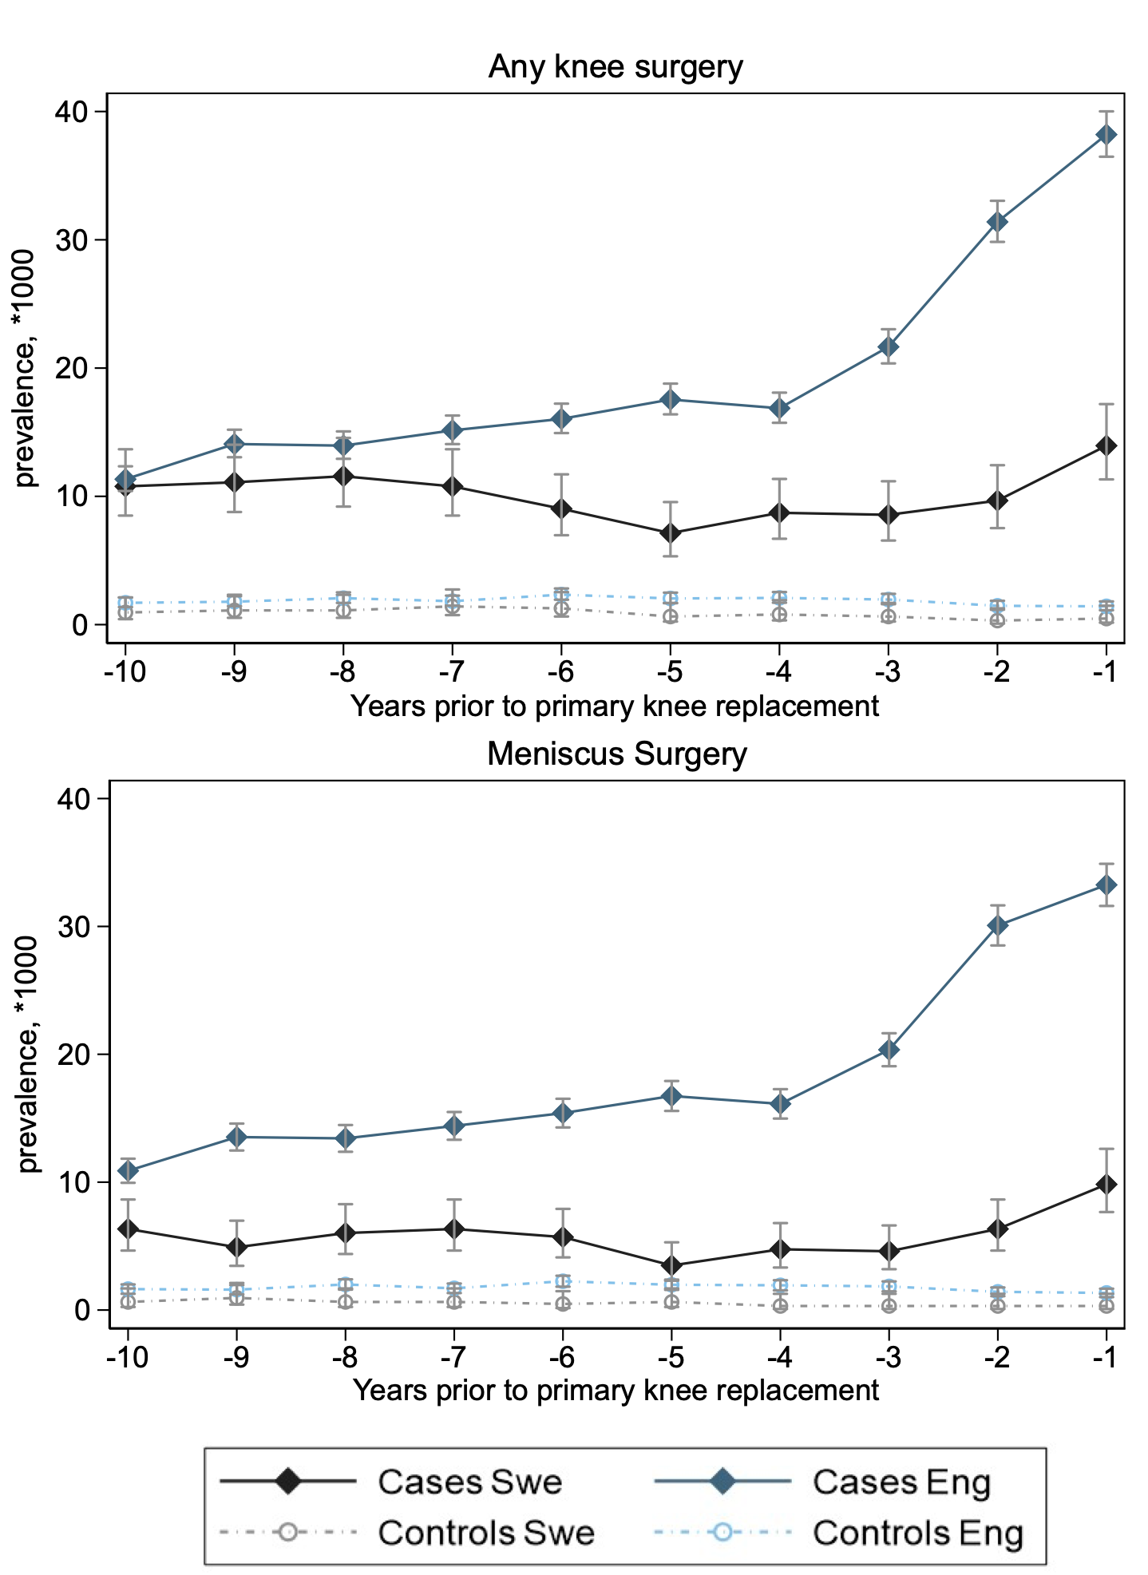
Figure 2: Prevalence of meniscus surgery in the ten years prior to primary total knee replacement in Sweden and England, stratified by age group
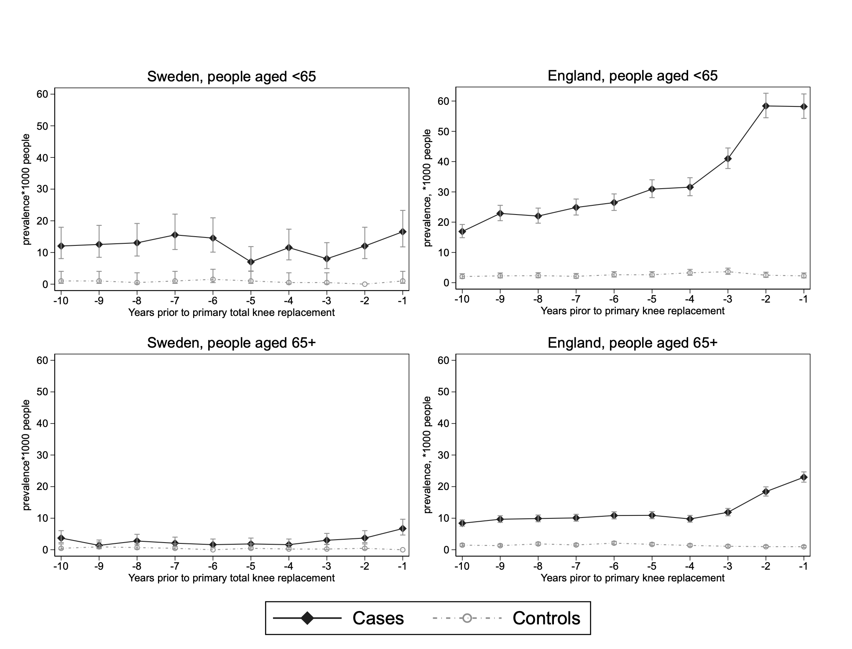

Figure 3: Prevalence of meniscus surgery in the ten years prior to total knee replacement, stratified by sex.

Figure 4: Prevalence of meniscus surgery for each calendar year by index year (year of primary total knee replacement) in Sweden and England

Supplementary file 1: Comparison of selected characteristics of population and healthcare in England and Sweden
 | England (UK) | Sweden | Source
Population (millions) - 2019 | 56.3 | 10.3 | Office for National Statistics; Statistics Sweden
Population over 65 years, % | 19% | 20% | Office for National Statistics; Statistics Sweden
Life expectancy at birth (2016): male/female | 79.4/83.0 | 80.6/84.1 | Trends in life expectancy and healthy life years at birth and age 65 in the UK, 2008–2016, and other countries of the EU28: An observational cross-sectional study - The Lancet Regional Health – Europe
Healthy life expectancy at birth (2016): male/female | 63.1/63.1 | 73.1/73.4 | Trends in life expectancy and healthy life years at birth and age 65 in the UK, 2008–2016, and other countries of the EU28: An observational cross-sectional study - The Lancet Regional Health – Europe
Healthcare spending (%GDP), 2017 | 9.6 | 11.0 | Commonwealth Fund https://www.commonwealthfund.org/international-health-policy-center/system-stats/percentage-gdp-spent-health-care
Type of public coverage | National health service | National health service | The social care and health systems of nine countries (kingsfund.org.uk)
Universal? | Yes | Yes | The social care and health systems of nine countries (kingsfund.org.uk)
Main funding source | General taxation (inc employment-based national insurance contributions) | General taxation | The social care and health systems of nine countries (kingsfund.org.uk)
Spending on pharmaceuticals per capita ($), 2017 | 469 | 515 | Spending on Pharmaceuticals per Capita | Commonwealth Fund
Prevalence of obesity (%), 2017 | 28.7 | 13.0* | Prevalence of Obesity (BMI>30) | Commonwealth Fund
Waited 4 months or more for elective surgery (%), 2016 | 12 | 12 | Waited Four Months or More for Elective Surgery | Commonwealth Fund
Availability of analgesic opioids (S-DDD per million inhabitants per day), 2014-2016 | 8771 | 9174 | Health at a Glance 2019 : OECD Indicators | OECD iLibrary (oecd-ilibrary.org)
Knee replacement surgery (per 1000 population), 2017 | 145 | 132 | Health at a Glance 2019 : OECD Indicators | OECD iLibrary (oecd-ilibrary.org)
Annual primary care consultation prevalence for osteoarthritis (per 10000 registered population, all ages), 2010 | 176 | 196 | Extended report: International comparisons of the consultation prevalence of musculoskeletal conditions using population-based healthcare data from England and Sweden (nih.gov)
* Self-reported, rather than measured

Supplementary file 2A: codes used to identify knee replacement in Sweden
Sweden
KVÅ Code
NGB39 | Primary total prosthetic replacement with hybrid technique
NGB49 | Primary total prosthetic replacement with cement
NGB29 | Primary total prosthetic replacement without cement
NGB53 | Primary prosthetic replacement of the patella
NGB59 | Primary prosthetic replacement of the patella with primary total knee replacement
NGB99 | Other primary total prosthetic replacement of the knee

Supplementary file 2B: codes used to identify knee replacement in England
England
OPCS Code
O181 | Primary hybrid prosthetic replacement of knee joint using cement
O188 | Other specified hybrid prosthetic replacement of knee joint using cement
O189 | Unspecified hybrid prosthetic replacement of knee joint using cement
W401 | Primary total prosthetic replacement of knee joint using cement
W408 | Other specified total prosthetic replacement of knee joint using cement
W409 | Unspecified total prosthetic replacement of knee joint using cement
W411 | Primary total prosthetic replacement of knee joint not using cement
W418 | Other specified total prosthetic replacement of knee joint not using cement
W419 | Unspecified total prosthetic replacement of knee joint not using cement
W421 | Primary total prosthetic replacement of knee joint NEC
W428 | Other specified other total prosthetic replacement of knee joint
W429 | Unspecified other total prosthetic replacement of knee joint
W431 | Primary total prosthetic replacement of joint using cement NEC
W438 | Other specified total prosthetic replacement of other joint using cement
W439 | Unspecified total prosthetic replacement of other joint using cement
W441 | Primary total prosthetic replacement of joint not using cement NEC
W448 | Other specified total prosthetic replacement of other joint not using cement
W449 | Unspecified total prosthetic replacement of other joint not using cement
W451 | Primary total prosthetic replacement of joint NEC
W458 | Other specified other total prosthetic replacement of other joint
W459 | Unspecified other total prosthetic replacement of other joint
W521 | Primary prosthetic replacement of articulation of bone using cement NEC
W528 | Other specified prosthetic replacement of articulation of other bone using cement
W529 | Unspecified prosthetic replacement of articulation of other bone using cement
W531 | Primary prosthetic replacement of articulation of bone not using cement NEC
W538 | Other specified prosthetic replacement of articulation of other bone not using cement
W539 | Unspecified prosthetic replacement of articulation of other bone not using cement
W541 | Primary prosthetic replacement of articulation of bone NEC
W548 | Other specified other prosthetic replacement of articulation of other bone
W549 | Unspecified other prosthetic replacement of articulation of other bone
W581 | Primary resurfacing arthroplasty of joint

Sweden
KVÅ Code
NGD0 | Total excision of the meniscus
NGD1 | Partial excision of the meniscus
NGD2 | Suture and replantation of the knee meniscus
NGD9 | Other operations on the meniscus
Supplementary file 3A: codes used to identify meniscus surgeries in Sweden

Supplementary file 3B: codes used to identify meniscus surgeries in England
England
OPCS Code
W701 | Open total excision of semilunar cartilage
W702 | Open excision of semilunar cartilage NEC
W821 | Endoscopic total excision of semilunar cartilage
W822 | Endoscopic resection of semilunar cartilage NEC
W703 | Open repair of semilunar cartilage
W823 | Endoscopic repair of semilunar cartilage
W828 | Other specified therapeutic endoscopic operations on semilunar cartilage
W829 | Unspecified therapeutic endoscopic operations on semilunar cartilage

Supplementary file 4A: codes used to identify ligament surgeries in Sweden
Sweden
KVÅ Code
NGE4 | Reconstruction of knee ligaments with foreign material
NGE2 | Suture or replantation of knee ligaments
NGE3 | Transposition of knee ligaments
NGE9 | Other operation on knee ligaments
MGE0 | Incision or suture of the joint capsule
MGE1 | Transection or incision of knee joint ligaments

Supplementary file 4B: codes used to identify ligament surgeries in England
England
OPCS Code
W723 | Primary prosthetic replacement of intra-articular ligament
W724 | Prosthetic replacement of intra-articular ligament NEC
W731 | Primary extra-articular prosthetic augmentation of intra-articular ligament NEC
W732 | Extra-articular prosthetic augmentation of intra-articular ligament NEC
W733 | Primary prosthetic reinforcement of intra-articular ligament NEC
W734 | Prosthetic reinforcement of intra-articular ligament NEC
W742 | Reconstruction of intra-articular ligament
W752 | Open repair of intra-articular ligament NEC
W841 | Endoscopic repair of intra-articular ligament
W842 | Endoscopic reattachment of intra-articular ligament
O271 | Extra-articular ligament reconstruction for stabilisation of joint
W725 | Primary prosthetic replacement of extra-articular ligament
W726 | Prosthetic replacement of extra-articular ligament NEC
W743 | Reconstruction of extra-articular ligament NEC
W753 | Open repair of extra-articular ligament NEC
W721 | Primary prosthetic replacement of multiple ligaments
W722 | Prosthetic replacement of multiple ligaments NEC
W728 | Other specified prosthetic replacement of ligament
W729 | Unspecified prosthetic replacement of ligament
W738 | Other specified prosthetic reinforcement of ligament
W739 | Unspecified prosthetic reinforcement of ligament
W741 | Reconstruction of multiple ligaments NEC
W748 | Other specified other reconstruction of ligament
W749 | Unspecified other reconstruction of ligament
W751 | Open repair of multiple ligaments NEC
W777 | Transposition of ligament for stabilisation of joint
W778 | Other specified stabilising operations on joint
Supplementary file 5A: codes used to identify osteotomy in Sweden
Sweden
KVÅ Code
NGK59 | Angle, rotational or displacement osteotomy of the knee or lower leg
NGK69 | Shortening or lengthening osteotomy of the knee or lower leg

Supplementary file 5B: codes used to identify osteotomy in England
England
OPCS Code
W121 | Biosseus angulation periarticular osteotomy and internal fixation HFQ
W122 | Angulation periarticular osteotomy and internal fixation NEC
W123 | Biosseus angulation periarticular osteotomy and external fixation HFQ
W124 | Angulation periarticular osteotomy and external fixation NEC
W125 | Biosseus angulation periarticular osteotomy NEC
W131 | Rotation periarticular osteotomy
W132 | Displacement osteotomy
W134 | Relocation and derotation osteotomy
W161 | Multiple osteotomy and internal fixation HFQ
W162 | Multiple osteotomy and external fixation HFQ
W163 | Multiple osteotomy NEC
W164 | Osteotomy and internal fixation NEC
W165 | Osteotomy and external fixation NEC
W775 | Periarticular osteotomy for stabilisation of joint

Supplementary file 6A: codes used to identify synovial surgery in Sweden
Sweden
KVÅ Code
NGF0 | Total Synovectomy
NGF1 | Partial synovectomy
NGF9 | Other operation to the synovial capsule or joint surface

Supplementary file 6B: codes used to identify synovial surgery in England
Sweden
OPCS Code
W691 | Total synovectomy
W692 | Subtotal synovectomy
W693 | Partial synovectomy (includes Synovectomy NEC)
W698 | Other specified open operations on synovial membrane of joint
W699 | Unspecified open operations on synovial membrane of joint

Supplementary file 7A: codes used to identify hip replacement in Sweden
Sweden
KVÅ Code
NFB09 | Primary hip semi- or partial prosthesis without cement
NFB19 | Primary hip semi- or partial prosthesis with cement
NFB29 | Primary total hip replacement without cement
NFB39 | Primary total hip replacement with hybrid technique
NFB49 | Primary total hip replacement with cement
NFB99 | Other primary hip replacement

Supplementary file 7B: codes used to identify hip replacement in England
England
OPCS Code
W371 | Primary total prosthetic replacement of hip joint using cement
W378 | Total prosthetic replacement of hip joint using cement, Other specified
W379 | Total prosthetic replacement of hip joint using cement, Unspecified
W381 | Primary total prosthetic replacement of hip joint not using cement
W388 | Total prosthetic replacement of hip joint not using cement, Other specified
W389 | Total prosthetic replacement of hip joint not using cement, Unspecified
W391 | Primary total prosthetic replacement of hip joint NE
W398 | Other specified hybrid prosthetic replacement of hip joint using cemented acetabular component
W399 | Unspecified hybrid prosthetic replacement of hip joint using cemented acetabular component
W521 | Primary prosthetic replacement of articulation of bone using cement NEC
W531 | Primary prosthetic replacement of articulation of bone not using cement NEC
W541 | Primary prosthetic replacement of articulation of bone NEC
W581 | Primary resurfacing arthroplasty of joint
W931 | Primary hybrid prosthetic replacement of hip joint using cemented acetabular component
W938 | Other specified hybrid prosthetic replacement of hip joint using cemented acetabular component
W939 | Unspecified hybrid prosthetic replacement of hip joint using cemented acetabular component
W941 | Primary hybrid prosthetic replacement of hip joint using cemented femoral component
W948 | Other specified hybrid prosthetic replacement of hip joint using cemented femoral component
W949 | Unspecified hybrid prosthetic replacement of hip joint using cemented femoral component
W951 | Primary hybrid prosthetic replacement of hip joint using cement NEC
W958 | Other specified hybrid prosthetic replacement of hip joint using cement
W959 | Unspecified hybrid prosthetic replacement of hip joint using cement
Supplementary file 8: prevalence of surgeries per 1,000 people in the ten years prior to primary total knee replacement
 | Sweden |  | England
Years prior TKR | Cases; n=6,337  Prevalence (95%CI) | Controls; n=6,337 Prevalence (95%CI) | Cases; n=47,010 Prevalence (95%CI) | Controls; n=47,010 Prevalence (95%CI)
 | Any knee surgery
-10 | 10.78 (8.50, 13.67) | 0.95 (0.43, 2.12) | 11.34 (10.42, 12.34) | 1.70 (1.37, 2.12)
-9 | 11.10 (8.78, 14.03) | 1.11 (0.53, 2.33) | 14.08 (13.05, 15.20) | 1.79 (1.44, 2.21)
-8 | 11.57 (9.20, 14.56) | 1.11 (0.53, 2.33) | 13.95 (12.93, 15.06) | 2.06 (1.69, 2.52)
-7 | 10.78 (8.50, 13.67) | 1.43 (0.74, 2.74) | 15.15 (14.07, 16.30) | 1.83 (1.48, 2.26)
-6 | 9.04 (6.97, 11.71) | 1.27 (0.63, 2.54) | 16.04 (14.93, 17.23) | 2.34 (1.94, 2.82)
-5 | 7.13 (5.33, 9.55) | 0.63 (0.24, 1.69) | 17.55 (16.39, 18.79) | 2.04 (1.67, 2.49)
-4 | 8.72 (6.69, 11.36) | 0.79 (0.33, 1.90) | 16.87 (15.73, 18.08) | 2.08 (1.71, 2.54)
-3 | 8.56 (6.56, 11.18) | 0.63 (0.24, 1.69) | 21.65 (20.36, 23.03) | 1.96 (1.60, 2.40)
-2 | 9.67 (7.52, 12.43) | 0.32 (0.08, 1.27) | 31.40 (29.84, 33.04) | 1.47 (1.16, 1.86)
-1 | 13.95 (11.32, 17.19) | 0.48 (0.15, 1.47) | 38.20 (36.48, 40.01) | 1.43 (1.12, 1.81)
 | Meniscus surgery
-10 | 6.34 (4.65, 8.64) | 0.63 (0.24, 1.69) | 10.89 (9.95, 11.83) | 1.64 (1.27, 2)
-9 | 4.91 (3.46, 6.99) | 0.95 (0.43, 2.12) | 13.53 (12.48, 14.58) | 1.6 (1.23, 1.96)
-8 | 6.02 (4.38, 8.28) | 0.63 (0.24, 1.69) | 13.42 (12.38, 14.47) | 2 (1.6, 2.4)
-7 | 6.34 (4.65, 8.64) | 0.63 (0.24, 1.69) | 14.4 (13.32, 15.49) | 1.7 (1.33, 2.07)
-6 | 5.71 (4.12, 7.91) | 0.48 (0.15, 1.47) | 15.4 (14.28, 16.52) | 2.25 (1.83, 2.68)
-5 | 3.49 (2.30, 5.30) | 0.63 (0.24, 1.69) | 16.74 (15.57, 17.91) | 1.98 (1.58, 2.38)
-4 | 4.76 (3.33, 6.80) | 0.32 (0.08, 1.27) | 16.12 (14.98, 17.27) | 1.94 (1.54, 2.33)
-3 | 4.60 (3.19, 6.62) | 0.32 (0.08, 1.27) | 20.36 (19.07, 21.65) | 1.85 (1.46, 2.24)
-2 | 6.34 (4.65, 8.64) | 0.32 (0.08, 1.27) | 30.08 (28.51, 31.65) | 1.43 (1.08, 1.77)
-1 | 9.83 (7.66, 12.61) | 0.32 (0.08, 1.27) | 33.25 (31.6, 34.9) | 1.34 (1.01, 1.67)
TKR: total knee replacement

Supplementary file 9: prevalence of surgeries per 1,000 people in the ten years prior to primary total knee replacement
 | Sweden |  | England
Years prior TKR | Cases; n=6,337  Prevalence (95%CI) | Controls; n=6,337 Prevalence (95%CI) | Cases; n=47,010 Prevalence (95%CI) | Controls; n=47,010 Prevalence (95%CI)
 | Synovium surgery
-10 | 1.27 (0.63, 2.54) | 0.00 (0.00, .) | 0.19 (0.07, 0.32) | 0.04 (-0.02, 0.1)
-9 | 3.80 (2.55, 5.68) | 0.00 (0.00, .) | 0.34 (0.17, 0.51) | 0.09 (0, 0.17)
-8 | 2.85 (1.80, 4.53) | 0.16 (0.02, 1.13) | 0.26 (0.11, 0.4) | 0.04 (-0.02, 0.1)
-7 | 2.54 (1.55, 4.14) | 0.32 (0.08, 1.27) | 0.28 (0.13, 0.43) | 0.06 (-0.01, 0.14)
-6 | 1.90 (1.08, 3.35) | 0.63 (0.24, 1.69) | 0.34 (0.17, 0.51) | 0.09 (0, 0.17)
-5 | 1.90 (1.08, 3.35) | 0.00 (0.00, .) | 0.47 (0.27, 0.66) | 0.06 (-0.01, 0.14)
-4 | 1.59 (0.85, 2.95) | 0.32 (0.08, 1.27) | 0.21 (0.08, 0.34) | 0.09 (0, 0.17)
-3 | 3.01 (1.92, 4.72) | 0.16 (0.02, 1.13) | 0.87 (0.61, 1.14) | 0.09 (0, 0.17)
-2 | 2.22 (1.31, 3.75) | 0.00 (0.00, .) | 0.98 (0.7, 1.26) | 0.02 (-0.02, 0.06)
-1 | 3.96 (2.68, 5.87) | 0.16 (0.02, 1.13) | 3.91 (3.35, 4.48) | 0.06 (-0.01, 0.14)
 | Hip replacement
-10 | 5.38 (4.19, 6.90) | 3.64 (2.69, 4.93) | 4.19 (3.61, 4.78) | 2.74 (2.27, 3.22)
-9 | 5.99 (4.73, 7.58) | 5.90 (4.65, 7.48) | 4.7 (4.08, 5.32) | 3.15 (2.64, 3.66)
-8 | 5.81 (4.58, 7.39) | 4.34 (3.29, 5.72) | 5.59 (4.92, 6.27) | 3.62 (3.07, 4.16)
-7 | 6.85 (5.50, 8.55) | 4.77 (3.66, 6.22) | 6.08 (5.38, 6.79) | 3.53 (2.99, 4.07)
-6 | 6.94 (5.58, 8.64) | 3.73 (2.77, 5.03) | 6.64 (5.9, 7.37) | 3.83 (3.27, 4.39)
-5 | 7.72 (6.27, 9.51) | 5.47 (4.27, 7.00) | 6.66 (5.92, 7.4) | 4.04 (3.47, 4.62)
-4 | 9.37 (7.76, 11.32) | 5.47 (4.27, 7.00) | 7.91 (7.11, 8.72) | 4.49 (3.88, 5.09)
-3 | 9.20 (7.60, 11.13) | 5.38 (4.19, 6.90) | 9.15 (8.28, 10.01) | 4.66 (4.04, 5.28)
-2 | 13.36 (11.41, 15.65) | 6.94 (5.58, 8.64) | 12.08 (11.09, 13.08) | 5.32 (4.66, 5.98)
-1 | 16.92 (14.70, 19.47) | 6.42 (5.11, 8.06) | 20.66 (19.36, 21.95) | 4.81 (4.18, 5.43)
TKR: total knee replacement

Supplementary file 10: prevalence ratio of any surgery and meniscus surgery between cases and controls (reference group: prevalence in control group) in the ten years prior to primary total knee replacement
 | Sweden |  | England
Years prior primary  TKR | Any knee surgery  Prevalence Ratio (95%CI) | Meniscus  Prevalence Ratio (95%CI) | Any knee surgery  Prevalence Ratio (95%CI) | Meniscus  Prevalence Ratio (95%CI)
-10 | 11.6 (5.0, 26.7) | 10.2 (3.6, 28.4) | 6.7 (5.3, 8.4) | 6.6 (5.2, 8.4)
-9 | 10.3 (4.7, 22.4) | 5.3 (2.2, 12.7) | 7.9 (6.3, 9.9) | 8.5 (6.7, 10.8)
-8 | 10.7 (4.9, 23.2) | 9.7 (3.4, 27.1) | 6.8 (5.5, 8.4) | 6.7 (5.4, 8.3)
-7 | 7.7 (3.9, 15.5) | 10.3 (3.7, 28.7) | 8.3 (6.6, 10.4) | 8.5 (6.7, 10.7)
-6 | 7.4 (3.5, 15.5) | 12.4 (3.8, 40.2) | 6.9 (5.6, 8.4) | 6.8 (5.6, 8.4)
-5 | 11.5 (4.1, 32.1) | 5.6 (1.9, 16.2) | 8.6 (7.0, 10.6) | 8.5 (6.8, 10.5)
-4 | 11.3 (4.5, 28.3) | 15.3 (3.7, 64.2) | 8.1 (6.6, 10.0) | 8.3 (6.7, 10.4)
-3 | 14 (5.1, 38.6) | 14.7 (3.5, 61.6) | 11.1 (8.9, 13.7) | 11.0 (8.8, 13.7)
-2 | 31.3 (7.6, 127.9) | 20.3 (4.9, 84) | 21.4 (16.8, 27.2) | 21.1 (16.5, 27.0)
-1 | 29.9 (9.4, 94.4) | 31.5 (7.7, 128.6) | 26.8 (21.0, 34.2) | 24.8 (19.3, 31.9)
TKR: total knee replacement

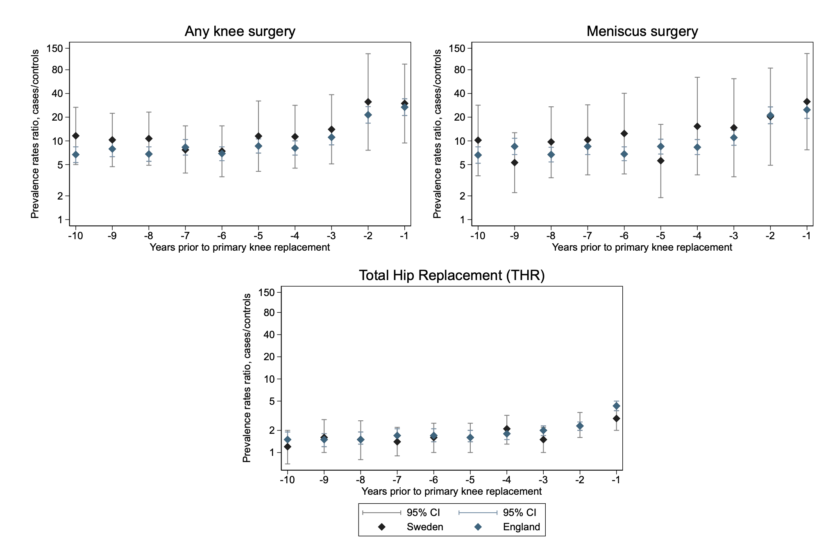
Supplementary file 11: Prevalence rates ratio (PRR) between cases and controls (reference category) of any knee surgery, meniscus surgery and total hip replacement in the ten years prior to primary total knee replacement.

Supplementary file 12: prevalence ratio of total hip replacement between cases and controls (reference group: prevalence in control group) in the ten years prior a primary knee replacement
 | Sweden | England
Years prior TKR | Hip replacement  Prevalence Ratio (95%CI) | Hip replacement  Prevalence Ratio (95%CI)
-10 | 1.2 (0.7, 2.0) | 1.5 (1.2, 1.9)
-9 | 1.6 (1, 2.8) | 1.5 (1.2, 1.8)
-8 | 1.5 (0.8, 2.7) | 1.5 (1.3, 1.9)
-7 | 1.4 (0.9, 2.2) | 1.7 (1.4, 2.1)
-6 | 1.6 (1, 2.5) | 1.7 (1.4, 2.1)
-5 | 1.6 (1, 2.5) | 1.6 (1.4, 2.0)
-4 | 2.1 (1.3, 3.2) | 1.8 (1.5, 2.1)
-3 | 1.5 (1, 2.2) | 2.0 (1.7, 2.3)
-2 | 2.3 (1.6, 3.5) | 2.3 (2.0, 2.6)
-1 | 2.9 (2.0, 4.2) | 4.3 (3.7, 5.0)
TKR: total knee replacement

Supplementary file 13: prevalence of meniscus surgery in the ten years prior to primary total knee replacement by age group
 | Sweden |  | England
Years prior TKT | Cases  Prevalence (95%CI) | Controls  Prevalence (95%CI) | Cases  Prevalence (95%CI) | Controls  Prevalence (95%CI)
 | < 65 years
-10 | 12.04 (8.07, 17.97) | 1.01 (0.25, 4.04) | 16.91 (14.87, 19.23) | 2.04 (1.41, 2.96)
-9 | 12.54 (8.48, 18.56) | 1.01 (0.25, 4.04) | 22.89 (20.49, 25.56) | 2.26 (1.59, 3.21)
-8 | 13.05 (8.88, 19.16) | 0.51 (0.07, 3.59) | 22.01 (19.67, 24.64) | 2.33 (1.65, 3.30)
-7 | 15.55 (10.94, 22.12) | 1.01 (0.25, 4.04) | 24.86 (22.35, 27.64) | 2.11 (1.47, 3.04)
-6 | 14.55 (10.11, 20.94) | 1.52 (0.49, 4.70) | 26.46 (23.87, 29.33) | 2.62 (1.89, 3.64)
-5 | 7.02 (4.16, 11.86) | 1.01 (0.25, 4.04) | 30.91 (28.10, 33.99) | 2.62 (1.89, 3.64)
-4 | 11.54 (7.67, 17.37) | 0.51 (0.07, 3.59) | 31.56 (28.72, 34.68) | 3.28 (2.45, 4.39)
-3 | 8.03 (4.92, 13.10) | 0.51 (0.07, 3.59) | 40.97 (37.71, 44.50) | 3.64 (2.76, 4.81)
-2 | 12.04 (8.07, 17.97) | 0.00 (0.00, .) | 58.39 (54.48, 62.57) | 2.48 (1.77, 3.47)
-1 | 16.56 (11.77, 23.29) | 1.01 (0.25, 4.04) | 58.17 (54.27, 62.35) | 2.26 (1.59, 3.21)
 | ≥ 65 years
-10 | 3.71 (2.27, 6.05) | 0.46 (0.12, 1.85) | 8.41 (7.48, 9.46) | 1.47 (1.11, 1.95)
-9 | 1.39 (0.62, 3.10) | 0.92 (0.35, 2.46) | 9.67 (8.67, 10.79) | 1.32 (0.98, 1.78)
-8 | 2.78 (1.58, 4.90) | 0.69 (0.22, 2.15) | 9.88 (8.87, 11.01) | 1.86 (1.45, 2.39)
-7 | 2.09 (1.09, 4.01) | 0.46 (0.12, 1.85) | 10.09 (9.07, 11.23) | 1.53 (1.16, 2.02)
-6 | 1.62 (0.77, 3.40) | 0.00 (0.00, .) | 10.84 (9.78, 12.02) | 2.10 (1.66, 2.66)
-5 | 1.85 (0.93, 3.71) | 0.46 (0.12, 1.85) | 10.90 (9.84, 12.09) | 1.71 (1.32, 2.22)
-4 | 1.62 (0.77, 3.40) | 0.23 (0.03, 1.64) | 9.76 (8.76, 10.88) | 1.38 (1.03, 1.84)
-3 | 3.01 (1.75, 5.19) | 0.23 (0.03, 1.64) | 11.87 (10.75, 13.09) | 1.11 (0.81, 1.53)
-2 | 3.71 (2.27, 6.05) | 0.46 (0.12, 1.85) | 18.41 (17.01, 19.93) | 0.99 (0.70, 1.39)
-1 | 6.72 (4.67, 9.67) | 0.00 (0.00, .) | 22.98 (21.41, 24.67) | 0.96 (0.68, 1.36)
* Total number of surgeries per group, an individual may have received more than one surgery of the same type
TKR: total knee replacement

Supplementary file 14: prevalence of meniscus surgery in the ten years prior to primary total knee replacement in men and women
 | Sweden |  | England
Years prior TKR | Cases  (n=6,337) | Controls  (n=6,337) | Cases  (n=47,010) | Controls  (n=47,010)
 | Men
-10 | 7.06 (4.51, 11.07) | 1.49 (0.56, 3.96) | 14.05 (12.53, 15.75) | 1.77 (1.29, 2.45)
-9 | 5.20 (3.08, 8.79) | 1.49 (0.56, 3.96) | 16.59 (14.93, 18.43) | 1.82 (1.33, 2.50)
-8 | 5.95 (3.64, 9.71) | 0.74 (0.19, 2.97) | 15.92 (14.30, 17.73) | 2.30 (1.73, 3.05)
-7 | 5.95 (3.64, 9.71) | 1.12 (0.36, 3.46) | 17.17 (15.48, 19.04) | 1.77 (1.29, 2.45)
-6 | 7.06 (4.51, 11.07) | 1.12 (0.36, 3.46) | 17.02 (15.34, 18.89) | 2.92 (2.28, 3.76)
-5 | 3.35 (1.74, 6.43) | 1.49 (0.56, 3.96) | 17.69 (15.98, 19.59) | 2.11 (1.57, 2.83)
-4 | 4.09 (2.26, 7.38) | 0.37 (0.05, 2.64) | 17.69 (15.98, 19.59) | 2.25 (1.69, 3.00)
-3 | 5.58 (3.36, 9.25) | 0.00 (0.00, .) | 21.05 (19.17, 23.11) | 2.11 (1.57, 2.83)
-2 | 4.83 (2.81, 8.32) | 0.37 (0.05, 2.64) | 29.49 (27.25, 31.91) | 1.25 (0.85, 1.83)
-1 | 10.78 (7.49, 15.51) | 0.00 (0.00, .) | 32.94 (30.57, 35.50) | 1.49 (1.05, 2.11)
 | Women
-10 | 5.80 (3.78, 8.90) | 0.00 (0.00, .) | 8.37 (7.33, 9.56) | 1.53 (1.12, 2.09)
-9 | 4.70 (2.92, 7.56) | 0.55 (0.14, 2.21) | 11.09 (9.88, 12.44) | 1.41 (1.03, 1.95)
-8 | 6.08 (4.00, 9.23) | 0.55 (0.14, 2.21) | 11.43 (10.21, 12.80) | 1.76 (1.32, 2.35)
-7 | 6.63 (4.45, 9.90) | 0.28 (0.04, 1.96) | 12.20 (10.93, 13.61) | 1.64 (1.22, 2.22)
-6 | 4.70 (2.92, 7.56) | 0.00 (0.00, .) | 14.11 (12.74, 15.62) | 1.72 (1.28, 2.30)
-5 | 3.59 (2.09, 6.19) | 0.00 (0.00, .) | 15.98 (14.52, 17.59) | 1.87 (1.42, 2.48)
-4 | 5.25 (3.35, 8.23) | 0.28 (0.04, 1.96) | 14.87 (13.47, 16.43) | 1.68 (1.25, 2.26)
-3 | 3.87 (2.29, 6.53) | 0.55 (0.14, 2.21) | 19.81 (18.17, 21.59) | 1.64 (1.22, 2.22)
-2 | 7.46 (5.12, 10.88) | 0.28 (0.04, 1.96) | 30.55 (28.50, 32.74) | 1.57 (1.15, 2.13)
-1 | 9.12 (6.48, 12.83) | 0.55 (0.14, 2.21) | 33.49 (31.35, 35.79) | 1.22 (0.87, 1.73)
* Total number of surgeries per group, an individual may have received more than one surgery of the same type
TKR: total knee replacement

Supplementary file 15: prevalence of total hip replacement (THR) in the ten years prior a primary knee replacement by age group
 |  | Sweden |  | England
Years prior TKR | Cases  (n=6,337) |  | Controls  (n=6,337) | Cases  (n=47,010) | Controls  (n=47,010)
 | < 65 years
-10 | 3.01 (1.35, 6.70) |  | 1.01 (0.25, 4.04) | 1.97 (1.35, 2.87) | 1.02 (0.60, 1.72)
-9 | 2.01 (0.75, 5.35) |  | 0.00 (0.00, .) | 2.26 (1.59, 3.21) | 0.80 (0.44, 1.45)
-8 | 0.50 (0.07, 3.56) |  | 0.51 (0.07, 3.59) | 2.84 (2.08, 3.89) | 0.87 (0.50, 1.54)
-7 | 1.51 (0.49, 4.67) |  | 0.51 (0.07, 3.59) | 2.70 (1.95, 3.72) | 1.75 (1.17, 2.61)
-6 | 1.51 (0.49, 4.67) |  | 0.00 (0.00, .) | 3.86 (2.95, 5.06) | 0.80 (0.44, 1.45)
-5 | 3.51 (1.67, 7.37) |  | 2.02 (0.76, 5.39) | 3.72 (2.83, 4.89) | 1.53 (1.00, 2.35)
-4 | 3.51 (1.67, 7.37) |  | 0.51 (0.07, 3.59) | 4.23 (3.27, 5.47) | 1.90 (1.29, 2.78)
-3 | 6.52 (3.79, 11.23) |  | 0.51 (0.07, 3.59) | 5.03 (3.97, 6.37) | 2.26 (1.59, 3.21)
-2 | 5.52 (3.06, 9.97) |  | 1.52 (0.49, 4.70) | 6.49 (5.27, 7.99) | 2.41 (1.71, 3.38)
-1 | 10.04 (6.47, 15.55) |  | 1.01 (0.25, 4.04) | 15.89 (13.92, 18.15) | 2.26 (1.59, 3.21)
 | ≥ 65 years
-10 | 5.56 (3.73, 8.30) |  | 5.31 (3.53, 7.99) | 5.11 (4.39, 5.93) | 3.45 (2.88, 4.15)
-9 | 7.42 (5.24, 10.49) |  | 5.08 (3.35, 7.72) | 5.71 (4.95, 6.58) | 4.12 (3.48, 4.87)
-8 | 6.26 (4.29, 9.12) |  | 4.16 (2.62, 6.60) | 6.73 (5.90, 7.67) | 4.75 (4.06, 5.55)
-7 | 10.20 (7.59, 13.70) |  | 7.39 (5.23, 10.45) | 7.48 (6.61, 8.47) | 4.27 (3.62, 5.03)
-6 | 10.43 (7.79, 13.97) |  | 6.93 (4.84, 9.91) | 7.78 (6.89, 8.79) | 5.08 (4.37, 5.90)
-5 | 8.81 (6.41, 12.10) |  | 5.77 (3.90, 8.54) | 7.87 (6.97, 8.88) | 5.08 (4.37, 5.90)
-4 | 12.75 (9.79, 16.60) |  | 6.70 (4.65, 9.64) | 9.43 (8.44, 10.54) | 5.56 (4.81, 6.42)
-3 | 10.43 (7.79, 13.97) |  | 9.01 (6.58, 12.33) | 10.84 (9.78, 12.02) | 5.65 (4.89, 6.51)
-2 | 16.45 (13.04, 20.76) |  | 7.39 (5.23, 10.45) | 14.39 (13.16, 15.74) | 6.52 (5.71, 7.45)
-1 | 22.48 (18.42, 27.43) |  | 8.78 (6.39, 12.06) | 22.62 (21.06, 24.29) | 5.86 (5.09, 6.74)
* Total number of surgeries per group, an individual may have received more than one surgery of the same type
TKR: total knee replacement

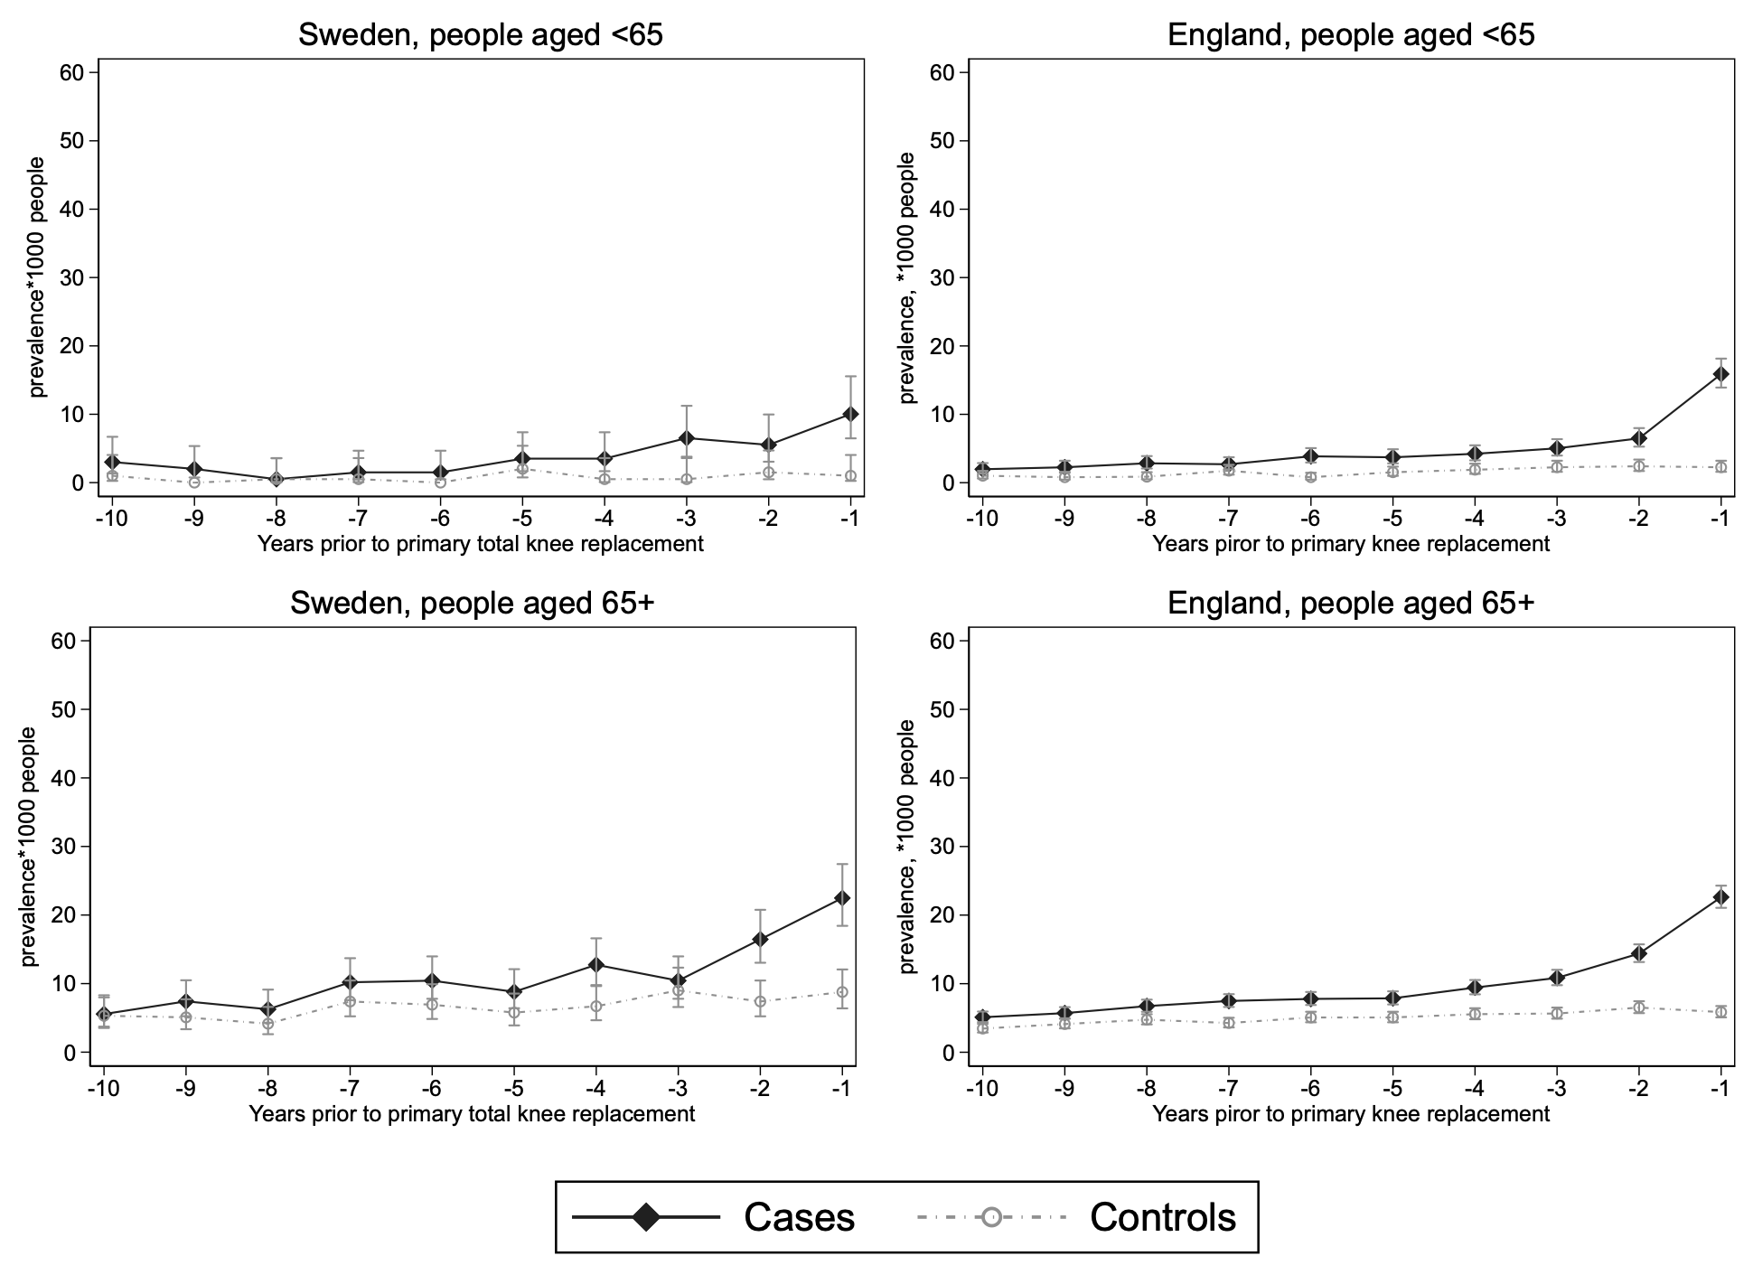
Supplementary file 16: prevalence of total hip replacement (THR) in the ten years prior a primary knee replacement by age group

Supplementary file 17: prevalence of total hip replacement (THR) in the ten years prior a primary knee replacement in men and women
 | Sweden |  | England
Years prior TKR | Cases  (n=6,337) | Controls  (n=6,337) | Cases  (n=47,010) | Controls  (n=47,010)
 | Men
-10 | 5.20 (3.08, 8.79) | 1.86 (0.77, 4.47) | 3.55 (2.83, 4.46) | 2.06 (1.53, 2.78)
-9 | 4.09 (2.26, 7.38) | 1.86 (0.77, 4.47) | 3.69 (2.95, 4.62) | 2.69 (2.07, 3.49)
-8 | 3.72 (2.00, 6.91) | 2.97 (1.49, 5.95) | 3.36 (2.66, 4.24) | 3.02 (2.36, 3.87)
-7 | 4.83 (2.81, 8.32) | 4.83 (2.81, 8.32) | 4.32 (3.51, 5.31) | 3.26 (2.57, 4.14)
-6 | 7.43 (4.80, 11.52) | 4.83 (2.81, 8.32) | 5.27 (4.38, 6.36) | 3.16 (2.49, 4.03)
-5 | 3.35 (1.74, 6.43) | 4.46 (2.53, 7.86) | 5.37 (4.46, 6.46) | 3.16 (2.49, 4.03)
-4 | 7.06 (4.51, 11.07) | 6.32 (3.93, 10.17) | 5.95 (4.99, 7.09) | 3.79 (3.04, 4.72)
-3 | 7.06 (4.51, 11.07) | 7.43 (4.80, 11.52) | 6.09 (5.12, 7.25) | 4.41 (3.60, 5.41)
-2 | 11.90 (8.41, 16.82) | 4.46 (2.53, 7.86) | 8.87 (7.68, 10.25) | 4.70 (3.85, 5.73)
-1 | 18.59 (14.09, 24.52) | 6.69 (4.22, 10.62) | 19.08 (17.30, 21.05) | 3.84 (3.08, 4.78)
 | Women
-10 | 4.42 (2.71, 7.22) | 5.53 (3.57, 8.57) | 4.70 (3.94, 5.61) | 3.29 (2.66, 4.06)
-9 | 6.91 (4.67, 10.23) | 4.70 (2.92, 7.56) | 5.51 (4.68, 6.48) | 3.52 (2.87, 4.32)
-8 | 4.98 (3.13, 7.90) | 3.04 (1.68, 5.49) | 7.38 (6.41, 8.50) | 4.09 (3.38, 4.94)
-7 | 9.40 (6.71, 13.15) | 5.53 (3.57, 8.57) | 7.49 (6.52, 8.62) | 3.75 (3.07, 4.57)
-6 | 7.74 (5.34, 11.21) | 4.70 (2.92, 7.56) | 7.72 (6.73, 8.87) | 4.36 (3.63, 5.24)
-5 | 9.95 (7.18, 13.79) | 4.70 (2.92, 7.56) | 7.69 (6.69, 8.82) | 4.74 (3.98, 5.65)
-4 | 11.89 (8.81, 16.03) | 3.59 (2.09, 6.19) | 9.48 (8.37, 10.74) | 5.05 (4.26, 5.99)
-3 | 10.78 (7.88, 14.75) | 5.53 (3.57, 8.57) | 11.59 (10.35, 12.97) | 4.86 (4.08, 5.78)
-2 | 13.82 (10.47, 18.23) | 6.36 (4.22, 9.57) | 14.64 (13.25, 16.19) | 5.81 (4.96, 6.81)
-1 | 18.52 (14.58, 23.53) | 6.08 (4.00, 9.23) | 21.91 (20.19, 23.78) | 5.58 (4.75, 6.57)
* Total number of surgeries per group, an individual may have received more than one surgery of the same type
TKR: total knee replacement

Supplementary file 18: prevalence of total hip replacement (THR) in the ten years prior to primary total knee replacement in men and women

