**Preparation of Methyl 1,2,3,4-tetra-*O*-acetyl-β-D-glucopyranuronate**

Aisling Ní Cheallaigh$, Garrett T. Potter$, John M. Gardiner$ and Gavin J. Miller^*1

^Synthesis and Medicinal Chemistry Cluster, School of Physical and Geographical Sciences, Keele University, Keele, Staffordshire, ST5 5BG, U.K.

$Manchester Institute of Biotechnology and School of Chemistry, 131 Princess Street, The University of Manchester, Manchester, M1 7DN, U.K.

*Checked by Michal Achmatowicz and Margaret Faul*

|  |
| --- |
|  |

**Procedure**

A. *Methyl 1,2,3,4-tetra-O-acetyl-β-D-glucopyranuronate* ***2.*** A three-necked 250-mL round-bottomed flask on a stirrer plate is equipped with a 2-cm Teflon coated magnetic stirrer bar, rubber septum, thermometer (with insert to monitor the internal reaction temperature) and a connection to a nitrogen line (Figure 1).

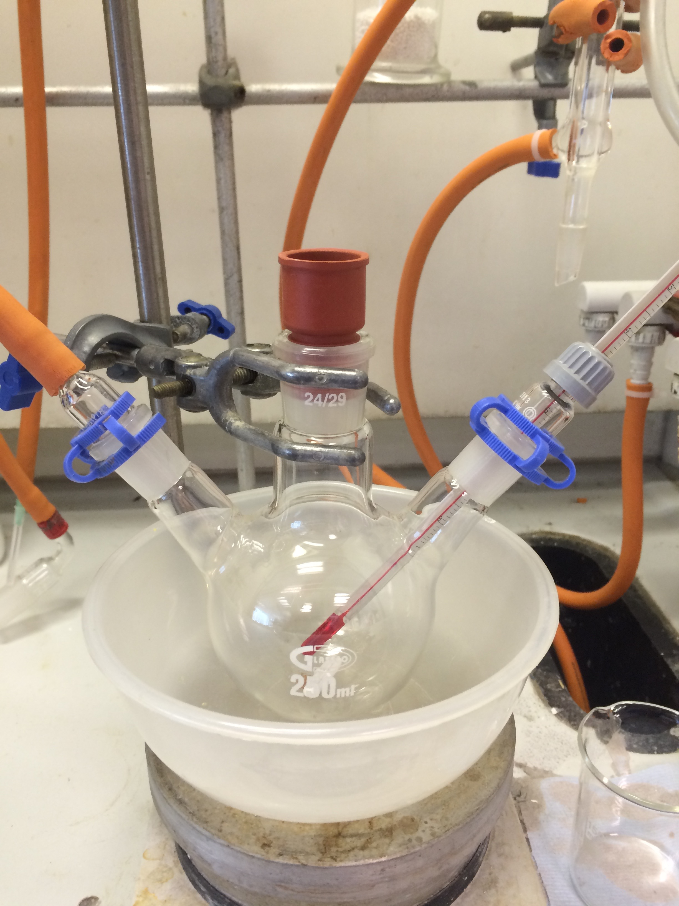

**Figure 1. Reaction set-up**

Under inert atmosphere the flask is charged with methanol (MeOH) (50 mL) (Note 1), NaOH (20 mg, 0.5 mmol, 0.02 equiv) (Note 2) and then stirred vigorously for 10 min to complete dissolution of NaOH. The clear solution is cooled to 0 °C with an ice/water bath and to this is added D-glucuronolactone **1** (5.0 g, 28 mmol, 1.0 equiv) portion-wise (Note 3) over 25 min (Note 4). The solution is stirred for an additional 30 min, while maintaining the internal temperature at 0 °C. Upon complete dissolution of **1**, the reaction solution is transferred to a one-necked 250-mL round-bottomed flask and the solvent removed by rotary evaporation (30 °C, 20 mmHg) (Note 5) to yield a pale yellow foam which is dried under vacuum (5 mmHg) for 2 h to remove the majority of residual MeOH (Figure 2).

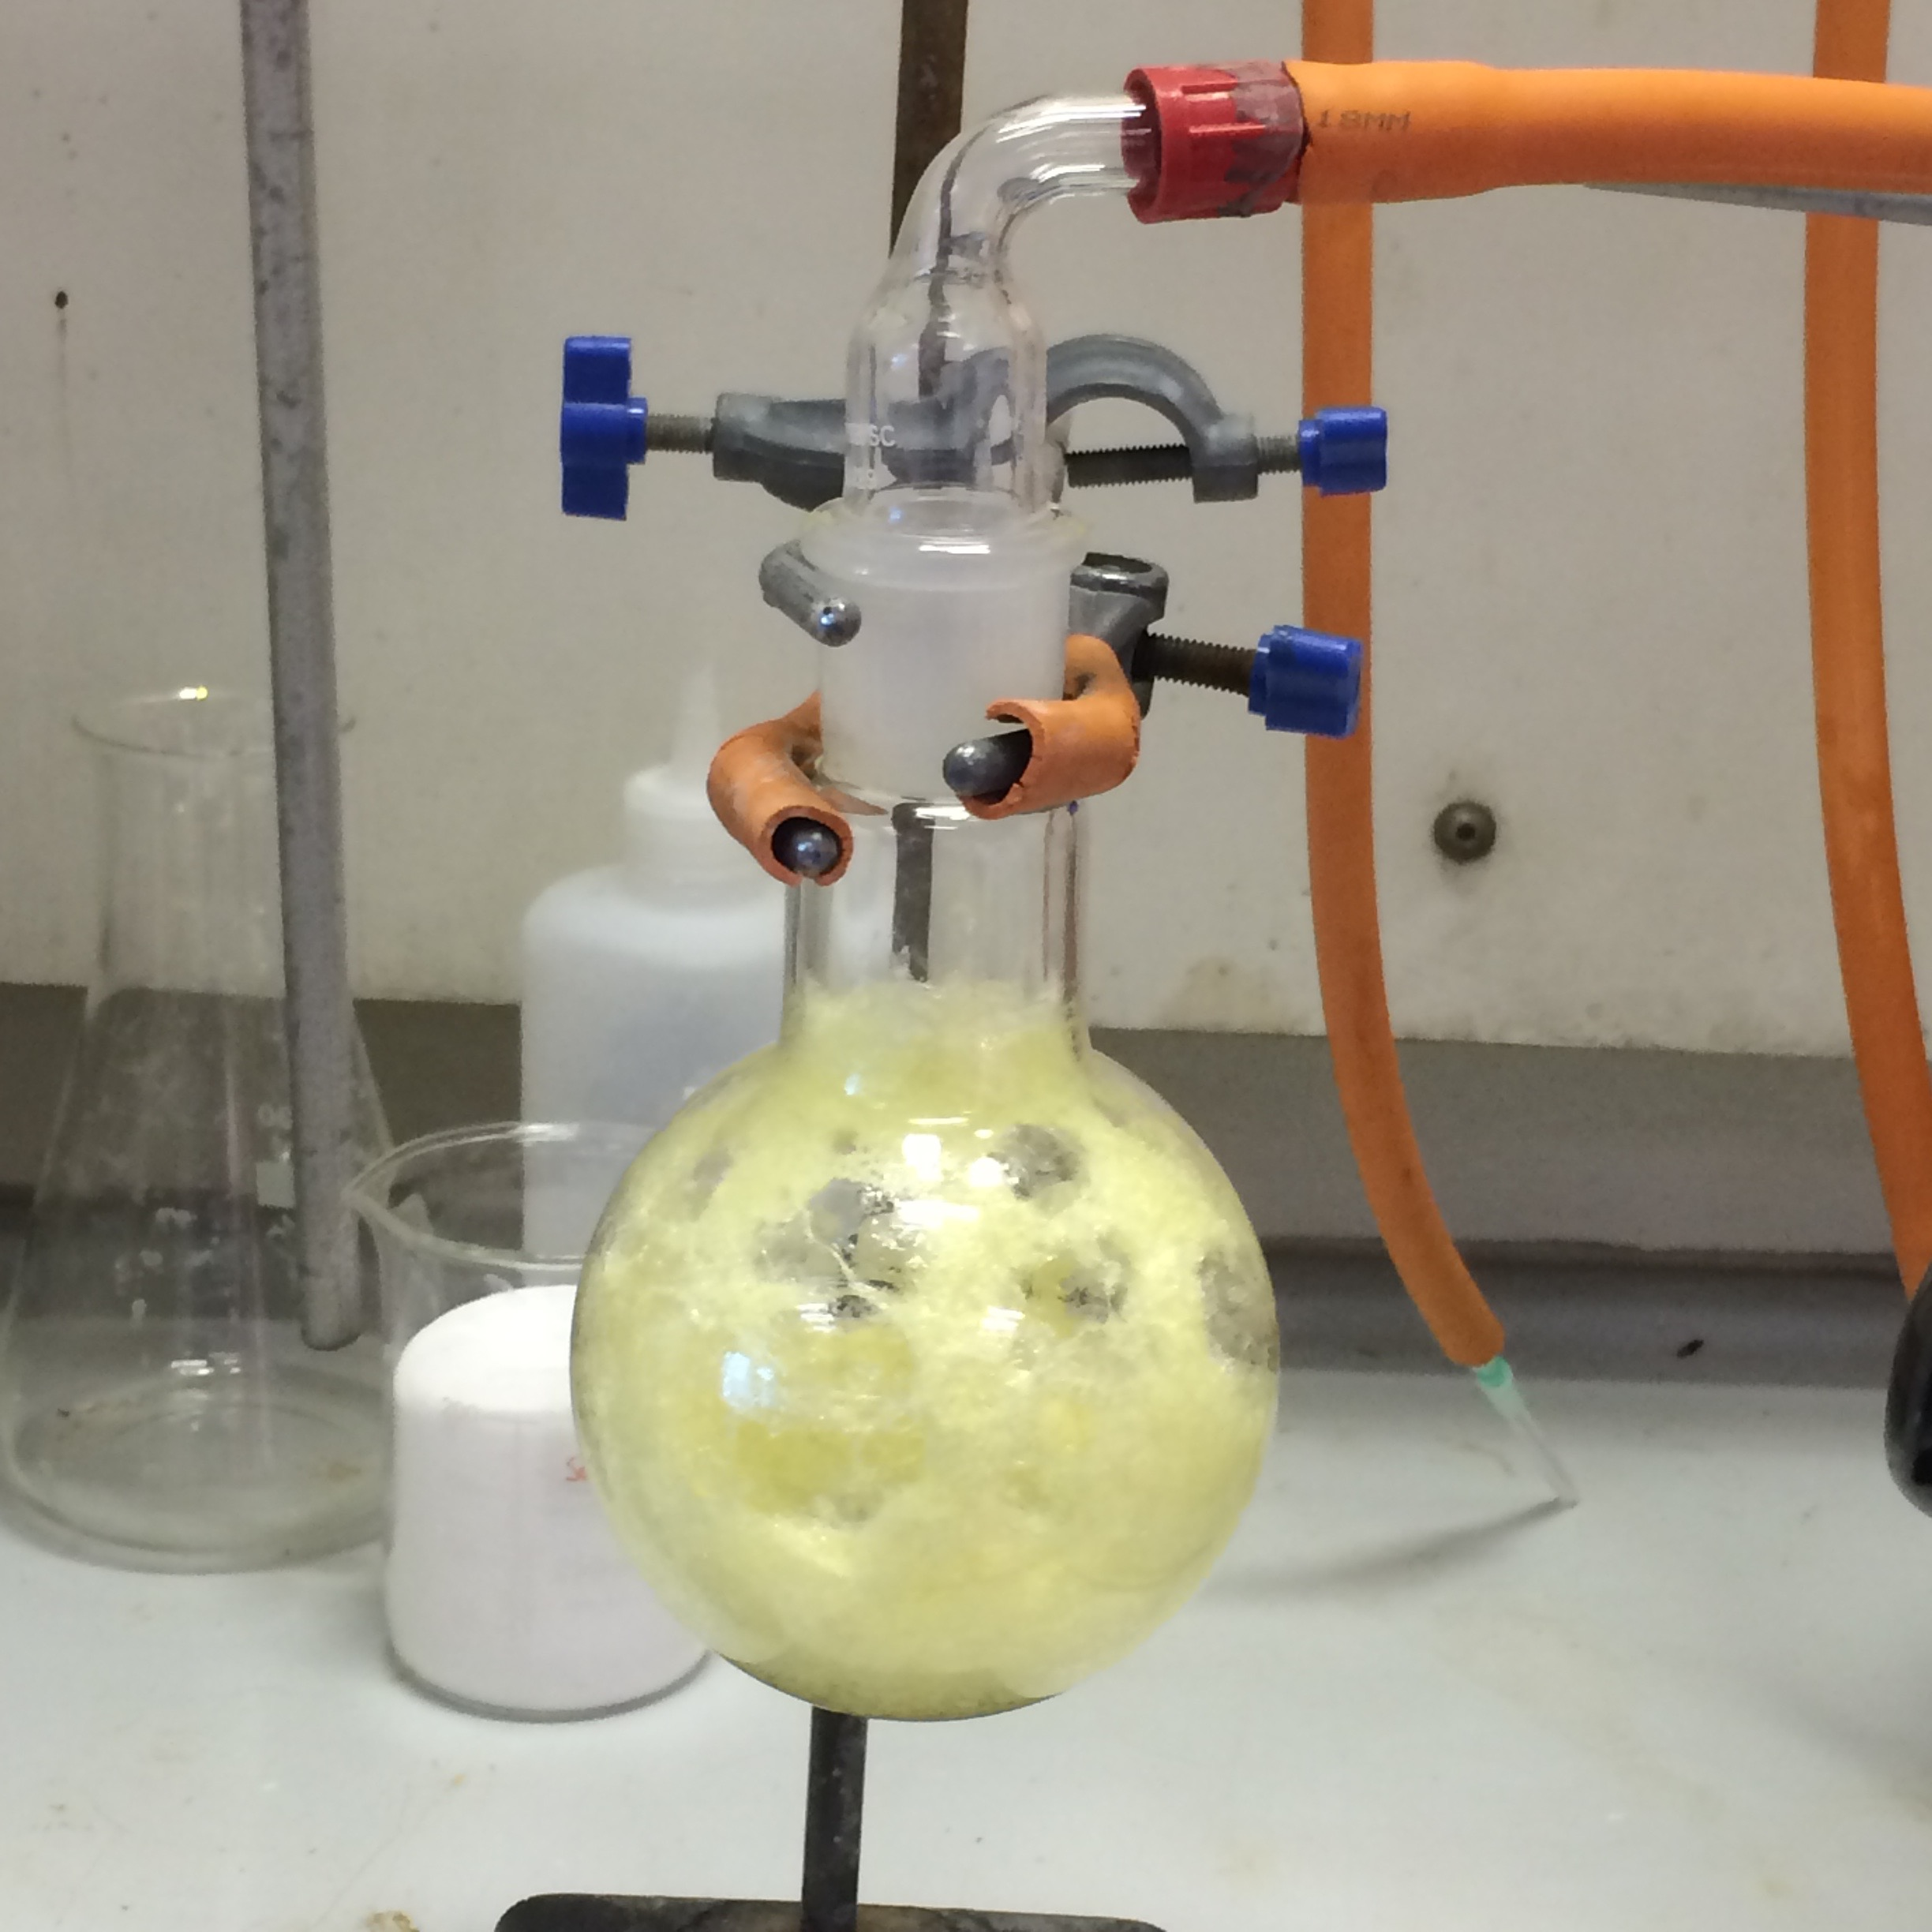

**Figure 2. Pale yellow foam after removal of methanol**

The flask (Note 6) containing the foam is charged with a 2-cm Teflon coated magnetic stirrer bar, acetic anhydride (54 g, 50 mL, 530 mmol, 19 equiv) and anhydrous NaOAc (9.5 g, 116 mmol, 4.1 equiv) (Note 7). A reflux condenser is attached, the reaction placed under nitrogen and the mixture heated (Note 8) to 90 **°**C for 1.5 h (Note 9). The light-brown suspension (Figure 3) is then allowed to cool. The solution is no longer stirred and is left standing overnight.

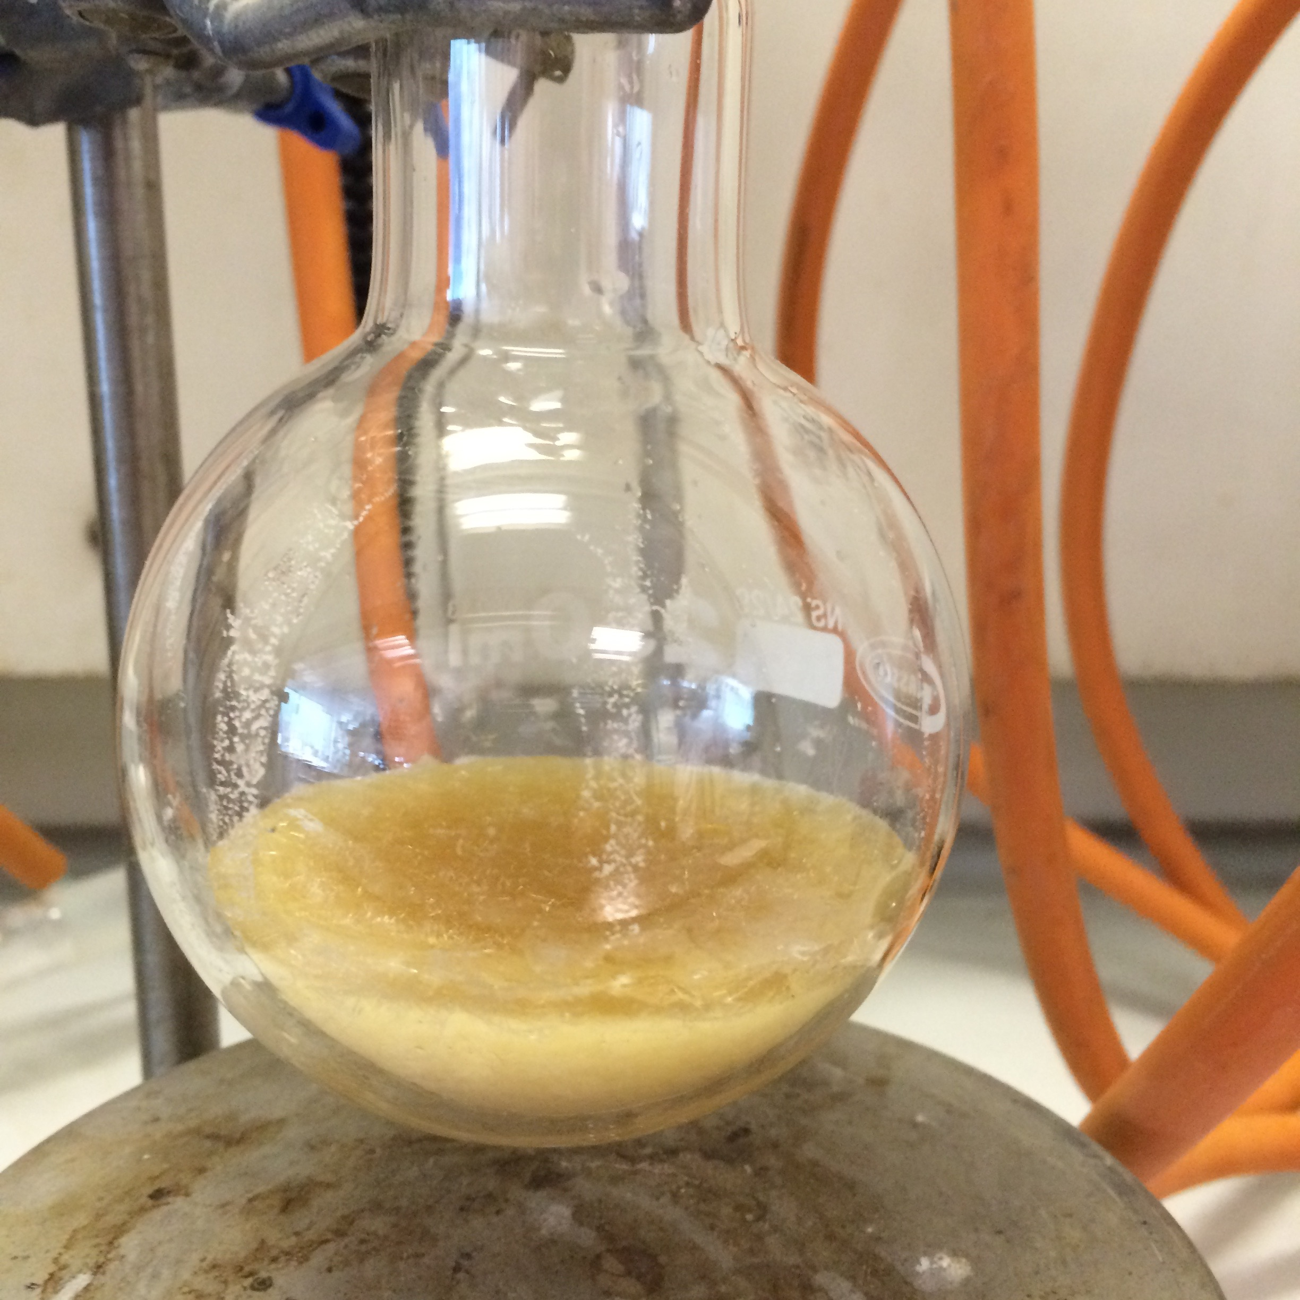

**Figure 3. Light brown suspension**

The resulting precipitate is diluted with EtOAc (100 mL) and any solids broken up carefully with a spatula. This enables stirring of the suspension, which is continued vigorously for 5 min. The suspension is then filtered through a 100-mL medium porosity sintered glass funnel into a 0.5 L flask, washing the solids with an additional portion of EtOAc (100 mL). This filtrate is retained. Sodium bicarbonate (NaHCO3) (90 g, 1.1 mol, 38 equiv) is weighed into a 1.0 L beaker on a stirrer plate and distilled water (250 mL) added. A 4-cm Teflon coated stirrer bar is added and stirring commenced to dissolve the majority of the NaHCO3. The reaction filtrate is added slowly to this stirred solution (Note 10) and stirring is continued for >30 min, or until all effervescence had ceased. The solution is then transferred to a 1.0 L separating funnel and the organic/aqueous layers separated. The aqueous phase is extracted once with EtOAc (50 mL) and the organics combined, washed with H2O (50 mL), dried over MgSO4 (10.0 g) for 10 min, and filtered through a sintered glass funnel into a flask. The solvent is removed on a rotary evaporator (40 °C, 20 mmHg) to reveal a sticky, brown oil mixed with solids. This residue is dissolved in hot (70 °C) EtOH (50 mL) and allowed to cool, which induces crystallisation of **2**. The solids are collected by vacuum filtration (Note 11) and dried under vacuum for 2 h (5 mmHg) furnishing 3.40 g (32%) of **2** as a light tan solid (Figure 4) (Notes 12 and 13).

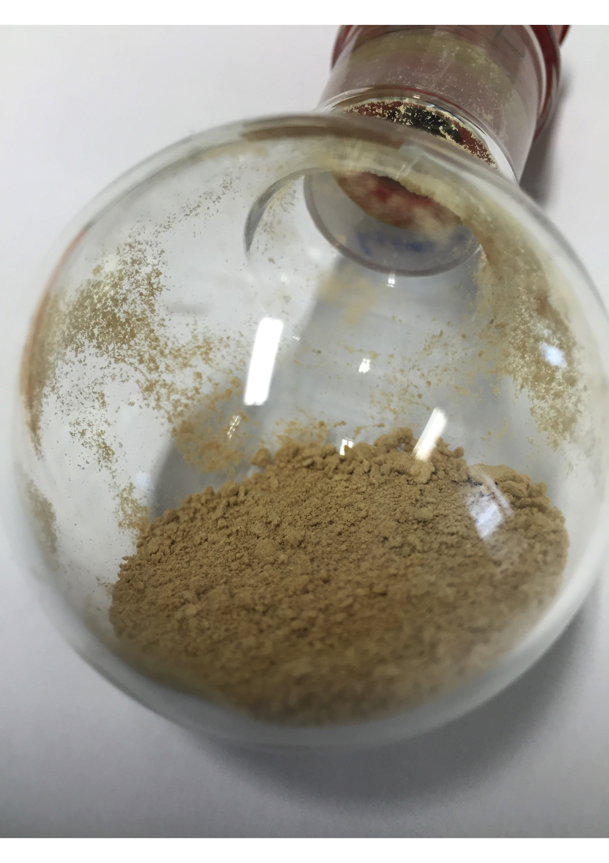

**Figure 4. Product (2) is a light tan solid**

**Notes**

1. Methanol (MeOH, HPLC Grade) was obtained from Sigma-Aldrich and used as received.
2. Sodium hydroxide (NaOH) was obtained from Fisher Scientific in pellet form and was used as received. For this procedure a pellet of NaOH was ground in a pestle with a mortar and the required amount weighed out into a small sample vial for transfer to the stirred MeOH solution.
3. D-Glucuronolactone **1** [D-(+)-glucuronic acid-γ-lactone, >99%] was purchased from Sigma Aldrich and used as received.
4. D -Glucuronolactone **1** was added to the solution in 5 x 1.0 g portions in 5 minute intervals. The solution color may turn from clear to very pale yellow during this addition process.
5. Upon complete dissolution of **1** into solution the evaporation of MeOH should be completed with a rotary evaporator bath temperature not exceeding 30 **°**C as this may lead to decomposition of the intermediate free sugar. As the last traces of MeOH are removed, the residue may begin to foam inside the flask and the intermediate material will appear as a light yellow foam.
6. As necessary and depending on the heating setup in use, the flask can be fitted with a Y-shaped adapter for a flexible thermocouple or a 2-necked flask used.
7. Acetic anhydride (ReagentPlus, ≥99%) and anhydrous NaOAc (ReagentPlus, ≥99%) were both obtained from Sigma Aldrich and used as received.
8. The pale yellow foam is quite sticky and may not immediately dissolve upon addition of the acetic anhydride and NaOAc. Heating from ambient temperature up to 90 **°**C is required to achieve this. As the solvent warms, the reagents will dissolve and a pale brown suspension results. The mixture was heated using a Drysyn**™** heating block and temperature thermocouple.
9. If lower heating temperature of 50 **°**C is applied for 4 h and then the solution is allowed to cool to room temperature overnight, the reaction delivers an improved yield of **2** (4.8-6.0 g, 45-60%) as white solid, but with a reduced diastereomeric preference for the *β* anomer. Experiments run at 50 °C gave approximately 3/7 (α/*β*) diastereomeric mixtures, as judged by 1H NMR analysis.



1. This step requires a careful addition of the filtrate to control the effervescence of CO2 upon destruction of excess Ac2O and neutralization of AcOH. Approximately 50 mL of filtrate should be added to the NaHCO3 solution every 5 minutes.
2. Following filtration, the solids should be washed with 10-20 mL of ice-cold diethyl ether.
3. Analytical data for **2**2: TLC Rf 0.15 (3/1, hexane:EOAc) visualised with phosphomolybdic acid (PMA) stain. mp 175–177 °C; []D20 +0.70° (*c* 0.55, CH2Cl2). d-(+)-Glucuronic acid γ-lactone []D20 +18.0° (*c* 8.0, H2O) (lit. 18.8°. IR (film): 2955, 1751, 1371, 1202, 1144, 1115, 1087, 1177, 1037 cm-1; 1H NMR (400 MHz, CDCl3) : 2.04 (s, 3H), 2.05 (s, 6H), 2.13 (s, 3H), 3.75 (s, 3H), 4.19 (d, *J* = 9.4 Hz, 1H), 5.15 (t, *J* = 8.3 Hz, 1H), 5.26 (t, *J* = 9.3 Hz, 1H), 5.32 (t, *J* = 9.1 Hz, 1H), 5.78 (d, *J* = 7.8 Hz, 1H); 13C NMR (100 MHz, CDCl3) : 20.4, 20.5, 20.6, 20.8, 53.0, 68.9, 70.2, 71.8, 73.0, 91.4, 166.8, 168.8, 169.1, 169.4, 169.9. MS *m/z* 399 (100, [M+Na+]); [M+Na+] calcd for C15H20NaO11: 399.08978. Found: 399.08980 (0.1 ppm). The *β* anomer is identified by a large 3J (H1-H2) coupling (*J* = 7.8 Hz). The product can be stored on the shelf for prolonged periods.
4. A second run of the reaction on the same scale provided 3.45 g (32%) of the product.

**Working with Hazardous Chemicals**

The procedures in *Organic Syntheses* are intended for use only by persons with proper training in experimental organic chemistry. All hazardous materials should be handled using the standard procedures for work with chemicals described in references such as "Prudent Practices in the Laboratory" (The National Academies Press, Washington, D.C., 2011; the full text can be accessed free of charge at <http://www.nap.edu/catalog.php?record_id=12654>). All chemical waste should be disposed of in accordance with local regulations. For general guidelines for the management of chemical waste, see Chapter 8 of Prudent Practices.

In some articles in *Organic Syntheses*, chemical-specific hazards are highlighted in red “Caution Notes” within a procedure. It is important to recognize that the absence of a caution note does not imply that no significant hazards are associated with the chemicals involved in that procedure. Prior to performing a reaction, a thorough risk assessment should be carried out that includes a review of the potential hazards associated with each chemical and experimental operation on the scale that is planned for the procedure. Guidelines for carrying out a risk assessment and for analyzing the hazards associated with chemicals can be found in Chapter 4 of Prudent Practices.

The procedures described in *Organic Syntheses* are provided as published and are conducted at one's own risk. *Organic Syntheses, Inc.*, its Editors, and its Board of Directors do not warrant or guarantee the safety of individuals using these procedures and hereby disclaim any liability for any injuries or damages claimed to have resulted from or related in any way to the procedures herein.

**Discussion**

The synthesis of methyl 1,2,3,4-tetra-*O*-acetyl-β-D-glucopyranuronate **2** described builds on an original report by Bollenback *et al.*2 In their article the authors prepare **2** using acid (periodic acid) or base (pyridine) catalyzed acetylation of the intermediate pyranouronate, obtained from methanolysis of **1**. While this is a useful procedure on large scale (the original scale was >2.3 mol, 400 g of **1**) we did not find it reliably reproducible on small to medium scales (often producing brown tars needing multiple repetitive chromatographic steps to isolate low % yields of **2**), and we also sought to eliminate the use of periodic acid and/or pyridine. The use of NaOAc in acetic anhydride proved a convenient alternative for the acetylation step and the process could be reliably scaled to 10 g of **1**. This method further provides an economic alternative to **2** derived from the commercially available, but more expensive D-glucuronic acid.3

D-Glucuronate **2** is a commonly required uronate building block (Scheme 2). For example, it has been used to access non-readily available L-IdoA units for the construction of complex heparin-related disaccharides,4 *via* an intermediate C5-bromide (Scheme 2, A). It has also seen utility for access to and characterization of the important glucuronide-containing metabolite **5** (Scheme 2, C).5 Importantly, **2** also serves as a vital precursor for the formation of alternative C-1 anomeric derivatives **4** (complicit to wider glycosylation applications and methodologies) including trichloroacetimidates,5 hemi-acetals,6 and glycosyl bromides7 (Scheme 2, B).



**References**

1. Email: [g.j.miller@keele.ac.uk](mailto:g.j.miller@keele.ac.uk). This work was supported by Keele University, Keele, Staffordshire, ST5 5BG, U.K.
2. Bollenback, G. N.; Long, J. W.; Benjamin, D. G.; Lindquist, J. A. *J. Am. Chem. Soc.* **1955**, *77*, 3310–3315.
3. Tosin, M.; Murphy, P. V. *Org. Lett.* **2002**, *4*, 3675–3678.
4. Yu, H. N.; Furukawa, J.-I.; Ikeda, T; Wong, C.-H. *Org. Lett.* **2004**, *6*, 723–726.
5. Hayes, J. A.; Eccles, K. S.; Lawrence, S. E.; Moynihan, H. A. *Carbohydr. Res.* **2012**, *349*, 108–112.
6. Nudelman, A.; Herzig, J.; Gottlieb, H. E.; Keinan, E.; Sterling, J. *Carbohydr. Res.* **1987**, *162*, 145–152.
7. Cheng, T.-C.; Roffler, S. R.; Tzou, S.-C.; Chuang, K.-H.; Su, Y.-C.; Chuang, C.-H.; Kao, C.-H.; Chen, C.-S.; Harn, I.-H.; Liu, K.-Y.; Cheng, T.-L.; Leu, Y.-L. *J. Am. Chem. Soc.* **2012**, *134*, 3103–3110.

**Appendix**

**Chemical Abstracts Nomenclature (Registry Number)**

D-Glucuronolactone: D-(+)-glucuronic acid-γ-lactone;(32449-92-6)

Acetic anhydride: acetic anhydride; (108-24-7)

Sodium acetate: Sodium acetate; (127-09-3)

|  |  |
| --- | --- |
|  | Gavin Miller was born in Newport, Wales and read a MChem in Chemistry at UMIST. He then undertook a Ph.D. in carbohydrate chemistry at the University of Manchester, followed by PDRA positions at Brown University, USA and at St Andrews, UK. Gavin then moved to industry, firstly at Ferring Pharmaceuticals and secondly at Peakdale Molecular. He returned to the University of Manchester in 2009 as a PDRA in the Manchester Institute of Biotechnology and secondly as a fixed-term lecturer in 2013, within the School of Chemistry. He took up his current Lectureship in Organic Chemistry at Keele University in 2015. |

|  |  |
| --- | --- |
|  | Aisling Ní Cheallaigh undertook a BSc. in Medicinal Chemistry and Chemical Biology at University College Dublin (UCD) and graduated with first class honours. Upon receipt of a prestigious IRCSET scholarship she began her postgraduate studies through which she obtained a Ph.D. in Synthetic Carbohydrate Chemistry. She then held a PDRA position at the University of Manchester carrying out organic synthesis of monoterpenoid derivatives for use in a synthetic biology programme. She currently holds a Senior Scientist position in Chemical Development at AstraZeneca. |
|  | Garrett Potter pursued a B.S. in Biochemistry/ Chemistry at The University of California, San Diego (UCSD). He then worked for biopharmaceutical start-up companies Actimis Pharmaceuticals and Axikin Pharmaceuticals prior to pursuing postgraduate studies with a Ph.D. in carbohydrate chemistry at the University of Manchester. He held a PDRA position at the University of Manchester, synthesizing carbohydrate building blocks toward heparan sulfate-derived bioactive scaffolds. Currently, he is a Postdoctoral Research Scholar at Stanford University in the ChEM-H Medicinal Chemistry Knowledge Center. |
|  | Gardiner |
|  | Michal Achmatowicz received his undergraduate education at the University of Warsaw, Poland where he completed his undergraduate thesis in Chemistry in 1997. He then joined Professor Janusz Jarczak’s research group at the Institute of Organic Chemistry of the Polish Academy of Sciences in Warsaw to pursue his Ph. D in organic chemistry. From 2001 to 20013 he was a post-doctoral research fellow with Professor Louis S. Hegedus at the Colorado State University. Subsequently he joined the Chemical Process Research and Development at Amgen at Thousand Oaks, California, where he has been developing robust processes toward active pharmaceutical ingredients, coauthoring several publications, and enjoying rock climbing in his spare time. |