Geophysical site assessment of an active urban development site, South Eastern Suburb of Cairo, Egypt
Medhat, N.I. ^{1,2*}, Atya, M. ¹, Ragab, E.A. ¹, El-Kenawy, A.A. ³, Abdel Zaher, M.¹ & Pringle, J.K.⁴
¹Geomagnetic and Geoelectric Department, National Research Institute of Astronomy and Geophysics, 11722 Helwan, Cairo, Egypt.
²now at Graduate School of System Engineering, Kochi University of Technology, Kochi, 782-8502, Japan.
³Geology Department, Faculty of Science, Zagazig University, Zagazig, Egypt
⁴School of Geography, Geology and Environment, William Smith Building, Keele University, Staffordshire, ST5 5BG, UK.
*Corresponding authors: (email: j.k.pringle@keele.ac.uk)
Abstract
There has been significant structural damage of newly-built residential buildings in Quarter-27 District in the South of Cairo, Egypt. The proximity of an active limestone quarry may also be affecting ground stability. This paper shows how a near-surface geophysics survey could characterize the site, unusually after the initial housing construction had already been undertaken. Geophysical surveys included seismic refraction (acquired between phases of quarry blasting), electrical resistivity and ground penetrating radar 1D and 2D datasets. Geophysical results produced maps of a 3D ground model that also included water table depth, known major faults and a saturated layer that may have caused the building damage. ERT and GPR data was deemed optimal of the geophysical techniques trialled. This study shows that it is possible to undertake geophysical surveys to characterize a restricted urban site development.
Keywords: near-surface geophysics, seismic, GPR, resistivity, ground stability.
The 15th May City study area is located to the south-east of Cairo, Egypt (Fig. 1). The Quarter-27 district is comprised of new residential developments that were built in 2013. Subsequently there have been major site issues with ground surface subsidence, fissures and cracks that have made some of the domestic housing complexes uninhabitable. The nearby Wadi El-Gibbu quarry mining limestone for cement, that is located 3.4 km from the southern part of the study area, may also be contributing to the ground surface deformation (Tealeb et al., 2000).
Near-surface geophysical surveys have been shown to be highly useful to characterize ground conditions for geotechnical site investigations, for example, to characterize sedimentary layer thicknesses (Mellett, 1995; Williams et al. 2005; Mitrofan et al. 2008; Mohamed et al. 2012), low density ground (Tuckwell et al. 2008), to locate cracks and joints (Cardimona, 2002), fractures and faults (Baek et al., 2017; Mohamed et al., 2012), landfills (Wang et al., 2014), cavities (Orlando, 2013), mines and mineshafts (Pringle et al., 2012; Banham & Pringle, 2011).
Previous recently published site investigations in Egypt have reported on geotechnical sites with various surface subsidence issues, their subsequent characterization and ground remediation (see, for example, Khalil & Hanafy, 2008; Sultan, 2010; Khalil, 2012, Mohamed et al., 2012; Morsy & Rashed, 2013; Mohamaden et al., 2016).

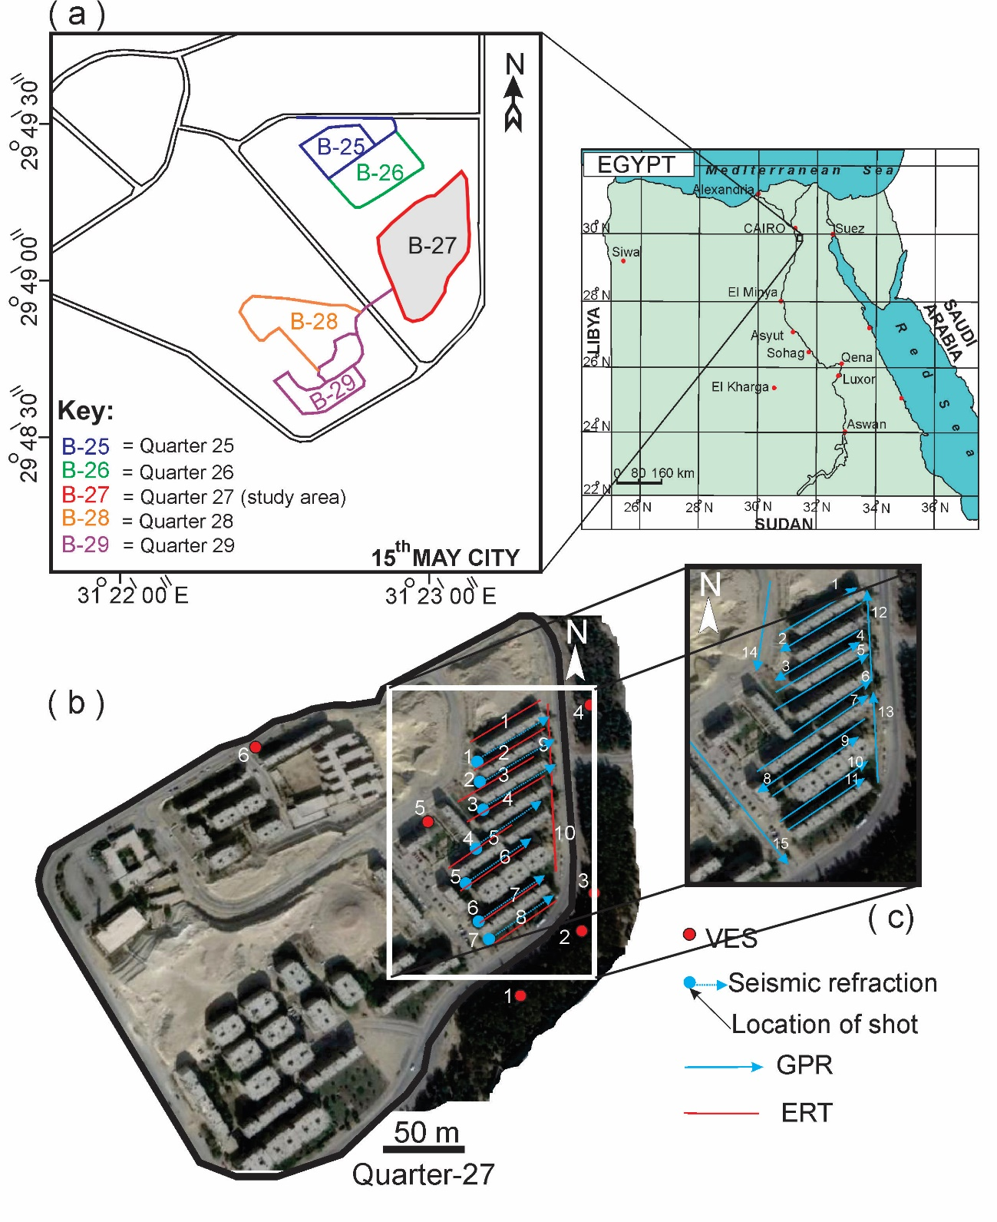
Fig. 1. (a) Location map of the Quarter-27 District study site residential area, SE of Cairo (Egypt map inset), (b) GoogleEarth™ image of Quarter-27 showing location of geophysical surveys (see key) and, (c) location and collection of GPR 2D profiles between domestic housing apartments.
This research used near-surface geophysical surveys to characterize the study site and to create a ground model, unusually after initial construction has already been undertaken. Study objectives are to: (1) collect multi-geophysical datasets to characterize the site, including Vertical Electrical Sounding (VES) 1D profiles, seismic refraction, Electrical Resistivity Tomography (ERT) and Ground Penetrating Radar (GPR) 2D profiles; (2) integrate these datasets to create a final 3D ground model and (3) identify optimal geophysical technique(s) in such studies.

Geology and structure setting
The flat (<4.5 m topographic variation) study area comprises sedimentary deposits of Pliocene, Upper, and Middle Eocene Age (Fig. 2). The site bedrock is the Eocene Qurn Formation, characterized by red-brown limestones (Tealeb et al., 2000), marls and shales (Said, 1990; Mohamed et al. 2012; Conoco Coral, 1987), with overlying Pliocene medium-coarse grain size sediment Wadi type soils present to the south-west of the study area (Fig. 1). There are also two major, eastsoutheast-westnorthwest trending normal faults that bisect the study area (Fig. 2).
Fig. 2. (a) Geological base map of the Quarter 27 study site (see key) and surrounding areas, (b) generalised stratigraphic section showing the five major sedimentary units. Modified from Mohamed et al. (2012).

Geophysical methods
Seven seismic refraction 2D profiles were acquired onsite between existing domestic buildings (see Fig. 1b for locations) to obtain a large-scale site characterization. Seismic data was collected using Geometrics™ StrataView and SmartSeis equipment, using 24 P-wave 14 Hz geophones on all profiles which were 4 m spaced (except for P3 which were 3 m spaced due to site constraints). Three repeat seismic shot positions were also used on all profiles to optimize image quality and account for any site inclined bedding geometries following standard methodologies (see Reynolds, 2011), at 2 m from either end of respective profiles and at the mid-point (46 m) on each profile. Acquisition was also undertaken between the nearby quarry blasting times so that that their ongoing operations did not interfere with the seismic data collection.
Seismic profiles were subsequently imported in OYO Corporation (2004) Geometrics™ SeisImager™ v.3.2 software, using a sequential data processing sequence of: (1) first primary wave arrival picking to flatten the arrival time in Geometrics™ Pickwin v.3.2, (2) high and low cut filters to reduce the effects of other noise sources, (3) generation of travel-time curves from respective profile time delay and ray traces in Geometrics™ Plotrefa v.2.8 software.
Six Vertical Electrical Sounding (VES) surveys were also acquired on-site to collect 1D site profiles (see Fig. 1b for locations), using IRIS Instruments™ Syscal-R2 equipment. These were acquired following standard methodologies using a four probe Schlumberger array configuration (see Milsom & Eriksen, 2011); with electrode probe spacings of 3 m, 4 m, 10 m, 15 m, 30 m, 40 m, 100 m and 140 m with up to 2 km of cable required to ensure enough data points at survey positions. The VES data were then initially graphically analyzed before each underwent an iterative process, of matching the acquired data with a quantitative 3-layer model interpretation and minimising their data/model match misfit, using the IPI2WIN v.2.1 software numerical modeling program, as other researchers have done (see, for example, Veeraiah and Ashok Babu, 2014). A three-layer model interpretation was based on the geotechnical stratigraphic layer thicknesses, and their bulk resistivities, derived by Mohamed et al. (2012) and shown in Figure 2. Finally the 1D results were used to generate 2D cross-sections of the study site.
Ten Electrical Resistivity Tomography (ERT) 2D profiles, 96 m long, were collected on-site (see Fig. 1b for locations), using IRIS™ Instruments Syscal-R2 equipment. Data was collected using 2 m spaced, 48 electrode probes in both Wenner and dipole-dipole array configurations (see Milsom & Eriksen, 2011). Electrode contact resistances were checked before each profile was collected and repositioned if necessary to gain equivalent contacts across each survey line, following standard practice (Milsom & Eriksen, 2011). The ERT profiles were then imported into Geotomosoft™ RES2DINV v.4.03 software and inverted, by calculating the current and resulting voltage measurements, before being converted into an apparent resistivity ($ρ_{a}$) value by using the following formula Eq. (2):
$$ρ_{a}=K\frac{∆V}{I}, (2)$$
where the geometrical factor $K$ depended on the configurations used.
Other numerical inversion options included using a one cell model width to be consistent with probe spacings, a least-squares fit model algorithm and damping factors to reduce the effect of varying electrode probe contact resistances at the surface following standard processing methodologies (see Loke and Barker, 1996; Loke, 2002). Repeat inversions continued until a RMS data-model match error of <5% was calculated, following standard methodologies (see Reynolds, 2011), to create the finalized 2D model inversions.
Fifteen Ground Penetrating Radar (GPR) 2D profiles were collected onsite (see Fig. 1b for locations), using a GSSI™ SIR 2000 System and 100 MHz central frequency, bistatic antennae. Radar trace spacing was 0.02 m, with a 300 ns Time Window. GPR profiles were imported into Sandmeier™ Reflexw v.7.1.6 software for data processing. The sequential data processing sequence was: (1) picking the first break arrivals on each 1D trace and moving all start times to zero for consistent arrivals on 2D profiles; (2) application of a 1D band pass filter (using both low and high cuts) to suppress noise; (3) application of a 2-D energy decay filter to preserve deeper reflection amplitudes; (4) use of running average to smooth the data horizontally; (5) trace interpolation where necessary to fill in blank traces where data was not recorded and finally; (6) two-way time (ns) conversion to depth (m) using the 0.06 m/ns average site velocity calculations that was obtained on-site.
Results
Seismic data
The seismic refraction 2D profiles showed that the study area could only be characterized into two separate zones with defined thicknesses and average velocities (Fig. 3). Calculations of the collected data, to determine the respective zone depths, were estimated by the delay time at each geophone and then compared with Eq. (1) according to (Palmer, 1986) as:
$$∆T_{D}=\frac{Z_{D}\cos\left(\sin^{-1}{{V_{1}}/{V_{2}}}\right)}{V_{1}} (1)$$
where; $Z_{D}$ is the depth under geophone “$D$”,$V_{1}$ is the velocity of the first layer and $V_{2}$is the velocity of the second layer.
The first zone was characterized by comparatively low seismic velocity values, ranging from ~350 m/s to ~445 m/s (Fig. 3). Due to these relatively slow velocities, this was interpreted to be dry sediments, probably marls and limestones from the identified site stratigraphy (Fig. 2b), which varied in thickness from 1.35 m to 5.85 m, due to the ~4.5 m surface topography variations, and was thickest in the southeast of the study area once an isopach contour map was generated from input data (Fig. 4). The second zone (thickness unknown) had relatively much higher seismic velocity values, ranging from ~1,550 m/s to ~2,070 m/s (Fig. 4) and was interpreted to be sediments below the water table.
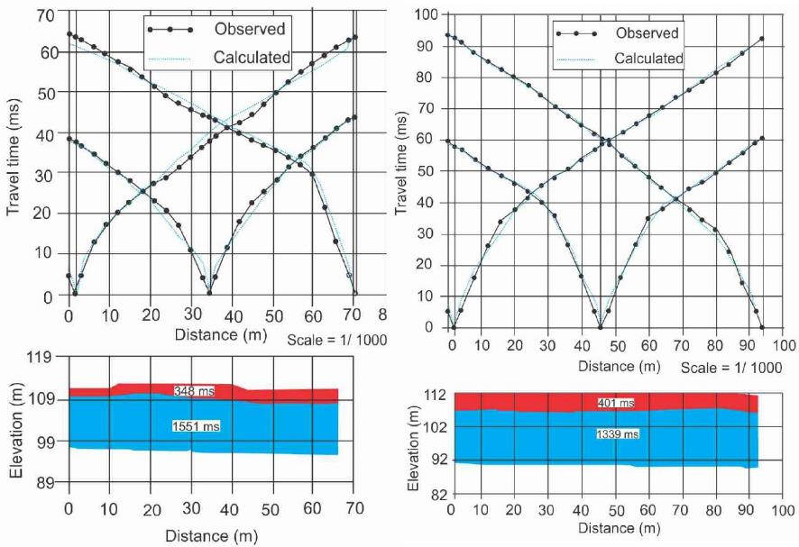
Fig. 3. (top left) P3 and (top right) P5 seismic profile travel time-distance curves (see Fig.1 for site locations), with (bottom) respective two-zone numerical model solutions (average wavelet speeds shown). Zones interpreted to be (top) dry and (bottom) wet zones. Note the three repeat shot positions on each seismic profile.

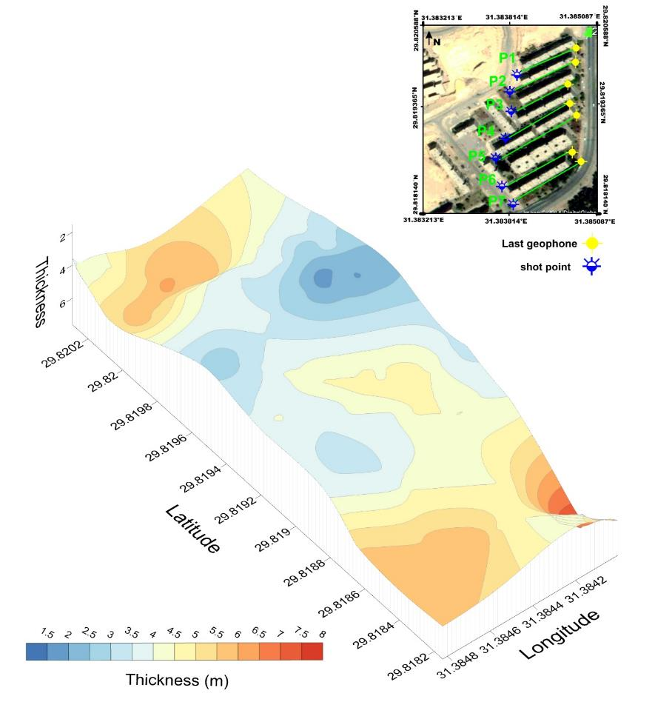
Fig. 4. Seismic isopach map of the interpreted top (dry) zone generated from seismic profiles (seismic profile positions shown inset). Note the zone is relatively thin in the middle which is probably topography related.

Vertical Electrical Sounding (VES) data
The VES data was interpreted to be a two-layer model, and was combined across the study site (see Fig. 5 for example). The top layer (ranging from ~0.6 m to ~8 m depth below ground level) had resistivity values varying from 4.8 $Ω.m$ to 300$Ω.m$, and was interpreted to be dry sediments with typical resistivity values (Milsom & Eriksen, 2011). The second layer (ranging from ~8 m to ~60+ m below ground level) had resistivity values varying from 3 $Ω.m$ to 50 $Ω.m$ and was interpreted to be sedimentary bedrock (see Fig. 2b) below the water table (Milsom & Eriksen, 2011).
Fig. 5. 2D VES cross section of interpreted two-layer models of material above/below the water table (see key), generated from 1D VES 1-4 site data (see location map inset). Numbers are measured apparent resistivity (Ω.m) values.

Electrical Resistivity Tomography (ERT) data
The ten 2D ERT profile inversions showed consistently apparent resistivity values ranging from 1 $Ω.m$ to 200 $Ω.m$ (examples shown in Fig. 6). They also had a vertical distribution of three separate zones of: (1) a relatively high resistant zone (which had resistivity values varying from 50 $Ω.m$ to 250 $Ω.m$) and was interpreted to be the bottom 3rd Unit dry limestones of the Qurn Formation, (2) a second moderate resistant zone (that had resistivity values varying from 20 $Ω.m$ to 40 $Ω.m$) and was interpreted to be the 3rd /2nd Unit saturated limestone/marls in the whole area and (3) a third low resistant zone (that had resistivity values recorded values less than 40$Ω.m$) and was interpreted to be the 2nd Unit saturated limestone/marl layers (see Fig. 2b for site stratigraphy). As the ERT profiles were relatively close to each other, ERT horizontal slices were also generated to better show site resistivity variations (Fig. 7). These showed relatively more resistant areas in the south-west of the site throughout all horizontal resistivity slices.
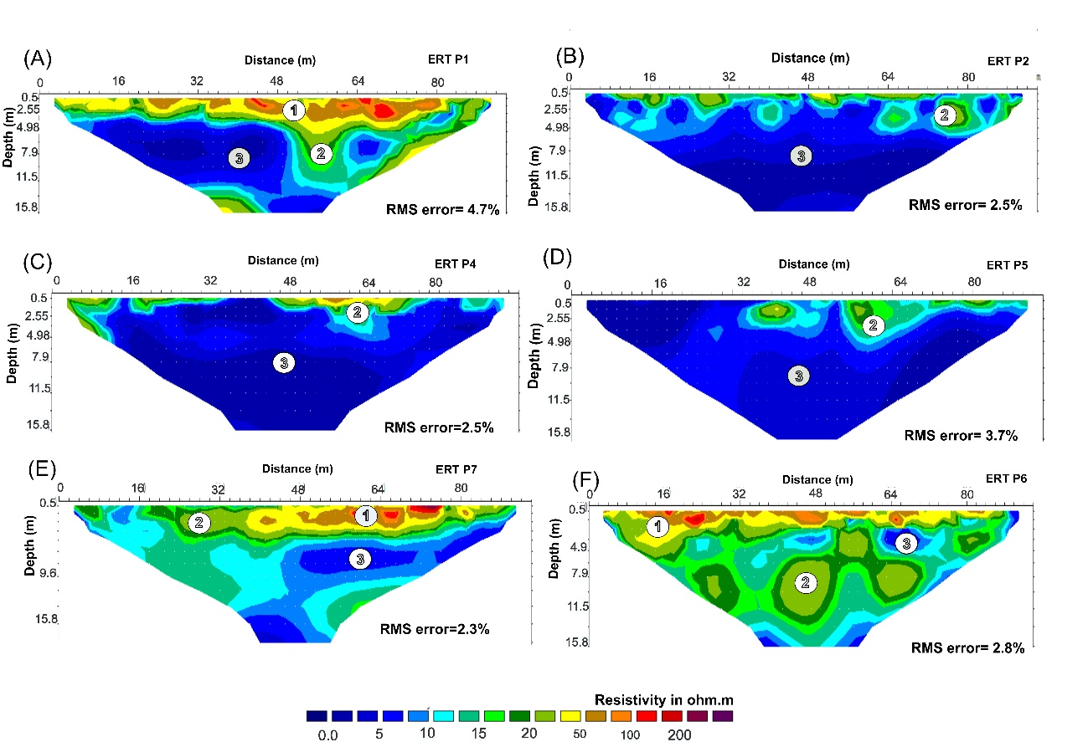
Fig. 6. ERT 2D Profile 1,2,4-6 (A-F) inversions shown (see Fig. 1 for location) with annotated; (1) 3rd Unit dry limestones, (2) 3rd/2nd Unit saturated limestones/marls and (3) 2nd Unit saturated limestones/marl zones of the Upper Eocene Qurn Formation (see Fig. 2b). Note profiles also have common color-contoured apparent resistivity values and data-model misfit (RMS) errors shown (see text).
Fig. 7. ERT horizontal depth slices (respective depths below surface shown) generated from the ERT 2D profile data (Fig. 6). The same annotated (1) 3rd Unit dry limestones zone, (2) 3rd/2nd Unit saturated limestones/marls zone and (3) 2nd Unit saturated limestones/marl zone of the Upper Eocene Qurn Formation (see Fig. 2b) are shown. Note the relatively high resistive areas to the south-west of the study area.
Ground Penetrating Radar (GPR) data
The fifteen GPR 100 MHz 2D profiles consistently showed a sequentially deepening succession of: (1) a shallow top layer, interpreted to contain (4) concrete pavements, utility services and power lines; (2) a deeper dry limestone/marl layer and; (3) a saturated wet limestone/marl layer (see Figs. 8-9), all within the 3rd Unit of the Upper Eocene Qurn Formation (see Fig. 2b). The high-amplitude, narrow reflection events (5) could be correlated to surface cracks and fissures, which appeared to penetrate up to 4 m depth below the ground surface (Fig. 9). Whilst these surface cracks were small, being potentially air/water filled they gave a sufficient contrast that they could be imaged by GPR (see Mohamed et al. 2012).
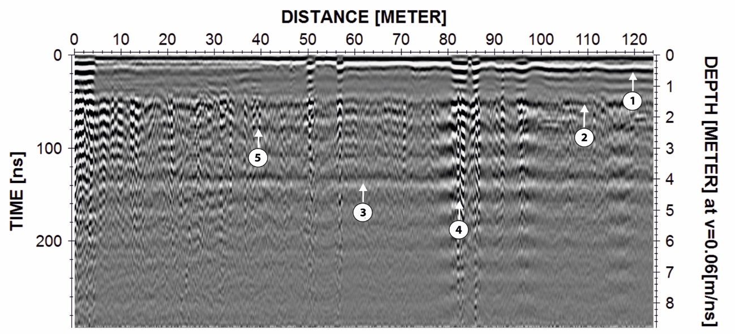
Fig. 8. GPR 2D 100 MHz Profile 9 data acquired over the study area (see Fig. 1 for location), with interpreted 3 layers: (1) top dry soil layer, (2) subsoil dry marl layer, and (3) water-saturated limestone/marl layers, all within the 3rd/2nd Unit of the Upper Eocene Qurn Formation (see Fig. 2b). There was also (4) concrete/utilities and high-amplitude reflection event anomalies (5) that were at known surface crack positions.
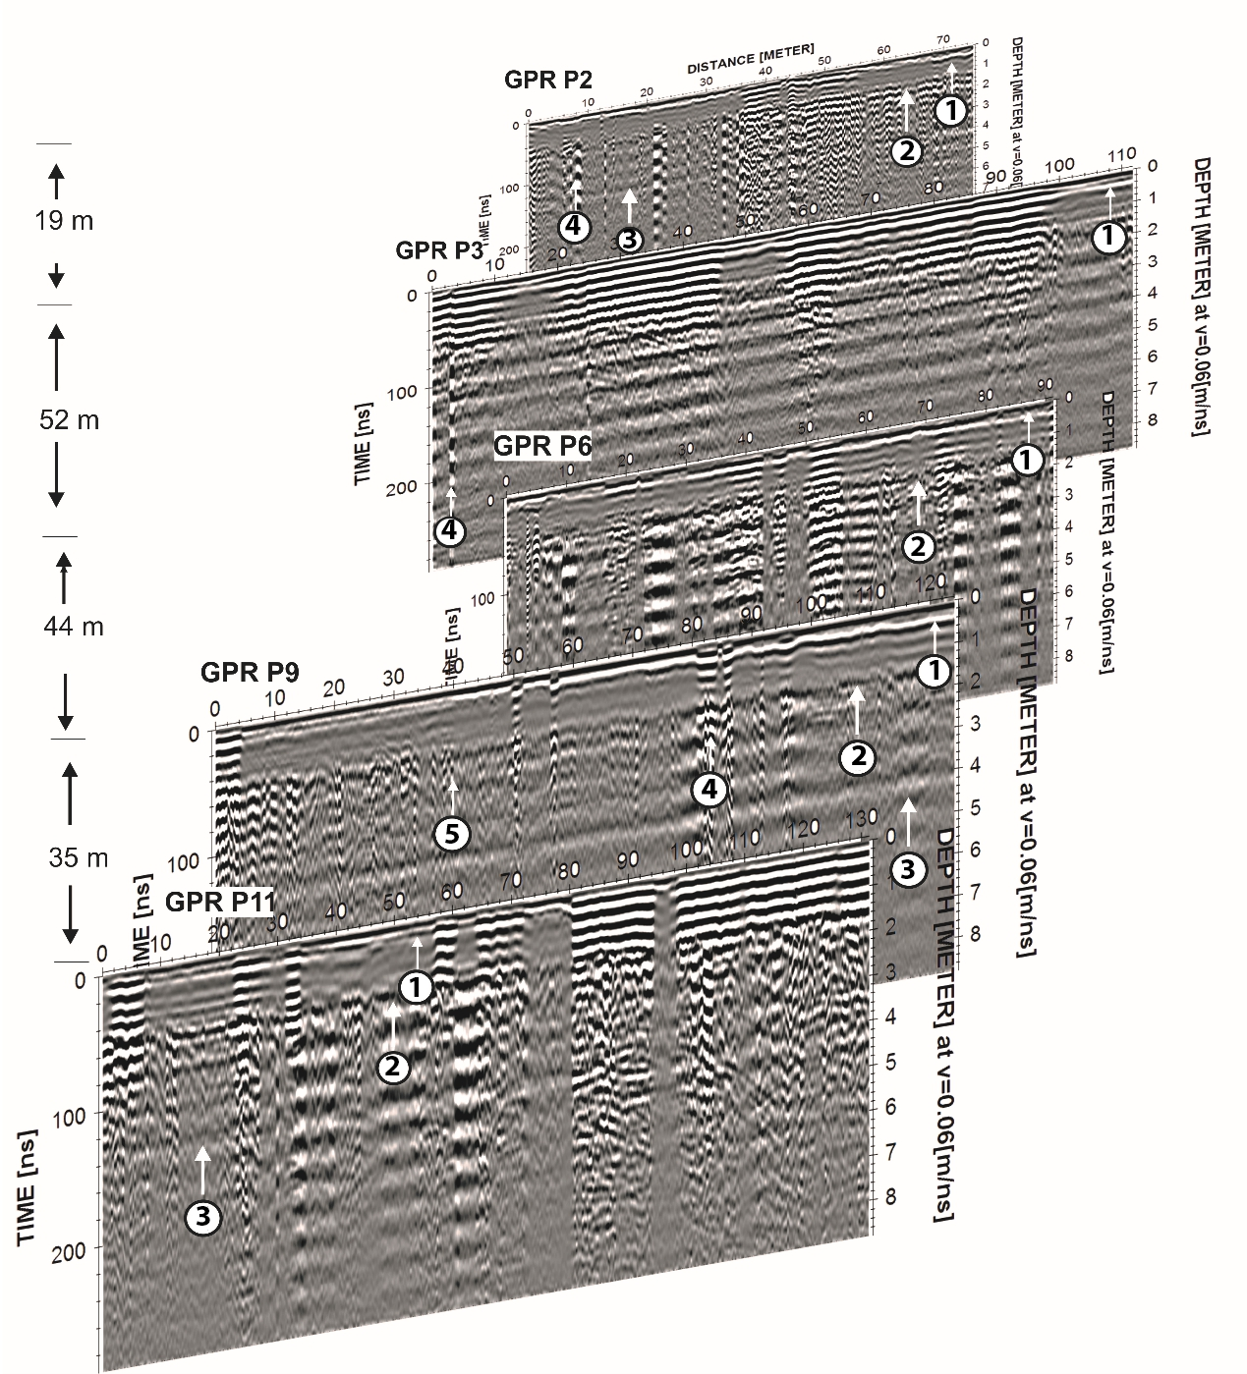
Fig. 9. GPR 100 MHz 2D profiles (P2, P3, P6, P9 and P11) acquired over the study area (see Fig. 1 for location), with interpreted three-layers: (1) top dry soil layer, (2) subsoil dry marl/limestone layer, (3) water-saturated marl/limestone layer, all within the 3rd/2nd Unit of the Upper Eocene Qurn Formation (see Fig. 2b). There was also (4) concrete/utilities and high-amplitude reflection event anomalies (5) that were at known surface crack positions.
Discussion
Using near-surface geophysical techniques to assess and characterize ground instability in geoengineering projects have been reported globally, e.g. in South Africa by Damhuis et al., (2019), the UK by Nichol & Reynolds (2002); Jeffery et al. (2020), in The Bahamas by Styles et al. (2005) and in Egypt by Khalil & Hanafy (2008); Sultan, (2010); Khalil, (2012), Morsy & Rashed, (2013); Mohamaden et al. (2016). Some researchers have ground-truthed geophysical anomalies by drilling to confirm results (e.g. Nicol & Reynolds, 2002; Styles et al., 2005; Damhuis et al., 2019), which could not be undertaken in this case unfortunately. Nevertheless, some key geophysical site results were still obtained which will be discussed here.
Due to it’s relatively poor vertical resolution and the lack of sufficient acoustic impedance contrast with the different sedimentary bedrock intervals (Fig. 2b), the seismic survey was only able to determine the dry/wet sediment interface (Figs. 3/4), as others have found using seismic surveys (e.g. Nicol & Reynolds, 2002). However, this still provided useful information on where the dry and saturated zones were present on site. The VES electrical resistivity survey also only found this interface (Fig. 5), but this was expected, as VES surveys are more commonly used as a reconnaissance technique for 1D site investigation, in order to provide information for more comprehensive geophysical surveys of sites (see, for example, Reynolds, 2011).
In contrast, the ERT datasets resolved three zones across the study site, as well as the dry/wet sediment boundary (Fig. 6). ERT surveys also picked a deeper, more competent bedrock zone, which did vary over the study site (Fig. 7), which other similar studies have found (see, for example, Mitrofan et a. 2008; Reynolds, 2011; Banham & Pringle, 2011). The GPR datasets had the best vertical resolution, which picked out the dry/wet interface, as well as the major faults, buried utility infrastructure and, most importantly, surface cracks and fissures. The south-west of the study site had most of the observed surface cracks and fissures, as well as the large known fault which looked to be source of the major ground instability issues (Fig. 10).
The geophysical data collected, as it was geo-spatially referenced (see Fig. 1), key results could then be integrated to generate a summary site map (shown in Figure 10). The main identified normal fault position crossing the site is shown, together with near-surface fractures (identified from the GPR data), water-saturated zones and damaged building locations. These identified areas will then be able to be further investigated, ideally ground-truthed by intrusive investigations to confirm results, which has been passed onto site engineers tasked with the remediation work.
As this study has shown, near-surface geophysical surveys are difficult but not impossible to acquire in restricted urban sites, few others have shown this (although see, for example, Anderson et al., 2018). This study site was particularly difficult to survey, due to the requirement to collect surveys between domestic high-rise buildings and associated infrastructure, as well as the adjacent active rock quarry which made acquisition of seismic surveys needing to be timed to avoid the quarry blasts causing interference.
It would have been ideal to collect the geophysical surveys on site before construction initiated, as common best practice suggests (e.g. see Reynolds, 2011; de Freitas et al., 2017), but it was not possible in this case. However, this study showed that it was still possible to characterize the site and identify the key site zones, water table, major faults and surface cracks even after building construction, which should prove helpful for other researchers working in such difficult active sites.
Fig. 10. Summary of the main study findings (see key). Central areas, affected by water, are marked (blue areas), together with damaged areas (yellow dots), buildings (red lines), and major faults (yellow line).

Conclusions
This study showed that near-surface geophysical surveys can be acquired and combined to characterize a difficult urban site, including the water table, buried utilities and major fault positions. Whilst it is, of course, recommended that geophysical surveys are conducted on sites prior to construction, this study shows that it is possible to gain meaningful geophysical results post-construction. Timing of geophysical survey data collection was also important, in this case to undertake seismic surveys between the nearby limestone quarry blasting. Further work should ground-truth results by intrusive investigations.

Acknowledgements
This work is financially supported by the Egyptian National Research Institute of Astronomy and Geophysics (NIRAG). We acknowledge the 15th of May City‘s government that gave permission to undertake this research. Finally Dr. Hany Mesbah (NIRAG), two anonymous reviewers and a journal editor are thanked for constructive comments on this paper.

References
Anderson, T.R., Poulsen, S.E., Thomsen, P. & Havas, K. 2018. Geological characterization in urban areas based on geophysical mapping: A case study from Horsens, Denmark. Journal of Applied Geophysics, 150, 338-349.
Banham, S.G. & Pringle, J.K. 2011. Geophysical and intrusive site investigations to detect an abandoned coal-mine access shaft, Apedale, Staffordshire, UK. Near Surface Geophysics, 9, 483-496.
Baek, S. H., Kim, S. S., Kwon, J. S. & Um, E. S. 2017. Ground penetrating radar for fracture mapping in underground hazardous waste disposal sites: A case study from an underground research tunnel, South Korea. Journal of Applied Geophysics, 141, 24-33.
Cardimona, S. 2002.Subsurface investigation using ground penetrating radar, The 2nd Annual Conference on the Application of Geophysical and NDT Methodologies to Transportation Facilities and Infrastructure, 1–15.
Conoco Coral. 1987. The Geological map of Egypt with Scale 1: 100,000. Egyptian General Petroleum Co-operation (EGPC).
Damhuis, R.M.J., Roux, P.L. & Fourie, C.J.S. 2019. The identification and mitigation of geohazards using shallow airborne engineering geophysics and land-based geophysics for brown- and greenfield road investigations. Quarterly Journal of Engineering Geology & Hydrogeology. https://doi.org/10.1144/qjegh2018-036
De Freitas, M.H., Griffiths, J.S., et al. 2017. Engineering investigation and assessment, Griffiths, J.S. & Martin, C.J. (eds.), Engineering Geology and Geomorphology of Glaciated and Peri-glaciated Terrains, Engineering Geology Special Publication, 28, 741-830.
Emad, H. A., Jassim M. T. A., & Salah N. A. 2015. Integrated GPR and ERT as Enhanced Detection for Subsurface Historical Structures Inside Babylonian Houses Site, Uruk City, Southern Iraq. Pure and Applied Geophysics, 173, 963-982.
Jeffery, Z.E., Penn, S., Giles, D.P. & Hastewell, L. 2020. Identification, investigation and classification of surface depressions and chalk dissolution features using integrated LiDAR and geophysical methods. Quarterly Journal of Engineering Geology and Hydrogeology, https://doi.org/10.1144/qjegh2019-098
Khalil, M.H. 2012. Magnetic, geo-electric, and groundwater and soil quality analysis over a landfill from a lead smelter, Cairo, Egypt. Journal of Applied Geophysics, 86, 146-159.
Khalil, M.H. & Hanafy, S.M. 2008. Engineering applications of seismic refraction method: A field example at Wadi Wardan, Northeast Gulf of Suez, Sinai, Egypt. Journal of Applied Geophysics, 65(3-4), 132-141.
Kiflu, H., Kruse, S., Loke, M.H., Wilkinson, P.B. & Harro, D. 2016. Improving resistivity survey resolution at sites with limited spatial extent using buried electrode arrays. Journal of Applied Geophysics, 135, 338-355.
Loke, M. H. 2002.2-D and 3-D Electrical Imaging Surveys. Available from: <www.geoelectrical.com>.
Loke, M. H. & Barker, R. D. 1996. Rapid least-squares inversion of apparent resistivity pseudosections by a quasi-Newton method. Geophysical Prospection, 44, 131–152.
Lontsi, A.M., Ohrnberger, M. & Kruger, F. 2016. Shear wave velocity profile estimation by integrated analysis of active and passive seismic data from small aperture arrays. Journal of Applied Geophysics, 130, 37-52.
Marecos V., Solla M., Fontul S., & Antunes V. 2017. Assessing the pavement subgrade by combining different non-destructive methods, Construction and Building Materials, 135, 76–85.
Mellett, J.S. 1995. Ground penetrating radar applications in engineering, environmental management, and geology. Journal of Applied Geophysics, 33, 157-166.
Milsom, J. &Eriksen, A. 2011. Field Geophysics, 4thEdition, Wiley, 287 p.
Mitrofan, H., Povara, I. &Mafteiu, M. 2008. Geoelectrical investigations by means of resistivity methods in karst areas in Romania. Environmental Geology, 55, 405–413.
Mohamaden, M. I. I., Hamouda, A. Z. & Mansour, S. 2016. Application of electrical resistivity method for groundwater exploration at the Moghra area, Western Desert, Egypt. Egyptian Journal of Aquatic Research, 42, 261-268.
Mohamed, A. M. E., Sultan, S. A. & Mohamed, N. I. 2012. Delineation of near-surface structure in the southern part of the city of 15th May Cairo, Egypt using geological, geophysical and geotechnical techniques. Pure Applied Geophysics, 169, 1641–1654.
Morsy, M. & Rashed, M. 2013. Integrated magnetic, gravity, and GPR surveys to locate the probable source of hydrocarbon contamination in Sharm El-Sheikh area, south Sinai, Egypt. Journal of Applied Geophysics, 88, 131-138.
Nichol, D. and Reynolds, J.M. 2002. Application of reflection seismology to foundation investigations at A5 Pont Melin Rûg, North Wales. Quarterly Journal of Engineering Geology and Hydrology, 35, 247-256.
Orlando, L. 2013. GPR to constrain ERT data inversion in cavity searching: Theoretical and practical applications in archeology. Journal of Applied Geophysics, 89, 35–47
OYO Corporation. 2004. SeisImager Manual Version 3.0 (Computer program manual) Japan: OYO Corporation.
Palmer, D. 1986. Refraction seismics: Geophysical Press Ltd. Patterson, H. D., and Thompson, R., 1971, Recovery of inter-block information when block sizes are unequal: Biometrika, 58, 545–554.
Pringle, J.K., Howell, C., Styles, P., Branston, M.D., Furner, R., & Toon, S.M. 2012. Long term time-lapse microgravity and geotechnical monitoring of relict salt-mines, Marston, Cheshire, UK.Geophysics, 77(6), B287-294.
Reynolds, J.M. 2011. An introduction to applied and environmental geophysics, 2nd edition, Wiley Publishers.
Rial F.I., Pereira M., Lorenzo H., Arias P. & Novo A.. 2007. Vertical and horizontal resolution of GPR bow-tie antennas. IEEE 4th International Workshop on Advanced Ground Penetrating Radar, IWAGPR. 187–191.
Said, R. 1990.Geology of Egypt, A. A. Balkema, Rotterdam, Brookfield, 722 p.
Sandmeier, K. J. 2000. Reflexw, Version 1.4, program for processing of seismic, acoustic or electromagnetic reflection and transmission data, version 1.4, Karlsruhe, Germany, 197.
Styles, P., McGrath, R., Thomas, E. & Cassidy, N.J. 2005. The use of microgravity for cavity characterization in karstic terrains. Quarterly Journal of Engineering Geology & Hydrogeology, 38, 155-169.
Sultan, S. A. 2010. Geophysical investigation for shallow subsurface geotechnical problems of Mokattam area, Cairo, Egypt. Environmental Earth Sciences Journal, 59, 1195–2207.
Tealeb, A.A., Sobaih, M., Mohamed, A.A. & Abdelrahman K. 2000. Stress level estimation for the ground beneath the 15th May City, Helwan, Cairo, Egypt. CEHM2000, Cairo University, Egypt, 72–83.
Tuckwell, G., T. Grossey, S. Owen & P. Stearns. 2008. The use of microgravity to detect small distributed voids and low-density ground. Quarterly Journal of Engineering Geology and Hydrogeology, 41, 371–380.
Veeraiah, B. & Ashok Babu, G. 2014. Deep Resistivity Sounding (DRS) technique for mapping of sub-trappean sediments — A case study from central India. Journal of Applied Geophysics, 105, 112-119.
Wang, T. P. et al. 2014. Applying FDEM, ERT and GPR at a site with soil contamination: A case study. Journal of Applied Geophysics, 121, 21–30.
Williams, R. A., Stephenson, W. J., Odum, J. K. & Worley, D. M. 2005.P- and S-wave Seismic Reflection and Refraction Measurements at CCOC. U.S. Geological Survey, 1–17.
Wunderlich T. & Rabbel, W. 2011. Attenuation of GPR Waves in Soil Samples Based on Reﬂection Measurements.

