**Calcareous Algae and Cyanobacteria.**

Michael C. Leaf, Jessica S. A. Gay, Matthew J. Newbould, Owen R. Hewitt and Steven L. Rogers

School of Geography, Geology and the Environment, William Smith Building, Keele University, Keele, Staffs, ST5 5BG, UK. s.l.rogers@keele.ac.uk

Algae is an informal term used to describe a broad group of simple organisms from the plant kingdom (Fig. 1). The organisms included within this grouping are aquatic photosynthetic biota with an extensive range of life habits and forms. These organisms range from micron-sized unicelular forms to giant seaweeds and kelps, which can grow to several metres long. Both benthic and planktonic modes of life are known and display a wide variety of life cycles. Major algal groups are generally based on the plants pigment colour (these pigments are derived from specialised photosynthetic cells); the major groups are (see Fig. 1): red (Rhodophyta), green (Chlorophyta) and brown (Phaeophyta) algae. A fourth major group exists known as the ‘blue-green algae’ (Cyanophyta, including cyanobacteria), this group is comprised of prokaryotes (the other groups being eukaryotes). It should be noted that broad group colourings do not mean the organisms are necessarily of the specific given colour (i.e. red, green etc.) since Rhodophyta may appear as blue-green and Cyanophyta are often found to be orange or yellow. Cyanophyta lack a discrete nucleus or the organelles associated with eukaryotes, and are more closely related to bacteria, indeed they are included within the Prokaryota, and grouped as cyanobacteria. Both groups are known from a wide range of environments, including marine and freshwater and are photosynthetic (with rare exceptions within the cyanobacteria). It is for these reasons that the Cyanophyta are often grouped with algae. This article provides a broad overview on fossil calcareous algae, each of the main algal groups covered here contain enough complexity and variety to warrant specific contributions regarding each of them. The sheer variety of organisms falling under the heading of “calcareous algae and cyanobacteria”, their extensive temporal and spatial ranges, their environmental sensitivities and their persistence as extent organisms all make these fossils excellent indicators and proxies for palaeo -environmental, -geographical, -oceanic and -depositional conditions. Their presence and discovery in the geological record, although often difficult to unravel, can be exceptionally useful to geologists from a multitude of sub-disciplines.

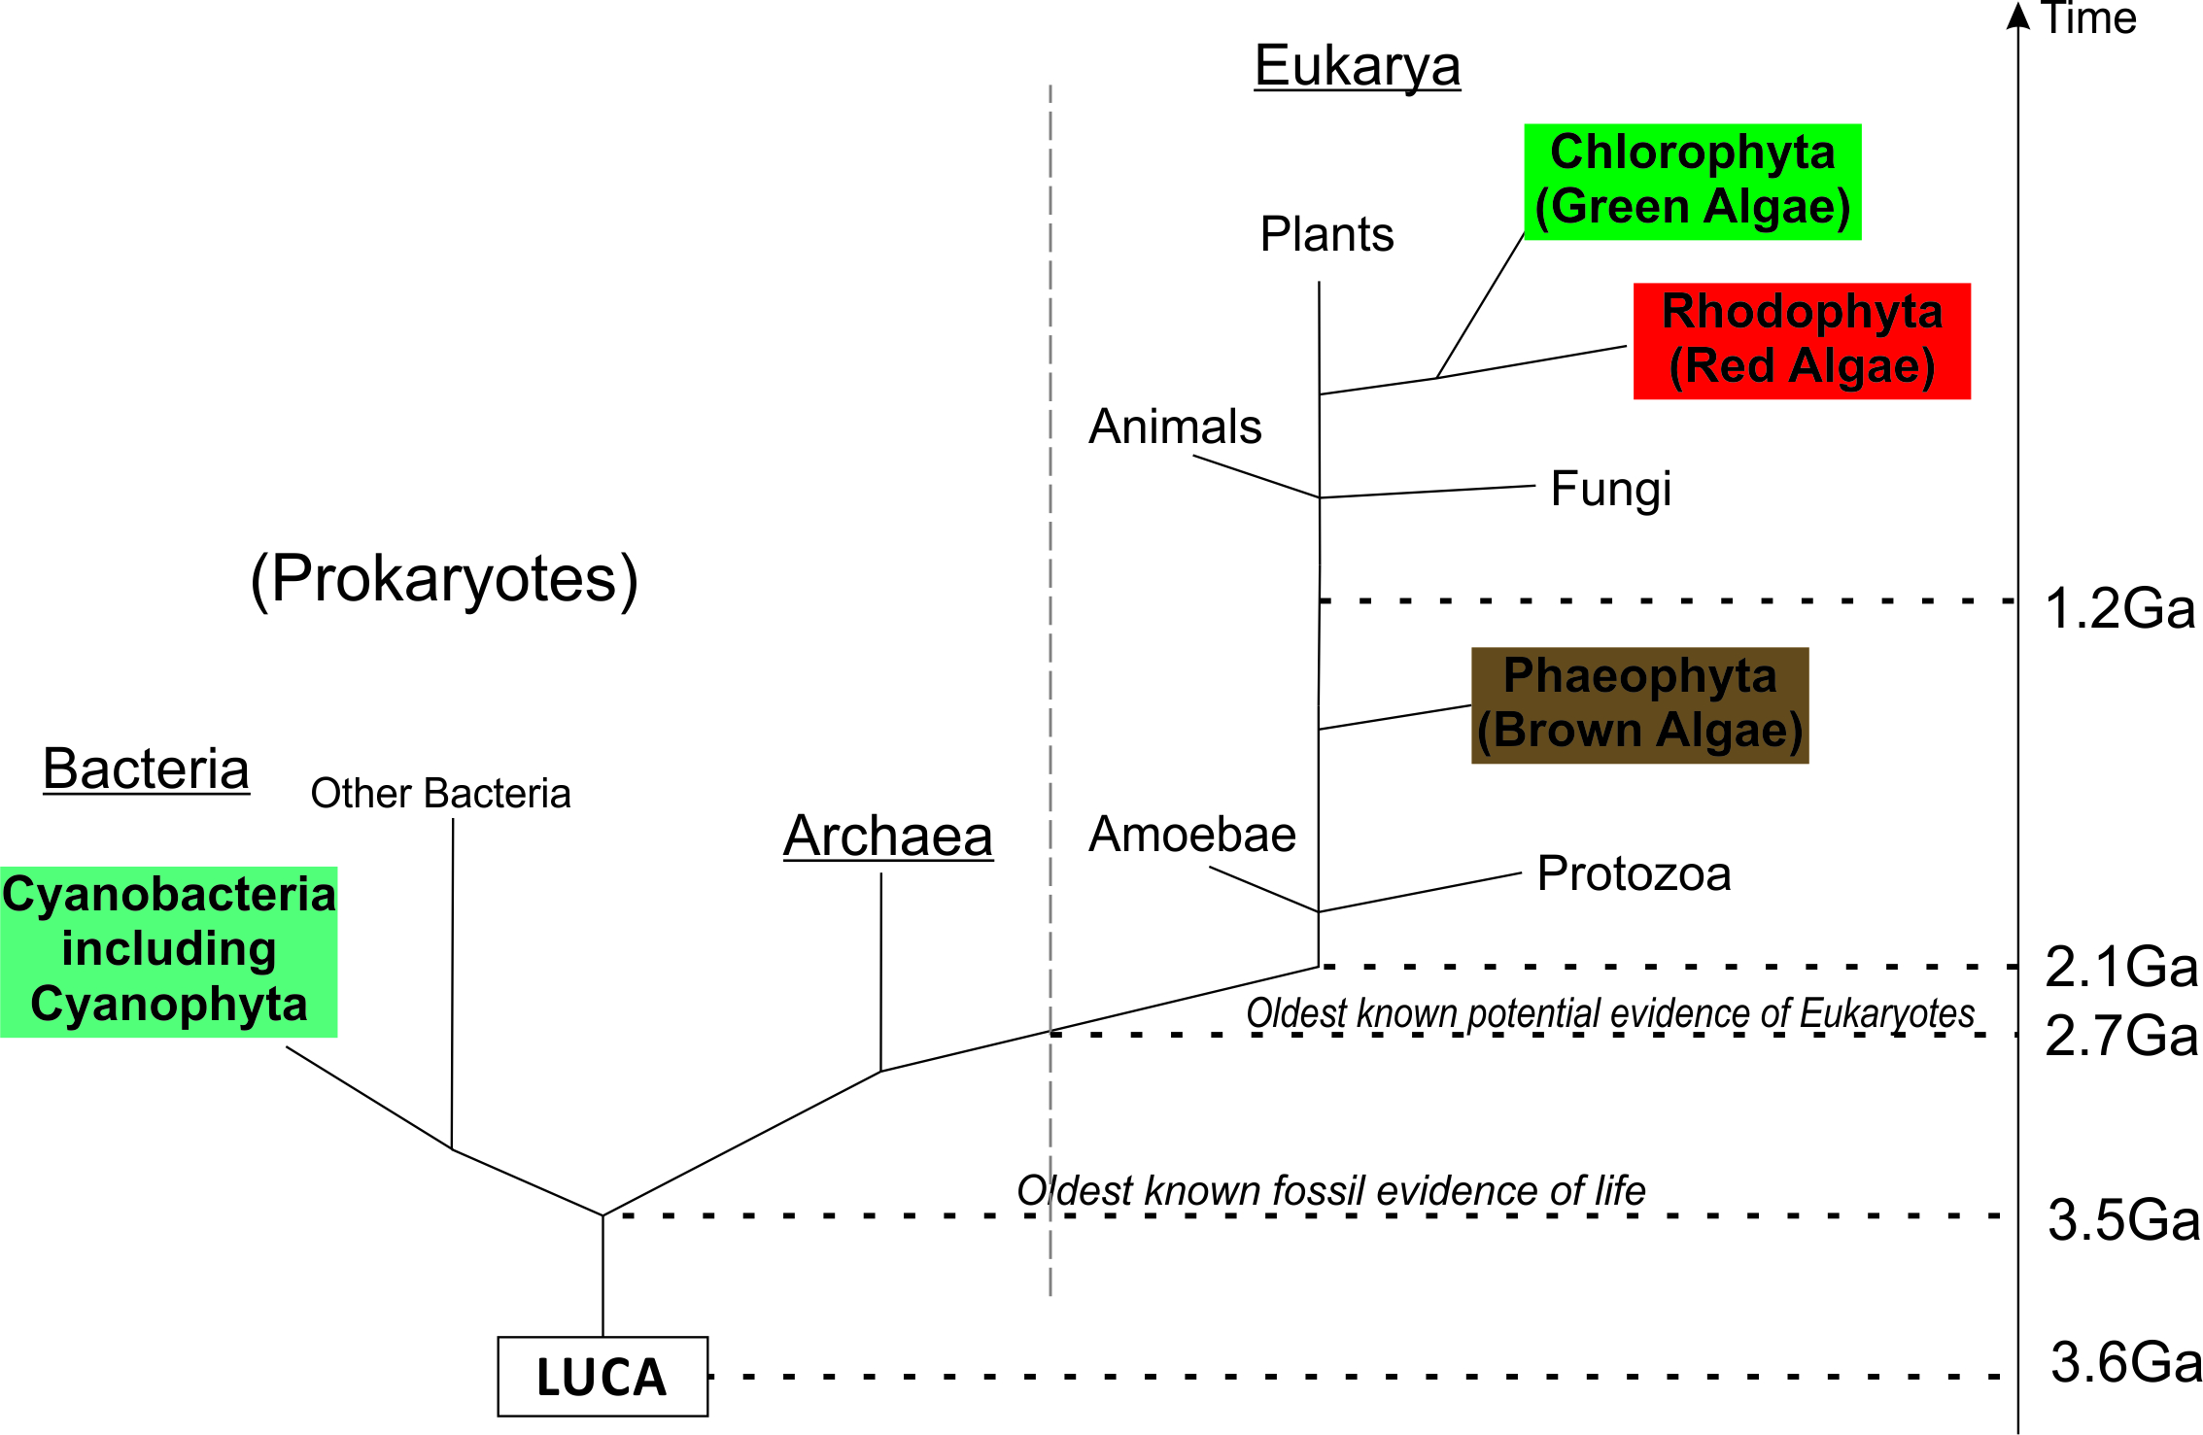

Figure 1. A basic phylogenetic tree showing the biological/temporal relationship between the various major algae groups and the cyanobacteria. LUCA = Last Universal Common Ancestor. Ga = Billions of years ago.

Calcareous algae are those biota that are capable of secreting or depositing carbonate around or within their body (known as a thallus; part of a plant body which is not differentiated into stem, leaf or root structures). The group consists of benthic and planktonic algae from a variety of systematic groups. Of modern day algae and cyanobacteria, less than 10% of benthic species are calcareous. Despite this apparent disparity between calcareous and non-calcareous algae, the group is a wholly practical association in geology. Modern day algae are classified based on several characteristics, including, morphology, pigmentation, type of flagellation and chloroplast ultrastructure. Importantly, the ability to produce carbonate components is not a classification criterium. Fossil calcareous algae are generally classified based on morphological characteristics alone, this includes thallus morphology, reproductive body (conceptacle) morphology, and the shape, size and configuration of any preserved cellular tissue. This means that many fossil algae cannot be related to any modern group of algae. There are several non-systematic groups that can be used to collectively group fossil algae of similar morphologies (e.g. ‘phylloid algae’ - a group of fossil algae whose name refers to their leaf-like shape (Fig. 2)). Other fossil algae are placed into taxonomic groups that have been tentatively linked to major groups of their modern equivalents (red or green algae).

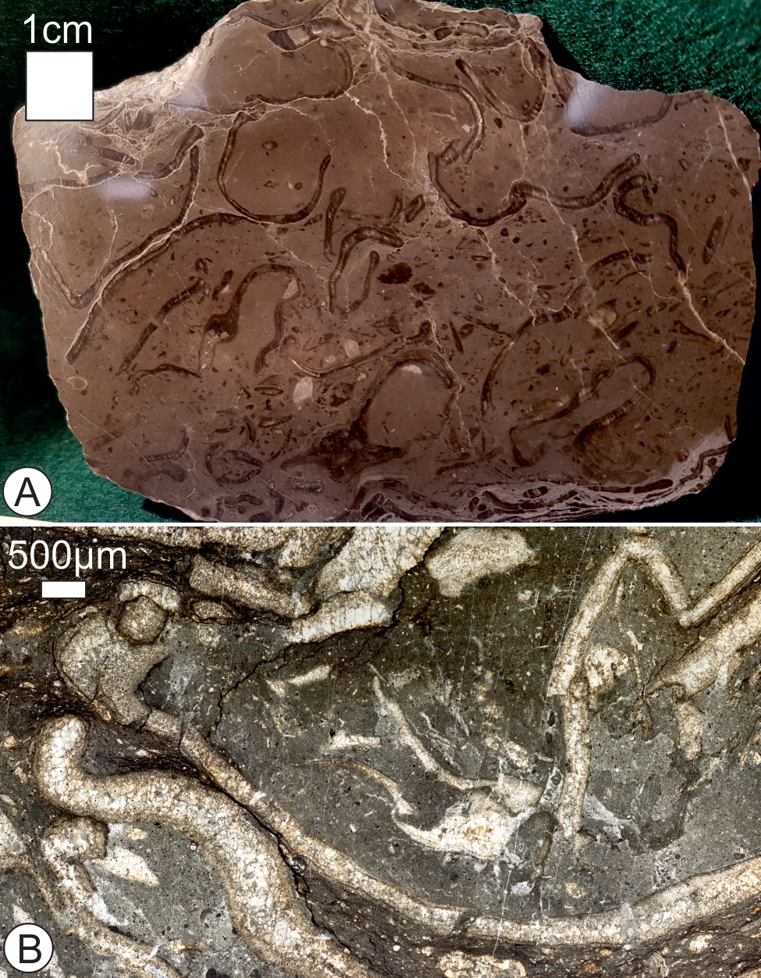

Figure 2. Examples of ‘phyloid’ algae. A) A cut and polished hand specimen exhibiting multiple cut throughs of ‘cup’ shaped ‘phyloid’ algae thalli (the dark, curved and elongate objects. B) A photomicrograph showing ‘phyloid’ algae in section, these algae are often poorly preserved, with their internal structure recrystalised - as seen in this image. Both specimens are from the Carboniferous San Emiliano Formation, Cantabrian Mountains, Spain.

Algal calcification occurs via the removal of carbon dioxide from water, which is secreted as carbonate around the thallus. Calcification has been interpreted as a means of providing: light-shading, protection against predators, and a way of receiving higher amounts of light and nutrients. Both cyanobacteria and calcareous algae often use photosynthesis as the driving mechanism that induces calcification. The primary mineralogy of the algae plays an important role in the preservation and diagenetic potential (and therefore geological presence) of the thalli. Examples of differing primary mineralogy include aragonitic vs calcitic skeletons and varying magnesium levels within calcites (low-Mg and high-Mg calcites). Modes of calcification can be observed to differ across the broad range of calcareous algae. The process of calcifying may occur within the algal cells (e.g. planktonic coccolithophorids), as a component of the cell walls (e.g. coralline red algae), as an extracellular secretion (e.g. most calcareous green algae) or as a deposit on the thallus (many blue-green algae).

Cyanobacteria are an ancient bacterial phylum, which often form sedimentary structures within carbonate rocks; Cyanophyta are commonly associated with the formation of stromatolites, oncolites and microborings. These organisms contain a photosynthetic pigment called phycocyanin, however they bear no direct taxonomic relationship to pigmented algae themselves. This pigment is located along lamellae around the edges of the cell and is sensitive to low concentrations of blue light.

Cyanobacteria live as either single cells, colonies (coccoid growth form: Chroococcales) or link together to form threads or trichomes (filamentous growth form: Hormogonophyceae). Filamentous growths can be branched and enclosed in a mucilaginous sheath. Cyanobacterial calcification often occurs because of bacterial initiated calcifying processes within this mucilaginous sheath. Calcification can occur either via the impregnation or via encrustation of the sheath with carbonate. Sheath formation and subsequent calcification is strongly environmentally controlled with extracellular precipitation requiring favourable CaCO3 conditions. Encrusted cyanobacteria are likely to be preserved as fossils whereas impregnated sheathes are more likely to breakdown into carbonate muds. The degradation of dead cyanobacteria also promotes the precipitation of microbial mats.

**Stratigraphic Range**

The earliest known calcifying algae are known from the lower Cambrian, whilst calcified cyanobacteria are known from the late Precambrian, and are responsible for the formation of the oldest known fossil evidence of life on Earth; Stromatolites. The oldest known example of stromatolites date to 3.7 Ga in the Isua supracrustal belt of Greenland (these stromatolites are controversial, with abiotic formation mechanisms being proposed to be responsible for them). Less controversial stromatolites are known from the 3.5 Ga Pilbara Supergroup of Western Australia. The sudden appearance of calcified cyanobacteria has been suggested to reflect a change in seawater chemistry near the Precambrian-Cambrian boundary; this relationship is based on the strong link between the calcification of cyanobacteria being linked to environmental conditions. It has been suggested that the Cyanophyta were likely responsible for the increase in oxygen levels in the atmosphere during Precambrian times, driven by photosynthesis. Major calcifying algae groups are known throughout the Phanerozoic (Fig. 3). The preservation of calcifying algae and cyanobacteria is generally restricted to calcareous lithologies.

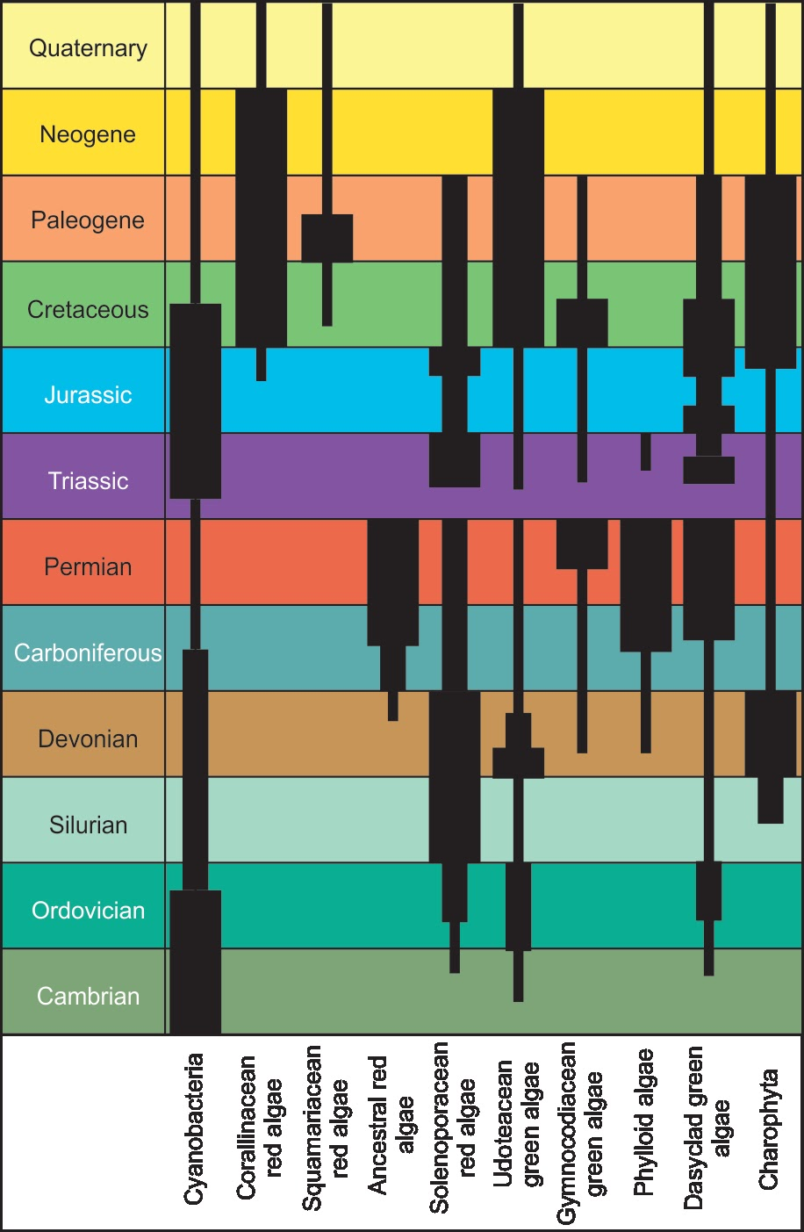

Figure 3. Distribution of major calcareous algal groups and cyanobacteria. Thickness of bars indicates the relative frequency of the groups as they appear in thin section, and not taxonomic diversity. Redrawn from Flügel, 2004.

**Environment, modern vs ancient. Preservation and fossil record**

The productivity of calcareous algae and cyanobacteria is controlled by factors that limit the possible environments they can survive in, and are dependent on the following: *physical factors* i.e. currents, light penetration, temperature, substrate conditions, physical accomodation space and shoreline geography; *chemical factors* i.e. water composition (pH, dissolved nutrients, gases and salts) and *biological factors* such as inter-species competition. By extrapolating these concepts into the fossil record, some of the environments that fossil algae lived in can be interpreted. Due to the significantly wide range of morphologies present across the spectrum of calcareous algae, plus the various cutting angles produced by sample preparation, the morphologies of these fossils have an exceptionally large variation when observed - to correctly attribute the taxonomy of individual specimens multiple cut throughs or sections are required.

Red algae.

Modern extant species of red algae frequently occur worldwide, occupying polar to tropical regions, yet their highest diversity is restricted to tropical coral reefs. These calcareous algae are known to maintain symbiotic relationships with the corals (Cnidaria). Modern red algae are known to inhibit the majority of the depth range occupied by most photosynthetic organisms.

Fossil red algae species were crucial for the formation of reef communities, this occurring as early as the Silurian. The Devonian aged red algae *Archaeoamphiroa*, closely resembling the extant coralline red algae *Amphiroa,* is interpreted as having grown in a shallow and surf-swept reef environment. One of the most common groups of fossilised red algae observed in the geological record are the Corallinales, which have two living families (*Corallinaceae* and *Sporolithaceae*), both of which can be found in Mesozoic and Cenozoic strata. Earlier records from the late Jurassic are questionable due to age attribution and taxonomic definition. Amongst the most famous of the red algae are the *Solenopora*, these are ancestral corallinales known for there red and white laminations (Fig. 4a), the history of the classification of *Solenopora* is perhaps typical for that of the algae, with several alternative classification given (including as a chetaeted sponge). Living *Corallinaceae* grow in depths ranging from intertidal to 250 m, preferring waters with a normal marine salinity (though some species can tolerate lower salinity conditions), and the majority choosing a firm substrate for attachment while others choose softer bottoms. Energy conditions of modern habitations also have a wide variety, ranging from areas with intense water agitation to very low energy systems.

Rhodoliths are a form of free living red algae (Fig. 4b), occurring in the absence of a hard substrate, resulting in a number of species occurring as free living rhodolith nodules within sandy sea floors. The nodules formed by rhodoliths commonly consist of undulose encrustations laminated with background sediments (Fig 4b.) They produce distinct rhodalgal facies which contain an abundance of coralline red algae, developing within nutrient rich zones under limited-light conditions. This facies is an important component within the geological record; in the early-late Miocene these facies reached peak abundance and dominated “classical” coral reef environments. They were first documented within the Paleogene, becoming widespread throughout the Neogene.

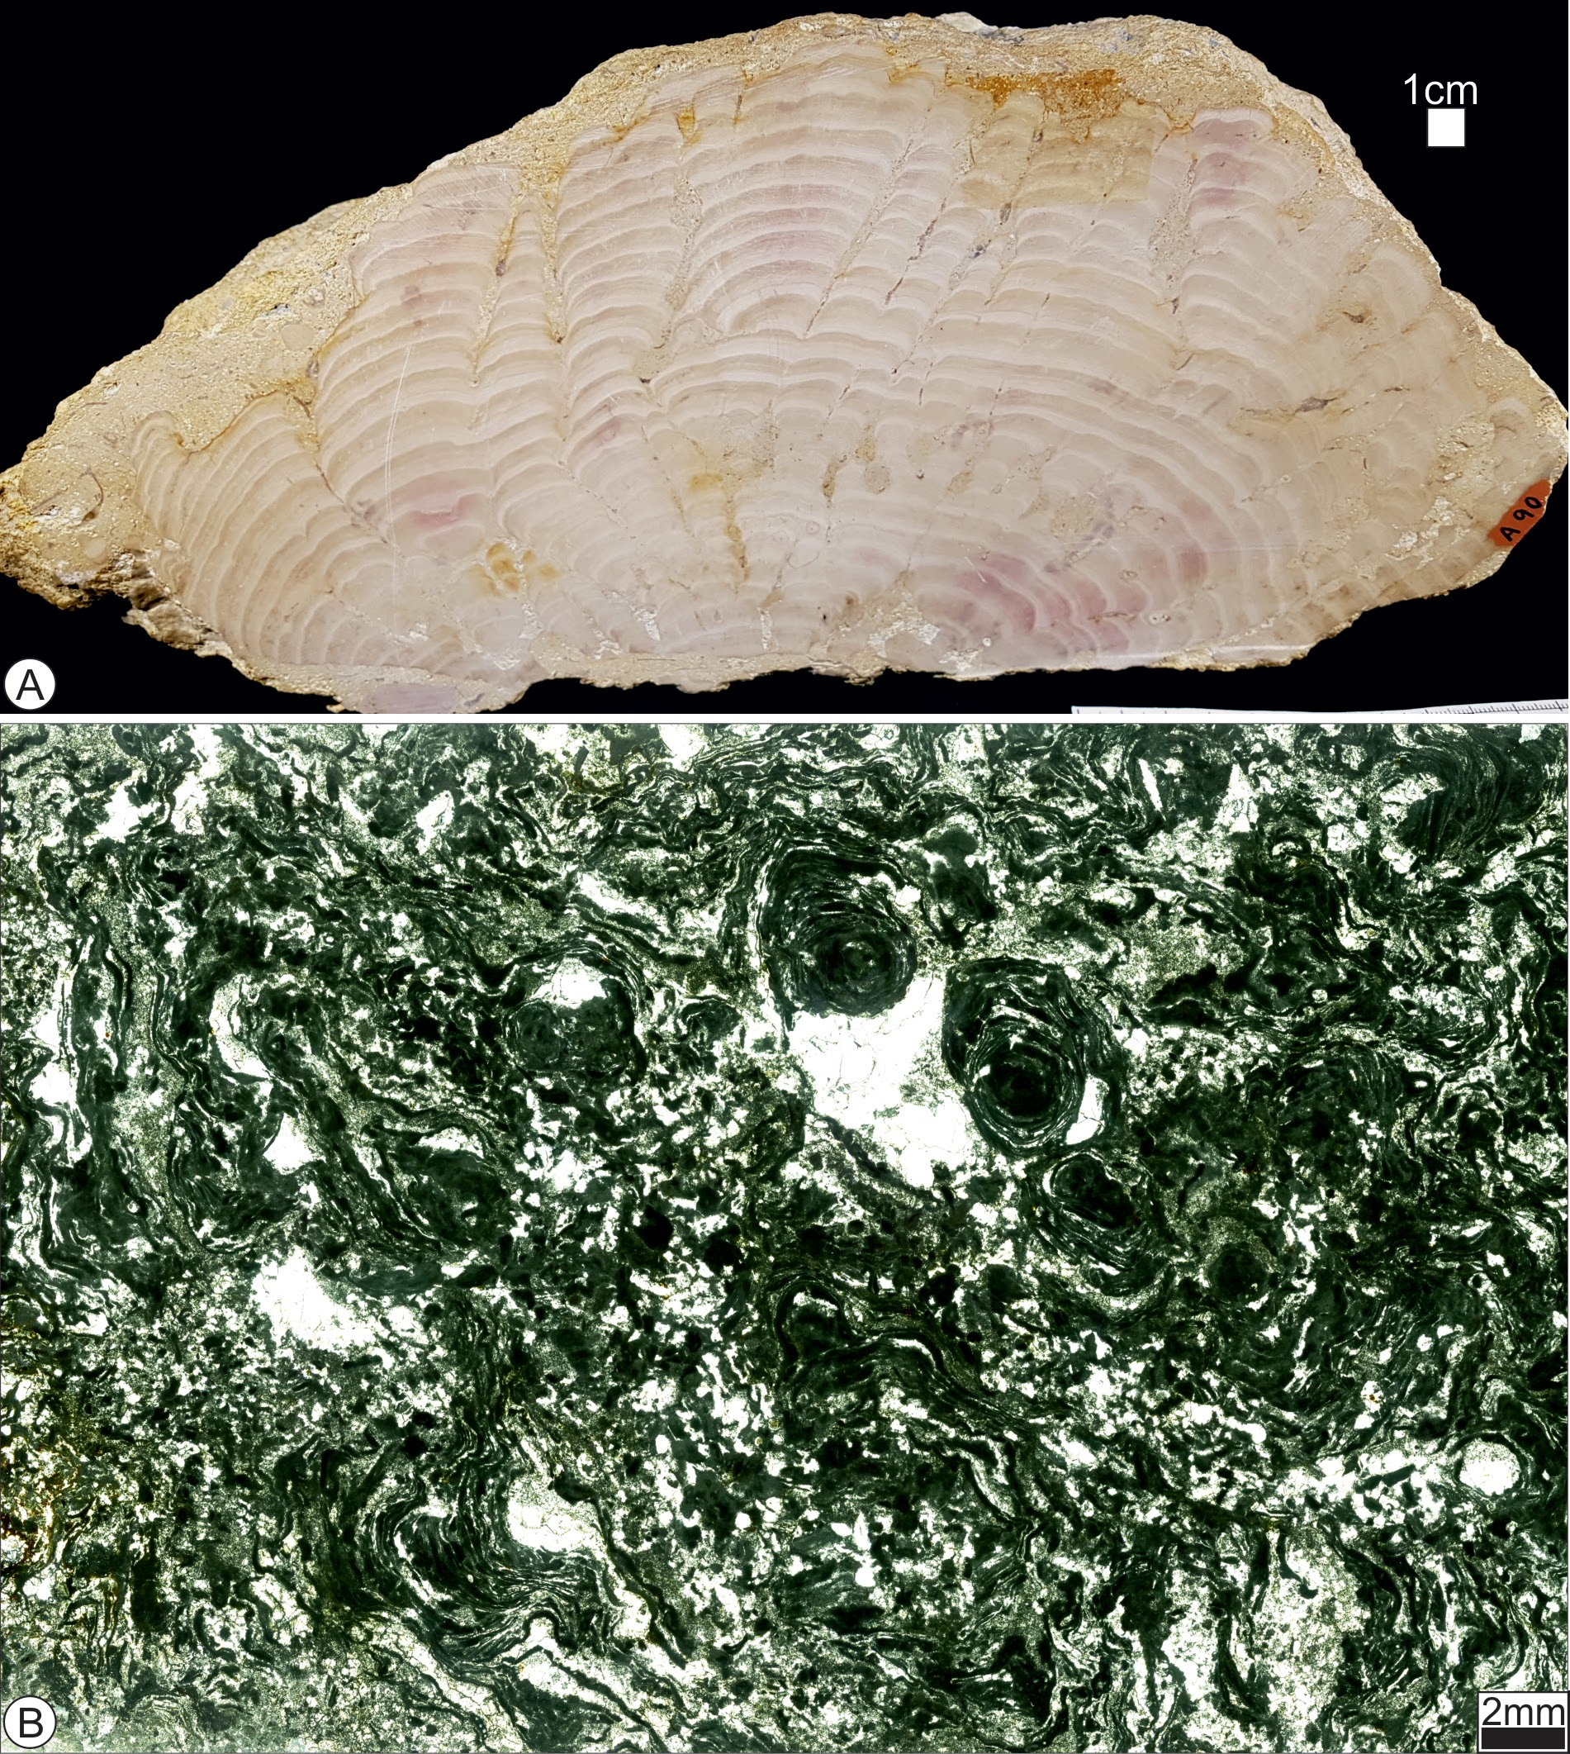

Figure 4. Examples of red algae. A) a photograph of Solenopora, the characteristic red and white colouration and be seen. This specimen is from the Jurassic of Gloucestershire, UK. B) a photomicrograph of a rhodolith, encrusting laminar forms are common, leading to the formation of free living nodules. These rhodoliths are Tortonian in age, from Mallorca.

The majority of Palaeozoic calcareous red algae thrived in an open-marine carbonate shelf environment, though when grouped together they can be seen to tolerate many environments. It is often difficult to relate Palaeozoic fossil algae to modern analogues due to the true taxonomy of the fossil being unknown. A lot of the time this comes down to factors such as reproductive structures not being calcified (and therefore preserved).

Green algae.

Modern green algae are a large (there are approximately 8000 extant species) and diverse group of organisms including unicellular, colonial, coccoid and filamentous forms and larger, multicellular forms, such as seaweeds. Green algae are found in a variety of environments, including both marine and freshwater setting, the latter being where the majority of modern green algal species inhabit. Marine species are typically found in tropical environments. Some terrestrial forms are known, living in soil or on larger plants and a few species are known to form part of a symbiotic relationship resulting in the formation of lichens.

Fossil green algae are almost exclusively marine in nature and have been described from Precambrian strata. Benthic and planktonic green algae are known from the fossil record. Possibly the most well-known of the green algae are the Dasycladales.There are over 120 fossil genera (there are eight extant genera) of this group of calcareous algae described, they became increasingly diverse from the Middle Ordovician through to the Lower Cretaceous, where they suffered a significant decline. Dasyclad algae are grouped by morphology, important morphological features include: a cylindrical central stem, radial symmetry, and a variety of branch forms (Fig. 5 provides an example of how observing these features is not always straightforward). From the Carboniferous onwards, dasyclad algae have had an important role in the accumulation of shallow-marine carbonates on platforms and ramps. Typical environments include open-marine lagoon and back reef environments. Towards the end of the Paleozoic and throughout the Mesozoic, dasyclads have been found to be important contributors to the formation of biogenic mounds.

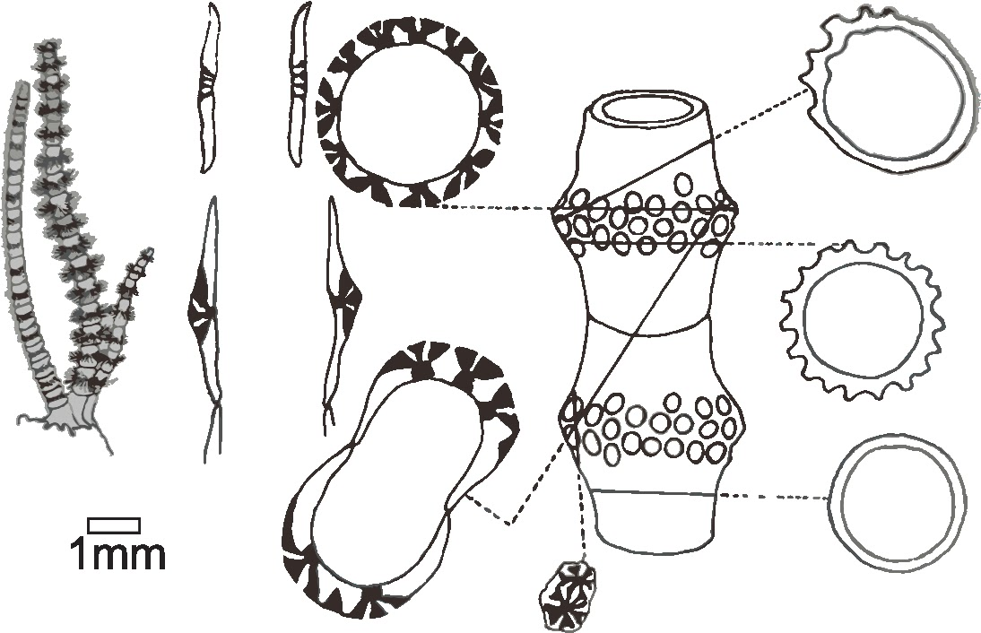

Figure 5. A schematic sketch showing longitudinal, oblique, tangential and cross sections through a green algae; it is this scale of variation that can make identifying specific taxonomic positions of calcified algae a complex task. Redrawn from Flügel, 2004.

Brown algae.

Modern brown algae consist of a large group of multicellular algae including many of the seaweeds found in cooler waters in the northern hemisphere (Fig. 6). The group is mostly marine, and in modern environments is known as an important source of food and habitat. Modern brown algae have no calcareous groups, so their preservation potential into the fossil record is particularly low. Several fossil specimens have been discovered that have been potentially linked to the brown algae, but these identifications are far from certain.

The majority of soft-bodied fossils are preserved as only a flattened outline, making it difficult to distinguish an accurate systematic or morphological-group affinity. The only known species to deposit minerals in and around their cell walls is *Padina*. Few Palaeozoic fossils are currently classified as brown algae, one such example, *Phascolophyllaphycus* has characteristics very similar to that of the modern genera of brown algae known as *Laminariales* (Kelp). Within Upper Ordovician strata fossils similar to brown algae are known to be found. The Devonian megafossil *Prototaxites* is has been considered as a brown algae, though many uncertainties exist with it being suggested that it was a terrestrial fungus or possibly a lichen.

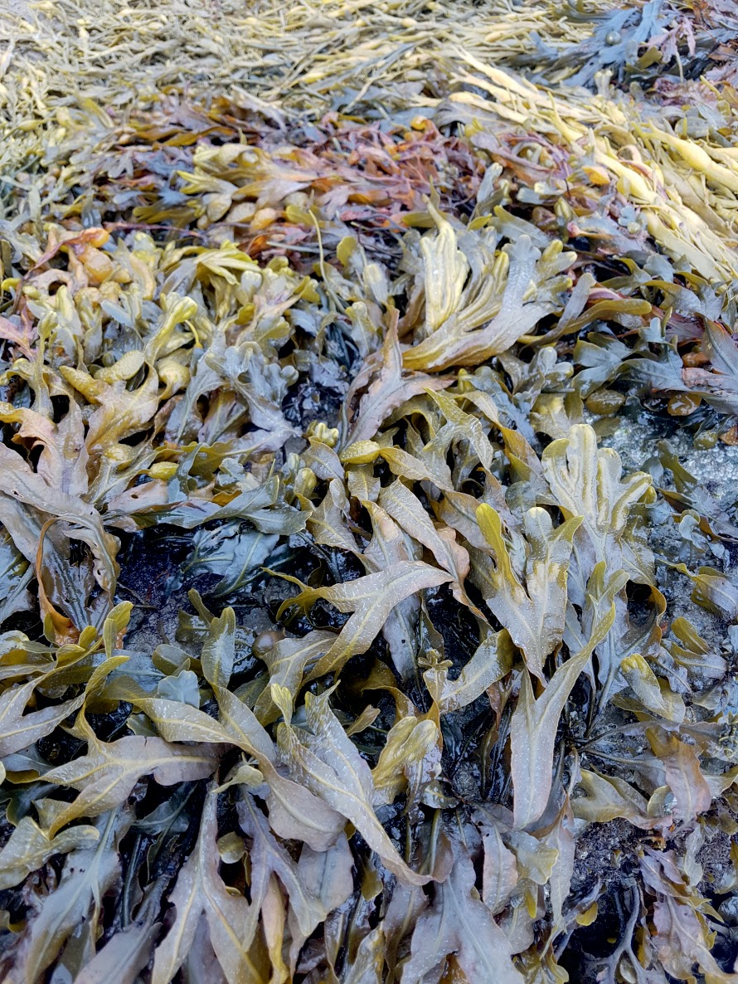

Figure 6. An image of a brown algae commonly found along the coastlines of the northern Atlantic (this example is from the northern coast of Wales): Bladder Wrack (*Fucus vesiculous*).

Cyanobacteria.

Modern Cyanophyta tend to form in restricted marine, or non-marine environments.

Fossilised cyanobacteria are formed of precipitated micritic (carbonate) tubes and have been observed from the Precambrian to modern time. Throughout this period of geological time, cyanobacteria are found to have been calcifying within a ‘normal’ marine environment. After the Cretaceous period, they became more restricted to non-marine settings; modern day cyanobacteria are commonly observed from freshwater, hypersaline and brackish environments. Biogenic sedimentary structures such as stromatolites (constructed from successive layers of microbial mats as a result of cyanobacterial growth (e.g. Fig. 7)) are common in the Precambrian rock record, they can extend for hundreds of kilometers laterally and can be hundreds of metres thick. These structures decreased in abundance and diversity with the onset of the Cambrian due to the rise in atmospheric oxygen and subsequent competition from metazoan organisms. Competition was a result of changing ecological niches as well as limitation on the available nutrients in the ecosystem. Other hypotheses for the decline of stromatolites include the burrowing of metazoans disrupting the process of stromatolite formation; predation (i.e. grazing organisms eating the microbial mats), and a change in sea water chemistry. Modern day investigations provide evidence of the influence metazoan competition has on stromatolite abundance. Modern blue-green algae are commonly associated with restricted environments, including Shark Bay (a hypersaline lagoon), Australia; Yellowstone National Park (hydrothermal pools), USA; and the Bahamas (shallow marine carbonate platform). These are shallow aquatic environments with the most abundant populations living in tropical to subtropical clear marine waters where carbonate accumulation and precipitation is optimal (as opposed to colder water), hence their concentration on continental shelf areas. In temperatures above 40 °C, Cyanophyta are the dominant photosynthetic organism, at temperatures above 73 °C only non-photosynthetic, extremophile bacteria are present. Cyanobacteria are adapted to a considerably larger array of environmental conditions when compared to their algal counterparts, including aphotic environments. That being said, it is not uncommon for cyanobacteria and algae (of various groups to thrive together (Fig. 7)

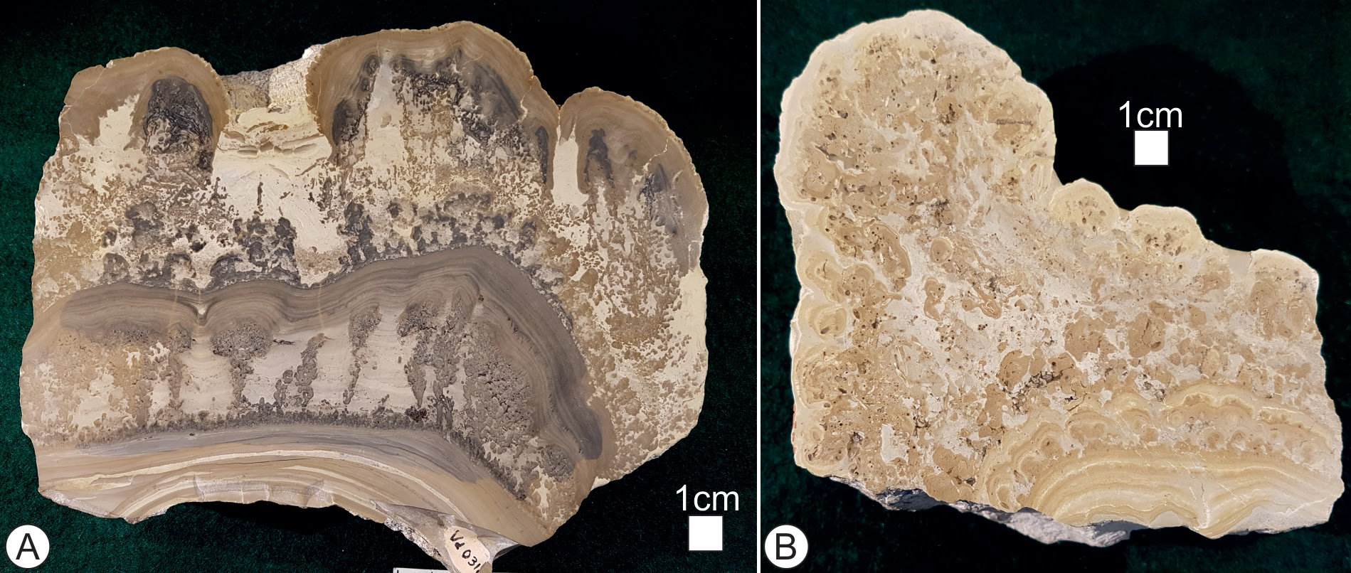

Figure 7. Images of cut and polished surfaces from “algal stromatolites”, these structures grow as the result of sediment binding by both cyanobacteria (blue-green algae), and green and red algae, in the samples from A and B examples of laminar and column like growth structures can be observed; both common growth habits of stromatolites. A) is an example of “Cotham Marble”, used as decorative stone this is Triassic ages algal stromatolite, collected from the Bristol area, UK. The cyanobacterial and algal structures preserved have been compared to modern algal mats. B) a Jurassic aged algal stromatolite from the Lower Purbeck Beds of Portland, Dorset, UK.

Concluding Remarks and Acknowledgements.

This Fossils Explained article provides a broad introduction to the calcareous algae and cyanobacteria.These groups of fossils are wide ranging (both in time and space) and are found from in/from a variety of environments. Whilst the sheer breadth of the groups, the taxonomic uncertainty associated with some of the organisms, and the often-questionable preservation potential is somewhat problematic, this diversity also makes these organisms incredibly useful for geologists. The recognition of algae can help to provide excellent environmental proxies in samples; from indications of water depth to “ecological tiering” (where they type and abundance of an organism can give clues to how established a particular palaeocommunity may have been) and many other factors in between. Each of the major groups discussed here (red, green and brown algae, and cyanobacteria (blue-green algae)) include sufficient complexity and diversity to warrant additional entries to the Fossils Explained series on their own, expanding on the broad foundation provided here.

This article was put together as part of an Undergraduate Research Opportunities Programme within the School of Geography, Geology and the Environment at Keele University; S L Rogers wishes to thank the undergraduate authors for their enthusiasm and perseverance with this project.

Recommended reading

* Flügel, E., 2013. Chapter 10 ‘Fossils in Thin Section: It is Not That Difficult’ in *Microfacies of carbonate rocks: analysis, interpretation and application*. Springer Science & Business Media.
* Flügel, E. ed., 1977 (e-book 2012). *Fossil algae: Recent results and developments*. Springer Science & Business Media. (The whole book is useful, however we particularly recommend the following sections ‘Green Algae’ pg. 143-166. In addition, ‘Red Algae’ pg. 167-201. Both sections contain various articles authored by multiple individuals.
* Riding, R. ed., 2012. *Calcareous algae and stromatolites*. Springer Science & Business Media. (Again, the whole book is very useful, here we recommend ’Calcified Cyanobacteria’ Riding, R. pg. 55-87. In addition ‘Coralline Algae: Mineralization, Taxonomy, and Palaeoecology, Bosence, D. W. J. pg. 98-113.)
* Wray, J.L., 1977 (e-book 2009). *Calcareous algae* (Vol. 4). Elsevier. (The introduction to each section provides excellent detail on each group of algae)