**Methyl gallate – rich fraction of *Syzygium coriaceum* Bosser & Guého leaf extract induced cancer cell cytotoxicity via oxidative stress**

Nawraj Rummun1,2,3, Elisabete Pires4, James McCullagh4, Timothy W.D. Claridge4, Theeshan Bahorun2, Wen-Wu Li3, *, Vidushi S. Neergheen1,2*

1Department of Health Sciences, Faculty of Medicine and Health Sciences, University of Mauritius, Réduit, 80837,

Republic of Mauritius

2Biopharmaceutical Unit, Centre for Biomedical and Biomaterials Research, MSIRI Building, University of Mauritius, Réduit, 80837, Republic of Mauritius

3Guy Hilton Research Centre, School of Pharmacy and Bioengineering, Faculty of Medicine and Health Sciences, Thornburrow Drive, Stoke on Trent, ST4 7QB, Keele University, UK

4 Chemical Research Laboratory, University of Oxford, Oxford, OX1 3TA, United Kingdom

*E-mail: [v.neergheen@uom.ac.mu](mailto:v.neergheen@uom.ac.mu); [w.li@keele.ac.uk](mailto:w.li@keele.ac.uk)

**ABSTRACT**

Whilst the pharmacological potential of *Syzygium* species is well reported in the literature, data on the Mauritian endemic *Syzygium* species is limited. Thus, the *in vitro* antioxidant and anti-proliferative propensities of three endangered *Syzygium* species, endemic to Mauritius, were investigated. Leaves samples of the three species were exhaustively extracted with a hydro-methanolic solvent and the antioxidant activities of the derived extracts were evaluated using a battery of six *in vitro* models. The antiproliferative effect of *S. coriaceum* was evaluated against lung carcinoma (A549), liposarcoma (SW872) and hepatocellular carcinoma (HepG2) cell lines. Further, the effect of *S. coriaceum* on intracellular reactive oxygen species (ROS) generation, intrinsic antioxidant enzymes activities and DNA damage in HepG2 cells were studied. MTT guided-fractionation coupled with spectrometry, chromatography and spectroscopy analysis was employed to characterise the bioactive entities in *S.coriaceum. S.coriaceum* showed the most potent antioxidant activities in all six assay models and alsoinduced a dose-dependent decrease in the cells viability. *S. coriaceum* treatment in HepG2 cells resulted in a dose-dependent increase in the level of ROS with a 4.4 folds increment at 100 µg/ml (p ≤ 0.0001). The surge in ROS level was corroborated by a parallel dose-dependent decrease in antioxidant enzyme activities. A significant 80.5 % drop in glutathione peroxidase activity was observed at 40 µg/ml (p ≤ 0.0001). MTT–guided fractionation followed by characterisation and structure elucidation analysis, revealed gallic acid (**1**) and methyl gallate (**2**) as major bioactive components in *S. coriaceum* leaf extract. Analysis of HepG2 cells treated with commercially available gallic acid and methyl gallate showed a similar trend in activities as *S. coriaceum* leaf extract. Collectively, these results demonstrated that *S. coriaceum* and its major bioactive phenolics: gallic acid and methyl gallate, may effectively induce cell death in HepG2 cells via upregulation of ROS.

**KEYWORDS**

Mauritian endemic, methyl gallate, antioxidant, cytotoxicity, assay-guided fractionation.

**ABBREVIATIONS**

CAT – catalase; COSY – correlated spectroscopy; DCFH-DA – dichloro-dihydro-fluorescein diacetate; FDA – food and drug administration; FRAP – ferric reducing antioxidant potential; GAE – gallic acid equivalent; GC-MS – gas chromatography–mass spectrometry; GPx – glutathione peroxidase; HHDP – hexahydroxydiphenoyl; HPLC – High performance liquid chromatography; HPLC – High performance liquid chromatography; HSQC – heteronuclear single quantum correlation; LC-MS – liquid chromatography–mass spectrometry; MTT – methyl thiazolyl diphenyl-tetrazolium bromide; NMR – nuclear magnetic resonance; ROS – reactive oxygen species; SEM – standard error of mean; SOD – superoxide dismutase; TPC – total phenolic content.

1. **INTRODUCTION**

Cancer remains a major public health concern despite the medico-technical advances in the field of therapeutics. With an alarming global death toll of 9.6 million in 2018, cancer ranks among the top leading causes of mortality due to non-communicable diseases (World Health Organisation, 2018). This is also the case in Sub Saharan Africa (Rebbeck, 2020). The complexity of cancer aetiology and multifactorial nature of tumour drug resistance along with the toxic effects render effective oncotherapy elusive (Nurgali et al., 2018; Rajpert-De Meyts and Skotheim, 2018). Therefore, there is a compelling need for developing new and alternative onco-therapeutics with novel oncogenic targets, reduced systemic toxicity and improved clinical efficacy against cancerous cells.

There is continued interest in terrestrial plants for lead compounds to be developed as chemotherapeutic agents. Undoubtedly, with the ethnomedicinal uses of over 3,000 global plant taxa in the treatment of cancer (Graham et al., 2000), plant-derived natural products provided the architectural blueprint for about 27 % of the clinically approved anticancer drugs, since 1980 (Willis, 2017). The search from unexplored biodiversity hotspots hence provides much optimism. Numerous studies reported the onco-therapeutic potentials of *Syzygium* (Myrtaceae) species (Chua et al., 2019; Cock and Cheesman, 2018). However, scientific reports on the anticancer potential of *Syzygium* species endemicto the Republic of Mauritius is scarce. Therefore, this untapped resource harbours a fertile ground to probe for lead bioactive compounds having potential for oncologic drug development.

Mauritius forms part of a biodiversity hotspot with 39.5 % of the 691 flowering plants being strictly endemic to the island (Myers et al., 2000). With more than 95 % of the original forest destroyed (Rummun et al., 2018), Mauritius ranks fourth among the top geographical regions with the highest extinction rate of plant species (Humphreys et al., 2019). Furthermore, the remnant of Mauritian endemic flora is becoming rarer in the wild and many endemic species are considered on the brink of extinction (Baider et al., 2010).

Thus, in view of encouraging conservation policies as well as to ascertain potential therapeutic role(s), it is of paramount importance to evaluate the beneficial effects of this endemic flora before the irreversible loss of this untapped biodiversity. This prompted us to investigate the *in vitro* antioxidant of leaf extracts of three *Syzygium* Gaertn. (Myrtaceae)species endemic to the island of Mauritius (**Figure 1**). The cytotoxic effect of *Syzygium coriaceum* and its ability to modulate intracellular oxidative stress in liver hepatocellular carcinoma (HepG2) cells were determined. The characterisation of the bioactive compounds in *S. coriaceum* leaf extract was also attempted, following methyl thiazolyl diphenyl-tetrazolium bromide (MTT) - viability guided fractionation.

1. **METHODOLOGY**
   1. **PLANT MATERIAL AND PREPARATION OF TOTAL EXTRACTS.**

The collection of Mauritian endemic plant samples was authorised by the National Parks & Conservation Service under the Ministry of Agro-Industry & Food Security, Réduit, Mauritius. Fresh leaves of *Syzygium bijouxii* Guého et A. J. Scottand *S. coriaceum* Bosser & Guého were collected, in October 2014, at Gaulette serré, near Camp Thorel situated in the district of Moka; while leaves of *S. pyneei* Byng, V. Florens & Baider were collected, in February 2015, at Mondrain situated in the district of Plaines Wilhems. A voucher specimen of the plant species were deposited at the Mauritius herbarium where the species were authenticated by the botanist (**Figure 1**). The fresh leaves were air-dried followed by exhaustive maceration with aqueous methanol (80 %, v/v) and freeze-dried as described previously (Rummun et al., 2013). The results are expressed in terms of the lyophilised weight of extracts.

* 1. **ESTIMATION OF POLYPHENOLIC CONTENTS.**

The total phenolic, flavonoid, and proanthocyanidin level in the total extracts were estimated using the Folin-Ciocalteu assay, aluminium chloride assay and HCl/Butan-1-ol assay as described (Rummun et al., 2013).

* 1. ***IN VITRO* ANTIOXIDANT CAPACITIES OF EXTRACTS.**

The antioxidant potential of the extracts was investigated by the iron-chelating; ferric reducing antioxidant power; superoxide anion radical scavenging; nitric oxide radical inhibition and deoxyribose degradation assays according to reported methods (Rummun et al., 2013). DPPH radical scavenging activity was performed as previously described (Rummun et al., 2019). Extract vehicle and gallic acid (or otherwise stated) were used as negative and positive controls respectively. The percentage activity of the extracts was calculated relative to the negative control. GraphPad Prism 6 software (GraphPad Inc., USA) was used to plot dose-response curves and generate the half-maximal inhibitory concentration (IC50) values. All experiments were performed in triplicates in three independent assays. The results were expressed as mean ± SEM.

* 1. **HUMAN CELL LINES AND CULTURE CONDITIONS.**

Human liposarcoma cells (SW872) (ATCC HTB-92), Human lung carcinoma cells (A549) (ATCC CCL-185) and Human hepatocellular carcinoma cells (HepG2) (ATCC HB-8065) were purchased from American Type Culture Collection (USA). Human ovarian epithelial (HOE) cells immortalized using SV40 large T antigen (Catalogue number: T1074) was obtained from Applied Biological Materials Inc (Canada). All cell lines, except HOE cells, were cultured in Dulbecco's Modified Eagle's Medium. Roswell Park Memorial Institute (RPMI) 1640 medium was used in the case of HOE cells. Culture medium was supplemented with 10% fetal bovine serum, 2 mM L-glutamine and 100 U/L streptomycin-penicillin. Cells were grown in a humidified atmosphere of 5 % carbon dioxide and 95 % humidity at 37 ˚C.

* 1. **CELL-BASED ASSAYS.**
     1. Methyl thiazolyl diphenyl-tetrazolium bromide (**MTT) viability assay.**

The viability of SW872, A549, HepG2 and HOE cells treated with test samples was evaluated using the MTT cell viability assay, performed in 96 – well plate (Ramful et al., 2010). The seeding densities for cancer cell lines and HOE cells were 5 x 103 cells/mL and 2 x 103 cells/mL per well, respectively. Following overnight acclimatisation of the cells, the latter were treated with six concentrations of the test samples (ranging between 10-100 µg/mL) and etoposide (ranging between1-10 µg/ml) for 48 hours. Sterile filtered extract (20 mg/mL) dissolved in DMSO: water (1: 19, v/v) was stored at -80 ˚C for subsequent dilutions using complete media. After extract treatment, the cells were incubated with MTT solution (5 mg/mL) for 2 hours. Subsequently the formazan formed was solubilised in 100 µL of DMSO and the absorbance read at 550 nm. The percentage cell viability relative to DMSO (0.025 %) control was calculated and the *IC50* value determined using GraphPad Prism 6 software (GraphPad Inc., USA). All experiments were performed in triplicates in three independent assays.

* + 1. **Determination of intracellular ROS production.**

The intracellular ROS level in HepG2 cells exposed to varying test sample concentrations was determined as described (Ramlagan et al., 2017). HepG2 cells (5 x 103 cells/mL) were allowed to attach in 96-well plates for 24 hours. The cells were treated with test samples for 48 hours, at six concentrations, as specified in section 2.5.1. Following incubation with the extracts, the cells were washed and incubated with 100 μL of 10 μM of DCFH-DA for 45 min in a humidified atmosphere at 37 °C. Fluorescence was measured at excitation and emission wavelengths of 485 nm and 520 nm respectively. Results were normalized to the percentage of viable cells and expressed as a percentage of the negative control.

* + 1. **Evaluation of intrinsic antioxidant activities.**

HepG2 cells (7 x 104 cells/ mL) were allowed to adhere overnight in 12 well plates and treated with different concentrations of test samples. After 48-hours, cells were washed twice with PBS, lysed and the protein concentration of cell lysates, as well as the activity of intrinsic antioxidant enzymes, namely, superoxide dismutase (SOD), catalase (CAT) and glutathione peroxidase (GPx) enzymes, were investigated as described (Ramlagan et al., 2017). For SOD activity, the final reaction mixture consisted of 20 µL protein lysate, 10 µL of 50 mM phosphate buffer and 150 µL reagent mix. The reduction of cytochrome c was monitored at 550 nm immediately after the addition of 20 µL of 4 mU xanthine oxidase, at 25 °C for 3 minutes at every 5-second intervals. For GPx activity, 20 µL of protein lysate was incubated, at 37 °C for 5 min, with 140 µL 50 mM tris buffer (pH 8), 20 µL 60 mM reduced glutathione, 20 µL 1.5 mM NADPH, and 10 µL buffer mix (consisting of 16 mM sodium azide, 100 mM tris buffer (pH 8) and 0.16 mM EDTA). Following incubation time, 20 µL 50 mM cumene H2O2 and 10 µL 7 mU glutathione reductase was added to the reaction mixture and the NADPH oxidation rate was monitored at 340 nm for 2 minutes every 5 seconds. The superoxide dismutase activity and glutathione peroxidase activity were expressed as a percentage of control per mg total protein. For catalase activity, 10 µL of lysate was added to a well containing 240 µL 0.2% (v/v) H2O2 and the absorbance read at 240 nm every 5 seconds for 1 minute at 25 °C. The CAT activity of lysate was calculated relative to the CAT standard curve and results expressed in unit (U) CAT per mg total protein. All experiments were carried out in triplicates.

* + 1. **MTT-guided purification and identification of bioactive molecules.**

The total extract of *S. coriaceum* was solubilised in distilled water and sequentially partitioned with ethyl acetate, followed by n-butanol. Each fraction was dried and their cytotoxicity evaluated against SW872, A549, HepG2 using the MTT cell viability assay. The ethyl acetate fraction being selective towards HepG2 cells was subjected to Sephadex LH-20 column chromatography (30 cm X 2.1 cm internal diameter) and eluted with water, water: methanol (3:1 v/v, 1:1 v/v and 1:3 v/v respectively), methanol and acetone. The flow rate was maintained at 1.5 ml/min. Guided by the cytotoxicity against HepG2 cells and purity profile, potent sub-fraction was further fractionated using semi-preparative HPLC column. The crude extract and thereof derived purified fractions were analysed by extensive spectroscopic methods including GC-MS, LC-MS, HPLC, 1H-NMR and 13C-NMR (Supporting Information). For analytical HPLC, the concentration of standards in the crude extract was determined from the linear regression of the analytical standards curve namely y = 12.317 x, R2 = 0.9996: gallic acid and y = 16.066 x, R2 = 0.9992: methyl gallate.

* 1. **STATISTICAL ANALYSIS.**

Statistical analyses were performed using GraphPad Prism 6 software (GraphPad Inc., San Diego, California). The sample normal distribution was confirmed using Kolmogorov - Smirnoff statistics. The mean values among extracts were compared using One-Way ANOVA. Student t-test and/or Tukey’s multiple comparisons as Post Hoc test was used to determine significances in mean phytochemicals, antioxidants and cytotoxic activities among different species. All charts were generated using Microsoft Excel software (version 2010).

1. **RESULTS**
   1. **ESTIMATION OF POLYPHENOLS LEVEL IN *Syzygium* LEAF TOTAL EXTRACTS.**

The polyphenol content varied significantly among the studied species (p <0.05) with amounts ranging between 254.32 ± 14.74 mg and 292.37 ± 17.97 mg gallic acid equivalent/ g. The highest level of total phenols was estimated in *S. bijouxii* (p <0.05), (**Table 1**). Total flavonoid levels ranged between 2.46 ± 0.05 mg and 5.50 ± 0.12 mg QE/ g, with *S. pyneei* being the richest followed by *S. bijouxii.* The proanthocyanidin content in terms of cyanidin chloride equivalent varied significantly between the analysed *Syzygium* leaf extracts with the utmost level estimated in *S. bijouxii,* while negligible amount being detected in *S. coriaceum* extract.

* 1. ***IN VITRO* ANTIOXIDANT ACTIVITIES OF *Syzygium* LEAF TOTAL EXTRACTS.**

Six independent *in vitro* antioxidant assays were used to identify the extract having the most potent antioxidant profile. The antioxidant propensity among the extracts differed significantly (p < 0.05) in each assay model (**Table 1**). All extracts showed a dose-dependent metal chelating and free radical scavenging activity; the *IC50* values are shown in **Table 1**. The iron-chelating activity of the extracts differed significantly (p ≤ 0.0001) from the positive control EDTA, a known iron chelator, having an *IC50*value of 0.01 ± 0.00 mg/ml (23.64 ± 0.22 µM). *Syzygium coriaceum* leaf extract exhibited significantly (p < 0.05) higher antioxidant potential in all evaluated antioxidant assays.

* 1. ***IN VITRO* CYTOTOXICITY OF *S. coriaceum* ON HUMAN-DERIVED CELL LINES.**

Cancer cells treated with *S. coriaceum* total leaf extract, selected for subsequent analysis based on the rich polyphenol content and high antioxidant power, displayed a dose-dependent decrease in cell viability. The *IC50* values differed significantly (p < 0.01) among the different cancer cell lines (Table 2). In this study, the cytotoxicity of *S. coriaceum* total extract was also evaluated against non-malignant HOE cells. In contrast to cancer cells, the total extract was less cytotoxic towards HOE cells (*IC50* = 63.7 ± 3.3 µg/ml). Among cancer cell lines, HepG2 was more sensitive to *S. coriaceum* treatment and had a selectivity index of 2.6 with respect to HOE cells, hence HepG2 cells were selected as an optimal cell model for subsequent assays.

For comparison to a clinically used drug, cell viability of cancer cell lines treated with etoposide was evaluated and *IC50* values determined (Table 2). The drug sensitivity of etoposide in HepG2 cells was 10 fold higher than that of *S. coriaceum* leaf extract after 48-hour exposure.

* 1. **MODULATION OF INTRACELLULAR ROS LEVEL AND INTRINSIC ANTIOXIDANT ENZYME ACTIVITIES IN HepG2 CELLS.**

The ability of *S. coriaceum* leaf extract to modulate intracellular ROS generation was measured as a percentage of DCF-fluorescence. *S. coriaceum* extract treatment evoked an upregulation in the production of cytosolic ROS in HepG2 cells, compared to untreated control cells (**Figure 2E**). Treatment for 48-hour resulted in a dose-dependent increase in relative fluorescence intensity thereby indicating an increase in intracellular ROS level. No significant differences were observed between cultures treated with 10 µg/ml extract compared to the negative control. However, the intracellular ROS generation reached statistical significance (p ≤ 0.0001) at 20 µg/ml and continued to rise in a dose-dependent manner at higher concentrations, highlighting the surge in oxidative insults at these experimental points. Given the link between intracellular ROS level and intrinsic antioxidant enzymes activities, the effect of *S. coriaceum* on HepG2 intracellular SOD, CAT and GPx activities, following 48-hour treatment, were evaluated at three different concentrations corresponding to half *IC50,* *IC50* and 2 X *IC50* values. Figure 3 depicts the status of SOD, CAT and GPx enzymes activities.

*S. coriaceum* leaf extract (10 µg/ml) treatment resulted in a significant decrease in HepG2 cells SOD activity (p ≤ 0.01). However, a gradual increment in SOD activity was noted from 10 µg/ml to 20 µg/ml. The activity reached that of untreated control at 40 µg/ml extract concentration (Figure 3A).

Contrary to SOD, *S. coriaceum* treatment induced a dose-dependent decrease (p ≤ 0.05) in CAT enzyme activities at the three concentrations tested (Figure 3D). *S. coriaceum* treatment also induced a dose-dependent decrease in GPx enzyme activities, with the reduction reaching statistical significance (p ≤ 0.05) at concentrations equivalent to 20 µg/ml and 40 µg/ml (Figure 3G).

* 1. **CYTOTOXICITY-DIRECTED PURIFICATION OF POTENT FRACTIONS AND CHARACTERISATION OF BIOACTIVE COMPOUNDS.**

The bioassay-guided fractionation of *S. coriaceum* total extract was carried out, to identify bioactive compounds responsible for the extracts potent cytotoxicity against HepG2 cells. Solvent fractionation of total extract yielded ethyl acetate, n-butanol and water-soluble fractions. The ethyl acetate fraction was more cytotoxic to cancerous cells compared to the n-butanol and water-soluble fraction (**Table 2**). The most potent cytotoxicity of ethyl acetate fraction was observed against HepG2 cells. Human hepatocellular carcinoma was therefore used as a model for further cytotoxicity- directed fractionation of *S. coriaceum* ethyl acetate fraction. Sephadex LH-20 column fractionation of *S. coriaceum* ethyl acetate fraction afforded 10 subfractions (F1 – F10). All the subfractions obtained, except F9 and F10, showed appreciable growth inhibitory activity against HepG2 cells, in a dose-dependent manner with *IC50* values ranging from 12.7 ± 1.1 µg/ml to 52.6 ± 4.7 µg/ml (Figure 4). No significant difference was observed in *IC50* value (p > 0.05) for the successive subfractions from F2 and F8. The complexity of the subfractions on HLPC chromatogram increased from F1 to F9, with the increasing number of not well-resolved peaks (Supporting information, Figure S1). Sub-fraction F4 showed three well-separated peaks on HPLC chromatogram and had the lowest IC50 value (12.7 ± 1.1 µg/ml). Hence, only sub-fraction F4 was subsequently purified through preparative HPLC into four fractions (F4.1 – F4.4). Only preparative chromatographic fractions F4.1 and F4.4 showed dose-dependent cytotoxicity with *IC50* values of 98.4 ± 33.8 µg/ml and 107.8 ± 28.8 µg/ml respectively.

To identify the potential bioactive components responsible for the cytotoxicity of *S. coriaceum* ethyl acetate fraction, their trimethylsilyl derivatives obtained following treatment with N,O-Bis(trimethylsilyl)trifluoroacetamide and pyridine was subjected to GC-MS analysis. Compounds were identified by comparison of their mass spectra with those of standard compounds. The mass spectrum of methyl gallate (**1**) and gallic acid (**2**) (**Figure 5**) present in the ethyl acetate fraction analyses is presented in supplementary figure S4. The presence of gallic acid and methyl gallate in *S. coriaceum* ethyl acetate sub-fraction F4 was further confirmed both by HPLC analysis based on their retention times (**Figure 4B**) and LC-MS analysis.

Further, LC-MS analysis of the preparative chromatographic fractions derived from F4, identified the peak at relative retention time 30.446 minutes in Figure 4B to comprise of a mixture of two quercetin glycosides. Their chemical structures were elucidated by 1H NMR, 13C NMR, HSQC, and COSY analysis, and comparison with reported data (Ganesan et al., 2018; Hanamura et al., 2005; Johnson-ajinwo et al., 2015; Rutkowska et al., 2019; Yakubu et al., 2019), as quercitrin (**3**) and quercetin 3-O-β-D-xylopyranosyl-(1→2)-α-L-rhamnopyranoside (**4**) (**Figure 5** and Supporting Information). Another potent fraction F6 was further fractionated by HPLC to yield two tannins, which were characterized using LC-MS/MS along with NMR spectroscopic analysis as 2,3-di-O-galloyl-4,6-O-hexahydroxydiphenoyl (HHDP)-β-D-glucopyranose (**5**, tellimagrandin I), and 3,4,6-tri-O-galloyl-d-glucose (**6**) (**Figure 5**). Their biological activities were not further investigated.

* 1. **QUANTITATIVE ANALYSIS OF GALLIC ACID AND METHYL GALLATE FROM *S. coriaceum* CRUDE LEAF EXTRACT.**

The gallic acid and methyl gallate contents of *S. coriaceum* leaf crude extract are presented in **Table 3**. Quantification of both compounds was done using analytical HPLC by comparing the retention time and peak area between the samples and commercially available standards.

* 1. **EFFECT OF GALLIC, METHYL GALLATE AND QUERCITRIN TREATMENTS IN HepG2 CELLS GROWTH.**

In view of delineating the contribution of individual phenolic identified compounds, the influence of authentic standards on HepG2 viability was investigated. Both gallic acid (*IC50* value = 26.3 ± 6.1 µg/ml) and methyl gallate (*IC50* value = 11.7 ± 1.3 µg/ml) inhibited the growth of HepG2 cells in a dose-dependent manner, with the latter being 2.25 fold more potent than the former **(Figure 2 B and C)**. In contrast, quercitrin showed no dose-dependent activity exhibiting 75 ± 7.5 % cell viability at the 100 µg/ml, the highest concentration tested. As depicted in **Figure 2J** and **K**, both gallic acid and methyl gallate increased intracellular ROS level in a similar manner as *S. coriaceum* crude leaf extract. However, only methyl gallate exhibited SOD enzyme activity similar to the *S. coriaceum* crude extract (**Figure 3B** and **C**).

1. **DISCUSSION**

Undoubtedly, the perpetual crisis of drug resistance to the available onco-therapeutic armamentarium, failure to drug response and life-threatening toxicity, accede the need to search for novel and alternative onco-therapeutics agents (Coombes, 2019; Maeda and Khatami, 2018; Vázquez et al., 2019). Terrestrial plants contributed massively to the development of the contemporary pharmaceutical industry. One-quarter of the FDA approved marketed drugs are derived exclusively from about 15 % of the investigated global plant taxa (Grigalius and Petrikaite, 2017; Patridge et al., 2016). The remaining unexplored plant diversity provides a fertile ground to probe for novel pharmaceutical lead compounds, having innovative and alternative molecular targets.

The Southern African countries are home to an extraordinary concentration of terrestrial plant biodiversity, with above 50000 surveyed species representing up to 25 % of the world flowering plant taxa (Van Wyk, 2011). Despite the widespread acceptance and use of plants in the ethnomedicinal system by more than 80 % of African populations, only a limited 10.8 % of the continents floral species are known for their medicinal properties (Shewamene et al., 2020; Van Wyk, 2011). Likewise, in Mauritius, the documented medicinal uses are restricted to 32 % of the island endemic plant taxa (Rummun et al., 2018). The vast majority of this unexplored floristic resource holds much prospect to probe for new herbal extracts and thereof derived natural product entities, providing alternative chemopreventive and/or chemotherapeutic modalities.

The pluri-pharmacological effect of plants is ascribed to the different classes of secondary metabolites, which can be broadly classified into polyphenolics, alkaloids and terpenoid derivatives. Among the diverse phytochemicals, phenolic compounds attracted considerable attention by virtue of their innate health-promoting abilities (Cory et al., 2018).

The present study revealed the polyphenolic richness, in terms of phenolics, flavonoids and proanthocyanidins subclasses, which varied significantly (p < 0.05) among the three *Syzygium* species (Table 1). The occurrence of the phenolic compounds in these plants may be ascribed to the high incidence of ultraviolet radiation levels throughout the year, characteristic to tropical islands like Mauritius (Bessafi et al., 2016; Rummun et al., 2013). Ultraviolet radiation is known to promote the accumulation in polyphenols in plants (Agati et al., 2012; Ferreyra et al., 2012). The amount of estimated total phenolic content (TPC) in *S. bijouxii* was comparable to that in the Mauritian endemic *Labourdonaisia glauca* (Sapotaceae) (298.9 ± 9.4 mg GAE/ g dry extract) (Rummun et al., 2019). In contrast, literature finding reported a lower level of TPC in Mauritian *Syzygium* endemic species ranging between 30.9 mg GAE to 86.3 mg GAE / g dry leaves, with *S. coriaceum* having 51.2 mg GAE/ g dry leaves (Toyokuni et al., 2003). Likewise, another study investigating the Mauritian endemic plants reported the TPC in *Syzygium* species to vary between 69 ± 0.9 mg GAE and 103 ± 1.2 mg GAE / g fresh leaves (Neergheen et al., 2006).

In this study, the level of methyl gallate was 2.4 folds higher than gallic acid in *S. coriaceum* leaf. However, Mahomoodally et al., (2019) reported the level of gallic acid to be 1.3 folds higher than that of methyl gallate, in the leaf extract of the same plant. This variation in the ratio of gallic acid to methyl gallate may be explained by the fact that accumulation of secondary metabolites is dependent on multiple parameters including geographical differences and seasonal changes (Yang et al., 2018). Furthermore, the yield of extracted phytochemicals is also influenced by factors including extraction techniques amongst others (Aires, 2017).

The dual role of free reactive species and antioxidants in human health and disease in well-established (Pizzino et al., 2017; Santo et al., 2016). Owing to their structural diversities, polyphenolics can act as potent antioxidants through an array of mechanisms (Huang et al., 2005). Thus, a multiplicity of *in vitro* antioxidant assays was used to comprehensively gauge the antioxidant capacities of the extracts under investigation. The experimental data revealed that *Syzygium coriaceum* exhibited the most potent antioxidant potential in terms of FRAP, iron chelating and free radical scavenging activities (Table 1).

Given the involvement of oxidative stress in the multistage carcinogenic process (Toyokuni, 2008), substances with potent antioxidant capacity are expected to prevent or halt the progression of cancer cells, as well as mitigating chemotherapy-induced adverse effects (Singh et al., 2018). While the cancer cell cytotoxicity of the endemic *S. coriaceum* is investigated for the first time, other species from the same genus are reported to suppress the growth of cancer cells (Chua et al., 2019). In the present study, the viability of SW872, A549 and HepG2 cell lines was observed to decrease in a general dose-dependent manner following 48-hours treatment with *S. coriaceum* (Table 2). However, the cytotoxicity was more selective towards HepG2 cells (*IC50* value of 24.2 ± 2.8 µg/ml). This highlights the promising cytotoxic activity of the extract against HepG2 cells and calls for further identifying the active components for proper assessments of their chemotherapeutic properties. Hence, the MTT-guided fractionation of the total extract revealed gallic acid and methyl gallate as prominent phenolic contributing to *S. coriaceum* leaf extract induced cytotoxicity in HepG2 cells.

The cytotoxicity of both gallic acid and methyl gallate against HepG2 was previously reported. Using similar experimental conditions, Sun et *al.* (2016) reported the *IC50* value of gallic acid against HepG2 cells as 28.5 ± 1.6 µg/ml comparable to the *IC50* value (26.3 ± 6.1 µg/ml) obtained in this study. Gallic acid and methyl gallate isolated from the methanol extract of *Abutilon hirtum* (Lam.) showed dose-dependent growth inhibition of HepG2 cells (Hamed *et al.* 2017).

The modulation of intracellular antioxidant enzyme activities and ROS level, in response to S*, coriaceum* treatment was investigated, in an attempt to establish the involvement of ROS mediated cell death. The findings revealed that HepG2 cells co-cultured with varying concentration of endemic *S. coriaceum* for 48 hours had a dose-dependent increase in intracellular ROS level (Figure 2), compared to untreated control cells. This increase was in conjunction with a decrease in intrinsic catalase and glutathione peroxidase activity (Figure 3). Contrary to the *in vitro* antioxidant activities, *S. coriaceum* exhibited *in vivo* pro-oxidative effect in HepG2 cell, further stimulating the generation of ROS. This dual role of polyphenolic was reported (Bayliak et al., 2016; Dai and Mumper, 2010; Park, 2017).

Polyphenols are shown to behave as antioxidants or pro-oxidants in differential pH environment (Zhou and Elias, 2012). The prooxidant effect of phenolic acids is ascribed to their ability to undergo auto-oxidation at alkaline pH and thus generating phenoxy and superoxide free radicals (Bayliak et al., 2016; Dai and Mumper, 2010). Cancer cells in comparison to non- malignant cells, have a more alkaline intracellular pH environment (Persi et al., 2018; White et al., 2017). This explains the pro-oxidative nature of phenolic rich *S. coriaceum* extract in HepG2 cells. Furthermore, both gallic and methyl gallate stimulated intracellular ROS generation and decreased antioxidant enzyme activities in HepG2 cells. Gallic acid is reported to induce cancer cell cytotoxicity by elevating intracellular ROS level (Hsu et al., 2016; Maurya et al., 2010; Park, 2017).

The trend of activities of methyl gallate parallels that of *S. coriaceum* extract. Thus, given the abundance of methyl gallate in the extract and the similarity in activities, it may be postulated that methyl gallate is the principal bioactive component of *S. coriaceum* leaf. However, the contribution of other phytochemicals presents, acting in synergism with methyl gallate cannot be excluded and requires further investigation.

1. **CONCLUSIONS**

In this work, the antioxidant-rich *Syzygium coriaceum* was selectively cytotoxic to HepG2 cells possibly induced by oxidative stress-induced cell death. The bioassay-guided fractionation of the plant extract using the HepG2 cell line allowed for the identification of gallic acid and methyl gallate as major bioactive components in the ethyl acetate fraction. Additionally, two quercetin glycosides namely quercitrin and quercetin 3-O-β-D-xylopyranosyl-(1→2)-α-L-rhamnopyranoside were identified and reported for the first time from *S. coriaceum* leaf. Taken all together, it may be strongly proposed that methyl gallate may individually or synergistically contribute to the growth inhibitory activity of *S. coriaceum*. However, the contribution of other phytochemicals present cannot be excluded thus requiring more in-depth investigation. In line with the US national cancer institute criteria, the *IC50* value of *S. coriaceum* obtained in this study, make the extract an interesting candidate with anticancer potential. Further mechanistic directed studies are warranted to establish the molecular cell death mechanisms in hepatocellular carcinoma as well as in other cancer cell types.



**Figure 1**: The Mauritian endemic *Syzygium* species under study. The Mauritius herbarium voucher specimen number is given in brackets (). A – *S. bijouxii* Guého & A. J. Scott (MAU 0013805); B – *S. coriaceum* Bosser & Guého (MAU 0016404); C – *S. pyneei* Byng, V. Florens & Baider (MAU 0014026).

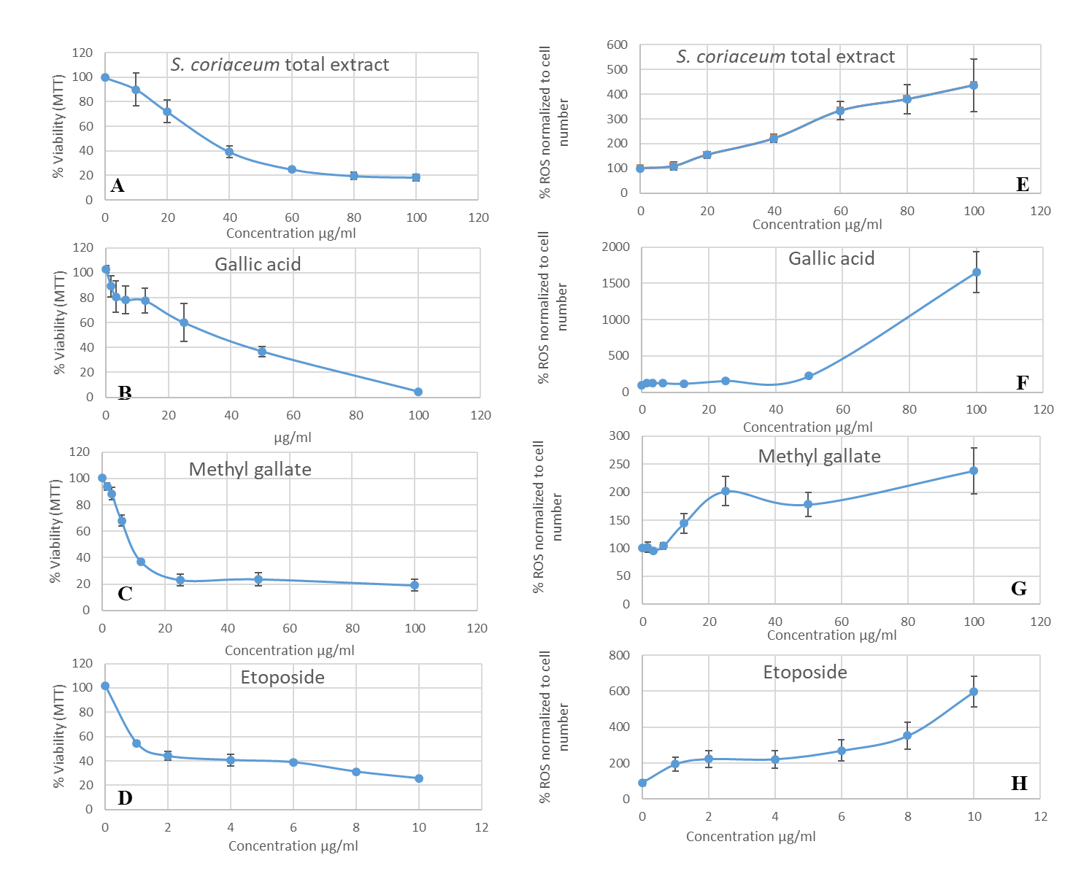

**Figure 2**: Cell viability profile (A-D) and modulation of intracellular ROS (E-H) in HepG2 cells 48 -hour post-treatment with test extracts. Data are expressed as a percentage of control cells and plotted as mean ± SEM of three independent experiments done in three replicates for each treatment.

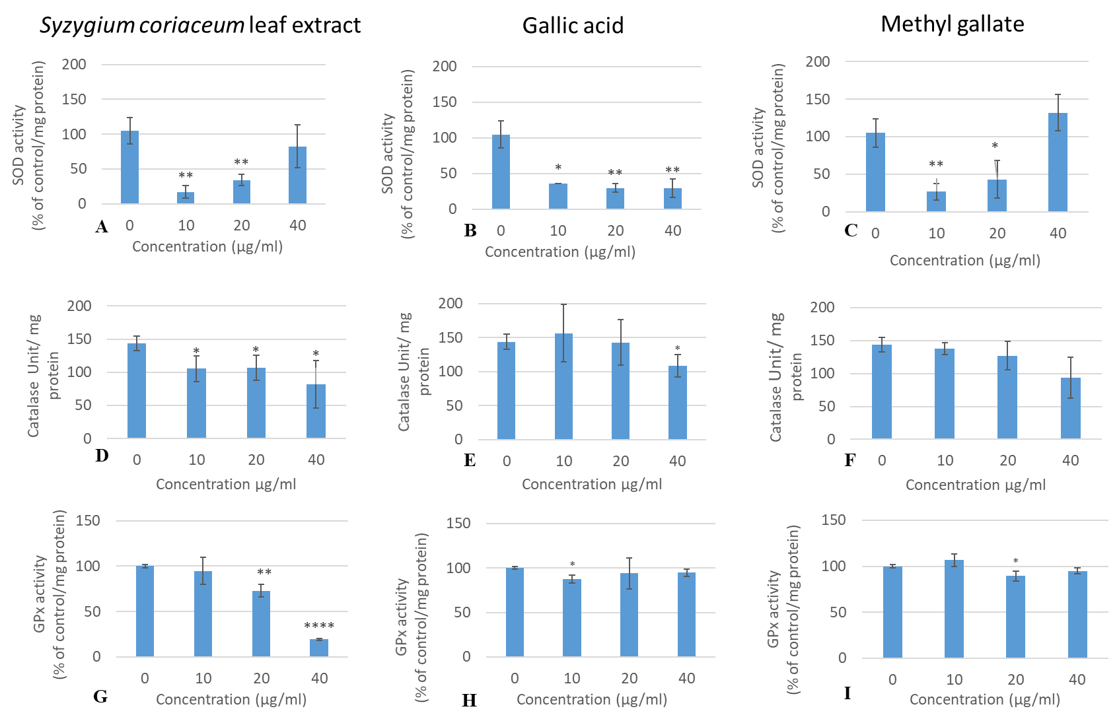

**Figure 3:** Catalase (CAT), superoxide dismutase (SOD) and glutathione peroxidase (GPx) enzyme activities in HepG2 cells with and without treatment. Data expressed as mean ± standard deviation of three independent experiments. Significance was assessed by Student`s t-test analysis; *P<0.05, **P<0.01, ***P<0.001 (vs. control).

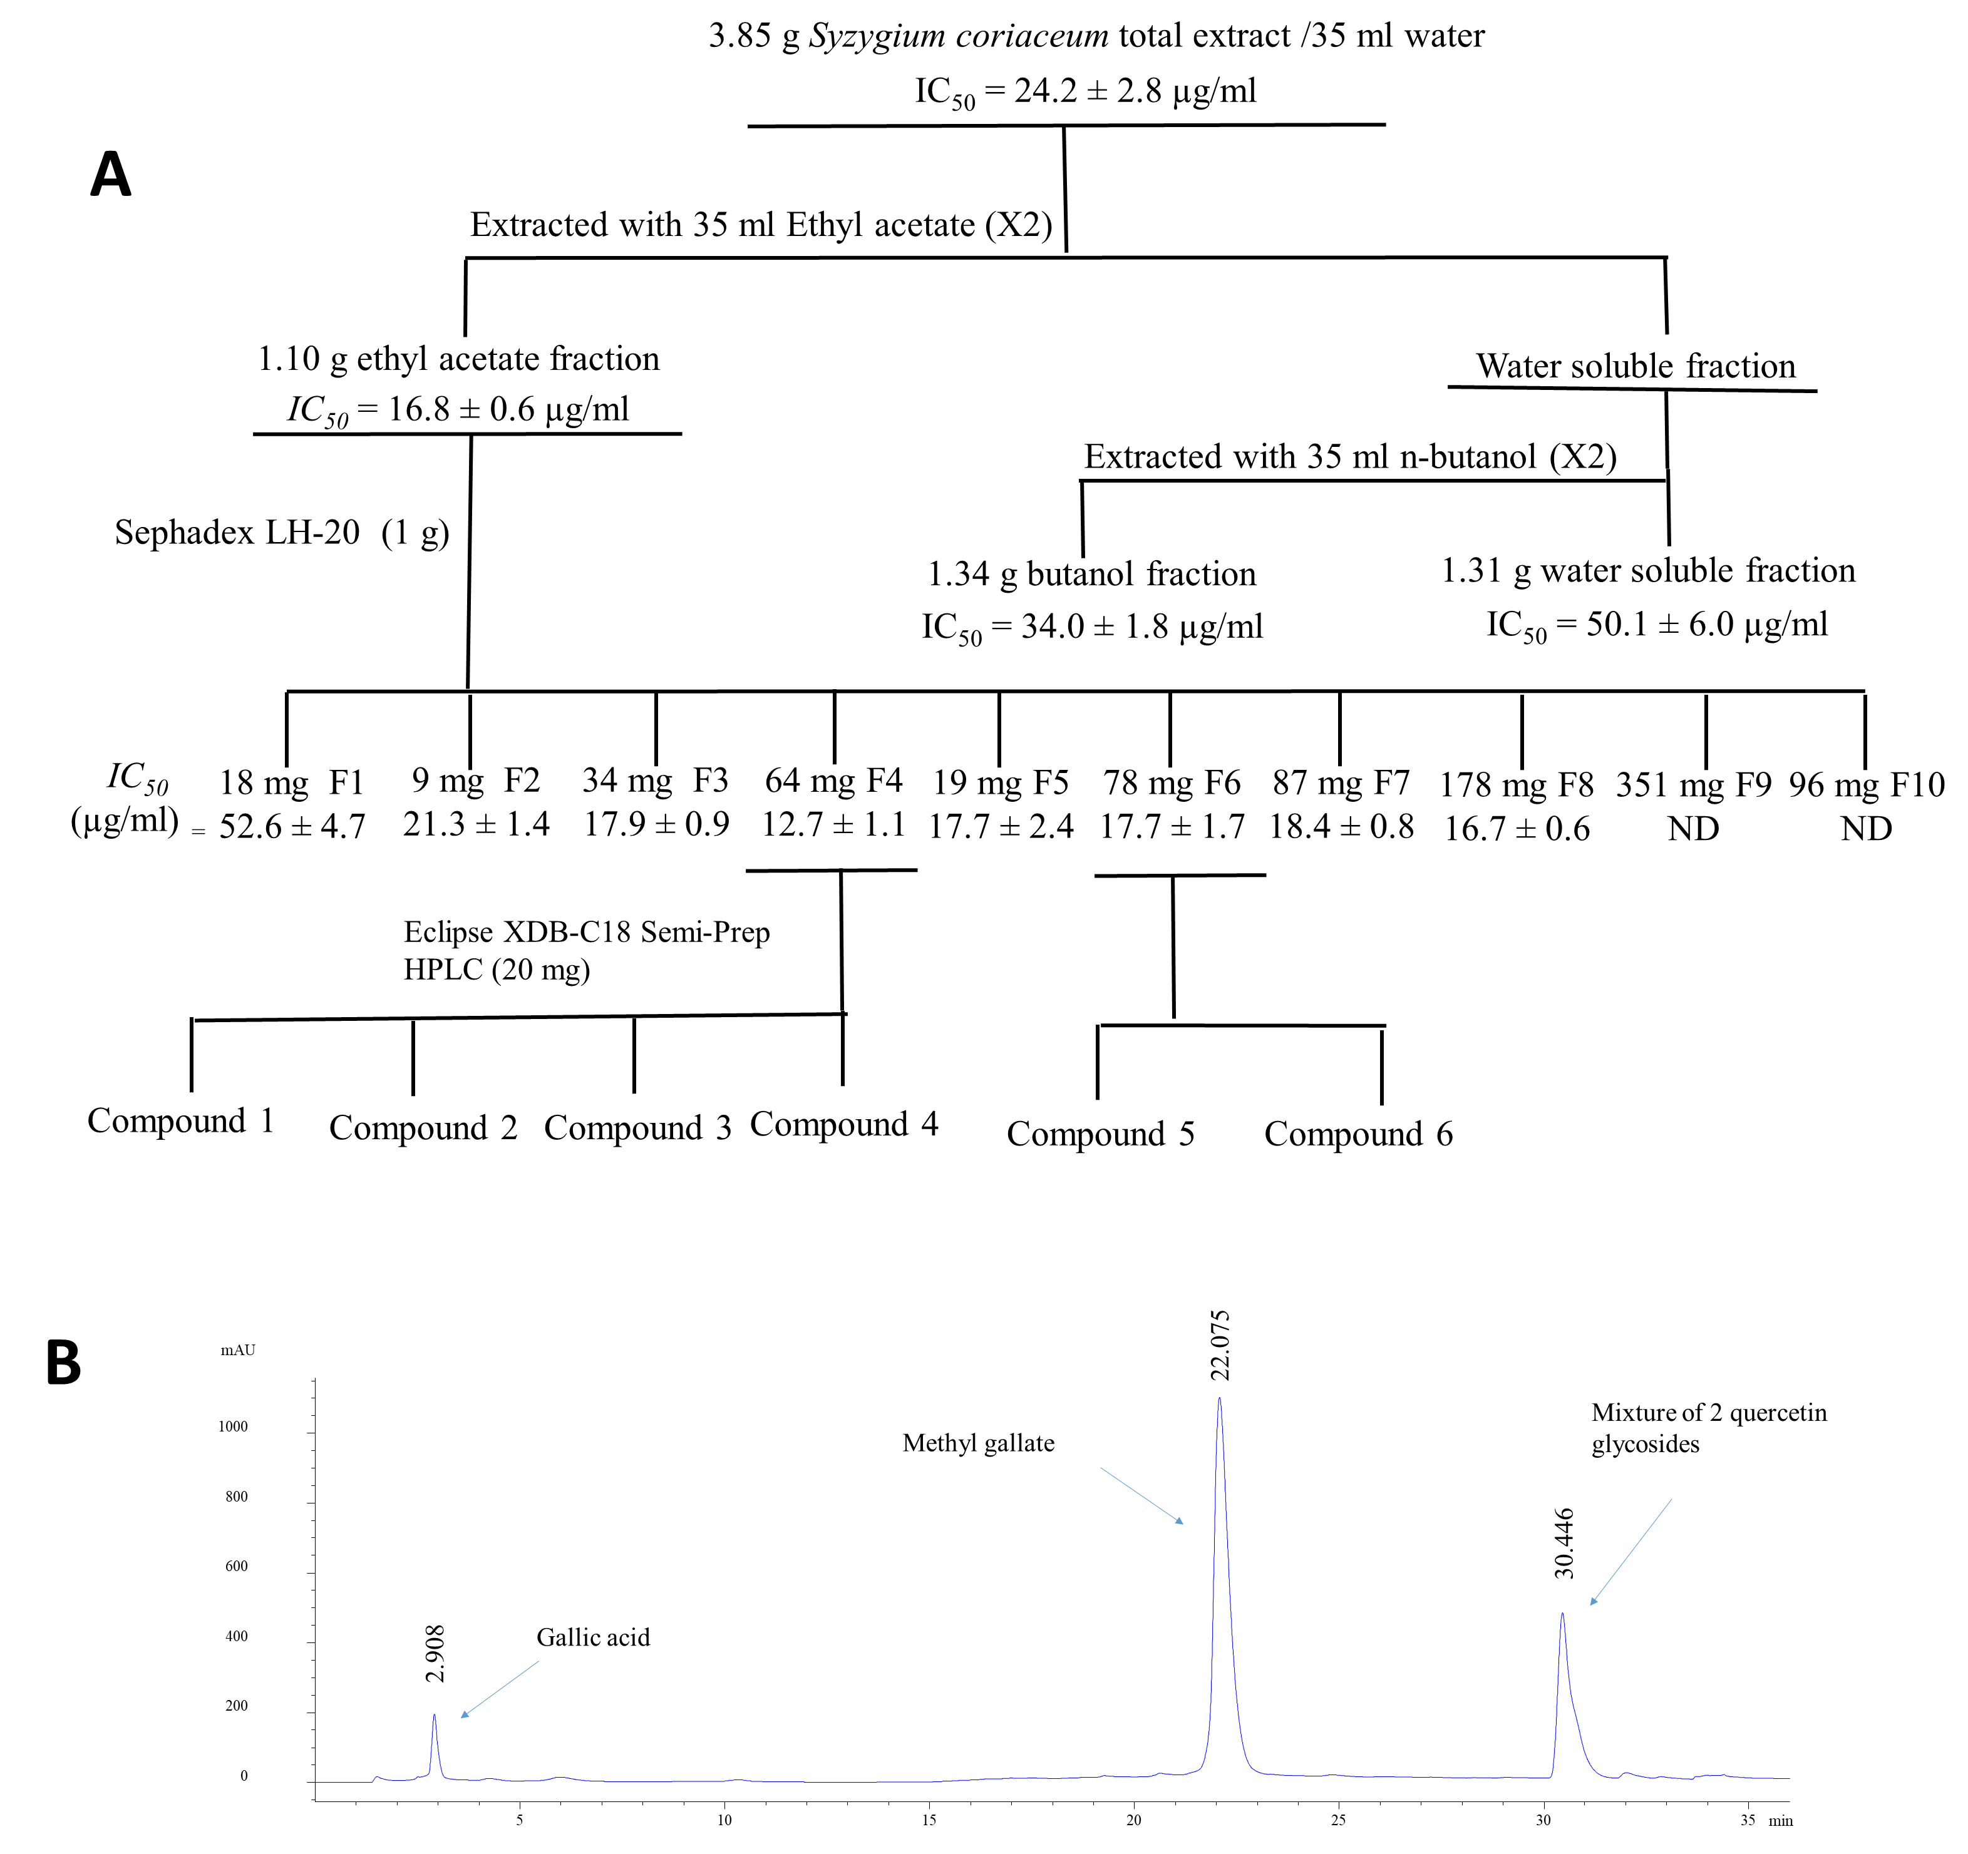

**Figure 4**: (A) Cytotoxicity guided fractionation of S. coriaceum total extract; (B) HPLC fingerprint of S. coriaceum leaf extract ethyl acetate subfraction F4.



**Figure 5**: Chemical structures of compounds (**1-6**) identified from *S. coriaceum* leaf.

Table 1: Phenolic content and antioxidant potential of investigated *Syzygium* leaf extracts.

|  |  |  |  |  |  |  |  |  |  |
| --- | --- | --- | --- | --- | --- | --- | --- | --- | --- |
| Extract | Total phenolics1 | Total flavonoids2 | Total proanthocyanidins3 | FRAP4 | Iron  chelating  activity5 | DPPH  Scavenging  activity6 | Superoxide  scavenging  activity6 | Nitric oxide  scavenging  activity6 | Inhibition of deoxyribose degradation5 |
| *S. coriaceum* | 265.62 ± 6.04a,b | 2.46 ± 0.05c | 0.77 ± 0.12c | 18.37 ± 0.78a,**** | 0.22 ± 0.01a,**** | 1.72 ± 0.06a,**** | 7.48 ± 0.31a,b,**** | 12.32 ± 3.71a | 0.14 ± 3.71**** |
| *S. pyneei* | 254.32 ± 14.74b | 5.50 ± 0.12a | 51.38 ± 1.23b | 12.27 ± 0.04c,**** | 0.71 ± 0.01c,**** | 2.73 ± 0.02b,**** | 8.52 ± 0.99b,**** | 15.24 ± 0.89a,b,** | ND |
| *S. bijouxii* | 292.37 ± 17.97a | 3.47 ± 0.08b | 83.20 ± 5.84a | 15.17 ± 0.64b,**** | 0.60 ± 0.02b,**** | 2.83 ± 0.02b,**** | 7.20 ± 0.41a,*** | 18.22 ± 2.69b,**** | ND |
| Gallic acid | - | - | - | 24.84 ± 0.22 | 8.00 ± 0.04 (47.04 ± 0.23 mM) | 0.62 ± 0.05 (4.18 ± 0.32 µM) | 5.52 ± 0.11 (31.43 ± 0.84 µM) | 9.61 ± 1.75 (68.01 ± 13.90 µM) | 1.65 ± 0.09 (9.70 ± 0.51 µM) |

1Values are expressed as mg of gallic acid equivalent (GAE)/g, 2values are expressed as mg of quercetin equivalent (QE)/g, and 3values are expressed as mg of cyanidin chloride equivalent (CCE)/g LW; 4Values are expressed in mmol Fe2+; 5*IC*50 values are expressed in mg LW/ml; 6*IC*50 values are expressed in µg/ml; Data represent mean ± standard error of mean (n=3). ND = *IC50* value was not reached at the highest concentration tested (1 mg/ml). Different letters between rows in each column represent significant differences between extracts (p < 0.05). Asterisks represent significant differences between extracts and gallic acid (positive control), * p ≤ 0.05, ** p ≤ 0.01, *** p ≤ 0.001, **** p ≤ 0.0001.

Table 2: Cytotoxicity (IC50 µg/ml) of endemic extracts against Human cancer cell lines*.*

|  |  |  |  |
| --- | --- | --- | --- |
| Extract/fractions | SW872 | A549 | HepG2 |
| Total extract | 35.3 ± 1.2 | 46.4 ± 2.1 | 24.2 ± 2.8 |
| Ethyl acetate fraction | 22.8 ± 1.8** | 36.9 ± 1.0 | 16.8 ± 0.6 |
| Butanol fraction | 30.8 ± 2.5 | 54.1 ± 5.9 | 34.0 ± 1.8 |
| Water soluble fraction | 45.3 ± 4.6* | 76.4 ± 6.9*** | 50.1 ± 6.0**** |
| Etoposide (Positive control) | 2.5 ± 0.2 | 6.8 ± 0.7 | 2.4 ± 0.5 |

Data represent mean calculated *IC50* values with a standard error of the mean (n =3). The half-maximal inhibitory concentration (*IC50* value) is defined as the concentration of test extract expressed in µg LW/ml required for 50 % cell growth inhibition relative to the DMSO control, following 48-hour treatment. Asterisks represent significant differences between fractions and total extract. *p ≤ 0.05, ** p ≤ 0.01, *** p ≤ 0.001, **** P ≤ 0.0001. All the organic fractions tested and the total extract was significantly (p ≤ 0.01) different from etoposide (positive control) for each cell lines.

**Table 3**: Quantity of gallic acid and methyl gallate in *S. coriaceum* leaf crude extract.

|  |  |  |
| --- | --- | --- |
| Retention time (min) | Compounds | Concentration (µg/ mgLW) |
| 2.908 | Gallic acid | 15.1 ± 3.6 |
| 22.075 | Methyl gallate | 36.4 ± 8.1 |

LW: Lyophilised weight; Values are mean ± standard deviation (n=3).

1. **ACKNOWLEDGEMENT**

We thank the director and staff of Alteo Group, Médine Sugar Estate and Mauritius National Park Conservation Services for permission to collect endemic plant samples and the Mauritius Herbarium for plant identification. This study was supported by the Royal Society and Royal Society of Chemistry international exchange award, Mauritius Research Council under the National Research and Innovation Chair Program studentship.

1. **CONFLICT OF INTEREST**

The authors declare no conflict of interest.

1. **REFERENCES**

Agati, G., Azzarello, E., Pollastri, S., Tattini, M., 2012. Flavonoids as antioxidants in plants: Location and functional significance. Plant Sci. 196, 67–76. https://doi.org/10.1016/j.plantsci.2012.07.014

Aires, A., 2017. Phenolics in Foods: Extraction, Analysis and Measurements. Phenolic Compd. - Nat. Sources, Importance Appl. https://doi.org/10.5772/66889

Baider, C., Florens, F.B.V., Baret, S., Beaver, K., Strasberg, D., Kueffer, C., 2010. Status of plant conservation in oceanic islands of the Western Indian Ocean. Proc. 4th Glob. Bot. Gard. Congr. 1–7.

Bayliak, M.M., Burdyliuk, N.I., Lushchak, V.I., 2016. Effects of pH on antioxidant and prooxidant properties of common medicinal herbs. Open Life Sci. 11, 298–307. https://doi.org/10.1515/biol-2016-0040

Bessafi, M., Oree, V., Khoodaruth, A., Chabriat, J.P., 2016. Mapping the incoming solar irradiance over Mauritius using time-series records of Satellite Application Facility on Climate Monitoring. 2015 IEEE Int. Conf. Smart Instrumentation, Meas. Appl. ICSIMA 2015 0–5. https://doi.org/10.1109/ICSIMA.2015.7559020

Chua, L.K., Lim, C.L., Ling, A.P.K., Chye, S.M., Koh, R.Y., 2019. Anticancer Potential of Syzygium Species: a Review. Plant Foods Hum. Nutr. 74, 18–27. https://doi.org/10.1007/s11130-018-0704-z

Cock, I.E., Cheesman, M., 2018. Plants of the genus Syzygium (Myrtaceae): a review on ethnobotany, medicinal properties and phytochemistry, in: Goyal, M., Ayeleso, A. (Eds.), Bioactive Compounds of Medicinal Plants: Properties and Potential for Human Health. Apple Academic Press, USA, pp. 35–84. https://doi.org/10.1201/b22426-20

Coombes, R., 2019. Cancer drug resistance needs urgent attention, says research chief. BMJ 365, l1934. https://doi.org/10.1136/bmj.l1934

Cory, H., Passarelli, S., Szeto, J., Tamez, M., Mattei, J., 2018. The Role of Polyphenols in Human Health and Food Systems: A Mini-Review. Front. Nutr. 5, 1–9. https://doi.org/10.3389/fnut.2018.00087

Dai, J., Mumper, R.J., 2010. Plant phenolics: Extraction, analysis and their antioxidant and anticancer properties. Molecules 15, 7313–7352. https://doi.org/10.3390/molecules15107313

Ferreyra, F.M.L., Rius, S.P., Casati, P., 2012. Flavonoids: biosynthesis, biological functions, and biotechnological applications. Front. Plant Sci. 3, 1–15. https://doi.org/10.3389/fpls.2012.00222

Ganesan, D., Al-Sayed, E., Albert, A., Paul, E., Singab, A.N.B., Govindan Sadasivam, S., Saso, L., 2018. Antioxidant activity of phenolic compounds from extracts of Eucalyptus globulus and Melaleuca styphelioides and their protective role on D-glucose-induced hyperglycemic stress and oxalate stress in NRK-49Fcells. Nat. Prod. Res. 32, 1274–1280. https://doi.org/10.1080/14786419.2017.1343324

Graham, J.G., Quinn, M.L., Fabricant, D.S., Farnsworth, N.R., 2000. Plants used against cancer – an extension of the work of Jonathan Hartwell. J. Ethnopharmacol. 73, 347–377. https://doi.org/10.1016/S0378-8741(00)00341-X

Grigalius, I., Petrikaite, V., 2017. Relationship between Antioxidant and Anticancer Activity of Trihydroxyflavones. Molecules 22, 2169. https://doi.org/10.3390/molecules22122169

Hamed, M.M., Refahy, L.A., Abdel-aziz, M.S., 2017. Assessing the bioactivity and antioxidative properties of some compounds isolated from Abutilon hirtum (lam.). Asian J. Pharm. Clin. Res. 10.

Hanamura, T., HAGIWARA, T., KAWAGISHI, H., 2005. Structural and Functional Characterization of Polyphenols Isolated from Acerola ( Malpighia emarginata DC.) Fruit. Biosci. Biotechnol. Biochem. 69, 280–286. https://doi.org/10.1271/bbb.69.280

Hsu, S.S., Chou, C.T., Liao, W.C., Shieh, P., Kuo, D.H., Kuo, C.C., Jan, C.R., Liang, W.Z., 2016. The effect of gallic acid on cytotoxicity, Ca2+ homeostasis and ROS production in DBTRG-05MG human glioblastoma cells and CTX TNA2 rat astrocytes. Chem. Biol. Interact. 252, 61–73. https://doi.org/10.1016/j.cbi.2016.04.010

Huang, D., Ou, B., Prior, R.L., 2005. The chemistry behind antioxidant capacity assays. J. Agric. Food Chem. 53, 1841–1856. https://doi.org/10.1021/jf030723c

Humphreys, A.M., Govaerts, R., Ficinski, S.Z., Nic Lughadha, E., Vorontsova, M.S., 2019. Global dataset shows geography and life form predict modern plant extinction and rediscovery. Nat. Ecol. Evol. 3, 1043–1047. https://doi.org/10.1038/s41559-019-0906-2

Johnson-ajinwo, O.R., Richardson, A., Li, W.-W., 2015. Cytotoxic effects of stem bark extracts and pure compounds from Margaritaria discoidea on human ovarian cancer cell lines. Phytomedicine 22, 1–4. https://doi.org/10.1016/j.phymed.2014.09.008

Maeda, H., Khatami, M., 2018. Analyses of repeated failures in cancer therapy for solid tumors: poor tumor-selective drug delivery, low therapeutic efficacy and unsustainable costs. Clin. Transl. Med. 7, 11. https://doi.org/10.1186/s40169-018-0185-6

Mahomoodally, M.F., Ugurlu, A., Llorent-Martínez, E.J., Nagamootoo, M., Picot-Allain, M.C.N., Baloglu, M.C., Altunoglu, Y.C., Hosenally, M., Zengin, G., 2019. Syzgium coriaceum Bosser &amp; J. Guého—An endemic plant potentiates conventional antibiotics, inhibits clinical enzymes and induces apoptosis in breast cancer cells. Ind. Crops Prod. 111948. https://doi.org/10.1016/j.indcrop.2019.111948

Maurya, D.K., Nandakumar, N., Devasagayam, T.P.A., 2010. Anticancer property of gallic acid in A549, a human lung adenocarcinoma cell line, and possible mechanisms. J. Clin. Biochem. Nutr. 48, 85–90. https://doi.org/10.3164/jcbn.11-004FR

Myers, N., Mittermeier, R.A., Mittermeier, C.G., da Fonseca, G.A.B., Kent, J., 2000. Biodiversity hotspots for conservation priorities. Nature 403, 853–858. https://doi.org/10.1038/35002501

Neergheen, V.S., Soobrattee, M.A., Bahorun, T., Aruoma, O.I., 2006. Characterization of the phenolic constituents in Mauritian endemic plants as determinants of their antioxidant activities *in vitro*. J. Plant Physiol. 163, 787–799. https://doi.org/10.1016/j.jplph.2005.09.009

Nurgali, K., Jagoe, R.T., Abalo, R., 2018. Editorial: Adverse Effects of Cancer Chemotherapy: Anything New to Improve Tolerance and Reduce Sequelae? Front. Pharmacol. 9, 1–3. https://doi.org/10.3389/fphar.2018.00245

Park, W.H., 2017. Gallic acid induces HeLa cell death via increasing GSH depletion rather than ROS levels. Oncol. Rep. 37, 1277–1283. https://doi.org/10.3892/or.2016.5335

Patridge, E., Gareiss, P., Kinch, M.S., Hoyer, D., 2016. Natural Products and Their Derivatives. Drug Discov. Today 21, 204–207. https://doi.org/10.1016/j.drudis.2015.01.009

Persi, E., Duran-Frigola, M., Damaghi, M., Roush, W.R., Aloy, P., Cleveland, J.L., Gillies, R.J., Ruppin, E., 2018. Systems analysis of intracellular pH vulnerabilities for cancer therapy. Nat. Commun. 9. https://doi.org/10.1038/s41467-018-05261-x

Pizzino, G., Irrera, N., Cucinotta, M., Pallio, G., Mannino, F., Arcoraci, V., Squadrito, F., Altavilla, D., Bitto, A., 2017. Oxidative Stress: Harms and Benefits for Human Health. Oxid. Med. Cell. Longev. 2017. https://doi.org/10.1155/2017/8416763

Rajpert-De Meyts, E., Skotheim, R.I., 2018. Complex Polygenic Nature of Testicular Germ Cell Cancer Suggests Multifactorial Aetiology. Eur. Urol. 73, 832–833. https://doi.org/10.1016/j.eururo.2018.02.023

Ramful, D., Tarnus, E., Rondeau, P., Robert Da Silva, C., Bahorun, T., Bourdon, E., 2010. Citrus fruit extracts reduce advanced glycation end products (AGEs)- and H2O2 -induced oxidative stress in human adipocytes. J. Agric. Food Chem. 58, 11119–11129. https://doi.org/10.1021/jf102762s

Ramlagan, P., Rondeau, P., Planesse, C., Neergheen-Bhujun, V.S., Bourdon, E., Bahorun, T., 2017. Comparative suppressing effects of black and green teas on the formation of advanced glycation end products (AGEs) and AGE-induced oxidative stress. Food Funct. https://doi.org/10.1039/c7fo01038a

Rebbeck, T.R., 2020. Cancer in sub-Saharan Africa. Science (80-. ). 367, 27–28. https://doi.org/10.1126/science.aay4743

Rummun, N., Hughes, R.E., Beesoo, R., Li, W.W., Aldulaimi, O., Macleod, K.G., Bahorun, T., Carragher, N.O., Kagansky, A., Neergheen-Bhujun, V.S., 2019. Mauritian Endemic Medicinal Plant Extracts Induce G2/M Phase Cell Cycle Arrest and Growth Inhibition of Oesophageal Squamous Cell Carcinoma *in vitro*. Acta Naturae 11, 81–90. https://doi.org/10.32607/20758251-2019-11-1-81-90

Rummun, N., Neergheen-Bhujun, V.S., Pynee, K.B., Baider, C., Bahorun, T., 2018. The role of endemic plants in Mauritian traditional medicine – Potential therapeutic benefits or placebo effect? J. Ethnopharmacol. 213, 111–117. https://doi.org/10.1016/j.jep.2017.10.006

Rummun, N., Somanah, J., Ramsaha, S., Bahorun, T., Neergheen-Bhujun, V.S., 2013. Bioactivity of Nonedible Parts of Punica granatum L.: A Potential Source of Functional Ingredients. Int. J. Food Sci. 2013, 1–12. https://doi.org/10.1155/2013/602312

Rutkowska, M., Owczarek, A., Kolodziejczyk-Czepas, J., Michel, P., Piotrowska, D.G., Kapusta, P., Nowak, P., Olszewska, M.A., 2019. Identification of bioactivity markers of Sorbus domestica leaves in chromatographic, spectroscopic and biological capacity tests: Application for the quality control. Phytochem. Lett. 30, 278–287. https://doi.org/10.1016/j.phytol.2019.02.004

Santo, A., Zhu, H., Li, Y.R., 2016. Free Radicals: From Health to Disease. React. Oxyg. Species 5, 107–118. https://doi.org/10.20455/ros.2016.847

Shewamene, Z., Dune, T., Smith, C.A., 2020. Use of traditional and complementary medicine for maternal health and wellbeing by African migrant women in Australia: a mixed method study. BMC Complement. Med. Ther. 20, 60. https://doi.org/10.1186/s12906-020-2852-6

Singh, K., Bhori, M., Kasu, Y.A., Bhat, G., Marar, T., 2018. Antioxidants as precision weapons in war against cancer chemotherapy induced toxicity – Exploring the armoury of obscurity. Saudi Pharm. J. 26, 177–190. https://doi.org/10.1016/j.jsps.2017.12.013

Toyokuni, S., 2008. Molecular mechanisms of oxidative stress-induced carcinogenesis : from epidemiology to oIUMB xygenomics. IUBMB Life 60, 441–447. https://doi.org/10.1002/iub.61

Toyokuni, S., Tanaka, T., Kawaguchi, W., Lai Fang, N.R., Ozeki, M., Akatsuka, S., Hiai, H., Aruoma, O.I., Bahorun, T., 2003. Effects of the phenolic contents of Mauritian endemic plant extracts on promoter activities of antioxidant enzymes. Free Radic. Res. 37, 1215–1224. https://doi.org/10.1080/10715760310001598150

Van Wyk, B.-E., 2011. The potential of South African plants in the development of new medicinal products. South African J. Bot. 77, 812–829. https://doi.org/10.1016/j.sajb.2011.08.011

Vázquez, C., Orlova, M., Verzura, M.A., Minatta, J.N., Scibona, P., Jáuregui, E.G., Díaz de Arce, H., Pallotta, M.G., Belloso, W.H., 2019. Severe toxicity in adult patients with lung cancer under treatment with pemetrexed: a prospective cohort study. J. Chemother. 31, 95–104. https://doi.org/10.1080/1120009X.2019.1572287

White, K.A., Grillo-Hill, B.K., Barber, D.L., 2017. Cancer cell behaviors mediated by dysregulated pH dynamics at a glance. J. Cell Sci. 130, 663–669. https://doi.org/10.1242/jcs.195297

Willis, K.J., 2017. State of the World’s Plants 2017. Report. Royal Botanic Gardens, Kew.

World Health Organisation, 2018. Global cancer data, International Agency for Research on cancer.

Yakubu, O.F., Adebayo, A.H., Dokunmu, T.M., Zhang, Y.-J., Iweala, E.E.J., 2019. Cytotoxic Effects of Compounds Isolated from Ricinodendron heudelotii. Molecules 24, 145. https://doi.org/10.3390/molecules24010145

Yang, L., Wen, K.S., Ruan, X., Zhao, Y.X., Wei, F., Wang, Q., 2018. Response of Plant Secondary Metabolites to Environmental Factors. Molecules 23, 762. https://doi.org/10.3390/molecules23040762

Zhou, L., Elias, R.J., 2012. Factors Influencing the Antioxidant and Pro-Oxidant Activity of Polyphenols in Oil-in-Water Emulsions. J. Agric. Food Chem. 60, 2906–2915. https://doi.org/10.1021/jf204939h