Spatial variation in the sedimentary architecture of a dryland fluvial system

Charlotte L. Priddy* & Stuart M. Clarke
Basin Dynamics Research Group, School of Geography, Geology and the Environment, Keele University, Keele, Staffordshire, ST5 5BG, UK (*E-mail: c.priddy@keele.ac.uk)

ABSTRACT
Ancient dryland terminal fluvial systems are often recognised within the rock record for having a progressive downstream decrease in the size and amalgamation of channel elements and systematic downstream increase in sheet and overbank elements, alongside the downstream decrease in grainsize that is displayed by most fluvial systems. The spatial distribution and downstream trends displayed by the fluvial sediments of the Lower Jurassic Kayenta Formation of south-western USA, have been examined quantitatively. The results indicate many trends that are similar to those of a dryland terminal fluvial system, including, a lack of confinement of the fluvial system, a downstream decrease in channel and sheet element amalgamation and width-to-thickness ratios, a downstream decrease in grainsize, albeit very small, and an increase in the percentage of overbank elements downstream. However, the study highlights several downstream relationships that are atypical. While some of these relationships may be the result of external factors inherent in this study, others, including the thicknesses of channel-fill and sheet elements that display no significant relationships to distance downstream, and channel-fill elements that display no significant variation in average grainsize with distance downstream, may be a consequence of fluvial interaction with a competing and coeval aeolian system. This work demonstrates the inherent complexity in arid dryland fluvial systems and the downstream architectural and compositional relationships that they depict. Consequently, models for fluvial style may provide only a first-order approximation for downstream trends in dryland systems, as the controlling factors upon these systems are inherently difficult to unravel, and the sedimentary detail is strongly dependent upon external setting and internal complexity. Consequently, a generalised model may not always be applicable to these systems.
Keywords: aeolian, distributive fluvial systems, dryland, ephemeral-fluvial, Kayenta Formation

INTRODUCTION
Fluvial systems are typically classified by hydrological regime (e.g. ephemeral versus perennial), by planform morphology (e.g. braided or meandering) and by prevailing climatic regime (e.g. arid, semi-arid, sub-humid, per-humid) (Colombera et al., 2013; Colombera & Mountney, 2019). Although classification of fluvial style using these terms is typically a factor of the scale of observation, at a regional scale, many rivers can be described as ‘distributive fluvial systems’ (DFS): a broad, more generalised classification that includes the sub-classification of ‘terminal fluvial fans’ (North & Warwick, 2007).
The first detailed model of a distributive fluvial system was introduced by Friend (1978) who recognised three distinctive characteristics: a downstream decrease in river depth, an absence of alluvial incision, and a convex-upwards, lobate topography to the river system. Nichols (1987, 1989) and Kelly & Olsen (1993) expanded upon these characteristics and developed conceptual models to describe the sediments, using data from the Miocene of the Ebro Basin, Spain, and Devonian examples from England, Ireland, and Greenland. These models have been applied to numerous further examples and refined (e.g. Nichols & Hirst, 1998; Tooth, 2000; Nichols & Fisher, 2007; Fisher et al., 2007), and recent advancements have attempted to quantify their spatial and temporal variations (Hartley et al., 2010; Weissmann et al., 2010; 2013; Owen et al., 2015; Coronel et al., 2020; Aliyuda & Howell, 2020). In general, these studies indicate that distributive fluvial systems are characterised by a radial distributive channel pattern in which channelized flow terminates before a substantial body of water is reached. The preserved deposits of these systems are characterised by a progressive downstream decrease in the dimensions and typically abundance of channel architectural elements, a downstream decrease in the amalgamation of channel-fill elements, and a downstream increase in sheet and floodplain elements, alongside the downstream decrease in grainsize displayed by most fluvial systems (Cain & Mountney, 2009; 2011; Hartley et al., 2010; Weissmann et al., 2010; 2013; Owen et al., 2015; Coronel et al., 2020).
This work focusses on distributive fluvial systems that are dominated by dryland rivers in arid to semi-arid climates. These systems are typically characterised by ephemeral to perennial fluvial discharge, and preserved channel elements with high width-to-depth ratios and vertical and lateral connectivity. The preserved deposits of these systems tend to exhibit the following downstream trends: (i) increased dispersal of palaeocurrent directions due to radiating channel patterns from an apex (Owen et al., 2015), (ii) a decrease in modal grain size due to reduced fluvial discharge with an increase in the proportion of floodplain deposits (Weissmann et al., 2010; 2013; Owen et al., 2015), (iii) a decrease in channel element width-to-depth ratios due to channel bifurcation and high rates of infiltration and evapotranspiration into the dry substrate (Horton & Decelles, 2001; Nichols & Fisher, 2007; Weissmann et al., 2010; 2013; Davidson et al., 2013; Ventra & Clarke, 2018), and (iv) a decrease in the confinement of channel elements due to a lack of lateral constraints on channel mobility (Weissmann et al., 2013; Terwisscha van Scheltinga et al., 2020). Whilst the individual characteristics of this model, when taken in isolation, are true for many types of fluvial system (Sambrook Smith et al., 2010), a combination of all these characteristics forms a strong basis for an interpretation of the system as an ancient dryland DFS (Terwisscha van Scheltinga et al., 2020).
Fluvial systems in dryland settings are commonly ephemeral in nature and are typically characterised by seasonal to strongly intermittent discharge (Mabutt, 1977; Tunbridge, 1984; Horn et al., 2018; Billi et al., 2018) as a result of seasonal and longer-term climatic variations in rainfall (Mather, 2007; Hooke, 2016; Billi et al., 2018). Many sandy ephemeral fluvial systems terminate within muddy flood plains or ephemeral lakes (Tunbridge, 1981; Tunbridge, 1984; Coronel et al., 2020), in a similar fashion to terminal fluvial fans (Nichols, 1987; 1989; Hampton & Horton, 2007; Nichols & Fisher, 2007; Fisher et al., 2007; 2008; Cain & Mountney, 2009; Gulliford et al., 2014; Coronel et al., 2020) and some distributive fluvial systems more generally (Hartley et al., 2010; Weissmann et al., 2010; 2013; Owen et al., 2015).
The fluvial architecture typically comprises sand-bodies representative of sheet-like and channelised elements with high width-to-depth ratios (Williams, 1971; Tunbridge, 1984; Sutfin et al., 2014; Al-Masrahy & Mountney, 2015), which decrease in size downstream and preserve the sedimentary evidence to indicate a progressive downstream decrease in discharge (Babcock & Cushing, 1941; Cornish, 1961; Lane et al., 1971; Mabutt, 1977; Tunbridge; 1984, Sutfin et al., 2014). This is as a result of substantial transmission losses due to high rates of evapotranspiration and infiltration into the surrounding dry substrate (Tooth, 2000; Sutfin et al., 2014). The fluvial architecture varies significantly downstream, with proximal regions characterised by highly amalgamated channels and sheets, and distal regions dominantly characterised by laterally extensive sheet and overbank deposits (Cain & Mountney, 2009; 2011; Hartley et al., 2010; Weissmann et al., 2010; 2013; Owen et al., 2015; Coronel et al., 2020).
The nature of flow within ephemeral systems is highly variable. In addition to cross strata produced by Newtonian subcritical flows that are typical of many fluvial systems, non-Newtonian flows tend to generate unconfined sheet-like deposits that display sedimentary textures and structures typical of a high sediment load (Picard & High, 1973; Jaeger et al., 2017), such as structureless sandstones (Horn et al., 2018). Periods of supercritical Newtonian flow, result in antidune cross strata and upper flow regime plane beds (Long, 2002; 2006; Fielding, 2006), along with some rarer features such as recumbent cross-bedding (Allen & Banks, 1972) and mudballs (Karcz, 1972; Foley, 1978; Bachmann & Wang, 2014). These features are typically described as the product of intermediate to high discharge variance (Fielding et al., 2018).
This study documents the spatial variations in sedimentary architecture of a well exposed, mixed ephemeral fluvial and aeolian system of the Lower Jurassic Kayenta Formation in south-western USA. In so doing, the work explores the processes that likely operated to determine the sedimentology of such a system. It seeks to unravel the complex controls upon the sedimentology to provide insight into the trends in downstream spatial sedimentary architecture that may be attributable to dryland ephemeral fluvial systems, and that could characterise a model for such systems. Consequently, the objectives of this study are: (i) to describe the key characteristic fluvial depositional elements of the system, (ii) to document and quantify spatial distributions and regional variations in fluvial architecture and composition, and (iii) to compare and contrast the results to published distributive fluvial models and unravel potential controls upon deposition.
GEOLOGICAL SETTING
The Kayenta Formation comprises the middle lithostratigraphical unit of the Upper Triassic to Lower Jurassic Glen Canyon Group of the Colorado Plateau in the south-western USA, (Fig. 1) (Pipiringos & O'Sullivan, 1978; Middleton & Blakey, 1983; Dickinson, 2018). The so-called J-sub-K unconformity marks the basal boundary between the Kayenta and underlying Wingate and Moenave formations, whereas the upper boundary of the formation with the overlying Navajo Sandstone is gradational (Riggs & Blakey, 1993; Carpenter & Morales, 1996; Chidsey, 2013; Lucas & Tanner, 2014; Dickinson, 2018).
During the late Triassic to early Jurassic periods, asymmetrical subsidence along the western edge of the Colorado Plateau resulted in two depocentres: the northeast–southwest orientated Utah-Idaho Trough and the northwest–southeast orientated Zuni Sag (Fig. 1) (Bjerrum and Dorsey, 1995; Blakey, 2008; Blakey and Ranney, 2018). Subsidence in both these depocentres was associated with the development of a retro-arc foreland basin as a result of loading and contraction of the Cordilleran Magmatic Arc and Mogollon Highlands (Fig. 1) towards the south and southwest (Blakey, 2008). The subsequent increase in accommodation space contributed to the preservation of thick successions of strata from the Kayenta Formation and Navajo Sandstone in the west of the Colorado Plateau, that thin dramatically toward the east (Blakey, 1994; Kirkland et al., 2014). Sediments of the Kayenta Formation range in thickness from 28 m in the east of the Plateau, near Cortez, to 460 m in the west, near St. George (Fig. 1).
The Kayenta strata were deposited upon a broad alluvial plain by a dominantly southwestward to westward flowing ephemeral fluvial system sourced from the Uncompahgre Uplift in the Ancestral Rocky Mountains (North & Taylor, 1996), supplemented by a northwestward flowing system sourced from the Mogollon Highlands in the Cordilleran Magmatic Arc (Luttrell, 1993; Hassan et al., 2018). The sediments were deposited dominantly in channel-forms and sheets (Harshbarger et al., 1957; Peterson & Pipiringos, 1979; Bromley, 1991, Luttrell, 1993), and are typically described as a ‘sandy’ facies in south-eastern Utah and western Colorado and a ‘silty’ facies in north-western Arizona (Harshbarger et al., 1957). The ‘sandy’ facies is sourced from the Uncompahgre Uplift (Luttrell, 1993; Hassan et al., 2018) and is characterised by fine- to coarse-grained, well sorted sandstones, with minor siltstones and matrix-supported conglomerates (Wilson, 1958). Whereas the ‘silty’ facies is sourced from both the Cordilleran Magmatic Arc (Luttrell, 1993; Hassan et al., 2018) and the waning fluvial sediment from the Uncompahgre Uplift, and is characterised by reddish purple siltstones, mudstones and minor sandstones (Wilson, 1958).
METHODS
This study is based upon extensive regional sedimentological outcrop logging, and three-dimensional photogrammetric models, to investigate downstream variations in the sedimentary characteristics and interactions between fluvial and aeolian deposits during deposition of the Kayenta Formation across the Colorado Plateau.
Twenty-five detailed vertical sections were logged, with a cumulative length of over 1700 m, each spaced laterally approximately 25 km apart, constrained to as close to a grid pattern as exposure allows, over an area of approximately 200 km², (Fig. 1 & Fig. 2). The sedimentary logs record full successions of the Kayenta Formation, from the J-sub-K unconformity to the last main fluvial occurrence within the gradational contact with the overlying Navajo Sandstone. In southern Utah and northern Arizona, this interval includes the basal Springdale Sandstone Member of the Kayenta Formation. The deposits have been classified into proximal, medial, and distal sections from the Uncompahgre Uplift, based upon regional changes in fluvial composition and stacking patterns. Proximal deposits are defined by greater than 70% amalgamated channels and less than 5% overbank, medial deposits are defined by 30-70% amalgamated channels and less than 30% overbank, and distal deposits are defined by less than 30% amalgamated channels and greater than 30% overbank (Priddy & Clarke, 2020).
Alongside the logs, an extensive palaeocurrent dataset was collected. This dataset comprises 235 measurements from planar and trough cross-bedded foresets, ripple-cross-laminated foresets and primary current lineations within fluvial sediments, and 127 measurements from planar and trough cross-bedded foresets within aeolian sediments of the Kayenta Formation.
Three digital photogrammetric models of representative outcrops from proximal, medial and distal fluvial settings (Fig. 3), collected using both a DSLR camera (Nikon D800E) and a drone (DJI Phantom 4 Pro), were processed in Agisoft PhotoScan, and analysed using Virtual Reality Geological Studio (VRGS), courtesy of David Hodgetts. Each model comprises between 400 and 600 photographs, with each sedimentary feature pictured in at least five images. Accompanying sedimentary logs along the outcrop face allow for ‘ground-truthing’ of the sedimentology displayed in the models. The models illustrate: (i) the lateral and vertical relationships between fluvial and aeolian architectural elements; (ii) the geometry and dimensions of the elements; (iii) the nature of contact between the elements; and (iv) differences in architecture and sedimentology between proximal, medial and distal settings.
Using VRGS, the dimensions of the depositional elements were mapped onto the digital outcrop models to determine apparent size of elements in the planes of the models. Palaeocurrent measurements were then used to correct for the orientation of the models and to calculate true element dimensions in directions perpendicular to flow (Visser & Chessa, 2000; Pringle et al., 2010; Rarity et al., 2013). The dimensions of partial or incomplete elements within models have been approximated using methods outlined by Geehan & Underwood (1993). For further detail on the methods of photogrammetric analysis used within this work, the reader is referred to Priddy et al., 2019.
Spatial variations in compositional characteristics; including the thicknesses of fluvial and aeolian strata, along with the percentage of sand, the percentage of conglomerate, and the grainsize distribution of the fluvial sediments, have been calculated and are illustrated as contour maps across the study area. Fluvial and aeolian sediment thicknesses are the total thicknesses of strata of each type observed within the Kayenta Formation at each locality. The percentages of fluvial sand and fluvial conglomerate at each locality were calculated by summing the thicknesses of individual beds of fluvial sediment with average grainsizes of each and comparing these values to the total thicknesses of fluvial sediment at each locality. The average grainsize for each locality was calculated from the observed average grainsize of each individual bed, with measurements determined per unit thickness in order to normalise by bed thickness.
Analysis of spatial variations in the five identified depositional elements has also been conducted. This includes the percentage of each depositional element per locality, calculated from the total thicknesses of elements of each type displayed in the sedimentary logs, and the average thickness and average grainsize of each type of depositional element per locality.
Each contour plot of data is supplemented with a line graph depicting the spatial variations downstream from the Uncompahgre Uplift (following the dominant direction of flow indicated by palaeocurrent data), a line of best fit, and arithmetic averages for the proximal, medial, and distal regions. For comparison, secondary lines of best fit are displayed on each contour plot and have been determined by excluding all four distal locations from the analysis. This was done to remove potential effects of sediment derived from the secondary source for the Kayenta - the Mogollon Highlands - from the analysis.
SEDIMENTOLOGY
Twenty-one facies have been identified within the Kayenta Formation. Five facies are interpreted as the product of wind-blown processes; the remaining sixteen facies are interpreted as the product of sub-aqueous processes. The facies are typical of those found in aeolian and ephemeral braided fluvial deposits, and their descriptions concur with those of previous workers (Hunter, 1977; Miall, 1988; Langford & Chan, 1989; Kocurek, 1991; North & Taylor, 1996; Hassan et al., 2018). Consequently, for the sake of brevity, the facies are summarised in Table 1.
The twenty-one facies form nine architectural elements, for which detailed descriptions are given in Priddy and Clarke (2020) and key characteristics are summarised in Table 2. Combinations of the nine architectural elements occur in differing arrangements and they can be classified into five key larger-scale fluvial depositional elements, each one representing a major component of the overall system. Each deposition element is described below (Fig. 4 & Fig. 5).
Amalgamated Sandstone-Dominated Channel-Fill
Laterally and vertically amalgamated sandstone-dominated channel-fill depositional elements comprise predominantly channel and accretionary architectural elements (Fig. 5 & Table 2) and occur primarily within the proximal and medial regions of the Kayenta Formation, with the degree of element amalgamation decreasing downstream towards the south-west. Small, isolated lenses of overbank are sporadically observed between stacked channel architectural elements. Examples of the depositional element typically form large laterally extensive sheet-like complexes, which are up to 0.5 km wide in directions perpendicular to palaeoflow, and up to 25 m thick.
Channelised architectural elements present within this larger depositional element are dominated by successions of medium-grained planar to trough cross-bedded sandstones (Sxb & Stxb) with conglomeratic basal lags and sporadic very coarse to granule-grade clasts lining crudely developed foresets. The upper-most strata of the channel elements comprise structureless (Smf) to parallel-laminated (Spl) sandstones. The accretionary elements within this depositional element are dominated by successions of medium-grained low-angle cross-bedded sandstones (Slxb) and sporadic planar (Sxb), trough (Stxb) and recumbent (Srb) cross-bedded sandstones, with the tops of the successions comprising ripple-cross-laminated sandstones (Sfrl).
Amalgamated sandstone-dominated channel-fill depositional elements represent extensive erosive channel complexes (Gibling, 2006) that extended over the proximal and medial regions during periods of increased fluvial activity (cf. Cain & Mountney, 2009). The development of the sheet-like bodies of amalgamated channels most probably resulted from the repeated avulsion of channels across a common stratigraphical horizon, cannibalising any overbank that developed (Mackey & Bridge, 1995; Miall, 1996; Bridge, 2003; cf. Cain & Mountney, 2009). The individual channel-fills are dominated by facies indicative of accumulation via bedload transport and deposition under conditions of high flow velocity and sediment load (Bridge, 2006). The vertical arrangement of facies, with no clear fining upward trend, suggests deposition in a flow with a strongly fluctuating sediment load, from which only minimal evidence of waning flow is preserved in the sedimentology (Priddy & Clarke, 2020). This interpretation is supported by pebble and mud-lined foresets which, along with the abundance of upper flow regime plane beds, suggest deposition within a river with episodic discharge (Miall, 1977; Stear, 1985; Lorenz & Nadon, 2002; Owen et al., 2015).
Isolated Sandstone-Dominated Channel-Fill
Isolated sandstone-dominated channel-fill depositional elements comprise predominantly channel architectural elements (Fig. 5 & Table 2) and occur within proximal, medial, and distal areas of the Kayenta Formation. In proximal and medial areas, the isolated depositional elements of this type are preserved sporadically between compound sandstone-dominated fluvial sheet deposits, but in the distal setting they are dominantly preserved within overbank deposits. The depositional elements have a lensoidal channel geometry, 0.5 m to 4 m thick in sections perpendicular to flow, with lateral extents up to 115 m, and a dominant palaeocurrent towards the south-west. Within the proximal and medial regions, the isolated channel-fill depositional elements are dominated by medium-grained low-angle cross-bedded (Slxb) and planar-bedded (Spb) to parallel-laminated (Spl) sandstones with a conglomeratic basal lag. Distal equivalents of these isolated channel elements are dominated by generally finer grained, structureless (Smf) to parallel-laminated (Spl) sandstones with rip-up-clast-dominated conglomeratic bases.
Isolated sandstone-dominated channel-fill depositional elements represent the deposits of largely fixed fluvial channels, typically termed ribbon channels (e.g., North & Taylor, 1996), which are generally stable and exhibit little lateral migration (cf. Friend et al., 1979; Gibling, 2006; Cain & Mountney, 2009; Owen et al., 2015). They occur along the same stratigraphical horizon, which may be due to the divergence of the active channel in a distributary network (Kelly & Olsen, 1993; Nichols & Fisher, 2007), the re-convergence and divergence of an anabranching channel pattern (Nanson & Knighton, 1996; Tooth & Nanson, 1999; Bridge, 2003), or a situation in which each isolated channel represents abandonment following avulsion and therefore each isolated channel element represents the deposits of channels that would not have been coevally active (Bridge, 2006; North & Warwick, 2007). Planform channel patterns are difficult to determine within the Kayenta Formation. Consequently, any of these processes may be responsible for depositing isolated channel depositional elements, but the ephemeral nature of the system suggests the latter process is more probable.
Isolated Gravel-Dominated Channel-Fill
Isolated gravel-dominated channel-fill depositional elements occur across the extent of Kayenta deposition, with the most prominent examples observed within the medial and distal regions. Each example of this depositional element is typically 1–2 m thick with lateral extents, in a direction perpendicular to flow, of tens of metres, or more. They are characterised by erosive basal bounding surfaces and lateral pinch-out displaying steep, near vertical profiles, and a representative succession dominantly composed of structureless to crudely cross-bedded clast-supported intraformational conglomerates (Ccs), fining upwards into structureless (Smf) to parallel-laminated (Spl) sandstones. The intraformational sediment in proximal and medial settings is dominantly composed of sub-lithic arenite and argillaceous material, with a minor calcareous content. The argillaceous and calcareous components increase towards the distal region.
Isolated gravel-dominated channel-fill depositional elements were deposited by high-energy fluvial channel discharge events that occasionally traversed into the distal alluvial plain (cf. Cain & Mountney, 2009). Within the proximal to medial regions, the presence of intraformational arenaceous clasts within individual channel elements suggests that the fluvial system eroded into adjacent non-cohesive sandy overbank/floodplain areas (Gómez-Gras & Alonso-Zarza, 2003). Within the distal region, abundant argillaceous and calcareous clasts suggest erosion of a silt-dominated floodplain with an indurated calcrete crust. The crude cross-bedding within the conglomeratic fill indicates periods of high flow velocities that were prolonged enough for some in-channel bedform development and migration (Williams, 1970), but generally the large sediment grainsize prevented bedload transport and the development of migrating bedforms. The structureless nature of overlying sandstones suggest rapid deposition from a system with a high sediment load that prevented the formation of bedforms (Bridge & Best, 1988; Todd, 1996).
Compound Sandstone-Dominated Fluvial Sheets
Compound sandstone-dominated fluvial sheet depositional elements occur across the expanse of the Kayenta, with high degrees of amalgamation in the proximal to medial regions, decreasing towards the distal setting. Examples of this depositional element are up to 1 km wide in directions perpendicular to a south-west palaeoflow, and up to 20 m thick.
Sheet-like architectural elements (Fig. 5 & Table 2) within this larger depositional element are dominated by medium-grained structureless sandstones (Smf) and planar-bedded (Spb) to sigmoidal-bedded (Sma) sandstones with basal rip-up clast conglomerates (Cru), with sporadic very coarse to granule (up to 30 cm along the long axis) sized rip-up clasts lining crudely developed foresets. The top of the element comprises parallel-laminated (Spl) to ripple-cross-laminated (Sfrl) sandstones.
Compound sandstone-dominated fluvial sheet depositional elements are attributed to the unconfined flow of flood waters across the alluvial plain (cf. Cain & Mountney, 2009). The un-channelised nature of the internal sheet-like elements probably initiated from breaches of the banks of active channels during times of high flow velocities (Tooth, 2000; 2005). Each individual fining upwards element with an erosive base represents an individual flood event (Miall 1996; 2014) within which the arrangement of facies in a vertical succession dominated by the preservation of upper flow regime structures suggests deposition within a high velocity flow that waned quickly (Williams, 1971). Ripple-laminated sandstones suggest flow waned enough for ripple-scale bedform development and migration; however, sediment supply was still significant enough to promote supercritical climb.
Overbank
Overbank depositional elements are most prominent within the distal region and comprise overbank and sheet-like architectural elements (Fig. 5 & Table 2) of Priddy and Clarke (2020). The depositional element is dominated by parallel-laminated to faintly rippled siltstones (Stpl), parallel-laminated sandstones (Spl), and structureless to undulose laminated siliciclastic-rich carbonate wackestones (Lm), with the proportion of each facies varying throughout the succession and depositional area. In the proximal region, preserved overbank depositional elements are very sporadic and do not exceed thicknesses of 1 m, but rip-up clasts of overbank material within fluvial channel and sheet architectural elements attest to probable greater overbank development than that preserved may suggest. Similar observations hold true for the medial setting, but with a slight increase in abundance of the depositional element. Here, the depositional element attains thicknesses of up to 5 m and is dominated by parallel-laminated sandstone (Spl) and parallel-laminated to faintly rippled siltstone (Stpl). Overbank depositional elements comprise a significant proportion of the distal region with mottling, bioturbation, rhizoliths and desiccation cracks being typical features within the parallel-laminated to faintly rippled siltstone (Stpl). Occurrences of the depositional element generally range in thickness from 2–10 m, but sporadically reach in excess of 15 m. Isolated lenses of structureless to undulose laminated siliciclastic rich carbonate wackestone (Lm) are abundant within this depositional element in the distal setting, forming as thin and laterally extensive sheets, generally 5 – 20 cm thick and 2 m wide.
Overbank depositional elements resulted from unconfined flow when the discharge exceeded the bank-full capacity of the channel network (Bridge, 2003; cf. Cain & Mountney, 2009). Preservation of this depositional element is generally poor due to reworking and erosion by other depositional elements, except for thick deposits near top of formation, which contain desiccation cracks and rhizoliths indicating stabilisation and drying of the floodplain (Miall, 1988), and within the distal region, indicating waning of flow and channel abandonment. Isolated siliciclastic-rich carbonate wackestone lenses result from entrapment of water in small depressions for relatively long periods of time after the fluvial system wanes (Allen, 1974; Pettigrew et al., 2019).
GENERAL SPATIAL VARIATIONS OF THE KAYENTA FORMATION
Spatial variations in the architecture, cumulative thickness, composition and grainsize of the Kayenta have been analysed across the expanse of the study area. The results focus on the data derived from the dominant south-westward flowing fluvial system sourced from the Uncompahgre Uplift. However, data from the second north-westward flowing axial system have been highlighted and the effects on the downstream trends are addressed within the discussion.
Architecture of the Kayenta Formation
The proximal region of the fluvial Kayenta system around Moab, UT, comprises a series of laterally and vertically amalgamated sandstone-dominated channel-fill depositional elements with abundant compound sandstone-dominated fluvial sheet depositional elements, but very few overbank depositional elements (Fig. 3A).
Lateral and vertical amalgamation of channel depositional elements decreases by the medial region of the system (around Comb Ridge, UT), but compound sandstone-dominated fluvial sheet depositional elements are still abundant and extend laterally for over 400 m (Fig. 3B). Channel depositional elements are typically isolated within compound sandstone-dominated fluvial sheet depositional elements, and overbank depositional elements are prevalent between channels and compound fluvial sheets.
The distal region around Kanab, UT, consists of isolated sandstone-dominated channel and compound sandstone-dominated fluvial sheet depositional elements preserved within overbank depositional elements (Fig. 3C). Compound sandstone-dominated fluvial sheet depositional elements form at distinct stratigraphic levels within the overbank to provide a relatively low degree of sandstone connectivity.
Thickness variations within the Kayenta Formation
The total thickness of the fluvial strata shows a gradual increase downstream, but with an abrupt thickening over a short distance within the distal region (62 m of fluvial sediment at Lees Ferry, compared to 154 m at Kanab, just 85 km away) (Fig. 6A & Fig. 6B). The thickness of the fluvial component of the succession also generally decreases towards the north-west and the south-east, perpendicular to palaeoflow. However, omitting the data within the distal region that may be influenced by the secondary source, reveals an opposing trend, with cumulative fluvial sediment thickness decreasing downstream (Fig. 6A & Fig. 6B).
The coeval aeolian deposits also show a gradual increase in thickness with respect to downstream distance of the fluvial system, again with an abrupt thickening over a short distance within the distal region (Fig. 6C & Fig. 6D). However, in relation to the prevailing east to southeast palaeowind direction (determined from the palaeocurrent measurements of the coeval aeolian deposits) the thickness of aeolian sediment generally decreases down-wind, particularly within the medial region.
Composition of the Kayenta Formation
The percentage of sand within the fluvial system decreases downstream towards the south-west (Fig. 6E & Fig. 6F) from up to 100% in the proximal region (Dewey Bridge, UT, and John Brown Canyon, CO) to 58% distally (The Gap, UT). Slightly anomalous sandstone percentages are observed within some medial sections (Kayenta, AZ - 95%; Mexican Water, UT - 96%), as well as Lees Ferry in the distal region (88%), but these values fit the general trend of a decrease in sandstone percentage towards the south-west. In the medial region, a progressive downstream reduction in the fraction of sandstone within the system is accompanied by a downstream increase in the proportion of siltstone from approximately 1 to 17%. However, within the distal region the progressive downstream reduction in the fraction of sandstone is accompanied by a progressive increase in both siltstone (9 to 34%) and conglomerates (3 to 8%) (Fig. 6G & Fig. 6H).
Overall Grainsize of the Kayenta Formation
The average grainsize of all fluvial sediment, irrespective of the depositional element in which it is preserved, gradually decreases downstream from dominantly medium-grained sandstone within the proximal region to fine- to very fine-grained sandstone within the distal region (Fig. 6I & Fig. 6J). The average grainsize also decreases radially from the dominant trend. A few anomalies are present, in particular, at Lees Ferry within the distal region where the largest average grainsize (1.26ɸ) of the whole system is observed. Despite local anomalies, a clear downstream fining is present.
ANALYSIS OF THE DEPOSITIONAL ELEMENTS
Spatial variations in distribution, thickness and grainsize for each depositional element have been analysed across the expanse of the study area. The results focus on the data derived from the dominant south-westward flowing fluvial system sourced from the Uncompahgre Uplift. However, data from the second north-westward flowing axial system have been highlighted and the effects on the downstream trends are considered within the discussion.
Distribution of Depositional Elements
The relative proportions of both amalgamated sandstone-dominated channel-fill (Fig. 7A & Fig 7B) and overbank (Fig. 7I & Fig. 7J) depositional elements display strong downstream trends and radial patterns. Weaker trends are present for isolated sandstone-dominated channel-fill (Fig. 7C & Fig. 7D), isolated gravel-dominated channel-fill (Fig. 7E & Fig. 7F) and compound sandstone-dominated fluvial sheet depositional elements (Fig. 7G & Fig. 7H).
The proportions of overbank depositional elements increase with distance downstream (Fig. 7I & Fig. 7J), with the lowest proportions preserved within the central proximal region (John Brown Canyon, Dewey Bridge, Lions Park, Wilhite Trail and Hite). Downstream, in the medial region, overbank depositional elements become more prevalent to constitute between 1% of the fluvial sediments at Newspaper Rock and up 35% of the succession at Comb Ridge. Between 36% (Colorado City) to 44% (The Gap) of the fluvial sediments in the distal region are overbank depositional elements.
By contrast, the proportions of amalgamated sandstone-dominated channel-fill depositional elements decrease with distance downstream (Fig. 7A & Fig 7B). The highest proportions are preserved in the fluvial sediments of the central proximal region, particularly those of Newspaper Rock (76%) and San Rafael Swell (71%). Downstream, the amalgamated sandstone-dominated channel-fill depositional elements decrease in abundance to constitute between 30% (Comb Ridge) and 69% (Hite) of the fluvial sediments by the medial region, and between 15% (The Gap) and 31% (Lees Ferry) by the distal regions.
The relative proportions of isolated sandstone-dominated channel-fill elements gradually increase downstream, although the relationship is weak (Fig. 7C & Fig. 7D). Low proportions of isolated sandstone-dominated channel-fill are preserved within the fluvial sediments of the eastern proximal to medial regions (0% at Sevenmile Canyon and Kayenta, 1% at Newspaper Rock, and 3% at both Comb Ridge and Comb Wash) with slightly higher proportions preserved towards the west-southwest in the medial and distal regions (13% at The Gap, 12% at Hickman Bridge Trail and 11% at Kanab). Despite an apparent overall increase in abundance with distance downstream, the relative proportions of isolated sandstone-dominated channel elements in some proximal and medial areas are somewhat anomalous. For example, at Mexican Water, anomalously high proportions of isolated sandstone-dominated channel-fill elements (35%) may be a result of under-sampling due to the small outcrop. The relatively low gradient of the relationship between the proportions of isolated sandstone-dominated channel-fill elements and the distance downstream (Fig. 7C & Fig. 7D) may suggest this relationship is controlled primarily by the diminishing abundance of other channel-fill elements with distance downstream, and there is little downstream control on the presence of this depositional element.
Both isolated gravel-dominated channel-fill (Fig. 7E & Fig. 7F) and compound sandstone-dominated fluvial sheet (Fig. 7G & Fig. 7H) depositional elements display very weak decreasing trends in relative proportions with distance downstream.
Thickness of Depositional Elements
Weak downstream trends in the average thicknesses of the depositional elements are observed (Fig. 8). The overbank depositional elements (Fig. 8E) and isolated sandstone-dominated channel-fill elements (Fig. 8B) display slight increases in their average thicknesses towards the distal region. Amalgamated sandstone-dominated channel-fill (Fig. 8A), isolated gravel-dominated channel-fill (Fig. 8C) and compound sandstone-dominated fluvial sheet (Fig. 8D) depositional elements all show very little to no variation downstream. However, when the data from elements displaying sediment derived from the secondary fluvial source are removed, a strong downstream trend is observed, with the thickness of isolated gravel-dominated channel-fill elements decreasing with distance downstream (Fig. 8C).
Grainsize Distribution of the Depositional Elements
Contrary to the first-order trend that is typical of all fluvial systems, the amalgamated sandstone-dominated channel-fill depositional element shows no downstream decrease in grainsize (Fig. 9A & Fig. 9B). Sediment calibre is consistently medium-grained sandstone throughout most of the system, although a few locations in the proximal and medial regions preserve anomalously finer grained fluvial sediment (San Rafael Swell – 2.64ɸ and Hickman Bridge Trail – 2.48ɸ). However, once data from elements displaying sediment derived from the secondary fluvial source are removed, a weak trend is observed, with a decrease in grainsize with distance downstream (Fig. 9A & Fig. 9B). Isolated sandstone-dominated channel-fill elements have a very weak downstream trend, displaying a gradual decrease in grainsize, from medium-grained sandstone within the proximal to fine-grained sandstone within the distal (Fig. 9C & Fig. 9D). The isolated gravel-dominated channel-fill depositional element has a strong downstream trend, but not in the manner that could be intuitively predicted (Fig. 9E & Fig. 9F). An increase in grainsize with distance downstream is observed, from very coarse-grained sandstone within the proximal to medium to coarse-grained pebbles within the distal. However, once data from elements displaying sediment derived from the secondary fluvial source are removed, a strong decrease in grainsize with distance downstream is observed, from a granule-grade conglomerate in the proximal to a coarse-grained sandstone in the distal. Compound sandstone-dominated fluvial sheet elements have a very weak downstream trend, displaying a gradual decrease in grainsize, from medium-grained sandstone within the proximal region to fine-grained sandstone within the distal region (Fig. 9G & Fig. 9H). However, once the data from elements displaying sediment derived from the secondary fluvial source are removed, a strong downstream trend is observed, with a decrease in grainsize from medium-grained sandstone within the proximal region to very fine-grained sandstone within the distal region (Fig. 9G & Fig. 9H). The overbank depositional element has the strongest trend, with an overall decrease in grainsize with distance downstream, from fine to very fine-grained sandstone within the proximal to coarse siltstone within the distal (Fig. 9I & Fig. 9J).
INTERPRETATION & DISCUSSION
Spatial Variations in the sedimentology of the Kayenta Formation
The high degree of channel and sheet amalgamation and connectivity within proximal region suggests the fluvial system was highly cannibalistic (North & Taylor, 1996; Hassan et al., 2018; Priddy & Clarke, 2020) with a high sediment supply (Weissman et al., 2013; Owen et al., 2015). The decrease in channel and sheet amalgamation, increase in the proportion of overbank, and overall grainsize reduction downstream can be attributed to a downstream decrease in energy and a downstream decrease in the river’s carrying capacity as a result of lateral expansion of the river system, channel bifurcation and high rates of evapotranspiration and infiltration into the dry substrate (Nichols & Fisher, 2007; Weissmann et al., 2010; 2013; Sutfin et al., 2014; Owen et al., 2015) (Fig. 10). The abundance of preserved channel depositional elements within the distal region may also be the result of preferential preservation and the function of channel belt avulsion, resulting in the preservation of channel elements at the same stratigraphic level that are not time equivalent (North & Warwick, 2007).
However, it must be noted that a decrease in amalgamation of channel and compound sheet elements, coupled with an overall increase in the total fluvial sediment thickness observed at each locality, could also be attributed to increased subsidence and the generation of additional accommodation space, coevally with deposition of the Kayenta sediments, as in the distal region where deposition of the Kayenta correlates with the location of the Zuni Sag (Fig. 1) (Blakey, 1994). It is also possible that the increase in cumulative fluvial sediment thickness within the distal section may also be attributed to a secondary, axial fluvial system, sourced from the Mogollon Highlands in the Cordilleran Magmatic Arc (Luttrell, 1993; Hassan et al., 2018) feeding additional sediment volume into the Zuni Sag, although ultimately the thickness of sediment preserved is probably controlled by developing accommodation space over any other factor.
Spatial variations in Depositional Elements
Amalgamated sandstone-dominated channel-fill depositional elements display downstream fluvial trends typical of fluvial systems including a decrease in their abundance and decrease in their constituent grainsize downstream. They can be attributed to a decrease in energy downstream as a result of high rates of evapotranspiration and infiltration into the dry substrate and channel bifurcation (Nichols & Fisher, 2007; Weissmann et al., 2010; 2013; Sutfin et al., 2014; Owen et al., 2015) or avulsion of the channel belt (North & Warwick, 2007).
A relatively flat linear trend line for the percentage of isolated sandstone-dominated channel-fill depositional elements suggests that there is no downstream control on the presence of this element. The very slightly higher prevalence in this element downstream that the data suggest is of little significance and may be due simply to the diminishing abundance of other channel-fill elements downstream. The increase in the average thicknesses of the isolated sandstone-dominated channel-fill depositional elements downstream is probably the result of increased preservation potential within the distal setting, where full thicknesses of the isolated channels are more likely to be preserved.
Isolated gravel-dominated channel-fill depositional elements comprise only small proportion of the fluvial succession with distance downstream. However, the grainsize of the isolated gravel-dominated channel-fill depositional elements increases downstream; a trend that is contrary to that intuitively expected for any waning fluvial system. This observation may be due directly to the secondary source of coarse-grained Kayenta fluvial sediment in south-west Utah (Luttrell, 1993) and it is something that would require in-depth petrographical and provenance studies to examine further.
Analysis of the compound sandstone-dominated fluvial sheet depositional elements reveal relatively constant percentage of elements and average thicknesses downstream. The flat linear trend lines for these characteristics suggests that there is no downstream control on the presence of this element, and the occasional more prevalent appearance downstream may be due to the interaction with the secondary fluvial system within the distal region.
The overbank depositional elements display the strongest trends within the data; an increase in the percentage and thickness of overbank downstream and a decrease in grainsize downstream, all of which are typical for waning fluvial system. These trends are a result of the decrease in energy and the river’s carrying capacity downstream as a result of lateral expansion of the river system, channel bifurcation and high rates of evapotranspiration and infiltration into the dry substrate (Nichols & Fisher, 2007; Weissmann et al., 2010; 2013; Sutfin et al., 2014; Owen et al., 2015) or avulsion of the channel belt (North & Warwick, 2007).
The sand-dominated fluvial depositional elements (amalgamated channel, isolated channel and compound sheet elements) display no significant trends in grainsize distribution downstream. Each of these elements is dominated by fine- to medium-grained sandstone of aeolian origin that has been blown off coeval dune fields, reworked and transported by the fluvial system (Priddy & Clarke, 2020). Coeval aeolian systems are a typical feature of many modern arid ephemeral fluvial basins (Veiga et al., 2002; Al-Masrahy & Mountney, 2015; Formolo Ferronatto et al., 2019; Reis et al., 2019; Coronel et al., 2020), and many preserved examples of arid fluvial strata contain significant proportions of aeolian sediment (Langford, 1989; Clarke & Rendell, 1998; Bullard & Livingstone, 2002, Field et al., 2009). This relationship could be recognised as a characteristic of dryland ephemeral fluvial systems.
Comparison to DFS Models
Analysis of the downstream trends of the dryland ephemeral fluvial Kayenta Formation illustrates a number of characteristics that are similar to those displayed by typical terminal fluvial fans and some distributive fluvial systems described by Hampton & Horton (2007); Nichols & Fisher (2007); Fisher et al., (2008); Cain & Mountney (2009); Hartley et al., (2010); Weissmann et al., (2010; 2013), and Owen et al., (2015). The Kayenta fluvial sediments display a clear lack of confinement of the fluvial system sourced from the Uncompahgre Uplift, illustrating very little evidence of significant tributary inputs, until the intersection with the axial fluvial system sourced from the Cordilleran Magmatic Arc (Fig. 11). A downstream decrease in amalgamation of channels and compound sheets (Fig. 3), a small decrease in grainsize downstream (Fig. 6I & Fig. 6J), and an overall increase in the percentage of overbank depositional elements with distance downstream (Fig. 7I & Fig. 7J) are also observed, all of which are characteristics that are consistent with previously published models (Nichols & Fisher, 2007; Hartley et al., 2010; Weissmann et al., 2010; 2013; Owen et al., 2015) (Fig. 12). Consequently, a downstream decrease in both energy and channel bifurcation, accompanied by high rates of evapotranspiration and infiltration of water into the substrate are considered the probable mechanisms that explain these trends in the Kayenta ephemeral fluvial sediments, just as they do in these models (Nichols & Fisher, 2007; Weissmann et al., 2010; 2013; Sutfin et al., 2014).
Conversely, there are several downstream relationships displayed by the Kayenta fluvial sediments that do not fit with published models. In the Kayenta, the total thicknesses of the fluvial sediment increase with distance downstream, the thicknesses of the channel-fill and sheet depositional elements display no significant relationships to distance downstream, and the channel-fill depositional elements downstream display no significant variation in average grainsize with distance downstream (cf: Friend & Moody-Stuart, 1972; Friend, 1978; Nichols, 1987; Hirst, 1991; Stanistreet & McCarthy, 1993; Nichols & Fisher, 2007; Cain & Mountney, 2009; Hartley et al., 2010; Weissmann et al., 2010; 2013; Owen et al., 2015) (Fig. 11).
Some of these anomalous trends may be attributable to case-specific external factors - an increase in total thicknesses of fluvial sediment downstream may be attributed to the increase in accommodation space provided by the Zuni Sag and Utah-Idaho Trough (Blakey, 2008), and relatively constant thicknesses of channel-fill and sheet depositional elements with distance downstream may be attributed to the influence of the secondary fluvial source (Luttrell, 1993) - but equally, external factors do not explain characteristics such as the channel-fill depositional elements that display no significant variation in average grainsize with distance downstream. This relationship may be the consequence of the interaction between a fluvial system and an ever-present coeval aeolian system throughout the fluvial course. Significant volumes of sediment derived locally from the aeolian system and fluvially reworked, may limit the downstream grainsize distribution of the fluvial deposits. Given that dryland ephemeral fluvial systems are typified by their close spatial and temporal links to aeolian systems, it is possible that some of these trends are typical of drylands ephemeral fluvial systems in general, but significant studies of comparative drylands systems are required to confirm such.
CONCLUSIONS
The spatial distribution and downstream trends of the Lower Jurassic Kayenta Formation of south-western USA, have been examined quantitatively and the analysis reveals a number of downstream trends in this ancient dryland ephemeral system. Some trends are similar to those observed in previously published DFS models, including, a lack of confinement of the fluvial system, a downstream decrease in channel and sheet architectural element amalgamation, a downstream decrease in grainsize; albeit very small, a downstream decrease in preserved channel and sheet width-to-thickness ratios and an increase in the percentage of overbank elements downstream. Consequently, these trends may be attributed to the same controlling factors as those attributed to published models. However, other relationships do not match the DFS model. While some of these relationships may be explained by the influence of external factors inherent in this study, others, including the channel-fill depositional elements that display no significant variation in average grainsize with distance downstream, may be a consequence of fluvial interaction with a competing and coeval aeolian system. Given that dryland ephemeral fluvial systems are typified by their close spatial and temporal links to aeolian systems, these trends may be typical of dryland ephemeral fluvial systems in general, although the single study presented in this work is insufficient dataset to determine this.
The analyses presented here demonstrates the inherent complexity in arid dryland fluvial systems and the downstream architectural and compositional relationships that they depict. This complexity arises not only from the style of the fluvial system and the climatic regime under which it evolves, but also from basinal factors and from the interaction with coeval environments. Consequently, models for fluvial style provide a good first-order approximation for architectural and compositional downstream trends in arid dryland systems, but the detail is strongly dependent upon external setting and internal complexity. This study highlights these important differences, and it reveals some of the value in applying generic fluvial models to the interpretation of subsurface data for resource exploitation, but the study also highlights the great dangers in over reliance on such an approach, particularly in arid dryland systems. The controlling factors upon these systems are inherently difficult to unravel. Consequently, a generalised model may not always be applicable.
ACKNOWLEDGEMENTS
This research was conducted during a study undertaken as part of the Natural Environment Research Council (NERC) Centre for Doctoral Training (CDT) in Oil & Gas under its Extending the Life of Mature Basins theme [grant number: NEM00578X/1]. It is sponsored by NERC and the British Geological Survey (BGS) via the British University Funding Initiative (BUFI) whose support is gratefully acknowledged. We are also grateful to the United States National Park Service for permitting this research and granting scientific research permits for Arches, Canyonlands, Capitol Reef and Zion National Parks, and to the Navajo Nation for granting access to conduct research within their land. Ross Pettigrew, David Cousins and Andrew Mitten are acknowledged for providing valuable field support and assisting with observations and interpretations. We are very grateful to Nigel Mountney, Colin North, Jonathan Redfern and one anonymous reviewer for their constructive and extremely useful comments that have greatly improved this work. The authors declare that they have no conflict of interests and the data that support the findings of this study are available from the corresponding author upon reasonable request.
REFERENCES
Aliyuda, K. and Howell, J. (2020), Progradation of a mid‐Cretaceous distributive fluvial system: The upper member of the Bima Formation, Northern Benue Trough, Nigeria. Sedimentology. Accepted Author Manuscript. https://doi.org/10.1111/sed.12831
Allen, J. R. L. (1974). Studies in fluviatile sedimentation: Implications of pedogenic carbonate units. Lower Old Red Sandstone, Anglo‐Welsh outcrop. Geological Journal, 9(2), 181-208.
Allen, J. R. L., and Banks, N. L. (1972). An interpretation and analysis of recumbent‐folded deformed cross‐bedding. Sedimentology, 19(3‐4), 257-283.
Al-Masrahy, M. A., and Mountney, N. P. (2015). A classification scheme for fluvial–aeolian system interaction in desert-margin settings. Aeolian Research, 17, 67-88.
Babcock, H. M., and Cushing E. M. (1941). Recharge to ground water from floods in a typical desert wash, Pinal County, Arizona, Eos Trans. AGU, 23, 49-56.
Bachmann, G. H. and Wang, Y. (2014). Armoured mud balls as a result of ephemeral fluvial flood in a humid climate: Modern example from Guizhou Province, South China. Journal of Palaeogeography, 3(4), 410-418.
Billi, P., Demissie, B., Nyssen, J., Moges, G., Fazzini, M. (2018). Meander hydromorphology of ephemeral streams: similarities and differences with perennial rivers. Geomorphology, 319, 35–46.
Bjerrum, C.J. and Dorsey, R.J. (1995). Tectonic Controls on deposition of Middle Jurassic strata in a retroarc foreland basin, Utah-Idaho trough, western interior, United States. Tectonics, (14)4, 962-978.
Blakey, R.C. (1994). Paleogeographic and tectonic controls on some Lower and Middle Jurassic erg deposits, Colorado Plateau. In: Mesozoic Systems of the Rocky Mountain Region, USA, (Eds. M.V. Caputo, J.A. Peterson and K.J. Franczyk), Rocky Mountain Section (SEPM), Denver, 273-298.
Blakey, R.C. (2008). Pennsylvanian–Jurassic sedimentary basins of the Colorado Plateau and southern Rocky Mountains. In: Sedimentary Basins of the World (Ed. A.D. Miall), 5, 245-296.
Blakey, R. and Ranney, W. (2018) Ancient Landscapes of Western North America: A Geologic History with Paleogeographic Maps. 1st Ed. Springer. 234pp.
Bridge, J. S. (2003). Rivers and floodplains: forms, processes, and sedimentary record. Blackwell Scientific Publishing, 491 pp.
Bridge, J.S. (2006). Fluvial facies models: recent developments, In: Facies Models Revisited (Eds. H.W. Posamentier and R.G. Walker), SEPM Special Publication, 84, pp. 85-170.
Bridge, J. S. and Best, J. L. (1988). Flow, sediment transport and bedform dynamics over the transition from dunes to upper‐stage plane beds: implications for the formation of planar laminae. Sedimentology, 35(5), 753-763.
Bromley, M. H. (1991). Architectural features of the Kayenta Formation (Lower Jurassic), Colorado Plateau, USA: relationship to salt tectonics in the Paradox Basin. Sedimentary Geology, 73(1-2), 77-99.
Bullard, J.E. and Livingstone, I. (2002). Interactions between aeolian and fluvial systems in dryland environments. Area, 34(1), 8-16.
Cain, S. A. and Mountney, N. P. (2009). Spatial and temporal evolution of a terminal fluvial fan system: the Permian Organ Rock Formation, South‐east Utah, USA. Sedimentology, 56(6), 1774-1800.
Cain, S.A. and Mountney, N.P. (2011). Downstream changes and associated fluvial-aeolian interactions in an ancient terminal fluvial fan system: the Permian Organ Rock Formation, SE Utah. In: From River to Rock Record (Eds. S. Davidson, S. Leleu and C. North), SEPM Special Publication, 97, 165-187.
Carpenter, M.C. and Morales, M. (1996). Synopsis of the Kayenta Formation, In: Guidebook for the Geological Excursion of the Continental Jurassic Symposium: Flagstaff, Museum of Northern Arizona (Ed. M. Morales), p. 15–23.
Chidsey, T.C., Jr. (2013). Geology of the San Rafael Swell, east-central Utah, In: The San Rafael Swell and Henry Mountains Basin–Geologic Centerpiece of Utah: Salt Lake City (Eds. T.H. Morris and R. Ressetar), Utah Geological Association Publication 42, p. 1–74.
Clarke, M.L. and Rendell, H.M. (1998). Climate change impacts on sand supply and the formation of desert sand dunes in the south-west USA. Journal of Arid Environments, 39(3), 517-531.
Colombera, L. and Mountney, N. P. (2019). The lithofacies organization of fluvial channel deposits: A meta-analysis of modern rivers. Sedimentary Geology, 383, 16-40.
Colombera, L., Mountney, N.P. and McCaffrey, W.D. (2013). A quantitative approach to fluvial facies models: Methods and example results. Sedimentology, 60(6), 1526-1558.
Cornish, J. H. (1961). Flow losses in dry sandy channels. Journal of Geophysical Research, 66(6), 1845-1853.
Coronel, M. D., Isla, M. F., Veiga, G. D., Mountney, N. P. and Colombera, L. (2020). Anatomy and facies distribution of terminal lobes in ephemeral fluvial successions: Jurassic Tordillo Formation, Neuquén Basin, Argentina. Sedimentology, 67(5), 2596-2624.
Davidson, S., Hartley, A.J., Weissmann, G.S., Nichols, G.J. and Scuderi, L.A. (2013). Geomorphic elements on modern distributive fluvial systems. Geomorphology, 180–181, 82–95.
Dickinson, W. R. (2018). Tectonosedimentary relations of pennsylvanian to Jurassic Strata on the Colorado Plateau (Vol. 533). Geological Society of America. 184pp.
Field, J.P., Breshears, D.D. and Whicker, J.J. (2009). Toward a more holistic perspective of soil erosion: why aeolian research needs to explicitly consider fluvial processes and interactions. Aeolian Research, 1(1-2), 9-17.
Fielding, C. R. (2006). Upper flow regime sheets, lenses and scour fills: extending the range of architectural elements for fluvial sediment bodies. Sedimentary Geology, 190(1-4), 227-240.
Fielding, C. R., Alexander, J. and Allen, J. P. (2018). The role of discharge variability in the formation and preservation of alluvial sediment bodies. Sedimentary Geology, 365, 1-20.
Fisher, J. A., Krapf, C. B., Lang, S. C., Nichols, G. J. and Payenberg, T. H. (2008). Sedimentology and architecture of the Douglas Creek terminal splay, Lake Eyre, central Australia. Sedimentology, 55(6), 1915-1930.
Fisher, J. A., Nichols, G. J. and Waltham, D. A. (2007). Unconfined flow deposits in distal sectors of fluvial distributary systems: examples from the Miocene Luna and Huesca Systems, northern Spain. Sedimentary Geology, 195(1-2), 55-73.
Foley, M. G. (1978). Scour and fill in steep, sand-bed ephemeral streams. Geological Society of America Bulletin, 89(4), 559-570.
Formolo Ferronatto, J.P., dos Santos Scherer, C.M., de Souza, E.G., dos Reis, A.D. and de Mello, R.G. (2019). Genetic units and facies architecture of a Lower Cretaceous fluvial-aeolian succession, São Sebastião Formation, Jatobá Basin, Brazil. Journal of South American Earth Sciences, 89, 158-172.
Friend, P.F. (1978). Distinctive features of some ancient river systems. In: Fluvial Sedimentology (Ed. A.D. Miall), Canadian Society of Petroleum Geologists Memoir, 5, 531–542.
Friend, P.F. and Moody-Stuart, M. (1972). Sedimentation of the Wood Bay Formation (Devonian) of Spitsbergen: regional analysis of a late orogenic basin. Norsk Polarinstitutt Skrifter, 157, 1-77.
Friend, P. F., Slater, M. J. and Williams, R. C. (1979). Vertical and lateral building of river sandstone bodies, Ebro Basin, Spain. Journal of the Geological Society, 136(1), 39-46.
Geehan, G. and Underwood, J. (1993). The use of length distributions in geological modeling. In: The Geologic Modelling of Hydrocarbon Reservoirs and Outcrop Analogs (Eds. S.S. Flint and I.D. Bryant), Int. Assoc. Sedimentol. Spec. Publ., 15, 205–212.
Gibling, M. R. (2006). Width and thickness of fluvial channel bodies and valley fills in the geological record: a literature compilation and classification. Journal of sedimentary Research, 76(5), 731-770.
Gómez-Gras, D. and Alonso-Zarza, A. M. (2003). Reworked calcretes: their significance in the reconstruction of alluvial sequences (Permian and Triassic, Minorca, Balearic Islands, Spain). Sedimentary Geology, 158(3-4), 299-319.
Gulliford, A. R., Flint, S. S. and Hodgson, D. M. (2014). Testing applicability of models of distributive fluvial systems or trunk rivers in ephemeral systems: reconstructing 3-D fluvial architecture in the Beaufort Group, South Africa. Journal of Sedimentary Research, 84(12), 1147-1169.
Hampton, B. A. and Horton, B. K. (2007). Sheetflow fluvial processes in a rapidly subsiding basin, Altiplano plateau, Bolivia. Sedimentology, 54(5), 1121-1148.
Harshbarger, J.W., Repenning, C.A. and Irwin, J.H. (1957). Stratigraphy of the uppermost Triassic and the Jurassic rocks of the Navajo Country (Colorado Plateau). Professional Paper. US Geological Survey, 291, 74.
Hartley, A. J., Weissmann, G. S., Nichols, G. J. and Warwick, G. L. (2010). Large distributive fluvial systems: characteristics, distribution, and controls on development. Journal of Sedimentary Research, 80(2), 167-183.
Hassan, M. S., Venetikidis, A., Bryant, G. and Miall, A. D. (2018). The Sedimentology of an ERG Margin: The Kayenta–Navajo Transition (Lower Jurassic), Kanab, Utah, USA. Journal of Sedimentary Research, 88(5), 613-640.
Hirst, J.P.P. (1991). Variations in alluvial architecture across the Oligo-Miocene Huesca fluvial system, Ebro Basin, Spain, In: The three dimensional facies architecture of terrigenous clastic sediments and its implications for hydrocarbon discovery and recovery (Eds. A.D. Miall and N. Tyer). SEPM Concepts in Sedimentology and Paleontology, 3, 111-121.
Hooke, J.M. (2016). Morphological impacts of flow events of varying magnitude on ephemeral channels in a semiarid region. Geomorphology, 252, 128-143.
Horn, B. L. D., Goldberg, K. and Schultz, C. L. (2018). Interpretation of massive sandstones in ephemeral fluvial settings: A case study from the Upper Candelária Sequence (Upper Triassic, Paraná Basin, Brazil). Journal of South American Earth Sciences, 81, 108-121.
Horton, B.K. and DeCelles, P.G. (2001). Modern and ancient fluvial megafans in the foreland basin system of the central Andes, southern Bolivia: implications for drainage network evolution in foldthrust belts. Basin Research, 13(1),43–63.
Hunter, R. E. (1977). Basic types of stratification in small eolian dunes. Sedimentology, 24(3), 361-387.
Jaeger, K. L., Sutfin, N. A., Tooth, S., Michaelides, K. and Singer, M. (2017). Geomorphology and sediment regimes of intermittent rivers and ephemeral streams. In: Intermittent Rivers and Ephemeral Streams Ecology and Management (Eds. T. Datry, N. Bonada and A. Boulton). Academic Press. pp. 21-49.
Karcz, I. (1972). Sedimentary structures formed by flash floods in southern Israel. Sedimentary Geology, 7(3), 161-182.
Kirkland, J.I. Milner, A.R.C. Olsen, P.E. and Hargrave, J.E. (2014). The Whitmore Point Member of the Moenave Formation in its type area in Northern Arizona and its age and correlation with the section in St. George, Utah: evidence for two major lacustrine sequences. In: Geology of Utah’s Far South (Eds. J.S. MacLean, R.F. Biek, and J.E. Huntoon). Utah Geological Association Publication, 43, 321–355.
Kelly, S. B. and Olsen, H. (1993). Terminal fans—a review with reference to Devonian examples. Sedimentary Geology, 85(1-4), 339-374.
Kocurek, G. (1991). Interpretation of ancient eolian sand dunes. Annual Review of Earth and Planetary Sciences, 19(1), 43-75.
Lane, L. J., Diskin, M. H. and Renard, K. G. (1971). Input-output relationships for an ephemeral stream channel system. Journal of Hydrology, 13, 22-40.
Langford, R.P. (1989). Fluvial‐aeolian interactions: Part I, modern systems. Sedimentology, 36(6), 1023-1035.
Langford, R. P. and Chan, M. A. (1989). Fluvial‐aeolian interactions: Part II, ancient systems. Sedimentology, 36(6), 1037-1051.
Long, D.F.G. (2002) Aspects of Late Paleoproterozoic fluvial style: The Uairen Formation, Roraima Supergroup, Venezuela. In: Precambrian Sedimentary Environments (Eds W. Altermann and P.L. Corcoran), Spec. Publ. Int. Ass. Sed., 33, 323–338.
Long, D.F.G. (2006) Architecture of pre-vegetation sandybraided perennial and ephemeral river deposits in Paleoproterozoic Athabasca Group, northern Saskatchewan, Canada as indicators of Precambrian fluvial style. Sedimentary Geology, 190, 71–95.
Lorenz, J. C. and Nadon, G. C. (2002). Braided-river deposits in a muddy depositional setting: the Molina Member of the Wasatch Formation (Paleogene), west-central Colorado, USA. Journal of Sedimentary Research, 72(3), 376-385.
Lucas, S.G. and Tanner, L.H. (2014). Unconformable contact of the lower Jurassic Wingate and Kayenta Formations, southeastern Utah. In: Geology of Utah’s Far South (Eds. J.S. MacLean, R.F. Biek and J.E. Huntoon), Utah Geological Association Publication, 43, 311-320.
Luttrell, P. R. (1993). Basinwide sedimentation and the continuum of paleoflow in an ancient river system: Kayenta Formation (Lower Jurassic), central portion Colorado Plateau. Sedimentary Geology, 85(1-4), 411-434.
Mabutt, J.A. (1977). Desert Landforms. MIT Press. 340 pp.
Mackey, S. D. and Bridge, J. S. (1995). Three-dimensional model of alluvial stratigraphy; theory and applications. Journal of Sedimentary Research, 65(1b), 7-31.
Mather, A. (2007). Arid Environments. In: Environmental Sedimentology (Eds. C. Perry and K. Taylor) 1st Edn., pp. 144-189. Blackwell Publishing, Oxford.
Miall, A.D. (1977). A review of the braided-river depositional environment. Earth-Science Reviews, 13(1), 1-62.
Miall, A. D. (1988). Architectural elements and bounding surfaces in fluvial deposits: anatomy of the Kayenta Formation (Lower Jurassic), southwest Colorado. Sedimentary Geology, 55(3-4), 233-262.
Miall, A.D. (1996). The Geology of Fluvial Deposits, Sedimentary Facies, Basin Analysis and Petroleum Geology. 1st Edn. Springer-Verlag, Berlin.
Miall, A.D. (2014). The facies and architecture of fluvial systems. In: Fluvial Depositional Systems (Ed. A.D. Miall) 1st Edn., pp. 9-68. Springer, Cham.
Middleton, L.T. and Blakey, R.C. (1983). Processes and controls on the intertonguing of the Kayenta and Navajo Formations, northern Arizona: eolian-fluvial interactions. In: Eolian Sediments and Processes (Ed. M. E. Brookfield and T. S. Ahlbrandt). Dev. Sediment., 38, 613-634. Elsevier, Amsterdam.
Nanson, G. C. and Knighton, A. D. (1996). Anabranching rivers: their cause, character and classification. Earth Surface Processes and Landforms, 21(3), 217-239.
Nichols, G.J. (1987). Structural controls on fluvial distributary systems–the Luna System, Northern Spain. In: Recent Developments in Fluvial Sedimentology (Eds. F.G. Ethridge, R.M. Florez and M.D. Harvey), SEPM Special Publication, 39, 269–277.
Nichols, G.J. (1989). Structural and sedimentological evolution of part of the west central Spanish Pyrenees in the Late Tertiary. Journal of the Geological Society (London), 146, 851–857.
Nichols, G. J. and Fisher, J. A. (2007). Processes, facies and architecture of fluvial distributary system deposits. Sedimentary Geology, 195(1-2), 75-90.
Nichols, G. J. and Hirst, J. P. (1998). Alluvial fans and fluvial distributary systems, Oligo-Miocene, northern Spain; contrasting processes and products. Journal of Sedimentary Research, 68(5), 879-889.
North, C. P. and Taylor, K. S. (1996). Ephemeral-fluvial deposits: integrated outcrop and simulation studies reveal complexity. AAPG Bulletin, 80(6), 811-830.
North, C. P. and Warwick, G. L. (2007). Fluvial fans: myths, misconceptions, and the end of the terminal-fan model. Journal of Sedimentary Research, 77(9), 693-701.
Owen, A., Nichols, G. J., Hartley, A. J., Weissmann, G. S. and Scuderi, L. A. (2015). Quantification of a distributive fluvial system: the Salt Wash DFS of the Morrison Formation, SW USA. Journal of Sedimentary Research, 85(5), 544-561.
Peterson, F. and Pipiringos, G.N. (1979). Stratigraphic relations of the Navajo Sandstone to Middle Jurassic formations, southern Utah and northern Arizona. Professional Paper. US Geological Survey, 1035-B, 1-43.
Pettigrew, R.P., Rogers, S.L. and Clarke, S.M. (2019). A microfacies analysis of arid continental carbonates from the Cedar Mesa Sandstone Formation, Utah, USA. The Depositional Record, 6(1), 41-61.
Picard, M.D. and High, L.R. (1973). Sedimentary Structures of Ephemeral Streams. Developments in Sedimentology, 17, Elsevier. 223 pp
Pipiringos, G. N., and O'Sullivan, R. B. (1978). Principal unconformities in Triassic and Jurassic rocks, western interior United States; a preliminary survey (No. 1035-A). United States Government Printing Office.
Priddy, C. L. and Clarke, S.M. (2020). The sedimentology of an ephemeral fluvial-aeolian succession. Sedimentology, 67(5), 2392-2425.
Priddy, C. L., Pringle, J. K., Clarke, S. M. and Pettigrew, R. P. (2019). Application of photogrammetry to generate quantitative geobody data in ephemeral fluvial systems. The Photogrammetric Record, 34(168), 428-444.
Pringle, J.K., Brunt, R.L., Hodgson, D.M., and Flint, S.S. (2010). Capturing stratigraphic and sedimentological complexity in 3D digital outcrop models of submarine channel complexes, Karoo Basin, South Africa. Petroleum Geoscience, 16(4), 307-330.
Rarity, F., Van Lanen, X. M. T., Hodgetts, D., Gawthorpe, R. L., Wilson, P., Fabuel-Perez, I. and Redfern, J. (2014). LiDAR-based digital outcrops for sedimentological analysis: workflows and techniques. Geological Society, London, Special Publications, 387(1), 153-183.
Reis, A.D.D., Scherer, C.M.D.S., Amarante, F.B.D., Rossetti, M.D.M.M., Kifumbi, C., Souza, E.G.D., Ferronatto, J.P.F. and Owen, A. (2019). Sedimentology of the proximal portion of a large-scale, Upper Jurassic fluvial-aeolian system in Paraná Basin, southwestern Gondwana. Journal of South American Earth Sciences, 95, 102248.
Riggs, N.R. and Blakey, R.C. (1993). Early and Middle Jurassic paleogeography and volcanology of Arizona and adjacent areas, In: Mesozoic Paleogeography of the Western United States—II: Los Angeles, Pacific Section (Eds. G.C. Dunne and K.C. McDougall), SEPM (Society for Sedimentary Geology) Book 71, 347–373.
Sambrook Smith, G.H., Best, J.L., Ashworth, P.J., Fielding, C.R., Goodbred, S.L. and Prokocki, E.W. (2010). Fluvial form in modern continental sedimentary basins: Distributive fluvial systems: COMMENT. Geology, 38(12), 230.
Stanistreet, I.G. and McCarthy, T.S. (1993). The Okavango Fan and the classification of subaerial fan systems. Sedimentary Geology, 85(1-4), 115-133.
Stear, W. M. (1985). Comparison of the bedform distribution and dynamics of modern and ancient sandy ephemeral flood deposits in the southwestern Karoo region, South Africa. Sedimentary Geology, 45(3-4), 209-230.
Sutfin, N. A., Shaw, J. R., Wohl, E. E. and Cooper, D. J. (2014). A geomorphic classification of ephemeral channels in a mountainous, arid region, southwestern Arizona, USA. Geomorphology, 221 164-175.
Terwisscha van Scheltinga, R. C., McMahon, W. J., van Dijk, W. M., Eggenhuisen, J. T. and Kleinhans, M. G. (2020). Experimental distributive fluvial systems: Bridging the gap between river and rock record. The Depositional Record, 6(3), 670-684.
Todd, S. P. (1996). Process deduction from fluvial sedimentary structures. In: Advances in Fluvial Dynamics and Stratigraphy (Eds. P.A. Carling, M.R. Dawson), Wiley, West Sussex, England, 299-350.
Tooth, S. (2000). Process, form and change in dryland rivers: a review of recent research. Earth-Science Reviews, 51(1-4), 67-107.
Tooth, S. (2005). Splay formation along the lower reaches of ephemeral rivers on the Northern Plains of arid central Australia. Journal of Sedimentary Research, 75(4), 636-649.
Tooth, S. and Nanson, G. C. (1999). Anabranching rivers on the Northern Plains of arid central Australia. Geomorphology, 29(3-4), 211-233.
Tunbridge, I.P. (1981). Sandy high-energy flood sedimentation—some criteria for recognition, with an example from the Devonian of SW England. Sedimentary Geology, 28(2), 79-95.
Tunbridge, I. P. (1984). Facies model for a sandy ephemeral stream and clay playa complex; the Middle Devonian Trentishoe Formation of North Devon, UK. Sedimentology, 31(5), 697-715.
Visser, C. A. and Chessa, A. G. (2000). A new method for estimating lengths for partially exposed features. Mathematical Geology, 32(1), 109-126.
Veiga, G.D., Spalletti, L.A. and Flint, S. (2002). Aeolian/fluvial interactions and high-resolution sequence stratigraphy of a non-marine lowstand wedge: the Avilé Member of the Agrio Formation (Lower Cretaceous), central Neuquén Basin, Argentina. Sedimentology, 49, 1001–1019.
Ventra, D. and Clarke, L.E. (2018). Geology and geomorphology of alluvial and fluvial fans: current progress and research perspectives. Geological Society, London, Special Publications, 440(1), 1–21.
Weissmann, G. S., Hartley, A. J., Nichols, G. J., Scuderi, L. A., Olson, M., Buehler, H. and Banteah, R. (2010). Fluvial form in modern continental sedimentary basins: distributive fluvial systems. Geology, 38(1), 39-42.
Weissmann, G.S., Hartley, A.J., Scuderi, L.A., Nichols, G.J., Davidson, S.K., Owen, A., Atchley, S.C., Bhattacharyya, P., Chakraborty, T., Ghosh, P. and Nordt, L.C. (2013). Prograding distributive fluvial systems: geomorphic models and ancient examples. In: New Frontiers in Paleopedology and Terrestrial Paleoclimatology (Eds. S.G. Driese, L.C. Nordt), SEPM, Special Publication, 104, 131-147.
Williams, G. E. (1971). Flood deposits of the sand‐bed ephemeral streams of central Australia. Sedimentology, 17(1‐2), 1-40.
Williams, G.P. (1970). Flume width and water depth effects in some sediment-transport experiments: U.S. Geol. Sur. Prof. Paper, 562-H, 37.
Wilson, R.F. (1958). The stratigraphy and sedimentology of the (Jurassic) Kayenta and (?Triassic) Moenave Formations, Vermilion Cliffs region, Utah and Arizona. Unpublished PhD Thesis, Stanford University.

FIGURE/TABLE CAPTIONS
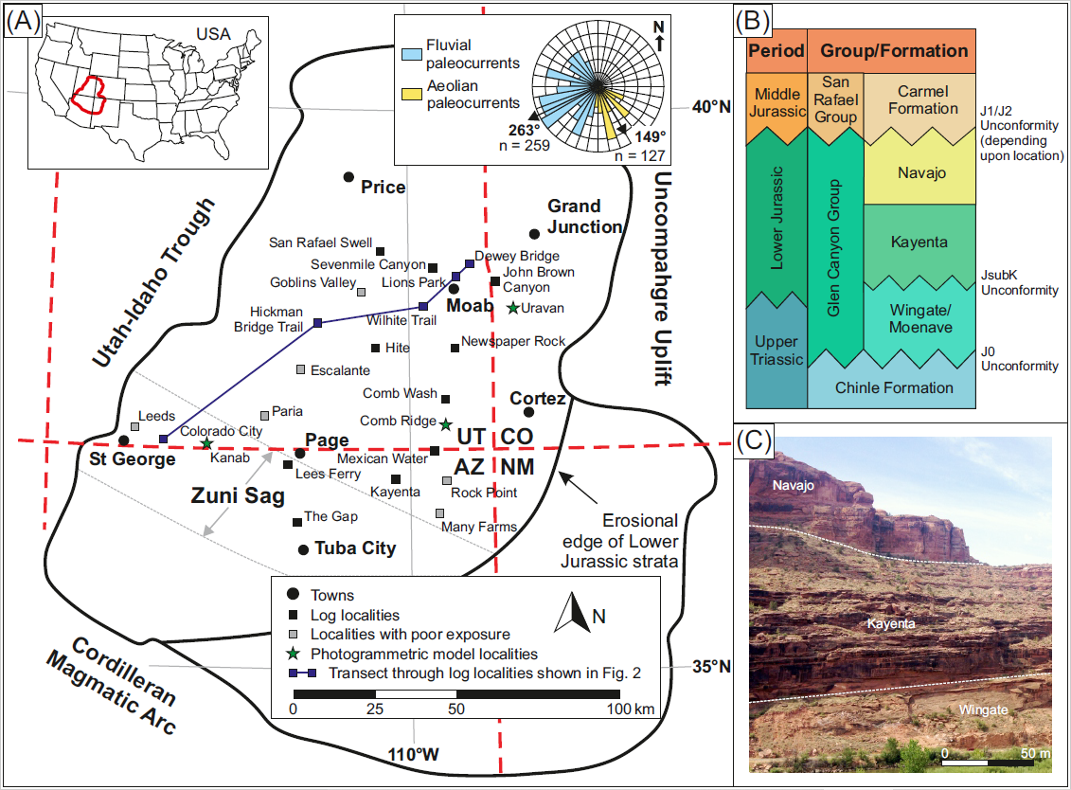Figure 1. (A) Location map of the Colorado Plateau and extent of the Kayenta Formation deposition with summary rose diagram illustrating the average palaeoflow directions of both the aeolian and fluvial strata. (B) Stratigraphic column of the Glen Canyon Group. (C) Photograph of the Glen Canyon Group stratigraphy taken along road UT-128 near Lions Park, Moab.

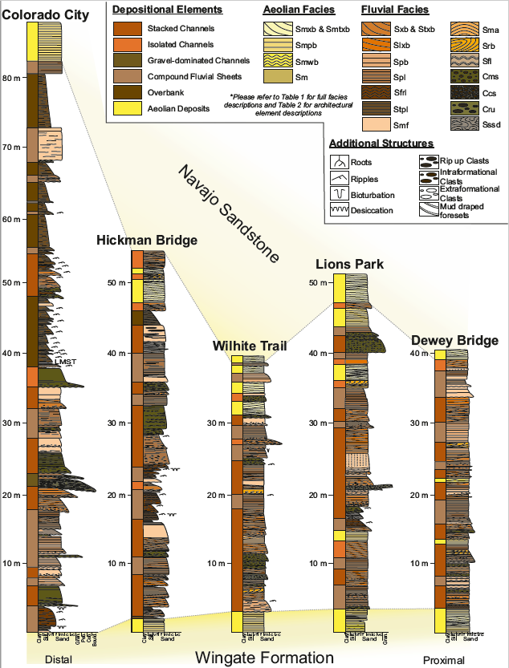
Figure 2. Representative transect of correlated sedimentary logs through the Kayenta Formation, showing the downstream variations in sedimentology. Sedimentary logs are coloured by lithofacies (see key) with depositional elements colour coded down the side. See Fig. 1 for line of section and locations.
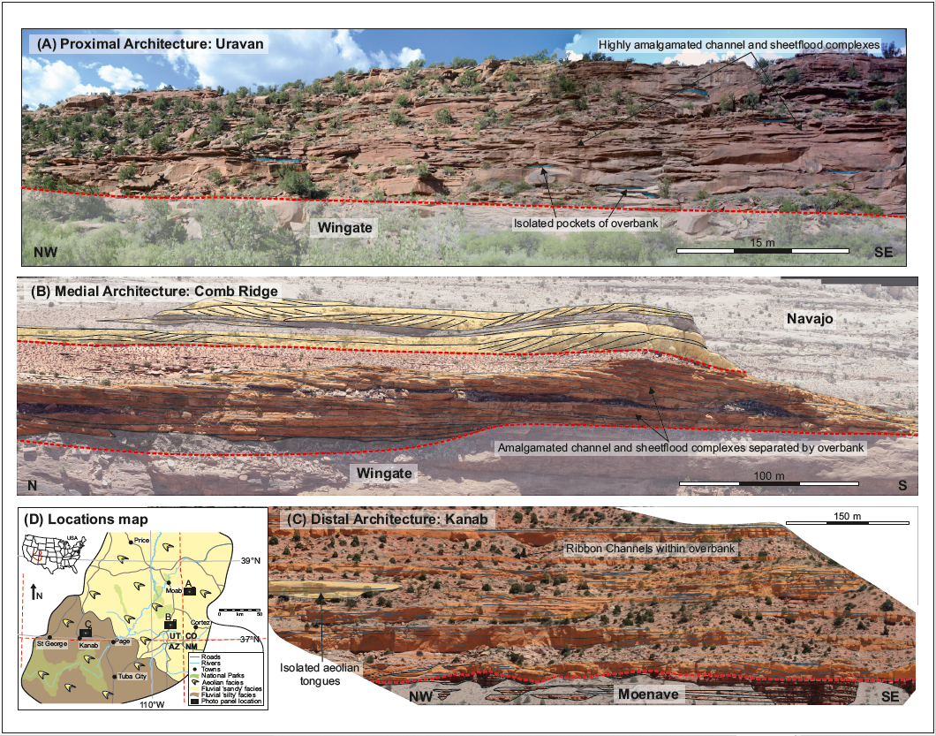
Figure 3. Architecture outcrop panels from three locations across the extent of the Kayenta Formation deposition depicting the change in architecture downstream, from highly amalgamated channels and sheets within the proximal to isolated channels and sheets within the distal. (A) Proximal architecture panel of Uravan, Colorado. (B) Medial architecture panel of Comb Ridge, southeast Utah. (C) Distal architecture panel of Kanab, southwest Utah. (D) Locations map illustrating the positions of panels A-C.
Table 1. Summary of lithofacies observed in the Kayenta Formation modified from Priddy & Clarke, 2020. Smxb: Sub-aerial planar cross-bedded sandstone; Smtxb: Sub-aerial trough cross-bedded sandstone; Smpb: Sub-aerial planar-bedded sandstone; Smwb: Sub-aerial undulose laminated sandstone; Sm: Sub-aerial structureless sandstone; Sxb: Sub-aqueous planar cross-bedded sandstone; Stxb: Sub-aqueous trough cross-bedded sandstone; Slxb: Sub-aqueous low-angle cross-bedded sandstone; Spb: Sub-aqueous planar-bedded sandstone; Spl: Sub-aqueous parallel laminated sandstone; Sfrl: Sub-aqueous ripple cross-laminated sandstone; Smf: Sub-aqueous structureless sandstone; Sma: Sub-aqueous sigmoidal bedded sandstone; Srb: Sub-aqueous recumbent cross-bedded sandstone; Sfl: Sub-aqueous flaser laminated sandstone; Sssd: Sub-aqueous soft sediment deformed sandstone; Stpl: Sub-aqueous parallel-laminated siltstone; Cms: Sub-aqueous matrix-supported conglomerate; Ccs: Sub-aqueous clast-supported conglomerate; Cru: Sub-aqueous rip-up clast conglomerate; Lm: Sub-aqueous siliciclastic-rich limestone.
Code | Lithology & Texture | Sedimentary Structures | Interpretation
Smxb | Grey to orange, fine to medium-grained, well sorted & well rounded sandstone. | Planar cross-bedding with mm/cm scale alternations in grainsize in single or multiple sets, sporadic soft sediment deformation. | Migration of wind-blown straight-crested dune-scale bedforms and dune trains. Soft sediment deformation formed as a result of loading on a damp substrate.
Smtxb | Grey to orange, fine to medium-grained, well sorted & well rounded sandstone. | Trough cross-bedding with mm/cm scale alternations in grainsize in single or multiple sets, sporadic soft sediment deformation. | Migration of wind-blown sinuous-crested dune-scale bedforms and dune trains. Soft sediment deformation formed as a result of loading on a damp substrate.
Smpb | Grey to orange, fine to medium-grained, well sorted & well rounded sandstone. | Planar-bedding with millimetre scale alternations in grainsize. | Wind-blown deposits formed by the deflation of dune-scale bedforms.
Smwb | Grey to orange, fine to medium-grained, well sorted & well rounded sandstone. | Undulose-laminations with millimetre scale alternations in grainsize. | Migration of wind-blown ripple-scale bedforms, producing pinstripe laminae.
Sm | Grey to orange, very fine to medium-grained, well sorted & well rounded sandstone. | Structureless, sporadic desiccation cracks and bioturbation. | Suspension settling of wind-blown sediment in areas affected by surface water, followed by drying.
Sxb | Brown medium-grained, moderate/well sorted & sub-rounded/well rounded sandstone. | Planar cross-bedding with normal grading, in single or multiple sets, sporadic clasts, mud draping and soft sediment deformation. | Migration of straight-crested dune-scale bedforms and dune trains sub-aqueously under lower flow regime conditions with high sediment load.
Stxb | Brown medium-grained, moderate/well sorted & sub-rounded/well rounded sandstone. | Trough cross-bedding with normal grading, in single or multiple sets, sporadic clasts and soft sediment deformation. | Migration of sinuous-crested dune-scale bedforms and dune trains sub-aqueously under lower flow regime conditions.
Slxb | Brown medium-grained, moderate/well sorted & sub-rounded/well rounded sandstone. | Low-angle cross-bedding in single or multiple lenticular sets and sporadic reactivation surfaces. | Lateral migration of macro-forms in lower flow regime conditions.
Spb | Brown medium-grained, moderate/well sorted & sub-rounded/well rounded sandstone. | Planar-bedding, sporadic clasts. | Sub-aqueous upper flow regime flat beds.
Spl | Brown fine to medium-grained, moderate/well sorted & sub-rounded/well rounded sandstone. | Parallel laminations. | Sub-aqueous upper flow regime flat beds.
Sfrl | Brown siltstone to medium-grained, moderate/well sorted & sub-rounded/well rounded sandstone. | Ripple-cross-laminations, with sub-critically to super-critically climbing multiple sets which form cosets. | Migration of ripple-scale bedforms in lower flow regime.
Smf | Orange to brown medium-grained, moderate/well sorted & sub-rounded/well rounded sandstone. | Structureless, sporadic clasts concentrated in basal sections. | Rapid deposition in high sediment load suppressing bedform development.
Sma | Orange to brown medium-grained, moderate/well sorted & sub-rounded/well rounded sandstone. | Sigmoidal-bedding with normally graded foresets in single or multiple sets. | Upper flow regime- antidune development.
Srb | Orange to grey medium-grained, moderate/well sorted & sub-rounded/well rounded sandstone. | Recumbent cross-bedding, sporadic mud draping on foresets in single or multiple sets, with slightly concave set bounding surfaces. | Migration of sinuous-crested dune-scale bedforms in lower flow regime with high sediment load.
Sfl | Brown siltstone to fine-grained sub-arkosic arenite. | Flaser laminations with silt lining foreset and set bounding surfaces. | Migration of ripple-scale bedforms in lower flow regime/waning flow conditions.
Sssd | Purple to brown siltstone to fine-grained sandstone matrix, with locally derived sediment, forming moderate/poorly sorted & sub-rounded clasts. | Soft sediment deformed clasts with silt lining the contorted foresets and between the deformed clasts. | Sub-aqueous mass transport deposits: debris flow/slumping/ sliding into a high sediment load flow.
Stpl | Dark brown siltstone, sporadic mottling. | Parallel to faint undulose laminations, sporadic rhizoliths, desiccation cracks and bioturbation. | Suspension fall out from stationary waters. Stabilization for vegetation to develop.
Cms | Grey to brown medium-grained sand to pebble-grade, polymictic conglomerate, poorly sorted, sub-rounded, matrix-supported. | Structureless to sporadic crude trough cross-bedding, with abundant clasts lining foresets. | Sub-aqueous lower flow regime conditions with high sediment load, intermittent development and migration of dune-forms.
Ccs | Grey to brown coarse-grained sand to pebble-grade, polymictic conglomerate, poorly sorted, sub-rounded, clast-supported. | Structureless to very crude cross-bedding, abundant clasts throughout. | Sub-aqueous, high energy Newtonian flow under high sediment load conditions, with suppressed bedform development.
Cru | Grey to orange medium-grained, poorly sorted, sub-rounded/sub-angular, matrix-supported. Rip up clasts ranging from granule to cobble grade. | Structureless to very sporadically crudely cross-bedded, rip up clasts at base. | Sub-aqueous high energy flow under high sediment load conditions and reworking of locally derived sediment.
Lm | Grey siliciclastic rich, carbonate wackestone with sporadic red chert. | Structureless to undulose laminated. | Sub-aqueous precipitation of allochthonous carbonate with siliciclastic input.

Table 2. Summary of architectural elements modified from Priddy & Clarke, 2020.
Element | Code | Facies | Description
Aeolian Dune | AD | Smxb, Smtxb, Smpl, Smwb | Tabular bodies with lateral extents up to 300m and vertical extents up to 150m.
Sandsheet | SS | Smpl, Smwb, Sm | Tabular bodies with lateral extents over 100’s m and vertical extents up to 3m.
Interdune | AI | Sm, Spl, Sfrl, Stpl | Lensoidal or sheet-like bodies with lateral extents up to 20m and vertical extents up to 2m.
Fluvial Channel | FC | Cms, Ccs, Cru, Sxb, Stxb, Spl, Srb, Smf | ‘U’ shaped elements with lateral extents up to 115m and vertical extents up to 4m.
Sheetflood | SF | Cru, Spb, Sma, Smf, Spl, Sfrl, Sfl | Tabular bodies with lateral extents between 250m and 400m and vertical extents up to 5m.
Lateral Accretion | LA | Stxb, Slxb, Spl, Sfrl | Lensoidal elements with lateral extents up to 100m and vertical extents up to 3m.
Downstream Accretion | DA | Cms, Sxb, Slxb, Srb, Spl, Sfrl | Lensoidal elements with lateral extents up to 200m and vertical extents up to 4m.
Bank Collapse | BC | Sssd, Stpl | Tabular bodies with lateral extents up to 20m and vertical extents up to 3m.
Overbank | OB | Stpl, Spl, Lm | Tabular bodies, rarely preserved with lateral extents up to 10m and vertical extents up to 4m.

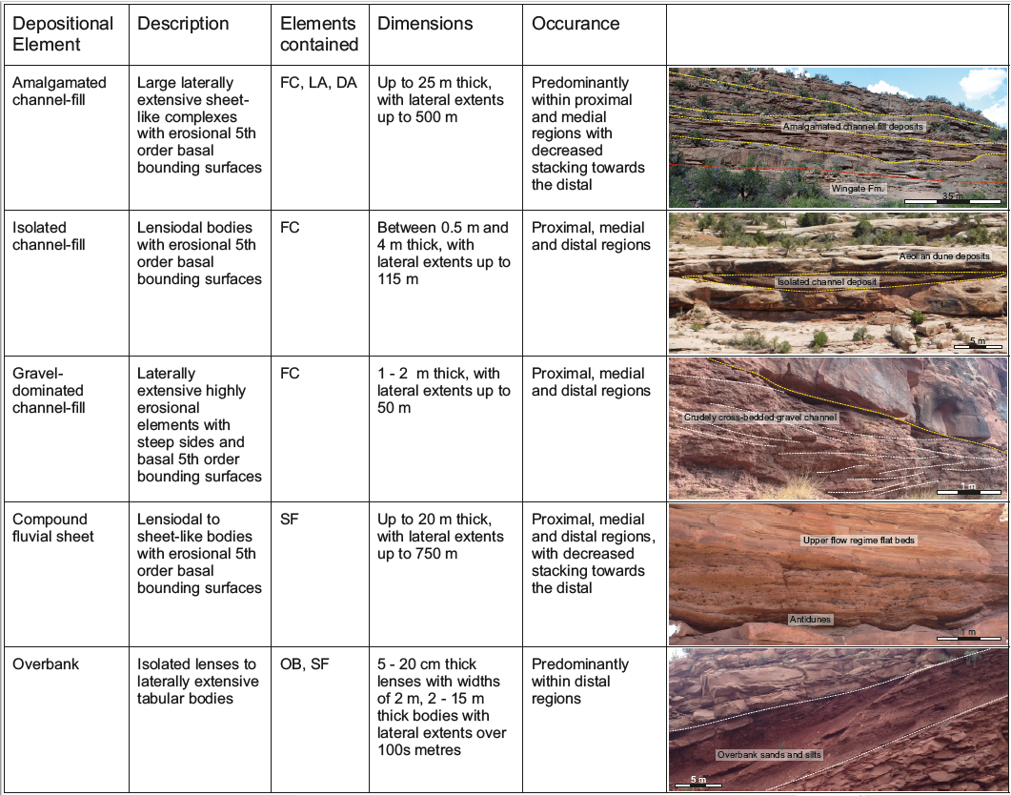
Figure 4. Summary table of fluvial depositional elements within the Kayenta Formation.

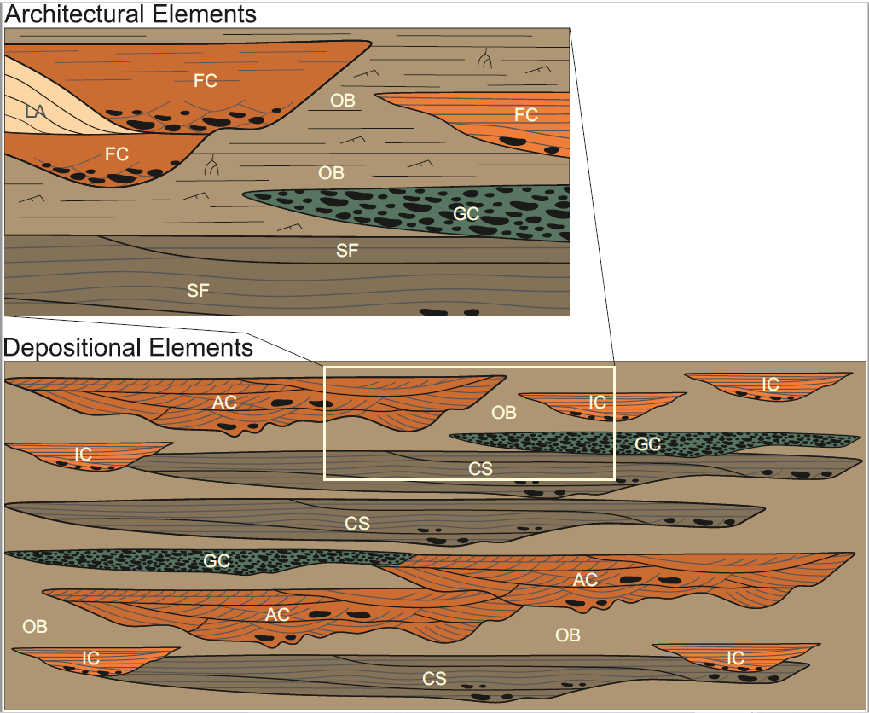Figure 5. Representation of the internal composition, architecture, and geometries of the large-scale depositional elements. Architectural elements: FC = fluvial channel, LA = lateral accretion, GC = gravel-dominated channel, SF = fluvial sheet, OB = overbank. Depositional elements: AC = amalgamated sandstone-dominated channel-fill, IC = isolated sandstone-dominated channel-fill, GC = isolated gravel-dominated channel-fill, CS = compound sandstone-dominated fluvial sheet, OB = overbank.
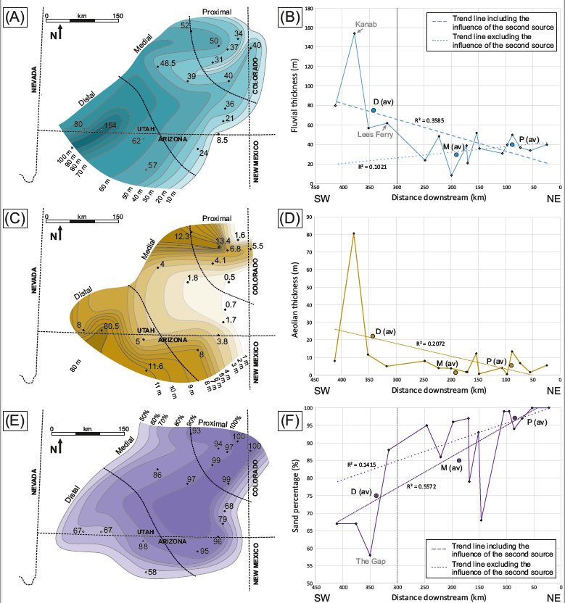
Figure 6. (A) Contour map of fluvial sediment thickness at each locality. (B) Graph of total fluvial sediment thickness against distance downstream. (C) Contour map of aeolian sediment thickness at each locality. (D) Graph of total aeolian sediment thickness against distance downstream. (E) Contour map of sand percentage at each locality. (F) Graph of sand percentage against distance downstream. (G) Contour map of conglomerate percentage at each locality. (H) Graph of conglomerate percentage against distance downstream. (I) Contour map of the average grainsize (Φ) at each locality. (J) Graph of average grainsize (Φ) against distance downstream. Average measurements of proximal, medial and distal portions are denoted as P (av), M (av), and D (av) on each graph. Dashed line in each case is a linear best fit to the total dataset and the dotted line is a linear best fit line excluding the data influenced by the secondary fluvial source.
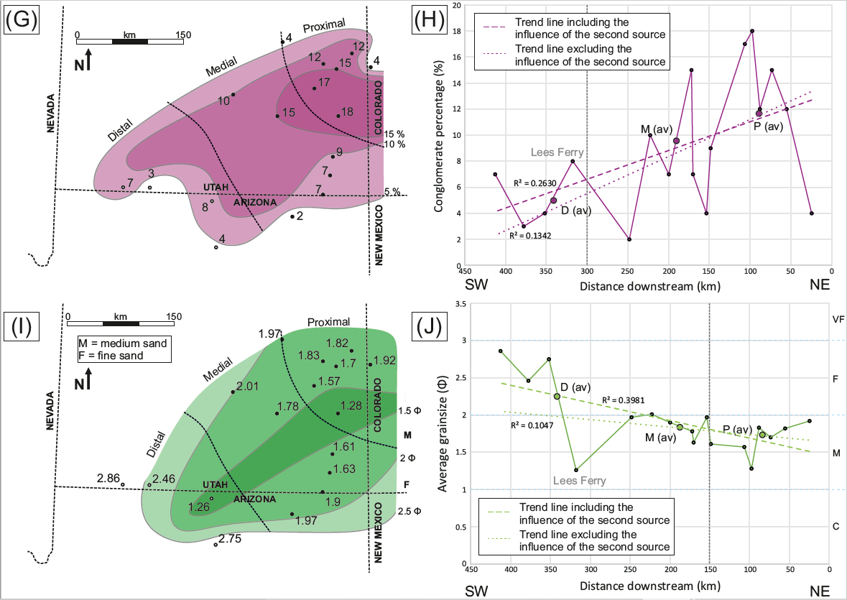Figure 6. (Continued).
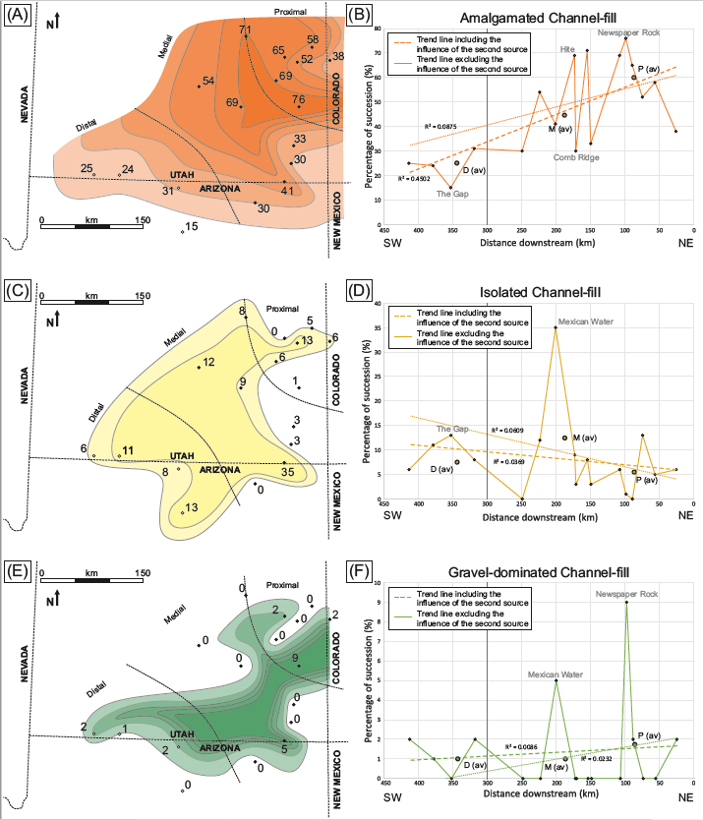
Figure 7. Contour maps and graphs illustrating the percentage that each depositional element constitutes of the whole fluvial succession at each locality. (A) Amalgamated channels contour map. (B) Graph of amalgamated channel percentage against distance downstream. (C) Isolated channels contour map. (D) Graph of isolated channel percentage against distance downstream. (E) Gravel-dominated channel contour map. (F) Graph of gravel-dominated channel percentage against distance downstream. (G) Compound fluvial sheet contour map. (H) Graph of compound fluvial sheet percentage against distance downstream. (I) Overbank contour map. (J) Graph of overbank percentage against distance downstream. Average measurements of proximal, medial and distal portions are denoted as P (av), M (av), and D (av) on each graph. Dashed line in each case is a linear best fit to the total dataset and the dotted line in each case is a linear best fit line excluding the data influenced by the secondary fluvial source.
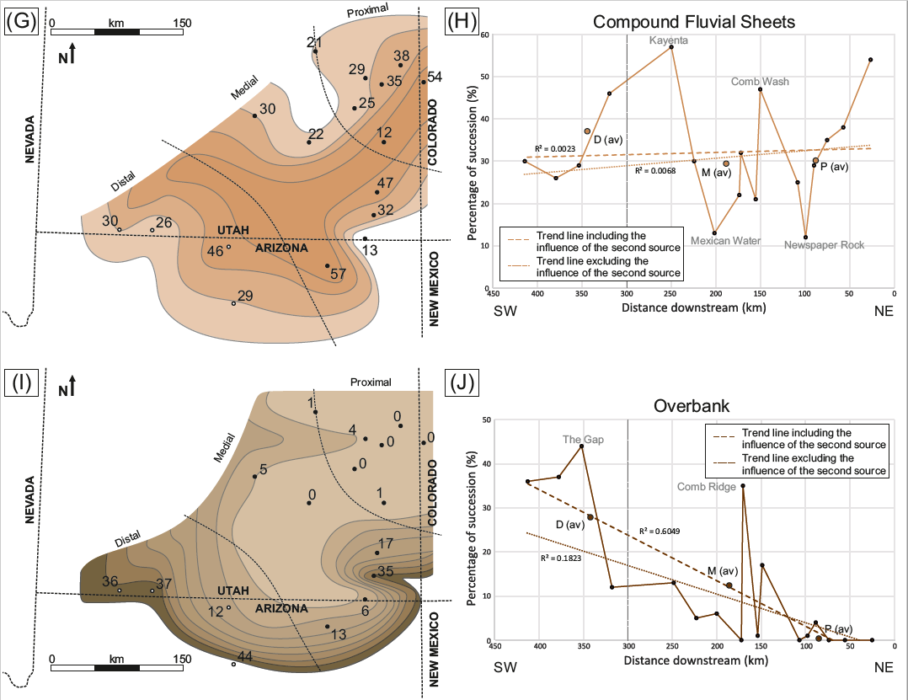
Figure 7. (Continued).
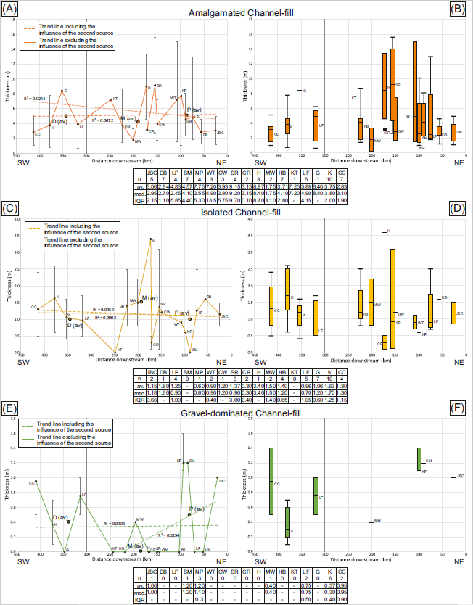
Figure 8. Graphs illustrating the average and range of sediment thickness at each locality for each depositional element plotted against distance downstream and box and whisker plots illustrating the median, interquartile range and outliers for each locality for each depositional element plotted against distance downstream. Average measurements of proximal, medial and distal portions are denoted as P (av), M (av), and D (av) on each graph. Dashed line in each case is a linear best fit to the total dataset and the dotted line in each case is a linear best fit line excluding the data influenced by the secondary fluvial source.
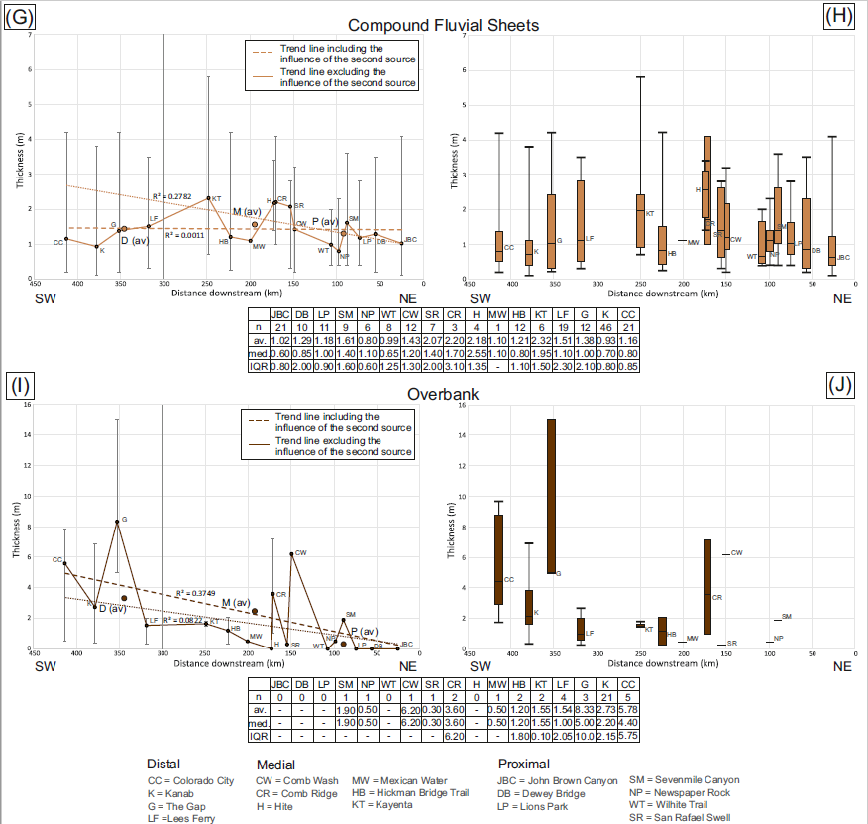
Figure 8. (Continued).
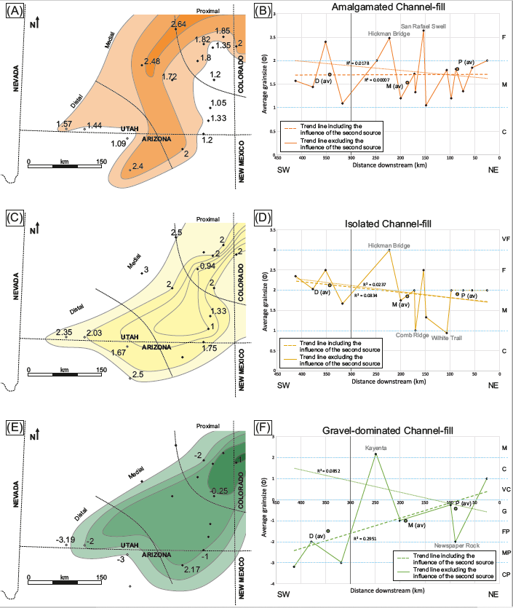
Figure 9. Contour maps and graphs illustrating the average grainsize (Φ) that each depositional element constitutes of the fluvial succession at each locality. (A) Amalgamated channel contour map. (B) Graph of amalgamated channel average grainsize against distance downstream. (C) Isolated channel contour map. (D) Graph of isolated channel average grainsize against distance downstream. (E) Gravel-dominated channel contour map. (F) Graph of gravel-dominated channel average grainsize against distance downstream. (G) Compound fluvial sheet contour map. (H) Graph of compound fluvial sheet average grainsize against distance downstream. (I) Overbank contour map. (J) Graph of overbank average grainsize against distance downstream. Average measurements of proximal, medial and distal portions are denoted as P (av), M (av), and D (av) on each graph. Dashed line in each case is a linear best fit to the total dataset and the dotted line in each case is a linear best fit line excluding the data influenced by the secondary fluvial source.
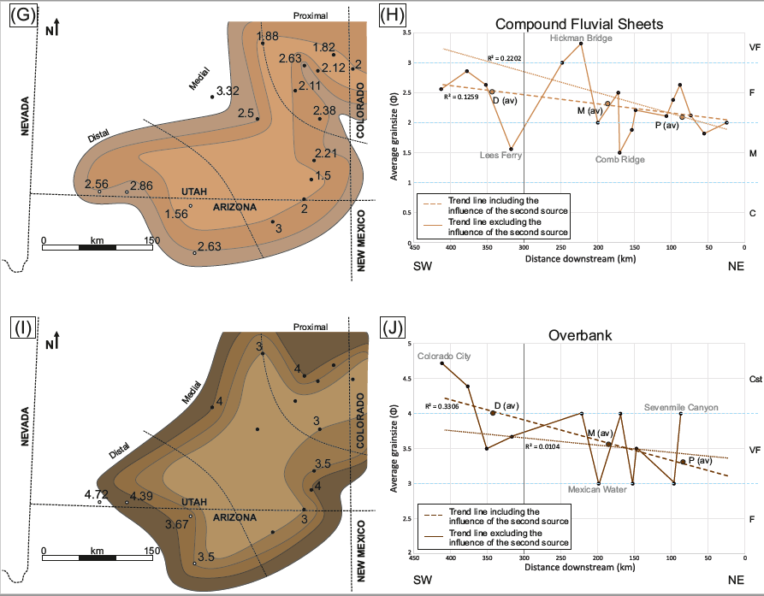
Figure 9. (continued).
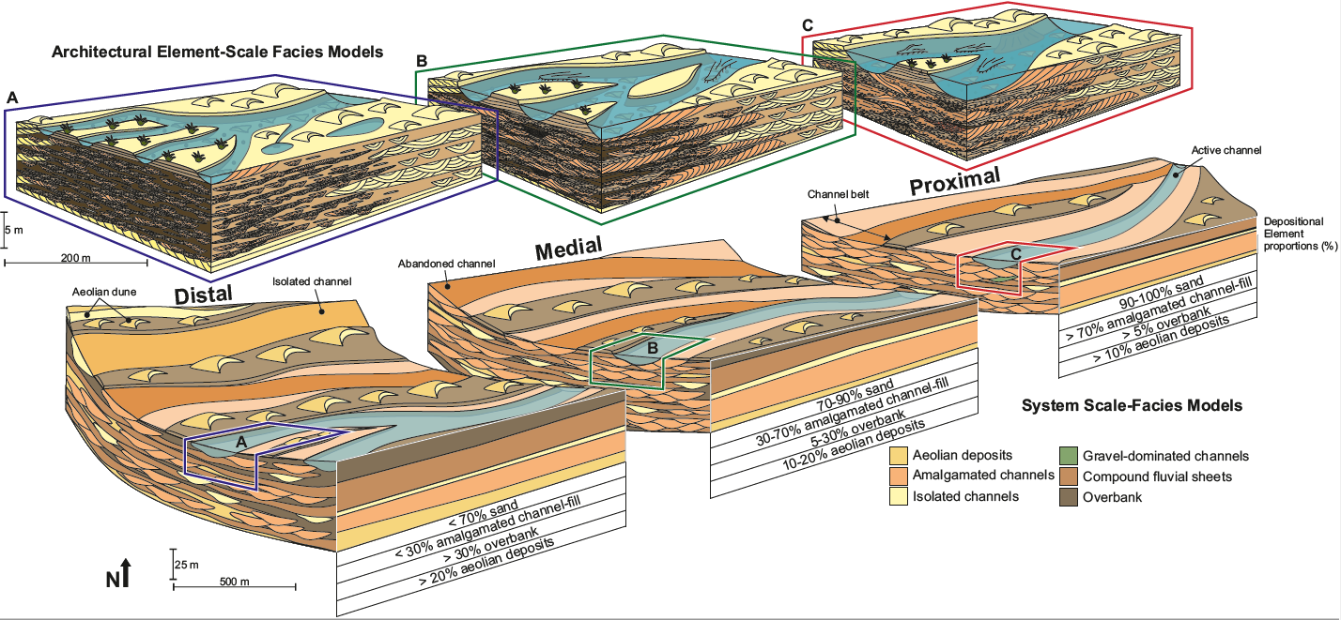
Figure 10. System-scale depositional model of the Kayenta Formation sub-divided into proximal, medial, and distal sections with a cross-section of the internal architecture and stacking patterns for each section. Depositional element proportions (%) are displayed along the side of each section of the system-scale model, along with their key characteristics. Architectural element-scale facies models of the proximal, medial, and distal settings highlight the detailed sedimentology observed within the depositional elements on the system-scale model.
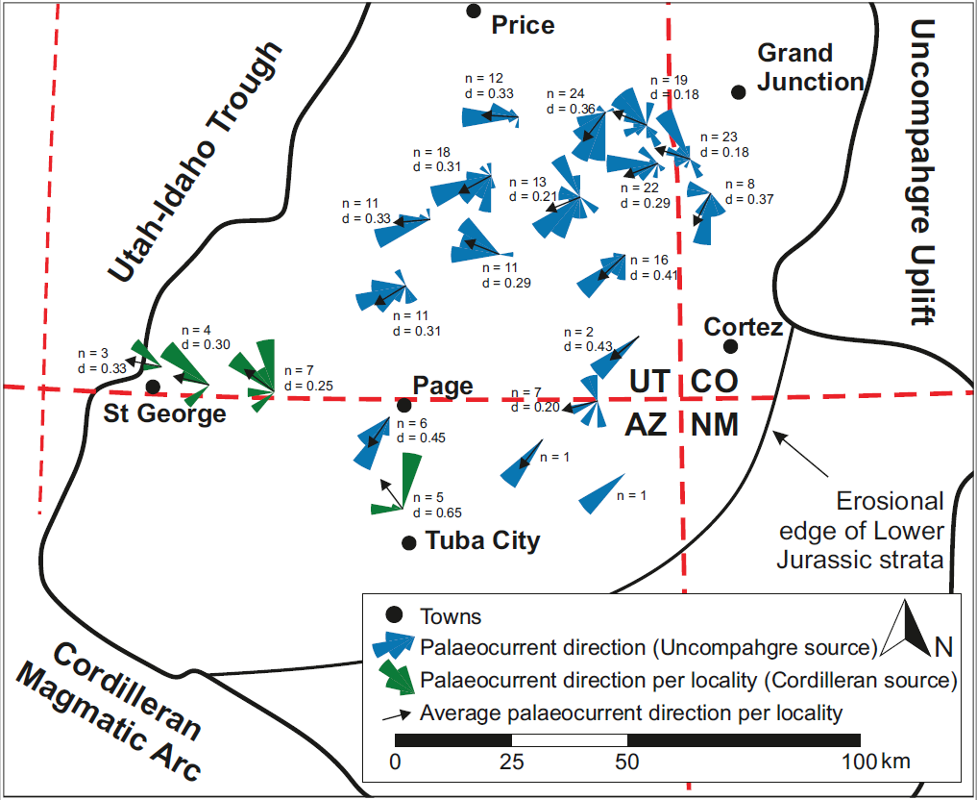
Figure 11. Palaeocurrent measurements of the fluvial sediment at each locality depicted by rose diagrams coloured by sediment source. The black arrows indicate the average palaeocurrent direction per locality along with the number of measurements and degree of dispersion per locality.
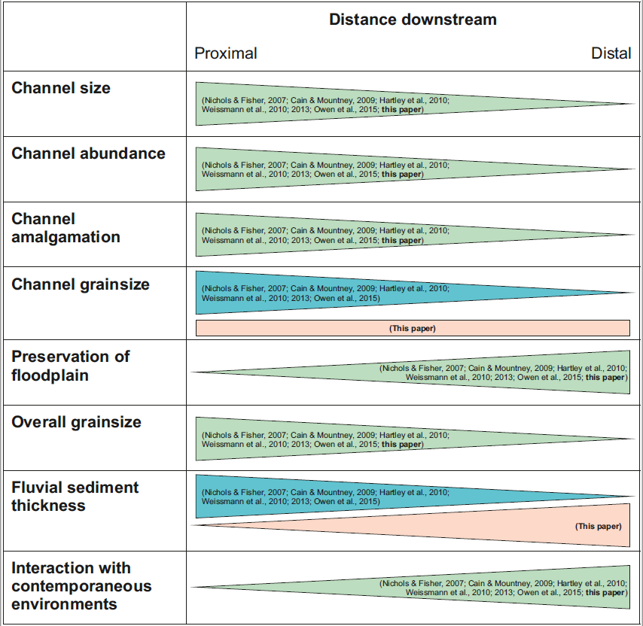Figure 12. Comparison of key characteristics of a distributive fluvial system. Triangles represent whether a key characteristic increases or decreases downstream and are coloured by similarities and differences in findings from previously published literature.

