eXtended Reality (XR) virtual practical and educational eGaming to provide effective immersive environments for learning and teaching in forensic science

Jamie K. Pringle^{1*}, Ian G. Stimpson¹, Adam J. Jeffery², Kristopher D. Wisniewski³, Timothy Grossey⁴, Luke Hobson¹, Vivienne Heaton³, Vladimir Zholobenko³ & Steven L. Rogers¹

¹School of Geography, Geology & Environment, Keele University, Keele, Staffs, ST5 5BG, U.K.
Emails: j.k.pringle@keele.ac.uk ; i.g.stimpson@keele.ac.uk ; l.hobson@keele.ac.uk ; s.l.rogers@keele.ac.uk
ORCIDs: 0000-0002-0009-361X (JKP) ; 0000-0002-1931-0522 (IGS) ; 0000-0002-4920-5408 (SLR)
²The Keele Institute for Innovation & Teaching Excellence, Keele University, Keele, Staffordshire, ST5 5BG, U.K. Email: a.j.jeffery@keele.ac.uk ; 0000-0002-2069-4893 (AJ);
³School of Physical & Chemical Sciences, Keele University, Keele, Staffordshire, ST5 5BG, U.K. Email: k.d.wisniewski@keele.ac.uk v.l.zholobenko@keele.ac.uk ; v.g.heaton@keele.ac.uk; ORCID: 0000-0001-5408-2417 (KW) ; 0000-0002-4658-9952 (VH) ; 0000-0002-6024-0503 (VZ)
⁴RSK Ltd., 18 Frogmore Road, Hemel Hempstead, Herts., HP3 9RT, U.K. Email: tgrossey@rsk.co.uk
*Corresponding author: j.k.pringle@keele.ac.uk

Abstract

Online virtual learning resources have been available for learning and teaching in forensic science for some years now, but the recent global COVID-19 related periods of irregular lockdown have necessitated the rapid development of these for teaching, learning and CPD activities. However, these resources do need to be carefully constructed and grounded in pedagogic theory to be effective. This article details eXtended Reality (XR) learning and teaching environments to facilitate effective online teaching and learning for forensic geoscientists. The first two case studies discussed in this article make use of Thinglink software to produce virtual learning and teaching XR resources through an internet system, which was delivered to undergraduate students in 2021. Case one details an XR virtual laboratory-based XRF equipment resource, providing a consistent, reliable and asynchronous learning and teaching experience, whilst the second case study presents an XR virtual learning applied geophysics resource developed for a 12-week CPD training programme. This programme involves recorded equipment video resources, accompanying datasets and worksheets for users to work through. Both case studies were positively received by learners, but there were issues encountered by learners with poor internet connections or computer skills, or who do not engage well with online learning. A third case study showcases an XR educational forensic geoscience eGame that was developed to take the user through a cold case search investigation, from desktop study through to field reconnaissance and multi-staged site investigations. Pedagogic research was undertaken with user questionnaires and interviews, providing evidence that the eGame was an effective learning and teaching tool. eGame users highly rated the eGame and reported that they raised awareness and understanding of the use of geophysics equipment and best practice of forensic geoscience search phased investigations. These types of XR virtual learning digital resources, whilst costly to produce in terms of development time and staff resource, provide a complementary virtual learning experience to in-situ practical sessions, and allow learners to asynchronously familiarise themselves with equipment, environments and techniques resulting in more efficient use of in situ time. The XR resources also allow learners to reinforce learning post in-situ sessions. Finally, XR resources can provide a more inclusive and authentic experience for learners who cannot attend or complete work synchronously.

Graphical abstract
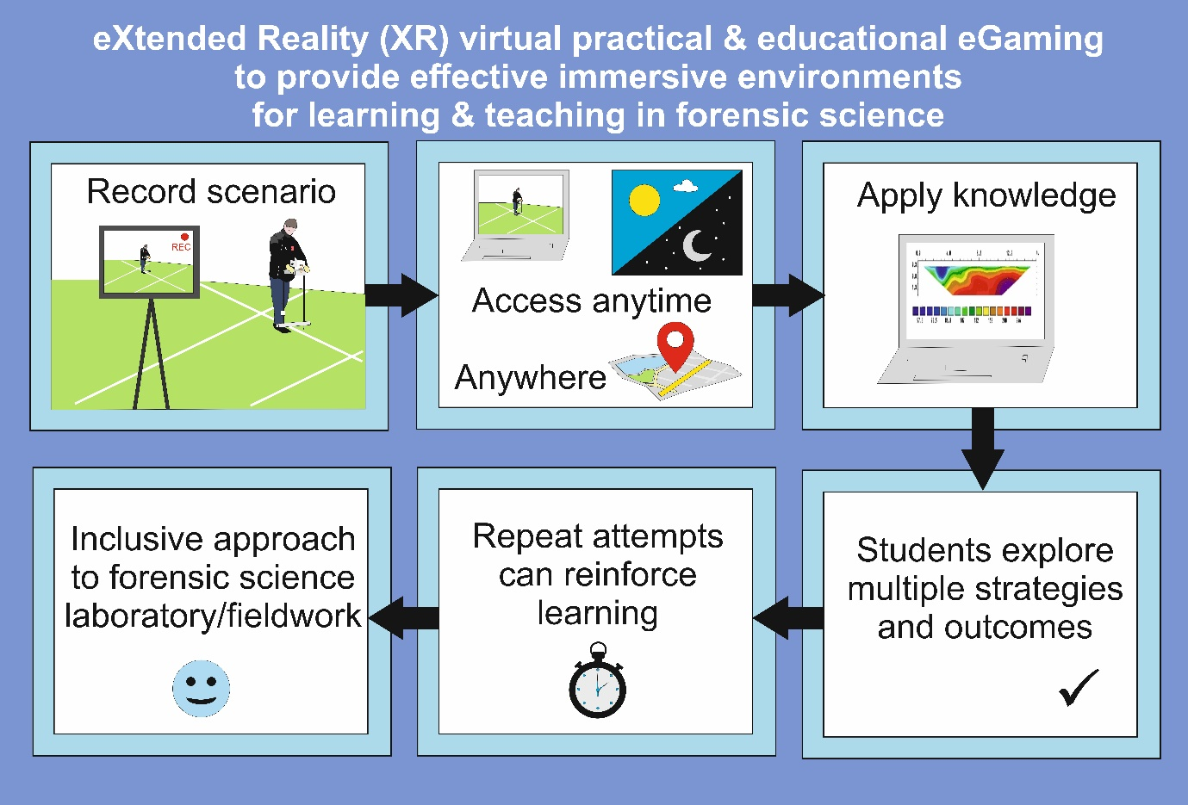
Keywords: search ; educational eGaming ; virtual practicals ; geophysics ; Flexible learning; XR

Highlights
- Extended Reality digital resources can complement traditional learning methods
- Benefits of 24/7 access, asynchronous teaching and widens learning environments
- Access issues if poor internet connection or if not technologically competent
- Widens inclusivity, accessibility and flexible work practices

Introduction
Over the past 10 years teaching and learning in Higher Education (HE) has evolved to make greater use of interactive learning environments, as well as digital and virtual technologies. The move away from more traditional theory lectures and associated laboratory practicals comes with many benefits, for both the teacher and the student, as evidenced by pedagogic research into outdoor field and HE campus ‘Living' or 'Natural Lab’ teaching and learning environments [1,2]. The recent COVID-19 pandemic and subsequent lockdowns, has necessitated more drastic changes to teaching and learning (see [3]), and has also highlighted the benefits and the drawbacks of virtual and online learning and teaching tools.
It has been recognised that there are significant barriers to the achievement of intended learning outcomes and the development of key required skills by both course and discipline regulators. This may be due to the financial costs associated with the acquisition and day-to-day running of specialised instrumentation, outdoor fieldwork costs, management of resources or indeed lack of specialised equipment access and skills to use them. Importantly, there are also other barriers for students to do fieldwork, including those with mobility or mental health issues [4], those from ethnic minorities and other specific educational needs (see [5,6]). Some of the stated problems, such as lack of equipment or specialised instrumentation can be solved, for example through specific HE financial hardship funds, but others may not be able to be resolved; for example, the lack of laboratory space, caring responsibilities [7], staff delivery time or health and safety restriction considerations. Certain types of fieldwork or crime scene processing typically encountered on a forensic science degree programme, such as excavating simulated clandestine graves or recovering trace evidence in wooded search environments, can be problematic for students with mobility issues or specific learning needs.
A study of 17,000 HE UK post-graduate research students noted that these students were sophisticated information-seekers that could use complex information sources and were highly competent IT users [8]. However, this is a generalisation as there will be students with different technological abilities, interests and cultural backgrounds and thus the student cohort will be more diverse as shown by Sternberg [9]. Availability of technology will also vary between different student cohorts and can be problematic with those who have little resources [10]. In addition, the student cohort will also include those who are not familiar with digital technologies, and those who may have visual or auditory impairment that provides a barrier to effective use of technologically-based teaching and learning.
The continuing time pressures of forensic science practitioners also makes it ever more challenging for them to undertake significant continuing professional development (CPD) activities, especially where their formal job roles, perhaps as active SOCOs (CSIs in the US) or PoLSAs, prevents them from being able to undertake significant formal training in scheduled work hours. With the closure of the Forensic Science Service (FSS) in the UK and the resulting forensic science marketisation [11,12], more police forces are developing or restructuring their scientific support departments so that they can do more of the work themselves rather than commissioning private forensic science contractors to save resources [13]. Both in the UK [14] and globally [15] there is also widely varying issues in technique validation and proficiency testing. Therefore, it is even more important that there are CPD courses for existing police forces staff. There are some online courses available (see [16]), but these tend to be somewhat limited in scope or are not able to provide the necessary detail and experience required to fully understand concepts or techniques.
Digital technology, including virtual reality and eGames, has been a part of crime scene investigation for some time now, whether that be the teaching of forensic science in HE, or its application to active casework [17]. These include the use of virtual reality for forensic visualisation [18], crime scene investigations [19-22], training incident first responders [23], reconstructing traffic incidents [24], footwear [25] and even re-association of human remains [26]. Virtual reality can also play a key role in the presentation of evidence in court [17]. In a learning environment, virtual reality software can be used to familiarise students with crime scene processing techniques and search and recovery procedures, as well as encouraging independent study and problem-solving skills. There is also inclusivity to consider, when online virtual learning activities can be delivered asynchronously, this will benefit students with caring responsibilities or part-time jobs, allowing them to manage their time accordingly, as well as students with mental or physical health or mobility issues who may not be able to traverse uneven ground looking for a subsequent clandestine grave excavation.
This paper aims to showcase the potential of extended reality (XR) learning environments as complementary learning and teaching educational tools for HE forensic geoscience students and practitioners, the concepts and technologies will be transferable to other field-based disciplines. This will be achieved by firstly introducing XR in a teaching and learning environment, before giving three different examples, namely an XR forensic laboratory case study, an XR online learning and teaching forensic geophysics course and finally an XR virtual outdoor forensic search through an educational eGame. A discussion section will also evaluate the effectiveness of such approaches. Specific paper objectives are:
- to showcase the potential of the Thinglink online platform to deliver XR learning resources of physical laboratory and outdoor field instrument design, data collection and analysis;
- to describe a pedagogic study to evaluate the effectiveness of a XR forensic geoscience search educational eGame for teaching and learning that was developed for HE students;
- to evaluate the effectiveness of XR learning to supplement learning and teaching of physical sciences, and its impact on inclusivity and accessibility in teaching.
Virtual Reality (VR) and eXtended Reality (XR) environments

The term eXtended Reality (or XR) is an overarching concept covering various immersive computer visualisation technologies, including Virtual Reality (VR), Augmented Reality (AR) and Mixed Reality (MR). In theory, this covers the spectrum from full-virtual to the real-world, but in practice involves at least some degree of technological augmentation [27]. The XR resources presented here constitute a variety of eLearning, defined by Normark and Cetindamar [28] as “a system which facilitates the electronic transfer, management, support, and supervision of learning”. The potential for virtual learning and teaching has been known in forensic science for some time, with several researchers [18, 21, 22] showing that 3D virtual reality can accurately reconstruct crime scenes and allow learners to become experienced in crime scene investigations without physically attending crime scenes themselves. Virtual environments have the capacity to allow learners to develop key skills and performance in a consistently reliable experience that can be repeatedly interrogated, available asynchronously 24/7 and be used for a variety of purposes [29]. As such, the application of such learning environments may have the potential to enhance accessibility and inclusivity, the value of which for technology-based education is generally recognised [30] and protected by the Equality Act 2010 in the U.K [31].

The Thinglink platform is an education technology platform which allows the user to create learning environments based around the use of augmented images and videos, creating interactive, XR experiences [32]. The platform allows the user to upload images and add a variety of ‘hotspots’ which, when interacted with, can provide additional images, text, audio files, or links to other images. The user may also upload 360° images or videos, which can also be augmented in the same manner. When complete, resources can be accessed through an internet browser. As a learning platform, Thinglink has numerous applications and has gained attention in recent years in teaching and outreach (e.g. [29,33]). There are powerful applications for Thinglink in the physical sciences, especially for virtual fieldwork [4], an area of teaching which has considerable potential for increasing accessibility of the field, and which has gained relevance in light of the limitations imposed by the COVID-19 health crisis (e.g. [34]). It should be noted however that an important part of fieldwork is peer-to-peer learning which is much more difficult with virtual learning. There are similarly powerful applications for laboratory-based instrumentation, particularly where the development of key practical skills is limited by accessibility issues (e.g. resource management, high student numbers, health and safety considerations).

XR Laboratory instrumentation

A range of scientific instrumentation was reconstructed digitally within the Thinglink platform as an XR learning and teaching environment, using photographs of the equipment and associated workspace, as well as schematic diagrams, text and image-based information pages, alongside simulated interaction with, and control of, the instrument (Figure 1). The virtual instruments generated included a polarising microscope, a handheld X-Ray Fluorescence spectrometer (XRF), an ion chromatography system and a laser particle size analyser [22]. In each case, the created resource included multiple sections, for example, introduction, background and theory, health and safety, instrument design, calibration and sample analysis. Each Thinglink incorporated ‘hotspots’ to provide information, imagery, or embedded audio, as well as both sequential and non-sequential navigation through the respective XR materials. The XR virtual instruments were each connected to, and accessed from, a single home page which simulated a workbench or station. In the case of the XR virtual analytical instruments, and with the intention of creating as authentic an experience as possible, data were collected using the physical laboratory instrument and this data was then embedded within a simulated sample analysis function. This allowed users to ‘analyse’ a range of samples and access real datasets for further analysis and interpretation.

The XR virtual learning and teaching resources were made available to a range of students and teaching staff in 2020/2021, including those from forensic science undergraduate programmes, as well as chemistry and environmental science programmes. This was, in part, a response due to the COVID-19 pandemic lockdown at the time, when students were not able to access any of the instrumentation or laboratory-related facilities. The generated XR resources thus provided learners with a user-friendly, repeatable means of engaging with XR virtual laboratory-based facilities at their own pace, in a location of their own choice (e.g. from home or on hand-held digital devices).
A number of these virtual learning resources were utilised as part of an action research pedagogic project, comprising two separate studies, aiming to gather HE student (levels 4, 5, and 6) and staff user feedback involving questionnaires and structured interviews after the necessary University project ethical approval had been obtained, see [6,35] for design and dissemination. Project results were overwhelmingly positive, with 97 % of the 59 questionnaire responses (staff and students) agreeing that the virtual resources would be beneficial to their understanding of the subject area in question, and 98 % of responses agreeing that the resources would be useful as an alternative or supplement to the instrumentation itself during times that it was not available (Figure 2). A smaller subset of 33 respondents associated with only one of the two studies described above [35], when asked if the learning resources fit well in a flexible, digital (hybrid) learning environment, provided a 100 % positive response. Open text comments were similarly positive (e.g., “It’s really well done”, “This was a really useful resource, thank you”, “I would like to see this used in my future studies”, and “If this style of resource was incorporated into other subjects/practicals, I would definitely use it”).
As part of the previously described action research study, one-to-one interviews were undertaken with four academic staff members, all of whom were, at that time, not involved in the project. The group comprised three academic lecturers and a senior lecturer, all of whom had scientific background within the field of geoscience, geography, environmental science, and sustainability. Of the four interviewees, all had some experience of designing and using blended learning approaches, including virtual fieldwork and external workshops, but not necessarily using the Thinglink platform. All interviewees expressed satisfaction that the resources were well structured, easy to navigate, and contained visual and audio elements which were of high enough quality for their needs. Key topics for consideration included the value of animations and audio, the need for a full narration for those with specific learning requirements, and the need for proper integration of materials with tasks for learners to undertake. All interviewees stated that the resource makes learning more accessible, promotes independence, removes time restrictions for instrument access, improves tolerance for variability in learning speed, potentially reduces student anxiety, and supports those with physical disabilities.
Despite these positive responses, there remain some key areas highlighted for consideration and continued development moving forward. For example, this style of learning resource is dependent upon access to, and time spent with, digital tools such as a desktop or laptop computer, or a handheld digital device. Physical impairments which make it difficult for the user to use a computer screen for prolonged periods of time therefore represent a key barrier to success. Similarly, the requirement for specific technology (e.g. access to a computer, available bandwidth), may introduce a financial bias in favour of those from wealthier backgrounds or institutions. These barriers to learning would require further consideration and investment prior to implementation; for example, an equipment loan scheme (where possible) could help to mitigate difficulties relating to the accessibility of required computing equipment. Varying degrees of digital competence is a fundamental problem which would require consideration, but could be, to some extent, mitigated via clear instruction on how to make full use of any resource created within this platform.
Although there were no specific problems reported surrounding the accessibility of the design, this also remains an important area for scrutiny moving forward. For example, the design of the slides, the colours used, the fonts and text sizes, and the images employed could all introduce difficulties for students with a range of specific disabilities (e.g. colour blindness, dyslexia), particularly given the potentially high number and length of interactions required with a given resource. One of the strengths of the Thinglink platform is that the creator has very little limitation on the design element of their learning resource; the nature of the Thinglink platform dictates that users create their own images and associated content elsewhere (e.g. Microsoft™ Powerpoint, vector drawing software), meaning that barriers to learning associated with design can be easily and quickly mitigated by the creator. Similarly, the route through a resource can be as linear or as open as the creator requires. The resources described above[6,35] were deliberately left open (although numbered sections were utilised to highlight the logical or intended pathway), allowing users to navigate through the various sections at their own pace. However, where a more specific path of learning is required, the designer can control entirely the user path through the material, and tools such as the ‘Conditional Transition’ function could be used to effectively password protect sections until their intended use.
Finally, the feedback indicated some potential concerns around learner engagement, and how this could be monitored and controlled. This style of asynchronous resource inevitably introduces some risks surrounding its use (i.e. is it being used), as well as an obvious lack of real-time interaction with peers and teaching staff. The Thinglink platform does offer a statistics function which allows the creator to monitor usage to some extent, and feedback from the above studies suggested that the resources could be made more engaging through the incorporation of additional video materials, which would better imitate the real experience. Nevertheless, it was raised by staff and student alike that the most powerful application of this style of resource was in supplementary rather than replacing physical practicals.

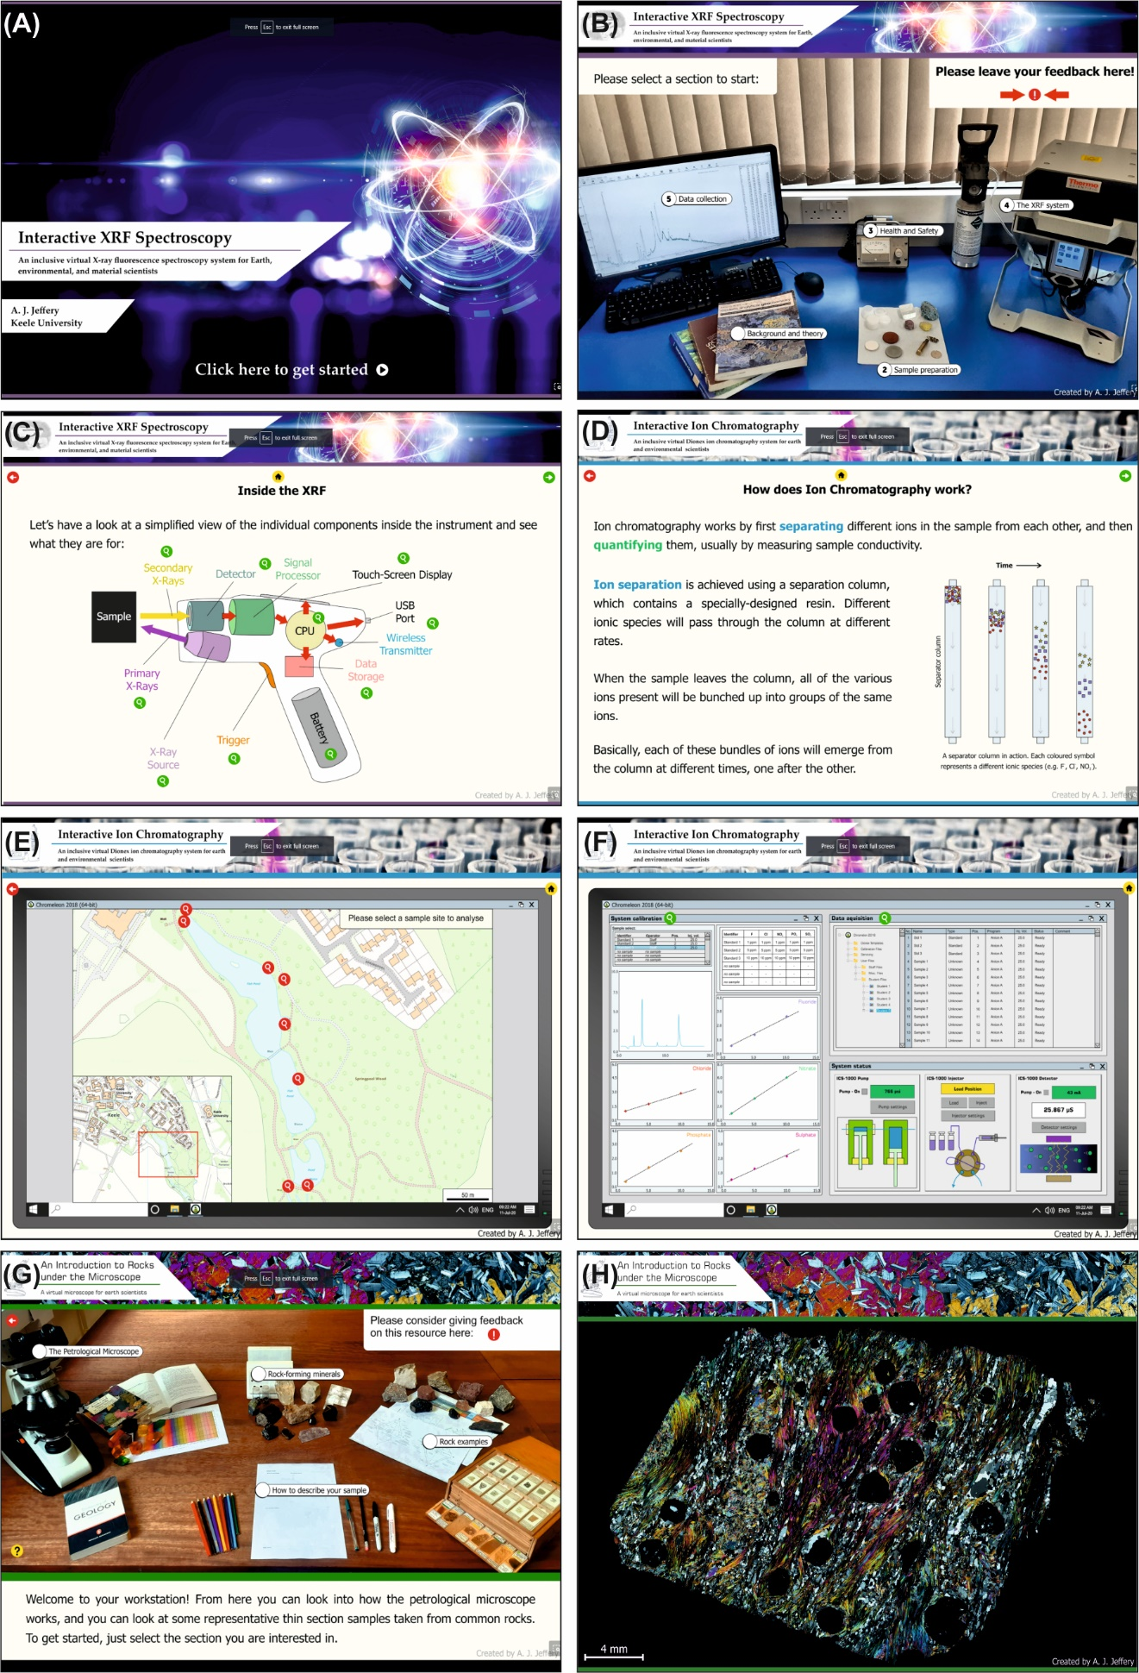Figure 1: XR laboratory screenshots from the Thinglink-based virtualized analytical instruments and microscopes. A) Title screen for virtualized XRF. B) Home page of XRF resource featuring simulated workstation. C) Interactive page detailing the interior components of the XRF instrument. D) Background theory page explaining the principles of ion chromatography. E) Example sample selection screen featuring an interactive map where users can collect and analyse virtual samples. F) Simulated ion chromatography analysis screen, featuring instrument control, calibration, and sample analysis. G) Home page for microscope resource, featuring a simulated workstation and various areas for users to explore. H) Example geological thin section within the microscope resource. A web-link is provided for readers to view and utilise this digital learning resource in the Supplementary Resources.

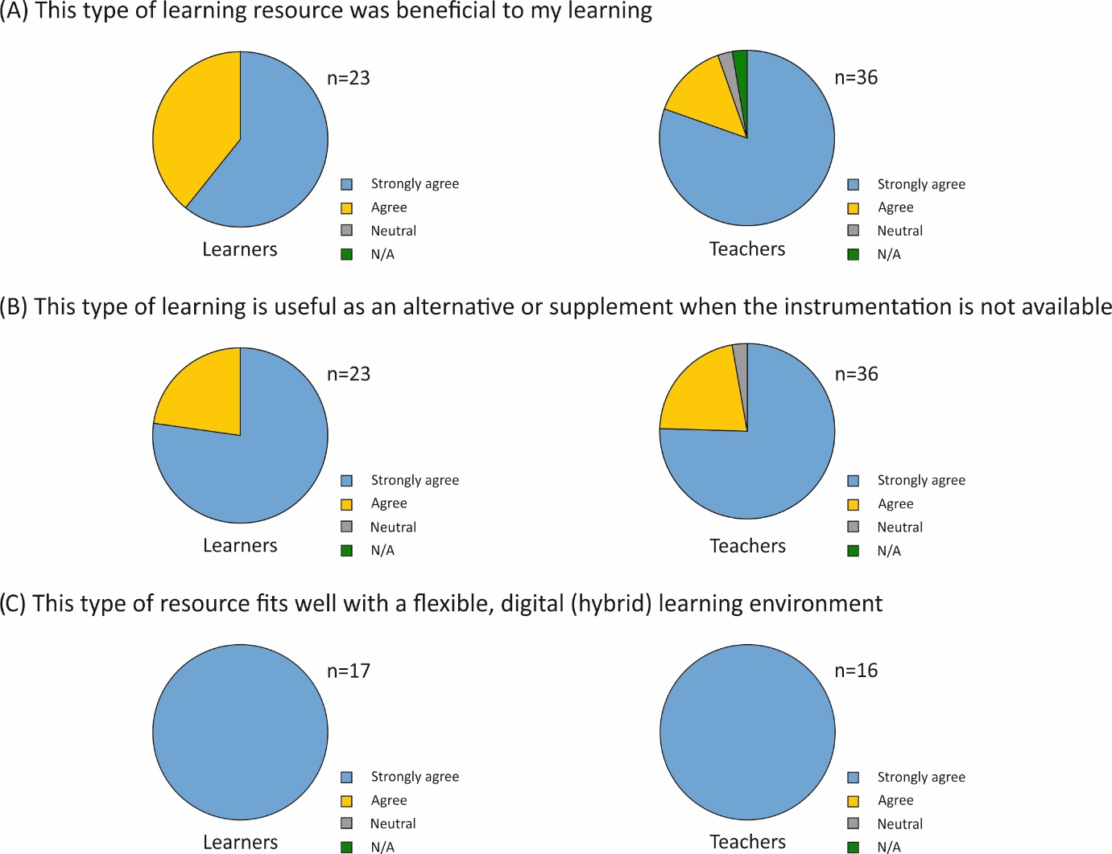
Figure 2: Graphical feedback summaries from staff and student study participants [6,35], measuring agreement of disagreement with given statements (A) This type of learning resource was beneficial to my learning, (B) This type of learning resource is useful as an alternative or supplement when the instrumentation is not available (C) This type of resource fits well with a flexible, digital (hybrid) learning environment.
XR field equipment: Geophysics

Due to COVID-19 lockdown, a 12-week applied geophysics course, funded by a UK Natural Environment Research Council (NERC) grant and accredited by the Geological Society of London could not be delivered face-to-face due to government restrictions. Instead, the course was delivered remotely online. Course attendees included 12 post-graduate taught MSc students, 33 external post-graduate research PhD students, 2 Early Career Researchers and 6 commercial company graduate entry employees. The course was mature as it was running for the fourth time, but this was the first time that it delivered virtually. The course was normally delivered as an intensive week, but this time was structured over 12-weeks to both allow attendees to absorb the various information supplied and for the instructors to generate the necessary resources. The course covered background theoretical geophysical knowledge, geophysical survey design, the commercial tendering, contracts and reporting process, geophysical hardware familiarisation and their respective equipment configurations, geophysical software training and data processing, interpretation and numerical modelling to calibrate geophysical results to give some confidence in geophysical interpretations.

Each week a geophysical technique was covered, which included electro-magnetics, magnetics, Ground Penetrating Radar (GPR), electrical resistivity, seismics, microgravity and surveying methods. The virtual course comprised a combination of asynchronous theory, Microsoft™ Sway presentations and virtual practical pre-recorded content, and synchronous problem-solving virtual sessions. The virtual pre-recorded practicals were recorded either on campus or by commercial colleagues elsewhere. Digital videos were recorded by a stationary 4k video camera with wide-angle lens, and a Bluetooth connected microphone, worn by the presenter, provided direct audio input into the video (Figure 3). A second tripod-mounted digital video camera was also used for close-up equipment shots. Screen capture software was used on the field PC laptop to provide digital videos of the different data being acquired. The collected field geophysical datasets were then made available for download for the synchronous data processing and interpretation learning and teaching session.
The digital videos were edited using Adobe™ Premiere Pro software, allowing static digital images and animated explanatory text to be digitally added. The Thinglink software (www.thinglink.com) was then used to combine these digital resources into a navigable, virtual learning XR resource. This used a summary Microsoft™ PowerPoint slide to provide the framework for virtual resource links to be added as ‘hotspot’ sources, similar to the laboratory instrument Thinglink projects already detailed (Figure 1). The Thinglink resource was also made available as a web-link within Microsoft™ Teams (Figure 4), to provide field resources for the working up of datasets and accompanying worksheets. Microsoft Teams was the software used to run the course, with the Thinglink resource, asynchronous lectures available on Microsoft™ Streams, Microsoft™ Sway background resources, and then the ‘live question and answer and practical sessions. A course web-link is provided for readers to view and utilise the Thinglink digital learning resource in the Supplementary Resources.
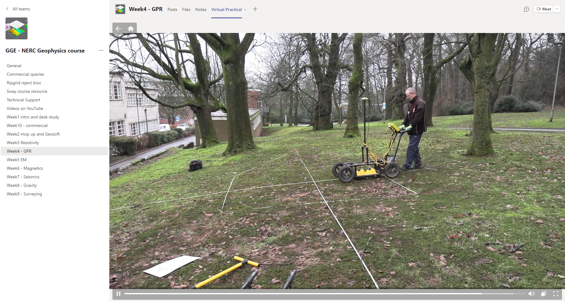
Figure 3: XR virtual practical screenshot of Ground Penetrating Radar (GPR) video walk-through, this stage showing how to collect a GPR 2D profile over a specified study area on campus to locate a near-surface buried object. A web-link is provided for readers to view and utilise this digital learning resource in the Supplementary Resources.
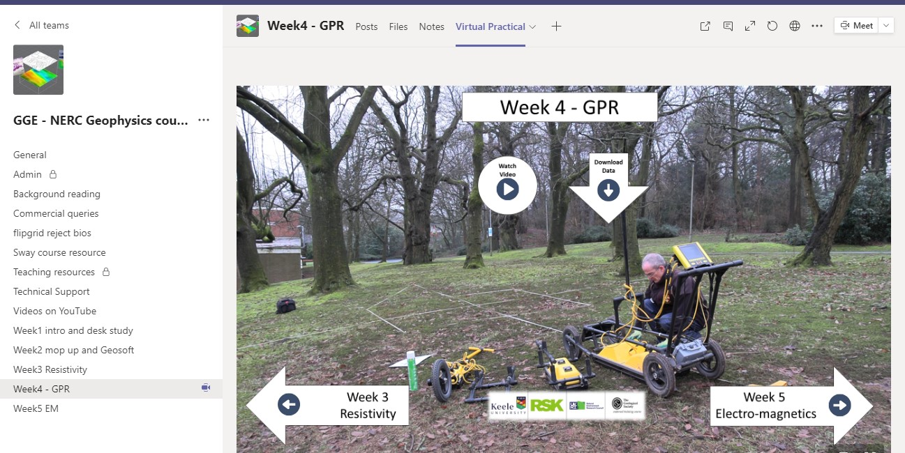
Figure 4: XR virtual practical screenshot summary of the Ground Penetrating Radar (GPR) technique showing field equipment, explanatory digital video link and digital data download that can be processed. A web-link is provided for readers to view and utilise this digital learning resource in the Supplementary Resources.

End-course attendee feedback rated the XR virtual teaching and learning resources highly, with the resources rated at 4.5 out of 5 (n=41). Questionnaire summaries revealed that 97% of learners agreed that the course was useful, and 89% were likely to put their course knowledge gained into practice (Figure 5). Anonymous comments included "the course has strengthened my confidence in handling near surface geophysical tools for exploration" {PGR student}, "the only way the course could be improved would be by offering it in person (which obviously was not possible this year)" {PGR student}. However, one PGR student commented, "I live and study on a remote Orkney island. The broadband bandwidth is very limited and the connection unstable which impacts on smooth running, especially in ‘live’ sessions" and "a written step sheet on use of the current software for each week would be useful to help people follow along who aren't as quick using PCs. Even with 2 monitors I found it hard to keep up with the speed of using the software at times especially during remotely logging in sessions. The saved videos are useful to go back and see the steps" {PGT student}.
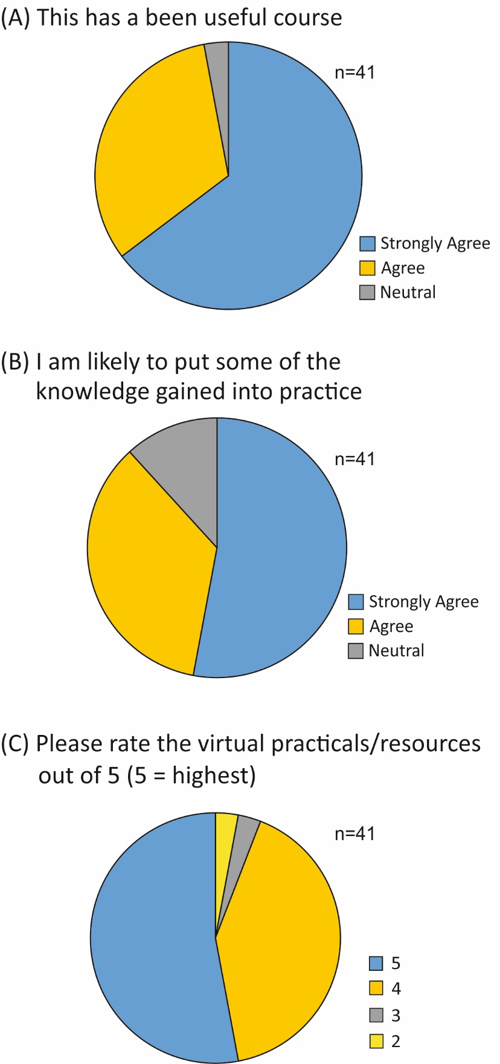
Figure 5: Graphical feedback summaries from course attendees (n=41) of (a) this has been a useful course, (b) I am likely to put some of the knowledge gained into practice and (c) please rate the virtual practicals/resources out of 5 (5 – highest).

Whilst the course was deemed successful by attendees, instructors and NERC the funding body, it was highly intensive for the instructors and technical support team to generate the specified XR virtual learning and teaching resources necessary. Whilst asynchronous pre-recorded lectures and background Microsoft™ Sways were relatively straightforward to generate, the outdoor field equipment and data collection demonstrations had to be repeatedly digitally recorded to optimise image and communication quality, although this became more efficient as experience increased. Course attendees also had issues with successfully remotely accessing specialist geophysical software due to poor internet connectivity, IT hardware and platform issues, or the lack of new software familiarity making it difficult for them to successfully complete tasks synchronously with the rest of the online cohort. To partly solve some of these issues, all synchronous sessions were also recorded to allow attendees to revisit where required, both datasets and explanatory worksheets were also provided, and the technical support team also had a dedicated Microsoft™ Teams channel for course attendees to directly have any issues solved offline. In order to deal with the issue that for some, the software demonstrations were going too fast to follow, one of the teaching team summarised the data processing steps taken via live text in a thread on Microsoft™ Teams so anyone falling behind, or missing a key step, could catch up. These live notes could be used as a basis for a more detailed summary worksheet if the course is repeated in the future. Finally course attendees watching synchronous teaching and learning sessions were advised to watch directly through Microsoft™ Teams rather than the host using the ‘screen share’ option.

XR educational eGame: Forensic Geoscience search

Virtual applied science field courses (VFCs) have been shown to provide direct learning opportunities and indeed bridge formal and informal learning, without the associated logistical challenges and risks involved in running real-world field courses [36-38]. The use of VFCs has grown dramatically out of necessity during the various waves of COVID-19 lockdowns that have prevented fieldwork being undertaken in many HE institutions globally in the last two years [39,40]. Non-educational science-based games have been created for public entertainment; for example, the US-based Crime Scene Investigation (CSI) TV series had on-line eGames developed, allowing the user to progress through various scenarios to become a criminal detective [41]. Whilst potentially useful and engaging, the primary focus of science educational eGames should be to encourage student understanding and learning, but still have a degree of engagement and entertainment [29,42].
This project focused on developing a XR forensic geoscience educational eGame loosely based on a closed forensic UK search case that the authors undertook (see [43] for case background). The XR eGame itself was generated by specialist computer programmers and graphical designers using the Unity™ gaming engine (https://unity.com/). Study site desk study resources were extracted from EDINA Digimap and incorporated into the eGame, a site visit captured contemporary photographs, graphic animators physically inspected and digitally reproduced the forensic geophysical equipment hardware used in such searches, and authors gave their experience of what typical sequential search techniques are utilised at the different search stages. Pringle and colleagues [42] detail the full digital resources required to generate an educational eGame, with a short digital video clip provided, as well as a web-link to the educational egame, which allows readers to view and utilise this digital learning resource in the Supplementary Resources.
The XR educational eGame was formalised into the four stages of a forensic terrestrial search (see [44] for forensic search best practice) of: (1) desk study to gain background case and site information (Figure 6a); (2) staged site investigation including reconnaissance (Figure 6b) and (3) full site surveys (Figure 6c) and finally; (4) excavation of prioritised suspected burial positions identified from the full site surveys (Figure 6d).
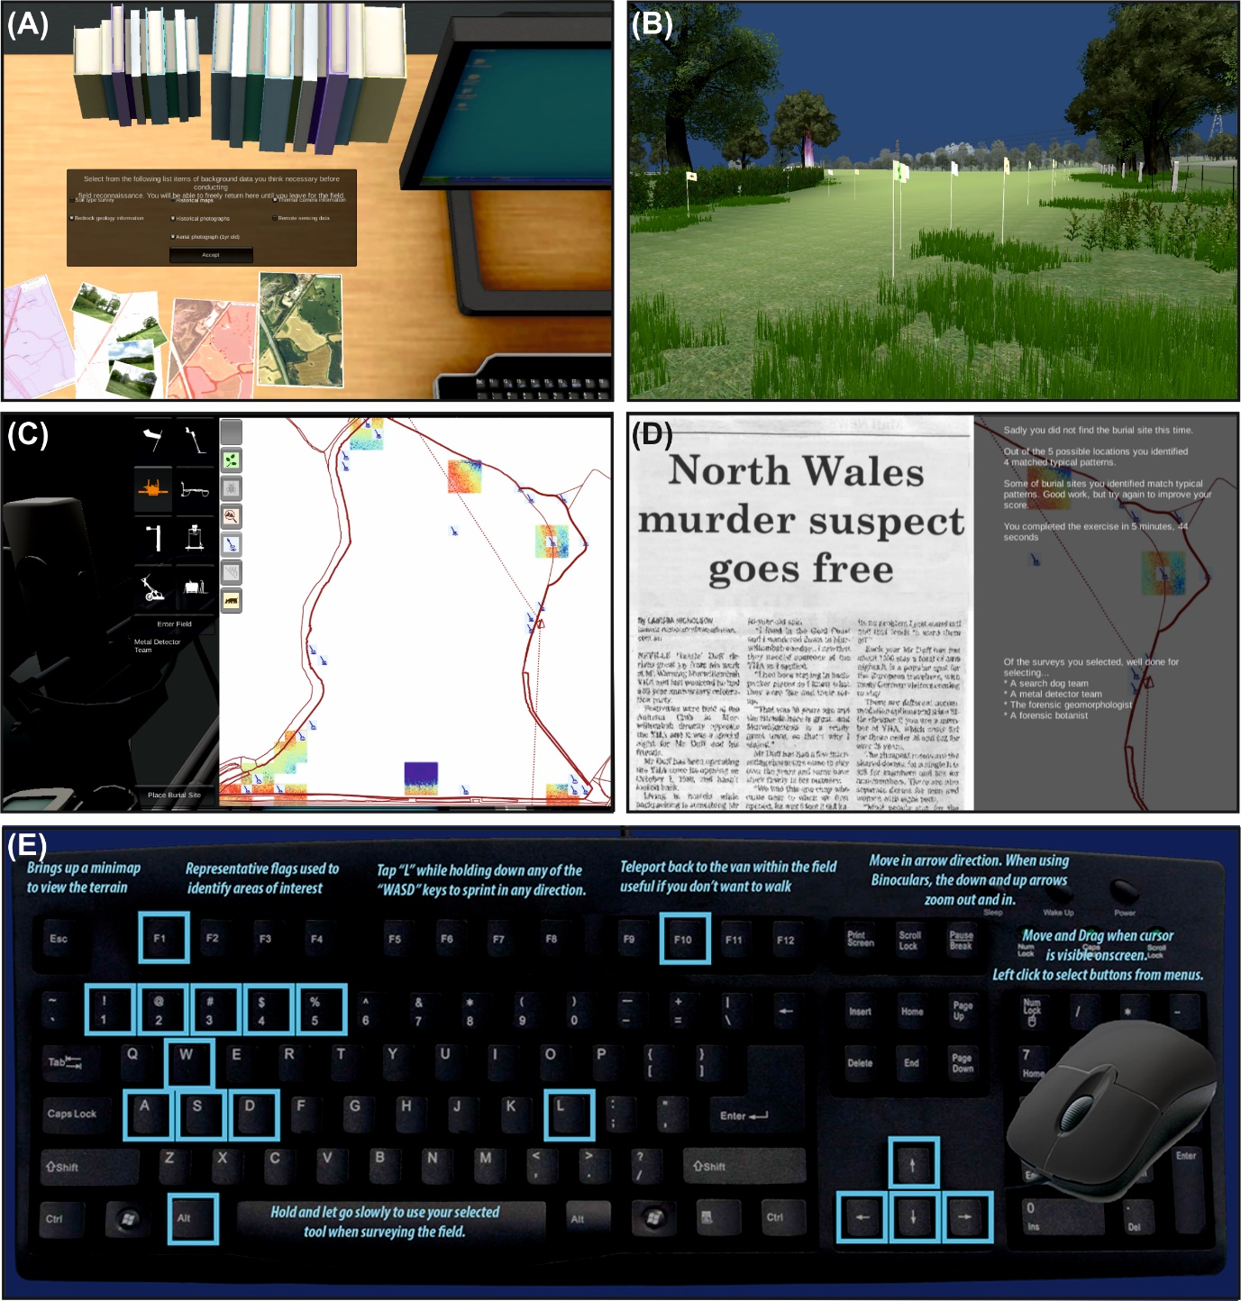Figure 6: XR educational eGame: screenshots showing (a) stage 1 initial desk study data , (b) initial reconnaissance stage 2 showing suspected positions (flags) and ‘teleport’ position (glowing area), (c) full site survey stage 3 with user viewing bulk ground conductivity data (coloured squares) and metal detector results (icons), with left bar allowing user to choose next equipment to be trialled, (d) eGame shot completion with text giving feedback, the alternative finish is a ‘Murderer sentenced’ newspaper headline and, (e) keyboard and mouse eGame navigation. A short digital video clip walk-through of the eGame is provided and a web-link is provided for readers to view and utilise this digital learning resource in the Supplementary Resources.

An Action Research (AR) project was undertaken involving 41 undergraduate and 20 postgraduate forensic, environmental and earth science students from a UK HE setting. These students used the eGame as formative assessment in their respective studies, which is more fully described in [42]. Ten HE relevant academic staff varying from Teaching Fellows to Readers also took part. The pre-intervention questionnaire findings showed 75% of undergraduates and 50% of post-graduate students were at least weekly gamers. As would be expected staff were the most experienced at the eGame search task followed by the postgraduate then undergraduate students. The pre-intervention questionnaire interestingly found that the undergraduate cohort self-rated their search knowledge highest of all cohorts (95%), perhaps an optimistic assessment of their abilities and being used to success in gaming environments. One undergraduate student commented that they found it novel that they could get the answer wrong. The end-project questionnaire revealed that 95% of undergraduates (n=41), 90% of post-graduate research students (n=20) and 80% of staff (n=10) highly rated the eGame, averaging 4 out of 5 (Figure 7), with undergraduates having a 32% rise in self-rating their search knowledge after having played the eGame with this being statistically significant (p=0) [42]. Participants’ anonymous questionnaire comments showed they enjoyed the eGame and found it fun, that it aided their understanding, showed how searches are conducted, was realistic, practical, good for revision and training [42]. Anonymous undergraduate student comments included: “I think it’s a good tool to use, [it] really helped develop my understanding to what sort of results I should expect in the field” and “useful as get chance to use all equipment in a real-life application, which can be revisited multiple times” although one commented “just a game, not really representative” [42]. Postgraduate students’ anonymous comments included: “great way to bring together different data sets and synthesize data to reach a conclusion” and “really good, makes you think about what techniques work best. Much easier when you play again. I used different techniques on the second go” [42]. Whilst eight staff enjoyed and engaged with the XR eGame, two staff did not, being unfamiliar with eGaming which would be an issue with users not being technologically adept.
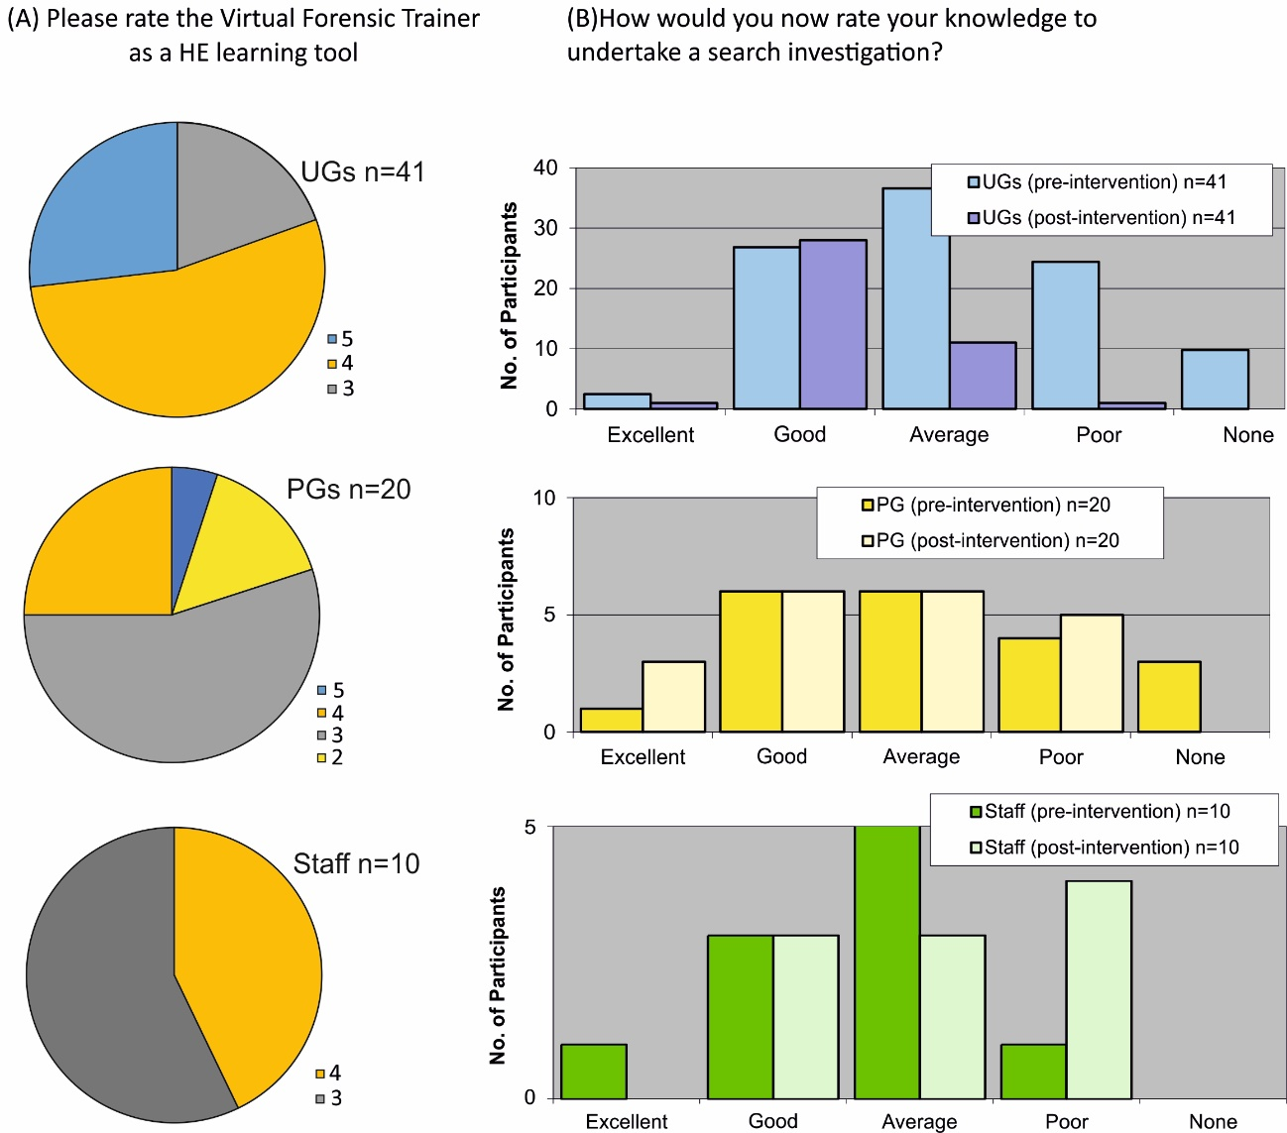
Figure 7. Graphical summary of XR educational eGame (see [40]) participating cohorts (A) rating the eGame as a HE learner tool (5 = highest) and (b) self-rating knowledge of how to undertake a search investigation.
Some interesting unintended learning outcomes included some student participants commenting that “remote sensing – I never got that until I played the game”, with another participant stating “I hated it yeah. I’m a girl. Girls don’t like games”, which was balanced out by her female peer who commented she was a “serious gamer” [42]. Another unexpected outcome was most participants’ wish to virtually move faster within the eGame virtual environment than the eGame allowed, this was thought better to be realistic rather than replicating commercial games, although a reward ‘badge’ system was thought to be beneficial to ensure user engagement which did replicate commercial games. Other researchers have used a similar approach, for example for geological mapping [44], although others have allowed a far larger amount of user movement such as the ability for their avatars to fly/teleportation etc [45]. There were contrasting participant suggestions and little agreement with having educational eGames as formative assessment; some suggested that XR educational eGames should be assessed to ensure engagement whilst others were worried peers may struggle with the technology and hence would be unfairly penalised if gaining a poor mark. Other participant suggestions were to run an additional laboratory practical to complement existing teaching module resources.

Discussion

The effectiveness of XR virtual learning environments for teaching and learning in forensic science has been demonstrated in this paper. The Thinglink-generated XR virtual learning environments had very positive responses from both fellow teachers and learners, with a high quality, easy access and consistent learning experience providing examples of good practice. Users commented positively on the freedom that the resources gave them to access them when and how it suited them and highlighted their potential power to enhance accessibility and inclusivity, two themes recognised as vital for technology-based learning [45] and protected by the United Kingdom’s Special Educational Needs and Disability Act (2001) [29] and the Equality Act (2010) [30]. The Thinglink platform is also very user-friendly and accessible to generate such resources, so that colleagues could easily adopt it for their own XR virtual teaching and learning environments. These XR virtual environments are significant in forensic science, where undergraduate courses are often comprised of laboratory-based work, indoor and outdoor crime scenes, and larger scale fieldwork, often in woodland or more remote locations. Thinglink has the potential to enhance learning in each of these three areas. Longer term these types of XR virtual environment resources can be utilised as complementary learning styles to the face-to-face and hybridised teaching styles that will hopefully become the norm in HEIs, with these resources acting as preparatory material, or to assist those who perhaps missed scheduled laboratory or field practicals, or for those with disabilities [4], mental health issues [5] or indeed caring responsibilities [7]. The XR virtual resources provide alternative asynchronous formats for learning, but they do not replace fieldwork learning. Online resources such as these also allow the student to repeat the exercise several times, which is not always possible when working at outdoor scenes or dealing with a strict teaching timetable. This promotes student learning, encouraging them to revisit a “scene” and approach it from a different angle, which could result in different outcomes.

The XR eGame interactive virtual learning resource was highly rated by users, although there were differences according to user(s) previous search experiences as already detailed, as similar studies have found (see [23,46]). The XR eGame gives a consistent and highly detailed reliable experience, not subject to adverse outdoor weather conditions, teaching staff and field equipment availability, expense and time of travelling to a field site, etc. (see [28,43, 44]). The XR eGame engaged the participating student cohort’s learning and teaching experience, the latter demonstrated by participants’ improvements in self-rating their forensic search knowledge after the eGame compared to beforehand. Interestingly, with more experienced users (i.e., the participating staff and postgraduate research students), the XR eGame was thought to be less effective as a learning tool, with students using it to refine their existing search skills rather than expanding their skillset. Half of the student study participants were daily or weekly game users and therefore eGaming has great potential as an as yet relatively untapped educational tool.

There are challenges to XR virtual learning and teaching environments being an effective learning tool for all users, however, with some learners struggling with technology, while some studies show this type of technology can be a greater challenge to more mature learners [47], those with poor internet connections, those who may be susceptible to motion sickness, or some individuals being physically incapable of using a PC screen for long periods of time [48]. However, caution should be given to suggestions that XR eGaming should be rolled out to all cohorts and formally assessed; a minority of participants were not comfortable with eGaming, did not enjoy the experience or struggled with the technology as well as potentially suffering from motion sickness as [48] evidenced. Table 1 summarises some key XR virtual learning environments for forensic science learning and teaching advantages and disadvantages.

Teaching and learning tool | Intended learning outcomes | Requirements | Advantages | Disadvantages
XR laboratory virtual equipment | Users gain technical knowledge and understanding of key techniques and instrumentation, including background theory, instrument use, data collection and data processing | Thinglink licence and familiarity with associated image creation/video manipulation software. | Consistent, repeatable XR learning environment.  Overcomes large practical class sizes, and inclusivity issues. Once created, resources are easy to adapt and update, as required. | Significant time investment required to create and update resources. Internet connection generally required for users.
XR field equipment | Technical knowledge, understanding of common geophysical surveying methods,  experience of tendering, survey design, data acquisition/processing, modelling and visualisation. | Asynchronous theory lectures and practicals with resultant data  Synchronous practical virtual sessions  Familiarity with Microsoft products, Thinglink, and video/audio recording equipment. | Consistent, repeatable XR learning environment.  Awareness & understanding of methods, equipment and data processing not otherwise available. | 100h to generate resources & deliver  Poor internet connectivity for ‘live’ sessions.  Attendees multi-tasking watching deliverer and undertaking tasks.  Specialist software access issues.
XR educational eGame | User(s) visualise search site, become familiar with sequential search strategies, including desk study, reconnaissance, full site surveys and target selection. | Digital data for desk study.  Digital land surface of search area generated.  Site photographs  XR virtual environment.  XR virtual geophysical equipment. | Most user(s) familiar with eGaming.  Consistent, repeatable XR learning environment.  Overcomes large practical class sizes, and inclusivity issues. | 109h to generate by site visit, instructor and programmers' time.  Issues with user(s) grasping not set answer.
Table 1. Overview of XR virtual learning environments for teaching and learning in forensic science given in this study.

Whilst this paper very much advocates the positive use of XR virtual learning environments for learning and teaching in forensic geoscience to create inclusive, accessible and engaging digital learning environments, the authors do not suggest that such activities should be planned for use in isolation or as a replacement of field or laboratory work. These XR resources are an efficient tool for scaffolding student learning in both the laboratory and in the field. XR resources can be used to cut down on the time required to teach certain techniques and methods, but XR does not replace the authentic use of physical equipment and the skills required to competently use them. The XR devices and environments highlighted in this paper have been embedded within a Campus Living Laboratory [2], students can access and engage with the XR materials both before and after authentic engagement with labs and field work, helping them to reflect and consolidate their learning. The digital nature of these learning and teaching XR tools also allow students to access them as many times as they need, in a flexible manner.

Further research is planned to continue to explore such XR virtual learning environments for teaching and learning in forensic geoscience, with its effectiveness, rather than user(s) simply rating them, needing to be more scientifically evaluated within a pedagogic research framework. Virtual world design is becoming easier, particularly for non-specialists, using platforms such as Unity or Unreal (e.g. see [49]). Developing such resources into standalone applications that can be downloaded onto portable devices would be the obvious progression of the XR eGame.

Conclusions

Extended reality (XR) environments have the potential for very effective learning and teaching in forensic science, which can be complementary to more traditional learning and teaching lectures, practicals and field methods. They are particularly effective as they are available 24/7, can be used asynchronously and repeatedly interrogated to reinforce learning, and users can explore different strategies without the time-consuming nature of physical fieldwork and practical classes which can be affected by inclement weather conditions, equipment availability or failure and variable teaching delivery.
However, XR virtual learning environments are time consuming to generate and, with the educational eGame in particular, need significant computer programming and user-experience design expertise, scientific input and time spent developing, evaluating and refining the product. For those learners with poor internet connections or computer skills, who have disability impairments or do not engage well with online learning, then these types of extended reality environments would prove challenging, which should be recognised if these materials are to be used for formal assessment.
Future work will no doubt progress such XR learning environments into the mainstream media offerings, such as standalone downloadable ‘apps’ for users’ portable devices, and other researchers will continue to produce and update other extended reality learning environments.

Acknowledgements
Karl Reid, Tom Pardoe and David Ledsam are thanked for computer programming and graphical design of the eGame.

Funding source
The National Environmental Research Council (NERC) are thanked for providing funding for the co-authors to deliver an Advanced Training Course that the Thinglink field equipment case study is showcasing. Keele University and the UK Higher Education Academy are thanked for providing small-project grants to fund the educational eGame development. Keele University are also acknowledged for providing funding from a Teaching Innovation Project Scheme for the educational eGame pedagogic study.

References
[1] J.K. Pringle, N.J. Cassidy, P. Styles, I.G. Stimpson, S.M. Toon, Training the next generation of near-surface geophysicists: team-based student-led, problem-solving field exercises, Cumbria, UK, Near Surface Geophysics, 8 (2010) 503-517.
[2] S.L. Rogers, A.J. Jeffery, A.C. Law, A. Nobojas, J.K. Pringle, K. Szkornik, A.C. Turner, L. Hobson, The University Campus as a Learning Environment: the role of a campus based Living Lab in a blended learning environment, Geoscience Communication, In review. https://doi.org/10.5194/gc-2021-32
[3] T.J.U. Thompson, A.J. Collings, H. Earwaker, G. Horsman, S. Nakhaeizadeh, U. Parekh, Forensic science education during and after the COVID-19 imposed lockdown: strategies and reflections from India and the UK, Forensic Science International 316 (2020) 110500.
[4] A. Stokes, A.D. Feig, C.L. Atchison, B. Gilley, Making geoscience fieldwork inclusive and accessible to students with disabilities, Geosphere 15 (2019) 1809-1825. https://doi.org/10.1130/GES02006.1
[5] S. Giles, C. Jackson, N. Stephen, Barriers to fieldwork in undergraduate geoscience degrees. Nature Reviews Earth & Environment 1 (2020) 77–78. https://doi.org/10.1038/s43017-020-0022-5
[6] A.J. Jeffery, S.L. Rogers, K.L.A. Jeffery, L. Hobson, A flexible, open, and interactive digital platform to support online and blended experiential learning environments: Thinglink and thin sections, Geoscience Communication 4 (2021) 95-110. https://doi.org/10.5194/gc-4-95-2021
[7] L. Kettell, Young adult carers in higher education: the motivations, barriers and challenges involved – a UK study, Journal of Further and Higher Education 44 (2020) 100-112. https://doi.org/10.1080/0309877X.2018.1515427
[8] Joint Information Systems Committee (JISC), Researchers of Tomorrow: the research behaviour of Generation Y doctoral students, Available from: http://www.jisc.ac.uk/media/documents/publications/reports/2012/researchers-of-tomorrow.pdf [Accessed 07/12/2016], 85pp., 2012.
[9] J. Sternberg, ‘It’s the end of the university as we know it (and I feel fine)’: the Generation Y student in HE discourse, Higher Education Research & Development 31 (2012) 571-583.
[10] R. Barrantes, Analysis of ICT demand: what is digital poverty and how to measure it? Digital Poverty: Latin American and Caribbean Perspectives, pp. 29-53, 2007.
[11] T.J. Wilson, A.M.C. Gallop, Criminal justice, science and the marketplace: the closure of the Forensic Science Service in perspective, Journal of Criminal Law 77 (2013) 56-77 https://doi.org/10.1350/jcla.2013.77.1.818
[12] A. Gallop, J. Brown, The market future for Forensic Sciences Services in England and Wales, Policing 8 (2014) 254-264. https://doi.org/10.1093/police/pau021
[13] House of Lords Science & Technology Select Committee, Forensic science and the criminal justice system: a blueprint for change, 2019. Available online: https://publications.parliament.uk/pa/ld201719/ldselect/ldsctech/333/333.pdf Last Accessed: 15/01/2022
[14] M. Chowdhury, A broken system? Examining the perilous state of quality assurance in crime scene practice, Science & Justice, 61 (2021) 564-572.
[15] M. Airlie, J. Robertson, M.N. Krosch, E. Brooks, Contemporary issues in forensic science – worldwide survey results, Forensic Science International 320 (2021) 110704. https://doi.org/10.1016/j.forsciint.2021.110704
[16] A. Biedermann, T. Hicks, R. Voisard, F. Taroni, C. Champod, C.G.G. Aitken, I.W. Evett, E-learning initiatives in forensic interpretation: report on experiences from current projects and outlook, Forensic Science International 230 (2013) 2-7. https://doi.org/10.1016/j.forsciint.2012.10.011
[17] T. Sieberth, D. Seckiner, A. Dobay, E. Dobler, R. Golomingi, L. Ebert. The forensic holodesk – recommendations after 8 years of experience for additional equipment to document VR applications, Forensic Science International, 329 (2021) 111092. https://doi.org/10.1016/j.forsciint.2021.111092
[18] M. Ma, H. Zheng, H. Lallie, Virtual reality and 3D animation in forensic visualization, Journal of Forensic Sciences, 55 (2010) 1227-1231.
[19] G.J. Edelman, M.C. Alders, Photogrammetry using visible, infrared, hyperspectral and thermal imaging of crime scenes. Forensic Science International 292 (2018) 181-189.
[20] J. Wang, Z. Li, W. Hu, Y. Shao, L. Wang, R. Wu, K. Ma, D. Zou, Y Chen, Virtual reality and integrated crime scene scanning for immersive and heterogeneous crime scene reconstruction, Forensic Science International 303 (2019) 109943. http://dx.doi.org/10.1016/j.forsciint.2019.109943
[21] N. Kader, W.B. Ng, S.W.L. Tan, F.M. Fung, Building an interactive immersive virtual reality crime scene for future chemists to learn forensic science chemistry, Journal of Chemical Education 97 (2020) 2651-2656.
[22] R. Mayne, H. Green, Virtual reality for teaching and learning in crime scene investigation, Science & Justice 60 (2020) 466-472.
[23] U. Karabiyik, C. Mousas, D. Sirota, T. Iwai, M. Akdere, A virtual reality framework for training incident first responders and digital forensic investigators, in: G. Bebis, R. Boyle, B. Parvin, D. Koracin, D. Ushizima, S. Chai, S. Sueda, X. Lin, A. Lu, D. Thalmann, C. Wang, P. Xu (Eds.), Advances in Visual Computing, Springer International Publishing, Cham, 2019, pp. 469–480.
[24] E. Kolla, V. Adamova, P. Verta, Simulation-based reconstruction of traffic incidents from moving vehicle mono-camera, Science & Justice, 2021 https://doi.org/10.1016/j.scijus.2021.11.001
[25] M. Crowther, S. Reidy, J. Walker, M. Islam, T. Thompson, Application of non-contact scanning to forensic podiatry: A feasibility study. Science & Justice 61 (2021) 79-88.
[26] L.M. Camine, V. Varlet, L. Campana, S. Grabherr, N. Moghaddam, The big puzzle: a critical review of virtual re-association methods for fragmented human remains in a DVI context’, Forensic Science International (2021) 111033. https://doi.org/10.1016/j.forsciint.2021.111033
[27] S. Greengard, Virtual Reality, MIT Press Essential Knowledge Series, 237p, 2019.
[28] O.R. Normark, D. Cetindamar, E-learning in a competitive firm setting, Innovations in Education & Teaching International 42 (2005) 325–335.
[29] J.K. Pringle, Educational egaming: the future for geoscience virtual learners? Geology Today, 30 (2014) 145-148.
[30] Special Educational Needs and Disability Act, available at https://www.legislation.gov.uk/ukpga/2001/10/contents (last access 18 November 2021), 2001.
[31] Equality Act, available at: https://www.legislation.gov.uk/ukpga/2010/15/contents (last access: 18 November 2021), 2010.
[32] P. Appasamy, Fostering student engagement with digital microscopic images using ThingLink, an image annotation program, Journal of College Science Teaching 47 (2018) 16-21.
[33] K. Nakatsuka, Making history come to life: ThingLink virtual museums, Social Studies Review 57 (2018/19) 47–52.
[34] E.M.L. Scerri, D. Kühnert, J. Blinkhorn, H.S. Groucutt, P. Roberts, K. Nicoll, A. Zerboni, E.A. Orijemie, H. Barton, I. Candy, S.T. Goldstein, J. Hawks, K. Niang, D. N’Dah, M.D. Petraglia, N.C. Vella, Field-based sciences must transform in response to COVID-19, Nature Ecology & Evolution 4 (2020) 1571-1574.
[35] A.J. Jeffery, S.L. Rogers, V. Zholobenko, K.L.A. Jeffery, J.K. Pringle, K.D. Wisniewski, Thinglink and the laboratory: interactive simulations of analytical instruments for HE science curricula, Journal of Chemical Education In review).
[36] J. Stainfield, P. Fisher, B. Ford, M. Solem, International virtual field trips: a new direction? Journal of Geography in Higher Education 24 (2000) 255-262.
[37] J.K. Pringle, Virtual Geology Special Issue: developing training, teaching and research skillsets for geoscientists, Geology Today 31 (2015) 213-215.
[38] J. Sriarunrasmee, P. Suwannatthachote, P. Dachakupt, Virtual Field Trips with inquiry learning and critical thinking process: a learning model to enhance students’ science learning outcomes, Procedia – Social & Behavioural Sciences 197 (2015), 1721-1726.
[39] S.J. Whitmeyer, M. Dordevic, Creating virtual geologic mapping exercised in a changing world, Geosphere 17 (2021) 226-243. https://doi.org/10.1130/GES02308.1
[40] M.S. Marshall, M.C. Higley, Multi-scale virtual field experience: sedimentology and stratigraphy of Grand Ledge, Michigan, USA, Geoscience Communications, 4 (2021) 461-474. https://doi.org/10.5194/gc-4-461-2021
[41] CSI: web adventures. Available online at: https://csi.webadventures.games/ Last accessed: 15/01/2022
[42] J.K. Pringle, L. Bracegirdle, J. Potter, Educational forensic e-gaming as effective learning environments for HE students. In: Williams, A., Cassella, J.P. & Maskell, P.D. (eds.); Forensic Science Education & Training, Wiley Press, 2017. ISBN: 978-1-118-68923-3.
[43] J.K. Pringle, J.R. Jervis, Electrical resistivity survey to search for a recent clandestine burial of a homicide victim, UK, Forensic Science International, 202 (2010) e1-e7.
[44] J.K. Pringle, A. Ruffell, J.R. Jervis, L. Donnelly, J. McKinley, J. Hansen, R. Morgan, D. Pirrie, M. Harrison, The use of geoscience methods for terrestrial forensic searches, Earth Science Reviews 114 (2012) 108-123.
[43] J.J. Houghton, G.E. Lloyd, A. Robinson, C.E. Gordon, D.J. Morgan, The Virtual Worlds project: geological mapping and field skills, Geology Today 31 (2015) 227-231.
[44] T. Argles, S. Minocha, D. Burden, Virtual field teaching has evolved: the benefits of a 3D gaming environment, Geology Today 31 (2015) 222-226.
[45] N. Selwyn, The use of computer technology in university teaching and learning: a critical perspective, Journal of Computer Assisted Learning 23 (2003) 83–94.
[46] K. Squire, Video game-based learning: an emerging paradigm for instruction, Performance Improvement Quarterly 21 (2008) 7-36.
[47] G. Nimrod, Technophobia among older Internet users, Educational Gerontology 44 (2018) 148-162.
[48] S. Weech, S. Kenny, M. Barnett-Cowan, Presence and cybersickness in virtual reality are negatively related: a review, Frontiers in Psychology 10 (2019) 158, https://doi.org/10.3389/fpsyg.2019.00158
[49] S.L. Rogers, Cheap, accessible, and virtual experiences as tools for immersive study: a proof of concept study, Research in Learning Technology, 28 (2020). https://doi.org/10.25304/rlt.v28.2416

Supplementary Material: https://doi.org/10.21252/4rtz-8639
The virtual equipment resources can be accessed through a mainstream internet browser via web-links for the XRF laboratory equipment here: https://www.thinglink.com/card/1368531711838650369 and the geophysics field equipment here: https://www.thinglink.com/videocard/1413542942487871491. The educational egame can be accessed through a mainstream internet browser via this web-link: www.keelesop.co.uk/csinorthwales/.

