Synthesis of thiazolidin-4-one derivatives as novel TDP1 inhibitors
Dmitry I. Ivankinª, Nadezhda S. Dyrkheeva^{b}, Alexandra L. Zakharenko^{b}, Ekaterina S. Ilina^{b}, Timofey O. Zarkov^{b}, Jóhannes Reynisson^{c}, Olga A. Luzinaª, Konstantin P. Volchoª, Nariman F. Salakhutdinovª and Olga I. Lavrik^{b}
ª N.N. Vorozhtsov Novosibirsk Institute of Organic Chemistry, Siberian Branch of the Russian Academy of Science, 9, Akademika Lavrentieva Ave., 630090, Novosibirsk, Russia
^{b} Institute of Chemical Biology and Fundamental Medicine, Siberian Branch of the Russian Academy of Science, 8, Akademika Lavrentieva Ave., 630090, Novosibirsk, Russia
^{c} School of Pharmacy and Bioengineering, Keele University, Hornbeam Building, Staffordshire ST5 5BG, UK
* Correspondence: volcho@nioch.nsc.ru
Abstract
Tyrosyl-DNA phosphodiesterase 1(TDP1) is a promising target for a new therapy in oncological disease as an adjunct to topoisomerase 1 (TOP1) drugs. In this paper, novel thiazolidin-4-one derivatives with a benzyl and monoterpene substituents were synthesized. Compounds with a monoterpene fragment attached via a phenyloxy linker were active against TDP1 with IC₅₀ values in the 1÷3 μM range, while direct attachment of monoterpene moiety to the thiazolidin-4-one fragment had no activity. Molecular modelling predicted two plausible binding modes of the active compounds both effectively blocking access to the catalytic site of TDP. At non-toxic concentrations the active ligands potentiated the efficacy of the TOP1 poison topotecan in human cervical cancer HeLa cells, but not in non-cancerous HEK293A cells.
Keywords: Tyrosyl-DNA phosphodiesterase 1, TDP1 inhibitors, thiazolidin-4-ones, monoterpenic derivatives

Inhibition of DNA repair enzymes is a viable strategy to fight drug-resistant tumors. Enzymes which inhibitors are already in clinical use, or in clinical trials, include PARP (poly(ADP-ribose)polymerases) [1], ATM (аtaxia telangiectasia mutated) and ATR (ataxia telangiectasia and Rad3-related protein) kinases, DNA-PKcs (DNA-dependent protein kinase, catalytic subunit) [2]. Inhibitors of a number of other DNA repair enzymes undergoing preclinical trials include, ligases I, III and IV, ERCC1–XPF, MRN complex proteins and others [2–4].
Tyrosyl-DNA phosphodiesterase 1 (TDP1) is a promising target to develop new oncological therapy based on small molecules; this enzyme removes various covalent adducts from the 3’-end of DNA [5]. The camptothecin derivatives in clinical use, topotecan and irinotecan, stabilize covalent complexes of topoisomerase 1 (TOP1) with DNA, leading to the accumulation of DNA damage and eventual death of the cancer cells [6]. TDP1 neutralizes the effect of these drugs, which is one of the reasons for tumors’ resistance to chemotherapy [6]. Thus, suppression of TDP1 activity could increase the efficacy of topotecan and irinotecan.
Thiazolidine derivatives have a wide range of biological activity such as anti-viral, anti-tumor, anti-ulcer, and anti-inflammatory effects [7–9]. Interestingly, there is little known about TDP1 inhibitory activity of thiazolidines except for compound 1 (Fig. 1) [10] and some usnic acid derivatives (compounds 2-4, Fig. 1) [11,12]. Of these, thiazoles with two substituents (compounds 2 and 3) showed the best activity in the double-digit nanomolar region. In addition, the presence of a monoterpene moiety results in improved activity (compound 3, IC₅₀ 16 nM) [10,11]. Finally, monoterpenoids are often used as starting material for the synthesis of potent TDP1 inhibitors [13–17].
Fig. 1. The molecular structures of known monoterpenoid- and aromatic- derived TDP1 inhibitors.
Thiazolidin-4-one is a member of the thiazole family and is considered as a pharmacophore in numerous anti-tumor compounds [18,19]; but thiazolidin-4-one was never used as a central scaffold for TDP1 inhibitors.
The aim of this work was to synthesize disubstituted thiazolidin-4-ones with monoterpenoid substituents at the second position and benzyl moiety at the third position (Fig. 2) to determine their TDP1 inhibiting activity and ability to enhance of topotecan antitumor potency.
Fig. 2. The design of novel TDP1 inhibitors.
At first, monoterpene bromides 7a-e (Scheme 1), required as starting material, were obtained from their corresponding alcohols using PBr₃ in Et₂O for 7a-d [13,20–22] or NBS and PPh₃ in DCM for 7e [23]. Alcohols 6c and 6d were obtained from commercially available aldehydes using NaBH₄ in EtOH as a reducing agent [15,17,18].
Scheme 1. Synthesis of bromides 7a-e.
Bromide 7f was synthesized from (+)-α-pinene 8. First, we obtained (-)-campholenic aldehyde 10. For this, (+)-α-pinene 8 was oxidized to (+)-α-pinene epoxide 9, which was then converted to aldehyde 10 by the action of ZnCl₂ followed by ring opening [26,27]. Then, aldehyde 10 was converted to alcohol 6f using NaBH₄ in EtOH [25]. Final synthesis of bromide 7f was carried out using NBS and PPh₃ in DCM [17] (Scheme 2).
Scheme 2. Synthesis of (-)-campholenic bromide 7f.
Aldehydes 5a and 5e (Scheme 3) were obtained by oxidation of 3,7-dimethyloctanol 6a with PCC [28] and (-)-nopol 6e with DMP, respectively [29].
Scheme 3. Synthesis of aldehydes 5a and 5d.
Substituted benzaldehyde derivatives 12a-f were obtained by reaction between monoterpene bromides 7a-f and p-hydroxybenzaldehyde 11 (Scheme 4).
Scheme 4. Synthesis of p-substituted aldehydes 12a-f.
2,3-Disubstituted thiazolidin-4-ones 15a-g and 16a,c-f,h were produced by one pot condensation between benzylamine 13, thioglycolic acid 14, and aldehydes 12a-g or 5a,c-f, 5h, respectively. Compound 16e was made using DCC as a cyclizing reagent (Scheme 5). Compounds 15a-g, 16a,c-f were obtained as a mixture of diastereomers; separation or preparation of individual stereoisomers was not carried out due to cost and would be done only for substances with substantial biological activity.
Scheme 5. Synthesis of the desired thiazolidin-4-ones 15a-g, 16a-f, and 16h.
NMR spectra of 15a-f do not have signal characteristics of pairs of diastereomers, apparently due to the asymmetric centers being separated by some distance. However, 16a, 16c-f have NMR spectra showing a mixture of diastereomers in approximately equal proportions (see Supplementary).
Then, we investigated the inhibiting activity of the synthesized compounds against TDP1 using a real-time oligonucleotide biosensor assay [30]. Human recombinant TDP1 was used as an enzyme and a 16-mer single-stranded oligonucleotide containing both a 5’-FAM (Fluorescein) fluorophore donor and a quenching 3’-BHQ1 (Black Hole Quencher 1) acceptor was used as a biosensor for in vitro screening. The results are presented in Table 1.

Table 1. TDP1 inhibitory activities and cytotoxicity of the thiazolidin-4-ones.
 | Structure | TDP1 IC₅₀, μM | HeLa  CC₅₀, μM | HEK293A  CC₅₀, μM
15a |  | 1.2±0.1 | 66±15 | >100
15b |  | 2.9±0.6 | >100 | >100
15c |  | >100 | nd* | nd*
15d |  | 1.6±0.4 | 74±25 | 51±14
15e |  | 2.1±0.4 | >100 | >100
15f |  | 1.2±0.2 | 79±13 | 90±22
15g |  | >100 | nd* | nd*
16a |  | >100 | nd* | nd*
16b |  | >100 | nd* | nd*
16d |  | >100 | nd* | nd*
16e |  | >100 | nd* | nd*
16f |  | >100 | nd* | nd*
16h |  | >100 | nd* | nd*
Furamidine |  | 1.2±0.3 | nd* | nd*
*not determined

Analysis of the data shows that the presence of monoterpenic moieties attached to the thiazolidin-4-one core via aromatic linker is a key factor resulting in activity; compounds with a monoterpene fragment attached by a phenyloxy linker were mostly active with IC₅₀ in the 1÷3 μM range. Surprisingly, compound 15c with a citronellol moiety was inactive, while both its analogues, 15a,b had good activity. Replacement of the monoterpenyloxy fragment by a methoxy group (15g), or even hydrogen (16h), resulted in inactivity. In addition, removal of the aromatic linker at the second position of the thiazolidin-4-one core 16a-h led to inactive derivatives. This means that a monoterpenic fragments and the phenyloxy linker are vital for this design approach.
The cytotoxicity of the inhibitors was tested, this is important because TDP1 inhibition is proposed to be an adjunct therapy thus the ligands ought to have no, or minimal, toxic footprint. Human cervical cancer (HeLa) and non-cancerous HEK293A cells were used and the compounds were slightly toxic, or non-toxic, to both cell lines (Table 1).
The effect of the TDP1 inhibitors on the cytotoxic potential of topotecan, a TOP1 inhibitor widely used in the clinic [6] was investigated using the same cell lines as before. With regard to the HeLa cells, all the compounds in non-toxic concentrations led to an increase in the cytotoxicity, i.e., they sensitize tumor cells to topotecan’s action (Fig. 3, left). As for the non-cancerous HEK293A cells no sensitization was observed. Furthermore there was some degree of protection for the cells from the action of topotecan for compounds 15d,e,f.
Fig. 3. The influence of the TDP1 inhibitors (at 10 µM) on topotecan (Tpc) cytotoxicity in HeLa (left) and HEK293A (right) cell lines.
To confirm the drug potentiation in HeLa cells, we calculated the combination index (CI) values [31] for combinations of 5 µM topotecan in conjunction with 5 or 20 µM for the TDP1 inhibitors. All the obtained values are less than one, which indicates a synergistic interaction of drugs (Table 2).

Table 2. Combination index (CI) values for topotecan and thiazolidin-4-one derivatives combinations
Compound | CI at 5 µM | CI at 20 µM
15a | 0.51 | 0.29
15b | nd* | 0.13
15d | nd* | 0.21
15e | 0.32 | 0.21
15f | 0.25 | 0.16
*not determined

The thirteen thiazolidin-4-one derivatives shown in Table 1 are either enantiomers or diastereomers. Six have two chiral centers (15a, 15c, 15f, 16a, 16b and 16e) and seven have one (15b, 15d, 15e, 15g, 16h, 16c and 16d) resulting in 38 distinct chemical structures. The chiral center on the thiazolidin-4-one ring was given the first specification for the diastereomers for either R (rectus) or S (sinister) followed by the center on the aliphatic chain. The classical rules of Cahn, Ingold and Prelog were used for all the designations (see e.g. Morrison and Boyd, Organic Chemistry, 6th Edition, 1992, pages 140 – 148, A Simon and Schuster Company, Englewood Cliffs, New Jersey, USA). All of the enantiomers and diastereomers were docked into the binding site of TDP1 (PDB ID: 6W7K, resolution 1.70 Å) [32]. The scoring functions GoldScore (GS) [33], ChemScore (CS) [34,35], ChemPLP (Piecewise Linear Potential) [36] and ASP (Astex Statistical Potential) [37] in the GOLD (v2020.2.0) docking algorithm were used; the robustness of the docking scaffold has been previously established [11]. Furthermore, the GOLD docking algorithm is reported to be an excellent molecular modelling tool [38,39]. The binding scores are given in Table S1 (see Supplementary); very similar scores are predicted between the enantiomers and diastereomers. Furthermore, the smaller ligands of the 16 series, as well as the 15g and 16h, which do not have terpene moieties, have lower scores than their larger counterparts in the 15 series. All the active derivatives have good scores as well as 15c, which interestingly is inactivite.
When the predicted configurations of the ligands were analysed two main binding modes appeared for the 15 series, excluding 15g and 16h; e.g., for ligand 15fRS these two binding modes are shown in Fig. 4; as can be seen both configurations occupy the catalytic pocket and fit well into the binding site of the enzyme. The terpene fragment is either placed in a lipophilic groove close to the allosteric site (Fig. 4A) or into a cleft (Fig. 4B). In many cases for the configuration shown in Fig. 4A the terpene fragment is placed deeper in the groove further away from the allosteric site. The phenyl ring is either placed in the cleft (Fig. 4A) or in a shallow pocket on the side of the binding site (Fig. 4B). The configuration depicted in Fig. 4A and 4C is predicted to have one hydrogen bonding with the side chain of Asn283 via the carbonyl group in the thiazolidin-4-one ring. Interestingly, no hydrogen bonding interaction were predicted for the binding mode shown in Fig. 4B and 4D, however a lone pair - π bond is predicted between the backbone carbonyl moiety of Pro461 and the phenyl ring.
An allosteric binding site was suggested based on molecular dynamics simulations next to the catalytic site as shown in Fig. 4A [40]. Further evidence for this allosteric binding site was found in a combined molecular modelling and structurally activity relationship study of usnic acid derivatives [11]. The modelling of the derivatives presented here did not show any special affinity for this allosteric pocket.
Derivative 15c, which has activity > 100 μM, did not display different binding modes than the other active 15 series members so its lack of efficacy cannot be explained in term of its binding modes to TDP1.
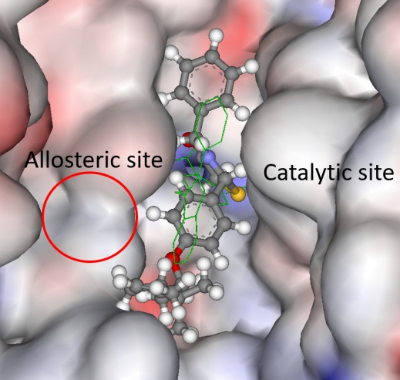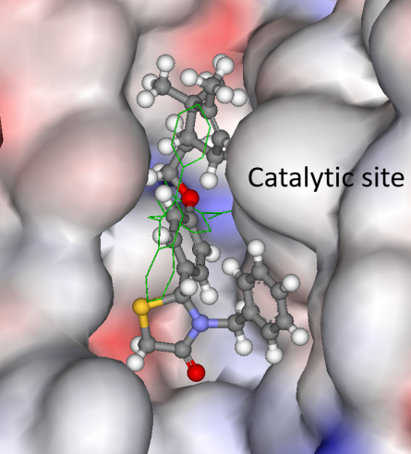
A B
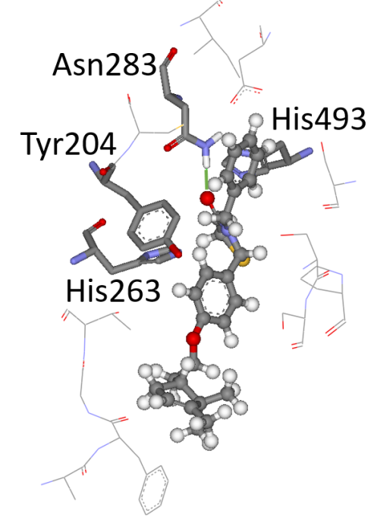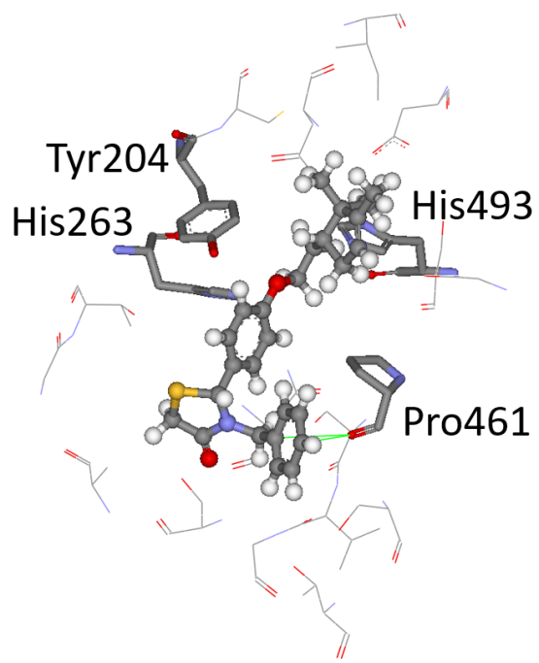
C D
Fig. 4. The docked pose of 15fRS in the catalytic site of TDP1; the ligand is shown in the ball-and-stick format. (A and B) The co-crystallised ligand is depicted as green lines. The protein surface is rendered; blue depicts regions with a partial positive charge on the surface; red depicts regions with a partial negative charge and grey shows neutral areas. (A) The predicted configuration using the ChemPLP scoring function and (B) by the ASP scoring function. (C and D) The catalytic amino acid residues His263 and His493 are shown as sticks as well as the Tyr204 making up the allosteric binding pocket. The adjacent amino acids (< 6 Å), buttressing the ligand, are shown as lines. The hydrogens on the amino acids are not shown for clarity. (C) Hydrogen bonding (green line - 1.7 Å) is predicted between the carbonyl group in the thiazolidine-4-one ring and the side chain of Asn283. (D) The phenyl ring forms a lone pair - π bond (green lines ~3.5 Å) with the backbone carbonyl moiety of Pro461.
The calculated molecular descriptors MW (molecular weight), log P (water-octanol partition coefficient), HD (hydrogen bond donors), HA (hydrogen bond acceptors), PSA (polar surface area) and RB (rotatable bonds) are given in Table S2 (see Supplementary). The values of the molecular descriptors lie within lead-like chemical space for HD and PSA; drug-like for HA. In the case for RB, MW they span both lead- and drug-like spaces and finally the Log P values are in lead-, drug and Known Drug Spaces (KDS) (for the definition of lead-like, drug-like and KDS regions see ref. [41] and Table S3 (see Supplementary)). The enantiomers and diastereomers have the same values for all the molecular descriptors except for Log P and PSA, which are structure dependent. All the descriptors for the inactive derivatives of series 16, plus 15g and 16h, have lower values than the active compounds in series 15. It is not possible to explain the lack of activity for 15c based on its physicochemical properties, as they are practically the same as for the active compounds in series 15.
JR: Either move to Supplementary or simply delete
The Known Drug Indexes (KDIs) for the ligands were calculated to gauge the balance of the molecular descriptors (MW, log P, HD, HA, PSA and RB). This method is based on the analysis of drugs in clinical use, i.e., the statistical distribution of each descriptor is fitted to a Gaussian function and normalized to 1 resulting in a weighted index. Both the summation of the indexes (KDI_{2a}) and multiplication (KDI_{2b}) methods were used [42] as shown for KDI_{2a} in Equation 1 and for KDI_{2b} in Equation 2; the numerical results are given in Table S2.
KDI_{2a} = I_{MW} + I_{log P} + I_{HD}+ I_{HA} + I_{RB} + I_{PSA} (1)
KDI_{2b} = I_{MW} × I_{log P} × I_{HD}× I_{HA} × I_{RB} × I_{PSA} (2)
The KDI_{2a} values for the ligands range from 3.63 to 4.90 with a theoretical maximum of 6 and the average of 4.08 (±1.27) for known drugs. The KDI_{2b} range is from 0.03 to 0.27, with a theoretical maximum of 1 and with KDS average of 0.18 (±0.20). Larger KDI_{2a/2b} values are associated with better bioavailability [42]. The KDIs for the 15 series (excluding 15g and 16h) are considerably lower than for the 16 series. This can mainly be explained in terms of the high Log P values of these ligands being >5 and therefore in KDS.
A group of disubstituted thiazolidin-4-ones with monoterpenoid and benzyl substituents was synthesized. Some of the compounds were active against TDP1 at low micromolar concentrations. It is established that an aromatic linker between the thiazolidin-4-one central scaffold and the terpene fragment is required for activity for this class of ligands as shown by the monoterpenyloxy fragment replacement by a methoxy group or hydrogen. The structure of the monoterpenyl fragment (bicyclic, monocyclic, and linear) does have minimal influence on the inhibitory activity, except of compound 15c, which was inactive. Two main binding modes were predicted for the active derivatives effectively blocking access to the catalytic pocket. The compounds are slightly toxic, or non-toxic, to cancerous HeLa and non-cancerous HEK293A cell lines and at non-toxic concentrations increased the cytotoxicity of topotecan in a dose-dependent manner. In sum, both experimental and in silico results support the proposed mechanism of action for the novel disubstituted thiazolidin-4-ones.
Funding: The research was supported by the Russian Scientific Foundation (grant 19-13-00040).
Data Availability Statement: The data presented in this study are available on request from the corresponding author.
Acknowledgements: Authors would like to acknowledge the Multi-Access Chemical Research Center SB RAS for spectral and analytical measurements.
Conflict of Interest: there are no conflicts to declare.
Abbreviations
DCC – N,N’-Dicyclohexylcarbodiimide
DCM – Dichloromethane
DMP – Dess-Martin periodinane
IBX – 2-Iodoxybenzoic acid
NBS – N-Bromosuccinimide
PCC – Pyridinium chlorochromate
TDP1 – Tyrosyl-DNA-phosphodiesterase 1

References
1. Curtin, N.J.; Szabo, C. Molecular Aspects of Medicine Therapeutic applications of PARP inhibitors : Anticancer therapy and beyond. J. Mol. Asp. Med. 2013, 44, doi:10.1016/j.mam.2013.01.006.
2. Prakash, A.; Garcia-Moreno, J.F.; Brown, J.A.L.; Bourke, E. Clinically applicable inhibitors impacting genome stability. Molecules 2018, 23, 1–66, doi:10.3390/molecules23051166.
3. Matsumoto, Y. Development and Evolution of DNA-Dependent Protein Kinase Inhibitors toward Cancer Therapy. Mol. Sci. 2022, 23, 1–24.
4. Alemi, F.; Malakoti, F.; Vaghari-Tabari, M.; Soleimanpour, J.; Shabestani, N.; Sadigh, A.R.; Khelghati, N.; Asemi, Z.; Ahmadi, Y.; Yousefi, B. DNA damage response signaling pathways as important targets for combination therapy and chemotherapy sensitization in osteosarcoma. J. Cell. Physiol. 2022, 1–13, doi:10.1002/jcp.30721.
5. Comeaux, E.Q.; Van Waardenburg, R.C.A.M. Tyrosyl-DNA phosphodiesterase I resolves both naturally and chemically induced DNA adducts and its potential as a therapeutic target. Drug Metab. Rev. 2014, 46, 494–507, doi:10.3109/03602532.2014.971957.
6. Pommier, Y.; Huang, S. yin N.; Gao, R.; Das, B.B.; Murai, J.; Marchand, C. Tyrosyl-DNA-phosphodiesterases (TDP1 and TDP2). DNA Repair (Amst). 2014, 19, 114–129, doi:10.1016/j.dnarep.2014.03.020.
7. Jain, A.; Vaidya, A.; Ravichandran, V.; Kashaw, S.; Agrawal, R. Recent developments and biological activities of thiazolidinone derivatives: a review. Bioorganic Med. Chem. 2012, 20, 3378–3395, doi:10.1016/j.bmc.2012.03.069.
8. Kaur, S.; Kaur, R.; Bhatia, R.; Kumar, K.; Singh, V.; Shankar, R.; Kaur, R.; Rawal, R. Synthetic and medicinal perspective of thiazolidinones : a review. Bioorg. Chem. 2017, 75, 406–423, doi:10.1016/j.bioorg.2017.10.014.
9. Borisova, M.S.; Ivankin, D.I.; Sokolov, D.N.; Luzina, O.A.; Rybalova, T. V.; Tolstikova, T.G.; Salakhutdinov, N.F. Synthesis, antiulcerative, and anti-inflammatory activities of new campholenic derivatives-1,3-thiazolidin-4-ones, 1,3-thiazolidine-2,4-diones, and 1,3-thiazinan-4-ones. Chem. Pap. 2021, 75, 5503–5514, doi:10.1007/s11696-021-01741-5.
10. Sirivolu, V.R.; Vernekar, S.K. V.; Marchand, C.; Naumova, A.; Chergui, A.; Renaud, A.; Stephen, A.G.; Chen, F.; Sham, Y.Y.; Pommier, Y.; et al. 5-Arylidenethioxothiazolidinones as Inhibitors of Tyrosyl-DNA Phosphodiesterase i. J. Med. Chem. 2012, 55, 8671–8684, doi:10.1021/jm3008773.
11. Dyrkheeva, N.S.; Filimonov, A.S.; Luzina, O.A.; Orlova, K.A.; Chernyshova, I.A.; Kornienko, T.E.; Malakhova, A.A.; Medvedev, S.P.; Zakharenko, A.L.; Ilina, E.S.; et al. New hybrid compounds combining fragments of usnic acid and thioether are inhibitors of human enzymes TDP1, TDP2 and PARP1. Int. J. Mol. Sci. 2021, 22, doi:10.3390/ijms222111336.
12. Dyrkheeva, N.S.; Filimonov, A.S.; Luzina, O.A.; Zakharenko, A.L.; Ilina, E.S.; Malakhova, A.A.; Medvedev, S.P.; Reynisson, J.; Volcho, K.P.; Zakian, S.M.; et al. New hybrid compounds combining fragments of usnic acid and monoterpenoids for effective tyrosyl-dna phosphodiesterase 1 inhibition. Biomolecules 2021, 11, 1–23, doi:10.3390/biom11070973.
13. Khomenko, T.M.; Zakharenko, A.L.; Chepanova, A.A.; Ilina, E.S.; Zakharova, O.D.; Kaledin, V.I.; Nikolin, V.P.; Popova, N.A.; Korchagina, D. V.; Reynisson, J.; et al. Promising new inhibitors of tyrosyl-DNA phosphodiesterase I (Tdp 1) combining 4- arylcoumarin and monoterpenoid moieties as components of complex antitumor therapy. Int. J. Mol. Sci. 2020, 21, doi:10.3390/ijms21010126.
14. Luzina, O.; Filimonov, A.; Zakharenko, A.; Chepanova, A.; Zakharova, O.; Ilina, E.; Dyrkheeva, N.; Likhatskaya, G.; Salakhutdinov, N.; Lavrik, O. Usnic Acid Conjugates with Monoterpenoids as Potent Tyrosyl-DNA Phosphodiesterase 1 Inhibitors. J. Nat. Prod. 2020, 83, 2320–2329, doi:10.1021/acs.jnatprod.9b01089.
15. Munkuev, A.A.; Mozhaitsev, E.S.; Chepanova, A.A.; Suslov, E. V.; Korchagina, D. V.; Zakharova, O.D.; Ilina, E.S.; Dyrkheeva, N.S.; Zakharenko, A.L.; Reynisson, J.; et al. Novel tdp1 inhibitors based on adamantane connected with monoterpene moieties via heterocyclic fragments. Molecules 2021, 26, 1–23, doi:10.3390/molecules26113128.
16. Il, I. V; Dyrkheeva, N.S.; Zakharenko, A.L.; Sidorenko, A.Y.; Li-zhulanov, N.S.; Korchagina, D. V; Chand, R.; Ayine-tora, D.M.; Chepanova, A.A.; Zakharova, O.D.; et al. Design, Synthesis, and Biological Investigation of Novel Classes of 3-Carene-Derived Potent Inhibitors of TDP1. 2020, 25, 1–22.
17. Munkuev, A.A.; Dyrkheeva, N.S.; Kornienko, T.E.; Ilina, E.S.; Ivankin, D.I.; Suslov, E. V; Korchagina, D. V; Gatilov, Y. V; Zakharenko, A.L.; Malakhova, A.A.; et al. Adamantane-Monoterpenoid Conjugates Linked via Heterocyclic Linkers Enhance the Cytotoxic Effect of Topotecan. 2022.
18. Gawrońska-Grzywacz, M.; Popiołek, Ł.; Natorska-Chomicka, D.; Piatkowska-CHMIEL, I.; Izdebska, M.; Herbet, M.; Iwan, M.; Korga, A.; Dudka, J.; Wujec, M. Novel 2,3-disubstituted 1,3-thiazolidin-4-one derivatives as potential antitumor agents in renal cell adenocarcinoma. Oncol. Rep. 2019, 41, 693–701, doi:10.3892/or.2018.6800.
19. Suthar, S.K.; Jaiswal, V.; Lohan, S.; Bansal, S.; Chaudhary, A.; Tiwari, A.; Alex, A.T.; Joseph, A. Novel quinolone substituted thiazolidin-4-ones as anti-inflammatory, anticancer agents: Design, synthesis and biological screening. Eur. J. Med. Chem. 2013, 63, 589–602, doi:10.1016/j.ejmech.2013.03.011.
20. Suslov, E. V.; Mozhaytsev, E.S.; Korchagina, D. V.; Bormotov, N.I.; Yarovaya, O.I.; Volcho, K.P.; Serova, O.A.; Agafonov, A.P.; Maksyutov, R.A.; Shishkina, L.N.; et al. New chemical agents based on adamantane-monoterpene conjugates against orthopoxvirus infections. RSC Med. Chem. 2020, 11, 1185–1195, doi:10.1039/d0md00108b.
21. Hanessian, S.; Cooke, N.G.; DeHoff, B.; Sakito, Y. The Total Synthesis of (+)-Ionomycin. J. Am. Chem. Soc. 1990, 112, 5276–5290, doi:10.1021/ja00169a041.
22. Odinokov, V.N.; Yakovleva, M.P.; Sultanov, R.M.; Serebryakov, E.P.; Dzhemilev, U.M.; Tolstikov, G.A.; Branch, U. Insect pheromones and their analogues. Chem. Nat. Compd. 1992, 27, 500–502, doi:10.1007/BF00636582.
23. Akgun, B.; Hall, D. Supporting information. Fast and tight boronate formation for click bioorthogonal conjugation. Angew. Chemie 1–160.
24. Guerrero, A.; Ramos, V.E.; López, S.; Alvarez, J.M.; Domínguez, A.; Coca-Abia, M.M.; Bosch, M.P.; Quero, C. Enantioselective Synthesis and Activity of All Diastereoisomers of (E)-Phytal, a Pheromone Component of the Moroccan Locust, Dociostaurus maroccanus. J. Agric. Food Chem. 2019, 67, 72–80, doi:10.1021/acs.jafc.8b06346.
25. Srikrishna, A.; Gowri, V.; Neetu, G. Enantioselective syntheses of diquinane and (cis, anti, cis)-linear triquinanes. Tetrahedron Asymmetry 2010, 21, 202–207, doi:10.1016/j.tetasy.2010.01.014.
26. Lopez, L.; Mele, G.; Fiandanese, V.; Cardellicchio, C.; Nacci, A. Aminium salts catalyzed rearrangement of a=pinene and p-ionone oxides. Tetrahedron Lett. 1994, 50, 9097–9106.
27. Chapuis, C.; Brauchli, R. Preparation of Campholenal Analogues: Chirons for the lipophilic moiety of sandalwood‐like odorant alcohols. Helv. Chim. Acta 1992, 75, 1527–1546, doi:10.1002/hlca.19920750507.
28. V. N. Odinokov, G. Yu. Ishmuratov, R. Ya. Kharisov, S.I.L.& G.A.T. Synthesis of ethyl 3,7,11-trimethyl-2,4-dodecadienoate (hydroprene) from 4-methyltetrahydropyran. Bull. Acad. Sci. USSR Div. Chem. Sci. 1989, 38, 1768–1770.
29. Evgenii Mozhaitsev, Evgenii Suslov*, Yuliya Demidova, Dina Korchagina, Konstantin Volcho, Alexandra Zakharenko, Inna Vasil’eva, Maksim Kupryushkin, Arina Chepanova, Daniel Moscoh Ayine-Tora, Jóhannes Reynisson, N.S. and O.L. The Development of Tyrosyl-DNA Phosphodyesterase 1 (TDP1) Inhibitors Based on the Amines Combining Aromatic/Heteroaromatic and Monoterpenoid Moieties. Lett. Drug Des. Discov. 2019, 16, 597–605, doi:10.2174/1570180816666181220121042.
30. Zakharenko, A.; Khomenko, T.; Zhukova, S.; Koval, O.; Zakharova, O.; Anarbaev, R.; Lebedeva, N.; Korchagina, D.; Komarova, N.; Vasiliev, V.; et al. Synthesis and biological evaluation of novel tyrosyl-DNA phosphodiesterase 1 inhibitors with a benzopentathiepine moiety. Bioorganic Med. Chem. 2015, 23, 2044–2052, doi:10.1016/j.bmc.2015.03.020.
31. Huang, R.Y.; Pei, L.; Liu, Q.; Chen, S.; Dou, H.; Shu, G.; Yuan, Z.X.; Lin, J.; Peng, G.; Zhang, W.; et al. Isobologram analysis: A comprehensive review of methodology and current research. Front. Pharmacol. 2019, 10, 1–12, doi:10.3389/fphar.2019.01222.
32. Zhao, X.Z.; Kiselev, E.; Lountos, G.T.; Wang, W.; Tropea, J.E.; Needle, D.; Hilimire, T.A.; Schneekloth, J.S.; Waugh, D.S.; Pommier, Y.; et al. Small molecule microarray identifies inhibitors of tyrosyl-DNA phosphodiesterase 1 that simultaneously access the catalytic pocket and two substrate binding sites. Chem. Sci. 2021, 12, 3876–3884, doi:10.1039/d0sc05411a.
33. Gereth Jones, Peter Willett, Robert C. Glen, Andrew R. Leach, and R.T. Development and Validation of a Genetic Algorithm for Flexible Docking. J. Mol. Biol. 1997, 267, 727–748.
34. Eldridge, M.D.; Murray, C.W.; Auton, T.R.; Paolini, G. V.; Mee, R.P. Empirical scoring functions: I. The development of a fast empirical scoring function to estimate the binding affinity of ligands in receptor complexes. J. Comput. Aided. Mol. Des. 1997, 11, 425–445, doi:10.1023/A:1007996124545.
35. Verdonk, M.L.; Cole, J.C.; Hartshorn, M.J.; Murray, C.W.; Taylor, R.D. Improved Protein–Ligand Docking Using GOLD Marcel. Proteins 2003, 52, 609–623.
36. Korb, O.; Stützle, T.; Exner, T.E. Empirical scoring functions for advanced Protein-Ligand docking with PLANTS. J. Chem. Inf. Model. 2009, 49, 84–96, doi:10.1021/ci800298z.
37. Mooij, W.T.M.; Verdonk, M.L. General and targeted statistical potentials for protein-ligand interactions. Proteins Struct. Funct. Genet. 2005, 61, 272–287, doi:10.1002/prot.20588.
38. Wang, Z.; Sun, H.; Yao, X.; Li, D.; Xu, L.; Li, Y.; Tian, S.; Hou, T. Comprehensive evaluation of ten docking programs on a diverse set of protein-ligand complexes: The prediction accuracy of sampling power and scoring power. Phys. Chem. Chem. Phys. 2016, 18, 12964–12975, doi:10.1039/c6cp01555g.
39. Bissantz, C.; Folkers, G.; Rognan, D. Protein-based virtual screening of chemical databases. 1. Evaluation of different docking/scoring combinations. J. Med. Chem. 2000, 43, 4759–4767, doi:10.1021/jm001044l.
40. Zakharenko, A.; Luzina, O.; Koval, O.; Nilov, D.; Gushchina, I.; Dyrkheeva, N.; Švedas, V.; Salakhutdinov, N.; Lavrik, O. Tyrosyl-DNA Phosphodiesterase 1 Inhibitors: Usnic Acid Enamines Enhance the Cytotoxic Effect of Camptothecin. J. Nat. Prod. 2016, 79, 2961–2967, doi:10.1021/acs.jnatprod.6b00979.
41. Zhu, F.; Logan, G.; Reynisson, J. Wine compounds as a source for HTS screening collections. A feasibility study. Mol. Inform. 2012, 31, 847–855, doi:10.1002/minf.201200103.
42. Eurtivong, C.; Reynisson, J. The Development of a Weighted Index to Optimise Compound Libraries for High Throughput Screening. Mol. Inform. 2019, 38, doi:10.1002/minf.201800068.

