Geophysical and intrusive site investigations to detect an abandoned coal-mine access shaft, Apedale, Staffordshire, UK

Banham, S.^{1,2} & Pringle, J.K.^{1*}

¹School of Physical Sciences & Geography, William Smith Building, Keele University, Keele, Staffs., ST5 5BG, UK.
²now at School of Earth & Environment, University of Leeds, Leeds, West Yorks., LS2 9JT, UK.

*correspondent email: j.k.pringle@esci.keele.ac.uk

Keywords: electrical resistivity imaging, micro-gravity, GPR, mine shaft

Text: 5,737 words. 13 Figures. 1 Table

Running head: geophysical and intrusive investigations to detect a mineshaft

Abstract

Derelict coalmine workings at Apedale in Staffordshire, United Kingdom were the focus for a multi-disciplinary geophysical and intrusive site investigation. Objectives were to: 1) locate the surface entrance to a coal-mine access shaft; 2) determine the inclined shaft’s changing depth below present ground level; 3) determine if it was open,, partly or fully filled; 4) locate it beneath a known shaft if (1) was unsuccessful and finally; 5) compare geophysical mine shaft detection techniques in difficult ground conditions.

After initial site reconnaissance, desktop study and modelling, field work collected surface micro-gravity and Electrical Resistivity Imaging 2D profiles to locate the shaft and entrance area. The made-ground nature of the site made identification of clear geophysical anomalies challenging. Subsequent intrusive investigations to locate the entrance were unsuccessful. A second phase of fieldwork down a known mine shaft imaged three geophysical anomalies beneath this shaft floor; after comparison with modelled data, subsequent intrusive investigations of the ERI anomaly successfully located the target shaft. Collapsed material was progressively cleared to the surface and a new shaft entrance stabilised.

Surface micro-gravity 2D profiles surprisingly did not produce clear target anomalies, likely to be due to the target depth below ground level and the variety of above-ground, relict mine structures present. Surface ERI 2D profiles were less affected by above-ground structures, but investigated anomalies were found to be heterogeneous ground materials. Comparisons of 2D micro-gravity, ERI and GPR profiles collected within a mine shaft showed ERI data were optimal. 2D micro-gravity and ERI modelling was shown to aid geophysical interpretations.
Introduction

The detection and characterisation of near-surface voids and relict mine shafts by geophysical methods have been successfully demonstrated by many authors (e.g. McCann et al. 1987; Branston & Styles 2003; Wilkinson et al. 2005; Chambers et al. 2007; Pringle et al. 2008). The detection of small distributed voids and low-density ground has also been recently proven to be possible using near-surface geophysics (Tuckwell et al. 2008). Geophysical methods can be implemented rapidly, covering a significant survey area in a relatively short time frame, compared to the traditional test-pits and boreholes commonly used during geotechnical investigations.

Electrical Resistivity Imaging (ERI) surveys are used to measure electrical properties of a volume of material to produce a 2D section of electrical resistivities (see e.g. Reynolds 1997). This method has been successfully previously employed to detect mineshafts and voids in restricted areas (see Antonio-Carpio et al. 2004; Wilkinson et al. 2005; Cardarelli et al. 2006; Chambers et al. 2007). Benefits of this method, compared to magnetic techniques, are reduced sensitivity to both above-ground surface objects and subsurface heterogeneities. Micro-gravity surveys have also been employed to locate and characterise near-surface voids and even low density ground (see Branston & Styles, 2003; Pringle et al. 2008; Tuckwell et al. 2008). Micro-gravity and ERI datasets can be validated to model data to allow the void size and depth below ground level (bgl) to be estimated. Ground Penetrating Radar (GPR) surveys have been successfully employed to detect and characterise a variety of near-surface objects, including pavement voids (Nichol & Reynolds 2001), cleared building foundations and cellars (Grandjean et al. 2000; Pringle et al. 2009) and relict mine workings (Ruffell et al. 2003; Pringle et al. 2008). GPR targets can be detected either directly by observing anomalies below survey lines or indirectly due to object ‘sideswipe’ affects on nearby datasets (see Pringle et al. 2008).

This paper describes a multi-phase, near-surface geophysical and intrusive site investigation at Apedale, Staffordshire, UK (Fig. 1). British Geological Survey (BGS) and mine records indicated that the site was situated on the south-dipping, Carboniferous (Silesian)-aged, Upper Coal Measures within the Potteries Syncline (Fig. 2). Historically the area had been extensively coal mined by (1) initial drift, (2) pillar and stall and lastly (3) open-cast methods due to the coal outcropping and dipping at 45º+, before the site was landscaped into its present country park status. Coal seams exploited at the site included the Great Row, Spencroft, Peacock, Bassey, Chalkey, and Cannel Row seams (Fig. 2d). Commercial mining continued on a small scale after 1969 until finally ceasing in 1996 with local landscaping removing most of both the above-ground infrastructure and filling in mine access shafts, plus adding an unknown thickness of made-ground materials on top to form the present ground level (Fig. 3).

Since 1996, part of the site was reopened as a tourist mining museum, using both relict machinery and old No. 3 and No. 4 mine access shafts to give underground mine tours (Fig. 3). The charitable trust running the mining museum approached Keele University to detect the No. 7 mine access shaft. The trust primarily needed to access the shaft as mining records indicated the mine shaft lay at a shallow level beneath the museum building and therefore needed to be reinforced to satisfy the insurers. A secondary reason was to re-open part of the old workings to extract coal on a charitable basis (Fig. 4). Due to their limited resources, conventional geotechnical site investigation approaches using drilling or trial pitting were not economically viable. It was suggested that a non-invasive geophysical investigation could be conducted instead to locate the target mine shaft before any invasive investigation occurred to reduce the incurred cost to the charity.

Project aims were therefore to: (1) identify the surface entrance to the target coal-mine access shaft; 2) determine it’s changing depth below present ground level; 3) determine if the shaft was open, partly or fully filled; 4) locate it beneath the known open No. 4 shaft if (1) was unsuccessful and finally; 5) compare near-surface geophysical detection techniques in difficult ground conditions.

Methodology

A multi-phase field work approach was used during this study. Phase one undertook an initial site reconnaissance to assess the suitability for near-surface geophysical investigations. A desk-study sourced available historical and mine records to assess both the likely position of the target mine access shaft beneath the survey area and its collapsed entrance. Simple 2D forward modelling suggested the likely mine images of surface geophysical surveys. Phase two collected trial geophysical ERI and micro-gravity surface surveys on the surface to determine if the target shaft could be detected and potentially locate the collapsed entrance area. Phase three then undertook intrusive site investigations to locate the target mine entrance. Phase four acquired further geophysical ERI, micro-gravity and GPR data sets down an existing mine shaft in order to locate the underlying target mine access shaft. Once compared to modelling data, phase five intrusively investigated ~ 4 m below the known mine shaft floor to the underlying target mine shaft, progressively cleared any collapsed material to the surface and created a new, stabilised mine shaft entrance.

Phase I Initial site reconnaissance, Desk Study and modelling

Initial site reconnaissance of the area to the east of the mining museum found a variety of above-ground structures, including a workshop, a winch house, a charitable garden scheme with plastic poly-tunnel and associated fences, a metal container, a partially buried septic tank, a ~2 m deep, wooded ditch and various relict mining machinery equipment, both from this mine and donated from other, now closed, local mines (Fig. 3a-c). The known No. 3 and No.4 mine access shaft entrances, together with shallow mine workings, were still accessible via mine tours of the Spencroft seam (Fig. 3d). Recently deposited made-ground materials were also clearly seen in the waste ground area (Fig. 3c), which included metallic waste, cleared building materials, rubber tyres and machine metallic components.

The desktop study sourced historical records of the site which comprised archive maps showing the various mine working developments, including multiple mine shafts, and associated infrastructure within the last 160 years (Fig. 4). Multiple railway line infrastructure were clearly developed and subsequently abandoned, with anecdotal evidence stating not only coal being mined and extracted, but also ironstone ore and ‘fire-clay’ seat earth, used by contemporary local steelworks and ceramics industries respectively (see Fig. 2d). As shown with previous studies (e.g. Pringle et al. 2008) building and mine positions often changed on the different aged maps due to the different map projection types utilised, so positional locations could not be known with certainty using the desk study information alone.

As the mine was abandoned in 1996, a digital mine plan was available, detailing the surveyed positions, entrances and dip angles of mine entrance shafts and ‘plugs’ put in place when the mine was abandoned (Fig. 5a). This allowed a 3D schematic reconstruction of the site to be created (Fig. 5b). The mine shaft ‘plugs’, comprising ~4 m long concrete seals, were required to both cut off access to old mine workings and prevent build up of carbon monoxide that was prevalent in this mine when actively worked. It was not known if the target No. 7 mine shaft was open, partly or fully filled between plugs under the museum building (see Fig. 5c). Contemporary photographs of the target mine shaft were supplied by trustees (Fig. 5d), with anecdotal evidence suggesting the supplied plans may not be accurate, due to unregulated coal removal on abandonment and the shaft entrance being collapsed as reinforcement rings were removed. An unknown thickness of artificial material was also subsequently deposited on top of the whole area, thought to be at least three metres in thickness but not uniformly distributed (R. Amos, 2008, pers. comm.).

Simple 2D forward modelling of both micro-gravity and ERI profiles were also conducted, in order to determine the likely geophysical responses from the target mine shaft and entrance areas within homogeneous ground (Fig. 6). These models were generated in Grav2Dc™ v.2.06 and Geotomo™ RES2DMOD v.3.01v modelling software programmes respectively. Interestingly even a loosely-filled mine shaft should be detected at 10 m bgl by micro-gravity data in ideal conditions, whereas target depth bgl looked to be key when analysing the ERI models; a mine shaft or entrance area more than 4 m bgl did not result in an anomaly being detected (cf. Fig. 6).

Phase II surface geophysical investigations

Contemporary photographs suggested a significant amount of metallic structure associated with the target mine shaft (specifically shaft reinforcement rings and corrugated iron sheeting) still remained below ground, but the significant above-ground metallic site objects present would provide too much interference for a successful magnetometry or bulk ground conductivity survey to be undertaken. Due to the 3 m+ of overlying made ground material, the collapsed mine shaft entrance and the predominantly clay-rich site soil, it was also thought unlikely that a GPR survey would be successful. It was decided that micro-gravity and ERI surveys would be undertaken. Generation of simple 2D forward modelling of micro-gravity showed that the target shaft should be detected at depth, even if loosely filled, whereas generated 2D ERI profile models showed that depth bgl was key to detecting the mineshaft (cf. Fig. 6). However it was still deemed worthwhile to collect both data types for comparison purposes.

Key features within the survey area were firstly surveyed by Leica 1200 total station equipment to give a consistent site base-map. Trial ERI and micro-gravity 2D profiles were then acquired to the east of the mining museum (Table 1), orientated to be approximately perpendicular to the suggested target mine shaft location (Fig. 7a). The start of each ERI profile was to the north (Fig.7a). Profile placements were placed so they mostly bisected the target following standard best practice (see e.g. Milsom, 2007) but site constraints did not always make this possible, especially on the southern end of the site where a ~4 m deep, vegetated ditch prevented extension of the 2D gravity profiles (see Fig. 7a).

A Scintrex™ CG-5 micro-gravimeter was utilised for the surface gravity surveys that had stated accuracies of 0.001 mGal, which automatically corrected for machine drift, temperature variations, some seismic events and wind effects (Fig. 7b). Gravity sample spacings of 1 m were used along profiles G1-G3 using three, 45-second sampling periods for each sampling position for data quality control (Table 1), with ~10% of positions re-acquired for QC purposes for repeatability and reliability. A gravity local base station reference was also collected at the beginning and end of each survey day to check the gravimeter was correctly, on an hourly basis, adjusting for temporal and instrument drift following standard procedures (e.g. Milsom, 2007). In total, 80 gravity readings were made (with a 0.02 Standard Deviation) over two days of data collection, with 8 re-observations and 4 base station observations (0.003 SD). Any residual temporal effects due to instrument drift and earth tides were removed using base station values by in-house software, which also corrected for instrument tilt, geographical (latitude/longitude) position and local elevation, the latter obtained from accurately surveyed total station positions (with an average positional error of 0.2 cm). Data was finally reduced to Bouguer Anomalies by the in-house software, using an initial site ground density of 2.2 Mg m⁻³, based on the typical subsurface conditions anticipated at the site. The G3 2D profile subsequently had to have 1.8 Mg m⁻³ density corrections on the gravity values collected from the waste ground area to gain consistent data (Fig. 7a. for location). The base station residuals were always less than 5 μGal. Finally simple 2D models of the correctly-sized mine access shaft likely location and depth were created with the information provided in the digital mine plan to best-fit the collected data (Fig. 8).

A CAMPUS TIGRE™ system with 32/64 electrode array capabilities was utilised for the ERI surveys (Fig. 6c). The equipment, powered by a 12 volt car battery, used ImagerPro™ 2000 v.1.0.5 software to automatically collect 2D Wenner array profiles along the electrode positions using a user-specified spacing to fit site constraints following standard practice (see e.g. Reynolds, 1997). The variable ground conditions made obtaining consistent electrode contact resistances challenging before each profile was collected. It was deemed important to have resistances consistent so profile results were not overly ‘noisy’. This was undertaken, where necessary after checking contact resistances, by re-siting electrodes (albeit maintaining consistent electrode spacing) or watering if resistances were too high. An initial ERI 2D profile (E1) with 64 electrodes at 2 m spacing was collected across the survey area (see Fig. 7a), in order to determine if the target mine shaft could be detected at depth. Three shorter ERI Wenner array profiles were then acquired to again locate the shaft (E2) and shaft entrance area (E3-4) respectively. These were shorter than the first profile due to site constraints, having 32 electrodes with 1.5 m, 1 m and 1 m spaced electrodes respectively (Table 1).

All ERI profiles were then processed using Geotomo Res2Dinv™ v. 3.4 software. Once ‘anomalous’ data points were removed, a least-squares L1 normalised inversion algorithm was utilised using a finite-difference modelling approach. Models were run for five iterations so a reasonable RMS inversion model error (2-5%) was achieved when compared to input data (see e.g. Loke & Barker 1996). A model refinement using ½-cell spacings was also undertaken to reduce the effect of near-surface resistivity variations following standard practice. The final inversions also used the topographic survey of the electrodes during this process (Fig. 9).

Surface micro-gravity 2D profiles G1-3 were then acquired to locate the target mine shaft. Due to site constraints, profiles were shorter than preferred (see Fig. 7a); although the data did not show clear low gravity anomalies where the mine plans suggested the shaft was located (cf. Fig. 8). Comparisons of observed data with calculated responses from simple 2D modelling suggested that locations and depths below ground level did not show a good likelihood of success (cf. Fig. 6). The lack of gravity anomalies was most probably due to variable made-ground material in the near-surface, the target depth below ground level and the variety of above-ground structures that were present in the survey area. Terrain corrections were not undertaken but were not, in the authors’ view, significantly variable to justify. The 2D profiles were topographically flat and were deliberately orientated parallel to the Museum building to minimise its affect, but there was still significant above-ground relict mine machinery present (see Fig. 3).

Surface ERI 2D profiles E1 and E2 were targeting the mine shaft. Profile E1 did have an anomalous high (~130 Ω.m) resistivity area centered at ~70 m along the profile that was approximately the same position as shown in the mine plan (marked on Fig. 9a). A high resistivity anomaly may have been consistent with a partly filled mine-shaft (cf. Fig. 6), although resistivity values were not significantly high. Two low (~50 Ω.m) anomalous areas were also present on the E1 profile (centered ~56 m and ~110 m respectively), their cause unclear but the made-ground nature of the site and heterogeneous near-surface material were thought to be significant factors. An anomalous high (~250 Ω.m) resistive area was also present from 0 – 40 m along the E1 profile that was thought to be due to coarse material present that formed the gravel car park (see Fig. 3a). The surface ERI profile E2 also had high (~600 Ω.m) anomalous resistive areas at the end of the profile, thought to be due to a gravel path and wooded ditch respectively (Fig. 9b). A significantly high (~900 Ω.m) resistivity area was also present, centered at ~28 m along the profile but being ~6 m bgl. This may be a potential location for the mine shaft, but this position did not agree with the mine plans for the target mine shaft location (see Fig. 7a).

Surface ERI profiles E3 and E4 were looking for the mine shaft entrance, but these did not show significantly high or low resistive anomalies when compared to background values (Fig. 9c/d), especially when potential positions were compared to the mine plans (see Fig. 7a). The area of waste ground to the east of the museum was thus highly heterogeneous which could be clearly observed from surface material (Figs. 7b/c). It was thought probable that the entrance and perhaps down to the first concrete plug (Fig. 7a) was therefore infilled, as was found in a separate study by Wilkinson et al. (2005).

Phase III Intrusive investigations to locate No. 7 mine shaft entrance

Three days of geotechnical site investigation were subsequently undertaken in the waste ground area (Figs. 3c/6b&c) in order to locate the entrance of the target mine access shaft. Site excavations were undertaken by a JCB™ 10 Tn mechanical excavator. The onsite geotechnical engineers decided to use the map plans as the priority locations to be investigated, with the Phase II geophysical anomalies to be the secondary targets. A variety of near-surface ground materials was firstly encountered, including deposits of local red fine-grained soil, a variety of coal-rich artificial layers, assorted building rubble, relict mine machinery components (including conveyor belt parts and steel cable remnants) and organic-rich muds. There were also significant proportions (~20%) of the ‘topsoil’ material containing a variety of rubber-based tyre components brought to the site after mining had ceased (Fig. 10). The variety of excavated material encountered was reflected by the variety of ERI anomalies observed over this area on profiles E2-4 at various depths bgl (cf. Fig. 9). Several resistivity anomalies identified on the ERI 2D profiles (E2-4) were subsequently found to be likely to be due to significant sized, solid objects, including a ~1 Tonne coal mine ‘tub’ truck and a ~2 m³ concrete block respectively (Fig. 10c/d). The truck was thought to be the probable cause of the low resistivity anomaly centered ~24 m on ERI profile E2 (Fig. 9b), whilst the block was the probably cause of the high resistivity anomaly centered ~ 18 m on ERI profile E4 (Fig. 9d). The block was thought to have been used as a termination for one of the old railway tracks; indeed one could still be observed on the surface (marked in Fig. 3b). Other resistive anomalies present on the ERI profiles that were not found could have been due to significant heterogeneous areas beside profile positions rather than beneath them, as profiles are not just 2D and can be affected my materials to either side of profile positions. Intrusive investigations then ceased after two days of excavation when at a maximum depth of ~6 m bgl without successfully locating the entrance area. The area was then partly infilled again for safety purposes.

Phase IV mine geophysical investigations within No. 4 access shaft

Once the intrusive investigations to locate the entrance of the target mine access shaft were unsuccessful, it was decided that geophysically locating its position below the open no. 4 mine access shaft would be the next investigation phase. Once located, museum volunteers could then break through to the underlying target mine shaft and clear collapsed material (if necessary) to the surface to open and stabilise a new mine entrance area.

If the digital mine plan showing both mine access shaft dip angles were consistent and correct (Fig. 5), then the target mine access shaft should be ~4 m – 8 m below the floor of the No. 4 mine access shaft. It was therefore decided that 2D profiles of ERI, microgravity and low frequency GPR data would be collected to try and determine the likely position of the target mine access shaft (Table 1).

An ERI 2D profile (E5) was therefore collected down the No. 4 mine access shaft using the CAMPUS TIGRE™ system as already detailed (Fig. 6a for location). The initial 2 m spaced, 32 electrode ERI E5 profile collected had a poor resolution so another was acquired, using 64 electrodes at 1 m spacing and a Wenner array configuration. It was processed initially using the same procedure as detailed in Phase II, but the initial inversion model had a 21% mis-fit error with the collected data, so this was reduced to 14% using the additional ‘robust data constrain’ option to reduce the effect of isolated anomalous resistivity data points. Other processing steps were utilised in order to further improve the model fit but without success. The finalised ERI model inversion and apparent pseudosection are shown in Fig. 11a.

Due to the Scintrex™ CG-5 micro-gravimeter being repaired, a Worden™ gravimeter was utilised instead for the mine microgravity survey. Sample spacings were 2 m for the first 16 m and 1 m until the end of the profile (see Fig. 7a for location). Three readings were taken at each position following standard procedures (see e.g. Milsom, 2007). Local gravity base stations were again collected at the beginning and end of each survey day and was also collected every hour to correct for temporal and instrument drift. The Worden™ instrument was less accurate than the Scintrex™ CG-5 (typically 0.01 mGal) which was unfortunate but unavoidable. In total, 43 gravity readings were made over 1 day of acquisition with 4 re-observations and 7 base station observations. Gravity data was subsequently processed, topographically corrected and reduced to Bouguer Anomalies using in-house software as previously described, using an initial site ground density of 2.2 Mg m⁻³, based on the typical subsurface conditions at the site. Once imported into Grav2Dc™ v.2.06 software, the regional gravity gradient across the profile was removed. Anomalous data points have been deliberately retained for illustrative purposes. Finally a simple 2D model of the correctly-sized mine access shaft was created with the information provided in the digital mine plan to compare with the collected data (Fig. 11b).

A GPR 2D profile was also acquired down the No. 4 mine access shaft, using PulseEKKO™ 1000 110 MHz shielded antennae to acquire a 2D, fixed-offset (1 m) bi-static, co-planar, broadside profile over a 45 m survey line (Fig. 7d), with 0.1 m trace spacing and a 200 ns time window. Shielded antennae were used due to concerns about above-mine floor infra-structure still present within the No. 4 mine-shaft that have been documented elsewhere (see Pringle et al. 2009). Thirty-two repeat pulse stacks were used to improve the signal-to-noise (SNR) ratio. GPR PulseEKKO™ raw data files were imported into REFLEX-W™ processing software. The first break arrival was then picked and flattened to 0 ns. A time-cut was next applied to remove blank data at the base of the profile before standard ‘dewow’ and DC_shift’ filters were applied. A manual gain function was also applied to boost deeper reflection events whilst retaining relative amplitudes. A mine floor average velocity of 0.08 m/ns, obtained by a common mid-point (CMP) profile, was used to convert the 2D profile from time (nanoseconds) to depth (metres). The survey data was finally used for profile elevation corrections before the optimised GPR 2D image was then interpreted (Fig. 11c).

The mine shaft ERI 2D profile apparent resistivity section showed an obvious high resistivity (~200 Ω.m) anomalous area at ~24 m from the entrance which was interpreted to be the likely position of the target mine shaft (Fig. 11a). This was more pronounced in the subsequent model inversion (Fig. 11a). Note that this position was ~4 m different from the mine plan position (Fig. 11a). These high values were not associated with an anomalously high contact resistance electrode and would be consistent with an underlying mine access shaft which was open. The lower (~20 Ω.m) resistance anomalies present on either side of the high anomaly looked very similar to the geometries from the generated 2D models and were thus interpreted to be modelling artefacts (cf. Fig. 6b-d).

The mine shaft micro-gravity 2D processed profile had very variable readings in the first 16 m from the entrance that were deliberately not removed during processing for illustrative purposes (Fig. 11b); these were presumably caused by the variable thickness of material above the mine-shaft along the profile and lack of material at the entrance to the left of the profile. The micro-gravity variability lessened as the profile descended the shaft, with a distinctive low (~ -0.04 μgal compared to background values) anomaly centered at ~38 m along the profile (marked on Fig. 11b). Simple 2D modelling of the correctly-sized No. 7 mine-shaft cross-section that was open and ~3 m below the No. 4 floor produced a similar-sized gravity anomaly (Fig. 11b). Note supplied mine-plans would suggest that it should be in a different location (see Table 1); either the mine plans were incorrect or some other, un-identified mine present at this position may be the cause of this anomaly.

The mine shaft GPR 110 MHz frequency 2D processed profile did not produce any clear hyperbolic targets, presumably due to the associated mine structures still present within the No. 4 mine access shaft. Several hyperbolic targets were observed, with the clearest, a broad hyperbolic target centered at ~29 m along the profile and ~4 m below the mine floor level, is marked on Fig. 11c. The potential cause for the GPR hyperbolae were unknown and were not shown on mine plans; these may be due to relict mine tracks and associated infrastructure still present within the No. 4 mine access shaft (cf. Fig. 12A).

Phase V mine Intrusive investigations to locate No. 7 access shaft

The down-mine geophysical data set showed three different anomalous areas down the No. 4 mine access shaft, at ~24 m, ~29 m and ~38 m respectively, with the resistivity anomaly at 24 m best-fitting with the mine plan location. The 24 m anomaly was therefore the first to be intrusively investigated. Once the necessary permissions were obtained from British Coal, museum volunteers then dug into the east side of the No. 4 mine shaft and down through friable sand at a 45º angle for ~6 m until breaking through to the underlying and open target mine shaft (Fig. 12a). Once the necessary ventilation measures had been undertaken, volunteers then progressively shored up the shaft and removed collapsed material, broke through and removed the ~2.5 m thick concrete ‘plug’ and gaining access to the surface. A shaft entrance was then constructed and stabilised to ensure future entrance integrity (Fig. 12b).

DISCUSSION

Project aims were to initially geophysically identify the surface entrance to the No.7 mine access shaft. This proved to be surprisingly difficult, predominantly due to the heterogeneous made-ground nature of the near-surface materials. The initial intrusive investigations were unsuccessful, primarily due to their position being determined by the mine plan alone and the collapsed entrance shaft being deeper than expected beneath present ground level. This was presumably due to mine entrance being collapsed and significant proportions of material subsequently added on top of the site. The secondary objective of determining the shaft’s location and depth below present ground level was also unsuccessful. A third objective of determining if the shaft was open, partly or fully filled was again surprisingly not possible to be determined from the surface geophysical surveys. However, the fourth objective of acquiring geophysical data down the No. 4 mine access shaft was successful in locating two clear anomalies from ERI and micro-gravity data with no clear anomalies from the GPR data. The ERI data, which had the clearest anomaly, was the first one intrusively investigated and was shown to be caused from the target No. 7 mine access shaft as this was intrusively broken into from the overlying mine access shaft. At this location, the No. 7 access shaft was also found to be open up to a concrete plug (Fig. 13); above this plug the shaft was filled in, proving why the surface geophysical surveys to locate the entrance were unsuccessful.

Whilst surface micro-gravity surveys have proven successful in other published case studies to detect near-surface voids (e.g. Branston & Styles, 2003; Tuckwell et al. 2008), in this case it was unsuccessful, despite initial modelling showing micro-gravity profiles should image an anomaly at the target depth, even if loosely filled (Fig. 6). This was probably due to the heterogeneous ground materials and the variety of above-ground structures present within the survey area. It should be noted that terrain corrections were not undertaken to the gravity data; this may have produced cleaner datasets. The surface ERI data showed more and clearer anomalies than the micro-gravity data and were not as affected by above-ground structures. However, the made-ground nature of the site made it challenging to obtain equivalent electrode contact resistances across each profile, with the resistive anomalies mostly due to different made-ground material rather than the target mine access shaft itself. The modelling also showed the target depth was likely to be too deep to be successfully imaged with ERI profiles.

The mine shaft ERI profile produced the clearest geophysical anomaly of the target shaft of the whole study albeit with a 12 % robust inversion model mis-fit error. Unfortunately reciprocal measurements to estimate the noise levels were not collected due to time constraints, but the TIGRE internal stacking values showed a 1.34 % average point error estimate (Table 1). The prominent low anomalies present in the ERI profile E5 model inversion were probably due to modelling artifacts. Other potential low anomalies present could be due to relict metal mine tracks still present (cf. Fig. 12a) or due to heterogeneities off to the side of the profile. The mine shaft micro-gravity profile also showed an anomalous low, with respect to background values, but not at the same location as the ERI resistive high anomaly (cf. Fig. 13). This could be due to another mine shaft that was not on the given mine plans, anecdotal evidence suggesting a variety of previous unrecorded mining occurred on site. The mine shaft gravity profile did not detect an anomaly at the ERI anomaly location (i.e. at 24m) for reasons which are, at present, not known (cf. Fig. 13). One potential reason is that the instrument used was not as sensitive as the one used for the surface surveys. The micro-gravity data also showed significant data variations near the mine access shaft entrance (Fig. 11b); presumably due to the changing thickness of overburden and air to the left of the 2D profile. The mine GPR data did not show a clear anomaly at either of the ERI or micro-gravity anomaly locations; probably due to the depth to target and the variable nature of the mine-floor and associated structures. It is recommended that shielded antennae should be used for such surveys as data showed they were mostly un-affected by above-mine floor structures, unlike the data shown in the Pringle et al. (2009) unshielded GPR antennae study within existing shop premises in Chester, UK. One potential reason for the location discrepancy between the ERI and GPR anomaly locations could be the GPR survey was collected parallel to the mine floor, the subsequent discrepancy between this position and the vertical could be in the order of ~2 m – 3 m. A 3D GPR survey within the mine shaft would perhaps have resulted in the target mine shaft to be detected.

Although the mine plan was relatively recent (1996), it was still found that the No. 7 mine access shaft entrance was not possible to be found during the initial intrusive investigations using this information alone. The shaft entrance collapse, removal of shaft-supporting structures and subsequent addition of made-ground material and landscaping made the intrusive investigations from mine plans alone very challenging. Mine plans were, however, helpful in prioritising which geophysical anomaly should be investigated first down the known mine access shaft.

Further work by museum volunteers will be to stabilise the existing mine workings where necessary, complete above-ground landscaping around the No. 7 access mine shaft entrance for safety and stability purposes, update and complete the above- and below-ground mine railway track system, build and operate an air compressed coal-truck haulage system for the No. 7 access mine shaft entrance, and finally complete the ventilation system for the mine as a whole to prevent build-up of carbon monoxide within the workings. As an example, present work is continuing to open up the access shaft from the No. 4 access mine shaft to the proposed Spencroft seam workings (see Fig. 7a).

CONCLUSIONS

This paper details a multi-phase site investigation using both near-surface and mine geophysics with associated geotechnical intrusive investigations was undertaken in Apedale, Stoke-on-Trent, UK. After an initial desk study, modelling and site reconnaissance stage, trial surface micro-gravity and ERI 2D profiles were unsuccessful at locating the target mine access entrance, although ERI 2D profiles were less affected than the micro-gravity profiles by above-ground relict mine structures. Subsequent geotechnical intrusive investigations targeting the entrance were also unsuccessful. Down-mine ERI, micro-gravity and GPR 2D profiles within the No. 4 access shaft imaged three anomalies, one of which may have been the underlying target No. 7 mine access shaft. The ERI highest priority anomaly, based on high resistance values and comparing to mine records, was then intrusively investigated and successfully broke through material to the target No. 7 mine access shaft which was found to be open. Subsequent museum volunteers have then cleared collapsed material up to the surface, built a stable entrance area and are presently creating mine and associated infrastructure to begin extracting coal on a charitable basis.

Surface geophysical surveys did not produce clear target anomalies, due to the significant target depth below present ground level, heterogeneous ground materials, relict above-ground mine structures and equipment and the entrance area being more significantly collapsed than records indicated. Micro-gravity data terrain correction processing may have improved the surface datasets although not, in our view, significantly. Down-mine geophysical surveys were surprisingly successful, despite the difficult conditions and relict mine infrastructures still present, leading to the successful location of the target shaft.

Acknowledgements

We gratefully acknowledge the Apedale Heritage trust, in particular Peter Johnson, David Rushton, Russell Amos (deceased) and Ken Pope (deceased) for allowing site access, providing logistical support and allowing us to become involved in this project. Phil Pepper and the J.C. Bamford (JCB) Excavators Ltd. demonstration team are thanked for providing three days of geotechnical site excavation. Sam Toon is acknowledged for micro-gravity data processing assistance. The Keele University geophysical and survey equipment used during this research were obtained from a 2003 UK HEFCE equipment bid. Richard Yorke and Layla Cartwright are thanked for assistance with data collection. Nigel Cassidy is thanked for fruitful manuscript discussions. Ugur Yaramanci and comments from two anonymous reviewers have greatly improved this manuscript.

References

Antonio-Carpio, R.G., Pérez-Flores, M.A., Camargo-Guzmán and Alanís-Alcantar, A. 2004. Use of resistivity measurements to detect urban caves in Mexico City and to assess the related hazard. Natural Hazards and Earth System Sciences 4, 541-547.

Branston M.W. and Styles P. 2003. The application of Time-Lapse Microgravity for the Investigation and Monitoring of Subsidence at Northwich, Cheshire. Quarterly Journal of Engineering Geology and Hydrogeology 36, 231-244.

Cardarelli, E., Di Filippo, G. and Tuccinardi, E. 2006. Electrical resistivity tomography to detect buried cavities in Rome: a case study. Near Surface Geophysics 4, 387-392.

Chambers J.E., Wilkinson P.B., Weller A.L., Meldrum P.I., Ogilvy R.D. and Caunt S. 2007. Mineshaft Imaging using Surface and Crosshole 3D Electrical Resistivity Tomography: A Case History from the East Pennine Coalfield, UK. Journal of Applied Geophysics 62, 324-337.

Grandjean G., Gourry J.C. and Bitri A. 2000. Evaluation of GPR techniques for civil-engineering applications: Study on a test site. Journal of Applied Geophysics 45, 141–156.

Loke, M.H., Acworth, I. and Dahlin, T. 2003. A comparison of smooth and blocky inversion methods in 2D electrical imaging surveys. Exploration Geophysics 34, 182-187.

Loke M.H. and Barker R.D. 1996. Rapid least-squares inversion of apparent resistivity pseudosections using a quasi-Newton method. Geophysical Prospection 44, 131-152.

McCann D.M., Jackson P.D. and Culshaw M.G. 1987. The use of geophysical surveying methods in the detection of natural cavities and mineshafts. Quarterly Journal of Engineering Geology 22, 59-73.

Milsom J. 2007. Field Geophysics (3rd Edition). John Wiley & Sons Ltd. Chichester, UK,169pp.

Nichol D. and Reynolds J.M. 2001. Ground-penetrating radar survey to detect sub-slab voids beneath the East Promenade at Rhyl. Water and Maritime Engineering 148, 47–56.

Pringle J.K., Lenham J.W. and Reynolds J.M. 2009. GPR investigations to characterise Medieval and Roman foundations under existing shop premises: a case study from Chester, Cheshire, UK. Near Surface Geophysics 7, 93-100.

Pringle J.K., Stimpson I.G., Toon S.M., Caunt S., Lane V.S., Husband C.R., Jones G.M., Cassidy N.J. and Styles P. 2008. Geophysical characterisation of derelict coalmine workings and mineshaft detection: a case study from Shrewsbury, United Kingdom. Near Surface Geophysics 6, 185-194.

Reynolds, J.M. 1997. An Introduction to Applied and Environmental Geophysics. John Wiley & Sons, Chichester, UK, 593pp.

Ruffell A., Kulessa B. and Glynn D. 2003. Geophysical investigation of abandoned salt mine hazards. Journal of Environmental & Engineering Geophysics 14, 14-24.

Tuckwell G., Grossey T., Owen S. and Stearns P. 2008. The use of microgravity to detect small distributed voids and low-density ground. Quarterly Journal of Engineering Geology & Hydrology 41, 371-380.

Wilkinson, P.B., Chambers, J.E., Meldrum, P.I., Ogilvy, R.D., Mellor, C.J. and Caunt, S. 2005. A comparison of self-potential tomography with electrical resistivity tomography for the detection of abandoned mineshafts. Journal of Environmental & Engineering Geophysics 10, 381-389.
Figure captions
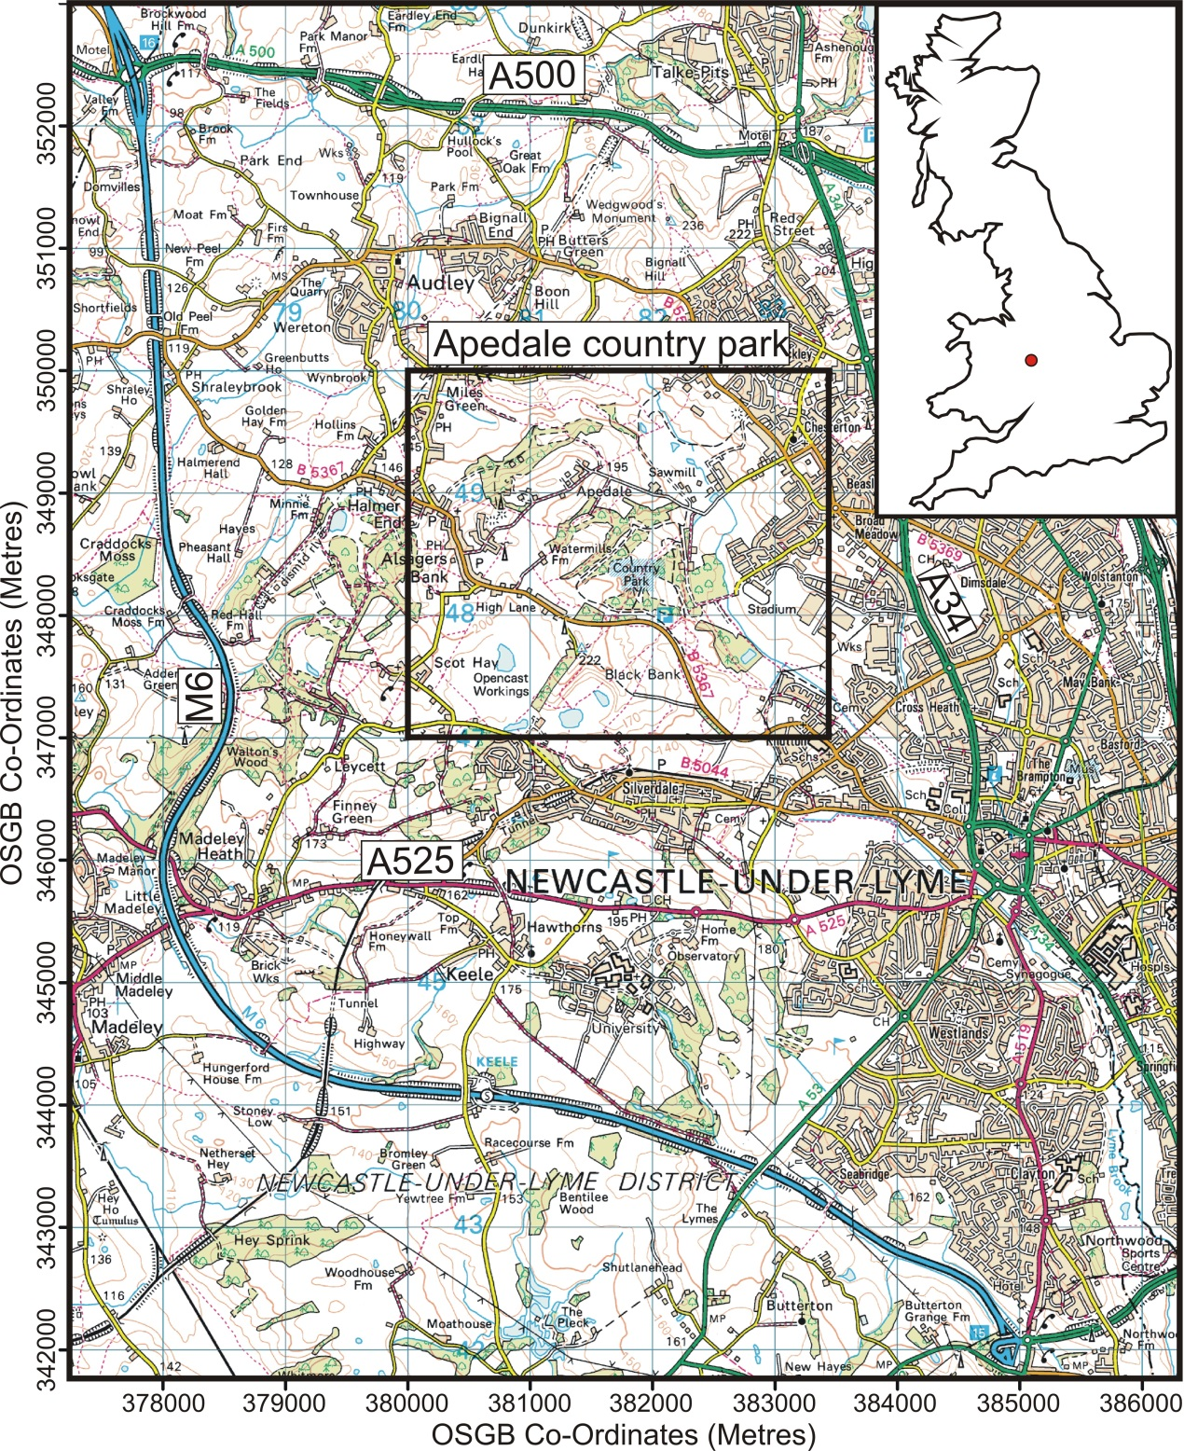
Figure 1. Annotated Apedale Country Park location with (inset) UK location map. Figure 2 area shown as bold black square. Images supplied by Ordnance Survey/EDINA service. © Crown Copyright Database 2010.

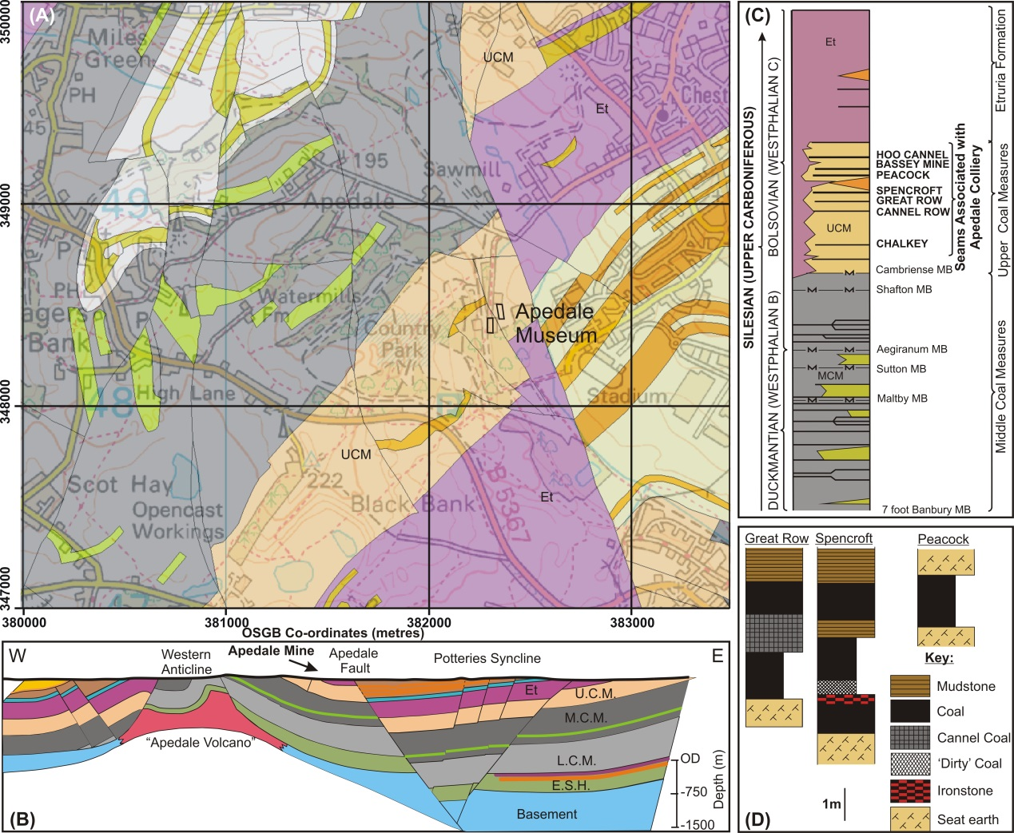
Figure 2. Geology of the Apedale country park area. (A) Local map with (B) schematic cross-section. (C) Local stratigraphic column with (D) detail of the three main worked coal seams in the area. Dating Marine Band (MB) positions are also shown. Modified from British Geological Survey (BGS) Sheet 123 (1994).
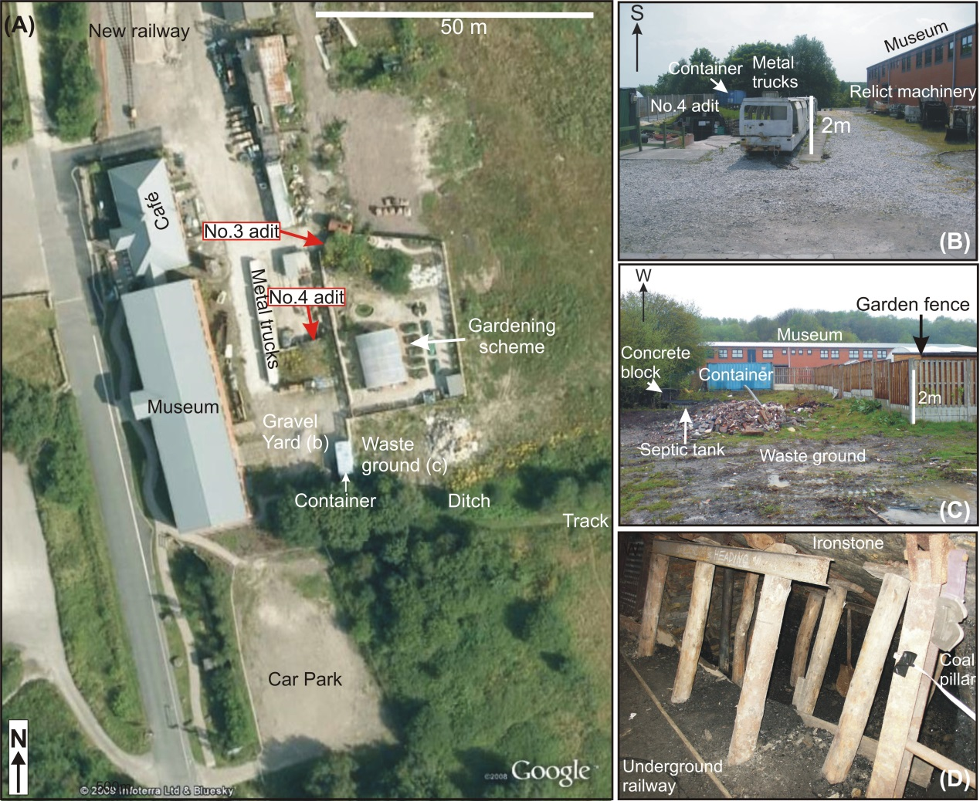
FIGURE 3. (A) Annotated aerial view of the area around the Mining museum, with the mine tour entrance (No. 4) and exit (No. 5) mine shafts marked and orientations shown. (B) Photograph of the gravel yard to the east of the Museum, with (C) photograph of the waste ground where the target No. 7 shaft entrance was thought to be located. (D) Mine tour photograph taken of typical site pillar and stall workings (see Fig. 5 for location).
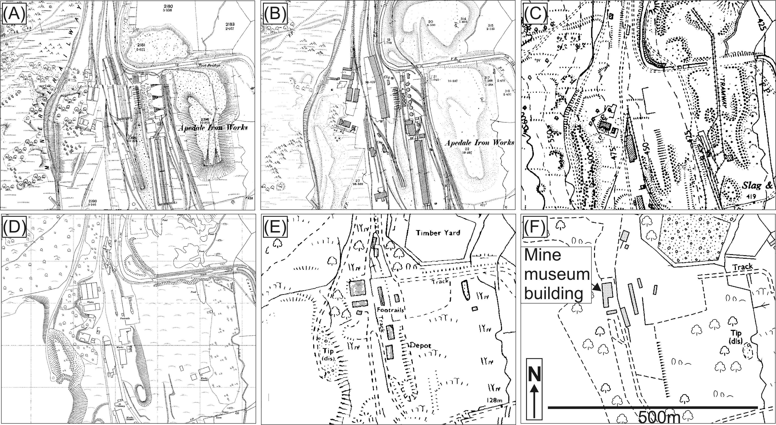
Figure 4. Historical site records from: (A) 1880, (B) 1900, (C) 1955, (D) 1961, (E) 1981 and (F) 1995 respectively, showing the mine development and associated above-ground structures before it’s abandonment in 1996. All map scales and orientations were the same as shown in (F). © Crown Copyright and Lind Information Group Ltd. 2010, all rights reserved.
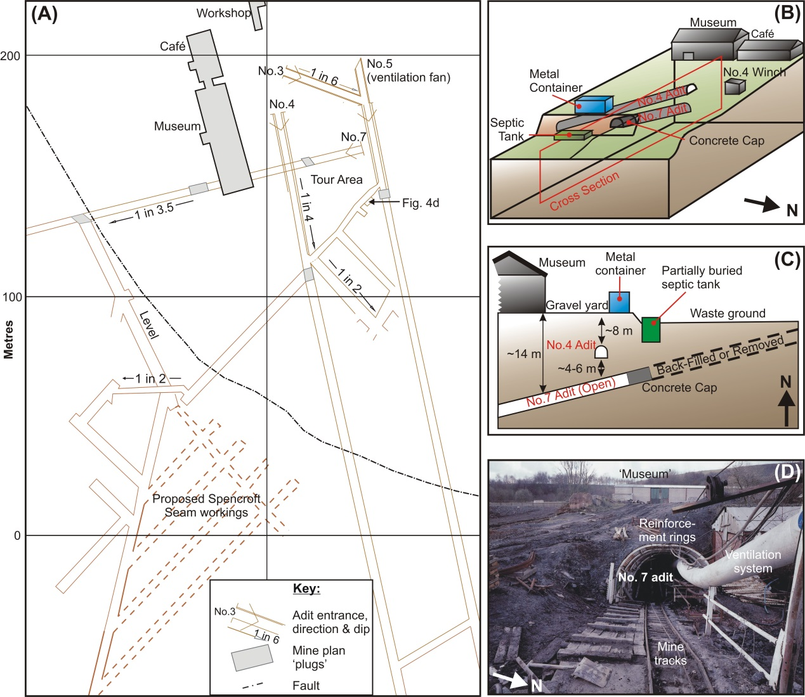
FIGURE 5. (A) Annotated mapview of known and proposed workings on site. Target No. 7 mine shaft shown, with No. 4 and No. 5 access shafts being the present mine tour entrance/exits respectively. (B) 3D annotated schematic of the site (not to scale) with; (C) site cross-section (location marked in B) with modern metal container and septic tank positions shown. (D) Contemporary photograph (date unknown) of target No. 7 access mine shaft with associated infrastructure, supplied by the Apedale Heritage Trust.
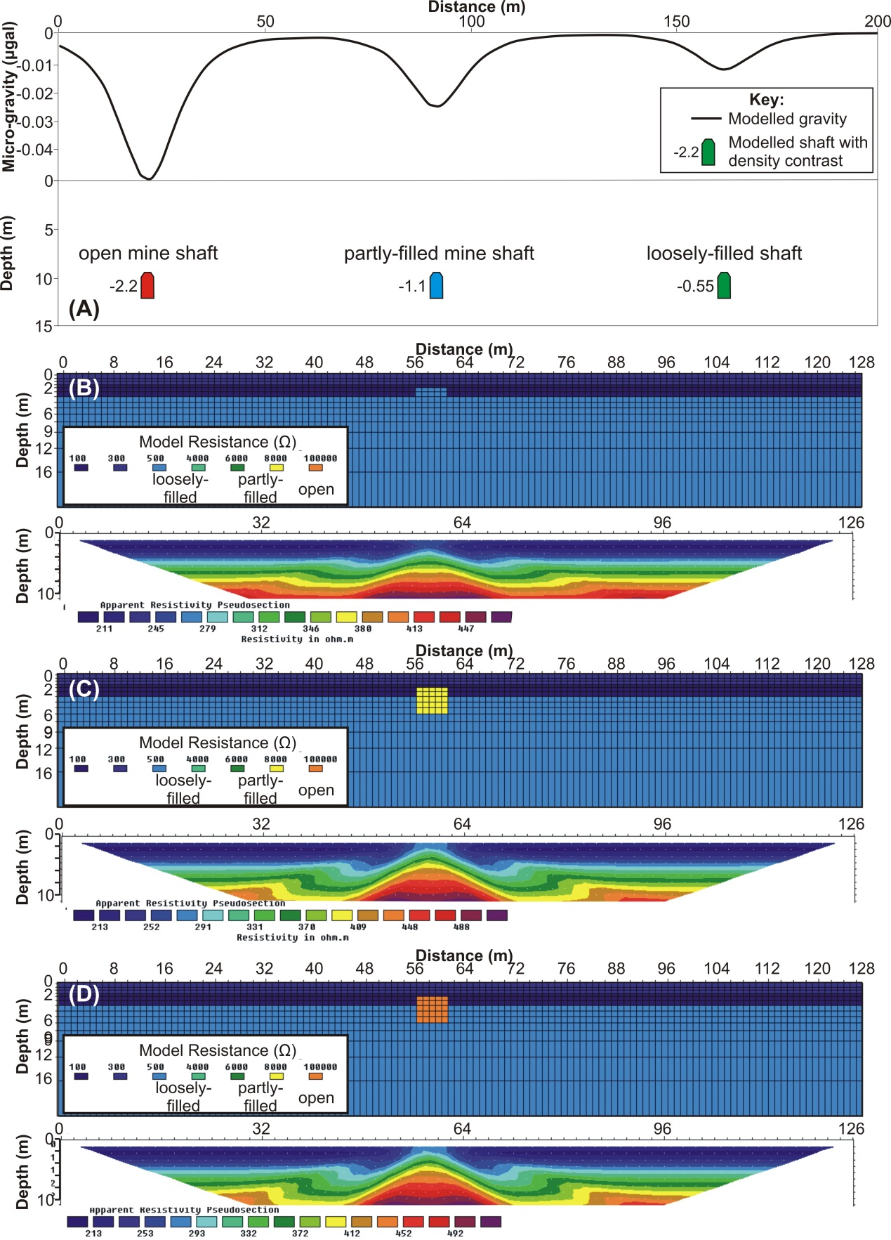
FIGURE 6. Simple 2D micro-gravity and ERI mine shaft forward models. (A) micro-gravity and (B-D) ERI profiles over open, partly-filled and loosely-filled mine shafts at the same depth in homogeneous ground (see text). Models were generated in Grav2Dc™ v.2.06 and RES2DMOD™ v.3.01v software respectively.
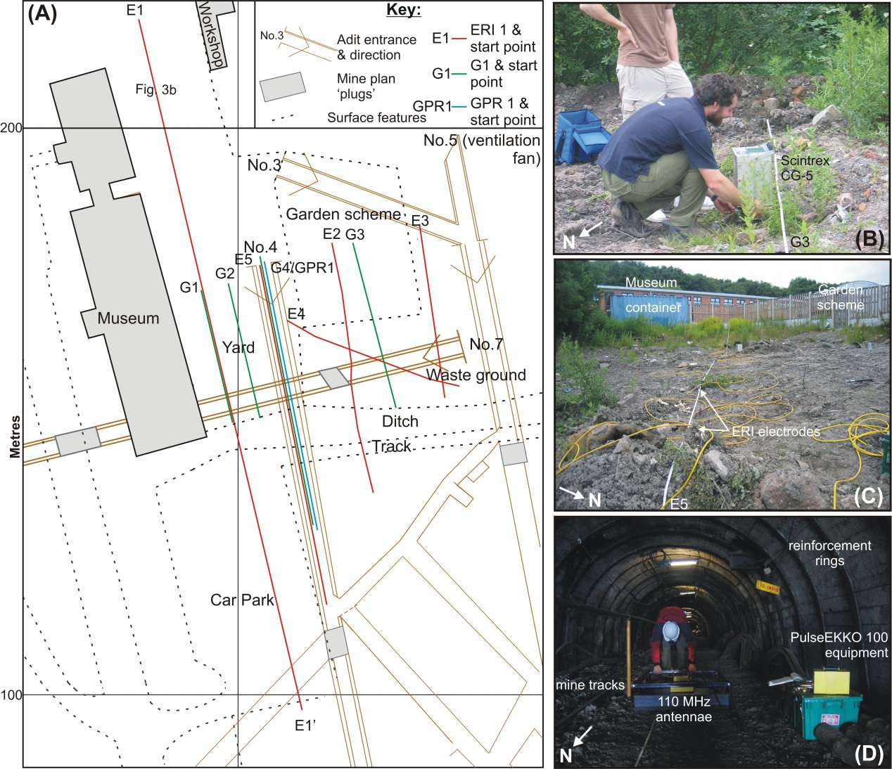
FIGURE 7. (A) Annotated mapview of survey area showing above-ground features, geophysical profile locations and near-surface mine workings (see key). (B) Sample position on micro-gravity 2D profile G3 acquired by a Scintrex™ CG-5 instrument; (C) Electrical Resistivity Imaging (ERI) profile E5 being acquired by Campus TIGRE™ instrumentation; (D) Ground Penetrating Radar (GPR) 2D profile GPR1 acquired down No. 4 mine access shaft by PulseEKKO™ 100 system using 110 MHz shielded antennae.
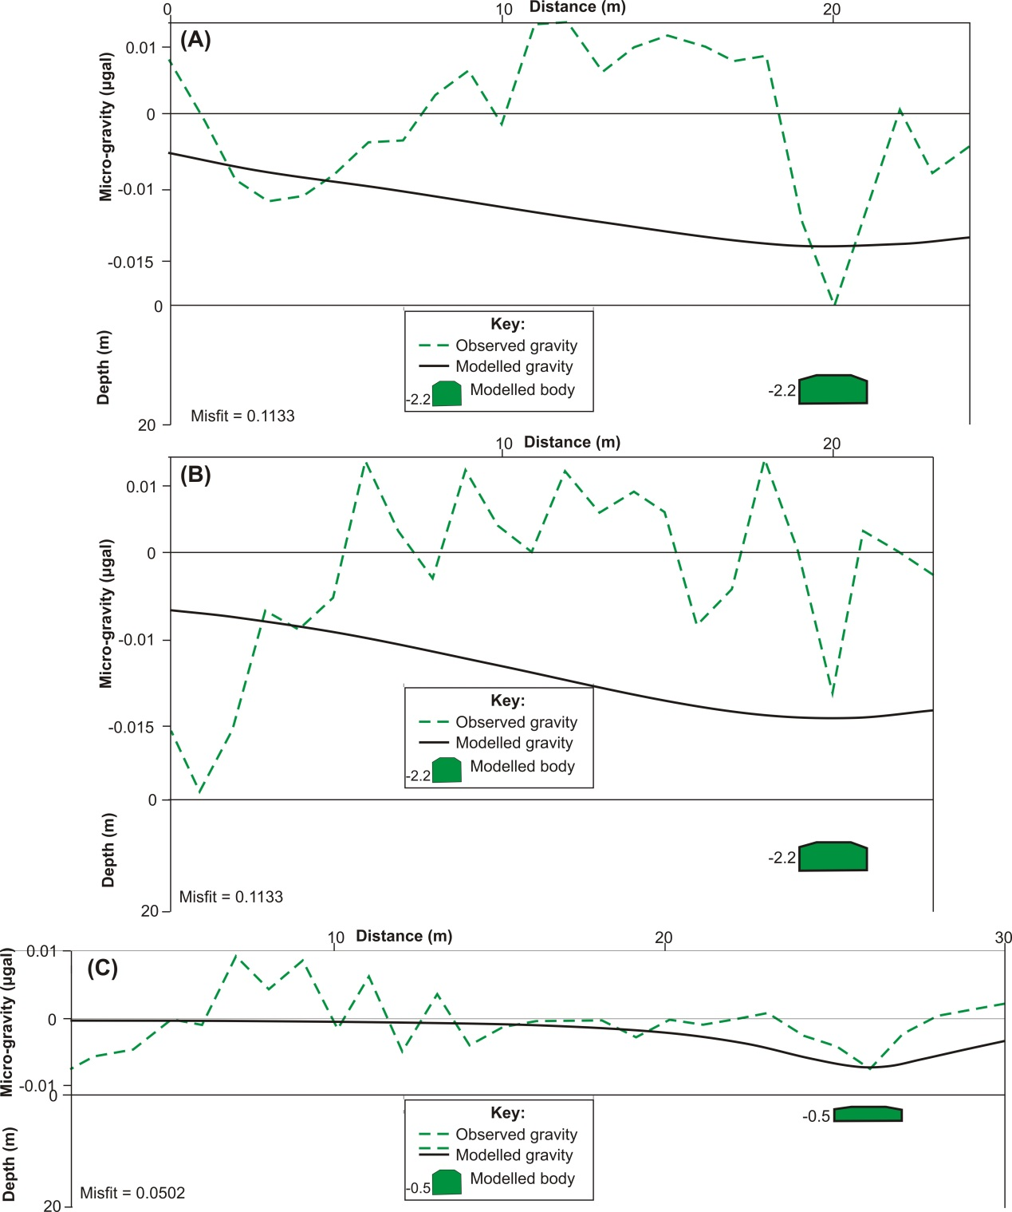
FIGURE 8. Annotated surface micro-gravity detrended 2D profiles (see Fig. 6 for location). (A-C) are profiles G1-3 respectively, with simple mine shaft models beneath. Modelled mineshaft gravity anomalies were relative to background values. Scales (gravity and depths) for all profiles and models are the same for comparison.

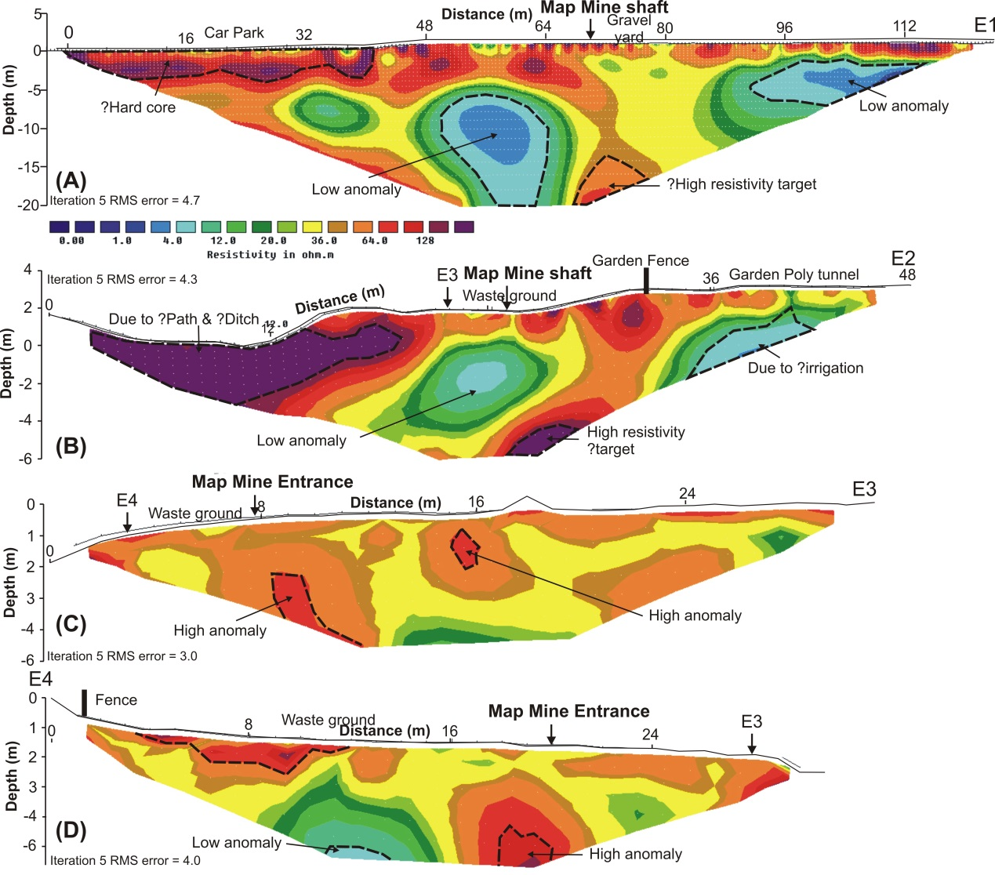
FIGURE 9. Annotated surface ERI 2D profile inversions (see Fig. 6 for location map). Contour scale in (A) is used for all profiles. Mine plan locations of (A-B) target shaft and (C-D) shaft entrance are also marked.
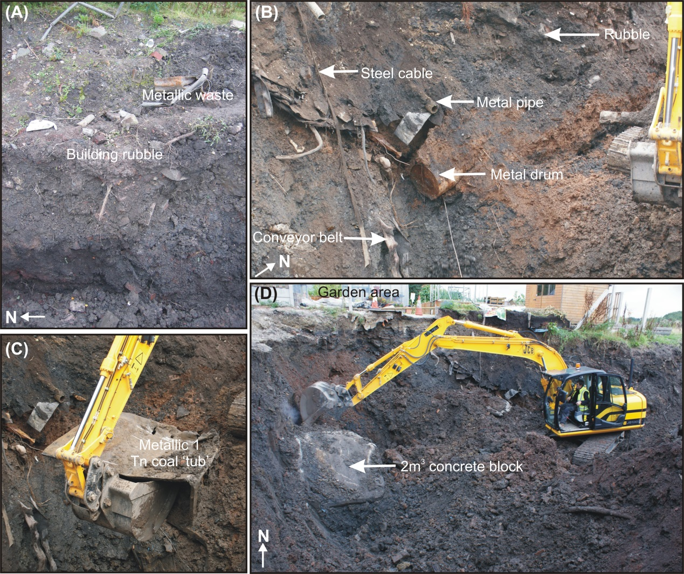
FIGURE 10. Annotated photographs of surface intrusive investigations. (A) Near-surface heterogeneous ground conditions with (B) showing the variety of mine infrastructure components still present onsite. (C) 1 Tonne coal ‘tub’ truck that was the probable cause of the low resistivity anomaly on ERI profile E2. (D) 2 m³ concrete block that may be the cause of the high resistivity anomaly on ERI profile E4.
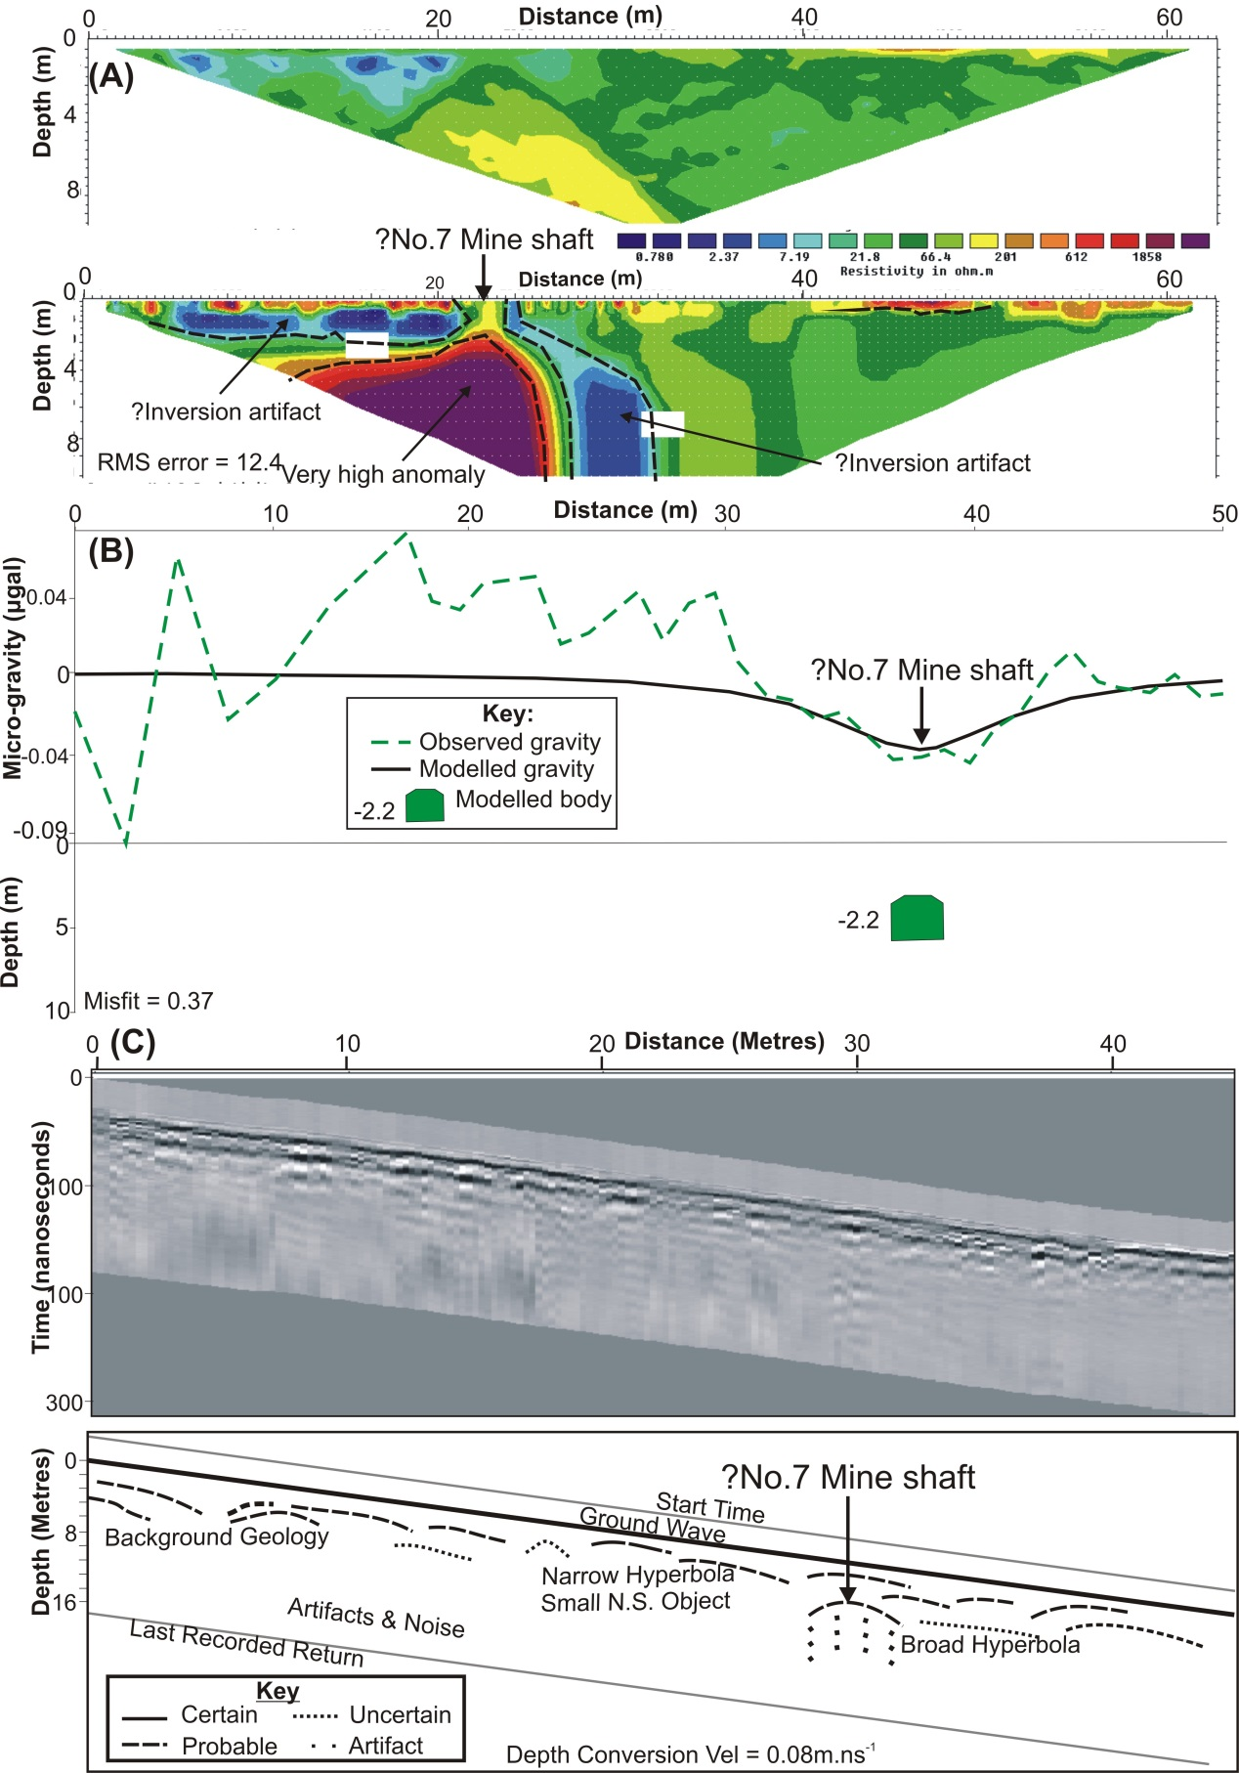
FIGURE 11. Geophysical data collected down No. 4 mine access shaft (see Fig. 6 for location). (A) ERI 2D apparent resistivity profile E5 (above) and model inversion (below) with annotations. (B) Micro-gravity 2D detrended profile G4 (above) with simple mine shaft model (below). Modelled mineshaft gravity was relative to background values. (C) GPR 110 MHz 2D processed profile (above) and annotated interpretation (below).
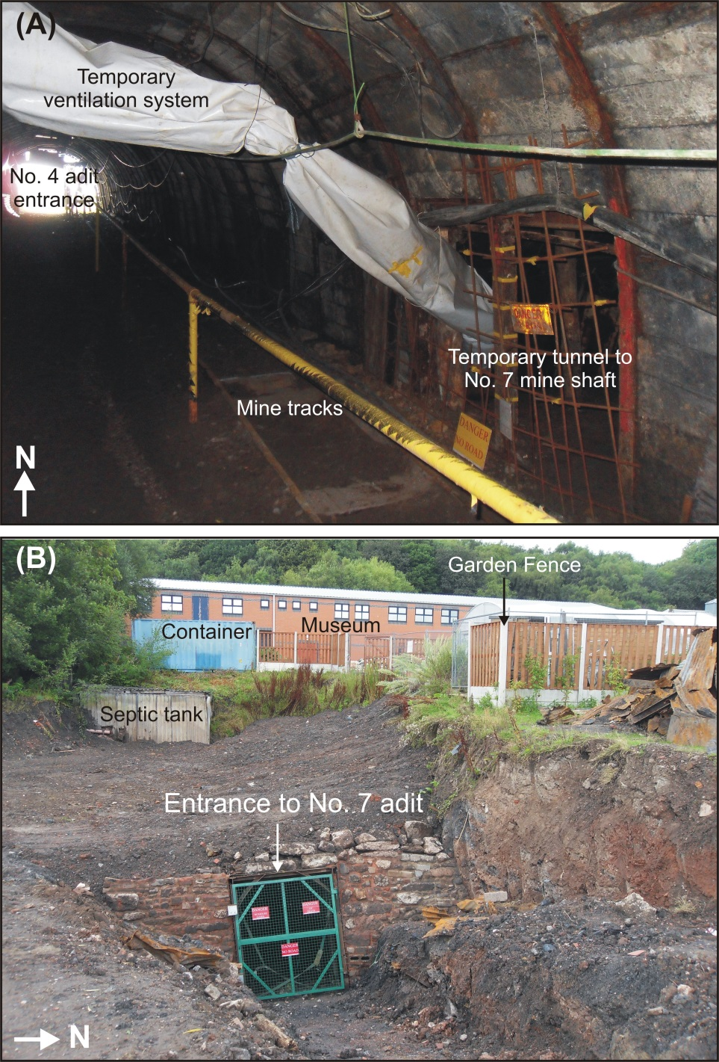
FIGURE 12. Annotated photographs of the final intrusive investigations. (A) mine photograph (looking north) of the temporary tunnel dug from No. 4 mine shaft down to the target No. 7 shaft. (B) Stabilised target No. 7 mine entrance dug out from (A).
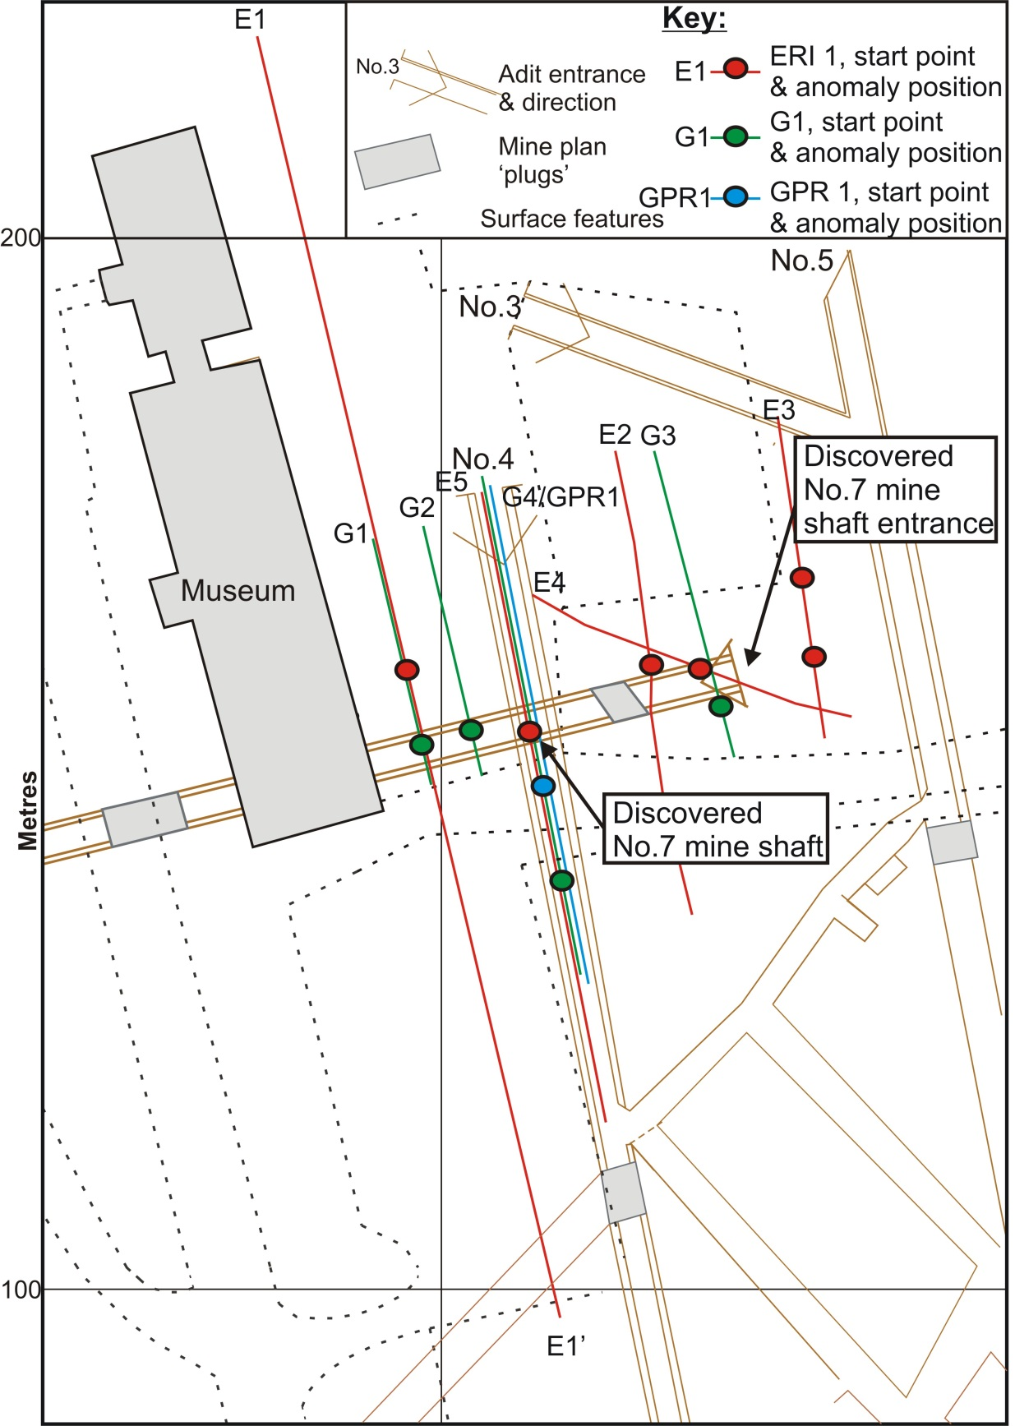
FIGURE 13. Annotated summary mapview of survey area. Detailed are above-ground features, geophysical profile locations, positions of key geophysical anomalies found in this investigation and the subsequently discovered mine-shaft and entrance area (see key).

TABLE CAPTION
Survey Date | Profile name | Profile length (m) | Survey type | ERI average error (%) | No. of electrodes / samples | Spacing (m) | Survey time (h) | Mine plan position along profile (m) | Prominent geophysical anomaly position along profile (m)
04/06/2008 | E1 | 126 | Surface | 2.87 | 64 | 2 | 6 | 70 | 70
05/06/2008 | E2 | 46.5 | Surface | 1.95 | 32 | 1.5 | 3 | 23 | 30
06/06/2008 | E3 | 46.5 | Surface | 0.65 | 32 | 1.5 | 3 | 24 | 15
14/07/2008 | E4 | 31 | Surface | 1.2 | 32 | 1 | 3 | 20 | 19
30/06/2009 | E5 | 63 | Mine | 1.34 | 64 | 1 | 4 | 20 | 24
05/07/2008 | G1 | 24 | Surface | N/A | 25 | 1 | 3 | 20 | 20
05/07/2008 | G2 | 24 | Surface | N/A | 25 | 1 | 3 | 20 | 20
14/07/2008 | G3 | 30 | Surface | N/A | 31 | 1 | 4 | 20 | 24
16/07/2008 | G4 | 49 | Mine | N/A | 43 | 1 - 2 | 6 | 20 | 38
30/06/2009 | GPR1 | 45 | Mine | N/A | 45 | 0.1 | 2 | 20 | 29

TABLE 1. Details of geophysical data collected during this case study.

