**Appendices**

**Contents of this file**

Figure S1 –Study site generalized soil auger profiles

Figures S2-S4 – Trial data collected over different distances from headstones in main manuscript

Figures S5-S21 – GPR magnetic susceptibility and electrical resistivity datasets collected over the three study sites.

Figures S22 – S24 – Cross-plots of electrical resistivity and magnetic susceptibility responses versus burial age over the three study sites not in main manuscript

Tables S1-S3 - Anonymised grave contents and summary statistics for the three study sites.

Tables S4-S6 - Summary of grave detection (ordered in burial age) by geophysical methods at the three study sites, using a qualitative anomaly ranking system of excellent, good, poor, and none (as defined by Schultz and Martin 2012).

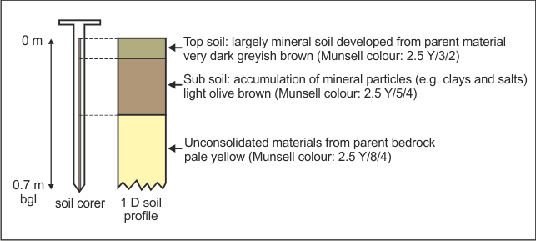

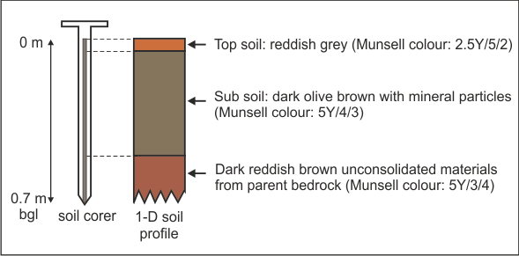

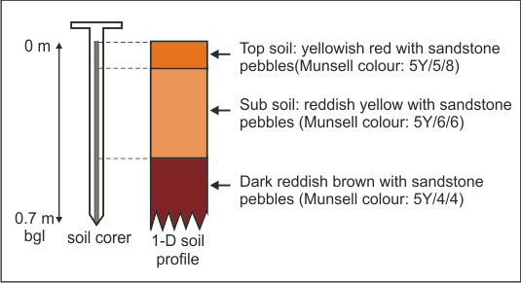

**Figure S1.** Schematic diagram showing the soil hand-auger and generalized soil profile results at (top) St. Michael’s of All Angels Church clay-rich graveyard, Stockton Norfolk, (middle) St. John’s Church sandy soil graveyard, Keele, Staffordshire, and (bottom) St. Luke’s Church sandy-pebbly soil graveyard, Endon, Staffordshire respectively.

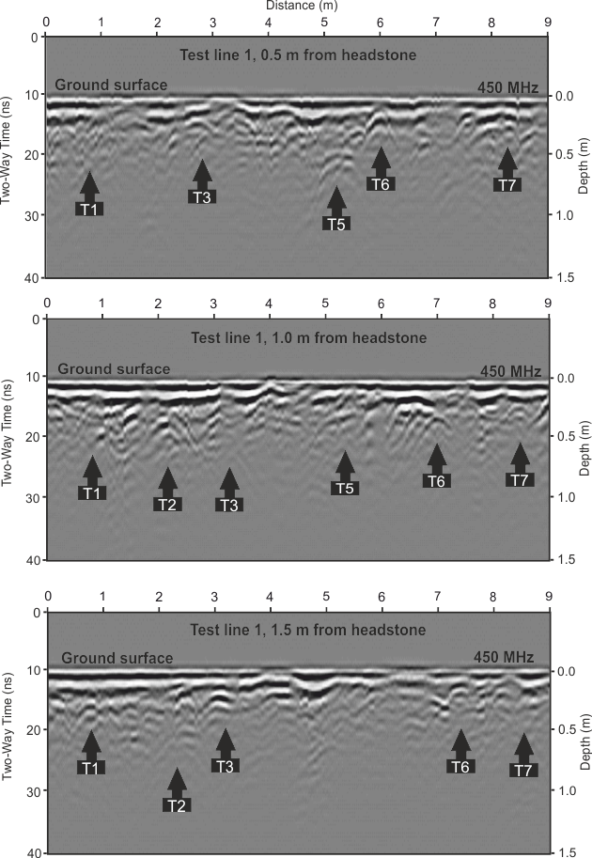

**Figure S2.** 450 MHz shielded 2D GPR profile processed results over survey line 1 at St. Johns church sandy loam soil graveyard at 0.5 m, 1 m and 1.5 m away from grave headstones (see Fig. 4 for location). Anomalies are marked as black arrows, with numbers corresponding to known grave positions (Table S1).

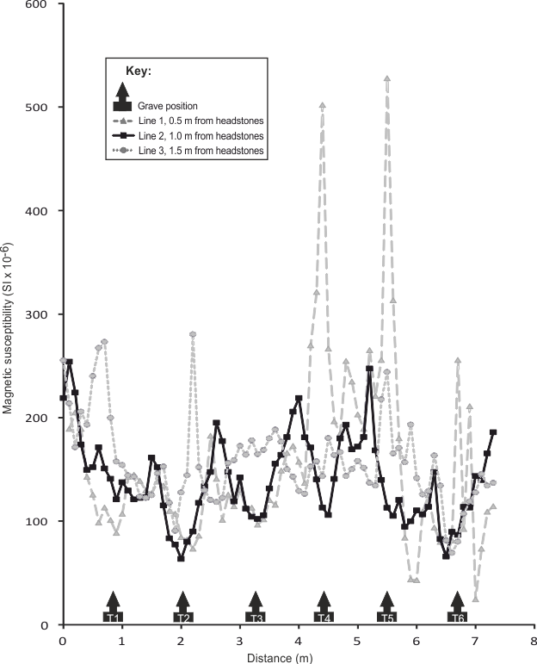**Figure S3.** Magnetic susceptibility processed results over a survey line 1 at St. Luke’s, Endon church sandy-pebbly soil graveyard at 0.5 m, 1 m and 1.5 m distance from grave headstones (see key and Fig. 5 for location). Anomalies are marked as black arrows, with numbers corresponding to known grave positions (Table S2). Note the much higher readings at 0.5 m may be due to the respective headstones being in close proximity to the surveys.

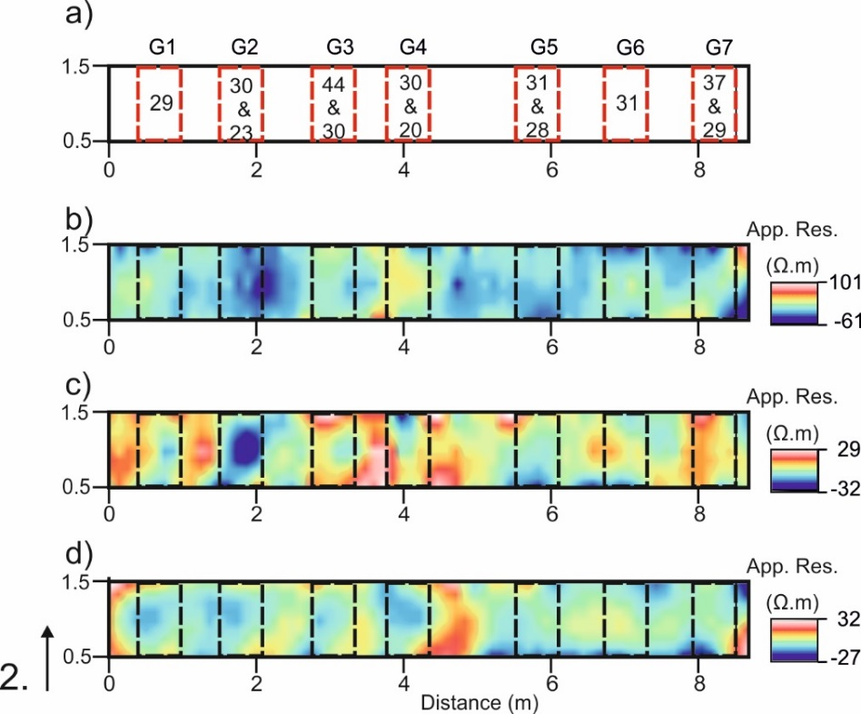

**Figure S4.** Resistivity survey data over survey line 1 at St. Johns’ Church sandy loam soil graveyard, Staffordshire, UK (see Fig. 4 for location and Table S2 for grave details). Three profiles were acquired at 0.5 m, 1 m and 1. 5 m away from the known G1-7 grave positions shown in (a), with the resulting data having a digital contoured surface applied to create the mapview images shown in b-d (see Data Processing). Repeat surveys were acquired on these profiles with mobile probe fixed-offset spacings at (b) 0.25 m, (c) 0.5 m and (d) 1 m respectively. The data shown in (c) has the clearest anomalies to match the known grave positions shown in (a).

*St. Michael of All Angels’ clay-rich soil graveyard in Stockton, Norfolk*

At the St. Michael of All Angels’ clay-rich soil graveyard in Stockton, Norfolk, GPR results showed 900 MHz frequency antennae were deemed optimal here. On survey line 1, 225 MHz dominant frequency data identified only 1 grave (G9), the 450 MHz dominant frequency data identified 3 graves (G7, G8 and G9) and perhaps an unknown burial (?G), with the 900 MHz dominant frequency data identified 5 graves (G3, G4, G7, G8 and G9) and the unknown burial as hyperbolic reflection events (Fig. S5). On survey line 2, 225 MHz dominant frequency data identified only 1 (G18) out of 9 graves, the 450 MHz dominant frequency data detected 8 out of 9 graves, and the 900 450 MHz dominant frequency data detected all 9 and indeed 2 unmarked graves as hyperbolic reflection events (Fig. S6). On survey line 3, 225 MHz dominant frequency data identified 3 (G19, G21 & G26) out of the 11 graves, the 450 MHz dominant frequency data detected 8 and the 900 MHz dominant frequency data detected 7 and indeed the 2 unmarked graves as hyperbolic reflection events (Fig. S7). A strong horizontal reflection event was also observed between two graves.

At the St. Michael of All Angels’ clay-rich soil graveyard in Stockton, Norfolk, on survey line 1, magnetic susceptibility data did not detect any graves (Fig. S8). These were, however, the oldest graves surveyed (Table 1) and may be picking up church building debris as these were observed on the ground surface. Resistivity surveys over the same profile only detected 2 graves (G5 and G7) as relatively low resistance anomalies compared to background values (Fig. S8). For survey line 2, magnetic susceptibility was successful, clearly detecting all 9 known young graves (Table S1) including 2 unknown burials (2 ?G) as relatively high magnetic anomalies when compared to background values (Fig. S9). Resistivity surveys over the same profile were also relatively successful with 8 of 9 burials detected as areas of low resistivity response (Fig. S9). However, in contrast the locations of the two unknown burials had high resistivity response when compared to background values. For survey line 3, magnetic susceptibility was reasonably successful, detecting 7 of 11 known graves (Table S1), with the majority (younger burials) shown as relatively high magnetic anomalies when compared to background values, and two (G20 and G21) that were ~100 years old were low anomalies (Fig. S10). Resistivity surveys over the same profile were not successful (Fig. S10).

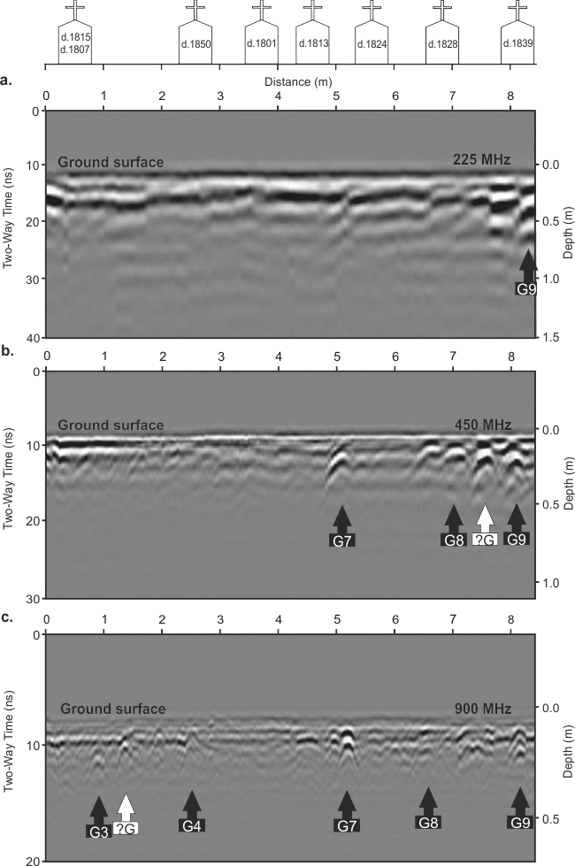

**Figure S5**: St. Michael’s church clay-rich soil graveyard survey line 1 (Fig. 3 for location), Norfolk, showing, (a) grave locations represented by headstones with year of burial inset, (b) 225 MHz, (c) 450 MHz and, (d) 900 MHz frequency 2D GPR profiles with marked interpreted burial (Table S1) position.

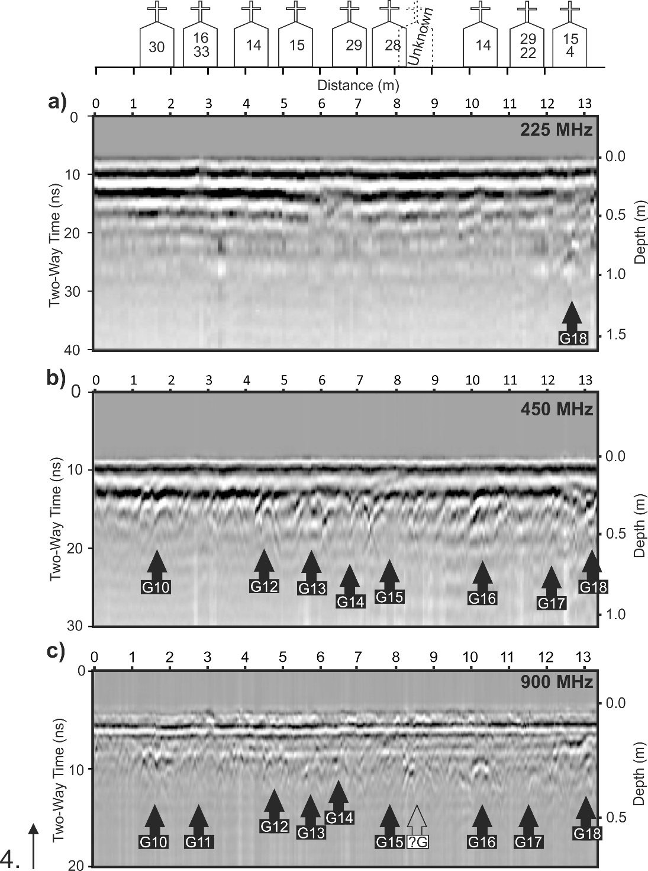

**Figure S6**: St. Michael’s church clay-rich soil graveyard survey line 2 (Fig. 3 for location), Norfolk, showing, (a) grave locations represented by headstones with year of burial inset, (b) 225 MHz, (c) 450 MHz and, (d) 900 MHz frequency 2D GPR profiles with marked interpreted burial (Table 1) position.

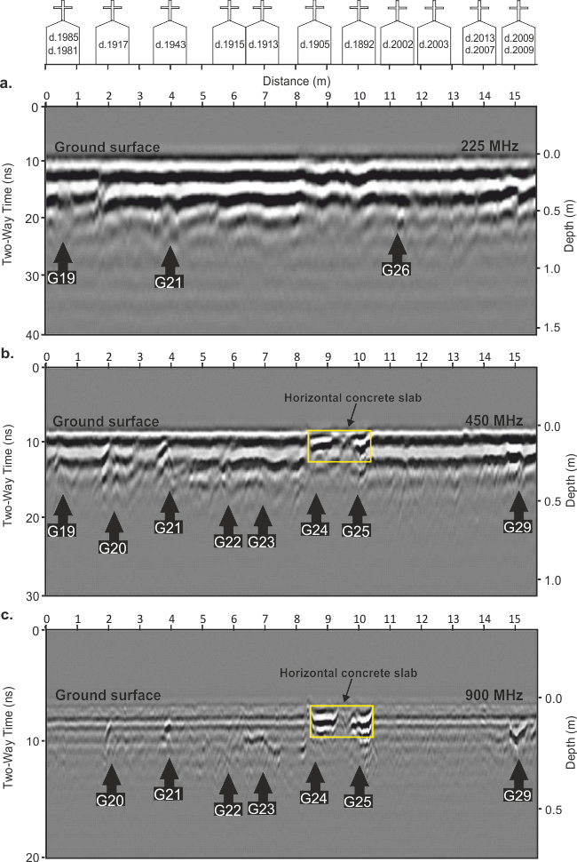

**Figure S7**: St. Michael’s church clay-rich soil graveyard survey line 3 (Fig. 3 for location), Norfolk, showing, (a) grave locations represented by headstones with year of burial inset, (b) 225 MHz, (c) 450 MHz and, (d) 900 MHz frequency 2D GPR profiles with marked interpreted burial (Table S1) position.

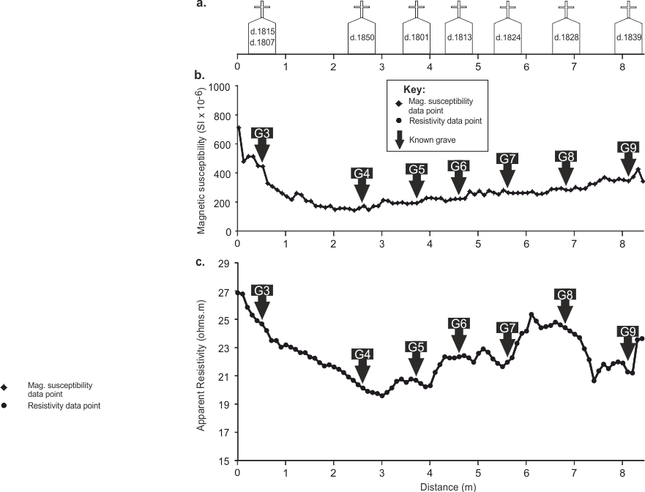

**Figure S8.** St. Michael’s church clay-rich soil graveyard survey line 1 (Fig. 3 for location), Norfolk, showing (a) grave locations represented by headstones with burial age(s) inset, (b) magnetic susceptibility and (c) apparent resistivity profile, both with numbered (Table S1) grave position anomalies arrowed.

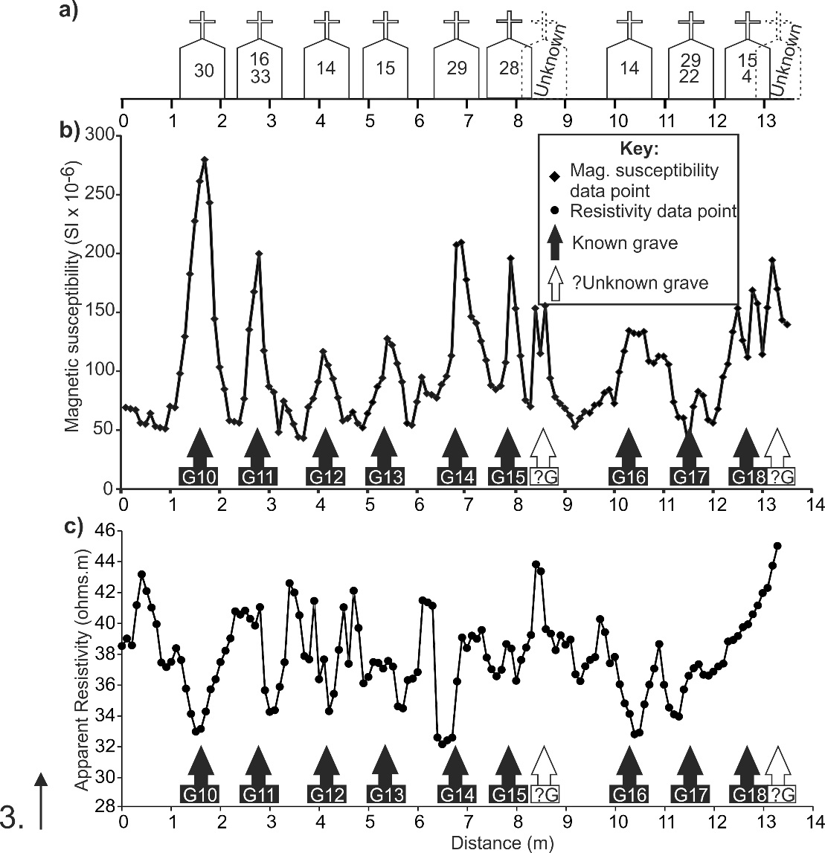

**Figure S9.** St. Michael’s church clay-rich soil graveyard survey line 2 (Fig. 3 for location), Norfolk, showing (a) grave locations represented by headstones with burial age(s) inset, (b) magnetic susceptibility and (c) apparent resistivity profile, both with numbered (Table 1) grave position anomalies arrowed.

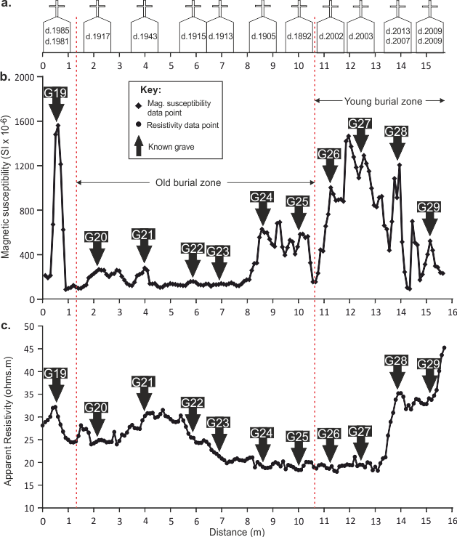

**Figure S10.** St. Michael’s church clay-rich soil graveyard survey line 3 (Fig. 3 for location), Norfolk, showing (a) grave locations represented by headstones with burial age(s) inset, (b) magnetic susceptibility and (c) apparent resistivity profile, both with numbered (Table S1) grave position anomalies arrowed.

*St. John’s Church sandy soil graveyard in Keele, Staffordshire,*

At the St. John’s Church sandy soil graveyard in Keele, Staffordshire, GPR results indicated that 450 MHz frequency antennae were deemed optimal here. On survey line 1, GPR 225 MHz dominant frequency data identified 3 out of the 7 graves, the 450 MHz dominant frequency data detected 6 and the 900 MHz dominant frequency data detected all 7 and indeed 1 unmarked grave as separate, isolated hyperbolic reflection events (Fig. S11). On survey line 2, GPR 225 MHz dominant frequency data only identified 1 out of the 4 graves, with both the 450 MHz dominant frequency data and the 900 MHz dominant frequency data detected all 4 and 1 unmarked grave as hyperbolic reflection events (Fig. S12). On survey line 3, GPR 225 MHz dominant frequency data identified all 4 graves and an unmarked grave, with both the 450 MHz dominant frequency data and 900 MHz dominant frequency data detecting 3 and 1 unmarked grave as hyperbolic reflection events (Fig. S13). On survey line 4, all three GPR 225 MHz, 450 MHz and 900 MHz dominant frequency data identified 2 of the 4 graves as hyperbolic reflection events (Fig. S14). Interestingly the double burial in G19 showed there were not positioned vertically (Fig. S14).

At the St. John’s Church sandy soil graveyard in Keele, Staffordshire, on survey line 1, magnetic susceptibility detected 5 of the 7 relatively young aged-graves, although there may be some headstone positional errors (Fig. 15). Resistivity surveys over the same profile only detected 2 graves (G1 and G2) as relatively low resistance anomalies, when compared to background values. On survey line 2, magnetic susceptibility detected all 4 old graves and indeed 1 unmarked burial (Fig. S16). In contrast, the resistivity surveys over the same profile did not detect any burials compared to background values. On survey line 3, magnetic susceptibility acquired over profile line 3 only detected 1 of the 4 young graves and indeed 1 unmarked burial (Fig. S17). The resistivity surveys over the same profile did not detect any burials compared to background values (Fig. S17).

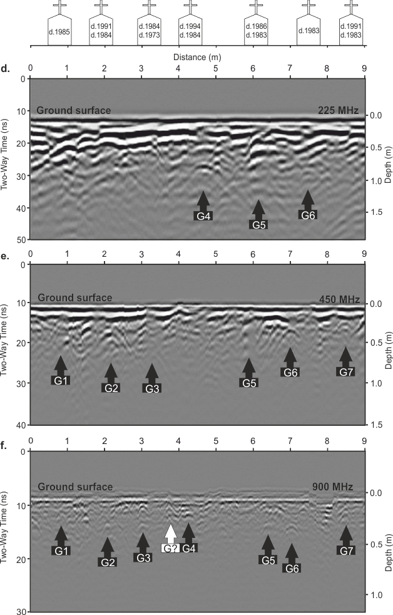

**Figure S11:** St. John’s church sandy-rich soil graveyard survey line 1 (Fig. 4 for location), Staffordshire, showing, (a) grave locations represented by headstones with year of burial inset, (b) 225 MHz, (c) 450 MHz and, (d) 900 MHz frequency 2D GPR profiles with marked interpreted burial (Table S2) positions.

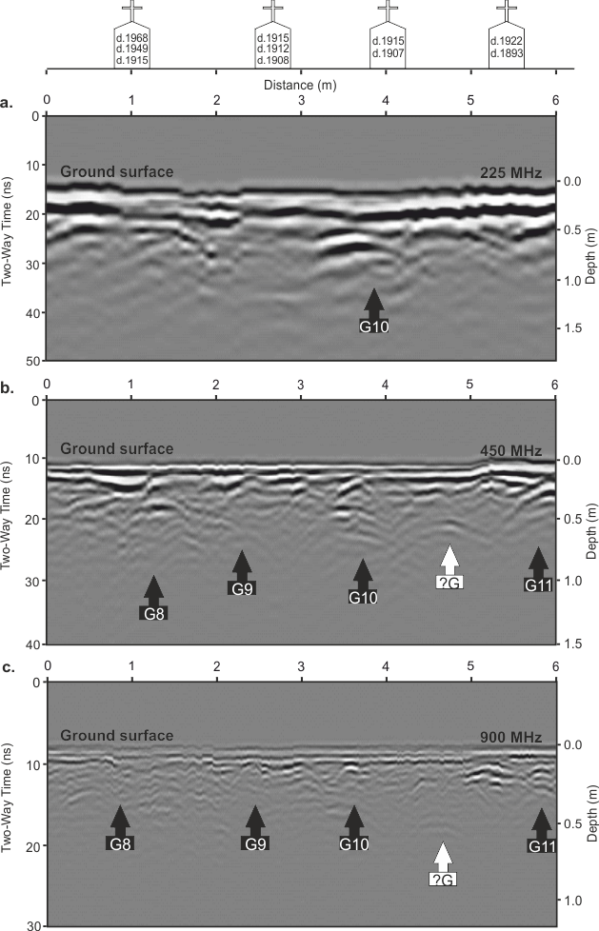

**Figure S12:** St. John’s church sandy-rich soil graveyard survey line 2 (Fig. 4 for location), Staffordshire, showing, (a) grave locations represented by headstones with year of burial inset, (b) 225 MHz, (c) 450 MHz and, (d) 900 MHz frequency 2D GPR profiles with marked interpreted burial (Table 2) positions.

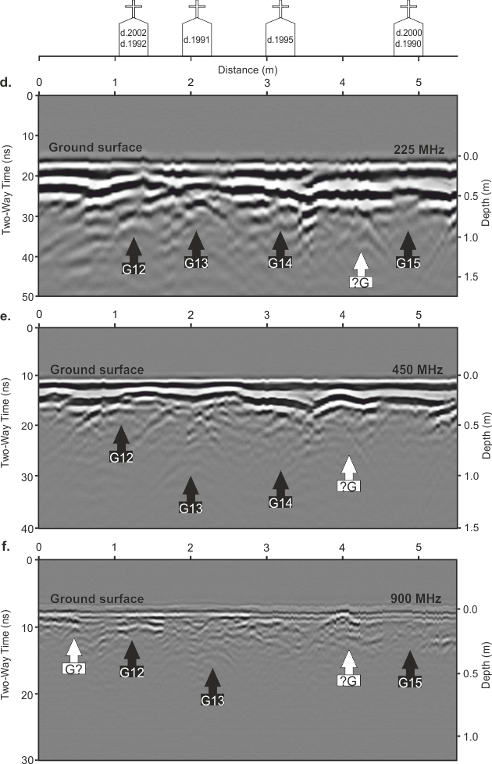

**Figure S13:** St. John’s church sandy-rich soil graveyard survey line 3 (Fig. 4 for location), Staffordshire, showing, (a) grave locations represented by headstones with year of burial inset, (b) 225 MHz, (c) 450 MHz and, (d) 900 MHz frequency 2D GPR profiles with marked interpreted burial (Table S2) positions.

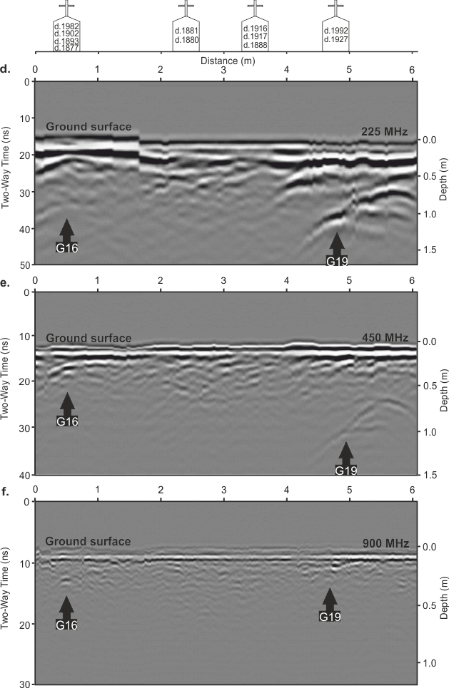

**Figure S14**: St. John’s church sandy-rich soil graveyard survey line 4 (Fig. 4 for location), Staffordshire, showing (a) grave locations represented by headstones with year of burial (inset), (b) 225 MHz and (c) 450 MHz frequency 2D GPR profiles with marked interpreted burial (Table S2) positions; white arrow depicts offset burial (see text).

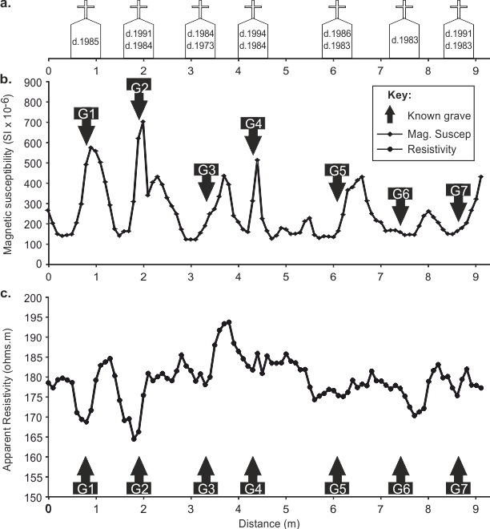

**Figure S15:** St. John’s church sand-rich soil graveyard survey line 1 (Fig. 4 for location), Norfolk, showing (a) grave locations represented by headstones with burial age(s) inset, (b) magnetic susceptibility and (c) apparent resistivity profile, both with numbered (Table S2) grave position anomalies arrowed.

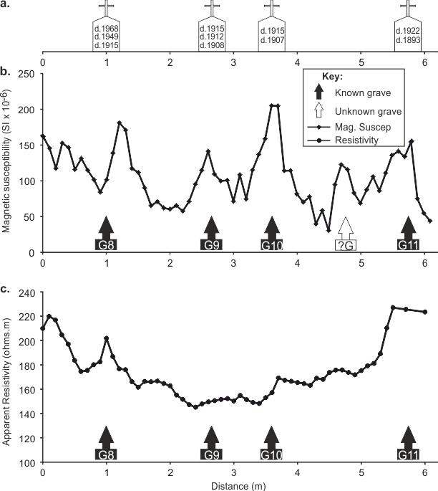

**Figure S16:** St. John’s church sand-rich soil graveyard survey line 2 (Fig. 4 for location), Staffordshire, showing (a) grave locations represented by headstones with burial age(s) inset, (b) magnetic susceptibility and (c) apparent resistivity profile, both with numbered (Table S2) grave position anomalies arrowed.

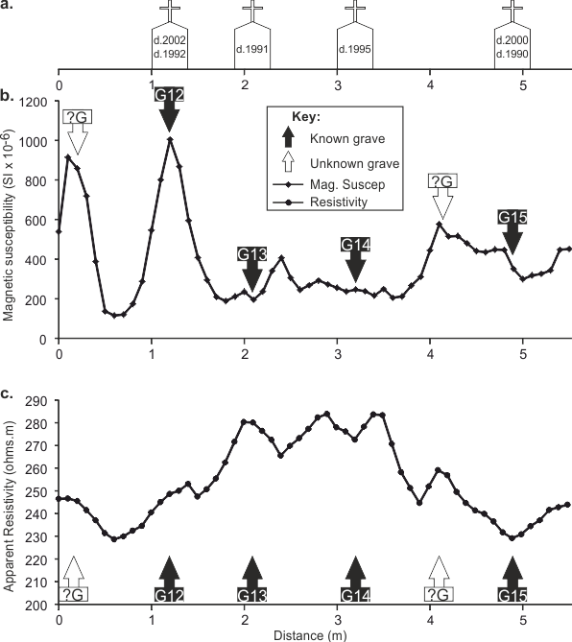

**Figure S17:** St. John’s church sand-rich soil graveyard survey line 3 (Fig. 4 for location), Staffordshire, showing (a) grave locations represented by headstones with burial age(s) inset, (b) magnetic susceptibility and (c) apparent resistivity profile, both with numbered (Table S2) grave position anomalies arrowed.

*St. Luke’s Church sandy-pebbly soil graveyard in Endon, Staffordshire,*

At the St. Luke’s Church sandy-pebbly soil graveyard in Endon, Staffordshire, GPR results indicated that 225 MHz frequency antennae data were deemed optimal here. For survey line 1, GPR 225 MHz dominant frequency data identified 15 out of the 19 graves, with the 450 MHz dominant frequency data detecting 10 and the 900 MHz dominant frequency data detecting 9 and 1 unmarked grave as discrete hyperbolic reflections (Fig. S18). For survey line 2, GPR 225 MHz dominant frequency data identified 14 out of the 20 graves, with the 450 MHz dominant frequency data detecting 10 and the 900 MHz dominant frequency data detecting 8 graves (Fig. S19).

At the St. Luke’s Church sandy-pebbly soil graveyard in Endon, Staffordshire, on survey line 1, magnetic susceptibility detected 15 of the 19 young graves, although these anomalies were relatively low, compared to background values, in contrast to the first two case studies (Fig. S20). Resistivity surveys over the same profile detected 13 of the 18 graves and one unknown grave as relatively low resistance anomalies, compared to background values (see Fig. S15). On survey line 2, magnetic susceptibility detected 19 of the 20 young graves with anonalies being relatively low compared to background values (Fig. S21). Resistivity surveys over the same profile detected all graves but were again relatively low resistance anomalies compared to background values (Fig. S21).

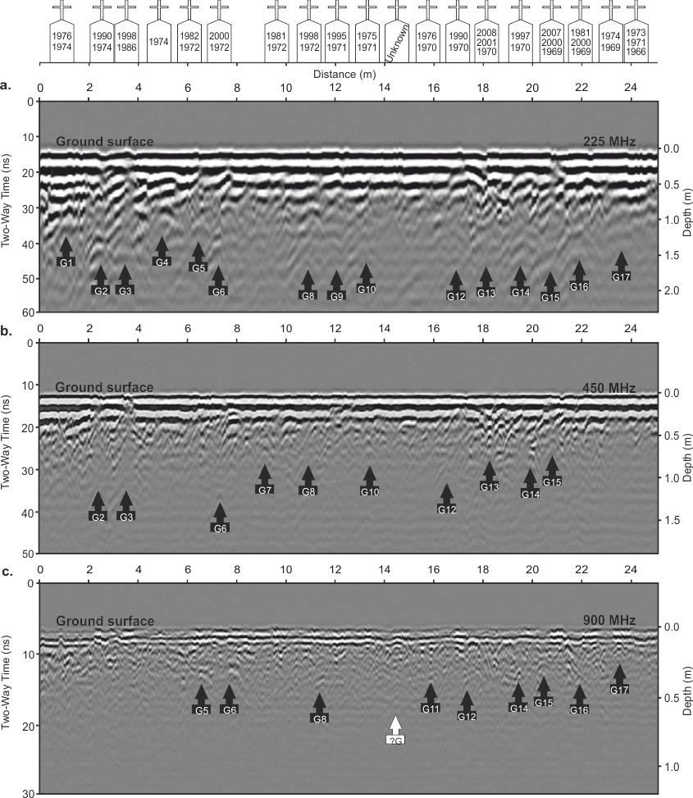

**Figure S18**: St. Luke’s survey line 1 (Fig. 3 for location), showing (a) grave locations represented by headstones with year of burial (inset), (b) 225 MHz (c) 450 MHz and (d) 900 MHz frequency 2D GPR profiles with anomalies (arrowed).

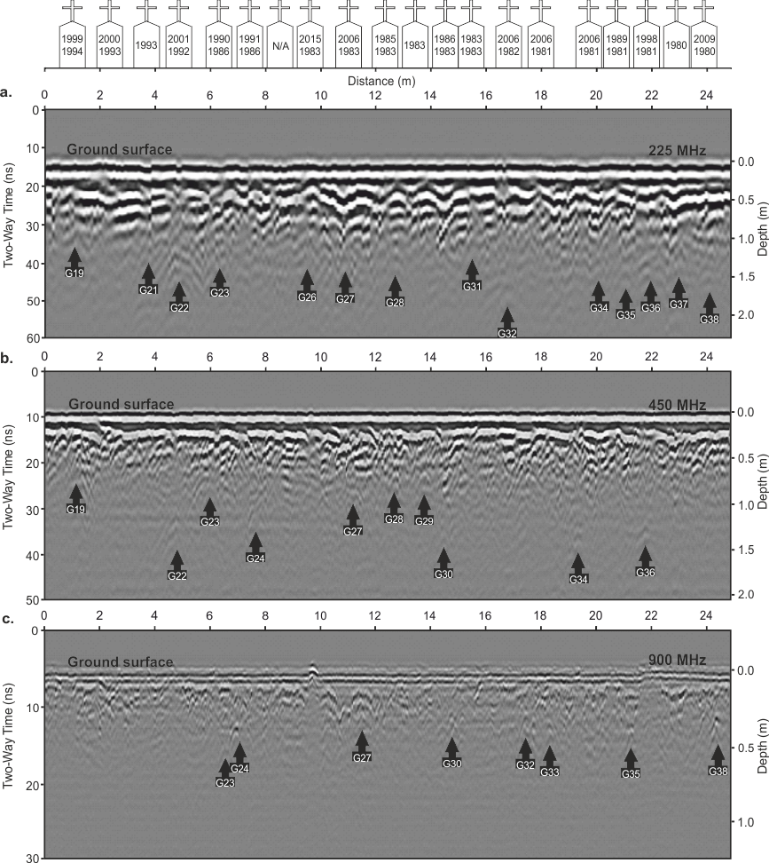

**Figure S19**: St. Luke’s church sandy-pebbly soil graveyard survey line 2 (Fig. 3 for location), showing grave locations represented by headstones with year of burial (inset), (a) 225 MHz (b) 450 MHz and (c) 900 MHz frequency 2D GPR profiles with anomalies (arrowed).

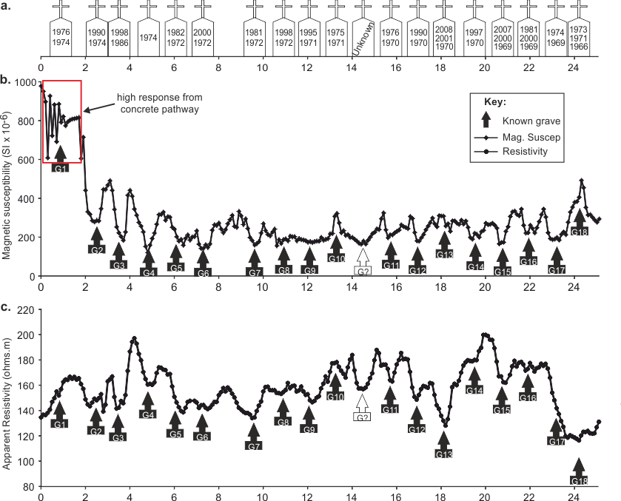

**Figure S20.** St. Luke’s church sand-pebbly soil graveyard survey line 1 (Fig. 5 for location), Staffordshire, showing (a) grave locations represented by headstones with burial age(s) inset, (b) magnetic susceptibility and (c) apparent resistivity profile, both with numbered (Table S3) grave position anomalies arrowed.

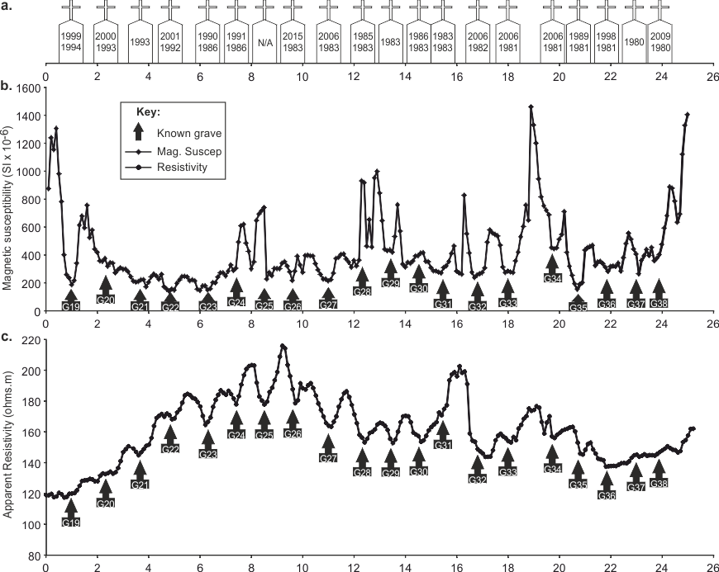

**Figure S21.** St. Luke’s church sandy-pebbly soil graveyard survey line 2 (Fig. 5 for location), Staffordshire, showing grave locations represented by headstones with year of burial inset, (a) 225 MHz, (b) 450 MHz and, (c) 900 MHz frequency 2D GPR profiles with anomalies (arrowed).

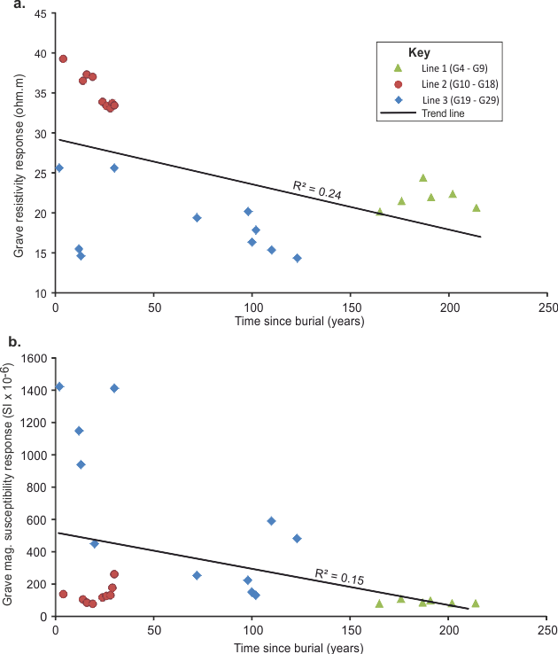

**Figure S22.** St. Michael’s church clay-rich soil graveyard, Norfolk, cross plots of (a) resistivity and (b) magnetic susceptibility survey responses versus known burial ages (Table 3).

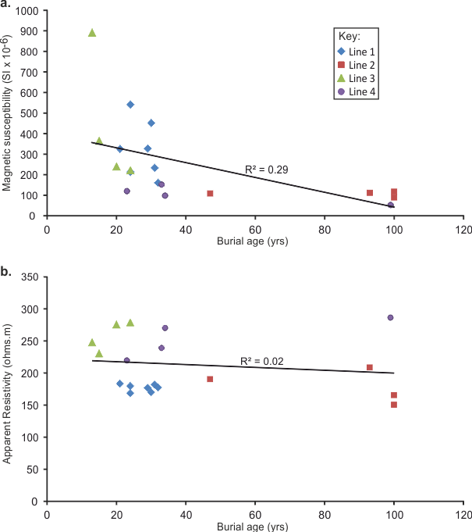

**Figure S23.** St. John’s church sandy loam soil graveyard, Keele, Staffordshire, cross plots of (a) resistivity and (b) magnetic susceptibility survey responses versus known burial ages (Table 4).

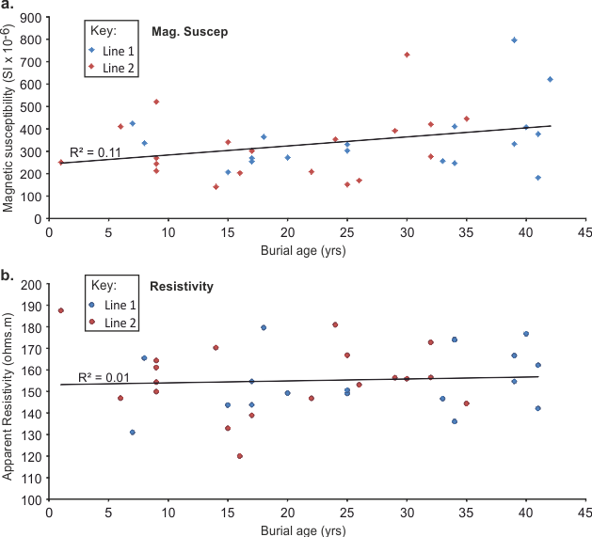

**Figure S24.** St. Luke’s church sandy-pebbly soil graveyard, Endon, Staffordshire, cross plots of (a) resistivity and (b) magnetic susceptibility survey responses versus known burial ages (Table 5).

|  |  |  |  |  |
| --- | --- | --- | --- | --- |
| **Survey Lines** | **Grave no** | **Mid-point distance (m)** | **Age of last burial (yrs)** | **Occupancy** |
| 1 | G3 | 0.5 | 200 | 2 |
| G4 | 2.6 | 165 | 1 |
| G5 | 3.7 | 214 | 1 |
| G6 | 4.6 | 202 | 1 |
| G7 | 5.6 | 191 | 1 |
| G8 | 6.8 | 187 | 1 |
| G9 | 8.1 | 176 | 1 |
| 2 | G10 | 1.7 | 30 | 1 |
| G11 | 2.6 | 26 | 2 |
| G12 | 4.2 | 14 | 1 |
| G13 | 5.2 | 16 | 1 |
| G14 | 6.8 | 29 | 1 |
| G15 | 7.8 | 28 | 1 |
| G16 | 10.2 | 24 | 1 |
| G17 | 11.7 | 19 | 2 |
| G18 | 12.5 | 4 | 2 |
| 3 | G19 | 0.6 | 30 | 2 |
| G20 | 2.2 | 98 | 1 |
| G21 | 4 | 72 | 1 |
| G22 | 5.8 | 100 | 1 |
| G23 | 6.9 | 102 | 1 |
| G24 | 8.6 | 110 | 1 |
| G25 | 10 | 123 | 1 |
| G26 | 11.4 | 13 | 1 |
| G27 | 12.4 | 12 | 1 |
| G28 | 13.9 | 2 | 2 |
| G29 | 15.2 | 20 | 2 |
| **Min** | - | - | 2 | 1 |
| **Average** | - | - | 81.7 | 1.3 |
| **Max** | - | - | 214 | 2 |
| **SD** | - | - | 74.5 | 0.4 |

**Table S1.** Anonymised grave contents and summary statistics for St. Michael’s of ‘All Angels’ church clay-rich soil graveyard, Stockton, Norfolk, UK (locations shown in Fig. 3).

|  |  |  |  |  |
| --- | --- | --- | --- | --- |
| **Survey Lines** | **Grave no** | **Mid-point distance (m)** | **Age of last burial (year)** | **Occupancy** |
| 1 | G1 | 0.8 | 30 | 1 |
| G2 | 1.9 | 24 | 2 |
| G3 | 3.4 | 31 | 2 |
| G4 | 4.3 | 21 | 2 |
| G5 | 6.3 | 29 | 2 |
| G6 | 7.3 | 32 | 1 |
| G7 | 8.8 | 24 | 2 |
| 2 | G8 | 1 | 47 | 3 |
| G9 | 2.7 | 100 | 3 |
| G10 | 4 | 100 | 2 |
| G11 | 5.4 | 93 | 2 |
| 3 | G12 | 1.2 | 13 | 2 |
| G13 | 2.1 | 24 | 1 |
| G14 | 3.2 | 20 | 1 |
| G15 | 4.9 | 15 | 2 |
| 4 | G16 | 0.5 | 33 | 4 |
| G17 | 2.4 | 34 | 2 |
| G18 | 3.5 | 99 | 3 |
| G19 | 4.8 | 23 | 2 |
| **Min** | - | - | 13 | 1 |
| **Average** | - | - | 41.7 | 2.1 |
| **Max** | - | - | 100 | 4 |
| **SD** | - | - | 30.8 | 0.8 |

**Table S2.** Anonymised grave contents and summary statistics for St. John’s church sandy loam soil graveyard, Keele, Staffordshire, UK (locations shown in Fig. 4).

|  |  |  |  |  |
| --- | --- | --- | --- | --- |
| **Survey Lines** | **Grave no** | **Mid-point distance (m)** | **Age of last burial (year)** | **Occupancy** |
| 1 | G1 | 0.8 | 39 | 2 |
| G2 | 2.5 | 25 | 2 |
| G3 | 3.5 | 17 | 2 |
| G4 | 4.8 | 41 | 1 |
| G5 | 6.3 | 33 | 2 |
| G6 | 7.3 | 15 | 2 |
| G7 | 9.6 | 34 | 2 |
| G8 | 10.9 | 17 | 2 |
| G9 | 12.1 | 20 | 2 |
| G10 | 13.3 | 40 | 2 |
| G11 | 15.7 | 39 | 2 |
| G12 | 16.9 | 25 | 2 |
| G13 | 18.2 | 7 | 3 |
| G14 | 19.5 | 18 | 2 |
| G15 | 20.7 | 8 | 3 |
| G16 | 21.9 | 34 | 3 |
| G17 | 23.2 | 41 | 2 |
| G18 | 24.2 | 42 | 3 |
| 2 | G19 | 1 | 16 | 2 |
| G20 | 2.3 | 15 | 2 |
| G21 | 3.7 | 22 | 1 |
| G22 | 4.8 | 14 | 2 |
| G23 | 6.3 | 25 | 2 |
| G24 | 7.4 | 24 | 2 |
| G25 | 8.5 | Unknown | 2 |
| G26 | 9.6 | 1 | 2 |
| G27 | 11 | 9 | 2 |
| G28 | 12.3 | 30 | 2 |
| G29 | 13.4 | 32 | 1 |
| G30 | 14.5 | 29 | 2 |
| G31 | 15.4 | 32 | 2 |
| G32 | 16.8 | 9 | 2 |
| G33 | 18 | 9 | 2 |
| G34 | 19.7 | 9 | 2 |
| G35 | 20.7 | 26 | 2 |
| G36 | 21.8 | 17 | 2 |
| G37 | 22.9 | 35 | 1 |
| G38 | 23.9 | 6 | 2 |
| **Min** | - | - | 1 | 1 |
| **Average** | - | - | 23.2 | 2 |
| **Max** | - | - | 42 | 3 |
| **SD** | - | - | 11.6 | 0.5 |

**Table S3.** Anonymised grave contents and summary statistics for St. Luke’s church sandy-pebbly soil graveyard, Endon, Staffordshire, UK (locations shown in Fig. 5).

|  |  |  |  |  |  |  |
| --- | --- | --- | --- | --- | --- | --- |
| **Grave**  **no.** | **Burial age (yrs)** | **Magnetic. Suscept.** | **App. Resistivity** | **GPR Antenna central frequency (MHz)** | | |
| **225** | **450** | **900** |
| G28 | 2 | Excellent | None | None | None | None |
| G18 | 4 | Good | None | Poor | Poor | Good |
| G27 | 12 | Good | Good | None | None | None |
| G26 | 13 | Good | Poor | Poor | None | None |
| G12 | 14 | Excellent | Excellent | None | Good | Poor |
| G13 | 16 | Excellent | Poor | None | Poor | Poor |
| G17 | 19 | None | Poor | None | Poor | Poor |
| G29 | 20 | Good | Good | None | Poor | Good |
| G16 | 24 | Excellent | Excellent | None | Poor | Excellent |
| G11 | 26 | Excellent | Excellent | None | No detection | Poor |
| G15 | 28 | Excellent | Poor | None | Poor | Poor |
| G14 | 29 | Excellent | Excellent | None | Poor | Poor |
| G10 | 30 | Excellent | Excellent | None | Poor | Poor |
| G19 | 30 | Excellent | Good | Poor | Poor | None |
| G21 | 72 | Good | None | Poor | Good | Good |
| G20 | 98 | Good | None | None | Poor | Good |
| G22 | 100 | None | None | None | Poor | Poor |
| G23 | 102 | None | None | None | Poor | Poor |
| G24 | 110 | Good | None | None | Good | Good |
| G25 | 123 | Good | Good | None | Poor | Good |
| G4 | 165 | None | None | None | None | Good |
| G9 | 176 | None | Excellent | Good | Good | Excellent |
| G8 | 187 | None | None | None | Poor | Poor |
| G7 | 191 | None | Good | Poor | Good | Excellent |
| G3 | 200 | None | None | None | None | Good |
| G6 | 202 | None | None | None | None | None |
| G5 | 214 | None | Poor | None | None | None |
| No. of graves detected (29) | | 17 | 15 | 6 | 19 | **21** |
| No. of graves detected (%) | | 59% | 51% | 21% | 65% | **72%** | |

**Table S4.** Summary of grave detection (ordered in burial age) by geophysical methods at St. Michael’s clay-rich soil graveyard, Norfolk, UK, using a qualitative anomaly ranking system of Excellent, Good, Poor and None (as defined by Schultz and Martin, 2012).

|  |  |  |  |  |  |  |
| --- | --- | --- | --- | --- | --- | --- |
| **Grave**  **no.** | **Burial age (yrs)** | **Magnetic. Suscept.** | **App. Resistivity** | **GPR Antenna central frequency [MHz]** | | |
| **225** | **450** | **900** |
| G12 | 13 | Excellent | None | Good | Good | Good |
| G15 | 15 | None | Excellent | Poor | No detection | Poor |
| G14 | 20 | None | Excellent | Poor | Poor | Poor |
| G4 | 21 | Good | Poor | Good | None | Poor |
| G19 | 23 | None | Good | Good | Good | Poor |
| G2 | 24 | Good | Excellent | None | Good | Poor |
| G7 | 24 | None | Good | None | Good | Excellent |
| G13 | 24 | None | None | Poor | Poor | Poor |
| G5 | 29 | Poor | Poor | Poor | Poor | Poor |
| G1 | 30 | Good | Excellent | None | Poor | Poor |
| G3 | 31 | Poor | Good | None | Poor | Excellent |
| G6 | 32 | None | Poor | Poor | Good | Good |
| G16 | 33 | None | Poor | Poor | Poor | Good |
| G17 | 34 | None | None | None | None | None |
| G8 | 47 | Poor | Poor | None | Poor | Poor |
| G11 | 93 | Good | None | None | Good | Excellent |
| G18 | 99 | None | None | None | None | None |
| G9 | 100 | Good | None | None | None | Poor |
| G10 | 100 | Excellent | Poor | Poor | Poor | Good |
| No. of graves detected (19) | | 10 | 13 | 10 | 14 | **17** | |
| No. of graves detected (%) | | 53 | 68 | 53 | 74 | **89** | |

**Table S5.** Summary of grave detection (ordered in burial age) by geophysical methods at St. John’s sandy soil graveyard, Staffordshire, UK, using a qualitative anomaly ranking system of Excellent, Good, Poor and None (as defined by Schultz and Martin 2012).

|  |  |  |  |  |  |  |
| --- | --- | --- | --- | --- | --- | --- |
| **Grave no.** | **Burial age (yrs)** | **Magnetic. Suscept.** | **App. Resistivity** | **Antenna central frequency (MHz)** | | |
| **225** | **450** | **900** |
| G21 | 0 | None | Good | Poor | None | None |
| G26 | 1 | Good | Good | Poor | None | None |
| G38 | 6 | Poor | None | Poor | None | Good |
| G13 | 7 | None | Excellent | Poor | Good | None |
| G15 | 8 | Excellent | Excellent | Poor | Poor | Poor |
| G27 | 9 | Excellent | Excellent | Poor | Poor | Poor |
| G32 | 9 | Excellent | Good | Poor | None | Poor |
| G33 | 9 | Excellent | Poor | None | None | Good |
| G34 | 9 | Good | Good | Poor | Poor | None |
| G22 | 14 | Excellent | Good | Excellent | Good | None |
| G6 | 15 | Good | Poor | Good | Poor | Poor |
| G20 | 15 | None | None | None | None | None |
| G19 | 16 | Excellent | Poor | Poor | Poor | None |
| G3 | 17 | Excellent | Excellent | Poor | Poor | None |
| G8 | 17 | None | Poor | Poor | Poor | Poor |
| G36 | 17 | Poor | Good | Good | Poor | None |
| G14 | 18 | Good | Poor | Good | Poor | Poor |
| G9 | 20 | None | Good | Poor | None | None |
| G24 | 24 | Excellent | Good | None | Poor | Good |
| G2 | 25 | Excellent | Poor | Good | Poor | None |
| G12 | 25 | Excellent | Excellent | Poor | Poor | Poor |
| G23 | 25 | Poor | Excellent | Poor | Good | Poor |
| G35 | 26 | Excellent | Good | Good | None | Poor |
| G30 | 29 | None | Good | None | Poor | Poor |
| G28 | 30 | Poor | Excellent | Poor | Poor | None |
| G29 | 32 | Good | Excellent | None | Good | None |
| G31 | 32 | Good | None | Poor | None | None |
| G5 | 33 | Poor | Good | Poor | None | Good |
| G7 | 34 | Good | Excellent | None | Good | None |
| G16 | 34 | Good | None | Good | None | Poor |
| G37 | 35 | Good | None | Poor | None | None |
| G1 | 39 | None | Poor | Poor | None | None |
| G11 | 39 | Poor | Excellent | None | None | Poor |
| G10 | 40 | None | None | Poor | Poor | None |
| G4 | 41 | Excellent | Excellent | Poor | None | None |
| G17 | 41 | Excellent | None | Poor | None | Poor |
| G18 | 42 | None | Good | None | None | None |
| G25 | unknown | Good | Excellent | None | None | None |
| No. of graves detected (38) | | 29 | **31** | 29 | 20 | 16 |
| No. of graves detected (%) | | 76 | **82** | 76 | 53 | 42 |

**Table S6.** Summary of grave detection (ordered in burial age) by geophysical methods at St. Luke’s sandy-pebbly soil graveyard, Staffs, UK, using the qualitative ranking system of Excellent, Good, Poor and None anomalies (as defined by Schultz and Martin 2012).