Solution-state Anion Recognition, and Structural Studies, of a Series of Electron-Rich meta-Phenylene bis(Phenylurea) Receptors and their Self-assembled Structures

Dermot M. Gillen,† Chris S. Hawes‡ and Thorfinnur Gunnlaugsson*†
† School of Chemistry and Trinity Biomedical Sciences Institute (TBSI), 152–160 Pearse Street, Trinity College Dublin, The University of Dublin, Dublin 2, Ireland.
‡ School of Chemical and Physical Sciences, Keele University, Staffordshire ST5 5BG, United Kingdom.
KEYWORDS anion binding, supramolecular chemistry, ureas, anion titration, helicates, anion templation
ABSTRACT meta-Phenylene bis(phenylurea) receptors 1–4 were designed and synthesized to investigate the association between receptor shape and anion-selective binding and anion-directed self-assembly processes. Solution studies, performed through ¹H NMR titrations with a variety of tetra-N-butylammonium (TBA) salts, demonstrated strong binding of two equivalents of H₂PO₄⁻, AcO⁻, BzO⁻ anions and comparatively weak binding of Cl⁻, HSO₄⁻ and SO₄²⁻ anions. Binding modes and stability constants (logβ) were determined by regression analysis of the obtained ¹H NMR titration data in DMSO-d₆, and the cooperativities of the binding interactions probed. Host-guest complexes of receptors 1 and 2 were studied in the crystalline phase to further probe the anion-binding behavior of this motif. This included the formation of a triple-stranded helicate consisting of three strands of receptor 2 arranged around a mixed-phosphate anionic core, which was characterized by using X-ray crystallography.

INTRODUCTION
The design and analysis of anion-binding receptors is an area of research that continues to grow, with applications that span organocatalysis, medicinal and materials chemistry.¹⁻⁴ Synthetic receptors are often designed to mimic the selectivity of anion-binding proteins through the careful and methodical design of binding sites, creating a structured array of hydrogen bonds.⁵ In particular, urea-based receptors have received much interest due to their rigidity and the directionality of their hydrogen bond donors.⁶ Electron-poor receptors are an attractive option owing to the anticipated increase in anion-binding affinity to the relatively acidic hydrogen-bond donor moieties.^{6b–c} However, some of these receptors are merely deprotonated in the presence of anions, and the interaction between anion and receptor may be dominated by their acidity;^{7d} a common feature often found for urea and thirourea based systems.^{7b-d} Moreover, some highly acidic systems bind anions less strongly than their electron-rich counterparts,^{8,9} in part due to dissociation of the host-guest complex in solution after proton transfer.
Structural effects have become much more important in the design of selective receptors in recent years, with the development of sophisticated anion-selective cages,¹⁰ cyclic peptides,⁵ and interlocked systems for the binding of simple anions,¹¹⁻¹³ and simple receptors for the differentiation of chiral anions.¹⁴ We previously reported allosteric effects in the binding of several anions to a series of acetamido-substituted diphenylureas and thioureas, due to the presence of the additional hydrogen-bonding group adjacent to the urea.^{15,16} Similar effects in symmetric phenylene bisureas have been noted: ortho-phenylene bisureas have been established by Gale and co-workers as excellent hydrogen bonding receptors for carboxylate anions and tetrahedral oxoanions due to the four convergent hydrogen bonds, while the bis(urea)-carboxylate interaction displayed by these has been utilized as a supramolecular synthon.¹⁷ Wu and co-workers have used bis(biurea) derivatives to form both PO₄³⁻ templated helicates and cages,¹⁸⁻²¹ while Das and coworkers have developed several electron-poor meta-phenylene bis(phenylurea) receptors, and studied their interactions with anions; with an emphasis on their crystalline adducts.²²⁻²⁴ Others have extended the aromatic moieties of this framework: Ghosh et al. developed a series of coumarin-containing receptors and studied their interactions with mono- and di-carboxylate anions,²⁵ while the group of Caltagirone found that pyrophosphate binding in phenylene bis(arylurea) systems is promoted in asymmetric hosts bearing a naphthalene and an indole ring.²⁶
Meanwhile, the effects of electron-rich substituents are not yet known. In such receptors, the relative affinity for various anions may be expected to differ to that described by others for simpler hydrogen bond donors, as has been suggested recently by Hunter and coworkers,²⁷ and by Fabbrizzi and coworkers,²⁸ as the contribution of receptor shape to the binding affinity may dominate over its acidity. This interest in electron-rich receptors is relevant to the wider study of anion-binding supramolecular systems, as electron donating substituents such as alkoxy groups are commonly used to extend the receptor architecture. Herein we report the anion binding properties of meta-phenylene bis(phenylurea) receptors 1–4, Scheme 1, which feature either hydroxy and methoxy functionalities on the distal phenylene rings, and as such, these receptors are an important addition to the field. Receptors 1–4 were designed in order to investigate the anticipated synergistic effect of two urea binding sites; with the intention of incorporating the bisurea motif into large multicomponent systems, such as helicates and mechanically interlocked molecules. The compounds were characterized, and their anion recognition abilities quantified via ¹H-NMR titrations with the tetra-N-butylammonium (TBA⁺) salts of H₂PO₄⁻, AcO⁻, BzO⁻, Cl⁻, HSO₄⁻ and SO₄²⁻, where the emphasis was also on elucidating any cooperativity in the anion binding by these receptors. The use of these receptors in the formation of anion directed self-assembled structures was probed using X-ray crystallography, which included the solid-state characterization of a novel supramolecular self-assembly helicate, consisting of a mixed-phosphate anionic core; but relatively few anion directed helicates have been developed to date.

RESULTS

Synthesis of Receptors 1–4
The anion receptors 1–4 were initially synthesized via reaction of 1,3-phenylene diisocyanate with the corresponding aniline. 1,3-Phenylene diisocyanate proved to be an unsatisfactory starting material, due to an inability to ensure its complete removal from the host samples, and its tendency to form unpredictable mixtures of degradation products, oligomers, etc. upon dissolution in the titration solvent (DMSO-d₆). The alternate syntheses of 1–2 were, however, achieved by grinding m-phenylene diamine with the corresponding commercially available methoxyphenyl isocyanate at room temperature for 2 minutes. This resulted in the formation of a paste, from which the ureas were isolated by successive trituration with methanol, acetonitrile and diethyl ether, the products being separated from each solvent upon centrifugation, followed by drying in vacuo. This yielded receptors 1 and 2 as white solids in moderate yields (50–70%) and high purity, which were suitable for spectroscopic titration (Supplementary Information). All products were analyzed using conventional methods (see experimental section), in addition to the use of X-ray crystallography in the case of the anion adducts of 1 and 2, see below. Similarly, compounds 3–4 were produced by grinding or agitating commercially available 1,3-phenylene diisocyanate with an excess of the corresponding aminophenol in organic solvent (CHCl₃ or THF) at room temperature for 2 minutes (grinding) or 2 hours (agitation). The precipitated ureas were collected using vacuum filtration and washed with CHCl₃ and MeOH and dried in vacuo. Receptors 3–4 were obtained as pale solids in moderate yields (50–58%), and were soluble in DMF and DMSO. For full characterization of receptors 1–4, see Figures S1–S22 in the Supplementary Information.
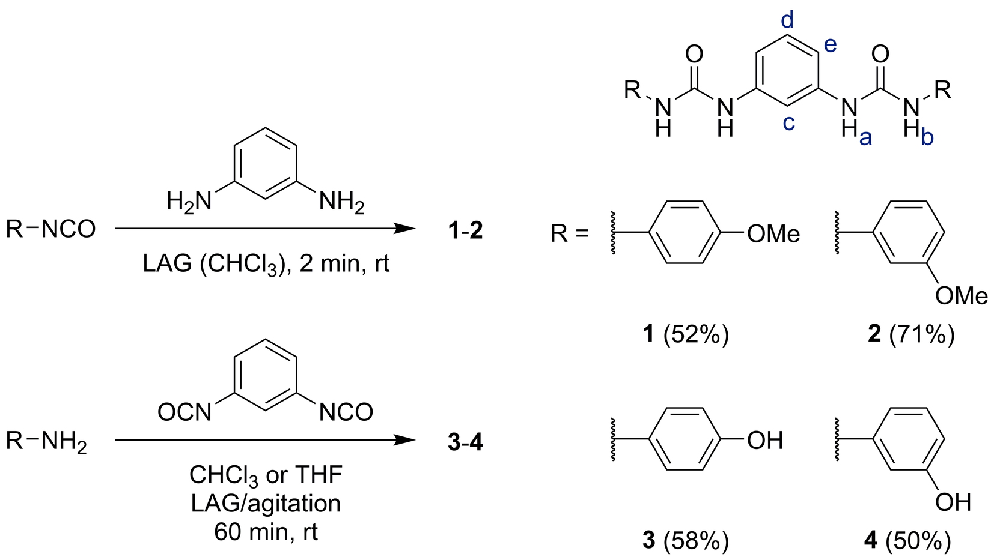
Scheme 1. Synthesis of compounds 1–4 used in this study to investigate the anion-binding properties and anion-templated self-assembly of the meta-phenylene bis(phenylurea) motif. Letters a–e indicate the protons of interest in the following ¹H NMR studies.

Solution-State Anion Binding Studies
Anion titrations were performed with receptors 1–4 to gain insight into the anion recognition process for this family of structures. The binding constants were determined by using non-linear regression analysis (see discussion below). Whilst compounds 3 and 4 could not be produced to the same degree of purity as 1 and 2 (as noted above), preliminary anion titrations were performed to complete the picture; the resulting values were largely in agreement with those obtained with hosts 1 and 2, with an exception in the case of the titration of compound 4 with phosphate. This titration could not be fit to the same 1:1, 1:2 host-guest stoichiometric model expected for this kind of design, and consequently, the anion binding was not investigated further due to the aforementioned concerns.

¹H NMR Titration of Receptors 1–4 with Dihydrogenphosphate To investigate the anion binding of 1–4, NMR titrations were carried out in competitive aprotic polar solvent (DMSO-d₆). Due to the nature of our design, where each receptor provides four hydrogen bonding donors, we anticipated that a variety of anions could be accommodated by such receptors, either as a simple 1:1 binding, or through the formation of higher order self-assemblies, such as where the anion coordination requirement is met by a 1:2 anion:receptor stoichiometry. To investigate this, we initially carried out titrations using TBA⁺ H₂PO₄⁻. The changes observed in the ¹H NMR spectrum are shown in Figure 1, and demonstrate significant changes in the chemical shifts of the resonances attributed to the urea protons (Ha, Hb), which were observed to increase in a monotonic and almost linear fashion during the addition of the first equivalent of anion (see Figure 1a, b). The aromatic resonance Hc was observed to move in a similar and opposite manner to the urea resonances (see Figure 1c).
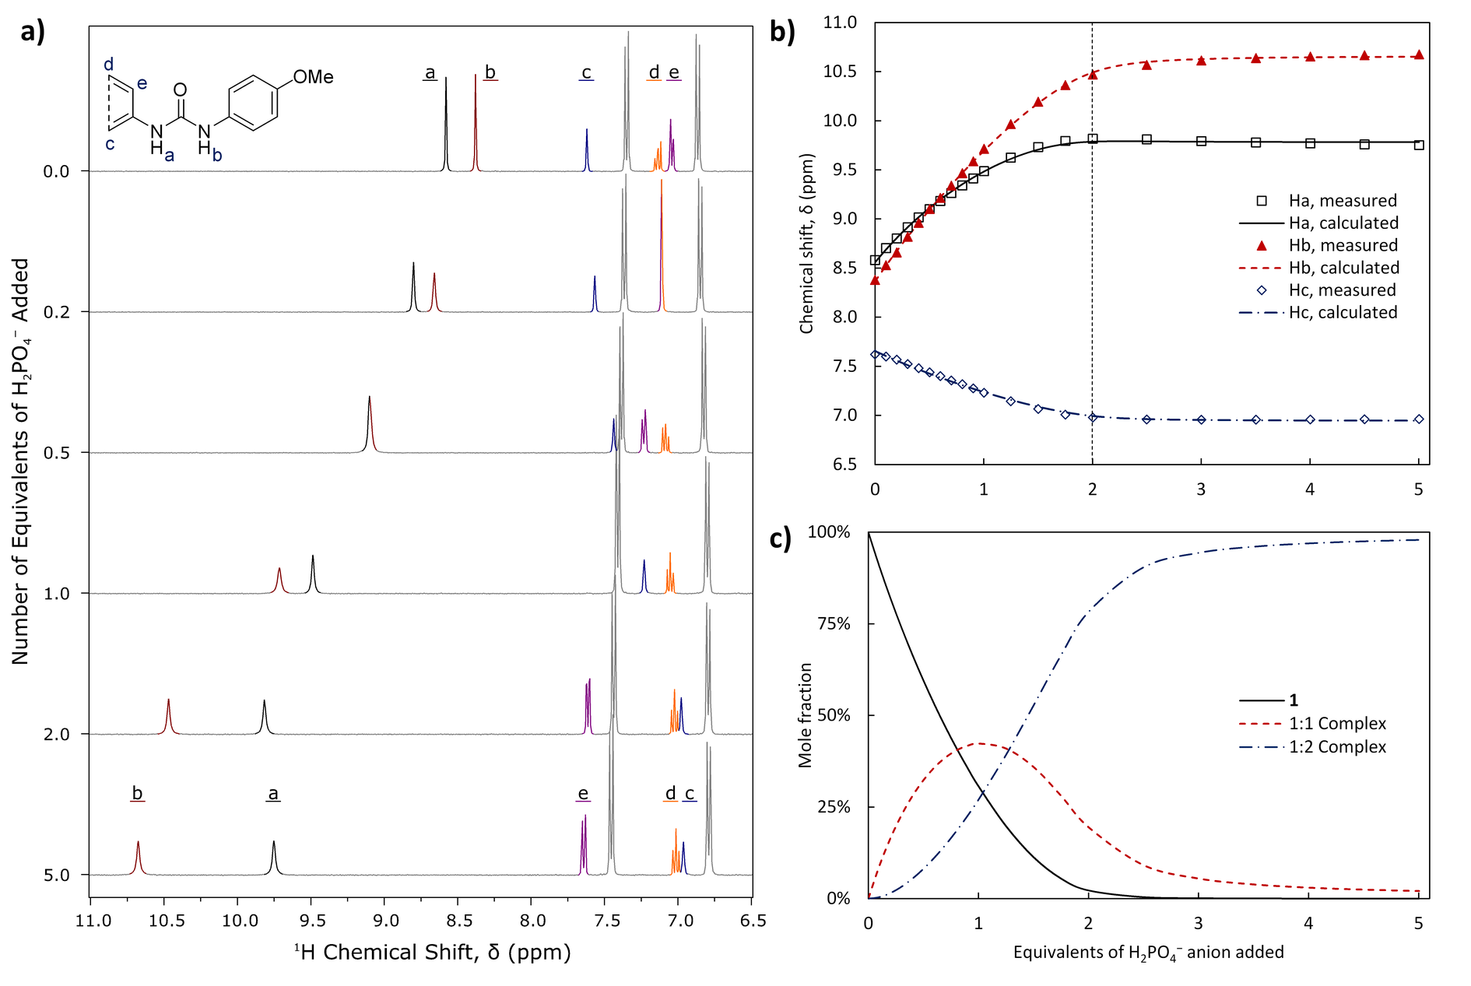
Figure 1. a) Selected spectra (6.5–11.0 ppm) from the titration of 1 with H₂PO₄⁻, with resonances of interest colored. b) Experimentally measured chemical shifts, (points) and calculated fit (lines) of resonances Ha–c of receptor 1. c) Speciation distribution diagram generated for from the fitting of the experimental data. The concentrations are presented as mole-percentage values relative to the total host concentration.
An inflection in each trend was observed between the addition of 1→2 equivalents of anion. The trends in chemical shift began to plateau, with more gradual changes observed in the region 2→5 equivalents. This consistent change in gradient at 2 equivalents for both resonances in all titrations was ascribed to the likely presence of a second binding equilibrium in solution. As such, each titration was fitted to a 1:1, 1:2 host-guest model, resulting in cumulative binding constants in the ranges logβ_{1:1} = 3.6–3.8 and logβ_{1:2} = 7.1–7.3 for receptors 1–2 (see Figure 1b and Table 1). The values of these constants for receptor 3 fell within the same range, supporting our hypothesis. As noted above, it was not possible to fit the data from the titration of receptor 4 with phosphate, to a combined 1:1, 1:2 host-guest binding model. Logarithmic binding constants could be obtained from a 1:1, 1:2, 1:3 host-guest binding model, however, these values were unrealistically large given the titration concentration.²⁹
Table 1. Cumulative Logarithmic Binding Constants, logβ_{1:1} and logβ_{1:2}, assuming both 1:1 and 1:2 Binding Modes as Determined from the Analysis of ¹H NMR Titrations in DMSO-d₆ at 298.2 K
Host | Binding mode, m:n | H₂PO₄⁻ |  | AcO⁻ |  | BzO⁻
 |  | logβ_{m:n} |  | logβ_{m:n} |  | logβ_{m:n}
1 ^{a)} | 1:1 | 3.74 | ± 0.11 | 3.54 | ± 0.23 | 3.18 | ± 0.12
 | 1:2 | 7.14 | ± 0.24 | 5.45 | ± 0.33 | 4.75 | ± 0.40
2 ^{a)} | 1:1 | 3.63 | ± 0.07 | 3.66 | ± 0.28 | 3.13 | ± 0.09
 | 1:2 | 7.24 | ± 0.07 | 5.86 | ± 0.49 | 4.88 | ± 0.13
3 ^{b)} | 1:1 | 3.77 | ± 0.29 | 3.43 | ± 0.06 | 3.37 | ± 0.06
 | 1:2 | 7.13 | ± 0.29 | 5.29 | ± 0.08 | 5.08 | ± 0.08
4 ^{b)} | 1:1 | ^{c)} |  | 3.40 | ± 0.07 | 3.00 | ± 0.10
 | 1:2 |  |  | 5.44 | ± 0.09 | 4.48 | ± 0.20
a) Association constants shown are averaged values, the errors shown are at the 95% confidence interval, b) Association constants are as calculated from a single fit, the associated errors are the “standard deviation” parameter reported by HYPNMR,³⁰ c) This titration could not be fit to a 1:1, 1:2 host-guest model. The TBA⁺ salts of each anion were used in all cases.
The relative magnitudes of the 1:1 and 1:2 binding constants imply a strongly cooperative process, perhaps aided by phosphate-phosphate hydrogen bonding. Such an interaction has been described in MeCN and DMSO, and in aqueous solution, ^{31,32} and is commonly observed in solid-state structures.³³ The cooperativity of a system may be quantified by the interaction parameter α = 4K_{1:2}/K_{1:1}, with values of α > 1 implying cooperative binding, α = 1 implying non-cooperative`binding, and α < 1 implying anticooperative binding.²⁹ As the program used herein reports values of logβ, in order to avoid the introduction of additional sources of error the logarithm of the parameter α will be used. Thus, logα is positive in the case of positive cooperativity, and negative in the case of negative cooperativity. In this system, the value of logα was found to be in the range 0.2–0.6 (see Table 2, and Figure S54 in the Supplementary Information). In a similar 1,2-trans-cyclohexyl derived system, weaker binding constants of logβ_{1:1} = 2.95 and logβ_{1:2} = 6.39 (averaged over both enantiomers) were reported for the 1:1 and 1:2 binding modes, respectively. The strongly cooperative binding in that system (logα = 1.1) was explained as a result of phosphate-phosphate hydrogen bonding, as had been observed in the crystalline phase.³⁴
Table 2: Logarithmic Cooperativity Parameters, logα, assuming both 1:1 and 1:2 Binding Modes as Determined from the Analysis of ¹H NMR Titrations in DMSO-d₆ at 298.2 K
Host | H₂PO₄⁻ |  | AcO⁻ |  | BzO⁻
 | logα |  | logα |  | logα
1 ^{a)} | 0.27 | ± 0.17 | -1.03 | ± 0.25 | -1.01 | ± 0.30
2 ^{a)} | 0.59 | ± 0.13 | -0.85 | ± 0.36 | -0.78 | ± 0.10
3 ^{b)} | 0.21 | ± 0.31 | -0.97 | ± 0.05 | -1.06 | ± 0.04
4 ^{b)} | ^{c)} |  | -0.75 | ± 0.06 | -0.91 | ± 0.05
a) Cooperativity constants shown are averaged values, the errors shown are at the 95% confidence interval, b) Cooperativity constants are as calculated from a single fit, the associated errors are as propagated from the “standard deviation” parameter and covariance reported by HYPNMR,²⁹ c) This titration could not be fit to a 1:1, 1:2 host-guest model.

¹H NMR Titration of Receptors 1–4 with Acetate In contrast to the behavior shown by receptors 1–4 towards H₂PO₄⁻, above, upon titration with AcO⁻ the chemical shifts of the resonances Ha and Hb increased monotonically; with no inflection or other evidence from these trends of a 1:2 host-guest complex (Figure 2a). This is not surprising, as AcO⁻ would be expected to bind through a planar or linear manner, unlike the tetrahedral H₂PO₄⁻ anion. Non-linear regression analysis with a 1:1 host-guest binding model afforded binding constants of logβ_{1:1} = 2.4 (see Table 3). These constants are low for urea-based receptors: Kadam et al. determined a value of 3.3 for diphenylurea in DMSO-d₆/water (99.5:0.5), with logβ_{1:1} being in the range 2.5–4.9 for other aryl-substituted ureas.³⁵ Casula et al. reported binding constants in the range logβ = 3.1–3.9 for asymmetric phenylene bis(arylureas), with the corresponding meta isomer having the lowest binding affinity for acetate.²⁶
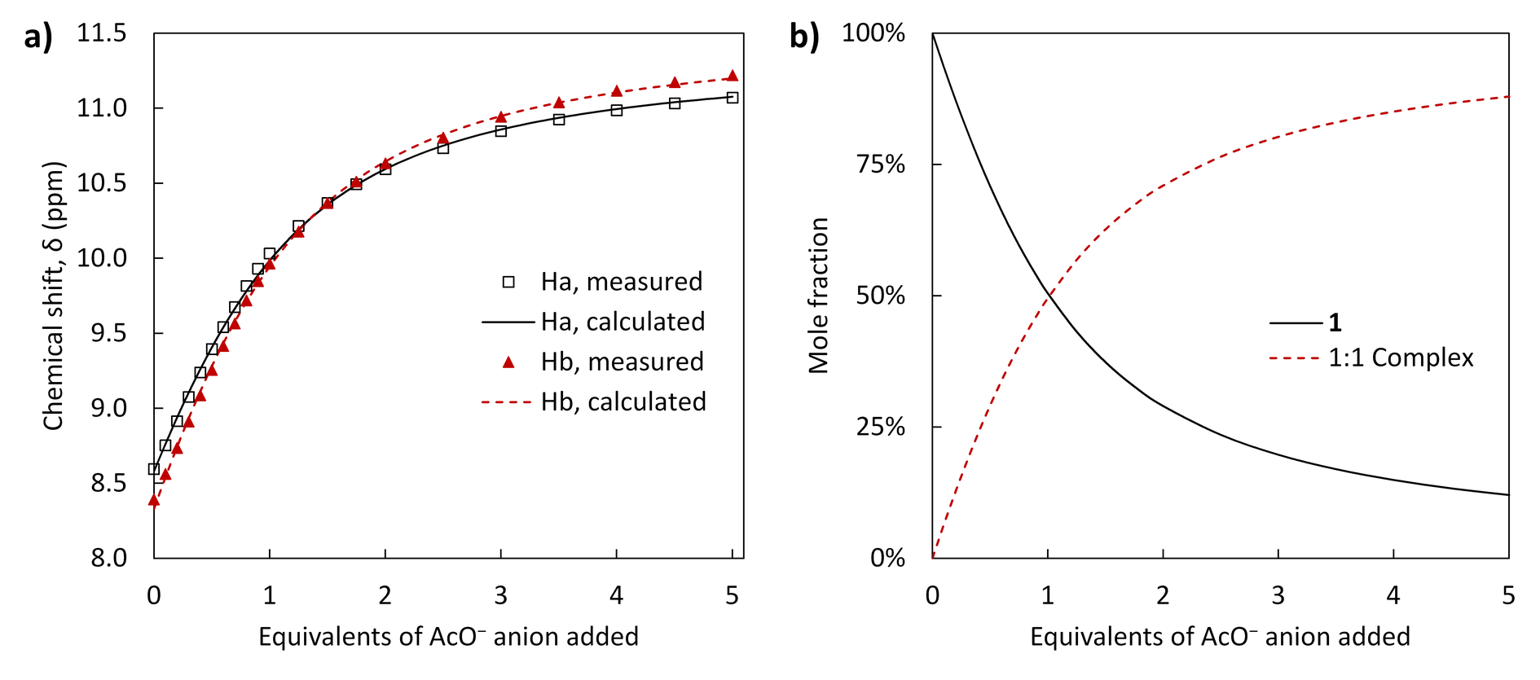
Figure 2. a) Experimentally measured chemical shifts (points) and calculated fit (lines) of resonances Ha and Hb of receptor 1, as fitted to a 1:1 binding model. b) Speciation diagram of this fit. The concentrations are presented as mole-percentage values relative to the total host concentration.
Table 3. Logarithmic Binding Constants, logβ_{1:1}, assuming a 1:1 Binding Mode Only as Determined from the Analysis of ¹H NMR Titrations in DMSO-d₆ at 298.2 K
Host | AcO⁻ |  | BzO⁻ |  | Cl⁻ |  | SO₄²⁻ |  | HSO₄⁻ ^{b)}
 | logβ_{1:1} |  | logβ_{1:1} |  | logβ_{1:1} |  | logβ_{1:1} |  | logβ_{1:1}
1 ^{a)} | 2.43 | ± 0.06 | 2.33 | ± 0.06 | 1.67 | ± 0.08 | 1.06 | ± 0.62 | 0.52 | ± 0.05
2 ^{a)} | 2.44 | ± 0.14 | 2.36 | ± 0.03 | 1.67 | ± 0.10 | 0.92 | ± 0.19 | 1.43 | ± 0.03
3 ^{b)} | 2.39 | ± 0.01 | 2.31 | ± 0.01 | 1.64 | ± 0.02 | 1.15 | ± 0.03 | 0.39 | ± 0.06
4 ^{b)} | 2.49 | ± 0.01 | 2.38 | ± 0.01 | n.d. ^{c)} |  | n.d. ^{c)} |  | n.d. ^{c)}
a) Association constants shown are averaged values (except for in the case of the HSO₄⁻ titrations), the errors shown are at the 95% confidence interval, b) Association constants are as calculated from a single fit, the associated errors are the “standard deviation” parameter reported by HYPNMR,²⁹ c) Not determined. The TBA⁺ salts of each anion were used in all cases.
In that and other works, the ortho-phenylene bis(phenylurea) receptor displayed especially strong binding, whereby one carboxylate anion forms hydrogen bonds to all four NH donors.¹⁷ A similar saturation of all hydrogen bonding donors in the meta system by a single carboxylate ion is improbable, as the receptor binding site is not concave in shape and the outermost nitrogen atoms are more distant from each other. This would leave part of the receptor available for binding to a second anion.
While there was no evidence of a 1:2 host-guest complex in the trends of the NH resonances, such evidence came instead from the trends observed in the Hc resonances of each host, whereby the chemical shifts decreased up to the addition of 1 equivalent of TBA⁺ AcO⁻, at which point an upward inflection (Figure 2b, indicative of an intermediate species, compare Figures 3a, 3b) followed by a gentle plateau was observed (Figure 2b). Fitting the data from all three resonances afforded binding constants of logβ_{1:1} = 3.5–3.7 and logβ_{1:2} = 5.4–5.9 (see Table 1). This fit also appears to suggest a strongly negative cooperative interaction, with logα between −1.1 and −0.8 (see Table 2) for receptors 1–2. Similar values were determined for the phenolic receptors 3 and 4.
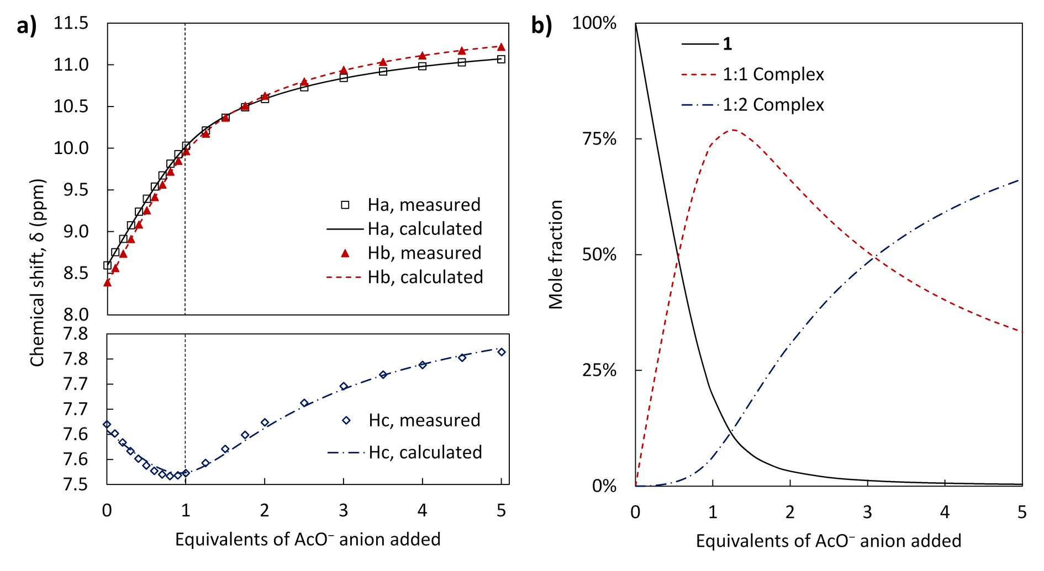
Figure 3. a) Experimentally measured chemical shifts, δ, (points) and calculated fit (lines) of resonances Ha–c of receptor 1, as fitted to a 1:1, 1:2 binding model. b) Speciation diagram of this fit. The concentrations are presented as mole-percentage values relative to the total host concentration.
¹H NMR Titration of Receptors 1–4 with Benzoate In the titrations with TBA⁺ BzO⁻, the traces of the urea resonances follow a largely similar trend to that observed with the AcO⁻ anion, above. The aromatic resonance Hc, meanwhile, followed a sigmoidal trend with positive curvature up to the addition of 1.5 equivalents of anion, and a negative curvature thereafter. A larger overall change in chemical shift was observed for each receptor. Non-linear regression analysis of these trends demonstrated that benzoate interacted in a similar manner to the acetate anions. As above, both the simple 1:1, and mixed 1:1/1:2 binding models were applied to the data from each titration (see Figure 4). The logβ_{1:1} values obtained by non-linear regression analysis of the benzoate titrations are in the range 2.3–2.4 (see Table 3). Once again, the logβ_{1:1} values may be compared to the series of aryl-substituted urea receptors reported by Kadam et al. The binding for compounds 1–4 (2.3–2.4) appears to be relatively weak, and at the lower end of the scale reported in the literature (2.1–4.1).³⁵ While in that work the binding for the benzoate anion is weaker than for the acetate anion (by 0.3 log units or more), the 1:1 binding constants for 1–4 are equivalent within error. The ranges of logβ_{1:1} and logβ_{1:2} values obtained with a combined 1:1/1:2 host-guest binding model are 3.1–3.2 and 4.7–4.9, respectively (see Table 1). The logarithmic cooperativity parameters indicated a similar degree of anticooperativity to the above acetate titrations, with logα between −1.1 and −0.7 for receptors 1–4 (see Table 2).

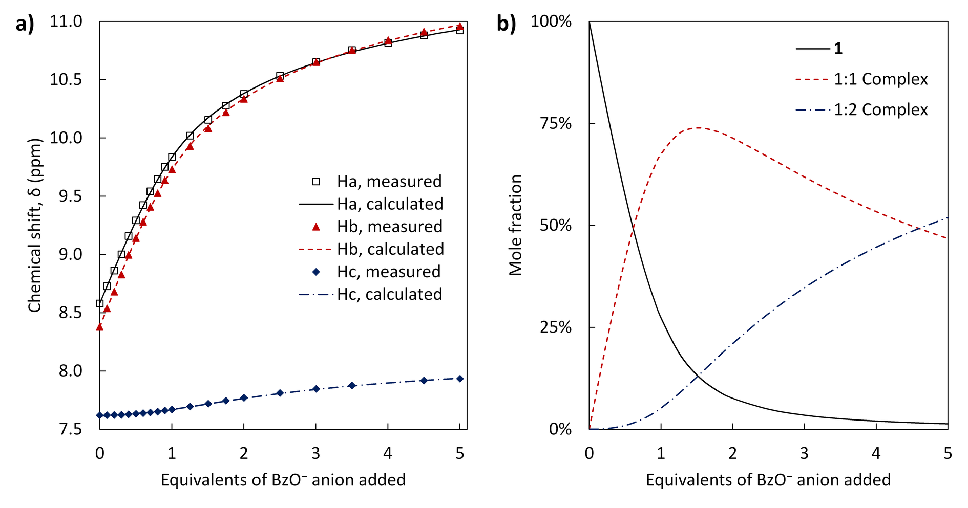
Figure 4. a) Experimentally measured chemical shifts, δ, (points) and calculated fit (lines) of resonances Ha–c of receptor 1, as fitted to a 1:1, 1:2 binding model. b) Speciation diagram of this fit. The concentrations are presented as mole-percentage values relative to the total host concentration.
¹H NMR Titration of Receptors 1–2 with Chloride Small monotonic changes in chemical shift of less than 0.50 ppm were observed for each proton resonance over the addition of 5 equivalents of TBA⁺ Cl⁻. These titrations were fitted to 1:1 models only as there was no evidence of other stoichiometries. The results obtained by non-linear regression analysis for receptors 1 and 2 are equivalent, with logβ_{1:1} = 1.67 (see Table 3). This is comparable to similar ortho-phenylene receptors, which have logβ values in the range 1.1–1.6,³⁶ but recent electron-poor Cl⁻ transporters based on that motif possess higher logβ_{1:1} values at ~ 2.2.³⁷
¹H NMR Titration of Receptors 1–2 with Sulfate and Bisulfate Titrations with TBA⁺ SO₄²⁻ and HSO₄⁻ show small monotonic changes in chemical shift of less than 0.25 ppm for the urea resonances up to the addition of 5 equivalents of anion, with little to no curvature observed in this trend. A greater curvature was noted in the case of the aromatic resonance Hc. Non-linear regression analysis produced logβ_{1:1} of 0.9–1.0 for SO₄²⁻ and 0.5–1.4 for HSO₄⁻ (see Table 3). The values of logβ_{1:1} should be viewed with some caution, due to poor fitting of the CH resonances, the lack of a curvature in the urea resonances, small overall change in chemical shift and the expected binding affinities for these anions. It must also be noted that only preliminary titrations were performed with the HSO₄⁻ salt. These values would indicate that 1–2 show a much lesser affinity for the strongly solvated sulfates compared to H₂PO₄⁻, BzO⁻ and AcO⁻. This is unsurprising as hydrogen bond based receptors are generally expected to bind the HSO₄⁻ anion least strongly of the anions studied.^{27,28} In a similar study, the value of logβ_{1:1} for HSO₄⁻ binding by ortho-phenylene bis(phenylurea) was determined to be less than 1.³⁶ However, more preorganized motifs bearing three urea,^{38b,39} or ortho-phenylene diurea arms bind SO₄²⁻ much more strongly, with logβ_{1:1} for the latter in the range 5.5–5.9 ⁴⁰
Structural Studies in the Crystalline Phase As the ¹H NMR titrations of 1–4 showed stronger interactions with AcO⁻ and H₂PO₄⁻, co-crystallizations with these anions were considered. While the urea hosts 1–4 are poorly soluble in suitable crystallization solvents, they may be solubilized in CHCl₃, MeCN and EtOAc by the addition of excess AcO⁻ anion. Therefore, it must be noted that both the crystals of 1(TBAOAc)₂⋅3H₂O and 2₃(TBA₃H₃P₂O₈)⋅0.5CHCl₃ discussed below could only be prepared very sporadically as a product from a large excess of the mixed TBA salts, given the multitude of complex equilibria at play in such mixtures. As such, the structural data below are not intended as exhaustive descriptions of the binding modes available to these hosts, nor as supporting evidence of the binding models established by the solution studies (being prepared under different conditions). Rather, these data are provided as experimentally determined “snapshots”, purely to visualize two of the many potential binding modes available to these hosts when crystallization is added as a further driving force to those equilibria.
X-ray Crystallographic Analysis of 1(TBAOAc)₂⋅3H₂O The para-substituted derivative 1 was dissolved in a boiling mix of CHCl₃ and EtOAc in the presence of an excess of AcO⁻ and H₂PO₄⁻ as their TBA⁺ salts. The solution was filtered hot and small thin colorless crystals of 1(TBAOAc)₂⋅3H₂O were obtained by slow evaporation of the solvent; in some instances, this was accompanied by various TBA OAc salts, hydrates and adducts.
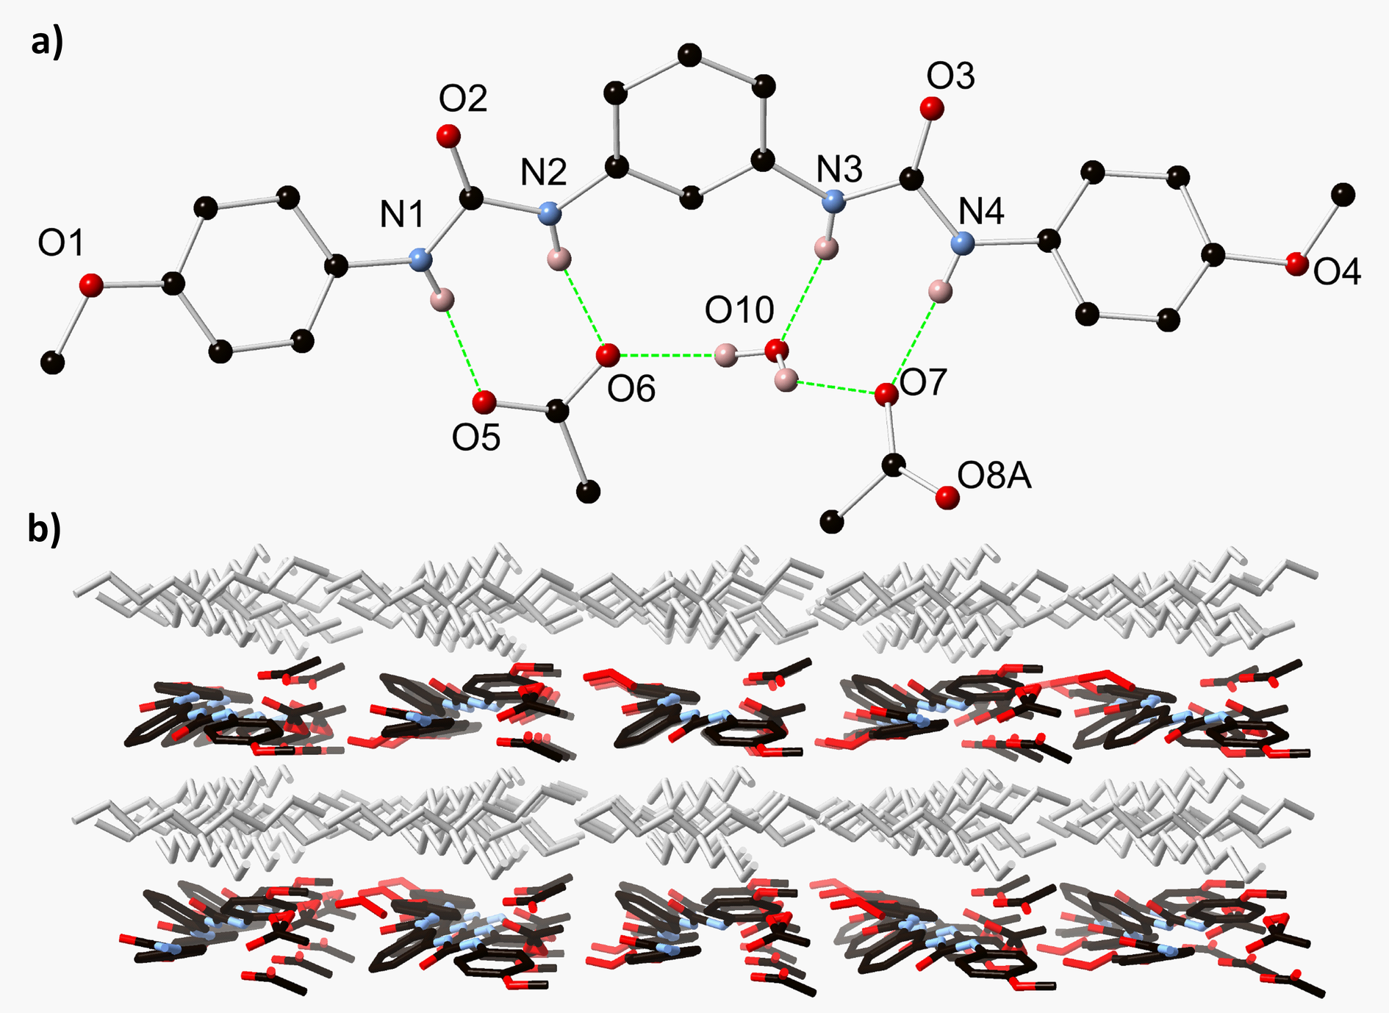
Figure 5. a) Hydrogen bonding environment of the host species within the structure of 1(TBAOAc)₂·3H₂O with heteroatom labelling scheme. Hydrogen atoms not involved in hydrogen bonding, tetrabutylammonium cations and disordered solvent molecules omitted for clarity; b) Extended structure of 1(TBAOAc)₂·3H₂O showing alternating layers of tetrabutylammonium cations (gray) and anionic host-anion layers (colored).
A crystal of 1(TBAOAc)₂⋅3H₂O was analyzed by single crystal X-ray diffraction, the diffraction data were solved and the model refined in the monoclinic space group Cc. Exhaustive searches were made for higher symmetry space groups, particularly the ubiquitous C2/c; although approximate twofold symmetry is present when considering the tetrabutylammonium cations and 1 molecules, the non-symmetric arrangement of the acetate and water species prohibits a precise C2/c setting. The asymmetric unit of 1(TBAOAc)₂⋅3H₂O contains one molecule of 1 in an acentric planar conformation, two acetate anions and associated tetrabutylammonium cations, two full-occupancy water molecules, and one disordered water molecule split across three sites. One of the two acetate moieties displayed minor rotational disorder and was modeled over two related orientations. The hydrogen bonding interactions in 1(TBAOAc)₂⋅3H₂O are largely centered on the interaction of one molecule of 1 with two acetate anions, bridged by a water molecule (Figure 5a). One acetate anion is bound in the well-known $R_{2}^{2}$(8) hydrogen bonding motif with a urea group,⁴¹ with N···O distances 2.795(8) and 2.842(9) Å and N−H···O angles 166.6(4) and 166.0(4)° for N1−H1···O5 and N2−H2···O6, respectively. The second acetate anion interacts with the remaining urea group via a single hydrogen bond, with the second potential interaction interrupted by the presence of a lattice water molecule O10, which donates a hydrogen bond to the acetate group and accepts a hydrogen bond from the inner urea N−H group, forming a cyclic assembly described by the $R_{2}^{3}$(8) graph set. The two distinct hydrogen bonding environments involving the urea groups are further linked by hydrogen bonding from the lattice water molecule O10 to acetate oxygen atom O6, defining a further cyclic $R_{2}^{3}$(10) motif edge-sharing with the two urea environments. Additional hydrogen bonding in the structure of 1(TBAOAc)₂⋅3H₂O involves the remaining lattice water molecules; the well-defined water molecule O9 bridges adjacent 1-acetate adducts through interactions with the acetate oxygen atom O5 and the urea oxygen atom O3 from an adjacent molecule of 1. Although individual hydrogen atoms could not be assigned to the disordered water sites, their proximity to the disordered acetate anion suggests additional hydrogen bonding interactions are likely. The extended structure of 1(TBAOAc)₂⋅3H₂O consists of alternating anionic [1⋅2OAc⋅3H₂O]²⁻ layers and cationic tetrabutylammonium layers, each extended in the ac plane (Figure 5b). No significant discrete interactions are visible between the cationic and anionic groups, and no π-π interactions were evident between molecules of 1.
X-ray Crystallographic Analysis of the Triple Stranded Helicate 2₃(TBA₃H₃P₂O₈)⋅0.5CHCl₃ The 3′-methoxy substituted derivative 2 was dissolved in a boiling mixture of CHCl₃ and EtOAc in the presence of an excess of AcO⁻ and H₂PO₄⁻ as their TBA⁺ salts. The orange solution was filtered hot and crystals of 2₃(TBA₃H₃P₂O₈)⋅0.5CHCl₃ were obtained by slow evaporation of the solvent. Despite exhaustive efforts, and owing to the practical difficulties described above, we were unable to optimize or repeat this crystallization process for larger-scale preparations.
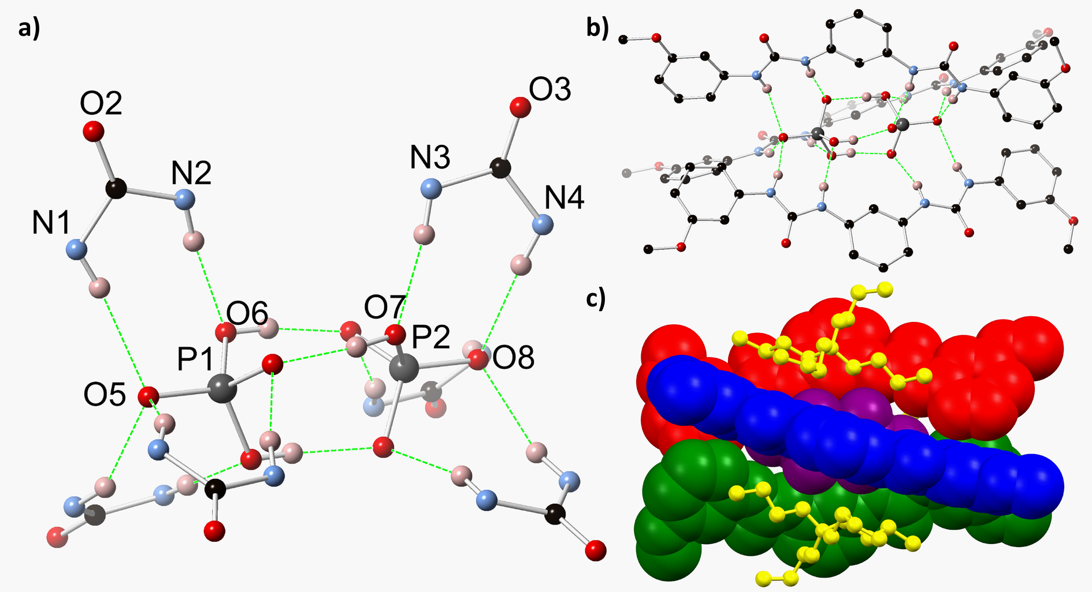
Figure 6. a) Hydrogen bonding environment within the structure of 2₃(TBA₃H₃P₂O₈)⋅0.5CHCl₃ with heteroatom labelling scheme, showing the encapsulation of the (HPO₄)(H₂PO₄) moiety by six urea groups. Phosphate hydrogen atoms shown in representative positions; b) Complete structure of the anionic assembly in the structure of 2₃(TBA₃H₃P₂O₈)⋅0.5CHCl₃. Selected hydrogen atoms are omitted for clarity, and phosphate hydrogen atoms are shown in representative positions. c) Interaction of tetrabutylammonium anions (yellow) with the external grooves of the anionic assembly in the structure of 2₃(TBA₃H₃P₂O₈)⋅0.5CHCl₃. Individual host molecules and central anionic moiety colored separately.
A crystal of 2₃(TBA₃H₃P₂O₈)⋅0.5CHCl₃ was analyzed by single crystal X-ray diffraction, the data were solved and the model refined in the rhombohedral space group R3c. The asymmetric unit contains one complete molecule of 2 in a planar acentric conformation, one tetrabutylammonium cation, a chloroform molecule overlapping the threefold axis with chemical occupancy of ½, and fragments of two phosphate-derived anionic species. Expansion of the structure through crystallographic symmetry elements reveals a complete assembly containing three equivalent molecules of 2 encapsulating two anions, with three accompanying tetrabutylammonium cations (Figure 6). Charge balance considerations require a total charge of 3⁻ for the dimeric anionic species, implying the presence of three protons per (PO₄)₂ moiety. The two phosphate groups share three crystallographically equivalent sites of hydrogen bonding, defined by a short O···O distance of 2.579(3) Å (Figure 6,a). Commensurate with the overall crystallographic symmetry and expected chemical formula of (H₂PO₄)(HPO₄), both oxygen atoms O6 and O7 were assigned riding hydrogen atoms at half occupancy, as a representation of the averaged configuration throughout the entire structure. The development of helicates from anions is relatively rare (particularly in comparison to the development of helicates from metal ions such as d- and f-metal ions), with some recent examples having been reported by Wu and co-workers¹⁸⁻²⁰.⁴² The phosphate adduct closely resembles that observed by Burns and coworkers in a related system, in which a (H₂PO₄)₂ dimer lies encapsulated within the cavity of a tetra(urea)-substituted porphyrin, receiving seven hydrogen bonds from the surrounding urea groups.⁴³ The (H₂PO₄)(HPO₄) moiety presented is found in two structures reported by Didio et al.^{44a} and Zhang et al. ^{44b}, respectively. In each a bis- or tris(urea) molecule hydrogen bonds to the ends of the dimer, but neither of these associated organic molecules encapsulate the anions. The structure also bears a strong resemblance to several adducts reported by Das and coworkers: those barrels consist of three or four molecules of a derivative of the meta-phenylene bis(phenylurea) scaffold around carbonate and sulfate cores, although these lacks the helical manner of the structure presented in this work.^{23,24}
The three molecules of 2 are arranged around each H₃P₂O₈ group in a triple-stranded helical fashion, with the helical axis aligned with the crystallographic threefold axis in the [0,0,1] direction. The encapsulated anions are supported by a series of hydrogen bonding interactions originating from the urea groups of 2. The terminal oxygen atoms of each phosphate residue O5 and O8 each accept three symmetry-equivalent hydrogen bonds from the outermost urea nitrogen atoms N1 and N4, respectively, with N···O distances 3.117(4) and 3.029 Å, and N−H···O angles 153.8(2) and 164.2(2)°, respectively. In addition to the O−H···O interactions supporting the two phosphate groups, each of the six central oxygen atoms accepts one hydrogen bond from the inner urea N−H groups, with N···O distances 2.892(4) and 2.896(5) Å and N−H···O angles 173.2(2) and 161.9(2)° for N3−H3···O7 and N2−H2···O6, respectively. The tetrabutylammonium cations associate with the outer grooves of the adduct, with two of the four butyl groups on each cation aligned parallel to the long axis of each molecule of 2 and interacting with the adduct via a series of C−H···π interactions. With the tetrabutylammonium cations occupying the interstitial regions, no substantial intermolecular interactions are observed between adjacent helicates in the structure of 2₃(TBA₃H₃P₂O₈)⋅0.5CHCl₃, and no void space or additional guest molecules were detected.
The crystalline product 2₃(TBA₃H₃P₂O₈)⋅0.5CHCl₃ was produced in sufficient quantities to perform analysis via powder FT-IR and ¹H NMR spectroscopy. In comparison to the solid host (2), the FT-IR spectrum of the above crystalline material shows suppression and broadening of the N−H stretching bands (3400–3150 cm⁻¹), and a shift in the C=O stretching frequency from 1635 to 1698 cm⁻¹ (see Supplementary Information, Figure S61), which has been noted for ureas bound to such hydrogen bonding acceptor molecules in the solid state.⁴⁵ The helicate assembly was observed by ¹H NMR to degrade upon contact with CDCl₃ (see Supplementary Information, Figure S60), due to the slow leaching of the phosphate salts into solution in a greater proportion to receptor 2, which remained as a white powder. ¹H NMR in DMSO-d₆ showed the urea resonances to be shifted significantly more (Δδ ≤ 2.5 ppm) with regards to the host (2) than at 0.7 eq. H₂PO₄⁻ in the corresponding titration (see Supplementary Information, Figure S58–S59), due to the stronger interacting HPO₄²⁻ ions present in the anionic assembly over the H₂PO₄⁻ ions used in the titration. Thus, while the H₂PO₄⁻ anion is known to form dimers in a ‘monodentate’ and a less abundant ‘bidentate’ form in solution,³¹ we do not expect discrete helicates of the type described above to assemble spontaneously within solutions containing salts of the H₂PO₄⁻ ion alone.

DISCUSSION
The similar values of cooperativity constants in the cases of AcO⁻ and BzO⁻ binding suggest that the manner of binding of these ions is not dependent on their steric bulk. As these are anti-cooperative processes, it is postulated that there is either a non-steric interaction (i.e. electrostatic) between the binding anions, or that host-guest complex can adopt an alternate, less favored, conformer to which the second anionic guest molecule may bind. In comparison, the positive cooperativity observed with H₂PO₄⁻ leads to a binding, which is stronger than with AcO⁻. This contrasts with a series previously derived for mono-urea based anion receptors, in which phosphate was bound less strongly than the carboxylates (AcO⁻ > BzO⁻ > H₂PO₄⁻ > HSO₄⁻).⁴⁶ These positive cooperativity constants imply that phosphate-phosphate hydrogen may occur at the binding site, allowing for two anions to be simultaneously bound by the receptor more easily. As noted above, such phosphate-phosphate binding is well known to occur in solution.^{30,31}
While it appears that the meta isomers 2 and 4 show differing binding strengths and cooperativities for H₂PO₄⁻, BzO⁻ and AcO⁻, the associated errors are too large to draw any conclusions. Indeed, no meaningful correlation between the calculated binding affinities and the relevant Hammet values can be observed (see Supplementary Information, Figure S55). While the values of logβ_{1:1} and logβ_{1:2} appear to be lower for receptors 2 and 4, it must also be noted that the values calculated for the 1:1 fits are equivalent to or slightly higher than the values for the corresponding para-substituted receptors.
From the titration data the importance of considering the behavior of all protons in the vicinity of the binding site can also be seen. While there are strong indications that the meta-phenylene bis(phenylurea) motif interacts with carboxylate anions in a 1:2 host-guest binding mode, this is only evident by considering the central aromatic proton Hc in the analysis. In our view this provides a much more convincing probe for studying the solution-state association processes of these systems, as well as giving a spectroscopic handle which is less sensitive to pH. Nevertheless, to ensure comparability to the 1:1 binding constants reported for similar receptors in the literature it was necessary to analyze 1–4 in the context of a purely 1:1 host-guest binding model.

CONCLUSION
Herein, we have presented a family of neutral electron-rich meta-phenylene bis(phenylurea) receptors and investigate their anion-binding ability, complementing research performed on electron-poor urea receptors. The binding affinities of receptors 1–4 to several common anions of various geometries have been determined by non-linear regression analysis of ¹H NMR trends in the solution-state. Evidence of 1:2 host-guest binding was observed for the H₂PO₄⁻, AcO⁻, BzO⁻ anions, and cooperativity parameters derived to elucidate the processes occurring at the binding site. The acetate binding is anti-cooperative, and in comparison to similar urea-based receptors in the literature appears relatively weak.⁴² Meanwhile the phosphate binding is the strongest of those studied in this work. The binding process is cooperative, and may be due to phosphate-phosphate hydrogen bonding at the receptor. A much lower affinity for Cl⁻, HSO₄⁻ and SO₄²⁻ anions was observed. Attempts at producing solid state adducts of 1 and 2 with phosphate and acetate anions led to the discovery of a new helicate centered on a mixed-phosphate core. This adds to a somewhat limited set of anion-based helicates present in the literature. We envisage that this work will help drive further research in designed urea-based receptors, including those that take advantage of phosphate dimerization, and stress the need to look beyond the protons of the hydrogen-bonding moiety in the binding site in determining binding behavior. We are in the process of exploring this, and the potential of the use of anions in general, to direct the formation of supramolecular self-assemblies in solution.

EXPERIMENTAL SECTION

General Experimental Details
All solvents and chemicals were purchased from commercial sources and used without further purification. Mass-spectrometry was carried out using HPLC grade solvents using electrospray mass spectrometry (ESI). High resolution ESI mass spectra were determined relative to a standard of leucine enkephalin. Infrared spectra were recorded on a Perkin Elmer Spectrum One FT-IR spectrometer fitted with a universal ATR sampling accessory. Melting points were determined using an Electrothermal IA9100 digital melting point apparatus. Elemental analysis was carried out at the UCD School of Chemistry Microanalytical Laboratory, University College Dublin. ¹H NMR spectra were recorded at 400 MHz on a Bruker Avance III 400 NMR or Agilent 400-MR, or at 600 MHz on a Bruker Avance II 600 NMR. ¹³C NMR spectra were recorded at either 150.9 MHz or 100.6 MHz. All ¹³C NMR spectra were decoupled from ¹H. Deuterated solvents used for NMR analysis (DMSO-d₆, CDCl₃) were purchased and used as received. Chemical shifts are reported in ppm with the residual solvent as internal reference, while 2D spectra were graphically referenced. All NMR spectra were carried out at 25.0 °C.
¹H NMR Titration Experiments ¹H NMR titration experiments were performed in DMSO-d₆ at 25.0 °C on a 400 MHz Bruker Avance III 400 NMR spectrometer. A Norrell 507-HP NMR tube was charged with 0.8 mL of a 7.0 mM solution of the host being studied and the ¹H NMR spectrum obtained. Sequential additions of a 0.28 M stock solution in DMSO-d₆ of the appropriate TBA⁺ salt were performed in 2–20 μL aliquots with a Gilson P20 pipette.
Single-crystal X-ray Crystallography Crystal and refinement data are presented in Table S40, Supplementary Information. CCDC 1840843-1840844. All datasets were collected on a Bruker APEX-II Duo dual-source instrument using Mo Kα (λ = 0.71073 Å) using ω and φ scans. Single crystals were mounted on Mitegen micromounts in NVH immersion oil, and maintained at a temperature of 100 K using a Cobra cryostream. The diffraction data were reduced and processed using the Bruker APEX suite of programs.⁴⁷ Multi-scan absorption corrections were applied using SADABS.⁴⁸ The data were solved using the Intrinsic Phasing routine in SHELXT and refined with full-matrix least squares procedures using SHELXL-2015 within the OLEX-2 GUI.⁴⁹⁻⁵¹ All non-hydrogen atoms were refined with anisotropic displacement parameters. All hydrogen atoms were placed in calculated positions and refined with a riding model, with isotropic displacement parameters equal to either 1.2 or 1.5 times the isotropic equivalent of their carrier atoms, unless involved in hydrogen bonding, in which case atoms were explicitly located from the Fourier residuals (where possible). Specific collection and refinement strategies, and treatment of the disorder in 1(TBAOAc)₂⋅3H₂O, are further outlined in the combined crystallographic information file (cif) under the _refine_special_details heading.

Synthesis and Characterization
1,3-Phenylene-bis(3-(4′-methoxyphenyl)urea) (1) meta-Phenylene diamine (56 mg, 0.52 mmol) and 4-methoxyphenyl isocyanate (0.15 mL, 1.2 mmol, 2.2 eq.) were ground together and CHCl₃ (5 mL) added as a solvent. The resulting white slurry was diluted with MeOH (10 mL), sonicated, separated by centrifugation and the process repeated with MeOH (5×10 mL) and MeCN (3×10 mL). Compound 1 was obtained as a white powder in 52% yield (110 mg, 2.7 mmol). mp 294 °C dec. HRMS–ESI (m/z): [M + H]⁺ calcd for C₂₂H₂₃N₄O₄, 407.1714; found 407.1718. ¹H NMR (600 MHz, DMSO-d₆, δ) 8.58 (s, 2H, NH, Ha), 8.38 (s, 2H, NH, Hb), 7.62 (t, J = 2.0 Hz, 1H, Hc), 7.41–7.29 (m, 4H, H2′), 7.14 (dd, J = 8.8, 7.2 Hz, 1H, Hd), 7.04 (dd, J = 7.5, 2.0 Hz, 2H, He), 6.93–6.80 (m, 4H, H3′), 3.72 (s, 6H, CH₃). ¹³C NMR (151 MHz, DMSO-d₆, δ) 154.5 (quat., C4′), 152.7 (quat., C=O), 140.3 (quat., C−N), 132.8 (quat., C−N, C1′), 129.1 (Cd), 120.0 (C2′), 114.0 (C3′), 111.5 (Ce), 107.7 (Cc), 55.2 (CH₃). FTIR (ATR, powder) ν_{max} (cm⁻¹): 3301 (m, N−H str.), 1638 (s, C=O str.), 1599 (m), 1560 (s, N−H vib.), 1510 (s), 1491 (s), 1403 (m), 1298 (m), 1218 (s, C-O str.), 1180 (m, N−C−N str.), 1108 (w), 1033 (m, C-O str.), 878 (w), 834 (m), 799 (m), 772 (m), 754 (m), 722 (m), 707 (m). Anal. calcd for C₂₂H₂₂N₄O₄: C, 65.01; H, 5.46; N, 13.78. Found: C, 64.96; H, 5.49; N, 13.83.
1(TBAOAc)₂⋅3H₂O The 4′-methoxy substituted derivative 1 was dissolved in a boiling mix of CHCl₃ and EtOAc in the presence of excess TBA⁺ AcO⁻ and H₂PO₄⁻. The solution was filtered while hot and small thin white crystals of 1(TBAOAc)₂⋅3H₂O were obtained by slow evaporation of the solvent. This material was then recrystallized from MeCN to yield crystals of a higher quality.
1,3-Phenylene-bis(3-(3′-methoxyphenyl)urea) (2) An alternate synthesis and the complete characterization of compound 2 has been previously reported.⁵² meta-Phenylene diamine (53 mg, 0.49 mmol) and 3-methoxyphenyl isocyanate (0.15 mL, 1.1 mmol, 2.3 eq.) were ground together and CHCl₃ (5 mL) added as a solvent. The resulting white slurry was diluted with MeOH (10 mL), sonicated, separated by centrifugation and the process repeated with MeOH (5×10 mL) and MeCN (3×10 mL). Compound 2 was obtained as a white powder in 71% yield (141 mg, 0.35 mmol). mp 276 °C dec. (lit. 294–297 °C) HRMS–ESI (m/z): [M + H]⁺ calcd for C₂₂H₂₃N₄O₄, 407.1714; found 407.1725. ¹H NMR (400 MHz, DMSO-d₆, δ): 8.68 (s, 2H, NH, Ha), 8.59 (s, 2H, NH, Hb), 7.66 (t, J = 1.8 Hz, 1H, Hc), 7.23–7.12 (m, 5H, Hd, H5′, H2′), 7.06 (dd, J = 8.1, 1.5 Hz, 2H, He), 6.91 (dd, J = 8.0, 1.2 Hz, 2H, H6′), 6.55 (dd, J = 8.1, 2.2 Hz, 2H, H4′), 3.73 (s, 6H, CH₃). ¹³C NMR (101 MHz, DMSO-d₆, δ): 159.8 (quat.), 152.4 (quat.), 141.0 (quat.), 140.1 (quat.), 129.6 (CH, C5′), 129.2 (CH, Cd), 111.8 (CH, Ce), 110.5 (CH, C6′), 107.9 (CH, Cc), 107.3 (CH, C4′), 103.9 (CH, C2′), 55.0 (CH₃). FTIR (ATR, powder) ν_{max} (cm⁻¹): 3274 (m, N-H str.), 1635 (s, C=O str.), 1600 (m), 1560 (s, N−H bend), 1490 (m), 1464 (m), 1402 (m), 1290 (m), 1269 (m), 1208 (m), 1167 (m, N−C−N str.), 1155 (m, N−C−N str.), 1080 (w), 1035 (m, C−O str.), 937 (w), 855 (m), 828 (w), 788 (m), 777 (m), 716 (m), 693 (m), 648 (s), 633 (s). Anal. Calcd for C₂₂H₂₂N₄O₄: C, 65.01; H, 5.46; N, 13.78. Found: C, 64.84; H, 5.33; N, 13.71.
2₃(TBA₃H₃P₂O₈)⋅0.5CHCl₃ The 3′-methoxy substituted derivative 2 was dissolved in a boiling mix of CHCl₃ and EtOAc in the presence of excess TBA⁺ AcO⁻ and H₂PO₄⁻. The orange solution was filtered while hot and crystals of 2₃(TBA₃H₃P₂O₈)⋅0.5CHCl₃ were obtained by slow evaporation of the solvent. FTIR (ATR, microcrystalline) ν_{max} (cm⁻¹): 3286 (w), 3210 (w), 2961 (m), 2874 (w), 2065 (w), 1697 (m), 1612 (m), 1598 (s), 1546 (s), 1479 (s), 1451 (s), 1436 (m), 1401 (w), 1380 (w), 1324 (m), 1292 (s), 1285 (m), 1264 (w), 1207 (s), 1155 (s), 1040 (s), 994 (m), 969 (m), 952 (m), 925 (m), 859 (m), 828 (m), 775 (s), 754 (m), 736 (m), 689 (s), 663 (w).
1,3-Phenylene-bis(3-(4′-hydroxyphenyl)urea) (3) 1,3-Phenylene diisocyanate (501 mg, 3.13 mmol) and para-aminophenol (884 mg, 8.10 mg, 2.6 eq.) were added to CHCl₃ (8 mL) and agitated, the thick mixture was ground together, filtered, triturated in MeOH and filtered to obtain compound 3 as a brown solid in 58% yield (685 mg, 1.81 mmol). Decomp. 240–250 °C. HRMS–ESI (m/z): [M + H]⁺ Calcd for C₂₀H₁₉N₄O₄, 379.1406; found, 379.1404. ¹H NMR (600 MHz, DMSO-d₆, δ): 9.06 (s, 2H, OH), 8.54 (s, 2H, NH, Ha), 8.25 (s, 2H, NH, Hb), 7.60 (s, 1H, Hc), 7.21 (d, J = 8.8 Hz, 4H, H2′), 7.17–7.09 (m, 1H, Hd), 7.09–6.97 (m, 2H, He), 6.68 (d, J = 8.8 Hz, 4H, H3′). ¹³C NMR (101 MHz, DMSO-d₆, δ): 152.8 (quat.), 152.6 (quat.), 140.5 (quat., C−N), 131.2 (quat., C−N, C1′), 129.1 (Cd), 120.5 (C2′), 115.3 (C3′), 111.4 (Ce), 107.6 (Cc). FTIR (ATR, powder) ν_{max} (cm⁻¹): 3300 (m, N−H str.), 1638 (s, C=O str.), 1601 (m), 1561 (s, NH), 1509 (s), 1492 (s), 1460 (m), 1406 (w), 1298 (m), 1213 (s, C−O str.), 878 (w), 838 (m), 808 (m), 780 (m), 754 (m), 730 (w).
1,3-Phenylene-bis(3-(3′-hydroxyphenyl)urea) (4) 3-Aminophenol (712 mg, 6.53 mmol, 2.1 eq.) and 1,3-phenylene diisocyanate (501 mg, 3.13 mmol) were added to THF (15 mL) and agitated for 2 hours. The resulting suspension was filtered and the solid washed with THF. Compound 4 was obtained as an off-white solid and dried in air (587 mg, 1.55 mmol, 50% yield). mp c. 250 °C dec. HRMS–ESI (m/z): [M + Na]⁺ calcd for C₂₀H₁₈N₄O₄Na, 401.1226; found 401.1215. ¹H NMR (400 MHz, DMSO-d₆, δ): 9.30 (s, 2H, OH), 8.61 (s, 2H, NH, Ha), 8.48 (s, 2H, NH, Hb), 7.66 (s, 1H, Hc), 7.15 (t, J = 8.0 Hz, 1H, Hd), 7.09–6.96 (m, 6H, He, H5′, H2′), 6.78 (d, J = 8.1 Hz, 2H, H6′), 6.36 (d, J = 8.1 Hz, 2H, H4′). ¹³C NMR (101 MHz, DMSO-d₆, δ): 157.8 (quat.), 152.3 (quat.), 140.8 (quat.), 140.2 (quat.), 129.5 (C5′), 129.1 (Cd), 111.6 (Ce), 109.0 (C4′), 108.8 (C6′), 107.7 (Cc), 105.2 (C2′). FTIR (ATR, powder) ν_{max} (cm⁻¹): 3308 (m, N−H str.), 1647 (s, C=O str.), 1602 (m), 1560 (s, NH bend), 1489 (s), 1448 (m), 1407 (m), 1289 (m), 1218 (s, C−O str.), 1156 (s, N−C−N str.), 1049 (m, C−O str.), 947 (w), 883 (m), 855 (m), 836 (m), 787 (m), 748 (m), 731 (m), 686 (s).

ASSOCIATED CONTENT
Supporting Information. NMR spectra, IR spectra, MS data, NMR titration data, notes on calculations and XRD data. This material is available free of charge via the Internet at http://pubs.acs.org.

AUTHOR INFORMATION

Corresponding Author
* E-mail: gunnlaut@tcd.ie

Author Contributions
The manuscript was written through contributions of all authors. All authors have given approval to the final version of the manuscript.

Funding Sources
We would like to thank the Irish Research Council (IRC) for both a postgraduate scholarship (GOIPG/2014/852 to DMG) and a postdoctoral fellowship (GOIPD/2015/446 to CSH) and Science Foundation Ireland (SFI) (PI Award 13/IA/1865 to TG) for financial support.

Notes
The authors declare no competing financial interest.
ACKNOWLEDGMENT
The authors would like to thank Dr. John O’Brien for his kind assistance and training in NMR spectroscopy.

REFERENCES
1. Aletti, A. B.; Gillen, D. M.; Gunnlaugsson, T. Luminescent/colorimetric Probes and (Chemo-) Sensors for Detecting Anions based on Transition and Lanthanide Ion Receptor/binding Complexes. Coord. Chem. Rev. 2018, 354, 98–120.
2. a) Gale, P. A.; Caltagirone, C. Fluorescent and Colorimetric Sensors for Anionic Species. Coord. Chem. Rev. 2018, 354, 2–27. b) Busschaert, N.; Caltagirone, C.; Van Rossom, W.; Gale, P. A. Applications of Supramolecular Anion Recognition. Chem. Rev. 2015, 115, 8038–8155. c) Gale, P. A.; Howe, E. N.W.; Wu, X. Anion Receptor Chemistry. Chem. 2016, 1, 351–422.
3. Evans, N. H.; Beer, P. D. Advances in Anion Supramolecular Chemistry: from Recognition to Chemical Applications. Angew. Chem. Int. Ed. 2014, 53, 11716–11754.
4. a) Yang, D.; Zhao, J.; Yang, X.-J.; Wu, B. Anion-coordination-directed Self-assemblies, Org. Chem. Front., 2018, 5, 662–690. b) He, Q.; Tu, P.; Sessler, J. L. Supramolecular Chemistry of Anionic Dimers, Trimers, Tetramers, and Clusters. Chem. 2018, 4, 46–93.
5. Elmes, R. B.; Jolliffe, K. A. Anion Recognition by Cyclic Peptides. Chem. Commun. 2015, 51, 4951–4968.
6. a) Blažek Bregović, V.; Basarić, N.; Mlinarić-Majerski, K. Anion Binding with Urea and Thiourea Derivatives. Coord. Chem. Rev. 2015, 295, 80–124. b) Lowe, A. J.; Dyson, G. A.; Pfeffer, F. M. Steric and Electronic Factors Influencing Recognition by a Simple, Charge Neutral Norbornene Based Anion Receptor. Org. Biomol. Chem. 2007, 5, 1343-1346. c) Lowe, A. J.; Dyson, G. A.; Pfeffer, F. M. Factors Influencing Anion Binding Stoichiometry: The Subtle Influence of Electronic Effects. Eur. J. Org. Chem. 2008, 2008, 1559-1567.
7. a) Pandurangan, K.; Aletti, A. B.; Montroni, D.; Kitchen, J. A.; Martínez-Calvo, M.; Blasco, S.; Gunnlaugsson, T.; Scanlan, E. M. Supramolecular Anion Recognition Mediates One-pot Synthesis of 3-Amino-[1,2,4]-Triazolo Pyridines from Thiosemicarbazides”. Org. Lett. 2017, 19, 1068−1071. b) Pandurangan, K.; Kitchen, J. A.; Gunnlaugsson, T. Colorimetric ‘Naked Eye’ Sensing of Anions Using a Thiosemicarbazide Receptor: A Case Study of Recognition through Hydrogen Bonding vs Deprotonation”. Tetrahedron Lett. 2013, 54, 2770–2775. c) Pfeffer, F.M.; Kruger, P.E.; Gunnlaugsson, T. Anion Recognition and Anion-mediated Self-assembly with Thiourea-functionalised Fused [3]Polynorbornyl Frameworks. Org. Biomol. Chem. 2007, 5, 1894–1902. d) Esteban-Gomez, D.; Fabbrizzi, L.; Licchelli, M.; Monzani, E. Urea vs. Thiourea in Anion Recognition. Org. Biomol. Chem. 2005, 3, 1495–1500.
8. a) Gunnlaugsson, T.; Glynn, M.; Tocci, G. M.; Kruger, P. E.; Pfeffer, F. M. Anion Recognition and Sensing in Organic and Aqueous Media using Luminescent and Colorimetric Sensors. Coord. Chem. Rev. 2006, 250, 3094–3117. b) Li, A.-F.; Wang, J.-H.; Wang, F.; Jiang, Y.-B. Anion Complexation and Sensing using Modified Urea and Thiourea-based Receptors, Chem. Soc. Rev. 2010, 39, 3729–3745. c) Veale, E. B.; Gunnlaugsson, T. Fluorescent Sensors for Ions based on Organic Structures. Annu. Rep. Prog. Chem., Sect. B 2010, 106, 376–406.
9. Busschaert, N.; Elmes, R. B. P.; Czech, D. D.; Wu, X.; Kirby, I. L.; Peck, E. M.; Hendzel, K. D.; Shaw, S. K.; Chan, B.; Smith, B. D.; Jolliffe, K. A.; Gale, P. A. Thiosquaramides: pH Switchable Anion Transporters. Chem. Sci. 2014, 5, 3617–3626.
10. a) Custelcean, R. Anion Encapsulation and Dynamics in Self-assembled Coordination Cages. Chem. Soc. Rev. 2014, 43, 1813–1824. b) Johnstone, M. D.; Pfeffer, F. M. Bis-thiourea Macrocycles incorporating Fused [n]Polynorbornanes: Binding of Flexible versus Rigid Dicarboxylates. Supramol. Chem. 2014, 26, 202–206. c) Lowe, A. J.; Long, B. M.; Pfeffer, F. M. Examples of Regioselective Anion Recognition among a Family of Two-, Three-, and Four-"armed" bis-, tris-, and tetrakis(Thioureido) [n]Polynorbornane hosts. J. Org. Chem. 2012, 77, 8507–8517. d) Johnstone, M. D.; Schwarze, E. K.; Ahrens, J.; Schwarzer, D.; Holstein, J. J.; Dittrich, B.; Pfeffer, F. M.; Clever, G. H. Desymmetrization of an Octahedral Coordination Complex Inside a Self‐Assembled Exoskeleton. Chem. Eur. J. 2016, 22, 10791–10795.
11. Langton, M. J.; Beer, P. D. Rotaxane and Catenane Host Structures for Sensing Charged Guest Species. Acc. Chem. Res. 2014, 47, 1935–1949.
12. Ayme, J.-F.; Beves, J. E.; Campbell, C. J.; Gil-Ramírez, G.; Leigh, D. A.; Stephens, A. J. Strong and Selective Anion Binding within the Central Cavity of Molecular Knots and Links. J. Am. Chem. Soc. 2015, 137, 9812–9815.
13. Byrne, J. P.; Blasco, S.; Aletti, A. B.; Hessman, G.; Gunnlaugsson, T. Formation of Self-Templated 2,6-Bis(1,2,3-triazol-4-yl)pyridine [2]Catenanes by Triazolyl Hydrogen Bonding: Selective Anion Hosts for Phosphate. Angew. Chem. Int. Ed. 2016, 55, 8938–8943.
14. Ito, S.; Okuno, M.; Asami, M. Differentiation of Enantiomeric Anions by NMR Spectroscopy with Chiral Bisurea Receptors. Org. Biomol. Chem. 2018, 16, 213–222.
15. a) dos Santos, C. M.; McCabe, T.; Watson, G. W.; Kruger, P. E.; Gunnlaugsson, T. The Recognition and Sensing of Anions through "Positive Allosteric Effects" using Simple Urea-amide Receptors. J. Org. Chem. 2008, 73, 9235–9244. b) Wu, F.-Y.; Li, Z.; Wen, Z.-C.; Zhou, N.; Zhao, Y.-F.; Jiang, Y.-B. A Novel Thiourea-based Dual Fluorescent Anion Receptor with a Rigid Hydrazine Spacer. Org. Lett. 2002, 4, 3203–3205
16. Boyle, E. M.; McCabe, T.; Gunnlaugsson, T. Synthesis, Photophysical and NMR Evaluations of Thiourea-based Anion Receptors Possessing an Acetamide Moiety. Supramol. Chem. 2010, 22, 586–597.
17. Brooks, S. J.; Gale, P. A.; Light, M. E. ortho-Phenylenediamine bis-Urea-carboxylate: a New Reliable Supramolecular Synthon. CrystEngComm 2005, 7, 586–591.
18. Wu, B.; Li, S.; Lei, Y.; Hu, H.; de Sousa Amadeu, N.; Janiak, C.; Mathieson, J. S.; Long, D.-L.; Cronin, L.; Yang, X.-J. The Effect of the Spacer of Bis(biurea) Ligands on the Structure of A₂L₃-type (A=anion) Phosphate Complexes. Chem. Eur. J. 2015, 21, 2588–2593.
19. Li, S.; Jia, C.; Wu, B.; Luo, Q.; Huang, X.; Yang, Z.; Li, Q.-S.; Yang, X.-J. A Triple Anion Helicate Assembled from a Bis(biurea) Ligand and Phosphate Ions. Angew. Chem. Int. Ed. 2011, 50, 5721–5724.
20. Yang, D.; Zhao, J.; Zhao, Y.; Lei, Y.; Cao, L.; Yang, X. J.; Davi, M.; Amadeu de Sousa, N.; Janiak, C.; Zhang, Z.; Wang, Y. Y.; Wu, B. Encapsulation of Halocarbons in a Tetrahedral Anion Cage. Angew. Chem. Int. Ed. 2015, 54, 8658–8661.
21. Jia, C.; Zuo, W.; Zhang, D.; Yang, X.-J.; Wu, B. Anion Recognition by oligo-(Thio)urea-based Receptors. Chem. Commun. 2016, 52, 9614–9627.
22. Manna, U.; Das, G. Anion Binding Consistency by Influence of Aromatic meta-Disubstitution of a Simple Urea Receptor: Regular Entrapment of Hydrated Halide and Oxyanion Clusters. CrystEngComm 2017, 19, 5622–5634.
23. Manna, U.; Chutia, R.; Das, G. Entrapment of Cyclic Fluoride-Water and Sulfate-Water-Sulfate Cluster Within the Self-assembled Structure of Linear meta-Phenylene Diamine Based Bis-Urea Receptors: Positional Isomeric effect. Cryst. Growth Des. 2016, 16, 2893–2903.
24. Manna, U.; Kayal, S.; Samanta, S.; Das, G. Fixation of Atmospheric CO₂ as Novel carbonate-(water)₂-carbonate Cluster and Entrapment of Double Sulfate within a Linear Tetrameric Barrel of a Neutral bis-Urea Scaffold. Dalton Trans. 2017, 46, 10374–10386.
25. Ghosh, K.; Adhikari, S.; Fröhlich, R.; Petsalakis, I. D.; Theodorakopoulos, G. Experimental and Theoretical Anion Binding Studies on Coumarin Linked Thiourea and Urea Molecules. J. Mol. Struct. 2011, 1004, 193–203.
26. Casula, A.; Bazzicalupi, C.; Bettoschi, A.; Cadoni, E.; Coles, S. J.; Horton, P. N.; Isaia, F.; Lippolis, V.; Mapp, L. K.; Marini, G. M.; Montis, R.; Scorciapino, M. A.; Caltagirone, C. Fluorescent Asymmetric bis-Ureas for Pyrophosphate Rcognition in Pure Water. Dalton Trans. 2016, 45, 3078–3085.
27. Pike, S. J.; Hutchinson, J. J.; Hunter, C. A. H-Bond Acceptor Parameters for Anions. J. Am. Chem. Soc. 2017, 139, 6700–6706.
28. Boiocchi, M.; Del Boca, L.; Gomez, D. E.; Fabbrizzi, L.; Licchelli, M.; Monzani, E. Nature of Urea-fluoride Interaction: Incipient and Definitive Proton Transfer. J. Am. Chem. Soc. 2004, 126, 16507–16514.
29. Thordarson, P. Determining Association Constants from Titration Experiments in Supramolecular Chemistry. Chem. Soc. Rev. 2011, 40, 1305–1323.30. Frassineti, C.; Ghelli, S.; Gans, P.; Sabatini, A.; Moruzzi, M. S.; Vacca, A. Nuclear Magnetic Resonance as a Tool for Determining Protonation Constants of Natural Polyprotic Bases in Solution. Anal. Biochem. 1995, 231, 374–382.
31. Bregović, N.; Cindro, N.; Frkanec, L.; Užarević, K.; Tomišić, V. Thermodynamic Study of Dihydrogen Phosphate Dimerisation and Complexation with Novel Urea- and Thiourea-Based Receptors. Chem. Eur. J. 2014, 20, 15863–15871.
32. Rull, F.; Del Valle, A.; Sobron, F.; Veintemillas, S. Raman Study of Phosphate Dimerization in Aqueous KH₂PO₄ Solutions using a Self-deconvolution Method. J. Raman Spectrosc. 1989, 20, 625–631.
33. Rajbanshi, A.; Wan, S.; Custelcean, R. Dihydrogen Phosphate Clusters: Trapping H₂PO₄– Tetramers and Hexamers in Urea-Functionalized Molecular Crystals. Cryst. Growth Des. 2013, 13, 2233–2237.
34. Amendola, V.; Boiocchi, M.; Esteban-Gomez, D.; Fabbrizzi, L.; Monzani, E. Chiral Receptors for Phosphate Ions. Org. Biomol. Chem. 2005, 3, 2632–2639.
35. Kadam, S. A.; Martin, K.; Haav, K.; Toom, L.; Mayeux, C.; Pung, A.; Gale, P. A.; Hiscock, J. R.; Brooks, S. J.; Kirby, I. L.; Busschaert, N.; Leito, I. Towards the Discrimination of Carboxylates by Hydrogen-Bond Donor Anion Receptors. Chem. Eur. J. 2015, 21, 5145–5160.
36. Brooks, S. J.; Gale, P. A.; Light, M. E. Carboxylate Complexation by 1,1'-(1,2-Phenylene)bis(3-phenylurea) in Solution and the Solid State. Chem. Commun. 2005, 37, 4696–4698.
37. Dias, C. M.; Li, H.; Valkenier, H.; Karagiannidis, L. E.; Gale, P. A.; Sheppard, D. N.; Davis, A. P. Anion Transport by ortho-Phenylene bis-Ureas across Cell and Vesicle Membranes. Org. Biomol. Chem. 2018, 16, 1083–1087.
38. a) Pandurangan, K.; Kitchen, J. A.; Blasco, S.; Boyle, E. B.; Fitzpatrick, B.; Feeney, M.; Kruger, P. E.; Gunnlaugsson, T. Unexpected Self-Sorting Self-Assembly Formation of a [4:4] Sulfate:Ligand Cage from a Preorganized Tripodal Urea Ligand. Angew. Chem. Int. Ed. 2015, 54, 4566–4570. b) dos Santos, C. M.; Boyle, E. M.; De Solis, S.; Kruger, P. E.; Gunnlaugsson, T. Selective and Tuneable Recognition of Anions using C_{(3v)}-symmetrical Tripodal Urea-amide Receptor Platforms. Chem. Commun. 2011, 47, 12176–12178.
39. Brunetti, E.; Picron, J.-F.; Flidrova, K.; Bruylants, G.; Bartik, K.; Jabin, I. Fluorescent Chemosensors for Anions and Contact Ion Pairs with a Cavity-Based Selectivity. J. Org. Chem. 2014, 79, 6179–6188.
40. Portis, B.; Mirchi, A.; Emami Khansari, M.; Pramanik, A.; Johnson, C. R.; Powell, D. R.; Leszczynski, J.; Hossain, M. A. An Ideal C₃-Symmetric Sulfate Complex: Molecular Recognition of Oxoanions by m-Nitrophenyl- and Pentafluorophenyl-Functionalized Hexaurea Receptors. ACS Omega 2017, 2, 5840–5849.
41. Etter, M. C. Encoding and Decoding Hydrogen-bond Patterns of Organic Compounds. Acc. Chem. Res. 1990, 23, 120–126.
42. Some examples include: a) Keegan, J.; Kruger, P. E.; Nieuwenhuyzen, M.; O’Brien, J.; Martin, N.; Anion Directed Assembly of a Dinuclear Double Helicate. Chem. Commun. 2001, 2192–2193. b) Coles, S. J.; Frey, J. G.; Gale, P. A.; Hursthouse, M. B.; Light, M. E.; Navakhun, K.; Thomas, G. L. Anion-directed Assembly: the First Fluoride-directed Double Helix. Chem. Commun. 2003, 568-569. c) Selvakumar, P. M.; Jebaraj, P. Y.; Sahoo, J.; Suresh, E.; Prathap, K. J.; Kureshy, R. I. Subramanian, P. S.; The First Bromide Ion Directed Double Helicate and its Role in Catalysis. RSC Adv. 2012, 2, 7689–7692. d) Haketa, Y.; Maeda, H.; From Helix to Macrocycle: Anion-Driven Conformation Control of p-Conjugated Acyclic Oligopyrroles. Chem. Eur. J. 2011, 17, 1485–1492. e) Jia, C.; Zuo, W.; Yang, D.; Chen, Y.; Cao, L.; Custelcean, R.; Hostaš, J.; Hobza, P.; Glaser, R.; Wang, Y.-Y.; Yang, X.-J.; Wu, B. Selective Binding of Choline by a Phosphate-coordination-based Triple Helicate featuring an Aomatic Box. Nat. Commun. 2017, 8, 938. f) Sánchez-Quesada, J.; Seel, C.; Prados P.; de Mendoza, J. Anion Helicates: Double Strand Helical Self-Assembly of Chiral Bicyclic Guanidinium Dimers and Tetramers around Sulfate Templates. J. Am. Chem. Soc. 1996, 118, 277–278.
43. Calderon-Kawasaki, K.; Kularatne, S.; Li, Y. H.; Noll, B. C.; Scheidt, W. R.; Burns, D. H. Synthesis of Urea Picket Porphyrins and Their Use in the Elucidation of the Role Buried Solvent Plays in the Selectivity and Stoichiometry of Anion Binding Receptors. J. Org. Chem. 2007, 72, 9081–9087.
44. a) Dydio, P.; Zieliński, T.; Jurczak, J. 7,7′-Diureido-2,2′-diindolylmethanes: Anion Receptors Effective in a Highly Competitive Solvent, Methanol. Org. Lett. 2010, 12, 1076–1078. b) Zhang, Y.; Zhang, R.; Zhao, Y.; Ji, L.; Jia, C.; Wu, B. Anion Binding of tris-(Thio)urea Ligands. New J. Chem. 2013, 37, 2266–2270.
45. Etter, M. C.; Panunto, T. W. 1,3-Bis(m-nitrophenyl)urea: an Exceptionally Good Complexing Agent for Proton Acceptors. J. Am. Chem. Soc. 1988, 110, 5896–5897.
46. a) Esteban-Gomez, D.; Fabbrizzi, L.; Licchelli, M. Why, on Interaction of Urea-based Receptors with Fluoride, Beautiful Colors Develop. J. Org. Chem. 2005, 70, 5717–5720. b) Evans, L. S.; Gale, P. A.; Light, M. E.; Quesada, R. Anion Binding vs. Deprotonation in Colorimetric Pyrrolylamidothiourea Based Anion Sensors. Chem. Commun. 2006, 965–967. c) Gunnlaugsson, T.; Kruger, P. E.; Jensen, P.; Pfeffer, F. M.; Hussey, G. M. Simple Naphthalimide Based Anion Sensors: Deprotonation Induced Colour Changes and CO₂ Fixation. Tetrahedron Lett. 2003, 44, 8909–8913. d) Pandurangan, K.; Kitchen, J. A.; Gunnlaugsson, T. Colorimetric 'Naked Eye' Sensing of Anions using a Thiosemicarbazide Receptor: A Case Study of Recognition through Hydrogen Bonding versus Deprotonation. Tetrahedron Lett. 2013, 54, 2770–2775.
47. Bruker APEX-3, Bruker-AXS Inc.: Madison, WI, 2016.
48. SADABS, Bruker-AXS Inc.: Madison, WI, 2016.
49. Sheldrick, G. SHELXT - Integrated Space-group and Crystal-structure Determination. Acta Crystallogr. Sect. A 2015, 71, 3–8.
50. Sheldrick, G. Crystal Structure Refinement with SHELXL. Acta Crystallogr. Sect. C 2015, 71, 3–8.
51. Dolomanov, O. V.; Bourhis, L. J.; Gildea, R. J.; Howard, J. A. K.; Puschmann, H. OLEX2: A Complete Structure Solution, Refinement and Analysis Program. J. Appl. Cryst. 2009, 42, 339–341.
52. Easton, A.; Gould, P.; Marsh, A. Use of DDX3X Inhibitors for the Treatment of Pneumovirus Infections. WO2015136292A1, 2014.

Insert Table of Contents Graphic and Synopsis Here

