Striking lung cancer response to self-administration of cannabidiol. A case report and literature review.
Sulé-Suso J.^{a,b}, Watson N. A.^{c}, van Pittius D. G.^{d}, and Jegannathen A.ª

a. Cancer Centre, Royal Stoke University Hospital, University Hospitals of North Midlands (UHNM), Newcastle Rd, Stoke on Trent, Staffordshire ST4 6QG, U. K.

b. Institute for Science and Technology in Medicine, Keele University, Guy Hilton Research Centre, Thornburrow Drive, Stoke on Trent ST4 7QB, U. K.

c. Imaging Department, Royal Stoke University Hospital, University Hospitals of North Midlands, Newcastle Rd, Stoke on Trent, Staffordshire ST4 6QG, U. K.

d. Histopathology Department, Royal Stoke University Hospital, University Hospitals of North Midlands, Newcastle Rd, Stoke on Trent, Staffordshire ST4 6QG, U. K.

Corresponding author:
Professor Josep Sulé-Suso
e-mail: josep.sulesuso@uhnm.nhs.uk

Keywords: lung cancer, cannabinoid, cannabidiol.

ABSTRACT

In spite of new drugs, lung cancer is associated with a very poor prognosis. Whilst targeted therapies are improving outcomes, it is not uncommon for many patients to have only a partial response, and relapse during follow up. Thus, new drugs or re-evaluation of existing therapies used to treat other non-malignant diseases (drug repurposing) are still needed. While this research both in vitro and in vivo is being carried out, it is important to be attentive to patients where the disease responds to treatments not considered standard in clinical practice. We report here a patient with adenocarcinoma of the lung who, after declining chemotherapy and radiotherapy, presented with tumour response following self-administration of cannabidiol, a non-psychoactive compound present in cannabis sativa. Prior work has shown that cannabidiol may have anti-neoplastic properties and enhance the immune response to cancer. The data presented here indicates that cannabidiol might have led to a striking response in a patient with lung cancer.

INTRODUCTION

The quest to improve the prognosis of lung cancer has led to the development and evaluation of new drugs with mechanisms of action that differ from those of conventional chemotherapy drugs used for many years worldwide. Great effort is now being placed in developing and assessing the potential of targeted therapies and immunotherapy in lung cancer which are leading to improved clinical outcomes¹. Thus, targeted therapy is replacing conventional chemotherapy as standard treatment for patients with targetable oncogenic drivers². However, it has to be acknowledged that responses to these agents are still partial with tumours recurring during follow up. In fact, due to tumours’ genetic heterogeneity, a complete response in lung cancer patients is very difficult to achieve².

The challenge to improve the outcome of patients with lung cancer is leading to the evaluation of alternative drugs which, alone or in combination, may lead to improved response and survival in patients with lung cancer. Therefore, further development of new drugs or even established therapies previously used to treat non-malignant diseases (drug repurposing) which could have shown an effect on lung cancer in vitro and/or in vivo are worth pursuing.

One possible example is cannabidiol (CBD), a non-psychoactive compound from cannabis sativa. CBD, which has been used in the management of several non-oncological pathologies³, could be a potential drug in the treatment of cancer. CBD has been shown to have anti-neoplastic effects in vitro and/or in vivo in lung cancer⁴⁻⁹ and other types of cancer^{10, 11}. However, although work is needed to better understand the mechanism/s of action of CBD both in vitro and in vivo, it is worth identifying any possible cases of patients with lung cancer whose disease responds to this drug. On this basis, we present here the case of a lung cancer patient whose tumour markedly responded to CBD.

CASE

In October 2016, an 81 year old man with Chronic Obstructive Pulmonary Disease (COPD) presented to his general practitioner with a 3 week history of increasing breathlessness but no cough. A chest radiograph identified a shadow in the lower zone in the left lung and subsequent CT Scan confirmed the presence of a 2.5 x 2.5 cm mass in the lower left lung and multiple mediastinal lymph nodes (Figures 1a and b). The patient underwent an endobronchial ultrasound guided biopsy of the paratracheal lymph nodes which revealed lung adenocarcinoma (T1c N3 M0). Tumour cells were strongly positive for CK7, TTF-1 and with moderate focal expression of ER. They were negative for CK20, S100, PSA, CD56, synaptophysin and chromogranin. The tumour was negative for EGFR and ALK mutations.

His previous medical history was COPD, diet controlled diabetes, and cancer of the prostate treated with radical prostatectomy in 2004 and in remission. He was not on regular medication and had no history of drug allergies. He was a retired salesman. There was no previous history of asbestos exposure. He was an ex-smoker (around 18 cigarettes daily for around 15 years) having stopped smoking 45 years ago. His ECOG performance status was 1. Physical examination was unremarkable.

The patient was offered chemotherapy and radiotherapy, but he declined as he was in his eighties and did not want any treatment that could adversely affect his quality of life. The decision was made to follow the patient up but without active treatment.

A CT Scan in December 2016 showed that the lung mass had increased in size to 2.7 x 2.8 cm though the mediastinal and left hilar lymph nodes had not changed in size. The patient was offered treatment but again declined. A chest X-Ray in July 2017 showed progressive changes in the left lower zone but no significant collapse or effusion evident. The patient had a further CT Scan in November 2017 which revealed near total resolution of the left lower lobe mass with only a small area of residual spiculated soft tissue remaining (1.3 x 0.6 cm) and a significant reduction in size and number of mediastinal lymph nodes (Figures 2a and b). The patient underwent another CT Scan in January 2018 which showed stable appearances of the small residual opacity in the left lower lobe and mediastinal lymph nodes.

On further questioning, the patient stated that he had started taking CBD oil 2% (200 mg CBD in 10 mL) from the beginning of September 2017. He took 2 drops (0.06 mL, 1.32 mg cannabidiol) twice daily for a week and then 9 drops (0.3 mL, 6 mg cannabidiol) twice daily until the end of September. Following the November 2017 CT Scan, the patient started taking 9 drops twice daily but had to stop around a week later The reason behind this was that the patient did not like the taste and caused him slight nausea. He was never physically sick. There were no other changes in the patient’s diet, medication or lifestyle from September 2017. Informed written consent was obtained from the patient.

DISCUSSION

The data presented here may indicate that CBD led to a partial tumour response in a patient with histologically-proven adenocarcinoma of the lung. Various possible mechanisms of action leading to this objective response might be postulated.

It has been described that CBD can act on tumour cells, directly or indirectly, through different pathways and that these effects might vary in different tumour cells. CBD acts as an inverse agonist for CB2 receptor and an antagonist for CB1 receptor¹². However, CBD has low affinity to either CB1 or CB2 receptors⁹. In addition, CBD has anti-cancer effects acting as an agonist for the transient receptor potential vanilloid (TRVP) 1 and 2 leading to changes in intracellular Ca²⁺ levels^{5,13}.

It is also reported that CBD can induce apoptosis in cancer cells via the production of reactive oxygen species (ROS), caspase activation^{4,13,14} and activation of p53 dependent apoptotic pathways in cancer cells^{14,15} and down-regulation of mTOR and cyclin D1¹⁶. CBD can also upregulate TNF/TNFR1 and TRAIL/TRAIL-R2 signaling by modulation of both ligand and receptor levels followed by apoptosis¹⁴. Furthermore, CBD, inhibits HUVEC endothelial cells migration, invasion and sprouting in vitro, and angiogenesis in vivo through down-modulation of several angiogenesis related molecules¹⁷.

From the immunological point of view, CBD signiﬁcantly inhibits the recruitment of tumour-associated macrophages (TAM) in primary tumour stroma and secondary lung metastases¹². CBD enhanced the susceptibility of cancer cells to adhere to and subsequently be lysed by Lymphokine-Activated Killer (LAK) cells, with both effects being reversed by a neutralizing ICAM-1 antibody⁹.

Based on these data, it is clear that several factors may have been involved in this patient’s response to CBD. However, although significantly lower potency in non-malignant cells has been described¹⁸, the effects of CBD on non-malignant cells has yet to be fully assessed.

CONCLUSION

In summary, the data presented here indicates that cannabidiol may have had a role in the striking response in a patient with histologically-proven adenocarcinoma of the lung as a result of self-administration of CBD oil for a month and in the absence of any other identifiable lifestyle, drug or dietary changes. Further work is needed both in vitro and in vivo to better evaluate the various mechanisms of action of CBD on malignant cells, and its potential application in the treatment of not only lung cancer but also other malignancies.

DECLARATION OF CONFLICTING INTERESTS
The authors declared no potential conflicts of interest with respect to the research, authorship and/or publication of this article.

ETHICAL APPROVAL
Our institution does not require ethical approval for reporting individual cases.

FUNDING
The authors received no financial support for the research, authorship and/or publication of this article.

INFORMED CONSENT
The patient described herein had given consent to the use of de-identified patient data for use in research and education.

REFERENCES

1. Rotow, J, Bivona, TG. Understanding and targeting resistance mechanisms in NSCLC. Nat Rev Cancer 2017; 17 (11): 637-658.
2. Mayekar, MK, Bivona, TG. Current Landscape of Targeted Therapy in Lung Cancer. Clin Pharmacol Ther 2017; 102 (5): 757-764.
3. Rong, C, Lee, Y, Carmona, NE, Cha, DS, Ragguett, R-M, Rosenblat, JD, et al. Cannabidiol in medical marijuana: Research vistas and potential opportunities. Pharmacol Res 2017;121:213-218.
4. Choi, WH, Park, HD, Baek, SH, Chu, JP, Kang, MH, Mi, YJ. Cannabidiol Induces Cytotoxicity and Cell Death via Apoptotic Pathway in Cancer Cell Lines. Biomol Ther 2008; 16: 87-94.
5. Ramer, R, Rohde, A, Merkord, J, Rohde, H, Hin, B. Decrease of Plasminogen Activator Inhibitor-1 May Contribute to the Anti-Invasive Action of Cannabidiol on Human Lung Cancer Cells. Pharm Res 2010; 27 (10): 2162-2174.
6. Ramer, R, Merkord, J, Rohde,, H, Hinz B. Cannabidiol inhibits cancer cell invasion via upregulation of tissue inhibitor of matrix metalloproteinases. Biochem Pharmacol 2010; 79 (7): 955-966.
7. Preet, A, Qamri, Z, Nasser, MW, Prasad, A, Shilo, K, Zou, X, et al. Cannabinoid receptors, cb1 and cb2, as novel targets for inhibition of non–small cell lung cancer growth and metastasis. Cancer Prev Res 2011; 4 (1): 65-75.
8. Ramer, R, Bublitz, K, Freimuth, N, Merkord, J, Rohde, H, Haustein, M, et al. Cannabidiol inhibits lung cancer cell invasion and metastasis via intercellular adhesion molecule-1. FASEB J 2012; 26 (4): 1535-1548.
9. Haustein, M, Ramer, R, Linnebacher, M, Manda, K, Hinz, B. Cannabinoids increase lung cancer cell lysis by lymphokine-activated killer cells via upregulation of ICAM-1. Biochem Pharmacol 2014; 92 (2): 312-325.
10. Sayeda, Y-K, Moreau, M, Mueller, R, Sinha, N, Dabney, R, Herman, A, Ngwa, W. Enhancing the therapeutic efficacy of cancer treatment with cannabinoids. Front Oncol 2018, 8 (114): 1-8.
11. Dumitru, CA, Sandalcioglu IE, Karsak M. Cannabinoids in Glioblastoma Therapy: New Applications for Old Drugs Front Mol Neurosci 2018, 11 (159): 1-7.
12 (10). Elbaz, M, Nasser, MW, Ravi, J, Wani, NA, Ahirwar, DK, Zhao, H, et al. Modulation of the tumor microenvironment and inhibition of EGF/EGFR pathway: Novel anti-tumor mechanisms of Cannabidiol in breast cancer. Mol Oncol 2015; 9 (4): 906-919.
13 (11). Ligresti, A, Moriello, AS, Starowicz ,K, Matias, I, Pisanti, S, De Petrocellis, L, et al. Antitumor Activity of Plant Cannabinoids with Emphasis on the Effect of Cannabidiol on Human Breast Carcinoma. J Pharmacol Exp Ther 2006; 318 (3): 1375-1387.
14 (12). Ivanov, VN, Wu, J, Hei, TK. Regulation of human glioblastoma cell death by combined treatment of cannabidiol, γ-radiation and small molecule inhibitors of cell signaling pathways Oncotarget 2017; 8 (43): 74068-74095.
15 (13). De Petrocellis, L, Ligresti, A, Moriello, AS, Iappelli, M, Verde, R, Stott, CG, et al. Non-THC cannabinoids inhibit prostate carcinoma growth in vitro and in vivo: pro-apoptotic effects and underlying mechanisms. Br J Pharmacol 2013; 168 (1): 79-102.
16. Sultan, AS, Marie, MA, Sheweita, SA. Novel mechanism of cannabidiol-induced apoptosis in breast cancer cell lines. The Breast 2018, 41 34-41.
17 (14). Ramer, R, Fischer, S, Haustein, M, Manda, K, Hinz, B. Cannabinoids inhibit angiogenic capacities of endothelial cells via release of tissue inhibitor of matrix metalloproteinases-1 from lung cancer cells. Biochem Pharmacol 2014; 91 (2): 202-216.
18 (15). Nabissi, M, Morelli, MB, Santoni, M, Santoni, G. Triggering of the TRPV2 channel by cannabidiol sensitizes glioblastoma cells to cytotoxic chemotherapeutic agent. Carcinogenesis 2013; 34 (1): 48-57.

LEGENDS TO FIGURES

Figure 1a. CT Scan image at diagnosis. Irregular rounded tumour seen in the periphery of left lower lobe.
Figure 1b. CT Scan image at diagnosis. Prominent multiple scattered mediastinal lymph nodes.
Figure 2a. CT Scan image following the patient taking cannabidiol. Marked regression of the left lower lobe mass leaving a small irregular residual linear band.
Figure 2b. CT Scan image following the patient taking cannabidiol. Striking regression of the mediastinal lymph nodes.

Figure 1a.

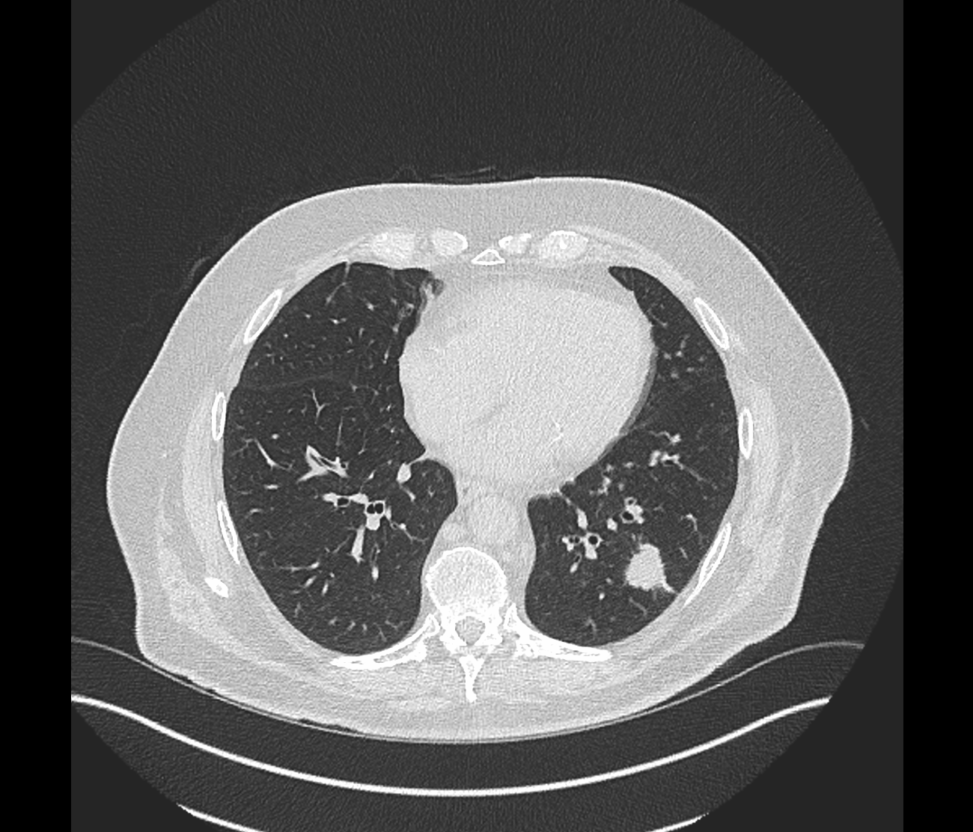

Figure 1b.

Figure 2a.

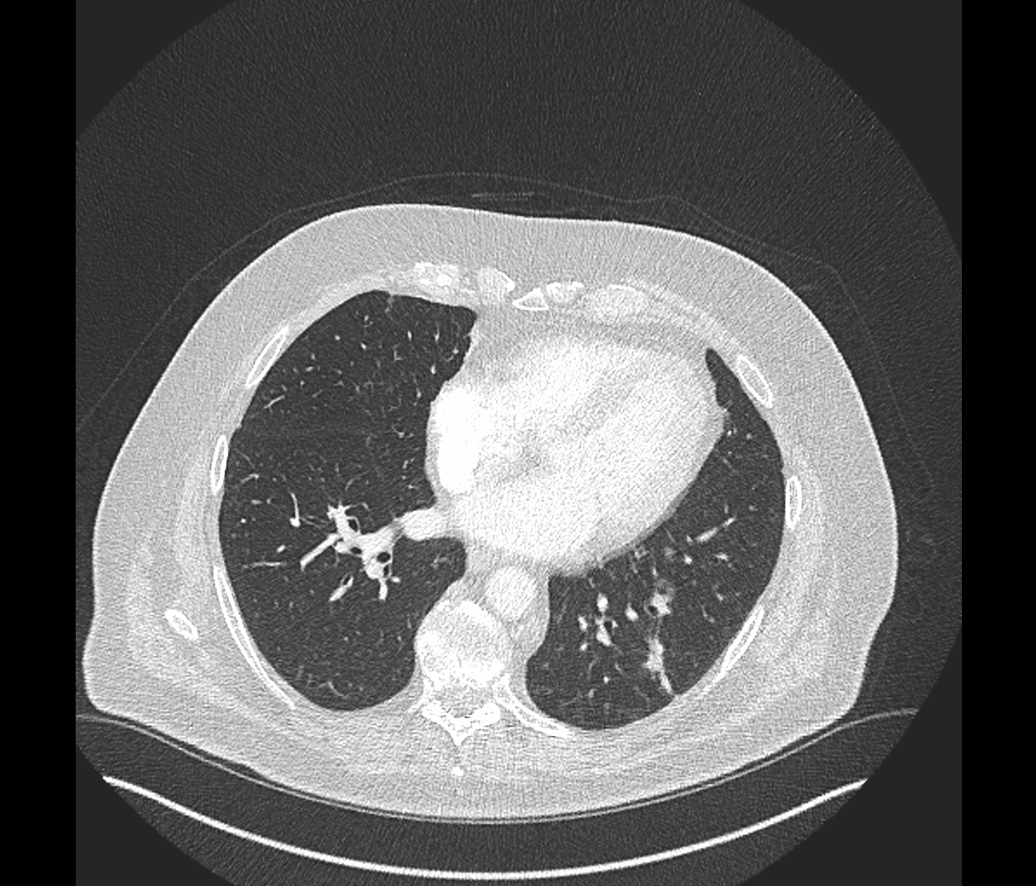

Figure 2b.

