Identification of a glass substrate to study cells with Fourier Transform Infrared Spectroscopy. Are we closer to spectral pathology?

A. V. Rutter¹, J. Crees², H. Wright³, M. Raseta⁴, D. G. van Pittius⁵, P. Roach⁶, and J. Sulé-Suso^{1,7}

1. Keele University, Guy Hilton Research Centre, Thornburrow Drive, Stoke on Trent
ST4 7QB, UK.
2. Histopathology Department, Royal Derby Hospital, Uttoxeter Road, Derby DE22 3NE, UK.
3. Directorate of Research, Innovation and Engagement, Keele University, Keele, Staffordshire ST5 5BG, UK.
4. Institute for Primary Care and Health Sciences and Research Design Service, Keele University, Keele, Staffordshire ST5 5BG, UK.
5. Histopathology Department, Royal Stoke University Hospital, University Hospitals of North Midlands (UHNM), Newcastle Rd, Stoke on Trent, Staffordshire ST4 6QG, UK.
6. Department of Chemistry, Loughborough University, Loughborough, Leicestershire LE11 3TU, UK.
7. Oncology Department, Royal Stoke University Hospital, University Hospitals of North Midlands, Newcastle Rd, Stoke on Trent, Staffordshire ST4 6QG, UK.

Corresponding author:
J. Sulé-Suso
e-mail: josep.sulesuso@uhnm.nhs.uk
Telephone number: ##44-1782-672571.

ABSTRACT

The rising incidence of cancer worldwide is causing an increase in the workload in pathology departments. This, coupled with advanced analysis methodologies, supports a developing need for techniques that could identify the presence of cancer cells in cytology and tissue samples in an objective, fast, and automated way. Fourier transform infrared (FT-IR) microspectroscopy can identify cancer cells in such samples objectively. Thus, it has the potential to become another tool to help pathologists in their daily work. However, one of the main drawbacks is the use of glass substrates by pathologists. Glass absorbs IR radiation, removing important mid-IR spectral data in the fingerprint region (1800 cm⁻¹ to 900 cm⁻¹). In this work, we hypothesized that, using glass coverslips of differing compositions, some regions within the fingerprint area could still be analyzed. We studied three different types of cells (peripheral blood mononuclear cells, a leukemia cell line, and a lung cancer cell line) and lymph node tissue placed on four different types of glass coverslips. The data presented here show that depending of the type of glass substrate used, information within the fingerprint region down to 1350 cm⁻¹ can be obtained. Furthermore, using principal component analysis, separation between the different cell lines was possible using both the lipid region and the fingerprint region between 1800 cm⁻¹ and 1350 cm⁻¹. This work represents a further step towards the application of FT-IR microspectroscopy in histopathology departments.

Keywords
Fourier transform infrared microspectroscopy, FT-IR microspectroscopy, lung cancer, leukaemia, peripheral blood mononuclear cells, glass coverslips.

Introduction

The increasing incidence of cancer¹ is putting pressure on hospitals which have to deal, amongst others, with the screening, diagnosis, treatment and follow up of patients with this disease. Any improvements in the management of cancer which could lead to a reduction of costs will always be very welcomed by the already stretched health services. In the case of cancer diagnosis, there is a consensus that Fourier Transform Infrared (FT-IR) microspectroscopy has a great potential as a technique that could help histopathologists in their daily work when dealing with tissue and/or cytology samples from patients with cancer or suspected cancer. However, further work is still needed to better understand which could be the best application/s of FT-IR microspectroscopy in histopathology departments. Some of these could be to better characterise cells deemed abnormal but not diagnostic for cancer, or to identify cancer cells in cytology and/or tissue samples in an automated way. In the latter case, FT-IR microspectroscopy could identify samples as abnormal which would then be further studied by pathologists. On the other hand, the capability of FT-IR microspectroscopy to study unstained samples can be advantageous when analysing big number of samples as no initial staining will be required. Only those samples requiring further analysis by pathologists would need to be stained thus reducing costs to hospitals. The possibility of using such an automated system would reduce the workload in histopathology departments as pathologists would need to concentrate only on those samples deemed abnormal by this technique. To the best of our knowledge, there is no such system in clinical practice yet, and therefore there is no gold standard prior to the staining process that could identify abnormal cells in cytology samples in an automated way. Thus, FT-IR microspectroscopy could become a new development in the management of cancer patients. However, the implementation of this new technology will have to fit within the standard established workflow in pathology departments.

In spite of the plethora of work carried out,² FT-IR microspectroscopy has been unable to fully develop its clinical application. One of the main drawbacks is the substrate onto which samples are placed. Pathologists use glass slides where samples are placed and later covered with a coverslip. The 1 mm thickness of these slides allows the study with FT-IR microspectroscopy of the lipid region but not the fingerprint region owing to the almost total absorbance of IR energy.^{3,4} This could have an application when studying cytology samples but poses further problems when studying tissue samples. The reason behind this is the fact that tissue samples are usually embedded in paraffin wax which has strong absorption bands in the lipid region.^{4,5} However, a protocol to neutralize the variance of the signal of paraffin wax in FT-IR images has been developed.⁶

We recently hypothesized that the thickness of the glass substrate would play a major role in the absorption of IR radiation. Thus, we used coverslips (thickness of around 0.12–0.17 mm) as substrates to study several cell types using FT-IR microspectroscopy.⁵ This work showed that coverslips as substrates allow the study of not only the lipid region but also the amide I band. However, this work was carried out using synchrotron-based FT-IR (S-FT-IR) microspectroscopy. While synchrotrons can provide high brilliance IR light, it is obvious that a clinical application in histopathology laboratories will require benchtop spectrometers. Furthermore, the constant development of these instruments, not only in IR light intensity but speed when collecting spectra,⁷ makes them potential tools in the aid of histopathology diagnosis.

On this basis, we have furthered this work using a benchtop spectrometer to study cells placed on glass coverslips. More importantly, we hypothesized that the material from which coverslips are made of could also influence the absorption of IR radiation by the coverslip. Thus, we sought to assess whether coverslips made of different material could allow not only the study of the lipid region and the amide I band but also other areas within the fingerprint region.

Materials and Methods
Cells
The cells used in this study were: CALU-1, an epidermoid lung cancer cell line from the European Collection of Cell Cultures (ECACC, Salisbury, UK). This cell line was cultured in Dulbecco’s Modified Eagle Medium (DMEM) supplemented with 10% foetal bovine serum, 5% L-Glutamine, 5% Antibiotic/Antimycotic, 5% Hepes Buffer, 5% Non-Essential Aminoacids and 5% Sodium Pyruvate (Sigma-Aldrich, UK). K562, a chronic myelogenous leukaemia cell line from ECCAC. Cells were grown in suspension in RPMI 1640 culture medium supplemented with 10% foetal bovine serum, 5% Antibiotic/Antimycotic, 5% L-Glutamine and 5% Hepes Buffer (Sigma-Aldrich, UK). Both cells were kept in culture flasks (Sarstedt, UK) at 37 °C and 5% CO₂. Peripheral blood mononuclear cells (PBMC) (AMSBIO, UK). PBMC were thawed and kept in culture at 37 °C and 5% CO₂ for 24 hours in supplemented RPMI (as above) prior to preparing samples for FTIR analysis. Cell viability for all cells was determined with the standard trypan blue exclusion method.
Lymph node
A lymph node was obtained from Amsbio, UK. The aim here was not to use FT-IR microspectroscopy to identify different types of cells within lymph nodes but rather to assess whether coverslips made of different materials could be used as a substrate to obtain spectral data not only from the lipid region but also from different areas within the fingerprint region. The lymph node sample had been fixed, kept in paraffin, and cut to a thickness of 5 mm prior to placing the sample on coverslips. No attempt was done to remove the paraffin as this process would affect the FT-IR spectra of cells (mainly removing information on lipids). Obviously, cytospun cell samples did not present this problem.

Sample preparation Sample preparation has been previously described and does not need to be iterated.5 The characteristics of the coverslips used in this work are as follows: DAKO coverslips (24 x 50mm and 0.12–0.17mm thickness, Agilent) made of borosilicate with a coating (information not disclosed by the company); GalvOptics microscope coverslips (24 x 50mm x 0.13–0.17mm thickness, GalvOptics, UK) made of soda–lime glass; BRAND cover glass (24 x 50mm x 0.13–0.17mm thickness, Sigma-Aldrich) made of borosilicate without coating; Richard–Allan Scientific cover glass (24 x 50mm x 0.13–0.17mm thickness, Fisher Scientific) made of water white glass. Theseglasses differ in chemical composition either by the addition of a surface chemical coating or by components within the glass structure (e.g., iron oxide is removed from water white glass to increase optical transparency). Figure S1a to S1c (Supplemental Material) show representative images of PBMC, K562, and CALU-1 cells cytospun on GalvOptics microscope coverslips. For each type of coverslip, two different coverslips from the same batch were used to obtain the FT-IR of 100 cells (50 cells in each coverslip).

FTIR Microspectroscopy
Mid-infrared (mid-IR) spectra of the samples were obtained using a Thermo Nicolet iN10(MX) spectrometer. Spectra were collected at 4 cm⁻¹ resolution, with 256 co-added scans using an aperture size of 15 x 15 mm centered on the cell nucleus based on our previous work.8 The time to obtain the spectrum of a single cell was less than 1 min. Background measurements were obtained under the same conditions from areas of coverslip without a biological sample. For all samples, spectra of 100 individual cells were obtained. As this was a continuation of our previous work carried out using S-FT-IR microspectroscopy, data pre-processing was carried out in the same way as previously described,⁵ i.e., spectra were cropped to the area to be analyzed and normalized using standard normal variate (SNV) which subtracts the mean spectrum and then divides the standard deviation for each spectrum removing the effect of different sample thickness and spectrum baseline offsets. The spectral analysis of cells on coverslips included the areas between 3100 cm⁻¹ and 2700 cm⁻¹ for the lipid region, and between 1800 cm⁻¹ and 1350 cm⁻¹ for the fingerprint region.

Data analysis
Principal component analysis (PCA) was performed using The Unscrambler X software (Camo Analytics). Statistical analysis was carried out as follows. First, a Levene’s test was carried out to assess whether the data was normally distributed. Only the PC2 data for the 1800 cm⁻¹ and 1350 cm⁻¹ region was not normally distributed; therefore, the nonparametric Kruskal–Wallis test was used. Analysis of variance was used for the PC1 data for the 1800 cm⁻¹ and 1350 cm⁻¹ region and for both the PC1 and PC2 data for the lipid region. IBM SPSS v.24 was used to identify statistically significant differences between cell spectra. The test was applied on the principal components (PCs).
The predictive power of eight models for the prediction of the exact type of cell, independently for the lipid region, and for the region between 1800 cm⁻¹ and 1350 cm⁻¹, was tested. These are summarized in Table I.
All models were built in R statistical software tool (R Core Team, 2018) and a R-package CARRoT,⁹ which combines principles of good practice from machine learning, such as cross-validation¹⁰ and those in medical statistics, such as best subset regression¹¹ restricted by the rule of 10 events per variable (‘‘one in ten rule’’).¹² The accuracy of the models was tested by running 100 cross-validations on the data set, which amounted to 30 test points for each of the feasible models in the case populations studied separately, and 3000 test points once they are merged. Each cross-validation was performed by splitting the whole data set into training (90%) and test sets (10%). On top of multivariate linear regressions, models including higher order terms on top of linear ones were also considered to increase the search space and yield further potential boost in the predictive power.

Results

This work is a continuation of the previous work showing that good quality spectra could be obtained in both the lipid and in the amide I band regions from cells placed on glass coverslips.⁵ However, this work was carried out using S-FT-IR microspectroscopy. The clinical application would require using benchtop spectrometers. Therefore, the current work utilizes benchtop instrumentation, building on previously published S-FT-IR microspectroscopy data.⁵ The first step was not only to use the same cell types and experimental methodology to study these cells using a benchtop spectrometer but also to assess whether different types of glass substrates could improve the quality of the spectra and/or expand the regions within the IR spectrum which could be studied. Therefore, we used the same three types of cells (CALU-1, K562, and PBMC). FT-IR spectra were obtained from each type of coverslips used in this work. Figure 1 shows the mean of 10 spectra obtained from each type of coverslip without cells. Out of all four types of coverslips, GalvOptics microscope coverslips had a lower cut-off at around 1300 cm⁻¹. The remaining types of coverslips had a cut-off at around 1550 cm⁻¹. The cut-off for good quality cell spectra at different wavenumbers varied when cells were cytospun on different types of substrates. Therefore, in order to present the data in a more homogeneous manner, we chose a cut-off of 1350 cm⁻¹ as good quality spectra could be obtained for some cell types placed on soda–lime substrate from GalvOptics from wavenumbers down to 1350 cm⁻¹.
Figures 2 to 5 show the mean spectrum of 100 spectra obtained for the three cell types used in this work and placed on different substrates. The data clearly shows that the use of any of these substrates can lead to good quality spectra in the lipid region. However, the situation is different for the fingerprint region. The substrates purchased from Agilent, Fisher, and Sigma can provide good quality spectra from 1800 cm⁻¹ to around 1550 cm⁻¹ (Figs. 2 to 4). This is not the case for spectra obtained from cells placed on soda–lime substrate from GalvOptics. As can be seen in Fig. 5, this substrate allows obtaining good quality spectra down to around 1350 cm⁻¹ wavenumbers (depending on the cell type). This allows the study of not only the amide I but also other sections within the fingerprint region.
While the data described above could have an application in the study of cytology samples in histopathology departments, it is also important to assess how different substrates could affect the spectra of tissue samples. The added problem here is the presence of paraffin wax used in the preparation and storage on these samples. Again, we wanted to compare the data obtained in our previous work using S-FT-IR microspectroscopy with the data obtained using a benchtop spectrometer. To this purpose, we used the same lymph node purchased from Amsbio, UK, and prepared the lymph node samples on different substrates using the same experimental setup.⁵ Figure 6 shows the mean spectrum of 200 spectra from different areas within the lymph node on different substrates. The purpose here as not to identify different cell types but rather how the different substrates could affect the FT-IR spectra of a lymph node section. In this case, there was high intensity for the peaks at 2920 cm⁻¹ and 2850 cm⁻¹ caused by the presence of paraffin wax. Regarding the 1800 cm⁻¹ to 1350 cm⁻¹ region, the intensity of the amide I band varied between the different substrates (Fig. 6). Furthermore, as expected from the data in Fig. 1, the use of GalvOptics coverslips provided more clear spectral data for the region between 1600 cm⁻¹ and 1350 cm⁻¹. It is difficult to ascertain to what extent the changes in the amide I band are caused by the transparency of the different substrates. This was a pilot study aimed at identifying possible glass substrates which could be used in the study of cytology samples using FT-IR microspectroscopy. Therefore, we did not try to assess how the different substrates could affect the amide I band. Further work is needed to fully assess this by comparing the amide I obtained from the same tissue and/or cells placed on slides made of materials with a wide optical window in this region, e.g., CaF₂ slides.
Based on these data, it would seem reasonable to carry out further analysis using the FT-IR spectra obtained from cells placed on the soda–lime substrates. The aim is to assess whether PCA could separate between different cell types presented on soda–lime coverslips obtained from GalvOptics. As seen in Fig. 7a, there was a clear separation between PBMC and both malignant cell lines (CALU-1 and K562). There was also some degree of separation between the two different malignant cell lines. A similar pattern was also seen when PCA of the region between 1800 cm⁻¹ and 1350 cm⁻¹ was carried out (Fig. 8a) with the greatest separation between PBMC and both malignant cells.
Furthermore, statistical analysis as described in Materials and Methods was carried out to assess the degree of separation between these cell lines. Table II summarizes these data. On the other hand, R package CARRoT was used to assess the predictive power of eight different models in terms of predicting the exact type of cell for the lipid region and the region between 1800 cm⁻¹ and 1350 cm⁻¹. Table III shows the accuracy for each individual PC and for the combination of both PC1 and PC2 for both lipids and the region between 1800 cm⁻¹ and 1350 cm⁻¹ from cells placed in GalvOptics soda–lime coverslips. The models with the largest accuracy for the region between 1800 cm⁻¹ and 1350 cm⁻¹ are Model 7 (based on PC1 and PC2) and Model 8 (based on both PC1 and PC2, their squares, and their interaction), the latter with an average accuracy of 92% in predicting the exact type of cell. Regarding the lipid region, the model with largest accuracy of 80% is based on PC1 and PC2 alone (Model 3).

Discussion

The way in which tissue and cell samples are prepared in pathology departments are, albeit certain degree of variations might exist, well standardized worldwide. Therefore, changing clinical practice is not an easy task due, in part, the maintenance of patient safety. While it has been proven that FT-IR microspectroscopy can identify malignant cells in tissue and cytology samples,² the substrates used for these studies have been different from those used in pathology departments, i.e., glass. Glass absorbs IR radiation, which reduces the information that can be obtained from the IR spectrum of cells and tissues. However, it is now clear that, depending on the thickness of the glass substrate, spectral data from different regions of the IR spectrum can be obtained.⁵ We hypothesized that using glass coverslips of differing compositions, some regions within the fingerprint area could still be analyzed. As can be seen in Fig. 1, the cutoff for GalvOptics coverslips falls to lower wavenumbers. It is therefore obvious that using this type of coverslip, FT-IR spectra of cells and tissues will provide information from the fingerprint region between 1800 cm⁻¹ to 1350 cm⁻¹. However, it is also crucial to assess whether using the lipid region or the region between 1800 cm⁻¹ to 1350 cm⁻¹, a separation between different cells could be obtained which could help towards the clinical application of FT-IR microspectroscopy.
The lipid region could be an important spectral parameter in the application of FT-IR microspectroscopy to assess the presence of malignant cells in tissue and cytology samples. Lipid content and metabolism has been shown to vary between non-malignant and malignant cells and could even be linked to how aggressive a tumor might behave.^{13–16} Thus, the study of the spectral peaks at 2850 cm⁻¹ and 2920 cm⁻¹ corresponding mainly to CH2 stretching modes of methylene chains in membrane lipids coupled to the peak at 1740 cm⁻¹ arising from the carbonyl C=O stretching mode of phospholipids^{17,18} could help in the histopathology diagnosis of cancer in tissue and cytology samples. The loadings in Fig. 7b (corresponding to the lipid region) indicate that the main differences reside around the peaks at 2850 cm⁻¹ and 2920 cm⁻¹, while the loadings in Fig. 8b also show a difference around 1700 cm⁻¹. The latter would indicate that the carbonyl C=O stretching mode of phospholipids is important in identifying different types of cells when using the 1800 cm⁻¹ to 1350 cm⁻¹ region. The data presented here indicates that using just the lipid region, PCA can show a clear difference between cell lines. In fact, combining both PC1 and PC2, the different types of cells could be predicted in 80% of cases (Table II).
It has to be recognized that some of the differences between these cells might be due to cell size. Once cytospun, the malignant cells CALU-1 and K562 have a diameter of around 20–25 µm, while PBMC have a diameter of around 15–20 µm. While it would be difficult to assess to what extent the spectral differences observed between cancer cells and PBMC are due to cell size, this is not an issue when comparing K562 and CALU-1 cells. As mentioned before, this pilot study was aimed at identifying possible glass substrates which could be used in the study of cytology samples using FT-IR microspectroscopy. Therefore, we did not study to what extent the cell size will cause spectral differences between PBMC and malignant cells. Further work is needed to assess this when using glass substrates.
It has to be acknowledged that the fingerprint region contains a vast array of information which is lost when using glass substrates. Thus, using a glass substrate which could be accepted in the preparation of tissue/cytology samples in clinical practice and allowing at the same time, the study of the fingerprint region would represent a big advance towards the application of FT-IR microspectroscopy in histopathology. Fig. 1 shows the FT-IR spectra of blank coverslips (without cells). It was not possible to obtain the exact composition of each type of coverslips due to proprietary information; therefore, it is difficult to ascertain how the different coverslip compositions could affect the FT-IR spectra. However, it is quite clear that the cut-off for GalvOptics coverslips falls to lower wavenumbers when compared to the other types of coverslips.
The work presented here shows for the first time that using an inexpensive and conventional thin-glass coverslip of the correct composition, information on both the amide I and amide II can be obtained. Furthermore, information in the fingerprint region down to 1350 cm⁻¹ can also be obtained (Fig. 5). It has to be acknowledged that the quality of the spectra in the fingerprint region might vary from one cell type to another (Fig. 5). This indicates that further work is needed, first, to better understand to what extent the information obtained within the fingerprint region from cells and tissues using soda–lime glass (GalvOptics) microscope coverslip substrates could be used to identify cancer cells in tissue and/or cytology samples. Second, to assess whether other types of coverslips could also yield similar data or spectral information below 1350 cm⁻¹. The data presented here indicate that using the region between 1800 cm⁻¹ and 1350 cm⁻¹, PCA can separate between malignant (CALU-1 and K562) and non-malignant cells (PBMC) (Fig. 8a). More importantly, this difference is statistically significant (Table II). Furthermore, using the same spectral region, a clear separation is observed between the two different types of malignant cells (Fig. 8a); combining both PC1 and PC2, the different types of cells could be predicted in more than 90% of cases (Table III).
It is important to note that paraffin wax does not affect the spectra in the region between 1800 cm⁻¹ and 1350 cm⁻¹. This has important implications as thin-glass coverslip substrates could be used to study tissue samples embedded in paraffin. Further work is needed to assess whether the information in this spectral region could be robust enough to help pathologists in the diagnosis of cancer from tissue samples.

Acknowledgements
The support from the Cancer Centre and University Hospital of North Midlands charities and the North Staffordshire Medical Institute is highly appreciated.

Conflict of interest
The authors declare that they have no conflict of interest.

Supplemental material
The supplemental material mentioned in the text, consisting of representative images of PBMC, K562, and CALU-1 cells cytospun on GalvOptics microscope coverslips, is available in the online version of the journal.

REFERENCES

1. C.P. Wild, C. Espina, L. Bauld, B. Bonanni, H. Brenner, K. Brown, J. Dillner, D. Forman, E. Kampman, M. Nilbert, K. Steindorf, H. Storm, P. Vineis, M. Baumann, J. Schüz. “Cancer Prevention Europe”. Mol Oncol. 2019. 13(3): 528-534.
2. A.A. Bunaciu, V.D. Hoang, H.Y. Aboul-Enein. “Vibrational Micro-Spectroscopy of Human Tissues Analysis: Review”. Crit Rev Anal Chem. 2017. 47(3): 194-203.
3. P. Bassan, J. Mellor, J. Shapiro, K.J. Williams, M.P. Lisanti, P. Gardner. “Transmission FT-IR Chemical Imaging on Glass Substrates: Applications in Infrared Spectral Histopathology”. Anal Chem. 2014. 86(3): 1648-1653.
4. M.J. Pilling, A. Henderson, J.H. Shanks, M.D. Brown, N.W. Clarke, P. Gardner. “Infrared spectral histopathology using haematoxylin and eosin (H&E) stained glass slides: a major step forward towards clinical translation”. Analyst. 2017. 142(8): 1258-1268.
5. A.V. Rutter, J. Crees, H. Wright, D.G. van Pittius, I. Yousef, J. Sulé-Suso J. “Fourier transform infrared spectra of cells on glass coverslips. A further step in spectral pathology”. Analyst. 2018. 143(23): 5711-5717.
6. F.A. de Lima, C. Gobinet, G.D. Sockalingum, S.B. Garcia, M. Manfait, V. Untereiner, O. Piot, L. Bachmann. “Digital de-waxing on FTIR images”. Analyst. 2017. 142(8): 1358-1370.
7. M.J. Baker, H.J. Byrne, J. Chalmers, P. Gardner, R. Goodacre, A. Henderson, S.G. Kazarian, F.L. Martin, J. Moger, N. Stone, J. Sulé-Suso. “Clinical applications of infrared and Raman spectroscopy: state of play and future challenges”. Analyst. 2018. 143(8): 1735-1757.
8. J. Pijanka, A. Kohler, Y. Yang, P. Dumas, S. Chio-Srichan, M. Manfait, G.D. Sockalingum, J. Sulé-Suso. “Spectroscopic signatures of single, isolated cancer cell nuclei using synchrotron infrared microscopy”. Analyst. 2009. 134(6): 1176-1181.
9. A. Bazarova, M. Raseta. “CARRoT: Predicting Categorical and Continuous Outcomes Using Rule of Ten. R package version 0.1.0.” https://CRAN.R-project.org/package=CARRoT, Accessed May, 2019.
10. S. Geisser. “Predictive Inference: An introduction”, 1st ed, New York, Chapman & Hall, 1993.
11. Z. Zhang. “Variable selection with stepwise and best subset approaches”. Ann Transl Med. 2016. 4(7): 136.
12. P. Peduzzi, J. Concato, E. Kemper, T.R. Holford, A.R. Feinstein. “A simulation study of the number of events per variable in logistic regression analysis”. J Clin Epidemiol. 1996. 49(12): 1373-1379.
13. C.E. Mountford, L.C. Wright. “Organization of lipids in the plasma membranes of malignant and stimulated cells: a new model”. Trends Biochem Sci. 1988. 13(5): 172-177.
14. U. Ray, S.S. Roy. “Aberrant lipid metabolism in cancer cells - the role of oncolipid-activated signalling”. FEBS J. 2018. 285(3): 432-443.
15. S. Beloribi-Djefaflia, S. Vasseur, F. Guillaumond. “Lipid metabolic reprogramming in cancer cells”. Oncogenesis. 2016. 5: e189.
16. S. Luanpitpong, M. Janan, K. Thumanu, J. Poohadsuan, N. Rodboon, P. Klaihmon, S. Issaragrisil. “Deciphering the Elevated Lipid via CD36 in Mantle Cell Lymphoma with Bortezomib Resistance Using Synchrotron-Based Fourier Transform Infrared Spectroscopy of Single Cells”. Cancers. 2019. 11(4): e576.
17. N. Jamin, P. Dumas, J. Moncuit, W.H. Fridman, J.L. Teillaud, G.L. Carr, G.P. Williams. “Highly resolved chemical imaging of living cells by using synchrotron infrared microspectrometry”. Proc Natl Acad Sci USA. 1998. 95(9): 4837-4840.
18. H.Y.N. Holman, M.C. Martin, E.A. Blakely, K. Bjornstad, W.R. McKinney. “IR spectroscopic characteristics of cell cycle and cell death probed by synchrotron radiation based Fourier transform IR spectromicroscopy”. Biopolymers. 2000. 57(6): 329-335.

Legends to figures

Figure 1 Mean spectra of SIGMA, Fisher, Agilent and GalvOptics coverslips without cells.
Figure 2 Mean spectra of PBMC, CALU-1 and K562 cells on Agilent coverslips.
Figure 3 Mean spectra of PBMC, CALU-1 and K562 cells on Fisher coverslips.
Figure 4 Mean spectra of PBMC, CALU-1 and K562 cells on SIGMA coverslips.
Figure 5 Mean spectra of PBMC, CALU-1 and K562 cells on GalvOptics coverslips.
Figure 6 Mean S-FTIR spectra of a lymph node (mean of 200 spectra) on different coverslips.
Figure 7 PCA (A) and loadings (B) for the lipid region for PBMC (filled squares), K562 (open squares) and CALU-1 (filled triangles) cells on GalvOptics coverslips.
Figure 8 PCA (A) and loadings (B) for the 1800 cm⁻¹ to 1350 cm⁻¹ region for PBMC (filled squares), K562 (open squares) and CALU-1 (filled triangles) cells on GalvOptics coverslips.

Supplemental Material

Figure S. Representative image of PBMC (a), K562 (b) and CALU-1 (c) cells cytospun on GalvOptics coverslips.

Table I. List of models for prediction test types.

Model no. | Prediction test type
1 | Prediction of the exact type of cell using the  lipid region based on PC1 alone
2 | Prediction of the exact type of cell using the  lipid region based on PC2 alone
3 | Prediction of the exact type of cell using the  lipid region based on both PC1 and PC2
4 | Prediction of the exact type of cell using the  lipid region based on both PC1 and PC2,  their squares, and their interaction
5 | Prediction of the exact type of cell using the  region between 1800 cm–1 and 1350 cm–1
6 | Prediction of the exact type of cell using the  region between 1800 cm–1 and 1350 cm–1  based on PC2 alone
7 | Prediction of the exact type of cell using the  region between 1800 cm–1 and 1350 cm–1  based on both PC1 and PC2
8 | Prediction of the exact type of cell using the  region between 1800 cm–1 and 1350 cm–1  based on both PC1 and PC2, their squares,  and their interaction

Table II. Statistical significance between cells for the PCA.

 | Lipid region |  | 1800 - 1350 cm⁻¹ region
 | PC1 | PC2 | PC1 | PC2
PBMC vs K562 | NS | p<0.001 | p<0.001 | NS
PBMC vs CALU-1 | p<0.001 | p<0.001 | p<0.001 | p<0.001
K562 vs CALU-1 | p<0.001 | p<0.001 | p<0.001 | p<0.001

NS: Not statistically significant.

Table III. Accuracy of prediction for cell lines.

 | Lipid region (%) | 1800 - 1350 cm⁻¹ region (%)
PC1 | 42 | 70
PC2 | 72 | 53
PC1 + PC2 | 80 | 91
Second order terms included | 80 | 92

Figure 1.
GALV
AGILENT
FISHER
SIGMA
Absorbance (a. u.)
Wavenumber (cm⁻¹)

Figure 2.

Absorbance (a. u.)

CALU

K562

PBMC

Wavenumber (cm⁻¹)
Figure 3.

Absorbance (a. u.)
CALU

K562

PBMC

Wavenumber (cm⁻¹)
Figure 4.

Absorbance (a. u.)

CALU

K562

PBMC

Wavenumber (cm⁻¹)
Figure 5.

Absorbance (a. u.)

CALU

K562

PBMC

Wavenumber (cm⁻¹)
Figure 6.
2850
2920
Wavenumber (cm⁻¹)
AGILENT
Absorbance (a. u.)
SIGMA
FISHER
GALV

Figure 7a.
PCA lipids

PC 2 (17 %)
PC 1 (74 %)

Figure 7b.
Wavenumber (cm⁻¹)
Loadings lipids

PC2
PC1

Figure 8a.
PCA fingerprint

PC 2 (14 %)
PC 1 (17 %)

Figure 8b.
Loadings fingerprint

Wavenumber (cm⁻¹)
PC2
PC1

Supplemental Material
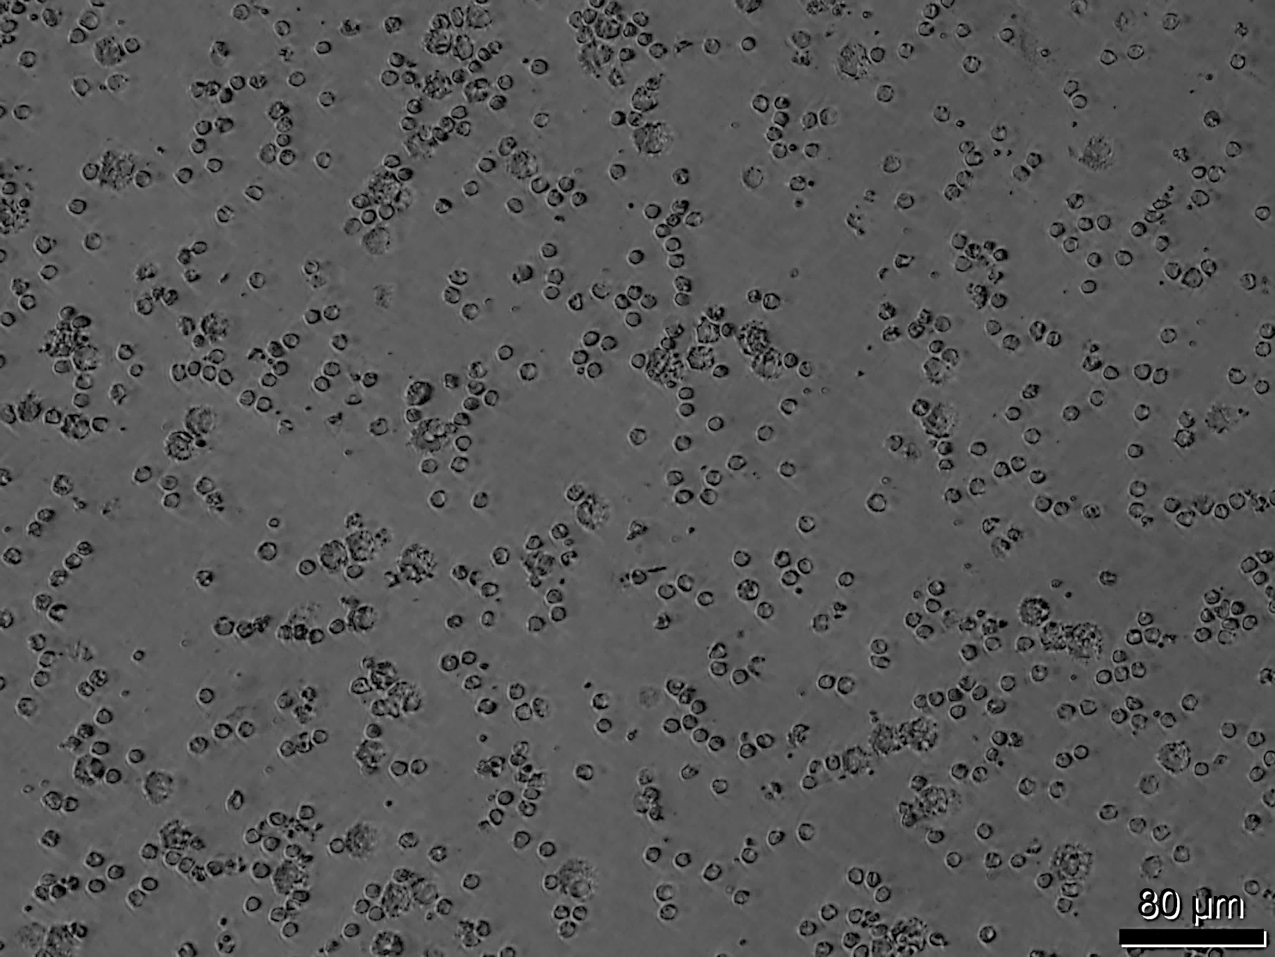
Figure Sa.

Figure Sb.
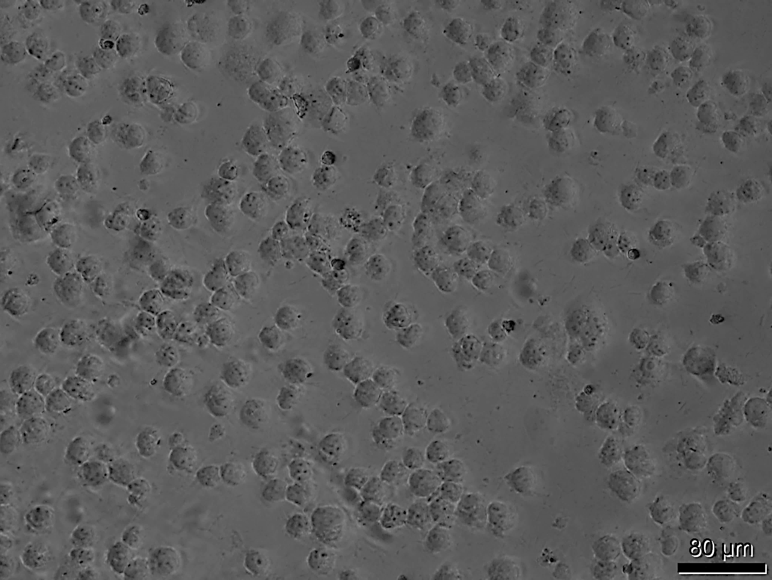

Figure Sc.
