Depositional conditioning of three dimensional training images: improving the reproduction and representation of architectural elements in sand-dominated fluvial reservoir models.
Mitten, A.J.^{a&c*}; Mullins, J.^{b}; Pringle, J.K.ª; Howell, J.^{b} and Clarke, S.M.^{c}

(a) School of Geography, Geology and the Environment, Keele University, Keele, Staffordshire, United Kingdom, ST5 5BG, UK.
(b) Department of Geology and Petroleum Geology, King's College, University of Aberdeen, Aberdeen, United Kingdom, AB24 3UE, UK.
(c) Basin Dynamics Research Group, School of Geography, Geology and the Environment, Keele University, Keele, Staffordshire, United Kingdom, ST5 5BG, UK.

*Corresponding author: Andy Mitten - a.j.mitten@keele.ac.uk
Declaration of interest: none

Abstract
Fluvial deposits create significant hydrocarbon reservoirs, although their characterisation can be difficult due to their differing scales of heterogeneity. Whilst numerical modelling methods have advanced to statistically honour fluvial input datasets, geologically realistic features are often lost, impacting hydrocarbon recovery predictions. Two dimensional training images are often used to dictate what heterogeneity is inputted into multi-point statistics based reservoir. In this study, a three dimensional training image is built, based upon depositional conditions derived from outcrop and modern satellite imagery data of a fluvial system. The aims of this study are to: identify the heterogeneity within the modern and outcrop data and to replicate it in a three dimensional training image, to model such heterogeneity using object-based, sequential indicator simulation and multi-point statistics and to qualitatively and quantitatively (through static net-connectivity testing) analyse the reproducibility and geological realism of the generated reservoir models.
Digital photogrammetric data from Tuscher Canyon, Utah, of the Lower Castlegate Sandstone and satellite imagery from the Jamuna River, northern India, are used to depositionally condition a three dimensional training image. This training image was then used to generate the multi-point statistics models, which were then tested against more traditional object-based and sequential indicator simulation reservoir models. Results indicated that object-based models realistically reproduced heterogeneous architectural elements, however, the connectivity of net-reservoir elements were unrealistically shaped and over-connected. The sequential indicator simulated models produced unrealistic heterogeneous architectural elements and overestimated the connectivity of net-reservoir elements. The multi-point statistical models realistically produced heterogeneous architectural elements geometries and the connectivity of net-reservoir elements. Study implications suggest that, based upon limited data, depositional conditioning can generate three dimensional training images to produce reservoir models that are both geologically realistic and reproducible.
Keywords: Training images, depositional conditioning, architectural elements, heterogeneity, multi-point statistic, connectivity.

Introduction
Fluvial strata provide important and effective hydrocarbon reservoirs (Tyler and Finley, 1991), although their characterisation is difficult due to the scale of heterogeneities associated with them (Figure 1; Tyler and Finley, 1994; Pranter et al., 2007; Henares et al., 2016; Yue et al., 2019). Meso-scale (architectural element scale) heterogeneity becomes more important over longer reservoir production periods due to the increased sensitivity of fluid migration to smaller-scale heterogeneity over time (Tyler et al., 1994). While research has addressed the giga- to mega-scopic sedimentary heterogeneity in fluvial systems (Figure 1), such as sandbody stacking (e.g. Laure and Hovadik, 2006, Hovadik and Laure, 2007, Villamizar et al., 2015; Cabello et al., 2018a) and its reproduction in reservoir models (Seifert and Jensen, 2000), relatively less attention has been given to the architectural element scale (Figure 1; Gibling, 2006; Enge et al., 2007; Rittersbacher et al., 2014; Colombera et al., 2016; Koneshloo et al., 2018). The need to constrain heterogeneity across multiple scales has led to the introduction of multi-scale modelling (Nordhal and Ringrose, 2008; Ringrose et al., 2008; Howell et al., 2014).
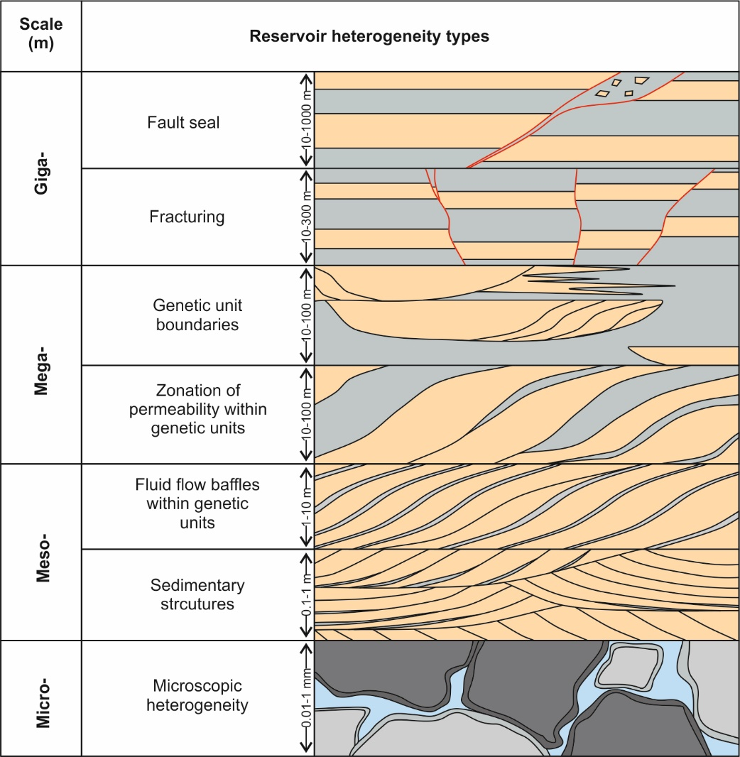
Figure 1 – The scales of typical fluvial reservoir heterogeneity (modified from Tyler and Finley, 1991; Morad et al., 2010). Note the 1 m - 10 m meso-scale of this study: zonation of permeability is within genetic units (Morad et al., 2010; Mitten et al., 2018). In giga- to meso-scale, the yellow indicates sandstone and the grey mud and siltstone, the red lines indicate faulting. In the micro-scale image the black and grey represent quartz grains and the light blue indicates pore space.
There are three major conventional geostatistical techniques currently used in reservoir modelling of fluvial deposits: object-based modelling (OBM), sequential-indicator simulation (SIS) and multi-point statistics (MPS). OBMs use pre-defined geometric shapes to occupy multiple-cells (Holden et al., 1998; Stephen et al., 2001; Manzocchi et al., 2007), rather than using two-point or multi-point statistics, to build facies models. SIS is one of the most commonly used pixel-based methods, it uses a two-point approach and populates a model volume using variograms derived from one- or two-dimensional data (Deutsch and Journel, 1992; Seifert and Jensen, 1999, 2000 and references therein; Martinius et al., 2017). The SIS method is designed to apply stationarity to a model, so that any realisation should honour the input parameters. MPS use a training image, a conceptual representation of the geometry and patterns of studied physical properties (Falivene et al., 2006; Maharaja, 2008; Pickel et al., 2015), to dictate the stationary distributions of sedimentary heterogeneity expected within a reservoir (Strebelle and Journel, 2001; Strebelle, 2002; Caers and Zhang, 2004; Strebelle and Levy, 2008; Daly and Caers, 2010). MPS models have the potential to provide more geologically realistic simulations of reservoir heterogeneity by incorporating analogous data into their workflows (Caers and Zhang, 2004, Strebelle and Levy, 2008; Le Coz et al., 2011; Hu et al., 2014; Zhou et al., 2018).
Each modelling approach has its limitations with regards to the replication of facies and the reproducibility of the input data. OBMs are limited by the pre-defined shapes they can produce (Holden et al., 1998; Stephen et al., 2001; Manzocchi et al., 2007). SIS commonly produces model elements with margins, geometries and distributions that are not realistic compared to the geology simulated (Seifert and Jensen, 1999; Deutsch, 2006; Ringrose and Bentley, 2015). Finally, MPS has been hampered, to-date, by the lack of appropriate libraries of training images, the difficulty in constructing three dimensional training images, their re-usability, and the lack of standardized methods for their development, particularly in three dimensions (see Comunian et al., 2012; Ringrose and Bentley, 2015).

Study aims
This study focuses on the reproduction of architectural element scale heterogeneity (Figure 1) within a sand-dominated braided channel system. This work utilizes sedimentary logs and digital photogrammetric outcrop data from Tuscher Canyon, Utah and aerial imagery data from the Jamuna River, northern India, to develop a training image conditioned to basic depositional characteristics known as depositional conditions.
The aims of this study are to: (1) identify heterogeneity bearing architectural elements within the datasets (Miall, 1993; 1994; Yoshida, 2000; Miall and Arush, 2001; Trower et al., 2018), (2) to construct a depositional conditioned three dimensional training image based on the modern and ancient data, (3) to replicate the architectural elements from the datasets in reservoir models using object-based models, sequential indicator simulations and multipoint statistics, and (4) to qualitatively and quantitatively analyse the reproducibility and geological realism of the generated reservoir models.
The paper will first, describe the geological settings of the study areas, the methods of sedimentological analysis used, and resulting interpretations of net-reservoir and heterogeneous non-net reservoir architectural elements. Secondly, the paper will describe the creation of a depositionally conditioned three dimensional training image, based upon the results of the sedimentary analysis. The final portion of the paper will present the construction of three sets of reservoir models, before qualitatively and quantitatively analysing the resulting models, through static net-connectivity tests, and discuss how geologically realistic and reproducible the resulting models are.

Study locations
Two study locations were chosen on the basis of similar fluvial depositional characteristics: the Cretaceous Lower Castlegate Sandstone of Tuscher Canyon, Utah (Figure 2), and the modern-day Jamuna River of northern India (Figure 3). Both of these systems represent low-sinuosity fluvial environments with a high proportion of sand (Miall, 1993; 1994; Ashworth et al., 2000; McLaurin and Steel, 2007), deposited in asymmetrical foreland basins, and at approximately the same moderate global latitude (Kauffman, 1977; Chan and Pfaff, 1991; Hampson et al., 2005). Both systems show variable discharge rates (Robinson and Slingerland, 1998; Adams and Bhattachyra, 2005; Ashworth et al., 2000), exhibiting frequent reactivation and avulsion (Ashworth et al., 2000; Hajek and Heller, 2012), and both systems are proximal of their respective backwater reaches (Samuels, 1989; Ashworth et al., 2000; Best et al., 2003; Marra et al., 2014; Trower et al., 2018).
Both systems are extremely well studied, with a wealth of data evidencing their genetic similarities (see, e.g. Samuels, 1989; Miall, 1993; 1994; Yoshida, 2000; Ashworth et al., 2000; Richardson and Thorne, 2001; Best et al., 2003; McLaurin and Steel, 2007), but sedimentary preservation issues and differing timescales of observation mean that direct comparisons between depositional models should be treated with caution (Miall, 2016).

The Lower Castlegate Sandstone at Tuscher Canyon, Utah, USA
The Upper Cretaceous Lower Castlegate Sandstone (Figure 2a, b) is part of the Mesaverde Group (Fouch et al., 1983; Olsen et al., 1995; Miall and Arush, 2001; McLaurin and Steel, 2007). The Group represents deposition of a clastic wedge that prograded from the Sevier Orogenic Belt eastwards into the Western Interior Seaway of central North America (Figure 2c) throughout the Cretaceous Period. The Castlegate Sandstone has been sub-divided into three informal lithostratigraphical units (Chan and Pfaff, 1991; Olsen et al., 1995; McLaurin and Steel, 2007): the Lower Castlegate Sandstone, a high net-to-gross fluvial sheet-sand deposited by a low sinuosity, bedload dominated fluvial system (Olsen et al., 1995; McLaurin and Steel, 2007); the middle Castlegate Sandstone that comprises sediments deposited in more isolated channels with a higher preservation of overbank material (McLaurin and Steel, 2007); and the Bluecastle Tongue, which is genetically similar to the Lower Castlegate Sandstone (Olsen et al., 1995). The more distal deposits at Tuscher Canyon, near Green River (Figure 2b), show a thinner succession of high net-to-gross Lower Castlegate Sandstone and an absence of the Middle Castlegate. This succession resulted from transgression at ~78 Ma - 77 Ma (Fouch et al., 1983) that interrupted progradation of the wedge and deposited the siltstones of the Buck Tongue over the Lower Castlegate.
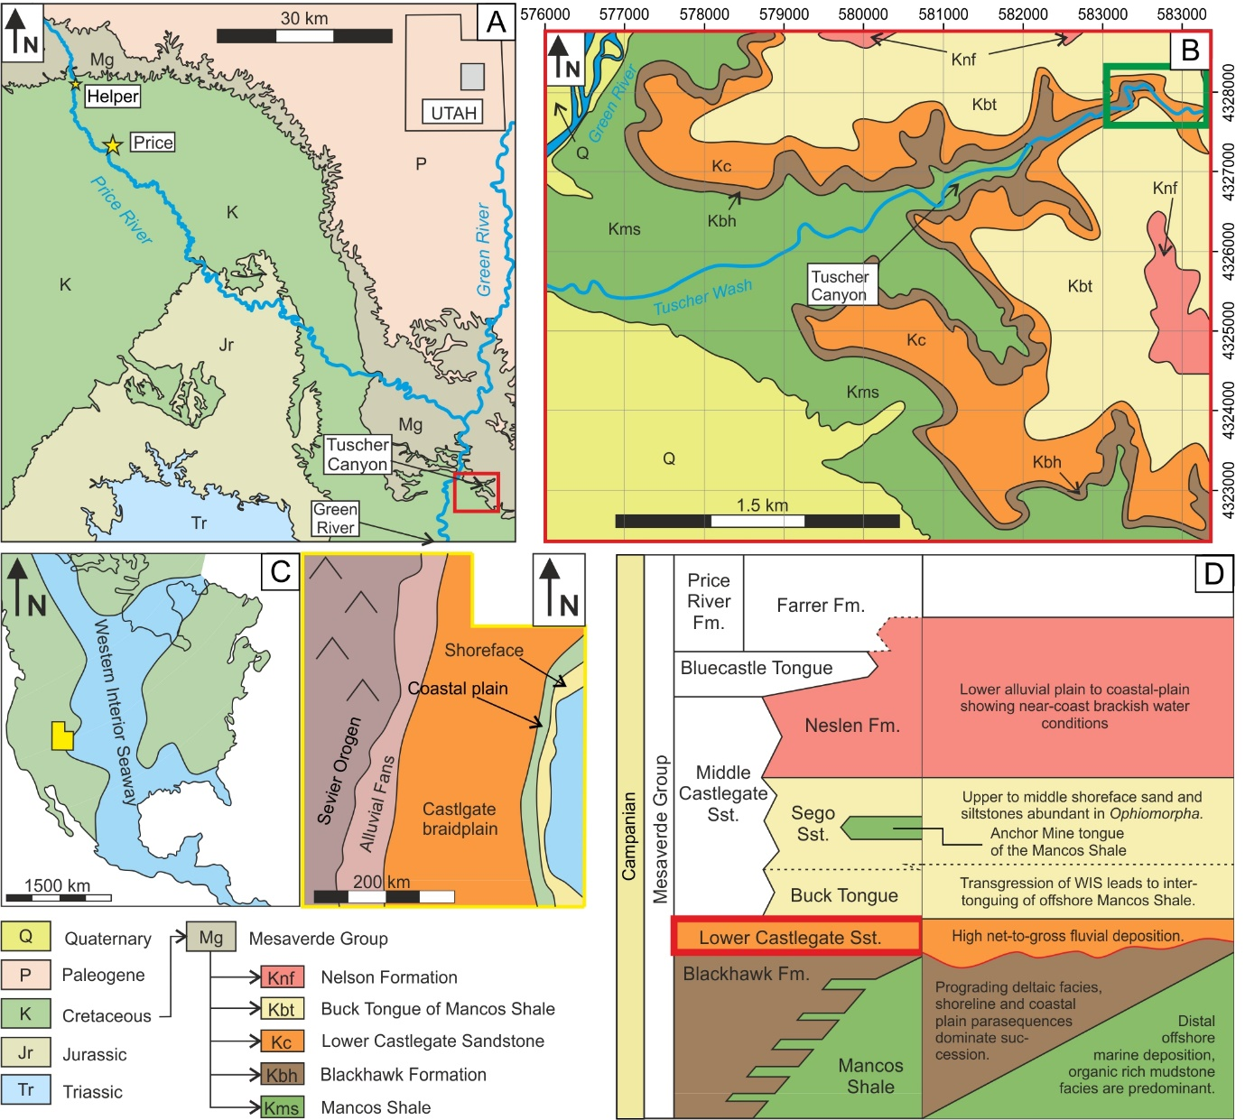
Figure 2 – A) Simplified geological map of east-central Utah, USA (modified from Watkind, 1995) showing the Mesaverde Group, of which the Castlegate is part, and the location of the study area (red box). B) Geological map of the study location at Tuscher Canyon, Utah (modified from Watkind, 1995). The green box represents the location of the study map in Figure 4A. C) (left) The palaeogeography of the Western Interior Seaway and North America, with Utah highlighted in a yellow box, and (right) gross depositional environments of the Early to Middle Campanian (modified from Van de Graff, 1972; Chan and Pfaff, 1991). D) Mesaverde Group depositional environment and associated lithostratigraphical units, with the Lower Castlegate Formation highlighted (red box), (modified from Burns et al., 2017).
Six architectural elements make up the Lower Castlegate succession at Tuscher Canyon (Miall, 1993). These are predominately sandy barforms and downstream accreting elements that show minimal lateral accretion (Miall, 1993, 1994). The Lower Castlegate deposits show a regional eastward palaeocurrent direction (Miall and Arush, 2001).

The Jamuna River, northern India
The modern-day bar complex within the Jamuna River is situated between the border of Bangladesh and Bhutan, in northern India (Figure 3). The Jamuna River has been studied extensively as an analogue for dynamic, sandy bedload dominated low-sinuosity river systems (see, for example, Coleman, 1969; Bristow, 1993; Bristow et al., 1999; Ashworth et al., 2000; Best et al., 2003). It transports material from the Himalaya down into the Bay of Bengal and feeds the Brahmaputra-Ganges river-deltaic system (Best et al., 2007). The bar complex in the study area is dominantly downstream accreting and has subordinate channel flows, re-working the top of the barform and impeding soil formation and vegetation growth (Bristow, 1993; Ashworth et al., 2000; Best et al., 2003).
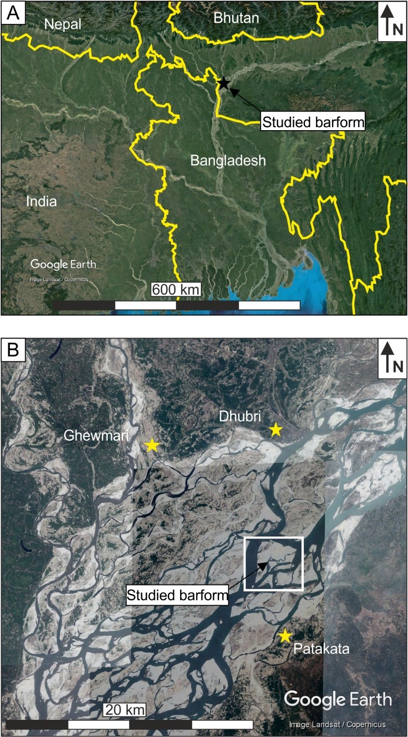
Figure 3 – A) Study site location map of the Jamuna River, northern India and B) close-up of the study area (box), modified from Mitten et al., (2018).

Data acquisition and processing
The 20 m thick, approximately 5 km² fluvial outcrop of the Lower Castlegate Sandstone in Tuscher Canyon, Utah (Figure 4A), was digitally captured using terrestrial structure-from-motion digital photogrammetry (see Buckley et al., 2006; Pringle et al., 2006; Bemis et al., 2014; Ellen et al., 2019). The photogrammetric model was constructed in Agisoft Photoscan Pro (v. 1.4.3; Agisoft LLC), using photographs with a ~85% overlap in each image. The resulting virtual outcrop analysis shows an outcrop-to-area ratio of 0.73 (see Enge et al., 2007 for background), indicating exceptional exposure (Figure 4B). The dataset was subsequently interpreted using Miall’s (1985; 1996) bounding surface numerical hierarchy scheme (Figure 4E). This scheme is used to interpret the terminations of bounding surfaces, relative to one another, and the facies the surfaces bound. It is used to build a hierarchical bounding surface framework of that increases from laminae- to set-scale bounding surfaces though channel-set bases, this aids in the interpretation of fluvial architectures.
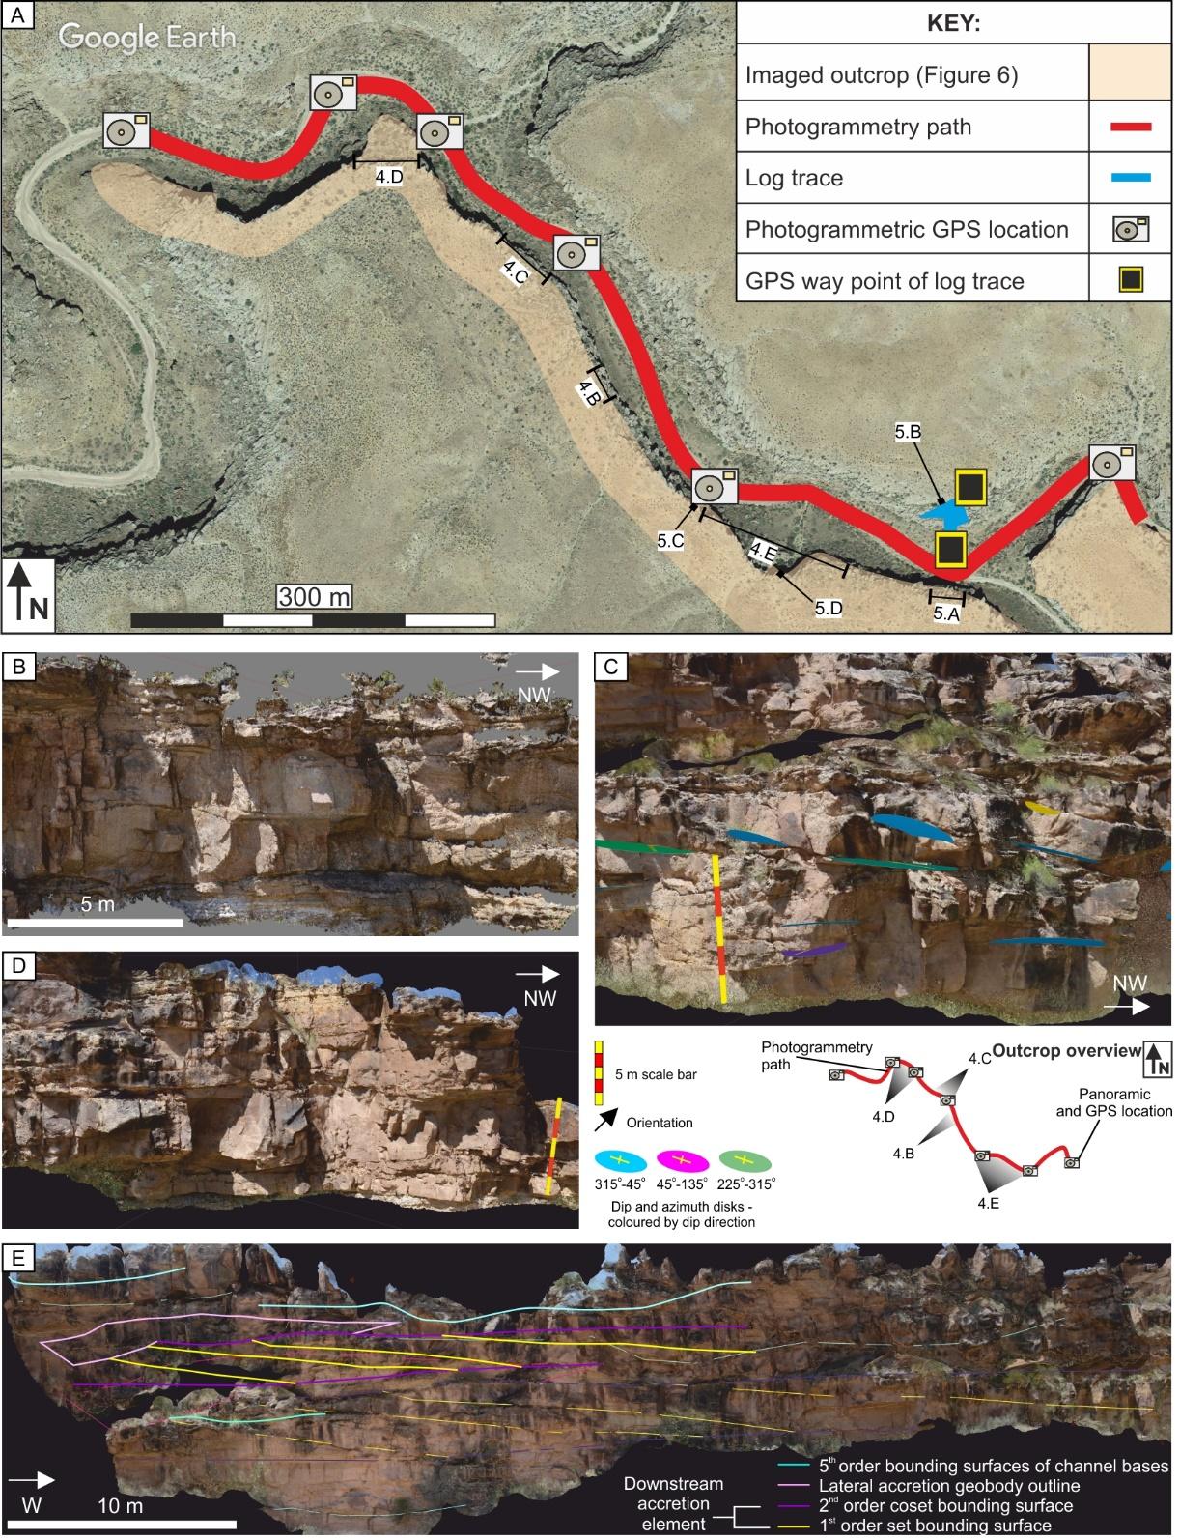
Figure 4 – A) Satellite image of the Tuscher Canyon section (Figure 2B), Utah, USA, showing the positions where sedimentary log and photogrammetric data were collected (see key) along with subsequent figure locations (numbered). B) Digital point cloud data from the outcrop dataset. Note: the bottom right shows the study location map of A. C) and D) show sedimentary dip and azimuth measurements (coloured surfaces) on the digital surface within the VRGS software (see text). E) Bounding surface analysis on the digitally-textured mesh surface.
Twenty-nine palaeocurrent readings were collected in the field (from crossbedding fabrics), and a further 447 were collected from the photogrammetric data using the Virtual Reality Geological Studio (VRGS) software (v. 2.39, Hodgetts et al., 2015; Figure 4C and D), from which detailed three-dimensional sedimentary architectures could be determined (Figure 4). Field-based sedimentary logging was also undertaken to supplement the sedimentary architecture data with facies-scale sedimentological observations.
The satellite image of the Jamuna River was captured on 24/04/14 and was subsequently interpreted using the same bounding surface nomenclature as the Tuscher Canyon outcrops (Miall, 1985, 1996). The image was imported into ImageJ (v.1.51; Rasband, 2009) software as a 32-bit image where accurate measurements of sedimentary architecture could be made (Potere, 2008; Yu and Gong, 2012; Colombera et al., 2012, 2013, 2016; Zhou and Wang, 2015; Gorelick et al., 2017). Thirty-eight channel and barform widths, and twenty-seven barform lengths were measured from the 8 km² downstream accreting bar complex. Width:length element ratios were calculated. Finally, the image was put into the equal surface area measurement tool within ImageJ (Rasband, 2009; Grove and Jerram, 2011) to analyse sedimentary architecture proportions.

Sedimentary architecture
The quantitative and qualitative data collected from the two systems are now described. The sedimentology of these systems is not discussed in depth here as they have been described previously. A detailed account of the facies and architectural composition of the Castlegate can be found in Van de Graff (1972), Chan and Pfaff (1991), Miall (1993, 1994), Adams and Bhattachyra (2005) and McLaurin and Steel (2007); for details of the Jamuna River see the works of Coleman (1969), Bristow (1993), Bristow et al., (1999), Ashworth et al., (2000) and Best et al., (2003).

Lower Castlegate Sandstone, Utah
The Castlegate Sandstone succession at Tuscher Canyon consists of eight facies (Table 1; Figure 5): one structureless conglomerate facies (Cc), six sandstone facies (St, Sp, Sh, Shv, Sm and Smv) and one fine-grained siltstone facies (Fl). Four major architectural elements have been identified, based on the distribution of these facies and their bounding surface framework. These are: simple cut-and-fill channel elements (CH), thalweg bedform complexes (TB), downstream accreting barforms (DA) and laterally accreting barforms (LA) (Miall, 1993; 1994; Yoshida et al., 2000; Figures 5, 6 and 7; Table 2).
Code | Facies description | Facies interpretation
Cc | Structureless conglomerate: Pebble-sized clasts, clast supported. Matrix is composed of fine- to very coarse-grained sandstone that is extremely poorly sorted. Clasts are comprised of quartz. Shows normally grading and is structureless with rip-up clasts of mudstone and siltstone. | Channel lag deposits, coarse grained bedload deposits in a high energy fluvial flow (Miall 1988). Rip-up clasts are associated with the erosion and subsequent transportation and deposition of previously deposited material (Bridge, 2003).
St | Trough cross-bedded sandstone: Fine to very coarse-grained, grey-brown arenite, sub- to well-rounded, moderate sorting and sphericity. Pervasive trough crossbedding with rip-up clasts of silt and mudstones. Pebble-sized clasts at the base of the facies and foresets surfaces. Soft sediment deformation is common. | Coarse-grained bedform migration of sinuous crested sub-aqueous dunes (Collinson et al., 2006). Pebble lining of foresets indicates mixed bedload sediment calibre and avalanche deposits of foresets (Allen, 1983).
Sp | Planar cross-bedded sandstone: Fine- to coarse-grained, grey-brown arenite, sub- to well-rounded, moderate sorting and sphericity. Planar crossbedding characterises the facies, foresets lined with darker clasts, sometimes granular to pebble sized clast material, asymmetrical and symmetrical ripples. | Bedload transport of straight crested subaqueous dunes with the formation of ripples (Miall, 1996).
Sm | Structureless sandstone: Medium-grained, black-grey arenite, sub-rounded, very poor to poor sorting and moderate sphericity. Structureless sandstone showing normal grading with large wood fragments and clast material throughout the facies. | High abundance of sediment with a mixed calibre forming a pseudo-plastic high energy flow supressing bedform development (Miall, 1996; Leeder, 1999).
Smv | Fine-grained massive sandstone: Very fine- to fine-grained, black-grey arenite, sub-rounded, very poor to poor sorting and moderate sphericity. Structureless sandstone showing normal grading with small wood fragments and micaceous rich. | Low-energy, high-sediment laminar deposition, transporting woody debris from upstream in the later stages of fluvial channel fill.
Sh | Horizontally bedded sandstone: Medium-grained, grey-brown arenite, sub- to well-rounded, poorly sorted, moderately spherical. Planar horizontal lamination with normal grading, large wood fragments and clasts throughout facies. | Upper flow regime plane bed deposits transporting eroded vegetated material (Miall, 1996; Collinson et al., 2006).
Shv | Fine-grained horizontally laminated sandstone: Fine-grained, grey-brown arenite, sub- to well-rounded, poorly sorted, moderately spherical. Planar horizontal lamination with minor asymmetrical ripple lamination on the upper surfaces of the facies. Planar horizontal lamination, asymmetrical ripple laminae. | Low energy lower flow regime deposits indicating settling deposits of sandstone calibre with some minor ripple scale bedform development (Miall, 1985).
Sr | Ripple laminated sandstone: Very fine- to fine-grained, grey-brown sandstone, sub-rounded, moderate sorting and sphericity. Asymmetrical ripple lamination, some finer black material on ripple laminae. | Lower-flow regime small-scale sub-aqueous bedform migration (Collinson et al., 2006)
Fl | Fine laminated siltstone: Grey, well-sorted siltstone, very fine-grained sandstone interbeds. Planar horizontal lamination with soft sediment deformation and pedogenic nodules. | Overbank sedimentation away from the main locus of fluvial transport, fine material deposited from settling out of material in flood phase deposition (Miall, 1996). Pedogenic nodules develop during periods of stabilisation and vegetation (Bridge, 2003).
Table 1 – Facies scheme used in this study, showing the description and interpretation of facies defined from the Tuscher Canyon outcrop site, Utah, USA. This also lists facies codes discussed within the text.
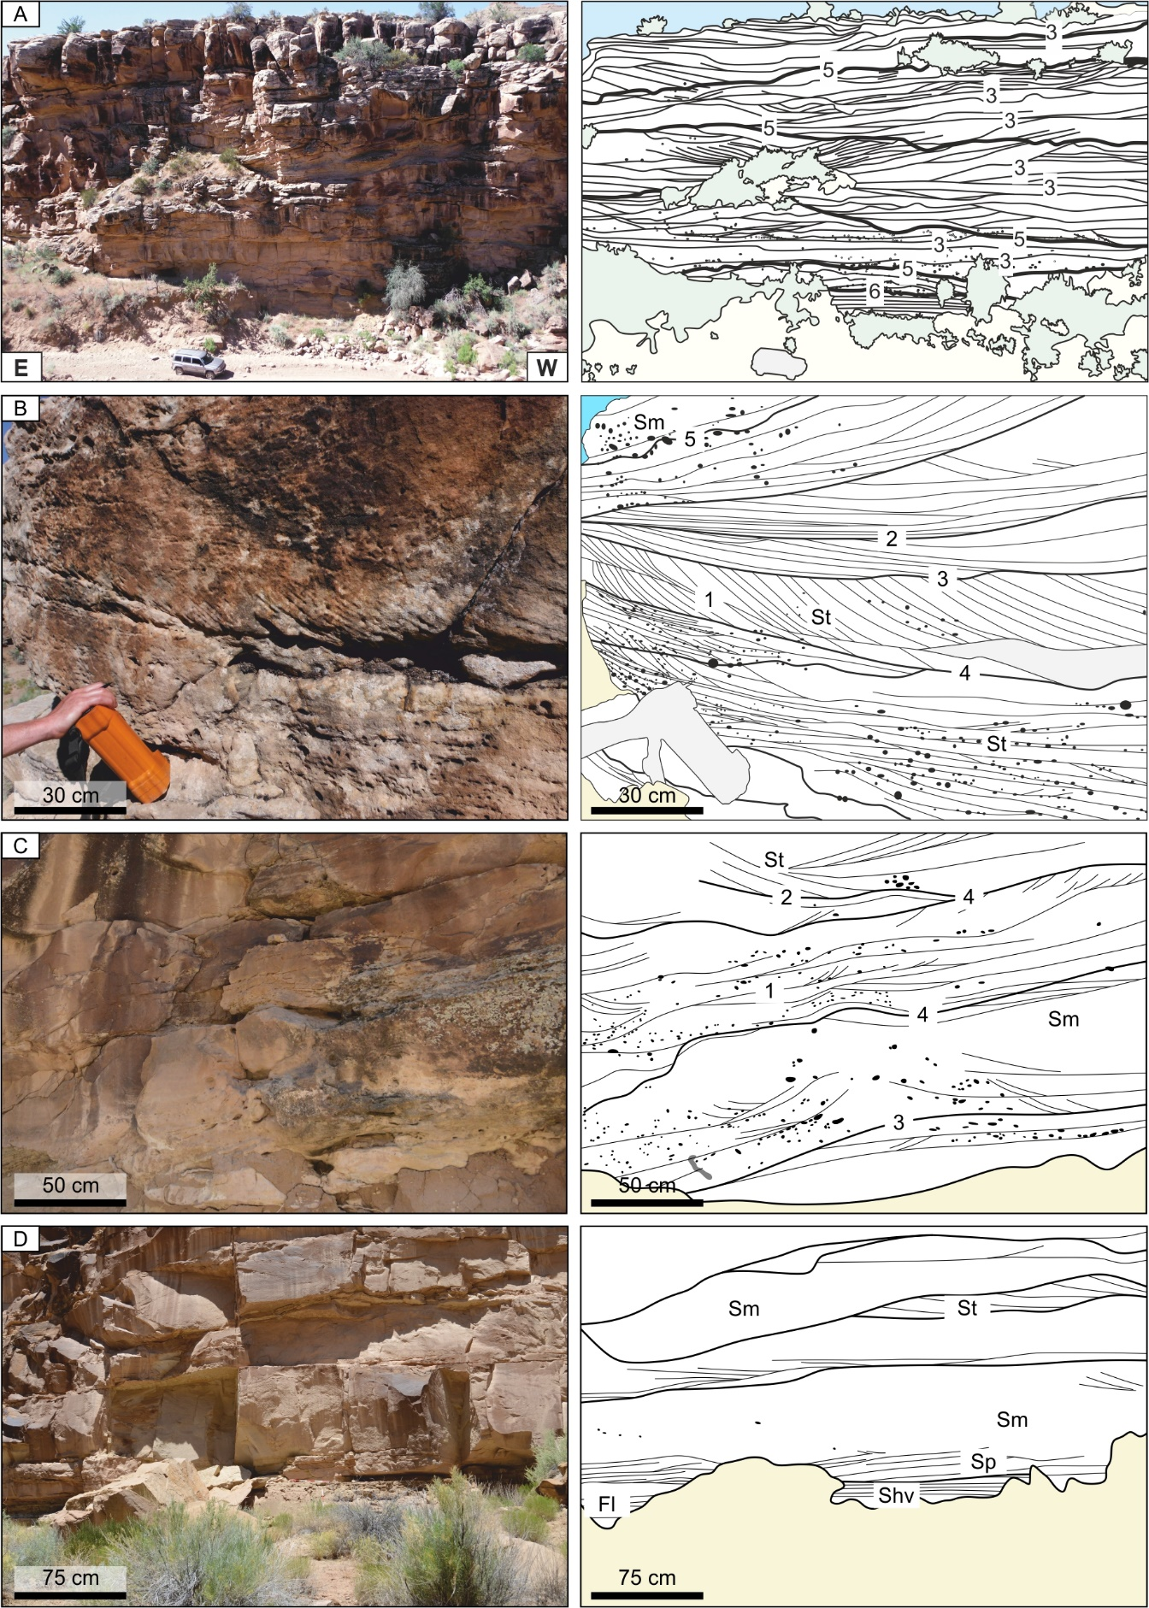
Figure 5 – The genetic units of the most common sedimentary facies found within the Castlegate Sandstone. The numbers indicate bounding surfaces hierarchy (Miall, 1985). A) Representative section of the bounding surface framework within the Lower Castlegate at Tuscher Canyon, and bounding surface hierarchy interpreted from that framework. B) Sandstone (St) facies showing pebble-lined foreset and set surfaces stacking below and above a third-order erosional scour surface. C) Third-order erosional surfaces bounding conformable packages of St and Sm facies. D) Sm facies within third-order scours (see Table 1 for facies codes).
The four elements have been classified as net or non-net reservoir based upon the heterogeneity of their internal structure (Eschard et al., 1998; Puig et al., 2019; Table 2). This study considers net and non-net reservoir units at an architectural element scale, constraining meso-scale heterogeneity (Figure 1) within the studied units. Facies commonly reported to have low petrophysical properties vital for fluid flow, structureless conglomerate (Cc) (Jones and Hartley 1993; North and Taylor 1996; Eschard et al., 1998; Puig et al., 2019) and Fine laminated siltstone (Fl) (Pranter et al., 2007; Yan et al., 2018; Puig et al., 2019), are defined as non-net reservoir facies in this study. Consequently, for modelling purposes, elements containing these facies are considered non-net reservoir.

Architectural Element | Bounding surfaces | Facies | Reservoir characterisation | Internal architecture of element | Net-Gross | Palaeocurrent | Width:Depth ratio
Channel  (CH) | Basal surface:  5th order  Top surface:  4th order  Internal surfaces:  3rd order | Sh, St, Sp, Smv | Channel lag deposits provide vertical element scale permeability, only to be considered a horizontal flow conduit (North and Taylor, 1996; Eschard et al., 1998; Puig et al., 2019).  This study: Non-net | 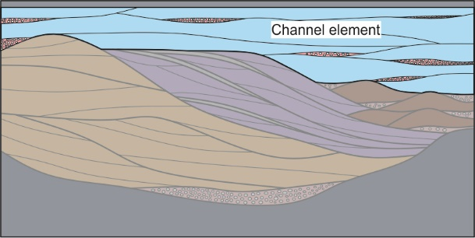 | 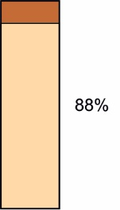 | 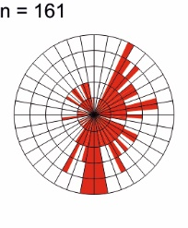 | 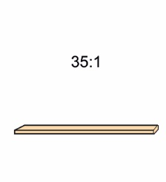
Downstream accretion  (DA) | Basal surface:  5th order  Top surface:  4th order  Internal surfaces:  1st, 2nd and 3rd order | Sm, Sh, St, Sr | Extremely homogeneous, some minor pebble lags but the majority of the element is uniform climbing bedforms comprising the downstream accretion element (Hornung and Ainger, 1999; Best et al., 2003; Miall and Jones, 2003; Ghinassi and Ielpi, 2018).  This study: Net | 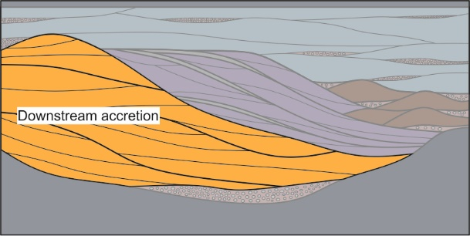 | 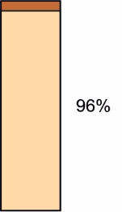 | 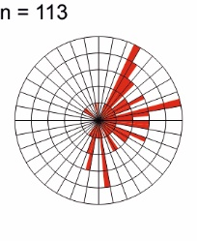 | 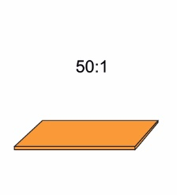
Lateral accretion  (LA) | Basal surface:  5th order  Top surface:  4th order  Internal surfaces:  1st, 2nd and 3rd order | Sm, Sh, St, Sp, Shv, Sr, | Inclined heterolithic strata of the element provide significant baffles to flow (Pranter et al., 2007; Ghinassi et al., 2014; Ielpi and Ghinassi 2014; Colombera et al., 2017; Cabello et al., 2018b).  This study: Non-net | 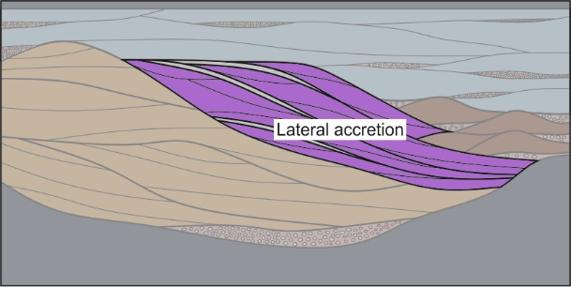 | 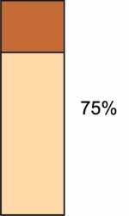 | 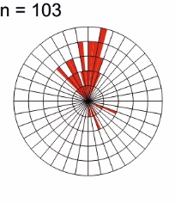 | 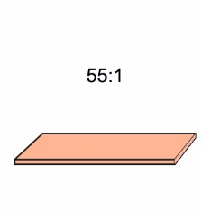
Thalweg bedform complex  (TB) | Basal surface:  5th order  Top surface:  4th order  Internal surfaces:  1st, 2nd and 3rd order | Sm, St, Sp, Sr | May be considered a baffle to flow relative to other elements, due to its immature make-up, basal lag deposits and the pebble lining of foresets.  This study: Non-net | 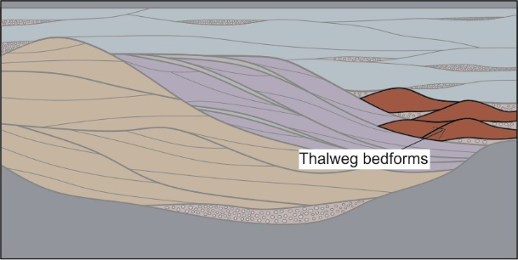 | 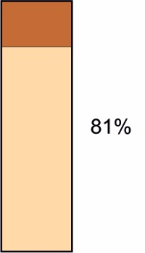 | 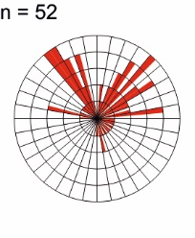 | 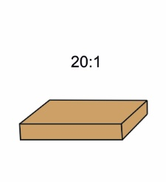
Table 2 – Architectural element summary of the Lower Castlegate at Tuscher Canyon. The table describes each element individually by: their top, bottom and internal bounding surface framework according to Miall (1996), the idealised facies succession (in the order the facies are shown), the reservoir characteristics of the element and whether they are considered net or gross when modelled in this study, and finally an internal two-dimensional schematic architectural framework. Note, the scale of these schematics is 100 m horizontally by 10 m vertically, and no foreset laminae have been illustrated. Finally a summary of the quantified statistical characteristics of each element: net-gross, palaeocurrent data and average width:thickness ratios are given.

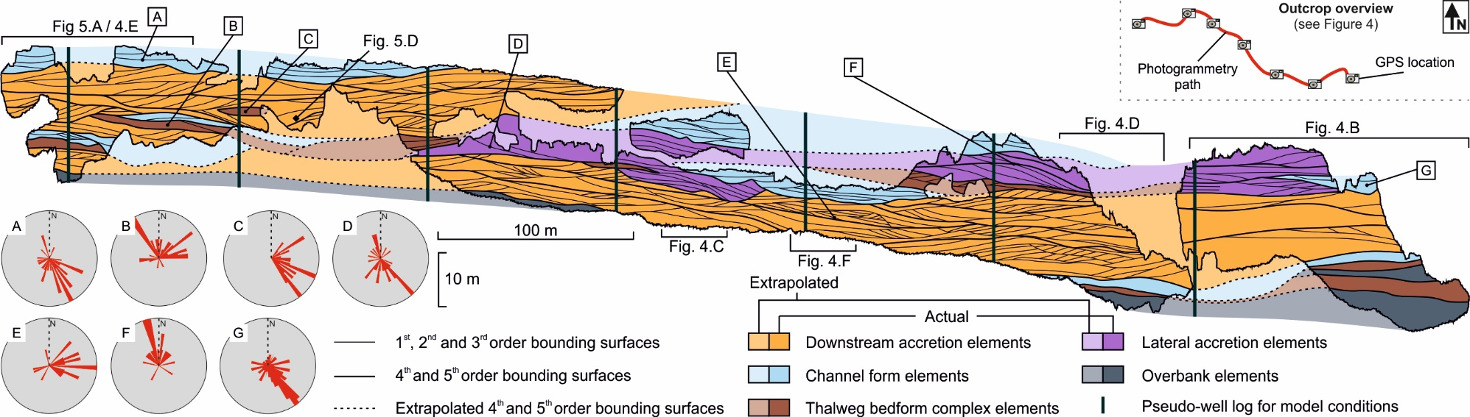
Figure 6 – Interpretation of the Lower Castlegate Tuscher Canyon outcrop, Utah, USA (see Figure 4A for location). Schematic shows the distribution of architectural elements and dominance of the downstream accretion element. Pseudo-well logs have also been incorporated to show positions of wells used to condition reservoir models. Measured palaeocurrent data (respective positions marked) of individual sedimentary architectural elements are also shown. Note the 2.5x vertical exaggeration.

The channel element has been characterised as non-net because of its pebble lag and poorly sorted basal strata above its erosional base (North and Taylor, 1996; Eschard et al., 1998; Puig et al., 2019). The thalweg bedform complex has been characterised as non-net as it is extremely poorly sorted and contains pebble-grade material within its sandy matrix. Finally, the inclined heterolithic strata within lateral accretion elements are considered non-net (Pranter et al., 2007; Yan et al., 2018). The only elements within the succession defined as net reservoir are the extremely homogeneous downstream accretion elements (see Table 2).
The Lower Castlegate Sandstone is mostly comprised of downstream accreting elements (Figure 7), with bar-top channels avulsing and modifying the tops of the elements, preventing full preservation of architectural elements succession. Lateral accretion elements only occur where the downstream accretion element is in contact with the channel element. These lateral accretion elements represent small sinuosities in the bar top channels that further cannibalise the bar tops. The net defined strata (downstream accretion element) are connected, as most of the channel elements do not migrate across the complete lateral extent of the element, allowing vertical communication between downstream accreting elements.

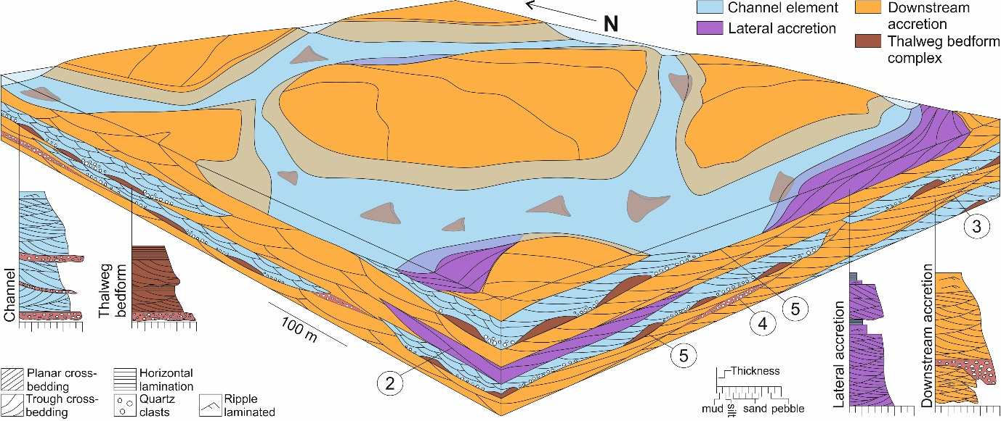
Figure 7 – Schematic representation of sedimentary architecture at the Lower Castlegate exposure in Tuscher Canyon, Utah, USA. The schematic has been orientated to show the regional eastward palaeocurrent direction measured from the outcrop exposure. Sedimentary logs and bounding surface hierarchy numbers (Miall, 1985) show the individual architectural elements idealised succession, with bounding surface annotations indicating the depositional framework.

Jamuna River, northern India
The studied section of the analysed Jamuna River, northern India, shows a large downstream accreting barform complex; with sub-ordinate channel forms migrating along the bar top (Figure 8). The downstream accreting bar complex is ~4,300 m in length and ~3,330 m wide.
Within the studied barform, channel elements are bar-top modification channels, eroding into the larger downstream-accreting element complex. The proportion of these subordinate channels is 35.6% of the totally imaged area. The channels have two distinct groupings of their widths which were ~290 m and ~110 m (mean values), dependent on the degree of bifurcation.
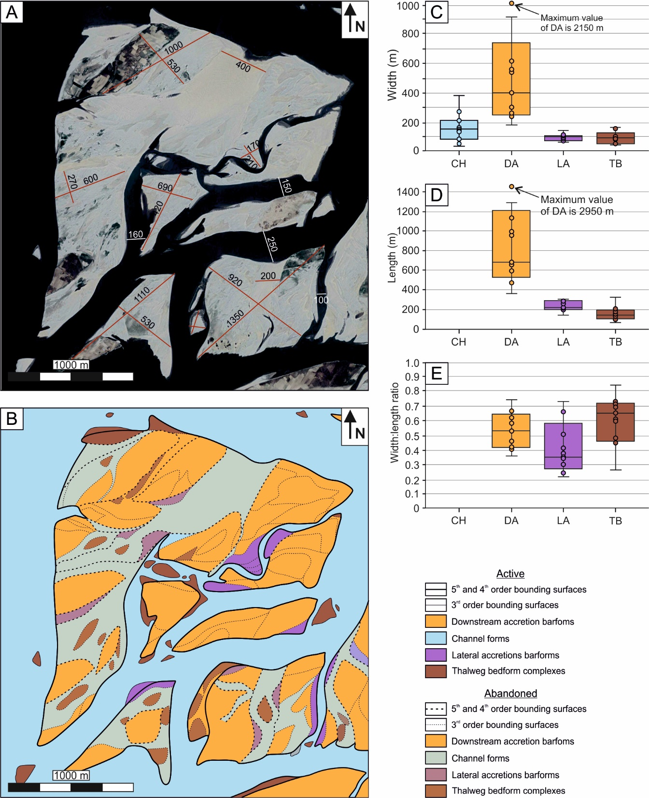
Figure 8 – A) The Jamuna downstream accreting barform in northern India (see Figure 3 for location), annotated with width and length measurements of active and abandoned fluvial sedimentary architectures. B) Interpretive line drawing (see key and text) – note colours are the same as for the Tuscher Canyon outcrop (Figure 7). C) Box plots of the width, D) length and E) width:length ratio of sedimentary architectural elements within the interpreted Jamuna River barform complex (CH = Channel element, TB = Thalweg bedform complex, DA = Downstream accretion element, LA = Lateral accretion element). Note the maximum measurements of the downstream accretion element exceeds the scope of the graph.
The downstream accretion elements dominate the majority of the surface area at 57%. They are confined within major channel margin erosion surfaces (fourth and fifth-order bounding surfaces; Figure 8) and are eroded by subordinate channel forms (Figure 8). The barforms show a wide range of sizes, but have a consistent width:length ratio of 1:1.3. Thalweg barform complexes are poorly imaged by satellite due them being rarely emergent bedform complexes. These elements are confined within channel forms and appear massive in character, with a width:length ratio of 1.3:3.1 with a maximum length of 400 m (Figure 8).
Lateral accretion elements represent a low proportion of the bedforms in the image, these are not large point bars but lateral accretion deposits associated with the sinuosity of bar-top modification channels. The architectures are confined within a channel margin (fifth-order) bounding surface and are usually located on the margins of a channel. Typically, the element has a width:length ratio of 1:2 and has a lower surface area proportion compared to what is preserved within the Tuscher Canyon section. This may be due to higher than usual preservation potential, due to the lateral migration during deposition of the element, or the imaged bar-top channels are not as sinuous as those preserving lateral accretion within the Castlegate.

Depositional conditioning and training image construction
In studies modelling fluvial strata, either outcrop or modern plan-view data are used to create training images. This renders the input data reliable in two dimensions only and it has been shown to be a major limitation of training images that are applied to MPS models (Strebelle, 2002; Comunian et al., 2012). This work uses quantitative and qualitative data, derived from both modern and ancient datasets, to condition a three dimensional training image. The current study refers to this as depositional conditioning. Concepts of depositional conditioning have been suggested by previous workers using outcrop (Buckley et al., 2006; Falivene et al., 2006; Cabello et al., 2018b; Puig et al., 2019) or modern plan view data (Gershenzon et al., 2015; Zhou et al., 2018). The technique for the development of three dimensional depositionally conditioned training images presented here provides a more geologically realistic basis for reservoir model generation than working in two dimensions only.
Depositional conditions fall under four categories; (1) the spatial distribution of types of architectural elements relative to others, (2) the dimensions of the elements; 3) the geometric shape of the elements and finally, (4) the relative proportion of elements within a total reservoir volume. These standard sedimentary inputs can be used to develop a simple set of conditional rules for the training image, derived from empirical patterns of deposition. The sedimentary characteristics used to develop depositional conditions can be derived for any representative elementary volume of sediment (Nordhal and Ringrose, 2008) at or above facies scale, making the approach extremely versatile. Consequently, the level of heterogeneity applied to a training image may depend upon the specific reservoir complexity, the abundance of data and interpretation, or reservoir type.
Recent studies combine multiple datasets to develop library-based approaches (e.g. the FAKTS database; Colombera et al., 2012, 2013, 2016a) from which quantitative conditioning data can be extracted for the construction of sequential indicator simulation and object-based models. Such object based-models could be used for the development of three dimensional training images. These techniques draw upon large amounts of data to increase their statistical validity. However, in the absence of such databases, depositional conditions must be generated from more limited datasets. In this paper, depositional conditions are derived from both an outcrop analogue dataset and a modern-day satellite image, to create a training image that realistically constrains meso-scale heterogeneity, in three dimensions. The use of standardised sedimentary inputs into training images provides a step to a reproducible set of input parameters for training images, a common problem creation of training images (Tahmasebi, 2018).
The training image, presented here, is produced in a simple three-dimensional grid generated in Schlumberger™ Petrel v.2016 software, using the top and base of the Tuscher Outcrop as deterministic surfaces (Enge et al., 2007). The simple grid is a single zone, 1,000 m x 1,000 m x 20 m, with a cell resolution of 10 m x 10 m x 0.5 m. The training image was manually filled by digitally painting the simple grid with the proportions, geometries, dimensions and juxtaposition of elements highlighted in the quantitative three-dimensional geological concept model (Figure 7) that used the depositional conditions (Table 3) extracted from the outcrop and modern study. The Castlegate outcrop at Tuscher Canyon provides constraints for the cross-sectional plane (parallel to flow; Figure 9) as this is the orientation of the studied section. The plan view (Figure 9) is constrained by the modern day Jamuna River data (Howell et al., 2014). The target fractions (elementary proportions), element dimensions and geometries were monitored during the painting of the three dimensional volume to ensure input data were matched. Corrections were made iteratively to the training image until the manually filled simple grid honoured the input parameters (or depositional conditions) developed from the input datasets.
Archi-tectural element | (1) Distributions | (2) Dimensions |  | (3) Proportion | (4) Geometry
Channel Fill (CH) | Subordinate CH elements cross cut DA. | length | N/A | 26 % | Plan: Ribbon  Cross-section: Lensoidal
 |  | width | Min:  90 m Max:  400 m
 |  | depth | Min:  1 m  Max:  8 m
 |  | Sinuosity amplitude | Min:  50 m  Max:  575 m
 |  | Sinuosity wavelength | Min:  370 m  Max:  3400 m
Thalweg barformcomplex (TB) | TB must be confined within CH. | length | Min:  50 m  Max:  400 m | 8* % | Plan: Irregular asymmetric lens  Cross-section: Lensoidal
 |  | width | Min:  50 m  Max:  300 m
 |  | depth | Min:  1 m  Max:  3 m
Lateral Accretion (LA) | LA must be located at the CH/DA boundary. | length | Min:  150 m  Max:  800 m | 14* % | Plan: Lensoidal  Cross-section: Tabular
 |  | width | Min:  75 m  Max:  800 m
 |  | depth | Min:  1 m  Max:  5 m
Downstream accretion (DA) | DA must be contained within CH on a large scale. | length | Min:  400 m  Max:  2000 m | 52% | Plan: Irregular kite  Cross-section: Lensoidal
 |  | width | Min:  200 m  Max:  2000 m
 |  | depth | Min:  4 m  Max:  12 m
Table 3 – Depositional conditions of mega-bar complexes for the training image construction. This details the main sedimentary architectural elements and their respective conditional requirements: distribution, dimensions, geometry, and proportions. * indicates values weighted to the data from the Tuscher Canyon outcrop due to imaging issues in the satellite images, see text for details. Note, channel sinuosity values are included, obtained from the Jamuna River satellite imagery data.
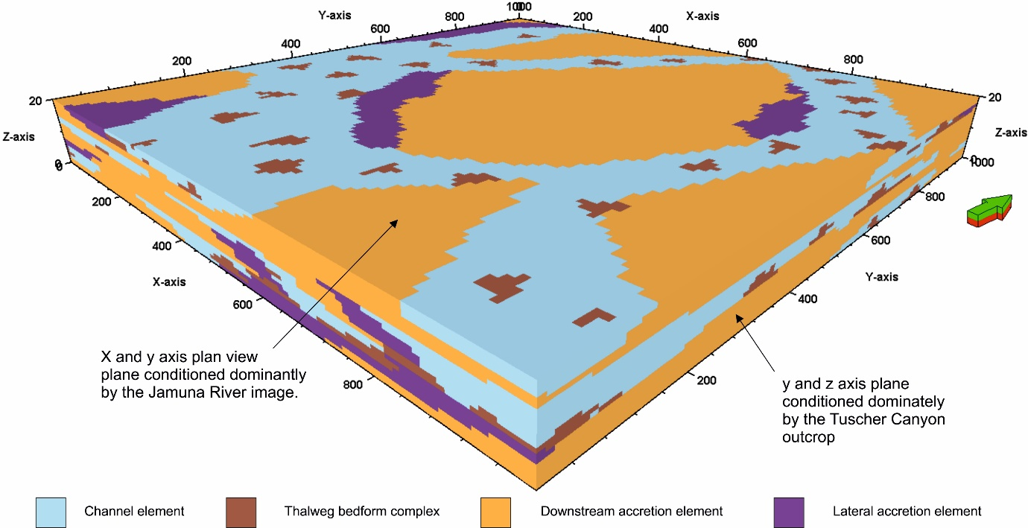
Figure 9 – Numerical depositionally-conditioned 3D training image used in this study, created within Schlumberger™ Petrel v.2016 software, using the input parameters given in Tables 2 and 3. The training image is 1,000 m x 1,000 m x 20 m at a cell resolution of 10 m x 10 m x 0.5 m. The datasets providing the major conditions for the planes are marked. The image provides the basis for the MPS model generation (see text).
Channel elements are conditioned to be cross- and down-cutting into the underlying downstream accretion element. They have widths between 90 m to 400 m, they are 1 m to 8 m thick, and they have a lensoidal cross-sectional geometry but ribbon plan-view geometry (Figure 9). The element occupies 26 % of the total model volume. Thalweg bedform complex elements must be confined within channel elements. They have lengths of 50 m to 400 m, widths of 50 m to 300 m and depths of 1 m to 3 m. Thalweg bedform complex elements occupy 8 % of the total model volume and have lensoidal geometries (Table 3). Due to thalweg bedfrom complexes being poorly imaged by satellite, respective element proportions are weighted against those exposed at the Tuscher Canyon outcrop, where they are preserved and visible. Lateral accretion elements must be located at the margins of channel elements and downstream accretion elements. They have lengths of 150 m to 800 m, widths of 75 m to 800 m and depths of 1 m to 5 m, with lensoidal plan views and tabular cross-sectional geometries (Table 3). The element has its volumetric percentage weighted against the preserved Tuscher Canyon outcrop to account for preservation. The lateral accretion architecture must cover 14% of the total modelled volume. Lateral accretion, as well as channel and thalweg bedform complex, should be considered as strata that contain baffles to fluid flow, thus considered as non-net reservoir.
Downstream accretion elements are the only elements in this model considered net, due to them being relatively homogenous (Best et al., 2003; Miall, 2003; Ghinassi and Ielpi, 2018). They have lengths of 400 m to 2000 m, widths of 200 m to 2000 m and depths of 4 m to 12 m. The downstream accretion element should populate 52 % of the total model volume (Table 3), and be distributed within CH elements as kite like shapes in plan view and lensoidal geometries in cross section.

Reservoir modelling
The three dimensional reservoir models used in this study were generated in Schlumberger™ Petrel v.2016 software. The top and base of the Lower Castlegate Sandstone from the Tuscher Canyon outcrop, were picked as key digital stratigraphic surfaces and marker horizons. These two horizons form the top and base of the modelling grid, which was modelled as a single zone. This forms a deterministic stratigraphic framework for the modelling grid (following common practice, see Enge et al., (2007) and references therein), that is proportionally layered, and is extended beyond the dimensions of the Lower Castlegate outcrop to fit with the spatial extent of the modern Jamuna River data (see Pringle et al., 2010 for specific methodology). The resultant reservoir model grid is 4,000 m x 3,000 m x 40 m, and contains 4.8 million cells, at a cell resolution of 10 m x 10 m x 0.5 mhonour the input datasets (c.f. Enge et al., 2007).
The three modelling techniques used in the development of the reservoir models for this study are: multi-point statistics (MPS), sequential-indicator simulation (SIS) and object-based modelling (OBM). In each model iteration, regardless of simulation algorithm, was conditioned to six pseudo-well logs taken from the photogrammetric model interpretation of Tuscher Canyon, Utah, the positions of which are indicated in Figure 6. (Pringle et al., 2010; Colombera et al., 2016b; Cabello et al., 2018b; Puig et al., 2019). The pseudo well logs lock the position of elements within the reservoir model volume and force the modelling algorithms to populate around the real data. Ten iterations of each modelling process were generated (Goovaerts, 1999; Falivene et al., 2006), so that a qualitative visual and quantitative statistical analysis of each model could be undertaken.
The MPS models were created using the depositionally conditioned three dimensional training image (Figure 9). The training image was then incorporated into the model volume by aligning the centraloid cell of the training image to that of the MPS model. The training image was then subjected to a neural-network-type analysis, where each pixel away from the training image volume and centraloid cell was given a value (see Strebelle and Journel, 2001; Strebelle, 2002; Caers and Zhang, 2004; Strebelle and Levy, 2008; Daly and Caers, 2010), based upon the training image and the patterns and geometries it contains. The network continues to populate the modelled reservoir volume until the framework is populated by the MPS algorithm (Strebelle and Chevron, 2012).
To generate the SIS models, variograms for each of the architectural elements were generated. Variograms of the major (east-west) and minor (north-south) directions were generated from measured sections through the Jamuna River data, and a variogram for the vertical dimension was generated from measured section through the Tusher Canyon data (Figure 10) (following standard practice of, Deutsch and Journel, 1992; Kupfersberger and Deutsch, 1999; Seifert and Jensen, 1999, 2000; Martinius et al., 2017; Mullins et al., 2019), The variograms are used, in conjunction with the element proportion statistics derived from the input datasets (Table 2) to populate the SIS reservoir model.
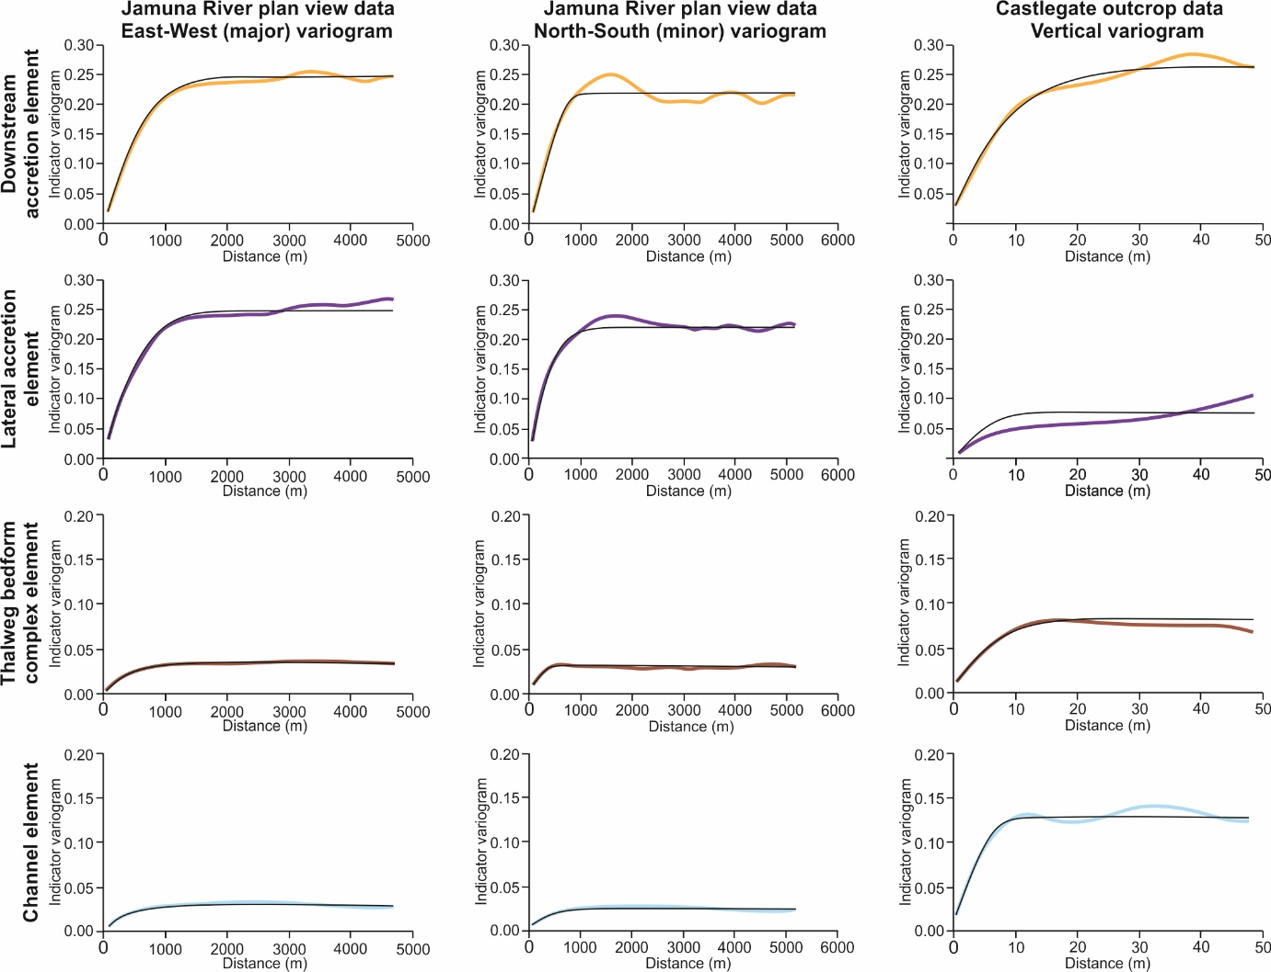
Figure 10 – Indicator variograms (coloured lines) showing the variance of the four architectural elements (DA = Downstream accretion element; CH = Channel element; LA = Lateral accretion element; TB = Thalweg bedform complex) across both data sets, providing input conditions for the SIS model iterations. Respective experimental variograms (black lines) are also shown, see text for details.
The OBMs were generated using the downstream accretion element as the background facies, as this is the host barform of the channels. The channels were built using the geometric and dimensional statistics derived from the outcrop and modern data sets (Table 2 and 3), with the channel sinuosity derived from the Jamuna River modern plan-view data (Table 3). Lateral accretion elements were constructed as ellipsoid bodies that erode into the downstream accretion elements, so as to maintain channel proportions. Thalweg bedform complex elements were modelled as small ellipses to erode into channel elements, and were trended to occur in the base and middle of the channel-fill elements, as they occur in the studied examples. These predefined shapes and relationships were modelled as a hierarchy within one-run (Holden, 1998; Seifert and Jensen, 2000; Vevle et al., 2018), iteratively correcting to enable the elementary proportions (or global target fraction) to be maintained.

Methods of model analysis
Qualitative analysis was conducted through visual comparison of each model iteration individually, and each model algorithm, to test if the input parameters of depositional conditions imposed by the depositional environment had been met. Quantitative whole model analysis was also conducted by comparing dimensional characteristics of individual architectural elements for each model iteration. The results of these analyses were compared to the mean input data (Table 2 and 3), with architectural element proportions also compared to their target fractions. Individual element thicknesses for each model iteration across the three algorithms were measured and compared to the dispersion in mean element thicknesses. Maximum element unit thicknesses were also compared to see how the model algorithms replicated the extreme cases of the element simulations, and whether they produced any anomalously thick element units that were unrealistic.
Finally, a single vertical well, penetrating the entire vertical extent of the model, was placed through the centraloid cell of all model iterations to provide a quantitative measure of static net-connectivity (Falivene et al., 2006). Static net-connectivity, also known as reservoir-to-well, is defined here as the volume of net-rock intersected and drainable by a single well (Laure and Hodavik, 2006, Hodavik and Larue, 2007). Quantitative measures of net-connectivity were supplemented by looking at the maximum, mean and variability in the thicknesses of net connectivity. This enabled, not only the proportion of interconnected net reservoir to be evaluated, but also the nature of the connections.

Qualitative model analysis
The depositionally-conditioned MPS models reproduced the distribution, geometry, dimensions and proportions of the modelled sedimentary architectures. The lateral accretion elements were always placed adjacent to the channel fill and downstream accretion elements. The channel elements replicated the ribbon-like plan view geometries of the depositional conditioning. The downstream accretion elements always displayed sensible trends of thickening and thinning both laterally and vertically throughout the modelled volume and commonly occurred as small discrete bar-like packages in plan-view (Figure 11). Avulsion events were observed with both the channel and lateral accretion element architectures across the reservoir volume on similar scales to those observed in both ancient (Smith et al., 1989; McLaurin and Stee,l 2007; Hajek and Heller, 2012; Li et al., 2015) and modern systems (Bristow et al., 1999; Pickering et al., 2014; Sarker et al., 2014). Thalweg bedform complex elements were only observed within channel fills. However, the square geometry of some of the smaller depositional elements (lateral accretion and thalweg bedform complex elements) appeared to differ from the original input data, with square geometries in cross section.
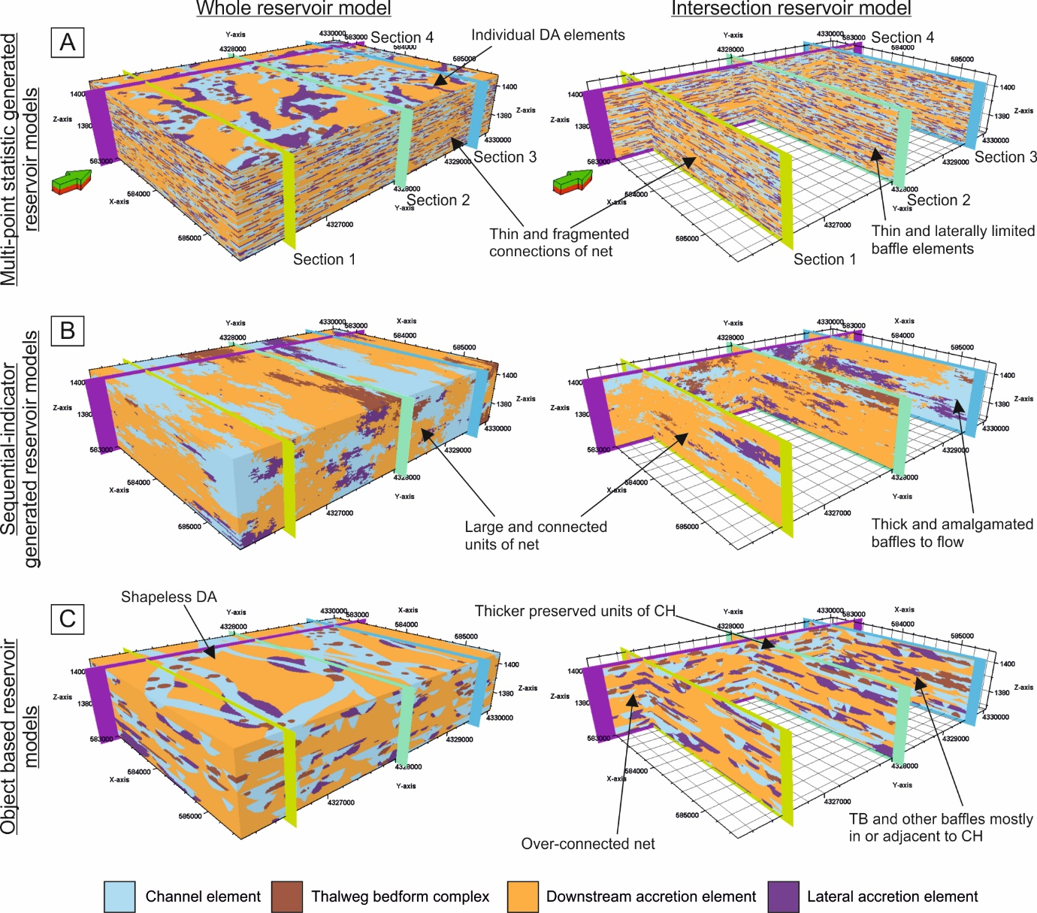
Figure 11 - Comparison of (A) Multi-point statistics (MPS)-, (B) sequential indicator simulation (SIS)-generated and (C) Object-based (OBM) reservoir models as whole models and in cross-sections. Models were generated using the same input parameters derived from the outcrop and modern studies (see text for details). A) MPS model generated from the training image shown in figure 9. This evidences thin and laterally restricted baffles, individual plan-view downstream accretion elements that showed some recognisable geometries and thin and fragmented net connectivity in cross section. B) SIS model generated from the variograms (Figure 10; see text). Model shows large and connected net reservoir and thick laterally extensive amalgamations of non-net baffle heterogeneity. C) OBM models generated from the quantitative statistics extracted to make the depositional conditioning rules. Model shows an over-connected net reservoir and thicker preserved channel elements. Note, all models have a 20x vertical exaggeration.
The SIS generated models honoured some realistic depositional rules. For example, lateral accretion elements were generally adjacent to channel fill elements. However, lateral accretion elements were typically represented as one large unit rather than separate, smaller discrete elements, and the model did not recreate the long ribbon-like, cross-cutting planforms of the channel element. The thalweg bedform complexes were not confined to the channel elements and were again reproduced at a much larger scale than was realistic (Figure 11). Very large volumes of downstream accretion elements were connected (Figure 11).
The OBMs produced channels that showed distinct concave-up geometries and amalgamations brought on by avulsion events. The thalweg bedform complexes were replicated to be only within the channel elements, and were mostly located in the middle to basal portions of the channel elements (Figure 11). The lateral accretion elements formed ellipse plan-view geometries and were adjacent to channel elements in the majority of cases. Downstream accretion elements have over-represented thickness and showed no discernible geometry as they have been modelled as background sedimentation.

Quantitative model analysis
The MPS models underestimated the thalweg bedform complex proportions and downstream accretion elements by ~2% and overestimated channel elements by ~3%. The MPS algorithm underestimated the mean thickness of the elements relative to the input data and reproduced more of the minimum element thicknesses (Figure 12; Table 4). The deviation away from the mean element thicknesses were well replicated, except for the lateral accretion elements. The lateral accretion elements showed a lower mean thickness (0.60 m) and a lower variation (Covariance (Cv) = 0.39) in thickness across their reproduction in the MPS models. The maximum thicknesses of the elements produced within the model were realistic and approximately replicated those seen within the input data.
 | Statistic |  | Multi-point statistics | Sequential-indicator simulation | Object-based models
Downstream accretion element | Proportions | Min. | 49.7 | 49.26 | 49.62
 |  | Mean | 50.48 | 50.84 | 51.77
 |  | Max. | 51.79 | 53.44 | 52.66
 |  | Sd | 0.77 | 1.24 | 0.79
 | Thickness | Min. | 0.50 | 0.50 | 0.50
 |  | Mean | 1.20 | 3.48 | 4.18
 |  | Max. | 18.00 | 40.00 | 40.00
 |  | Cv | 0.78 | 1.33 | 0.94
Channel element | Proportions | Min. | 29.01 | 24.49 | 25.28
 |  | Mean | 29.56 | 26.08 | 32.02
 |  | Max. | 30.17 | 27.68 | 32.38
 |  | Sd | 0.33 | 1.07 | 0.60
 | Thickness | Min. | 0.50 | 0.50 | 0.50
 |  | Mean | 1.80 | 2.00 | 2.33
 |  | Max. | 9.00 | 38.00 | 31.50
 |  | Cv | 0.60 | 1.35 | 0.76
Lateral accretion element | Proportions | Min. | 13.81 | 10.99 | 13.78
 |  | Mean | 14.29 | 13.57 | 13.93
 |  | Max. | 14.72 | 16.87 | 14.27
 |  | Sd | 0.31 | 2.01 | 0.16
 | Thickness | Min. | 0.50 | 0.50 | 0.50
 |  | Mean | 0.60 | 1.92 | 1.96
 |  | Max. | 10.00 | 27.50 | 13
 |  | Cv | 0.39 | 1.19 | 0.65
Thalweg bedform complex element | Proportions | Min. | 5.39 | 7.52 | 8.00
 |  | Mean | 5.67 | 9.51 | 8.00
 |  | Max. | 5.85 | 12.42 | 8.00
 |  | Sd | 0.18 | 1.25 | 0.00
 | Thickness | Min. | 0.50 | 0.50 | 0.50
 |  | Mean | 0.50 | 1.76 | 1.50
 |  | Max. | 3.00 | 26.50 | 10.00
 |  | Cv | 0.29 | 1.09 | 0.59
Net connectivity | Proportions | Min. | 49.48 | 48.84 | 49.44
 |  | Mean | 50.25 | 50.44 | 51.67
 |  | Max. | 51.54 | 53.23 | 52.51
 |  | Sd | 0.76 | 1.38 | 0.81
 | Thickness | Min. | 0.50 | 0.50 | 0.50
 |  | Mean | 1.20 | 3.60 | 4.21
 |  | Max. | 18.00 | 40.00 | 40.00
 |  | Sd | 0.92 | 4.71 | 3.89
Table 4 – Output data for the architectural elements and net connectivity for the multi-point statistics, sequential indicator and object-based model iterations. Note, Min. = minimum, Mean = arithmetic mean, Max. = maximum, Sd = standard deviation, Cv = covariance.
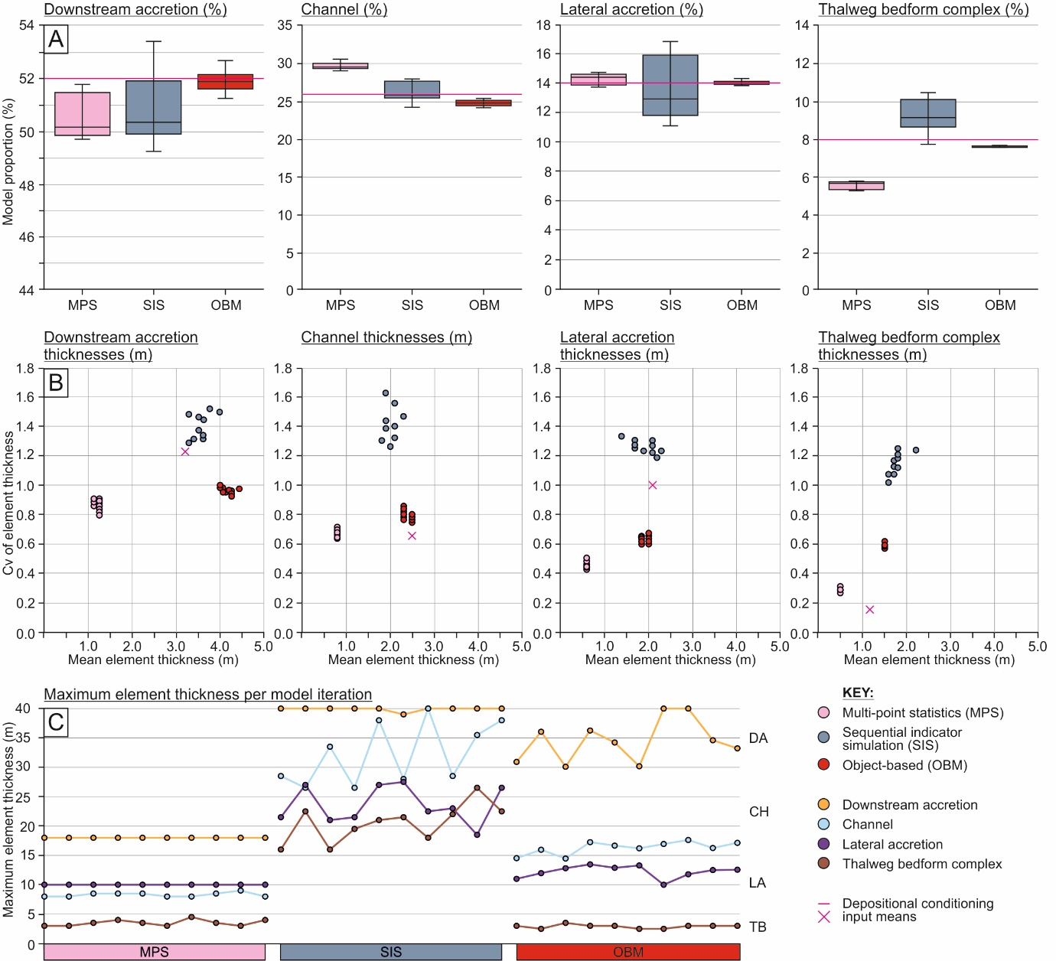 Figure 12 – Summary model statistics derived from the three-dimensional summaries of the reservoir models generated using each iteration of the three algorithms. A) The relative proportions of each architectural element modelled within the reservoir model algorithms. The pink line highlights the model input data derived from the sedimentary analysis. B) Mean element thicknesses for each element plotted against the covariance (Cv) of each element, to highlight the thickness and dispersion in thickness across each element. C) Maximum element thickness plot for each model iteration in each algorithm to show how overestimations of vertical connectivity were affected by the choice of algorithm. Note, the depositional conditioning input means are indicated on the graph showing where the input data and training image values plot.
The SIS models produced the largest amount of variance across the element thicknesses. SIS generated iterations reproduced the mean element proportions best of the three algorithms. The SIS algorithm statistically best reproduced the downstream accretion element with the mean element thickness (3.48 m) and variability (Covariance (Cv) = 1.33) of mean thickness (Figure 12; Table 4). The mean and variability of the reproduced element thickness for the lateral accretion was also closely related to that of the input data. However, it proved the least effective at replicating the mean thicknesses of the thalweg bedform complex and lateral accretion elements. The maximum thicknesses of all the elements were over represented, for example, the maximum thicknesses of the downstream accretion elements was 40 m (the entire modelled reservoir thickness), and ~20 m for the thalweg bedfrom complex.
OBMs accurately reproduced the elementary proportions, and produced the lowest degree of variance in the element proportions between each model iteration. The OBMs overrepresented the mean thickness of downstream accretion elements and thalweg bedform complexes (4.1 m and 1.6 m respectively). The variance replicated in the thicknesses of channel element (Cv = 0.8) and downstream accretion element (Cv=1.0; Figure 12) was well produced. The maximum thicknesses of these elements were, however, over estimated at 40 m and 18 m respectively. The mean and maximum thicknesses of the lateral accretion elements (mean = 1.96 m, maximum = 13 m) and thalweg bedform complex (mean = 1.50 m maximum = 10 m) were similar to those of the MPS generated models and those found in the input datasets.
All three algorithms produced broadly similar results in the static connectivity test of net reservoir The single production well was able to drain over half of the modelled volume (Figure 13), equivalent to a total drainable volume of ~229,000,000 m³. However, OBMs returned greater drainable volumes across the model iterations, with the smallest variance in the drainable volumes produced. The SIS algorithm produced the greatest range in connected net (Figure 13).
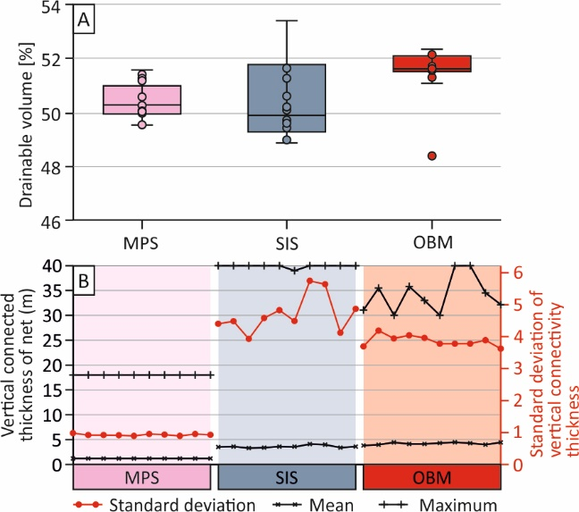
Figure 13 – Drainable volumes and vertical connectivity statistics from all thirty model iterations across the three algorithms. A) Drainable percentage volume box-plots of the SIS-, MPS- and OBM-generated models, showing the variance in results across the ten iterations of SIS-generated reservoir volumes and a narrow variance in MPS-generated and OBM-generated iterations. B) Maximum, mean and standard deviation of the vertical thickness of net connectivity across all iterations of MPS-, SIS- and OBM-generations. OBM and SIS show a maximum thickness equal to that of the entire model, whereas MPS shows a maximum connectivity thickness of 18. The standard deviations of the SIS and OBM models also showed a high variance, whereas the MPS showed less of a variation away from the mean.
The SIS model produced a 48.84/50.44/53.23 (min/mean/max) percentage drainable volume with a standard deviation of 1.38. The MPS model iterations produced a 49.48/50.25/51.54 (min/mean/max) percentage drainable volume with a standard deviation of 0.76 (Table 4). This suggests that, although the two models were similar in terms of average in drainable volume, the range and standard deviation was much greater for the SIS models when compared to those models generated by MPS. The OBM iterations produced 49.44/51.67/52.51 (min/mean/max) in the drainable volumes, which is a much tighter distribution than SIS and MPS generated iterations, with a range of only 1.21%. Consequently, the MPS realisations were far more repeatable and representative in their reproduction of realistic meso-scale heterogeneity within the reservoir volumes.
The vertical thickness of connected net was also measured to derive its vertical connectivity and the pathway thickness replicated within the models. The MPS generations produced a much smaller vertical connectivity (1.2 mean and ~18 maximum; Table 4) than SIS or OBM. The SIS and OBM iterations generated vertical connectivity thicknesses equal to the entire reservoir thickness (~40 m), with large variability with approximately 5 m and 4 m standard deviation respectively. This is unrealistic when comparing to the maximum thicknesses within the input data (Figure 6), which show vertical connections of net (downstream accretion elements) were no bigger than approximately 15 m.

Discussion
The Lower Castlegate outcrop exhibits the preservation of a large low-sinuosity, sand-dominated, channel reach, which is predominantly composed of downstream accretion and channel elements (Miall, 1993; 1994). The meso-scale heterogeneity (Figure 1) within the system comes from parallel laminated mud- and siltstones and pebble-lag facies. The distribution of these facies led to the classification of channel elements, and their associated thalweg bedfrom complexes (North and Taylor, 1996; Eschard et al., 1998; Henares et al., 2016; Puig et al., 2019), along with lateral accretion elements (Pranter et al., 2007; Ghinassi et al., 2014; Ielpi and Ghinassi, 2014; Colombera et al., 2017; Cabello et al., 2018b) as non-net reservoir, and the extremely homogeneous downstream accretion element as net reservoir (Table 2; Hornung and Ainger, 1999; Best et al., 2003; Miall, 2003; Ghinassi and Ielpi, 2018).

The limitations of combining modern and ancient data
Despite showcasing the successful model generation using modern and ancient data together to produce a three dimensional training image, there are limitations in the use of modern and ancient datasets for depositional conditioning and training image development. The two systems correspond to two different timescales of observation, and it is difficult to determine whether the sedimentation rate across the two systems is equal. The Jamuna River represents a snap shot of a specific fluvial system, whereas the Castlegate at Tuscher Canyon provides a much broader view of time but preserved as snapshots of past depositional events.
The scales of analyses with the preserved volumes of the Castlegate and the actively depositing modern day Jamuna River may provide further limitations to the study. These must be considered as an unavoidable limitation in the analysis of sedimentary environments (Miall, 2006). Furthermore, despite the fact that both datasets are proximal of the backwater reach (Samuels, 1989; Ashworth et al., 2000; Best et al., 2003; Marra et al., 2014; Trower et al., 2018), differences in the proximity of the data to their respective reaches is not considered in this study. However, differences in proximity to the backwater reach may add natural variability to training images and increase their recyclability, a key issue training image production and use (Ringrose and Bentley 2015; Tahmasebi 2018).

The depositional conditioning of training images
Current common practice in the construction of reservoir models is to rely on OBM or SIS methods because of the inherent complexities associated with generating appropriate training images for MPS. To-date, using MPS is limited by the re-usability of training images and the lack of standardized methods for their development, particularly in three dimensions (Comunian et al., 2012; Ringrose and Bentley, 2015; Tahmasebi, 2018), the overprinting of local controls upon reservoir models, and the inability of MPS to reproduce non-stationary patterns within a training image (Strebelle and Zhang, 2004).
This study presents a repeatable method for the generation of geologically realistic training images, by conditioning them to the depositional environment. Depositional conditioning uses four key characteristics of sedimentary architecture: (1) distributions, (2) dimensions, (3) geometries and (4) proportions (Table 3; Figure 14). These four categories can be used to develop training images that are representative of a sedimentary environment rather than an individual dataset.
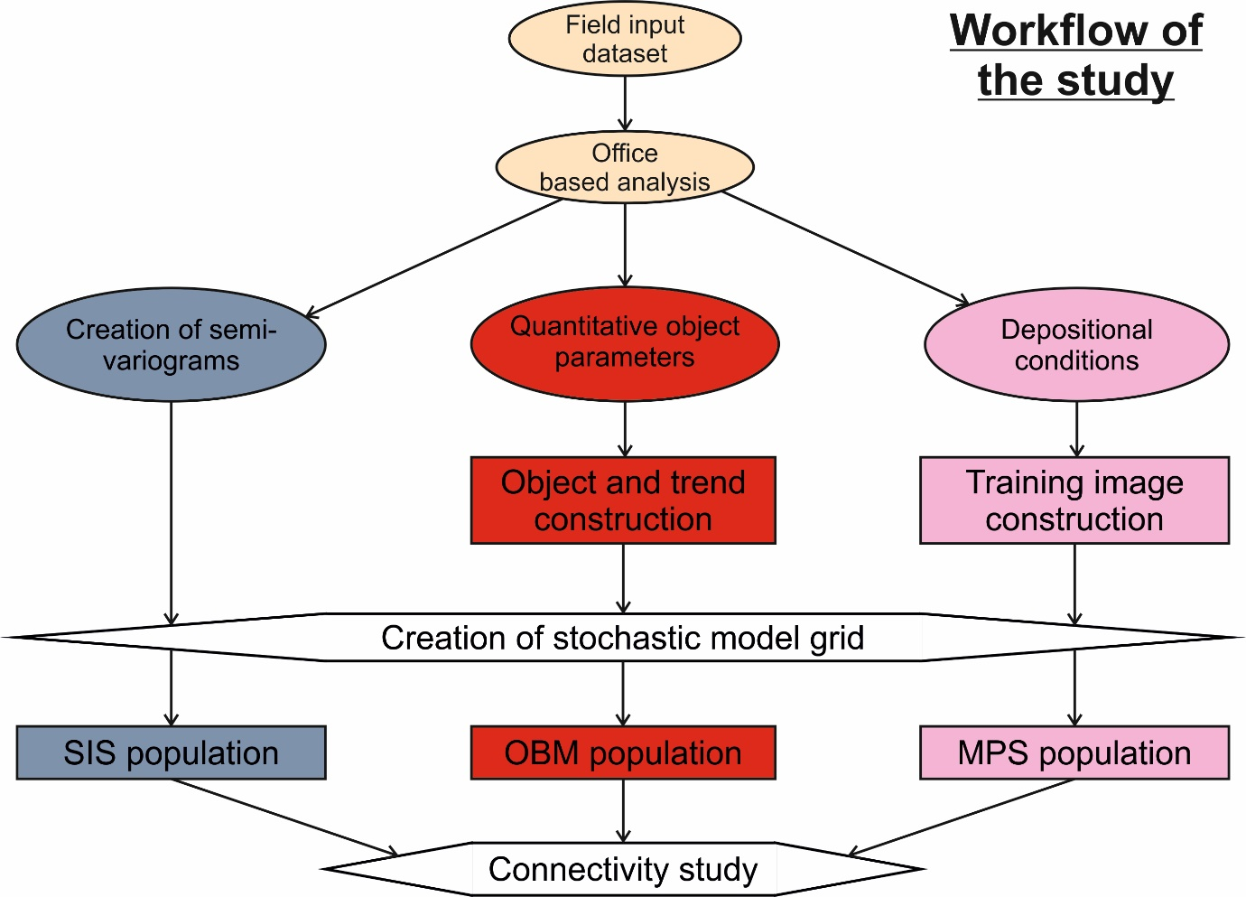
Figure 14 – Generalised workflow of this study to generate the reservoir models. Note, SIS = Sequential Indicator Simulation, MPS = Multi-Point Statistics, OBM = Object-based Modelling.
The depositional conditioning workflow proposed (Figure 14), provides a simpler but standardized methodology, when compared with traditional MPS and SIS simulated reservoir models (Deutsch and Journel, 1992; Seifert and Jensen, 1999, 2000; Caers and Zhang, 2002, Strebelle and Levy, 2008; Le Coz et al., 2011; Hu et al., 2014). Developing depositional conditioning is heavily dependent on the studied geology and thus helps sedimentology to translate into reservoir modelling, simplifying the relationship between the two disciplines. Depositional conditioning also allows the modeller to input their own level of stationarity into a training image as well as heterogeneity (Figure 9). The biggest advantage, shown in this study, is the visual impact they have upon subsurface models.
The manual development of training images is laborious, as it requires multiple iterations and manual checks of intersectional planes through the training image volume and target fractions to ensure that input statistics were honoured. This is the biggest remaining issue in the production of geologically conceptual training images and is therefore dependent upon low human error. Subsequent work would benefit from projecting the input cross-sectional and plan-view planes through the three-dimensional volume in an automated fashion, projecting logical rules dictated by the depositional conditioning throughout the training image. This may be a future application for how machine learning algorithms receive and read two dimensional data and use multi-iterative analysis in their reproduction of sedimentary products into three dimensional volumes.
Results from this study suggest there is scope to apply depositional conditioning methods to other environments and to see how conditioning training images for MPS model generation constrains geological realism across sedimentary environments.

The reproducibility of geologically realistic data
During this study, more emphasis was placed on the reproduction of the patterns, geometries, architectures and relationships contained in the training image, than to match the exact target fractions (element proportions) to keep computing simulations times to a reasonable level.
OBMs, while producing visually and statistically realistic outputs, are notoriously difficult to match to hard data (Holden, 1998; Seifert and Jensen, 2000; Vevle et al., 2018). They are also extremely limited to their pre-defined geometries (Holden et al., 1998; Stephen et al., 2001; Manzocchi et al., 2007) and have shown in the current work to over represent the maximum thickness of the background facies (Figure 12; in this study, the downstream accretion element). This problem leads to a large overestimation in the dimensions of net-connectivity (Figure 13). Furthermore, the use of the downstream accretion element as background leads to a poor representation of its geometry and dimensions in OBMs. However, OBMs do produce models that visually represent the environment they are simulating, with the dimensions, proportions and juxtapositions of the other elements being well represented.
SIS is a method that uses the probability and variance of one model unit to another to populate a model framework. This provided little visual resemblance to the system being simulated (Figure 11; Seifert and Jensen, 1999; 2000 and references therein; Martinius et al., 2017). The resultant dimensions of net connectivity were also extremely over estimated (Figure 13). The standard deviations reported for the static connectivity of the SIS models were anomalously high, this may, in part, be due to the use of 10 model iterations (Goovaerts, 1999); however this is sufficient to negate any sequential fluctuations in the model reproduction (Falivene et al., 2006) and further iterations would have been computationally expensive for a relatively small improvement on the standard deviations (Goovaerts, 1999). Although SIS simulations honoured some of the rules within the conditioning dataset, the geological realism of the resulting models was poor.
The depositional conditioning of training images in MPS modelling provides a more realistic visual representation of a fluvial system. This work shows that the distribution of sedimentary architectures and therefore, the distribution of heterogeneity within a reservoir, is better constrained when using MPS than SIS. The MPS model honoured the depositional conditions imposed and produced models that visually were recognisable as the environments which they simulated. Despite the minor differences between the depositional conditioning proportions and those of the MPS simulations, the MPS results were closer to those in the original depositional conditioning rules, when compared to the SIS or the OBMs. In the MPS simulations the juxtaposition of one element to another was extremely well constrained (Zhang et al., 2006; Daly and Caers, 2010; Zhou et al., 2018), and the dimensions of the four sedimentary architectures fell within the minimum and maximum values imposed in the depositional conditions (Table 3; Figure 11).
MPS provided geologically realistic distributions of the net reservoir facies and associated heterogeneities. The relative portions of the elements in the depositionally conditioned training images may have minor variations from the input data, due to the algorithm reproducing the other three aspects of depositional conditioning. The smaller sized geometric rules, such as minor fluctuations in the size of thalweg bedform complexes, imposed by the training image were not followed by the MPS models. This may be because the MPS algorithm does not recognise such small-scale variations (Strebelle, 2002; Comunian et al., 2012) in shape, or be due to the model resolution or it may be due to the number of variations in the size of thalweg bedform complexes repeated within the training image volume. A low number of repetitions within a training image volume may lead to poor reproduction by MPS (Strebelle, 2002). The reproduction of thalweg bedform complexes was far more realistically reproduced by the OBM generated models.
The connectivity study showed that almost all of the net-defined reservoir rock was connected to the single penetrating well (Figure 13). The SIS iterations showed a large range in their drainable volumes. By contrast, the depositionally conditioned MPS and OBM simulations showed very little variance in their results (Figure 13), indicating more reliable and repeatable methodologies. However, both OBM and SIS iterations did show an unrealistic over estimation in the thickness of the net reservoir connectivity. These results contrast those of Zhou et al., 2018, where MPS provided a higher connectivity than OBM with no significant improvement of reproduction accuracies. Zhou et al., (2018) concluded that MPS were limited by the robustness of training images. This study provides a method of constructing training images that are directly fit-for-purpose in a more accurate and realistic manner than previously presented.

Conclusions
The work presented here showcases a method of inputting heterogeneity and stationarity into a three dimensional training image. The concept of depositional conditioning is shown as a simple and standardized method of generating geologically realistic training images, based upon limited data. Depositional conditioning uses four categories inputting sedimentary properties: (1) spatial distribution of an architectural element relative to others, (2) 3D dimension of the respective depositional element; 3) geometric shape of the depositional elements and finally, (4) the proportion of a depositional element of the total reservoir volume.
A depositionally conditioned three dimensional training image was produced from architectural element scale analysis of heterogeneity within the Lower Castlegate Sandstone, Tuscher Canyon, Utah, and the Jamuna River, northern India. The use of two datasets, one modern and one outcrop, allowed the training image to constrain the heterogeneity of the environment of deposition in three dimensions, based upon limited input data. After deterministic surfaces were generated from the input data to form a model framework, 10 iterations of multi-point statistic (MPS), sequential-indicator simulation (SIS) and object-based (OBM) reservoir models were generated and statically tested.
Results showed MPS and OBM models to have more geologically realistic element distributions. Whilst similar connectivity means were achieved, through the MPS and SIS generations, smaller ranges were achieved through OBM and MPS-generated reservoir models. This study presents one depositional environment, four architectural elements and static testing of reservoir models, results showed that MPS models could be generated in a reproducible and realistic manner. The results demonstrated real potential for the use of outcrop data libraries to improve reservoir model of architectural element scale heterogeneity. Study implications suggest the reduction of uncertainty surrounding secondary and tertiary phases of production, which are commonly more susceptible to the influences of sedimentary heterogeneity.

Acknowledgements
Keele University Faculty of Natural Science Funding for Training and Transferable Skills are acknowledged for part-funding this study. The Basin Dynamics Research Group at Keele University are thanked for stimulating discussion and comments on the manuscript. The second author would like to thank members of the FORCE consortium (AkerBP, BP, ConocoPhillips, DEA, ENGIE, ENI Norge, INEOS, Lundin Norway, Point Resources, Repsol, Statoil, Spirit Energy, Suncor Energy, Total and VNG Norge), the Norwegian Petroleum Directorate (NPD) and the Research Council of Norway’s Petromaks 2 project (project number 234111/E30) for funding through the SAFARI Phase 3 programme. Schlumberger are acknowledged for providing academic software licenses. David Hodgetts (Manchester Uni.) and Schlumberger Ltd. are thanked for providing academic licensing of VRGS and Petrel software respectively.

References
Adams, M.M. and Bhattacharya, J.P., 2005. No change in fluvial style across a sequence boundary, Cretaceous Blackhawk and Castlegate Formations of central Utah, USA. J. Sediment. Res., 75(6), 1038-1051. https://doi.org/10.2110/jsr.2005.080
Allen, J.R.L., 1983. Studies in fluviatile sedimentation: bars, bar-complexes and sandstone sheets (low-sinuosity braided streams) in the Brownstones (L. Devonian), Welsh Borders. Sediment. Geol., 33(4), 237-293. https://doi.org/10.1016/0037-0738(83)90076-3
Ashworth, P.J., Best, J.L., Roden, J.E., Bristow, C.S. and Klaassen, G.J., 2000. Morphological evolution and dynamics of a large, sand braid‐bar, Jamuna River, Bangladesh. Sedimentology, 47(3), 533-555. https://doi.org/10.1046/j.1365-3091.2000.00305.x
Bemis, S.P., Micklethwaite, S., Turner, D., James, M.R., Akciz, S., Thiele, S.T. & Bangash, H.A. 2014. Ground-based and UAV-based photogrammetry: A multi-scale, high-resolution mapping tool for structural geology and paleoseismology. J. Struct. Geol., 69, 163-178. https://doi.org/10.1016/j.jsg.2014.10.007
Best, J.L., Ashworth, P.J., Bristow, C.S. and Roden, J., 2003. Three-dimensional sedimentary architecture of a large, mid-channel sand braid bar, Jamuna River, Bangladesh. J. Sediment. Res., 73(4), 516-530. https://doi.org/10.1306/010603730516
Best, J.L., Ashworth, P.J., Sarker, M.H. and Roden, J.E., 2007. The Brahmaputra-Jamuna River, Bangladesh. In: Gupta, A. (Ed.), Large rivers: geomorphology and management. John Wiley & Son, West Sussex, 395-430.
Bridge, J.S., 2003. Rivers and Floodplains. Forms, Processes, and Sedimentary Record. Blackwell, Oxford.
Bristow, C.S., 1993. Sedimentary structures exposed in bar tops in the Brahmaputra River, Bangladesh. Geol. Soc. Spec. Pub. 75(1), pp.277-289. https://doi.org/10.1144/GSL.SP.1993.075.01.17
Bristow, C.S., Smith, N. and Rogers, J., 1999. Gradual avulsion, river metamorphosis and reworking by underfit streams: a modern example from the Brahmaputra River in Bangladesh and a possible ancient example in the Spanish Pyrenees. In: Smith, N.D. and Rogers, J. (Eds.), Fluvial sedimentology VI, 28, 221-230. https://doi.org/10.1002/9781444304213.ch17
Buckley, S., Howell, J.A., Enge, H.D., Leren, B.L.S. & Kurz, T.H. 2006. Integration ofterrestrial laser scanning, digital photogrammetry and geostatistical methods for high-resolution modelling of geological outcrops. In: The International Archives of the photogrammetry, Remote Sensing and Spatial Information Sciences. Dresden, Germany.
Burns, C.E., Mountney, N.P., Hodgson, D.M. and Colombera, L., 2017. Anatomy and dimensions of fluvial crevasse-splay deposits: Examples from the Cretaceous Castlegate Sandstone and Neslen Formation, Utah, USA. Sediment. Geol., 351, 21-35. https://doi.org/10.1016/j.sedgeo.2017.02.003
Cabello, P., Lopez, C., Gamba, N., Dussán, M.I., Torres, E., Ballesteros-Torres, C.I., Cantisano, M.T., Marfisi, N., Calvo, R., Vázquez-Taset, Y.M., Ramos, E., 2018a. An integrated approach to define new plays in mature oil basins: the example from the Middle Magdalena Valley basin (Colombia). AAPG Bull. 102, 2201 - 2238. https://doi.org/10.1306/03291816528
Cabello, P., Domínguez, D., Murillo-López, M.H., López-Blanco, M., García-Sellés, D., Cuevas, J.L., Marzo, M. and Arbués, P., 2018b. From conventional outcrop datasets and digital outcrop models to flow simulation in the Pont de Montanyana point-bar deposits (Ypresian, Southern Pyrenees). Mar. Petrol. Geol., 94, pp.19-42. https://doi.org/10.1016/j.marpetgeo.2018.03.040
Caers, J., and Zhang, T., 2004, Multiple-point Geostatistics: A quantitative vehicle for integrating geologic analogs into multiple reservoir models, in Integration of outcrop and modern analogs in reservoir modelling, AAPG Memoir, 80, 383-394.
Chan, M.A. and Pfaff, B.J., 1991. Fluvial sedimentology of the Upper Cretaceous Castlegate Sandstone, Book Cliffs, Utah. In: Chidsey Jnr., T.C. (Ed.). Geology of East-Central Utah. Utah Geological Association Special Publication 19, 95-110.
Coleman, J.M., 1969. Brahmaputra River: channel processes and sedimentation. Sediment. Geol., 3(2-3), pp.129-239. https://doi.org/10.1016/0037-0738(69)90010-4
Collinson, J.D.; Mountney, N. P. and Thompson, D. B. 2006. Sedimentary Structures, Third edition, Terra Publishing, Hertfordshire.
Colombera, L., Mountney, N.P. and McCaffrey, W.D., 2012. A relational database for the digitization of fluvial architecture concepts and example applications. Pet. Geo., 18(1), 129-140. https://doi.org/10.1144/1354-079311-021
Colombera, L., Mountney, N.P. and McCaffrey, W.D., 2013. A quantitative approach to fluvial facies models: methods and example results. Sedimentology, 60(6), 1526-1558. https://doi.org/10.1111/sed.12050
Colombera, L., Mountney, N.P., Hodgson, D.M. and McCaffrey, W.D., 2016a. The Shallow-Marine Architecture Knowledge Store: a database for the characterization of shallow-marine and paralic depositional systems. Mar. Petrol. Geol., 75, 83-99. https://doi.org/10.1016/j.marpetgeo.2016.03.027
Colombera, L., Mountney, N.P., Howell, J.A., Rittersbacher, A., Felletti, F. and McCaffrey, W.D., 2016b. A test of analog-based tools for quantitative prediction of large-scale fluvial architecture. AAPG Bull., 100(2), pp.237-267. https://doi.org/10.1306/11181514227
Colombera, L., Mountney, N.P., Russell, C.E., Shiers, M.N. and McCaffrey, W.D., 2017. Geometry and compartmentalization of fluvial meander-belt reservoirs at the bar-form scale: Quantitative insight from outcrop, modern and subsurface analogues. Mar. Petrol. Geol., 82, 35-55. https://doi.org/10.1016/j.marpetgeo.2017.01.024
Comunian, A., Renard, P., and Straubhaar, J., 2012, 3D multiple-point statistics simulation using 2D training images, Comput. Geo., 40, 49-65. https://doi.org/10.1016/j.cageo.2011.07.009
Daly, C. and Caers, J., 2010. Multi-point geostatistics–an introductory overview. First Break, 28(9), 39-47. https://doi.org/10.3997/1365-2397.2010020
Deutsch, C.V., 2006, A sequential indicator simulation program for categorical variables with point and block data: BlockSIS, Comput. Geo., 10, 1669-1681. https://doi.org/10.1016/j.cageo.2006.03.005
Deutsch, C.V., and Journal, A., 1992, GSLIB: Geostatistical Software Library and User’s Guide¸ Oxford University Press, New York.
Ellen, R., Browne, M.A.E., Mitten, A.J., Clarke, S.M., Leslie, A.G. and Callaghan, E., 2019. Sedimentology, architecture and depositional setting of the fluvial Spireslack Sandstone of the Midland Valley, Scotland: insights from the Spireslack surface coal mine. Geol. Soc. Spec. Pub., 488. https://doi.org/10.1144/SP488.2
Enge, H.D., Buckley, S.J., Rotevatn, A. and Howell, J.A., 2007. From outcrop to reservoir simulation model: Workflow and procedures. Geosphere, 3(6), 469-490. https://doi.org/10.1130/GES00099.1
Eschard, R., Lemouzy, P., Bacchiana, C., Desaubliaux, G., Parpant, J. and Smart, B., 1998. Combining sequence stratigraphy, geostatistical simulations, and production data for modelling a fluvial reservoir in the Chaunoy field (Triassic, France). AAPG Bull., 82(4), 545-568.
Falivene, O., Arbues, P., Gardiner, A., Pickup, G., Munoz, J.A. and Cabrera, L., 2006. Best practice stochastic facies modeling from a channel-fill turbidite sandstone analog (the Quarry outcrop, Eocene Ainsa basin, northeast Spain). AAPG Bull., 90(7), 1003-1029. https://doi.org/10.1306/02070605112
Fouch, T.D., Lawton, T.F., Nichols, D.J., Cashion, W.B. and Cobban, W.A., 1983. Patterns and timing of synorogenic sedimentation in Upper Cretaceous rocks of central and northeast Utah. Mesozoic Paleogeography of the West-Central United States: Rocky Mountain Symposium. Rocky Mountain Section (SEPM). 305-336.
Gershenzon, N.I., Soltanian, M., Ritzi, R.W. and Dominic, D.F., 2015. Understanding the impact of open-framework conglomerates on water–oil displacements: the Victor interval of the Ivishak Reservoir, Prudhoe Bay Field, Alaska. Petrol. Geosci., 21(1), 43-54. https://doi.org/10.1144/petgeo2014-017
Ghinassi, M., Nemec, W., Aldinucci, M., Nehyba, S., Özaksoy, V. and Fidolini, F., 2014. Plan‐form evolution of ancient meandering rivers reconstructed from longitudinal outcrop sections. Sedimentology, 61(4), 952-977. https://doi.org/10.1111/sed.12081
Ghinassi, M. and Ielpi, A., 2018. Precambrian snapshots: Morphodynamics of Torridonian fluvial braid bars revealed by three‐dimensional photogrammetry and outcrop sedimentology. Sedimentology, 65(2), 492-516. https://doi.org/10.1111/sed.12389
Gibling, M.R., 2006. Width and thickness of fluvial channel bodies and valley fills in the geological record: a literature compilation and classification. J. Sediment. Res., 76(5), 731-770. https://doi.org/10.2110/jsr.2006.060
Goovaerts, P., 1999. Impact of the simulation algorithm, magnitude of ergodic fluctuations and number of realizations on the spaces of uncertainty of flow properties. Stoch. Env. Res. Risk A., 13(3), 161-182. https://doi.org/10.1007/s004770050037
Gorelick, N., Hancher, M., Dixon, M., Ilyushchenko, S., Thau, D. and Moore, R., 2017. Google Earth Engine: Planetary-scale geospatial analysis for everyone. Remote Sens. Environment, 202, 18-27. https://doi.org/10.1016/j.rse.2017.06.031
Grove, C. and Jerram, D.A., 2011. jPOR: An ImageJ macro to quantify total optical porosity from blue-stained thin sections. Comput. & Geosci., 37(11), 1850-1859. https://doi.org/10.1016/j.cageo.2011.03.002
Hajek, E. A., and Heller, P. L., 2012, Flow-depth scaling in alluvial architecture and nonmarine sequence stratigraphy: example from the Castlegate Sandstone, Central Utah, U.S.A. J. of Sediment. Res., 82(2), 121-130. https://doi.org/10.2110/jsr.2012.8
Hampson, G.J., Davies, W., Davies, S.J., Howell, J.A. and Adamson, K.R., 2005. Use of spectral gamma-ray data to refine subsurface fluvial stratigraphy: Late Cretaceous strata in the Book Cliffs, Utah, USA. J. Geol. Soc. London, 162(4), 603-621. https://doi.org/10.1144/0016-764904-059
Henares, S., Caracciolo, L., Viseras, C., Fernández, J. and Yeste, L.M., 2016. Diagenetic constraints on heterogeneous reservoir quality assessment: A Triassic outcrop analog of meandering fluvial reservoirs. AAPG Bull., 100(9), 1377-1398. https://doi.org/10.1306/04041615103
Hodgetts, D., Seers, T., Head, W., and Burnham, B.S., 2015, High performance visualisation of multiscale geological outcrop data in single software environment, In: 77th European Association of Geoscientists and Engineers (EAGE) Conference and Exhibition: Proceedings for the 2015 EAGE meeting in Madrid, Spain, https://doi.org/10.3997/2214-4609.201412862.
Holden, L., Hauge, R., Skare, Ø., and Skorstad, A., 1998. Modeling of fluvial reservoirs with object models, Math. Geol., 30(5), 473-496. https://doi.org/10.1023/A:1021769526425
Hornung, J. and Aigner, T., 1999. Reservoir and aquifer characterization of fluvial architectural elements: Stubensandstein, Upper Triassic, southwest Germany. Sediment. Geol., 129(3-4), 215-280. https://doi.org/10.1016/S0037-0738(99)00103-7
Hovadik, J., and Laure, D.K., 2007. Static characterizations of reservoirs: Refining the concept of connectivity and continuity, Petrol. Geo., 13, 237-252. https://doi.org/10.1144/1354-079305-697
Howell, J.A., Martinius, A.W. and Good, T.R., 2014. The application of outcrop analogues in geological modelling: a review, present status and future outlook. Geol. Soc. Spec. Pub., 387, 1-25. https://doi.org/10.1144/SP387.12
Hu, L.Y., Liu, Y., Scheepens, C., Shultz, A.W. and Thompson, R.D., 2014. Multiple-point simulation with an existing reservoir model as training image. Math. Geo., 46, 227-240. https://doi.org/10.1007/s11004-013-9488-8
Ielpi, A. and Ghinassi, M., 2014. Planform architecture, stratigraphic signature and morphodynamics of an exhumed Jurassic meander plain (Scalby Formation, Yorkshire, UK). Sedimentology, 61(7), 1923-1960. https://doi.org/10.1111/sed.12122
Jones, J.A. and Hartley, A.J., 1993. Reservoir characteristics of a braid-plain depositional system: the Upper Carboniferous Pennant Sandstone of South Wales. Geol. Soc. Spec. Pub, 73(1), 143-156. https://doi.org/10.1144/GSL.SP.1993.073.01.09
Kauffman, E.G. 1977. Geological and biological overview. Mountain Geologist, 14, 79–99.
Koneshloo, M., Aryana, S.A. and Hu, X., 2018. The impact of geological uncertainty on primary production from a fluvial reservoir. Petrol. Sci., 15(2), 270-288. https://doi.org/10.1007/s12182-018-0229-y
Laure, D.K., and Hodavik, J., 2006. Connectivity of channelized reservoirs: A modelling approach, Petrol. Geo., 12, 291-308. https://doi.org/10.1144/1354-079306-699
Le Coz, M., Genthon, P., and Adler, P.M., 2011, Multiple-point statistics for modelling facies heterogeneities in a porous medium: The Komadugu-Yobe alluvium, Lake Chad Basin, Math. Geo., 43, 861-878. https://doi.org/10.1007/s11004-011-9353-6
Leeder, M.R. 1999, Sedimentology and Sedimentary Basins: from Turbulence to Tectonics. Blackwell Science, Oxford.
Li, S., Yu, X., Chen, B. and Li, S., 2015. Quantitative Characterization of Architecture Elements and Their Response To Base-Level Change In A Sandy Braided Fluvial System At A Mountain Front. J. Sediment. Res., 85(10), 1258-1274. https://doi.org/10.2110/jsr.2015.82
Maharaja, A., 2008. TiGenerator: Object-based training image generator. Comput & Geosci, 34(12), 1753-1761. https://doi.org/10.1016/j.cageo.2007.08.012
Manzocchi, T., Walsh, J.J., Tomasso, M., Strand, J., Childs, C. and Haughton, P.D., 2007. Static and dynamic connectivity in bed-scale models of faulted and unfaulted turbidites. Geol. Soc. Spec. Pub., 292(1), 309-336. https://doi.org/10.1144/SP292.18
Marra, W.A., Kleinhans, M.G. and Addink, E.A., 2014. Network concepts to describe channel importance and change in multichannel systems: test results for the Jamuna River, Bangladesh. Earth Surf. Processes, 39(6), 766-778. https://doi.org/10.1002/esp.3482
Martinius, A.W., Fustic, M., Garner, D.L., Jablonski, B.V.J., Strobl, R.S., MacEachern, J.A. and Dashtgard, S.E., 2017. Reservoir characterization and multiscale heterogeneity modelling of inclined heterolithic strata for bitumen-production forecasting, McMurray Formation, Corner, Alberta, Canada. Mar. Petrol. Geol., 82, 336-361. https://doi.org/10.1016/j.marpetgeo.2017.02.003
McLaurin, B.T. and Steel, R.J., 2007. Architecture and origin of an amalgamated fluvial sheet sand, lower Castlegate Formation, Book Cliffs, Utah. Sediment. Geol., 197, 291-311. https://doi.org/10.1016/j.sedgeo.2006.10.005
Miall, A.D., 1985. Architectural-element analysis: a new method of facies analysis applied to fluvial deposits. Earth-Sci. Rev., 22, (4), 261-308. https://doi.org/10.1016/0012-8252(85)90001-7
Miall, A.D., 1988. Reservoir heterogeneities in fluvial sandstones: lessons from outcrop studies. AAPG Bull. 72, 682–697.
Miall, A.D., 1993. The architecture of fluvial-deltaic sequences in the Upper Mesaverde Group (Upper Cretaceous), Book Cliffs, Utah. In: Best, J.L. and Bristow, C.S. (Eds.). Braided Rivers, Geol. Soc. Spec. Pub., 75, 305-332. https://doi.org/10.1144/GSL.SP.1993.075.01.19
Miall, A.D., 1994. Reconstructing fluvial macroform architecture from two-dimensional outcrops: examples from the Castlegate Sandstone, Book Cliffs, Utah. J. Sediment. Res., B64 (2). 146-158. https://doi.org/10.1306/D4267F78-2B26-11D7-8648000102C1865D
Miall, A.D., 1996. The Geology of Fluvial Deposits: Sedimentary Facies, Basin Analysis and Petroleum Geology. Springer-Verlag, New York.
Miall, A.D., 2006. Reconstructing the architecture and sequence stratigraphy of the preserved fluvial record as a tool for reservoir development: a reality check. AAPG Bull., 90, 989–1002. https://doi.org/10.1306/02220605065
Miall, A.D., 2016. Facies analysis. In Stratigraphy: A Modern Synthesis. Springer, Cham, 77-159.
Miall, A.D. and Jones, B.G., 2003. Fluvial architecture of the Hawkesbury sandstone (Triassic), near Sydney, Australia. J. Sediment. Res., 73(4), 531-545. https://doi.org/10.1306/111502730531
Miall, A.D. and Arush, M., 2001. The Castlegate Sandstone of the Book Cliffs, Utah: sequence stratigraphy, paleogeography, and tectonic controls. J. Sediment. Res., 71(4), pp.537-548. https://doi.org/10.1306/103000710537
Mitten, A.J., Clarke, S.M., Pringle, J.K., Richards, P.C. (2018). 2854396 Combining Terrestrial Photogrammetry, Applied Sedimentology and Hand-Held Gamma Ray Spectrometry to Characterise the Cretaceous Lower Castlegate Formation, Tuscher Canyon, Utah, U.S.A. Search and Discovery, AAPG database.
Morad, S., Al-Ramadan, K., Ketzer, J.M. and De Ros, L.F., 2010. The impact of diagenesis on the heterogeneity of sandstone reservoirs: A review of the role of depositional facies and sequence stratigraphy. AAPG Bull., 94, (8), 1267-1309. https://doi.org/10.1306/04211009178
Mullins, J.R., Nyberg, B., Eide, C., Comunian, Renard, P., Straubhaar, J., Howell, J. 2019. Automated workflows for reservoir modelling, can we get there? AAPG ACE, San Antonio. Search and Discovery.
North, C.P. and Taylor, K.S., 1996. Ephemeral-fluvial deposits: integrated outcrop and simulation studies reveal complexity. AAPG Bull., 80(6), 811-830.
Olsen, T., Steel, R., Hogseth, K., Skar, T. and Roe, S.L., 1995. Sequential architecture in a fluvial succession: sequence stratigraphy in the Upper Cretaceous Mesaverde Group, Price Canyon, Utah. J. Sediment. Res., 65, (2), 265-280. https://doi.org/10.1306/D426822A-2B26-11D7-8648000102C1865D
Pickel, A., Frechette, J.D., Comunian, A. and Weissmann, G.S., 2015. Building a training image with Digital Outcrop Models. J. Hydrol., 531, 53-61. https://doi.org/10.1016/j.jhydrol.2015.08.049
Pickering, J.L., Goodbred, S.L., Reitz, M.D., Hartzog, T.R., Mondal, D.R. and Hossain, M.S., 2014. Late Quaternary sedimentary record and Holocene channel avulsions of the Jamuna and Old Brahmaputra River valleys in the upper Bengal delta plain. Geomorphology, 227, pp.123-136. https://doi.org/10.1016/j.geomorph.2013.09.021
Potere, D., 2008. Horizontal positional accuracy of Google Earth’s high-resolution imagery archive. Sensors, 8(12), pp.7973-7981. https://doi.org/10.3390/s8127973
Pranter, M.J., Ellison, A.I., Cole, R.D. and Patterson, P.E., 2007. Analysis and modelling of intermediate-scale reservoir heterogeneity based on a fluvial point-bar outcrop analogy, Williams Fork Formation, Piceance Basin, Colorado. AAPG Bull., 91, (7), 1025-1051. https://doi.org/10.1306/02010706102
Pringle, J.K., Howell, J.A., Hodgetts, D., Westerman, A.R. and Hodgson, D.M., 2006. Virtual outcrop models of petroleum reservoir analogues: a review of the current state-of-the-art. First break, 24(3), pp.33-42. https://doi.org/10.3997/1365-2397.2006005
Pringle, J.K., Brunt, R.L., Hodgson, D.M. and Flint, S.S. 2010. Capturing stratigraphic and sedimentological complexity in 3D digital outcrop models of submarine channel complexes, Karoo Basin, South Africa. Petrol. Geo., 16, (4), 307-330. https://doi.org/10.1144/1354-079309-028
Puig, J.M., Cabello, P., Howell, J. and Arbués, P., 2019. Three-dimensional characterisation of sedimentary heterogeneity and its impact on subsurface flow behaviour through the braided-to-meandering fluvial deposits of the Castissent Formation (late Ypresian, Tremp-Graus Basin, Spain). Mar. Petrol. Geol., 103, 661-680. https://doi.org/10.1016/j.marpetgeo.2019.02.014
Rasband, W.S., 2009. ImageJ, US National Institutes of Health, Bethesda, Maryland, USA, http://rsb.info.nih.gov/ij/.
Richardson, W.R. and Thorne, C.R., 2001. Multiple thread flow and channel bifurcation in a braided river: Brahmaputra–Jamuna River, Bangladesh. Geomorphology, 38(3-4), pp.185-196. https://doi.org/10.1016/S0169-555X(00)00080-5
Ringrose, P. and Bentley, M., 2015. The Property Model. In Reservoir Model Design. Springer, Dordrecht. 173-231
Ringrose, P.S., Martinius, A.W. and Alvestad, J., 2008. Multiscale geological reservoir modelling in practice. In: Robinson, A., Griffiths, P., Price, S., Hegre, J., and Muggeridge, A., (Eds.) The Future of Geological Modelling in Hydrocarbon Development, Geol. Soc. Spec. Pub., 309, 123-134. https://doi.org/10.1144/SP309.9
Rittersbacher, A., Howell, J.A. and Buckley, S.J., 2014. Analysis of fluvial architecture in the Blackhawk Formation, Wasatch Plateau, Utah, USA, using large 3D photorealistic models. J. Sediment. Res., 84(2), 72-87. https://doi.org/10.2110/jsr.2014.12
Samuels, P.G., 1989. Backwater lengths in rivers. Proceedings of the Institution of Civil Engineers, 87(4), 571-582.
Sarker, M.H., Thorne, C.R., Aktar, M.N. and Ferdous, M.R., 2014. Morpho-dynamics of the Brahmaputra–Jamuna River, Bangladesh. Geomorphology, 215, 45-59. https://doi.org/10.1016/j.geomorph.2013.07.025
Seifert, D. and Jensen, J.L., 1999. Using sequential indicator simulation as a tool in reservoir description: issues and uncertainties. Math. Geol., 31(5), 527-550. https://doi.org/10.1023/A:1007563907124
Seifert, D. and Jensen, J.L., 2000. Object and pixel-based reservoir modelling of a braided fluvial reservoir. Math. Geol., 32(5), 581-603. https://doi.org/10.1023/A:1007562221431
Stephen, K.D., Clark, J.D. and Gardiner, A.R., 2001. Outcrop-based stochastic modelling of turbidite amalgamation and its effects on hydrocarbon recovery. Petrol. Geo., 7(2), 163-172. 10.1144/petgeo.7.2.163
Strebelle, S., 2002. Conditional simulation of complex geological structures using multiple-point statistics. Math. Geol., 34(1), 1-21. https://doi.org/10.1023/A:1014009426274
Strebelle, S.B. and Journel, A.G., 2001, Reservoir modelling using multiple-point statistics. In: SPE Annual Technical Conference and Exhibition. Society of Petroleum Engineers.
Strebelle, S., and Levy, M., 2008, Using multiple-point statistics to build geologically realistic reservoir models: the MPS/FDM workflow. In: Robinson, A., Griffiths, P., Price, S., Hegre, J., and Muggeridge, A., (Eds.) The Future of Geological Modelling in Hydrocarbon Development, Geol. Soc. Spec. Pub., 309, 67-74. https://doi.org/10.1144/SP309.5
Strebelle, S. and Chevron, E.T.C., 2012. Multiple-point geostatistics: from theory to practice. In: Expanded Abstract Collection from Ninth International Geostatistics Congress. Norwegian Computing Center, 1-65.
Strebelle, S. and Zhang, T., 2004. Non-stationary multiple-point geostatistical models. In: Leuangthong, O. and Deutsch, C.V., Geostatistics Banff 2004. Springer, Dordrecht, 235-244. https://doi.org/10.1007/978-1-4020-3610-1_24
Tahmasebi P. (2018) Multiple Point Statistics: A Review. In: Daya Sagar, B., Cheng, Q., Agterberg, F., (Eds.). Handbook of Mathematical Geosciences. Springer, Cham. https://doi.org/10.1007/978-3-319-78999-6_30
Trower, E.J., Ganti, V., Fischer, W.W. and Lamb, M.P., 2018. Erosional surfaces in the Upper Cretaceous Castlegate Sandstone (Utah, USA): Sequence boundaries or autogenic scour from backwater hydrodynamics? Geology, 46(8), 707-710. https://doi.org/10.1130/G40273.1
Tyler, N., Finley, R.J., 1991. Architectural controls on the recovery of hydrocarbons from sandstone reservoirs. In: Miall, A.D., Tyler, N., (Eds.), The three-dimensional facies architecture of terrigenous clastics sediments and its implications for hydrocarbon discovery and recovery—SEPM Concepts in Sedimentology and Palaentology, 1–5.
Tyler, K., Henriquez, A. and Svanes, T., 1994. Modeling heterogeneities in fluvial domains: a review of the influence on production profiles. In: Yarus, J.M. and Chambers, R.L. (Eds.) Stochastic modelling and geostatistics: principles, methods, and case studies. AAPG Computer Applications in Geology; No. 3.
Van de Graaff, F.R., 1972. Fluvial--deltaic facies of the Castlegate Sandstone (Cretaceous), east-central Utah. J. Sed. Res., 42(3).
Vevle, M.L., Skorstad, A. and Vonnet, J., 2018. Recent developments in object modelling opens new era for characterization of fluvial reservoirs. First Break, 36(6), pp.85-89.
Villamizar, C.A., Hampson, G.J., Flood, Y.S., and Fitch, P.J.R., 2015. Object-based modelling of avulsion-generated sandbody distributions and connectivity in a fluvial reservoir analogue of low to moderate net-to-gross ration, Petrol. Geo., 21, 249-270. https://doi.org/10.1144/petgeo2015-004
Watkind, I.J., 1995. Geologic Map of the Price 1 x 2 Quadrangle, Utah. Miscellaneous investigations Map I-2462. U.S. Geological Survey.
Yan, N., Colombera, L., Mountney, N.P. and Dorrell, R.M., 2018. Fluvial point‐bar architecture and facies heterogeneity and their influence on intra‐bar static connectivity in humid coastal‐plain and dryland fan systems. In: Ghinassi, M., Mountney, N., Colombera, L. and Reesink, A.J. (Eds.) Fluvial meanders and their depositional products in the rock record, Special Publication, 48, 475-508.
Yu, L. and Gong, P., 2012. Google Earth as a virtual globe tool for Earth science applications at the global scale: progress and perspectives. Int. J. Remote Sens., 33(12), 3966-3986. https://doi.org/10.1080/01431161.2011.636081
Yue, D., Li, W., Wang, W., Hu, G., Qiao, H., Hu, J., Zhang, M. and Wang, W., 2019. Fused spectral-decomposition seismic attributes and forward seismic modelling to predict sand bodies in meandering fluvial reservoirs. Mar. Petrol. Geol., 99, 27-44. https://doi.org/10.1016/j.marpetgeo.2018.09.031
Zhang, T., Switzer, P. and Journel, A., 2006. Filter-based classification of training image patterns for spatial simulation. Math. Geol., 38(1), 63-80. https://doi.org/10.1007/s11004-005-9004-x
Zhou, X. and Wang, H., 2015. Application of google earth in modern river sedimentology research. J. Geo. Environ. Protect., 3(08), 1-8. , http://dx.doi.org/10.4236/gep.2015.38001
Zhou, F., Shields, D., Tyson, S. and Esterle, J., 2018. Comparison of sequential indicator simulation, object modelling and multiple-point statistics in reproducing channel geometries and continuity in 2D with two different spaced conditional datasets. J. Petrol. Sci. Engineer., 166, 718-730. https://doi.org/10.1016/j.petrol.2018.03.043

Table 1 – Facies scheme used in this study, showing the description and interpretation of facies defined from the Tuscher Canyon outcrop site, Utah, USA. This also lists facies codes discussed within the text.
Table 2 – Architectural element summary of the Lower Castlegate at Tuscher Canyon. The table describes each element individually by: their top, bottom and internal bounding surface framework according to Miall (1996), the idealised facies succession (in the order the facies are shown), the reservoir characteristics of the element and whether they are considered net or gross when modelled in this study, and finally an internal two-dimensional schematic architectural framework. Note, the scale of these schematics is 100 m horizontally by 10 m vertically, and no foreset laminae have been illustrated. Finally a summary of the quantified statistical characteristics of each element: net-gross, palaeocurrent data and average width:thickness ratios are given.
Table 3 – Depositional conditions of mega-bar complexes for the training image construction. This details the main sedimentary architectural elements and their respective conditional requirements: distribution, dimensions, geometry, and proportions. * indicates values weighted to the data from the Tuscher Canyon outcrop due to imaging issues in the satellite images, see text for details. Note, channel sinuosity values are included, obtained from the Jamuna River satellite imagery data.
Table 4 – Output data for the architectural elements and net connectivity for the multi-point statistics, sequential indicator and object-based model iterations. Note, Min. = minimum, Mean = arithmetic mean, Max. = maximum, Sd = standard deviation, Cv = covariance.
Figure 1 – The scales of typical fluvial reservoir heterogeneity (modified from Tyler and Finley, 1991; Morad et al., 2010). Note the 1 m - 10 m meso-scale of this study: zonation of permeability is within genetic units (Morad et al., 2010; Mitten et al., 2018). In giga- to meso-scale, the yellow indicates sandstone and the grey mud and siltstone, the red lines indicate faulting. In the micro-scale image the black and grey represent quartz grains and the light blue indicates pore space.
Figure 2 – A) Simplified geological map of east-central Utah, USA (modified from Watkind, 1995) showing the Mesaverde Group, of which the Castlegate is part, and the location of the study area (red box). B) Geological map of the study location at Tuscher Canyon, Utah (modified from Watkind, 1995). The green box represents the location of the study map in Figure 4A. C) (left) The palaeogeography of the Western Interior Seaway and North America, with Utah highlighted in a yellow box, and (right) gross depositional environments of the Early to Middle Campanian (modified from Van de Graff, 1972; Chan and Pfaff, 1991). D) Mesaverde Group depositional environment and associated lithostratigraphical units, with the Lower Castlegate Formation highlighted (red box), (modified from Burns et al., 2017).
Figure 3 – A) Study site location map of the Jamuna River, northern India and B) close-up of the study area (box), modified from Mitten et al., (2018).
Figure 4 – A) Satellite image of the Tuscher Canyon section (Figure 2B), Utah, USA, showing the positions where sedimentary log and photogrammetric data were collected (see key) along with subsequent figure locations (numbered). B) Digital point cloud data from the outcrop dataset. Note: the bottom right shows the study location map of A. C) and D) show sedimentary dip and azimuth measurements (coloured surfaces) on the digital surface within the VRGS software (see text). E) Bounding surface analysis on the digitally-textured mesh surface.
Figure 5 – The genetic units of the most common sedimentary facies found within the Castlegate Sandstone. The numbers indicate bounding surfaces hierarchy (Miall, 1985). A) Representative section of the bounding surface framework within the Lower Castlegate at Tuscher Canyon, and bounding surface hierarchy interpreted from that framework. B) Sandstone (St) facies showing pebble-lined foreset and set surfaces stacking below and above a third-order erosional scour surface. C) Third-order erosional surfaces bounding conformable packages of St and Sm facies. D) Sm facies within third-order scours (see Table 1 for facies codes).
Figure 6 – Interpretation of the Lower Castlegate Tuscher Canyon outcrop, Utah, USA (see Figure 4A for location). Schematic shows the distribution of architectural elements and dominance of the downstream accretion element. Pseudo-well logs have also been incorporated to show positions of wells used to condition reservoir models. Measured palaeocurrent data (respective positions marked) of individual sedimentary architectural elements are also shown. Note the 2.5x vertical exaggeration.
Figure 7 – Schematic representation of sedimentary architecture at the Lower Castlegate exposure in Tuscher Canyon, Utah, USA. The schematic has been orientated to show the regional eastward palaeocurrent direction measured from the outcrop exposure. Sedimentary logs and bounding surface hierarchy numbers (Miall, 1985) show the individual architectural elements idealised succession, with bounding surface annotations indicating the depositional framework.
Figure 8 – A) The Jamuna downstream accreting barform in northern India (see Figure 3 for location), annotated with width and length measurements of active and abandoned fluvial sedimentary architectures. B) Interpretive line drawing (see key and text) – note colours are the same as for the Tuscher Canyon outcrop (Figure 7). C) Box plots of the width, D) length and E) width:length ratio of sedimentary architectural elements within the interpreted Jamuna River barform complex (CH = Channel element, TB = Thalweg bedform complex, DA = Downstream accretion element, LA = Lateral accretion element). Note the maximum measurements of the downstream accretion element exceeds the scope of the graph.
Figure 9 – Numerical depositionally-conditioned 3D training image used in this study, created within Schlumberger™ Petrel v.2016 software, using the input parameters given in Tables 2 and 3. The training image is 1,000 m x 1,000 m x 20 m at a cell resolution of 10 m x 10 m x 0.5 m. The datasets providing the major conditions for the planes are marked. The image provides the basis for the MPS model generation (see text).
Figure 10 – Indicator variograms (coloured lines) showing the variance of the four architectural elements (DA = Downstream accretion element; CH = Channel element; LA = Lateral accretion element; TB = Thalweg bedform complex) across both data sets, providing input conditions for the SIS model iterations. Respective experimental variograms (black lines) are also shown, see text for details.
Figure 11 - Comparison of (A) Multi-point statistics (MPS)-, (B) sequential indicator simulation (SIS)-generated and (C) Object-based (OBM) reservoir models as whole models and in cross-sections. Models were generated using the same input parameters derived from the outcrop and modern studies (see text for details). A) MPS model generated from the training image shown in figure 9. This evidences thin and laterally restricted baffles, individual plan-view downstream accretion elements that showed some recognisable geometries and thin and fragmented net connectivity in cross section. B) SIS model generated from the variograms (Figure 10; see text). Model shows large and connected net reservoir and thick laterally extensive amalgamations of non-net baffle heterogeneity. C) OBM models generated from the quantitative statistics extracted to make the depositional conditioning rules. Model shows an over-connected net reservoir and thicker preserved channel elements. Note, all models have a 20x vertical exaggeration.
Figure 12 – Summary model statistics derived from the three-dimensional summaries of the reservoir models generated using each iteration of the three algorithms. A) The relative proportions of each architectural element modelled within the reservoir model algorithms. The pink line highlights the model input data derived from the sedimentary analysis. B) Mean element thicknesses for each element plotted against the covariance (Cv) of each element, to highlight the thickness and dispersion in thickness across each element. C) Maximum element thickness plot for each model iteration in each algorithm to show how overestimations of vertical connectivity were affected by the choice of algorithm. Note, the depositional conditioning input means are indicated on the graph showing where the input data and training image values plot.
Figure 13 – Drainable volumes and vertical connectivity statistics from all thirty model iterations across the three algorithms. A) Drainable percentage volume box-plots of the SIS-, MPS- and OBM-generated models, showing the variance in results across the ten iterations of SIS-generated reservoir volumes and a narrow variance in MPS-generated and OBM-generated iterations. B) Maximum, mean and standard deviation of the vertical thickness of net connectivity across all iterations of MPS-, SIS- and OBM-generations. OBM and SIS show a maximum thickness equal to that of the entire model, whereas MPS shows a maximum connectivity thickness of 18. The standard deviations of the SIS and OBM models also showed a high variance, whereas the MPS showed less of a variation away from the mean.
Figure 14 – Generalised workflow of this study to generate the reservoir models. Note, SIS = Sequential Indicator Simulation, MPS = Multi-Point Statistics, OBM = Object-based Modelling.

