Controls on the deposition and preservation of architectural elements within a fluvial multi-storey sandbody
A.J. Mitten ª; L.P. Howellª; S.M. Clarkeª; J.K. Pringle^{b}
(a) Basin Dynamics Research Group, School of Geography, Geology and the Environment, Keele University, Keele, Staffordshire, United Kingdom, ST5 5BG, UK.
(b) School of Geography, Geology and the Environment, Keele University, Keele, Staffordshire, United Kingdom, ST5 5BG, UK.
* Corresponding author: Andy Mitten – a.j.mitten@keele.ac.uk
Declaration of conflict of interest: none

Abstract
Architectural elements of fluvial multi-storey sandbodies provide principal controls on the distribution of meso-scale (10⁰-10¹ m scale) heterogeneity and reservoir quality. Consequently, it is valuable to understand the deposition and preservation of sedimentary architecture in such systems in relation to autogenic (stream capture and avulsion) and allogenic controls (subsidence rates, climate and sediment supply). The aims of this study are to quantify the architectural and erosional nature of a fluvial multi-storey sandbody and to establish the effects of downstream distance and subsidence rates upon the preservation of architectural elements, using the Lower Castlegate Sandstone, Utah, USA, as an example. Quantitative architectural element analysis and palaeodischarge reconstructions were undertaken from eight locations using sedimentary logs and three terrestrial photogrammetric outcrop datasets along a 150 km down-dip profile. These observations were supplemented by burial history analysis of ten wells across the same profile. Results show the Lower Castlegate comprises channel-fill, downstream accretion, lateral accretion, upstream accretion and overbank elements. From these observations, calculations of sinuosity and flow depths along with architectural geometric analysis provide evidence of stream capture contemporaneous with foreland basin subsidence. The preservation of lateral accretion and overbank elements is limited within the distal portion of the multi-storey sandbody, as a result of local avulsion and limited subsidence rates. Results demonstrate that complex sedimentary architecture can form in fluvial multi-storey sandbodies as a product of variable discharge rates, the fluvial graded profile and spatially variable aggradation rates, driven principally by subsidence rates. The use of meso-scale architectural analysis, with analysis of in-channel sinuosity and hydrodynamics, along with erosional bounding surfaces, has helped to complemented basin-scale interpretations of fluvial architecture.
Keywords: Architectural elements, Lower Castlegate Sandstone, multi-storey sandbody, sequence stratigraphy

Introduction
Fluvial strata can form high net-to-gross producing hydrocarbon reservoirs (Tyler and Finley, 1991; Bowman et al., 1993; Salter, 1993; Laure and Hodavik, 2006; Labourdette, 2011) and significant aquifers (Guin et al., 2010; Ronayne et al., 2010). As a result, the stacking pattern and stratigraphic significance of high net-to-gross fluvial multi-storey sandbodies (MSBs) has received much attention (e.g., Shanley and McCabe, 1994; Heller and Paola, 1996; Catuneanu and Elango, 2001; Miall and Arush, 2001; Adams and Bhattacharya, 2005; McLaurin and Steel, 2007; Hajek and Heller, 2012; Colombera et al., 2015; Sahoo et al., 2016; Wang and Plink-Björkland, 2019a), most notably with the application of distributary fluvial systems (DFS) as a model for stratigraphic architecture (Nichols and Fisher, 2007; Hartley et al., 2010; Weissmann et al., 2010; Owen et al., 2015; Batezelli et al., 2019). The DFS model describes the radial deposition of a fluvial system, where the proportion of sand, the grain size and channel thicknesses decrease downstream (Owen et al., 2015), and channel sinuosities increase towards the distal zone (Nichols and Fisher, 2007). However, the tributary fluvial system is also a common model fluvial stratigraphic architecture (Fielding et al., 2012).
Fluvial systems can preserve as multi-storey sandbodies that are formed during one cycle of deposition, by the superimposition of one or more sandbodies upon each another (Bridge and McKay, 1992; Gibling, 2006). This study considers the controls on deposition and preservation of an unconfined multi-storey sandbody (in this case, a fluvial sheet-like sandstone). Unconfined fluvial systems, such as braidplains, are those without significant topographical confinement (Gibling, 2006; Chamberlin and Hajek, 2015) and they are dominated generally by aggradation or avulsion (Mohrig et al., 2000). Consequently, their preserved architecture is dependent upon the graded profile of the fluvial system and the aggradation rate (Holbrook et al., 2006). The aggradation rate is most commonly dictated by a complex interplay of autogenic and large, basin-scale, allogenic controls (Holbrook et al., 2006). While autogenic controls on sedimentation can generate highly amalgamated successions (McLaurin and Steel, 2007; Hajek and Heller, 2012; Chamberlin and Hajek 2015), it is more common for large scale allogenic controls to produce accommodation-based systems tracts in upstream areas (Catuneanu and Elango, 2001; Leckie and Boyd, 2003; Catuneanu, 2006). These controls include subsidence rate (Leeder, 1993; Heller and Paola, 1996; Bridge et al., 2000; López-Gómez et al., 2010), sediment input rate and climate (Fielding and Paola, 2013).
Currently, little attention is given to the controls upon meso-scale (typically at 10⁰-10¹ m scale) architectural elements within high net-to-gross MSBs (Miall, 1993, 1994; Pranter et al., 2007; Li et al., 2015; Wang and Plint-Björkland, 2019b; Mitten et al., 2020), particularly allogenic controls such as subsidence rates, yet these are fundamental to understanding the preservation potential of meso-scale heterogeneity (Tyler and Finley, 1991; Horung and Aigner, 1999) and the distribution of reservoir quality within fluvial reservoirs. This is despite the general acceptance that key influences upon fluid flow through sandstones are typically of this scale (Tyler and Finley, 1991; Koneshloo et al., 2018), that are notoriously difficult to characterise from down-hole drill and core data alone (Miall, 1994; Bridge and Tye, 2000; Pringle et al., 2006).
This study examines the preservation of meso-scale architectural elements in response to variable subsidence rates across a foreland basin, using the Campanian Lower Castlegate Sandstone MSB, Utah, USA (Figure 1), as an example. The aims of the study are: (1) to quantify the architectural and erosional nature of a high net-to-gross fluvial multi-storey sandbody; (2) to establish the effects of downstream distance and coeval subsidence rate upon the preservation potential of architectural elements in such a system; and (3) to discuss the effects of autogenic and allogenic controls on fluvial MSBs and the implications for such controls in sequence stratigraphic interpretation.

Geological Setting
The Campanian succession of the Book Cliffs (Figure 1A) was deposited within the North American Cordilleran retro-foreland basin (Olsen et al., 1995; Robinson and Slingerland, 1998; Aschoff and Steel, 2011a; Pattison, 2019a) that trends north-south across the entire North American continent (Dickinson et al., 1986; Lawton, 1986; Miall and Arush, 2001). The basin may have formed during the late Jurassic to Paleocene (Lawton, 1986; Kauffman and Caldwell, 1993; DeCelles, 2004), as a result of the eastward migration of the Sevier Orogeny (Figure 1B), which provided the main source of sediment supply to the basin (Hampson et al., 2005; Aschoff and Steel, 2011a, 2011b).
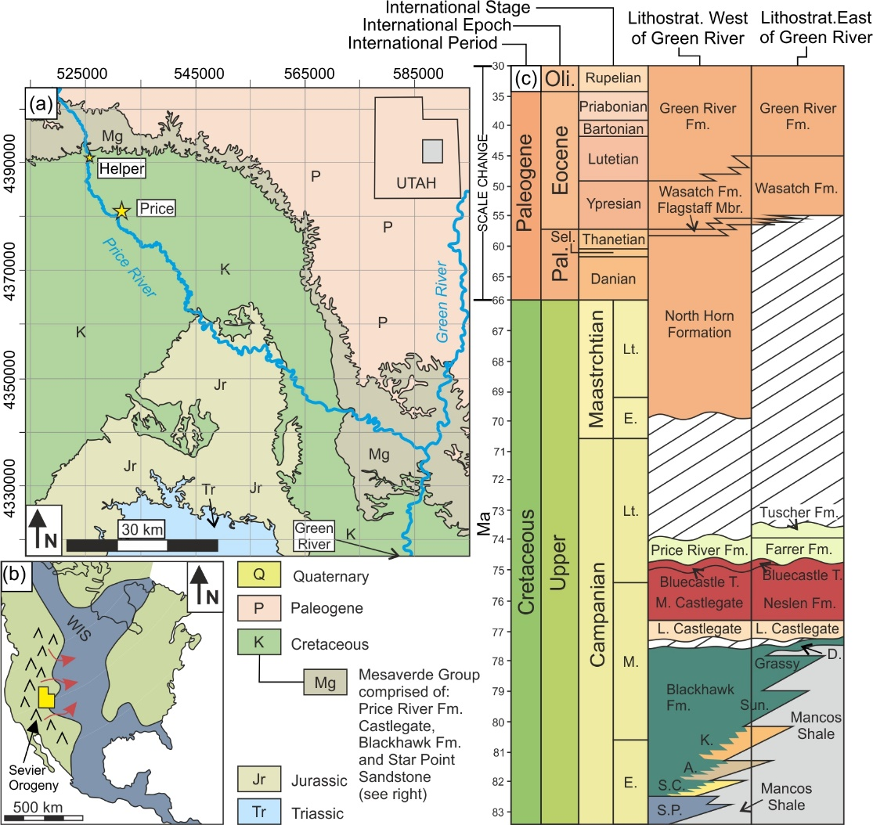
Figure 1. Lithostratigraphic and chronostratigraphic context of the Campanian Lower Castlegate Sandstone MSB, Utah. (A) A geological map of the Book Cliffs in the area between Price and Green River (modified from Watkind 1995), showing the distribution of the Mesaverde Group outcrops. (B) A palaeogeographic reconstruction of the Sevier Orogeny and sediment supply pathway (red arrows), feeding the Western Interior Seaway (WIS) that spanned across North America (modified from Van de Graff, 1972; Chan and Pfaff, 1991). (C) Generalised vertical section detailing the lithostratigraphic make-up of the Upper Cretaceous and Lower Paleogene of the study area, west and east of Green River (modified from Pitman et al., 1987; Seymour and Fielding, 2013; Burns et al., 2017).
The Book Cliffs succession is composed of the Mesaverde Group (Figure 1A), a clastic wedge that prograded eastwards (Aschoff and Steel, 2011a, 2011b) from Sevier Fold and Thrust Belt into the Western Interior Seaway of the North American Cordilleran retro-foreland basin (Dickinson et al., 1986; Lawton, 1986; Robinson and Slingerland, 1998) (Figure 1B). The Group grades eastwards from proximal non-marine facies to distal shoreface facies that spatially grade into the contemporaneous offshore sediments of the Mancos Shale (Lawton, 1986; Olsen at al., 1995; Hampson et al., 2005). Broadly, the Group comprises the Star Point Sandstone, the Blackhawk Formation, the Castlegate Sandstone and the Price River Formation (Fouch et al., 1983; Olsen et al., 1995; Seymour and Fielding, 2013). However, the lithostratigraphic nomenclature of the Group changes to the east beyond the town of Green River (Figure 1C).
Seymour and Fielding (2013) correlated the Book Cliffs succession to time-equivalent strata of the western Henry Mountains, to the south, based upon four distinct lithostratigraphic units: The Star Point Sandstone, the lower Blackhawk Formation, the middle and upper Blackhawk Formation, and the Lower Castlegate Sandstone MSB. The lower Blackhawk Formation (as defined by Seymour and Fielding, 2013) consists of prograding and aggrading, shoreface and coastal plain parasequence sets (Figure 1C). The Blackhawk is unconformably overlain by the Lower Castlegate Sandstone MSB (Olsen et al., 1995; Yoshida et al., 1996; McLaurin and Steel, 2000; Miall and Arush, 2001), deposited in a humid climate (Miall, 1994).
The Castlegate Sandstone is informally sub-divided into three units (Chan and Pfaff, 1991; Olsen et al., 1995; McLaurin and Steel, 2007): the Lower and Middle Castlegate Sandstones, and the Bluecastle Tongue. The Lower Castlegate Sandstone is the subject of this study. West of Green River it comprises a 40-80 m thick, highly amalgamated, high net-to-gross fluvial MSB (Yoshida, 2000). Palaeocurrent analysis indicates a south-east to east palaeoflow from the Sevier Fold and Thrust Belt (Willis, 2000; Yoshida, 2000; McLaurin and Steel, 2007). The more distal deposits to the east of Green River, at Tuscher Canyon (Figure 1A, C), show a thinner, approximately 25 m succession of the Lower Castlegate Sandstone (Fouch et al., 1983; McLaurin and Steel, 2000). The Castlegate MSB extends 140 km downslope from the proximal portion of the basin, covering an area of over 20,000 km² (Gibling, 2006). The Lower Castlegate is an extremely complex unit and no one continuous stratigraphic surface can be traced through it (Miall and Arush, 2001; Hajek and Heller, 2012; Pattison, 2018).
The Blackhawk – Lower Castlegate boundary has long been considered a sequence boundary (Van Wagoner, 1995, Olsen et al., 1995; Yoshida et al., 1996; McLaurin and Steel, 2000; Miall and Arush, 2001). However, more recent correlations of shoreface incising channels (Pattison, 2018, 2019a), correlations to eustatic events (Howell et al., 2018) and provenance analysis (Pettit et al., 2019) have suggested a far more complex Lower Castlegate deposition, in which two source areas feed a prograding fluvial system. The progradation of the fluvial system and its associated autogenic scouring (Trower et al., 2018) have persevered as a sequence boundary-like surface at the Blackhawk – Lower Castlegate boundary (Howell et al., 2018; Pattison, 2018, 2019a,b).

Methodology
The study uses sedimentological data from eight field sites selected to form a broadly west to east palaeoflow-parallel transect along the Book Cliffs. Sedimentary logs were collected from field sites at a centimetre resolution to permit accurate set thickness measurements. These data were supplemented with ten down-hole well logs used to construct burial history and calculate subsidence rates (Figure 2A). Three large, well exposed, outcrops were chosen for terrestrial photogrammetric data collection: the Castle Gate type locality (Figure 2B) in the proximal region of the Lower Castlegate fluvial system, Sunnyside (Figure 2C) in the medial region, and Tuscher Canyon in the distal region (Figure 2D).
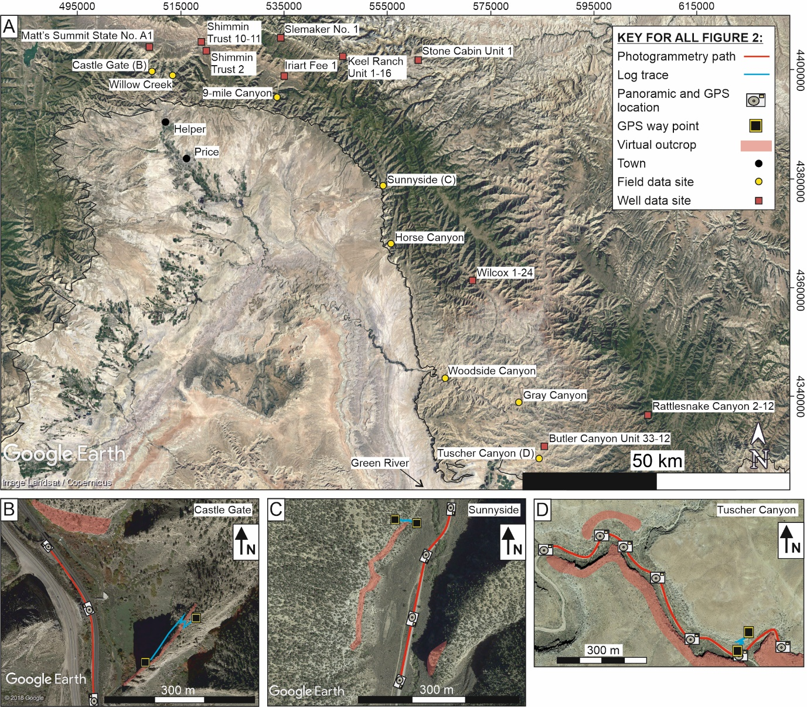
Figure 2. (A) Location map (GoogleEarth image acquired on 12/31/2016) showing wells (red) and outcrops (yellow). (B) Data collection map from the proximal Castle Gate study site (GoogleEarth image acquired on 10/16/2013). (C) Data collection map from the medial Sunnyside study site (GoogleEarth image acquired on 08/08/2015). (D) Data collection map from the distal Tuscher Canyon study site (GoogleEarth image acquired on 07/28/2015). Note, key in Figure 2A applies to all.
Outcrop photographs, with approximately 85% overlap, were processed using structure-from-motion digital photogrammetry software (see Buckley et al., 2006; Pringle et al., 2006; Bemis et al., 2014; Ellen et al., 2019; Priddy et al., 2019; Bilmes et al., 2019) to create virtual outcrop models (VOMs) for each location. Each photogrammetric dataset collected has an outcrop-to-area ratio (Enge et al., 2007) of approximately 0.75 and the total area covered by the photogrammetric models is approximately 280,000 m². VOMs were spatially referenced to ground control points, using hand-held GPS (Ellen et al., 2019; Priddy et al., 2019) (Figure 2).
Analysis of the VOMs was performed using Virtual Reality Geoscience Studio (VRGS, v. 2.39, Hodgetts et al., 2015), to provide interpretations of bounding surface hierarchy (Miall, 1985), sedimentary architectural elements, sedimentary geometry (width and thickness measurements), vertical set thicknesses and measured palaeocurrent directions (following the approach of Burnham and Hodgetts, 2018). Geometric measurements of elements are corrected, for the relationship between the orientation of the outcrop to compared to their palaeoflow direction, within VRGS to give measurements perpendicular to palaeoflow in all cases (Burnham and Hodgetts, 2018). The architectural element geometric data, presented herein, are uncorrected for partial and complete elements, due to the lack of complete and abundance of unlimited elements (Visser and Chessa, 2000) and the highly erosional nature of the formation. It should, therefore be considered that the values presented here are minimum values (Visser and Chessa, 2000). This may also influence and underestimate true width:thickness ratios. Two-dimensional architectural element proportions where obtained from orthorectified images of the VOM interpretations. This was done using an equal surface are measurement tool (e.g., Grove and Jerram, 2011; Mitten et al., 2020) in Image J (v. 1.51; Rasband, 2009).
In addition to photogrammetry, a total 306 m of high-resolution sedimentary logs, measuring 21-77 m vertically was collected from the eight field localities (Figure 2). The sedimentary logs were used to ground-truth the interpretations made from photogrammetric datasets, to make facies-scale observations, and to determine the relative abundance of each facies within a field site. Facies proportions are based upon thickness in log data and are therefore one-dimensional (Miall, 1973; Priddy and Clarke, 2020).
The occurrence of preserved barfom topsets provide insight into palaeoflow depths, avulsion mechanisms (Chamberlin and Hajek, 2015) and aggradational profiles of ancient fluvial systems (Heller and Paola, 1996; Mohrig et al., 2000; Hajek and Heller, 2012; Chamberlin and Hajek, 2019). Erosion of topset strata can be produced from element scour (Hajek and Heller, 2012) and discharge reactivation (Herbert et al., 2020). Therefore, each preserved topset and erosional surface found within an accretionary element was counted in the VOMs. The ratio of topset occurrences to erosional surfaces within individual elements is used as a rough proxy for aggradation rate and discharge variability. This is done with the assumption that the more prevalent are erosional surfaces within a succession, the lower the preservation. Conversely, preservation of a clinoform top indicates that, at that time, aggradation was dominant (Hajek and Heller, 2012; Chamberlin and Hajek, 2019). The ratio of these two types of surface is considered as an indication of preservation. The higher the ratio the more aggradational and stable the flow is during deposition of the element; the lower the ratio the greater the amount of erosion or denudation that is taking place during deposition of the element.

Palaeoflow-dynamics reconstruction
A standard analysis using circular statistics (Allen, 1967; Petit and Beauchamp, 1986) of palaeocurrent measurements taken from crossbed foresets was employed in this study to give the vector mean direction (v_{m}) and dispersion (r) of the flow and the sinuosity of the system. Equal area, 15° bin, rose diagrams where plotted using GeoRose (v.0.4.3; Y.O.N.G., 2015). Maximum channel sinuosity estimations were calculated using the sine-generated curve method (Bridge et al., 2000; Equation 1) using half the maximum palaeocurrent range in radians (φ) and the assumption that meanders are generated as sine-curves (Bridge et al., 2000). In this approach, sinuosity (P) is given by:
$$P=4.84/(4.84-φ^{2})$$
[1]
To validate the results of this analysis two further methods of estimating channel sinuosity were used. La Roux (1992, 1994) proposed a method using the operation range (ɸ; 3.2 times Curray’s (1956) circular standard deviation; La Roux, 1994). Equation 2 should be used when ɸ is less than 180° and Equation 3 when ɸ is greater than 180°.
$$P={π\left(ɸ/360\right)}/{\left\{sin\left(ɸ/2\right)\right\}}$$
[2]
$$P={π\left(ɸ/360\right)}/{\left\{sin\left(360-ɸ/2\right)\right\}}$$
[3]
The final method (Equation 4) used to determine maximum channel sinuosity uses the vector magnitude as a percentage (L; Ghosh, 2000).
$$\ln{P= 3.68-0.0684L+{0.00032L}^{2}}$$
[4]
Sinuosity was calculated for channel fill elements to account for single channel thalweg sinuosity (independent of barform accretion), and also for total palaeocurrent data, to account for total channel-form sinuosity (including barform accretion). The results of the sinuosity analysis allow downstream variations in local palaeocurrent, changes in dispersions and sinuosity to be observed. The sine-generated curve method (Equation 1) may be biased towards larger sinuosity values, these have therefore been treated as maximum values. However, the trends represented within the Bridge et al. (2000) reconstructions are complemented by the results of other reconstruction methods (La Roux, 1994; Ghosh, 2000) and therefore can be considered representative of trends, despite the limitations imposed upon the absolute values.
Maximum flow depth reconstructions were produced from crossbed set thicknesses (Equation 5; Bridge and Tye, 2000). This approach uses the mean of measured crossbed set thicknesses (s_{m}) to determine the maximum depth of a flow (h_{m}) during the time of deposition of the measured set from:
$$h_{m}=5.3β+0.001β^{2} where β≈{s_{m}}/{1.8}$$
[5]

Burial history analysis
Subsidence rates provide primary controls upon fluvial depositional architecture and preservation potential (Catuneanu and Elango, 2001; Leckie and Boyd, 2003; Catuneanu, 2006). In order to determine basin-scale variations in subsidence rate, decompacted one-dimensional burial history curves were constructed in the basin modelling software Genesis (Zetaware) software for ten borehole sections penetrating the Mesaverde Group along a ~150 km WNW-orientated transect, parallel to depositional dip. Calculation of the decompacted rock unit thickness was performed in Genesis and is lithology specific (c.f., Perrier and Quiblier, 1974). The gamma ray responses of the ten borehole sections (from Hampson et al., 2005) were used to determine depths to unit tops (identified in Hampson et al., 2005; Seymour and Fielding, 2013), unit thicknesses and lithology. Values for depth to top and unit thickness and were obtained for the Star Point, Lower Blackhawk, Upper Blackhawk and the Lower Castlegate Sandstone (Seymour and Fielding, 2013), based on similar interpretations made by Hampson et al. (2005). The biostratigraphic zonation schemes of Obradovich (1993) and Seymour and Fielding (2013; and references therein) are used to provide timing constraints. The estimates of Pitman et al. (1987), Olsen et al. (1995) and Aschoff and Steel (2011b) provided control upon eroded overburden thicknesses. Deposition is assumed to have occurred at or close to sea level so the effects of bathymetry are not accounted for in our models.

The Architecture and bounding surfaces of the Lower Castlegate Sandstone
Seven facies are recognised within the Lower Castlegate MSB (Table 1). For a detailed facies-scale analysis of the Lower Castlegate the reader is referred to Van de Graff (1972), Chan and Pfaff (1991), Miall (1993, 1994), Adams and Bhattachyra (2005) and McLaurin and Steel (2007).

Table 1. Facies scheme showing the lithofacies assemblage of the Lower Castlegate Sandstone in the study area.
Facies | Lithological Description | Interpretation
Clast-supported conglomerate  (Cc) | Boulder-sized clasts, little matrix, clast supported. Matrix (where present) comprises fine- to very coarse-grained sandstone, moderate to poorly sorted. Structureless, normally graded, with rip-up clasts and coal clasts. | Subaqueous, pseudo-plastic, high sediment load, non-Newtonian deposits (Miall, 1988).
Trough-crossbedded sandstone  (St) | Fine- to very coarse-grained, grey-brown sandstone, sub- to well-rounded, moderate sorting and sphericity. Trough-crossbedding, some pebble-sized material lining basal surface of the facies, soft sediment deformation. | High-energy lower-flow regime sinuous-crested dune-scale sub-aqueous bedforms (Collinson et al., 2006) (Figure 3B, C).
Planar-crossbedded sandstone  (Sp) | Fine- to coarse-grained, grey-brown sandstone, sub- to well-rounded, moderate sorting and sphericity. Planar crossbedding, forsesets occasionally lined with darker clasts, sometimes granule- to pebble-sized clast material, rare asymmetrical ripples. | Lower- flow regime straight crested dune-scale bedforms (Miall 1996) (Figure 3E, I).
Massive sandstone  (Sm) | Medium-grained, black-grey sandstone, sub-rounded, very poor to poor sorting and sphericity. Structureless, normally graded, large wood fragments at the base of the facies. | High sediment load during rapid deposition (Miall, 1996; Leeder, 1999) (Figure 3F, G, H).
Horizontally laminated sandstones  (Sh) | Medium- to coarse-grained, grey-brown sandstone, sub- to well-rounded, poorly sorted, moderately spherical. Planar horizontal lamination, normally graded with wood fragments at the base of the facies. | Upper-flow regime plane bed deposits (Miall, 1996; Collinson et al., 2006).
Ripple laminated sandstone  (Sr) | Very fine- to fine-grained, grey-brown sandstone, sub-rounded, moderate sorting and sphericity. Asymmetrical ripple lamination, some finer black material on ripple laminae. | Lower-flow regime small-scale sub-aqueous bedform migration (Miall, 1985) (Figure 3A)
Planar laminated fines  (Fl) | Grey, well-sorted mudstone to siltstone, very fine- grained sandstone interbeds. Planar horizontal lamination, some symmetrical ripple lamination. Soft sediment deformation, pedogenic nodules, organic enrichment of laminae. | Suspension settling, with mild flow fluctuations, some sub-aerial exposure (Figure 3G), some evidence of standing water (Miall, 1996; Bridge, 2003).
Five distinct architectural elements are recognised in the lower Castlegate: (1) erosionally based, lensoid to sheet sandstones representing channel fill elements; (2) low-angle, cross stratified sandstones representing upstream accretion elements; (3) large-scale, inclined heterolithics representing lateral accretion elements; (4) large-scale, cross-stratified tabular to lensoid sandstones representing downstream accretion elements; and (5) tabular, fine-grained sandstone to mudstones elements interpreted as overbank elements. Each element is described and interpreted below.

Erosionally based, lensoid to sheet sandstones

Description
Occurrences of these elements are typically 2-10 m thick and 20-180 m wide, with a width to depth ratio of 10:1 to 30:1. The sand bodies are confined within fifth-order, concave-up, basal scour bounding surfaces. The elements (when fully preserved) are capped by fourth-order bounding surfaces. However, in the majority of cases across the Lower Castlegate, the full succession is truncated by a fifth-order erosional surface. The elements typically show a succession of conglomerate pebble-lag material (Cc), fining upwards from coarse- to fine-grained crossbedded facies (St, Sp; Figures 3B, C, E, F; Table 1) to, fine- to very fine-grained horizontally laminated sandstone facies (Figure 4). Some coarse- to medium-grained structureless sandstones are also found within the succession (Sm; Figures 3G, H). At the base of the element, wood fragments and imprints can be found along with mud- to siltstone rip-up clasts. Convolute to wavy soft sediment deformation structures are also abundant within the lower portion of the element. Measured thicknesses of crossbed sets within the element vary from 0.23 m to 0.88 m. The sets within the major sandstone facies do not often form cosets. Fourth-order, small-scale scour surfaces are also common and punctuate the development of sets within the element. The mean palaeocurrent of the elements measured (n = 476) is 92° with a dispersion of 45% across the study area.

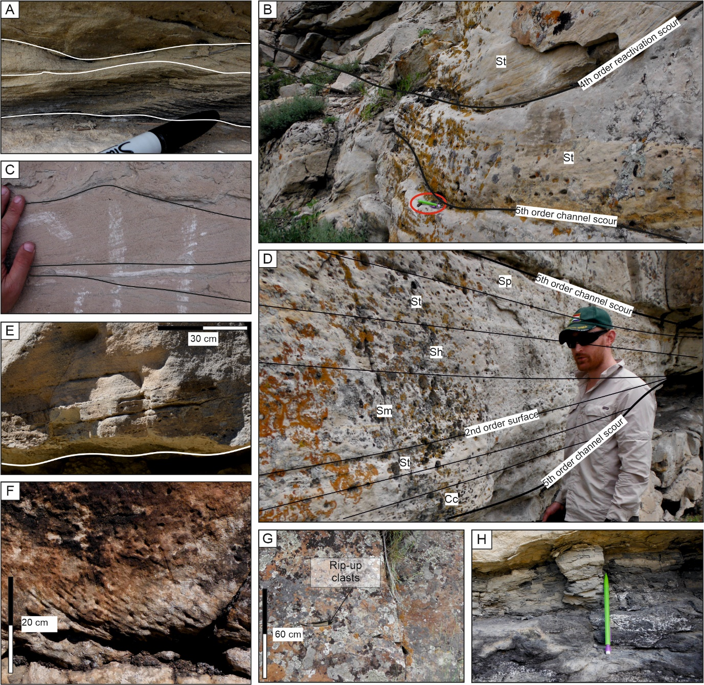
Figure 3. Facies photoplate from the Lower Castlegate, Utah. (A) Two sets of asymmetrical ripple laminated sandstone from the Castle Gate log at approximately 52 m, pen for scale. (B) Large trough crossbedded sandstone sets showing downlapping onto basal channel surface, highlighted is a pencil for scale. Clast moulds can be seen along the set surfaces. Image is taken from the Castle Gate log at approximately 33 m. (C) Smaller scale trough cross-bedded sets from Horse Canyon log at approximately 31 m. (D) Asymmetrical channel fill from the Castle Gate log at approximately 36 m. (E) Planar cross-bedded sandstone from 9-Mile Canyon log at approximately 28 m. At the base of the cross bedded facies an erosional base has been interpreted overlying fine-grained material, this erosive surface is overlain by a minor channel lag consisting of small extra- and intra-formational clast material. (F) Horizontally laminated sandstone erosionally overlain by trough crossbedded sandstone from Tuscher Canyon log, at approximately 5 m. (G) Massive structureless sandstone with some rip-up clasts, comprised of siltstone that have been deformed due to compaction. Photo is from the Castle Gate log at approximately 18 m. (H) Fine grained siltstones and massive sandstones in the overbank succession of the Castle Gate log, from approximately 15 m.
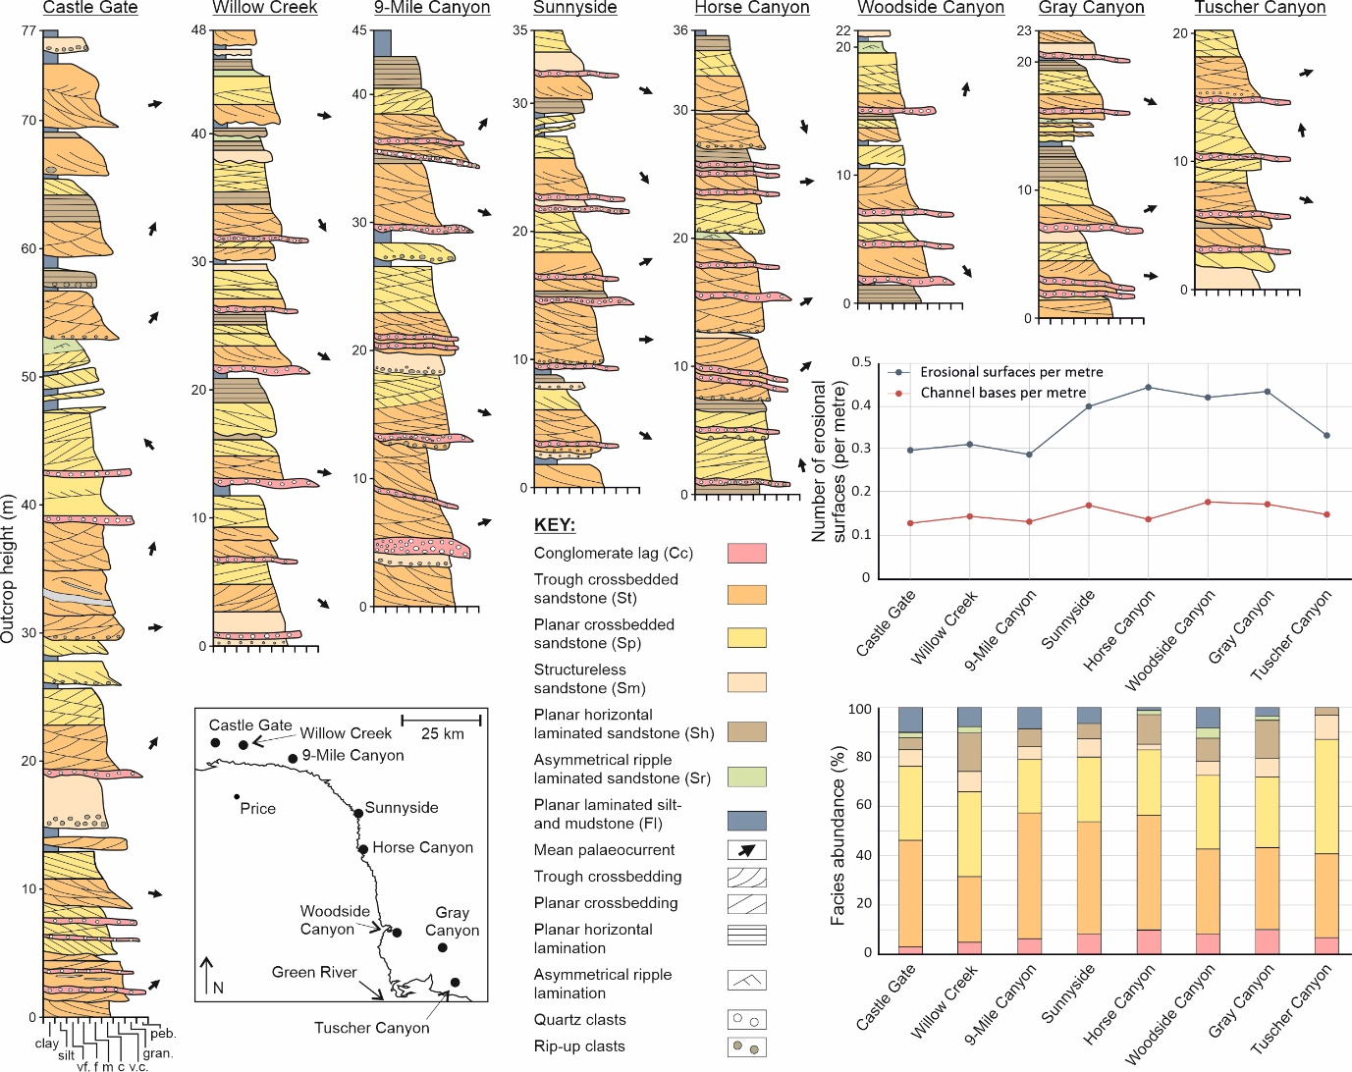
Figure 4. Field-obtained sedimentary logs and mean palaeocurrent directions of architectures collected in the field for each study locality. Logs are ordered (left to right) from west to east, highlighting the thickness variations observed across the Lower Castlegate Sandstone. A stacked bar graph of facies proportions is shown, proportions are obtained from the vertical thickness of the facies in the logs shown. A graph of erosional surfaces shows the number of erosional surfaces per metre, for each logged locality, and the number of channel bases per metre preserved across the Castlegate. This highlights the lack of preservation of in channel material towards the more distal portion of the basin.
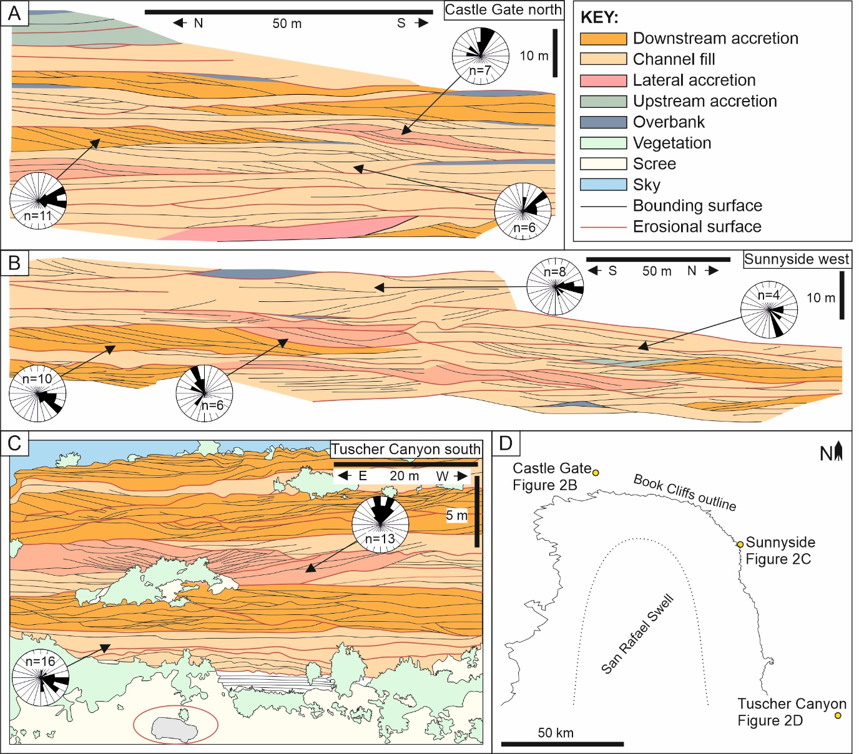
Figure 5. Outcrop interpretation images with (inset) location map, with palaeocurrent data and n values of individual elements (15° bins). (A) Castle Gate north outcrop (509831, 4400284) from McLaurin and Steel (2007) showing the proximal section of the Castlegate MSB. (B) Sunnyside west outcrop (553925, 4379887) for the medial section. (C) Tuscher Canyon south (584290, 4327974), note mid-sized SUV for scale (highlighted). (D) Inset map showing the locations of the outcrops and the Book Cliffs classic outcrop outline in Figure 2.

Interpretation
The confining erosional nature of the concave-up basal scour surface and waning flow deposits suggest channel fill deposits (Figures 3D, 5). The progression from pebble-lag material through upper flow regime to lower flow regime deposits indicates the preservation of a complete channel cut-and-fill succession (Miall, 1985; Bridge, 1993). The presence of rip-up and wood clasts indicates the transport, and therefore presence of overbank material, which was re-worked by channel elements. Variations in set thickness indicate variable flow depths (Bridge and Tye, 2000; Bridge et al., 2000; Adams and Bhattachyra, 2005; McLaurin and Steel, 2007; Lunt et al., 2013). This is further evidenced by the abundant nature of fourth-order scour surfaces and the lack of coset development, and indicates either immature unit bar formation (Hubert et al., 2020) or the simple migration of single bedforms. The mean palaeocurrent direction of elements measured across the Lower Castlegate is 92° (Figure 6), indicating a generally eastward flow to the channels, and agrees with that found in previous studies (Miall, 1993, 1994; Miall and Arush 2001). The lateral and vertical amalgamation of channel elements within the Lower Castlegate has been attributed to the local avulsion events (Miall, 1994; Miall and Arush, 2001; Gibling, 2006; McLaurin and Steel, 2007; Hajek and Heller, 2012).

Low angle cross-stratified sandstone elements

Description
Sandstone elements that are typically 3 m thick and 20 m-80 m wide. The elongate lensoid geometries of the elements (width-to-depth ratio of approximately 25:1) are confined within fourth- or fifth-order bounding surfaces at the tops of elements and fourth-order scour surfaces at the bases. These elements always form on the more upstream side of other architectural elements. The succession comprises trough and planar cross-bedded facies. No grain size trend can be determined, as no sedimentary log records an example of the element. The element shows prominent low-angle accretionary third-order and small-scale fourth-order scour bounding surfaces that bound crossbed sets. The set thicknesses within the element range from 0.20 to 0.43 m. Low-angle accretion surfaces dip at about 12° to the west and upstream from the recorded channel palaeocurrent directions.

Interpretation
The lensoidal geometries and locations of elements of this type on the upstream margins of another elements, coupled with low-angle and upstream dipping accretionary surfaces within them (Figure 5a), indicate elements of this type are most probably deposited as upstream accretion elements (Bristow, 1993; Skelly et al., 2003). Upstream accretion occurs as a result of bank-low discharge when planar and sinuous bedforms amalgamate on the upstream margin of bars and stack to the water depth (Bristow, 1993; Skelly et al., 2003; Wang and Plink-Björklund, 2019b). This stacking causes back-stepping of bedform migration and the development of low-angle accretionary surfaces that dip upstream (Skelly et al., 2003). The erosional nature of the fourth-order, small-scale scour surfaces seen within the element are produced by scour pits generated by eddies as dunes migrate (Hajek and Heller, 2012). Such barforms have been found within modern analogues such as the Niobrara River, Nebraska (Skelly et al., 2003) and the Jamuna River (Ashworth et al., 2000). They have been attributed to early stage compound barform development (Ashworth et al., 2000).
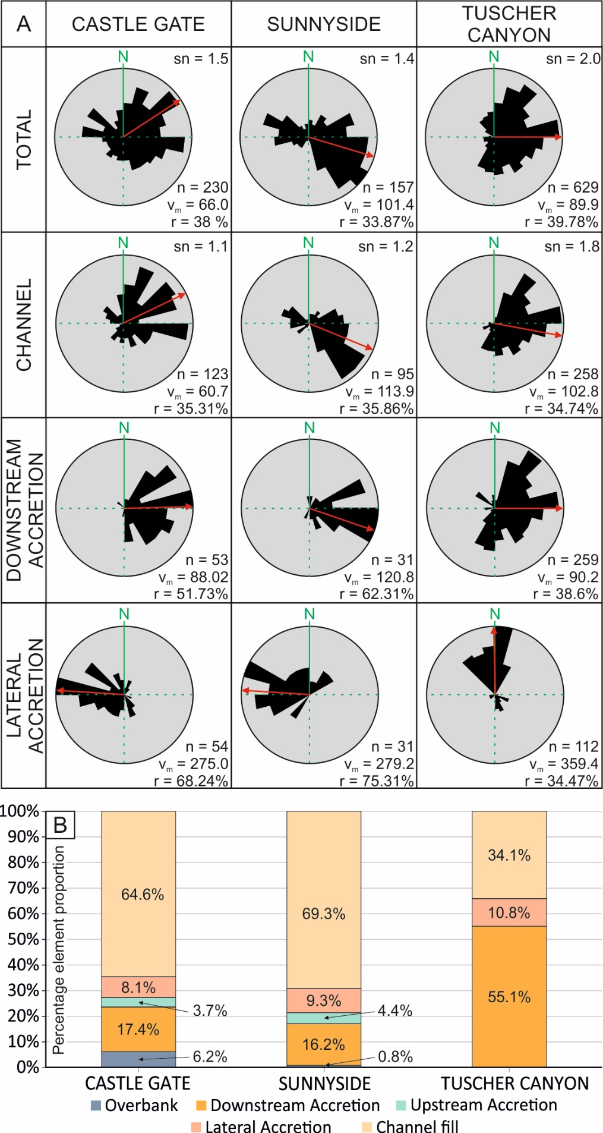
Figure 6. (A) Palaeocurrent summary of the Lower Castlegate MSB, divided by architectural elements at each location. Note, n = number of measured forests, v_{m} = mean azimuth, r = dispersion as a percent, sn = sinuosity value. (B) The abundance of architectural elements across the three photogrammetric datasets across the Book Cliffs derived from the photogrammetric analysis of the proximal (Castle Gate), medial (Sunnyside) and distal (Tuscher Canyon) sections. Note, bin sizes for the rose diagrams are 15°.
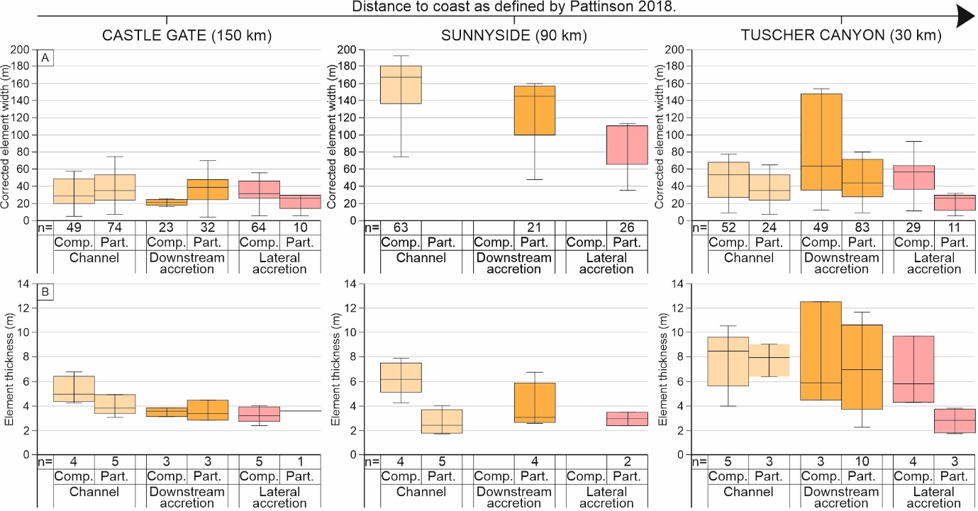
Figure 7. Width and thickness measurements of architectural elements that comprise the Lower Castlegate Sandstone for each photogrammetric data set, relative to their position downstream (see top axis). Complete and partial element occurrence statistics are shown, unlimited elements are not included here. (A) The corrected element width data whisker box plots for each analysed locality. (B) The element thickness data whisker box plots for each analysed locality.

Large scale inclined heterolithic elements

Description
Elements of this type are heterolithic and exhibit alternating inclined units of sandstones and planar-laminated siltstones (Fl; Figure 5C). The interbeds have an asymptotic nature, are not laterally extensive, and are inclined at moderate- to high-angles. The elements are typically 2 - 4 m thick, are 15 - 110 m wide (Figure 7), and is found mainly on the margins of other accretionary elements. The elements are lensoid and confined within fourth- or fifth-order bounding surfaces at their tops, and fourth- or fifth-order scour surfaces at their bases. Trough and planar cross-bedded sandstone facies (St and Sp) are abundant within medium to fine grained sandstone strata. Minor sporadic occurrences of massive sandstones (Sm) are also observed. Towards the top of the succession (when preserved) planar horizontal (Sh) and ripple (Sr) lamination are present within fine- to very fine-grained sandstone. The top of the element may also be gradational into finer grained sediments (Fl). Crossbeds form sets that are typically 0.10-0.30 m thick. Accretionary surfaces and internal set surfaces are commonly punctuated by small-scale scour surfaces. The elements show palaeocurrent directions that are normal to that of the local channel fill element (Figure 6A).

Interpretation
The inclined heterolithic and lensoidal nature of the elements, and the mean palaeocurrent directions approximately normal to those recorded in channel elements, indicate that these elements are lateral accretion elements (Jordan and Pryor, 1992; Best et al., 2003). The high angle of the asymptotic interbeds suggests steep accretionary surfaces between the sandstones and siltstones that indicate local discharge rate variation and sporadic bedform migration at the margins of lateral accretion elements (Miall, 1985; Ielpi and Ghinassi, 2014). Internal small-scale scour punctuations to the inclined heterolithic strata further indicate variable discharge rates. The preservation of horizontally laminated sandstones at the tops of the barform and ripple lamination are evidence of very shallow water depths and therefore probably represent bar top facies (McLaurin and Steel, 2007; Hajek and Heller, 2012; Chamberlin and Hajek, 2019). A dominant occurrence of these elements on the margins of other accretionary elements suggests that they are not to the scale of large point-bar elements, but probably represent lateral growth strata of small intra-channel belt channels and barforms.
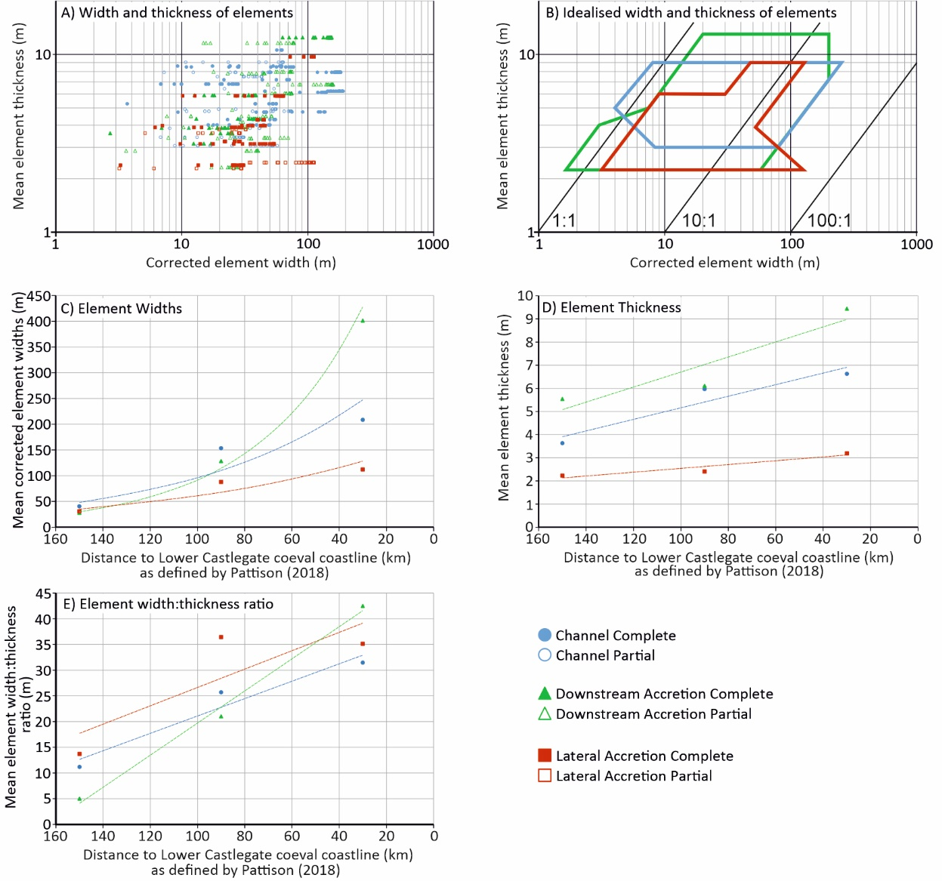
Figure 8. (A) Scatter log-log plot showing the relationship of corrected width to thickness for each of the major constituent architectural elements within the Lower Castlegate Sandstone. (B) The corrected width against thickness for each of the major constituent architectural elements of the Lower Castlegate, shown as data envelopes (Gibling, 2006) highlighting the area in which corrected widths and thicknesses will occur. (C) Mean complete and partial element thickness for each field site relative to the palaeo-coastline. (D) Mean complete and partial element widths for each field site relative to the palaeo-coastline. (E) Mean complete and partial element width:thickness ratio for each field site relative to the palaeo-coastline. Note, the n values for C, D and E are given in Figure 7.

Large-scale cross-stratified tabular to lensoid sandstone elements

Description
Elements of this type are typically 4-12 m thick and are 20-160 m wide. Their lensoid geometries are confined within fourth- to fifth-order bounding surfaces at the tops of the elements and fourth-order scour surfaces beneath. Tabular to lensoid geometries are usually much greater in lateral extent relative to preserved thickness. Such elements are typically the largest of the elements seen within the Lower Castlegate Sandstone (Figure 7, 8). They consist of trough to planar crossbedded medium-grained sandstone facies (St, Sp) with minor occurrences of structureless medium- to fine-grained sandstones (Sm; Figure 4). When fully preserved, the succession grades normally to horizontal and ripple laminated fine- to very fine-grained sandstone facies (Sh, Sr). The internal bounding surface framework of these elements is dominated by climbing sets forming cosets and large, high-angle (12°-20°) accretionary surfaces (Figure 5), forming clinoform geometries. The framework is punctuated by small-scale, fourth-order scour surfaces. The mean palaeocurrent of these elements, derived from data from all localities (n=344), is 107° but shows a higher dispersion (over 50%; Figure 6A) than that of the channel elements.

Interpretation
The presence of accretionary surfaces, a lensoidal to tabular geometry, and a mean palaeocurrent direction (107°), sub-parallel to parallel with that of local channel fill elements (Figure 6A), suggest these are downstream accretion elements (Miall, 1985; Hornung and Aigner, 1999; Best et al., 2003; Miall and Jones, 2003; Ghinassi and Ielpi, 2018). They represent the largest dimension architectural elements within the Lower Castlegate Sandstone (Figure 8b). Any packages of sediment extending up to 50° away from the mean channel thalweg palaeocurrent direction have been attributed to oblique barform migration or slip-face failure (Best et al., 2003). The normally graded, sand dominated, succession suggests a waning flow, until low flow depths cause the deposition of bar top facies (Cant and Walker, 1978; Hajek and Heller, 2012; Chamberlin and Hajek, 2019). Fourth-order local scour surfaces have been interpreted as forming through reactivation of flow in variable discharge. Scour marks potentially form as a result of variable discharge rates (Hajek and Heller, 2012; Chamberlin and Hajek, 2019).

Tabular fine-grained sandstone and mudstone elements

Description
These elements preserve as thin tabular bodies that are usually no wider than 170 m or thicker than 1.5 m and represent the least abundant of the elements within the Lower Castlegate (only 2.3% of the total Lower Castlegate in the three VOMs). The basal bounding surfaces of the elements are a gradational fourth-order top surfaces of the underlying element. The margins and tops of the elements are always fifth-order erosional bounding surfaces. The elements consist of fine-grained massive to horizontally laminated sandstones (Sm, Sh) to planar laminated mudstone facies. Some minor plant fragments, rooting (approximately 0.5-8 cm wide) and poorly preserved pedogenic nodules are noted within the mudstone facies, along with very minor intercalations of coal and millimetre- scale siderite concretions.

Interpretation
The fine-grained nature, minor palaeosol nodules, minor coal intercalations and the presence of rooting indicate sediment deposited as a moderately wet and vegetated sub-strate. Consequently, occurrences of this element are interpreted as overbank or floodplain material (Nanson and Croke, 1992; Törnqvist and Bridge, 2002). Planar lamination develops from suspension settling within the flow when discharge breaches channel banks. The limited extent of the element suggests that regular avulsion of channels eroded the overbank material, and that overbank elements have occupied previously abandoned channels (Reinfields and Nanson, 1993).

Downstream variations in preservation and erosion

Downstream distribution of facies
The Lower Castlegate MSB mainly comprises trough and planar crossbedded sandstone, with little notable downstream trend apparent for either facies. Trough cross-bedded sandstone proportions range from 33% to 50% (Figure 4). The relative proportion of planar crossbedded sandstone facies remains largely similar downstream (22 % to 35%), with an exception at the more distal Tuscher Canyon section (44%). The amount of preserved channel-lag increases downstream to a medial setting (Horse Canyon), before remaining relatively constant, at approximately 10%, towards the more distal portion of the fluvial system. Conversely, preservation of planar laminated mudstones decreases downstream towards the distal Tuscher Canyon section, where they are not preserved (Figures 4, 6B), with the exception of Horse Canyon to Woodside Canyon where an increase in mudstone content of 9% is noted. The proportion of bar-top facies (horizontally laminated and ripple laminated sandstones; Hajek and Heller, 2012) (Figure 4) shows a very general decrease downstream.

Downstream variations in architecture and preservation
The architecture of the proximal Lower Castlegate MSB, in its type locality area (Figure 2), is dominated by channel fill elements (64%; Figure 6B). The proximal region of the Lower Castlegate shows notable preservation of overbank elements (6%) but shows a low preservation of downstream accretion elements (17%). A similar proportion of architectural elements is noted in the medial Sunnyside outcrop, in which channel elements comprise the dominant portion of the succession. However, overbank preservation is negligible (<1%; Figure 6B). The Sunnyside and Castle Gate outcrops show similar proportions of upstream accretion (approximately 4%) and lateral accretion elements (approximately 8-9%). The distal Tuscher Canyon section exhibits a markedly different proportion of architectural elements than the more proximal sections, with over 50% of the succession comprising downstream accretion elements and 11% comprising lateral accretion elements. The succession has a reduced channel proportion (34%) and has no upstream accretion or overbank elements preserved (Figure 6B).
Channel fill elements in the proximal Castle Gate are approximately 40 m wide (Figures 7, 8) and generally 3.5 m thick. The channel elements become progressively wider and deeper through Sunnyside (150 m wide and 6 m thick) and Tuscher Canyon (208 m wide and 6.6 m thick). The width to thickness ratio of channel elements increases from 11:1 in the proximal region to 31:1 in the distal Tuscher Canyon section (Figure 8). An increasing width to thickness ratio is also shown in downstream accretion elements (Figure 8), where it progressively changes from 5:1 to 42:1 between the Castle Gate and Tuscher Canyon sections, respectively. Lateral accretion elements, however, do not experience the same trends. Whilst displaying the same width to thickness ratio trend downstream (14:1-35:1; Figure 8) they do not show any major increase in thickness from proximal and distal settings (ranging from approximately 2.2 m to 3.2 m). The trends of lateral accretion are only defined by partial element exposure in Sunnyside, it is therefore likely that a further increase in size of lateral accretion elements downstream has been suppressed.

Downstream variation in erosional surfaces and barform preservation
There are at least two-types of erosional surfaces within the Lower Castlegate MSB: reactivation scours, element scours and channel bases (Hajek and Heller, 2012) (Figure 5). Concave-up listric reactivation surfaces scour crossbed sets and cosets of accretionary elements, and form when channel discharge increases from bank-low conditions to bank-full conditions and accompanying increased flow rates promote erosion into in-channel elements (Herbert et al., 2020). Undulatory horizontal to shallowly dipping element scour surfaces are formed from autogenically induced changes of in-channel hydrodynamics that can partially or completely erode bar top facies (Miall, 1994; Hajek and Heller, 2012). The depth of such scours can depend upon subsidence rate, discharge and aggradation rate (Hajek and Heller, 2012). Erosional concave-up (in flow perpendicular orientation) and undulatory planar to shallowly dipping channel bases that incise much deeper than element scour surfaces and typically show a large grain size increase across the erosional surface. Such scours formed from local avulsion of a channel belt (Lynds and Hajek, 2006; McLaurin and Steel, 2007; Hajek and Heller, 2012; Chamberlin and Hajek, 2015), whereby a fluvial channel will avulse to a topographically lower area (Bridge and Leeder, 1979; Straub et al., 2009).
The number of channel bases per metre, vertically, does not change moving downstream and remains between 0.12 and 0.18 (Figure 4) across the Lower Castlegate MSB. The number of erosional surfaces per metre within the sedimentary logs increases moving downstream towards the distal Tuscher Canyon section. There is an increase from 0.3 in the proximal Castle Gate, Willow Creek and 9-Mile Canyon region, to 0.42 in the more distal Horse Canyon to Gray Canyon sections. There is a markedly lower number of erosional surfaces per metre (0.33), vertically, in the most distal Tuscher Canyon section.
This increase in erosional pattern is also seen further downstream where accretionary element clinoforms rarely preserve their topset (Hajek and Heller, 2012) (Figure 9). In-channel accretionary element topsets preserve well within the proximal Castle Gate section (2.5 topset surfaces to erosional surfaces); whereas downstream in the distal Tuscher Canyon section, erosional surfaces dominate (0.4 topset surfaces to erosive surfaces; Figure 9), preserving only the basal to mid-portions of the accretionary elements.
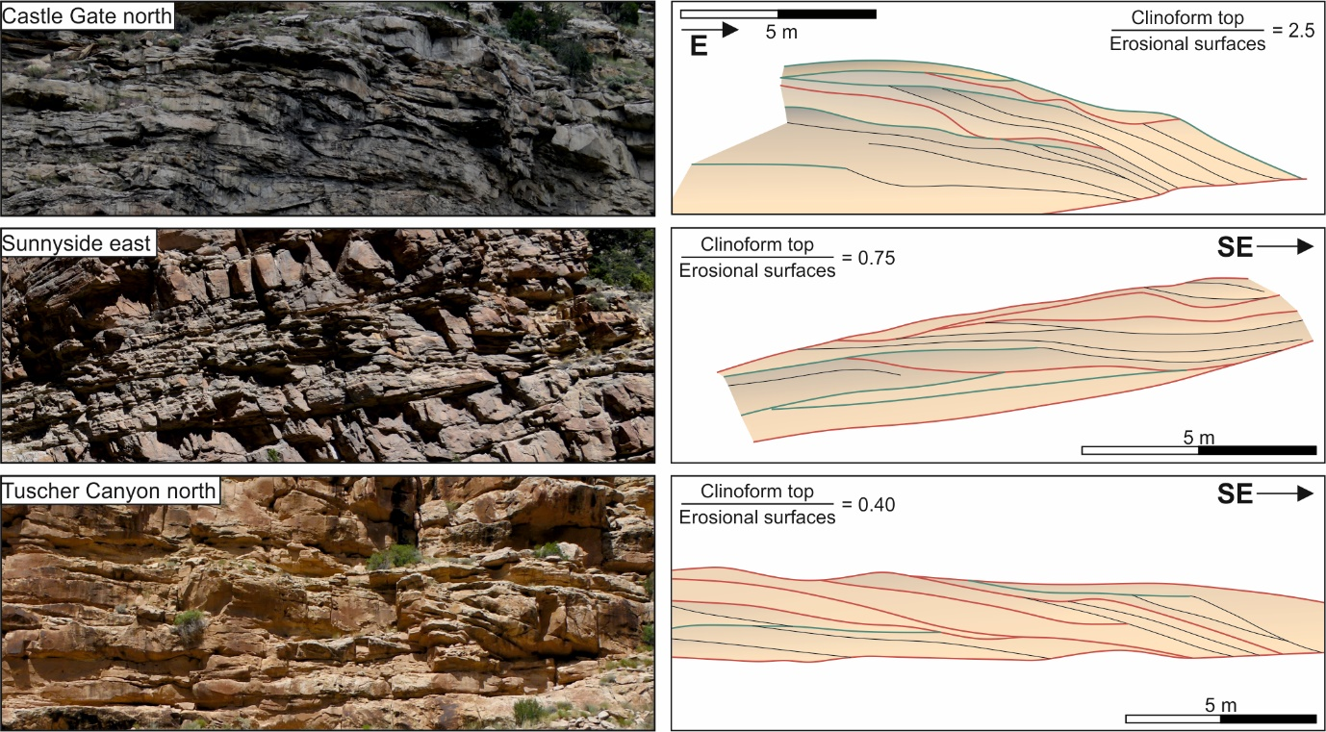
Figure 9. Three preserved barforms from the Lower Castlegate Sandstone in the studied log sections. The images show a downstream accretion barform and to the right there is an interpretation of the bounding surface nature for each barform, along with a rough quantification of erosional surfaces against clinoform top (Hajek and Heller, 2012) to highlight the degree of barform preservation.

Downstream variability in reconstructed palaeoflow dynamics
Maximum flow depths reconstructed from crossbed set thicknesses in the Caste Gate proximal locality suggest depths of 3.8-11.6 m (Figure 10A) with a general deepening up section. These results concur with those of McLaurin and Steel (2007), who recorded estimated flow depths of approximately 4.6-7.7 m and a maximum depth of 14.7 m. The general deepening upwards through the succession is also recorded by previous studies (McLaurin and Steel, 2007; Hajek and Heller, 2012). The reconstructed maximum flow depths within the type locality area show a mean of 6.9 m and a variance of 0.32 indicating variable discharge (Figure 10), and confirming the interpretation presented from the reactivation surfaces within the accretionary element bounding surface framework.
Reconstructed maximum flow depths in the Sunnyside locality are between 3.7-12.1 m (Figure 10B) with a mean of 6.7 m and a variance of 0.38. The Sunnyside locality shows a similar depth of flow to the type locality. However, there is an increase in discharge variability shown in the variance, and no obvious increasing in flow depth is indicated up-section. Reconstructions from Tuscher Canyon indicate flow depths of 4-12.3 m (Figure 10C) that are similar to those indicated for the more proximal areas. However, mean maximum flow depth is much greater (8 m) and shows a much lower variance of 0.28 (Figure 10D). Consequently, a deepening of flow with a more consistent discharge rate may be implied for the distal portion of the study area.
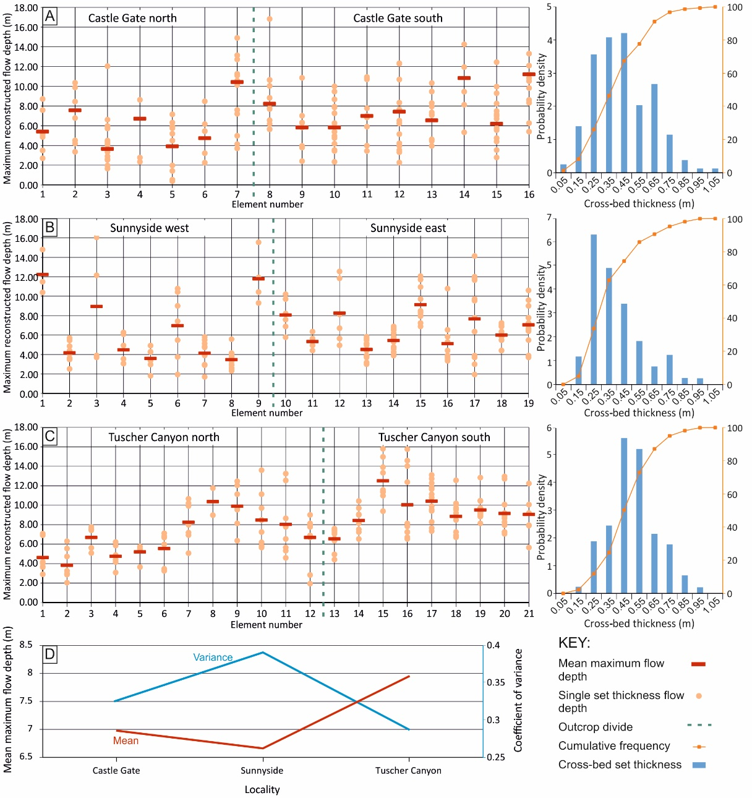
Figure 10. Reconstructed flow depths from set thicknesses in each VOM locality. (A) The Castle Gate locality, showing mean maximum flow depth of each element relative to a single set thickness measurement. The green dashed line represents where data from one outcrop ends and another begins. Each element has been assigned a number; the numbers assigned to elements increase upsection (elements 1-7 make up the northern outcrop, 8-16 make up the type locality). Histograms based on the probability density of set thicknesses are provided with the cumulative frequency (%, orange). (B) The Sunnyside locality (elements 1-9 make up the western outcrop, 10-19 make up the eastern), showing mean maximum flow depth of each element relative to a single set thickness measurement. (C) The Tuscher Canyon locality (elements 1-12 make up the northern outcrop, 13-21 make up the southern), showing mean maximum flow depth of each element relative to a single set thickness measurement. (D) The mean maximum reconstructed flow depths of each locality plotted with the coefficient of variance (secondary y-axis) of those means as a proxy of variable maximum flow depths.
The sinuosity of the Lower Castlegate MSB shows a progressive increase downstream. The proximal Castle Gate section shows low sinuosity (1.11; Table 2) in channel fill elements and intermediate sinuosity (1.54) when incorporating accretionary element data. The distal Tuscher Canyon section gives values of sinuosity of 1.83 and 2.03 (Table 2), with and without accretionary element data respectively, that indicate intermediate to high sinuosity. These trends are consistent for all three methods of sinuosity reconstruction (Table 2).
Table 2. Sinuosities reconstructed using all three methods: Equation 1 (Bridge et al., 2000), Equation 2 and 3 (La Roux, 1994) and Equation 4 (Ghosh, 2000). Each reconstruction is shown by location from proximal to distal across the study area. Calculations have been made for channels independent of accretionary elements and for total palaeocurrent data at each locality.
Method | Castle Gate |  | Sunnyside |  | Tuscher Canyon
 | Channel | Total | Channel | Total | Channel | Total
La Roux (1994) | 1.24 | 1.75 | 1.31 | 1.73 | 2.21 | 2.51
Ghosh (2000) | 1.21 | 1.83 | 1.28 | 1.88 | 1.82 | 2.98
Bridge et al. (2000) | 1.11 | 1.54 | 1.21 | 1.4 | 1.83 | 2.03
The channel fill elements show a greater dispersion of palaeocurrent data towards the distal portion of the Lower Castlegate Sandstone (Figure 6A) implying a downstream increase in sinuosity. Downstream accretion elements show a greater dispersion of palaeocurrent data towards the distal portion of the Lower Castlegate MSB, which may reflect different directions to accretionary element palaeoflow in the distal section, or more probably an increase in oblique growth of the elements due to their more mature development. Palaeocurrent trends for lateral accretion elements, that are normal to local thalweg flow, become more prominent downstream towards Tuscher Canyon, implying further evidence of sinuosity increase. These results concur with those previously published (Miall, 1993, 1994) and indicate sinuosity and lateral accretion trends increasing downstream.

Subsidence rates across the Lower Castlegate Sandstone
Results of the burial history analysis (conducted using the data shown in Figure 11 and 12) show that the Lower Castlegate Sandstone is at its thickest in the eastern part of the Cordilleran retro-foreland basin system and pinches out towards the west (Figures 12, 13A), reflecting syn-depositional downwards flexure of the foreland due to the easterly migration of the Sevier Fold and Thrust Belt (Lawton, 1986; Hampson et al., 2005; Aschoff and Steel, 2011a, 2011b). In the more proximal foreland (e.g., Matt’s Summit State; Figure 13B), the Upper Cretaceous succession is interrupted by two breaks in deposition at 77 Ma and 70 Ma respectively (Seymour and Fielding, 2013) (Figure 11). The earliest of these is associated with the unconformity at the base of the Lower Castlegate Sandstone (Olsen et al., 1995; Yoshida et al., 1996; McLaurin and Steel, 2000; Miall and Arush, 2001). The latest of these unconformities is the regional pre-North Horn unconformity (Lawton, 1986; Guiseppe and Heller, 1998; Olsen et al., 1995). In the more distal foreland, only the latest of these breaks in deposition is apparent (Figure 13B). Although this may be attributed to the poorer stratigraphic constraints within the condensed succession of the distal foreland region.
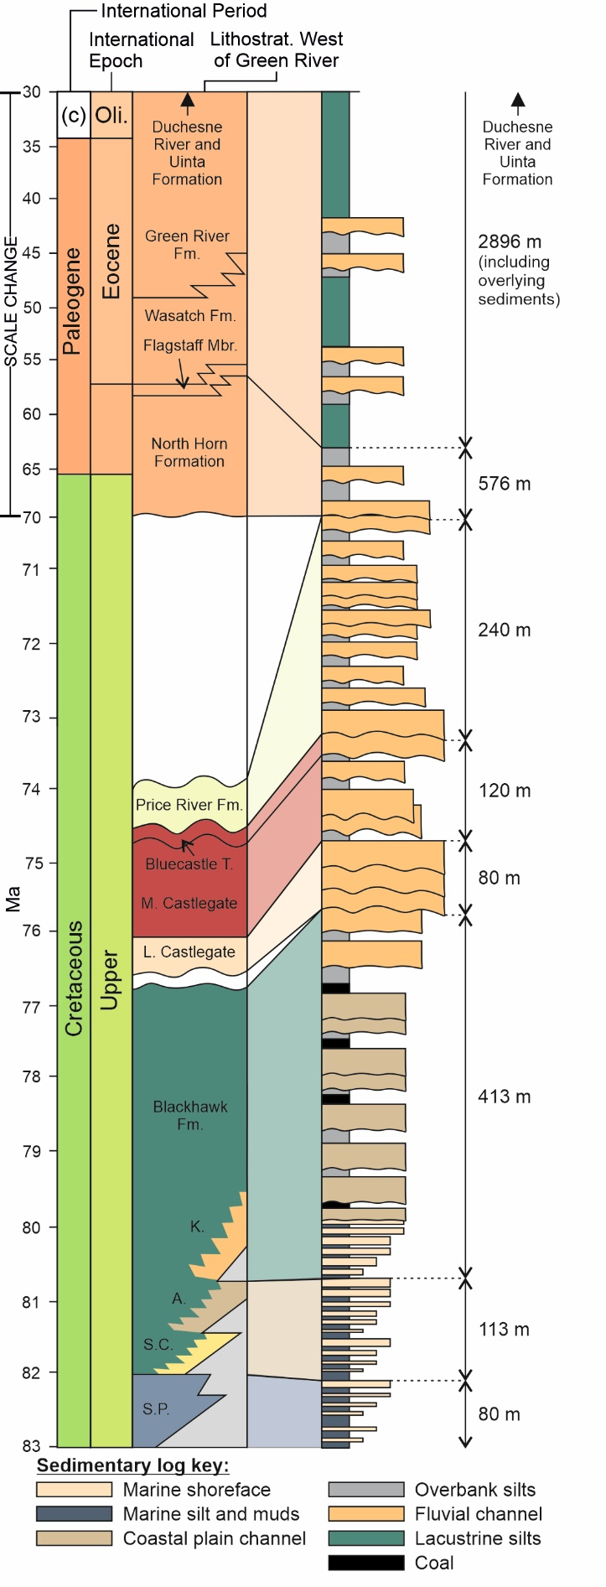
Figure 11. Information used in the creation of the burial history plots. Thicknesses for the Blackhawk and Castlegate are shown in Figure 12. Thicknesses of the overburden and environment of deposition have been taken from Pitman et al. (1987), Olsen et al. (1995), Miall and Arush (2001), Aschoff and Steel (2011a,b) and Seymour and Fielding (2013).
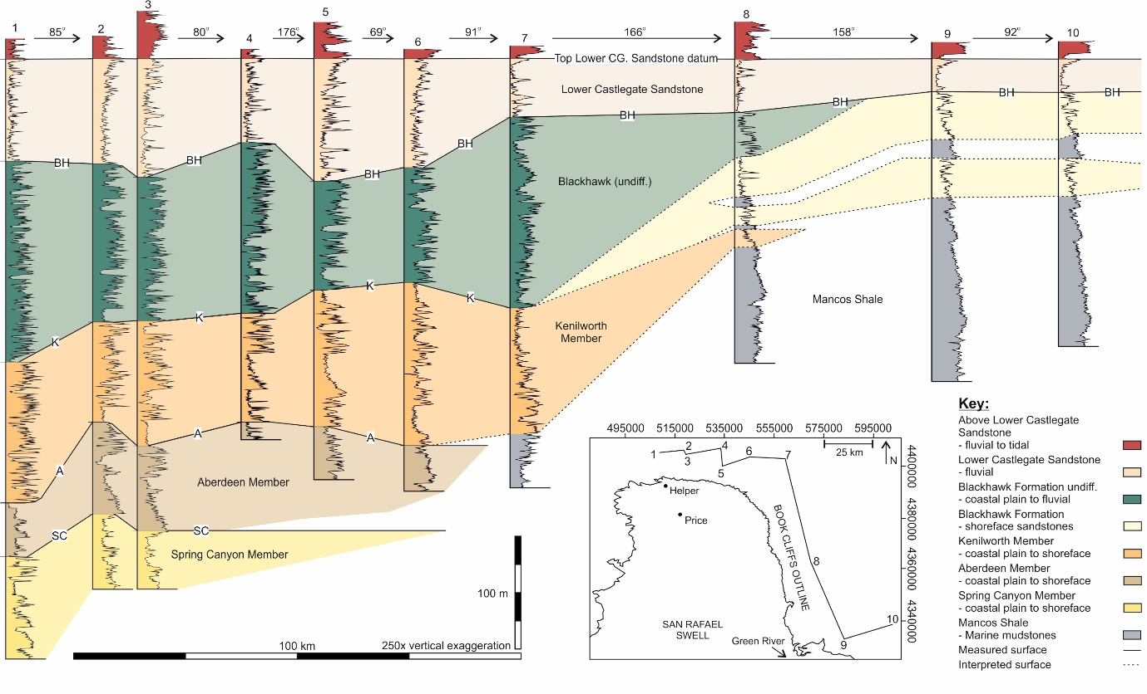
Figure 12. Gamma ray correlations of the Mesaverde Group strata up to the top of the Lower Castlegate (here used as a correlation datum) from the Book Cliffs (based upon Hampson et al. 2005). Inset map shows the outline of the Book Cliffs and the profile of the log transect represented in the correlation. Dotted lines and colours represent fewer probable correlations, rather than measured data. Correlation plot shows the thinning of the Lower Castlegate moving distally in the basin (eastwards from Green River). Numbers of well locations are: 1 = Matt’s Summit State A1, 2 = Shimmin Trust 10-11, 3 = Shimmin Trust 2, 4 = Slemaker A1, 5 = Iriart Fee 1, 6 = Keel Ranch 1-16, 7 = Stone Cabin 1, 8 = Wilcox 1-24, 9 = Butler Canyon Unit USA 33-12 and 10 = Rattlesnake Canyon 2-12 respectively. Note, abbreviations of formation tops are as follows: SC = Spring Canyon, A = Aberdeen Member, K = Kenilworth Member, and BH = Blackhawk Formation undivided.
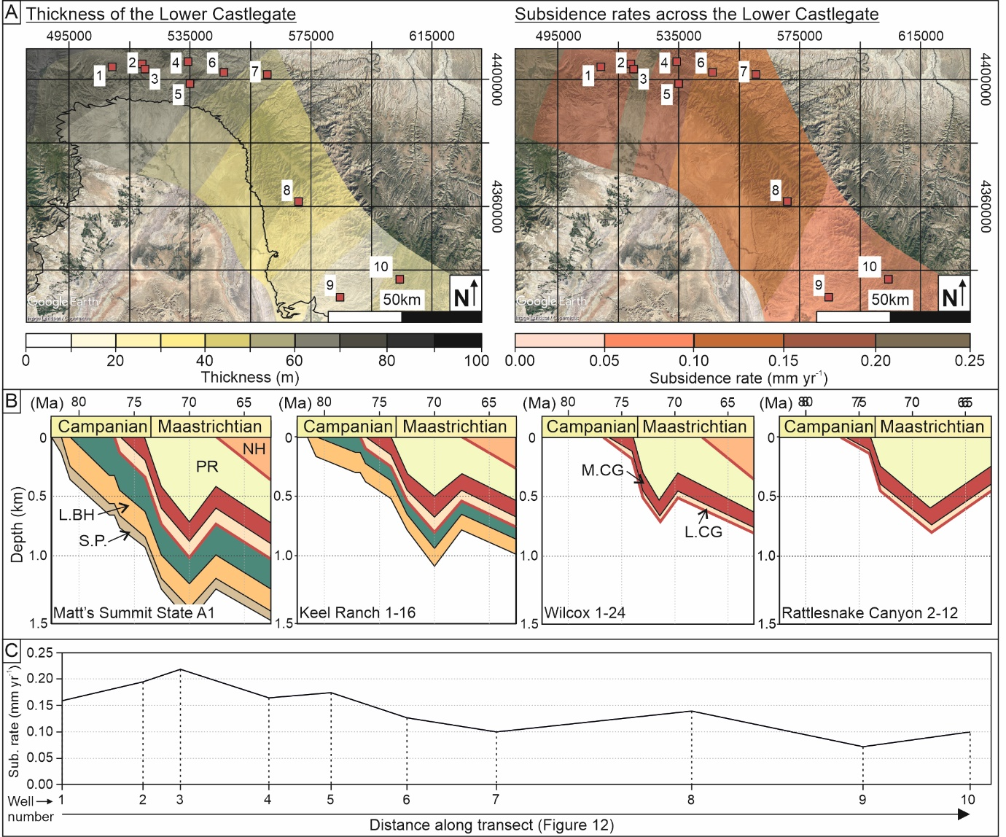
Figure 13. Burial history analysis of the Lower Castlegate Sandstone, Utah. (A) Thickness map from the down-hole logs from Figure 11. Subsidence rate map based upon burial history from down-hole formation thicknesses. (B) One dimensional burial history curves for four of the wells. (C) Subsidence rate for each down-hole log based upon their respective burial history analysis, plotted relative to the well positions across the basin (Figure 12). Numbers of well locations are: 1 = Matt’s Summit State A1, 2 = Shimmin Trust 10-11, 3 = Shimmin Trust 2, 4 = Slemaker A1, 5 = Iriart Fee 1, 6 = Keel Ranch 1-16, 7 = Stone Cabin 1, 8 = Wilcox 1-24, 9 = Butler Canyon Unit USA 33-12 and 10 = Rattlesnake Canyon 2-12.
Subsidence curves for each of the ten borehole successions (Figure 13B) display a convex upwards profile, indicating exponentially increasing subsidence rates due to the basinward convergence of a thrust belt or orogenic load (cf., DeCelles and Giles, 1996; Littke et al., 2000; Burgess and Gayer, 2000). There are significant (<150%) lateral variations in the subsidence rates during deposition of the Lower Castlegate Sandstone, perpendicular to the thrust-belt (Pang and Nummedal, 1995). In the more proximal region of the foreland (e.g., the Matt’s Summit State A1 and Shimmin Trust boreholes; Figure 13) average subsidence rates are approximately 0.2 mm yr⁻¹ (Figure 13C). This decreases towards the more distal region of the foreland (e.g., the Butler Canyon Unit USA 33-12 and Rattlesnake Canyon 2-12 boreholes; Figure 13), where average subsidence rates are 0.08 mm yr⁻¹, which reflects the proximity of the succession to the orogenic load (Pang and Nummedel, 1995) (Figures 1B and 12).

The influence of subsidence rates on fluvial architecture preservation
The small, low-sinuosity channel-fill elements of the proximal Lower Castlegate (Miall and Arush, 2001; McLaurin and Steel, 2007) contain small accretionary elements that preserve a large number of clinoform topsets (Hajek and Heller, 2012) (Figure 8). The succession also exhibits overbank preservation. This overbank and clinoform topset preservation is perhaps indicative of high subsidence rates. The preservation of fluvial systems is dominated, principally, by the aggradation rate, which is controlled in upstream areas by subsidence rates and a buffer zone of the graded fluvial profile (Holbrook et al., 2006). The buffer zone is controlled by the sediment supply and stream power. If sediment supply exceeds stream power then an aggradational profile is established. Such a profile may be visible within the proximal type locality of the Lower Castlegate strata. The combination of buffer zone aggradation and high local subsidence rates in the type locality area may explain the dramatically thicker succession (Holbrook et al., 2006). This is supported in this study by burial history analysis that indicates that subsidence rates were approximately 0.19 mm yr⁻¹ at the time the Lower Castlegate MSB was deposited. The minor presence of upstream accretion elements suggests some primitive compound architecture (Skelly et al., 2003; Ashworth et al., 2011; Lunt et al., 2013) and the presence of reactivation surfaces in accretionary elements, along with evidence presented in the reconstruction of maximum flow depths (Figure 10A), indicate variable discharge (Lunt et al., 2013; Almeida et al., 2016) within the channel flow.
The same pattern of upstream accretion and reactivation is present within the Sunnyside succession (Figures 6B, 9), however, greater channel sinuosity is noted (Figure 6a, Table 2). Intermediate-sinuosity channel-fill elements (Figure 6A) again dominate the succession and accretionary elements comprise the remaining proportion of the outcrop (Figure 6B). Poor overbank preservation within the succession can be attributed to reduced subsidence rates (approximately 0.11 mm yr⁻¹). The channel dominance and increased sinuosity is interpreted to be a product of the fluvial system’s downstream evolution (Holbrook et al., 2006; Li et al., 2015), as it reaches a more stable medial portion of its reach. An increased discharge variability (Figure 10D) may also play a factor in the dominance for channel forms, with accretionary barform element formation being supressed.
Finally, the distal Tuscher Canyon section shows a markedly different architectural assemblage than the two more proximal locations (Figure 6B). Lateral accretion and downstream accretion elements occur without upstream accretion elements being preserved, and suggest a more mature compound architecture formation. The channels, although much larger and more sinuous (Figures 6A, 7, 8), form the subordinate proportion of the outcrop. Maximum flow depth reconstructions show less variability (Figure 10C, D) and infer that flow depths were more consistent in the area. No overbank elements are preserved in the area. This is most probably due to a minimal subsidence rate of 0.08 mm yr⁻¹ that the burial history analysis indicates. However, despite the presence of high-sinuosity channel deposits with large width to thickness ratio, and indicators of a relatively stable flow, little lateral accretion is preserved.
These interpretations highlight the preferential preservation of compound downstream accretion elements instead of lateral accretion elements within a fluvial MSB preserved in the distal portion of a retro-foreland basin. The increased sinuosity within a fluvial system downstream will generate and deposit lateral accretion elements (not necessarily at the large point bar scale), but the preservation of such elements is dependent upon aggradation rates, that are here dominantly controlled by subsidence rate. Preserved lateral accretion elements occupy the margins of channels and downstream accreting elements (Miall, 1993; Best et al., 2003). The location of such elements makes them susceptible to erosion, when local avulsion, during periods of low subsidence, encourages the reoccupation of old channel courses (Mohrig et al., 2000). Subsequent flows will most likely occupy previous channel reaches and erode their internal architecture (Chamberlin and Hajek, 2015). This will erode the lateral accretion elements, given their location, preferentially preserving the downstream accretion elements.

Discussion
The understanding of architectural preservation down depositional dip is fundamental to the interpretation of reservoir quality and heterogeneity in the subsurface. The results of potential overbank preservation and palaeodischarge reconstruction, presented herein, agree with previously published works (Miall, 1985, 1993, 1994; Wright and Marriott, 1993; Leeder, 1993; Shanley and McCabe, 1994; Bridge and Tye, 2000; Weismann et al., 2010; Owen et al., 2015; Li et al., 2015). When subsidence rates are higher, overbank preservation is more likely (Catuneanu, 2006; McLaurin and Steel, 2007; Hajek and Heller, 2012). In the more downstream reaches of a fluvial system, sinuosity and barform preservation increases (Wright and Marriott, 1993; Shanley and McCabe, 1994; Holbrook et al., 2006; Nichols and Fisher, 2007), showing the downstream evolution of a fluvial system.
The analysis of the preservation of the architecture within the proximal Castle Gate and medial Sunnyside localities presented here yields similar results to previously published studies on other fluvial strata. For example, Li et al. (2015) studied the fluvial architecture of the Middle Jurassic Rockcave Member of the Yungang Formation, China. The results of their study indicate channel thickness decreasing from proximal to more distal areas (Li et al., 2015 their Table 3) in direct comparison with this study presented here. Further to this Li et al. (2015) evidence a 49-65% increase in channel architecture and a 10% decrease in barform preservation. These results also compare to the data presented herein between the proximal Castle Gate and medial Sunnyside localities. It is proposed that these proximal systems operate as a result of downstream evolution of a mountain run off (DFS-like) system (Weismann et al., 2010; Owen et al., 2015) in an active foreland setting (Li et al., 2015), further highlighting that these are not location unique trends in fluvial architecture across a basin. However, the Tuscher Canyon section remains anomalous.
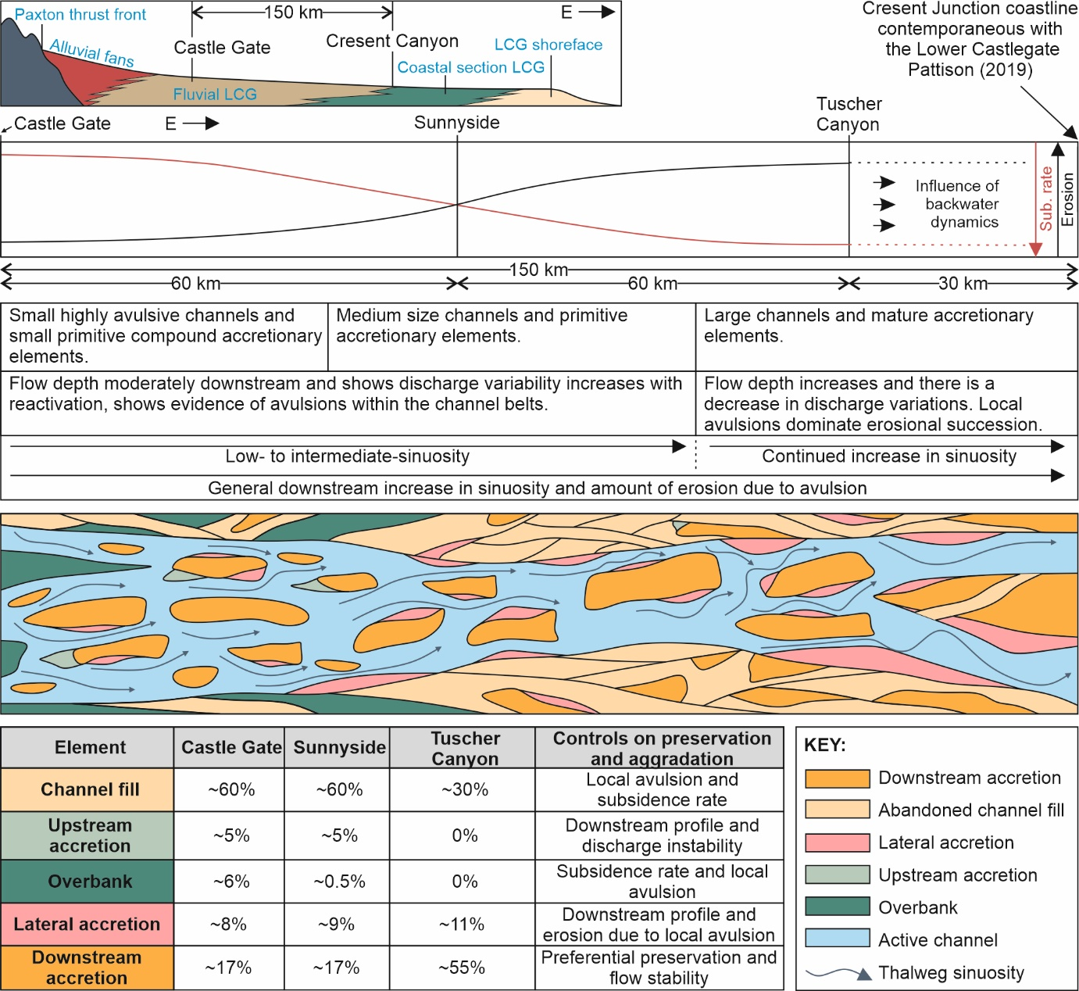
Figure 14. Summary figure of the Lower Castlegate Sandstone MSB. Image is comprised of a cross-sectional view of the Western Interior Seaway during the Lower Castlegate deposition and higher resolution view of the profile within the fluvial profile. Descriptive interpretations of the fluvial strata and architectural elements making the idealised profile are highlighted, relative to their position downstream. This assumes constant avulsion frequency. A top-down view is also given showing the relative size and complexity of the channel and barform architecture within the Castlegate MSB. Finally, a brief summary of the critical changes observed downstream are highlighted and their controls stated.
The sedimentary architecture preserved in the distal Tuscher Canyon location (Figure 14) challenges conventional fluvial profile evolution. The increased sinuosity and lack of variation in discharge may be typical of downstream trends within a fluvial graded profile (Schumm et al., 2002; Holbrook et al., 2006; Li et al., 2015). However, the high proportion of barforms present and the lack of an observable decrease in sediment calibre, show anomalous results that do not conform to the standard DFS model, and those like it (Nichols and Fisher, 2007; Hartley et al., 2010; Weissmann et al., 2010; Owen et al., 2015). Such contrasting fluvial architecture is most simply explained by stream capture (Mikesell et al., 2010), and this may imply that there is more than one fluvial system operating within the study area. Such an argument is further evidenced by the discharge variation (as reported previously by Miall, 1993) indicated by the sedimentology of the proximal (Castle Gate; Figure 10A) and medial (Sunnyside; Figure 10B) portions of the Lower Castlegate, compared to indications of a more consistent flow in the distal Tuscher Canyon section (Figure 10C, D). Flow stability may also explain the more mature compound architecture of accretionary elements, and the absence of upstream accretion elements, in Tuscher Canyon (Wang and Plink-Björklund, 2019b) (Figures 6, 13). Where more proximal and medial deposits have shown small channels with immature compound element development and variable discharge rates (a coefficient of variance for the maximum reconstructed flow depths of approximately 0.35; Figure 10D), the distal region shows larger-scale more stable characteristics (coefficient of variance for the maximum reconstructed flow depths of 0.27; Figure 10D). It is therefore proposed that a smaller more immature fluvial system, such as a proximal mountain run off DFS, was active in the Castlegate and Sunnyside areas, feeding a larger more sustained fluvial system forming the deposits of Tuscher Canyon. The confluence of the two fluvial systems created a significant hydrodynamic change downstream, when compared to more proximal areas.
This interpretation has been suggested previously (Pettit et al., 2019), where detrital-zircon data have suggested a river confluence upstream of Tuscher Canyon, around Horse Canyon (Figure 2), and the presence of an axial fluvial system draining a secondary sediment source area to the south-west, typically referred to as the Mogollon Highland Source Area (Pettit et al., 2019). It is therefore proposed that the proximal (the Castle Gate) and medial (Sunnyside) regions of the study area operated within a typical small DFS-type system (Nichols and Fisher, 2007), whereas the distal Tuscher Canyon section represents a stable and more mature fluvial system. Further evidencing intrabasinal stream capture between Sunnyside and Tuscher Canyon.
This study, whilst providing interpretations for the impact of subsidence on in-channel fluvial architecture, recognises that this is not the only controlling factor. Avulsion scale (regional or local) and avulsion frequency are major controls on fluvial architecture (Mackey and Bridge, 1995; Heller and Paola, 1996; Colombera et al., 2015). Here, variations in avulsion frequency have not been considered specifically, and are therefore assumed to be relatively constant along the down-dip profile, despite the fact that, in this tectonic setting, avulsion is likely to be more frequent in the proximal region of the basin (Heller and Paola, 1996). Indeed, the presence of upstream accretion elements (Figure 6B), the small size of accretionary elements (Figure 7) and preservation of overbank (Figure 6B) within the proximal region of the study area indicate a lack of barform maturity that may indicate a higher avulsion frequency compared to downstream. Equally, sedimentation rate can significantly affect fluvial architecture and may contribute to the sedimentology observed in this study. However, whilst sedimentation rates have been reported to decrease toward the distal portion of retro-foreland (Heller and Paola 1996), no such evidence is found within the Lower Castlegate. Aggradation rates of fluvial deposits can be linked to both subsidence rate and sedimentation rate. The proximal Castle Gate and medial Sunnyside locations show vastly different aggradation rates which are attributed, predominantly, here to differences in subsidence rate.

Implicationsfor sequence stratigraphy
This study shows, through the analysis of in-channel fluvial architecture and palaeoflow dynamics, that the Lower Castlegate Formation has a progressive downstream change from a low-sinuosity system to a more intermediate- to moderately high-sinuosity fluvial system towards the coastal plain and the backwater reach (Figure 14). This supports recent interpretations of a non-sequence boundary between the Lower Castlegate MSB and the underlying coastal plain Desert Member of the Blackhawk Formation (Howell et al., 2018; Pattison, 2018, 2019a,b; Trower et al., 2018). The visually, but not genetically, different strata were interpreted to be unconformable (Olsen et al., 1995; Yoshida et al., 1996; McLaurin and Steel, 2000; Miall and Arush, 2001), when in reality they display a simple progradational regime (Howell et al., 2018; Pattison, 2018; 2019a,b).
Pattison (2019b) used the Tuscher Canyon outcrop to show how miscorrelation of shoreface elements and distributive channels in the Blackhawk and Castlegate, to those in Thompson Canyon (farther east), had major implications for the genetic temporal and spatial linkage of coastal plain and fluvial strata. The Desert Member of the Blackhawk Formation is well recognised as a moderate to high-sinuosity fluvial system deposited within a coastal plain environment (Olsen et al., 1995; Adams and Bhattachyra, 2005). However, the Castlegate was previously interpreted to be a more braided proximal fluvial system (Olsen et al., 1995; Yoshida et al., 1996; McLaurin and Steel, 2000), when in fact, as demonstrated here, there is sinuosity within the Lower Castlegate fluvial system at Tuscher Canyon. This study demonstrates that no major facies dislocation occurs across the Blackhawk-Castlegate boundary. Although its simple visual recognition is difficult to see from basic palaeocurrent and facies analysis alone.
Further evidence of sequence stratigraphic significance can be found in the increasing reconstructed flow depths up-section in the proximal region of the study area, this same observation was noted by McLaurin and Steel (2007). This is most probably due to headwater expansion and erosion of the uplifted hinterland as a consequence of active Sevier-aged thrusting and the subsequent incision of the fluvial system as it re-equilibrated to a graded fluvial profile (Holbrook et al., 2006). The product of such uplift and erosion is increased discharge and sedimentation rates (Yoshida, 2000; Holbrook et al., 2006; Fielding and Paola; 2013). However, given the aggradational profile and buffer zone effects interpreted from evidence in the proximal Castle Gate, it is suggested that discharge rates do not exceed sedimentation rate in that locality. The base of the Lower Castlegate is relatively flat, which may indicate that the boundary has been produced by increased discharge (Fielding and Paola 2013), or that increased discharge has played a role in its formation.

Conclusions
The Lower Castlegate MSB shows a complex sedimentary architecture that formed as a product of variable discharge rates, the fluvial graded profile and spatially variable aggradation rates produced by subsidence rate variation across the basin. Furthermore, stream capture has played a role in the analomous architecture shown in the more distal region of the Lower Castlegate, providing hydrodynamic changes and flow stabilisation.
Using multiple approaches to analyse the controls on deposition and preservation of architectural elements within MSBs deposited in foreland basins. This study demonstrates that downstream profiles, discharge variations, avulsion scales and subsidence rates play a key role in the preservation of fluvial architectural elements. Discharge variability and position along the fluvial profile provide control over the upstream accretion of barforms, whereas subsidence rates control the preservation of lateral accretion and overbank elements. The understanding of controls to fluvial meso-scale architecture is fundamental in the estimation of connectivity, heterogeneity and reservoir quality in MSBs.
In this study, the use of meso-scale architectural analysis, with analysis of in-channel sinuosity and hydrodynamics, along with erosional bounding surfaces, has helped to complement basin-scale interpretations of fluvial sedimentary architecture. The use of such analysis is clearly important at multiple scales of interpretation, and its addition into fluvial work flows should be encouraged. Fluvial deposits always have an erosive element to them, however, in regions of minimal subsidence certain elements may be underrepresented leading to mis-interpretation.

Acknowledgements
Thanks go to David Cousins, Charlotte Priddy and Ross Pettigrew for their field assistance. Other members of the BDRG are thanked for their discussion. Jon Howell, Mike Boyle and Phil Richards are thanked for their insights into the Castlegate Sandstone. The people at the Price City Water Treatment Department and US Forest Service Manti-La Sal Supervisor's Office are thanked for granting access to field sites and for their great help during fieldwork. Thank you to Amanda Owen for her contribution to larger scale stratigraphic comparisons. One anonymous reviewer and José Allard are thanked for reviewing the paper and making substantial improvements to it. Editor Jasper Knight is also thanked for his comments.

References
Adams, M.M., Bhattacharya, J.P., 2005. No change in fluvial style across a sequence boundary, Cretaceous Blackhawk and Castlegate Formations of central Utah, USA. J. Sediment. Res. 75, 1038-1051.
Allen, J.R.L., 1967. Notes on some fundamentals of palaeocurrent analysis, with reference to preservation potential and sources of variance. Sedimentology 9, 75-88.
Almeida, R.P., Freitas, B.T., Turra, B.B., Figueiredo, F.T., Marconato, A., Janikian, L., 2016. Reconstructing fluvial bar surfaces from compound cross‐strata and the interpretation of bar accretion direction in large river deposits. Sedimentology 63, 609-628.
Aschoff, J., Steel, R., 2011a. Anomalous clastic wedge development during the Sevier-Laramide transition, North American Cordilleran foreland basin, USA. AAPG Bull. 123, 1822-1835.
Aschoff, J.L.m Steel, R.J., 2011b. Anatomy and development of a low-accommodation clastic wedge, upper Cretaceous, Cordilleran Foreland Basin, USA. Sed. Geol. 236, 1-24.
Ashworth, P.J., Best, J.L., Roden, J.E., Bristow, C.S., Klaassen, G.J., 2000. Morphological evolution and dynamics of a large, sand braid‐bar, Jamuna River, Bangladesh. Sedimentology 47, 533-555.
Ashworth, P.J., Sambrook Smith, G.H., Best, J.L., Bridge, J.S., Lane, S.N., Lunt, I.A., Reesink, A.J., Simpson, C.J., Thomas, R.E., 2011. Evolution and sedimentology of a channel fill in the sandy braided South Saskatchewan River and its comparison to the deposits of an adjacent compound bar. Sedimentology 58, 1860-1883.
Batezelli, A., Ladeira, F.S.B., Nascimento, D.L.D., Da Silva, M.L., 2019. Facies and palaeosol analysis in a progradational distributive fluvial system from the Campanian–Maastrichtian Bauru Group, Brazil. Sedimentology 66, 699-735.
Bemis, S.P., Micklethwaite, S., Turner, D., James, M.R., Akciz, S., Thiele, S.T., Bangash, H.A., 2014. Ground-based and UAV-based photogrammetry: A multi-scale, high-resolution mapping tool for structural geology and paleoseismology. J. Struct. Geol. 69, 163-178.
Best, J.L., Ashworth, P.J., Bristow, C.S., Roden, J., 2003. Three-dimensional sedimentary architecture of a large, mid-channel sand braid bar, Jamuna River, Bangladesh. J. Sediment. Res. 73, 516-530.
Bilmes, A., D’Elia, L., Lopez, L., Richiano, S., Varela, A., Alverez, M. P., Bucher, J., Eymand, I., Muravichik, M., Franzese, J., Ariztegui, D. 2019. Digital outcrop modelling using “structure-from- motion” photogrammetry: Acquisition strategies, validation and interpretations to different sedimentary environments. J. S. Am. Earth Sci. 96, 102325
Bowman, M.B.J., McClure, N.M., Wilkinson, D.W., 1993. Wytch Farm oilfield: deterministic reservoir description of the Triassic Sherwood Sandstone. In: Parker, J.R. (Ed.) Petroleum geology of Northwest Europe Proceedings of the 4th conference. Geological Society of London, Petroleum Geology Conference series, 4, pp. 1513-1517.
Bridge, J., 1993.The interaction between channel geometry, water flow, sediment transport and deposition in braided rivers. In: Best, J.L., Bristow, C.S. (Eds.), Braided Rivers. Geological Society Of London, Spec. Pub. 75, pp. 13-71.
Bridge, J.S., Tye, R.S., 2000. Interpreting the dimensions of ancient fluvial channel bars, channels, and channel belts from wireline-logs and cores. AAPG Bull., 84, 1205-1228.
Bridge, J.S., Leeder, M.R., 1979. A simulation model of alluvial stratigraphy. Sedimentology, 26, 617–644.
Bridge, J.S., Jalfin, G.A., Georgieff, S.M., 2000. Geometry, lithofacies, and spatial distribution of Cretaceous fluvial sandstone bodies, San Jorge Basin, Argentina: outcrop analog for the hydrocarbon-bearing Chubut Group. J. Sediment. Res., 70, 341-359.
Bridge, J.S., MacKey, S.D., 1992. A theoretical study of fluvial sandstone body dimensions, In: Flint, S.S., Bryant, I.D., (Eds.), The Geological Modelling of Hydrocarbon Reservoirs and Outcrop Analogues. IAS, Special Publications, 15, pp. 213–236.
Bristow, C.S., 1993. Sedimentary structures exposed in bar tops in the Brahmaputra River, Bangladesh. In: Best, J.L., Bristow, C.S. (Eds.), Braided Rivers. Geological Society of London, Special Publication, 75, pp. 277-289.
Buckley, S., Howell, J.A., Enge, H.D., Leren, B.L.S., Kurz, T.H., 2006. Integration of terrestrial laser scanning, digital photogrammetry and geostatistical methods for high-resolution modelling of geological outcrops, ISPRS Commission V Symposium, September 25–27. International Archives of the Photogrammetry, Remote Sensing and Spatial Information Sciences, Dresden, Germany.
Burgess, P.M., Gayer, R.A., 2000. Late Carboniferous tectonic subsidence in South Wales: implications for Variscan basin evolution and tectonic history in SW Britain. J. Geol. Soc. Of London, 157, 93-104.
Burnham, B.S., Hodgetts, D., 2018. Quantifying spatial and architectural relationships from fluvial outcrops. Geosphere, 15, pp. 236-253.
Burns, C.E., Mountney, N.P., Hodgson, D.M., Colombera, L., 2017. Anatomy and dimensions of fluvial crevasse-splay deposits: Examples from the Cretaceous Castlegate Sandstone and Neslen Formation, Utah, USA. Sediment. Geol., 351, 21-35.
Cant, D.J., Walker, R.G., 1978. Fluvial processes and facies sequences in the sandy braided South Saskatchewan River, Canada. Sedimentology, 25, 625-648.
Catuneanu, O., Elango, H.N., 2001. Tectonic control on fluvial styles: the Balfour Formation of the Karoo Basin, South Africa. Sed. Geol., 140, 291-313.
Catuneanu, O., 2006. Sequence Models. In: Principles of sequence stratigraphy, Elsevier, pp. 253.
Chamberlin, E.P., Hajek, E.A., 2015. Interpreting paleo-avulsion dynamics from multistory sand bodies. J. Sediment. Res., 85, pp. 82-94.
Chamberlin, E.P., Hajek, E.A., 2019. Using bar preservation to constrain reworking in channel-dominated fluvial stratigraphy. Geology, 47, 531-534.
Chan, M.A., Pfaff, B.J., 1991. Fluvial sedimentology of the Upper Cretaceous Castlegate Sandstone, Book Cliffs, Utah. In: Chidsey Jnr., T.C. (Ed.), Geology of East-Central Utah. Utah Geol. Assoc. Special Publication. 19, pp. 95-110.
Colombera, L., Mountney, N.P., McCaffrey, W.D., 2015. A meta-study of relationships between fluvial channel-body stacking pattern and aggradation rate: implications for sequence stratigraphy. Geology, 43, 283-286.
Curray, J.R., 1956. The analysis of two-dimensional orientation data. J. Geol., 64, pp. 117-131.
DeCelles, P.G., Giles, K.A., 1996. Foreland basin systems. Basin research, 8, 105-123.
DeCelles, P.G., 2004. Late Jurassic to Eocene evolution of the Cordilleran thrust belt and foreland basin system, western USA. Am. J. Sci., 304, 105-168.
Dickinson, W.R., Klute, M.A., Swift, P.N., 1986. The Bisbee basin and its bearing on Late Mesozoic paleogeographic and paleotectonic relations between the Cordilleran and Caribbean regions. In: P.L. Abbott (Ed.), Cretaceous Stratigraphy, Western North America. Pacific Sect., SEPM, pp. 51-62.
Ellen, R., Browne, M.A.E., Mitten, A.J., Clarke, S.M., Leslie, A.G., Callaghan, E., 2019. Sedimentology, architecture and depositional setting of the fluvial Spireslack Sandstone of the Midland Valley, Scotland: insights from the Spireslack surface coal mine. In: Corbett, P.W.M., Owen, A., Hartley, A.J., Pla-Pueyo, S., Barreto, D., Hackney, C., Kape, S.J. (Eds.), Rain, Rivers and Reservoirs. Geological Society of London Special. Publication, 488.
Enge, H.D., Buckley, S.J., Rotevatn, A. and Howell, J.A., 2007. From outcrop to reservoir simulation model: Workflow and procedures. Geosphere, 3, 469-490.
Fielding C.R., Paola C., 2013. Sequence boundaries generated by climate change. Proceedings of the 10th International Conference on Fluvial Sedimentology, Leeds, UK, 14-19th, 305-306.
Fielding C.R., Ashworth P.J., Best J.L., Prokocki E.W., Sambrook Smith G.H., 2012. Tributary, distributary and other fluvial patterns: What really represents the norm in the continental rock record? Sed. Geol. 261–262, 15–32.
Fouch, T.D., Lawton, T.F., Nichols, D.J., Cashion, W.B. and Cobban, WA., 1983. Patterns and timing of synorogenic sedimentation in Upper Cretaceous rocks of central and northeast Utah. In: Reynolds, M.W., Dolly, E.D. (Eds.), Mesozoic Paleogeography of the West Central United States, SEPM. Rocky Mountain Section. Second Rocky Mountain Patengeography Symposium, pp. 305-336.
Ghinassi, M., Ielpi, A., 2018. Stratal Architecture and Morphodynamics of Downstream-Migrating Fluvial Point Bars (Jurassic Scalby Formation, U.K.). J. Sediment. Res., 85, 1123–1137.
Ghosh P., 2000. Estimation of channel sinuosity from paleocurrent data: a method using fractal geometry. J. Sediment. Res., 70, 449–455.
Gibling M.R., 2006. Width and thickness of fluvial channel bodies and valley fills in the geological record: a literature compilation and classification. J. Sediment. Res., 76, 731–770.
Grove, C., Jerram, D.A., 2011. jPOR: An ImageJ macro to quantify total optical porosity from blue-stained thin sections. Comput. Geosci., 37, 1850-1859.
Guin, A.R., Ramanathan, R.W., Ritzi, D.F., Dominic, I.A., Lunt, I.A., Scheibe, T.D., Freedmand, V.L., (2010). Simulating the heterogeneity in bradied channel belt deposits: 2. Examples of results and comparison to natural deposits, Water Resour. Res., 46, W04516.
Guiseppe, A.C., Heller, P.L., 1998. Long-term river response to regional doming in the Price River Formation, central Utah. Geology, 26, 239-242.
Hajek, E.A., Heller, P.L., 2012. Flow-depth scaling in alluvial architecture and nonmarine sequence stratigraphy: example from the Castlegate Sandstone, central Utah, USA. J. Sediment. Res., 82, 121-130.
Hampson, G.J., Davies, W., Davies, S.J, Howell, J.A., Adamson, K.J. 2005. Use of spectral gamma-ray data to refine subsurface fluvial stratigraphy: late Cretaceous strata in the Book Cliffs, Utah, USA. J. Geol. Soc. of London, 162, 603–621.
Hartley, A.J., Weissmann, G.S., Nichols, G.J., Warwick, G.L., 2010. Large distributive fluvial systems: characteristics, distribution, and controls on development. J. Sediment. Res., 80, 167-183.
Heller P.L., Paola C., 1996. Downstream changes in alluvial architecture: an exploration of controls on channel-stacking patterns. J. Sediment. Res., 66, 297-306.
Herbert, C., Alexander, J., Fielding, C.R., Amos, K.J., 2020. Unit bar architecture in a highly‐variable fluvial discharge regime: Examples from the Burdekin River, Australia: Unit bar architecture. Sedimentology, 67, 576-605.
Hodgetts, D., Seers, T., Head, W., Burnham, B.S., 2015. High performance visualisation of multiscale geological outcrop data in single software environment. In: 77th EAGE Conference and Exhibition, Proceedings for the 2015 EAGE meeting in Madrid, Spain.
Holbrook, J., Scott, R.W., Oboh-Ikuenobe, F.E., 2006. Base-level buffers and buttresses: a model for upstream versus downstream control on fluvial geometry and architecture within sequences. J. Sediment. Res., 76, 162-174.
Hornung, J., Aigner, T., 1999. Reservoir and aquifer characterization of fluvial architectural elements: Stubensandstein, Upper Triassic, southwest Germany. Sediment. Geol., 129, 215-280.
Howell, J., Eide, C., Hartley, A. 2018. No evidence for sea level fall in the Cretaceous strata of the Book Cliffs of Eastern Utah. EarthArXiv.
Ielpi, A., Ghinassi, M., 2014. Planform architecture, stratigraphic signature and morphodynamics of an exhumed Jurassic meander plain (Scalby Formation, Yorkshire, UK). Sedimentology, 61, 1923-1960.
Jordan, D.W., Pryor, W.A., 1992. Hierarchical levels of heterogeneity in a Mississippi River meander belt and application to reservoir systems: Geologic note. AAPG Bull., 76, 1601-1624.
Kauffman, E.G., Caldwell, W.G.E., 1993. The Western Interior Basin in space and time. In: Caldwell, W.G.E., Kauffman, E.G. (Eds.). Evolution of the Western Interior Basin, Geological Association of Canada, Special Paper, 39, pp. 1-30.
Koneshloo, M., Aryana, S.A., Hu, X., 2018. The impact of geological uncertainty on primary production from a fluvial reservoir. Petrol. Sci., 15(2), 270-288.
Labourdette, R., 2011. Stratigraphy and static connectivity of braided fluvial deposits of the lower Escanilla Formation, south central Pyrenees, Spain. AAPG Bull., 95, 585-617.
Laure, D.K., Hodavik, J., 2006. Connectivity of channelized reservoirs: A modelling approach, Petrol. Geo., 12, 291-308.
Lawton, T.F., 1986. Fluvial systems of the Upper Cretaceous Mesaverde Group and Paleocene North Horn Formation, central Utah: a record of transition from thin skinned to thick-skinned in the foreland region. In Peterson, J.A. (Ed.), Paleotectonics and Sedimentation in the Rocky Mountain Region, United States: American Association of Petroleum Geologists, Memoir 41, pp. 423–442.
Le Roux J.P., 1992. Determining the channel sinuosity of ancient fluvial systems from paleocurrent data. J. Sediment. Petrol. 62, 283-291.
Le Roux. J.P., 1994. The angular deviation of paleocurrent directions as applied to the calculation of chanel sinousities. J. Sediment. Res., 64, 86-87.
Leckie, D.A., Boyd, R., 2003. Towards a nonmarine sequence stratigraphic model. In: American Association of Petroleum Geologists Annual Convention, Salt Lake City, 11, 14.
Leeder, M.R., 1993. Tectonic controls upon drainage basin development, river channel migration and alluvial architecture: implications for hydrocarbon reservoir development and characterization. Geological Society of London Special Publications, 73, pp. 7-22.
Li, S., Yu, X., Chen, B., Li, S., 2015. Quantitative Characterization of Architecture Elements and Their Response To Base-Level Change In A Sandy Braided Fluvial System At A Mountain Front. J. Sediment. Res., 85, 1258-1274.
Littke, R., Büker, C., Hertle, M., Karg, H., Stroetmann-Heinen, V., Oncken, O., 2000. Heat flow evolution, subsidence and erosion in the Rheno-Hercynian orogenic wedge of central Europe. In: Franke, W., Haak, V., Oncken, O., Tanner, D., (Eds.), Orogenic Processes: Quantification and Modelling in the Variscan Belt. Geological Society of London Special Publications, 179, pp. 231-255.
López-Gómez, J., Arche, A., Vargas, H., Marzo, M., 2010. Fluvial architecture as a response to two-layer lithospheric subsidence during the Permian and Triassic in the Iberian Basin, eastern Spain. Sediment. Geol., 223, 320-333.
Lunt, I.A., Sambrook Smith, G.H., Best, J.L., Ashworth, P.J., Lane, S.N., Simpson, C.J., 2013. Deposits of the sandy braided South Saskatchewan River: Implications for the use of modern analogs in reconstructing channel dimensions in reservoir characterization. AAPG Bull., 97, 553-576.
Lynds R., Hajek E., 2006. Conceptual model for predicting mudstone dimensions in sandy braided-river reservoirs. AAPG Bull., 90, 1273-1288
Mackey, S.D., Bridge, J.S., 1995. Three-dimensional model of alluvial stratigraphy; theory and applications. J. Sediment. Res., 65, 7-31.
McLaurin, B.T., Steel, R.J., 2000. Fourth-order nonmarine to marine sequences, middle Castlegate Formation, Book Cliffs, Utah. Geology, 28, 359-362.
McLaurin, B.T., Steel, R.J., 2007. Architecture and origin of an amalgamated fluvial sheet sand, lower Castlegate Formation, Book Cliffs, Utah. Sediment. Geol., 197, 291-311.
Miall, A.D., Arush, M., 2001. The Castlegate Sandstone of the Book Cliffs, Utah: sequence stratigraphy, paleogeography, and tectonic controls. J. Sediment. Res., 71, 537-548.
Miall, A.D., Jones, B.G., 2003. Fluvial architecture of the Hawkesbury sandstone (Triassic), near Sydney, Australia. J. Sediment. Res., 73, 531-545.
Miall, A.D., 1973. Markov chain analysis applied to an ancient alluvial plain succession. Sedimentology, 20, 347-364.
Miall, A.D., 1985. Architectural-element analysis: a new method of facies analysis applied to fluvial deposits. Earth-Sci. Rev., 22, 261-308.
Miall, A.D., 1993. The architecture of fluvial-deltaic sequences in the Upper Mesaverde Group (Upper Cretaceous), Book Cliffs, Utah. In: Best, J.L. and Bristow, C.S. (Eds.). Braided Rivers, Geological Society of London Special Publications, 75, pp. 305-332.
Miall, A.D., 1994. Reconstructing fluvial macroform architecture from two-dimensional outcrops: examples from the Castlegate Sandstone, Book Cliffs, Utah. J. Sediment. Res., B64, 146-158.
Mikesell, L.R., Weissmann, G.S., Karachewski, J.A., 2010. Stream capture and piracy recorded by provenance in fluvial fan strata. Geomorphology, 115, 267-277.
Mitten, A.J., Mullins, J., Pringle, J.K., Howell, J., Clarke, S.M., 2020. Depositional conditioning of training images: improving the reproduction and representation of architectural elements in sand-dominated fluvial reservoir models. Mar. Petrol. Geol. 113, 104156.
Mohrig, D., Heller, P.L., Paola, C., Lyons, W.J., 2000. Interpreting avulsion process from ancient alluvial sequences: Guadalope-Matarranya system (northern Spain) and Wasatch Formation (western Colorado). Geol. Soc. Am. Bull., 112, 1787-1803.
Nanson, G.C., Croke, J.C., 1992. A genetic classification of floodplains. Geomorphology, 4, 459-486.
Nichols, G.J., Fisher, J.A., 2007. Processes, facies and architecture of fluvial distributary system deposits. Sediment. Geol., 195, 75-90.
Obradovich, J.D., 1993. A Cretaceous time scale. In: Caldwell,W.G.E., Kauffman, E.G., (Eds.), Evolution of the Western Interior Basin. Geol. Assoc. Canada Special Paper, 39, pp. 379–396.
Olsen, T., Steel, R., Hogseth, K., Skar, T., Roe, S.L., 1995. Sequential architecture in a fluvial succession: sequence stratigraphy in the Upper Cretaceous Mesaverde Group, Price Canyon, Utah. J. Sediment. Res., 65, 265-280.
Owen, A., Nichols, G.J., Hartley, A.J., Weissmann, G.S., Scuderi, L.A., 2015. Quantification of a distributive fluvial system: the Salt Wash DFS of the Morrison Formation, SW USA. J. Sediment. Res., 85, 544-561.
Pang, M., Nummedal, D., 1995. Flexural subsidence and basement tectonics of the Cretaceous Western Interior basin, United States. Geology, 23, 173-176.
Pattison, S.A., 2018. Rethinking the Incised-Valley Fill Paradigm For Campanian Book Cliffs Strata, Utah–Colorado, USA: Evidence For Discrete Parasequence-Scale, Shoreface-Incised Channel Fills. J. Sediment. Res., 88, 1381-1412.
Pattison, S.A., 2019a. High resolution linkage of channel-coastal plain and shallow marine facies belts, Desert Member to Lower Castlegate Sandstone stratigraphic interval, Book Cliffs, Utah-Colorado, USA. Geol. Soc. Am. Bull., 131, 1643-1672.
Pattison, S.A., 2019b. Re-evaluating the sedimentology and sequence stratigraphy of classic Book Cliffs outcrops at Tuscher and Thompson canyons, eastern Utah, USA: Applications to correlation, modelling, and prediction in similar nearshore terrestrial to shallow marine subsurface settings worldwide. Mar. Petrol. Geol., 102, 202-230.
Perrier, R., Quiblier, J., 1974. Thickness changes in sedimentary layers during compaction history; methods for quantitative evaluation. AAPG Bull., 58, 507-520.
Petit, J.P., Beauchamp, J., 1986. Synsedimentary faulting and palaeocurrent patterns in the Triassic sandstones of the High Atlas (Morocco). Sedimentology, 33, 817-829.
Pettit, B.S., Blum, M., Pecha, M., McLean, N., Bartschi, N.C., Saylor, J.E. 2019. Detrital-Zircon U-Pb Paleodrainage Reconstruction and Geochronology of the Campanian Blackhawk–Castlegate Succession, Wasatch Plateau and Book Cliffs, Utah, U.S.A. J. Sediment. Res., 89, 273–292.
Pitman, J.K., Franczyk, K.J., Anders, D.E., 1987. Marine and nonmarine gas-bearing rocks in Upper Cretaceous Blackhawk and Neslen formations, eastern Uinta Basin, Utah: sedimentology, diagenesis, and source rock potential. AAPG Bull., 71, 76-94.
Pranter, M.J., Ellison, A.I., Cole, R.D., Patterson, P.E., 2007. Analysis and modelling of intermediate-scale reservoir heterogeneity based on a fluvial point-bar outcrop analogy, Williams Fork Formation, Piceance Basin, Colorado. AAPG Bull., 91, 1025-1051.
Priddy, C.L. and Clarke, S.M., 2020. The sedimentology of an ephemeral fluvial–aeolian succession. Sedimentology.
Priddy, C.L., Pringle, J.K., Clarke, S.M., Pettigrew, R.P., 2019. Application of Photogrammetry to Generate Quantitative Geobody Data in Ephemeral Fluvial Systems. In: Granshaw, S.I. (Ed.) VGC2018 Special Issue. Photogramm. Rec., 34, pp. 428-444.
Pringle, J.K., Howell, J.A., Hodgetts, D., Westerman, A.R., Hodgson, D.M., 2006. Virtual outcrop models of petroleum reservoir analogues: a review of the current state-of-the-art. First break, 24, 33-42.
Rasband, W.S., 2009. ImageJ. US National Institutes of Health, Bethesda, Maryland, USA. http://rsb.info.nih.gov/ij/.
Reinfelds I., Nanson G., 1993. Formation of braided river floodplains, Waimakariri River, New Zealand. Sedimentology, 40, 1113-1127.
Robinson, R.A., Slingerland, R.L., 1998. Grain-size trends, basin subsidence and sediment supply in the Campanian Castlegate Sandstone and equivalent conglomerates of central Utah. Basin Research, 10, 109-127.
Ronayne, M.J., Gorelick, S.M., Zheng, C., 2010. Geological modeling of submeter scale heterogeneity and its influence on tracer transport in a fluvial aquifer. Water Resour. Res., 46.
Sahoo, H., Gani, M.R., Hampson, G.J., Gani, N.D. Ranson, A., 2016. Facies-to sandbody-scale heterogeneity in a tight-gas fluvial reservoir analog: Blackhawk Formation, Wasatch Plateau, Utah, USA. Mar. Petrol. Geol., 78, 48-69.
Salter, T., 1993. Fluvial scour and incision: models for their influence on the development of realistic reservoir geometries. In: North, C.P., Posser, D.J. (Eds.). Charaterisation of Fluvial and Aeolian Reservoirs. Geological Society of London Special Publication, 73, 33-51.
Schumm, S.A., Schumm, S.A., Dumont, J.F., Holbrook, J.M., 2002. Active tectonics and alluvial rivers. Cambridge University Press.
Seymour, D.L., Fielding, C.R., 2013. High resolution correlation of the Upper Cretaceous stratigraphy between the Book Cliffs and the western Henry Mountains Syncline, Utah, USA. J. Sediment. Res., 83, 475-494.
Shanley, K.W., McCabe, P.J., 1994. Perspectives on the sequence stratigraphy of continental strata. AAPG Bull., 78, 544-568.
Skelly, R.L., Bristow, C.S., Ethridge, F.G., 2003. Architecture of channel-belt deposits in an aggrading shallow sandbed braided river: the lower Niobrara River, northeast Nebraska. Sediment. Geol., 158, 249-270.
Straub, K.M., Paola, C., Mohrig, D., Wolinsky, M.A., George, T. 2009, Compensational stacking of channelized sedimentary deposits. J. Sediment. Res., 79, 673–688.
Törnqvist, T.E., Bridge, J.S., 2002. Spatial variation of overbank aggradation rate and its influence on avulsion frequency. Sedimentology, 49, 891-905.
Trower, E.J., Ganti, V., Fischer, W.W., Lamb, M.P., 2018. Erosional surfaces in the Upper Cretaceous Castlegate Sandstone (Utah, USA): Sequence boundaries or autogenic scour from backwater hydrodynamics? Geology, 46, 707-710.
Tyler, N., Finley, R.J., 1991. Architectural controls on the recovery of hydrocarbons from sandstone reservoirs. In: Miall, A.D., Tyler, N., (Eds.), The three-dimensional facies architecture of terrigenous clastics sediments and its implications for hydrocarbon discovery and recovery. SEPM Concepts in Sedimentology and Palaentology, pp. 1–5.
Van de Graaff, F.R., 1972. Fluvial--deltaic facies of the Castlegate Sandstone (Cretaceous), east-central Utah. J. Sed. Res., 42.
Van Wagoner, J.C., 1995. Sequence stratigraphy and marine to nonmarine facies architecture of foreland basin strata, Book Cliffs, Utah, USA. In: Van Wagoner, J.C. and Bertram, G.T. (Eds.), Sequence Stratigraphy of Foreland Basin Deposits. AAPG Special Volumes M64. Pp. 137-223.
Visser, C.A., Chessa, A.G. 2000. Estimation of length distributions from outcrop datasets – application to the Upper Permian Cutler Formation, Utah. Petrol. Geo. 6, 29–36.
Wang, J., Plink‐Björklund. P., 2019a. Stratigraphic complexity in fluvial fans: Lower Eocene Green River Formation, Uinta Basin, USA. Basin Research, 31, 892-919.
Wang, J., Plink‐Björklund, P., 2019b. Variable‐discharge‐river macroforms in the Sunnyside Delta Interval of the Eocene Green River Formation, Uinta Basin, USA. Sedimentology.
Watkind, I.J., 1995. Geologic Map of the Price 1 x 2 Quadrangle, Utah. Miscellaneous investigations Map I-2462. U.S. Geological Survey.
Weissmann, G.S., Hartley, A.J., Nichols, G.J., Scuderi, L.A., Olson, M., Buehler, H., Banteah, R., 2010. Fluvial form in modern continental sedimentary basins: distributive fluvial systems. Geology, 38, 39-42. https://doi.org/10.1130/G30242.1
Willis, A., 2000. Tectonic control of nested sequence architecture in the Sego Sandstone, Neslen Formation and upper Castlegate Sandstone (Upper Cretaceous), Sevier foreland basin, Utah, USA. Sediment. Geol., 136, 277-317.
Wright, V.P., Marriott, S.B., 1993. The sequence stratigraphy of fluvial depositional systems: the role of floodplain sediment storage. Sediment. Geol., 86, 203-210.
Y.O.N.G., 2015. GeoRose, Technologies Inc. GeoRose 0.4. 3–Rose Plot Software. http://www.yongtechnology.com/georose/
Yoshida, S., 2000. Sequence and facies architecture of the upper Blackhawk formation and the lower Castlegate Sandstone (Upper Cretaceous), Book Cliffs, Utah, USA. Sediment. Geol., 136, 239-276.
Yoshida, S., Willis, A., Miall, A.D., 1996. Tectonic control of nested sequence architecture in the Castlegate Sandstone (upper Cretaceous), Book Cliffs, Utah. J. Sediment. Res., 66, 737-748.

Figure 13. Burial history analysis of the Lower Castlegate Sandstone, Utah. (A) Thickness map from the down-hole logs from Figure 11. Subsidence rate map based upon burial history from down-hole formation thicknesses. (B) One dimensional burial history curves for four of the wells. (C) Subsidence rate for each down-hole log based upon their respective burial history analysis, plotted relative to the well positions across the basin (Figure 12). Numbers of well locations are: 1 = Matt’s Summit State A1, 2 = Shimmin Trust 10-11, 3 = Shimmin Trust 2, 4 = Slemaker A1, 5 = Iriart Fee 1, 6 = Keel Ranch 1-16, 7 = Stone Cabin 1, 8 = Wilcox 1-24, 9 = Butler Canyon Unit USA 33-12 and 10 = Rattlesnake Canyon 2-12.
Figure 14. Summary figure of the Lower Castlegate Sandstone MSB. Image is comprised of a cross-sectional view of the Western Interior Seaway during the Lower Castlegate deposition and higher resolution view of the profile within the fluvial profile. Descriptive interpretations of the fluvial strata and architectural elements making the idealised profile are highlighted, relative to their position downstream. This assumes constant avulsion frequency. A top-down view is also given showing the relative size and complexity of the channel and barform architecture within the Castlegate MSB. Finally, a brief summary of the critical changes observed downstream are highlighted and their controls stated.

